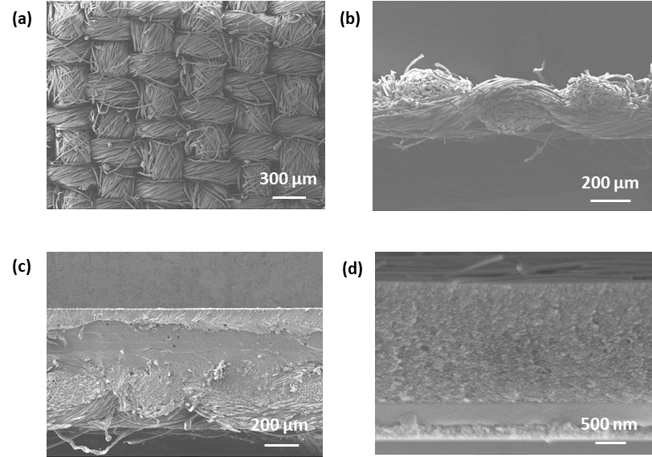

**Figure 1:** a) Plain view and b) Cross-sectional view of woven 65/35 polyester cotton fabric substrate. c) Interface coated fabric substrate. d) cross-sectional SEM image shows the spray coated layer sequence on the fabric substrate (from top down: AgNW, PEDOT:PSS, active layer, ZnO-NP, Ag and interface layer on textile).

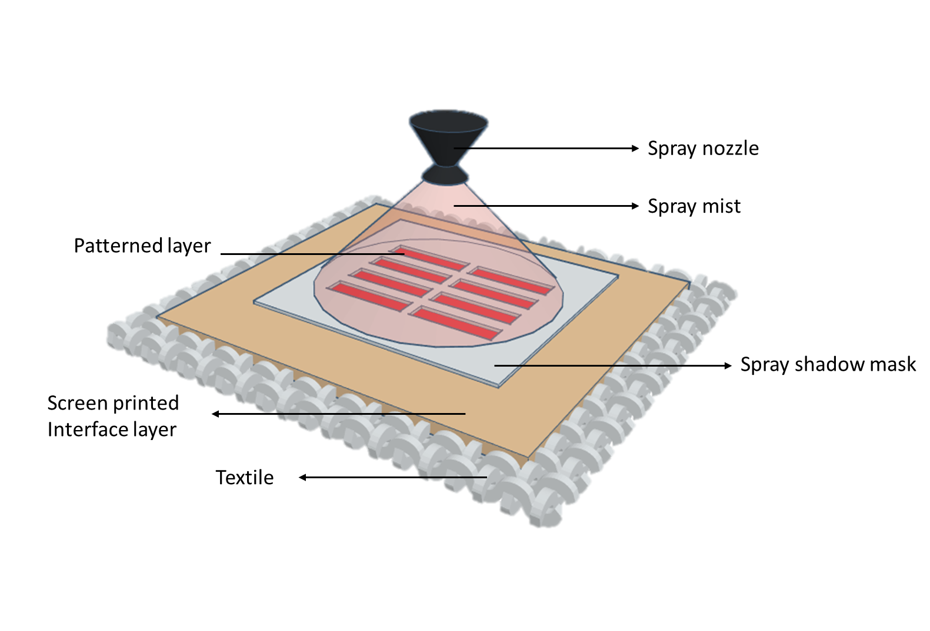

**Figure 2:** Pictorial representation of the fully solution processed spray coated fabric solar cells.

 

**Figure 3:** a) J/V characteristics of OSCs fabricated on FTO (type 1), bare glass substrate (type 2) and fabric substrate (type 3) using the spray coating method. b) EQE and UV-Vis spectra of type 1 device.

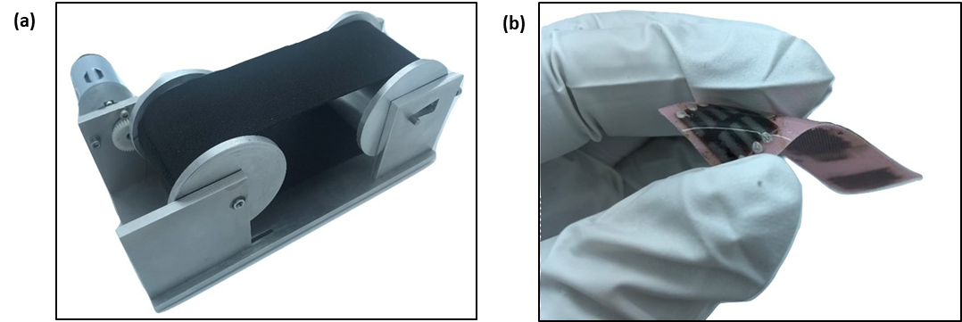

**Figure 4:** a) Photo image of the bending machine for testing the durability of the spray coated solar cells on textiles. b) Photo image of the encapsulated spray coated solar cells on textiles.

 

**Figure 5:** J/V curves of device type 3 after (a) outer and (b) inner bending cycling tests.



**Figure 6:** Isometric view of the schematic diagram of the spray coated organic solar cells with each layer defined.

**Tables:**

T**able 1:** Summary of the spray coated solar cell characteristics on both fabric and glass substrates.

|  |  |  |  |  |  |
| --- | --- | --- | --- | --- | --- |
| Devices | Device configuration | VOC (V) | FF | JSC (mA/cm2) | PCE (%) |
| Type 1 | Glass/FTO/ZnO-NP/ Active layer/PEDOT:PSS/AgNW | 0.56 | 0.26 | 10.6 | 1.5 |
| Type 2 | Glass/Ag-NP/ZnO-NP/ Active layer /PEDOT:PSS/AgNW | 0.52 | 0.24 | 8.06 | 1.0 |
| Type 3 | Fabric/Ag-NP/ZnO-NP/Active layer/PEDOT:PSS/AgNW | 0.50 | 0.24 | 3.44 | 0.4 |

**Table 2:** Summary of the outer and inner bending cycling test of fabric substrates (type 3).

|  |  |  |  |  |  |  |  |  |
| --- | --- | --- | --- | --- | --- | --- | --- | --- |
| Cycles | Outer bending cycles | | | | Inner bending tests | | | |
| VOC (V) | FF | JSC (mA/cm2) | PCE (%) | VOC (V) | FF | JSC (mA/cm2) | PCE (%) |
| 5 | 0.50 | 0.24 | 3.44 | 0.4 | 0.50 | 0.24 | 3.44 | 0.4 |
| 10 | 0.32 | 0.24 | 2.83 | 0.2 | 0.24 | 0.25 | 1.81 | 0.1 |
| 15 | 0.20 | 0.25 | 1.12 | 0.05 | 0.14 | 0.25 | 0.74 | 0.02 |
| 20 | 0.20 | 0.25 | 0.64 | 0.03 | 0.05 | 0.25 | 0.40 | 0.006 |
| 25 | 0.07 | 0.24 | 0.11 | 0.001 | - | - | - | - |