Agricultural shocks and drivers of livelihood precariousness across Indian rural communities

Tristan Berchoux (corresponding author)  
[t.berchoux@soton.ac.uk](mailto:t.berchoux@soton.ac.uk)  
*Geography & Environment, University of Southampton, United Kingdom 44/2035, University Road, Southampton SO17 1BJ*

Gary R. Watmough  
[gary.watmough@ed.ac.uk](mailto:gary.watmough@ed.ac.uk)  
*School of GeoSciences, University of Edinburgh, United Kingdom Surgeon’s Square, Drummond Street, Edinburgh EH8 9XP*

Craig W. Hutton  
[cwh@geodata.soton.ac.uk](mailto:cwh@geodata.soton.ac.uk)  
*GeoData Institute, University of Southampton, United Kingdom 44/2091, University Road, Southampton SO17 1BJ*

Peter M. Atkinson  
[pma@lancaster.ac.uk](mailto:pma@lancaster.ac.uk)  
*Lancaster Environment Centre, Lancaster University, United Kingdom Lancaster University, Lancaster LA1 4YQ*

Abstract

Spatial factors, such as environmental conditions, distance to natural resources and access to services can influence the impacts of climate change on rural household livelihood activities. But neither the determinants of precarious livelihoods nor their spatial context has been well understood. This paper investigates the drivers of livelihood precariousness using a place-based approach. We identify five community types in rural regions of the Mahanadi Delta, India; exurban, agro-industrial, rainfed agriculture, irrigated agriculture and resource periphery by clustering three types of community capitals (natural, social and physical). Based on this typology, we characterise the associations between precarious livelihood activities (unemployment or engagement in agricultural labour) with agricultural shocks and household capitals. Results demonstrate that, the type of community influences the impact of agricultural shocks on livelihoods as four of the five community types had increased likelihoods of precarious livelihoods being pursued when agricultural shocks increased. Our research demonstrates that the bundle of locally available community capitals influences households' coping strategies and livelihood opportunities. For example, higher levels of physical capital were associated with a lower likelihood of precarious livelihoods in agro-industrial communities but had no significant impact in the other four. Results also indicate that agricultural shocks drive livelihood precariousness (odds ratios between 1.03 and 1.07) for all but the best-connected communities, while access to household capitals tends to reduce it. Our results suggest that poverty alleviation programmes should include community typologies in their approach to provide place-specific interventions that would strengthen context-specific household capitals, thus reducing livelihood precariousness.

**Keywords:** livelihoods, community typologies, rural development, agricultural shocks, chronic poverty, India

**Acknowledgement**

This work was carried out under the Deltas, vulnerability and Climate Change: Migration and Adaptation (DECCMA) project under the Collaborative Adaptation Research Initiative in Africa and Asia (CARIAA) programme, with financial support from the UK Government’s Department for International Development (DFID), the International Development Research Centre (IDRC) (Canada) [grant number 107642] and the UK Economic and Social Research Council [grant number 1501613]. The views expressed in this work are those of the creators and do not necessarily represent those of DFID, IDRC, ESRC or its Boards of Governors. Prior to commencing the study, ethical clearance was obtained from the University of Southampton [ERGO number 15234]. Data used in this research come from the Census of India provided by the Office of the Registrar General & Census Commissioner of India. The authors acknowledge the use of the IRIDIS High Performance Computing Facility, and associated support services at the University of Southampton, in the completion of this work. The authors wish to thank all participants for providing their time and knowledge. Additional gratitude goes to Shubashree Samal and Pratap Malla who both helped in the organisation, planning and interpretation of field visits.

# Introduction

Investigating the impacts of climate change on rural livelihoods and rural poverty is a continuing concern within environmental sciences and development studies. Repeated exposure to climatic stresses can undermine current and future coping capacity, which can lead to shifts from transient to chronic poverty (Ahmed, Diffenbaugh, & Hertel, 2009). However, the impacts of climate shocks on rural households depend on coping strategies and livelihood opportunities and cannot be explained by income-based approaches alone (Scoones, 2015). Livelihood approaches reveal that inequalities in access to livelihood capitals and in livelihood opportunities are spatially dependent and that they perpetuate poverty and undermine households' ability to cope with external shocks (de Sherbinin et al., 2008). Understanding the links between multiple stressors and livelihoods is central to achieving sustainable development pathways. However, insufficient work assesses the spatial distribution of livelihoods as a consequence of weather shocks. This paper aimed to bridge this gap by conducting a place-based analysis of the associations between livelihood strategies, agricultural shocks and livelihood capitals. The objective of this paper was to demonstrate how the type of rural community in which households are situated modifies the relationships between livelihood strategies, agricultural shocks and access to livelihood capitals.

Our research demonstrates that the bundle of locally available community capitals influences households' coping strategies and livelihood opportunities, thus influencing the drivers of rural poverty. We also argue that agricultural shocks drive livelihood precariousness, while access to capitals tends to reduce it. Our results suggest that poverty alleviation programmes should include community typologies in their approach to provide place-specific interventions that would strengthen context-specific household capitals, thus reducing livelihood precariousness.

**1.1 Access to Community Capitals and Household Livelihood Activities**

A major theoretical issue that has dominated the field of livelihood studies for many years concerns the use of quantitative methods to characterise rural livelihoods and their dynamics (Jiao, Pouliot, & Walelign, 2017). However, most of these studies have considered that the effect of capitals on livelihood strategies is constant across space, without considering community-level effects (Berchoux & Hutton, 2019; Bhandari, 2013). For example, access to a common agricultural area in the village can have a positive effect on livelihoods as it can create synergies between farmers to invest into agricultural equipment or irrigation infrastructure and it can increase their bargaining power (Agarwal, 2018). Community-level studies that paid particular attention to the spatial component of livelihoods led to descriptive results, such as the creation of indices (e.g. Singh and Hiremath, 2010). Although such indices are a useful mapping tool for policy makers, they fail to break down the different livelihood components and thus characterise the place-based dimensions of rural poverty.

Overall, despite the recommendations from previous poverty studies (e.g. Palmer-Jones and Sen, 2006) and from livelihood studies (e.g. Angelsen et al., 2014) that have shown the importance of place-based approaches to rural poverty, there have been very few studies that have characterised the place-based sensitivity of livelihood strategies to livelihood capitals and external shocks. To the authors' best knowledge, the only study that looked at the associations between livelihood capitals and livelihood strategies using a place-based approach relied on an arbitrary categorisation of community types based on a total of six settlements (Fang, Fan, Shen, & Song, 2014). In their study, Fang et al. (2014) demonstrated that different settlement types affect how access to capitals influences households' livelihood strategies. However, the interpretation of the results was micro-localised and difficult to reproduce across a larger spatial extent. Our approach helps meet this challenge by identifying how the effects of key determinants of precarious livelihood strategies vary across a broad geographic extent.

Community capitals can be defined as public goods through which people are able to widen their access to resources and to economic opportunities (Lindenberg 2002; Gutierrez-Montes et al. 2009). They can include factors such as environmental conditions (e.g. elevation, rainfall, soil quality), distance to natural resources (e.g. forest, wetlands) and access to services (e.g. markets, hospitals, schools). These community capitals vary spatially and can shape differential vulnerabilities and influence the impacts of climate change on rural households (Berchoux, Watmough, Johnson, Hutton, & Atkinson, 2019). These spatial factors form a group of interacting services that co-occur in time and space, creating bundles of community capitals (Turner, Odgaard, Bøcher, Dalgaard, & Svenning, 2014; Yang et al., 2015).

**1.2 Characterising community capitals using typologies**

Typologies are useful tools for policy-makers, planners and other practitioners to improve place-specific understandings of rural heterogeneity and rural change. The heterogeneity of rural areas can be categorised into community typologies that reflect similar combinations of natural resources (i.e., water, cropland, forest), social services (including education, health, governance), and productive infrastructures (Alessa, Kliskey, & Altaweel, 2009; Van Eetvelde & Antrop, 2009). These different combinations of assets reflect different underlying types of communities (van der Zanden, Levers, Verburg, & Kuemmerle, 2016), which influence the drivers of livelihood strategies and rural poverty, and therefore lead to different responses to multiple stressors. In this paper, we investigate the drivers of livelihood precariousness using a place-based approach. We create a typology of rural communities (defined here as villages derived from [national population and housing censuses](https://en.wikipedia.org/wiki/Population_and_housing_censuses_by_country)) by clustering characteristic variables of community capitals, focused on natural resources, social services and productive infrastructures. Based on this typology, we characterise the associations between precarious livelihoods, agricultural shocks and household capitals for each community type. This approach helps to elucidate how the type of community can determine the impact that agricultural shocks can have on household livelihood activities and in particular on the likelihood that households pursue precarious activities.

## Weather shocks and impacts on livelihood activities

Despite the Government of India’s efforts to enhance livelihood security in rural areas, only 53.2% of the working age rural population is able to get work throughout the year (Indian Ministry of Labour and Employment, 2015). While the majority of the employed population depends on agriculture, forestry and the fishing sector for their livelihoods, around 78% of households do not earn any wages. Weather shocks affect agricultural production through frequent floods, droughts, and storm surges with subsequent impacts on rural livelihoods (Birthal, Roy, & Negi, 2015). Households put in place coping strategies to adjust to the loss of wages following a crop failure.

Coping strategies are defined as temporary adjustments made by households in their livelihood systems in response to shocks, which can be external (natural hazards, movements in markets, changes in policy environment) or internal (health problems, changes in household composition, social rituals) (Scoones, 2015). Three different types of coping mechanisms can be highlighted based on their reversibility: (i) reversible mechanisms (temporary activity shift, disposal of protective assets); (ii) erosive mechanisms (disposal of productive assets such as land); and (iii) destitution (unemployment, distress migration). Reversible mechanisms can be observed when some members take wage labour or migrate to find paid work (temporary activity shift) or when using self-insurance mechanisms, such as selling protective assets. Protective assets include any asset held as a store of value and that can be sold if the household faces an external shock, including cash, jewellery or livestock (Chena et al., 2013). Erosive mechanisms are usually implemented in response to heavy shocks or persisting stresses and undermine households' productive capacity. In the case of disposal of agricultural land, this leads to a long-term livelihood change, as households shift from cultivation to other activities, for example, agricultural labour. The last category of coping mechanisms comes as a last resort for the household and indicates its destitution, with household members becoming unemployed or choosing permanent out-migration.

In India, although the percentage of farmers with land access rights declined from 72 to 45% between 1951 and 2011, the percentage of landless agricultural labourers increased from 28 to 55% (Indian Ministry of Labour and Employment, 2015). This considerable rise in landless agricultural labourers is an indication that many households have put in place erosive mechanisms to cope with the impacts of agricultural shocks (Williams et al., 2016). However, the effects of such shocks vary widely across a broad geographic extent, with livelihood opportunities (and, thus, the ability to put in place reversible coping mechanisms) being conditioned by access to community capitals (Berchoux et al., 2019).

# Conceptual framework

The approach taken in this paper (Figure 1) is based on the household livelihood strategy framework (Nielsen, Rayamajhi, Uberhuaga, Meilby, & Smith-Hall, 2013) and shows the different components used to understand how access to community capitals can influence the associations between precarious livelihoods, agricultural shocks and livelihood capitals.

A livelihood system combines the capabilities, assets and activities of one household to achieve its means of living (Scoones, 2015). Assets are resources that people have access to, which can be private goods (household capitals) or public goods (community capitals). Household assets are grouped into a set of five livelihood capitals: natural (private natural resource stocks), physical (productive assets), financial (liquidities and protective assets), human (capabilities and capacities of the households) and social (networks and kinships). Regarding community capitals, three categories can be differentiated (Flora, Flora, & Gasteyer, 2015): common-pool natural resources, social services (access to social amenities) and productive infrastructures (road networks, markets and industries). Based on their access to community and household assets, households put in place a range of livelihood activities to achieve their basic needs. Livelihood opportunities depend on the household and community capitals that households have access to. The combination of capitals and activities leads to livelihood outcomes if the household does not face any shocks, which are reinvested in the system. In the case of a shock (internal or external), households can implement three types of coping strategies depending on their assets, as well as public assets from the community they live in: reversible mechanisms (activity shift, sell of protective assets), disposal of productive assets (sell land) and destitution (unemployment, distress migration).

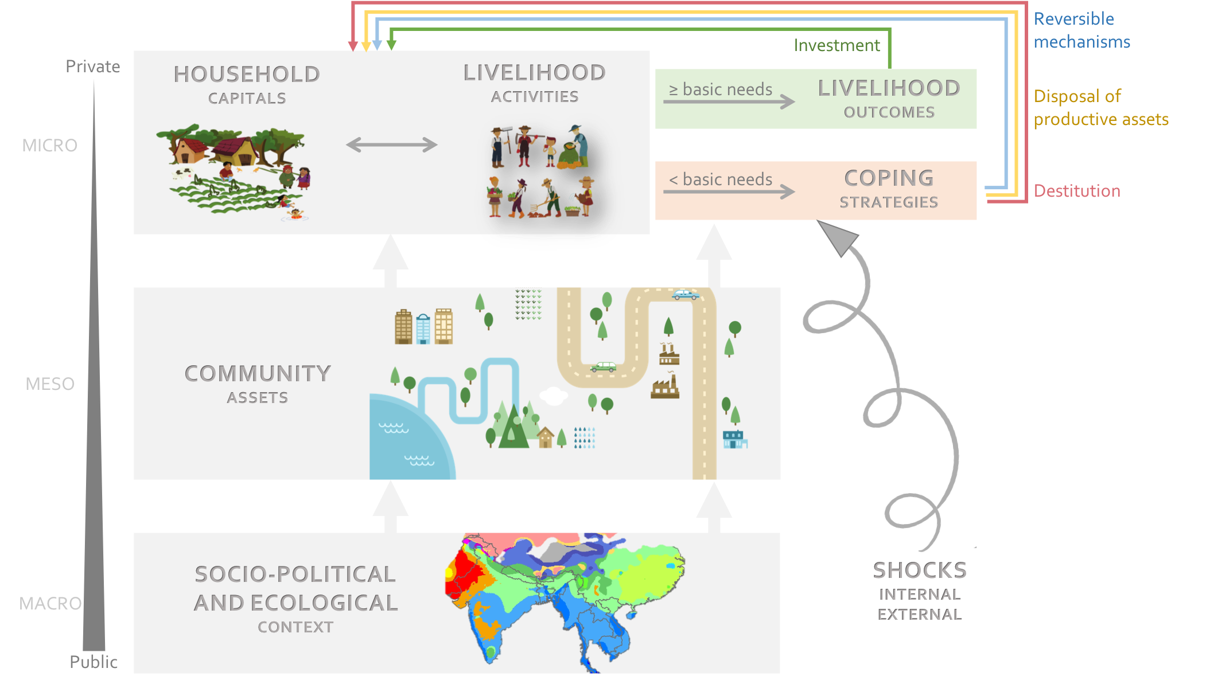

Figure 1: Dynamic multilevel livelihood framework.

# Methods

Most of the people who live in deltas rely on agriculture to ensure their food security and to generate economic incomes. However, deltas are exposed to multiple stressors arising from both terrestrial (such as run-off from rivers) and marine processes (such as storms, waves or sea-level from oceans), which are a threat for rural populations relying on agriculture for their livelihoods. Moreover, deltas are one of the most exposed ecosystems to climate change (Ericson, Vorosmarty, Dingman, Ward, & Meybeck, 2006). As a consequence, rural households located in deltas that rely on agriculture are amongst the most vulnerable to climate change, as their main livelihood is highly vulnerable to the projected increase in the frequency of floods and droughts. Despite the ecological services they perform, the economic value they generate and that they are home to around 500 million people (Ericson et al., 2006), little attention has been paid to deltas as a socio-ecological unit. Therefore, we selected the Mahanadi Delta located within the state of Odisha in East India as study site.

## Study site

The Mahanadi Delta in Odisha, India, is a populous delta where livelihood opportunities are affected negatively by environmental stressors, such as floods, droughts cyclones, erosion and storm surges. The combination of environmental stresses has resulted in a loss of income for rural households who are dependent on agriculture for their livelihoods (68% of the delta's population), due to major crop failures (Duncan, Tompkins, Dash, & Tripathy, 2017). As a consequence of their inability to cope with the impacts of environmental shocks, many households have to sell off their agricultural land. Their members often become unemployed with limited livelihood opportunities to move out of poverty, either to migrate or become agricultural labourers (Sahu & Dash, 2011).

This research focused on an area covering the five districts of the Mahanadi Delta in Odisha, eastern India: Bhadrak, Jagatsinghpur, Kendrapara, Khorda and Puri (Figure 2). Given that communities are statutory units in India with a definite boundary and separate land records, we used the administrative boundaries provided by the Registrar General and Census Commissioner (2011) for our analysis. In total, 9,829 rural communities were considered.

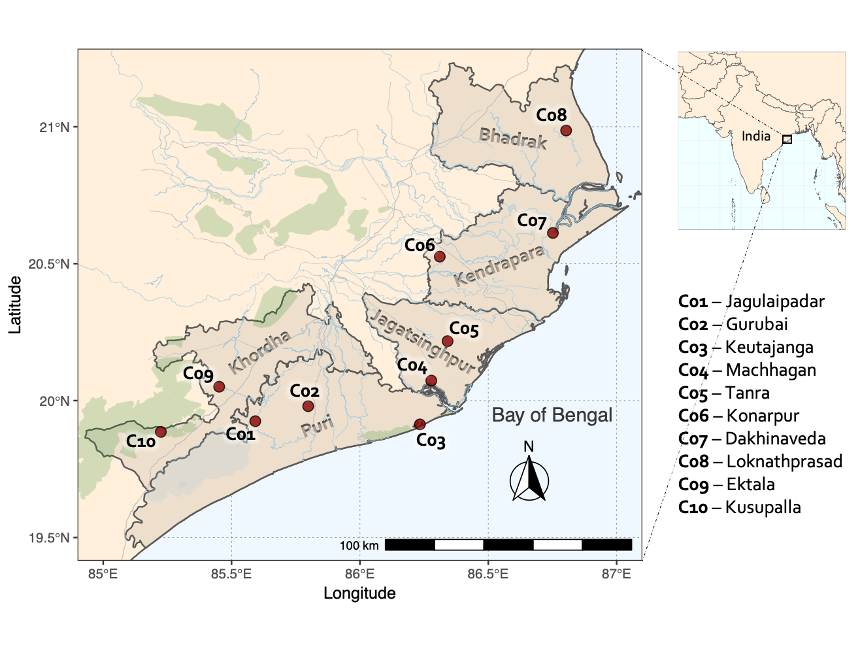

Figure 2: Location of the study area. The study area covers all five districts (Bhadrak, Jagatsinghpur, Kendrapara, Khorda and Puri) located within the Mahanadi Delta. Rapid Rural Appraisals were conducted in ten communities (C01-C10).

## Local perceptions of the drivers of livelihood strategies

Fieldwork was conducted between February and May 2016 to identify indicators that stakeholders, experts and local residents perceive as representative and robust to examine the effects of community and household capitals on their livelihoods. A Rapid Rural Appraisal (RRA) was used for data collection to highlight the perceptions and opinions of rural dwellers (Supplementary Material S1). This method enables local people to share their knowledge and discuss their situation using their own terms (Mukherjee, 2005). In total, ten communities were selected by using stratified random sampling based on their access to community capitals and on the main livelihood activities conducted by households (Fig. 2).

A variety of additional activities were used to cross-check the data acquired from the RRA. First, a focus group was held to identify general information about the village and the evolution of its infrastructure. The focus group also investigated differences in livelihood assets and strategies within the community which were combined into a series of categories by the participants. The proportion of households falling into each livelihood category were subsequently quantified by the participants. The last activity was a participatory photography workshop using the photovoice methodology (Wang & Burris, 1997) on the theme of “Key assets to achieve your livelihoods”; a theme broad enough to let the participants themselves highlight the different roles that community and household capitals play in their decision to pursue an economic activity.

## Developing Community Typologies

Every community has common-pool resources (i.e. road, market, forest, lake) that can provide services for rural dwellers' livelihoods. For example, a road can provide farmers with alternative outlets for their agricultural production, while a forest can give the opportunity for households to collect and sell non-timber forest products. Such common-pool resources appear together repeatedly in the landscape, creating bundles of community capitals (Bański & Mazur, 2016). We used cluster analysis on 18 variables derived from open source data to generate community typologies. Indicators were selected based on participatory rural appraisals conducted in ten communities located across the Mahanadi delta. Participants argued that remoteness plays an important role in their access to community capitals, and thus in their choice of livelihood strategy. As a consequence, we used travel time to key amenities rather than amenity availability to reflect community remoteness in the cluster analysis. Euclidean distances are inappropriate for this purpose as the Mahanadi delta has several water bodies, which act as boundaries to travel. We thus estimated accessibility to key amenities by creating a least accumulative cost surface to estimate time (in hours) to travel from each community to the nearest amenity of interest, using the R package “gdistance” (van Etten, 2017).

### Estimating accessibility

We downloaded road data from OpenStreetMap, using the R package “osmdata” (Padgham, Rudis, Lovelace, & Salmon, 2017). Roads were converted to a raster with 30 m spatial resolution and merged with 30 m spatial resolution land cover data from 2010 GlobeLand30 (Chen et al., 2014). Based on a previous study in India (Watmough, Atkinson, Saikia, & Hutton, 2016), average speeds were assigned to each land cover class (Table 1) and were based on travel by foot across land covers and footpaths and travel by motorised vehicles on other forms of road and track.

Table 1: Estimated travel speeds for different land cover types (based on Watmough et al. 2016). Pedestrian movement was assumed where no roads exist, travel by motor vehicles was assumed where roads are available and travel by boat was assumed on waterways. Speeds were then used to generate travel cost to nearest amenities.



### Variables for community typologies

In total, 18 variables were chosen to be included in the cluster analysis (Table 2). These were selected to represent the diversity of drivers that were highlighted by participants during the participatory rural appraisals. They can be grouped into three categories, natural resources, social services and productive infrastructure. Locations of the main amenities were extracted from the Village Amenities tables of the 2011 Indian National Population and Household Census and from OpenStreetMap data. We used 2010 MODIS data at 250 m spatial resolution to obtain a land cover dataset detailing the different types of cropping systems found in the delta (Gumma et al., 2014). Travel costs to the nearest amenity of interest were computed from the least accumulative cost surface dataset mentioned earlier. In situations where multiple indicators for the same service were found (type of education or health facility), we favoured the indicator that exhibited the greatest variation among communities. Based on the results from RRA (S1), travel times to six types of amenities were chosen to reflect access to social services: public services and polling stations, secondary schools, banks and credit cooperatives, hospitals, worship temples and recreational areas, such as sports centres and playgrounds. Three amenities were used to reflect access to productive infrastructures: travel time to communication services, agricultural outlets and industrial areas. Availability of public transport was also chosen to represent productive infrastructures, as they can be used by smallholders to access agricultural markets. Eight variables were chosen to reflect the natural resources from which most households derived their incomes, seven of which were derived from satellite sensor data and one from OpenStreetMap data (Table 2). The variables to reflect the natural resources included: the area of forest, the area of cropland available per household, the type of agricultural system (based on the proportion of each cropping pattern within the community) and the travel time from each community to the nearest aquaculture ponds. These variables were chosen since the number of growing seasons and the availability of irrigation systems can be a determinant for livelihood outcomes.

Table 2: Variables used for community typologies. Indicators for social services are based on travel times to the closest service found by using a least accumulative cost surface dataset, computed from road networks and land cover data. Natural services are derived from agricultural-relevant metrics from land cover data.



### Clustering method

We used a model-based clustering method to avoid the limitations of deterministic procedures, such as hierarchical and *k*-means clustering algorithms. As demonstrated by (Raykov, Boukouvalas, Baig, & Little, 2016), these two popular clustering methods rely on restrictive assumptions that lead to severe limitations in accuracy and interpretability. In particular, these algorithms cluster data points based on geometric closeness to the cluster centroid, without taking cluster densities into account. Therefore, they implicitly assume that each cluster must contain the same number of data points, which is a biased assumption for building community typologies. On the contrary, model-based clustering considers that the data comes from a distribution that is a mixture of two or more clusters, and assigns to each data point a probability of belonging to each cluster (C Fraley & Raftery, 2002). Each cluster is modelled by the Gaussian distribution and is characterised by its mean vector, covariance matrix and the probability of each point belonging to this cluster. These parameters are estimated using the Expectation-Maximisation algorithm, which is initialised by hierarchical model-based clustering. The covariance matrix determines the geometric shape of each cluster, the latter being centred at the mean, around which there is an increased density of points. The model with the greatest integrated likelihood, or Bayesian Information Criterion (BIC), is considered as the best fitting model. We used the R package “mclust” (Chris Fraley, Raftery, Murphy, & Scrucca, 2012) to implement the model-based clustering algorithm, which estimated the best finite mixture model according to different covariance structures and different numbers of clusters.

## Quantifying livelihood capitals

The quantification of livelihood capitals was based on register data at the village level from a subset of the 2011 Indian National Population and Household Census. The variables selected to quantify livelihood capitals are proxies for the participants' views, regarding the capitals that they perceived as determinant for their livelihood opportunities (Supplementary Material S2). Given the high correlation amongst the selected variables, a principal component analysis was used to circumvent the problem of multicollinearity and to derive a single factor score for each capital. Multiple factors were not combined as this would have distorted what the component represents and would have made interpretation difficult (McKenzie, 2005). After ensuring that the factor loadings corresponded with the conceptualisation of each capital based on the RRA activity, the first factor score was selected to represent each capital. Low loading factors (|λ| ≤ 0.2) were kept as excluding them would have distorted the views from RRA participants. Moreover, McKenzie (2005) showed that low loading factors should be included when measuring inequality, especially when the variable is a known (or perceived) determinant of poverty.

Table 3: List of variables used for the quantification of household livelihood capitals. The associated factor loading retrieved from the PCA represents the weight for each variable in the construction of their associated livelihood capital. The justification for the inclusion of each variable is based on participants' views from participatory rural appraisals.



## Quantifying precarious livelihoods

The census indicators comprise population enumeration including cultivators, agricultural labourers, entrepreneurs and unemployed. Detailed examinations of poverty structures in rural India show that households engaged in agricultural labour or the unemployed are the poorest of the rural poor (Ravi and Engler, 2015). We, thus, defined precarious livelihoods as the proportion of working-age people (15-59) who are engaged in agricultural labour or unemployed, as defined in the Census of India. The census defines a person as an agricultural labourer if they work on another person’s land for wages in money or kind or share, with no right of lease or contract on the land on which they work, while a person is defined as a non-worker if they do not engage in any economically productive activity for more than 6 months per year.

## Proxying climate shocks

Extreme events, such as heat waves, droughts, floods and cyclones are becoming more frequent and both their frequency and intensity are likely to increase in the future (Baker et al., 2018). Extreme weather events can result in agricultural losses, which can lead to shifts from transient to chronic poverty (Krishnan & Dercon, 2000). Decreases in agricultural production can be identified by remotely sensed satellite sensor data in the form of abrupt changes in vegetation greening (Liu, Liu, & Yin, 2013). This section presents the materials and methods used to detect decreases in agricultural production, which are used as proxies of weather shocks (see Supplementary Material S3 and S4 for R codes).

### Choosing a vegetation index to capture crop production

We used the Wide Dynamic Range Vegetation Index (WDRVI) as it preserves a linear relationship with LAI/vegetation fraction and captures well crop growth dynamics. It was also found to be more accurate than other vegetation indices at estimating crop yield over the Mahanadi Delta (Duncan, Dash, & Atkinson, 2015). The index is calculated following the equation:

$$WDRVI=\frac{α*ρ_{NIR}-α*ρ_{red}}{α*ρ_{NIR}+α*ρ_{red}}$$

Where ρNIR is the near-infrared reflectance, ρred the red reflectance and α a weighting parameter selected by the user. A weighting of α = 0.20 was used, as it has been found to be the optimum value to monitor phenological processes when using computer-intensive algorithms (Testa, Soudani, Boschetti, & Borgogno Mondino, 2018). We used band 1 (ρred, 620-670 nm) and band 2 (ρNIR, 841-876 nm) from MODIS surface reflectance products to compute the WDRVI at a spatial resolution of 250 m and a temporal resolution of every 8-days for the time period 2000 to 2011 (506 composite images from 26/02/2000 until 26/02/2011.

### Detecting breaks in crop production

The Breaks For Additive Season and Trend (BFAST) technique was used to detect changes in time-series of WDRVI to identify crop failures. This method was used to determine the number, type, and timing of trend and seasonal changes within historical time-series (Verbesselt, Hyndman, Newnham, & Culvenor, 2010). It estimates the dates, the magnitude and direction of change without setting a threshold or defining a reference period, and thus can be used to characterise changes occurring in seasonal and trend components. The general decomposition model fits a piecewise linear trend Tt and a seasonal model St, and is of the form: Yt = Tt + St + et, with t = 1,…, n. The ordinary least squares (OLS) residuals-based MOving SUM (MOSUM) test is used to detect whether one or more breakpoints are occurring. If breaks are occurring, the number and position of breaks are determined by minimising the residual sum of squares and by minimising an information criterion, such as the Bayesian Information Criterion (BIC). The intercept and slope of consecutive linear models are used to characterise the magnitude and direction of abrupt changes in the trend.

Figure 3 presents the outputs from the break detection in the WDRVI time-series, where only negative breaks were considered. The algorithm was run on pixels that were used for agricultural production throughout 2000-2011. Pixels that changed land use during that period (i.e. specifically if they were converted to urban) were not included to prevent the detection of false-breaks due to land use changes. Thanks to the linear correlation that exists between WDRVI and crop yield over the Mahanadi Delta (Duncan et al., 2015), breaks in WDRVI time-series represent abrupt changes in crop production, and negative breaks are thus considered to represent crop failures. Moreover, Watts and Laffan (2014) showed that breaks in vegetation indices detected by BFAST corresponded with the timing of known floods in the study region for between 68% and 79% of breaks detected across the sample pixels. Taken together, these studies indicate that the BFAST method is able to detect abrupt changes in vegetation greening caused by climatic hazards. We thus consider negative breaks in the WDRVI time-series as proxies of weather shocks that had a negative impact on crop production.

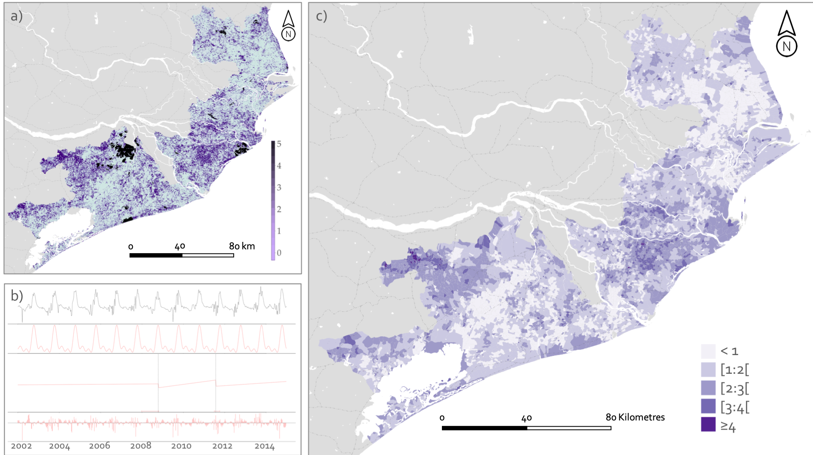

Figure 3: Breaks in WDRVI time series detected using BFAST. For each pixel, the time series is decomposed into its seasonal and trend components to identify breakpoints using the Breaks For Additive Season and Trend (BFAST) technique. Figure b shows an example of the decomposition of the WDRVI time series for one random pixel, highlighting two breaks. These breaks represent shocks in the agricultural production. The maps show the count of negative breaks in croplands: per pixel at a resolution of 250 m (map a); and averaged at the village level for modelling purposes (map c).

## Statistical modelling

Multilevel regression techniques were used to control for contextual factors, by allowing the model to vary at the Tehsil level. To characterise how community typologies affect the associations between livelihood capitals, crop failures and precarious livelihood activities, we fitted separate models for each one of the village types identified through model-based clustering. Access to livelihood capitals is mediated by overarching systems of power, the demographic pressure and the local political context, which have been shown to be one of the main causal determinants of poverty in India (Lerche, 2009). To avoid inferring any definite causal relationship, we controlled for these mediating factors by using the respective proxy variables: proportion of scheduled castes and tribes, population density and District. For each community type, a two-level random intercept model was fitted using the R package “R2MLwiN” (Charlton, Rasbash, Browne, Healy, & Cameron, 2017):

${\text{logit}}_{\text{Cluster}}\left(π_{ij}\right)=\log{(\frac{π_{ij}}{1-π_{ij}})}=β_{0j}+β_{1}{\text{District}}_{ij}\text{+}β_{2}{\text{PopDensity}}_{ij}+β_{3}{\text{SCST}}_{ij}+{β_{4}\text{Breaks}}_{ij}^{\text{WDRVI}}+β_{5}{\text{Natural}}_{ij}+β_{6}{\text{Physical}}_{ij}+β_{7}{\text{Human}}_{ij}+β_{8}{\text{Financial}}_{ij}+β_{9}{\text{Social}}_{ij}$,

where πij refers to: the probability of being engaged in precarious livelihoods (unemployment and agricultural labour) for the village *i* in the Tehsil *j*. Each level 1 unit (village) had an associated denominator ni, which was the total number of people of working age (every person aged 15-59. Two sets of explanatory variables were considered: livelihood capitals and the number of breaks in the WDRVI time-series, as a proxy of the number of crop failures. As the response variable is binomial, we used a linearisation method in the model to transform the discrete response model (binomial) to a continuous response model (Goldstein, 2003), with a Maximum Likelihood modelling approximation method to estimate the unknown parameters of interest in the model.

# Results

## Typology of rural communities

The clustering of 18 variables in three domains (natural resources, social services and productive infrastructures) resulted in five distinct clusters being identified. These formed the basis for five community typologies that could be used to investigate how the place-based relationships between livelihood precariousness, agricultural shocks and household capitals. The five community types were spatially clustered in the landscape (Figure 4) and each was named based on the type of services available to the community and on the dominant land cover class.

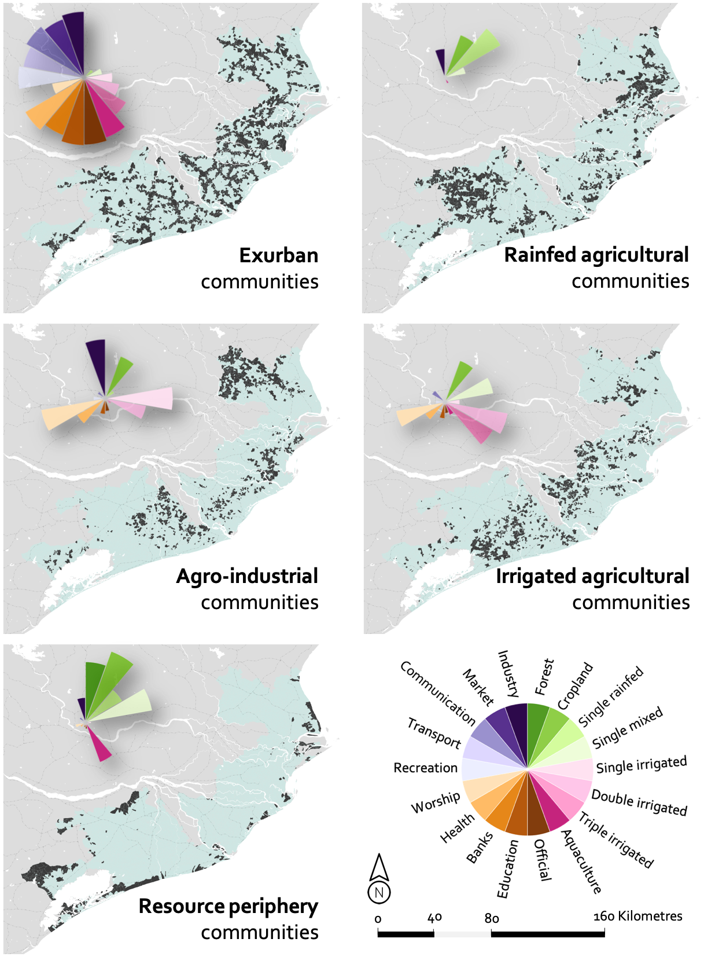

Figure 4: Community typologies as identified by model-based clustering. Types of communities were identified based on their access to natural resources, social services and productive infrastructures. Five clusters were identified: communities with great access to productive infrastructures and social services (exurbs), production communities with low agricultural infrastructures (rainfed agricultural) and with irrigation infrastructures (irrigated agricultural), production communities with industries (agro-industrial) and remote communities with high natural resources (resource periphery).

### Exurban communities

This cluster reveals a clear geographic profile, with a total of 2,245 communities (total population of 1,928,232) located in the near vicinity of main roads. It reveals characteristics that are ascribed to communities well connected to urban and peri-urban areas, defined as exurbs. This cluster is characterised by a high availability of public transport and close proximity to markets (19 minutes average travel time) and industries (1h 29 minutes average travel time). Communities also have high levels of access to social services such as education (10 minutes average travel time) and health facilities (45 minutes average travel time) and are located near local official institutions (average travel time of 8 minutes). The main agricultural systems are a combination of freshwater aquaculture, irrigated rice crop grown once (22.8% of cropland area on average), twice (19.0% of cropland area on average) and thrice (22.1% of cropland area on average) per year. However, although the total area of land devoted to agriculture is lower than for other clusters (average of 91 ha), the average farm size is 1.07 ha per cultivator.

### Rainfed agricultural communities

This cluster represents a total of 2,563 agricultural communities (total population of 2,511,527) mainly located in the south western and north-eastern parts of the delta. These communities are characterised by low access to social services (average travel times to secondary schools, hospitals and public offices are 56, 2h14 and 32 minutes respectively) and productive infrastructures, such as markets (average travel time of 1h 21 minutes) and industries (average travel time of 3h03 minutes). The main agricultural system is single rice crop (38.3% of cropland area on average) or single mixed crops (14.6% of cropland area on average) grown in rainfed conditions. The total cultivated area in each community is 101 ha on average, with an average farm size of 1.00 ha per cultivator.

### Agro-industrial communities

The 2,174 communities (total population of 2,122,436) of this cluster are located in the northern part of the delta and in the south of the axis Bhubaneswar-Cuttack. They have a high access to worship amenities, a relatively high access to other social services (average travel times to secondary schools, hospitals and public offices are 51, 2h05 and 30 minutes respectively) combined with a greater proximity to industrial areas (1h 51 minutes average travel time) and markets (1h 14 minutes average travel time) compared to the other agricultural communities. The main agricultural system is irrigated rice crop grown once (36.5% of cropland area on average) or twice (20.0% of cropland area on average) per year. The communities within this cluster have an average cultivated area of 97 ha for an average of 0.96 ha per cultivator.

### Irrigated agricultural communities

The 2,438 agricultural communities (total population of 2,422,307) of this cluster are located in the central part of the delta and near the Chilika lake. They share similar characteristics with agro-industrial communities in terms of their access to social services (average travel times to secondary schools, hospitals and public offices are 53, 2h04 and 30 minutes respectively) but with lower access to productive infrastructures (average travel times to markets and industries are respectively 1h17 and 2h57). However, unlike rainfed communities, the irrigated agricultural communities are characterised by a high share of irrigated rice crop grown twice (24.1% of cropland on average) and thrice (23.5% of cropland area on average) per year. The area of cropland is on average 98 ha in total and 0.99 ha per cultivator in the cluster.

### Resource periphery communities

The 409 resource periphery communities (total population of 362,797) are located in remote areas, far from market towns and urban centres. These communities are characterised by a very low access to social services (average travel times to secondary schools, hospitals and public offices are 1h06, 3h18 and 41 minutes respectively) and to productive infrastructures (average travel time to industries: 4h10; and to markets: 1h40). Due to the lack of irrigation infrastructures, the main agricultural systems are single mixed crops (34.7% of cropland area on average) and single rice crop grown in rainfed conditions (26.5% of cropland area on average). The communities within this cluster are characterised by the dominance of natural resources, such as forests (area of 0.92 ha on average), proximity to aquaculture ponds and a large cropland area with an average of 1.11 ha per cultivator for a total cultivated area of 112 ha on average.

## Statistical modelling

Odds ratios were used to quantify the relationships between the response variable (proportion of people engaged in precarious livelihood activities) and the explanatory variables (livelihood capitals and number of agricultural shocks), controlling for district and population density effects, but also for the effects of class and caste (Table 4). An odds ratio above one indicates that, as the explanatory variable increases, the odds of being engaged in precarious livelihood activities also increase. When explanatory variables are categorical (e.g. “District”), odds are interpreted by comparing the variable level to a reference (district “Bhadrak”). For example, in rainfed agricultural communities, an odds ratio of 0.74 for Jagatsinghpur can be interpreted as: the likelihood of being engaged in precarious livelihood activities for communities located in Jagatsinghpur is 26% lower compared to communities located in Bhadrak.

Table 4: Results of the logistic models for each community. The dependent variable represents the odds of engaging in precarious activities (agricultural labourers and unemployed) for people who are within the legal working age. The explanatory variables represent the capitals that households have access to and the number of agricultural shocks that the community faced between 2000 and 2011.



Amongst the five household capitals, human and financial capital show consistent associations across all clusters: a greater access to these decreases the odds of being engaged in precarious livelihood activities (Table 4). The effect of human capital is the strongest in exurban communities (OR = 0.83, 95% CI = 0.81, 0.85) and the weakest in agro-industrial communities (OR = 0.93, 95% CI = 0.91, 0.95), while the effect of financial capital is the weakest in remote communities, such as rainfed agricultural (OR = 0.93, 95% CI = 0.91, 0.95) and resource periphery (OR = 0.92, 95% CI = 0.86, 0.99). The model shows that access to transportation and to electricity (physical capital) is associated with lower odds of engaging in precarious livelihood activities only for households located in agro-industrial communities (OR = 0.96, 95% CI = 0.94, 0.99). The odds of having a precarious livelihood decrease with greater access to natural capital in rainfed agricultural (OR = 0.80, 95% CI = 0.64, 0.99) and agro-industrial (OR = 0.77, 95% CI = 0.61, 0.95) communities, whereas it is the contrary in exurban communities (OR = 1.11, 95% CI = 1.02, 1.20). Social capital was found to be negatively associated with the odds of having a precarious livelihood in exurban (OR = 0.87, 95% CI = 0.85, 0.89), rainfed agricultural (OR = 0.92, 95% CI = 0.91, 0.94) and resource periphery (OR = 0.94, 95% CI = 0.89, 0.98) communities, but positively associated in agro-industrial communities (OR = 1.03, 95% CI = 1.01, 1.05).

The models show that it is more likely that households will engage in precarious livelihood activities when the number of agricultural shocks increases, except for exurban communities (OR = 0.99, 95% CI = 0.97, 1.01) and agro-industrial communities (OR = 1.02, 95% CI = 1.00, 1.05) where associations between shocks and livelihoods are not significant. Figure 5 shows the predicted probability of being engaged in precarious livelihood activities depending on the number of agricultural shocks faced by the community during the ten previous years. From these data, we can see that the probability of precarious livelihoods strongly increases with the number of agricultural shocks in agricultural-based communities with low access to productive infrastructures, such as rainfed agricultural, irrigated agricultural and resource periphery. However, we found that the number of agricultural shocks does not have a significant effect on precarious livelihoods in exurban and agro-industrial communities.

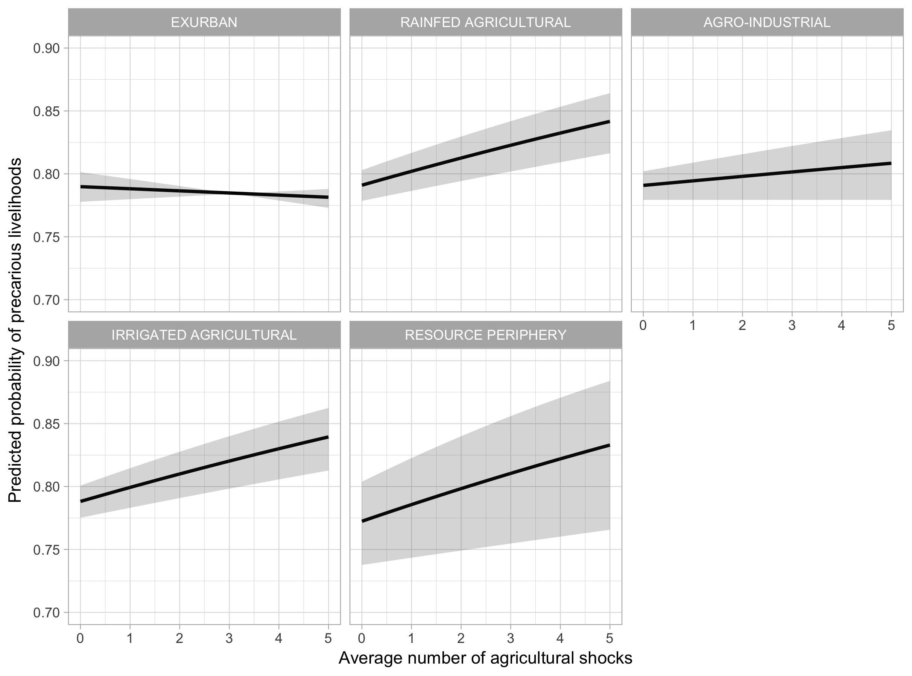

Figure 5: Predicted probability of precarious livelihoods conditioned on the average number of agricultural shocks for each community typologies. Based on multiple logistic models (Table 4). The range of values in the x-axes are constrained to number of shocks that are likely to be observed in the area over 10 years. The envelope includes the mean plus or minus one standard error.

Results for the control variables indicated that there was a significant and negative effect of population density on the odds of being engaged in precarious livelihoods only in exurb communities: an increase in population density is associated with a decrease in the odds of being an agricultural labourer or unemployed (OR = 0.94, 95% CI = 0.90, 0.97). It is also apparent that belonging to disadvantaged groups (scheduled castes and tribes) increases the odds of being engaged in precarious livelihoods only in exurban (OR = 1.13, 95% CI = 1.04, 1.22) and agro-industrial communities (OR = 1.14, 95% CI = 1.06, 1.22). Households located in Puri and Jagatsinghpur have lower odds of engaging in precarious activities, compared to those located in Bhadrak, especially in rainfed agricultural communities (ORPuri = 0.78, 95% CI = 0.72, 0.83; (ORJagatsinghpur = 0.74, 95% CI = 0.69, 0.80).

# Discussion

This paper presents a geographical perspective of livelihood systems and of the impact of agricultural shocks on livelihood activities. The results suggest that multiple agricultural shocks increase the probability for households engaging in precarious livelihood activities in most rural communities, except for those located near main roads and higher levels of productive infrastructures. Another important finding is that access to human capital and to financial capital are associated with more stable livelihoods, such as cultivation, self-employment and salaried employment. Self-employment, defined as household industry work in the census of India, is considered here as a more desirable livelihood compared to agricultural labour and joblessness as it is associated with greater returns to capital and skills (Falco & Haywood, 2016). Our findings also indicate that access to physical capital significantly reduces the likelihood of being engaged in agricultural labour or being unemployed only in agricultural communities with irrigation infrastructures and located near industrial areas (agro-industrial landscapes). We found that an increase in natural capital is associated with a decrease in the likelihood of having a precarious livelihood in rainfed agricultural and agro-industrial landscapes. Importantly, our findings show that this trend is reversed in exurban communities.

## Climate change impacts on livelihoods and poverty

Our findings showed no significant associations between agricultural shocks and the likelihood of engaging in precarious livelihood activities in exurban communities and only weak associations in agro-industrial communities, when compared to more remote clusters. These results suggest that investments in infrastructure, such as connections to market centres and social services, provide households with a greater flexibility and agency to cope with climate shocks. Overall, the impact of an increase in the variance of climate will probably lead to a greater variability in agricultural productivity and to a greater number of crop failures (Challinor et al., 2014). The findings from this study support the idea that such changes are likely to drive households into precarious livelihood strategies, thus exacerbating rural poverty especially in remote rural agricultural communities. Although the probability to be an agricultural labourer or unemployed in resource periphery communities is lower than in other clusters in the absence of shocks, we found that it is the cluster where households' livelihoods are the most likely to be negatively impacted by crop failure. Arguably, the most important result from this research is that rural typologies should be included in the design of climate change assessments to take into account the differential vulnerability of communities to crop failure.

## Spatial dimensions of livelihoods

Rural poverty is spatially distributed, with factors such as institutional linkages, access to and control over resources affecting livelihood opportunities. Previous studies showed that the sensitivity of on-farm and off-farm livelihood strategies to livelihood capitals exhibit different patterns depending on the type of settlement considered (Fang et al., 2014). Our findings demonstrate that the probability of engaging in precarious livelihoods depends on households' access to capitals, and that the type of community in which households live modifies this association. For example, financial capital has a weaker effect on livelihoods in remote communities than in exurban communities, natural capital is associated with more precariousness in exurban communities but reduces the likelihood of precarity in single rice crop agricultural systems and physical capital is a determinant only in agro-industrial communities.

In remote communities that did not benefit from the technological packages of the green revolution, such as rainfed agricultural and agro-industrial communities, farmers have kept traditional single rice cropping systems (Gumma et al., 2014). We found that in these communities, access to natural capital has a positive effect on stable livelihood strategies, notably because of the increased probability to engage in cultivation. This finding was also reported by van den Berg (2010) who showed that lack of access to natural resources in rural areas can drive households into more precarious on-farm activities such as daily-wage labour. However, access to natural capital is associated with precarious livelihoods in exurban communities. A similar finding is likely to be related to the connection of such communities to urban centres: proximity to market increases the pressure on farm holdings, encourages smallholders' land dispossession and thus leads to the cornering of natural resources by a few large-scale farmers (Manjunatha, Anik, Speelman, & Nuppenau, 2013). Previous research has demonstrated that a larger average of cropland per household was associated with fewer large-scale farms owning the natural resources (Levien, 2013). This hypothesis is further supported by the descriptive statistics presented earlier, showing that the area of cropland per cultivator in exurban communities is amongst the largest of all clusters, despite having the lowest average of cropland area. It shows that smallholders in exurban communities are more likely to be driven out of agriculture than in the other types of rural communities.

The findings show that access to human and financial capitals has a positive effect on the probability of engaging in stable livelihood strategies. Access to financial services and workforce availability enable households to decrease the barrier to engage in more remunerative on-farm activities, but also to engage in off-farm livelihood strategies (Jansen, Pender, Damon, Wielemaker, & Schipper, 2006). Our typology of rural communities shows that the effect of financial capitals is weaker in remote communities with rainfed agricultural systems (rainfed agricultural, resource periphery). These differences can be explained in part by the physical lack of access to job opportunities in remote communities: although access to financial services helps households to decrease the barrier to engage in stable activities, the lack of livelihood opportunities reduces the positive impact of access to financial capital (Zenteno, Zuidema, de Jong, & Boot, 2013). We found that access to physical capital reduces the probability of engaging in precarious activities, but only in agro-industrial communities. This result highlights the link between physical capital and off-farm strategies: private means of transportation enables households to reach more livelihood opportunities.

The overarching influence of social and cultural norms on lowest castes’ access to decent employment depends on the proximity to productive infrastructures and markets. People who belong to disadvantaged groups are more likely to be engaged in precarious labour in exurban and agro-industrial communities, confirming that people with higher caste status have better endowments required for absorption in the non- farm market (Chandrasekhar & Mitra, 2018). On the contrary, it appears that the effect of caste is not the most significant driver to explain the causes of precarious livelihoods in more remote communities. This surprising result can be explained by the prevalence of culturally homogeneous communities in Odisha’s remote areas, thus reducing its influence on access to land ownership and assets (Lakerveld, Lele, Crane, Fortuin, & Springate-Baginski, 2015).

## Policy relevance

The above findings suggest several courses of action for public policies in India to reduce rural outmigration and reduce rural poverty. The National Rural Livelihood Mission (NRLM) aims to enable the poorest households to access self-employment and skilled wage employment opportunities seems to be well targeted to help reduce livelihood precarity. This research supports the scheme’s main focus of strengthening human (skill building), financial (access to credit) and physical (access to markets) capitals for the poorest households, through their participation in strong and sustainable grassroots institutions (Self-Help Groups). However, important changes would need to be made to ensure that it plays a role in long-term poverty alleviation. We would argue that the NRLM should include community typologies in its approach to provide an opportunity for place-specific activities to strengthen livelihoods of the rural poor. In exurban communities, such activities could focus on human capital (skills) to ensure that households are able to adapt their livelihoods to off-farm strategies. In agro-industrial communities, schemes focusing on strengthening household physical capital, especially through the ownership of private means of transportation, would enable households to diversify their livelihood opportunities. In remote agricultural communities, in addition to activities strengthening human and financial capitals, the NRLM should work hand in hand with the Mahatma Gandhi National Rural Employment Guarantee Act (MGNREGA) to ensure work stability throughout the year, especially during the lean season. Finally, agricultural tenancy laws should be implemented and enforced to regulate rents and offer security of tenure to tenants. Interventions in property rights would prevent land grabbing by agro-industries and increase smallholders' bargaining power and secure their productive assets, thus reducing livelihood precarity.

Overall, the findings demonstrate that conducting place-based analyses of the determinants of livelihood strategies is necessary to design effective policies for poverty alleviation and rural development. Community typologies based on selected key indicators are an effective way to implement such analyses in order to highlight the different drivers of precarity within the landscape.

# Conclusion

This research makes several contributions to the current literature. First, it defined a set of indicators that adequately capture the multi-dimensional and multi-attribute nature of rural communities and household capitals. Two different methods were used to obtain the final results: a deductive binning of indicators into different categories based on participatory rural appraisals, followed by an inductive indicator method constructed via model-based clustering for community typologies and via principal components analysis for household capitals.

Second, the community typologies show a distinct spatial pattern, highlighting a profile of rural communities with similar bundles of capitals. It was demonstrated that the type of rural community in which households live modifies the associations between livelihood capitals and precarious livelihoods. Access to physical capital reduces the likelihood of being engaged in precarious activities only in communities located near industrial areas, where people can find alternative livelihood opportunities. In rural communities, access to natural capital has a positive effect on stable livelihood strategies, notably because of the increased probability to engage in cultivation, while it has a negative effect in exurban communities, showing that smallholders in these places are more likely to be driven out of agriculture than in the other agricultural communities. Our results also demonstrate that lack of access to financial services and workforce unavailability prevent households to profit by local job opportunities that would enable them to engage in more sustainable livelihoods. Finally, people who belong to disadvantaged groups are more likely to be engaged in precarious labour in exurban and agro-industrial communities, confirming that people with higher caste status have better endowments required for absorption in the off-farm market and for land-ownership where agricultural land is scarce.

Third, the paper demonstrated quantitatively that the type of rural community in which households live modifies households' opportunities for coping strategies. The findings show that recurrent weather shocks are a driver of precarious livelihoods, except in exurban communities where the number of crop failures faced by the community does not influence livelihood opportunities. This result is explained by the availability of off-farm livelihood opportunities in well-connected communities: households can engage in off-farm daily wage activities as a coping strategy, preventing them to sell their productive assets and thus to become agricultural labourers or unemployed.

A final caveat is that this paper did not address the persistent difficulty in quantifying livelihood dynamics in the long-term, including questions of asset trade-off and migration. Nevertheless, such a quantitative analysis has a wider application for rural development policies seeking to make livelihoods more resilient to climate hazards and to reduce poverty. Identifying typologies of rural communities is useful for assessing needs and targeting intervention or mitigation programs. It provides an approach for policy makers to take into account the contextual factors that drive livelihood precarity and thus to target more strategically anti-poverty programmes to maximise their effect rather than equally distributing them across all places. Interventions should focus on strengthening human and physical capitals in well-connected communities to ensure that households are able to diversify their livelihoods to off-farm strategies, while they should be targeted on providing financial capital and complementary livelihood opportunities during lean season in remote areas.

**Bibliography**

Agarwal, B. (2018). Can group farms outperform individual family farms? Empirical insights from India. *World Development*, *108*, 57–73. http://doi.org/10.1016/j.worlddev.2018.03.010

Ahmed, S. A., Diffenbaugh, N. S., & Hertel, T. W. (2009). Climate volatility deepens poverty vulnerability in developing countries. *Environmental Research Letters*, *4*. http://doi.org/10.1088/1748-9326/4/3/034004

Alessa, L., Kliskey, A., & Altaweel, M. (2009). Toward a typology for social-ecological systems. *Sustainability: Science, Practice, & Policy*, *5*(1), 31–41. http://doi.org/10.1080/15487733.2009.11908026

Angelsen, A., Jagger, P., Babigumira, R., Belcher, B., Hogarth, N. J., Bauch, S., … Wunder, S. (2014). Environmental Income and Rural Livelihoods: A Global-Comparative Analysis. *World Development*, *64*(S1), S12–S28. http://doi.org/10.1016/j.worlddev.2014.03.006

Baker, H. S., Millar, R. J., Karoly, D. J., Beyerle, U., Guillod, B. P., Mitchell, D., … Allen, M. R. (2018). Higher CO2 concentrations increase extreme event risk in a 1.5 °c world. *Nature Climate Change*, *8*(7), 604–608. http://doi.org/10.1038/s41558-018-0190-1

Bański, J., & Mazur, M. (2016). Classification of rural areas in Poland as an instrument of territorial policy. *Land Use Policy*, *54*, 1–17. http://doi.org/10.1016/j.landusepol.2016.02.005

Berchoux, T., & Hutton, C. W. (2019). Spatial associations between household and community livelihood capitals in rural territories: An example from the Mahanadi Delta, India. *Applied Geography*, *103*(February), 98–111. http://doi.org/10.1016/j.apgeog.2019.01.002

Berchoux, T., Watmough, G. R., Johnson, F. A., Hutton, C. W., & Atkinson, P. M. (2019). Collective influence of household and community capitals on agricultural employment as a measure of rural poverty in the Mahanadi Delta, India. *Ambio*. http://doi.org/10.1007/s13280-019-01150-9

Bhandari, P. B. (2013). Rural livelihood change? Household capital, community resources and livelihood transition. *Journal of Rural Studies*, *32*, 126–136. http://doi.org/10.1016/j.jrurstud.2013.05.001

Birthal, P. S., Roy, D., & Negi, D. S. (2015). Assessing the impact of crop diversification on farm poverty in India. *World Development*, *72*(i), 70–92. http://doi.org/10.1016/j.worlddev.2015.02.015

Challinor, A. J., Watson, J., Lobell, D. B., Howden, S. M., Smith, D. R., & Chhetri, N. (2014). A meta-analysis of crop yield under climate change and adaptation. *Nature Climate Change*, *4*(March), 287–291. http://doi.org/10.1038/NCLIMATE2153

Chandrasekhar, S., & Mitra, A. (2018). Migration, caste and livelihood: evidence from Indian city-slums. *Urban Research and Practice*, *00*(00), 1–17. http://doi.org/10.1080/17535069.2018.1426781

Charlton, C., Rasbash, J., Browne, W. J., Healy, M., & Cameron, B. (2017). MLwiN. Centre for Multilevel Modelling, University of Bristol.

Chen, J., Chen, J., Liao, A., Cao, X., Chen, L., Chen, X., … Mills, J. (2014). Global land cover mapping at 30 m resolution: A POK-based operational approach. *ISPRS Journal of Photogrammetry and Remote Sensing*, *103*, 7–27. http://doi.org/10.1016/j.isprsjprs.2014.09.002

Chena, H., Zhu, T., Krotta, M., Calvo, J. F., Ganesh, S. P., & Makot, I. (2013). Measurement and evaluation of livelihood assets in sustainable forest commons governance. *Land Use Policy*, *30*(1), 908–914. http://doi.org/10.1016/j.landusepol.2012.06.009

de Sherbinin, A., VanWey, L. K., McSweeney, K., Aggarwal, R., Barbieri, A., Henry, S., … Walker, R. (2008). Rural household demographics, livelihoods and the environment. *Global Environmental Change*, *18*, 38–53. http://doi.org/10.1016/j.gloenvcha.2007.05.005

Duncan, J. M., Dash, J., & Atkinson, P. M. (2015). The potential of satellite-observed crop phenology to enhance yield gap assessments in smallholder landscapes. *Frontiers in Environmental Science*, *3*(August), 1–16. http://doi.org/10.3389/fenvs.2015.00056

Duncan, J. M., Tompkins, E. L., Dash, J., & Tripathy, B. (2017). Resilience to hazards: rice farmers in the Mahanadi Delta, India. *Ecology and Society*, *22*(4). http://doi.org/10.5751/ES-09559-220403

Ericson, J., Vorosmarty, C., Dingman, S., Ward, L., & Meybeck, M. (2006). Effective sea-level rise and deltas: Causes of change and human dimension implications. *Global and Planetary Change*, *50*(1–2), 63–82. http://doi.org/10.1016/j.gloplacha.2005.07.004

Falco, P., & Haywood, L. (2016). Entrepreneurship versus joblessness: Explaining the rise in self-employment. *Journal of Development Economics*, *118*, 245–265. http://doi.org/10.1016/j.jdeveco.2015.07.010

Fang, Y., Fan, J., Shen, M., & Song, M. (2014). Sensitivity of livelihood strategy to livelihood capital in mountain areas: Empirical analysis based on different settlements in the upper reaches of the Minjiang River, China. *Ecological Indicators*, *38*, 225–235. http://doi.org/10.1016/j.ecolind.2013.11.007

Flora, C. B., Flora, J. L., & Gasteyer, S. P. (2015). *Rural communities: Legacy+ change*.

Fraley, C., & Raftery, A. (2002). Model-based clustering, discriminant analysis, and density estimation. *Journal of the American Statistical Association*, *97*(458), 611–631. http://doi.org/10.1198/016214502760047131

Fraley, C., Raftery, A. E., Murphy, T. B., & Scrucca, L. (2012). mclust Version 4 for R: Normal Mixture Modeling for Model-Based Clustering, Classification, and Density Estimation. *Technical Report 597, University of Washington*, 1–50.

Goldstein, H. (2003). *Multi-level statistical models* (3rd editio). London: Arnold. http://doi.org/10.1902/jop.1992.63.8.690

Gumma, M. K., Mohanty, S., Nelson, A., Arnel, R., Mohammed, I. a., & Das, S. R. (2014). Remote sensing based change analysis of rice environments in Odisha, India. *Journal of Environmental Management*, *148*, 31–41. http://doi.org/10.1016/j.jenvman.2013.11.039

Hall, R., Edelman, M., Borras, S. M., Scoones, I., White, B., & Wolford, W. (2015). Resistance, acquiescence or incorporation? An introduction to land grabbing and political reactions ‘from below.’ *Journal of Peasant Studies*, *42*(3–4), 467–488. http://doi.org/10.1080/03066150.2015.1036746

Indian Ministry of Labour and Employment. (2015). *India Labour year book 2011 and 2012*. Retrieved from http://labourbureau.nic.in/ILYB_2011_2012.pdf

Jansen, H. G. P., Pender, J., Damon, A., Wielemaker, W., & Schipper, R. (2006). Policies for sustainable development in the hillside areas of Honduras: a quantitative livelihoods approach. *Agricultural Economics*, *34*(2), 141–153. http://doi.org/10.1111/j.1574-0864.2006.00114.x

Jiao, X. I., Pouliot, M., & Walelign, S. Z. (2017). Livelihood Strategies and Dynamics in Rural. *World Development*, (May). http://doi.org/10.1016/j.worlddev.2017.04.019

Krishnan, P., & Dercon, S. (2000). Vulnerability, Seasonality and Poverty in Ethiopia. *Journal of Development Studies*, *36*(6), 25–51.

Lakerveld, R. P., Lele, S., Crane, T. A., Fortuin, K. P. J., & Springate-Baginski, O. (2015). The social distribution of provisioning forest ecosystem services: Evidence and insights from Odisha, India. *Ecosystem Services*, *14*, 56–66. http://doi.org/10.1016/j.ecoser.2015.04.001

Lerche, J. (2009). From ‘rural labour’to ‘classes of labour’: class fragmentation, caste and class struggle at the bottom of the Indian labour hierarchy. In *The Comparative Political Economy of Development* (pp. 90–111). Routledge.

Levien, M. J. (2013). Regimes of Dispossession: Special Economic Zones and the Political Economy of Land in India. *The Journal of Peasant Studies*, *39*(October), 933–969.

Liu, G., Liu, H., & Yin, Y. (2013). Global patterns of NDVI-indicated vegetation extremes and their sensitivity to climate extremes. *Environmental Research Letters*, *8*(2), 025009. http://doi.org/10.1088/1748-9326/8/2/025009

Manjunatha, A. V., Anik, A. R., Speelman, S., & Nuppenau, E. A. (2013). Impact of land fragmentation, farm size, land ownership and crop diversity on profit and efficiency of irrigated farms in India. *Land Use Policy*, *31*, 397–405. http://doi.org/10.1016/j.landusepol.2012.08.005

McKenzie, D. J. (2005). Measuring inequality with asset indicators. *Journal of Population Economics*, *18*(2), 229–260. http://doi.org/10.1007/s00148-005-0224-7

Nielsen, Ø. J., Rayamajhi, S., Uberhuaga, P., Meilby, H., & Smith-Hall, C. (2013). Quantifying rural livelihood strategies in developing countries using an activity choice approach. *Agricultural Economics*, *44*(1), 57–71. http://doi.org/10.1111/j.1574-0862.2012.00632.x

Padgham, M., Rudis, B., Lovelace, R., & Salmon, M. (2017). R Package “‘osmdata.’”

Palmer-Jones, R., & Sen, K. (2006). It is where you are that matters: The spatial determinants of rural poverty in India. *Agricultural Economics*, *34*(3), 229–242. http://doi.org/10.1111/j.1574-0864.2006.00121.x

Raykov, Y. P., Boukouvalas, A., Baig, F., & Little, M. A. (2016). What to do when K-means clustering fails: A simple yet principled alternative algorithm. *PLoS ONE*, *11*(9), 1–28. http://doi.org/10.1371/journal.pone.0162259

Registrar General and Census Commissioner. (2011). *Census Data 2011*. New Delhi, India.

Sahu, S. K., & Dash, M. (2011). Expropriation of Land and Cultures: The Odisha Story and Beyond. *Social Change*, *41*(2), 251–270. http://doi.org/10.1177/004908571104100204

Scoones, I. (2015). *Sustainable livelihoods and rural development*. Practical Action Publishing.

Singh, P. K., & Hiremath, B. N. (2010). Sustainable livelihood security index in a developing country: A tool for development planning. *Ecological Indicators*, *10*(2), 442–451. http://doi.org/10.1016/j.ecolind.2009.07.015

Testa, S., Soudani, K., Boschetti, L., & Borgogno Mondino, E. (2018). MODIS-derived EVI, NDVI and WDRVI time series to estimate phenological metrics in French deciduous forests. *International Journal of Applied Earth Observation and Geoinformation*, *64*(August 2017), 132–144. http://doi.org/10.1016/j.jag.2017.08.006

Turner, K. G., Odgaard, M. V., Bøcher, P. K., Dalgaard, T., & Svenning, J. C. (2014). Bundling ecosystem services in Denmark: Trade-offs and synergies in a cultural landscape. *Landscape and Urban Planning*, *125*, 89–104. http://doi.org/10.1016/j.landurbplan.2014.02.007

van den Berg, M. (2010). Household income strategies and natural disasters: Dynamic livelihoods in rural Nicaragua. *Ecological Economics*, *69*(3), 592–602. http://doi.org/10.1016/j.ecolecon.2009.09.006

van der Zanden, E. H., Levers, C., Verburg, P. H., & Kuemmerle, T. (2016). Representing composition, spatial structure and management intensity of European agricultural landscapes: A new typology. *Landscape and Urban Planning*, *150*, 36–49. http://doi.org/10.1016/j.landurbplan.2016.02.005

Van Eetvelde, V., & Antrop, M. (2009). A stepwise multi-scaled landscape typology and characterisation for trans-regional integration, applied on the federal state of Belgium. *Landscape and Urban Planning*, *91*(3), 160–170. http://doi.org/10.1016/j.landurbplan.2008.12.008

van Etten, J. (2017). R Package gdistance : Distances and Routes on Geographical Grids . *Journal of Statistical Software*, *76*(13). http://doi.org/10.18637/jss.v076.i13

Verbesselt, J., Hyndman, R., Newnham, G., & Culvenor, D. (2010). Detecting trend and seasonal changes in satellite image time series. *Remote Sensing of Environment*, *114*(1), 106–115. http://doi.org/10.1016/j.rse.2009.08.014

Wang, C., & Burris, M. A. (1997). Photovoice: Concept, Methodology, and Use for participatory Needs Assessment. *Health Education & Behavior*, *24*(3), 369–387.

Watmough, G. R., Atkinson, P. M., Saikia, A., & Hutton, C. W. (2016). Understanding the Evidence Base for Poverty–Environment Relationships using Remotely Sensed Satellite Data: An Example from Assam, India. *World Development*, *78*, 188–203. http://doi.org/10.1016/j.worlddev.2015.10.031

Watts, L. M., & Laffan, S. W. (2014). Effectiveness of the BFAST algorithm for detecting vegetation response patterns in a semi-arid region. *Remote Sensing of Environment*, *154*(1), 234–245. http://doi.org/10.1016/j.rse.2014.08.023

Williams, L. J., Afroz, S., Brown, P. R., Chialue, L., Grünbühel, C. M., Jakimow, T., … Roth, C. H. (2016). Household types as a tool to understand adaptive capacity: case studies from Cambodia, Lao PDR, Bangladesh and India. *Climate and Development*, *8*(5), 423–434. http://doi.org/10.1080/17565529.2015.1085362

Yang, G., Ge, Y., Xue, H., Yang, W., Shi, Y., Peng, C., … Chang, J. (2015). Using ecosystem service bundles to detect trade-offs and synergies across urban-rural complexes. *Landscape and Urban Planning*, *136*, 110–121. http://doi.org/10.1016/j.landurbplan.2014.12.006

Zenteno, M., Zuidema, P. A., de Jong, W., & Boot, R. G. A. (2013). Livelihood strategies and forest dependence: New insights from Bolivian forest communities. *Forest Policy and Economics*, *26*, 12–21. http://doi.org/10.1016/j.forpol.2012.09.011