Optical interleaver based on nested multiple knot microfiber resonators
Yating Yi, Jibo Yu, Yuxuan Jiang, Elfed Lewis, Gilberto Brambilla, Pengfei Wang

Abstract: A novel design of nested multiple knot resonators is presented. The design comprises three knot resonators, two of which share a significant fraction of their optical path. The relationship between the knots diameter ratio and the transmission spectrum is explored. Ratio values of 2, 3 and 4 are considered and compared with the output spectra obtained using numerical simulations and experimentally. The output spectrum is numerically simulated by the transfer matrix analysis. Experimental results demonstrate that the periodic spectrum agrees well with simulations. The free spectral range (FSR) is adjustable simply by fine-tuning the diameter of the small knot. The device periodic spectrum has several applications in the sensing and communications field, e.g optical interleavers, frequency combs, filters and fiber lasers. This letter demonstrates that the variation of the output spectrum can simply be implemented by changing the knot sizes and coupling coefficients.

Index Terms-knot resonator, double-knot, semi-loop, optical interleaver.

- Introduction
In recent years, microfiber knot resonators (MKRs) have attracted much research attention due to their unique advantages, such as small size, high stability and ease of fabrication [1]. A MKR is usually formed by two microfibers with diameters between 2 and 10 um. One of the microfibers is manipulated into a knot structure, and the two fibers become in contact via a combination of Van Der Waals and electrostatic attractive forces. The light transmitted in the MKR is divided into two parts, one of which propagates around the knot which subsequently interferes with the other part that did not enter the resonator [2]. Owing to its many attractive characteristics such as high sensitivity, low loss and stable performance, the MKR structure has been widely reported in optical sensing [3-5], spectral filtering [6] and fiber lasers [7]. In addition, the combination of MKR and Mach-Zehnder interferometer [8], Sagnac loop reflector [9], Fiber Bragg grating [10] and other structures have been demonstrated. Polymer fiber [11,12] can also be tapered to fabricate MKR and have been applied to sensing and lasers.
Most of the current MKR devices and sensors include a single knot, but some complex multi-ring/knot resonators have recently emerged. However, many of these designs require complex fabrication processes and high cost. Xu investigated slow- and fast-light in a microfiber double-knot resonator which included a parallel structure [13]; Nodehi demonstrated coupled-knots filters [14]; Shahal designed complex microfiber knots and measured their spectral response [15]; Wan demonstrated dissipative sensing in a self-interference microring resonator [16]. Multi-knot resonators, for which the optical fiber is wound on a ring or the whispering gallery mode in the optical fiber is exploited, have the inherent and significant disadvantage of being non-tunable in diameter.
In this paper, a novel multi-knot structure based optical interleaver (comb filter) is fabricated and its performance measured. The resonator consists of three nested knots sharing part of the optical path and coupling regions (Fig. 1). The multi-knot transmission is described using numerical simulations based on the transfer matrix which yields a theoretical output spectrum. The output spectrum variations are further investigated when changing the ratio of the knots diameters. The numerical simulations have been compared with experimentally measured data and good agreement between the two sets of values has been obtained. The novel interleaver structure design using this method overcomes the shortcomings of the high cost and complex manufacturing process of the traditional comb filter. The periodic spectrum is the result of the superposition of the field components associated with the individual microfiber knots, which interfere in the output spectral comb. Therefore, the resonator can be used as an interleaver in an optical passband filter [17], multi-wavelength fiber lasers [18] and optical fiber communication systems [19,20] for its compatibility with single mode fiber systems; it can also be exploited in sensing [21-23], in combination with an appropriate functionalization, thanks to its high sensitivity to its surrounding environment.
- Theory and Experiment
This work focuses on the theoretical simulation and practical realization of a highly novel MKR based structure. The structure includes a double-knot superimposed, partly overlapping with a third knot. Fig.1a shows a schematic diagram of the structure, which include the light propagation paths. Fig.1b illustrates the experimental setup for measuring the resonator transmission spectrum. The field component ${\text{E}}_{\text{1}}$ is defined as the input Electric Field of the propagating light wave. ${\text{E}}_{\text{1}}$ splits into two parts at the coupling region 1: ${\text{E}}_{\text{3}}$ and ${\text{E}}_{\text{4}}$, described by:
 | $$\left[\begin{aligned}{\text{E}}_{\text{3}} \\ {\text{E}}_{\text{4}}\end{aligned}\right]\text{=}\sqrt{\text{1-}{\text{γ}}_{\text{1}}}\left[\begin{matrix}\sqrt{\text{1-}{\text{κ}}_{\text{1}}} & \text{j}\sqrt{{\text{κ}}_{\text{1}}} \\ \text{j}\sqrt{{\text{κ}}_{\text{1}}} & \sqrt{\text{1-}{\text{κ}}_{\text{1}}}\end{matrix}\right]\left[\begin{aligned}{\text{E}}_{\text{2}} \\ {\text{E}}_{\text{1}}\end{aligned}\right]$$ | (1)
where ${\text{E}}_{\text{2}}$ is the electric field component in the large diameter knot.
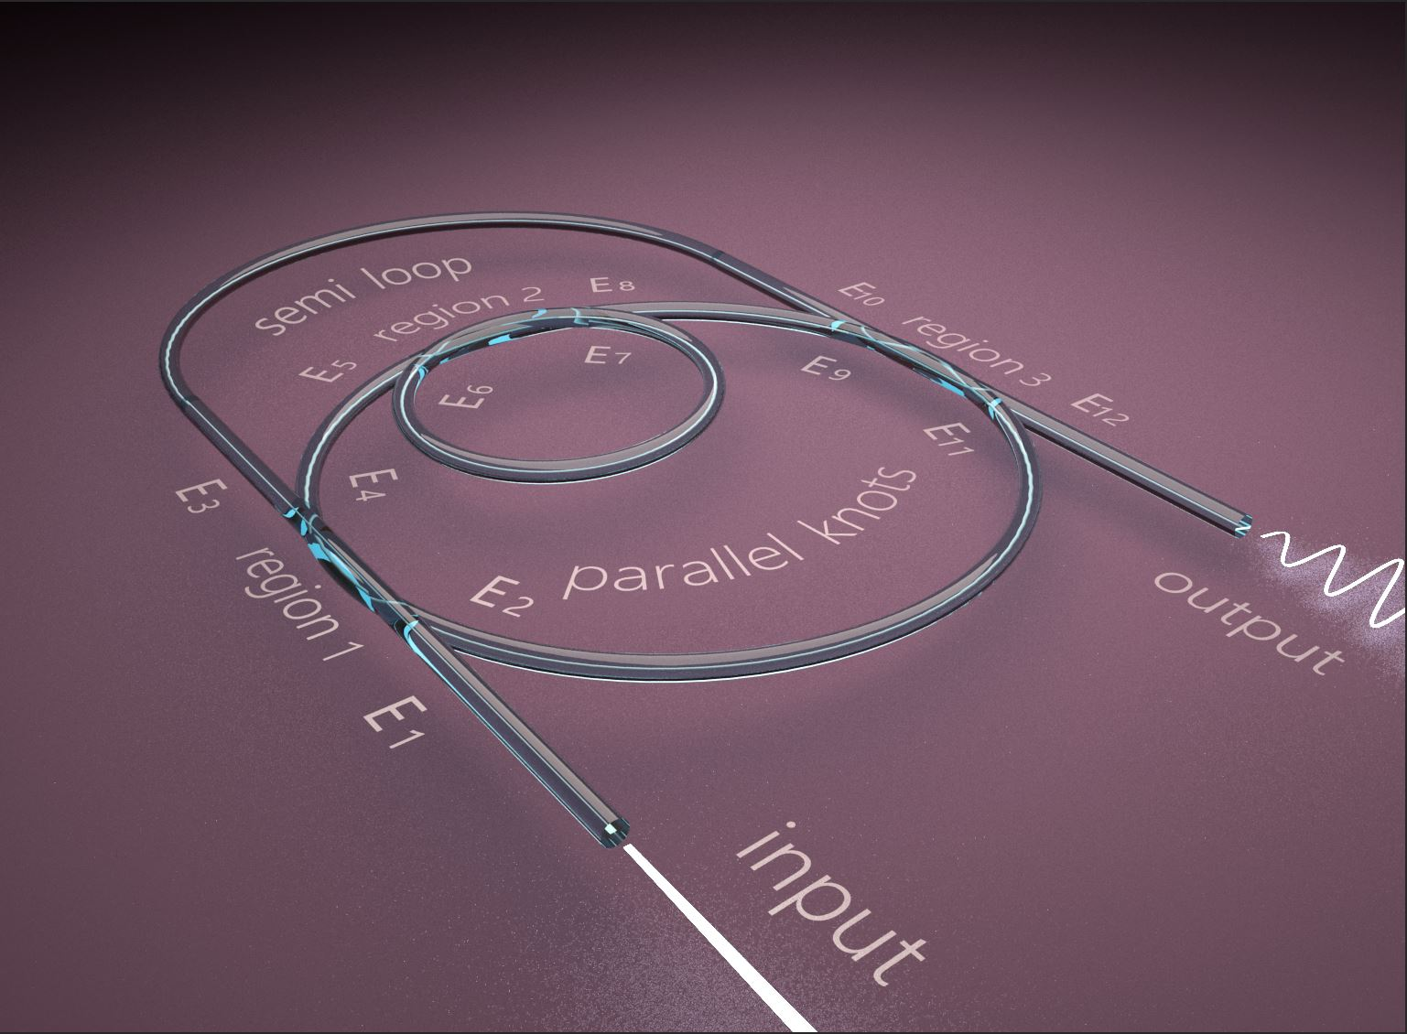
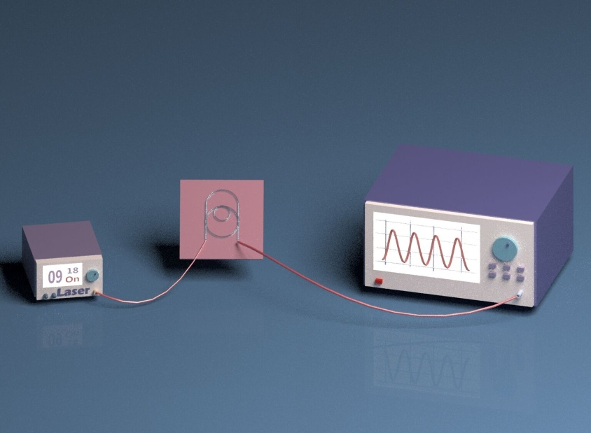
Figure 1. (a) Schematic diagram of the proposed structure, (b) Schematic of the experimental setup for measuring the transmission spectrum of the resonator
As shown in Fig.1a, ${\text{E}}_{\text{5}}$ and ${\text{E}}_{\text{10}}$ are the field components in the largest and medium diameter knots, , which can be expressed using the following equations:
 | $${\text{E}}_{\text{10}}\text{=}{\text{E}}_{\text{3}}\text{∙exp}\left[\left(\text{-α+jβ}\right)\left({\text{L}}_{\text{2}}\text{+π}{\text{R}}_{\text{3}}\text{+}{\text{L}}_{\text{1}}\right)\right]$$ | (2)
 | $${\text{E}}_{\text{5}}\text{=}{\text{E}}_{\text{4}}\text{∙exp}\left[\left(\text{-α+jβ}\right)\left({\text{π}{\text{R}}_{\text{2}}}/{\text{2}}\right)\right]$$ | (3)
where $\text{α}$ is the transmission loss, $β$ is the propagation constant, ${\text{R}}_{\text{2}}$ and ${\text{R}}_{\text{3}}$ are the radii of the largest and medium diameter knots,, ${\text{L}}_{\text{1}}$ and ${\text{L}}_{\text{2}}$ represent the length of straight sections between the curve part of the large knot and the coupling regions 3 and 1 respectively.
The light entering from ${\text{E}}_{\text{5}}$interferes with itself after one circulation around the small knot at the coupling region 2, where ${\text{E}}_{\text{8}}$ is the output field as defined from:
 | $$\left[\begin{aligned}{\text{E}}_{\text{7}} \\ {\text{E}}_{\text{8}}\end{aligned}\right]\text{=}\sqrt{\text{1-}{\text{γ}}_{\text{2}}}\left[\begin{matrix}\sqrt{\text{1-}{\text{κ}}_{\text{2}}} & \text{j}\sqrt{{\text{κ}}_{\text{2}}} \\ \text{j}\sqrt{{\text{κ}}_{\text{2}}} & \sqrt{\text{1-}{\text{κ}}_{\text{2}}}\end{matrix}\right]\left[\begin{aligned}{\text{E}}_{\text{5}} \\ {\text{E}}_{\text{6}}\end{aligned}\right]$$ | (4)
${\text{E}}_{\text{6}}$ and ${\text{E}}_{\text{7}}$ are the field components in the small knot, and are interrelated by:
 | $${\text{E}}_{\text{6}}\text{=}{\text{E}}_{\text{7}}\text{∙exp}\left[\left(\text{-α+jβ}\right)\left(\text{2π}{\text{R}}_{\text{1}}\right)\right]$$ | (5)
where ${\text{R}}_{\text{1}}$ is the radius of the small knot. ${\text{E}}_{\text{9}}$ is the field component in the large diameter knot:
 | $${\text{E}}_{\text{9}}\text{=}{\text{E}}_{\text{8}}\text{∙exp}\left[\left(\text{-α+jβ}\right)\left({\text{π}{\text{R}}_{\text{2}}}/{\text{2}}\right)\right]$$ | (6)
The light waves transmitted from ${\text{E}}_{\text{9}}$ and ${\text{E}}_{\text{10}}$ interfere with each other at the coupling region 3. ${\text{E}}_{\text{1}\text{1}}$ is the field component in the large diameter knot and ${\text{E}}_{\text{1}\text{2}}$ is the field output, which is given as:
 | $$\left[\begin{aligned}{\text{E}}_{\text{11}} \\ {\text{E}}_{\text{12}}\end{aligned}\right]\text{=}\sqrt{\text{1-}{\text{γ}}_{\text{3}}}\left[\begin{matrix}\sqrt{\text{1-}{\text{κ}}_{\text{3}}} & \text{j}\sqrt{{\text{κ}}_{\text{3}}} \\ \text{j}\sqrt{{\text{κ}}_{\text{3}}} & \sqrt{\text{1-}{\text{κ}}_{\text{3}}}\end{matrix}\right]\left[\begin{aligned}{\text{E}}_{\text{10}} \\ {\text{E}}_{\text{9}}\end{aligned}\right]$$ | (7)
where $κ_{1}$, $κ_{2}$, $κ_{3}$ and $γ_{1}$, $γ_{2}$, $γ_{3}$ are the coupling coefficients and the coupling loss coefficients of the coupling regions 1, 2, 3 respectively.
The relation between the field components ${\text{E}}_{\text{2}}$ and ${\text{E}}_{\text{11}}$ can be expressed as:
 | $${\text{E}}_{\text{2}}\text{=}{\text{E}}_{\text{11}}\text{∙exp}\left[\left(\text{-α+jβ}\right)\left(\text{π}{\text{R}}_{\text{2}}\right)\right]$$ | (8)
where the light emerging from ${\text{E}}_{\text{2}}$ interferes with the input light at the coupling region 1. Thus, due to the effective interference between the different field components, resonance appears at three coupling regions.
For simplicity, assuming $\text{-α+jβ=b}$,${\text{L}}_{\text{2}}\text{+π}{\text{R}}_{\text{3}}\text{+}{\text{L}}_{\text{1}}\text{=}{\text{l}}_{\text{1}}$ , ${\text{π}{\text{R}}_{\text{2}}}/{\text{2}}\text{=}{\text{l}}_{\text{2}}$, $\text{2π}{\text{R}}_{\text{1}}\text{=}{\text{l}}_{\text{3}}$, the output spectrum of the multi-knot resonator is described by:
 | $$\text{T=}{{\text{E}}_{\text{12}}}/{{\text{E}}_{\text{1}}}\text{=A}\text{/}\text{B}$$ | (9)
where
 | $$\text{A=}-{\text{e}}^{\text{b}\left({\text{l}}_{\text{1}}\text{+4}{\text{l}}_{\text{2}}\text{+}{\text{l}}_{\text{3}}\right)}-\text{j}{\text{e}}^{\text{b}\left({\text{l}}_{\text{1}}\text{+4}{\text{l}}_{\text{2}}\right)}\sqrt{{\text{κ}}_{\text{2}}}\text{+}{\text{e}}^{\text{b}\left(\text{2}{\text{l}}_{\text{2}}\text{+}{\text{l}}_{\text{3}}\right)}\sqrt{\left(\text{1-}{\text{κ}}_{\text{1}}\right)\left(\text{1-}{\text{κ}}_{\text{3}}\right)}\text{+j}{\text{e}}^{\text{2b}{\text{l}}_{\text{2}}}\sqrt{\left(\text{1-}{\text{κ}}_{\text{1}}\right){\text{κ}}_{\text{2}}\left(\text{1-}{\text{κ}}_{\text{3}}\right)}\text{-}{\text{e}}^{\text{b}{\text{l}}_{\text{1}}}\sqrt{{\text{κ}}_{\text{1}}{\text{κ}}_{\text{3}}}\text{+j}{\text{e}}^{\text{b}\left({\text{l}}_{\text{1}}\text{+}{\text{l}}_{\text{3}}\right)}\sqrt{{\text{κ}}_{\text{1}}{\text{κ}}_{\text{2}}{\text{κ}}_{\text{3}}}$$ | (10)
 | $$\text{B=-1+j}{\text{e}}^{\text{b}{\text{l}}_{\text{3}}}\sqrt{{\text{κ}}_{\text{2}}}\text{+}{\text{e}}^{\text{b}\left({\text{l}}_{\text{1}}\text{+2}{\text{l}}_{\text{2}}\right)}\sqrt{\left(\text{1-}{\text{κ}}_{\text{1}}\right)\left(\text{1-}{\text{κ}}_{\text{3}}\right)}\text{-j}{\text{e}}^{\text{b}\left({\text{l}}_{\text{1}}\text{+2}{\text{l}}_{\text{2}}\text{+}{\text{l}}_{\text{3}}\right)}\sqrt{\left(\text{1-}{\text{κ}}_{\text{1}}\right){\text{κ}}_{\text{2}}\left(\text{1-}{\text{κ}}_{\text{3}}\right)}\text{-}{\text{e}}^{\text{b}\left(\text{4}{\text{l}}_{\text{2}}\text{+}{\text{l}}_{\text{3}}\right)}\sqrt{{\text{κ}}_{\text{1}}{\text{κ}}_{\text{3}}}\text{-j}{\text{e}}^{\text{4b}{\text{l}}_{\text{2}}}\sqrt{{\text{κ}}_{\text{1}}{\text{κ}}_{\text{2}}{\text{κ}}_{\text{3}}}$$ | (11)
From the previous analysis, the knot diameters as well as the microwire lengths within the largest knot (${\text{L}}_{\text{1}}$ and ${\text{L}}_{\text{2}}$), are closely related to the spectrum as important variables. In addition, the extinction ratio (ER) is adjustable as a consequence of manipulating the loss coefficient b and the coupling coefficients ($κ_{1}$, $κ_{2}$, $κ_{3}$).
According to Darmawan's article [24], where the diameter of the semi-loop is an integer/half-integer multiple of that of the large knot, the spectrum of the resonator is regular. Furthermore, by changing the length of the semi-loop or the coupling coefficient at the intertwisted area, the output spectrum can be adjusted accordingly. This is will be the subject of future research. The numerical simulation analysis of the work of this investigation is based on the transfer matrix formalism and to simplify calculations, the diameter of the semi-loop is maintained the same as that of the large knot in both simulations and experiments. In the simulations, the diameter of the microfiber was set to 5 um. Moreover, ${\text{L}}_{\text{1}}$ was set equal to ${\text{L}}_{\text{2}}$ to further simplify calculations. The simulation curves are shown in Fig. 2a, 3a and 4a, where the corresponding ratios of the diameter of the two knots are 2, 3 and 4 respectively.
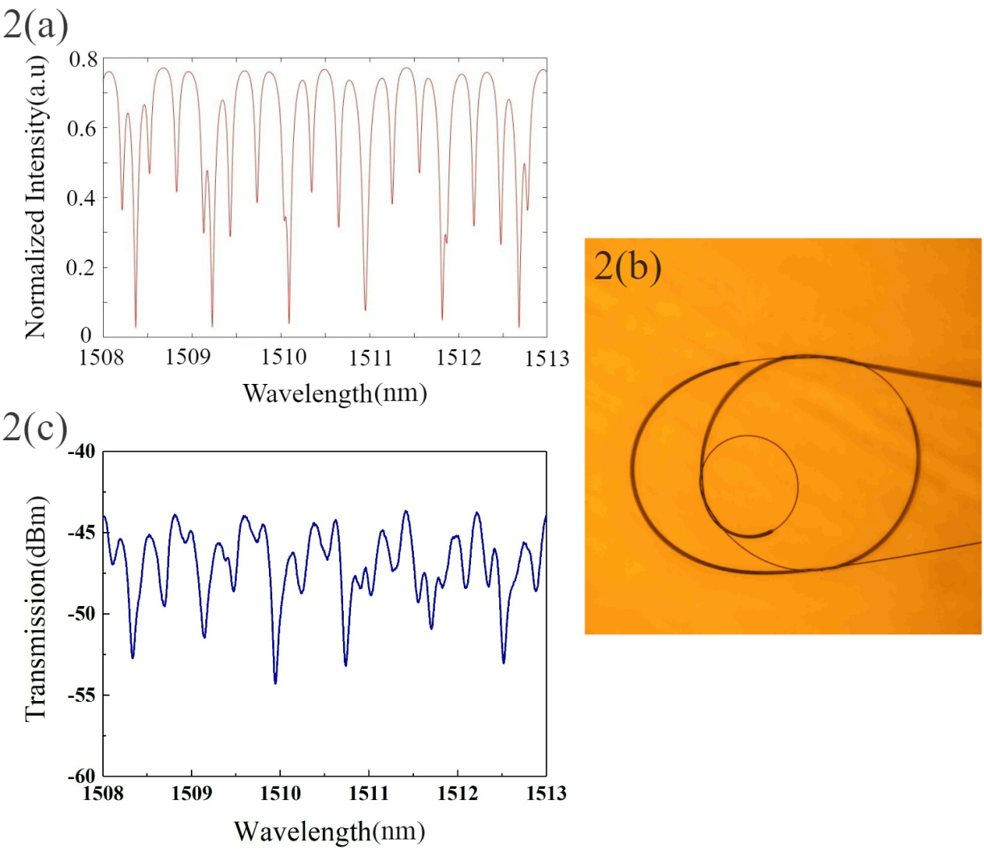
Figure 2. Transmission spectrum of sample 1: (a) numerical simulation, (c) experimental response. (b) The microscope picture of the nested multi-knot microfiber resonators.
The fabrication of the nested multi-knot microfiber resonator requires the drawing of a standard single mode fiber (SMF-28, Corning, NY, USA) into a microfiber using a fiber tapering system. Typically, microfibers obtained using this method are about 2 um in diameter. From previous work [20], it is known that high-quality knot resonators fabricated using micrometer-diameter fibers could show particular advantages, such as easy fabrication and high stability. In addition, the knot structure is robust in the presence of environmental variations such as temperature and humidity. Furthermore, the larger the knot diameter, the easier the manipulation can be operated in the air. Although the evanescent field generated by the microfiber is less than that associated with sub-micro/nano-fibers, the intertwisted area of the knot is long enough to achieve effective coupling. In this work, two microfibers were fabricated, with lengths and minimum diameters of 30 mm and 5 µm. In order to prevent the microfibers from adhering to themselves and causing the structure to rupture, a ceramic rod was used in the manufacturing process. The two tapered fibers were both cut to make them have a single free end. One of them was initially shaped to form a small single knot by intertwisting the free end, and the same method was used to fabricate the medium knot. The ceramic rod was used to manipulate the small knot into the medium one. Next, the remaining free microfiber end was coupled back into the medium knot to form the large knot and the free end of the microfiber was slowly pulled until the target diameter was reached. Finally, the two tapered fibers were fixed onto two precision three-dimensional platforms (Newport) and manipulated close to each other until their free ends became coupled via Van Der Waals and electrostatic forces. The two platforms remained in position and were used to maintain the coupled areas under a reasonable degree of tension and firmly attached in order to ensure the stability of the whole structure.
This entire fabricated process was conducted in air at room temperature. It was necessary to mount the fabricated resonator on MgF₂ glass or a thin layer of low refractive index polymer, with refractive indices lower than that of silica. The benefit of this approach is that light can be contained within the microfiber and effectively guided along it, owing to the large refractive index difference between the microfiber and the substrate, and yet there is a physical support to the resonators. In this work, low refractive index ultraviolet (UV) glue (Luvantix ADM PC 373 XP), whith refractive index n~1.3740 at λ~852 nm in the cured state, was used to fix all components to the substrate. The UV curing glue was also employed to fix both ends of the multi-knot resonator, as was the case with the tapered fiber and the coupling area, to prevent light scattering and enhance the long-term stability.
- Results and discussion
The resonator was connected to a supercontinuum (SC) generation light source (YSL SC-series) to observe the output spectrum at room temperature, where the spectrum was recorded by an optical spectrum analyzer (OSA) (AQ6317C, Yokogawa, Japan). The light source has a broad emission spectrum in the wavelength range λ~750-1650 nm. Fig. 2b shows a micrograph image of a fabricated sample using the above technique, where the diameter of the small and medium knots are 575.35 µm and 1304.12 µm, respectively, representing a ratio of ~2.27. The curvature of the large loop is 1358.8 µm. For convenience, this sample is referred to as #1. The corresponding spectrum in Fig. 2c illustrates that sample 1 provides high ER (nearly 10 dB) with a free spectral ranfe FSR$≅$760 pm.
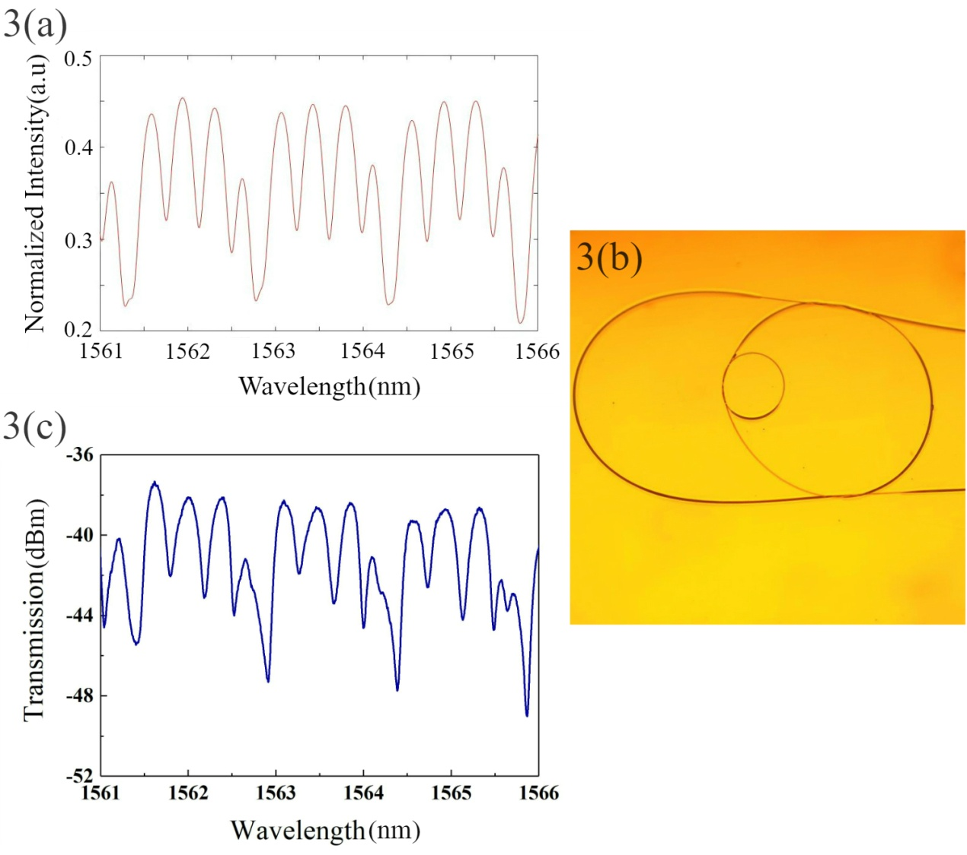
Figure 3. Transmission spectrum of sample 2, (a) numerical simulation, (c) experimental response. (b) Microscope picture.
To further explore the influence of the structure on the spectral response, anotherresonator with a similar structure, but different dimensions is shown in Fig. 3b. This resonator is referred to as sample #2. The small and medium knots have different diameters of 335.83 um and 1043.51 um, representing a ratio of ~3. Likewise, the curvature of the large knot is 1050.7 µm. The corresponding output spectrum of this sample displays similar performance to that of sample 1. The spectrum has the following characters: ER$≅$10 dB and FSR = 1500 pm.
Finally, another nested multi-knot microfiber resonator was fabricated, with the diameters of the small and medium knot of 436.31 µm and 1714.06 µm respectively, and curvature of the large knot of 1699.73 µm, which results in a ratio of 4. This resonator is referred to as sample #3. Fig. 4b shows the micrograph and the corresponding transmission spectrum of sample #3. Fig. 4c shows the characteristics corresponding to ER = 10 dB and FSR = 1125 pm. Due to the field of view limitations of the microscope, it was not possible to observe the entire structure of sample# 3 in the microscope image.
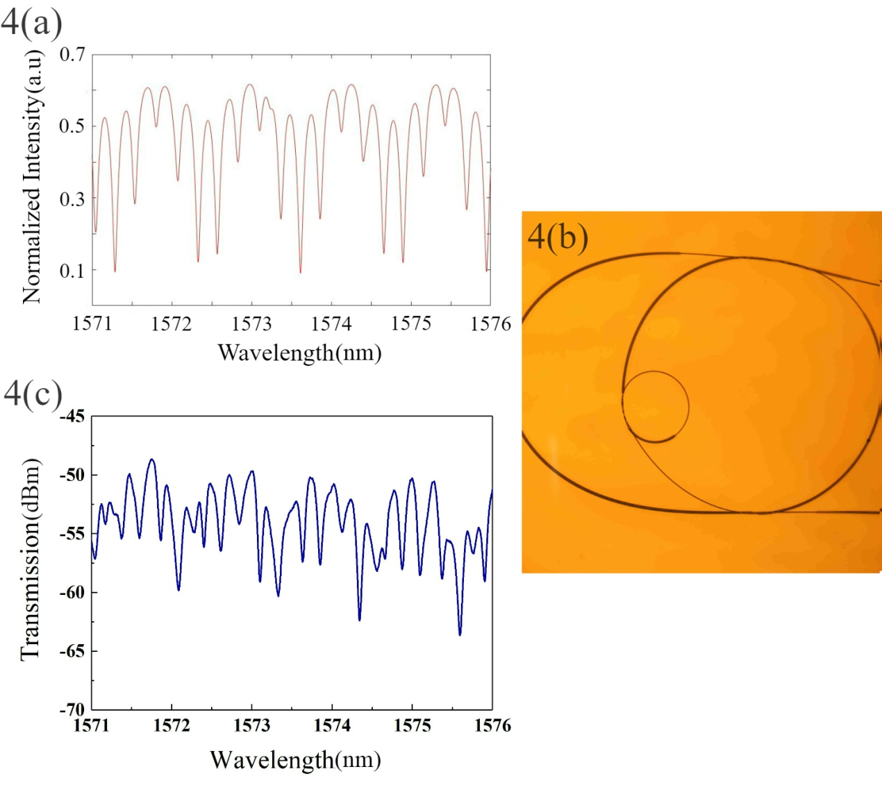
Figure 4. Transmission spectrum of sample #3, (a) numerical simulation, (c) experimental response. (b) Microscope image.
A comparison of the response of samples 1, 2 and 3 shows that the small knot diameter dominates the FSR, with smaller dimensions associated with wider FSRs. Changes in the coupling or loss coefficient also result in a variation of ER. ER is defined as $\text{ER=}{\text{I}}_{\text{max}}\text{-}{\text{I}}_{\text{min}}$, where ${\text{I}}_{\text{max}}$ and ${\text{I}}_{\text{min}}$ represent the adjacent maximum and minimum values of the spectrum intensity [20]. Using the transfer matrix analysis, it was possible to calculate the coupling coefficients $κ_{1}$, $κ_{2}$, $κ_{3}$ of sample 1 as 0.3, 0.7, 0.12 respectively and sample 2 as 0.55, 0.8, 0.09 respectively. In addition, the coupling coefficients $κ_{1}$, $κ_{2}$, $κ_{3}$ of sample 3 were calculated as 0.5, 0.98, 0.1 respectively. Due to the transmission loss of the microfiber, $κ_{3}$ is always the smallest coupling coefficient. As the diameter of the medium knot increases or the diameter of the small knot decreases, the number of ripples in the spectrum increases. The experimental results presented in Fig 2c, 3c and 4c are similar to the simulation results. During the manufacturing process it is possible to accurately control the ratio of the diameters of the two knots to achieve the desired spectrum. Moreover, the fabricated novel structure of the microfiber resonator not only has the advantages of miniaturization, integration, easy fabrication and low cost, but also has great potential for use as a comb filter in applications such as multi-wavelength fiber lasers and optical networks.
- Conclusion
The characteristics of a novel nested multi-knot resonator (MKRs) structure have been experimentally demonstrated and accurately simulated using numerical methods. The entire structure was successfully fabricated using only a single microfiber by means of a double knot accompanied by a parallel structure and a semi-loop. The novel structure described in this article is easy to manufacture, low cost and low loss. The periodic output spectrum of the resonator makes it applicable for use as an optical interleaver (comb filter), which can be achieved simply by changing the ratio of the optical paths of the three knots which result in changing the coupling coefficients. In addition, the resonator can also be applied to filters, optical switches, photonic logic gates, and lasers. Further future improvements include reducing the size of the microfiber and optimizing the fabrication process which will contribute to a further enhancement of the performance of the structure.

References
- X.S. Jiang, L.M. Tong, G. Vienne, et al. "Demonstration of optical microfiber knot resonators. " Applied physics letters, 22, (2006):223501.1-223501.3.
- Y.P. Xu, L.Y. Ren, J. Liang, et al. "A simple, polymer-microfiber-assisted approach to fabricating the silica microfiber knot resonator. " Optics Communications, 321(2014):157-161.
- K.S. Lim, S.W. Harun, S.S.A. Damanhuri, et al. "Current sensor based on microfiber knot resonator. " Sensors &amp; Actuators: A. Physical, 167(2011).
- Y. Wu, Y.J. Rao, Y.H. Chen, et al. "Miniature fiber-optic temperature sensors based on silica/polymer microfiber knot resonators. " Opt Express, 17(2009):18142-18147.
- G. Brambilla. "Optical fibre nanotaper sensors. " Optical Fiber Technology, 16(2010):331-342.
- X. Jiang, Y. Chen, G. Vienne, et al. "All-fiber add-drop filters based on microfiber knot resonators. " Optics Letters, 32(2007):1710-2.
- X. Jiang, Q. Song, L. Xu, et al. "Microfiber knot dye laser based on the evanescent-wave-coupled gain. " Applied Physics Letters, 90(2007):816.
- A.D. Gomes and O. Frazão. "Mach-Zehnder Based on Large Knot Fiber Resonator for Refractive Index Measurement. " IEEE Photonics Technology Letters, 28(2016):1279-1281.
- Y.P. Xu, L.Y. Ren, Y. Wang, et al. "Enhanced slow light in microfiber double-knot resonator with a Sagnac loop reflector. " Optics Communications, 350(2015):148-153.
- Q. Ye, Z. Pan, Z. Wang, et al. "Novel Slow-Light Reflector Composed of a Fiber Ring Resonator and Low-Reflectivity Fiber Bragg Grating. " Journal of Lightwave Technology, 33(2015):3016-3022.
- Y. Wu, T.H. Zhang, Y.J. Rao, et al. "Miniature interferometric humidity sensors based on silica/polymer microfiber knot resonators. " Sensors & Actuators B Chemical, 155(2011):258-263.
- Q. Song, L. Liu, L. Xu. "Lasing Action in Dye Doped Polymer Nanofiber Knot Resonator. " Journal of Lightwave Technology, 27(2009):4374-4376.
- Y. P. Xu, L.Y. Ren, C.J. Ma, et al. "Slow light and fast light in microfiber double-knot resonator with a parallel structure." Appl. Opt. 55(2016):8612-8617.
- S. Nodehi, W.S. Mohammed, H. Ahmad, S.W. Harun. "Fabrication and characterization of high order filter based on resonance in hybrid multi-knots microfiber structure." Optics & Laser Technology 78(2016):120-124.
- S. Shahal, H. Duadi, Y. Linzon and M. Fridman. "Complex Fiber Micro-Knots." Sensors 18.4(2018):44.
- S. Wan, R. Niu, H.L. Ren, et al. "Experimental demonstration of dissipative sensing in a self-interference microring resonator." Photonics Research 7(2018).
- S. Nodehi, W.S. Mohammed, H. Ahmad, S.W. Harun. "Demonstration of a Periodic Passband Filter Based on Coupled Microfiber Knots." IEEE Photonics Technology Letters 28.10(2016):1061-1064.
- Y. P. Xu, L.Y. Ren, C.J. Ma, et al. "Stable and uniform multiwavelength erbium-doped fiber laser based on a microfiber knot resonator with a Sagnac loop reflector." Journal of Optics (2017):1-5.
- Z.P. Wang, S.J. Chang, C.Y. Ni, and Y.J. Chen. "A High-Performance Ultracompact Optical Interleaver Based on Double-Ring Assisted Mach-Zehnder Interferometer." IEEE Photonics Technology Letters 19.14(2007):1072-1074.
- G.R. Zhou, R. Kumar, Q. Wu, et al. "A simple all-fiber comb filter based on the combined effect of multimode interference and Mach-Zehnder interferometer." Scientific Reports 8 (2018):11803.
- X. Li, and H. Ding. "All-fiber magnetic-field sensor based on microfiber knot resonator and magnetic fluid." Optics Letters 37.24(2012):5187.
- H. Yang, S.S. Wang, X. Wang, et al. "Temperature sensing in seawater based on microfiber knot resonator." Sensors 14.10(2014):18515.
- M.Q. Wang, D. Li, R.D. Wang, et al. "PDMS-assisted graphene microfiber ring resonator for temperature sensor." Optical & Quantum Electronics 50.3(2018):132.
- S. Darmawan, Y. M. Landobasa, and M. K. Chin. "Nested-ring Mach-Zehnder interferometer." Optical & Quantum Electronics 38.12-14(2006):1151-1157.

