Evaluation of inductively coupled plasma tandem mass spectrometry for radionuclide assay in nuclear waste characterisation
P.E. Warwick, B.C. Russell, I.W. Croudace, Ž. Zacharauskas

Abstract

Decommissioning and monitoring around nuclear sites presents challenges with regards to the range of sample matrices and radionuclides that must be accurately characterised. Over the last few decades, inductively coupled plasma mass spectrometry (ICP-MS) has been increasingly used in the nuclear sector as a rapid alternative to decay counting techniques for long-lived radionuclides, as well as an expanding range of shorter-lived radionuclides. The presence of various interferences still presents a major challenge in achieving accurate measurements, often necessitating extensive chemical clean-up prior to measurement. This study evaluates the potential application of tandem ICP-MS/MS for the measurement of a range of radionuclides of interest to nuclear decommissioning and waste management. The flexibility of the instrumental setup is shown in achieving improved interference removal compared to alternative instrument designs, improving sample throughput by reducing reliance on offline separation, and increasing the potential application of ICP-MS/MS for routine measurement of difficult-to-measure radionuclides.

Introduction

Effective radioactive waste management is critically dependent on robust, focussed and efficient waste characterisation in order to reliably inform all waste management steps and the safety of the operators, the general public and the environment. Nuclear waste characterisation represents a major challenge for nuclear sites, with a requirement to accurately measure a diverse range of activation products, fission products and naturally occurring radionuclides in various matrices. In particular, characterisation of Difficult-To-Measure (DTM) radionuclides (including pure alpha and beta emitting and long-lived, low abundance radionuclides) often involves complex separation chemistry to remove interferences and separate / concentrate the analyte from the matrix prior to radiometric or mass-spectrometric measurement. Of the available measurement techniques, mass spectrometry (most commonly inductively coupled plasma mass spectrometry, ICP-MS) has expanded the number of radionuclides measurable compared to decay counting techniques alone, as well as offering reduced measurement time and resulting improvements to the sample throughput. The most common early applications of ICP-MS with regards to radionuclide measurement were in the detection of long-lived radionuclides, most commonly in the actinide series¹⁻³ where low specific activities favour atom counting-based techniques. However, developments in instrumentation have extended the range of radionuclides measurable. Extensive reviews of the role of ICP-MS for radionuclide analysis with regards to nuclear decommissioning and following nuclear accidents have recently been published.^{4,5}

The accurate measurement of radionuclides by ICP-MS is impacted by multiple interferences, namely:
- Stable or radioactive isobars
- Polyatomic species formed by reactions with gases in the plasma and/or reaction cell
- Peak tailing from an abundant isotope (mass m) to a neighbouring mass (m±1 or m±2; expressed as the abundance sensitivity).
The removal of interferences can be achieved by offline chemical separation (such as ion exchange and extraction chromatography) and/or instrumental separation through the use of a collision or reaction cell⁶⁻¹⁰, high resolution instruments¹¹⁻¹³ and/or sample introduction-based separation such as membrane desolvation, electro thermal vaporisation and glow discharge¹⁴⁻¹⁸. The impact of the sample matrix in decommissioning samples must also be considered, as this can result in signal suppression, and reduced ion transmission through gradual blocking of the interface cones. The impact of the sample matrix can be reduced using the techniques listed above, but there are additional considerations. These include running matrix-matched rather than ‘clean’ calibration standards, and use of an internal standard to monitor drift and reduction in ion transmission. A number of newer ICP-MS designs also offer online aerosol dilution as a rapid alternative to offline dilution, enabling samples with up to 25 % total dissolved solid (TDS) content to be measured¹⁹, compared to ~0.25 % without aerosol dilution.
The recent commercial availability of tandem mass spectrometers (ICP-MS/MS) offers a potential improvement in interference removal capabilities over alternative instrument designs with regards to radionuclide measurement. Such instruments are equipped with a quadrupole mass filter positioned in front of a collision-reaction cell, followed by a second quadrupole mass filter (Figure 1). The use of two mass filters improves the abundance sensitivity compared to single quadrupole instruments. Additionally, filtering the ion beam entering the collision/reaction cell improves efficiency of the cell chemistry, and prevents the formation of secondary polyatomic interferences through interactions of ions with the reaction gas. ICP-MS/MS may reduce the extent of chemical separation required prior to sample introduction, further reducing the total procedural time and improving the sample throughput, as well as reducing the number of reagents used and analyst working time.
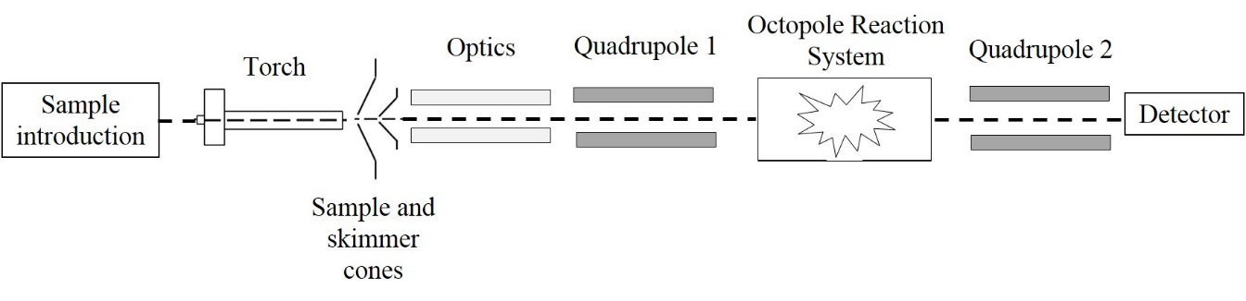
Figure 1. ICP-MS/MS layout (Agilent 8800/8900)

ICP-MS/MS has been applied to measurement of radionuclides including ⁹⁰Sr, ¹³⁵Cs/¹³⁷Cs, ¹²⁹I, ²²⁶Ra, ²³⁶U/²³⁸U and ²³⁹Pu²⁰⁻²⁶. This paper reviews these applications and considers how the technique can be extended to include a broader range of radionuclides of interest in nuclear waste characterisation, considering the interferences that affect accurate measurement of these radionuclides and the capabilities of ICP-MS/MS for removal of these interferences. Given the diverse range of matrices that may be encountered in nuclear waste characterisation, specific matrix effects on instrument sensitivity and stability were not considered in this study although such effects would be significant when developing techniques for routine application.

Methodology

Selection of radionuclides
Radionuclides to be considered in the study were selected based on the following criteria -
- The radionuclide is a fission product, activation product or actinide that is typically associated with nuclear waste (based on IAEA, 2009a²⁷) or NORM-contaminated wastes.
- The radionuclide is classified as Difficult-To-Measure (DTM) i.e. the radionuclide cannot be readily quantified in a waste package using non-destructive techniques such as gamma spectrometry (as detailed in IAEA, 2009b²⁸).
- There are benefits of ICP-MS measurement of the radionuclide relating to good sensitivity, interference handling and speed of determination.
A total of 24 radionuclides relevant to nuclear waste decommissioning were identified (Table 1) where ICP-MS/MS could offer potential benefits for their determination.
Table 1. Radionuclides of nuclear sector interest that can be measured by mass spectrometry
Origin | Nuclide | Principle mode of decay | Half-life (years) (uncertainties in parenthesis) | SpA (Bq g⁻¹) | Mass equivalent to 1 Bq g⁻¹ (pg g⁻¹)
Activation products | ³⁶Cl | β | 30.2(4)×10⁴ | 1.2×10⁹ | 821.8
 | ⁴¹Ca | Electron capture | 100.2(17)×10³ | 2.5×10⁹ | 402.9
 | ⁵⁹Ni | X-ray | 76(5)×10³ | 3.0×10⁹ | 339.0
 | ⁶³Ni | β | 98.7(24) | 2.1×10¹² | 0.5
 | ⁹⁴Nb | β | 20.0(24) ×10³ | 7.0×10⁹ | 1.4×10²
Fission products | ⁷⁹Se | β | 356(40) ×10³ | 2.8×10⁸ | 3583.0
 | ⁹⁰Sr | β | 28.8(7) | 5.1×10¹² | 0.2
 | ⁹³Zr | β | 1.61(6) ×10⁶ | 9.3×10⁷ | 1.1×10⁴
 | ⁹⁹Tc | β | 211.5(11) ×10³ | 6.3×10⁸ | 1.6×10³
 | ¹⁰⁷Pd | β | 6.5(3) ×10⁶ | 1.9×10⁷ | 5.3 ×10⁴
 | ¹²⁶Sn | β | 2.3(14) ×10⁵ | 1.0×10⁹ | 952.4
 | ¹²⁹I | β | 16.1(7) ×10⁶ | 6.5×10⁶ | 1.5×10⁵
 | ¹³⁵Cs  ¹³⁷Cs | β  γ | 2.3(3) ×10⁶  30.1(8) | 4.1×10⁷  3.2×10¹² | 2.4×10⁴  0.3
 | ¹⁵¹Sm | β | 94.7(6) | 9.7×10¹¹ | 1.1
Naturally occurring radioactive material (NORM) | ²²⁶Ra | α | 1.6(7) ×10³ | 3.7×10¹⁰ | 27.3
Actinides | ²³⁵U | α | 704(1) ×10⁶ | 8.0×10⁴ | 1.3×10⁷
 | ²³⁶U | α | 23.4(6) ×10⁶ | 1.7×10⁶ | 4.2×10⁵
 | ²³⁷Np | α | 2.1(7) ×10⁶ | 2.6×10⁷ | 3.8×10⁴
 | ²³⁸U | α | 4.5(5) ×10⁹ | 1.2×10⁴ | 8.0×10⁷
 | ²³⁹Pu | α | 24.1×10³ | 2.3×10⁹ | 4.4×10²
 | ²⁴⁰Pu | α | 6.6(7) ×10³ | 8.4×10⁹ | 1.2×10²
 | ²⁴¹Pu | β | 14.3 | 3.8×10¹² | 0.3
 | ²⁴¹Am | α | 432.6(6) | 1.3×10¹¹ | 7.9

Instrumentation

All experimental work was carried out using two separate Agilent 8800 instruments operated by GAU-Radioanalytical Laboratories (based at the National Oceanography Centre, Southampton) and the Nuclear Metrology Group at the National Physical Laboratory, Teddington. As standard, the instruments were fitted with a collision-reaction cell (Octopole Reaction System, ORS³) positioned between two quadrupole mass filters (termed Q1 and Q2) (Figure 1). The instruments also incorporated a Scott double pass spray chamber, Micromist nebuliser (uptake rate 0.368 mL min⁻¹, nebulisation efficiency 8.0 %) quartz torch, and nickel sample and skimmer cones. Both instruments were fitted with four cell gas lines- Lines 1 and 2 are dedicated to hydrogen and helium, respectively, Line 3 is for corrosive gases (in this study NH₃) and Line 4 is for non-corrosive gases (in this study O₂) (Table 2). The corrosive gas is balanced with at least 90% He to protect the ORS. When operating cell Line 3, the helium line automatically runs at a flow rate of 1 mL/min. All gases were provided by BOC with a purity of 99.9999% (N6.0). The major operational modes are termed ‘Single Quad’ (with only Q2 operating as a mass filter) and ‘MS/MS’ (with both Q1 and Q2 operating as mass filters).

Table 2. General operating conditions of the Agilent 8800 for different setups

Instrument parameter | MS/MS | H₂ | He | O₂ | NH₃
RF power (W) | 1550
Plasma gas (L/min) | 15
Carrier gas (L/min) | 1.05
Extraction lens 1 (V) | 0
Extraction lens 2 (V) | -200 to -140
Omega Bias (V) | -120 to -70
Omega lens (V) | 5-18
Octopole bias (V) | -8 | -18 | -18 | -5
Energy Discrimination (V) | 5 | 5 | 0 | -7
Cell gas flow rate range (mL min⁻¹) | - | 0-10 | 0-12 | 0-1 | 0-10

Characterisation of ICP-MS/MS performance

Experimental work was carried out using a combination of stable and radioactive tracers. Iodine-129 and ²³⁷Np were supplied by Amersham QSA (Amersham, UK), ⁹³Zr from Kinetrics Inc. (Toronto, Canada), and ⁹⁰Sr and ²³⁹Pu from NPL (Teddington, UK). All solutions were prepared in 0.3 M Trace Metal Grade HNO₃ (Fisher Scientific, Loughborough, UK) with the exception of ¹²⁹I, which was prepared in 0.5% tetramethylammonium hydroxide (TMAH; >97%, Sigma Aldrich, UK). Stable element standards were supplied by Fisher Scientific (Loughborough, UK).

Background scans were measured at the masses of the radionuclides of interest (Table 1) using 0.3 M HNO₃ as a blank solution. Scans were performed in Single Quad and MS/MS mode with no reaction gas and with He as a collision gas.

For sensitivity determination, single element standards (1 – 10 ng mL⁻¹) were measured in Single Quad and MS/MS mode, without specifically tuning at each mass. Where possible, stable element analogues of the radionuclide were used for sensitivity determinations. The normalised response in counts per second (cps)/ng g⁻¹ was determined for each element, correcting for the isotopic abundance of the measured isotope. Matrix suppression was assessed through the measurement of a series of 5 ng mL⁻¹ In, Re and/or Bi solutions with total dissolved solids (TDS) contents ranging from 0 to 0.1%. Dissolved solids comprised either CaCl₂ or FeCl₃ to represent either concrete or ferrous metal digests.

To determine the abundance sensitivity and degree of hydride formation, solutions of the interferent nuclide were prepared with concentrations ranging from 10 to 100,000 ng mL⁻¹. The solutions were introduced and the signals at m/z+1 and m/z-1 were measured in Single Quad and MS/MS mode. The abundance sensitivity was determined from the m/z-1 signal and the MH⁺ formation was determined using the m/z+1 signal and correcting for the abundance sensitivity, assuming equal peak tailing on the low and high mass side. For radionuclides potentially affected by tailing from two mass units away e.g. ⁸⁸Sr on ⁹⁰Sr and ¹²⁷I on ¹²⁹I, the signals at m/z+2 and m/z-2 were also measured, permitting an assessment of the magnitude of MH₂⁺ formation.

Assessment and potential for removal of isobaric interferences was achieved by reviewing the literature for potentially effective reaction gases that could overcome identified overlaps (either by reaction with the interferent or the analyte and subsequent mass shift). The potential for polyatomic interferences was similarly assessed and an evaluation was made of the effectiveness of collision gases for polyatomic suppression.

Data on the background and sensitivity were used to determine an effective instrument detection limit for each of the selected radionuclides. Detection limits were calculated based on 3 s.d. of the background count and assuming 1 g of sample was taken for analysis, a 100 % chemical recovery and a final purified solution volume of 10 mL. The potential for application of ICP-MS/MS for radionuclide measurement was then evaluated based on a comparison of the predicted limits of detection with specific radionuclide exemption limits for radioactive wastes, assessment of the impact of abundance sensitivity, hydride formation and potential for isobaric interference formation and removal.

Case studies

The application of ICP-MS/MS to radionuclide measurement was further assessed using five case studies; ⁹⁰Sr, ⁹³Zr, ¹²⁹I, ²³⁷Np and ²³⁹Pu. Measurement of each of these radionuclides is impacted to a greater or lesser extent by isobaric, polyatomic and/or abundance sensitivity interferences. Consideration of the way tandem mass spectrometry helps overcome these interferences and identification of other factors impacting on their measurement provides an insight into how ICP-MS/MS could be further developed for application to other radionuclides. The impact of customised tuning for achieving optimal radionuclide sensitivity and interference removal is a key consideration, with particular attention paid to the impact of varying the cell gas flow rate(s), the residence times of ions in the cell (energy discrimination), and the cell energy (octopole bias).

Results & discussion

Instrument background

Background scans of relevant masses measured during blank reagent runs showed significant peaks at m/z = 36 (³⁶Ar, 0.3 % abundance) and m/z = 41 (tailing from ⁴⁰Ar, 99.6 % abundance, and ⁴⁰Ar¹H). At m/z=36, the background reduced from 1.0×10⁸ cps in MS/MS no-gas mode, to 1.6×10⁶ cps with the introduction of 5 mL min⁻¹ He. The instruments used in this study do not allow measurement of background at m/z=41 without the use of collision gas, but background signals reduced from 4.3×10⁹ cps at 1 mL min⁻¹ to 3.4×10⁷ cps at 5 mL min⁻¹ He. High collision gas flow rates are needed to significantly reduce the background, and this will impact the sensitivity for ³⁶Cl and ⁴¹Ca, with a reduction of ~1 order of magnitude at 5 mL/min He compared to no-gas mode. The impact of isobaric, polyatomic and tailing interferences must also be considered for these nuclides, which may require the use of both collision and reaction gases in the cell.

Several other background peaks were also detected in MS/MS mode with no cell gas, the magnitude of which is likely to vary depending on the laboratory conditions, instrumental setup and composition of the samples being measured. In this study, a peak at m/z = 63 (~500 cps) was a result of ⁶³Cu, potentially from copper in the interface cones. If measuring ⁶³Ni, this contribution could be reduced by operating with Pt cones. The elevated background at m/z = 79 (~700 cps) was considered to be a combination of isobaric ⁷⁹Br, polyatomic interferences and ⁴⁰Ar⁴⁰Ar tailing, whilst Ba contamination was responsible for the elevated background at m/z = 135 and 137 (~260 and 500 cps, respectively). Finally, the high background at m/z = 129 (~3,000 cps) was associated with ¹²⁹Xe present as an impurity in the Ar plasma gas. In cases where polyatomic interferences are the cause of elevated background, the introduction of H₂ or He into the cell at any flow rates reduced the background signal. In the case of isobaric interferences, the background increased at collision gas flow rates up to ~3 mL min⁻¹ as a result of collisional focussing, before decreasing at higher flow rates (see discussion of sensitivity). In some cases, a reaction gas can also be used to reduce the background signal (e.g. using O₂ to reduce the Xe interference at m/z = 129 – see later case study). Alternatively, reaction gases can be used to shift the target nuclide or interference to a different mass (e.g. using O₂ to convert ²³⁹Pu and ²³⁸U¹H to ²³⁹Pu¹⁶O and ²³⁸U¹⁶O, respectively, converting to a U polyatomic that no longer overlaps with the analyte). Background count-rates in MS/MS mode were 0 cps for actinides (<5 cps for ²³²Th and ²³⁸U), and for all other masses of interest ranged from 5-40 cps, with typical uncertainties of +/- 5-15% cps (1σ).

Sensitivity

For the majority of nuclides, a sensitivity of approximately 1-2×10⁵ cps/ ng mL⁻¹ was achievable when operating in MS/MS mode with no reaction / collision gas (Figure 2). The sensitivity was lower for radionuclides with higher first ionisation potentials, specifically ¹²⁹I (10.45 eV) and ⁷⁹Se (9.75 eV). The sensitivity in MS/MS mode was approximately 40 % lower than for Single Quad mode, although this value varied depending on the radioanalyte, and any decrease was off-set by improved abundance sensitivity and control over cell chemistry. Introduction of dissolved solids resulted in a small reduction in sensitivity, with up to 14% reduction observed for both In and Re with a TDS of 0.1% CaCl₂ or FeCl₃.
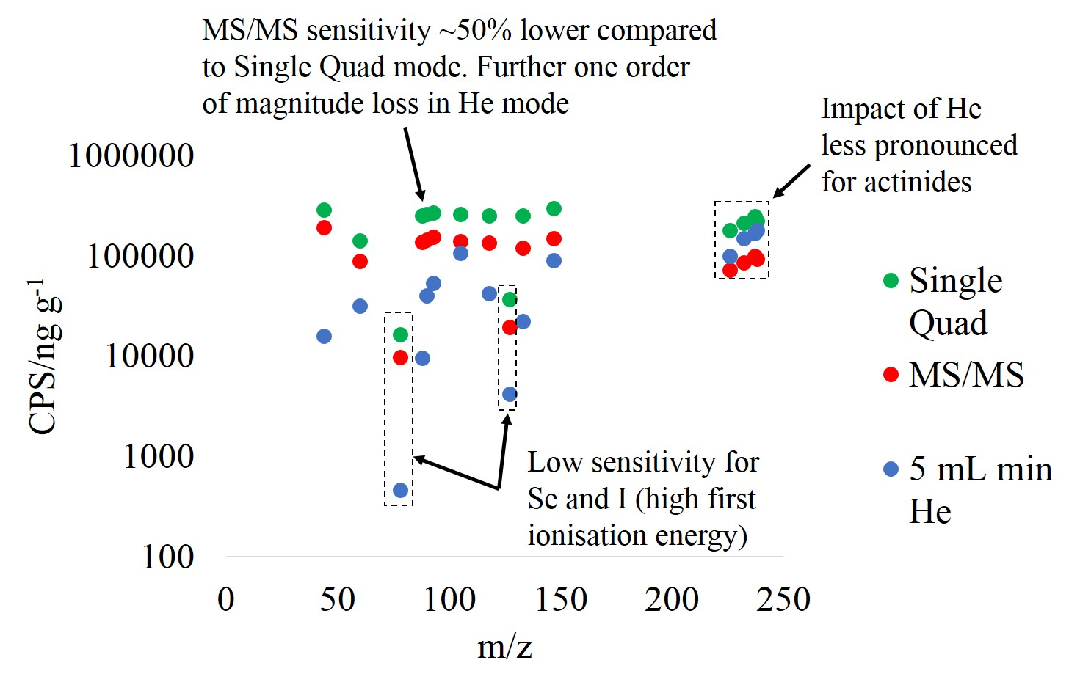
Figure 2: ICP-MS/MS instrument response versus mass number: Data for Single Quad and MS/MS in no gas and He modes. All analytes were measured in 0.3 M HNO₃, other than iodine (0.5 % TMAH)

Instrument sensitivity decreased by approximately a factor of 10 when He was introduced as a collision gas at a flow rate of 5 mL min⁻¹. The decrease was less pronounced for the actinides, which may be a result of the heavier ions being more closely confined to the centre of the ion beam, resulting in less scattering at higher cell gas flow rates compared to lighter ions²⁹. Operating with a collision gas (H₂ or He) can reduce or eliminate polyatomic interferences, and at low flow rates (up to ~3 mL/min) can increase sensitivity compared to no-gas mode through collisional focusing. A similar effect was observed for reaction gases (NH₃ or O₂), for elements that did not react to form a cell product (e.g. Sr and I in O₂ mode, see case studies). A reduction in radioanalyte sensitivity at higher flow rates may be necessary in order to achieve isobaric interference separation. It is also possible to use a mixture of a reaction and collision gas to simultaneously remove isobaric and polyatomic interferences, respectively, such as O₂ and H₂ for removal of ⁹⁰Zr and ⁸⁸Sr¹H₂, respectively, for measurement of ⁹⁰Sr ³⁰.

Abundance sensitivity & hydride formation

Comparison of the response at m/z-1 and m/z+1 can be used to evaluate the magnitude of tailing and hydride formation, assuming symmetrical peak shape and hence equal tailing on the low mass and high mass side. A similar approach can be applied to assessing peak tailing over 2 mass units and di-hydride formation by measuring at m/z-2 and m/z+2, respectively, for example ¹²⁷I and ¹²⁷I¹H₂ affecting ¹²⁹I. Examples of identified tailing interferences and measured hydride formation rates are summarised in Table 3.

Operating with two quadrupole mass filters (MS/MS mode) offers an improvement in abundance sensitivity compared to single quadrupole instruments, with values quoted by the instrument manufacturer of <10⁻¹⁰ for MS/MS mode compared with ~10⁻⁶ for single quad mode. For all radionuclides of interest affected by a tailing interference, the abundance sensitivity at m/z-1 in MS/MS mode was 10⁻⁹ or better, in good agreement with previous studies^{20,21}. The improved abundance sensitivities facilitate the measurement of low abundance radionuclides in the presence of high abundance nuclides (e.g. ²³⁷Np in the presence of high concentrations of ²³⁸U) reducing or eliminating the need for chemical separation. Peak tailing from a high abundance isotope into a low abundance isotope of the same element is more problematic, as separation prior to detection is not practical. This is a particular issue for neutron activation products formed via the (n,γ) reaction which will typically be associated with significantly higher concentrations of their stable precursor and are one mass unit higher than the precursor due to the mode of their formation. For example, in irradiated bioshield concretes, the ratio of ⁴¹Ca to stable ⁴⁰Ca has been measured as 10⁻⁷ – 10⁻⁸ (based on data from Warwick et al ³¹). For ⁵⁹Ni measurement, it is estimated that ⁵⁹Ni/⁵⁸Ni ratios in irradiated Ni metal would be in the order of 10⁻⁸ for a ⁵⁹Ni activity concentration of 100 Bq g⁻¹. Measurement of ⁵⁹Ni in the presence of ⁵⁸Ni would be challenging for a single quadrupole ICP-MS, but theoretically achievable for ICP-MS/MS. However, although abundance sensitivities were low, hydride formation at m/z+1 was still significant (Table 3) with values of MH+/M+ ranged from 1×10⁻⁴ to 6×10⁻⁶. For Ni, the measured 59/58 ratios of 1×10⁻⁵ is sufficiently high to prevent the analysis of ⁵⁹Ni without suppression of the hydride. Addition of a collision gas did not significantly improve the 59/58 ratio. Likewise, for ⁹⁴Nb, the 94/93 ratio of 1×10⁻⁵ would limit the measurement of ⁹⁴Nb to activity concentrations ca 2×10⁵ Bq/g Nb. In such instances sample desolvation would be required to minimise hydride formation.

Table 3. Tailing and hydride interferences for radionuclides. Those highlighted in bold represent tailing from an isotope of the radioanalyte. *The hydride formation rate could not be reliably measured because of the high instrument background in no-gas MS/MS mode
Nuclide | Tailing interference | Isotopic abundance (%) | Hydride formation  (MH⁺/M⁺) unless otherwise stated
³⁶Cl | ³⁵Cl | 75.76 | -*
⁴¹Ca | ⁴⁰Ca, ⁴⁰Ar | 96.94, 99.60 | -*
⁵⁹Ni | ⁵⁸Ni | 68.08 | 1×10⁻⁵
⁷⁹Se | ⁷⁸Se | 23.77 | -*
⁹⁰Sr | ⁸⁸Sr | 82.58 | 1.7×10⁻⁵ (⁸⁸Sr¹H₂)
⁹³Zr | ⁹²Mo, ⁹²Zr | 14.77, 17.15 | 1.1×10⁻⁵
⁹⁴Nb | ⁹³Nb | 100 | 1×10⁻⁵
⁹⁹Tc | ⁹⁸Mo | 24.19 | 5.6×10⁻⁶
¹⁰⁷Pd | ¹⁰⁶Pd | 26.46 | 1.2×10⁻⁵
¹²⁶Sn | ¹²⁵Te | 7.07 | 2.5×10⁻⁴
¹²⁹I | ¹²⁷I, ¹²⁸Xe, ¹²⁸Te, ¹³¹Te | 100, 1.91, 31.74, 34.08 | 9.0×10⁻⁶ (¹²⁷I¹H₂)
¹³⁵Cs | ¹³³Cs, ¹³⁴Ba, ¹³⁴Xe | 100, 2.42, 10.44 | 2.4×10⁻⁴ (¹³³Cs¹H₂)
¹⁵¹Sm | ¹⁵⁰Sm, ¹⁵⁰Nd | 7.38, 5.60 | 8.3×10⁻⁶
²³⁵U | ²³⁶U | - | 4.6×10⁻⁴
²³⁶U | ²³⁸U | 99.27
²³⁷Np | ²³⁸U | 99.27
²³⁹Pu | ²³⁸U | 99.27 | 3.8×10⁻⁵

Polyatomic suppression

Polyatomic interferences such as argides, hydrides and oxides can arise from the plasma gas / reagents (background peaks), via interactions with the sample matrix (sample-specific polyatomics interferences), or through interactions with a reaction gas in the cell. The introduction of a collision gas (H or He) can reduce or remove polyatomic interferences formed during sample introduction, however, the resulting impact on analyte sensitivity must be considered.

When only concerned with polyatomic interferences and not isobars (e.g. ²²⁶Ra), it is beneficial to operate in Single Quad rather than MS/MS mode, because the interferences are formed in the plasma (e.g. ⁸⁸Sr¹³⁸Ba) and will therefore not be removed by the additional quadrupole mass filter²⁵. On the other hand, MS/MS mode is beneficial when using the reaction cell to remove isobaric interferences, as filtering the ion beam prior to the cell entrance can prevent the formation of polyatomics generated through reactions of elements with the reaction gas (e.g. oxide-based polyatomics affecting ⁹⁰Sr- see later discussion). It is also possible to use a combination of a reaction and collision gas in the cell at the same time to remove isobaric and polyatomic interferences, respectively.

During method development, operating in MS/MS mode enables assessment of potential polyatomic interferences and cell products using pre-cursor and product ion scans, respectively. An early indication of the nature of polyatomic interferences can be established using a precursor ion scan. The second quadrupole (Q2) is set to a single mass value, and Q1 scans over a predefined m/z range. This can be used to identify the nature of the polyatomic interference e.g. argide, hydride etc. and to determine the optimal instrumental setup (e.g. which cell gas to be used). A product ion scan sets Q1 to a single mass, and Q2 scans the entire mass range. Product ion scans are used to establish the potential of a cell gas to intentionally generate polyatomic species that could be utilised to separate the analyte and isobaric interference

Isobaric interference suppression

The separation of the analyte from stable or radioactive isobars using a reaction gas offers a rapid support, or in some cases replacement, for offline chemical separation. Additionally, MS/MS mode gives an improved understanding of the cell chemistry, by mass filtering the ion beam prior to entering the cell. This prevents formation of secondary polyatomic interferences that can potentially form in the cell and is also beneficial for understanding cell reactions with more complex reaction gases such as ammonia or methyl fluoride. The isobaric interferences affecting the radionuclides of interest are shown in Table 4, along with the examples where reaction gases have successfully been used for analyte/isobar separation. A number of decommissioning-relevant radionuclides have not been investigated for reaction cell-based separation capability.

Table 4. The application of reaction gases for separation of isobaric interferences from decommissioning radionuclides

Nuclide | Interference | Reaction gas | Reaction | Reference
³⁶Cl | ³⁶Ar, ³⁶S | C₂H₂ | $$S^{+}+C_{2}H_{2}→{CHCS}^{+}+H$$  $${Cl}^{+}+C_{2}H_{2}→No reaction$$ | Bandura (2005) ³²
⁴¹Ca | ⁴¹K | N₂O | $${Ca}^{+}+N_{2}O→{CaO}^{+}+N_{2}$$  $$K^{+}+N_{2}O→No reaction$$ | Bandura (2005) ³²
⁵⁹Ni | ⁵⁹Co | No known cell reaction
⁶³Ni | ⁶³Cu | No known cell reaction
⁷⁹Se | ⁷⁹Br | O₂ | $${Br}^{+}+O_{2}→Br+O_{2}^{ +}$$  $${Se}^{+}+O_{2}→No reaction$$ | Bandura (2005) ³²
⁹⁰Sr | ⁹⁰Zr | O₂ | $${Zr}^{+}+O_{2}→{ZrO}^{+}+O$$  $${Sr}^{+}+O_{2}→No reaction$$ | Russell et al. (2017)²⁰, Amr et al. (2016)²³
⁹³Zr | ⁹³Nb | NH₃+H₂ | $${Zr}^{+}+{NH}_{3}+H_{2}→Zr{\left({NH}_{3}\right)}_{6 }^{ +}$$  $${Nb}^{+}+{NH}_{3}+H_{2}→No reaction$$ | Petrov et al. (2018)³³
⁹⁴Nb | ⁹⁴Zr, ⁹⁴Mo | NH₃+H₂ | $${Zr}^{+}+C_{6}F_{6}→{ZrF}_{2}^{ +}, {ZrF}_{3}^{ +}$$  $${Mo}^{+}+C_{6}F_{6}→{Mo}^{+}C_{6}F_{6}$$  $${Nb}^{+}+C_{6}F_{6}→{NbF}_{4}^{ +}, {Nb}^{+}C_{6}F_{6}$$ | Bandura (2005) ³²
⁹⁹Tc | ⁹⁹Ru | No known cell reaction
¹⁰⁷Pd | ¹⁰⁷Ag | C₃H₈ | $${Ag}^{+}+C_{3}H_{8}→No reaction$$  $${Pd}^{+}+C_{3}H_{8}→{PdC}_{2}H_{4}^{ +} , {PdC}_{3}H_{6}^{ +}$$ | Bandura (2005) ³²
¹²⁶Sn | ¹²⁶Te | CH₄ | $${Te}^{+}+{CH}_{4}→{TeCH}_{2}^{ +}, TeCH_{4}^{ +}$$  $${Sn}^{+}+{CH}_{4}→No reaction$$ | Bandura (2005) ³²
¹²⁹I | ¹²⁹Xe | O₂ | $${Xe}^{+}+O_{2}→Xe+O_{2}^{ +}$$  $$I^{+}+O_{2}→No reaction$$ | Shikamori et al. (2012)³²
¹³⁵Cs  ¹³⁷Cs | ¹³⁵Ba  ¹³⁷Ba | N₂O | $${Ba}^{+}+N_{2}O→{BaO}^{+}+N_{2}$$  $${Cs}^{+}+N_{2}O→No reaction$$ | Zheng et al. (2014, 2015)^{21,22}, Ohno et al. (2013)³⁴
¹⁴⁷Pm | ¹⁴⁷Sm | No known cell reaction
¹⁵¹Sm | ¹⁵¹Eu | O₂ | $${Eu}^{+}+O_{2}→No reaction$$  $${Sm}^{+}+O_{2}→{SmO}^{+}+O$$ | Garcia-Miranda et al. (2018)³⁵
²³⁹Pu | ²³⁸U¹H | O₂ | $${Pu}^{+}+O_{2}→{PuO}^{+}+O$$  $${UH}^{+}+O_{2}→{UO}^{+}+H+ O$$ | Tanimizu et al. (2013)²⁶, This study
²⁴¹Am | ²⁴¹Pu | No known cell reaction

Evaluation of ICP-MS/MS for DTM radionuclide measurement

A number of DTM radionuclides have been successfully measured by ICP-MS/MS in a range of instrument modes (see section 4.7). Where no data exist, the predicted detection limits based on the instrument background and sensitivity for interference-free standards in MS/MS mode with no cell gas have been calculated (Table 5).

The results highlight the impact of a high instrument background on the detection limits achievable for ³⁶Cl (2.8×10³ pg g⁻¹) and ⁴¹Ca (7.3×10⁴ pg g⁻¹), compared to a maximum detection limit of 3.3 pg g⁻¹ for other target radionuclides in Table 3.

Table 5. Estimated limit of detection for radionuclides not yet measured by ICP-MS/MS. *LOD based on no-gas MS/MS mode with interference-free standard solutions, assuming 5 g of a 1 Bq/g sample diluted in 5 g. **0.5 mL/min He flow rate was required, as m/z = 41 cannot be measured in no gas mode. (E.L. – Exemption limit are as defined in IAEA/RS-G 1.7 ²⁷)

Radionuclide | LOD, pg g⁻¹ (Bq g⁻¹)* | E.L.  (Bq g⁻¹)
³⁶Cl | 2.8×10³ (34) | 1
⁴¹Ca** | 7.3×10⁴ (180) | -
⁵⁹Ni  ⁶³Ni | 0.3 (9×10⁻⁴)  3.3 (7) | 100  100
⁷⁹Se | 2.4×10² (0.07) | -
⁹⁴Nb | 0.2 (1.×10⁻³) | 0.1
⁹⁹Tc | 0.03 (2×10⁻⁵) | 1
¹⁰⁷Pd | 1.1 (2×10⁻⁵) | -
¹²⁶Sn | 0.2 (2×10⁻⁴) | -
¹⁴⁷Pm | 0.1 (5) | 1000
²³⁹Pu | 0.1 (2×10⁻⁴) | 0.1
²⁴¹Am | 0.1 (1×10⁻²) | 0.1

Case studies

A number of difficult-to-measure radionuclides have been successfully measured using ICP-MS/MS (Table 6). This section considers several of these radionuclides in greater detail.

Table 6. Measurement of radionuclides by ICP-MS/MS. (E.L. – Exemption limit as defined in IAEA/RS-G 1.7)
Radionuclide | Sample matrix | Chemical separation | Instrument setup | Collision / reaction gas | LOD, pg g⁻¹ (Bq g⁻¹) | E.L.  (Bq g⁻¹) | Reference
⁹⁰Sr | Soil, sediment, cement  Soil | 2-stage bulk matrix precipitation, extraction chromatography  None | MS/MS  MS/MS | O₂ | 0.8-1.0 (4.0-5.0)  0.6  (3.1) | 1 | Russell et al. (2017)²⁰  Amr et al. (2016)²³
⁹³Zr | Spiked standard solution | TBP extraction | MS/MS | H₂, NH₃ | 0.1 (1.3×10⁻⁵) | 10 | Petrov et al. (2018)³³
¹²⁹I | Standard solutions  Soils | None | MS/MS | O₂ | 0.07 (1.10×10⁻⁶) | 0.01 | Shikamori et al. (2012)²⁴  Ohno et al. (2013)³⁴
¹⁵¹Sm | Spiked graphite | Bulk matrix separation, extraction chromatography | MS/MS | O₂ | 1.1 (1.0) (instrument LOD) | 1000 | Garcia Miranda et al. (2018)³⁵
¹³⁵Cs/¹³⁷Cs | Environmental samples | Ammonium molybdo-phosphate (AMP),  Anion exchange and  Cation exchange chromatography | MS/MS | N₂O | 10/6 (4.1×10⁻⁴/19.2) | 100 / 0.1 | Zheng et al. (2014)²²
²²⁶Ra | Water | Extraction or cation exchange chromatography | Single Quad | He | 0.1 (0.0035) | n/a | Van Es et al. (2017)²⁵, Russell et al. (2017)³⁶
²³⁶U/²³⁸U | Seawater | Chelating disk | MS/MS | O₂ | 0.001  (4.1×10⁻¹⁰ / 1.2×10⁻¹⁰) | 10 / 1 | Tanimizu et al. (2013)²⁶
²³⁷Np | Sediment | Bulk matrix separation, ion exchange chromatography | MS/MS | None | 25.0 (6.5×10⁻⁴) | 1 | Caborn (2017)³⁷

Strontium-90

Strontium-90 is a beta-emitting high yield fission product (5.84 %) with a half-life of 28.8 years, and is of major importance with regards to decommissioning, environmental monitoring and environmental protection. The capabilities of ICP-MS for ⁹⁰Sr determination have been established using sector field ICP-MS ^{11,38}, and more commonly using reaction cell instruments ^{7,39,40}. Accurate measurement is affected by isobaric ⁹⁰Zr (51.45% abundance), peak tailing from stable ⁸⁸Sr (82.58 % abundance), and multiple polyatomic interferences including ⁸⁹Y¹H, ⁵⁸Ni¹⁶O₂ and ⁵⁰Ti⁴⁰Ar. The relatively short half-life of ⁹⁰Sr also presents a challenge for ICP-MS, with an activity concentration of 1 Bq mL⁻¹ equivalent to 0.19 pg mL⁻¹.

Isobaric ⁹⁰Zr can be shifted to ⁹⁰Zr¹⁶O using O₂ as a reactive gas ^{6,7,40}, providing effective support to chemical separation prior to sample introduction. Significant formation of SrO (>5 % of the total signal) does not occur unless higher O₂ flow rates (> ~0.3 mL min⁻¹), or a stronger oxidant gas, such as N₂O are used. The formation of secondary polyatomic oxide interferences in the cell, such as ⁵⁸Ni¹⁶O₂ and ⁷⁴Ge¹⁶O are removed by the first mass filter in MS/MS mode, whilst this instrument mode also improved abundance sensitivity (<10⁻¹⁰) and tailing removal of ⁸⁸Sr ¹⁹.

Strontium-90 has been measured by ICP-MS/MS using O₂ as a reactive gas (Figure 3), with optimal flow rates ranging from 0.3-1.0 mL/min ^{20,23,41}. In one study using stable element standards, H₂ collision gas was also introduced into the cell to remove polyatomic ⁸⁸Sr¹H₂ ⁴¹. The extent of sample preparation prior to measurement varies between studies, with successful detection of soil samples after acid leaching and chemical separation²⁰, and in a separate study following acid leaching and no further treatment ²³. The latter achieved a detection limit of 3.1 Bq g⁻¹ (0.6 pg g⁻¹). Strontium-90 has also been directly measured in atmospheric particulate matter following gas-exchange introduction, which is beneficial for environmental monitoring following nuclear accidents⁴². A combination of O₂, H₂ and NH₃ was used for removal of ⁹⁰Zr and ⁸⁹Y¹H, achieving a detection limit of 1.8×10⁻⁶ Bq cm⁻³ (3.6×10⁻⁴ ng m⁻³).

For shorter-lived radionuclides such as ⁹⁰Sr, the reduction in instrument sensitivity when operating in MS/MS mode with the reaction cell must be considered. The sensitivity dropped by approximately 50% when operating in MS/MS mode compared to Single Quad mode, and at an O₂ flow rate of 0.3 mL min⁻¹, ~5% of Sr was detected as SrO. Following offline chemical separation prior to measurement, the Zr concentration in the procedural blank (~10 pg mL⁻¹) contributes significantly more to the signal at m/z=90 than ⁹⁰Sr when measured at the Bq mL⁻¹ level, necessitating the use of the reaction cell.

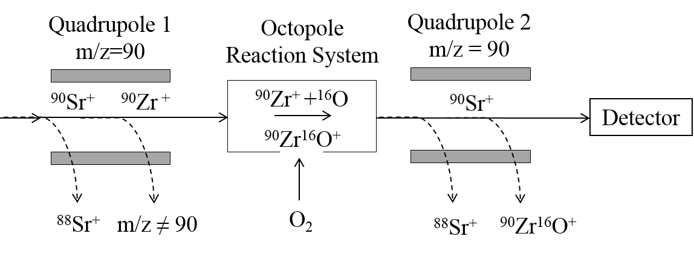

Figure 3. Instrument layout for measurement of ⁹⁰Sr in the presence of isobaric ⁹⁰Zr and peak tailing from ⁸⁸Sr

Zirconium-93

Zirconium-93 is a high yield fission product (6.35 % yield) that is also produced from activation of stable ⁹²Zr from the zircaloy fuel cladding in certain reactor designs. Routine radiometric measurement is challenging given the low beta energy (E_{max} = 56 keV), lack of gamma emission, and interference from ⁹⁵Zr in irradiated materials. The long half-life (1.53 million years) is well suited to mass spectrometric determination, however, ICP-MS measurement of ⁹³Zr is affected by isobaric interferences arising from stable ⁹³Nb (100 % abundance) and activation product ⁹³Mo (half-life 4.0×10³ a), as well as polyatomic ⁹²Mo¹H. Of these, ⁹³Nb is considered the primary challenge, given that it is monoisotopic, and the similarity in Zr/Nb chemistry that makes wet chemical separation challenging. Previous studies have used isotope dilution with a certified reference standard solution for Zr, followed by measurement by multi-collector ICP-MS ^{43,44}. With regards to reaction cell separation, Bandura et al. concluded that a suitable reaction gas could not be found ³².

Operating in MS/MS mode using a combination of NH₃ and H₂ can separate ⁹³Zr from isobaric interferences by shifting ⁹³Zr to m/z=195 as ⁹³Zr(NH₃)₆, whilst ⁹³Nb and ⁹³Mo do not react (Figure 4) ³³. Multiple other potential cell products were formed in NH₃+H₂ mode and O₂+H₂ mode, however, the optimal decontamination factor for Nb was measured with a mass shift of ⁹³Zr from m/z=93 to m/z=195. This highlights an advantage of the tandem mass spectrometry setup, as mass filtering the sample prior to the reaction cell gives greater understanding of the cell chemistry, which is particularly advantageous for more complex reaction gases like NH₃ where multiple potential cell products can form. A further advantage of this application is that it facilitates Zr/Nb separation, which is challenging using offline separation techniques. The optimised instrument setup was effectively tested on a high salinity ⁹³Zr standard solution, following liquid extraction to remove the sample matrix. A ⁹³Nb separation factor of up to 10⁵ was achievable in NH₃+H₂ mode, with a ⁹³Zr detection limit of 1.3×10⁻⁵ Bq g⁻¹ (0.1 pg g⁻¹), which is significantly below the 10 Bq g⁻¹ out of scope limit.

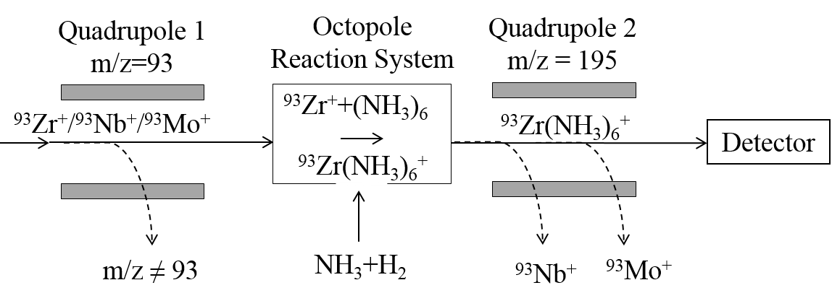

Figure 4. Instrument layout for measurement of ⁹³Zr in the presence of isobaric ⁹³Nb and ⁹³Mo ²⁹

Iodine-129

Iodine-129 (half-life 1.57×10⁷ years) is a weak beta-gamma emitting fission product (0.6 % yield), with a beta E_{max} of 151.2 keV (99.5 %) and gamma energy of 39.6 keV (7.42 %). As well as quantification in nuclear wastes, variation in the ¹²⁹I/¹²⁷I ratio is of interest in identifying the source of contamination, with values ranging from 10⁻³ in reprocessing sites to <10⁻¹³ in uncontaminated samples ⁴⁵⁻⁴⁷. Mass spectrometric measurement is impacted by multiple interferences, as well as the high first ionization energy (10.45 eV) and corresponding reduction in sensitivity. Additionally, the volatile nature of iodine under acidic conditions requires sample introduction in alkali media, such as dilute ammonia, or tetramethylammonium hydroxide (TMAH) ^{24,34,48,49}. These limitations also present a challenge in finding a suitable internal standard, with previous example including Te, Re, Cs and Rh ^{8,48}.

Routine measurement of ¹²⁹I by ICP-MS has been prevented by peak tailing from stable ¹²⁷I (100 % abundance), an isobaric interference from ¹²⁹Xe (26.40 % abundance) present as an impurity in the plasma gas, and polyatomic interferences, primarily ¹²⁷I¹H₂, and others including ⁹⁷Mo¹⁶O₂ and ¹¹³Cd¹⁶O. These interferences led to the majority of previous procedures measuring isotope ratios by combining ICP-MS detection of ¹²⁷I with accelerator mass spectrometry (AMS) measurement of ¹²⁹I/¹²⁷I ratios ⁵⁰⁻⁵².

Improved removal of ¹²⁷I tailing is achievable using ICP-MS/MS, with a measured abundance sensitivity of <10⁻¹⁰. In the presence of 88.9 mg L⁻¹ ¹²⁷I, no signal was detected at m/z = 129 in MS/MS mode ²⁴. Two papers measured ¹²⁹I/¹²⁷I in Fukushima-contaminated soil samples following digestion, one using ICP-MS/MS and the other using ICP-MS ^{34,53}. Both used O₂ to suppress ¹²⁹Xe through conversion of Xe⁺ to Xe via a thermodynamically favourable charge transfer reaction (Equation 1) (Figure 5)⁵¹, whilst the reaction with iodine is not thermodynamically favourable and does not proceed (Equation 2)²⁴.

Xe⁺ + O₂ Xe + O₂⁺ (∆Hr = -0.07 eV) [Equation 1]
I⁺ + O₂ I + O₂⁺ (∆Hr = +2.08 eV) [Equation 2]

The study using ICP-MS/MS was able to operate with a negative voltage gap (energy discrimination) between the cell and the quadrupole for ICP-MS/MS, which enables Xe⁺ suppression without significantly impacting on ¹²⁹I sensitivity compared to the single quadrupole instrument. The optimum flow rate using ICP-MS/MS was determined to be 0.9 mL min⁻¹, which yielded a background equivalent concentration 100 times lower than achieved by ICP-MS.

Filtering of the ion beam by setting Q1 to m/z = 129 prevents ⁹⁷Mo and ¹¹³Cd from entering the cell and potentially forming ⁹⁷Mo¹⁶O₂ and ¹¹³Cd¹⁶O when operating with O₂ reaction gas. This instrument setup also removes ¹²⁷I, so only ¹²⁷I¹H₂ formed in the plasma passed through to Q2. The ¹²⁷I¹H₂ / ¹²⁷I ratio was an order of magnitude lower for ICP-MS/MS compared to ICP-MS, as the single quadrupole instrument allowed ¹²⁷I to pass into the cell and react with hydride impurities. The use of collision gas has also been successfully used for removal of ¹²⁷I¹H₂ (Equation 3)²⁴.

${{}_{}^{127}I{{}_{}^{1}H}_{2}}^{+}+He→ {}_{}^{127}{I^{+}+ 2{}_{}^{1}{H_{}^{+}+He}}$ [Equation 3]

ICP-MS/MS has measured ¹²⁹I/¹²⁷I isotope ratios in the 10⁻⁶ – 10⁻⁸ range, with the results showing good agreement with those measured by AMS ³⁴. A recent study applied ICP-MS/MS to measurement of ¹²⁹I in various decommissioning samples (including graphite, sludge and ion exchange resin) following combustion-based extraction of ¹²⁹I in a tube furnace, with the results showing good agreement with LSC ⁵⁵. The achieved detection limit of 1.05×10⁻⁴ Bq g⁻¹ (0.016 ng g⁻¹) was significantly lower than the out-of-scope waste criteria value of 0.1 Bq g⁻¹ (1.53 ng g⁻¹). The low iodine sensitivity as a result of high first ionisation energy was overcome through matrix modification, by increasing the TMAH concentration from 0.5 – 3 %, with the addition of methanol or glycerine at the same concentration being similarly effective. Tellurium-130 was determined to be the most effective internal standard.

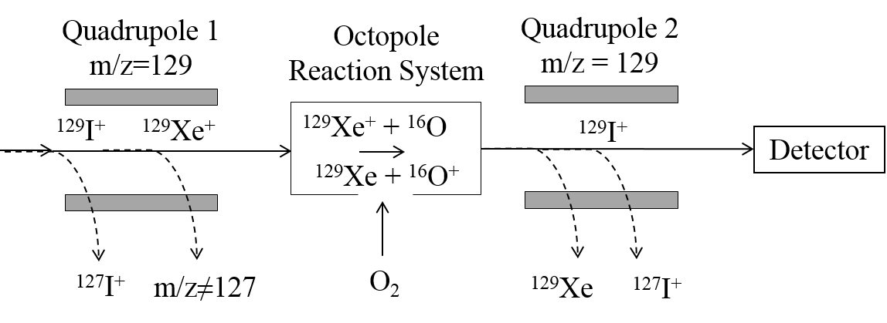

Figure 5. Instrument layout for measurement of ¹²⁹I in the presence of isobaric ¹²⁹Xe and peak tailing from ¹²⁷I

Neptunium-237

Neptunium-237 is an alpha emitting actinide with a half-life of 2.1×10⁶ years. The radionuclide is produced via a series of neutron activation and decay steps within the reactor fuel. The long half-life and corresponding low specific activity means that ²³⁷Np is well suited to mass spectrometric measurement, and low-level detection in the fg g⁻¹ region is achievable by sector field ICP-MS ⁵⁶⁻⁵⁸. Prior to measurement, removal of peak tailing from ²³⁸U usually necessitates chemical separation prior to sample introduction ⁵⁹⁻⁶¹, increasing procedural time and the analytical expense through the number of resins and reagents required, as well as risking loss of ²³⁷Np through the procedure.

In MS/MS mode, a significantly higher uranium concentration can be tolerated without tailing into the 237 signal, reducing the extent of chemical separation required prior to measurement (Figure 6). In Single Quad mode, abundance sensitivities of ~10⁻⁶ were measured for ²³⁸U/²³⁷Np, with ²³⁸U concentrations of 100 ng g⁻¹ resulting in increased background at m/z = 237. In MS/MS mode abundance sensitivities were reduced to < 10⁻⁹ with no observable tailing in the m/z=237 region in the presence of 50 μg g⁻¹ U. This enabled direct measurement of ²³⁷Np in aqueous waste samples containing 0.1 - 1 μg g⁻¹ U without sample pre-treatment⁶². The high salinity of the samples necessitated the use of matrix-matched calibration standards and High Matrix Introduction (HMI) aerosol dilution, with ²⁰⁹Bi used as an internal standard. Samples were measured at activities ranging from 1.7×10⁻³ – 95.5 Bq g⁻¹ (65.2 – 3.64×10⁶). ICP-MS/MS has also been successfully utilised for the measurement of ²³⁷Np in intertidal sediment samples with ²³⁷Np activity concentrations in the 0.5 – 10 Bq kg⁻¹ range following digestion and chemical separation ³⁷.

Reaction cell chemistry of other actinides has been well documented through the use of O₂, NH₃ as well as other reaction gases ^{32,63}. A recent ICP-MS/MS application note used O₂ reaction gas, which converted 99% of Np to NpO₂, achieving a detection limit of 0.56 fg g⁻¹, compared to 1.9 fg g⁻¹ when measured in no-gas mode ⁶⁴.

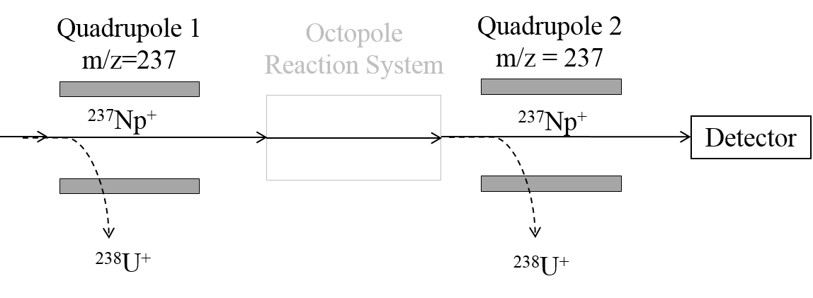

Figure 6. Instrument layout for measurement of ²³⁷Np in the presence of peak tailing from ²³⁸U

Plutonium-239

Plutonium-239 is an alpha emitting actinide with a half-life of 24,110 years, which is formed via neutron capture within the reactor fuel. Detection is achievable by ICP-MS, most commonly represented as ²³⁹Pu/²⁴⁰Pu isotopic ratios to determine the source of the Pu ⁶⁵⁻⁶⁶. This represents an advantage over alpha spectrometry, which cannot resolve the similar alpha energies of the two isotopes, and can therefore only measure a combined ²³⁹⁺²⁴⁰Pu activity. Detection limits in the fg g⁻¹ (10⁻⁶ Bq g⁻¹) are achievable by sector field ICP-MS⁶⁵⁻⁶⁸, with accurate measurement dependent on the removal of ²³⁸U, which interferes both as tailing and as polyatomic ²³⁸U¹H, the latter of which forms during sample introduction.

Uranium can be removed by offline chemical separation, whilst ²³⁸U¹H formation from residual U can be reduced using a desolvating sample introduction system ^{69,70}. More rapid ²³⁸U separation is achievable using ICP-MS/MS, with improved peak tailing removal operating in MS/MS mode (<10⁻⁹). Additionally, polyatomic ²³⁸U¹H can be removed by using O₂ reaction gas, following a procedure developed for ²³⁶U/²³⁸U isotope ratio measurements ²⁶. A ²³⁸U solution was introduced, and Q1 set to m/z=239 to monitor ²³⁸U¹H. When operating with O₂ reaction gas, the majority of the U signal (70 %) was detected as ²³⁸U¹⁶O, compared to 1 % measured as ²³⁸U¹⁶O¹H, with the remainder measured as either ²³⁸U or ²³⁸U¹H. This enabled measurement of ²³⁶U/²³⁸U as ²³⁶U¹⁶O/²³⁸U¹⁶O, with polyatomic ²³⁵U¹H converted to ²³⁵U¹⁶O.

The same approach can be applied to separation of ²³⁹Pu from ²³⁸U¹H. By setting Q1 to m/z=239, both ²³⁸U¹H and ²³⁹Pu pass into the cell. Plutonium is detected by setting Q2 to m/z=255 (²³⁹Pu¹⁶O), whilst ²³⁸U¹H is largely converted to non-interfering ²³⁸U¹⁶O at m/z=254 (Figure 7). Carbon dioxide has also been demonstrated as an effective reaction gas using a multi-collector ICP-MS, but this has not been applied to an ICP-MS/MS procedure ⁷¹. Using this gas, ²³⁸U was shifted to ²³⁸U¹⁶O or ²³⁸U¹⁶O₂, whilst ~40 % of the ²³⁹Pu signal remained on mass.
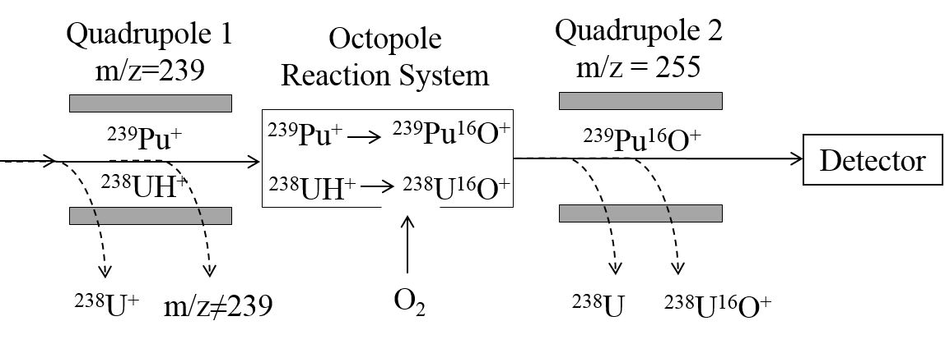

Figure 7. Instrument layout for measurement of ²³⁹Pu in the presence of polyatomic ²³⁸UH and tailing from ²³⁸U

Conclusions

ICP-MS is an increasingly used technique for radionuclide detection with regards to nuclear waste characterisation, expanding the range of radionuclides routinely measurable at nuclear sites, whilst offering an improvement in sample throughput as a result of reduced measurement time compared to decay counting techniques. The removal of isobaric, polyatomic and tailing interferences prior to detection remains the major factor preventing accurate measurement using this technique. The commercial availability of ICP-MS/MS offers improved interference removal over alternative instrument designs, which can be used to support or even replace relatively time-consuming and labour-intensive offline chemical separation techniques, further improving the sample throughput. ICP-MS/MS has been successfully applied to measurement of multiple radionuclides of interest to nuclear sites in a range of sample matrices, including ⁹⁰Sr, ⁹³Zr, ¹²⁹I, ¹³⁵Cs, ¹⁵¹Sm, ²³⁶U and ²³⁷Np, as well as NORM-relevant ²²⁶Ra. The flexibility of the instrument allows the setup to be varied depending on the analytical requirements e.g. sensitivity, tailing removal, or target decontamination factors for interferences. ICP-MS/MS is potentially applicable to detection of a number of other difficult-to-measure radionuclides relevant to nuclear waste clean-up, but for which no routine measurement technique currently exists. Reactive gases can be used to remove isobaric / polyatomic interferences and permit effective measurement of ¹²⁶Sn and ²³⁹Pu. Reactive gases may also benefit ⁹⁹Tc measurement although no suitable reactive gases have been identified to separate ⁹⁹Tc from ⁹⁹Ru. The significant improvement in abundance sensitivity achieved by ICP-MS/MS is beneficial to the measurement of ⁵⁹Ni, ⁷⁹Se, ⁹⁴Nb and ¹⁰⁷Pd in the presence of stable isotopes of the element. However, hydride formation is still a dominant contributor to m/z+1 signal and does not appear to be significantly affected (reduced) by the introduction of a collision gas. For fission products ⁷⁹Se and ¹⁰⁷Pd it is likely that the stable isotopes will not be present in significant concentrations to result in problematic levels of hydride generation. However, for activation products ⁵⁹Ni and ⁹⁴Nb, the stable analogues will always be associated with the nuclide of interest and desolvation is required to suppress hydride formation to acceptable levels. For ³⁶Cl and ⁴¹Ca, sufficiently sensitive ICP-MS/MS measurement is considered unviable given the high background signals observed.

Conflicts of interest
There are no known conflicts of interest

Acknowledgements

Ben Russell thanks the Nuclear Decommissioning Authority (NDA tender WP_B2_18), for funding and NSG for leading the strontium-90 research undertaken at NPL, and funding through the National Measurement System by the Department of Business, Energy and Industrial Strategy. Z Zacharauskas acknowledges joint PhD funding from NPL and GAU-Radioanalytical.

References

1 G. P. Russ and J. M. Bazan, Spectrochim. Acta, Part B, 1987, 42, 49–62.

2 D. W. Boomer and M. J. Powell, Anal. Chem., 1987, 59, 2810– 2813.

3 R. M. Brown, S. E. Long and C. J. Pickford, Sci. Total Environ., 1988, 70, 265–274.

4 I.W. Croudace, Russell, B.C. and P.E. Warwick, J. Anal. Atom. Spectrom., 2017, 32, 494-526.

5 W. Bu, Youyi, N., Steinhauser, G. Zheng, W., Zheng, J. and N. Furuta, J. Anal. Atom. Spectrom., 2018, 33, 519–546
6 R. N. Taylor, T. Warneke, J. A. Milton, I. W. Croudace, P. E. Warwick and R. W. Nesbitt, J. Anal. At. Spectrom., 2003, 18, 480–484.

7 Y. Takagi, M. Furukawa, Y. Kameo and K. Suzuki, Anal. Methods., 2014, 6(2), 355-362

8 H. Fujiwara, K. Kawabata, J. Suzuki and O. Shikino, J. Anal. At. Spectrom., 2011, 26, 2528–2533.

9 S.D. Tanner, V.I. Baranov, D.R. Bandura, Spectrochimica Acta part B, 57, 2002, 1361-1452

10 I. Feldmann, N. Jakubowski, D. Stuewer, Frensius Journal of Analytical Chemistry, 1999, 365, 5, 415-421

11 A. P. Vonderheide, M. V. Zoriy, A. V. Izmer, C. Pickhardt, J. A. Caruso, P. Ostapczuk, R. Hille and J. S.
Becker, J. Anal. At. Spectrom., 2004, 19(5), 675–680.

12 Y. Gao, W. Baeyens, S. De Galan, A. Poffijn and M. Leermakers, Environ. Pollut., 2010, 158, 2439–2445.

13 Y. Shi, R. Collins and C. Broome, J. Radioanal. Nucl. Chem., 2013, 269, 509–515.

14 M. Ayranov, U. Krähenbühl, H. Sahli, S. Röllin and M. Burger, Radiochim. Acta, 2005, 93, 631–635.

15 P. Grinberg, S. Willie and R. E. Sturgeon, J. Anal. At. Spectrom., 2007, 22(11), 1409–1414.

16 M. Song, T. U. Probst and N. G. Berryman, Fresenius' J. Anal. Chem., 2001, 370(6), 744–751.

17 L. A. De las Heras, E. Hrnecek, O. Bildstein and M. Betti, J. Anal. At. Spectrom., 2002, 17, 1011–1014.

18 M. Betti and L. A. de las Heras, Spectrochim. Acta, Part B, 2004, 59(9), 1359–1376.

19 Agilent ICP-MS Accessories: Ultra High Matrix Introduction, https://www.agilent.com/en/products/icp-ms/icp-ms-accessories/icp-ms-ultra-high-matrix-introduction-(uhmi)-accessory (accessed 17/04/2019)

20 B. Russell, M. Garcia Miranda and P. Ivanov, Appl. Radiat. Isot., 2017, 126, 35-39.

21 J. Zheng, K. Tagami, W. Bu, S. Uchida, Y. Watanabe, Y. Kubota, S. Fuma and S. Ihara, Environ. Sci. Technol., 2014, 48, 5433–5438.

22 J. Zheng, W. Bu, K. Tagami, Y. Shikamori, K. Nakano, S. Uchida and N. Ishii, Anal. Chem., 2014, 86(14), 7103–7110.

23 M. A. Amr, A.-F. I. Helal, A. T. Al-Kinani and P. Balakrishnan, J. Environ. Radioact., 2016, 153, 73–87.

24 Y. Shikamori, K. Nakano, N. Sugiyama and S. Kakuta, Agilent Application note, 2012, https://www.agilent.com/cs/library/applications/5991-0321EN_AppNote_8800_I.pdf (accessed 02/08/2017)

25 E.M. van Es, B.C. Russsell, P. Ivanov and D. Read, Appl. Radiat. Isot., 2017, 126, 31-34.

26 M. Tanimizu, N. Sugiyama, E. Ponzevera and G. Bayon, J. Anal. At. Spectrom., 2013, 28, 1372–1376.

27 IAEA Safety Standards Series Safety Guide No. RS-G 1.7 Application of the concepts of exclusion, exemption and clearance. http://www-pub.iaea.org/MTCD/publications/PDF/Pub1202_web.pdf (accessed 17/04/2019)

28 IAEA Nuclear Energy Series NW-T-1.18. Determination and use of scaling factors for waste characterization in nuclear power plants. https://www-pub.iaea.org/MTCD/Publications/PDF/Pub1363_web.pdf (accessed 17/04/2019)

29 D.J. Douglas & J.B. French, J. Am. Mass Spec, 1992, 3, 398-408.
30 Agilent Technologies, 2015, Agilent 8800 Triple Quadrupole ICP-MS https://www.agilent.com/cs/library/brochures/5991-0079EN_8800_ICPQQQ_Brochure.pdf (accessed 06/07/2017)
31 Warwick P.E., Croudace I.W. & Hillegonds D.J., Anal. Chem., 2009, 81, 1901 – 1906.
32 D. R. Bandura, V. I. Baranov, A. E. Litherland and S. D. Tanner, Int. J. Mass Spectrom., 2006, 235–236, 312–327.

33 P. Petrov, B.Russell, D.Douglas and H. Goenaga-Infante., Anal. Bioanal. Chem., 2018, 410 (3), 1029-1037

34 T. Ohno, Y. Muramatsu, Y. Shikamori, C. Toyama, N. Okabe and H. Matsuzaki, J. Anal. At. Spectrom., 2013, 28, 1283-1287.

35 M. Garcia-Miranda, B. Russell and P. Ivanov., 2018, J. Radioanal. Nucl. Chem., 2018, 316 (2), 831-838

36 B. Russell, E. van Es, G. Woods and D. Read, Agilent Application Note, https://www.agilent.com/cs/library/applications/8800_ICP-MS_5991-8324EN_radium_analysis.pdf, (accessed 22/05/2018)

37 Caborn J (2017), PhD thesis, University of Southampton, Southampton, UK

38 M. V. Zoriy, L. Halicz, M. E. Ketterer, C. Pickhardt, P. Ostapczuk and J. S. Becker, J. Anal. At. Spectrom., 2004, 19, 362.

39 M. Sakama, Y. Nagano, T. Saze, S. Higaki, T. Kitade, N. Izawa, O. Shikino and S. Nakayama, Appl. Radiat. Isot., 2013, 81, 201–207.

40 J. Feuerstein, S. F. Boulyga, P. Galler, G. Stingeder and T. Prohaska, J. Environ. Radioact., 2008, 99(11), 1764–1769.

41 Y. Shikamori and K. Nakano, Agilent 8800 ICP-QQQ Applications Handbook, 2012, 77-78
42 Y. Suzuki, R. Ohara and K. Matsunaga, Spectrochim. Acta. B., 2017, 135, 82-90.

43 F. Chartier, H. Isnard, J. P. Degros, A. L. Faure and C. Fréchou, Int. J. Mass Spectrom., 2008, 270(3), 127–133.

44 P. Cassette, F. Chartier, H. Isnard, C. Fréchou, I. Laszak, J. P. Degros, M. M. B´e, M. C. L´epy and I. Tartes, Appl. Radiat. Isot., 2010, 68, 122–130.

45 C. Vockenhuber, N. Casacuberta, M. Christl and H.-A. Synal, Nucl. Instrum. Methods Phys. Res., Sect. B, 2015, 361, 510–516.

46 R. Michel, A. Daraoui, M. Gorny, D. Jakob, R. Sachse, L. Tosch, H. Nies, I. Goronocy, J. Herrman, H. A. Synal, M. Stocker and V. Alfimov, Sci. Total Environ., 2012, 419, 151–169.

47 T. Matsunaka, K. Sasa, K. Sueki, T. Takahashi, Y. Satou, M. Matsumara, N. Kinoshita, J. Kitagawa and H. Matsuzaki, J. Environ. Radioactiv., 2016, 151 (1), 209-217.
48 Ž. Ežerinskis, A. Spolaor, T. Kirchgeorg, G. Cozzi, P. Vallelonga, H. A. Kjaer, J. Šapolaité, C. Barbante and R. Druteikiené, J. Anal. At. Spectrom., 2014, 29, 1827–1834.

49 J. Qiao, V. Hansen, X. Hou, A. Aldahan and G. Possnert, Appl. Radiat. Isot., 2012, 70 (8), 1698-1708

50 V. Hansen, P. Roos, A. Aldahan, X. Hou and G. Possnert, J. Environ. Radioact., 2011, 102, 1096–1104.

51 J. Lehto, T. Räty, X. Hou, J. Paatero, A. Aldahan, G. Possnert, J. Flinkman and H. Kankaanpää, Sci. Total Environ., 2012, 419, 60–67.

52 R. Michel, A. Daraoui, M. Gorny, D. Jakob, R. Sachse, L. Tosch, H. Nies, I. Goronocy, J. Herrman, H. A. Synal, M. Stocker and V. Alfimov, Sci. Total Environ., 2012, 419, 151–169.

53 T. Ohno, Y. Muramatsu, C. Toyama, K. Nakano, S. Kakuta and H. Matsuzaki, Anal. Sci., 2013, 29, 271-274

54 E. Bolea-Fernandez, L. Balcaen, M. Resano and F. Vanhaecke, J. Anal. Atom. Spectrom., 2017
55 Z. Zacharauskas, P.E. Warwick, B.C. Russell and I.W. Croudace, In preparation.
56 C-H. Graser, N. lal Banik, K. A. Bender, M. Lagos, C.M. Marquardt, R. Marsac, V. Montoya and H. Geckeis, Anal. Chem., 2015, 87 (19), 9786-9794

57 C. S. Kim, C. K. Kim and K. J. Lee, J. Anal. At. Spectrom., 2004, 19, 743–750.

58 J. B. Truscott, P. Jones, B. E. Fairman and E. H. Evans, Anal. Chim. Acta, 2001, 433, 245–253.

59 J. Qiao, X. Hou, P. Roos and M. Miró, Anal. Chem., 2011, 83, 374–381.

60 S. L. Maxwell, B. K. Culligan, V. D. Jones, S. T. Nichols, M. A. Bernard and G. W. Noyes, Anal. Chim. Acta, 2010, 682, 30–136.

61 S. Röllin, H. Sahli, R. Holzer, M. Astner and M. Burger, Appl. Radiat. Isot., 2009, 67, 821–827.

62 B. Russell, P. Ivanov, M. Garcia Miranda and S. Jerome, 63rd Radiobioassay & Radiochemical Measurements Conference, 2018

63 S. Tanner, C. Li, V. Vais, V.I. Baranov and D.R. Bandura, Anal. Chem., 2004, 76 (11), 3042-3048G.

64 Woods, Handbook of ICP-QQQ Applications, https://www.agilent.com/cs/library/brochures/ICP-QQQ-5991-2802EN-eHandbook_3rd_Edition.pdf (accessed 22/05/2018)

65 A. Habibi, B. Boulet, M. Gleizes, D. Larivière and G. Cote, Anal. Chim. Acta, 2015, 883, 109–116.

66 F. N. Pointurier, N. Baglan and P. Hémet, Appl. Radiat. Isot. 2004, 60, 561–566.

67 S. Cagno, K. Hellemans, O. C. Lind, L. Skipperud, K. Janssens and B. Salbu, Environ. Sci.: Processes Impacts,
2014, 16, 306–312.
68 K. Bu, J. V. Cizdziel and D. Dasher, J. Environ. Radioact., 2013, 124, 29–36.

69 S. F. Boulyga, C. Testa, D. Desideri and J. S. Becker, J. Anal. At. Spectrom., 2001, 16, 1283–1289.

70 J. S. Becker, Spectrochim. Acta, Part B, 2003, 58, 1757–1784.

71 A. Gourgiotis, M. Granet, H. Isnard, A. Nonell, C. Gautier, G. Stadelmann, M. Aubert, D. Durand, S. Legand and F. Chartier, J. Anal. At. Spectrom., 2010, 25, 1939–1945.

