Temperature insensitive fiber interferometry
W. Zhu^{1 ,2} E. R. Numkam Fokoua,¹ Y. Chen,¹ T. Bradley,¹ M. N. Petrovich,¹ F. Poletti,¹ M. Zhao,² D. J. Richardson,¹ AND R. Slavík^{1 ,*}
¹Optoelectronics Research Centre, University of Southampton, Southampton, SO17 1BJ, UK
² School of Optoelectronic Engineering and Instrumentation Science, Dalian University of Technology, Liaoning, 116024, China.
*Corresponding author: R.Slavik@soton.ac.uk
Received XX Month XXXX; revised XX Month, XXXX; accepted XX Month XXXX; posted XX Month XXXX (Doc. ID XXXXX); published XX Month XXXX

We show for the first time the interference pattern of a Mach-Zehnder interferometer to be fully insensitive to temperature. This is achieved using silica glass made hollow core fiber and operating it at the temperature of -71^{O}C, which is very close to the temperature at which the thermal expansion of silica glass crosses zero. Our results highlight for the first time an alternative to bulky and difficult-to-align, ultra-low-expansion glass-based optical cavities for metrology and sensing. © 2019 Optical Society of America
http://dx.doi.org/10.1364/OL.99.099999
Optical interferometers lie at the heart of some of the most precise instruments ever constructed. They are essential in optical metrology [1], in ultraprecise precise position and rotation sensing (e.g., gyroscopes [2]) and even for the gravitational waves detection [3].
In all of these applications, the cross-sensitivity to temperature has to be very carefully managed in order to achieve the required levels of accuracy and precision. For example, in metrology, an Ultra-Low Expansion (ULE) glass is stabilized at its zero-sensitivity turning point and a hole at its center is used to define a Fabry-Perot cavity. The Fabry-Perot configuration is the only practical interferometer there, as it allows for the long light delays necessary to achieve ultra-high sensitivity in a cavity of practical dimensions (e.g., 50 cm long). To achieve long delays, an ultra-high finesse (e.g., >100,000) is necessary, which unavoidably makes the cavity very difficult to align. Even though ULE glass can achieve zero thermal expansion at ambient temperature, the ultimate limiting factor to sensitivity is found to be thermal noise in the resonator end mirrors [4]. An alternative approach is to use a cavity made from a single crystal of silicon, which exhibits zero expansion at a temperature of 124 K, simultaneously enabling both zero thermal expansion and low thermal noise when operated at 124 K [5]. Restricted by the cost and ultra-sensitive alignment requirements, these cavities are found today only in specialized metrology laboratories.
Optical fibers allow for the construction of interferometers with effectively arbitrary optical delays (from millimeters up to 10’s of km), however, the silica glass of which fibers are made has a relatively high thermo-optic coefficient (48 $rad/m/℃$ at 1550 nm [6]), meaning that these interferometers are highly sensitive to temperature fluctuations leading to correspondingly high thermal
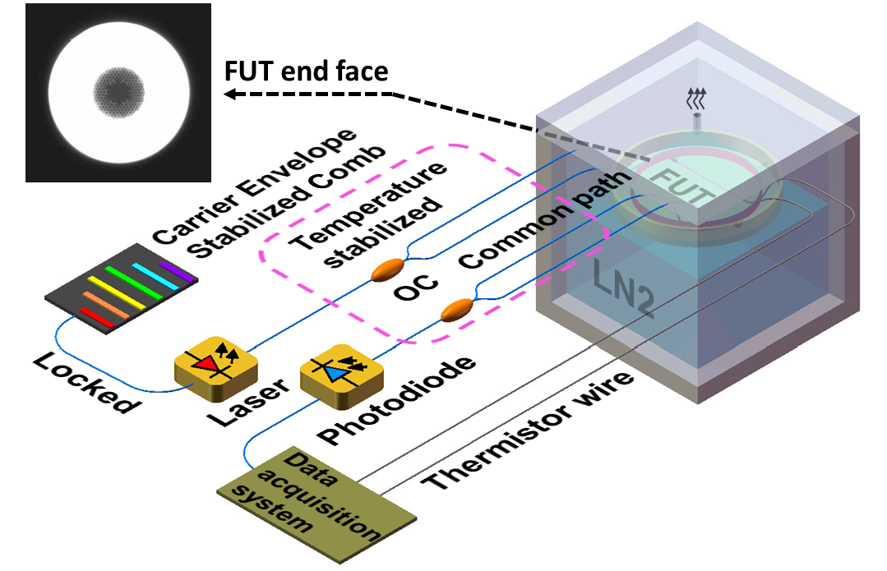
Fig. 1. Experimental setup. Laser light with a frequency locked to an optical frequency comb passes through a Mach-Zehnder interferometer incorporating the hollow core fiber (end face shown in inset) under test in one of its arms. OC: optical coupler, LN2: liquid nitrogen, FUT: fiber under test.
phase noise [7]. This sensitivity can be reduced by using hollow-core optical fibers (HCF) [6][8], in which the light propagates through air (which has a very low thermo-optic response). In such fibers the dominant source of thermal instability is thermally-induced elongation/contraction, which although very low for fused silica (5.5x10⁻⁷/K) [9], is too high for precise interferometers.
Recently, we showed that the optical propagation delay through a HCF can be made to be fully insensitive to temperature over a limited bandwidth [10]. Unfortunately, the thermal sensitivity of the accumulated phase, which dictates the interferometer performance, cannot be nulled in the same way as for the delay. Besides interferometers, this capability is of interest in other applications that require, for example, the transmission of carrier-envelope-stabilized pulses for which both the temporal delay and accumulated phase are of critical importance.
To the best of our knowledge, there has been no report to date of an optical fiber (or a path-imbalanced (i.e., two interfering arms of different length) fiber based interferometer) in which the phase of light is completely insensitive to temperature changes.
Here, we report the first path-imbalanced fiber interferometer that can be made completely insensitive to thermal fluctuations. Use of such a device will enable ultra-stable, alignment-free, and compact fiber interferometers to be used in real world applications, e.g., for precise laser stabilization. Ultra-stable lasers are essential for high-precision timing and length measurements, as required in many diverse fields, e.g., communications, positioning, relativistic geodesy [11], amongst others.
Crucial to the result presented here is the fact that the thermal coefficient of expansion of fused silica crosses zero at temperatures between $-85 ℃$ and $-110 ℃$ [9]. Although this is unimportant for solid core fibers where the thermal sensitivity is dominated by the thermo-optic effect of the silica glass, it should allow zero sensitivity to be reached in HCF in which the thermal sensitivity is dominated by thermally-induced elongation. Additionally, at low temperature, where the zero thermal expansion occurs, the dynamic thermal noise is also significantly reduced [7] [12].
We carried a proof of concept experiment as shown in Fig. 1. An imbalanced Mach-Zehnder interferometer (MZI) had a piece of photonic bandgap HCF (HC-PBGF type) in both arms. The HC-PBGF was of 19-cell design, had air filled core of 29.2 $μm$ diameter, and the outer diameter of the fiber silica glass jacket was 210$μm$ [6].
For our proof-of-principle experiment, the HCF was directly spliced to the SMF-28 pigtails of two couplers with each splice having about 5 dB loss (total device loss of about 10 dB). We did not implement any more sophisticated technique (e.g., in [13], loss below 0.3 dB per interconnection was achieved), since only the optical phase change that could be measured even in the presence of moderate loss was of our interest.
The SMF-28 pigtails lengths were carefully balanced and kept as close as possible to cancel their thermal response. Both arms contained 1-m long HCF, but the longer arm incorporated an additional 8 m length of HCF (the fiber under test (FUT)) with the acrylate coating removed, as we expected that the coating could significantly contribute to the total fiber thermal sensitivity at low temperatures. This is because the fiber coating is in a soft rubbery state at room temperature but comes into a stiff glassy state at low temperatures, thereby imparting thermal stresses on the fiber. The MZI couplers were physically placed away from the FUT, thermally-insulated and actively temperature stabilized. The FUT was placed inside a glass Petri dish fixed to the top of a polystyrene box. The polystyrene box was then filled with liquid nitrogen (LN2) right up to the bottom of the Petri dish. As the LN2 evaporated away, the temperature of the FUT increased slowly. Due to the temperature changes, the optical path length nL of the FUT changed, and the phase of the light propagating through it changed accordingly (φ=2πnL/λ, λ: wavelength), affecting the power recorded at the MZI output.

$P_{out}=γP_{in}cos(φ)$, (1)

where$γ$ is the total loss of the MZI, and $P_{in}$ is the input optical power.
Then, by counting the number of passing fringes in the output signal, we can calculate the thermal phase sensitivity as

$S=\frac{1}{L}\frac{dφ}{dT}=\frac{number of fringes∙2π}{∆T∙L}$, (2)

where ∆T is the temperature change over the observation time.
In deriving Eq. (2) we considered $λ$ to be constant (not changing with temperature). This means that there is no drift in the laser used to probe the interferometer. For our 8-m imbalanced HCF-based MZI, laser frequency change as small as 38 MHz causes $Δφ=360°$ (move by one interference fringe). For a reliable measurement, we had to ensure that our laser drifts by significantly less than 38 MHz (e.g., < 1 MHz) over the duration of the measurement, which is challenging to be achieved in any free-running laser. Thus, we phase locked our laser (RockTM laser, operating at 1555.7 nm) to a carrier-envelop-stabilized optical frequency comb (Menlo FC1500-250). This reduced the drift several orders below the 1-MHz level required for our measurement.
The optical power launched into the interferometer was kept to 0 dBm and the output signal was captured by a photodiode.
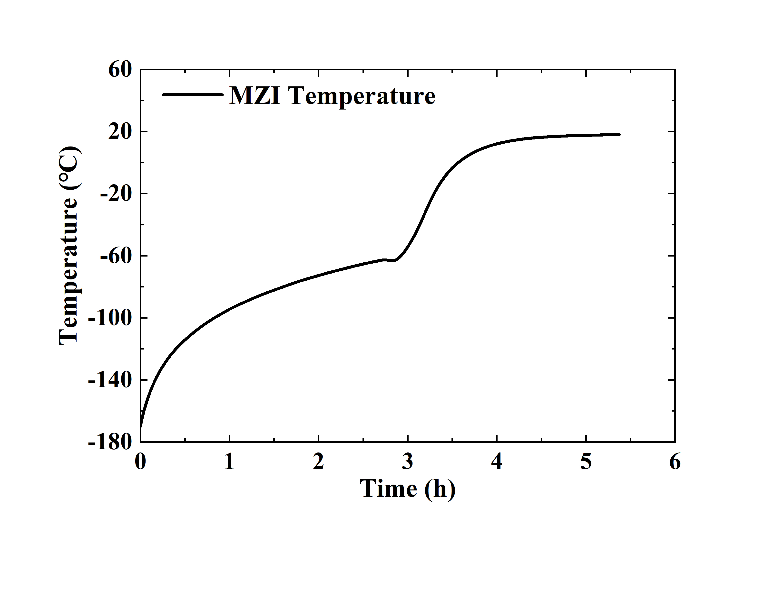
Fig. 2. Temperature change of the MZI as a function of time.
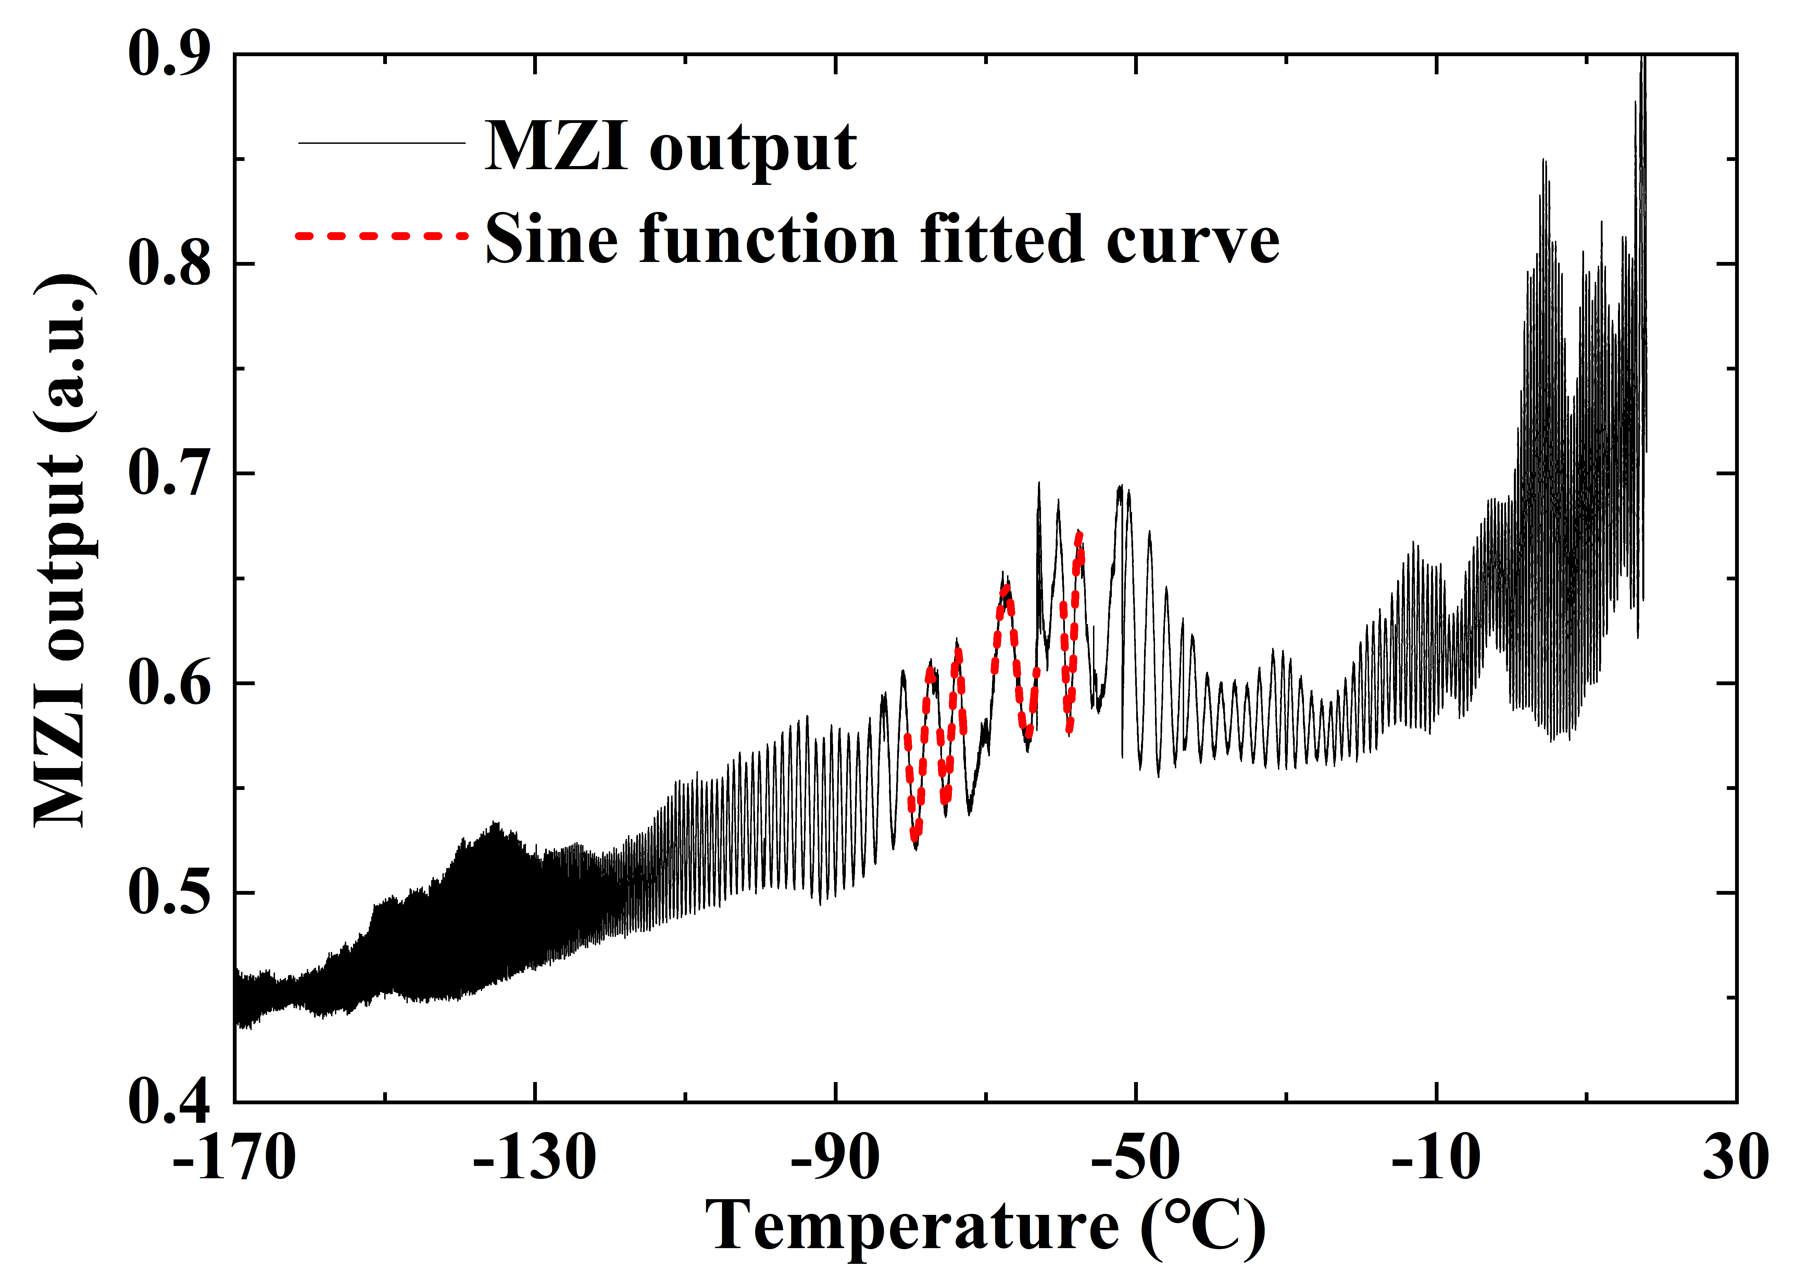
Fig. 3. Interference fringes of the interferometer as a function of temperature.
Two thermistors placed at different positions long the coiled FUT were used to monitor the temperature of FUT. At the beginning of the experiment, when the polystyrene box was filled with LN2, the temperature distribution across FUT was not uniform and the temperature reading obtained with the two thermometers was different. After finishing the filling and closing the polystyrene box, the temperature decreases quickly to its minimum and then rises up, and when it reaches about $-170 ℃$, the two thermometers start showing the same temperature, indicating uniform temperature distribution along the FUT. At this point, we started to record data. The temperature data are shown in Fig. 2. We see that the FUT temperature first rose up relatively quickly, slowing down till LN2 was present in the polystyrene box. Around $-60 ℃$, there was no LN2 left and the temperature started to rise quicker again, until the ambient temperature had been achieved.
Fig. 3 shows the MZI output power as a function of temperature. The non-uniform fringe contrast is due to thermally-induced changes of optical length in the two MZI arms, which (due to slight birefringence of the coiled/bent fibers) induced changes in the light polarization propagating through the MZI arms. We did not actively control the polarization state here as this was not essential to obtain our key result. At low temperatures, the fringes change rapidly with temperature, slowing down as temperature increases to $\sim -70 ℃$, beyond which they appear more rapidly again at higher temperatures.
When extracting phase data from the measured MZI output, we first used sinusoidal function to fit every interference fringe - fitted curves within the sparse region around $-70 ℃$ are shown in Fig. 3 with red dashed line. After obtaining the period for every interference fringe (which corresponds to a phase φ difference of $360°$), we calculated the thermal sensitivity using Eq. (2) and plot it in Fig. 4 (red solid curve) together with the expected sensitivity based on the thermal expansion of fused silica (blue dashed line) [9]. The measured sensitivity curve matches our expectations from ambient temperatures down to about $-100 ℃$. We believe the difference bellow $-100 ℃$ is due to changes in the thermal properties of the air inside the HCF [14]. Within the temperature range $-73 ℃$ to $-69 ℃$ the measured thermal sensitivity is within $±50 mrad/m/℃$, which is 1000 times lower than that of SMF-28 at room temperature. The zero sensitivity point for the HCF under test was measured to occur at $-71 ℃$. The phase sensitivity around $-71 ℃$ changed at a rate of $6×{10}^{-9} ℃^{-2}$, which is three times lower than for crystalline silicon at its zero temperature crossing point at 124 K $(-149 ℃)$ [5].
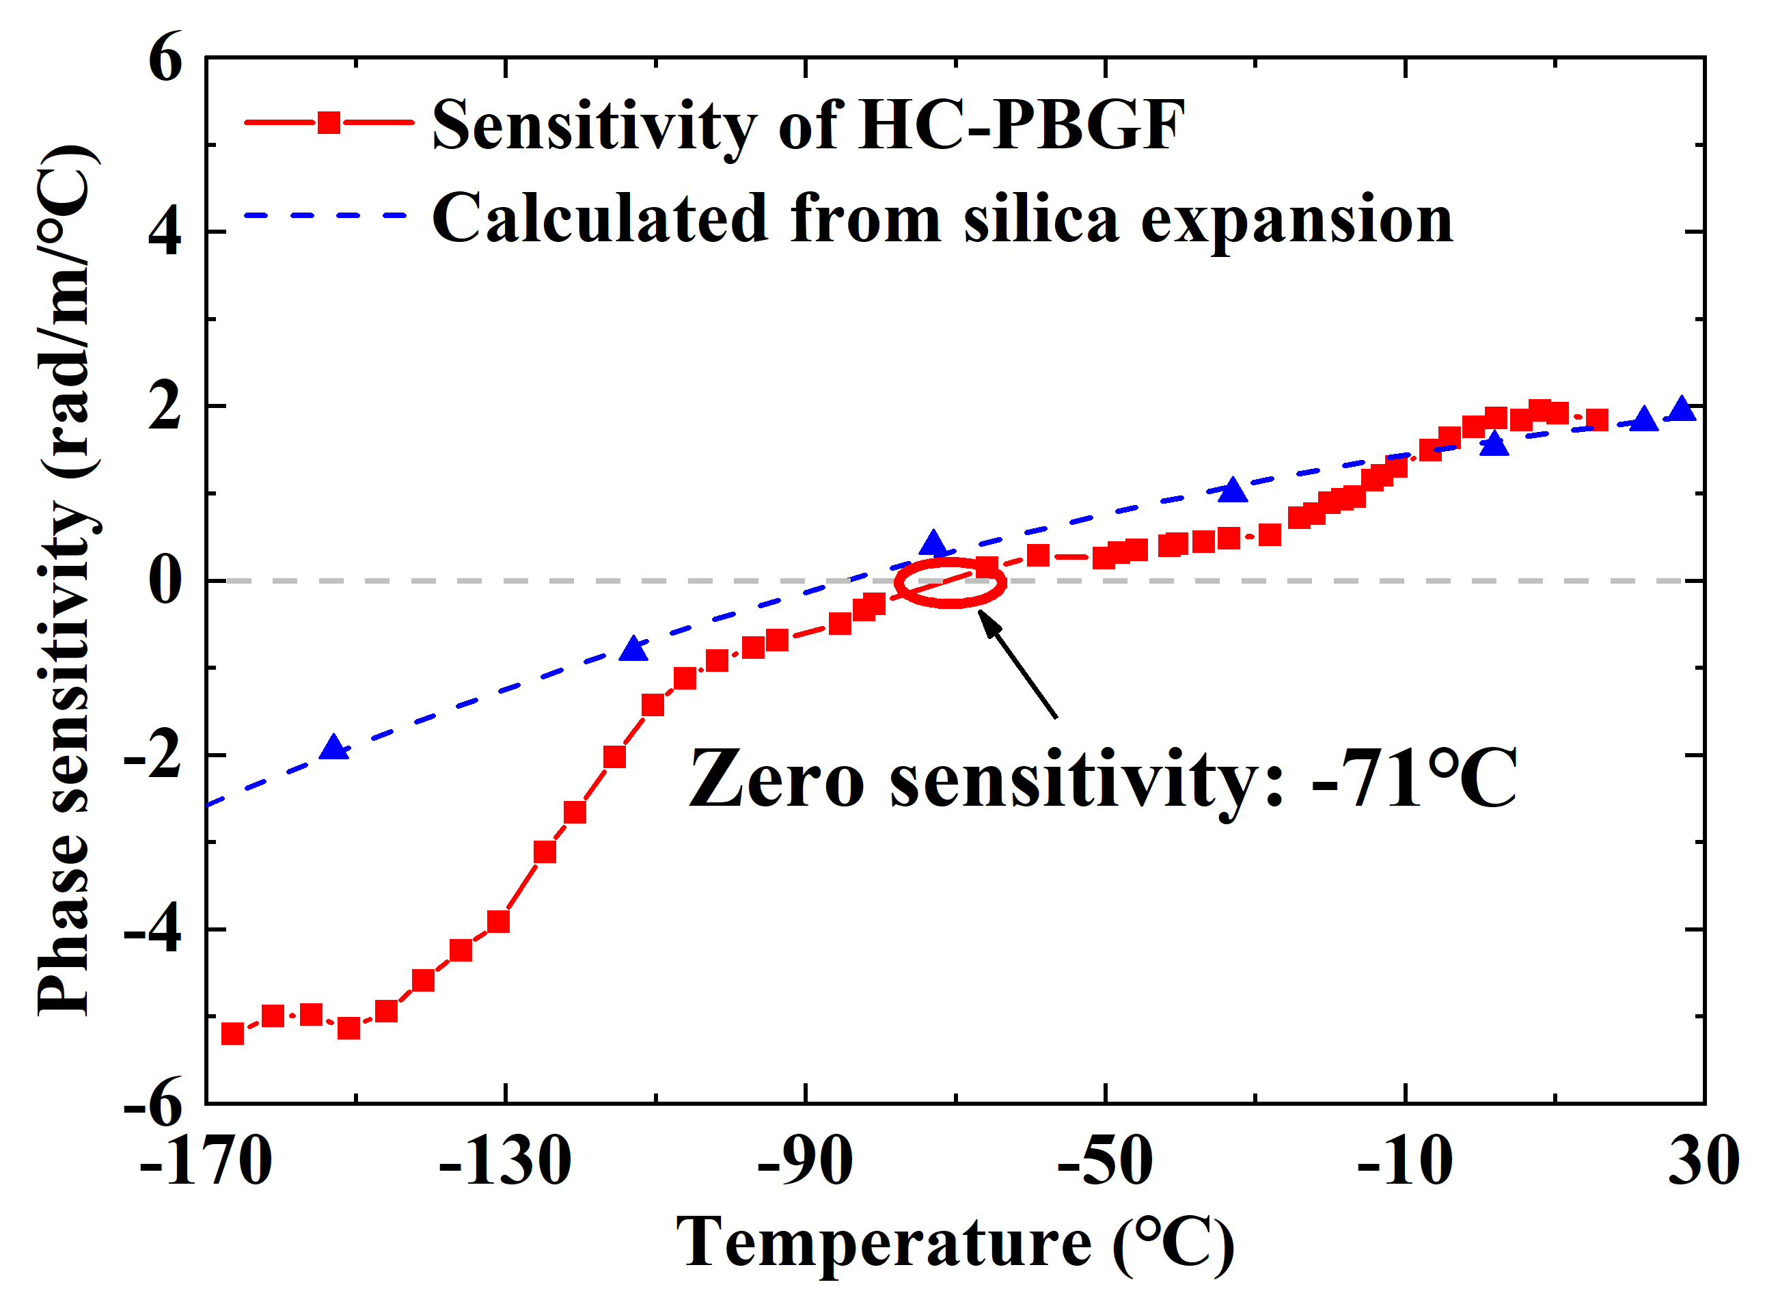
Fig. 4. Measured thermal sensitivity of stripped HC-PBGF (red solid) and expected thermal sensitivities (blue, dashed) based on the data for fused silica from [9].
In conclusion, we have demonstrated an optical fiber interferometer with zero phase thermal sensitivity for the first time. Having previously shown that the particular fiber we employed can be designed to make its propagation delay insensitive to temperature, this work paves the way to fibers (and devices made thereof) in which both phase and propagation delays are engineered to be thermally-insensitive. The zero sensitivity was achieved at a temperature of $-71 ℃,$which can be readily achieved with a Stirling engine, Peltier cooler, or simple LN2 cooling system, making it extremely suitable for those working in fields that require ultra-stable interferometers. Since such properties result from the glass properties themselves rather than the fiber structure, other HCF geometries (e.g., Anti-resonant fibers [15], Kagome fibers [16]), are also expected to show zero phase sensitivity. Although our proof-of-principle experiment used a relatively short length of a HCF (8 m), interferometers with significantly longer length should have the same thermal properties, allowing for ultra-sensitive thermally-insensitive fiber interferometers to be made.

Funding. EPSRC Airguide Photonics (EP/P030181/1); RAEng Senior Research Fellowship (R. Slavík), CSC scholarship (W. Zhu), ERC Lightpipe (F. Poletti). The data for this work is accessible through the University of Southampton Institutional Research Repository (https://doi.org/10.5258/SOTON/D0909).

Acknowledgment. We thank Mr. Wei Xiao for help with the cryogenic part of the experiment.
References
1. J. Alnis, A. Matveev, N. Kolachevsky, T. Udem, and T. W. Hänsch, Phys. Rev. A - At. Mol. Opt. Phys. 77, 1 (2008).
2. V. M. N. Passaro, A. Cuccovillo, L. Vaiani, M. De Carlo, and C. E. Campanella, Sensors 17, 2284 (2017).
3. B. P. Abbott, R. Abbott, T. D. Abbott, M. R. Abernathy, F. Acernese, K. Ackley, C. Adams, T. Adams, P. Addesso, and R. X. Adhikari, Phys. Rev. Lett. 116, 61102 (2016).
4. T. Kessler, T. Legero, and U. Sterr, JOSA B 29, 178 (2012).
5. T. Kessler, C. Hagemann, C. Grebing, T. Legero, U. Sterr, F. Riehle, M. J. Martin, L. Chen, and J. Ye, Nat. Photonics 6, 687 (2012).
6. R. Slavík, G. Marra, E. N. Fokoua, N. Baddela, N. V. Wheeler, M. Petrovich, F. Poletti, and D. J. Richardson, Sci. Rep. 5, 1 (2015).
7. G. A. Cranch and G. A. Miller, Appl. Opt. 54, 8 (2015).
8. V. Dangui, H. K. Kim, M. J. F. Digonnet, and G. S. Kino, Opt. Express 13, 6669 (2005).
9. G. K. White, J. Phys. D. Appl. Phys. 6, 2070 (1973).
10. E. N. Fokoua, M. N. Petrovich, T. Bradley, F. Poletti, D. J. Richardson, and R. Slavík, Optica 4, 659 (2017).
11. J. Flury, in J. Phys. Conf. Ser. (IOP Publishing, 2016), p. 12051.
12. K. H. Wanser, Electron. Lett. 28, 53 (1992).
13. M. Komanec, D. Suslov, S. Zv, Y. Chen, T. Bradley, S. R. Sandoghchi, E. R. N. Fokoua, G. T. Jasion, M. N. Petrovich, F. Poletti, D. J. Richardson, and R. Slav, IEEE Photonics Technol. Lett. Early posted, (2019).
14. G. Bönsch and E. Potulski, Metrologia 35, 133 (1998).
15. M. B. S. Nawazuddin, N. V Wheeler, J. Hayes, S. R. Sandoghchi, T. Bradley, G. Jasion, R. Slavik, D. J. Richardson, and F. Poletti, J. Light. Technol. 36, 1213 (2018).
16. N. V Wheeler, T. D. Bradley, J. R. Hayes, M. A. Gouveia, S. Liang, Y. Chen, S. R. Sandoghchi, S. M. Abokhamis, F. Poletti, and M. N. Petrovich, Opt. Lett. 42, 2571 (2017).

References - full
1. J. Alnis, A. Matveev, N. Kolachevsky, T. Udem, and T. W. Hänsch, "Subhertz linewidth diode lasers by stabilization to vibrationally and thermally compensated ultralow-expansion glass Fabry-Pérot cavities," Phys. Rev. A - At. Mol. Opt. Phys. 77, 1–9 (2008).
2. V. M. N. Passaro, A. Cuccovillo, L. Vaiani, M. De Carlo, and C. E. Campanella, "Gyroscope Technology and Applications: A Review in the Industrial Perspective," Sensors 17, 2284 (2017).
3. B. P. Abbott, R. Abbott, T. D. Abbott, M. R. Abernathy, F. Acernese, K. Ackley, C. Adams, T. Adams, P. Addesso, and R. X. Adhikari, "Observation of gravitational waves from a binary black hole merger," Phys. Rev. Lett. 116, 61102 (2016).
4. T. Kessler, T. Legero, and U. Sterr, "Thermal noise in optical cavities revisited," JOSA B 29, 178–184 (2012).
5. T. Kessler, C. Hagemann, C. Grebing, T. Legero, U. Sterr, F. Riehle, M. J. Martin, L. Chen, and J. Ye, "A sub-40-mHz-linewidth laser based on a silicon single-crystal optical cavity," Nat. Photonics 6, 687 (2012).
6. R. Slavík, G. Marra, E. N. Fokoua, N. Baddela, N. V. Wheeler, M. Petrovich, F. Poletti, and D. J. Richardson, "Ultralow thermal sensitivity of phase and propagation delay in hollow core optical fibres," Sci. Rep. 5, 1–7 (2015).
7. G. A. Cranch and G. A. Miller, "Coherent light transmission properties of commercial photonic crystal hollow core optical fiber," Appl. Opt. 54, 8–16 (2015).
8. V. Dangui, H. K. Kim, M. J. F. Digonnet, and G. S. Kino, "Phase sensitivity to temperature of the fundamental mode in air-guiding photonic-bandgap fibers," Opt. Express 13, 6669 (2005).
9. G. K. White, "Thermal expansion of reference materials: Copper, silica and silicon," J. Phys. D. Appl. Phys. 6, 2070–2078 (1973).
10. E. N. Fokoua, M. N. Petrovich, T. Bradley, F. Poletti, D. J. Richardson, and R. Slavík, "How to make the propagation time through an optical fiber fully insensitive to temperature variations," Optica 4, 659 (2017).
11. J. Flury, "Relativistic geodesy," in Journal of Physics: Conference Series (IOP Publishing, 2016), Vol. 723, p. 12051.
12. K. H. Wanser, "Fundamental phase noise limit in optical fibres due to temperature fluctuations," Electron. Lett. 28, 53–54 (1992).
13. M. Komanec, D. Suslov, S. Zv, Y. Chen, T. Bradley, S. R. Sandoghchi, E. R. N. Fokoua, G. T. Jasion, M. N. Petrovich, F. Poletti, D. J. Richardson, and R. Slav, "Low-Loss and Low-Back-Reflection Hollow-Core to Standard Fiber Interconnection," IEEE Photonics Technol. Lett. Early posted (2019).
14. G. Bönsch and E. Potulski, "Measurement of the refractive index of air and comparison with modified Edlén’s formulae," Metrologia 35, 133–139 (1998).
15. M. B. S. Nawazuddin, N. V Wheeler, J. Hayes, S. R. Sandoghchi, T. Bradley, G. Jasion, R. Slavik, D. J. Richardson, and F. Poletti, "Lotus Shaped Negative Curvature Hollow Core Fiber with 10.5 dB/km at 1550 nm Wavelength," J. Light. Technol. 36, 1213-1219 (2018).
16. N. V Wheeler, T. D. Bradley, J. R. Hayes, M. A. Gouveia, S. Liang, Y. Chen, S. R. Sandoghchi, S. M. Abokhamis, F. Poletti, and M. N. Petrovich, "Low-loss Kagome hollow-core fibers operating from the near- to the mid-IR.," Opt. Lett. 42, 2571 (2017).

