Titanate nanotubes–incorporated poly(vinyl alcohol) mixed matrix membranes for pervaporation separation of water-isopropanol mixtures

Zohreh Raeisi ª, Ahmad Moheb ª, Morteza Sadeghi ª, Amir Abdolmaleki ^{b}, Mehrdad Alibouri ^{c, *}
ª Department of Chemical Engineering, Isfahan University of Technology,
Isfahan, 84156-83111, Iran
^{b} Department of Chemistry, Isfahan University of Technology,
Isfahan, 84156-83111, Iran
^{c,} * Faculty of Physical Sciences and Engineering, University of Southampton, Southampton, Southampton, SO17 1BJ, UK
m.alibouri@soton.ac.uk
Abstract
Mixed matrix membranes (MMMs) base on poly(vinyl alcohol) (PVA) incorporated with titanate nanotubes (TNTs), cross-linked with glutaraldehyde, were prepared. The hydrothermally synthesized TNTs and the membranes were characterized by Fourier transform infrared spectroscopy (FTIR), X-ray diffractometer (XRD), Thermogravimetric analysis (TGA), Field emission scanning electron microscope (FESEM), and tensile strength analyses. The prepared nanocomposite membranes were used for dehydration of isopropanol by pervaporation process. The effects of the weight fraction of TNTs, feed temperature, and concentration on the performance of the membranes were investigated. The results indicated that incorporation of hydrophilic TNTs could effectively improve the separation performance of PVA membranes in terms of both permeability and separation factor. Based on the results, the separation factor of all nanocomposite membranes was increased. Moreover, the membrane containing 4 wt% of TNTs exhibited the highest separation factor value of 5520, while the maximum value of flux was about 0.126 kg/m²h for the membrane containing 10 wt% TNTs. So, there was about 794% and 741% enhancement in separation factor and flux respectively, compared to the pristine PVA membranes. Consequently, the results confirm incorporating TNTs in the PVA matrix could improve the separation of water from isopropanol aqueous solutions effectively due to the intrinsic hydrophilicity and special structure of TNTs.
Key Words: Titanate nanotubes; pervaporation; separation factor; flux; isopropanol.
- Introduction
Isopropanol (IPA) dehydration has attracted a great deal of attention as it has been widely used in the paint and ink, electronics and semiconductor, pharmaceutical, and resin production industries [1-5]. Moreover, IPA has been used as a foam inhibitor, deicer, and cleaning agent, which is why it ranks among the top 20 intermediates. Owing to forming an azeotropic mixture with water, IPA dehydration via traditional processes such as distillation would be both difficult and energy consuming [1, 2, 5-10]. Therefore, many attempts have been made to conduct IPA dehydration by alternative processes.
Pervaporation (PV) is an emerging process in dehydration of organic solvents as a green and energy-saving membrane-based technology. Poly(vinyl alcohol), chitosan, sodium alginate, polyvinylamine, polyvinylpyrrolidone, poly(methyl methacrylate), polysulfone, and poly(acrylic acid) are among the polymeric moieties used in preparation of PV membranes for dehydration purposes [3, 5, 11-22]. Poly(vinyl alcohol) (PVA)–based membranes have been widely used for fabrication of hydrophilic pervaporation membranes due to their good film formation, high hydrophilicity, chemical, mechanical, and thermal resistance properties [2, 6, 23-25]. Although PVA offers many advantages in the field of alcohol dehydration membranes, its high crystallinity and excessive swelling negatively affect PVA membranes performance. Consequently, many attempts have been made to modify the separation ability of PVA membranes. Crosslinking, blending with other materials, and incorporation of fillers into PVA matrix have been studied to overcome undesirable behavior of PVA films in the field of solvent dehydration [2, 26]. When fillers such as zeolites are dispersed in a polymer matrix, the resultant structure is known as mixed matrix membranes (MMMs) [27-31]. In this regard, a wide range of fillers including zeolites and nanoparticles have been used to prepare suitable MMMs for pervaporation purposes [18, 27, 32]. Zeolites, iron oxide, TiO2 nanoparticles, silicalite-1, (3-aminopropyl)triethoxysilane (APTEOS), and phosphomolybdic heteropolyacid have been incorporated into PVA matrix to investigate the PV performance of these MMMs in IPA dehydration[4, 15, 32-35]. Recently, carbon nanotubes (CNTs) have gained great interest when incorporated into polymer matrices in order to modify pervaporation membranes, owing to their special yet different cylindrical structure and properties [17, 36]. Nanotubes allow molecules to transport faster through membranes because of their smooth walls and long tubular geometry [36, 37].
On the one hand, strong Van der Waals attractions among the tubes make these nanofillers agglomerate, which is why the main challenge in fabrication of their membranes is to provide a uniform dispersion of nanotubes in nanocomposites [36, 38]. A few publications focus on incorporation of CNTs into PVA matrices for IPA dehydration purposes; in 2011, Shirazi et al. [38] observed a significant rise in separation factor from 119 for pristine PVA membrane to 1794 when they dispersed 2 wt% of the oxidized-CNTs. In this regard, Amirilargani et al. [39, 40] reported the successful modification of CNTs by wrapping two different polymers to improve the IPA dehydration performance of PVA membranes.
On the other hand, the hydrophobic nature of CNTs makes their application in pervaporation dehydration challenging. Consequently, CNTs must be modified before embedding in polymer matrices consuming time and energy and requiring complicated steps such as in situ polymerization or wrapping polymer chains around nanotubes. Titanate nanotubes (TNTs) offer not only the advantages of tubular structural properties of CNTs, but for purposes of their intrinsic hydrophilicity, this new generation of nanotubes is compatible with hydrophilic polymer matrix for purposes of solvent dehydration. Nowadays, the application of hydrophilic fillers into hydrophilic polymer matrices such as PVA or incorporation of hydrophobic moieties into hydrophilic polymer matrices is debated. The former would increase the total hydrophilicity of the MMMs, which may swell excessively despite the enhanced flux. The latter may result in rigidified morphologies in favor of selective transport of water across the nanocomposites. As a matter of fact, whether the intrinsic hydrophilic nanotubes (e.g., TNTs) or the hydrophobic nanotubes (CNTs) functionalized partially with hydrophilic moieties would favor IPA dehydration via PV is of interest.
To our knowledge, few publications focus on preparation of TNTs-filled MMMs. Only one paper has been published that uses TNT-based MMMs in IPA pervaporation [12]. Titanate nanotubes–embedded chitosan supported by polyacrylonitrile (PAN) membranes were used for IPA dehydration by Liu et al. [12] in 2011, and the effects of modification of TNTs by poly(aspartic acid) (PASP) were investigated. Based on the reported results it appears that PASP (as the modifier agent of TNTs) could improve pervaporation performance by building a bridge between TNTs and chitosan. As a result, by incorporation of 6 wt%–modified TNTs, the permeation flux and selectivities of 1.498 kg/m²h and 6237 were observed, respectively, for dehydration of 90 wt% IPA aqueous feed at 80$℃$. It appears that there is no further publication on embedding TNTs in polymer matrix in the field of pervaporation application, though there are some reports in which TNTs were used to fabricate nanocomposite membranes to evaluate their performance in other fields, such as fuel cells and osmosis [41-45]. For example, Yang et al. [34] dispersed TNTs in blends of PVA and poly(styrene sulfonic acid) (PSSA) and the PVA-TNTs-PSSA mixed matrix membranes were used successfully as highly proton-conductive methanol fuel cells.
Sairam et al. [32] implemented TiO₂ nanoparticles into PVA matrix and investigated the PV performance of the MMMs for IPA aqueous mixtures. They reported infinite values for separation factor in spite of sacrificing the flux by further increasing the filler loading, which could be attributed to PVA chain rigidification. In contrast, it has been asserted that nanotubes’ high aspect ratio, and smooth and frictionless structure, could be responsible for rapid mass transport inside nanotubes [36]. Moreover, it seems that although there are some publications on embedding carbon nanotubes (CNTs) in polymer matrices for pervaporation applications, fabrication of TNTs-based mixed matrix membranes for alcohol dehydration purposes is in its first steps.
The previously discussed study by Liu et al. [12] resulted in better PV performance of chitosan-based membranes. In this work, for the first time, we investigate the effect of incorporating TNTs into PVA matrix in different loading amounts and at different feed temperatures and concentrations. Next, whether incorporation of fillers with intrinsic hydrophilicity or hydrophobic fillers functionalized with hydrophilic moieties could improve the dehydration performance of PV membranes is sought by comparing the reported results for CNTs-PVA and TNTs-PVA membranes.
- Experiments
2.1. Materials
PVA (MW: 60,000) with hydrolysis degree of more than 98%, isopropanol (IPA), glutaraldehyde (GA, 50% aqueous solution), acetic acid, sodium hydroxide, and hydrochloric acid were all purchased from Merck. Titanium dioxide powder was kindly supplied by Sorentec Co.
2.2. TNTs preparation
Titanate nanotubes were synthesized via hydrothermal method as described by Geng et al. [46]. First, 1 g of TiO₂ powder and 50 ml of 10 M NaOH aqueous solution were mixed by a mechanical stirrer for an hour at ambient temperature. Next, the prepared mixture was heated for 72 h at 150 $℃$ in a Teflon-lined autoclave. After cooling to room temperature, the mixture was centrifuged and the resulting white solid was immersed in 0.1 M HCl for 3 h. After being centrifuged and washed with deionized water until no H⁺ was detected, the final product was dried for 24 h at 80$℃$. The resultant TNTs powder was further heated at 250 $℃$ in a furnace for 2 h to remove any impurities.
2.3. Membrane preparation
The PVA-TNTs nanocomposites were fabricated by solution-casting method. First, TNTs were dispersed in 2 wt% aqueous solution of acetic acid at 50 $℃$ for 24 h. Then, the TNTs aqueous solution was sonicated by a UP200S probe for 2 h. Meanwhile, 0.6 g PVA was dissolved in deionized water at 90 $℃$ for 6 h to obtain a 5 wt% PVA solution. The weight ratio of TNTs to PVA varied from 0 to 10 wt% based on PVA weight, and the corresponding membranes were designated as PVA-T-x where x = 0, 2, 4, 6, 8, and 10 (as shown in Table 1). Next, the TNTs solution was mixed with PVA solution and stirred for 24 h at room temperature followed by 1 h sonication. Then, 5$μl$ GA and 5$μl$ HCl were added to the solution. After 15 min stirring at room temperature, the solution was poured into glass Petri dishes. Finally, the casted membranes were dried at room temperature for 36 h, upon which they were peeled off. All as-prepared membranes were 50$± 5μm$ in thickness.
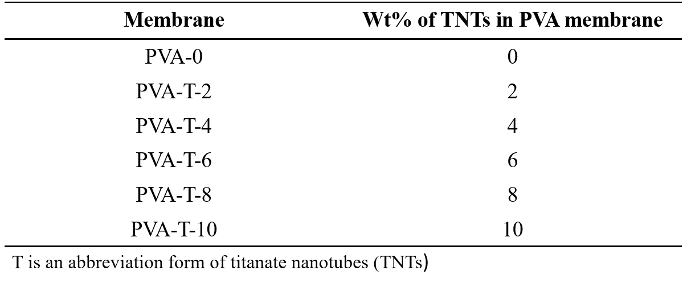
Table 1. Prepared membranes.

2.4. PV experiments
The PV experiments were completely the same as those carried out by Heydari et al. with a PV set-up, shown in Fig. 1[5]. First, membranes with 19.6 ${cm}^{2}$effective surface area were inserted on a stainless steel mesh as support to avoid membranes buckling at the bottom of the cell. Then, aqueous IPA feed (with three different water concentrations, 10, 20, and 30 wt%) was poured into the cell while a mechanical stirrer kept the feed solution homogenous. An external electrical heating coil equipped with a temperature controller was used to adjust the feed temperature at three different levels, 40, 50, and 60 $℃$. While the feed pressure side was atmospheric, a vacuum pump (MD1 diaphragm pump, Vacuubrand) was used to keep the downstream pressure below 5 mm Hg. The permeated product was collected in a glass U-tube in a cryogenic cold trap at –41 $℃$. Two identical routes collected the product, with one of them at circuit for the first 2 h to allow the feed to reach equilibrium with the membrane and the system to reach its steady state. A balance with accuracy of 0.001 g was used to calculate the permeate weight, so the permeation flux in kg/m²h is:
$J=\frac{W}{A*t}$ (1)
where W is the collected permeate weight in kg, A is the membrane effective area in $m^{2}$, and t is the test duration in hours.
The IPA and water content of the product were determined by a PrismaTech refractometer, by comparing the result of each permeated product with a standard graph in which its y-coordinate is the refractometry index versus the IPA weight percent of the sample. After calculation of IPA and the water content of the product, the separation factor ($α)$ was obtained as follows:
$α=\frac{{y_{w}}/{1-y_{w}}}{{x_{w}}/{1-x_{w}}}$ (2)
where $y_{w}$ and $x_{w}$ are the weight fractions of water in permeate and feed, respectively. To evaluate the PV performance in term of one parameter, it is useful to calculate and refer to the pervaporation separation index (PSI) by using the following equation:
$PSI=J×(α-1)$ (3)
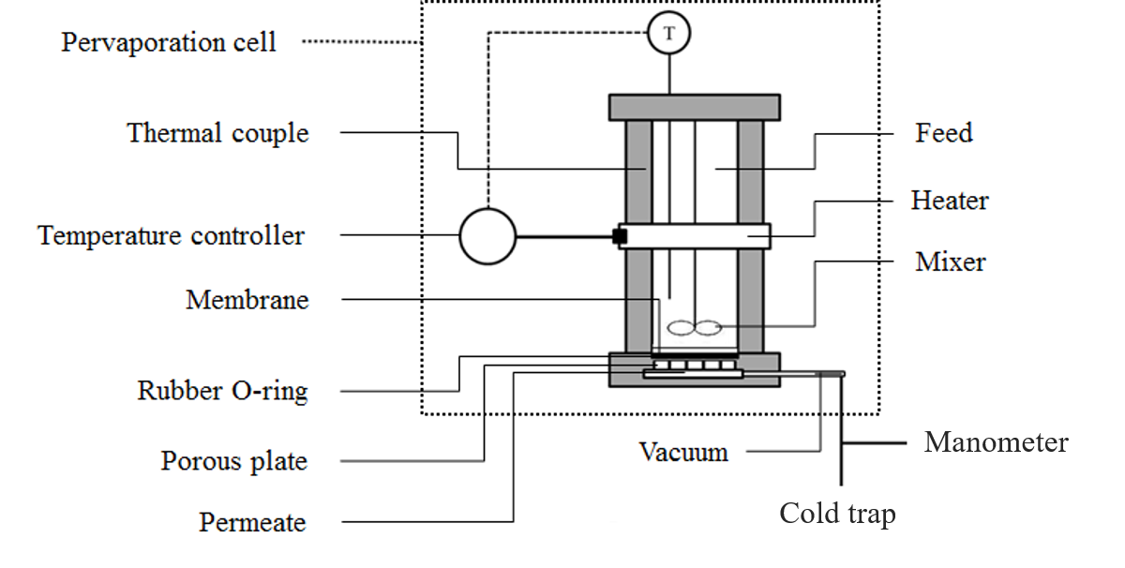
Fig. 1. Schematic of the experimental pervaporation system.
2.5. Water uptake
The water uptake behavior of all membranes was studied by sorption evaluation. After drying at 80 $℃$ for 8 h in an oven, a 1.5 $×$1.5 cm piece of each membrane was weighed by a digital balance with 0.0001 g accuracy as dry weight$(W_{d})$, and immersed in 10wt% water-containing feed for 48 h at 50 $℃$. Swollen membranes were dried carefully between two pieces of clean tissues, then weighed again for swelled weight ($W_{s})$. The water uptake degree (WUD %) was calculated from the following equation:
$WUD\%=\frac{W_{s}-W_{d}}{W_{d}}×100$ (4)
2.6. Characterization
Fourier transform infrared spectroscopy (FTIR, 4000–400 cm–1) was conducted by Jasco FT/IR-680 Plus spectrometer to determine the functional groups of the prepared membranes. To study the crystallinity changes of PVA-0 membranes after incorporation of TNTs, X-ray diffractometer (XRD) in the range of 5–60$°$ was used. In addition, field emission scanning electron microscope (FESEM) images were taken by application of MIRA3 TESCAN-XMU device to analyze the morphological properties of both pristine PVA membrane and MMMs and investigate the dispersion of TNTs in the PVA matrix. In order to analyze both thermal and mechanical stability of the prepared membranes, TGA and stress-strain tests were conducted. Thermogravimetric analysis (TGA) was employed with a heating rate of 10 °C/min from ambient temperature up to 800 °C under argon (Ar) atmosphere. The mechanical properties of the fabricated membranes were determined by a Universal Testing Machine (UTM) (Zwick, Model 1446-60). Samples were prepared according to the ASTM-D882 standard, and a programmed elongation rate of 2 mm/min was employed under ambient conditions.
FTIR, XRD, and FESEM analyses were conducted to investigate the chemical structure and morphology of TNTs prepared via hydrothermal method. The membrane thickness usually measured using a micrometer screw gage.
- Results and discussion
3.1. TNTs characterization
Based on FTIR spectrum of TNTs shown in Fig. 2a, two distinct absorption peaks at 1630 and 3339 cm^{–1} were noted, corresponding to $H-O-H$ and hydroxyl groups on the surface of the synthesized titanate nanotubes [12, 44, 47]. Moreover, there is a broad peak between 400–800 cm^{–1} that can be attributed to Ti-O-Ti and Ti-O stretching vibrations [32, 48]. The XRD pattern of TiO₂ nanoparticles exhibits some diffraction peaks shown in Fig. 2b, indicating TiO₂ in the anatase phase [48, 49]. Then again, the synthesized TNTs pattern shows four distinct peaks at 10.5$°$, 24.3$°$, 28.6$°$, and 48.5$°$ corresponding to (0 2 0), (1 1 0), (1 3 0), and (2 0 0) planes, respectively, which could be attributed to H₂Ti₂O₅. H₂O structure of the synthesized TNTs [12, 45]. This indicates that some hydroxyl groups on outer surfaces of the synthesized TNTs were confirmed by the FTIR results discussed earlier [12, 45]. Comparing the XRD patterns of TiO₂ nanopowder and the synthesized TNTs, it can be seen that there are some peaks in TiO₂ powder that disappeared in the XRD pattern of the TNTs, confirming the complete conversion of the raw materials into the titanate structure [48]. In addition, FESEM analysis examined the morphological structure of the hydrothermally synthesized nanotubes, investigating the fabrication of tubular structures with 15$±5$ nm tube diameter and 150$±50$nm tube length.
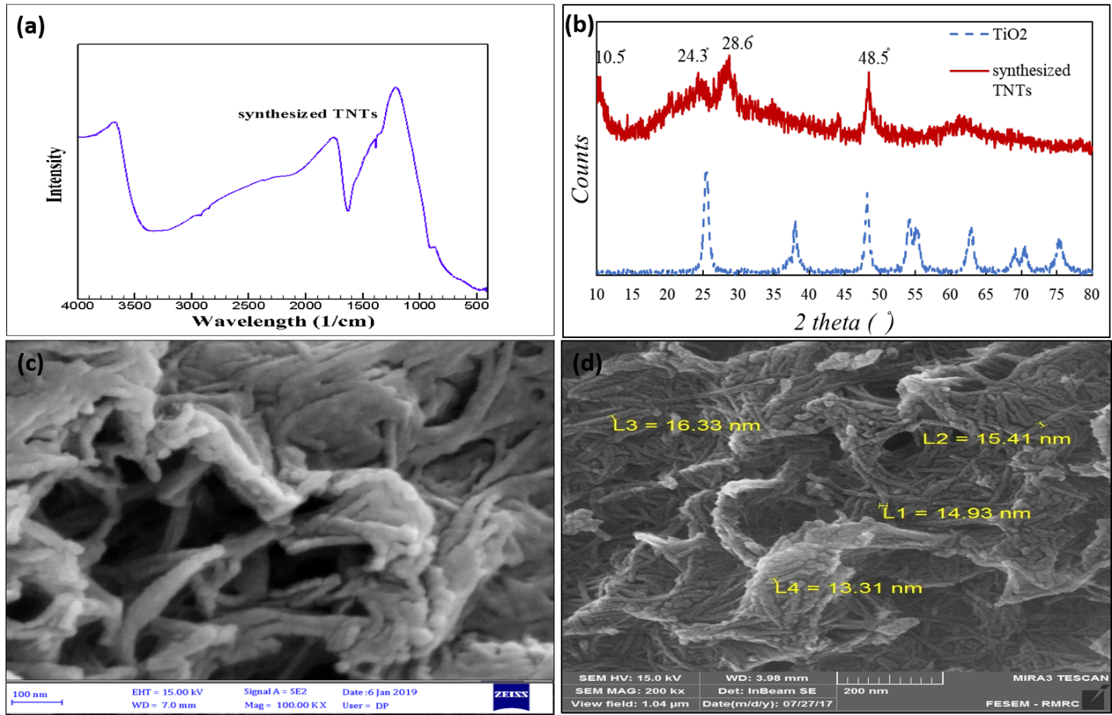
Fig. 2. TiO₂ nanopowder and synthesized TNTs characterizations: (a) TNTs FTIR spectrum, (b) TiO₂ and TNTs XRD patterns, (c, d) TNTs FESEM images.
3.2. Membranes characterization
3.2.1. Morphological study by FESEM analysis
The cross-sectional FESEM images of PVA-0 and PVA-T-x nanocomposites with 2, 6, and 10 wt% TNTs are shown in Fig. 3a, b, c, d, e. As shown in Fig. 3a, the cross-section of pristine PVA membrane is homogenously smooth. Fig. 3b, c reveals that titanate nanotubes could disperse homogenously through the PVA matrix. Clearly, there are no agglomerated regions in PVA-T-2 nanocomposites that may be ascribed to good adhesion and interactions between hydroxyl groups on TNTs’ walls and the same groups in PVA [12, 38]. Consequently, there is a suitable compatibility between the polymeric phase and the incorporated nanotubes, as both are hydrophilic in nature [12, 38]. The number of light dots represents the presence of TNTs increases when the TNTs loading changed from 2 to 10 wt% [39, 40]. Although the distance among the tubes decreased by increasing the TNTs loading from 2 to 6 wt%, TNTs are well dispersed and distributed through the PVA matrix in PVA-T-6 nanocomposites. For MMMs with 10 wt% of TNTs, FESEM images reveal that the compatibility between TNTs and PVA matrices in terms of hydrophilicity could not prevent TNTs agglomeration. Thus, some agglomerated regions can be detected in Fig. 3d, e, f. It has been asserted that strong Van der Waals attractions among the nanotubes make these nanofillers agglomerate, which is why the main challenge in fabrication of their membranes is to provide a uniform dispersion of nanotubes in nanocomposites. As a result, increasing nanotubes loading up to 10 wt% enhances probable agglomeration of the tubes.
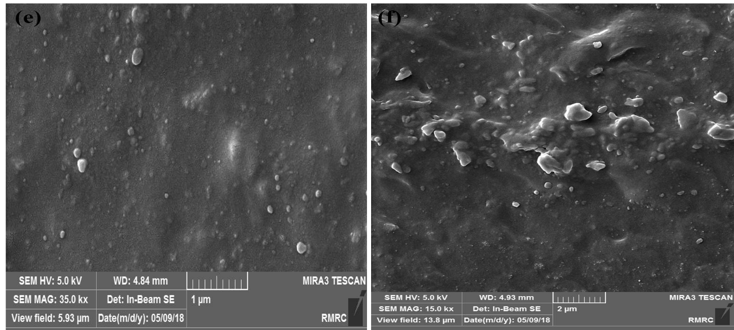
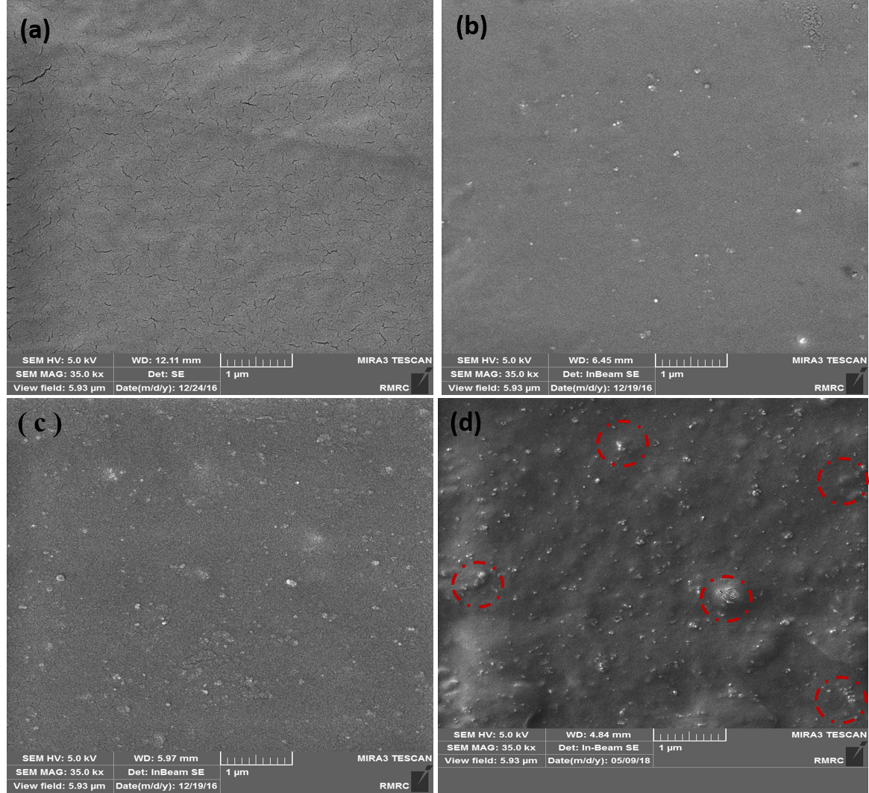
Fig. 3. Cross-sectional FESEM images of (a) PVA-0, (b) PVA-T-2, (c) PVA-T-6, and (d, e, f) PVA-T-10.
3.2.2. FTIR analysis
As can be interpreted from Fig. 4a, the characteristic peaks at 1063, 1404, and 1739 cm^{–1} are detected for crosslinked PVA-0 film corresponding to C-O, C-O-O, CO-O- bands of esters and ethers, respectively, all of which indicate the successful crosslinking reaction between the hydroxyl groups in the PVA polymer and the aldehyde groups in GA [40]. The absorption peak at 2898 cm^{–1} could be assigned to the presence of symmetric CH₂- bands in both the pristine PVA and nanocomposite membranes. Furthermore, the existence of a broad peak from 3200 to 3400 cm^{–1} can be attributed to the hydroxyl groups in the PVA matrix and the bonded water in PVA network [5]. In addition to displaying a broad peak from 600 to 800 cm^{–1} representing the existence of Ti-O bands [32, 48], the FTIR spectra of the pristine PVA and PVA-T-x MMMs samples are nearly the same, because the TNTs content is much less than that of the polymeric matrix, and the FTIR spectra of TNTs shows three peaks corresponding to O-H and Ti-O/ Ti-O-Ti bands.
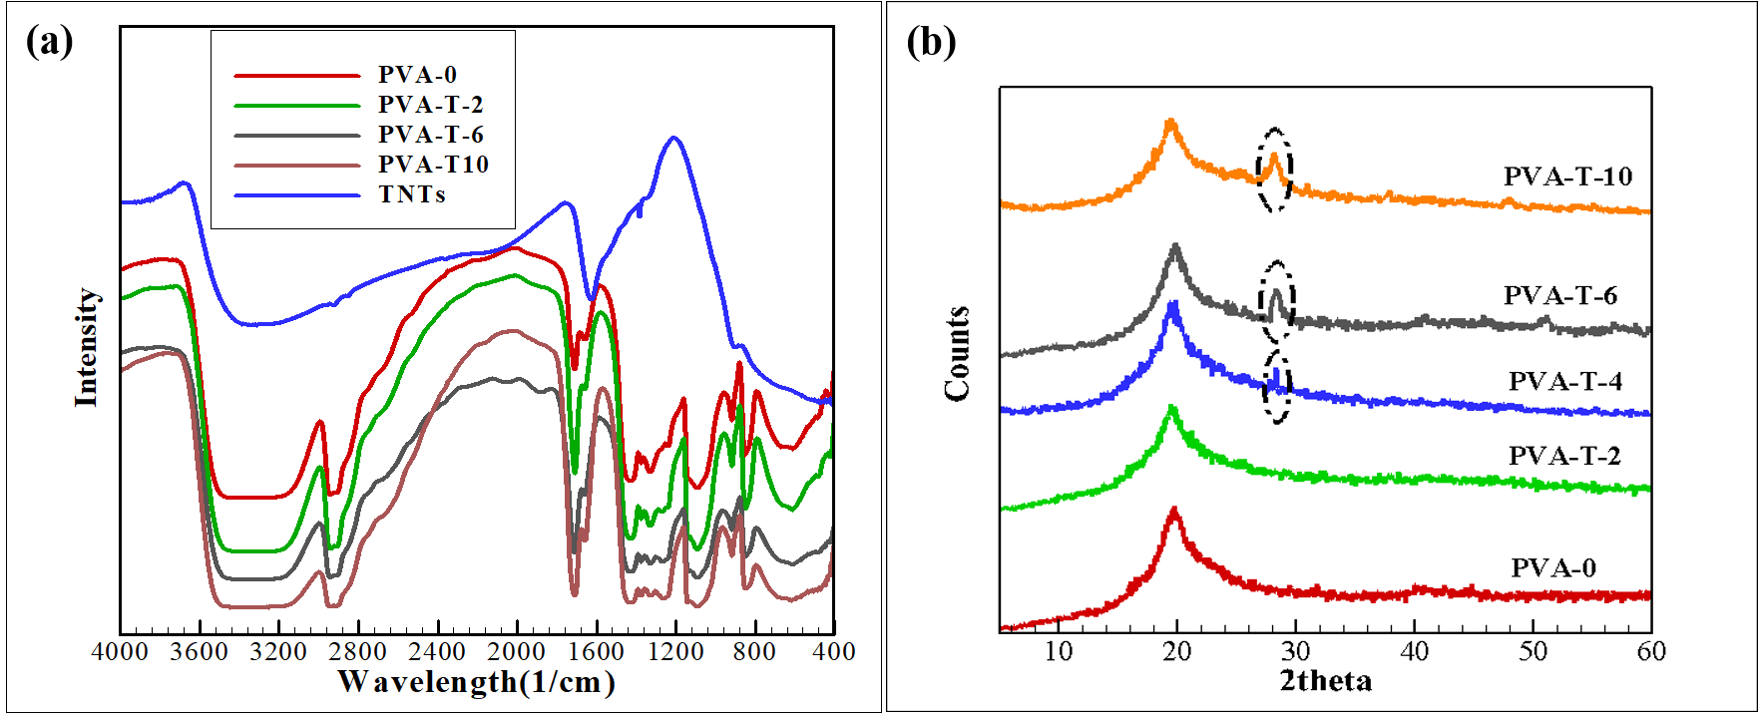
Fig. 4. (a) FTIR and (b) XRD spectra for the TNTs and some membranes.

3.2.3. XRD analysis
According to data from the XRD patterns, it is apparent that the pristine PVA membranes show only one sharp peak at 2$θ≅$ 20$°$, corresponding to crystalline PVA. In fact, PVA structure is semi-crystalline owing to the presence of hydroxyl groups and hydrogen bonds among the mentioned functional groups [50]. As can be seen in Fig. 4b, the XRD pattern of PVA-T-2 MMMs has nearly remained intact compared to that of PVA-0, due to the small concentration of TNTs in these composites [51]. However, the appearance of a distinct peak at about 28$°$ indicates the presence of TNTs in PVA-T-4, PVA-T-6 and PVA-T-10 MMMs.
Based on the following equation, in which A_{c} and A_{t} are the area under the crystalline peaks and the total area respectively, the crystallinity degree ($X_{c}\%)$ is directly proportional to the A_{c}:
$X_{c}(\%)=\frac{A_{c}}{A_{t}}×100$ (5)
Comparing the diffraction peak intensities demonstrates that there are no obvious differences between the membranes except for PVA-T-2 MMMs; the crystallinity of the MMMs containing 2 wt% is less than that of the pristine PVA membranes.
3.2.4. TGA analysis
Fig. 5 and Table 1 display TGA thermo diagrams and results for the pristine PVA and the nanocomposites with 2, 4, 6, and 10 wt% TNTs. The pristine PVA shows three distinct weight loss percentages. First, a typical weight loss occurring around 100 $℃$ can be attributed to the removal of adsorbed water [40]. Fig. 5 shows a second major weight loss at 200–400 $℃,$ corresponding to the PVA dehydroxylation and formation of a polyacetylene-like structure [40, 50]. The third weight loss step is likely due to the main structural decomposition of the PVA chains between 400–500 $℃$ [50].
Fig. 5. TGA curves for PVA-0, PVA-T-2, PVA-T-4, PVA-T-6, and PVA-T-10 membranes.
For quantitative investigation, the temperatures at which 5, 10, and 50 wt% weight loss were recorded (T_{5%}, T_{10%} and T_{50%,} respectively, as decomposition temperatures) and the residual weight percent after TGA process at maximum temperature 800 $℃$ (char yield) are calculated from TGA data [14, 52]. Fig. 5 and Table 2 show that incorporation of fillers could significantly improve the thermal stability of the membranes through enhancing the decomposition temperatures and the char yields for PVA-T-2, PVA-T-4, and PVA-T-6 MMMs, compared to the neat PVA. The improved thermal stability for mixed matrix membranes may be assigned to good dispersion of the fillers into PVA as well as their good interactions with the polymer matrix [50, 52]. In the case of PVA-T-10, the extracted information from the thermo diagrams shows lower thermal stability than that of the pristine PVA. As a matter of fact, the TNTs tendency to agglomerate is great at the maximum TNTs loading. As a result, nonselective interfacial voids and free volumes led to weak heat transfer through the PVA-T-10 MMMs [52]. It is worthy to mention that TNTs would decompose during changing temperature from 100 to 800 $℃$. So, TiO₂ and H₂O would be released during TGA analysis [53-55]. As TiO₂ possess catalytic properties, it may cause the PVA chains to be decomposed at lower temperatures. As a result, the decomposition temperature and thermal stability of PVA-T-10 MMMs would decrease when the TNTs loading is high enough [53-55].
Table 2. Thermal characteristic data of the membranes calculated from TGA analysis.
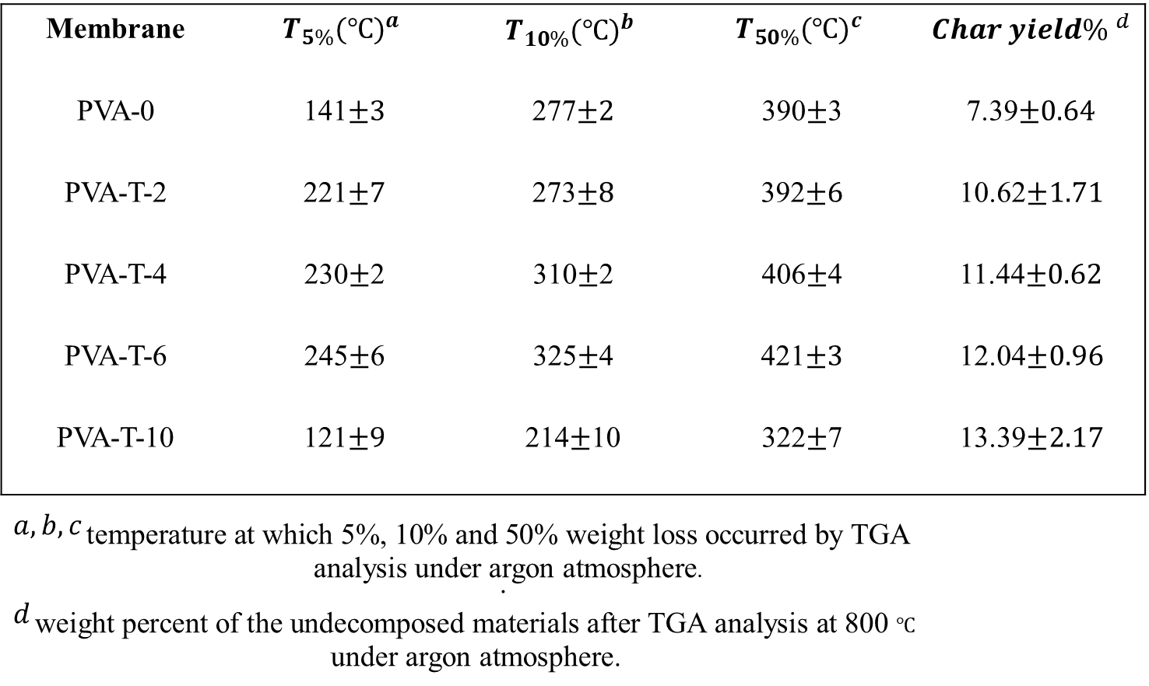

3.2.5. Tensile test
It has been declared that the mechanical properties of nanocomposites can be affected by the rigidity effect of fillers or the weakening effect of a soft interface [52]. The tensile strength, Young’s modulus, and elongation at break are listed in Table 3. For the composite membranes with 2 wt% TNTs, both tensile strength and Young’s modulus increase by 12.37, and 12%, respectively, compared to the pristine PVA membranes, because of good dispersion and compatibility between the hydrophilic TNTs and the polymeric matrix. For the composite membranes composed of 4 and 6 wt% TNTs, Young’s modulus increases by 15.4 and 20%, respectively (compared to the neat PVA membranes) revealing that dispersion of TNTs could lead to strong hindrance of chain mobility of PVA as a result of more interactions between the hydroxyl groups of the PVA and TNTs, as well as the rigidity effect of the inorganic fillers [40, 52, 56]. On the contrary, Young’s modulus experiences a remarkable decrease when MMMs contain 10 wt% of TNTs, which indicates the formation of agglomerated regions and free volumes as observed in the FESEM images [52].
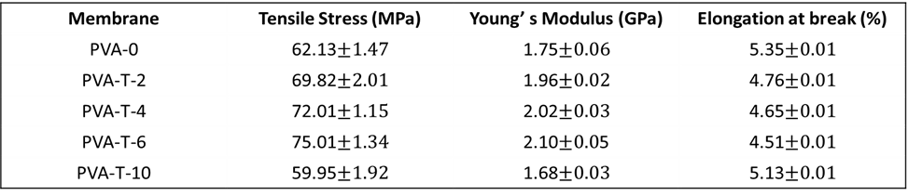
Table 3. Mechanical properties of the membranes from the tensile tests.

3.3. Membrane separation performance
3.3.1. Water uptake tests
The results of water uptake tests for PVA-T-x membranes are shown in Fig. 6a for water-IPA mixtures with 10 wt% water concentrations at 50$℃$. The water uptake experiments reveal that the nanocomposite with 10 wt% TNTs showed the maximum degree of water uptake, while the minimum value of water uptake degree belonged to MMMs with 6 wt% TNTs. Generally, incorporation of hydrophilic TNTs increases the membrane water uptake degree due to enhanced hydrophilicity. However, implementation of TNTs may have two opposite effects through their interactions with the matrix: first, TNTs could change the morphological properties of membranes in favor of polymer chain rigidification, which could be responsible for decreased water uptake degree (WUD%) for MMMs with 2 to 6 wt% TNTs. Second, agglomeration of TNTs at higher loadings may result in formation of free volumes and voids in the MMMs [38, 40]. Moreover, incorporation of higher TNTs loadings corresponds to increasing in density of the hydrophilic OH groups that could be resulted in enhanced mass transport of water molecules. Then, there are more interactions of the membranes with water molecules for PVA-T-8 and PVA-T-10 MMMs resulted in increased degree of water uptake.
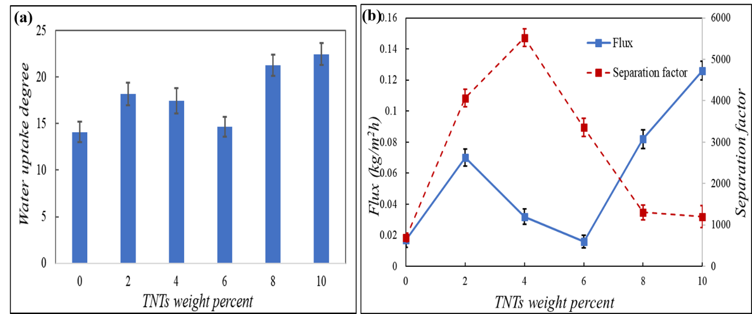
Fig. 6. Water uptake degree (WUD%) results (a) and (b) total flux and separation factor for PV separation of aqueous feed containing 90 wt% IPA at 50 $℃$.
3.3.2. PV results
3.3.2.1. Effect of TNTs loading on PV results
In order to evaluate the effect of embedding TNTs in PVA matrix for dehydration of IPA, pervaporation experiments were studied for feed mixture containing 90 wt% IPA at 50 $℃$. As is discernable from Fig. 6, in general, the incorporation of TNTs could remarkably affect both separation factor and permeation flux. Membranes separation factor increased with increasing the loading percent of the nanofillers, and the maximum value of 5520 was obtained for the separation factor when the PVA matrix was incorporated with 4 wt% TNTs. Then, MMMs with a higher percent of fillers showed lower separation factor.
From characterization section, FESEM, TGA, and tensile stress results indicate on good dispersion of TNTs in MMMs and improved thermal and mechanical properties of PVA-T-2 nanocomposites compared to PVA-0 membranes. In fact, strong compatibility and interactions between TNTs and the PVA chains by incorporation of 2 wt% of hydrophilic TNTs is resulted in lower crystallinity of PVA-T-2 membranes according to XRD characterizations in section 3.2.3. As a result, the amorphous regions increase by addition of 2 wt% of TNTs. As mass transport can take place through amorphous region, the permeation flux rises when TNTs concentration varies between 0 and 2 wt%. As for separation factor, strong compatibility and interactions between TNTs and the PVA chains is resulted in not only good dispersion of TNTs in the matrix, but also preferentially adsorption of water molecules by the PVA-T-2 MMMs, which is why increasing in separation factor was observed for PVA-T-2 MMMs. It is worthy to mention that these results agree with those obtained by FESEM, TGA, XRD and tensile stress tests.
However, further addition of TNTs makes polymer chains rigid which means the chains mobility decreases. Based on TGA and tensile stress results for PVA-T-4 and PVA-T-6 composites, the strong interactions between PVA chains and TNTs in PVA-T-4 and PVA-T-6 MMMs lead to intensified chain rigidifications specially for PVA-T-6 MMMs. So, the permeation flux decreased when the TNTs content increased from 2 to 6 wt%. Decreased chain mobility and enhanced density of membranes due to incorporation of another polymer or fillers are resulted in increased separation factor for PVA-T-4 membrane.
As for MMMs with rigidified chains, permeate species could pass across the membrane in two pathways. First, water molecules could diffuse selectively through the hydrophilic PVA chains. Second, TNTs could provide an additional size-selective pathway via their channels [12]. Based on TGA and tensile stress results for PVA-T-4 and PVA-T-6 composites, the strong interactions between PVA chains and TNTs in PVA-T-6 MMMs led to intensified chain rigidification specially for PVA-T-6 MMMs. So, selective water permeation through the chains may be hindered (which is responsible for lower permeation flux), which means mass transport inside TNTs plays a crucial role. Since the diameter of TNTs is much greater than both water and IPA kinetic diameters, nonselective permeation of these molecules resulted in lower separation factor observed for PVA-T-6 versus PVA-T-4 MMMs [57].
For MMMs containing 8 and 10 wt% of the TNTs, it could be assumed that the agglomeration of the fillers at high loading amounts would occur [39, 40], as confirmed via FESEM, TGA, and tensile stress analysis. Generally, formation of agglomerated regions accompanies with the existence of nonselective voids and free volumes, which is why increasing in the flux by sacrificing the separation factor were observed [12, 39]. As explained in Section 3.3.1, increasing the water uptake of MMMs containing 8 to 10 wt% of the TNTs could also be the result of formation of agglomerated regions as well as enhanced-hydrophilicity of the PVA-T-8 and PVA-T-10 MMMs. This observation is consistent with those reported by Amirilargani et al. [40]. They reported that when the concentration of CNTs increased from 3 to 4 wt% in PVA matrix, increasing the flux and decreasing the separation factor were observed due to agglomeration of the fillers. The same behavior was reported by Amirilargani et al. [39] when they prepared poly(allylamine hydrochloride)–wrapped multiwalled carbon nanotubes incorporated in poly(vinyl alcohol) (PVA) membranes to separate water from IPA.
3.3.2.2. Effect of feed temperature on PV experiments
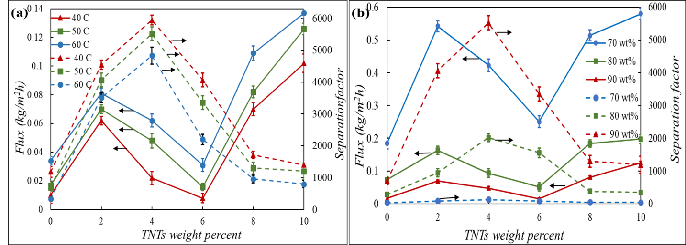
In general, temperature is one of the important parameters that can play a significant role in pervaporation process. As a matter of fact, chain mobility of polymer increases at higher temperatures; consequently, MMMs with same TNTs loading showed higher permeation flux at 60 $℃$ in comparison with those at 50 $℃$and 40 $℃$ [27]. It has been asserted that the higher the temperature is, the more the mass transport driving force is enhanced. This is the reason why higher permeation fluxes were reported at 60$℃$. On the other hand, when chains are more mobile, both IPA and water molecules could be transported through the increased volumes in the amorphous region, which causes a remarkable decline in the separation factor. In fact, when the temperature rises, the mass driving force would increase for not only water molecules but also for IPAs, which caused the total permeation to be increased at the expense of the separation factor [27, 58, 59].
Fig. 7. The effect of feed temperature (a) and concentration (b) on the flux (solid), and the separation factor (dashed) results of PV performance
Solution-diffusion model is a well-recognized mechanism explaining the mass transfer of species of a liquid mixture through a dense membrane [5]. Thus, sorption and diffusion are two important phenomena governing the permeation properties of membranes. In this regard, determining the diffusion coefficient is of interest that can be estimated by Fick’s first law of diffusion:
$-J_{i}=-D_{i}\frac{dC_{i}}{dx}$ (6)
In which J_{i} is the permeation flux per unit area in kg/m²h, D_{i} is the diffusion coefficient in m²/s, C_{i} is the concentration of the permeated species in Kg/m³ and x is the diffusion length in m. Assuming a linear behavior for the concentration profile, the diffusion coefficient can be calculated by the following equation:
$D_{i}=\frac{J_{i}δ}{C_{i,f}}$ (7)
where $δ$ is the membrane thickness and C_{i,f} is the feed concentration for species i.
Due to very low partial pressure of the permeating species in the permeate side, concentration of the species in the downstream is neglected in equation (7).
The calculated diffusion coefficients for water and IPA in pervaporation separation of the feed containing 90 wt% IPA are given in Table 4 at different operating temperatures.

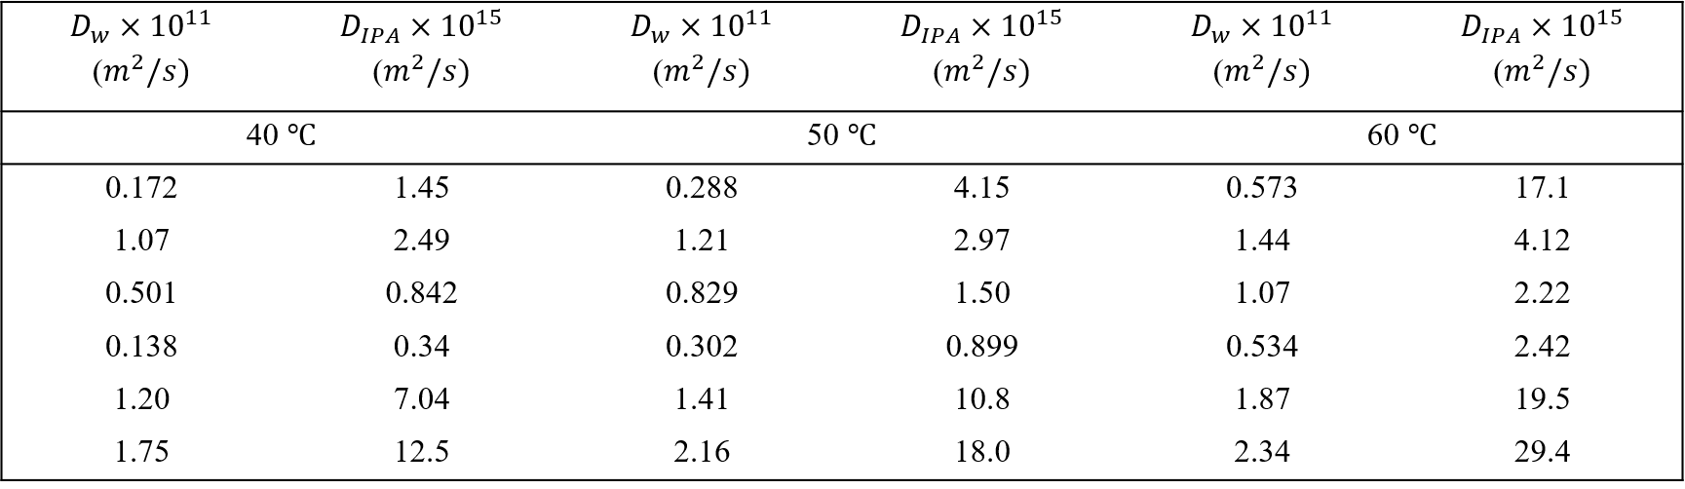
Table 4. Diffusion coefficients of water and IPA for an aqueous feed mixture containing 90 wt% IPA at different temperatures.

From Table 4, it is obvious that the diffusion coefficients for water are higher than those for IPA which means water molecules could diffuse more easily through the membranes compared to IPA molecules. It is observed that the minimum diffusion coefficients belong to PVA-T-6 MMMs. In fact, intensive chain rigidification prevents both water and IPA molecules to diffuse through the membranes because of reduced free spaces in PVA-T-6 membranes. Thus, decreasing in the permeation flux is observed.
It is clear from Table 3 that the diffusion coefficients of both water and IPA enhance when temperature changes from 40 $℃$ to 60$℃$. However, increasing in diffusion coefficients for IPA is higher than those for water which means the membranes separation factor decreases with increasing temperature.
An Arrhenius type equation is used to describe the temperature dependence of the permeation flux:
$J=J_{0} exp(-\frac{E_{a}}{RT})$ (8)
where J is the permeation flux, J₀ is a constant representing the preexponential factor, E_{a} represents the activation energy of permeation, R is gas constant, and T is the absolute temperature in Kelvin.
It is obvious that the permeation flux follows the Arrhenius relationship (see Fig. S3 in supplementary information section).
Using the slopes of the plots, the activation energy values for the membranes are given in Table 5. As all the activation energy values of the membranes are positive, the permeation flux increases at higher temperature.

Table 5. Activation energy values for some of membranes.

As variation of the permeation flux versus temperature depends on the magnitude of the activation energy, smaller values for Ea for PVA-T-2 and PVA-T-10 MMMs are expected (based on data summarized in Table S1.). Based on FESEM, XRD data and mechanical properties, free volumes are responsible for permeation behavior of both PVA-T-2 and PVA-T-10 MMMs which show less sensitivity to variation in temperature. As a result, smaller values for Ea seem reasonable for these two types of MMMs. Actually, owing to larger free volumes of both PVA-T-2 and PVA-T-10, permeating species needed less energy to pass through these membranes. Reduced crystallinity and formation of defects/voids around agglomerated regions are respectively responsible for increased free spaces in PVA-T-2 and PVA-T-10 MMMs. Consequently, the lowest increment in PVA-T-2 diffusion coefficients followed by minimum changes in the flux and separation factor (Table S1) has occurred compared to other MMMs. However, the permeation flux of the PVA-T-6 MMMs with the maximum value for activation energy shows the highest dependency on temperature which is in consistent with observed results summarized in Table S1. In fact, chain rigidification is responsible for the observed separation performance of PVA-T-6 membranes. As increasing the temperature strongly influences the chain mobility, so water and IPA molecules could diffuse through less rigid chains with increased free volumes. Then, the separation performance of PVA-T-6 membranes changed significantly compared to other MMMs.
3.3.2.3. Effect of feed composition on PV experiments
Fig. 7b illustrates the influence of IPA concentration of feed, in the range of 70–90 wt%, on both flux and separation factor. As expected, by increasing the water concentration, the total flux enhanced owing to the so-called “plasticizing effect” of water, leading to increasing the membrane free volumes, which makes molecules pass more easily through membranes [24, 60]. Furthermore, more hydrogen bonds may be formed between the hydrophilic polar PVA groups and water in the feed mixture at higher water concentrations, which is responsible for enhanced flux and the correspondingly lower separation factor at the same TNT loadings. Fig. 7b shows that the maximum flux belongs to nanocomposites containing 10 wt% TNTs for the feed containing 30 wt% water, which is about 0.58 kg/m²h while its corresponding value when the water concentration of feed is 10 wt% is about 0.126 kg/m²h. As for the separation factor, the same trend is observed for pervaporation performance of all nanocomposites over three different water contents of the feeds, which is also true about the flux results. Herein, however, the plasticizing and swelling effects of water had a negative impact on membranes separation factor; since polymer chains could move rapidly and easily, the resultant enhanced free volumes of MMMs are responsible for lower selectivities at low concentrated IPA mixtures.
- Comparison of PV performance
Table 6 summarizes reported data for dehydration of IPA via different mixed matrix membranes made up of PVA or nanotubes, which means that all of these membranes have at least one similar component. The published report by Shirazi et al. [30] has been chosen as one of the main motivations of this study, to provide a comparison between the PV performance potential of CNTs and TNTs implemented in the same PVA matrix in IPA dehydration. When incorporation of TNTs into PVA matrix resulted in higher values for the permeated flux in all weight fractions compared with PVA-0 membrane (except for PVA-T-6), the total flux of CNTs-PVA membranes decreased for all CNTs loading. Moreover, the maximum value of separation factor and PSI were higher when PVA membranes have been modified with TNTs. For example, the maximum value of PSI was about 266 in the case of PVA-T- 2, while this parameter was reported at about 141 for PVA-CNTs-2 MMMs for PV dehydration of aqueous feed with 90 wt% IPA. TNTs might be more effective in enhancing PVA membrane performance. The CNTs surface is free of functional groups, so at least acid treatment and oxidization should be applied to CNTs to be dispersed into hydrophilic polymers including PVA. The earlier Section 3.1 has shown that there are some hydroxyl groups on TNTs surface, resulting in no need to modify TNTs further.
It is reasonable to conclude that the PVA-TNTs nanocomposites prepared in this study have shown better separation performance at least in terms of one of the three main parameters i.e., flux, separation factor, or PSI, except when NaAlg-CNTs-2 or CS-TNTs-6/PAN membranes were used; however, the preparation procedure of PVA-TNTs MMMs in this study has been easier and simpler than the aforementioned prepared membranes, which means our results are comparable with the aforementioned publications. In fact, desirable adhesion and compatibility between titanate nanotubes and PVA were verified through TGA, tensile stress analysis, and FESEM images, resulting in improved dehydration ability of PVA membranes. Last but not least, the improved PV performance might be attributed to the high aspect ratio of TNTs covered by OH groups as mentioned in section 3.1. Thus, we could prepare nanocomposites containing higher loadings of TNTs compared to the TiO₂ particles used by Sairam et al. [32]. Comparing the PV results of our work and the reports publishes by Sairam et al. [32] indicates that although both TNTs and TiO₂ nanoparticles could improve the separation properties of PVA membranes, their results are mainly different.

Table 6. Summary of the reported PV data by MMMs for isopropanol aqueous mixtures.

Ref | Notifications | PSI | J  (kg/m²h) | SF | Thickness  ($μm$) | Temp.  ($℃)$ | wt% IPA | Membrane
[38] | Oxidized CNTs by acid treatment | 79 | 0.096 | 817 | 25 | 30 | 90 | PVA-CNTs-1
[38] | Oxidized CNTs by acid treatment | 141 | 0.079 | 1794 | 25 | 30 | 90 | PVA-CNTs-2
[39] | PAH-w-CNTs | 197 | 0.207 | 948 | 15 | 30 | 90 | PVA-CNTs-1/PAN
[14] | CS-w-CNTs | 1397 | 0.2176 | 6419 | 50 | 30 | 90 | NaAlg-CNTs-2
[12] | PASP-g-TNTs | 9343 | 1.498 | 6237 | 50-90 | 80 | 90 | CS-TNTs-6/PAN
[32] | PANI-f-TiO₂ nanoparticles | $$∞$$ | 0.0221 | $$∞$$ | 50-55 | 30 | 90 | PVA-TiO2-1
[32] | TiO₂ nanoparticles | $$∞$$ | 0.025 | $$∞$$ | 50-55 | 30 | 90 | PVA-TiO2
[4] | silane agents | 53 | 0.60 | 891 | 30-40 | 30 | 90 | PVA-(APTEOS+TEOS)
[61] | silane agents | 42 | 0.027 | 1580 | 18 | 30 | 90 | PVA-APTEOS
[62] | zeolite | 50 | 0.22 | 233 | 70-80 | 30 | 90 | PVA-NaX
[62] | zeolite | 60 | 0.18 | 328 | 70-80 | 30 | 90 | PVA-NaA
[15] | Silicalite-1 | 109 | 0.08 | 1295 | 50 | 30 | 90 | PVA-(Silicalite-1)
[62] | zeolite | 73 | 0.18 | 410 | 70-80 | 30 | 90 | PVA-KA
This study | TiO₂ nanotubes | 266 | 0.062 | 4291 | 50-55 | 40 | 90 | PVA-T-2
this study | TiO₂ nanotubes | 172 | 0.029 | 5945 | 50-55 | 40 | 90 | PVA-T-4
this study | TiO₂ nanotubes | 109 | 0.137 | 797 | 50-55 | 60 | 90 | PVA-T-10

- Conclusion
In this paper, we have modified the PVA membranes’ properties to separate water and IPA by incorporating hydrothermally synthesized hydrophilic TNTs. TNTs are hydrophilic in nature. Some OH groups on TNTs surface have been confirmed by FTIR, and the phase structure of the synthesized TNTs by XRD analysis. They are dispersed in the polymer matrix without any special pretreatment. MMMs were prepared simply by the solution-casting method. The PV results show that the PV performance of PVA membranes improves through incorporation of TNTs. Generally, the membrane separation factor increases when the TNTs contents varies from 0 to 4 wt%, but a reverse trend for separation factor is observed by further addition of the TNTs to 10 wt%. Enhanced hydrophilicity, suitable compatibility (morphological structure) and increased amorphous regions are all in favor of selective mass transport of water molecules by incorporation of 2 wt% of TNTs in PVA matrix. Next, while chain rigidification is responsible for decreased flux of PVA-T-4 and PVA-T-6 MMMs, agglomeration of nanotubes plays the main role for MMMs containing 8 or 10 wt% of TNTs. Then, the permeated flux and water uptake degree increase for PVA-T-8 and PVA-T-10 membranes due to reduced compactness of the polymer chains and increased free volumes.

References
[1] P. Das, S.K. Ray, S.B. Kuila, H.S. Samanta, N.R. Singha, Systematic choice of crosslinker and filler for pervaporation membrane: A case study with dehydration of isopropyl alcohol–water mixtures by polyvinyl alcohol membranes, Separation and Purification Technology, 81 (2011) 159-173.
[2] S. Sridhar, B. Smitha, A. Shaik, Pervaporation‐Based Separation of Methanol/MTBE Mixtures—A Review, Separation & Purification Reviews, 34 (2005) 1-33.
[3] A. Svang-Ariyaskul, R.Y.M. Huang, P.L. Douglas, R. Pal, X. Feng, P. Chen, L. Liu, Blended chitosan and polyvinyl alcohol membranes for the pervaporation dehydration of isopropanol, Journal of Membrane Science, 280 (2006) 815-823.
[4] S. Razavi, A. Sabetghadam, T. Mohammadi, Dehydration of isopropanol by PVA–APTEOS/TEOS nanocomposite membranes, Chemical Engineering Research and Design, 89 (2011) 148-155.
[5] M. Heydari, A. Moheb, M. Ghiaci, M. Masoomi, Effect of cross-linking time on the thermal and mechanical properties and pervaporation performance of poly(vinyl alcohol) membrane cross-linked with fumaric acid used for dehydration of isopropanol, Journal of Applied Polymer Science, 128 (2013) 1640-1651.
[6] W.-Y. Chiang, Y.-H. Lin, Properties of modified poly(vinyl alcohol) membranes prepared by the grafting of new polyelectrolyte copolymers for water–ethanol mixture separation, Journal of Applied Polymer Science, 86 (2002) 2854-2859.
[7] A.A. Kittur, M.Y. Kariduraganavar, U.S. Toti, K. Ramesh, T.M. Aminabhavi, Pervaporation separation of water–isopropanol mixtures using ZSM-5 zeolite incorporated poly(vinyl alcohol) membranes, Journal of Applied Polymer Science, 90 (2003) 2441-2448.
[8] T. Khosravi, S. Mosleh, O. Bakhtiari, T. Mohammadi, Mixed matrix membranes of Matrimid 5218 loaded with zeolite 4A for pervaporation separation of water–isopropanol mixtures, Chemical Engineering Research and Design, 90 (2012) 2353-2363.
[9] C. Yu, C. Zhong, Y. Liu, X. Gu, G. Yang, W. Xing, N. Xu, Pervaporation dehydration of ethylene glycol by NaA zeolite membranes, Chemical Engineering Research and Design, 90 (2012) 1372-1380.
[10] Y.T. Ong, S.H. Tan, Pervaporation separation of a ternary azeotrope containing ethyl acetate, ethanol and water using a buckypaper supported ionic liquid membrane, Chemical Engineering Research and Design, 109 (2016) 116-126.
[11] R.Y.M. Huang, R. Pal, G.Y. Moon, Crosslinked chitosan composite membrane for the pervaporation dehydration of alcohol mixtures and enhancement of structural stability of chitosan/polysulfone composite membranes, Journal of Membrane Science, 160 (1999) 17-30.
[12] G. Liu, D. Yang, Y. Zhu, J. Ma, M. Nie, Z. Jiang, Titanate nanotubes-embedded chitosan nanocomposite membranes with high isopropanol dehydration performance, Chemical Engineering Science, 66 (2011) 4221-4228.
[13] Y.T. Ong, A.L. Ahmad, S.H.S. Zein, K. Sudesh, S.H. Tan, Poly(3-hydroxybutyrate)-functionalised multi-walled carbon nanotubes/chitosan green nanocomposite membranes and their application in pervaporation, Separation and Purification Technology, 76 (2011) 419-427.
[14] A.M. Sajjan, B.K. Jeevan Kumar, A.A. Kittur, M.Y. Kariduraganavar, Novel approach for the development of pervaporation membranes using sodium alginate and chitosan-wrapped multiwalled carbon nanotubes for the dehydration of isopropanol, Journal of Membrane Science, 425 (2013) 77-88.
[15] S.G. Adoor, B. Prathab, L.S. Manjeshwar, T.M. Aminabhavi, Mixed matrix membranes of sodium alginate and poly(vinyl alcohol) for pervaporation dehydration of isopropanol at different temperatures, Polymer, 48 (2007) 5417-5430.
[16] Y. Q. Dong, L. L. Zhang, J. N. Shen, M. Y. Song, H. L. Chen, Preparation of poly(vinyl alcohol)-sodium alginate hollow-fiber composite membranes and pervaporation dehydration characterization of aqueous alcohol mixtures, Desalination, 193 (2006) 202-210.
[17] J. Lu, Q. Nguyen, J. Zhou, Z.-H. Ping, Poly(vinyl alcohol)/poly(vinyl pyrrolidone) interpenetrating polymer network: Synthesis and pervaporation properties, Journal of Applied Polymer Science, 89 (2003) 2808-2814.
[18] V.T. Magalad, G.S. Gokavi, K.V.S.N. Raju, T.M. Aminabhavi, Mixed matrix blend membranes of poly(vinyl alcohol)–poly(vinyl pyrrolidone) loaded with phosphomolybdic acid used in pervaporation dehydration of ethanol, Journal of Membrane Science, 354 (2010) 150-161.
[19] S.S. B. S. D.A. Devi, T.M. Aminabhavi, Pervaporation separation of dimethylformamide/water mixtures through poly(vinyl alcohol)/poly(acrylic acid)blend membranes, Separation and Purification Technology, 51 (2006) 104-111.
[20] S.Y. Hu, Y. Zhang, D. Lawless, X. Feng, Composite membranes comprising of polyvinylamine-poly(vinyl alcohol) incorporated with carbon nanotubes for dehydration of ethylene glycol by pervaporation, Journal of Membrane Science, 417–418 (2012) 34-44.
[21] S.-H. Chen, K.-C. Yu, S.-S. Lin, D.-J. Chang, R.M. Liou, Pervaporation separation of water/ethanol mixture by sulfonated polysulfone membrane, Journal of Membrane Science, 183 (2001) 29-36.
[22] S.G. Adoor, L.S. Manjeshwar, B.V. Kumar Naidu, M. Sairam, T.M. Aminabhavi, Poly(vinyl alcohol)/poly(methyl methacrylate) blend membranes for pervaporation separation of water+isopropanol and water+1,4-dioxane mixtures, Journal of Membrane Science, 280 (2006) 594-602.
[23] V. Giménez, A. Mantecón, J.C. Ronda, V. Cádiz, Poly(vinyl alcohol) modified with carboxylic acid anhydrides: crosslinking through carboxylic groups, Journal of Applied Polymer Science, 65 (1997) 1643-1651.
[24] Z. Huang, Y. Shi, R. Wen, Y.-H. Guo, J.-F. Su, T. Matsuura, Multilayer poly(vinyl alcohol)–zeolite 4A composite membranes for ethanol dehydration by means of pervaporation, Separation and Purification Technology, 51 (2006) 126-136.
[25] F. Ebrahimian, M. Sadeghi, A. Moheb, M. Shafiei, Pervaporation separation of water–isopropyl alcohol mixture by PVA/LiBr membrane, Polymer Engineering & Science, Published online in Wiley Online Library, DOI 10.1002/pen.24876.
[26] Y. Wang, Y.-L. Hsieh, Crosslinking of polyvinyl alcohol (PVA) fibrous membranes with glutaraldehyde and PEG diacylchloride, Journal of Applied Polymer Science, 116 (2010) 3249-3255.
[27] S. Amnuaypanich, J. Patthana, P. Phinyocheep, Mixed matrix membranes prepared from natural rubber/poly(vinyl alcohol) semi-interpenetrating polymer network (NR/PVA semi-IPN) incorporating with zeolite 4A for the pervaporation dehydration of water–ethanol mixtures, Chemical engineering science, 64 (2009) 4908-4918.
[28] A. Khosravi, M. Sadeghi, H.Z. Banadkohi, M.M. Talakesh, Polyurethane-Silica Nanocomposite Membranes for Separation of Propane/Methane and Ethane/Methane, Industrial & Engineering Chemistry Research, 53 (2014) 2011-2021.
[29] M. Sadeghi, M. Mehdi Talakesh, B. Ghalei, M. Shafiei, Preparation, characterization and gas permeation properties of a polycaprolactone based polyurethane-silica nanocomposite membrane, Journal of Membrane Science, 427 (2013) 21-29.
[30] M. Sadeghi, M.A. Semsarzadeh, H. Moadel, Enhancement of the gas separation properties of polybenzimidazole (PBI) membrane by incorporation of silica nano particles, Journal of Membrane Science, 331 (2009) 21-30.
[31] S. Mosleh, T. Khosravi, O. Bakhtiari, T. Mohammadi, Zeolite filled polyimide membranes for dehydration of isopropanol through pervaporation process, Chemical Engineering Research and Design, 90 (2012) 433-441.
[32] M. Sairam, M.B. Patil, R.S. Veerapur, S.A. Patil, T.M. Aminabhavi, Novel dense poly(vinyl alcohol)–TiO2 mixed matrix membranes for pervaporation separation of water–isopropanol mixtures at 30°C, Journal of Membrane Science, 281 (2006) 95-102.
[33] A. Kittur, M. Kariduraganavar, U.S. Toti, R. Karuppannan, T. Aminabhavi, Pervaporation separation of water–isopropanol mixtures using ZSM‐5 zeolite incorporated poly(vinyl alcohol) membranes, Journal of Applied Polymer Science, 90 (2003) 2441-2448.
[34] M. Sairam, B.V.K. Naidu, S.K. Nataraj, B. Sreedhar, T.M. Aminabhavi, Poly(vinyl alcohol)-iron oxide nanocomposite membranes for pervaporation dehydration of isopropanol, 1,4-dioxane and tetrahydrofuran, Journal of Membrane Science, 283 (2006) 65-73.
[35] S.B. Teli, G.S. Gokavi, M. Sairam, T.M. Aminabhavi, Mixed matrix membranes of poly(vinyl alcohol) loaded with phosphomolybdic heteropolyacid for the pervaporation separation of water–isopropanol mixtures, Colloids and Surfaces A: Physicochemical and Engineering Aspects, 301 (2007) 55-62.
[36] Q. Li, H. Zhang, Z. Tu, J. Yu, C. Xiong, M. Pan, Impregnation of amine-tailored titanate nanotubes in polymer electrolyte membranes, Journal of Membrane Science, 423-424 (2012) 284-292.
[37] A.I. Skoulidas, D.M. Ackerman, J.K. Johnson, D.S. Sholl, Rapid Transport of Gases in Carbon Nanotubes, Physical Review Letters, 89 (2002) 185901.
[38] Y. Shirazi, M.A. Tofighy, T. Mohammadi, Synthesis and characterization of carbon nanotubes/poly vinyl alcohol nanocomposite membranes for dehydration of isopropanol, Journal of Membrane Science, 378 (2011) 551-561.
[39] M. Amirilargani, A. Ghadimi, M.A. Tofighy, T. Mohammadi, Effects of poly (allylamine hydrochloride) as a new functionalization agent for preparation of poly vinyl alcohol/multiwalled carbon nanotubes membranes, Journal of Membrane Science, 447 (2013) 315-324.
[40] M. Amirilargani, M.A. Tofighy, T. Mohammadi, B. Sadatnia, Novel Poly(vinyl alcohol)/Multiwalled Carbon Nanotube Nanocomposite Membranes for Pervaporation Dehydration of Isopropanol: Poly(sodium 4-styrenesulfonate) as a Functionalization Agent, Industrial & Engineering Chemistry Research, 53 (2014) 12819-12829.
[41] J. Geng, Z. Jiang, J. Wang, Y. Shi, D. Yang, L. Xiao, Chitosan/titanate Nanotube Hybrid Membrane with Low Methanol Crossover for Direct Methanol Fuel Cells, Chemical Engineering & Technology, 33 (2010) 244-250.
[42] C.-C. Yang, W.-C. Chien, Y.J. Li, Direct methanol fuel cell based on poly(vinyl alcohol)/titanium oxide nanotubes/poly(styrene sulfonic acid) (PVA/nt-TiO2/PSSA) composite polymer membrane, Journal of Power Sources, 195 (2010) 3407-3415.
[43] B.R. Matos, E.I. Santiago, F.C. Fonseca, M. Linardi, V. Lavayen, R.G. Lacerda, L.O. Ladeira, A.S. Ferlauto, Nafion–Titanate Nanotube Composite Membranes for PEMFC Operating at High Temperature, Journal of The Electrochemical Society, 154 (2007) B1358-B1361.
[44] J. Wang, Y. Zhao, W. Hou, J. Geng, L. Xiao, H. Wu, Z. Jiang, Simultaneously enhanced methanol barrier and proton conductive properties of phosphorylated titanate nanotubes embedded nanocomposite membranes, Journal of Power Sources, 195 (2010) 1015-1023.
[45] D. Emadzadeh, W.J. Lau, M. Rahbari-Sisakht, H. Ilbeygi, D. Rana, T. Matsuura, A.F. Ismail, Synthesis, modification and optimization of titanate nanotubes-polyamide thin film nanocomposite (TFN) membrane for forward osmosis (FO) application, Chemical Engineering Journal, 281 (2015) 243-251.
[46] J. Geng, Z. Jiang, Y. Wang, D. Yang, Carbon-modified TiO2 nanotubes with enhanced photocatalytic activity synthesized by a facile wet chemistry method, Scripta Materialia, 59 (2008) 352-355.
[47] J. Geng, D. Yang, J. Zhu, D. Chen, Z. Jiang, Nitrogen-doped TiO2 nanotubes with enhanced photocatalytic activity synthesized by a facile wet chemistry method, Materials Research Bulletin, 44 (2009) 146-150.
[48] S. Muniyappan, T. Solaiyammal, K. Sudhakar, A. Karthigeyan, P. Murugakoothan, Conventional hydrothermal synthesis of titanate nanotubes: Systematic discussions on structural, optical, thermal and morphological properties, Modern Electronic Materials, 3 (2017) 174-178.
[49] K. Thamaphat, P. Limsuwan, B. Ngotawornchai, Phase characterization of TiO2 powder by XRD and TEM, Kasetsart Journal (Natural Science), 42 (2008) 357-361.
[50] S. Mallakpour, A. Abdolmaleki, S. Borandeh, l-Phenylalanine amino acid functionalized multi walled carbon nanotube (MWCNT) as a reinforced filler for improving mechanical and morphological properties of poly(vinyl alcohol)/MWCNT composite, Progress in Organic Coatings, 77 (2014) 1966-1971.
[51] F. Momayez, J. Towfighi Darian, S.M. Teimouri Sendesi, Synthesis of zirconium and cerium over HZSM-5 catalysts for light olefins production from naphtha, Journal of Analytical and Applied Pyrolysis, 112 (2015) 135-140.
[52] M. Laghaei, M. Sadeghi, B. Ghalei, M. Shahrooz, The role of compatibility between polymeric matrix and silane coupling agents on the performance of mixed matrix membranes: Polyethersulfone/MCM-41, Journal of Membrane Science, 513 (2016) 20-32.
[53] E. Morgado, M.A.S. de Abreu, O.R.C. Pravia, B.A. Marinkovic, P.M. Jardim, F.C. Rizzo, A.S. Araújo, A study on the structure and thermal stability of titanate nanotubes as a function of sodium content, Solid State Sciences, 8 (2006) 888-900.
[54] A. Thorne, A. Kruth, D. Tunstall, J.T.S. Irvine, W. Zhou, Formation, Structure, and Stability of Titanate Nanotubes and Their Proton Conductivity, The Journal of Physical Chemistry B, 109 (2005) 5439-5444
[55] R. Ma, Y. Bando, T. Sasaki, Nanotubes of lepidocrocite titanates, Chemical Physics Letters, 380 (2003) 577-582.
[56] P.S. Rachipudi, M.Y. Kariduraganavar, A.A. Kittur, A.M. Sajjan, Synthesis and characterization of sulfonated-poly(vinyl alcohol) membranes for the pervaporation dehydration of isopropanol, Journal of Membrane Science, 383 (2011) 224-234.
[57] Q.W. Yeang, S.H.S. Zein, A.B. Sulong, S.H. Tan, Comparison of the pervaporation performance of various types of carbon nanotube-based nanocomposites in the dehydration of acetone, Separation and Purification Technology, 107 (2013) 252-263.
[58] H.-K. Yuan, J. Ren, X.-H. Ma, Z.-L. Xu, Dehydration of ethyl acetate aqueous solution by pervaporation using PVA/PAN hollow fiber composite membrane, Desalination, 280 (2011) 252-258.
[59] T.A. Peters, C.H.S. Poeth, N.E. Benes, H.C.W.M. Buijs, F.F. Vercauteren, J.T.F. Keurentjes, Ceramic-supported thin PVA pervaporation membranes combining high flux and high selectivity; contradicting the flux-selectivity paradigm, Journal of Membrane Science, 276 (2006) 42-50.
[60] R.Y.M. Huang, C.K. Yeom, Pervaporation separation of aqueous mixtures using crosslinked poly(vinyl alcohol)(pva). II. Permeation of ethanol-water mixtures, journal of membrane science, 51 (1990) 273-292.
[61] Q.G. Zhang, Q.L. Liu, Y. Chen, J.H. Chen, Dehydration of Isopropanol by Novel Poly(vinyl alcohol)−Silicone Hybrid Membranes, Industrial & Engineering Chemistry Research, 46 (2007) 913-920.
[62] Z. Gao, Y. Yue, W. Li, Application of zeolite-filled pervaporation membrane, Zeolites, 16 (1996) 70-74.

Polyaniline
3-Aminopropyl triethoxysilane (APTEOS)
Tetraethoxysilane (TEOS)

