There is an individual tolerance to mechanical loading in compression induced deep tissue injury
Willeke A. Traa^{a*}, Mark C. van Turnhoutª, Jules L. Nelissen^{a,b,c}, Gustav J. Strijkers^{a,c}, Dan L. Bader^{a,d}, Cees W.J. Oomensª
a Department of Biomedical Engineering, Eindhoven University of Technology, Eindhoven, The Netherlands
b Department of Radiology and Nuclear Medicine, Academic Medical Center, Amsterdam, The Netherlands
c Amsterdam UMC, University of Amsterdam, Biomedical Engineering and Physics, Meibergdreef 9, Amsterdam, the Netherlands
d Faculty of Health Sciences, University of Southampton, Southampton, United Kingdom
* Corresponding author:
Email: w.a.traa@tue.nl
Eindhoven University of Technology
Gemini-Zuid 4.12
P.O.Box 513
5600MB Eindhoven
The Netherlands
Word count abstract: 146
Word count article: 3902
Conflict of interest: none

Abstract
Background: Deep tissue injury is a type of pressure ulcer which originates subcutaneously due to sustained mechanical loading. The relationship between mechanical compression and damage development has been extensively studied in 2D. However, recent studies have suggested that damage develops beyond the site of indentation. The objective of this study was to compare mechanical loading conditions to the associated damage in 3D.
Methods: An indentation test was performed on the tibialis anterior muscle of rats (n=39). Changes in the form of oedema and structural damage were monitored with MRI in an extensive region. The internal deformations were evaluated using MRI based 3D finite element models.
Findings: Damage propagates away from the loaded region. The 3D analysis indicates that there is a subject specific tolerance to compression induced deep tissue injury.
Interpretation: Individual tolerance is an important factor when considering the mechanical loading conditions which induce damage.
Keywords: Finite element analysis, deep tissue injury, individual susceptibility, pressure ulcers, MRI

Introduction
Pressure induced deep tissue injury (DTI) is a severe type of pressure ulcer where tissue damage originates subcutaneously, usually close to a bony prominence (NPUAP et al., 2014). If undetected, the wound will progress to the skin surface where it can be detected as a category III or IV pressure ulcer with variable prognosis. Both the spinal cord injured (SCI) and patients in intensive care units are typically at risk of developing a DTI (Cox, 2011; Scheel-Sailer et al., 2013) due to their inherent lack of sensation, immobility and the exposure of their soft tissues to prolonged mechanical loading. However, objective reliable prediction of patients at imminent risk of tissue damage is limited. Risk factors such as activity levels, micro-environment, prior skin damage and general health provide the primary subjective indicators available to medical professionals. These factors are evaluated based on clinical expertise, usually in association with risk assessment tools, typically using the Braden, Norton, or Waterlow scales (Moore and Cowman, 2014; NPUAP et al., 2014; Šateková et al., 2017). Unfortunately, individual risk models for developing DTI have limited predictive value.
To evaluate generic risk of developing PUs due to mechanical loading interface, pressure-time curves have been established (Daniel et al., 1981; Kosiak, 1961; Reswick and Rogers, 1976). The hyperbolic interface pressure-time curve suggest that a high pressure over a short time period and a smaller pressure over an extended period would present a similar risk to PU formation. However, studies have indicated that interface pressure mapping, although clinically useful, provides only limited information on the internal mechanical deformations in soft tissue. Indeed, finite element (FE) modelling has predicted that the highest strains occur internally near the bony prominences as opposed to the interface of the skin and supporting surface (Gefen and Levine, 2007; Linder-Ganz et al., 2008, 2007, Oomens et al., 2010, 2003). Hence, interface pressures alone are a poor predictor of the internal damage-causing strains.
Using a multi-scale approach, ranging from cell models, ex-vivo studies with tissues and animal models of DTI, it was subsequently shown by the host group that there are at least two damage mechanisms which play an important role in PU development (Bosboom et al., 2003, 2001, Ceelen et al., 2008b, 2008a, Gawlitta et al., 2007a, 2007b, Loerakker et al., 2011b, 2011a, 2010, Stekelenburg et al., 2006b, 2007). One of the mechanisms is ischaemia/reperfusion damage; a process in which cells experience a shortage of oxygen and nutrients and waste products accumulate in the tissues. This process takes several hours before the first signs of cell damage can be detected (Breuls et al., 2003; Loerakker et al., 2011b, 2011a; Stekelenburg et al., 2007). Studies by Stekelenburg et al. and Loerakker et al. showed with MRI that muscle damage in rats due to ischemia is evident after 2-4 hours (Loerakker et al., 2011b, 2011a; Stekelenburg et al., 2007). Reperfusion following load release can cause additional damage by oxidative stress. A second mechanism involved cells damage by direct (shear) deformation (Bosboom et al., 2003, 2001; Breuls et al., 2003; Ceelen et al., 2008a; Loerakker et al., 2010; Stekelenburg et al., 2006b, 2006a). This damage can be evident in a period of minutes and the amount of cell damage was linearly correlated to the magnitude of applied strain (Loerakker et al., 2010). This process has been termed direct deformation damage. The processes by which this fast-occurring damage develops are not entirely clear, although it probably involves damage to the cell membrane and re-organisation of internal cell structures. These authors found, by combining an animal model of DTI with numerical modelling, that this type of damage only occurs when a certain strain threshold is exceeded. The amount of damage clearly correlated to the total applied strain energy. These findings are in agreement with the sigmoid-like pressure/strain versus time risk curve as originally proposed by Linder-Ganz et al. based on animal studies (Linder-Ganz et al., 2006) and later confirmed using tissue engineered constructs (Gefen et al., 2008) and animal models (Loerakker et al., 2011b, 2010).
The aforementioned experimental studies were analysed with 2D FE-models. In the animal studies an oblong-shaped indenter was employed to ensure that the muscle deformation could be simulated with a 2D FE-analysis (Ceelen et al., 2008a, 2008b, Loerakker et al., 2011a, 2010, Stekelenburg et al., 2007, 2006b). Gefen et al. used an axi-symmetric model to analyse cell death in tissue engineered muscle (Gefen et al., 2008). In a recent study by the authors an indenter with a spherical head was applied to the lower leg of rats and damage development was analysed using different MR-imaging techniques. Analysis included regions of the leg that were not actually deformed (Nelissen et al., 2018). Interestingly, damage was not limited to the site of indentation, but extended throughout the entire muscle tissue. From this finding it was evident that an accurate evaluation of strain-damage relationship requires a 3D, as opposed to a 2D FE-approach.
The aim of this study was therefore to employ a 3D FE analysis for estimation of internal tissue strains in a rat model of DTI, and to correlate strain levels with the extent and severity of damage throughout the leg, to provide an improved understanding of both the spatial and temporal relationships between internal strains and damage.

methods

Animal model
Female Brown-Norway (n=6) and Sprague-Dawley rats (n=33), age 11-14 weeks (Charles River, Paris, France) were housed under controlled laboratory conditions (12 hours light/dark cycles) with standard chow and water provided ad libitum. All animal experiments were approved by the Animal Care and Use Committee of Maastricht University, The Netherlands (protocol 2013-047). Experiments were performed in accordance with the European Union Directive for animal experiments (2010/63/EU). The animals used in this study were part of a larger study on damage development in rats (Nelissen et al., 2018).

Experimental protocol
Detail on the experimental set-up to study the development of DTI in an MRI scanner have been detailed previously (Nelissen et al., 2017). An overview of the experimental set-up is shown in figure 1. To review briefly, anaesthesia was induced with isoflurane (3-4 vol% for induction, 0.8-2 vol% for maintenance), in 0.6 l/min medicinal air (Fig 1-A). Analgesia was injected subcutaneously (Buprenorphine: 0.05 mg/kg, Temgesic). Dehydration of the eyes was prevented with ointment. Each animal was placed supine on a heating blanket (Fig 1-B) to maintain body temperature between 35-37 ⁰C, as monitored by a rectal probe. Breathing rate was monitored with a balloon pressure sensor and kept within the physiological range (50-80 breaths per minute) by fine-tuning the anaesthesia. The right hind limb was shaven and fixated with alginate in a specially designed holder (Fig 1-F). For MRI visualization a hollow cylindrical indenter (Fig 1-C), with a spherical head of 3 mm diameter, was filled with 1g/l CuSO₄. Positioning of the indenter (Fig 1-C) was achieved with a movable indenter holder (Fig 1-D) in a rotatable half arch (Fig 1-E). Indentation was applied manually by moving the indenter through the indenter holder and fixing it in the experimental setup. Indentation was maintained for a period of 2 hours. MRI scans were acquired before (the reference scans), during and after indentation.
Fig. 1: Overview of the MR compatible indentation setup. Following parts are labelled: A) anaesthesia mask, B) heating blanket, C) indenter, D) indenter holder, E) rotatable half arch, F) U-shape profile.

MR measurements
MRI was performed with a 7.0 T small animal MRI scanner equipped with an 86-mm diameter quadrature transmit coil and a 20-mm-diameter surface receive coil (Bruker Biospin MRI GmbH, Ettlingen, Germany). Anatomical images were acquired using an T₁-weighted sequence. These scans were used to create dedicated FE models. Presence of oedema, indicative of damage, was assessed using a quantitative T₂-mapping sequence. For both scans: sequence = 2D multi-slice-multi-echo (MSME) in axial orientation, number of slices 20, slice thickness = 1 mm, field of view (FoV) = 25x25 mm², matrix (MTX) = 256 x 256, and fat suppression. For the T₁ scan: echo time (TE)=11.5 ms, and repetition time (TR)=800 ms. For the T₂-mapping scan: TR = 4000 ms, TE=6.95-180.7 ms, with 26 equally spaced echoes.
Quantitative T₂-maps were obtained by fitting the MR signal (S) of the first 16 echoes per voxel to:
$S=S_{0}e^{\frac{-TE}{T_{2}}}$
A region of interest (RoI) of the tibialis anterior muscle (TA) was manually drawn on the first TE image of the T₂-mapping images. A slice was accepted for analysis if > 90% of the RoI voxels yielded a coefficient of determination: R² > 0.9. A minimum of 8 accepted slices in the region of indentation were required for analysis.
Per slice of the reference scan the mean and standard deviation (SD) were calculated. When 3 or more adjacent voxels yielded a T₂-value which exceeded the mean + 3 SD, the region was considered significantly enhanced. It was previously extensively validated that elevated T₂-values correspond to oedema formation and muscle damage (Bosboom et al., 2003; Nelissen et al., 2018; Stekelenburg et al., 2006b).

Finite element analysis
FE modelling was performed as described in (Traa et al., 2018). To review briefly, pre- and post-processing was performed with Matlab (R2013b, the Mathworks, Matick, MA, USA), and the GIBBON toolbox 1.01 (Moerman, 2018). Meshing and FE analysis was performed with Simulia Abaqus (2017, Dassault Systèmes Simulia corp., Providence, RI, USA). The geometry of the leg was derived from segmented skin and bone contours in the T₁-weighted reference scan (Fig. 2A). The leg was meshed with quadratic tetrahedral elements with modified hourglass control and hybrid linear pressure formulation (C3D10MH). The mesh size of the leg ranged from 0.9-1.0 mm which resulted in a mean number of elements and nodes of 45000 and 65000 respectively. The geometry of the cast was created by giving a radial offset of 0.2 mm to the skin contour. The cast was meshed with surface elements (SFM3D3). The indenter direction and position were obtained from the T₁-scan during indentation (Fig. 2B). Movement of the tibia was determined by calculating the translation and rotation of the bone contours before and during indentation. The indenter was modelled as an analytical rigid surface. The cast and tibia were modelled as rigid surfaces (Fig. 2C). Displacement of the tibia bone and indenter were provided as essential boundary conditions. Frictionless surface-to-surface contact was assumed between the skin (slave) and both the cast and the indenter (masters). The leg was described as a homogenous elastic material using the Ogden model according to:
$U=\sum{\frac{2μ}{α^{2}}\left({{\overline{λ}}_{1}}^{α}+{{\overline{λ}}_{2}}^{α}+{{\overline{λ}}_{3}}^{α}-3\right)+\sum{\frac{1}{D}{\left(J-1\right)}^{2}}}$ and
${\overline{λ}}_{i}=J^{-\frac{1}{3}}λ_{i}$
with $U$ the strain energy and $λ_{i}$ the principal stretches. Material parameters were adapted from earlier research: $μ$ = 3.65 kPa, $α$ = 5, $D$ = 57.5 [mm²/N] (Loerakker et al., 2010).
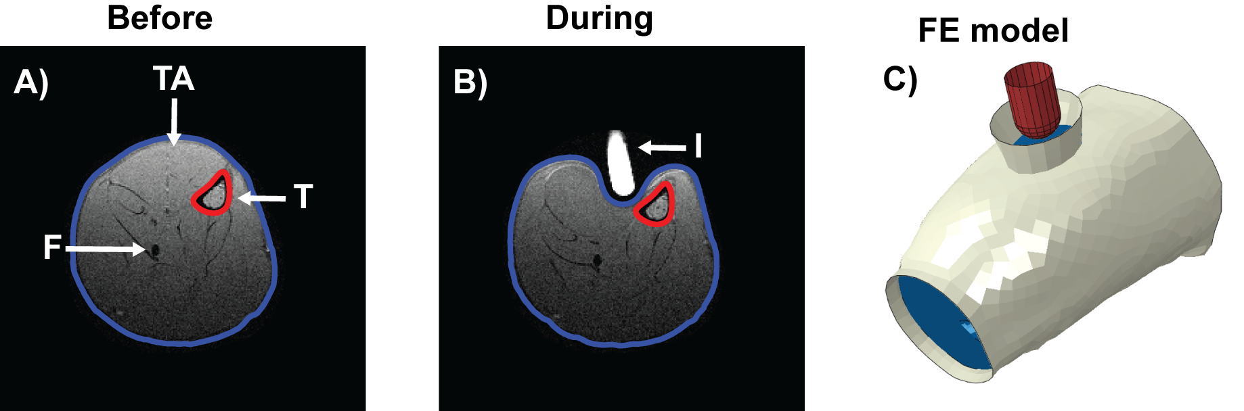
Fig. 2: T₁ weighted MR images before (A) and during (B) indentation with the skin contour in blue and tibia contour in red. The displacement of the indenter and bone were determined from the MRI images. T = tibia, F = fibula, TA = tibialis anterior muscle, I = indenter. C) The FE model with the indenter in red, soft tissue in blue and cast in white.

Post processing
Maximum shear strain (MSS) was calculated with Abaqus according to:
$γ_{max}=\frac{1}{2}\left(ε_{1}^{l}-ε_{3}^{l}\right)$
with $ε_{1}^{l}$ the maximum principal logarithmic strain and $ε_{3}^{l}$ the minimum principal logarithmic strain. The strain energy density and the volume per element were exported from Abaqus. The MSS was exported on the centroid of the elements. Based on previous work, a volume of interest (VOI) was defined with MSS above a shear strain threshold of 0.6 (Ceelen et al., 2008a; Moerman et al., 2016). For the purpose of analysis and presentation animals with a MSS > 0.6 were categorised in three groups according the highest MSS present in the VOI according to the following ranges: 0.6-0.8, 0.8-1.0, and >1.0.
To compare the current results with those from previously published data (Loerakker et al., 2010) a similar approach was adopted to relate strains to deformation-induced damage. The strain energy was calculated according to:
$U_{tot} = \left(\sum_{i =1}^{N_{v}^{TA ROI}}{U_{i} × v_{v}}\right)$
With $U_{i}$ the strain energy density in gridpoint $i$, $N_{v}^{TA ROI}$ the number of gridpoints of the TA muscle RoI and $v_{v}$ the voxel volume. The strain energy necessary to deform the TA muscle was correlated to the volume of significantly increased T₂-values in the RoI of the TA muscle in the four slices directly under the indenter. Strain energy density data were interpolated to a 3D grid corresponding to the MRI coordinate system using a natural neighbour interpolation algorithm.

Results
For 2 animals the T₂-maps did not satisfy our quality criterion and the FE models of 5 animals did not reach convergence, which resulted in a total of 32 animals included in the subsequent analysis.
Fig. 3 shows axial cross sections of the leg, obtained from the T₂-maps and FE model, for a representative animal with extensive muscle damage (animal 22). Before indentation the T₂-values of muscle tissue were consistent throughout the leg muscles (Fig. 3A-D). During indentation T₂-values increased mainly in the anterior compartment of the leg. There was a diffuse increase in the extensor digitorum longus (EDL) and a localised increase at the interosseous membrane (IM) and between the crural fascia and the skin, indicated with an # in Fig 3J, in all regions of the leg (Fig. 3E-H). Distally a localised increase at the fascia of the TA and EDL muscles was observed. After removal of the indenter, T₂ increase in the EDL and the TA muscles displayed a structured epi-perimysium like pattern (Fig. 3 I-L). This was observed in all regions of the leg, exposing damage in areas even where the internal strains during indentation were low, indicated with an * in Fig 2L,P. The highest maximum shear strains (0.8-1.0) were localized adjacent to the indenter (Fig. 3M-P).
Affected volumes derived from MRI, i.e. volume with high T₂-values (V_{di}), were compared to strain parameters derived from FE analysis, i.e. volumes of voxels (VOI) with MSS > 0.6 (Fig. 4A). In animals where the MSS threshold of 0.6 (VOI = 0) was not reached T₂-values increased only marginally (animal 27,31,32). By contrast, in all animals with MSS > 1.0 and a VOI > 12mm³ a damage response was observed. Animals with 0.6 < MSS < 1 showed a variable response. In those cases with a damage response, V_{di} was 2-20 times larger than VOI, illustrating that once damage occurred, it progressed to regions with lower strains. Affected volumes derived from MRI, i.e. volume with high T₂ values (V_{di}), were also compared to the total strain energy density (U_{tot}) of the TA muscle (Fig. 4B), similar to (Loerakker et al., 2010). The main observations are similar to Fig. 4A. In particular, where no damage was evident strain energy values were below 0.05J, whereas damage occurred above 0.15J in all but one animal. In-between these values a large variability in the damage response is observed.
It is well known that this animal model of DTI yields a variable response, depending on a number of factors, including variability in the magnitude and direction of indentation, magnitude and extent of induced ischemia, and physiological variability between animals(Nelissen et al., 2018). Therefore, it is appropriate to present a few observations for individual animals. First a subset of 3 animals with different loading condition and varying degrees of resulting damage, i.e. animal 31, 3 and 6, as shown in Fig. 5. For animal 31, which experienced minimal indentation, MSS < 0.6 , VOI = 0 mm³ and U_{tot} = 0.03 J (Fig. 4). This animal presented negligible increase in T₂-values in the TA muscle (Fig. 5A-D). For animal 3, with moderate indentation, 0.6 < MSS < 1.0, VOI = 6.6 mm³ and U_{tot} = 0.08 J (Fig. 4). The structured increase in T₂-values resembled a muscle fibre pattern (Fig. 5I-L) with a volume of 39.7 mm³ (Fig. 4A). Animal 6 was subjected to a severe mechanical deformation with MSS up to 1.23 resulting in a VOI = 23.3 mm³ and U_{tot} = 0.26 J (Fig. 4A-B). A structured increase of T₂ was evident in the TA and EDL muscles in all regions of the lower leg (Fig. 5Q-T), leading to a V_{di} = 169.8 mm³.
However, some animals presented a different damage response at comparable loading, examples of which are shown in Fig. 6 for animal 13 and 28. For animal 13 (Fig. 6A-D), VOI = 5.0 mm³ with the highest MSS present in the range (0.8-1.0) localised adjacent to the indenter (Fig. 4A, Fig. 6E-H). After indentation V_{di} was rather small (0.5 mm³) despite the moderate loading. By contrast, for animal 28, VOI = 2.6 mm³ with the highest MSS in the range of 0.6-0.8 (Fig. 6M-P). Despite that both VOI and MSS are lower than for animal 13, a larger structured increase throughout the whole lower leg was observed with V_{di} = 49.2 mm³ which amounts to 36% of the TA muscle.
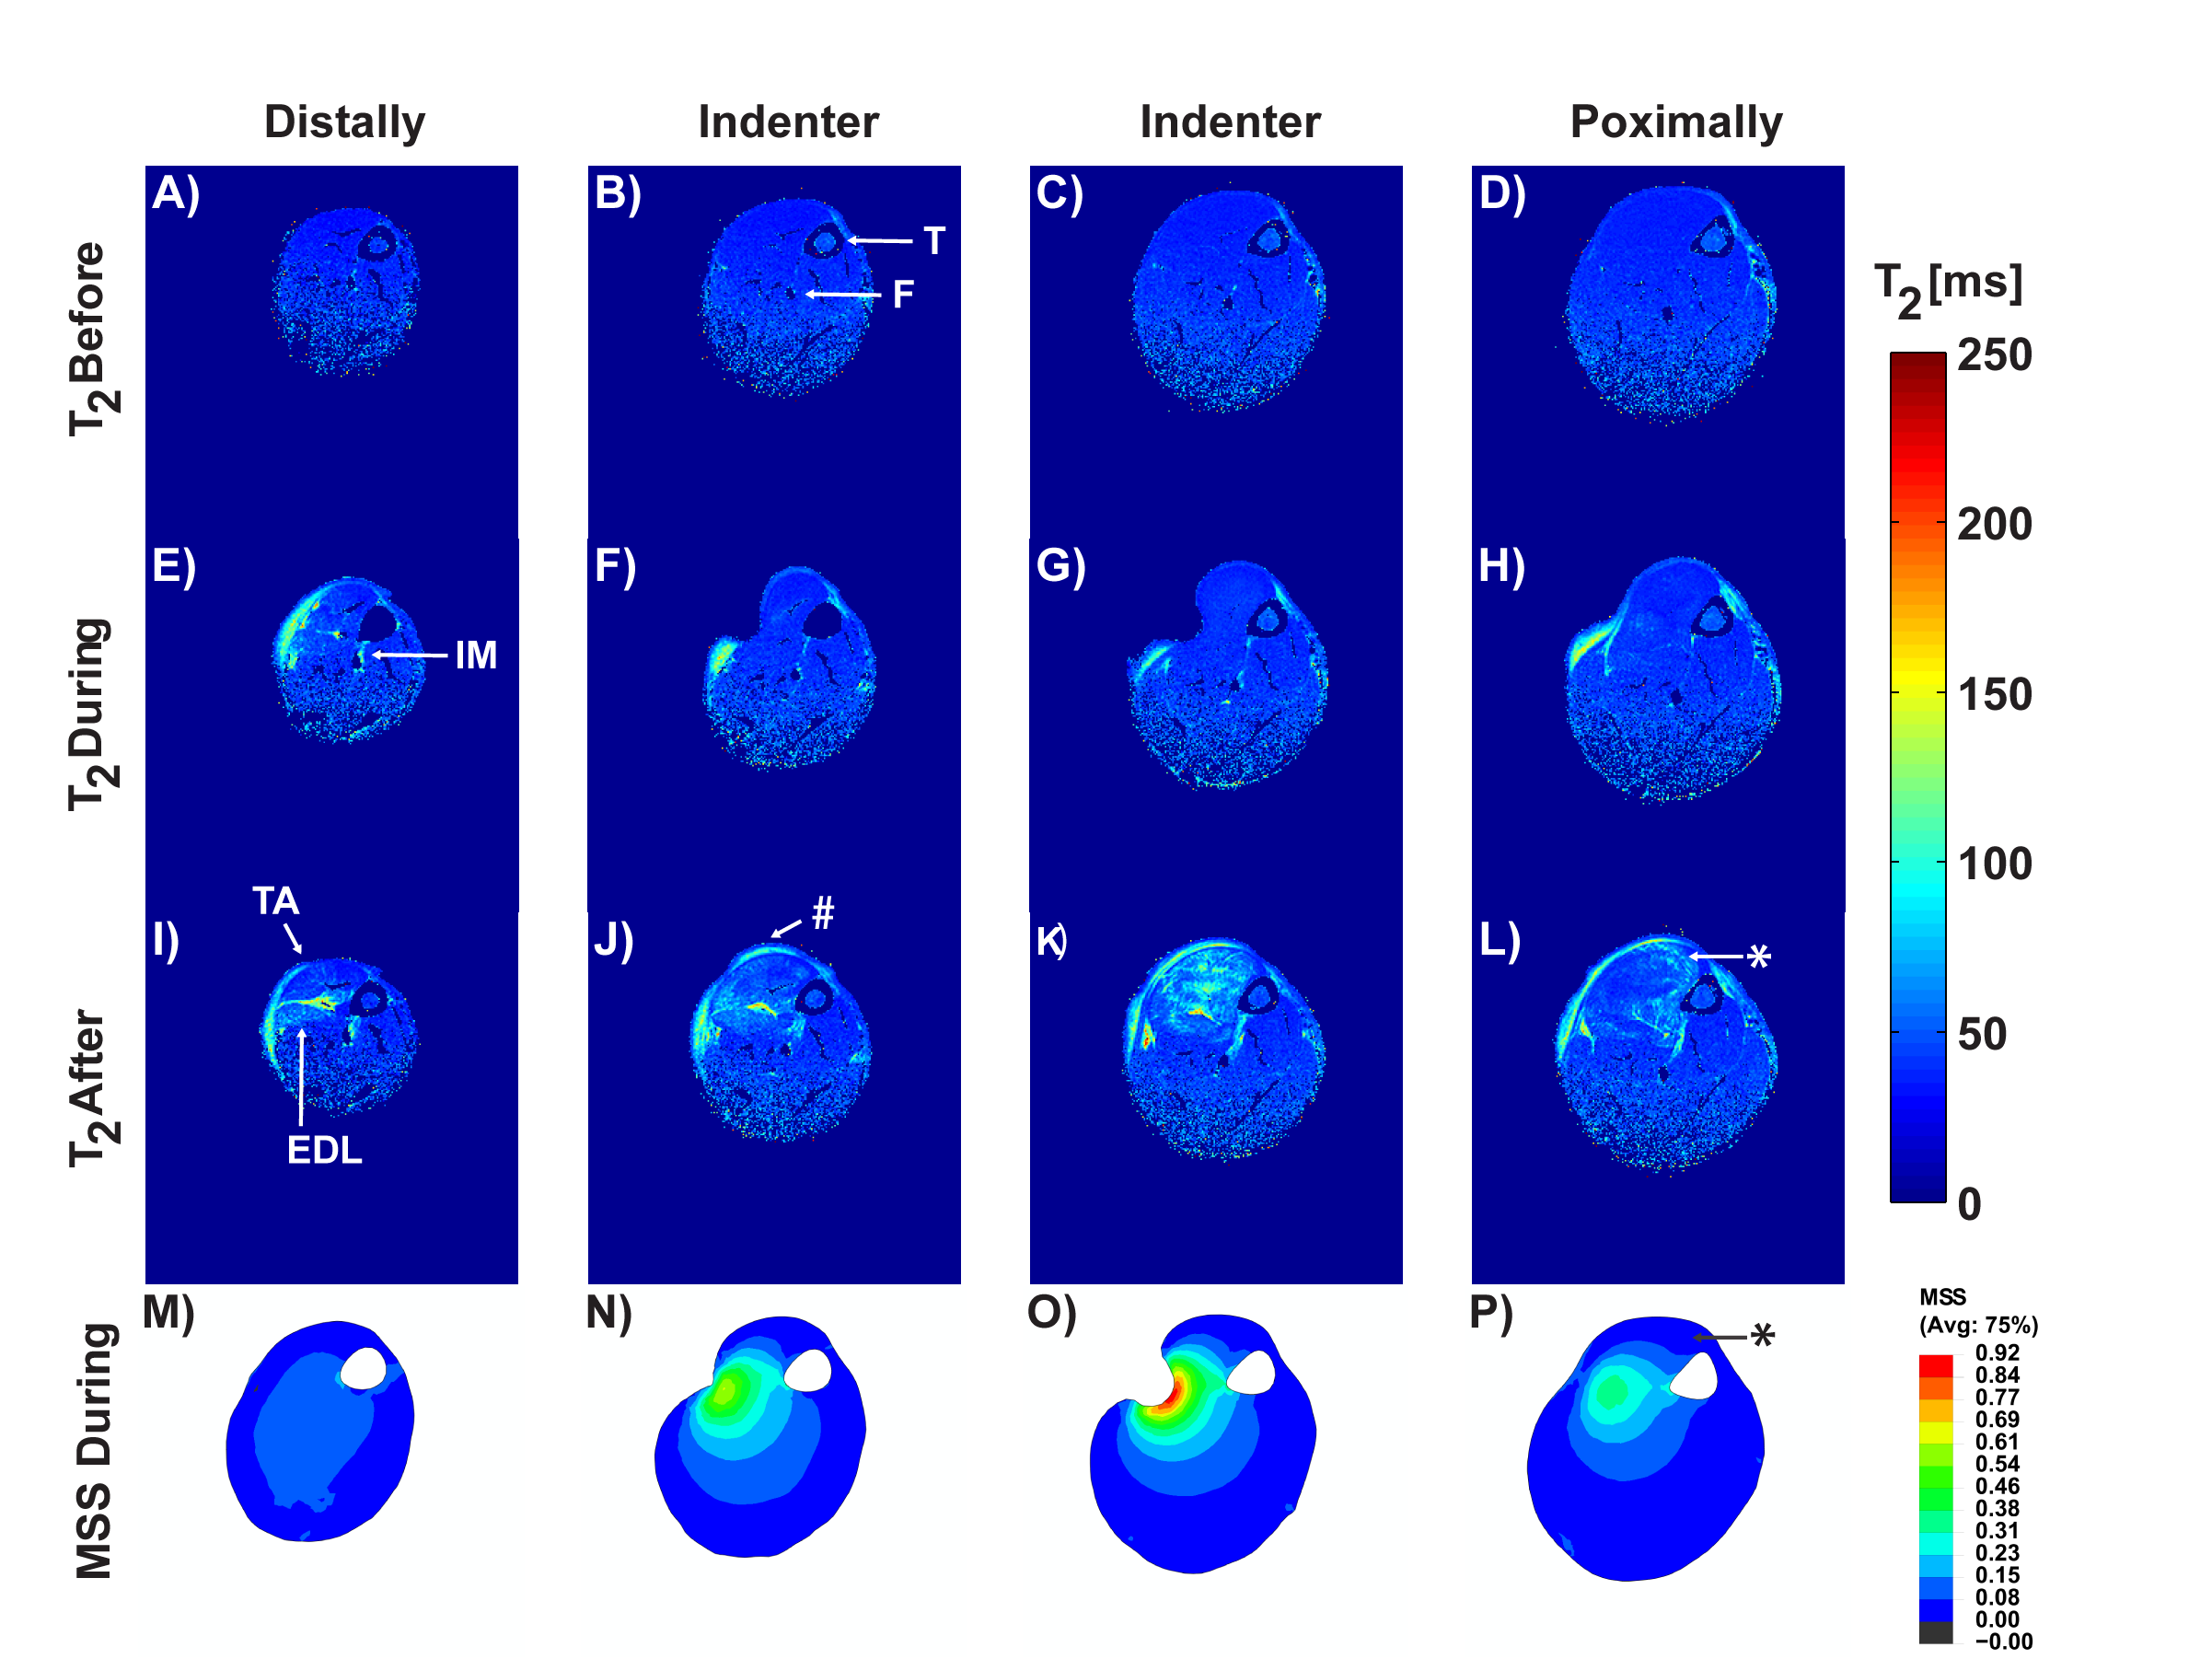
Fig. 3: T₂ maps pre, during, and post indentation as well as calculated maximum shear strain (MSS) maps of a representative animal (#22) with severe muscle damage. Axial T₂-maps (A-D) before, (E-H) during, and (I-L) after indentation. (M-P) Maximum shear strain (MSS) map during indentation calculated with FE analysis. Slices were located distal to indentation (1st column), along the axis of indentation (2nd and 3rd column), and proximal to indentation (4th column). IM = Interosseous membrane, EDL = extensor digitorum longus.
Fig. 4: TA muscle volume of significantly elevated T2-values (V_{di}) as function of FE-derived strain metrics. (A) V_{di} as function of volume of voxels (VOI) with varying maximal MSS range. (B) V_{di} as function of the total strain energy density (U_{tot}) of the TA muscle. Each data point represents an individual rat. Data points are divided and color-coded in 7 groups according to rat strain (SD: Sprague-Dawley, BN: Brown-Norway) and the highest MSS range present in the model.
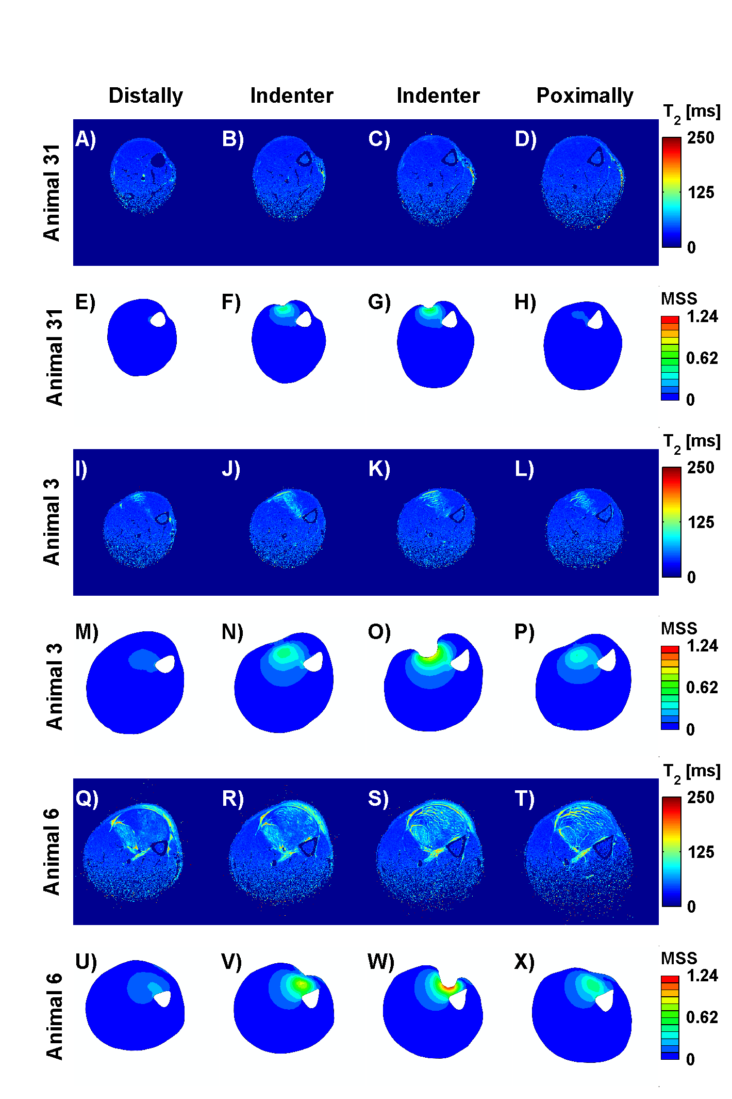
Fig. 5: T₂ maps and calculated MSS maps for animal 31, 3, and 6, illustrating a different damage response with varying degree of indentation. Slices were located distal to indentation (1st column), along the axis of indentation (2nd and 3rd column), and proximal to indentation (4th column).
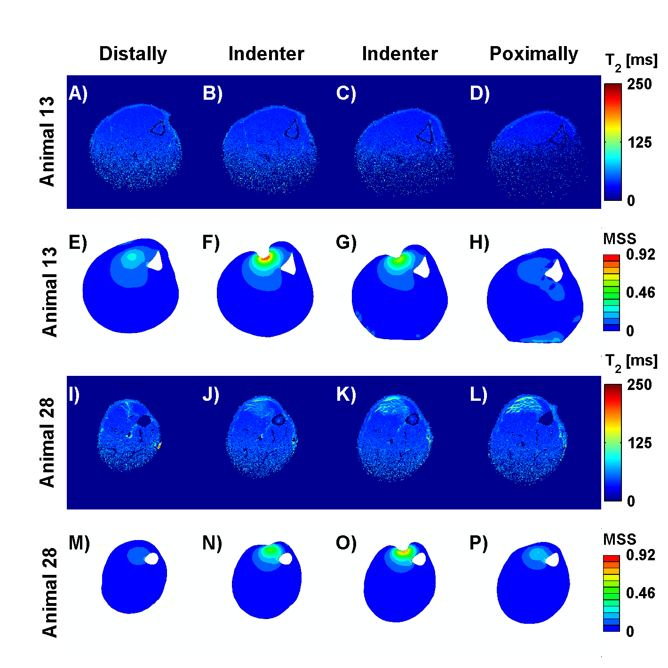
Fig. 6: T₂ maps and calculated MSS maps for animal 13 and 28, illustrating a different damage response with similar degree of indentation. Slice were located distal to indentation (1st column), along the axis of indentation (2nd and 3rd column), and proximal to indentation (4th column).

Discussion
In this study we employed 3D FE modelling in order to quantify the relationship between internal tissue strains and the amount of tissue damage in a rat model of deep tissue injury. Key to our approach was the use of a dedicated 3D FE model for each individual animal, which was possible because of precise 3D anatomical information gained from MRI (T₁ weighted) scans pre, during, and post damage-inducing deformation (Traa et al., 2018). Additionally, T₂-mapping MRI provided precise information on the magnitude and extent of muscle damage.
We observed a mechanical threshold above which deformation damage occurs for the 2 hour loading condition, similar to previous findings with this model (Loerakker et al., 2010). However, there was a less evident correlation between damage volume and applied strain energy than observed previously. The animals presented no distinct threshold at a well determined strain or strain energy value, but rather a transition zone between a ‘safe’ region and a ‘danger’ region with a high probability of tissue damage. Additionally, from the 3D approach it is now clear that once damage occurs in muscle it extends to a much larger area than that associated with the highest strains.
Dedicated FE models were used to simulate internal tissue deformations during loading. These 3D models build on the previously validated 2D FE-models developed in the host lab (Ceelen et al., 2008b; Loerakker et al., 2013). The model was described as a single isotropic nonlinear elastic material, even though multiple tissues are present in the leg namely, skin, fat and muscle. The focus of the analysis is the strain distribution was the skeletal muscle. The loading in the experiment was applied by prescribing the displacement of the indenter, which was derived from the images, and prescribed as kinematic boundary conditions to the FE model. This, together with the boundary condition describing the cast, dominates the strain field in the muscle, as was established from an earlier analysis the group. (Loerakker et al., 2013). In addition, the thin and loose skin and the very thin fat layer of the Sprague Dawley rats has little influence on the strain distribution in the muscle. The material description will not have a substantial influence on the calculated internal strain distributions, because of the large kinematic restriction of the experiment and the model, viz. leg movement is restricted by the cast and the indenter displacement largely dictates the deformation. Therefore, the internal tissue strains and the strain threshold can be compared to previous work (Ceelen et al., 2008b, 2008a). In both sets of studies a maximum shear strain of approximately 0.6 represented a threshold for deformation damage in healthy rats. However, a direct quantitative comparison between strain energy values in the different studies was not possible due to important influence of the assigned material properties (Loerakker et al., 2010).
The damage threshold transition zone found in this study clearly demonstrates that prediction of the location and amount of damage after short-term mechanical loading is near to impossible if only static mechanical modelling is employed. As shown in Fig. 4 and 6, the extent and amount of damage may vary with similar loading conditions. This implies that damage development is not dictated by the applied mechanical loading alone. Multi-scale modelling combined with damage models could be used as a new approach in investigating which factors are important in damage development in DTI formation. For example, it can be assumed that muscle damage starts locally at a location with high strains. It is well known that the membrane of muscle fibres become more permeable when a muscle is damaged (Slomka and Gefen, 2012), which will influence the formation of oedema. This micro-effect can be coupled to a macro model, by modelling the influx of material in the muscle compartment, in this case oedema. Because of the micro-structure of the muscle and its fibres it is highly probable that this fluid is transported along the muscle leading to T₂-changes outside the high strain region.
A detailed model of the muscle micro geometry might be able to explain some of the phenomena seen in this MRI study (Röhrle et al., 2012). To develop such models, the current finite element model should be extended to include other macro anatomical structures such as the fibula, the muscle compartments and fibre direction. It should also incorporate the influx and distribution of oedema with fluid models, as well as the subsequent increase in intra-compartmental pressure which eventually will lead to partial ischemia (Pechar and Lyons, 2016). Such a micro-model could focus on factors, which influence the vulnerability of muscle fibres. These could include, the rupture of muscle fibres due to mechanical loading, as well as the change in membrane permeability, the change in pH, and calcium fluxes (Jagannathan and Tucker-Kellogg, 2016).
Our 3D analysis shows that there is a subject specific tolerance to mechanical loading and that amount of tissue damage is not dictated by tissue deformations alone. Our work therefore stresses the importance of appropriate modelling of physiological (damage) processes and of assessment of individual susceptibility in future investigation into the aetiology of PUs.

Acknowledgments
The authors gratefully acknowledge David Veraart, Leonie Niessen, Carlijn Tijsen-van Helvert, Roy Lucassen and Marije Janssen for their biotechnical assistance.

Funding
This work was supported by the Dutch Technology Foundation (STW) under grant 12398. STW is part of the Netherlands Organisation for Scientific Research (NWO) and is partly funded by the Ministry of Economic Affairs.

References
Bosboom, E.M.H., Bouten, C.V.C., Oomens, C.W.J., Baaijens, F.P.T., Nicolay, K., 2003. Quantifying pressure sore-related muscle damage using high-resolution MRI. J. Appl. Physiol. 95, 2235–2240. doi:10.1152/japplphysiol.01023.2001
Bosboom, E.M.H., Bouten, C.V.C., Oomens, C.W.J., Van Straaten, H.W.M., Baaijens, F.P.T., Kuipers, H., 2001. Quantification and localisation of damage in rat muscles after controlled loading; a new approach to study the aetiology of pressure sores. Med. Eng. Phys. 23, 195–200. doi:10.1016/S1350-4533(01)00034-0
Breuls, R.G.M., Bouten, C.V.C., Oomens, C.W.J., Bader, D.L., Baaijens, F.P.T., 2003. Compression Induced Cell Damage in Engineered Muscle Tissue: An In Vitro Model to Study Pressure Ulcer Aetiology. Ann. Biomed. Eng. 31, 1357–1364. doi:10.1114/1.1624602
Ceelen, K.K., Stekelenburg, A., Loerakker, S., Strijkers, G.J., Bader, D.L., Nicolay, K., Baaijens, F.P.T., Oomens, C.W.J., 2008a. Compression-induced damage and internal tissue strains are related. J. Biomech. 41, 3399–3404. doi:10.1016/j.jbiomech.2008.09.016
Ceelen, K.K., Stekelenburg, A., Mulders, J.L.J., Strijkers, G.J., Baaijens, F.P.T., Nicolay, K., Oomens, C.W.J., 2008b. Validation of a Numerical Model of Skeletal Muscle Compression With MR Tagging: A Contribution to Pressure Ulcer Research. J. Biomech. Eng. 130, 061015. doi:10.1115/1.2987877
Cox, J., 2011. Predictors of pressure ulcers in adult critical care patients. Am. J. Crit. Care 20, 364–75. doi:10.4037/ajcc2011934
Daniel, R.K., Priest, D.L., Wheatly, D.C., 1981. Etiologic factors in pressure sores, an experimental model.pdf. Arch. Phys. Med. Rehabil. 62, 492–498.
Gawlitta, D., Li, W., Oomens, C.W.J., Baaijens, F.P.T., Bader, D.L., Bouten, C.V.C., 2007a. The relative contributions of compression and hypoxia to development of muscle tissue damage: an in vitro study. Ann. Biomed. Eng. 35, 273–84. doi:10.1007/s10439-006-9222-5
Gawlitta, D., Oomens, C.W.J., Bader, D.L., Baaijens, F.P.T., Bouten, C.V.C., 2007b. Temporal differences in the influence of ischemic factors and deformation on the metabolism of engineered skeletal muscle. J. Appl. Physiol. 103, 464–73. doi:10.1152/japplphysiol.01374.2006
Gefen, A., Levine, J., 2007. The false premise in measuring body-support interface pressures for preventing serious pressure ulcers. J. Med. Eng. Technol. 31, 375–80. doi:10.1080/03091900601165256
Gefen, A., van Nierop, B., Bader, D.L., Oomens, C.W.J., 2008. Strain-time cell-death threshold for skeletal muscle in a tissue-engineered model system for deep tissue injury. J. Biomech. 41, 2003–2012. doi:10.1016/j.jbiomech.2008.03.039
Jagannathan, N.S., Tucker-Kellogg, L., 2016. Membrane permeability during pressure ulcer formation: A computational model of dynamic competition between cytoskeletal damage and repair. J. Biomech. 49, 1311–1320. doi:10.1016/j.jbiomech.2015.12.022
Kosiak, M., 1961. Etiology of decubitus ulcers. Arch. Phys. Med. Rehabil. 42, 19–29.
Linder-Ganz, E., Engelberg, S., Scheinowitz, M., Gefen, A., 2006. Pressure-time cell death threshold for albino rat skeletal muscles as related to pressure sore biomechanics. J. Biomech. 39, 2725–32. doi:10.1016/j.jbiomech.2005.08.010
Linder-Ganz, E., Shabshin, N., Itzchak, Y., Gefen, A., 2007. Assessment of mechanical conditions in sub-dermal tissues during sitting: a combined experimental-MRI and finite element approach. J. Biomech. 40, 1443–1454. doi:10.1016/j.jbiomech.2006.06.020
Linder-Ganz, E., Shabshin, N., Itzchak, Y., Yizhar, Z., Siev-Ner, I., Gefen, A., 2008. Strains and stresses in sub-dermal tissues of the buttocks are greater in paraplegics than in healthy during sitting. J. Biomech. 41, 567–80. doi:10.1016/j.jbiomech.2007.10.011
Loerakker, S., Bader, D.L., Baaijens, F.P.T., Oomens, C.W.J., 2013. Which factors influence the ability of a computational model to predict the in vivo deformation behaviour of skeletal muscle? Comput. Methods Biomech. Biomed. Engin. 16, 338–345. doi:10.1080/10255842.2011.621423
Loerakker, S., Manders, E., Strijkers, G.J., Nicolay, K., Baaijens, F.P.T., Bader, D.L., Oomens, C.W.J., 2011a. The effects of deformation, ischemia, and reperfusion on the development of muscle damage during prolonged loading. J. Appl. Physiol. 111, 1168–77. doi:10.1152/japplphysiol.00389.2011
Loerakker, S., Oomens, C.W.J., Manders, E., Schakel, T., Bader, D.L., Baaijens, F.P.T., Nicolay, K., Strijkers, G.J., 2011b. Ischemia-reperfusion injury in rat skeletal muscle assessed with T2-weighted and dynamic contrast-enhanced MRI. Magn. Reson. Med. 66, 528–37. doi:10.1002/mrm.22801
Loerakker, S., Stekelenburg, A., Strijkers, G.J., Rijpkema, J.J.M., Baaijens, F.P.T., Bader, D.L., Nicolay, K., Oomens, C.W.J., 2010. Temporal effects of mechanical loading on deformation-induced damage in skeletal muscle tissue. Ann. Biomed. Eng. 38, 2577–2587. doi:10.1007/s10439-010-0002-x
Moerman, K.M., 2018. GIBBON: The Geometry and Image-Based Bioengineering add-On. J. Open Source Softw. 3, 506. doi:10.21105/joss.00506
Moerman, K.M., van Vijven, M., Solis, L.R., van Haaften, E.E., Loenen, A.C.Y., Mushahwar, V.K., Oomens, C.W.J., 2016. On the importance of 3D, geometrically accurate, and subject-specific finite element analysis for evaluation of in-vivo soft tissue loads. Comput. Methods Biomech. Biomed. Engin. 20, 483–491. doi:10.1080/10255842.2016.1250259
Moore, Z.E.H., Cowman, S., 2014. Risk assessment tools for the prevention of pressure ulcers. Cochrane Database Syst. Rev. 5, 1–31. doi:10.1002/14651858.CD006471.pub3
Nelissen, J.L., Graaf, L. d., Traa, W.A., Schreurs, T.J.L., Moerman, K.M., Nederveen, A.J., Sinkus, R., Oomens, C.W.J., Nicolay, K., Strijkers, G.J., 2017. A MRI-Compatible Combined Mechanical Loading and MR Elastography Setup to Study Deformation-Induced Skeletal Muscle Damage in Rats. PLoS One 12, 1–22. doi:10.1371/journal.pone.0169864
Nelissen, J.L., Traa, W.A., de Boer, H.H., de Graaf, L., Mazzoli, V., Savci-Heijink, C.D., Nicolay, K., Froeling, M., Bader, D.L., Nederveen, A.J., Oomens, C.W.J., Strijkers, G.J., 2018. An advanced magnetic resonance imaging perspective on the etiology of deep tissue injury. J. Appl. Physiol. 124, 1580–1596. doi:10.1152/japplphysiol.00891.2017
NPUAP, EPUAP, PPPIA, 2014. Prevention and Treatment of Pressure Ulcers: Clinical Practice guideline. Cambridge media:, Perth, Western Australia.
Oomens, C.W.J., Bressers, O.F.J.T., Bosboom, E.M.H., Bouten, C.V.C., Blader, D.L., 2003. Can loaded interface characteristics influence strain distributions in muscle adjacent to bony prominences? Comput. Methods Biomech. Biomed. Engin. 6, 171–80. doi:10.1080/1025584031000121034
Oomens, C.W.J., Loerakker, S., Bader, D.L., 2010. The importance of internal strain as opposed to interface pressure in the prevention of pressure related deep tissue injury. J. Tissue Viability 19, 35–42. doi:10.1016/j.jtv.2009.11.002
Pechar, J., Lyons, M.M., 2016. Acute Compartment Syndrome of the Lower Leg: A Review. J. Nurse Pract. 12, 265–270. doi:10.1016/j.nurpra.2015.10.013
Reswick, J.B., Rogers, J.E., 1976. Experience at rancho los amigos hospital with devices and techniques to prevent pressure sores, in: Kenedi, R.M., Cowden, J.M. (Eds.), Bed Sore Biomechancis. Strathclyde Bioengineering Seminars, pp. 301–310.
Röhrle, O., Davidson, J.B., Pullan, A.J., 2012. A physiologically based, multi-scale model of skeletal muscle structure and function. Front. Physiol. 3 SEP, 1–14. doi:10.3389/fphys.2012.00358
Šateková, L., Žiaková, K., Zeleníková, R., 2017. Predictive validity of the Braden Scale, Norton Scale, and Waterlow Scale in the Czech Republic. Int. J. Nurs. Pract. 23, 1–10. doi:10.1111/ijn.12499
Scheel-Sailer, A., Wyss, A., Boldt, C., Post, M.W., Lay, V., 2013. Prevalence, location, grade of pressure ulcers and association with specific patient characteristics in adult spinal cord injury patients during the hospital stay: a prospective cohort study. Spinal Cord 51, 828–33. doi:10.1038/sc.2013.91
Slomka, N., Gefen, A., 2012. Relationship between strain levels and permeability of the plasma membrane in statically stretched myoblasts. Ann. Biomed. Eng. 40, 606–18. doi:10.1007/s10439-011-0423-1
Stekelenburg, A., Oomens, C.W.J., Strijkers, G.J., de Graaf, L., Bader, D.L., Nicolay, K., 2006a. A new MR-compatible loading device to study in vivo muscle damage development in rats due to compressive loading. Med. Eng. Phys. 28, 331–338. doi:10.1016/j.medengphy.2005.07.005
Stekelenburg, A., Oomens, C.W.J., Strijkers, G.J., Nicolay, K., Bader, D.L., 2006b. Compression-induced deep tissue injury examined with magnetic resonance imaging and histology. J. Appl. Physiol. 100, 1946–54. doi:10.1152/japplphysiol.00889.2005
Stekelenburg, A., Strijkers, G.J., Parusel, H., Bader, D.L., Nicolay, K., Oomens, C.W.J., 2007. Role of ischemia and deformation in the onset of compression-induced deep tissue injury: MRI-based studies in a rat model. J. Appl. Physiol. 102, 2002–11. doi:10.1152/japplphysiol.01115.2006
Traa, W.A., van Turnhout, M.C., Moerman, K.M., Nelissen, J.L., Nederveen, A.J., Strijkers, G.J., Bader, D.L., Oomens, C.W.J., 2018. MRI based 3D finite element modelling to investigate deep tissue injury. Comput. Methods Biomech. Biomed. Engin. doi:10.1080/10255842.2018.1517868

