Tinoco et al.
Survival estimates of tropical Andean species
Survival estimates of tropical Andean bird species across altered habitats
Boris A. Tinoco,^{1,#} Laura Graham,^{2,3,#,}* Pedro X. Astudillo,¹ Andrea Nieto,¹ Juan Manuel Aguilar,¹ Steven C. Latta,⁴ and Catherine H. Graham^{2,5}
¹ Escuela de Biología, Ecología y Gestión, Universidad del Azuay, Cuenca, Ecuador
² Department of Ecology and Evolution, Stony Brook University, Stony Brook, New York, USA
³Geography and Environment, University of Southampton, Southampton, UK
⁴ National Aviary, Allegheny Commons West, Pittsburgh, Pennsylvania, USA
^{b}Swiss Federal Research Institute WSL, Birmensdorf, Zurich, Switzerland
# These authors contributed equally to the paper
*Corresponding author: laurajaneegraham@gmail.com

Abstract
The probability of long term persistence of a population is strongly determined by adult survival rates; however, estimates of survival are currently lacking for the majority of bird species in the Tropical Andes, a global biodiversity hotspot. Here we calculate apparent survival rates of birds from the Ecuadorian Tropical Andes, using a moderately long-term (11 yr) capture-recapture data set, from three habitats varying in the degree to which they have been modified by human activities (native forest, introduced forest, shrubs). We fit mark-recapture models for 28 species with habitat as a co-variable. For all species, recapture rates between sampling sessions were low and varied from 0.12 for Masked Flowerpiercer (Diglossa cyanea) to 0.37 for White-browed Spinetail (Hellmayrea gularis) when averaged across all occupied habitats. Annual survival rates varied from 0.45 for Tyrian Metaltail (Metallura tyrianthina) to 0.78 for Russet-crowned Warbler (Myiothlypis coronatus). We did not detect significant differences in survival rates among occupied habitats, nor did we find significant differences in survival rates of species grouped by habitat specialization. Because we found similar survival rates in native forest and human-modified habitats, our results support recent findings indicating the potential value of secondary habitats for the conservation of some species in the tropics. However, our conclusions are tempered by the uncertainty around all of our estimates of survival rates. We suggest that despite the relative long-term nature of our study, obtaining survival estimates for bird species in this region is challenging, and more years of study, or modifications of field protocols may be warranted to obtain more precise survival estimates.
Keywords: anthropogenic disturbance, demography, Ecuador, montane forest, secondary forest.
Survival is a key demographic parameter which strongly influences population size (Saether and Bakke 2000); therefore, estimates of survival rates are necessary to determine the probability of long-term persistence of bird populations. In particular, information on survival rates of bird populations is critically needed in areas that harbor high levels of diversity and endemism, such as the Neotropics (Myers et al. 2000), where the transformation of forests and other native habitats is threatening the conservation of multiple species (Orme et al. 2005). Although the number of studies which have estimated survival rates of birds in the Neotropics has recently increased (Blake and Loiselle 2013, Wolfe et al. 2014), less than 5% of Neotropical species have been evaluated (Ruiz-Gutiérrez et al. 2012), and these estimates come from only a very few locations. In addition, published survival estimates do not include any species from the tropical Andes, a biodiversity hotspot heavily impacted by anthropogenic activities (Stotz et al. 1996) and increasingly threatened by climate change (Latta et al. 2011, Şekercioğlu et al. 2012, Velásquez-Tibatá et al. 2013).
Anthropogenic habitat alteration can affect survival rates of birds by changing the availability of resources and nesting sites, modifying the community of predators, and increasing physiological stress of birds (Brawn and Robinson 1996, Brown and Graham 2015, Visco et al. 2015). However, habitat alteration may not affect equally all bird species that are part of a community (Laurance et al. 2002). Particular ecological characteristics, such as the degree of habitat specialization, may influence how species respond to land use change (Morante-Filho et al. 2015). For example, generalist species are usually able to exploit resources offered by the early successional habitats created by disturbance (Johnson et al. 2006). In contrast, among forest specialists a decrease in survival rates is frequently observed in disturbed habitats (Ruiz-Gutiérrez et al. 2008). Therefore, measures of survival rates across species and habitats, considering their species habitat specialization, will help us predict the long-term effects of anthropogenic disturbance on populations.
To date, most research on the effects of habitat alteration on bird populations in the Tropical Andes relies on measures of species richness or abundance (Renjifo 2001, Latta et al. 2011, Tinoco et al. 2013), thus limiting our ability to predict the long term effects of habitat disturbance on populations. In particular, a species may be abundant in a habitat as a result of high immigration, but can have low survival rates in that habitat resulting in a sink population (Van Horne 1983, Pulliam 1988, Brawn and Robinson 1996).
To begin to overcome this issue we explored whether survival rates of birds, based on a constant-effort mist-netting protocol, varied across three vegetation types that have different alteration histories. These habitats included native montane forest (minimally -altered), introduced forest plantation (dominated by exotic trees), and early-successional shrub (recovering from cattle grazing). We predicted that: (1) survival rates of each species will vary across occupied habitats; and (2) when species are grouped by habitat specialization, survival will be highest for generalists, followed by middle-term specialists, and lowest for specialists. To analyze these predictions, we fit mark-recapture models for each of 28 Andean bird species, and also averaged survival rates across species grouped by habitat specialization (generalists, intermediate specialists and specialists), with survival estimated separately in each habitat. To our knowledge, our results provide the first estimates of survival rates for any bird species in the Tropical Andes.
METHODS
Study Area and Design
This study was conducted in Cajas National Park and the adjacent Mazán private reserve in the high Andes of Azuay province, Ecuador. These areas are of global importance for biodiversity conservation (Astudillo et al. 2015), have been designated together as an Important Bird Area (IBA) (Freile and Santander 2005), and are part of the Macizo del Cajas International Biosphere Reserve (UNESCO). Cajas National Park and Mazán are both managed by ETAPA-EP (Empresa Pública Municipal de Teléfonos, Agua Potable y Saneamiento Ambiental), a local public department that serves the city of Cuenca, Ecuador.
The 2700 ha Mazán reserve (02.870° S, 79.120° W), is mostly covered by native montane forest, with páramo grasslands occupying the extreme upper ridges of the valley. Limited selective logging occurred in Mazán more than thirty years ago, but today the reserve is under strict protection that allows only particular scientific activities.
In Cajas National Park we worked in the U-shaped Llaviuco valley (02.840 S, 79.160° W). Recreational activity (hiking) is common in this valley, but is restricted to select trails. Most of the forest in this valley was cleared for cattle ranching, but since its incorporation to Cajas National Park in 1996 and the removal of the cattle, vegetation has naturally re-established. The study area receives 1200-1500 mm of rain annually in a bimodal pattern, with a main rainy season January-June, a dry season July-September, and a secondary rainy season October-December (Celleri et al. 2007). Mean monthly temperatures range from 5-12 °C, but temperature variation within a day can range from 0-20 °C.
Within Mazán and Llaviuco we placed three sampling stations in areas with unique habitat types: native montane forest (hereafter native forest), mixed stands of mature exotic Eucalyptus globulus and Pinus patula with a native understory (hereafter introduced forest), and early successional vegetation (hereafter shrubs). The native forest station was located in Mazán at an elevation of 3200 meters above sea level (m.a.s.l.). Tree species common in this area include Hedyosmum cumbalense, Symplocos quitensis and Myrcianthes sp., with an understory mainly composed of Miconia bracteolata, Viburnum triphyllum and Oreopanax avicenniifolius. The canopy reaches 10-15 m. The mixed introduced forest was also located in Mazán at 3100 m.a.s.l.. The canopy varies from 15-20 m, composed of the exotic tree species Pinus patula and Eucalypthus globulus. These trees were planted more than 30 years ago. Species common in the understory include Rubus sp. and Baccharis sp, with little to no regeneration by the exotic overstory species. The native shrub site was located in Llaviuco Valley at an elevation of 3150 m.a.s.l.. This area was subjected to cattle grazing before it was incorporated to Cajas National Park in 1996. Common shrub species here are Barnadesia arborea, Brachyotum sp., Rubus floribundus and Salvia corrugata. The canopy is low (< 2-3 m), with isolated taller trees mainly along very small creeks and open pastures across our sampling area.
Sampling Protocol
At each of the three sampling stations we captured birds by placing 20 mist nets (12 m x 32 mm mesh) for two continuous days along trails, with mist nets extending ~510 m in distance. At each sampling station, nets were open from dawn to 17:00 of day 1, and dawn to 11:00 of day 2. All captured birds were identified to species, sexed and aged (young, adults) using plumage characteristics (Pyle 2001, Ridgely and Greenfield 2001). All birds were uniquely banded with a numbered aluminum band.
Birds were sampled three times annually from 2006 to 2016. To cover the climatic seasonality of the study area we sampled once in the main wet season (April 1 - May 15), once in the dry season (July 15 - August 15), and once in the secondary rainy season (November 9 - December 18).
We classified bird species into habitat specialization categories, taking into account their primary habitat and number of occupied habitats. These categories included: specialists, intermediate specialists, and generalists. This classification is relative to the studied species, and was informed by habitat types available in the study area, and classifications published by Stotz et al. (1996), Tinoco and Astudillo (2007), and Latta et al. (2011), and personal observations.
Mark-recapture Analysis
We pooled observations from the three survey sessions within a year to obtain annual survival estimates. We omitted from analyses birds aged as juveniles because these individuals usually disperse from the sampling area and can bias the estimates of survival (Pradel et al. 1997). We estimated survival probability for all species that regularly use the understory (Tinoco and Astudillo 2007). This allowed us to make an estimate of recapture probability, and thus survival probability, for as many species as possible. However, when recapture rates are low there may not be enough information to get precise estimates of survival, so the error estimate (presented here as credible intervals) should be taken into account when interpreting the results. Our estimates of survival should be treated as apparent survival since with our sampling protocol and data analysis it is not possible to distinguish emigration from true survival. Nonetheless, emigration among habitats was rare; based on mist net recaptures of previously banded birds, we detected movement among habitats for only 24 individuals across the study period.
Statistical Models
We estimated survival probabilities ($ϕ$) and recapture probabilities ($p$) for each species by fitting a multi-species Bayesian state-space formation of the Cormack-Jolly-Seber models (Lebreton et al. 1992, Royle 2008). We modelled species as random rather than a fixed effect (sensu Muñoz et al. 2018). We chose this method because it results in increased precision in the parameter estimates by using the information from the full data set, and not just the individual species. This is particularly useful when recapture rates and sample sizes are low. Additionally, by modelling species as a random effect, we can make inferences about population-level apparent survival in the community, and not just for the observed species.
In our model, we assumed that both $ϕ$ and $p$ varied across habitats, and we estimated how survival varied by habitat specialization categories. We estimated $ϕ$ between initial capture and first recapture separately from all subsequent recaptures: a time since marked (TSM) model. Suppressing the first recapture for each individual removes potentially transient individuals from the analysis and therefore controls for the effect of transience on the estimate of survival (Pradel et al. 1997). Finally, we estimated the effect of group on differences in $ϕ$ by modelling $ϕ$ as a function of habitat specialization of species, with family as a random effect to control for phylogenetic similarities.
We modelled the state process as:
$$z_{(i,t)}∼Bernoulli(μ_{ϕ(i,t)})$$
$$μ_{ϕ(i,t)}=z_{i,t-1}*ϕ_{tsm,hab(i,t)}$$
Where $z_{(i,t)}$ represents the probability that individual $i$ is alive at time $t$.
We modelled the observation process as:
$$y_{(i,t)}∼Bernoulli(μ_{p(i,t)})$$
$$μ_{p(i,t)})=z_{(i,t)}*p_{hab}$$
We estimated community level apparent survival ($ϕ$) and recapture probability ($p$) parameters as follows:
$$ϕ_{s,tsm,hab}={\overline{ϕ}}_{s,tsm,hab}+β^{group}*group+β^{family}+ϵ$$
$${\overline{ϕ}}_{s,tsm,hab}∼N(μ_{ϕ(tsm,hab)},σ_{ϕ(tsm,hab)})$$
$$p_{s,hab}∼N(μ_{p(hab)},σ_{p(hab)})$$
We estimated the apparent survival ($ϕ$) probability for each of the two categories of time since marked (tsm), and each of the three habitats (hab). For example, the hyper-parameter $μ_{ϕ(1,native)}$ will provide the community-level apparent survival probability between initial banding and first recapture in native habitat. We obtain species level estimates from $ϕ_{s,tsm,hab}$, such that $phi_{1,2,introduced}$ provides the apparent survival estimate for species 1, between all recapture occasions since initial banding, in the introduced habitat. Similarly, the hyper-parameter $μ_{p(hab)}$ provides the community-level recapture probability, and $p_{s,hab}$ the species-level recapture probability by habitat; $β^{group}$ determines the effect of habitat specialization groups on apparent survival; and, $β^{family}$ is a random effect to control for phylogenetic similarity.
All hyper-parameters were given non-informative priors. We estimated all parameters using Markov Chain Monte Carlo (MCMC) simulation in JAGS. For all models we set the number of MCMC chains to 3, the number of iterations to 20000, the burn-in period to 10000 and thinned by a factor of 10. We checked for convergence of chains visually and by checking if Gelman-Rubin statistic was below 1.1. All analyses were coded in R (R Development Core team 2018) and JAGS was called using the ‘R2jags’ package (Su and Yajima 2015).
RESULTS
Capture and recapture summary
Through 33 banding sessions across 11 years, we banded 3528 birds of 72 species. The median number of individuals banded for a species was 15.
We omitted 44 species from this analysis which did not regularly use the understory, or did not have recaptures (see Supplemental Material Table S1 for full details). We then proceeded with survival estimates for 28 species. For these species, the maximum number of recaptures for a species was 188, Sapphire-vented Puffleg (Eriocnemis luciani) (Fig. 1), with a maximum number of 12 recaptures for a single individual of Sapphire-vented Puffleg. The species with least number of recaptures included in the analysis was five, Buff-breasted Mountain-Tanager (Dubusia taeniata) (Fig. 1).
Apparent survival rates
For all estimates, we provide mean and 95% credible interval for the overall survival rate (mean across habitats). Annual apparent survival rates for individual species across habitats ranged from ϕ₂ = 0.45 (Tyrian Metaltail - Metallura tyrianthina) to ϕ₂ = 0.78 (Russet-crowned Warbles - Myiothlypis coronatus) (Table 1). For all species, recapture rates between years were low and varied from p = 0.12 (Masked Flowerpiercer - Diglossa cyanea) to p = 0.37 (White-browed Spinetail - Hellmayrea gularis) (Table 1).
Mean survival estimates were lowest for birds occupying native forest habitat (ϕ = 0.41 [0.11, 0.71]), followed by introduced forest (ϕ = 0.58 [0.34, 0.78]), with the highest survival rates occurring in shrubs (ϕ = 0.65 [0.45, 0.81]). However, the 95% credible intervals for each of these differences overlap with zero, meaning there are no significant differences in survival between habitat types (Fig. 2). Further, any differences we did observe may be influenced by differences in recapture probability between habitat types (Fig. S1).
For individual species, we also found no significant difference in survival estimates between habitats for any species due to large credible intervals (Fig. S2, Table S2). Similarly, there was more variation among than between habitat specialization groups (Fig. 3). The habitat specialization coefficient was non-significant ($β^{group}$ = 0.15 [-0.12,0.41]).

DISCUSSION
Here we present the first estimates of survival rates for any bird species in the Tropical Andes. We found large variation in survival rates across species and low recapture rates. Individual species presented a variety of responses in survival rates across habitats. While we predicted that survival rates in each habitat will be influence by the degree of habitat specialization of species, we did not reveal a variation in survival rates across habitats for species groups. Even within specialist species, a group often profoundly impacted by habitat disturbance (Ruiz-Gutiérrez et al. 2008; Morante-Filho et al. 2015), we found no pattern of a negative response to the different land use histories of our studied habitats.
The lack of observed differences in survival rates of individual species across habitat types, or among species grouped by habitat specialization, can be explained by several factors. First, uncertainty in estimates of survival rates may be affected by low recapture rates of birds. Our average recapture probability was 0.21. This value is much lower that the recapture rates reported in other Neotropical sites, where bird recaptures ranged from 0.29 in central Amazonia (Wolfe et al. 2014) to 0.41 in the western Amazon (Blake and Loiselle 2013). Low recapture rates in our site compared to the lowlands could be influenced by differences in intrinsic characteristics of populations between highlands and lowlands. For example, species from high elevations can have larger home range sizes and smaller population sizes than species from lowlands (Terborgh 1977, Ding et al. 2005), which could result in low recapture rates at high elevations. Second, inter-Andean valleys in Ecuador have been disturbed for centuries (White and Maldonado 1991, Loughlin et al. 2018), and consequently, present-day avian communities in our study region may be composed mainly of disturbance-tolerant species (Latta et al. 2011). As a result, many of the disturbance-sensitive species, and especially the forest-dependent species, may already be locally extirpated from our study sites. For example, none of our studied species could be considered a strict understory forest interior specialist, thus suggesting that our study sites might be already composed of many species that are adapted to some levels of disturbance, and that could maintain populations in multiple habitat types. Third, transient individuals, and seasonal movements across vegetation types and elevational gradients, could produce low site fidelity (Parker et al. 2006, Wilson et al. 2011) resulting in the observed lack of significant differences in survival rates. Site fidelity is the probability that an individual returns to the same sampling area and is available to be caught again (Sandercock 2006). Low site fidelity can be problematic for the survival rate models we utilized since the models cannot distinguish true survival from permanent emigration; this could have potentially resulted in the underestimation of survival rates in this study. However, we attempted to overcome this problem by using time since capture survival models (Pradel et al. 1997), which distinguish survival rates of resident individuals from transients.
Nonetheless, our results do suggest that secondary shrub-scrub vegetation, and plantations containing exotic Eucalyptus and pine with a native shrub understory, might provide conservation opportunities for multiple Andean species. With comparable survival rates for multiple species – including species considered habitat specialists – across native and anthropogenically impacted habitats, our results support recent findings on how anthropogenically altered habitats for in the tropics may still provide some benefits for some species (Hughes et al. 2002, Haslem and Bennett 2008, Latta et al. 2017, Whitworth et al. 2018). However, it is important to point out that in this study the shrubs and introduced habitats were not subjected to the common management practices suffered by similar habitats outside the boundaries of Cajas National Park (e.g. active cattle browsing and logging, respectively), and thus our results may not completely reveal the magnitude of the effects of habitat alteration in tropical Andean birds in this region. It is also important to recognize that mist-nets sample only those species that occur in the lower strata of the vegetation. Therefore, a large proportion of species in the bird communities of our study areas were not evaluated. For example, we can make no conclusions regarding those species that regularly use the canopy of the forest, such as the threatened Gray-breasted Mountain Toucan (Andigena hypoglauca), Red-faced Parrot (Hapalopsittaca pyrrhops), and Golden-plumed Parakeet (Leptosittaca branicki) (Astudillo et al. 2015). Thus, despite the fact that we did not detect a decrease in survival rates among a large number of species analyzed, the Andean native forest is still an irreplaceable habitat for multiple species of conservation concern.
Finally, our work suggests that future studies to determine survival rates in similar habitats may need to look closely at long-term monitoring protocols. Capture-recapture studies in the highlands will have to consider the challenge of maximizing recaptures in order to minimize the uncertainty that may obscure differences in survival rates when designing sampling protocols. A study by Blake and Loiselle (2013) from western Amazonia demonstrated that increasing the number of years in capture –recapture studies can decrease the uncertainty in the estimates of survival rates, but increasing the within-year frequency of mist netting, or uniquely color-banding individuals to allow resighting as an alternate form of “capture” could also be implemented (Latta et al. 2005, Ruiz-Gutiérrez et al. 2012). Thus, we expect that our continued work in Cajas National Park and Mazán will improve the precision of our estimates of survival rates and perhaps uncover greater differences in survival rates.
Conclusion
Little is known about the effects of habitat alteration on important demographic parameters in the Tropical Andes; therefore, the information presented here will help to explore the probabilities of long-term persistence of avian species in the region. Our results show similar survival rates across habitats with different disturbances, irrespective of habitat specialization of species, and suggests that secondary habitats are able to maintain populations of several species in the Tropical Andes. We also show that despite the relatively long-term (11 year) nature of our study, it can be challenging to obtain precise survival estimates for bird species in this region. Ornithologists and managers considering long-term monitoring programs in the region should consider protocols which minimize uncertainty around survival rate estimates when planning bird monitoring programs in the region.
ACKNOWLEDGMENTS
We thank Francisco Sanchez, Juan Carlos Quezada, and people from the “Department of Gestion Ambiental” of ETAPA for logistical support in Cajas National Park. Edwin Zárate has supported this project with logistics and administration. We thank especially the multiple students from University of Azuay who have been part of data collection across these years, in particular: Gabriela Samaniego, Cristina Rios, Santiago Cárdenas, Francisco Neira. Funding for this project was provided by ETAPA, University of Azuay, PRBO Conservation Science (now Point Blue Conservation Science), The Avian Conservation Endowment of the National Aviary and NASA grant NNX11AO28G.

LITERATURE CITED
Astudillo, P. X., B. A. Tinoco, and D. Siddons. 2015. The avifauna of Cajas National Park and Mazán Reserve, southern Ecuador, with notes on new records. Cotinga 37: 1–11.
Blake, J. G., and B. A. Loiselle. 2013. Apparent survival rates of forest birds in eastern Ecuador revisited: improvement in precision but no change in estimates. PLoS ONE 8: e81028.
Brawn, J. D., and S. K. Robinson. 1996. Source-sink population dynamics may complicate the interpretation of long-term census data. Ecology 77: 3–12.
Brown, L. M., and C. H. Graham. 2015. Demography, traits and vulnerability to urbanization: can we make generalizations? Journal of Applied Ecology 52: 1455–1464.
Celleri, R., P. Willems, W. Buytaert, and J. Feyen. 2007. Space–time rainfall variability in the Paute basin, Ecuadorian Andes. Hydrological Processes 21: 3316–3327.
Ding, T.-S., H.-W. Yuan, S. Geng, Y.-S. Lin, and P.-F. Lee. 2005. Energy flux, body size and density in relation to bird species richness along an elevational gradient in Taiwan. Global Ecology and Biogeography 14: 299–306.
Freile, J. F., and T. Santander. 2005. Áreas importantes para la conservación de las aves en Ecuador. In: Áreas importantes para la conservación de las aves en los Andes Tropicales: sitios prioritarios para la conservación de la biodiversidad. BirdLife International, Quito, Ecuador, pp. 283–470.
Haslem, A., and A. F. Bennett. 2008. Birds in agricultural mosaics: the influence of landscape pattern and countryside heterogeneity. Ecological Applications 18: 185–196.
Hughes, J. B., G. C. Daily, and P. R. Ehrlich. 2002. Conservation of tropical forest birds in countryside habitats. Ecology Letters 5: 121–129.
Johnson, D. M., T. W. Sherry, R. T. Holmes, and P. P. Marra. 2006. Assessing habitat quality for a migratory songbird wintering in natural and agricultural habitats. Conservation Biology 20: 1433–1444.
Laurance, W. F., T. E. Lovejoy, H. L. Vasconcelos, E. M. Bruna, R. K. Didham, P. C. Stouffer, C. Gascon, R. O. Bierregaard, S. G. Laurance, E. Sampiao. 2002. Ecosystem decay of Amazonian forest fragments: a 22-year investigation. Conservation Biology 16: 605–618.
Latta, S. C., C. J. Ralph, and G. Geupel. 2005. Strategies for the conservation monitoring of permanent resident landbirds and wintering neotropical migrants in the Americas. Ornitología Neotropical 16: 163-174.
Latta, S. C., B. A. Tinoco, P. X. Astudillo, and C. H. Graham. 2011. Patterns and magnitude of temporal change in avian communities in the Ecuadorian Andes. The Condor 113: 24–40.
Latta, S. C., N. Brouwer, A. Olivieri, J. Girard-Woolley, and J. F. Richardson. 2017. Long-term monitoring reveals an avian species credit in secondary forest patches of Costa Rica. PeerJ 5: e3539.
Lebreton, J.D., K. P. Burnham, J. Clobert, and D. R. Anderson. 1992. Modeling survival and testing biological hypotheses using marked animals: a unified approach with case studies. Ecological Monographs 62: 67–118.
Loughlin, N. J. D., Gosling, W. D., Mothes, P., & Montoya, E. 2018. Ecological consequences of post-Columbian indigenous depopulation in the Andean–Amazonian corridor. Nature Ecology & Evolution 2: 1233 – 1236.
Morante-Filho, J. C., D. Faria, E. Mariano-Neto, and J. Rhodes. 2015. Birds in anthropogenic landscapes: the responses of ecological groups to forest loss in the Brazilian Atlantic Forest. PLoS ONE 10: e0128923.
Myers, N., R. A. Mittermeier, C. G. Mittermeier, G. A. B. da Fonseca, and J. Kent. 2000. Biodiversity hotspots for conservation priorities. Nature 403: 853–858.
Orme, C., R. Davies, M. Burgess, F. Eigenbrod, N. Pickup, V. Olson, A. Webster, T. Ding, P. Rasmussen, R. Ridgely, A. Stattersfield, P. M. Bennet, T. M. Blackburn, K. J. Gaston, and I. P. F. Owens. 2005. Global hotspots of species richness are not congruent with endemism or threat. Nature 436: 1016–1019.
Parker, T. H., C. D. Becker, B. K. Sandercock, and A. E. Agreda. 2006. Apparent survival estimates for five species of tropical birds in an endangered forest habitat in western Ecuador. Biotropica 38: 764–769.
Muñoz, A. P., M. Kery, P. V. Martins, and G. Ferraz. 2018. Age effects on survival of Amazon forest birds and the latitudinal gradient in bird survival. The Auk 135: 299-313
Pradel, R., J. E. Hines, J.-D. Lebreton, and J. D. Nichols. 1997. Capture-recapture survival models taking account of transients. Biometrics 53: 60–72.
Pulliam, H. R. 1988. Sources, sinks, and population regulation. The American Naturalist 132: 652–661.
Pyle, P. 2001. Identification guide to North American birds. Slate Creek Press, Bolinas California, USA.
R Development Core team. 2018. R: A language for environmental and statistical computing. <htpp://www.R-project.org>
Renjifo, L. 2001. Effect of natural and anthropogenic landscape matrices on the abundance of Subandean bird species. Ecological Applications 11: 14–31.
Ridgely, R. S., and P. J. Greenfield. 2001. The birds of Ecuador: field guide. Cornell University Press, Ithaca, New York, USA.
Royle A. J. 2008. Modelling individual effects in the Cormak-Jolly-Seber model: a state-space formulation. Biometrics 64: 364–370.
Ruiz-Gutiérrez, V., T. A. Gavin, and A. A. Dhondt. 2008. Habitat fragmentation lowers survival of a tropical forest bird. Ecological Applications 18: 838–846
Ruiz-Gutiérrez, V., P. F. Doherty, E. S. C, S. C. Martínez, J. Schondube, H. V. Munguía, and E. Iñigo-Elias. 2012. Survival of resident neotropical birds: considerations for sampling and analysis based on 20 years of bird-banding efforts in Mexico. The Auk 129: 500–509.
Saether, B.-E., and O. Bakke. 2000. Avian life history variation and contribution of demographic traits to the population growth rate. Ecology 81: 642–653.
Sandercock, B. K. 2006. Estimation of demographic parameters from live-encounter data: a summary review. Journal of Wildlife Management 70: 1504–1520.
Şekercioğlu, Ç. H., R. B. Primack, and J. Wormworth. 2012. The effects of climate change on tropical birds. Biological Conservation 148: 1–18.
Stotz, D. F., J. W. Fitzpatrick, T. A. Parker, and D. K. Moskovits. 1996. Neotropical birds: ecology and conservation. University of Chicago Press, Chicago, Illinois, USA.
Su, Y. S., and M. Yajima. 2012. R2jags: a package for running jags from R. R package version 0.03-08. <http://CRAN. R-project. org/package= R2jags>
Terborgh, J. 1977. Bird species-diversity on an Andean elevational gradient. Ecology 58: 1007–1019.
Tinoco, B., and P. X. Astudillo. 2007. Guía de campo de las aves del Parque Nacional Cajas. ETAPA, Cuenca, Ecuador.
Tinoco, B. A., P. X. Astudillo, S. C. Latta, D. Strubbe, and C. H. Graham. 2013. Influence of patch factors and connectivity on the avifauna of fragmented Polylepis forest in the Ecuadorian Andes. Biotropica 45: 602–611.
Van Horne, B. 1983. Density as a misleading indicator of habitat quality. The Journal of Wildlife Management 47: 893–901.
Velásquez-Tibatá, J., P. Salaman, and C. Graham. 2013. Effects of climate change on species distribution, community structure, and conservation of birds in protected areas in Colombia. Regional Environmental Change 13: 235–248.
Visco, D. M., N. L. Michel, W. A. Boyle, B. J. Sigel, S. Woltmann, and T. W. Sherry. 2015. Patterns and causes of understory bird declines in human-disturbed tropical forest landscapes: a case study from Central America. Biological Conservation 191: 117–129.
White, S., and F. Maldonado. 1991. The use and conservation of natural resources in the Andes of southern Ecuador. Mountain Research and Development 11: 37–55.
Whithworth, A., R. Pillco-Huarcaya, R. Downie, J. Villacampa, L. D. Braunholtz, and R. MacLeod. 2018. Long lasting impressions: after decades of regeneration rainforest biodiversity remains differentially affected following selective logging and clearance for agriculture. Global Ecology and Conservation: e00375.
Wilson, S., D. M. Collister, and A. G. Wilson. 2011. Community composition and annual survival of lowland tropical forest birds on the Osa Peninsula, Costa Rica. Ornitologia Neotropical 22: 421–436.
Wolfe, J. D., P. C. Stouffer, and G. F. Seeholzer. 2014. Variation in tropical bird survival across longitude and guilds: a case study from the Amazon. Oikos 123: 964–970.

TABLES
Table 1 Annual apparent survival estimates for 28 species of birds studied in Cajas National Park and Mazan private reserve, south Ecuador. Shown are recapture probabilities (p), survival probability between banding and first recapture ($ϕ_{1}$), survival probability for all subsequent recaptures ( $ϕ_{2}$). All values shown are means (95% credible interval) for the species across all occupied habitats.
Species | Specialization | p | $$ϕ_{1}$$ | $$ϕ_{2}$$
Grass Wren (Cistothorus platensis) | Generalists | 0.18 (0.09, 0.34) | 0.46 (0.3, 0.63) | 0.52 (0.28, 0.76)
Plain-colored Seedeater (Catamenia inornata) | Generalists | 0.2 (0.1, 0.35) | 0.46 (0.32, 0.59) | 0.56 (0.34, 0.77)
Rufous-collared Sparrow (Zonotrichia capensis) | Generalists | 0.18 (0.08, 0.33) | 0.48 (0.33, 0.64) | 0.52 (0.29, 0.76)
Azara's Spinetail (Synallaxis azarae) | Intermediate specialist | 0.26 (0.17, 0.39) | 0.58 (0.46, 0.69) | 0.57 (0.38, 0.76)
Black-crested Warbler (Myiothlypis nigrocristata) | Intermediate specialist | 0.3 (0.21, 0.4) | 0.63 (0.53, 0.73) | 0.59 (0.41, 0.77)
Black Flowerpiercer (Diglossa humeralis) | Intermediate specialist | 0.24 (0.17, 0.34) | 0.49 (0.39, 0.59) | 0.63 (0.43, 0.79)
Blakish Tapaculo (Scytalopus latrans) | Intermediate specialist | 0.23 (0.14, 0.34) | 0.63 (0.51, 0.77) | 0.6 (0.4, 0.82)
Buff-breasted Mountain Tanager (Dubusia taeniata) | Intermediate specialist | 0.22 (0.12, 0.36) | 0.52 (0.39, 0.65) | 0.56 (0.34, 0.77)
Cinereous Conebill (Conirostrum cinereum) | Intermediate specialist | 0.21 (0.1, 0.37) | 0.54 (0.41, 0.67) | 0.57 (0.35, 0.79)
Pearled Treerunner (Margarornis squamiger) | Intermediate specialist | 0.24 (0.14, 0.4) | 0.55 (0.42, 0.68) | 0.69 (0.51, 0.85)
Purple-throated Sunangel (Heliangelus viola) | Intermediate specialist | 0.15 (0.07, 0.26) | 0.4 (0.27, 0.52) | 0.5 (0.3, 0.71)
Rufous-chested Tanager (Thlypopsis ornata) | Intermediate specialist | 0.21 (0.11, 0.38) | 0.53 (0.4, 0.65) | 0.56 (0.35, 0.77)
Rufous-naped Brush Finch (Atlapetes latinuchus) | Intermediate specialist | 0.18 (0.1, 0.29) | 0.5 (0.37, 0.63) | 0.54 (0.31, 0.76)
Rufous Antpitta (Grallaria rufula) | Intermediate specialist | 0.16 (0.08, 0.28) | 0.47 (0.29, 0.64) | 0.53 (0.29, 0.77)
Sapphire-vented Puffleg (Eriocnemis luciani) | Intermediate specialist | 0.27 (0.19, 0.36) | 0.43 (0.32, 0.51) | 0.57 (0.41, 0.76)
Scarlet-bellied Mountain Tanager (Anisognathus igniventris) | Intermediate specialist | 0.17 (0.09, 0.27) | 0.59 (0.46, 0.7) | 0.56 (0.34, 0.77)
Tufted Tit-Tyrant (Anairetes parulus) | Intermediate specialist | 0.29 (0.16, 0.46) | 0.58 (0.44, 0.72) | 0.6 (0.37, 0.81)
Tyrian Metaltail (Metallura tyrianthina) | Intermediate specialist | 0.17 (0.12, 0.23) | 0.47 (0.39, 0.55) | 0.45 (0.28, 0.64)
Violet-throated Metaltail (Metallura baroni) | Intermediate specialist | 0.2 (0.1, 0.35) | 0.42 (0.3, 0.54) | 0.52 (0.31, 0.74)
Crowned Chat-Tyrant (Ochthoeca frontalis) | Specialists | 0.23 (0.13, 0.37) | 0.57 (0.43, 0.71) | 0.63 (0.44, 0.81)
Masked Flowerpiercer (Diglossa cyanea) | Specialists | 0.12 (0.07, 0.18) | 0.55 (0.43, 0.66) | 0.56 (0.33, 0.78)
Mountain Velvetbreast (Lafresnaya lafresnayi) | Specialists | 0.17 (0.09, 0.29) | 0.47 (0.35, 0.58) | 0.49 (0.29, 0.69)
Mountain Wren (Troglodytes solstitialis) | Specialists | 0.22 (0.13, 0.33) | 0.57 (0.42, 0.71) | 0.57 (0.35, 0.8)
Rainbow Starfrontlet (Coeligena iris) | Specialists | 0.21 (0.14, 0.31) | 0.47 (0.37, 0.57) | 0.54 (0.38, 0.71)
Russet-crowned Warbler (Myiothlypis coronatus) | Specialists | 0.22 (0.15, 0.29) | 0.63 (0.53, 0.72) | 0.78 (0.67, 0.87)
Spectacled Whitestart (Myioborus melanocephalus) | Specialists | 0.14 (0.09, 0.21) | 0.65 (0.54, 0.74) | 0.68 (0.48, 0.86)
Stripe-headed Brush Finch (Arremon assimilis) | Specialists | 0.22 (0.15, 0.31) | 0.61 (0.48, 0.73) | 0.64 (0.44, 0.83)
White-browed Spinetail (Hellmayrea gularis) | Specialists | 0.37 (0.24, 0.5) | 0.61 (0.48, 0.73) | 0.76 (0.61, 0.87)

FIGURE LEGENDS
Figure 1. Recapture histories of 28 bird species a studied in Cajas National Park and Mazan private reserve, south Ecuador.
Figure 2. Posterior distributions of the difference between mean apparent survival ($ϕ$) of all bird species occurring in each habitat (Native forest, Introduced forest, Shrubs). Density plots show the difference between each pairwise combination of habitats. Vertical lines show the 95% credible intervals.
Figure 3. Posterior distributions comparing apparent survival ($ϕ$) of bird species grouped by degree of habitat specialization.

Figure 1
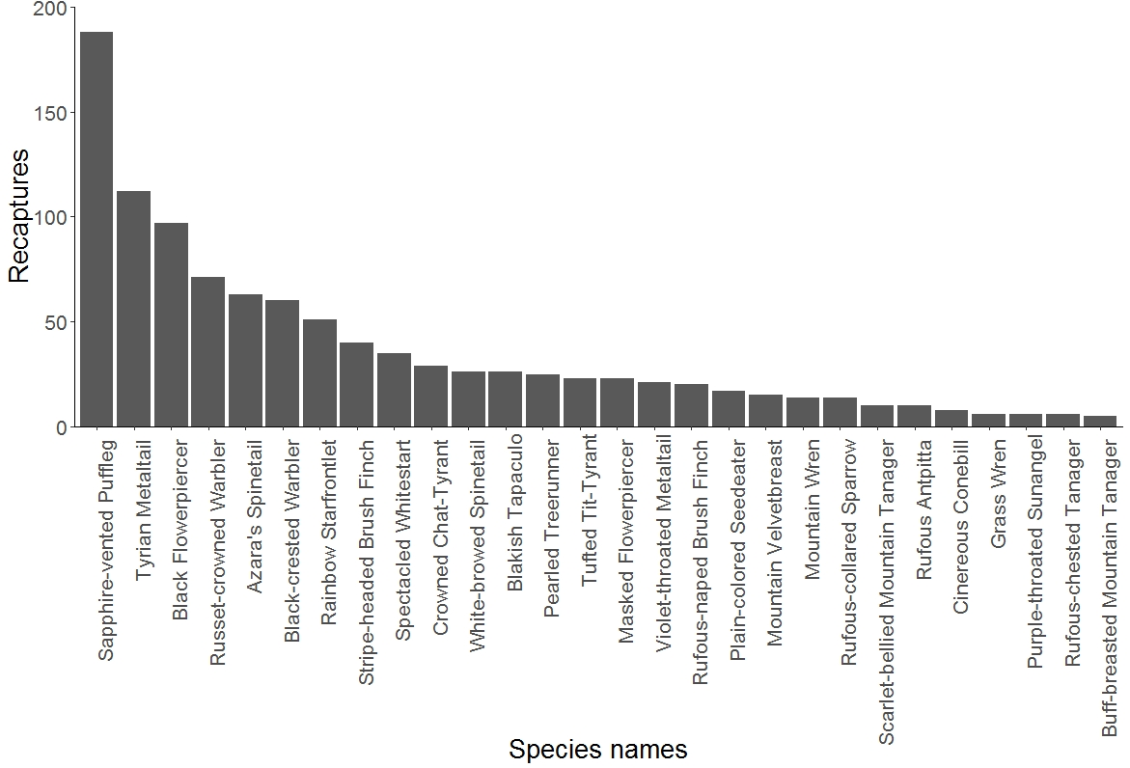

Figure 2
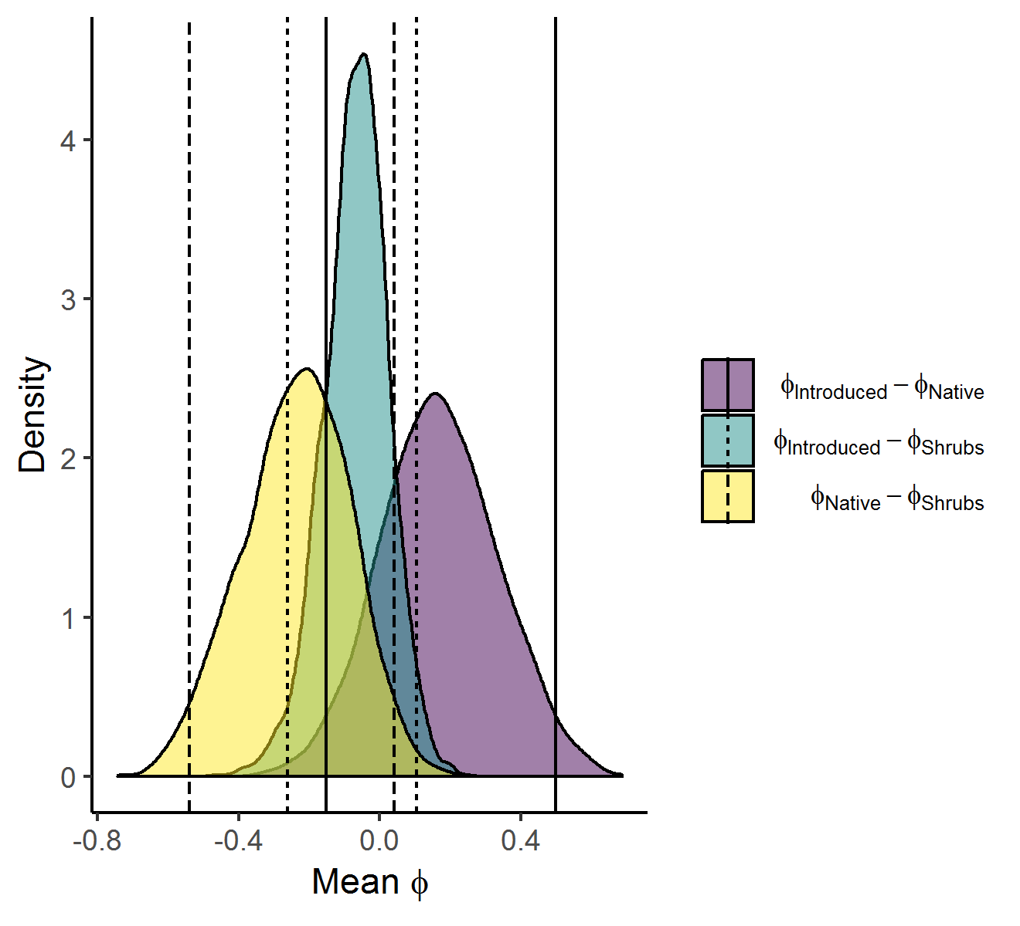

Figure 3
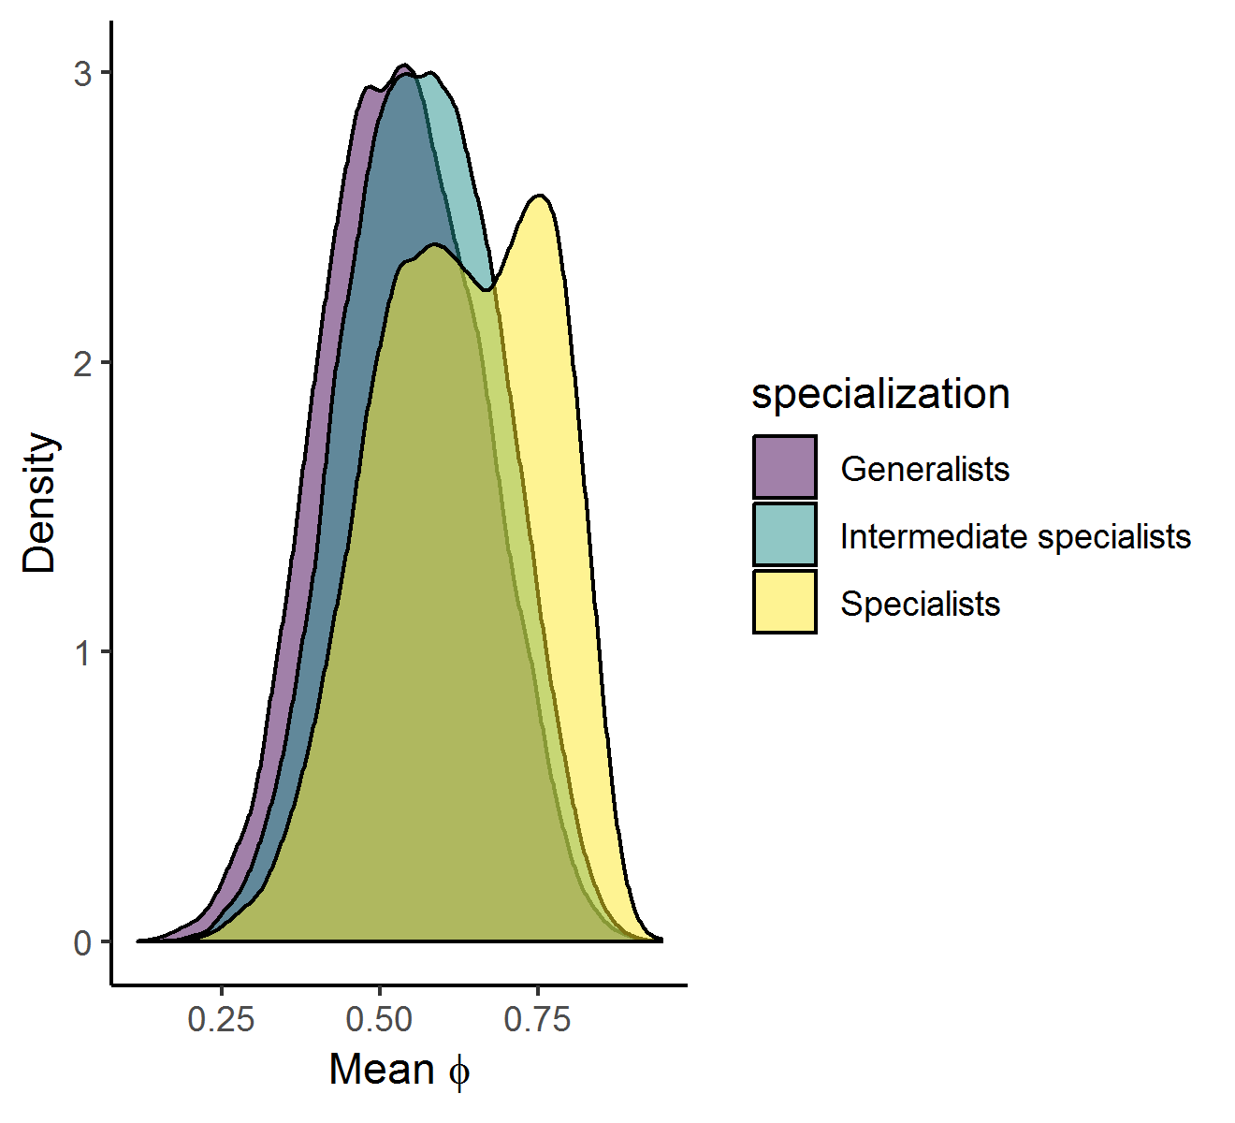

APPENDIX
Table S1: Recapture history
Scientific name | Common name | Number of times recaptured |  |  |  |  |  |  |  |  |  | Number of individuals | Number of recaptures | Evaluated
 |  | 0 | 1 | 2 | 3 | 4 | 5 | 6 | 7 | 8 | 12
Anairetes parulus | Tufted Tit-Tyrant | 18 | 4 | 4 | 0 | 1 | 0 | 0 | 1 | 0 | 0 | 28 | 23 | Y
Anisognathus igniventris | Scarlet-bellied Mountain Tanager | 29 | 6 | 2 | 0 | 0 | 0 | 0 | 0 | 0 | 0 | 37 | 10 | Y
Atlapetes latinuchus | Rufous-naped Brush Finch | 67 | 11 | 3 | 1 | 0 | 0 | 0 | 0 | 0 | 0 | 82 | 20 | Y
Basileuterus coronatus | Russet-crowned Warbler | 106 | 20 | 8 | 5 | 3 | 0 | 0 | 0 | 1 | 0 | 143 | 71 | Y
Basileuterus nigrocristatus | Black-crested Warbler | 54 | 20 | 10 | 3 | 0 | 1 | 1 | 0 | 0 | 0 | 89 | 60 | Y
Buarremon torquatus | Stripe-headed Brush Finch | 55 | 15 | 6 | 3 | 1 | 0 | 0 | 0 | 0 | 0 | 80 | 40 | Y
Catamenia inornata | Plain-colored Seedeater | 95 | 9 | 1 | 0 | 0 | 0 | 1 | 0 | 0 | 0 | 106 | 17 | Y
Cistothorus platensis | Grass Wren | 70 | 6 | 0 | 0 | 0 | 0 | 0 | 0 | 0 | 0 | 76 | 6 | Y
Coeligena iris | Rainbow Starfrontlet | 155 | 25 | 4 | 4 | 0 | 0 | 1 | 0 | 0 | 0 | 189 | 51 | Y
Conirostrum cinereum | Cinereous Conebill | 15 | 5 | 0 | 1 | 0 | 0 | 0 | 0 | 0 | 0 | 21 | 8 | Y
Diglossa humeralis | Black Flowerpiercer | 160 | 26 | 11 | 5 | 2 | 4 | 1 | 0 | 0 | 0 | 209 | 97 | Y
Diglossopis cyanea | Masked Flowerpiercer | 163 | 12 | 4 | 1 | 0 | 0 | 0 | 0 | 0 | 0 | 180 | 23 | Y
Dubusia taeniata | Buff-breasted Mountain Tanager | 16 | 5 | 0 | 0 | 0 | 0 | 0 | 0 | 0 | 0 | 21 | 5 | Y
Eriocnemis luciani | Sapphire-vented Puffleg | 253 | 59 | 12 | 5 | 8 | 3 | 4 | 1 | 0 | 1 | 346 | 188 | Y
Grallaria rufula | Rufous Antpitta | 48 | 8 | 1 | 0 | 0 | 0 | 0 | 0 | 0 | 0 | 57 | 10 | Y
Heliangelus viola | Purple-throated Sunangel | 77 | 4 | 1 | 0 | 0 | 0 | 0 | 0 | 0 | 0 | 82 | 6 | Y
Hellmayrea gularis | White-browed Spinetail | 15 | 4 | 0 | 2 | 1 | 0 | 2 | 0 | 0 | 0 | 24 | 26 | Y
Lafresnaya lafresnayi | Mountain Velvetbreast | 95 | 11 | 2 | 0 | 0 | 0 | 0 | 0 | 0 | 0 | 108 | 15 | Y
Margarornis squamiger | Pearled Treerunner | 37 | 4 | 4 | 3 | 1 | 0 | 0 | 0 | 0 | 0 | 49 | 25 | Y
Metallura baroni | Violet-throated Metaltail | 118 | 13 | 4 | 0 | 0 | 0 | 0 | 0 | 0 | 0 | 135 | 21 | Y
Metallura tyrianthina | Tyrian Metaltail | 447 | 72 | 14 | 4 | 0 | 0 | 0 | 0 | 0 | 0 | 537 | 112 | Y
Myioborus melanocephalus | Spectacled Whitestart | 113 | 17 | 5 | 1 | 0 | 1 | 0 | 0 | 0 | 0 | 137 | 35 | Y
Ochthoeca frontalis | Crowned Chat-Tyrant | 65 | 12 | 2 | 1 | 1 | 0 | 1 | 0 | 0 | 0 | 82 | 29 | Y
Scytalopus latrans | Blakish Tapaculo | 32 | 13 | 4 | 0 | 0 | 1 | 0 | 0 | 0 | 0 | 50 | 26 | Y
Synallaxis azarae | Azara's Spinetail | 62 | 25 | 7 | 5 | 1 | 1 | 0 | 0 | 0 | 0 | 101 | 63 | Y
Thlypopsis ornata | Rufous-chested Tanager | 27 | 4 | 1 | 0 | 0 | 0 | 0 | 0 | 0 | 0 | 32 | 6 | Y
Troglodytes solstitialis | Mountain Wren | 40 | 8 | 3 | 0 | 0 | 0 | 0 | 0 | 0 | 0 | 51 | 14 | Y
Zonotrichia capensis | Rufous-collared Sparrow | 54 | 10 | 2 | 0 | 0 | 0 | 0 | 0 | 0 | 0 | 66 | 14 | Y
Accipiter ventralis | Sharp-shinned Hawk | 2 | 0 | 0 | 0 | 0 | 0 | 0 | 0 | 0 | 0 | 2 | 0 | N
Aglaeactis cupripennis | Shining Sunbeam | 13 | 0 | 0 | 0 | 0 | 0 | 0 | 0 | 0 | 0 | 13 | 0 | N
Amblycercus holosericeus | Yellow-bellied Cacique | 18 | 1 | 0 | 0 | 0 | 0 | 0 | 0 | 0 | 0 | 19 | 1 | N
Carduelis magellanica | Hooded Siskin | 1 | 0 | 0 | 0 | 0 | 0 | 0 | 0 | 0 | 0 | 1 | 0 | N
Catamblyrhynchus diadema | Plushcap | 5 | 0 | 0 | 0 | 0 | 0 | 0 | 0 | 0 | 0 | 5 | 0 | N
Catamenia analis | Band-tailed Seedeater | 1 | 0 | 0 | 0 | 0 | 0 | 0 | 0 | 0 | 0 | 1 | 0 | N
Catamenia homochroa | Paramo Seedeater | 8 | 0 | 0 | 0 | 0 | 0 | 0 | 0 | 0 | 0 | 8 | 0 | N
Chaetocercus mulsant | White-bellied Woodstar | 2 | 0 | 0 | 0 | 0 | 0 | 0 | 0 | 0 | 0 | 2 | 0 | N
Colibri coruscans | Sparkling Violetear | 9 | 0 | 0 | 0 | 0 | 0 | 0 | 0 | 0 | 0 | 9 | 0 | N
Conirostrum sitticolor | Blue-backed Conebill | 3 | 0 | 0 | 0 | 0 | 0 | 0 | 0 | 0 | 0 | 3 | 0 | N
Cranioleuca antisiensis | Line-cheeked Spinetail | 13 | 2 | 0 | 0 | 0 | 0 | 0 | 0 | 0 | 0 | 15 | 2 | N
Cyanolyca turcosa | Turquoise Jay | 9 | 0 | 0 | 0 | 0 | 0 | 0 | 0 | 0 | 0 | 9 | 0 | N
Elaenia albiceps | White-crested Elaenia | 5 | 0 | 0 | 0 | 0 | 0 | 0 | 0 | 0 | 0 | 5 | 0 | N
Ensifera ensifera | Sword-billed Hummingbird | 1 | 2 | 0 | 0 | 0 | 0 | 0 | 0 | 0 | 0 | 3 | 2 | N
Eriocnemis vestitus | Glowing Puffleg | 16 | 1 | 0 | 0 | 0 | 0 | 0 | 0 | 0 | 0 | 17 | 1 | N
Glaucidium jardinii | Andean Pygmy-Owl | 6 | 1 | 1 | 0 | 0 | 0 | 0 | 0 | 0 | 0 | 8 | 3 | N
Grallaria quitensis | Tawny Antpitta | 1 | 0 | 0 | 0 | 0 | 0 | 0 | 0 | 0 | 0 | 1 | 0 | N
Grallaria ruficapilla | Chestnut-crowned Antpitta | 5 | 0 | 0 | 0 | 0 | 0 | 0 | 0 | 0 | 0 | 5 | 0 | N
Grallaria squamigera | Undulated Antpitta | 4 | 0 | 0 | 0 | 0 | 0 | 0 | 0 | 0 | 0 | 4 | 0 | N
Hemispingus superciliaris | Superciliated Hemispingus | 29 | 2 | 3 | 0 | 0 | 0 | 0 | 0 | 0 | 0 | 34 | 8 | N
Lesbia nuna | Green-tailed Trainbearer | 12 | 0 | 0 | 0 | 0 | 0 | 0 | 0 | 0 | 0 | 12 | 0 | N
Lesbia victoriae | Black-tailed Trainbearer | 23 | 2 | 0 | 0 | 0 | 0 | 0 | 0 | 0 | 0 | 25 | 2 | N
Mecocerculus leucophrys | White-throated Tyrannulet | 8 | 0 | 0 | 0 | 0 | 0 | 0 | 0 | 0 | 0 | 8 | 0 | N
Mecocerculus stictopterus | White-banded Tyrannulet | 13 | 0 | 0 | 0 | 0 | 0 | 0 | 0 | 0 | 0 | 13 | 0 | N
Myiotheretes fumigatus | Smoky Bush-tyrant | 1 | 0 | 0 | 0 | 0 | 0 | 0 | 0 | 0 | 0 | 1 | 0 | N
Notiochelidon murina | Brown-bellied Swallow | 2 | 0 | 0 | 0 | 0 | 0 | 0 | 0 | 0 | 0 | 2 | 0 | N
Ochthoeca cinnamomeiventris | Slaty-backed Chat-Tyrant | 10 | 1 | 0 | 0 | 0 | 0 | 0 | 0 | 0 | 0 | 11 | 1 | N
Ochthoeca fumicolor | Brown-backed Chat-Tyrant | 6 | 1 | 0 | 0 | 0 | 0 | 0 | 0 | 0 | 0 | 7 | 1 | N
Ochthoeca rufipectoralis | Rufous-breasted Chat-tyrant | 12 | 1 | 0 | 0 | 0 | 0 | 0 | 0 | 0 | 0 | 13 | 1 | N
Phyllomyias nigrocapillus | Black-capped Tyrannulet | 1 | 0 | 0 | 0 | 0 | 0 | 0 | 0 | 0 | 0 | 1 | 0 | N
Phyllomyias uropygialis | Tawny-rumped Tyrannulet | 11 | 3 | 0 | 0 | 0 | 0 | 0 | 0 | 0 | 0 | 14 | 3 | N
Piculus rivolii | Crimson-mantled Woodpecker | 3 | 0 | 0 | 0 | 0 | 0 | 0 | 0 | 0 | 0 | 3 | 0 | N
Poroaria coronata | Red-crested Cardinal | 1 | 0 | 0 | 0 | 0 | 0 | 0 | 0 | 0 | 0 | 1 | 0 | N
Pseudocolaptes boissonneautii | Streaked Tuftedcheek | 12 | 0 | 1 | 0 | 0 | 0 | 0 | 0 | 0 | 0 | 13 | 2 | N
Pterophanes cyanopterus | Great Sapphirewing | 25 | 1 | 0 | 0 | 0 | 0 | 0 | 0 | 0 | 0 | 26 | 1 | N
Pyrrhomyias cinnamomea | Cinnamon Flycatcher | 3 | 0 | 0 | 0 | 0 | 0 | 0 | 0 | 0 | 0 | 3 | 0 | N
Tangara vassorii | Blue-and-black Tanager | 55 | 6 | 0 | 0 | 0 | 0 | 0 | 0 | 0 | 0 | 61 | 6 | N
Thripadectes flammulatus | Flammulated Treehunter | 7 | 2 | 1 | 0 | 0 | 0 | 0 | 0 | 0 | 0 | 10 | 4 | N
Trogon personatus | Masked Trogon | 3 | 0 | 0 | 0 | 0 | 0 | 0 | 0 | 0 | 0 | 3 | 0 | N
Turdus fuscater | Great Thrush | 15 | 0 | 0 | 0 | 0 | 0 | 0 | 0 | 0 | 0 | 15 | 0 | N
Uromyias agilis | Agile Tit-Tyrant | 3 | 0 | 0 | 0 | 0 | 0 | 0 | 0 | 0 | 0 | 3 | 0 | N
Veniliornis nigriceps | Bar-bellied Woodpecker | 1 | 0 | 0 | 0 | 0 | 0 | 0 | 0 | 0 | 0 | 1 | 0 | N
Table S2: Apparent survival estimates for 28 birds species with apparent survival (ϕ) and recapture probability (p) estimated separately for each habitat. Values show mean (95% credible interval).
Species | Specialization | Habitat | P | ϕ
Grass Wren | Generalists | Native forest | 0.17 (0.04, 0.38) | 0.42 (0.01, 0.95)
Grass Wren | Generalists | Introduced forest | 0.25 (0.03, 0.67) | 0.55 (0.15, 0.87)
Grass Wren | Generalists | Shrubs | 0.14 (0.05, 0.29) | 0.59 (0.28, 0.81)
Plain-colored Seedeater | Generalists | Native forest | 0.17 (0.04, 0.4) | 0.43 (0.01, 0.95)
Plain-colored Seedeater | Generalists | Introduced forest | 0.23 (0.03, 0.64) | 0.57 (0.18, 0.87)
Plain-colored Seedeater | Generalists | Shrubs | 0.19 (0.09, 0.34) | 0.68 (0.52, 0.85)
Rufous-collared Sparrow | Generalists | Native forest | 0.17 (0.04, 0.39) | 0.42 (0.01, 0.95)
Rufous-collared Sparrow | Generalists | Introduced forest | 0.22 (0.02, 0.61) | 0.56 (0.17, 0.88)
Rufous-collared Sparrow | Generalists | Shrubs | 0.15 (0.07, 0.27) | 0.59 (0.3, 0.79)
Azara's Spinetail | Intermediate specialist | Native forest | 0.19 (0.07, 0.4) | 0.38 (0.01, 0.82)
Azara's Spinetail | Intermediate specialist | Introduced forest | 0.26 (0.09, 0.55) | 0.62 (0.25, 0.86)
Azara's Spinetail | Intermediate specialist | Shrubs | 0.34 (0.23, 0.47) | 0.72 (0.57, 0.85)
Black-crested Warbler | Intermediate specialist | Native forest | 0.17 (0.08, 0.3) | 0.4 (0.01, 0.83)
Black-crested Warbler | Intermediate specialist | Introduced forest | 0.46 (0.26, 0.68) | 0.65 (0.44, 0.82)
Black-crested Warbler | Intermediate specialist | Shrubs | 0.28 (0.16, 0.45) | 0.72 (0.49, 0.86)
Black Flowerpiercer | Intermediate specialist | Native forest | 0.2 (0.07, 0.42) | 0.63 (0.22, 0.98)
Black Flowerpiercer | Intermediate specialist | Introduced forest | 0.14 (0.04, 0.31) | 0.56 (0.14, 0.83)
Black Flowerpiercer | Intermediate specialist | Shrubs | 0.4 (0.28, 0.53) | 0.7 (0.59, 0.81)
Blakish Tapaculo | Intermediate specialist | Native forest | 0.19 (0.07, 0.37) | 0.44 (0.01, 0.92)
Blakish Tapaculo | Intermediate specialist | Introduced forest | 0.27 (0.14, 0.43) | 0.64 (0.38, 0.86)
Blakish Tapaculo | Intermediate specialist | Shrubs | 0.23 (0.08, 0.5) | 0.73 (0.48, 0.9)
Buff-breasted Mountain Tanager | Intermediate specialist | Native forest | 0.17 (0.04, 0.38) | 0.46 (0.01, 0.96)
Buff-breasted Mountain Tanager | Intermediate specialist | Introduced forest | 0.18 (0.03, 0.45) | 0.58 (0.17, 0.86)
Buff-breasted Mountain Tanager | Intermediate specialist | Shrubs | 0.31 (0.12, 0.6) | 0.64 (0.35, 0.8)
Cinereous Conebill | Intermediate specialist | Native forest | 0.17 (0.04, 0.37) | 0.45 (0.01, 0.96)
Cinereous Conebill | Intermediate specialist | Introduced forest | 0.24 (0.03, 0.69) | 0.6 (0.2, 0.89)
Cinereous Conebill | Intermediate specialist | Shrubs | 0.21 (0.09, 0.38) | 0.67 (0.45, 0.83)
Pearled Treerunner | Intermediate specialist | Native forest | 0.18 (0.09, 0.31) | 0.69 (0.32, 0.98)
Pearled Treerunner | Intermediate specialist | Introduced forest | 0.2 (0.02, 0.59) | 0.64 (0.22, 0.9)
Pearled Treerunner | Intermediate specialist | Shrubs | 0.34 (0.17, 0.58) | 0.74 (0.58, 0.89)
Purple-throated Sunangel | Intermediate specialist | Native forest | 0.14 (0.04, 0.26) | 0.36 (0.01, 0.85)
Purple-throated Sunangel | Intermediate specialist | Introduced forest | 0.11 (0.01, 0.3) | 0.53 (0.14, 0.85)
Purple-throated Sunangel | Intermediate specialist | Shrubs | 0.21 (0.06, 0.48) | 0.61 (0.38, 0.79)
Rufous-chested Tanager | Intermediate specialist | Native forest | 0.19 (0.06, 0.4) | 0.42 (0.01, 0.91)
Rufous-chested Tanager | Intermediate specialist | Introduced forest | 0.34 (0.1, 0.75) | 0.6 (0.25, 0.88)
Rufous-chested Tanager | Intermediate specialist | Shrubs | 0.11 (0.03, 0.24) | 0.66 (0.41, 0.83)
Rufous-naped Brush Finch | Intermediate specialist | Native forest | 0.14 (0.03, 0.28) | 0.45 (0.01, 0.96)
Rufous-naped Brush Finch | Intermediate specialist | Introduced forest | 0.18 (0.07, 0.33) | 0.5 (0.11, 0.77)
Rufous-naped Brush Finch | Intermediate specialist | Shrubs | 0.23 (0.08, 0.47) | 0.67 (0.44, 0.86)
Rufous Antpitta | Intermediate specialist | Native forest | 0.14 (0.04, 0.27) | 0.38 (0.01, 0.89)
Rufous Antpitta | Intermediate specialist | Introduced forest | 0.14 (0.02, 0.38) | 0.56 (0.15, 0.87)
Rufous Antpitta | Intermediate specialist | Shrubs | 0.2 (0.05, 0.47) | 0.64 (0.36, 0.85)
Sapphire-vented Puffleg | Intermediate specialist | Native forest | 0.13 (0.03, 0.25) | 0.39 (0.01, 0.94)
Sapphire-vented Puffleg | Intermediate specialist | Introduced forest | 0.33 (0.16, 0.55) | 0.65 (0.46, 0.86)
Sapphire-vented Puffleg | Intermediate specialist | Shrubs | 0.35 (0.26, 0.44) | 0.65 (0.54, 0.77)
Scarlet-bellied Mountain Tanager | Intermediate specialist | Native forest | 0.13 (0.03, 0.26) | 0.46 (0.01, 0.96)
Scarlet-bellied Mountain Tanager | Intermediate specialist | Introduced forest | 0.22 (0.07, 0.47) | 0.56 (0.16, 0.84)
Scarlet-bellied Mountain Tanager | Intermediate specialist | Shrubs | 0.15 (0.06, 0.29) | 0.66 (0.38, 0.82)
Tufted Tit-Tyrant | Intermediate specialist | Native forest | 0.17 (0.04, 0.38) | 0.49 (0.02, 0.96)
Tufted Tit-Tyrant | Intermediate specialist | Introduced forest | 0.34 (0.07, 0.79) | 0.6 (0.2, 0.87)
Tufted Tit-Tyrant | Intermediate specialist | Shrubs | 0.36 (0.2, 0.57) | 0.71 (0.54, 0.85)
Tyrian Metaltail | Intermediate specialist | Native forest | 0.15 (0.08, 0.24) | 0.29 (0.01, 0.76)
Tyrian Metaltail | Intermediate specialist | Introduced forest | 0.13 (0.06, 0.25) | 0.51 (0.18, 0.79)
Tyrian Metaltail | Intermediate specialist | Shrubs | 0.21 (0.13, 0.32) | 0.56 (0.34, 0.7)
Violet-throated Metaltail | Intermediate specialist | Native forest | 0.17 (0.04, 0.39) | 0.41 (0.01, 0.94)
Violet-throated Metaltail | Intermediate specialist | Introduced forest | 0.25 (0.03, 0.67) | 0.53 (0.13, 0.85)
Violet-throated Metaltail | Intermediate specialist | Shrubs | 0.2 (0.1, 0.35) | 0.62 (0.43, 0.79)
Crowned Chat-Tyrant | Specialists | Native forest | 0.2 (0.1, 0.35) | 0.46 (0.07, 0.87)
Crowned Chat-Tyrant | Specialists | Introduced forest | 0.3 (0.08, 0.67) | 0.68 (0.32, 0.94)
Crowned Chat-Tyrant | Specialists | Shrubs | 0.2 (0.09, 0.38) | 0.76 (0.58, 0.9)
Masked Flowerpiercer | Specialists | Native forest | 0.12 (0.04, 0.23) | 0.42 (0.01, 0.9)
Masked Flowerpiercer | Specialists | Introduced forest | 0.13 (0.05, 0.26) | 0.55 (0.13, 0.83)
Masked Flowerpiercer | Specialists | Shrubs | 0.1 (0.03, 0.22) | 0.71 (0.5, 0.88)
Mountain Velvetbreast | Specialists | Native forest | 0.17 (0.07, 0.29) | 0.31 (0.01, 0.76)
Mountain Velvetbreast | Specialists | Introduced forest | 0.22 (0.05, 0.52) | 0.54 (0.15, 0.84)
Mountain Velvetbreast | Specialists | Shrubs | 0.12 (0.04, 0.26) | 0.62 (0.36, 0.82)
Mountain Wren | Specialists | Native forest | 0.16 (0.06, 0.31) | 0.44 (0.01, 0.95)
Mountain Wren | Specialists | Introduced forest | 0.37 (0.17, 0.64) | 0.6 (0.27, 0.84)
Mountain Wren | Specialists | Shrubs | 0.12 (0.03, 0.27) | 0.68 (0.39, 0.87)
Rainbow Starfrontlet | Specialists | Native forest | 0.22 (0.12, 0.39) | 0.39 (0.05, 0.77)
Rainbow Starfrontlet | Specialists | Introduced forest | 0.3 (0.16, 0.49) | 0.61 (0.4, 0.81)
Rainbow Starfrontlet | Specialists | Shrubs | 0.13 (0.04, 0.27) | 0.62 (0.34, 0.81)
Russet-crowned Warbler | Specialists | Native forest | 0.23 (0.14, 0.35) | 0.75 (0.58, 0.92)
Russet-crowned Warbler | Specialists | Introduced forest | 0.3 (0.18, 0.44) | 0.82 (0.67, 0.96)
Russet-crowned Warbler | Specialists | Shrubs | 0.13 (0.04, 0.27) | 0.76 (0.55, 0.9)
Spectacled Whitestart | Specialists | Native forest | 0.12 (0.03, 0.23) | 0.51 (0.02, 0.96)
Spectacled Whitestart | Specialists | Introduced forest | 0.15 (0.06, 0.29) | 0.75 (0.52, 0.94)
Spectacled Whitestart | Specialists | Shrubs | 0.15 (0.08, 0.26) | 0.77 (0.61, 0.9)
Stripe-headed Brush Finch | Specialists | Native forest | 0.14 (0.04, 0.27) | 0.47 (0.01, 0.94)
Stripe-headed Brush Finch | Specialists | Introduced forest | 0.35 (0.22, 0.51) | 0.72 (0.56, 0.87)
Stripe-headed Brush Finch | Specialists | Shrubs | 0.17 (0.06, 0.32) | 0.72 (0.48, 0.89)
White-browed Spinetail | Specialists | Native forest | 0.16 (0.06, 0.3) | 0.8 (0.48, 0.99)
White-browed Spinetail | Specialists | Introduced forest | 0.63 (0.35, 0.89) | 0.75 (0.56, 0.92)
White-browed Spinetail | Specialists | Shrubs | 0.32 (0.13, 0.6) | 0.73 (0.5, 0.88)

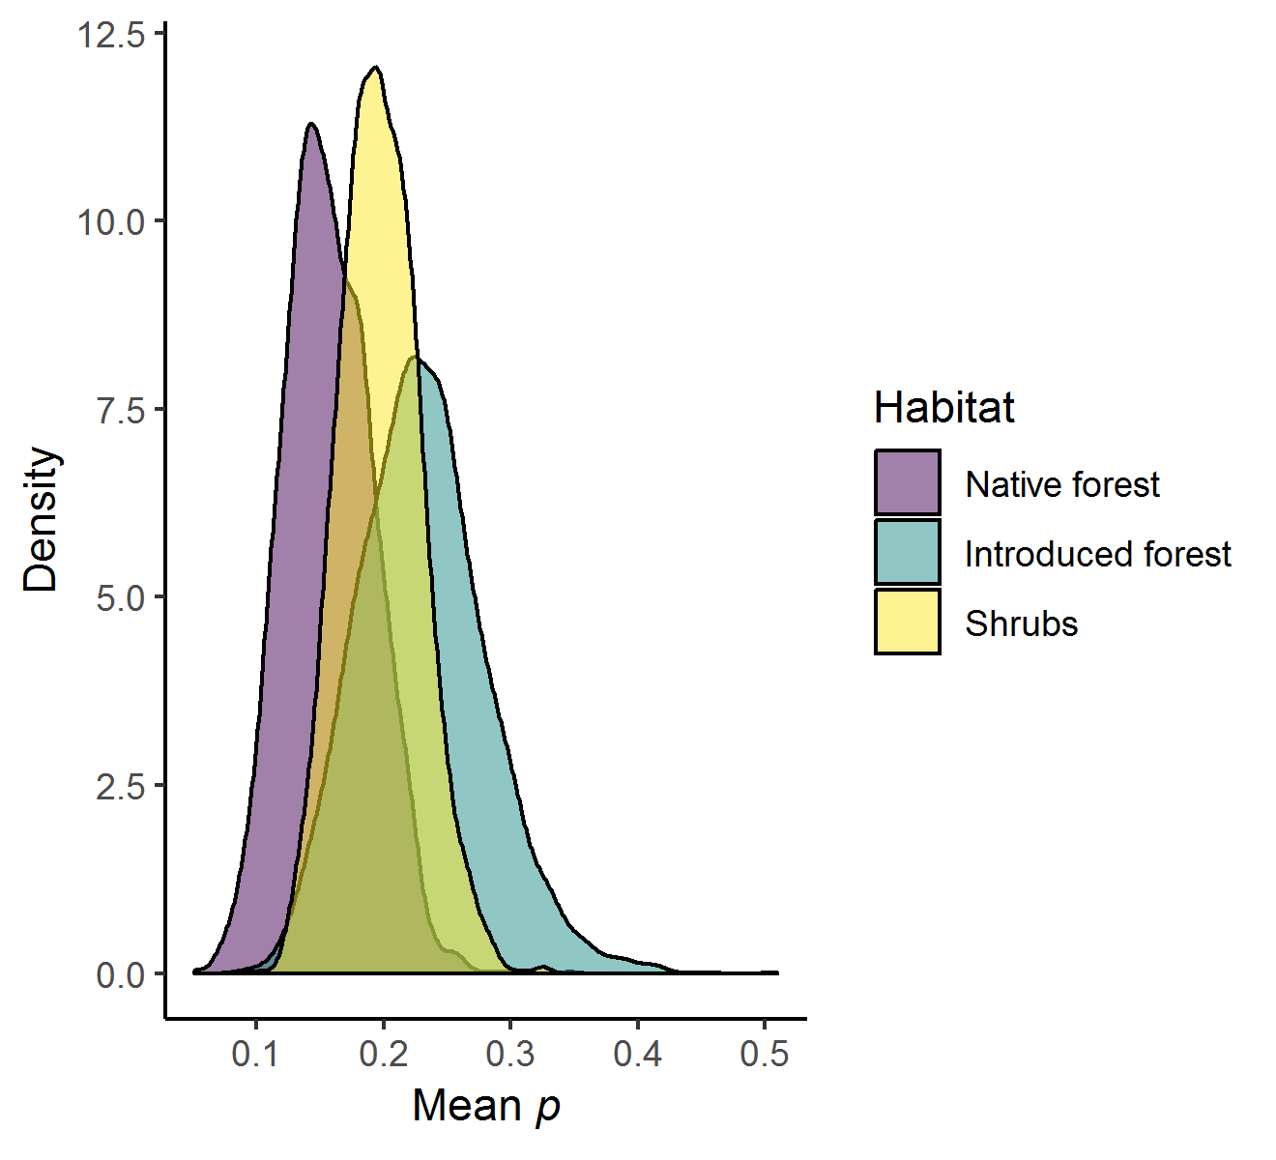

Figure S1 Comparison of recapture probability (p) of all individuals occurring in each of three habitats.

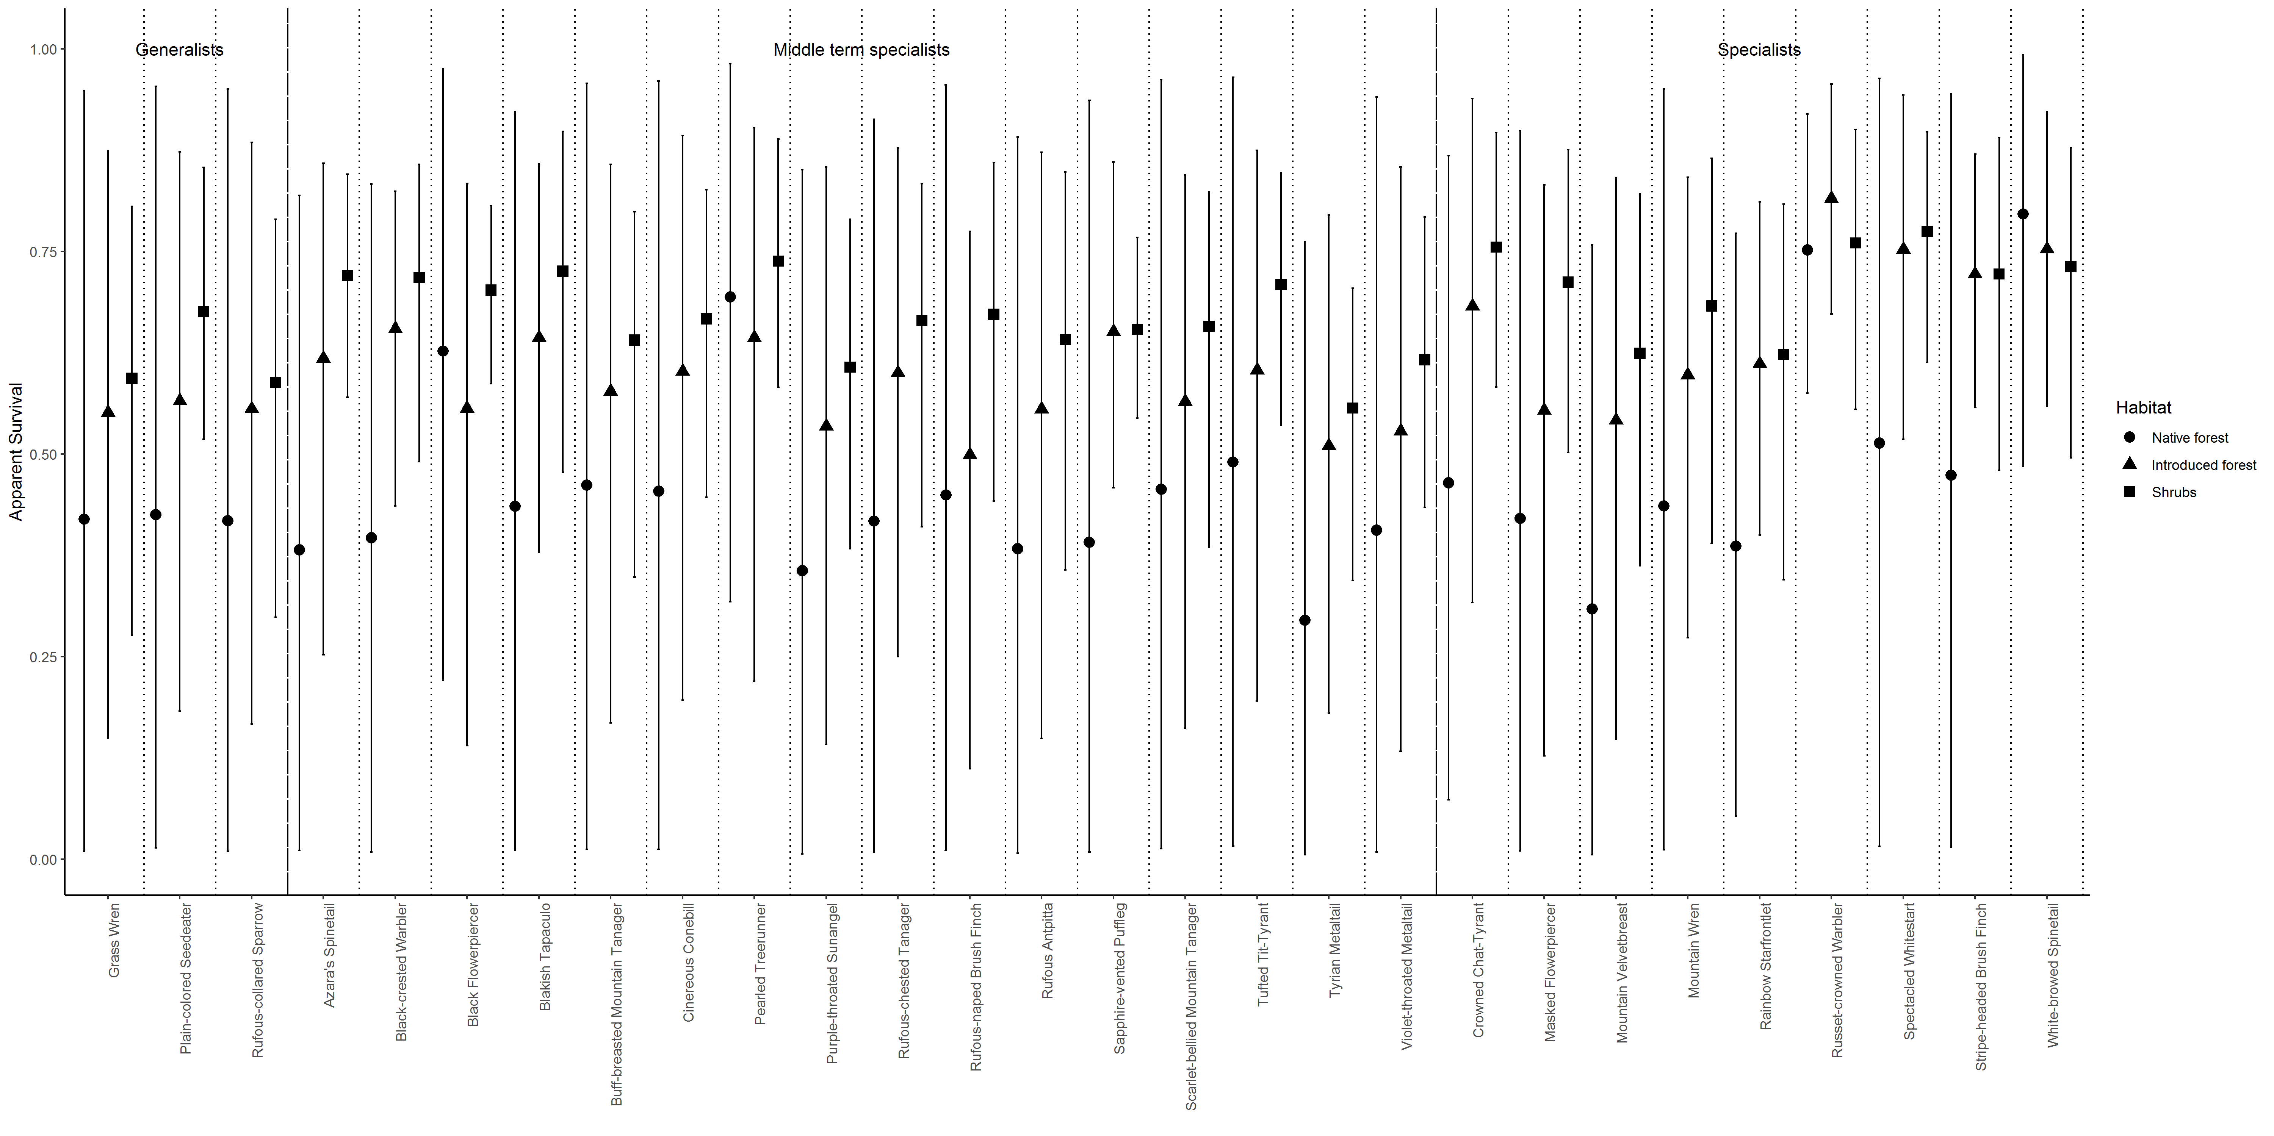
Figure S2 Apparent survival ($ϕ$) and 95% credible individual for each species in each habit

