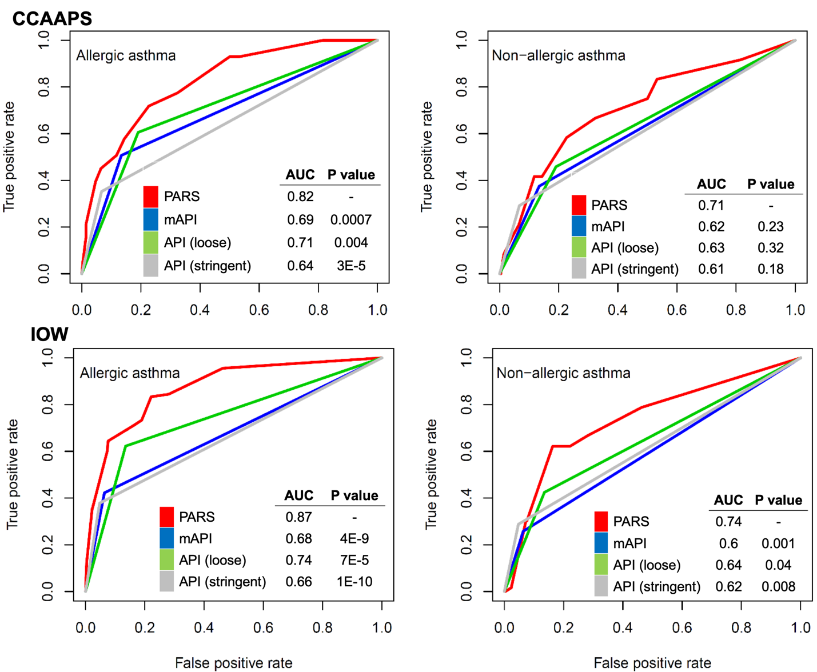

Figure 1: ROC for asthma prediction models applied to allergic and non-allergic asthma in the CCAAPS and IOW cohorts

