The Geography of Changing Fertility in Myanmar

Anne Schuster, Andrew Hinde and Sabu Padmadas

Department of Social Statistics and Demography
University of Southampton
SOUTHAMPTON
SO17 1BJ
United Kingdom

Please address correspondence to Anne Schuster: as13g15@soton.ac.uk

Draft: please do not quote without permission
Abstract
BACKGROUND: Between 1983 and 2014, the total fertility rate in Myanmar declined from 4.7 to 2.3 children per woman. Previous analyses of fertility decline in the country suggest that the decline varied regionally, but the geography of the decline has not been formally assessed.
METHODS: Using data from the 1983 and 2014 censuses, we examine fertility trends and geospatial patterns in fertility decline in Myanmar during the intercensal period, and investigate the aggregate socioeconomic factors underlying fertility decline at sub-regional levels.
RESULTS: Between 1983 and 2014, fertility change at sub-regional level was characterised by a precipitous decline in fertility rates in the broad central valley areas and a much weaker decline in remote, peripheral areas. Regression analysis of the 2014 census data, adjusting for state/region level variances, reveals a strong negative correlation between fertility and access to modern communication technologies. District level female education and road connectivity were also associated with fertility.
CONCLUSIONS: The geographical diversity in Myanmar’s fertility transition has intensified over time, as fertility decline is concentrated in areas with greater development, higher socioeconomic status and better connectivity to information networks.
CONTRIBUTION: A district’s digital connectivity, measured through access to communication technologies, was a better predictor of fertility than other traditional measures. There is a need to explore to what extent digital connectivity is a proxy indicator for levels of modernisation and access to family planning and reproductive health services, and the extent to which it measures the intensity of social networks and the diffusion of information.
Introduction
Myanmar has experienced rapid population growth over the past half century, more than tripling in population since establishing its current borders in 1948. However, the most recent census data show a smaller than forecasted population. Intercensal estimates assumed sustained population growth and projected a population between 45 and 64 million by 2003 (Maung 1986, Myint 1991, Tint 1991, Spoorenberg 2013), but the 2014 Census counted only around 51 million people. Recent analyses report a deceleration of population growth consistent with fertility decline (Spoorenberg 2013, World Bank 2016). This paper examines the geography of, and the factors associated with, this fertility decline.
Myanmar is a geographically diverse country. There are 21 administrative sub-divisions; seven regions and seven states, one union territory (Nay Pyi Taw), one self-administered region and five self-administered zones (Figure 1a). Regions and states are subdivided into 73 districts and 330 townships. (General Administrative Department 2018). Border states are typically remote, sparsely populated and mountainous. Travel is difficult and their populations are ethnically heterogeneous, a situation associated with civil unrest. As a result, factors typically associated with fertility are affected. For example, access to health facilities and education is poor. The majority of health facilities offering maternal and reproductive health services in Chin and Shan states are more than 21 miles from the closest medical depot (Department of Medical Research et al. 2016). In eastern Shan state, only 8.5% of women were estimated to have secondary or higher education in 2009-2010 and in 2014 only 66% of Shan state’s population were literate (Ministry of National Planning and Economic Development, Ministry of Health, and UNICEF 2011, Department of Population, Ministry of Labour, Immigration and Population 2016a). In comparison, those living in the central regions of the country are predominantly ethnically Burmese, and are of generally higher socioeconomic status with better access to health and education services.
[Figure 1 about here]
Border states have also been affected by conflict during the past decades. Conflict event data for the census year of 2014 indicate that conflict incidents were widespread throughout the country, though most intense in Rakhine, northern Shan, and western Kachin states (Figure 1b). Although less frequent, Kayin state also regularly experienced conflict during the same period. The most intensive conflicts have been in peripheral areas inhabited by ethnic minorities, such as Rakhine state.
Finally, access to digital technology was severely restricted until 2013 when private mobile telephone providers were introduced. Official statistics report that the number of mobile telephone users increased 100 times over between 2010 and 2016, but critics have noted that rural areas and women were left behind during the rapid growth of the country’s telecommunications systems (Shadrach 2018).
In this paper we examine regional fertility trends using data from the 1983 and 2014 censuses, validated using data from the recently released 2016 Demographic and Health Survey (DHS). We compare sub-regional fertility patterns in 2014 with those reported 31 years earlier. Aggregate data from the 2014 census are examined to provide insight into the factors influencing fertility at a sub-regional level, and how these factors may contribute to our understanding of other health and social outcomes across the country.
We generated maps showing the geospatial distribution of fertility and associated factors using ArcGIS 10.4.1 and applying Shapefiles and Place Codes from the Myanmar Information Management Unit (2007). Statistical analysis was carried out using Microsoft Excel and IBM SPSS Statistics v.24.

Data and methods
Data for 1983 were abstracted from individual state- and region-level published census reports. The reports include tables of population by five-year age groups and sex for each township, but do not include information on births below the state/region level (Immigration and Manpower Department, Ministry of Home and Religious Affairs 1986). For this reason, we calculated the implied Total Fertility Rate (iTFR) to obtain fertility estimates for smaller geographic areas (Hauer, Baker, and Brown 2013). The iTFR uses data on the population aged under five years to estimate the annual number of births in a particular area, and divides this by the population of women in the fertile age range to estimate the mean age-specific fertility rate across the fertile ages. Multiplying this by the number of years in the fertile age range produces the iTFR. The iTFR has been found to perform well compared with other methods of estimating the TFR, such as the Bogue-Palmore method (Hauer, Baker and Brown 2013).
The iTFR as originally proposed assumes no child mortality or migration. As we had access to child mortality estimates, we adjusted our iTFR estimates for the expected number of children born in the last five years who would have died before the census. At the state/region level, our iTFRs were generally lower than Myint’s (1991) estimates of the 1983 fertility rates using Brass, Trussell and Arriaga’s methods.
We use the estimates of township TFR that were computed for the 2014 Census (Department of Population, Ministry of Labour, Immigration and Population 2016a). As a check on the accuracy of the Census data, we compared the state/region TFRs reported in the census with those from the 2016 DHS (Ministry of Health and Sports and ICF 2017), and found them to be very similar. Of the 322 townships with data from either 1983 or 2014, 18 could not be compared between the two years. This was primarily because of the creation of new districts during the intercensal period (notably the union territory and capital of Nay Pyi Taw in 2005). The census data for conflict areas are known to be deficient. Access to some areas was restricted during both census enumerations. In 1983, access to 830 village tracts was restricted and another 112 were only partially enumerated. In 2014, enumeration was restricted in Kachin, Kayin and Rakhine states: the number of non-enumerated village tracts is not documented, but an estimated 1.2 million individuals lived in the non-enumerated areas. In most cases, the census estimated population figures and demographic characteristics for these townships, but eight townships were excluded completely from data collection during at least one of the two censuses. Data for these townships are not included in our maps. However, as the census records do not identify the townships that were only partially enumerated, we have included them in the analysis.
WorldPop (2017), while generating population estimates for Myanmar, identified several townships and districts requiring adjustment. In their analysis, three townships in Rakhine were merged, two townships and a district were merged in Kachin; and additional mergers of areas took place in Shan state. Limitations on the availability of micro-data meant that we could not reconstruct the TFRs of new townships for comparison between the two censuses or derive TFR estimates for the merged geographic areas suggested by WorldPop.
New townships and partially enumerated townships were included in the regression analysis of the district-level 2014 census data. As a check, we re-ran our model with all districts and excluding those districts for which data might be unreliable. While the coefficient estimates varied slightly, the direction and magnitude of the effects, and the standard errors, were similar with and without the contested districts.

Geographical variations in fertility, 1983-2014
In 1983, geographical fertility variations in Myanmar were modest (Figure 2a). Fertility was low in parts of Shan province and in areas of Rakhine, Bago and Ayeyarwady provinces, but there were few other obvious patterns. By 2014, the TFR in a broad swathe of the centre of the country was below three children per woman, and in several townships it was below two children per woman (Figure 2b). The lowest rates were found in townships in Mandalay and Magway regions and in an area spanning the west of Bago region and the north of Ayeyarwady region. By contrast, several townships in peripheral border areas of the north and west, and in Shan state in the east, had TFRs in excess of five children per woman. Most of Chin state had a TFR of more than four children per woman.
[Figure 2 about here]
Previous comparisons of 1973 and 1983 census data suggest that the fertility decline began in the early 1970s in urban areas but also reached into rural parts of the country (Myint 1991). At the state/regional level, a similar pattern of decline is found from 1983 to 2014. However, analysis of township level estimates (Figure 3) suggest that larger declines in some urban townships may be masking stalls or increases in fertility decline in peripheral areas. The general pattern is of fertility decline in the central valley, but constant or increasing fertility in the rural, ethnically heterogeneous, periphery.
[Figure 3 about here]

Factors associated with fertility in 2014
The 2014 TFRs shown in the previous section are estimated at the township level, but data used to measure factors associated with fertility are only publicly available at the district or state/region levels. For this reason, examination of the factors associated with fertility in Myanmar based on the 2014 Census was conducted for the 71 districts then extant. Besides information on fertility, district proportions of married and educated women, households with safe sanitation, households with dirt floors, households that were apartments or condominiums, and households with access to various modes of digital communication were extracted from the 2014 census data. These indicators were selected because they have either: 1) been found to be associated with fertility in previous work (marriage, female education); 2) are indicators of poverty and living conditions (type of housing, sanitation) or; 3) indicate exposure to mass media and communication. Finally, we used ArcGIS 10.4.1 to calculate the average distance from a road intersection in each district using raster data developed as a part of the Global High Resolution Population Denominators Project (University of Southampton Department of Geography and Environmental Sciences et al. 2018).
Based on preliminary analysis of the correlations between the various measures of digital connectivity, we reduced these measures to two. The first is household access to a radio. The second is the first component from a principal component analysis of the remaining connectivity variables: household ownership of a computer, mobile phone, internet and television. Each of the different instruments of connectivity loads positively on the component, so high values of the component denote a high level of connectivity. Analysis of DHS data in other countries reveals that the residents of households with televisions are wealthier, older, better educated and more likely to live in urban areas (Westoff and Koffman 2011) than households with access to a radio. It may be, therefore, that access to a radio is measuring a basic level of digital connectivity, whereas the principal component is measuring the extent of connectedness among households beyond a basic level.
We estimated regression models of the district-level TFRs on various characteristics of the districts. The 71 districts are nested within the 15 states/regions. Self-administered regions and zones were not considered for this analysis. We found an inter-cluster correlation for an empty (variance components) model of the TFR clustered on state/region of 0.47, indicating that just under half of the inter-district variation in the TFR was explained by differences between the states/regions. Therefore, our models use district as the unit of analysis, but include a random intercept at state/region level to account for potential state/region characteristics.
The results (Table 1) showed that only the two measures of access to digital communication, average distance to a road intersection and the proportion of women aged 25 years and over with some education were statistically significant at conventional levels (p < 0.05). Variables measuring other household characteristics, including access to sanitation, and other proxies for social and economic status were not significant once access to digital communication and women’s education were accounted for. Examination of the residuals from Model 2 found relatively high errors in some contested areas (such as Rakhine) but no other strong geographical patterning.
The proportion of households with access to radio and the proportion of adult women with education are negatively associated with the TFR. Household ownership of televisions, mobile phones, and computers, or access to the internet, is associated with lower fertility. Districts where there was a greater average distance to a road intersection had higher fertility. The strong relationship between household access to digital communication and fertility in 2014 can be illustrated by maps (Figure 4). In large parts of Sagaing region, Kachin, Shan and Kayin states and the whole of Chin state, fewer than three out of every five households had access to any form of digital communication, and in parts of Chin and Rakhine states the figure was fewer than two out of every five households (Figure 4a). Many of these areas (notably southern Chin, northern Kachin and eastern Shan states) are the areas of highest fertility (Figure 4b).

Discussion
A detailed examination of the spatial distribution of fertility in Myanmar in 1983 and 2014 reveals a growing core-peripheral divide between low and high fertility areas. As expected (Myint 1991), fertility appears to have declined in areas of greater development and higher socioeconomic status. But in 2014, better information connectivity has an independent association with fertility decline. Where households have better access to digital communication, fertility is low, and access to digital communication is a stronger predictor of the district total fertility rate than other measures of development. These relationships remain despite the inclusion of a variable measuring physical remoteness through road networks.
The 2014 Census came at a time of very rapid change in access to mobile telephones and the internet in Myanmar. It may be that in the future the disparity in access between the central and the peripheral areas will diminish. It is also possible that in 2014 part of the disparity was the result of under-reporting of digital connectivity in conflict zones. However, even if this is so, the 2014 snapshot has illuminated divisions within the country which are closely associated with fertility differentials. The geographical areas that lag behind in terms of fertility transition are remote from the centre of Myanmar geographically, socially and politically. Similar patterns in fertility decline have been observed in other countries and regions (Watkins 1991; Bongaarts and Watkins 1996; Guilmoto and Rajan 2001; Amin, Basu and Stephenson 2002; Potter et al. 2010). Physical distance from other communities or urban centres is still important to measuring remoteness, as seen in this analysis, but digital and social remoteness is becoming increasingly important and can be seen as a proxy for an area’s level of development and poverty (Copus 2001, Department of Population, Ministry of Labour, Immigration and Population 2016b). Thus, access to digital communication may be useful as a means of measuring overall remoteness as an alternative to more traditional spatial measures. While the rapid expansion of telecommunications in the country may lead to greater use of mobile technology, internet and computers in rural parts of the country, evidence from other countries suggests that even when widely available, internet users tend to have higher education levels and come from higher socioeconomic households (Pearce and Rice 2013).
Remoteness affects fertility in several ways. Centrality leads to stability, which can decrease the need for the economic protection provided by having a large family (Cain 1980). Living in well-connected areas improves access to new information and potentially leads to a spread of fertility limiting and spacing behaviour (van de Walle 1992, Casterline 2001, Rosero-Bixby and Casterline 1993). In Myanmar, the central ‘corridor’ is mainly ethnically Burmese. Women living in this part of the country, especially in urban areas, are more likely to speak the official language of the country, to be better educated and to be engaged in the labour market, all characteristics linked with declining fertility. These characteristics of central Myanmar, which also include non-traditional marriage patterns and socioeconomic development, have been suggested as the main drivers of fertility change (Jones 2007, Chan and Taylor 2013). Finally, a strong association between digital connectivity and fertility is also consistent with the fertility diffusion hypothesis argued by Watkins (1991) and empirically tested by Bongaarts and Watkins (1996).
As new ideas and technologies have become more available in central Myanmar, those in remote areas remain isolated by the combination of difficult terrain, ongoing conflict and the fact that many of those living in these areas belong to ethnic groups speaking different languages, which complicates health messaging. Accessing family planning services or health care from one of these areas may mean hours of travel over poorly maintained roads or walking through dense rain forest (Teela et al. 2009). Health workers face additional challenges locating and caring for displaced villagers and ensuring the safety of their staff (Teela et al. 2009, Lee et al. 2006). Furthermore, prolonged conflict itself may have affected fertility in these areas in a number of different ways not explored in this analysis. Finally, language barriers may limit rural populations’ ability to use mobile devices and comprehend health messaging from mobile or online sources, which are unlikely to be in all languages, when it becomes available (Pearce and Rice 2013). Our results suggest that physical and technological isolation have an independent effect on fertility in Myanmar.
While our analysis helps to explain the factors associated with fertility change in Myanmar, we must acknowledge the limitations of the census data. We excluded from the analysis an estimated 1.2 million population living in village tracts and townships not enumerated in the censuses. While the censuses attempted to estimate the populations living in these areas, these estimates assume that these townships behave similarly to those around them. However, the populations of these townships are, in general, highly exposed to conflict and they generally have restricted access to health and technology services. Future analysis of sub-national fertility trends in Myanmar would benefit from a deeper examination of the relationship between conflict and fertility.

Conclusions
Myanmar is an economically and culturally diverse nation, with 135 recognised ethnic groups living in remote rainforests, mountain villages, flat plains and fertile deltas. In this diverse setting, often plagued by internal conflict, the country is undergoing its fertility transition. The fertility transition in Myanmar is characterised by a rapid decline in core areas with stalling or even increasing fertility rates in remote, peripheral areas of the country. Current fertility rates are significantly associated with household access to digital communication, physical remoteness and district levels of female education. There is increased geographical diversity in fertility rates across Myanmar, as seen elsewhere in Asia. Additional analysis is needed to evaluate the causes for fertility decline, but this initial research indicates that the peripheral areas have not experienced fertility transition due to their isolation and lack of connectedness to physical and virtual networks. There is a need to explore to what extent digital connectivity is a proxy indicator for levels of modernisation and access to family planning and reproductive health services, and the extent to which it measures the intensity of social networks and the diffusion of information.

References
Amin, S., Basu, A.M., and Stephenson, R. (2002). Spatial variation in contraceptive use in Bangladesh: looking beyond the borders. Demography 39: 251-267. doi:10.1353/dem.2002.0014
Bongaarts, J. and Watkins, S.C. (1996). Social interactions and contemporary fertility transitions. Population and Development Review 22: 639-682. doi:10.2307/2137804
Cain, M. (1980). Risk, fertility, and family planning in a Bangladesh village. Studies in Family Planning 11: 219-223. doi: 10.2307/1966379
Casterline, J. (ed.) (2001). Diffusion processes and fertility transition: selected perspectives. Washington: National Academy Press.
Chan, M.F. and Taylor, B.J. (2013). Impact of demographic change, socioeconomics, and health care resources on life expectancy in Cambodia, Laos, and Myanmar. Public Health Nursing 30: 183-192. doi:10.1111/phn.12005
Copus, A.K. (2001). From core-periphery to polycentric development: concepts of spatial and aspatial peripherality. European Planning Studies 9: 539-552. doi:10.1080/713666491
Department of Medical Research, Department of Public Health, Department of Medical Services and United Nations Population Fund (2016). 2015 Health facility assessment for reproductive health commodities and services [electronic resource]. Yangon, Myanmar: United Nations Population Fund. https://myanmar.unfpa.org/en/publications/2015-health-facility-assessment-reproductive-health-commodities-and-services [accessed 15 May 2019].
Department of Population, Ministry of Labour, Immigration and Population (2016a). The 2014 Myanmar Population and Housing Census: thematic report on fertility and nuptiality. Nay Pyi Taw, Myanmar: Department of Population, Ministry of Labour, Immigration and Population.
Department of Population, Ministry of Labour, Immigration and Population (2016b). The 2014 Myanmar Population and Housing Census: thematic report on mortality. Nay Pyi Taw: Department of Population, Ministry of Labour, Immigration and Population.
General Administration Department (2018). List of districts, townships, sub-townships, towns and villages in regions and states in Myanmar. Nay Pyi Taw, Myanmar: Government of Myanmar. http://www.gad.gov. /en/content/total-list-districts-townships-sub-townships-towns-wards-village-tracts-and-villages-regions [accessed 15 May 2019].
Guilmoto, C.Z. and Rajan, S.I. (2001). Spatial patterns of fertility transition in Indian districts. Population and Development Review 27: 713-738.
doi:10.1111/j.1728-4457.2001.00713.x
Hauer, M., Baker, J., and Brown, W. (2013). Indirect estimates of total fertility rate using child women/ratio: a comparison with the Bogue-Palmore Method. PLoS ONE 8(6) e67226. doi:10.1371/journal.pone.0067226
Immigration and Manpower Department, Ministry of Home and Religious Affairs. (1986). Burma: 1983 Population Census. Yangon: Ministry of Home and Religious Affairs.
Jones, G. (2007). Delayed marriage and very low fertility in pacific Asia. Population and Development Review 33: 453-478. doi:10.1111/j.1728-4457.2007.00180.x
Lee, T., Mullany, L.C, Richards, A.K, Kuiper, H.K., Maung, C., and Beyrer, C. (2006). Mortality rates in conflict zones in Karan, Karenni and Mon states in eastern Burma. Tropical Medicine and International Health 11: 1,119-1,127.
doi:10.1111/j.1365-3156.2006.01651.x
Maung, M.I.K. (1986). The population of Burma: an analysis of the 1973 Census (Papers of the East-West Population Institute 97). Honolulu: East-West Population Institute.
Ministry of Health and Sports and ICF (2017). Myanmar Demographic and Health Survey 2015-16. Nay Pyi Taw and Rockville, MD: Ministry of Health and Sports and ICF.
Ministry of National Planning and Economic Development, Ministry of Health and UNICEF (2011). Myanmar – monitoring the situation of children and women: Multiple Indicator Cluster Survey Report 2009-2010. Yangon: Ministry of Health.
Myanmar Information Management Union (2007). Myanmar states/regions and townships overview map. Yangon, Myanmar Information Management Union.
Myint, N. (1991). Recent levels and trends of fertility and mortality in Myanmar. Asia-Pacific Population Journal 6: 3-19.
Pearce, K.E. and Rice, R.E. (2013). Digital divides from access to activities: comparing mobile and personal computer internet use. Journal of Communication 63: 721-744. doi: 10.1111/jcom.12045
Potter, J.E., Schmertmann, C.P., Assunção, R.M., and Cavenaghi, S.M. (2010) Mapping of timing, pace, and scale of the fertility transition in Brazil. Population and Development Review 36: 283-307. doi: 10.1111/j.1728-4457.2010.00330.x
Raleigh, C., Linke, A., Hegre, H. and Karlsen, J. (2010) Introducing ACLED: an armed conflict location and event dataset. Journal of Peace Research 47: 651-660.
doi: 10.1177/0022343310378914
Rosero-Bixby, L. and Casterline, J. (1993) Modelling diffusion effects in fertility transition. Population Studies 47: 147-167. doi: 10.1080/0032472031000146786
Shadrach, B. (2018). Upgrading Myanmar’s internet. East Asia Forum: Economics, Politics and Public Policy in East Asia and the Pacific. https://www.eastasiaforum.org/2018/ 06/16/upgrading-myanmars-internet-connection/ [accessed 19 May 2019].
Spoorenberg, T. (2013) Demographic changes in Myanmar since 1983: an examination of official data. Population and Development Review 39: 309-324.
doi: 10.1111/j.1728-4457.2013.00593.x
Teela, K.C., Mullany, L.C., Lee, C.I., Poh, E., Paw, P., Masenior, N., Maung, C., Beyrer, C. and Lee, T.J. (2009). Community-based delivery of maternal care in conflict-affected areas of eastern Burma: perspectives from lay maternal health workers. Social Science and Medicine 68: 1,332-1,340. doi.org/10.1016/j.socscimed.2009.01.033
Tint, W. (1991). Population projections for Myanmar, 1983-2013. Asia-Pacific Population Journal 6: 21-54.
University of Southampton Department of Geography and Environmental Sciences WorldPop, Universtiy of Louisville Department of Geography and Geosciences, Université de Namur Département de Géographie and Columbia University Center for International Earth Science Information Network (2018). Global High Resolution Population Denominators Project. Bill and Melinda Gates Foundation (OPP1134076). ftp://ftp.worldpop.org.uk/GIS/Covariates/Global_2000_2020/MMR/OSM/DST/
[accessed 27 February 2019].
van de Walle, E. (1992). Fertility transition, conscious choice, and numeracy. Demography 29: 487-502. doi: 10.2307/2061848
Watkins, S.C. (1991). From provinces into nations: demographic integration in Western Europe 1870–1960. Princeton: Princeton University Press.
Westoff, C.F. and Koffman, D.A. (2011). The association of television and radio with reproductive behaviour. Population and Development Review 37: 749-759.
doi: 10.1111/j.1728-4457.2011.00455.x
World Bank (2016). Data. Geneva: World Bank Group. http://databank.worldbank.org/data/reports.aspx?source=2&country=MMR [accessed 14 May 2019]
WorldPop (2017). Myanmar population map metadata report. Southampton: GeoData Institute, University of Southampton. https://www.worldpop.org/tabs/gdata/html/57/Myanmar_100m_Population_metadata.html [accessed 14 May 2019].

Figure 1
States and regions of Myanmar, 2014 (a), and conflict incidents during year 2014 (b)
(a) (b)
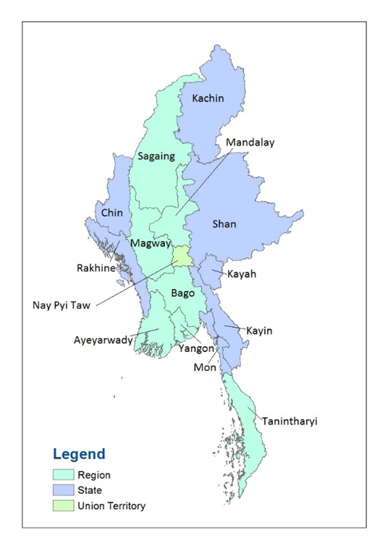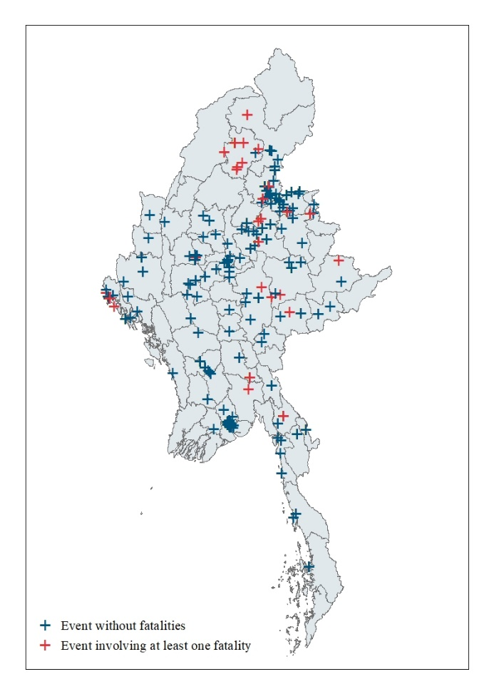
Source: Myanmar Information Management Union (2007); Raleigh et al. (2010).

Figure 2
Township fertility rates: Myanmar, 1983 (a) and 2014 (b)
(a) (b)
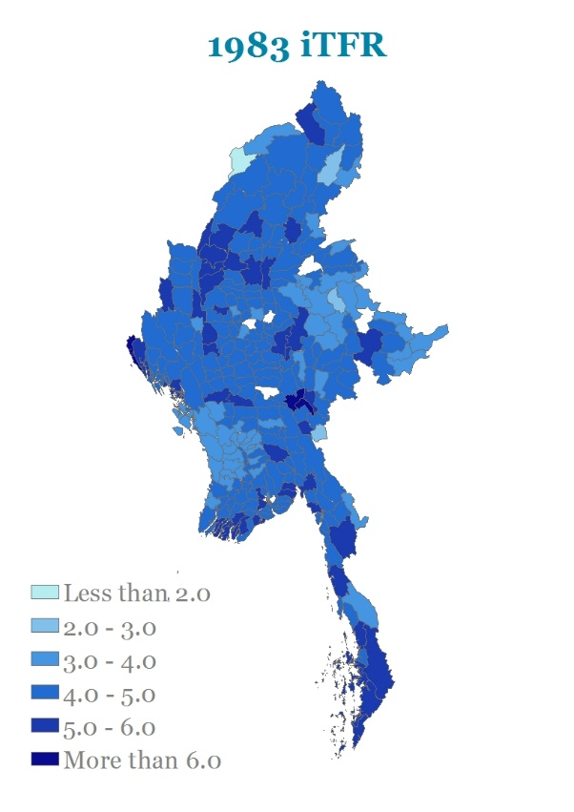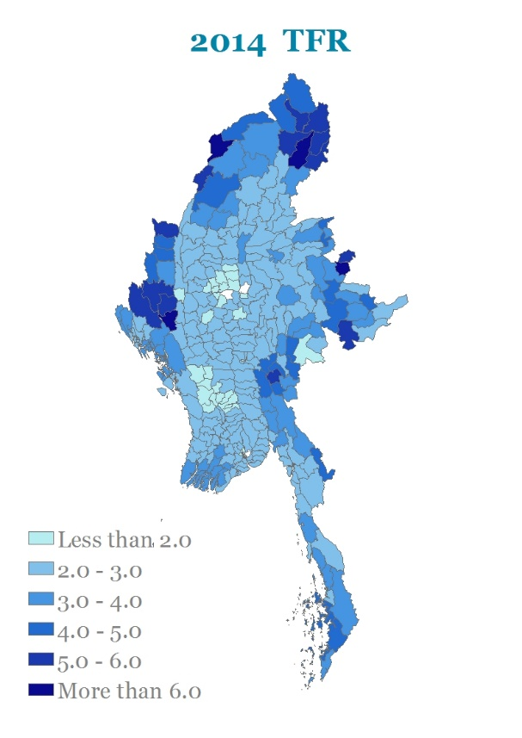
Note: For method of calculation of iTFR for 1983, see Hauer et al. (2013).

Sources: Myanmar Information Management Union (2007); Immigration and Manpower Department, Ministry of Home and Religious Affairs (1986); and Department of Population, Ministry of Labour, Immigration and Population (2016a).

Figure 3
Estimated change in total fertility rate: Myanmar, 1983 to 2014

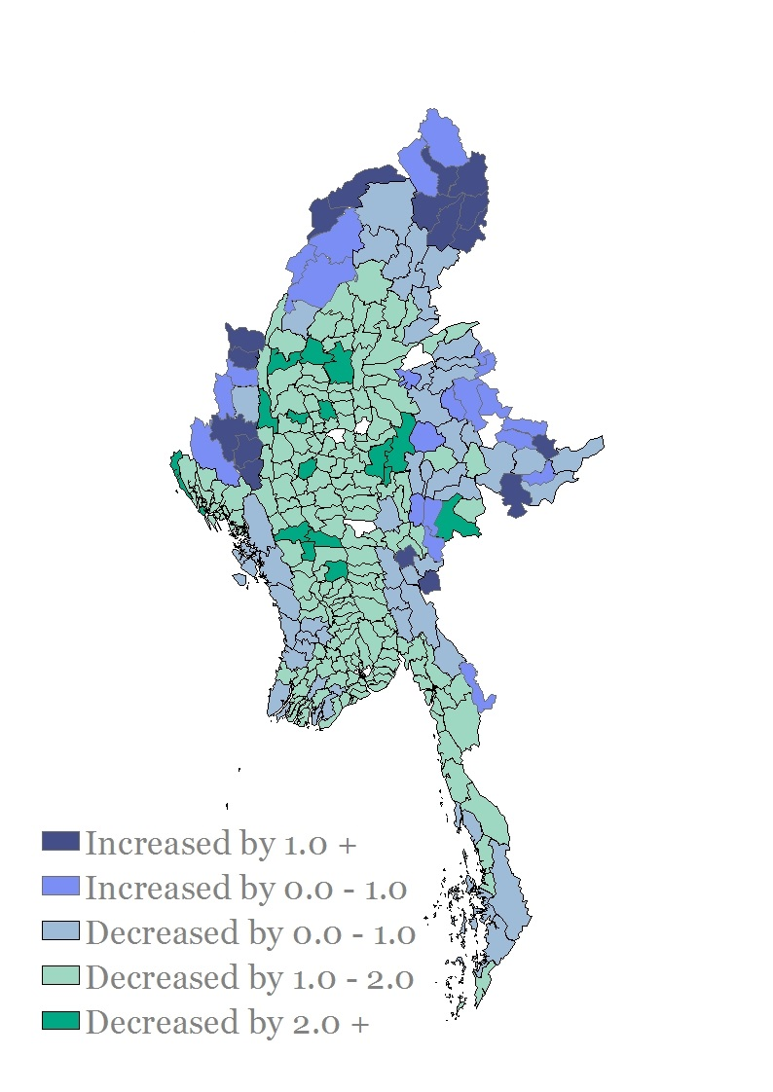
Note: The figures mapped here are the absolute differences in each township between the implied total fertility rate in 1983 and the total fertility rate in 2014.

Sources: Myanmar Information Management Union (2007); and Department of Population, Ministry of Labour, Immigration and Population (2016a).
Figure 4
Percentage of households without access to any form of digital communication (a) compared with total fertility rate (b): districts of Myanmar, 2014
(a) (b)
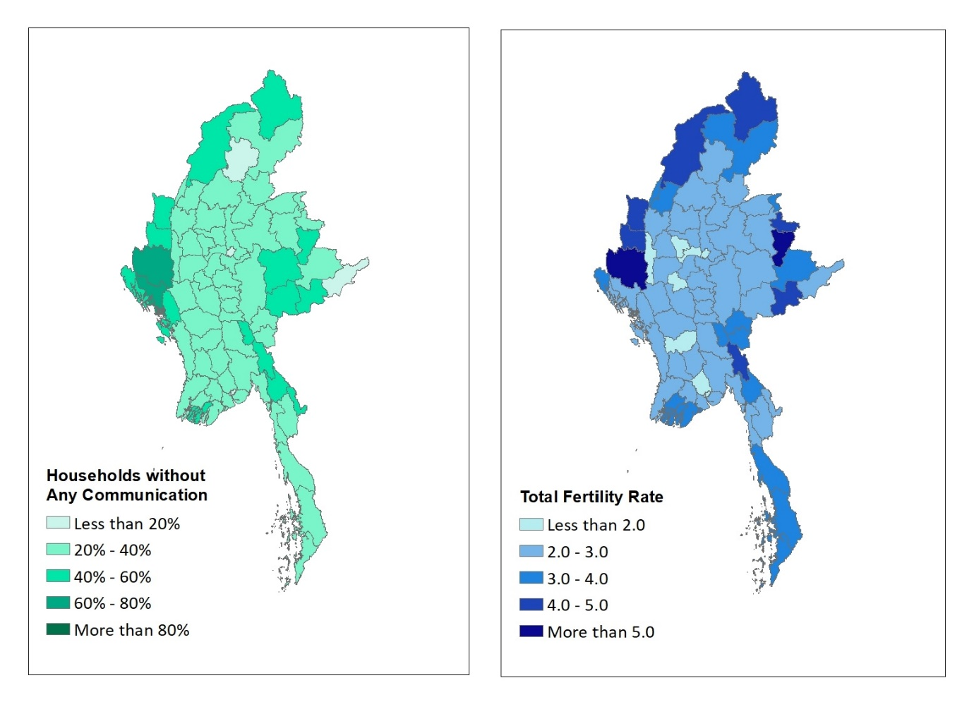
Sources: Myanmar Information Management Union (2007); and Department of Population, Ministry of Labour, Immigration and Population (2016a).

Table 1
Regression of total fertility rate on district-level characteristics: Myanmar, 2014

Covariate | Model 1 |  | Model 2
 | Parameter estimate | Standard error | Parameter estimate | Standard error
Intercept | 4.422 | 0.238 | 4.370 | 0.305
Percentage of households that own a radio | -0.045 | 0.007 | -0.024 | 0.004
Principal component score for household ownership of other digital communication methods | -0.390 | 0.072 | -0.203 | 0.061
Average distance to a road intersection across the district |  |  | 0.021 | 0.004
Percentage of female population aged 25 years and over with some education |  |  | -0.015 | 0.004

Note: The models include a random intercept at the state/region level.

Source: Department of Population, Ministry of Labour, Immigration and Population (2016a). University of Southampton Department of Geography and Environmental Science et al. (2018).

