Ultra-Trace Determination of Selenium and Tellurium in Coal by ICP-MS

Filipe S. Rondanª, Alessandra S. Henn^{b}, Paola A. Mello^{b}, Magali Perez^{c}, Liam A. Bullock^{d}, John Parnell^{d}, Joerg Feldmann^{c}, Erico M. M. Flores^{b}, Marcia F. Mesko^{a*}

ª Centro de Ciências Químicas, Farmacêuticas e de Alimentos, Universidade Federal de Pelotas, 96010-610, Capão do Leão, RS, Brazil
^{b} Departamento de Química, Universidade Federal de Santa Maria, 97105-900, Santa Maria, RS, Brazil
^{c} Trace Element Speciation Laboratory (TESLA), Department of Chemistry, University of Aberdeen, King’s College, Aberdeen, AB24 3UE, Scotland, UK
^{d} Department of Geology & Petroleum Geology, Meston Building, University of Aberdeen, King’s College, Aberdeen, AB24 3UE, Scotland, UK

*Corresponding author
E-mail address: marcia.mesko@pq.cnpq.br
Telephone number: + 55 53 3275 7387

Abstract
In this study, a method for selenium and tellurium determination at very low levels in coal by inductively coupled plasma mass spectrometry (ICP-MS) was developed. Samples (up to 500 mg) were digested by microwave-induced combustion (MIC) in a closed system pressurized with 20 bar of oxygen. Inorganic acids or their mixtures (HNO₃; HCl; HNO₃ + HCl (1:1, v/v); HNO₃ + HCl (2:1, v/v); HNO₃ + HCl (1:1, 50%, v/v)) were evaluated as absorbing solution. Using HNO₃ + HCl (1:1), results obtained for Se and Te after digestion by MIC were in agreement with those obtained by the reference method (microwave-assisted wet digestion - MAWD), for all coals. Moreover, agreement close to 100% was obtained for Se, using CRM NIST 1632c. The obtained limit of quantification (LOQ) was very low: 0.002 and 0.007 mg kg⁻¹ for Se and Te, respectively. The proposed method was applied to 23 samples of coal from different deposits from United Kingdom, with a widespread inorganic composition, showing its feasibility for routine analysis. The results showed a wide variation for Se concentrations (0.291 to 11.5 mg kg⁻¹), whereas for Te this was not observed (< 0.007 to 0.110 mg kg⁻¹). The proposed method presents several advantages over the reference method, such as the digestion of a higher sample mass, better LOQs and no necessity of using HF.

Keywords: Coal Analysis; Sample preparation; Microwave-induced combustion; ICP-MS.
Introduction
The global trend in environmental awareness has increased the interest in strategic elements, such as Se and Te. These elements are essential for future green energy technologies due to their photovoltaic and photoconductive properties [1,2]. In addition, Se and Te can be used in metallurgical applications, glass, ceramics and polymer industry [3]. They occur in low abundances in the Earth’s crust [4] and are known to be found in organic-rich sediments, such as coal [5,6]. Thereby, the accurate determination of Se and Te at low levels in coal is very important to know the resource potential and understand the environmental threats relating to their occurrence and processing.
Atomic spectrometric techniques such as atomic absorption spectrometry (AAS), inductively coupled plasma optical emission spectrometry (ICP-OES) and inductively coupled plasma mass spectrometry (ICP-MS) have been used for the determination of Se and Te in coal [7,8,9]. However, a sample preparation step is mandatory to bring the analytes into a solution and assuring its compatibility with those techniques. This is particularly challenging when considering the difficulties for coal digestion [10]. Usually, dry ashing [11], microwave-assisted wet digestion (MAWD) [7,8,9], pyrohydrolysis [12] and combustion methods [13-17] are the methods of choice for coal digestion. Solid sampling methods using electrothermal vaporization ICP-MS [18], graphite furnace atomic absorption spectrometry (GF AAS) [19] and laser ablation ICP-MS [20] have also been used for coal analysis. However, these methods have some limitations such as the use of a low sample mass and matrix effects can hamper calibration with aqueous standard solutions [18-20].
Microwave-assisted wet digestion using concentrated acids is the most frequently used method [7,8]. Microwave heating using closed vessels is a fast and efficient way for this task. Whereas microwave heating contributes to the reduction of the digestion time, the use of closed vessels minimizes losses of volatile analytes and the risk of cross contamination [21]. However, MAWD is generally carried out using concentrated HF mixed with other acids as HNO₃ and HCl, resulting in digests with high HF content. It requires the removal or complexation of HF to avoid damage to the nebulizer and quartz torch of spectrometric techniques [22]. Specific sample introduction consumables must be used or an excessive dilution must be carried out, impairing the limit of detection (LOD) and quantification (LOQ) [22]. In addition, the sample mass that can be digested is limited, usually in the range of 50 to 300 mg, even using high pressure systems. Furthermore, the “difficult-to-digest” coal matrix commonly leads to high residual carbon content in digests, that can result in spectral and non-spectral interferences [10,11]. Besides, when MAWD is used, the inorganic matter present in samples, such as coal, remains solubilized in the digests, which can also cause interferences during the analysis. It is important to mention that in spite of the common use of MAWD for coal digestion, there is a lack of works showing it application for further Se and mainly, Te determination.
Combustion methods have been proposed for coal digestion once they can effectively eliminate the organic fraction based on the reaction with oxygen [23]. The American Society for Testing and Materials (ASTM) recommends the digestion of coal by dry ashing following by the ash digestion with aqua regia and hydrofluoric acid and further dissolution in nitric acid [23]. Nevertheless, this method is not recommended for further Se and Te determination, since losses of these elements may occur due to the high temperature [21]. As the recommended method is an open system, the risk of contamination is also high.
In this sense, the microwave-induced combustion (MIC) method has been proposed to overcome limitations of conventional sample preparation methods [24]. The method allows the digestion of very hard to digest samples, especially those with high carbon content, such as carbon nanotubes [25], crude oil [26], graphite [27], pitch [28] and polymers [29,30] for further element determination. Unlike digestion methods, in the MIC method, the inorganic residues are contained in the sample holders, not making them available to the absorbing solution. This contributes for avoiding the occurrence of interferences and/or the need to perform excessive dilutions previously to the analysis. Moreover, it is possible to digest relatively high sample masses (generally up to 500 mg) in closed vessels, obtaining lower LOD and LOQ, and avoiding losses and contamination. Recently, MIC has been applied for coal digestion for sulfur determination by isotope dilution sector field inductively coupled plasma mass spectrometry (SF-ICP-MS) [31] and was used as reference to obtain certified values of the Standard Reference Material 2682c (Subbituminous coal).
In this sense, the aim of this work was to demonstrate the feasibility of MIC for the digestion of relatively high coal mass, without any HF, and further Se and Te determination at low concentration by collision/reaction cell (CRC) ICP-MS (Se) and ICP-MS (Te). The operational parameters of MIC, such as the sample mass and the kind and concentration of absorbing solution were evaluated. Accuracy was evaluated by the analysis of a certified reference material (CRM) of coal and by comparison of results with those obtained after MAWD (reference method).

- Material and Methods
  - Instrumentation
Coal samples were digested by MIC using a microwave oven (Multiwave 3000®, Microwave Sample Preparation System, Anton Paar, Austria, software version v1.27-Synt) equipped with eight high-pressure quartz vessels (80 mL of internal volume, maximum temperature and pressure of 280 °C and 80 bar, respectively). Additionally, samples of coal were digested by MAWD using the same microwave system equipped with sixteen polytetrafluoroethylene (PTFE) vessels (100 mL of internal volume, maximum operational temperature and pressure of 220 °C and 40 bar, respectively).
The determination of Se and Te was performed using a quadrupole-based inductively coupled plasma mass spectrometer (NexION 300X®, Perkin Elmer, Canada) equipped with a concentric nebulizer (Meinhard, USA), a cyclonic spray chamber (Glass Expansion, Inc., Australia) and a quartz torch with a quartz injector tube (2 mm i.d.). This instrument was also equipped with a CRC, which was used only for Se determination, as described in a previous work [32]. The instrumental parameters are described in Table 1.
Table 1. Operational parameters for the determination of Se by CRC-ICP-MS and Te by ICP-MS.
Parameter | CRC-ICP-MS | ICP-MS
Collision/reaction cell gas | H₂ | -
Collision/reaction cell gas flow rate, mL min⁻¹ | 4.8 | -
Nebulizer gas flow rate, L min⁻¹ | 0.95 | 0.95
Auxiliary gas flow rate, L min⁻¹ | 1.20 | 1.20
Plasma gas flow rate, L min⁻¹ | 18.0 | 18.0
RF power, W | 1300 | 1300
RPa | 0 | -
RPq | 0.45 | -
Sweeps/reading | 60 | 5
Reading/replicate | 5 | 3
Replicates | 5 | 3
Dwell time, ms | 50 | 50
Isotopes, m/z ratio | ⁷⁸Se | ¹²⁸Te

An analytical balance (AY 220, Shimadzu, Kyoto, Japan, 220 g, 0.0001 g of resolution) was used for weighing the coal samples. A hydraulic press (Manual Hydraulic press 15 ton, Specac, UK) was used for pressing samples as pellets (2 ton). Disks of filter paper (15 mm of diameter, about 15.3 ± 0.3 mg) with low ash content (Black Ribbon Ashless, Schleicher and Schuell, Germany) were used as auxiliary for the combustion process. Filter papers were previously washed with 20% (v/v) HNO₃ solution for 20 min in an ultrasonic bath and dried in a class-100 laminar flow hood (CSLH-12, Veco, Campinas, Brazil).
A scanning electron microscope (model Sigma 300 VP, Carl Zeiss, Germany) operating in the high vacuum mode with a secondary electron detector was used for analysis of surface morphology. An energy-dispersive detector for X-ray spectrometry (model Quantax EDS, Bruker, Germany), coupled to the scanning electron microscope (SEM-EDS) was used for qualitative analysis of solid residue that remained after MIC.
All statistical calculations, including Student’s t-test (confidence level of 95%, p > 0.05) and, in some cases, one-way analysis of variance (ANOVA) were performed using GraphPad InStat (GraphPad InStat Software Inc, Version 3.00, 1997) software.

  - Reagents and Samples
Water was purified using a Milli-Q system, (Millipore, USA, 18.2 MΩ cm) and it was used for the preparation of standards and absorbing solutions. Concentrated HNO₃ (65%, 1.4 kg L⁻¹, Merck, Germany) and HCl (37%, 1.19 kg L⁻¹, Merck) were distilled in a sub-boiling system (DuoPur, Milestone, Italy) and used as absorbing solution for MIC and for MAWD methods. Concentrated HF (40%, 1.15 kg L⁻¹, Sigma Aldrich, USA) was used for coal digestion by MAWD without previous purification. Ammonium nitrate solution (Merck) was dissolved in water (6 mol L⁻¹) to be used as igniter for MIC. Reference solutions of Se and Te (0.01 to 10 µg L⁻¹) were prepared by sequential dilution of stock solutions (1000 mg L⁻¹, Merck) in 5% (v/v) HNO₃. Argon (99.998%, White Martins, Brazil) was used for plasma generation, nebulization and as auxiliary gas. Oxygen (99.6%, White Martins, Brazil) was used for pressurization in the MIC method, and hydrogen (99.999%, White Martins, Brazil) was used in the collision/reaction cell.
Coal samples were obtained from coal mines from the United Kingdom and were named from “A” to “X”. Samples were ground using a cryogenic mill (model 6750, Spex Certiprep, USA), with 2 min of pre-cooling followed by 3 min for grinding. This last procedure was repeated three times [32]. Samples were dried at 105 ± 5 ºC for 2 h in an oven (model 400/2ND, Nova Ética, Brazil) before use. The accuracy was evaluated using a CRM of coal (NIST 1632c, bituminous coal) from the National Institute of Standards and Technology (USA).

  - Sample preparation methods
    - Microwave-assisted wet digestion
For comparison of the results, coal was digested by MAWD in closed vessels, according to previous work [32]. In this case, a maximum sample mass of 250 mg of coal was weighted inside the PTFE vessels and 5 mL of 14 mol L⁻¹ HNO₃ and 1 mL of 40% HF were added. The heating program was: i) 1400 W for 40 min (10 min of ramp) and ii) 0 W for 20 min (cooling). After cooling, the digests were diluted with water to 25 mL for further determination of Se by CRC-ICP-MS and Te by ICP-MS. After each run, vessels were cleaned using 6 mL of concentrated HNO₃ and microwave program was: i) 1400 W for 10 min and ii) 0 W for 20 min (cooling).

    - Microwave-induced combustion
Coal masses in the range of 300 to 550 mg were pressed as pellets and placed in disks of filter paper on the quartz holders containing 50 μL of 6 mol L⁻¹ NH₄NO₃ solution. The holders were placed inside the quartz vessels containing 6 mL of absorbing solution (HNO₃, HCl, HNO₃ + HCl (1:1, v/v), HNO₃ + HCl (2:1, v/v) or 50% v/v HNO₃ + HCl (1:1,). Quartz vessels were closed, placed on the rotor and pressurized with 20 bar of oxygen. The following heating program was used for digestion: i) 1400 W for 5 min (ignition and reflux) and ii) 0 W for 20 min (cooling). Final solutions were diluted with water up to 25 mL for further Se determination by CRC-ICP-MS and Te by ICP-MS. After each run, vessels were cleaned using 6 mL of concentrated HNO₃ and microwave program was: i) 1400 W for 10 min and ii) 0 W for 20 min (cooling).
- Results and discussion
  - Composition of samples
The distribution of the inorganic matter in coal is not uniform. Thus, due to the coal-mineral and mineral-mineral associations, some trace elements can be retained in the ash when the coal is burned, especially when there is a high concentration of minerals [33]. In this way, it is noteworthy to mention that the samples studied in this work present a wide variation in the ash content, from 3 to 41%. Besides the high concentration of Si in the samples, they also presented a diverse composition with regard to the concentration of Al, Ca, K, Mg, Na and Fe (Al: 770 to 12000 µg g⁻¹, Ca: 40 to 8300 µg g⁻¹; K: 10 to 5000 µg g⁻¹; Mg: 20 to 900 µg g⁻¹; Na: 90 to 2400 µg g⁻¹; Fe: 220 to 247000 µg g⁻¹). The high inorganic content of some samples requires the use of HF when wet digestion methods were used to assure the complete recovery of the analytes from the matrix. In addition, with the use of HF, the inorganic fraction remains soluble in the final solution. Thus, the presence of HF and the high inorganic content in the solution makes necessary to carry out excessive dilutions prior to ICP-MS analysis, to minimize interferences and avoid equipment damage. In view of these limitations, MIC method was optimized to overcome the disadvantages of the reference method (MAWD).

  - MIC optimization
    - Evaluation of sample mass
The capacity of digestion systems to deal with high sample masses directly impacts the LOQ. Taking into account that ultra-trace levels of selenium and, mainly, tellurium, are expected for the investigated coals, this parameter is of concern. In order to verify the maximum sample mass that could be efficiently digested with safety, an evaluation was performed. In this way, coal masses in the range of 300 to 550 mg were digested without the reflux step, using 20 bar as initial oxygen pressure, 14.4 mol L⁻¹ HNO₃ as absorbing solution. When 300 mg of sample were digested, the maximum pressure in the system (28 bar) was not significantly increased allowing to investigate higher masses. It was possible to observe that masses from 300 to 500 mg were efficiently digested by MIC with maximum pressures ranging from 28 to 30 bar. It was observed a proportional increase of pressure when the sample mass was increased. In addition, the maximum pressure reached when 500 mg of coal were combusted was about 37% of the maximum pressure recommended by the manufacturer (80 bar). However, when 550 mg of sample were used, organic residues were observed on the base of the quartz holder, demonstrating an incomplete combustion. Thus, 500 mg of sample was chosen as sample mass for further evaluations. It is important to mention that the inorganic fraction of the coal samples remains on the quartz holder after the combustion, as shown in Figure 1(a), and in Figure 1 (c) it is possible to observe the surface morphology of this residue. In addition, as can be seen the energy dispersive spectra in Figure 1(b) the inorganic fraction is composed by Al, Si and O, this is aluminosilicates.

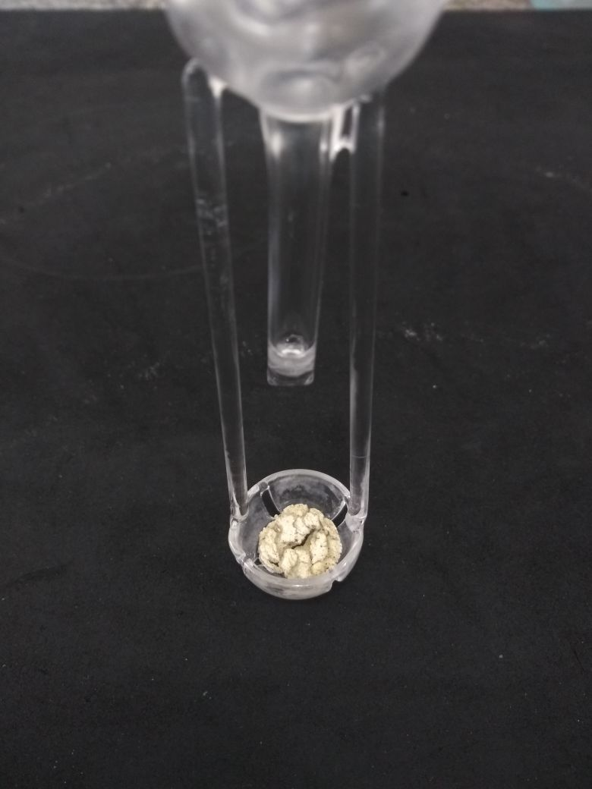
b
a
c
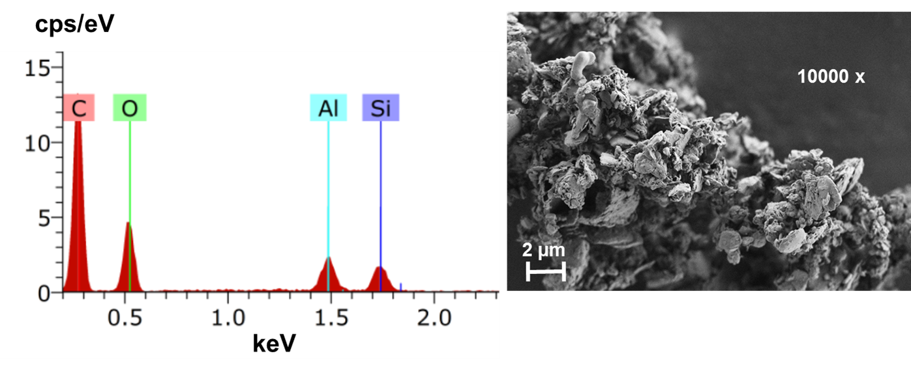
Fig. 1. (a) Image of inorganic residue remaining on the quartz holder after digestion of sample A by MIC and (b) energy dispersive spectra and (c) SEM image (amplified at 10000x).

    - Evaluation of absorbing solution
Considering that the kind of the absorbing solution is directly related to the suitable recovery of the analytes and depends on the analyte and the sample matrix, this evaluation is essential for the development of the MIC method. Therefore, a systematic study was carried out by evaluating the absorbing solution to select a suitable medium for Se and Te recoveries. In these experiments, sample “A” (41% of ash), sample “B” (19% of ash), and sample “C” (10% of ash) were digested by MIC, using the following acid absorbing solutions: HNO₃, HCl, HNO₃ + HCl (1:1, v/v), HNO₃ + HCl (2:1, v/v) or 50%, v/v HNO₃ + HCl (1:1). For all experiments, 500 mg of coal and 6 mL of acid solution were used, and Se was determined by CRC-ICP-MS and Te by ICP-MS. The results obtained after MIC were compared with those obtained after MAWD, and the results are shown as agreement of MIC with MAWD values (Fig. 2).

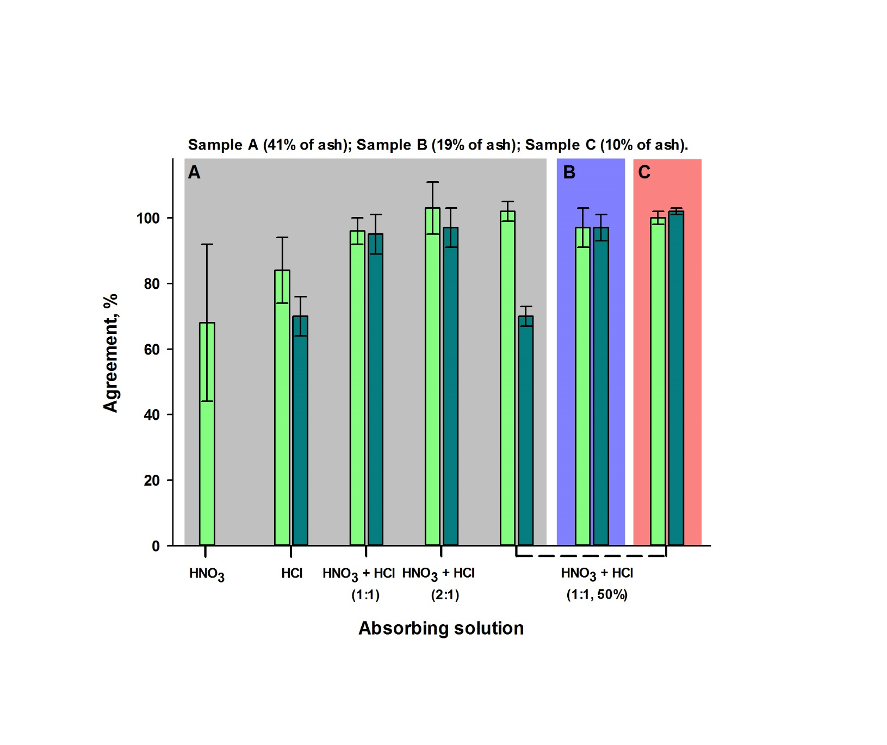
Fig. 2. Influence of absorbing solution on Se (■) and Te (■) recoveries from coal. Agreement was calculated taking into account results obtained by CRC-ICP-MS and ICP-MS after MAWD. Error bars represent the standard deviation, n = 3.

When concentrated HNO₃ was used as absorbing solution, an agreement of about 68% was obtained for Se and the relative standard deviation (RSD) was about 35%. For Te, the results were lower than the LOQ. These results indicate that only HNO₃ as absorbing solution was not suitable for Se and Te recoveries from coal. Similarly, when concentrated HCl was used as absorbing solution, agreement of 84% for Se and 70% for Te was obtained, demonstrating that this solution was also not suitable for absorption of these analytes. On the other hand, when HNO₃ was used combined with HCl as absorbing solution, in both proportions (1:1 and 2:1, respectively), better agreement was obtained for both analytes. Taking into account the suitable agreement using these solutions, the possibility to use a diluted solution was evaluated (50%, v/v HNO₃ + HCl (1:1)). Thus, it was possible to observe that when this solution was used, agreement of about 100% was obtained for Se, for samples “A”, “B” and “C”. However, a suitable agreement for Te was obtained only for coal samples with lower ash content (sample “B” and “C”). It indicates that Te presents a stronger affinity with the inorganic fraction of coal in comparison with Se, and thus concentrated acids should be used in order to obtain accurate results for this analyte. Other studies reported in the literature observed similar behavior for this element [34-36].
Although diluted HCl + HNO₃ (1:1) could be used as absorbing solution for Se and Te for coal with lower ash content, good agreements were obtained using concentrated HNO₃ + HCl (1:1) for all types of evaluated coal, and thus it was selected for analytes absorption. Additionally, the RSD using this solution was lower than 8%. Therefore, 500 mg of coal and 6 mL of a mixture of HNO₃ + HCl (1:1) was selected as suitable condition for MIC. In order to evaluate the accuracy of MIC, a CRM of coal (NIST 1632c) with 7% of ash was digested under optimized conditions. Results are shown in Table 2.

Table 2. Results for Se and Te in CRM NIST 1632c by CRC-ICP-MS (for Se) and ICP-MS (for Te) after MIC (mean ± standard deviation, n = 3).
Element | Concentration (µg g⁻¹)
Element | Obtained | Certified
Se | 1.34 ± 0.10 | 1.32 ± 0.071
Te | 0.020 ± 0.001 | 0.05*
*informed value

No statistical difference (Student t test, P < 0.05) was observed between the results for Se and the certified value. Nevertheless, the results obtained for Te were lower than the informed value. However, it is important to mention that no statistical difference (Student t test, P < 0.05) was observed between the results for Te after digestion by MIC or MAWD suggesting the selected conditions allows for the accurate determination of Te in evaluated coals.

  - Determination of Se and Te in coal
After the optimization, MIC method was applied to 23 samples of coal from different deposits from United Kingdom and with a high variability of inorganic composition for further Se and Te determination. Table 3 shows the results obtained by CRC-ICP-MS (Se) and ICP-MS (Te) after sample preparation using MIC or MAWD.

Table 3. Results for Se and Te (µg g⁻¹) in coals by CRC-ICP-MS (Se) and ICP-MS (Te) after MIC and MAWD (mean ± standard deviation, n = 3).
 |  | Selenium |  |  | Tellurium
Sample |  | MAWD | MIC |  | MAWD | MIC
A |  | 2.60 ± 0.13 | 2.38 ± 0.15 |  | 0.064 ± 0.006 | 0.069 ± 0.005
B |  | 3.32 ± 0.14 | 3.23 ± 0.09 |  | 0.066 ± 0.003 | 0.062 ± 0.002
C |  | 5.31 ± 0.54 | 5.47 ± 0.43 |  | 0.077 ± 0.004 | 0.075 ± 0.005
D |  | 2.03 ± 0.10 | 1.85 ± 0.10 |  | < 0.05ª | 0.029 ± 0.002
E |  | 1.53 ± 0.09 | 1.36 ± 0.14 |  | < 0.05ª | < 0.007^{b}
F |  | 0.401 ± 0.029 | 0.447 ± 0.029 |  | < 0.05ª | < 0.007^{b}
G |  | 1.35 ± 0.05 | 1.38 ± 0.09 |  | < 0.05ª | < 0.007^{b}
H |  | 11.0 ± 0.2 | 11.5 ± 0.9 |  | < 0.05ª | < 0.007^{b}
I |  | 4.17 ± 0.20 | 3.75 ± 0.38 |  | < 0.05ª | 0.009 ± 0.001
J |  | 0.600 ± 0.015 | 0.679 ± 0.095 |  | < 0.05ª | 0.010 ± 0.001
K |  | 0.798 ± 0.041 | 0.807 ± 0.064 |  | < 0.05ª | < 0.007^{b}
L |  | 6.00 ± 0.17 | 5.95 ± 0.20 |  | 0.105 ± 0.003 | 0.110 ± 0.005
M |  | 0.769 ± 0.038 | 0.777 ± 0.011 |  | < 0.05ª | 0.019 ± 0.002
N |  | 1.03 ± 0.05 | 1.18 ± 0.17 |  | < 0.05ª | 0.014 ± 0.002
O |  | 1.00 ± 0.06 | 1.18 ± 0.15 |  | < 0.05ª | 0.014 ± 0.001
P |  | 1.09 ± 0.09 | 1.17 ± 0.10 |  | < 0.05ª | 0.018 ± 0.002
Q |  | 1.70 ± 0.03 | 1.81 ± 0.12 |  | < 0.05ª | 0.012 ± 0.001
R |  | 1.20 ± 0.03 | 1.18 ± 0.05 |  | < 0.05ª | 0.012 ± 0.001
S |  | 1.78 ± 0.04 | 1.66 ± 0.10 |  | < 0.05ª | 0.021 ± 0.002
T |  | 0.738 ± 0.026 | 0.940 ± 0.163 |  | < 0.05ª | < 0.007^{b}
U |  | 1.56 ± 0.11 | 1.70 ± 0.10 |  | < 0.05ª | 0.013 ± 0.001
V |  | 1.46 ± 0.06 | 1.53 ± 0.08 |  | < 0.05ª | 0.016 ± 0.002
X |  | 0.297 ± 0.016 | 0.291 ± 0.006 |  | < 0.05ª | 0.009 ± 0.001
ª LOQ obtained by ICP-MS after MAWD; ^{b} LOQ obtained by ICP-MS after MIC.

In general, the results obtained after MIC were in good agreement with those obtained after MAWD. No statistical difference (Student t test, P < 0.05) was observed between Se concentrations in all coal samples obtained using MIC or MAWD. In addition, as can be seen in Table 3, the concentrations of Se varied in a wide range, from 0.291 to 11.5 µg g⁻¹, while the concentrations of Te were very low, varying from < 0.007 to 0.110 µg g⁻¹.
The LOQ obtained for Se by CRC-ICP-MS and Te by ICP-MS after MIC were 0.002 µg g⁻¹ and 0.007 µg g⁻¹, respectively. The LOQ obtained for Se using MIC was about 15 times lower than that obtained by MAWD (0.03 µg g⁻¹). For Te, the LOQ was about 7 times lower than that obtained by MAWD (0.05 µg g⁻¹). The lower LOQs obtained by MIC made possible the determination of Te in 17 of the 23 samples used in this work, which was not possible using MAWD. The lower LOQs obtained are directly related to the high sample mass used in the MIC method and the lower blank values. Additionally, the proposed method presents a great advantage over the reference method since it avoids the use of HF for digestion. Moreover, the inorganic fraction remains in the quartz holder, reducing the risk of interferences from these major inorganic components during ICP-MS analysis. Once the inorganic fraction is not introduced into the system, the method also prevents damages to the equipment. Thus, excessive dilutions before the determination step were not necessary. Besides, using the MIC method (8 samples per round) it was possible to obtain a shorter time of digestion when compared to MAWD (16 samples per round).
The carbon content in digests is an important parameter to evaluate the digestion efficiency once it can cause interferences on Se and Te determination by ICP-MS, as well as carbon deposition on the equipment interface [37]. In this way, carbon content in digests obtained after MAWD and MIC was determined. The carbon content by MIC was below 10 mg L⁻¹ whereas they were about 2000 mg L⁻¹ using MAWD, which required the sample dilution before determination to avoid interferences. Additionally, due to the high temperature achieved during coal combustion, it was possible to obtain the complete digestion of organic coal matrix, reducing digests carbon content.

- Conclusion
A suitable method for coal digestion using MIC for further Se and Te determination at ultra-trace levels by ICP-MS was developed. Using the proposed method, the samples were efficiently digested in closed vessels. Thus, low blank values were obtained and it was possible to achieve lower LOQs, which allowed the determination of analytes in various coal samples at very low concentration.
The proposed method presented various advantages when compared to the reference method, as to allow the digestion of sample mass twice higher. Besides, the throughput is other advantage, since using the proposed method up to eight samples can be digested in about 25 minutes. Additionally, it is worth highlighting that the developed method does not require the use of HF for the digestions, avoiding the need to perform excessive dilutions previous to the determination step. Furthermore, it is important to mention that using a diluted acid solution made possible to obtain suitable recoveries for Se and Te for samples with low ash content (10% and 19%), which is another great advantage for digestion of samples with these characteristics.

Acknowledgements
The authors are grateful to Conselho Nacional de Desenvolvimento Científico e Tecnológico (CNPq, Grant 309297/2016-8), Instituto Nacional de Ciência e Tecnologia de Bioanalítica – INCTBio (CNPq Grant Nr. 573672/2008-3) and Fundação de Amparo à Pesquisa do Estado do Rio Grande do Sul (FAPERGS, Grant 16/2551-0000516-8) for supporting this study. Funding for the sample collection provided by NERC Security of Supply programme UK (grant NE/L001764/1).
References

[1] M. Woodhouse, A. Goodrich, R. Margolis, T.L. James, M. Lokanc, R. Eggert, Supply-Chain Dynamics of Tellurium, Indium, and Gallium within the Context of PV Manufacturing Costs, IEEE J. Photovolt. 3 (2013) 833-837.
[2] L. Talens Peiró, G.V. Méndez, R.U. Ayres, Rare and critical metals as by-products and the implications for future supply. INSTEAD Facility and Research Working Paper 2011/129/EPS/TOM/ISIC, 2011.
[3] G.K. Ahluwalia, Applications of Chalcogenides: S, Se, and Te, Springer, New York, 2017.
[4] R.L. Rudnick, S. Gao, Composition of the continental crust, in: R.L. Rudnick, (Ed.), The Crust 3, Elsevier, New York, 2003, pp. 1-64.
[5] J. Parnell, D. Bellis, J. Feldmann, T. Bata, Selenium and tellurium enrichment in palaeo-oil reservoirs, J. Geochem. Explor. 148 (2015) 169-173.
[6] L.A. Bullock, J. Parnell, J. Feldmann, J.G. Armstrong, A.S. Henn, M.F. Mesko, P.A. Mello, E.M.M. Flores, Selenium and tellurium concentrations of British coals, Geol. J. Accepted Manuscript (2018).
[7] J. Wang, T. Nakazato, K. Sakanishi, O. Yamada, H. Tao, I. Saito, Microwave digestion with HNO₃/H₂O₂ mixture at high temperatures for determination of trace elements in coal by ICP-OES and ICP-MS, Anal. Chim. Acta. 514 (2004) 115-124.
[8] J. Wang, T. Nakazato, K. Sakanishi, O. Yamada, H. Tao, I. Saito, Single-step microwave digestion with HNO₃ alone for determination of trace elements in coal by ICP spectrometry, Talanta. 68 (2006) 1584-1590.
[9] H. Lachas, R. Richaud, A.A. Herod, D.R. Dugwell, R. Kandiyoti, K.E. Jarvis, Determination of 17 trace elements in coal and ash reference materials by ICP-MS applied to milligram sample sizes, Analyst. 124 (1999) 177-184.
[10] K. Srogi, Microwave‐assisted sample preparation of coal and coal fly ash for subsequent metal determination, Anal. Lett. 40 (2007) 199-232.
[11] R.A. Nadkarni, Multitechnique multielemental analysis of coal and fly ash, Anal. Chem. 52 (1980) 929-935.
[12] V.L. Dressler, D. Pozebon, E.L.M. Flores, J.N.G. Paniz, E.M.M. Flores, Potentiometric determination of fluoride in geological and biological samples following pyrohydrolytic decomposition, Anal. Chim. Acta 466 (2002) 117-123.
[13] W. Geng, T. Furuzono, T. Nakajima, H. Takanashi, A. Ohki, Determination of total arsenic in coal and wood using oxygen flask combustion method followed by hydride generation atomic absorption spectrometry, J. Hazardous Mater. 176 (2010) 356-360.
[14] E.M.M. Flores, M.F. Mesko, D.P. Moraes, J.S.F. Pereira, P.A. Mello, J.S. Barin, G. Knapp, Determination of halogens in coal after digestion using the microwave-induced combustion technique, Anal. Chem. 80 (2008) 1865-1870.
[15] E.M.M. Flores, J.S. Barin, M.F. Mesko, G. Knapp, Sample preparation techniques based on combustion reactions in closed vessels - a brief overview and recent applications Spectrochim. Acta Part B. 62 (2007) 1051-1064.
[16] F.G. Antes, F.A. Duarte, M.F. Mesko, M.A.G. Nunes, V.A. Pereira, E.I. Muller, V. L. Dressler, E.M.M. Flores, Determination of toxic elements in coal by ICP-MS after digestion using microwave-induced combustion, Talanta. 83 (2010) 364-369.
[17] G. Corazza, A.S. Henn, M.F. Mesko, F.A. Duarte, E.M.M. Flores, P.A. Mello, Microwave-induced combustion of coal for further sulfur determination by inductively coupled plasma optical emission spectrometry or ion chromatography, J. Brazil. Chem. Soc. 27 (2016) 1569-1576.
[18] A.S. Henn, E.M.M. Flores, V.L. Dressler, M.F. Mesko, J. Feldmann, P.A. Mello, Feasibility of As, Sb, Se and Te Determination in Coal by Solid Sampling Electrothermal Vaporization Inductively Coupled Plasma Mass Spectrometry, J. Anal. Atom. Spectrom. Submitted Manuscript (2018).
[19] D.L. Borges, A.F. Silva, A.J. Curtius, B. Welz, U. Heitmann, Determination of lead in coal using direct solid sampling and high-resolution continuum source graphite furnace atomic absorption spectrometry, Microchim. Acta 154 (2006) 101-107.
[20] I. Rodushkin, M.D. Axelsson, E. Burman, Multielement analysis of coal by ICP techniques using solution nebulization and laser ablation, Talanta 51 (2000) 743-759.
[21] E.M.M. Flores, Microwave-assisted sample preparation for trace element determination, Elsevier Science, Amsterdam, 2014.
[22] M. F. Mesko, D.L.R. Novo, F.S. Rondan, R.M. Pereira, V.C. Costa, Sample preparation of lipstick for further Cd and Pb determination by ICP-MS: is the use of complexing acids really necessary?, J. Anal. Atom. Spectrom. 32 (2017) 1780-1788.
[23] Annual book of ASTM standards, ASTM D 6357-11, Standard test methods for determination of trace elements in coal, coke, and combustion residues from coal utilization processes by inductively coupled plasma atomic emission spectrometry, inductively coupled plasma mass spectrometry, and graphite furnace atomic absorption spectrometry, West Conshohocken, 2011.
[24] J.S. Barin, E.M.M. Flores, G. Knapp, in: M.A.Z. Arruda (Ed.), Trends in Sample Preparation, Nova Science Publishers, New York, 2006, pp. 73–114.
[25] P. Grinberg, R.E. Sturgeon, L.O. Diehl, C.A. Bizzi, E.M.M. Flores, Comparison of sample digestion techniques for the determination of trace and residual catalyst metal content in single-wall carbon nanotubes by inductively coupled plasma mass spectrometry, Spectrochim. Acta Part B. 105 (2015) 89-94.
[26] J. S. F. Pereira, L.S.F. Pereira, P.A. Mello, R.C.L. Guimaraes, R.A. Guarnieri, T.C.O. Fonseca, E.M.M. Flores, Microwave-induced combustion of crude oil for further rare earth elements determination by USN–ICP-MS, Anal. Chim. Acta. 844 (2014) 8-14.
[27] S.M. Cruz, L. Schmidt, F.M. Dalla Nora, M.F. Pedrotti, C.A. Bizzi, J.S. Barin, E.M.M. Flores, Microwave-induced combustion method for the determination of trace and ultratrace element impurities in graphite samples by ICP-OES and ICP-MS, Microchem. J. 123 (2015) 28-32.
[28] L.S.F. Pereira, G.D. Iop, E.M.M. Flores, R.A. Burrow, P.A. Mello, F.A. Duarte, Strategies for the determination of trace and toxic elements in pitch: evaluation of combustion and wet digestion methods for sample preparation, Fuel. 163 (2016) 175-179.
[29] E.M.M. Flores, E.I. Muller, F.A. Duarte, P. Grinberg, R.E. Sturgeon, Determination of trace elements in fluoropolymers after microwave-induced combustion, Anal. Chem. 85 (2013) 374-380.
[30] L.S.F. Pereira, M.F. Pedrotti, T.M. Miceli, J.S.F. Pereira, E.M.M. Flores, Determination of elemental impurities in poly(vinyl chloride) by inductively coupled plasma optical emission spectrometry, Talanta. 152 (2016) 371-377.
[31] S.J. Christopher, T.W. Vetter, Application of microwave-induced combustion and isotope dilution strategies for quantification of sulfur in coals via sector-field inductively coupled plasma mass spectrometry, Anal. Chem. 88 (2016) 4635-4643.
[32] A.S. Henn, F.S. Rondan, M.F. Mesko, P.A. Mello, M. Perez, J. Armstrong, L.A. Bullock, J. Parnell, J. Feldmann, E.M.M. Flores, Determination of Se at low concentration in coal by collision/reaction cell technology inductively coupled plasma mass spectrometry, Spectrochim. Acta Part B. 143 (2018) 48-54.
[33] F. Vejahati, Z. Xu, R. Gupta, Trace elements in coal: Association with coal and minerals and their behavior during coal utilization – A review, Fuel. 89 (2010) 904-911.
[34] D.J. Swaine, Trace elements in coal and their dispersal during combustion, Fuel Process. Technol. 39 (1994) 121-137.
[35] X. Querol, J.L. Fernandez-Turiel, A. Lopez-Soler, Trace elements in coal and their behaviour during combustion in a large power station, Fuel. 74 (1995) 331-343.
[36] F. Vejahati, Z. Xu, R. Gupta, Trace elements in coal: Associations with coal and minerals and their behavior during coal utilization – A review, Fuel. 89 (2010) 904-911.
[37] G. Grindlay, J. Mora, M. de Loos-Vollebregt, F. Vanhaecke, A systematic study on the influence of carbon on the behavior of hard-to-ionize elements in inductively coupled plasma–mass spectrometry, Spectrochim. Acta Part B. 86 (2013) 42-49.

