Note: this is a draft of the journal article:

Luciana E. Bostan1*, Peter R. Worsley1, Shabira Abbas2, Daniel L. Bader1 (2019) “The influence of incontinence pads moisture at the loaded skin interface.”

Journal of Tissue Viability, accepted
The final, fully proofed and peer-reviewed journal article is available from the publisher online,

The influence of incontinence pads moisture at the loaded skin interface
Luciana E. Bostan^{1*}, Peter R. Worsley¹, Shabira Abbas², Daniel L. Bader¹

- School of Health Sciences, University of Southampton, Southampton UK
- Essity Hygiene and Health AB, Gothenburg, Sweden

*Corresponding Address
Luciana E. Bostan
University of Southampton, Faculty of Environmental and Life Sciences, School of Health Sciences, Southampton General Hospital, Tremona Road, Southampton, SO16 6YD, UK.
Email: p.r.worsley@soton.ac.uk.

Declarations of interest: none
Highlights:
- Dry incontinence pads provide some skin barrier protection during mechanical loading
- Addition of moisture within the incontinence pads reduces the skin barrier function, with recovery during off-loading
- Inflammatory cytokines levels increased after loading with moistened pads , with partial recovery during off-loading
- Periods of pressure relief and careful management of moisture are critical for the maintenance of skin health

ABSTRACT
Aim
Prolonged mechanical loading on soft tissues adjacent to bony prominences can lead to pressure ulcers. The presence of moisture at the skin interface will lower the tolerance to load. Absorbent pads manage moisture in individuals with incontinence, although their role in maintaining skin health is unknown. The present study investigated the effects of moist incontinence pads on skin physiology after periods of mechanical loading.
Material and methods
Twelve healthy participants were recruited to evaluate a single incontinence pad design under three moisture conditions: 0% (dry), 50% and 100% fluid capacity. For each pad condition, pressure (9kPa) or pressure in combination with shear (3N) was applied to the sacrum, followed by a period of off-loading. Measures included trans-epidermal water loss (TEWL) and inflammatory biomarkers sampled at the skin interface.
Results
Results revealed no change in TEWL in the loaded dry pad condition. By contrast, when the pads contained moisture, significant increases in TEWL were observed. These increases were reversed during off-loading. Inflammatory biomarkers, specifically IL-1α/total protein ratio, were up-regulated during dry pad loading, which recovered during off-loading. Loaded moist pads caused a significant increase in biomarkers, which remained elevated throughout the test period.
Conclusion
The study revealed a marked compromise to stratum corneum integrity when the skin was exposed to moist incontinence pads in combination with mechanical loads. These physiological changes were largely reversed during off-loading. Incontinence pads provided some protection in the dry state, although more research is required to determine optimal clinical guidance for their use.
Keywords
Incontinence pads, moisture, pressure, pressure ulcers, shear, skin.
Highlights:
- Dry incontinence pads provide some skin barrier protection during mechanical loading
- Addition of moisture within the incontinence pads reduces the skin barrier function, with recovery during off-loading
- Inflammatory cytokines levels increased after loading with moistened pads , with partial recovery during off-loading
- Periods of pressure relief and careful management of moisture are critical for the maintenance of skin health
1. Introduction
The skin can be damaged by a variety of environmental insults, which can lead to injuries and chronic wounds. The insults to the skin are particularly common in individuals who have impaired mobility and suffer from urinary or faecal incontinence [1], where prolonged exposure to pressure, shear forces and moisture can be observed. The resulting chronic wounds, termed pressure ulcers (PUs) can have a significant impact on an individual’s quality of life and are considered to represent a quality of care indicator in many healthcare institutions [2-3]. Despite significant investment in raising the profiles of these wounds, PUs incidence has remained unacceptably high [4]. This has led to a significant cost burden for treating these chronic wounds, PUs contributing to an estimated of £5 billion per annum in UK [5].
The skin tolerance to mechanical loading will be affected by the local microclimate, with changes in temperature and humidity directly influencing both the local structures and tissue homeostasis [6]. Indeed, it is well established that both heat and moisture decrease the mechanical integrity of the epidermis and hence increase its susceptibility to damage at the skin-support interface in load-bearing regions [7-9]. In addition, moisture has been shown to increase the interfacial friction, which can prove damaging to the skin surface [10]. Indeed, exposure to moisture in the form of urine, faeces and sweat can lead to skin irritation, commonly termed ‘incontinence associated dermatitis’ (IAD), which largely resolvable within few days [11].
Within a clinical context, individuals with incontinence will often wear pads incorporating super-absorbent materials, to transport or “wick” moisture away from the skin surface. However, their application can result in an individual lying or sitting for prolonged periods while the pad accumulates urine. By implication, the skin will be subjected to varying levels of moisture, pressure and shear from these sustained postures. Indeed, infrequent changing of the pad has been observed to result in an increase in PUs formation [12]. However, the precise mechanisms by which the pad affects the risk of skin and soft tissue damage are largely unknown.
Accordingly, the study is designed to investigate the effects of incontinence pads containing various levels of fluid on the physiological response of skin, when exposed to periods of pressure and shear loading in a cohort of healthy able-bodied volunteers.

2. Materials and Methods
The study design included a cohort of healthy able-bodied volunteers recruited from the local community. Exclusion criteria concerned individuals presenting with back pain, active skin diseases, diabetes and non-steroidal anti-inflammatory drugs intake in the last 7 days. All tests were performed in the Clinical Academic Facility at Southampton General Hospital where the testing laboratory was set to an ambient temperature of 22±1ºC and relative humidity of 42±6%. The research protocol was approved by the Ethics committee of the University of Southampton (ERGO 25851). Written informed consent was obtained from all participants prior to testing.
The core of the incontinence pads used in this study was sandwiched between a water-permeable nonwoven topsheet and a breathable backsheet. The core itself comprised a non-absorbent acquisition layer immediately below the topsheet, while the absorbent material beneath it was a mix of fluffed wood pulp and superabsorbent granules. (Tena, Flex, Medium, Super, ESSITY Hygiene Products, Gothenburg, Sweden) (Fig.1).
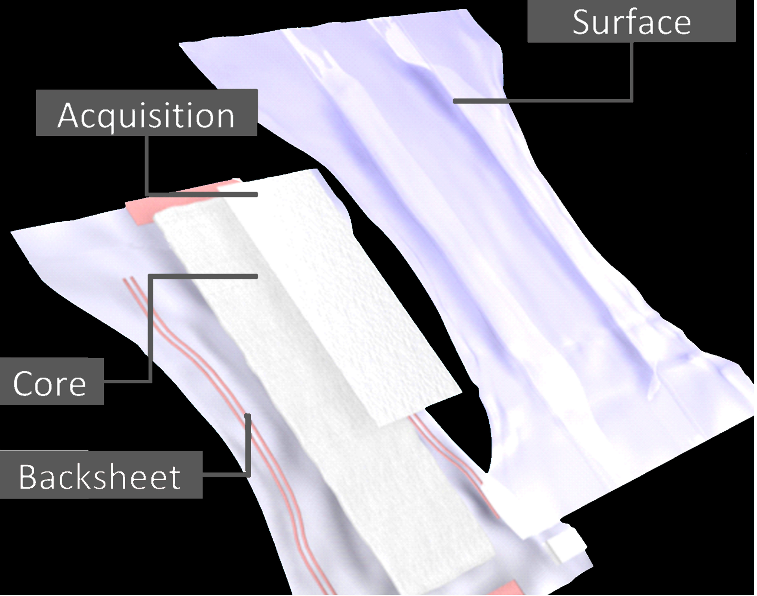
Figure 1. Typical structure of an incontinence pad: surface; acquisition layer (facilitates fast absorption); core (stores the liquid); back-sheet (adapted from [13])
The incontinence pads were orientated onto a flat surface and two 60 mm x 60 mm x 5 mm sections were cut from the sacral region, so they would match the correct position contact as they are in real-life scenario. The border of this section was stapled about 10 mm from the edge, in order to maintain the structural integrity of the multi-layered pad.
Each pad specimen was weighed dry and after complete immersion in saline (0.9% (w/v) NaCl) for 5 minutes, to estimate its swelling capacity. Subsequently, gravimetric test showed that this produced full saturation an approximate 6-fold increase in weight and that the weight remained constant for a period in excess of 4h.

2.1 Test Methodology
The mechanical loading regimens involved the application of either pressure alone or pressure in combination with a shear force applied to the sacral area during prone lying on a standard hospital viscoelastic foam mattress (Medstrom, Ashby de la Zouche, UK) (Fig. 2a). The loading areas were selected on the right and left sacrum with a 50 mm gap in between them. The sacrum was considered an appropriate site for testing as it represents both an area frequently exposed to incontinence and a common site for pressure ulcer formation [14-17].
A simple custom-made device (Fig. 2a) was used to apply mechanical loading to the sacrum by means of a rigid cylindrical indenter with a diameter of 35 mm. The normal force, equivalent to a pressure of 9kPa, was applied by adding weights above the indenter. This value is within the range of pressures at the sacrum when an individual is semi-recumbent supported by a head of bed angle of 45° [17]. A shear force of 3N was produced by applied weights connected to a pulley system, similar to the method previously described [18]. The indenter interface head was designed with curved edges to minimize stress concentrations.
Testing involved first marking four 50mm × 50mm areas on the sacrum with a non-permanent marker. The complete test set-up is illustrated in figure 2, which included the four test sites on the sacrum. It is evident that site 1 represents an unloaded negative control and site 2, the positive control, where the stratum corneum was disrupted using repeated tape stripping [19]. Sites 3 and 4 were randomly exposed to one of the mechanical loading regimens namely, pressure or pressure in combination with shear. Specifically sites 3 and 4 were exposed to three complete consecutives load/recovery phases involving i) 0% moisture (dry incontinence pads located at the interface between the indenter and the skin); ii) pads moistened with 50% fluid capacity and iii) pads saturated with 100% fluid capacity.

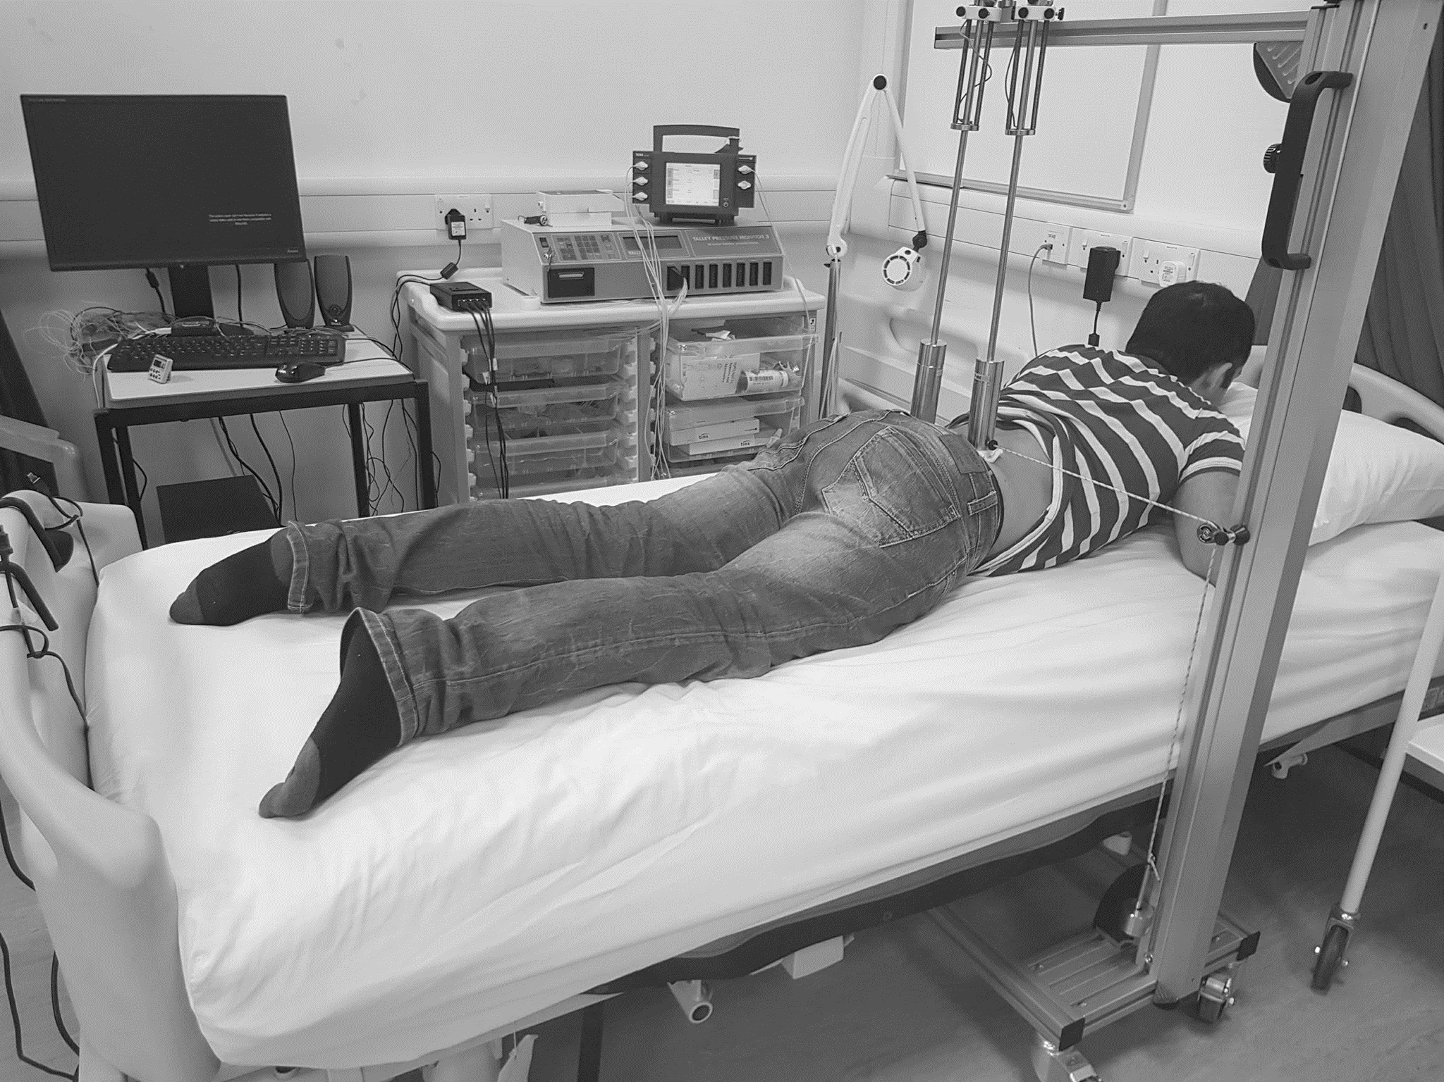
Figure 2. Experiment set-up including two sites (3 and 4) which are loaded with two identical indenters. Inset indicates site 1, the unloaded control, site 2 exposed to tape stripping and sites 3 and 4 randomly allocated to pressure or pressure in combination with shear.

2.2 Skin output parameters
Skin barrier function was assessed using an open-chamber probe measuring transepidermal water loss (TEWL, MPA9, Courage & Khazaka, Germany), which is an established non-invasive method to assess the status of the skin barrier i.e., the integrity of the stratum corneum used in both in-vitro and in-vivo studies [19-22].
Inflammatory biomarkers in skin were recovered with a simple and non-invasive absorption method, using Sebutape® [23]. Several studies have subsequently employed this method to analyze cytokine levels in sebum on healthy and mechanically-irritated skin [24-26].
A temporal evaluation of skin response was undertaken over the 3 hour test period, as illustrated in figure 3. Baseline measurements of TEWL and sebum biomarkers were recorded from each of the four sites prior to mechanical/moisture challenge. Two sessions were randomized into either no pad or pad condition. In the case of the former, the loading was applied to Sites 3 and 4. After this 30 minute period, repeat TEWL measurements and sebum samples were taken, which was subsequently followed by a refractory period of 30 minutes at the end of which measurements were taken (Fig. 3). The sebum tapes were left on the skin for 2 minutes during sampling and removed using tweezers, to avoid contamination. Upon removal, sebutape samples were immediately frozen at -80°C, for subsequent biochemical analysis.
The protocol involves three periods of loading for each pad moisture condition (0-30min; 60-90min; 120-150min) separated by refractory periods where the skin was relieved of both loading and pad exposure (Fig. 3).
Figure 3. Schematic representation of protocols adopted for sessions 1 and 2 and the time points in
which measurements of TEWL and sebum collection were recorded.
The two test sessions were separated by a period of at least one week to ensure skin recovery. Both the order and site of pad application (Site 3 or 4) were randomized for each participant.
2.3 Biochemical Analysis
The Sebutape® extraction process followed a standard protocol [23]. To review briefly, frozen samples were thawed to room temperature and 2ml of buffered solution with a non-ionic detergent (phosphate buffered saline (PBS), Sigma-Aldrich Co, St. Louis, USA) containing 0.05% TWEEN, Sigma-Aldrich Co, St. Louis, USA) was added to each vial. After immersion for 1 hour, the tapes were sonicated for 10 minutes at 20±2°C, vortexed vigorously for 2 minutes, and mixed with a pipette tip. After refreezing overnight at -80°C, the tape extracts were thawed, vortexed for 1 minute and mixed with a pipette to recover the total extracts from the tapes. Samples from all participants (n=12) were then processed and analyzed using Enzyme-Linked Immunosorbent assay kits (Peprotech, London, UK) to estimate concentrations for the pro-inflammatory cytokine, interleukin 1-α (IL-1α). In order to correct for different sebum uptake from the tapes, the levels of IL-1α were normalized to the total protein using a standard assay (Coomassie Blue, Sigma-Aldrich Co, St. Louis, USA ).

2.4 Data analysis
Data were assessed for normality using histogram analysis and a Shapiro-Wilk test. Accordingly, data was presented using non-parametric descriptors, namely medians, quartiles and range. GraphPad Prism 7.01 (GraphPad Software Inc., San Diego, CA) was used to create box and whisker plots of the data. Comparisons between test conditions were conducted using a Wilcoxon signed rank test. A statistical significance level of 5% was prescribed (p<0.05). Subsequent cluster analysis of biomarker data involved summing the ranks of values for all the participants during each of the three loading and refractory periods.

3. Results
3.1 Participants
The participants consisted of 4 males and 8 females, aged between 24-64 years, with a BMI range from 19.1-34.7 kg/m².

  - TEWL
The results for TEWL revealed minimal changes at the unloaded site over the test period (Fig. 4a). By contrast, following tape stripping, there was a statistically significant increase, equivalent to a two-fold change in TEWL, which was maintained throughout the test period (Fig. 4b).

- Unloaded | - Tape stripping
Figure 4 Box and whisker plots of TEWL data for: a) Unloaded site and b) Tape stripping site. Wilcoxon rank-sum test reveal ** and *** indicating p<0.05 and p<0.005 respectively.
The patterned background indicates the tape stripping insult.
TEWL values increased significantly with both types of loading in the dry state (NO PAD), although the values were restored to basal levels on the removal of load (Figs. 5a and c). By contrast, there were minimal changes in TEWL following the corresponding periods of loading with dry pads in-situ (Figs. 5b and d). The addition of fluid within the pads resulted in a statistically significant increase (p<0.05) in median TEWL values for both mechanical loading regimens. The highest TEWL values were observed when the pads were saturated with 100% fluid capacity, representing a 2.7 and 2.6 fold increase for pressure and pressure in combination with shear, respectively. All these increases were observed to be reversible during the refractory period.

- Pressure (9kPa)  NO PAD | - Pressure (9kPa)  PAD
- Pressure (9kPa)+Shear (3N)  NO PAD | - Pressure (9kPa)+Shear (3N)  PAD
Figure 5. Box and whisker plots of TEWL data for pressure (a and b) and pressure plus shear (c and d) for different conditions (NO PAD and PAD). Wilcoxon rank-sum test reveal *, *** and **** indicating p<0.05, p<0.005 and p<0.001, respectively. The shaded and unshaded backgrounds indicate the loading and refractory phases, respectively.

3.3 Inflammatory Biomarkers
The pro-inflammatory cytokine Il-1α was successfully quantified from Sebutapes samples. No changes in the IL-1α/TP ratio values were evident at the unloaded site (Fig. 6a). By contrast, the corresponding increases were statistically significant immediately after tape stripping, with elevated levels of IL-1α/TP ratio for much of the test period (Fig. 6b). However, there was considerable variability in the inflammatory response between participants.
- Unloaded | - Tape stripping
Figure 6. Box and whisker plots of cytokine data for: a) Unloaded site and b) Tape stripping site. Wilcoxon rank-sum test reveal * indicating p<0.05 (n=12). The patterned background indicates the tape stripping insult.

Figures 7 a and c reveal that the IL-1α/TP ratios were increased after the application of loading in the dry state, which was observed both in the presence and absence of the pad. Following the 30 minutes refractory period there was some decrease, although median values remained higher than basal values after 60 minutes. When the pads contained 50% and 100% fluid capacity, the IL-1α/TP ratios increased (Figs. 7b and d). However, while in the former case ratios reduced after the refractory period, when the pad was saturated the ratios remained significantly higher than the basal values for both loading regimens (p<0.05). The median changes of the IL1-α/TP ratios tended to increase after periods of loading, suggesting that there might be a cumulative effect over the test period.

- Pressure (9kPa)  NO PAD | - Pressure (9kPa)  PAD
- Pressure (9kPa)+Shear (3N)  NO PAD | - Pressure (9kPa)+Shear (3N)  PAD
Figure 7. Box and whisker plots of cytokine data for pressure (a and b) and pressure plus shear (c and d) for different conditions. Wilcoxon rank-sum test reveal * and ** that indicates p<0.05 and p<0.01. The shaded and unshaded backgrounds indicates the loading and refractory phases, respectively.

There were clear differences between individuals in terms of the inflammatory response over the test period. This is exemplified with the findings resulting from the loading of pressure in combination with shear and subsequent refractory periods (Fig. 8a). It was clear that groups emerge depending on the magnitude of the IL-1α/TP ratios. By ranking the response at each period, two groups or clusters were revealed related to the individual BMI (Fig.8b). In particular, individuals with a BMI ≤26 kg/m² tended to exhibit elevated IL-1α/TP ratios compared to those with a BMI >26 kg/m².
a) | b)
Figure 8. a) Individual values of IL-1α/TP ratios over the test protocol involving loading of pressure in combination with shear; b) Ranked sum of inflammatory response as a function of BMI of individuals.

4. Discussion
The overall aim of this research was to examine the relative effects of a dry and fluid-filled incontinence pad during periods of prolonged mechanical loading on the skin. Accordingly, a test protocol was developed to examine the skin response at the sacrum, involving both biophysical and biochemical techniques, in a cohort of able-bodied participants. These participants were exposed to dry and fluid-filled incontinence pads in combination with pressure and shear forces. The data revealed that the skin barrier function, as monitored using TEWL, could be protected from mechanical loads with a dry incontinence pad (Figs. 5b and d). However, when moisture was added to the pads, there was a significant increase in TEWL values. This change in skin barrier was recovered in the subsequent refractory periods of off-loading. By contrast, pressure and shear loading on the skin resulted in an immediate up-regulation of pro-inflammatory biomarkers, irrespective of moisture content (Fig. 7). This inflammatory response was either partially recovered or even slightly increased during the subsequent off-loading period.
Previous studies had reported that disruption of barrier function occurred with a range of insults. Studies include both chemical exposure (water or sodium lauryl sulphate solution) and mechanical loads, on different skin sites (sacrum, heel, volar aspect of the hand) indicated by an increase in TEWL values [27-29]. The present study represents the first to examine the barrier function as a result of a combination of insults. Results indicated that the absolute increase in TEWL was approximately 11.4 and 16.2 g/hm² in both 50% and 100% fluid capacity, respectively. These values are higher than previously reported for only single insults, i.e. chemical or mechanical [27]. However, while these changes in barrier function are pronounced they were reversed during periods of off-loading.
Inflammatory biomarkers sampled from sebum revealed an up-regulation of IL-1α/TP ratios following mechanical loading to the skin, independent of fluid exposure. Similar changes have been previously reported when either pressure (3.9 kPa) or pressure (2.4kPa) in combination with shear (14.5N) was applied to the forearm for 30 minutes, with IL-1α/TP ratios increases of 1.7 fold in case of combined loading [18]. In the present study a higher applied pressure (9kPa) combined with a smaller shear force (3N) resulted in a 1.2 fold increase of IL-1α/TP ratio, when the sacrum was loaded without the pad. The inflammation reduced during the refractory period in the dry conditions (Fig. 7a and c). However, with the introduction of an incontinence pad containing 50% and 100% of its fluid capacity, the inflammatory state was sustained during the unloading period. Local up-regulation of these inflammatory cytokines, namely IL-1α, has also been reported in other clinical scenarios where vulnerable skin tissues have been periodically loaded at elevated levels of relative humidity [26, 30]. Clearly others cytokines may prove worthy of study [26], particularly as the state of tissues will vary with time, depending on the exposure to moisture and loading.
A close examination of the cluster data (Fig. 8b) revealed some relationship between the inflammatory response and BMI, namely an increased inflammation response for BMI≤26 kg/m². Indeed, it has been reported that low BMI represents an independent risk of PUs for hospitalised patients, particularly at the sacrum [31-32]. However, there is no consideration of BMI when assessing an individual risk using traditional scales [31, 33]. Individuals with low BMI may have reduced tissue tolerance to moisture and mechanical loads, attributed to, for example, reduced thickness of the skin and subcutaneous tissues. Further investigations would therefore involve imaging modalities associated with ultrasound techniques.
The study was clearly limited by the small sample of able-bodied participants restricting the generalization of the data. The individual periods of loading were restricted to 30 minutes, although in many clinical situations individuals wearing incontinence pads will be exposed to mechanical loads and moisture for many hours during both the day and night. In addition, only a single magnitude of pressure (approximately 68 mmHg) was applied, and clearly further research could involve a range of both magnitudes and durations of pressure and shear on the incontinence pads when investigating the associated skin response.
The clinical implications of this study highlight the importance of regular changes of incontinence pads in order to maintain skin barrier function. It suggests that the presence of a dry pad provides some protection to the skin barrier when the skin is exposed to pressure and shear loading. However, with fluid in the pad a sustained skin inflammatory response was observed, with an association potential risk to vulnerable tissues. Even during the refractory period, the inflammatory markers remained elevated particularly when excess moisture was present (Figs. 7b and d). Therefore, a careful regimen of moisture management and adequate regular off-loading must be applied to minimize the risk of skin damage with a consideration of the individual BMI. Regular skin checks are needed to support the clinical judgment of tissue health and provide the means to monitor vulnerable skin sites exposed to moisture, pressure and shear loads. The use of biophysical and biomarker screening may represent a valuable objective measure allied to clinical judgment.

5. Conclusions
This study represents the first in-vivo assessment of mechanical loads with the presence of moistened incontinence pads, simulating a clinical scenario of vulnerable individuals with limited mobility and incontinence. The study demonstrated that a commercial incontinence pad can provide some skin protection to mechanical loads when applied in a dry state. However, the addition of fluid within the pad affected both the barrier function and inflammatory response of loaded skin. With respect to the former, the response could be reversible during periods of off-loading. It is therefore clear that periods of pressure relief and careful management of moisture particularly at loaded sites are critical for the maintenance of skin health, in individuals at risk of PUs.

Acknowledgments
This research was supported by Essity, Göteborg, Sweden. The work forms part of EPSRC-NIHR Network Plus Award (EP/N02723X/1) Medical devices and vulnerable skin (MDVSN^{PLUS}): Intelligent sensing to promote self-management (EP/N02723X/1).

Bibliography
1. Garcia-Fernandez F.P., Pancorbo-Hidalgo P.L. and Agreda J.J. (2014) Predictive capacity of risk assessment scales and clinical judgment for pressure ulcers: a meta-analysis. J Wound Ostomy Continence Nurs 41(1): 24-34.
2. Gorecki C., Nixon J., Madill A., Firth J. and Brown J.M. (2012) What influences the impact of pressure ulcers on health-related quality of life? A qualitative patient-focused exploration of contributory factors. J Tissue Viability 21(1): 3-12.
3. Spilsbury K., Nelson A., Cullum N., Iglesias C., Nixon J. and Mason S. (2007) Pressure ulcers and their treatment and effects on quality of life: hospital inpatient perspectives. J Adv Nurs 57(5): 494-504.
4. Gallagher P., Barry P., Hartigan I., Mccluskey P., O'connor K. and O'connor M. (2008) Prevalence of pressure ulcers in three university teaching hospitals in Ireland. J Tissue Viability 17: 103-109.
5. Guest J.F., Ayoub N., McIlwraith T., Uchegbu I., Gerrish A., Weidlich D., Vowden K. and Vowden P. (2017) Health economic burden that different wound types impose on the UK's National Health Service. Int Wound J 14: 322-330.
6. Kottner J., Black J., Call E., Gefen A. and Santamaria N. (2018) Microclimate: A critical review in the context of pressure ulcer prevention. Clin Biomech 59: 62-70.
7. Sae-Sia W., Wipke-Tevis D. and Williams D. (2005) Elevated sacral skin temperature (Ts): a risk factor for pressure ulcer development in hospitalized neurologically impaired Thai patients. Appl Nurs Res 18: 29-35.
8. Sprigle S., Linden M., McKenna D., Davis K. and Riordan B. (2001) Clinical skin temperature measurement to predict incipient pressure ulcers. Adv Skin Wound Care 14: 133-7.
9. Clark M., Romanelli M., Reger S., Ranganathan V., Black J. and Dealey C. (2010) Microclimate in context. International guidelines. Pressure ulcer prevention: pressure, shear, friction and microclimate in context. A consensus document. Wounds Int 19-25.
10. Gerhardt L.C., Strassle V., Lenz A., Spencer N.D. and Derler S. (2008) Influence of epidermal hydration on the friction of human skin against textiles. J R Soc Interface 5: 1317-28.
11. Gray M., Beeckman D., Bliss D.Z., Fader M., Logan S., Junkin J., Selekof J., Doughty D., Kurz P. (2012) Incontinence-associated dermatitis: a comprehensive review and update." J Wound Ostomy Continence Nurs 39(1): 61-74.
12. Fader M., Clarke-O'Neill S., Cook D., Dean G., Brooks R., Cottenden A. and Malone-Lee J. (2003) Management of night-time urinary incontinence in residential settings for older people: an investigation into the effects of different pad changing regimes on skin health. J Clin Nurs 12(3): 374-386.
13. Falloon S.S., Abbas S., Stridfeldt C. and Cottenden A. (2018). The Impact of Microclimate on Skin Health With Absorbent Incontinence Product Use: An Integrative Review. J Wound Ostomy Continence Nurs 45(4): 341-348.
14. Defloor T. (2000) The effect of position and mattress on interface pressure. Appl Nurs Res 13(1): 2-11.
15. Fader M., Bain D. and Cottenden A. (2004) Effects of absorbent incontinence pads on pressure management mattresses. J Adv Nurs 48(6): 569-574.
16. Reger S.I., Ranganathan V.K. and Sahgal V. (2007) Support surface interface pressure, microenvironment, and the prevalence of pressure ulcers: an analysis of the literature. Ostomy Wound Management 53(10): 50-58.
17. Swain I.D. and Bader D.L. (2002) The measurement of interface pressure and its role in soft tissue breakdown. J Tissue Viability 12(4): 132-134, 136-137, 140-136.
18. de Wert L. A., Bader D. L, Oomens C.W.J., Schoonhoven L., Poeze M. and Bouvy N.D. (2015) A new method to evaluate the effects of shear on the skin. Wound Repair and Regen 23(6): 885-890.
19. Gao Y. X., Wang S., Chen S. and Liu X. (2013) Acute skin barrier disruption with repeated tape stripping: an in vivo model for damage skin barrier. Skin Research and Technology 19(2): 162-168.
20. Kompaore F., Marty J. and Dupont C. (1993) In vivo evaluation of the stratum corneum barrier function in blacks, Caucasians and Asians with two noninvasive methods. Skin Pharmacol Physiol 6(3): 200-207.
21. Kottner J., Lichterfeld A.and Blume-Peytavi U. (2013) Transepidermal water loss in young and aged healthy humans: a systematic review and meta-analysis. Arch Dermatol Res 305(4): 315-323.
22. Imhof R.E., De Jesus M.E.P., Xiao P., Ciortea L.I. and Berg E.P. (2009) New developments in skin barrier measurements. Skin Moisturization, 2nd ed. New York: Informa Healthcare USA: 463-479.
23. Perkins M.A., Osterhues M.A., Farage M.A. and Robinson M.K. (2001) A non-invasive method to assess skin irritation and compromised skin conditions using simple tape adsorption of molecular markers of inflammation. Skin Research and Technology 7(4): 227-237.
24. De Jongh C.M., Verberk M.M., Spiekstra S.W., Gibbs S. and Kezic S. (2007) Cytokines at different stratum corneum levels in normal and sodium lauryl sulphate‐irritated skin. Skin Research and Technology 13(4): 390-398.
25. Perkins M., Cardin C., Osterhues M. and Robinson M. (2002) A non‐invasive tape absorption method for recovery of inflammatory mediators to differentiate normal from compromised scalp conditions. Skin Research and Technology 8(3): 187-193.
26. Worsley P., Prudden G., Gower G. and. Bader D.L. (2016) Investigating the effects of strap tension during non-invasive ventilation mask application: a combined biomechanical and biomarker approach. Medical Devices: Evidence and Research 9: 409-417.
27. Firooz A., Aghazadeh N., Rajabi Estarabadi A. and Hejazi P. (2015) The effects of water exposure on biophysical properties of normal skin. Skin Res Technol 21(2): 131-136.
28. Pfannes E.K.B., Blume-Peytavi U. and Kottner J. (2018) Patterns and associations of structural and functional cutaneous responses during loading at heel and sacral skin in aged females: A reanalysis of clinical study data. J Tissue Viability 27(3): 123-129.
29. Tomova-Simitchieva T., Lichterfeld-Kottner A., Blume-Peytavi U. and Kottner J. (2018) Comparing the effects of 3 different pressure ulcer prevention support surfaces on the structure and function of heel and sacral skin: An exploratory cross-over trial. Int Wound J 15(3): 429-437.
30. Hemmes B., de Wert L.A., Brink P.R.G., Ooomens C.W.J., Bader D.L. and Poeze M. (2017) Cytokine IL1α and lactate as markers for tissue damage in spineboard immobilization. A prospective, randomized open-label crossover trial. J Mech Behav Biomed Mater 75:82-88.
31. Hyun S., Li X., Vermillion B., Newton C., Fall M., Kaewprag P., Moffatt-Bruce S. and Lenz E. R. (2014) Body mass index and pressure ulcers: improved predictability of pressure ulcers in intensive care patients. Am J Crit Care 23(6): 494-500.
32. Kottner J., Gefen A. and Lahmann N. (2011) Weight and pressure ulcer occurrence: A secondary data analysis. Int J Nurse Stud 48(11): 1339-1348.
33. Drake D.J., Swanson M., Baker G., Pokorny M., Rose M.A., Clark-Reed L., Waters W., Watkins F.R.Jr and Engelke M.K. (2010) The association of BMI and Braden total score on the occurrence of pressure ulcers. J Wound Ostomy Continence Nurs 37(4): 367-371.

