CJEU excludes retroactive application of reformed language of Article 7(1)(e)(iii) of the EU Trade Mark Regulation and does not clarify what ‘another characteristic’ means

CJEU, Textilis Ltd and Ozgur Keskin v Svenskt Tenn Aktiebolag, C-21/18, EU:C:2019:199, 14 March 2019

In its judgment in Textilis Ltd and Ozgur Keskin v Svenskt Tenn Aktiebolag (‘Textilis’), the Court of Justice of the European Union (CJEU) found that the reformed language of the absolute ground for refusal concerning signs which consist exclusively of the “the shape, or another characteristic, which gives substantial value to the goods”: (1) is not applicable to trade marks registered before the entry into force of Regulation 207/2009, as amended by Regulation 2015/2424; and (2) does not apply to a sign that consists of two-dimensional decorative motifs affixed to goods.

Legal context

In the context of the 2015 EU trade mark reform, the language of the absolute ground for refusal in Article 7(1)(e)(iii) of the EU Trade Mark Regulation 207/2009 (now EU Trade Mark Regulation 2017/1001) was reformed, so that the exclusion from registration envisaged therein would not just apply to the ‘shape’, but also to ‘another characteristic’ that gives substantial value to the goods.

What remained unclear after the reform was both whether the reformed language of this absolute ground would be also applicable to trade marks registered prior to the entry into force of the new legislation (thus paving the way to the potential invalidation of registrations granted under the earlier law) and the meaning of ‘another characteristic’. With particular regard to the latter, in fact, despite the attempt of Advocate General (AG) Szpunar to touch upon it, especially in his First Opinion in Christian Louboutin and Christian Louboutin Sas v van Haren Schoenen BV, C-163/16, EU:C:2017:495, paras 61-66, the CJEU failed to provide any express guidance in its 2018 judgment in Christian Louboutin and Christian Louboutin Sas v van Haren Schoenen BV, C-163/16, EU:C:2018:423 (‘Louboutin’).

Facts

In the 1930s, architect Joseph Frank worked with Svenskt Tenn to create a pattern for furnishing fabrics that would then become iconic for this furniture and furnishing fabric house: MANHATTAN.

In 2012, Svenskt Tenn successfully applied to register the MANHATTAN pattern (as represented below) as an EU trade mark for a variety of goods in classes 11, 16, 20, 21, 24, 27, and 35:

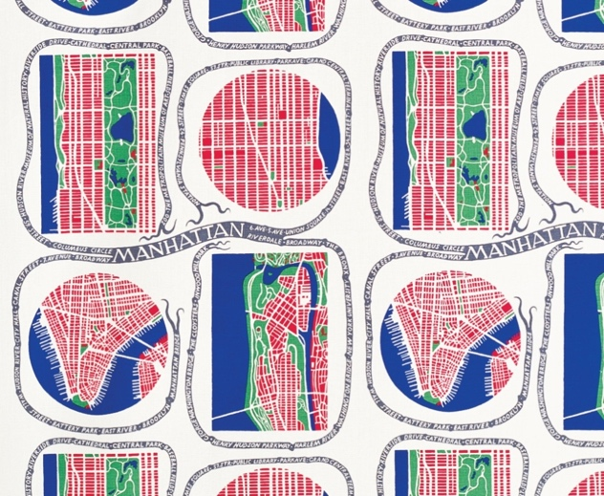

Subsequently, Svenskt Tenn sued UK company Textilis, claiming that the latter’s fabrics and goods for interior decoration bearing patterns similar to MANHATTAN would infringe rights in its registered trade mark. As a counterclaim, Textilis requested a declaration of invalidity of the MANHATTAN trade mark on grounds, first, of insufficient distinctiveness and, second, that the way in which it was used would render it a shape which gives substantial value to the goods within the meaning of Article 7(1)(e)(iii) of the EU Trade Mark Regulation. The Stockholm District Court ruled in favour of Svenskt Tenn and also found that Textilis had infringed copyright in MANHATTAN.

Textilis appealed, arguing that the rationale of the absolute ground in Article 7(1)(e)(iii) is such that a sign consisting of the pattern on a fabric cannot be registered as a trade mark without subverting the principle of limited duration of copyright protection. The Svea Court of Appeal, Patents and Market Court of Appeal, Stockholm stayed the proceedings and asked the CJEU to clarify, first, the application in time of the reformed language of Article 7(1)(e)(iii) and, second, the content thereof, including whether it is applicable to two-dimensional signs that represent two-dimensional goods and such language has resulted in a substantial alteration (broadening) of the original scope of the ground, as well how the relevant assessment is to be undertaken.

Analysis

Application of the reformed language of Article 7(1)(e)(iii)

Starting from the question relating to the application in time of the reformed language of Article 7(1)(e)(iii), the CJEU recalled the well-established principles of legal certainty and the protection of legitimate expectations to reiterate that the substantive rules of EU law may apply to situations existing before their entry into force only insofar as it clearly follows from their terms, objectives or general scheme that such effect must be given to them (Bureau national interprofessionnel du Cognac, C-4/10 and C-27/10, EU:C:2011:484, para 26).

This would not be the case of Regulation 2015/2424, which actually highlights (Recital 12) the relevance that EU legislature attaches to the principle of legal certainty. As a result, the reformed language of Article 7(1)(e)(iii) does not apply to trade marks registered before the entry into force of the amended EU Trade Mark Regulation.

Content and scope of the absolute ground contained in Article 7(1)(e)(iii)

Turning to the assessment of the substantive content of Article 7(1)(e)(iii), the CJEU recalled the definition of ‘shape’ as provided in Louboutin, including the consideration that the application of a particular colour to a specific location of a product is not a ‘shape’ where it is not the form of the product or part of the product that registration of the mark seeks to protect. The sign at issue in Textilis would not consist ‘exclusively of the shape’. As a result, it would not fall within the scope of the absolute ground:

Although it is true that, in the main proceedings, the sign under consideration represents shapes which are formed by the external outline of drawings representing, in a stylised manner, parts of geographical maps, the fact remains that, apart from those shapes, that sign contains decorative elements which are situated both inside and outside those outlines. (para 40)

The Court added that the fact that the sign at issue is also protected by copyright has no bearing on whether or not it consists exclusively of a ‘shape’.

Practical significance

As expected, the CJEU clarified that the reformed language of the EU Trade Mark Regulation does not apply to signs registered as trade marks prior to the entry into force of the amended provisions.

With regard to the substantive assessment of the content of the ground, the Court refrained from providing an explicit response to the question whether the reformed language of Article 7(1)(e) (not just (iii)) has entailed an alteration of the scope of this absolute ground for refusal. Indeed, the CJEU limited its analysis to consideration of whether the MANHATTAN print could be regarded as a shape. Unsurprisingly (considering the definition of ‘shape’ as laid down in Louboutin), it found that it could not.

The judgment remains silent as to what the meaning of ‘another characteristic’ is. It seems plausible to conclude that the reformed language of the absolute ground has not entailed a substantive change in the law, but merely a clarification thereof. Two considerations support this conclusion. First, as AG Szpunar observed in his First Opinion in Louboutin (para 64) in relation to the new EU Trade Mark Directive 2015/2436, if EU legislature had meant to alter the scope of the absolute ground relating to shapes (and now also to other characteristics), it would have laid down transitional provisions. This has not been the case. Second, the CJEU has provided an expansive definition of ‘shape’, both in Louboutin and in Textilis, so that one wonders what room is left for ‘another characteristic’ as a standalone concept. From all this one might infer that, even in the event that the CJEU had deemed that the reformed language of Article 7(1)(e)(iii) applied to the MANHATTAN print, this would have not been enough to challenge the validity of the MANHATTAN trade mark registration.

Eleonora Rosati
University of Southampton and Bird & Bird
eleonora@e-lawnora.com

