1
2

4 1 Time trends in diagnostic testing for PCD in
3
5
6 2 Europe
7
- 3 Halbeisen Florian S1, Shoemark Amelia2-3, Barbato Angelo4-5, Boon Mieke6, Carr Siobhan2,
- 4 Crowley Suzanne7, Hirst Rob8, Karadag Bulent9, Koerner-Rettberg Cordula10, Loebinger Michael
- 5 R11, Lucas Jane S12, Maitre Bernard13-14, Mazurek Henryk15, Özçelik Uğur16, Martinů Vendula17,
- 6 Schwerk Nicolaus18, Thouvenin Guillaume13,19-20, Tschanz Stefan A21-22, Yiallouros Panayiotis23,
- 7 *Goutaki Myrofora1,24, *Kuehni Claudia E1,24
13
14 8 * Both authors contributed equally
15
16 9
17

10 Author affiliations:
- 11 1. Institute of Social and Preventive Medicine, University of Bern, Switzerland
- 12 2. Department of Paediatrics, Primary Ciliary Dyskinesia Centre, Royal Brompton and Harefield
- 13 Foundation Trust, London, UK
- 14 3. School of Medicine, University of Dundee, Dundee, Scotland
- 15 4. for the Italian PCD Consortium
- 16 5. Department of Paediatrics, University of Padova, Padova, Italy
- 17 6. Department of Paediatrics, University Hospital Gasthuisberg, Leuven, Belgium
- 18 7. Unit for Paediatric Heart, Lung, Allergic Diseases, Rikshospitalet, Oslo, Norway
- 19 8. Department of Infection, Immunity and Inflammation, Institute for Lung Health, University of
- 20 Leicester, Leicester, United Kingdom
21 9. Department of Pediatric Pulmonology, Marmara University, School of Medicine, Istanbul, Turkey
- 22 10. Department of Paediatric Pneumology, University Children's Hospital of Ruhr University Bochum,
- 23 Germany
- 24 11. Host Defence Unit, Royal Brompton and Harefield NHS Foundation Trust, London, UK
- 25 12. Primary Ciliary Dyskinesia Centre, NIHR Respiratory Biomedical Research Centre, University of
- 26 Southampton, UK
- 27 13. on behalf of the French Reference Centre for Rare Lung Diseases
- 28 14. Hopital intercommunal de Créteil, Service de Pneumologie, DHU ATVB, Université Paris Est Créteil,
- 29 France
- 30 15. Department of Pneumonology and Cystic Fibrosis, Institute of Tuberculosis and Lung Disorders,
- 31 ul.Prof.Rudnika 3b, 34-700 Rabka - Zdrój, Poland
- 32 16. Department of Pediatric Pulmonology, Hacettepe University Faculty of Medicine, Ankara, Turkey
- 33 17. Pediatric Department, Charles University Prague and University Hospital Motol, Prague, Czech
- 34 Republic.
- 35 18. Clinic for paediatric pulmonology, allergiology and neonatology, Hannover Medical School, Germany
- 36 19. Paediatric Pulmonary Department, Trousseau Hospital APHP, Sorbonne Universities and Pierre et
- 37 Marie Curie University, Paris, France
- 38 20. INSERM U938-CRSA, Paris, France
- 39 21. on behalf of the Swiss PCD Group
- 40 22. Institute of Anatomy, University of Bern, Bern, Switzerland
- 41 23. Medical School, University of Cyprus, Nicosia, Cyprus
- 42 24. Paediatric Respiratory Medicine, Children’s University Hospital of Bern, University of Bern,
- 43 Switzerland
51 44
52 45 Word counts: 1648 / 1500
53
54 46 References: 14 / 15

1
2
3 47 To the Editor:
4
- 48 Despite recent advances in diagnostic methods, diagnosis of primary ciliary dyskinesia (PCD)
- 49 remains complex. We need a combination of different diagnostic tests, and all have their limitations
7
8 50 [1]. In 2009, the first European Respiratory Society Task Force (ERS TF) on PCD in children
9
- 51 published recommendations [2], suggesting that: 1) Nasal nitric oxide (nNO) should be measured
- 52 to screen for PCD in patients aged ≥5 years [3]; and 2) video microscopy (VM) analysis of ciliary
12
- 53 beat pattern and frequency [4] plus electron microscopy (EM) [5] should be the key confirmatory
- 54 diagnostic tests. Genetic testing was not recommended as part of the initial diagnostic testing, but
15
16 55 as additional test for inconclusive cases. The recommended test combination was nNO, VM and
17
18 56 EM for patients aged ≥ 5 years and VM plus EM for younger patients.
19
- 57 In 2017, a second ERS TF on PCD diagnosis revised the accumulated literature and published
- 58 evidence-based guidelines [6]. Although evidence-based guidelines have become the norm in
22
23 59 research, their practical implementation can be challenging [7]. We wanted to assess whether the
24
- 60 2009 diagnostic recommendations had been implemented and how diagnosis of PCD changed in
- 61 Europe over time. This knowledge will help to improve implementation of the new guidelines.
27
28 62 We analysed data from the international PCD cohort (iPCD) (details are published elsewhere [8]).
29
30 63 By May 2018, iPCD included data on 3733 patients from 26 centres in 21 countries. For this study,
31
- 64 we included all datasets from European centres that tested patients with PCD, both before and
- 65 after 2009, and had complete information on nNO, EM and VM testing. We excluded patients in
34
35 66 whom diagnosis was based only on clinical presentation, patients with unknown dates of testing.
36
37 67 We included 2108 patients from 16 centres (11 European countries) (Belgium, Cyprus, Czech
38
- 68 Republic, France, Germany, Italy, Norway, Poland, Switzerland, Turkey and United Kingdom); 51%
- 69 were male, 818 patients (39%) had been diagnosed before and 1290 after 2009. All three
41
- 70 recommended tests were available in all countries, with the exception of Norway where VM testing
- 71 was not available neither before nor after 2009.
44
45
- 72 Based on the 2009 recommendations, we only considered nNO measurements in patients aged 5
- 73 years or older [2]. We considered the nNO test as positive when nNO was below 77 nL·min−1
48
- 74 [9,10]. VM had been performed with different techniques over time, with high speed video analysis
- 75 being the most commonly used technique in recent years. We classified VM and EM results as
51
- 76 pathological based on information provided by the centres on the beat frequency, beat pattern and
- cilia ultrastructure. For each patient, we defined the calendar year of diagnosis based on the date
77
54
55 78 of the earliest positive test result. We then assessed whether there was a change over time in the
56
- 79 proportion of diagnosed patients who had received a) the recommended test combination; b) any
- 80 single test. We compared the proportion of patients with the recommended test combination (VM
59
60

1
2
3 81 and EM for patients aged <5 years and nNO, VM and EM for older patients) for the two time
4
5 82 periods, before and after 2009. We used R version 3.1.2 for all analyses.
6
7 83 Recommended test combination: Overall, we found no significant trend over time in the use of
8
- 84 the test combination. The three tests had been used in 54% of patients diagnosed before 2009 and
- 85 in 57% after 2009 (p=0.15) (Figure 1). In preschool children the proportion diagnosed with the
11
- 86 recommended combination was 72% before and 75% (p=0.47) after 2009; in older patients it
- 87 increased from 46% to 52% (p=0.03). Results differed between countries. Few countries (e.g.
14
- 88 Belgium, Cyprus) combined all 3 tests already before 2009 for most patients and continued to do
- 89 so after 2009. In Germany, the UK and the Czech Republic, the combined use of all 3 tests was
17
18 90 common already before 2009 but increased even more after 2009, with almost ¾ of the patients
19
- 91 tested according to recommendations. The remaining countries (Turkey, Switzerland, Italy, France
- 92 and Poland) showed little or no change over time. In these countries, less than half of the patients,
22
23 93 were tested with all 3 approaches even in the later period.
24
25 94 Nasal NO testing increased overall from 63% before 2009 to 84% afterwards (p<0.001). This
26
- 95 increase was seen in most countries (Figure 1). After 2009, nNO was measured in over ¾ of
- 96 patients in all countries, except in Czech Republic (65%), Italy (70%) and UK (77%).
29
- 97 Electron microscopy was frequently performed before 2009 (97%) but decreased to 80%
- 98 (p<0.001) in the later period. Its use became less common in Poland (79% to 69%), Switzerland
32
- 99 (88% to 62%) and Turkey (100% to 18%), in all other countries it remained stable or increased
- 100 after 2009. Video microscopy analysis increased overall from 76% to 87% (p<0.001). This was
35
36 101 mainly because the use of VM for PCD diagnosis increased considerably in Italy (36% to 69%) and
37
- 102 Turkey (25% to 88%). In most countries, its use remained stable, while in Switzerland (50% to
- 103 21%) it decreased substantially.
40
41 104 This is the first multi-national study that compared diagnostic testing in PCD patients between
42
43 105 countries and over time. Although a large number of countries contribute to iPCD, some had to be
44
- 106 excluded for this analysis as they only contributed patients diagnosed after 2009 to the iPCD
- 107 cohort. Thus, our study describes how the consensus recommendations were implemented in 11
47
- 108 countries. They are not representative for all European countries, but only for those with
- 109 established PCD diagnostic protocols. In this analysis we included both children and adults.
50
51 110 However when we limited the analysis to children only, for whom the 2009 recommendations were
52
53 111 intended, results remained similar.
54
- 112 Our results suggest that the implementation of the recommended diagnostic combination of nNO,
- 113 EM and VM testing after the 2009 consensus statement remained low. This reflects the complex
57
58 114 nature of PCD diagnostics and the regional resources. Many countries continued to perform only
59
60 115 one or two of the recommended tests. There are several explanations for this observation. First,

1
2
3 116 the availability of local resources could have led to the development of alternative diagnostic
4
- 117 pathways, which may have been most appropriate for the local situation at that time. All PCD
- 118 diagnostic tests need specialised expensive equipment and personnel experienced in analysis of
7
- 119 VM and EM results, which are not available in all settings. Limited resources or decentralised
- 120 healthcare might not have allowed to set up diagnostic centres with scientists experienced in all
10
11 121 methods. For countries with limited resources cost-effective alternatives for diagnostic testing have
12
- 122 been suggested, which might provide an acceptable diagnostic accuracy [11]. Second, since 2009
- 123 the use of other methods including genetic testing [12,13] and immunofluorescence microscopy
15
- 124 [14,15] became more widespread. These newer methods might have been used instead of the
- 125 recommended tests in some centres. Lastly, the lack of sufficient evidence supporting the use of
18
19 126 some diagnostic tests in 2009 might have prevented some countries to implement the full set of
20
- 127 recommended tests but let them to develop their own diagnostic algorithms. We found
- 128 considerable heterogeneity between countries in the use of the three tests. Overall, countries with
23
- 129 low prior use of nNO showed improvement and nNO is now used in most patients aged ≥ 5 years
- 130 suspected for PCD. For the proportion of patients who were still not tested after 2009, we
26
- 131 speculate that nNO was not performed as a screening test, and the primary investigators chose to
- 132 do directly one or both of the other tests. In this case, if the diagnosis was already established
29
30 133 based on the results of the other tests, the patients might not have been invited posthoc to perform
31
- 134 also nNO measurement. This would be in line with the recommendations. We found that use of EM
- 135 analysis decreased, and VM increased, suggesting that there might be a shift from EM to VM
34
- 136 overall. Possible reasons are the realization that a significant proportion of patients have normal
- 137 EM findings [16] and the high costs of EM analysis combined with an increased availability of VM,
37
38 138 so that only patients with inconclusive VM results were referred for EM testing. The overall
39
- 139 changes in use of VM and EM analyses were strongly affected by the marked increase in VM and
- 140 decrease in EM analysis in Turkish patients. This shift is explained by the development of a new
42
43 141 PCD centre, which uses VM more and EM less frequently.
44
45 142 The 2009 PCD diagnostic consensus is a typical example of how difficult it is to implement
46
- 143 guidelines in clinical practice. Even though the recommendations were widely presented in
- 144 scientific conferences and meetings, improving knowledge is not sufficient to change daily
49
- 145 practices. A synthesis of systematic reviews on clinical guideline implementation strategies showed
- 146 that passive dissemination was an ineffective measure and that implementation strategies should
52
- 147 be multifaceted, and actively engage clinicians throughout the process [7]. In the case of PCD
- 148 diagnosis, implementation is further hindered by fragmentation of national diagnostic services in
55
56 149 many centres and the cost of diagnostic equipment. In our study, countries with limited resources
57
- 150 (e.g. Poland, Turkey) or decentralised diagnosis (e.g. France, Italy, Switzerland) performed the
- 151 recommended test combination less frequently, than countries with more resources (e.g. Germany,
60
152 Belgium, UK) or established centralised PCD diagnosis (e.g. Cyprus, UK). National and multi-

1
2
3 153 national collaborations, such as the European Reference Network for respiratory diseases (ERN-
4
- 154 Lung; https://ern-lung.eu/) might play an important role, in the future to facilitate centralised
- 155 diagnosis and standardised patient care. With the further development and improvement of
7
- 156 diagnostic tests for PCD and with new centres emerging, that might lack the necessary expertise,
- 157 there is an increased need for national and international collaboration in PCD diagnostic testing.
10
11
- 158 Overall, we found a low adherence to the 2009 consensus recommendations mainly due to the
- 159 decrease in use of EM analysis in some countries. This resulted in low use of the recommended
14
- 160 test combination. To further improve PCD diagnosis, we must be more diligent and engaging in
- 161 implementing the new evidence-based guidelines published in 2017, putting more emphasis on
17
18 162 establishing specialised diagnostic centres and close international collaboration.
19
20 163
21
22
23
24
25
26
27
28
29
30
31
32
33
34
35
36
37
38
39
40
41
42
43
44
45
46
47
48
49
50
51
52
53
54
55
56
57
58
59
60

1
2
3 164 1. Lucas JS, Paff T, Goggin P, Haarman E. Diagnostic Methods in Primary Ciliary Dyskinesia. Paediatr
4 165 Respir Rev 2016;18:8-17.
5 166 2. Barbato A, Frischer T, Kuehni CE, Snijders D, Azevedo I, Baktai G, Bartoloni L, Eber E, Escribano A,
6
- 167 Haarman E, Hesselmar B, Hogg C, Jorissen M, Lucas J, Nielsen KG, O'Callaghan C, Omran H, Pohunek P,
- 168 Strippoli MP, Bush A. Primary ciliary dyskinesia: a consensus statement on diagnostic and treatment
- 169 approaches in children. Eur Respir J 2009;34:1264-76.
- 170 3. Lundberg JO, Weitzberg E, Nordvall SL, Kuylenstierna R, Lundberg JM, Alving K. Primarily nasal
- 171 origin of exhaled nitric oxide and absence in Kartagener's syndrome. Eur Respir J 1994;7:1501-4. 12 172 4. Santamaria F, de Santi MM, Grillo G, Sarnelli P, Caterino M, Greco L. Ciliary motility at light 13 173 microscopy: a screening technique for ciliary defects. Acta Paediatr 1999;88:853-7.
- 174 5. Afzelius BA. A human syndrome caused by immotile cilia. Science 1976;193:317-9.
- 175 6. Lucas JS, Barbato A, Collins SA, Goutaki M, Behan L, Caudri D, Dell S, Eber E, Escudier E, Hirst RA,
16
17 176 Hogg C, Jorissen M, Latzin P, Legendre M, Leigh MW, Midulla F, Nielsen KG, Omran H, Papon JF, Pohunek P, 18 177 Redfern B, Rigau D, Rindlisbacher B, Santamaria F, Shoemark A, Snijders D, Tonia T, Titieni A, Walker WT, 19 178 Werner C, Bush A, Kuehni CE. European Respiratory Society guidelines for the diagnosis of primary ciliary 20 179 dyskinesia. Eur Respir J 2017;49.
- 180 7. Grimshaw J, Eccles M, Tetroe J. Implementing clinical guidelines: current evidence and future
- 181 implications. J Contin Educ Health Prof 2004;24 Suppl 1:S31-7.
- 182 8. Goutaki M, Maurer E, Halbeisen FS, Amirav I, Barbato A, Behan L, Boon M, Casaulta C, Clement A,
- 183 Crowley S, Haarman E, Hogg C, Karadag B, Koerner-Rettberg C, Leigh MW, Loebinger MR, Mazurek H,
25
26 184 Morgan L, Nielsen KG, Omran H, Schwerk N, Scigliano S, Werner C, Yiallouros P, Zivkovic Z, Lucas JS, Kuehni 27 185 CE. The international primary ciliary dyskinesia cohort (iPCD Cohort): methods and first results. Eur Respir J 28 186 2017;49.
- 187 9. Collins SA, Gove K, Walker W, Lucas JS. Nasal nitric oxide screening for primary ciliary dyskinesia:
- 188 systematic review and meta-analysis. Eur Respir J 2014;44:1589-99.
- 189 10. Leigh MW, Hazucha MJ, Chawla KK, Baker BR, Shapiro AJ, Brown DE, Lavange LM, Horton BJ, Qaqish
- 190 B, Carson JL, Davis SD, Dell SD, Ferkol TW, Atkinson JJ, Olivier KN, Sagel SD, Rosenfeld M, Milla C, Lee HS, 33 191 Krischer J, Zariwala MA, Knowles MR. Standardizing nasal nitric oxide measurement as a test for primary 34 192 ciliary dyskinesia. Ann Am Thorac Soc 2013;10:574-81.
35
- 193 11. Rumman N, Jackson C, Collins S, Goggin P, Coles J, Lucas JS. Diagnosis of primary ciliary dyskinesia:
- 194 potential options for resource-limited countries. Eur Respir Rev 2017;26.
- 195 12. Omran H, Haffner K, Volkel A, Kuehr J, Ketelsen UP, Ross UH, Konietzko N, Wienker T, Brandis M,
- 196 Hildebrandt F. Homozygosity mapping of a gene locus for primary ciliary dyskinesia on chromosome 5p and 40 197 identification of the heavy dynein chain DNAH5 as a candidate gene. Am J Respir Cell Mol Biol 2000;23:696- 41 198 702.
- 199 13. Kim RH, D AH, Cutz E, Knowles MR, Nelligan KA, Nykamp K, Zariwala MA, Dell SD. The role of
- 200 molecular genetic analysis in the diagnosis of primary ciliary dyskinesia. Ann Am Thorac Soc 2014;11:351-9.
44
- 201 14. Fliegauf M, Olbrich H, Horvath J, Wildhaber JH, Zariwala MA, Kennedy M, Knowles MR, Omran H.
- 202 Mislocalization of DNAH5 and DNAH9 in respiratory cells from patients with primary ciliary dyskinesia. Am J
47 203 Respir Crit Care Med 2005;171:1343-9.
48 204 15. Shoemark A, Frost E, Dixon M, Ollosson S, Kilpin K, Patel M, Scully J, Rogers AV, Mitchison HM, Bush 49 205 A, Hogg C. Accuracy of Immunofluorescence in the Diagnosis of Primary Ciliary Dyskinesia. Am J Respir Crit 50 206 Care Med 2017;196:94-101.
- 207 16. Kouis P, Yiallouros PK, Middleton N, Evans JS, Kyriacou K, Papatheodorou SI. Prevalence of primary
- 208 ciliary dyskinesia in consecutive referrals of suspect cases and the transmission electron microscopy
53
54 209 detection rate: a systematic review and meta-analysis. Pediatr Res 2017;81:398-405.
55 210
56
57
58
59
60

1
2
3
4
5
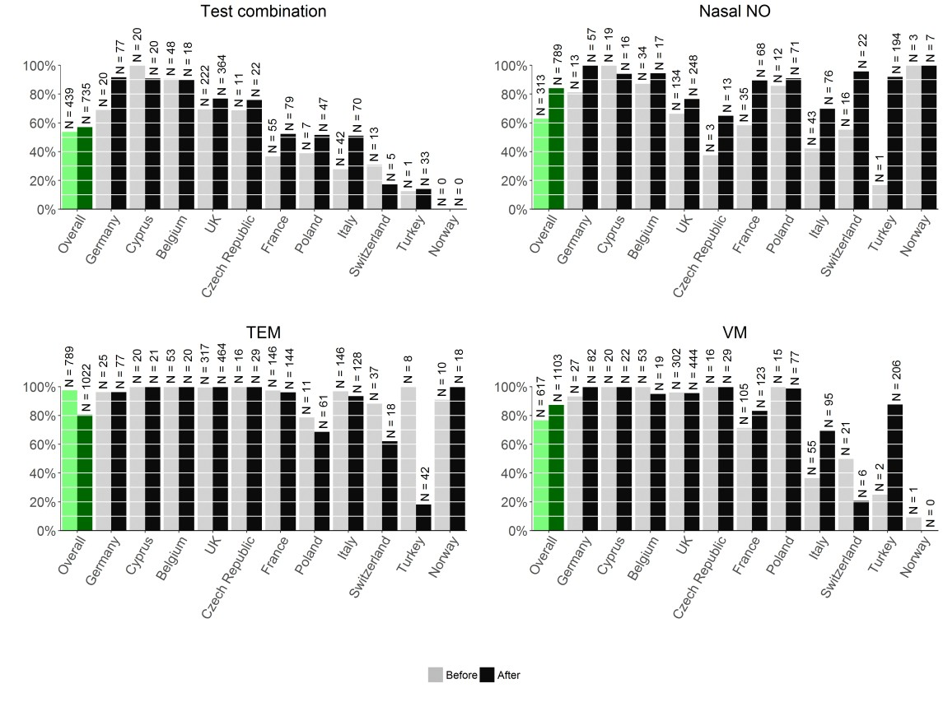
6
7
8
9
10
11
12
13
14
15
16
17
18
19
20
21
22
23
24
25
26
27
28
29
30
- Figure 1: Proportion of performed diagnostic tests in European countries before and after the 2009
- consensus statement on PCD diagnostics.
33
58
59
60

