Mobile Application for Thai & Foreign Tourists Visiting Thai Temple

# Abstract

This research gathered requirements from Thai and foreign tourists to successfully design Thai & English Android and IOS versions of a mobile application to provide an enhanced experience for tourists visiting the Phra Mahathat Woramahawihan (PMW) Temple in Thailand. The content and user interface were designed based on theories and related research and three experts evaluated the prototype to improve the final application versions which were evaluated at the temple by Thai and foreign tourists. Analysis of the results showed that both the Thai and foreign tourists found similar high satisfaction with the performance of the Android and IOS mobile applications. The mobile app text, pictures and voice allowed tourists to know how important each point of visit was, where to go, where the starting point was, and what were the rituals, the history and other information of each point. One main benefit for all foreign tourists was the app provided the history and other information of each point in English as only the names of each point were provided in English at the temple.

Keywords: mobile application, Phra Mahathat Woramahawihan Temple, user interface design, requirements

**Keywords:** Thai temple,mobile application, Buddhist

# Introduction

In 2015, the volume of tourists in Thailand increased by 9.5% compared to 2014 (Tourism Authority of Thailand, 2005). The average growth rate of tourism income in 2016 was greater than the GDP growth rate (Tourism Authority of Thailand, 2016). Mobile communication technology like smart phones has taken on a greater role in people’s way of life as sixty-four percent of the Thai population owns a smart phone with the ability to communicate quickly, anywhere and anytime (Wearesocial.com, 2016). The increasing mobile trend leads to growth of mobile application services which helps meet the needs for access to a wide unlimited range of information at any time and place. Most local cultural attractions are not funded by the government but are managed personally with most revenue coming from the sale of commemorative products or from visitor fees. There is little technology used in such tourist services compared to large tourist attractions funded by the public and private sectors.

Phra Mahathat Woramahawihan (PMW) Temple in Nakhon Sri Thammarat province formerly known as Wat Phra Borommathat is a first-class royal monastery. The Fine Arts Department announced the registration of PMW Temple as an ancient site on September 27, 1936 . PMW Temple is one of the most important places in the south of Thailand where the visitors must worship to pray for an auspicious life. The highlight is the large Relics Stupa with gold on its top and containing the relics (Tourism Authority of Thailand, 2015). An interview by the authors with tourists who visited PMW Temple found that most tourists visiting PMW Temple are not sure which way to walk around the historic site and which areas are not to be missed. There is a signpost service on a pedestal before the entrance to the temple, but if a visitor does not notice it they will not know that it is there or know about the important spots of the temple as there is no map information. The temple provides a public relations services such as leaflets and signs of information of objects. However, the information is not complete as for example there are no illustrations of the top of relics, so visitors need to imagine what it is like. Because the pagoda is located high and unavailable to see visitors cannot learn and understand clearly the history, beliefs, faith and myths inside of the temple which is something addressed in this study of PMW Temple.

Therefore, the researchers have come up with the idea to develop mobile applications of PMW Temple in order to use this technology to support tourists to visit the temple, reducing the difficulty of accessing such tourist information, and to attract more tourists to visit Thai art and culture. This directly affects the PMW Temple increase in economic potential and local culture for tourism sustainability in accordance with the Tourism Authority of Thailand's tourism promotion plan.

The Research Objectives were:

1. To study Thai and foreign tourists’ requirements in visiting PMW Temple
2. To design and develop a mobile application for Thai and foreign tourists visiting PMW Temple
3. To evaluate the mobile application for Thai tourists and foreign tourists visiting PMW Temple

# Literature Review

Nabona&Arasa (2016) stated that Alvaro del Portillo App offered useful information on the app e.g. how to travel from the airport to esplanade, event schedule, map around the city, where the beatification take place, and experience of the pilgrimage to the city of Madrid etc. A Google Map included in the app allowed pilgrims to follow a historical route in the city. The app was downloaded 25,377 times within 7 months. In addition, the app also on Whatsapp was grouped in 200 contacts to send news about the event to the group. It is useful for gathering feedback or creating a community after the event.

Timothy and Olsen (2006) and Geary (2013) mentioned that economic potential of religious motivated travel in an increasing globally. Governments see through the sacred as a potential resource that can be include in the tourism marketplace with the other leisure activities. Geary (2013) revealed that the tourist campaign called “Incredible India” was launched in 2002 with the concept of circuits around the world especially in Asia.

Geary (2018) stated that Buddhism in Asian cultural and historical sites provides a significant investment opportunity for India’s wider national vision. Religious circuits provide a way of communities of emotion and ritual practice that can be a strangeness national identity and provide economic benefit to the country.

Choe et al (2015) found that the temple in Los Angeles, California motivates non Buddhism to visit temples by having activities, such as yoga and meditation, as well as the Buddhist-themed tourism campaigns. The findings provide insights for tourism officials responsible for promoting ways to attract tourists to Buddhist temples within their respective destinations.

Ketmaneechairat et al (2014) reported that the mobile application for travel guide information on different provinces of the Southern Thailand had two modes: online and offline mode. The two languages: Thai and English language were provided in the application on Apple's iOS Software Development Kit. The results show that the tourists can search tourist attraction including history, picture, address, phone number, website, and map and travel detail. The maps can show the current location of the users and can display in three modes: standard, satellite and hybrid. Overall information on tourist attraction can be shared on Twitter, Facebook, and E-mail. The application is better support for the foreign tourists and Thai tourists that they are used iPhone mobile.

The advantages of using technology in the arts and cultural destinations include creating an interest and attracting more visitors .

It was decided for this project that it was not possible for the temple to be involved in the expense of wireless and location-based services as described by (Proctor 2005) or RFID tags used by Rukzio et al (2008) for their prototype mobile museum guide

Sung et al (2010) compared college students visiting a history exhibition with an electronic guidebook; a worksheet; and without any supplementary tools and found they spent more time with the electronic guidebooks but there were no significant differences in the knowledge gained. Some participants complained about the weight of the tablet PCs provided.

In our project participants all used their own mobile devices and no worksheet was provided for comparison and as we were interested in tourists rather than college students no knowledge tests were administered, only questionnaires.

Pilgrims in the Digital Age: a research manifesto (deAscaniis et al 2016) noted that ‘An important driver of tourism is Religion, both for worshipping and for knowledge reasons’ and considered (i) a social sciences approach, focusing on ICT potential and (ii) an engineering approach, focusing on ICT tools. The aspects closest to our work were: making access to information easier and developing a ‘church navigator’, especially for churches rich in art.

The content and user interface were designed based on the following theories and related research.

## 2.1 Technology Acceptance Model

The Technology Acceptance Model is a theory developed from the Theory of Reasoned Action, invented by Davis (1989), which is a popular concept used as a measure of success of use of technology to predict or describe the user's computer behavior by describing the relationship of two variables: perceived usefulness (PU) and perceived ease of use (PEOU). PU and PEOU will affect attitudes toward System usage and can predict the user's demand for the system. In addition PU also affects the willingness to commit behavior that leads to real-life applications. Trakulmaykee & Hnuchek (2015) also applied TAM to predict users’ intention to use a Mobile Tourist Guide and identified perceived compatibility, perceived content quality, perceived interaction quality, and perceived appearance quality.

## 2.2 Perceived Usefulness

PU is the level of individual beliefs that perceive any system usage to help maximize performance and offer valuable alternatives in the workplace. Also, people using this new technology, get better quality work and finish work faster. PEOU reflects that unless technology is easy to use, it is unlikely to be acceptable to the user (Davis, 1989). Perceptions of enjoyment and perceived benefits influence the perception of ease of use which results in the intention to use the application. Perception of enjoyment indicates the level of application awareness in its own right, beyond the system. Perceived benefits and perceived ease of use are reflected outside of the intent to use specific applications while the perception of enjoyment reflects a true inspiration for the intent to use a specific application (Davis, 1989; Chen, 2008).

## The process of accepting innovation

The process of accepting innovation is divided into five stages (Rogers, 2003).

1. Awareness is the stage where the recipient receives information about the innovation.
2. Interest is the stage of interest and starting to find information.
3. Evaluation is the stage where the recipient will take the information into consideration.
4. Trial is the stage where the participants test a system.
5. Adoption is a stage where users agree to adopt permanently or until it is deemed inefficient.

Various attributes of innovation affect acceptance. Relative Advantage is better perception. Compatibility is the level of relevance to the existing experience and needs. Complexity of innovation is the difficulty of understanding an application. Trial ability is the visible level that can see the experimental results and performance results, and the results of the use can be noticed. Observability is the level of ability to see the process in a tangible way.

## 2.4 User Interface Design

Shneiderman (2016) proposed principles of User Interface Designs which were derived from experience and applicable in interactive systems in order to improve a well-designed interface. Shneiderman's "Eight Golden Rules of Interface Design" are guides to improve good interaction design.

1. Strive for consistency: (e.g. sequences of actions; terminology; commands)
2. Enable frequent users to use shortcuts: (e.g. abbreviations, function keys, hidden commands, and macros).
3. Offer informative feedback: (e.g. modest for minor or frequent actions, more substantial for major and infrequent actions)
4. Design dialog to yield closure: (e.g. organize sequences of actions into groups)
5. Offer simple error handling: (e.g. system detects any error and offers mechanisms for handling it).
6. Permit easy reversal of actions: (e.g. relieving anxiety encourages exploration)
7. Support internal locus of control: (e.g. design system to make users initiators of actions)
8. Reduce short-term memory load: (e.g. keep displays simple, reduce window-motion frequency)

## 2.5 Universal Design

The seven principles of Universal Design (The Center for Universal Design 1997) consist of equitable use, flexibility in use, simple and intuitive use, perceptible information, tolerance for error, low physical effort, and size and space for approach and use.

|  |  |
| --- | --- |
|  |  |
|  |  |
|  |  |
|  |  |
|  |  |
|  |  |
|  |  |

# Gathering Requirements

* 1. **Research Design**

There is no record of the number of tourists who have visited the temple. The sample number of 31 participants was chosen based on recommendations by Jakob (2008) in selecting at least 20 participants in the experiment. The data were collected by using questionnaires asking questions related to gathering requirements and designing the mobile application. All participants had been to PMW Temple before. There were two parts to the questionnaire: 1) gathering requirements in developing questions, and 2) designing the mobile application. The questions to gather requirements were developed based on the TEIF Framework of Angkananon, Wald, & Gilbert (2016) in gathering / evaluating requirements and also considering the TAM Framework in developing questions. The three experts who each had at least five years experience in mobile application development validated and reviewed the questionnaire. The researchers improved the questions following the suggestions to be more clear, easy to understand, and concise. The researchers asked three participants to use the questionnaire and asked for the feedback and then improved it and tried it out with ten participants in order to reduce errors before using it in the experiment (Coombes, 2001).

## 3.2 Findings from Expert Validations and Reviews

In order to save time and money in developing the Mobile Application, the researchers designed the interactive prototype and showed it to the three experts who each had at least five years’ experiences in developing mobile application to validate and review the user interface in various aspects: buttons, menus, pictures, text font, text size, navigation, text color, and background color etc.

|  |  |  |  |  |  |
| --- | --- | --- | --- | --- | --- |
|  |  | | |  | |
|  |  |  |  |  |
|  |  |  |  |  |  |
|  |  |  |  |  |  |
|  |  |  |  |  |  |
|  |  |  |  |  |  |
|  |  |  |  |  |  |
|  |  |  |  |  |  |

The validation and review from the three experts about the user interface shows that all experts agreed that: buttons are easy to use and appear in appropriate positions; menus are easy to use and appear in appropriate positions; pictures are clear and interesting; navigation works well, and background color contrasts with text color. Only one expert disagreed that text size is easy to read. Therefore, the researchers changed the text size to be bigger and easy to read.

## 3.3 Demographic data

Thirty Thai participants and thirty foreign participants who had been to the temple were asked to answer the questionnaire to get information needed for developing the mobile application.

|  |  | |  | |
| --- | --- | --- | --- | --- |
|  |  |  |  |
|  | | |  |  |
|  |  |  |  |  |
|  |  |  |  |  |
|  | | |  |  |
|  |  |  |  |  |
|  |  |  |  |  |
|  |  |  |  |  |
|  |  |  |  |  |
|  |  |  |  |  |
|  | | |  |  |
|  |  |  |  |  |
|  |  |  |  |  |
|  |  |  |  |  |
|  |  |  |  |  |
|  |  |  |  |  |
|  |  |  |  |  |
|  | | |  |  |
|  |  |  |  |  |
|  |  |  |  |  |
|  | | |  |  |
|  |  |  |  |  |
|  |  |  |  |  |
|  |  |  |  |  |
|  |  |  |  |  |
|  |  |  |  |  |
|  | | |  |  |
|  |  |  |  |  |
|  | | |  |  |
|  |  |  |  |  |

## 3.4 Perception of information

A study on the perception of tourist information of PMW Temple found that most Thai tourists perceive information from friends or family the most, following by personal experience, and the least is publishing media. The majority of Thai and foreign tourists’ perceived travel information from friends and families. The second channel was from personal experience, and the least from print media (3.2%) for Thai tourists and no foreign tourists perceived information from the application Line.

|  |  | |  | |
| --- | --- | --- | --- | --- |
|  |  |  |  |
|  |  |  |  |  |
|  |  |  |  |  |
|  |  |  |  |  |
|  |  |  |  |  |
|  |  |  |  |  |
|  |  |  |  |  |
|  |  |  |  |  |
|  |  |  |  |  |
|  |  |  |  |  |

## 3.5 Decisions and problems in visiting PMW Temple

. The majority of Thai tourists’ decisions in visiting the temple (63.3%) were from personal experiences and friends and families followed by Facebook (50.0%), and the least from print media (3.2%). Most foreign tourists’ decision in visiting the temple was from friends / families (96.7%) followed by personal experiences (80.0%), and none of the foreign tourists retrieved information from print media as it was in Thai.

|  |  | |  | |
| --- | --- | --- | --- | --- |
|  |  |  |  |
|  |  |  |  |  |
|  |  |  |  |  |
|  |  |  |  |  |
|  |  |  |  |  |
|  |  |  |  |  |
|  |  |  |  |  |
|  |  |  |  |  |
|  |  |  |  |  |
|  |  |  |  |  |



Problems in visiting PMW Temple of Thai tourists are shown in Table 6 which shows that most Thai tourists do not know how important each point of visit is (61.3%), where to go (51.6%), where is the starting point (45.2%), what the rituals are, and the history or other information of each point (35.5%). All foreign tourists do not know the history or other information of each point as it is all in Thai only names of each point provided in English, followed by do not know the starting point (16.7%) and do not know how important is each point (13.3%).

## 3.6 Technology required



All Thai tourists are interested in using the mobile applications to help improve travel services of PMW Temple. Most Thai tourists prefer technology that is narrated by text, pictures, and voice options for users to listen to when needed ($\overline{x}$ = 4.67). The second preference is technology with text description and voice options for users to listen to when needed ($\overline{x}$ = 4.37), and the least preference is technology with text description only needed ($\overline{x}$ = 4.23). While foreign tourists prefer technology that is narrated by text, pictures, and voice options for users to listen to when needed and technology with text description and voice options for users to listen to when needed ($\overline{x}$ = 5.00), and the least preference is technology with text description only needed ($\overline{x}$ = 4.50).

## 3.7 Information need

Thirty Thai participants and thirty foreign participants were asked to rate the information needed to help develop the Mobile Application. The participants used 5 point Likert rating scales of 1 (very poor) to 5 (very good) in answering a questionnaire. The overall average score for Thai tourists in all aspects is 4.29 while for foreign tourists it is 4.74 and one sample t-tests showed that both were better than 4.0 at p < 0.05. Most of the Thai visitors require information about important points at the temple that they should not miss ( $\overline{x}$ = 4.67). The second requirement is the visitors need text and pictures to describe the information about the temple ( $\overline{x}$ = 4.57), and signs, and maps to explain the important points ( $\overline{x}$ = 4.53). However, most of the foreign visitors require voice information to describe the information about the temple, enough information about the temple, and information about the points they shouldn’t miss = 5.00). The second requirement is text and pictures describe the information about the temple ( = 4.83).

|  |  |  |  |  |
| --- | --- | --- | --- | --- |
|  |  | |  | |
|  |  |  |  |
|  |  |  |  |  |
|  |  |  |  |  |
|  |  |  |  |  |
|  |  |  |  |  |
|  |  |  |  |  |
|  |  |  |  |  |
|  |  |  |  |  |
|  |  |  |  |  |

# Designing Mobile Application PMW Temple

The requirements from 31 participants informed content and user interface design. The content design was developed based on TAM framework (Davis, 1989) and the concept of Trakulmaykee & Hnuckek (2016).



The User Interface was developed based on the study of the “Eight Golden Rules of Interface Design" of Shneiderman's (2016), Ruzic, Lee, Liu, &, Sanford’s (2016) Universal Design Mobile Interface Guidelines (UDMIG), the Center for Universal Design (1997), and Angkananon, Wald, & Gilbert’s (2015) Technology Enhanced Interaction Framework and Method. It was designed to make mobile interactions more accessible. Examples of the English Mobile Application Design are shown in Figures 1 - 6.

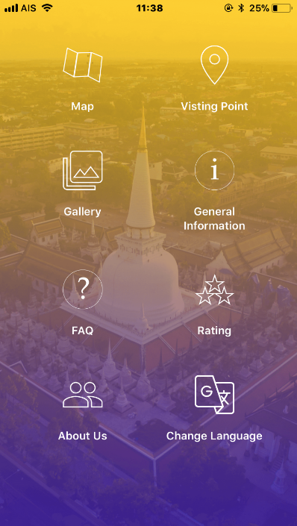 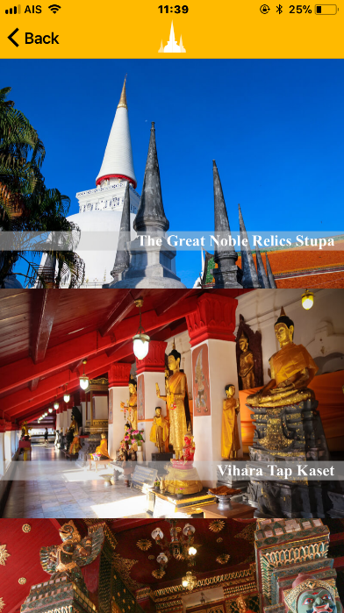

Figure 1. Main Menu Figure 2. Visiting point

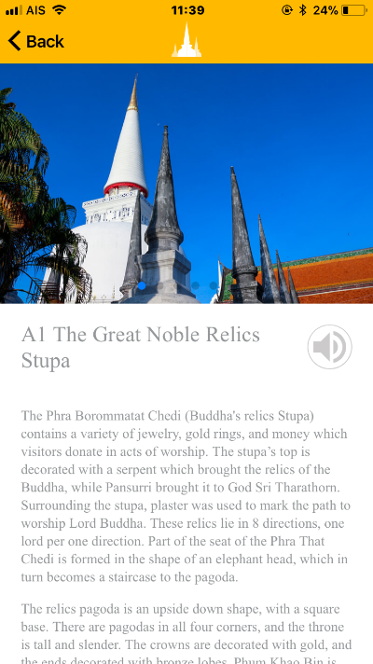 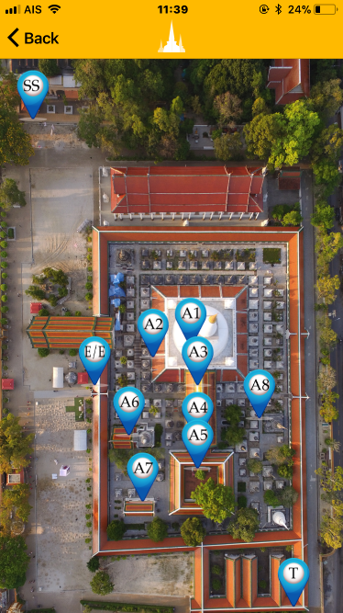

Figure 3. The Great Noble Relics Figure 4. Map

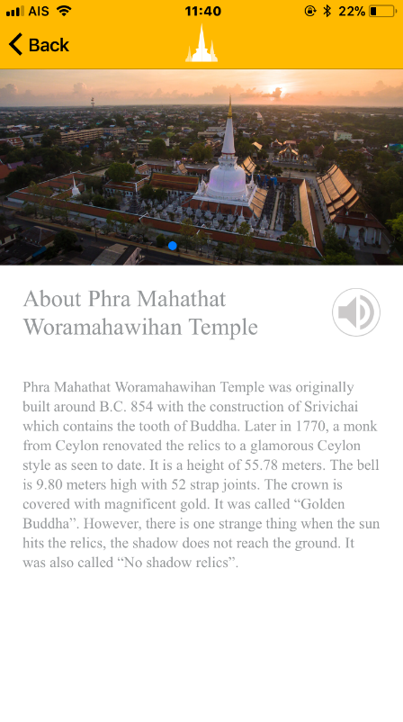 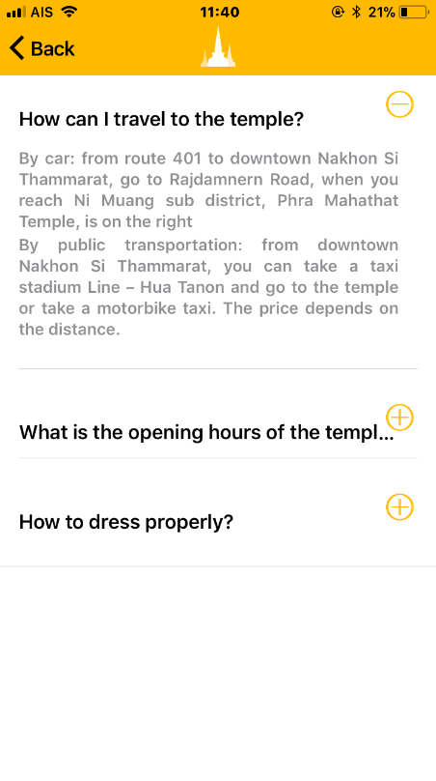

Figure 5. About PMW Figure 6. FAQ

Temple

# Evaluating Mobile Application

There were two main criteria in evaluating the Mobile Application: Accessibility Evaluation and User Interface Evaluation.

### **5.1 Accessibility Evaluation**

|  |  |  |
| --- | --- | --- |
|  |  |  |
|  |  |  |
|  |  |  |
|  |  |  |
|  |  |  |
|  |  |  |
|  |  |  |
|  |  |  |
|  |  |  |
|  |  |  |
|  |  |  |
|  |  |  |
|  |  |  |
|  |  |  |
|  |  |  |
|  |  |  |

Thirty participants rated the accessibility of the Mobile Application Design of PMW Temple referring to Angkananon, Wald, & Plodaksorn (2017) method of evaluating the Web Thai Accessibility design. The overall mean score was 4.23. All participants agreed sound of recording is not boring ($\overline{x}$ = 5.00). Participants rated the satisfaction form is easy to use ($\overline{x}$ = 4.57), followed by text layout is appropriate ( $\overline{x}$ = 4.43). Participants rated lower than 4.0 in three aspects: Menu operations are accurate and easily return to the main menu ( $\overline{x}$ = 3.14), contrast colors of the text and background are at the right level. It is readable ( $\overline{x}$ = 3.86), and size of the letters read well ( $\overline{x}$ = 3.86). The three issues have been improved following the suggestions. The one sample t-test showed that the mean rating was greater than 3.5 at p < 0.05.

### **5.2 User Interface Evaluation**

|  |  |  |
| --- | --- | --- |
|  |  |  |
|  |  |  |
|  |  |  |
|  |  |  |
|  |  |  |
|  |  |  |
|  |  |  |
|  |  |  |
|  |  |  |
|  |  |  |
|  |  |  |
|  |  |  |
|  |  |  |

Thirty participants rated the prototype of Mobile Application of PMW Temple using the Likert 5 point scales of 1 (very poor) to 5 (very good). The overall rating in user interface and design was 4.22. All participant agreed that the mobile application uses appropriate and clear illustrations ( $\overline{x}$ = 5.00). The issues that needed to be improved were name of menu could be understood ( $\overline{x}$ = 3.58), clean and simple screen layout ( $\overline{x}$ = 3.83), and menus were placed in the appropriate position and easy to use ( $\overline{x}$ = 3.92). The research improved the design following the suggestions. A one sample t-test showed that the mean rating was better than 4.0 at p < 0.05.

## 5.3 Application Satisfaction Results



60% percent of both Thai and Foreign tourists were female. 80% of Foreign Tourists were older than 40 compared to 13.3% of Thai Tourists. 13.3% of Thai students compared to 16.4% of foreign students had lower than an undergraduate education. Seventy-six percent of foreign tourists visited PMW temple for the first time compared to 73.3% of Thai tourists while 86.7 percent of foreign tourists had used a mobile application for travel compared to 36.7% of Thai tourists.

Figure 7. Number of foreign tourists by nationality.

Figure 7 shows the nationality of the 30 foreign tourists who used the PMW temple mobile applications. There were 9 Malaysian tourist (30%), 8 Chinese tourists (26.7%), 3 Indonesian tourists (10%), 3 Canadian tourists (10%), 2 Romanian tourists (6.7%), 2 English tourists (6.7%), 1 American tourist (3.3%), 1 Germany tourist (3.3%), 1 French tourist (3.3%) and 1 Singaporean tourist (3.3%).

|  |  |  |  |  |  |
| --- | --- | --- | --- | --- | --- |
|  |  |  |  |  |  |
|  |  |  |  |  |  |
|  |  |  |  |  |  |
|  |  |  |  |  |  |
|  |  |  |  |  |  |
|  |  |  |  |  |  |
|  |  |  |  |  |  |
|  |  |  |  |  |  |
|  |  |  |  |  |  |
|  |  |  |  |  |  |
|  |  |  |  |  |  |

Figure 8. The average mean score of Thai tourists’ satisfaction with the use of PMW temple mobile applications compared by each topic of study.

Figure 8 show the study results of 30 Thai tourists’ satisfaction after using PMW temple mobile application for touring the PMW temple. The results found that the mean score of all study topics was 4.21 with all individual scores above 4.

|  |  | | | | | |
| --- | --- | --- | --- | --- | --- | --- |
|  |  |  |  |  | |
|  |  |
|  |  |  |  |  |  |  |
|  |  |  |  |  |  |  |
|  |  |  |  |  |  |  |
|  |  |  |  |  |  |  |
|  |  |  |  |  |  |  |
|  |  |  |  |  |  |  |
|  |  |  |  |  |  |  |
|  |  |  |  |  |  |  |
|  |  |  |  |  |  |  |
|  |  |  |  |  |  |  |

The score of 10 evaluation topics were higher than One Sample test value 3 with significance p < .001 which means that the respondents agreed that mobile applications can be useful for navigating around PMW temple. The overall mean 4.21, suggests that respondents were satisfied with the overall mobile application at a high level statistically significant at p < .05

|  |  |  |  |  |  |
| --- | --- | --- | --- | --- | --- |
|  |  |  |  |  |  |
|  |  |  |  |  |  |
|  |  |  |  |  |  |
|  |  |  |  |  |  |
|  |  |  |  |  |  |
|  |  |  |  |  |  |
|  |  |  |  |  |  |
|  |  |  |  |  |  |
|  |  |  |  |  |  |
|  |  |  |  |  |  |
|  |  |  |  |  |  |

Figure 9. Comparison of mean score of foreigner tourist’s satisfaction of PMW temple mobile application usefulness.

Figure 9 show the result of 30 foreign tourists’ satisfaction after using PMW temple mobile application. The results found that the overall mean score was at a high level (=4.2). The majority of foreign tourists were satisfied with the knowledge from using the mobile application and prefer to use mobile application more than reading the information from the signs provided by the temple (=4.43). The attractiveness of using the mobile application to navigate around PMW temple made tourists want to visit the temple again (= 4.37). The tourists wanted to spend more time inside the temple because of the information about visiting points provided in the mobile application and the mobile application made navigating around the PMW temple more independent (=4.30).

|  |  | | | | | |
| --- | --- | --- | --- | --- | --- | --- |
|  |  |  |  |  | |
|  |  |
|  |  |  |  |  |  |  |
|  |  |  |  |  |  |  |
|  |  |  |  |  |  |  |
|  |  |  |  |  |  |  |
|  |  |  |  |  |  |  |
|  |  |  |  |  |  |  |
|  |  |  |  |  |  |  |
|  |  |  |  |  |  |  |
|  |  |  |  |  |  |  |
|  |  |  |  |  |  |  |

The overall score of 10 evaluation topics was higher than the score of 3 at significance (p-value) < .001. The overall mean score was 4.24 suggesting the respondents were satisfied with the use of PMW temple mobile application at a high level, significant at p < 0.05

|  |  |  |  |  |  |
| --- | --- | --- | --- | --- | --- |
|  |  |  |  |  |  |
|  |  |  |  |  |  |
|  |  |  |  |  |  |
|  |  |  |  |  |  |
|  |  |  |  |  |  |
|  |  |  |  |  |  |
|  |  |  |  |  |  |
|  |  |  |  |  |  |
|  |  |  |  |  |  |
|  |  |  |  |  |  |
|  | |  |  |  |  |

Figure 10 Comparison of Thai tourists’ average satisfaction with the design and performance of PMW Temple mobile application.

Figure 10 show the satisfaction and performance of PMW temple mobile application of 30 Thai tourists. The results show the high level of overall mean score (=4.23). The majority of Thai tourists were satisfied with the presentation format in the mobile application being easy to understand (=4.37), followed by the satisfaction of the usefulness of the mobile application as a tour guide (=4.30). The lowest mean score was the presentation format in the mobile application is enjoyable (= 3.97).

|  |  | | | | | |
| --- | --- | --- | --- | --- | --- | --- |
|  |  |  |  |  | |
|  |  |
|  |  |  |  |  |  |  |
|  |  |  |  |  |  |  |
|  |  |  |  |  |  |  |
|  |  |  |  |  |  |  |
|  |  |  |  |  |  |  |
|  |  |  |  |  |  |  |
|  |  |  |  |  |  |  |
|  |  |  |  |  |  |  |
|  |  |  |  |  |  |  |
|  |  |  |  |  |  |  |

Using One-Sample Test statistic with test value of 3 the result show the score was higher than this test value with significance p < .001, which suggests the respondents were satisfied with the overall design and performance of PMW Temple mobile application at a high level with an overall mean score of 4.23.

|  |  |  |  |  |  |
| --- | --- | --- | --- | --- | --- |
|  |  |  |  |  |  |
|  |  |  |  |  |  |
|  |  |  |  |  |  |
|  |  |  |  |  |  |
|  |  |  |  |  |  |
|  |  |  |  |  |  |
|  |  |  |  |  |  |
|  |  |  |  |  |  |
|  |  |  |  |  |  |
|  |  |  |  |  |  |
|  |  |  |  |  |  |

Figure 11 Satisfaction of design and performance of PMW temple mobile application of foreigner tourists.

As shown in Figure 11, the satisfaction with the design and performance of PMW temple mobile application of 30 Thai tourists shows the overall mean score at a high level (=4.32). The majority of Thai tourists were satisfied that the mobile application supported both IOS and Android operating systems (=4.97) and that the content of an application helps understand the history of the place (=4.60) and the presentation format in the application was easy to understand and the application was very useful to tour the temple (=4.33).

|  |  |  |  |  |  |  |
| --- | --- | --- | --- | --- | --- | --- |
|  |  | | | | | |
|  |  |  |  |  | |
|  |  |
|  |  |  |  |  |  |  |
|  |  |  |  |  |  |  |
|  |  |  |  |  |  |  |
|  |  |  |  |  |  |  |
|  |  |  |  |  |  |  |
|  |  |  |  |  |  |  |
|  |  |  |  |  |  |  |
|  |  |  |  |  |  |  |
|  |  |  |  |  |  |  |
|  |  |  |  |  |  |  |

Analysis of the results of PMW temple mobile application’s design and performance rated by 30 foreigner tourists found that the overall rating of topics was higher than the one sample test statistic score 3, at significance p<.001 suggesting the respondents were satisfied with the design and performance of the PMW temple mobile application at a high level with overall mean score 4.32.

In addition, some Thai tourists gave their opinions and suggestions including sound should be muted in some menus, the history about the constructions of PMW temple should be provided. Foreign tourist’s comments included that mobile applications help to explain the history and provides useful information for visiting PMW temple since information is not currently available in English, and so is difficult to understand. It should also have the option to turn the background music on and off, and should adjust the language selection menu to make it clearer.

|  |  |  |  |  |  |
| --- | --- | --- | --- | --- | --- |
|  | |  |  |  |  |
|  |  |  |  |  |  |
|  |  |  |  |  |  |

The overall mean satisfaction score of 10 evaluation topics for the use of PMW temple mobile application by Thai tourists was 4.21 while the foreign tourists’ score was 4.23, which was at a similar high level.

|  |  |  |  |  |  |  |  |  |  |
| --- | --- | --- | --- | --- | --- | --- | --- | --- | --- |
|  |  | |  | | | | | | |
|  |  |  |  |  |  |  |  | |
|  |  |
|  |  |  |  |  |  |  |  |  |  |
|  |  |  |  |  |  |  |  |  |  |

The results of the independent sample t-test used to determine the difference in satisfaction with the use of the mobile applications by Thai and foreign tourists found that the satisfaction level of mobile applications of Thai tourists and foreign tourists was not different at .05 significance level.

|  |  |  |  |  |  |
| --- | --- | --- | --- | --- | --- |
|  |  |  |  |  |  |
|  |  |  |  |  |  |
|  |  |  |  |  |  |

The comparison result of satisfaction with the Performance of PMW temple mobile application between Thai and Foreign Tourists found that the overall mean score of satisfaction with the performance of the PMW temple mobile application on 10 evaluation topics of Thai tourists was 4.23 and foreign tourists with an overall mean score of 4.32 were at the same high level.

|  |  |  |  |  |  |  |  |  |  |
| --- | --- | --- | --- | --- | --- | --- | --- | --- | --- |
|  |  | |  | | | | | | |
|  |  |  |  |  |  |  |  | |
|  |  |
|  |  |  |  |  |  |  |  |  |  |
|  |  |  |  |  |  |  |  |  |  |

The results of the independent sample t-test used to determine the difference in satisfaction with the design and performance of mobile applications of PMW temple of Thai tourists and foreign tourists found that the level of satisfaction with the design and performance of mobile applications of Thai tourists and foreign tourists were not different at .05 significance level.

# Discussion and Conclusion

In the audio presentation, the researcher selected the prepared recording method.  Because of the Thai sound recognition technique, there is still a lot of speech recognition error. According to Suebvisai et al (2005) stated that Thai speech recognition techniques have not been successful. It is because Thai is a very challenging language in terms of vowel and tonal characters.  Firstly, Thai uses 5 tones to convey different meanings. This affects the acoustic modelling of the acoustic modelling. Each tone has different meanings.  Secondly, having bad character features results in a more predictable dictionary.  Thirdly, insufficient word segmentation results in the need for automatic word segmentation. It is because Thai is written without words or spaces between words or sentences.

The mobile application developed by Wat Phra Mahathat Woramahawihan was designed based on the study of users' needs both Thai and foreign tourists.  It focuses on screen content design and performance. This is in line with Trakulmaykee and Hnuchek (2016) that focus on quality content and quality of appearance and quality in interactivity. The mobile application can work correctly in all functions. The researcher has tested the use throughout the development period.

However, there are issues with the presentation of information that is erroneous in terms of grammar and English words because of a specialized vocabulary so need to understand the arts and culture together with spelling. The mobile application tester has provided feedback on how to fix it. Researchers and developers have resolved issues as suggested before mobile applications. Based on the results of the satisfaction survey, only one participant commented on the topic of grammatical presentation and the use of English. He is American who has been living in Thailand for 12 years. Therefore, he knows quite a lot of Thai culture.

The design of technology takes into account the interactions between people, technology and objects, which correspond to research by Angkananon et al (2016). It includes the collection process and the need for problems and obstacles in the design. The technology helps to solve the problem for the benefit of users. This is due to the design of the development that corresponds to the needs of the end user.

This is consistent with Davis et al. (1989) and Trakulmaykee and Hnuchek (2016). The perception of usefulness and perceived ease of use will have a positive effect on attitudes towards the use of the system and affect the intention and needs to continue. It can be explained that the development of mobile applications that meet the needs of users will result in satisfaction with the use to measure satisfaction. The researcher was designed to allow users to express their satisfaction through the link of the application linking to the Google Form via the online channel.

From the results the study concluded that without the mobile app most Thai tourists did not know how important each point of visit was, where to go, where the starting point was, and what were the rituals, the history or other information of each point. The main issue for all foreign tourists was not knowing the history or other information of each point as only the names of each point are provided in English. The tourists were interested in using the mobile applications to help improve navigating around PMW Temple, especially technology with text and pictures description, and voice options for users to listen to when needed. Most visitors required information about important points such as text and pictures to describe the temple and signs and maps to explain the important points.

The Mobile Application Thai and English prototype versions were successfully designed with information gathered from Thai and Foreign tourists and evaluated by 3 experts. The final android and IOS Mobile Application Thai and English versions were developed and uploaded to the android and app stores and the experiment with Thai and Foreign tourist participants was run at the PMW Temple. The participants answered questions before and after using the application including questions about their satisfaction in using the application. The analysis of results showed that Thai and Foreign tourists had similar high satisfaction with the performance of the Android and IOS mobile applications of PMW temple.

**References**

Angkananon, K., Wald, M., & Ploadaksorn, P. (2017). **Developing and Evaluating a Thai Website Accessibility Checker.** In: Stephanidis C. (eds) HCI International 2017 – Posters' Extended Abstracts. HCI 2017. Communications in Computer and Information Science, vol 713. Springer, Cham

Angkananon, K., Wald, M., & Gilbert, L. (2016). **Evaluation of Technology Enhanced Accessible Interaction Framework and Method for Local Thai Museums**. Journal of Management Science Suratthani Rajabhat University.

Chen, L. (2008). **A model of consumer acceptance of mobile payment.** International Journal of Mobile Communications, vol. 6, no. 1, pp. 32-52, 2008.

Choe, J., Blazey, M. & Mitas, O. (2015). Motivations of non-Buddhists visiting Buddhist temples, Current Issues in Tourism, 18:1, 70-82, DOI: [10.1080/13683500.2013.771627](https://doi.org/10.1080/13683500.2013.771627)

Coombes, H. (2001). **Research Using IT.** New York: PALGRAVE.

Davis, F. (1989). **Perceived usefulness, perceived ease of use, and user acceptance of information technology**, MIS Quarterly, vol. 13, no. 3, pp. 319-340, 1989.

deAscaniis, S. and Cantoni, L. (2016) "Pilgrims in the Digital Age: a research manifesto," International Journal of Religious Tourism and Pilgrimage: Vol. 4: Iss. 3, Article 3.   
doi:10.21427/D7Z120  
Available at: <https://arrow.dit.ie/ijrtp/vol4/iss3/3>

Geary, D. (2013). Incredible India in a global age: The cultural politics of image branding in tourism, *Tourist Studies* 13(1) 36-61.

Geary, D. (2018). “India’s Buddhist circuit (s) : A growing investment market for a “rising” Asia,” International Journal of Religious Tourism and Pilgrimage: Vol. 6: Iss. 1, Article 6. Doi:10.21427/D7PT46. Available at: https://arrow.dit.ie/ijrtp/vol6/iss1/6

Jacob, R. J., Girouard, A., Hirshfield, L. M., Horn, M. S., Shaer, O., Solovey, E. T., & Zigelbaum, J. (2008). **Reality-based interaction: a framework for post-WIMP interfaces.** Paper presented at the CHI-CONFERENCE-.

Ketmaneechairat, H., Yoksiri . P.,and Jaisiri, T. (2014) "Searching application for Southern Thailand Travel Guide on iPhone," *The Fifth International Conference on the Applications of Digital Information and Web Technologies (ICADIWT 2014)*, Bangalore, 2014, pp. 195-200.  
doi: 10.1109/ICADIWT.2014.6814684

Nabona, J. & Arasa, D. (2016). **The Role and Usage of Apps and Instant Messaging in Religious Mass Events,**  *International Journal of Religious Tourism and Pilgrimage*: Vol. 4: Iss. 3, Article 6. Doi: 10.21427/D7JT6Q. Available at: https//arrow.dit.ie/ijrtp/vol4/iss3/6

Proctor, N. (2005). **Off Base or On Target? Pros and Cons of Wireless and Location.** Aware Applications in the Museum Paper presented at the ICHIM 05 - Digital Culture & Heritage, Paris, France. Retrieved from:http://www.archimuse.com/publishing/ichim05/Proctor.pdf

Rogers, E.M. (2003). **Diffusion of innovations**. 5th ed. New York: The Free Press.

Rukzio, E., Broll, G., Wetzstein, S. (2008). **The Physical Mobile Interaction Framework (PMIF).** Technical Report LMU-MI-2008-

Ruzic, L., Lee, S. T., Liu, Y. E., & Sanford, J. A. (2016, July). **Development of Universal Design Mobile Interface Guidelines (UDMIG) for Aging Population.** In International Conference on Universal Access in Human-Computer Interaction (pp. 98-108). Springer International Publishing.

Shneiderman, B., Plaisant, C., Cohen, M., Jacobs, S., and Elmqvist, N., (2016). **Designing the User Interface: Strategies for Effective Human-Computer Interaction**: Sixth Edition, Pearson (May 2016) Retrieved from: http://www.cs.umd.edu/hcil/DTUI6

Sung, Y.-T., Chang, K.-E., Hou, H.-T., & Chen, P.-F. (2010). **Designing an electronic guidebook for learning engagement in a museum of history.** Computers in Human Behavior, 26(1), 74-83. doi: 10.1016/j.chb.2009.08.004

The Center for Universal Design. (1997). **Principles of Universal Design. NC State University.** Retrieved form:http//www.ncsu.edu/project/design- projects/edi/center-for-Universal-design/the-principles-of-Universal-design/ (24.01.2012.

Timothy, D. & Olsen, D. (Eds.) (2006). *Tourism, Religion and Spiritual Journeys*, London: Routledge.

Tourism Authority of Thailand. (2015). **Tourist Marketing Plan.** Retrieved on 7 August 2015. From: http://marketingdatabase.tat.or.th/download/

file_upload/Untitled%20attachment%2000032.pdf

Tourism Authority of Thailand. (2016). **Phramahathat Woramahawihan Temple.** Retrieved on 20 February 2016, from https://thai.tourismthailand.org

Tourism Authority of Thailand. (2015). **TAT Annual Report.** Retrieved on 22 December 2016. From :https://www.tourismthailand.org/fileadmin/

Trakulmaykee, N., & Hnuchek, H. (2016). **Examining the Model of Information Needs on Mobile Devices: Massage-Spa Therapy Context**. Journal of Management Sciences, Vol. 3 (2).

Trakulmaykee, N., Trakulmaykee, Y., & Hnuchek, K. (2015). **Two Perceived Dimensions of Technology Acceptance Model in Mobile Tourist Guide Context.** International Journal of Trade, Economics and Finance, Vol. 6, No. 5, October 2015.

Tussyadiah, L. (2014). **Toward a Theoretical Foundation for Experience Design in Tourism**. Journal of Travel Research 2014, Vol. 53(5) 543–564.downloads/TAT_ANNUAL_REPORT/TAT-AR2015.pdf

WearSocail.com. (2017).**Digital in 2017Global Overview.** Retrieved on 8 May 2017. Form: https:// wearsocail.com/special-reports/digital-in-2017-gobal-overview.

**Acknowledgement**

I would like to thank Suratthani Rajabhat University for funding the research and also thank to Phra Mahathat Woramahawihan Temple for allowing us to do the research.

Appendix Tables

|  |  |
| --- | --- |
|  |  |
|  |  |
|  |  |
|  |  |
|  |  |
|  |  |
|  |  |

|  |  |  |  |  |  |
| --- | --- | --- | --- | --- | --- |
|  |  | | |  | |
|  |  |  |  |  |
|  |  |  |  |  |  |
|  |  |  |  |  |  |
|  |  |  |  |  |  |
|  |  |  |  |  |  |
|  |  |  |  |  |  |
|  |  |  |  |  |  |

|  |  | |  | |
| --- | --- | --- | --- | --- |
|  |  |  |  |
|  | | |  |  |
|  |  |  |  |  |
|  |  |  |  |  |
|  | | |  |  |
|  |  |  |  |  |
|  |  |  |  |  |
|  |  |  |  |  |
|  |  |  |  |  |
|  |  |  |  |  |
|  | | |  |  |
|  |  |  |  |  |
|  |  |  |  |  |
|  |  |  |  |  |
|  |  |  |  |  |
|  |  |  |  |  |
|  |  |  |  |  |
|  | | |  |  |
|  |  |  |  |  |
|  |  |  |  |  |
|  | | |  |  |
|  |  |  |  |  |
|  |  |  |  |  |
|  |  |  |  |  |
|  |  |  |  |  |
|  |  |  |  |  |
|  | | |  |  |
|  |  |  |  |  |
|  | | |  |  |
|  |  |  |  |  |

|  |  | |  | |
| --- | --- | --- | --- | --- |
|  |  |  |  |
|  |  |  |  |  |
|  |  |  |  |  |
|  |  |  |  |  |
|  |  |  |  |  |
|  |  |  |  |  |
|  |  |  |  |  |
|  |  |  |  |  |
|  |  |  |  |  |
|  |  |  |  |  |

|  |  | |  | |
| --- | --- | --- | --- | --- |
|  |  |  |  |
|  |  |  |  |  |
|  |  |  |  |  |
|  |  |  |  |  |
|  |  |  |  |  |
|  |  |  |  |  |
|  |  |  |  |  |
|  |  |  |  |  |
|  |  |  |  |  |
|  |  |  |  |  |

Table 6. Problems in visiting PMW Temple of Thai tourists.

|  |  |  |  |  |
| --- | --- | --- | --- | --- |
| **Problems** | **Thai tourists** | | **Foreign tourists** | |
| **Frequency** | **Percent** | **Frequency** | **Percent** |
| Do not know where to go | 16 | 51.6% | 0 | 0.0% |
| Do not know how important each point is | 19 | 61.3% | 4 | 13.3% |
| Do not know what the rituals are | 11 | 35.5% | 3 | 10.0% |
| Do not know where to go first | 14 | 45.2% | 5 | 16.7% |
| Do not know the history or other information of each point | 11 | 35.5% | 30 | 100% |

|  |  |  |  |  |
| --- | --- | --- | --- | --- |
|  |  | |  | |
|  |  |  |  |
|  |  |  |  |  |
|  |  |  |  |  |
|  |  |  |  |  |

|  |  |  |  |  |
| --- | --- | --- | --- | --- |
|  |  | |  | |
|  |  |  |  |
|  |  |  |  |  |
|  |  |  |  |  |
|  |  |  |  |  |
|  |  |  |  |  |
|  |  |  |  |  |
|  |  |  |  |  |
|  |  |  |  |  |
|  |  |  |  |  |

Table 9. Example content of the Mobile Application

|  |  |  |
| --- | --- | --- |
| **Menu** | **Thai content** | **English content** |
| เกี่ยวกับวัด  (About Phra Mahathat  Woramahawihan Temple) | วัดพระมหาธาตุวรมหาวิหาร สร้างขึ้นครั้งแรกประมาณ ปี พ.ศ. 854 ด้วยศิลปะการก่อสร้างแบบศรีวิชัย ซึ่งภายในบรรจุด้วยฟันของพระพุทธเจ้า ต่อมาในปี พ.ศ. 1770 มีพระภิกษุจากลังกามาบูรณะองค์พระบรมธาตุให้เป็นแบบทรงลังกาอย่างที่เห็นจนถึงปัจจุบัน โดยมีความสูง 55.78 เมตร องค์ระฆังสูง 9.80 เมตร มีปล้องไฉน 52 ปล้อง ปลียอดหุ้มด้วยทองคำงดงาม จนถูกเรียกว่า  “พระธาตุทองคำ” แต่มีเรื่องแปลก คือ เวลาที่แสงอาทิตย์กระทบกับตัวบรมพระธาตุ เงากลับทอดไม่ถึงพื้น ทำให้ถูกเรียกอีกชื่อหนึ่งว่า พระธาตุไร้เงา | Phra Mahathat Woramaha  Wihan Temple was originally built around B.C. 854 with the construction of Srivichai which contains the tooth of Buddha. Later in 1770, a monk from Ceylon renovated the relics to a glamorous Ceylon style as seen to date. It is a height of 55.78 meters. The bell is 9.80 meters high with 52 strap joints. The crown is covered with magnificent gold. It was called “Golden Buddha”. However, there is one strange thing when the sun hits the relics, the shadow does not reach the ground. It was also called “No shadow relics”. |

|  |  |  |
| --- | --- | --- |
|  |  |  |
|  |  |  |
|  |  |  |
|  |  |  |
|  |  |  |
|  |  |  |
|  |  |  |
|  |  |  |
|  |  |  |
|  |  |  |
|  |  |  |
|  |  |  |
|  |  |  |
|  |  |  |
|  |  |  |
|  |  |  |

|  |  |  |
| --- | --- | --- |
|  |  |  |
|  |  |  |
|  |  |  |
|  |  |  |
|  |  |  |
|  |  |  |
|  |  |  |
|  |  |  |
|  |  |  |
|  |  |  |
|  |  |  |
|  |  |  |
|  |  |  |

|  |  | |  | |
| --- | --- | --- | --- | --- |
|  |  |  |  |
|  | | | | |
|  |  |  |  |  |
|  |  |  |  |  |
|  | | | | |
|  |  |  |  |  |
|  |  |  |  |  |
|  |  |  |  |  |
|  |  |  |  |  |
|  |  |  |  |  |
|  |  |  |  |  |
|  | | | | |
|  |  |  |  |  |
|  |  |  |  |  |
|  |  |  |  |  |
|  |  |  |  |  |
|  | | | | |
|  |  |  |  |  |
|  |  |  |  |  |
|  | | | | |
|  |  |  |  |  |
|  |  |  |  |  |
|  |  |  |  |  |
|  |  |  |  |  |
|  |  |  |  |  |
|  |  |  |  |  |
|  | | | | |
|  |  |  |  |  |
|  |  |  |  |  |

|  |  |  |  |  |  |
| --- | --- | --- | --- | --- | --- |
|  |  |  |  |  |  |
|  |  |  |  |  |  |
|  |  |  |  |  |  |
|  |  |  |  |  |  |
|  |  |  |  |  |  |
|  |  |  |  |  |  |
|  |  |  |  |  |  |
|  |  |  |  |  |  |
|  |  |  |  |  |  |
|  |  |  |  |  |  |
|  |  |  |  |  |  |

|  |  | | | | | |
| --- | --- | --- | --- | --- | --- | --- |
|  |  |  |  |  | |
|  |  |
|  |  |  |  |  |  |  |
|  |  |  |  |  |  |  |
|  |  |  |  |  |  |  |
|  |  |  |  |  |  |  |
|  |  |  |  |  |  |  |
|  |  |  |  |  |  |  |
|  |  |  |  |  |  |  |
|  |  |  |  |  |  |  |
|  |  |  |  |  |  |  |
|  |  |  |  |  |  |  |

|  |  |  |  |  |  |
| --- | --- | --- | --- | --- | --- |
|  |  |  |  |  |  |
|  |  |  |  |  |  |
|  |  |  |  |  |  |
|  |  |  |  |  |  |
|  |  |  |  |  |  |
|  |  |  |  |  |  |
|  |  |  |  |  |  |
|  |  |  |  |  |  |
|  |  |  |  |  |  |
|  |  |  |  |  |  |
|  |  |  |  |  |  |

|  |  | | | | | |
| --- | --- | --- | --- | --- | --- | --- |
|  |  |  |  |  | |
|  |  |
|  |  |  |  |  |  |  |
|  |  |  |  |  |  |  |
|  |  |  |  |  |  |  |
|  |  |  |  |  |  |  |
|  |  |  |  |  |  |  |
|  |  |  |  |  |  |  |
|  |  |  |  |  |  |  |
|  |  |  |  |  |  |  |
|  |  |  |  |  |  |  |
|  |  |  |  |  |  |  |

|  |  |  |  |  |  |
| --- | --- | --- | --- | --- | --- |
|  |  |  |  |  |  |
|  |  |  |  |  |  |
|  |  |  |  |  |  |
|  |  |  |  |  |  |
|  |  |  |  |  |  |
|  |  |  |  |  |  |
|  |  |  |  |  |  |
|  |  |  |  |  |  |
|  |  |  |  |  |  |
|  |  |  |  |  |  |
|  | |  |  |  |  |

|  |  | | | | | |
| --- | --- | --- | --- | --- | --- | --- |
|  |  |  |  |  | |
|  |  |
|  |  |  |  |  |  |  |
|  |  |  |  |  |  |  |
|  |  |  |  |  |  |  |
|  |  |  |  |  |  |  |
|  |  |  |  |  |  |  |
|  |  |  |  |  |  |  |
|  |  |  |  |  |  |  |
|  |  |  |  |  |  |  |
|  |  |  |  |  |  |  |
|  |  |  |  |  |  |  |

|  |  |  |  |  |  |
| --- | --- | --- | --- | --- | --- |
|  |  |  |  |  |  |
|  |  |  |  |  |  |
|  |  |  |  |  |  |
|  |  |  |  |  |  |
|  |  |  |  |  |  |
|  |  |  |  |  |  |
|  |  |  |  |  |  |
|  |  |  |  |  |  |
|  |  |  |  |  |  |
|  |  |  |  |  |  |
|  |  |  |  |  |  |

|  |  |  |  |  |  |  |
| --- | --- | --- | --- | --- | --- | --- |
|  |  | | | | | |
|  |  |  |  |  | |
|  |  |
|  |  |  |  |  |  |  |
|  |  |  |  |  |  |  |
|  |  |  |  |  |  |  |
|  |  |  |  |  |  |  |
|  |  |  |  |  |  |  |
|  |  |  |  |  |  |  |
|  |  |  |  |  |  |  |
|  |  |  |  |  |  |  |
|  |  |  |  |  |  |  |
|  |  |  |  |  |  |  |

|  |  |  |  |  |  |
| --- | --- | --- | --- | --- | --- |
|  | |  |  |  |  |
|  |  |  |  |  |  |
|  |  |  |  |  |  |

|  |  |  |  |  |  |  |  |  |  |
| --- | --- | --- | --- | --- | --- | --- | --- | --- | --- |
|  |  | |  | | | | | | |
|  |  |  |  |  |  |  |  | |
|  |  |
|  |  |  |  |  |  |  |  |  |  |
|  |  |  |  |  |  |  |  |  |  |

|  |  |  |  |  |  |
| --- | --- | --- | --- | --- | --- |
|  |  |  |  |  |  |
|  |  |  |  |  |  |
|  |  |  |  |  |  |

|  |  |  |  |  |  |  |  |  |  |
| --- | --- | --- | --- | --- | --- | --- | --- | --- | --- |
|  |  | |  | | | | | | |
|  |  |  |  |  |  |  |  | |
|  |  |
|  |  |  |  |  |  |  |  |  |  |
|  |  |  |  |  |  |  |  |  |  |