Presenting Health and Medical Geography: people, places and change

Abstract
Assessments of the development of geography as a discipline, and studies of sub-disciplinary development within geography, have generally focussed on the subject matter under study. Consideration has concentrated on topics, theories, methods and paradigm shifts identified by analyses of published literature. There has been rather less interest in the spatialisation of the practice and performance of the discipline by people and institutions (though there have been exceptions) and equally little attention to the evidence provided by geographical conferences. We address these lacunae in current knowledge through a quantitative study of changing disciplinary endeavour in health geography as evidenced by participation in the International Medical Geography Symposia. For 35 years this biennial meeting has been the flagship conference for health and medical geographers. We have obtained, reviewed and coded the proceedings of all 17 symposia, analysing the submitted papers by location of symposia, lead authorship, affiliation, and country of authorship. We investigate the globalisation of the sub-discipline and changes in key institutional involvement. Novel network analysis methods are used to identify changing linkages between research centres. What emerges is a complex sub-discipline driven by the changing neoliberal context of higher education and marked by both continuities and discontinuities in its practitioner networks.

Key Words
health geography, medical geography, conferences, disciplinary practices, social networks

INTRODUCTION
Histories of academic geography generally base their analysis on published works, interpreting change within the discipline in the light of evolving concerns evidenced in journals, edited collections and books. They identify a canonical narrative in which key texts, moments and individuals, ’schools’ of study and external pressures frame disciplinary change (Johnston and Sidaway, 2015, Agnew and Livingstone, 2011). Novelty triumphs or is undone; new orthodoxies emerge and old ones persist. Paradigms shift, usually slowly, in a complex, multifaceted way that ensures that different parts of the discipline change at different rates. This paper takes a different, novel perspective, focussing on the academic conference and shifting from an assessment of what is done, to an analysis of where it is done and by whom; our intention is to ‘think geographically about geography’ (Agnew and Livingstone, 2011: 18).
Conferences are widely seen as the ‘principal mechanisms for professional organizations to advance their missions’ (Waite and Hume, 2016), sites where individuals perform particular identities and where epistemic communities are formed (Craggs and Mahony, 2014). Looking beyond their academic content, conferences function as networking opportunities that bring together people with shared interests from different institutions and provide the basis for new collaborations to emerge. We aim to draw out the idea of the conference as a locus for networked practices that change and shift over time as people change places and institutions wax and wane in their relative importance for the sub-discipline. We will devote attention to conference participants, their affiliations and the locations of conferences as key variables in understanding the dynamics that lie behind academic change.
In focussing on conference papers, and more specifically on the dynamics of conference participation, we aim to add to the very small prior literature in Geography that has shared this concern (Craggs and Mahony, 2014). Baker (2010, 2016) examined participation at the International Conference of Historical Geographers, focussing on internationalisation, subject matter and the constraints associated with the use of English as the only conference language. Attendances at the European Congresses of the Regional Science Association between 1998 and 2003 have been subject to a similarly thorough examination (Van Dijk and Maier, 2006), with additional testing of hypotheses about participant origins in relation to meeting locations and their association with frequency of attendance and travel distance. A second paper using the same data focusses on co-authorship (Maier and Dijk, 2006). Derudder and Liu (2015), drawing on prior work on sociology conferences (Stegbauer and Rausch, 2012), assessed the geographies of interactions in paper and panel sessions at the annual conferences of the Association of American Geographers in 2005 and 2013. They employed social network analysis to compare international and intra-national affiliations in conference sessions with a randomised model, concluding that nationalities tend to flock together and human geography sessions tend to have fewer international participants. Social network analysis was also employed in an analysis of Francophone involvement in the European Colloquia on Theoretical and Quantitative Geography between 1978 and 2013 (Cuyala, 2016). One exception to this focus on internationalisation is an examination of the slowly evolving role of women in the annual conference of the Israeli Geographical Society (Blumen and Bar-Gal, 2006). Other relevant studies include Hodder (2015) and Waite and Hume (2016). Parallels can be drawn with studies of disciplinary evolution using citation patterns (Mao, 2014, Sun and Manson, 2011)
Our analysis is based on a Iongitudinal study of the International Symposium in Medical Geography (IMGS) since its inception in 1985. In the following section, we set out background material on the factors that have underpinned change in health and medical geography over the past 30 years and introduce the IMGS, the long-running flagship conference of the sub-discipline. After a short outline of our data and research methods, we address two key issues, using the IMGS as an exemplar. We start with an analysis of the geographic distribution of conference participants. We frame this analysis within an assessment of the degree to which the IMGS meets its ‘international’ appellation. The second part of the analytical section then offers a novel consideration of the interplay of people, affiliations and conference attendance over time, focussing on the idea of conference participation as networked practice and seeking to reveal the changing roles of both individuals and departments. In this section, we develop further the use of social network methods for studying conference participation. We end the paper by drawing conclusions about the changing role of conferences for the development of international knowledge communities and the impact on this role of the neo-liberal (re)framing of higher education.

BACKGROUND

2.1 Change in health and medical geography
There is no shortage of reviews, syntheses and programmatic statements charting the evolution of academic health and medical geography over recent decades (Kearns and Moon, 2002). Like other parts of human geography, the sub-discipline has seen changes and continuities many of which have parallels in other parts of the discipline. A ‘new’ health geography has emerged to challenge disease ecology traditions; socio-cultural theory most recently in the shape of non-representational ideas has challenged more established perspectives; and perhaps more than many other areas of human geography, an increasingly sophisticated emphasis on statistical modelling has been retained. This ground has been ably captured by Philo (2016) in an assessment based around papers published in Progress in Human Geography. Philo’s paper, like other recent reviews (eg. Rosenberg, 2015, Rosenberg, 2017, Andrews, 2019), tells us what has been studied or what might be studied. In contrast to this extensive literature on content, there has been far less consideration of the individuals, departments and universities that have generated this content. In contrast to the ‘what?’ question, we have little systematic knowledge of ‘who’ or ‘where’ despite these themes long being central to analyses of change within the wider discipline (Johnston, 2000, Johnston, 2003). It is on ‘who’ and ‘where’ that we focus.
We see the forces that underpin ‘who’ and ‘where’ in medical and health geography under three headings. These are not specific to health and medical geography. All however have served to shape the investment and disinvestment decisions that have affected the sub-discipline since the early 1980s. First, we note a sense in which (sub-) disciplinary subject matter has, in part, influenced academic practice. Departments develop reputations for particular academic foci and individual academics serve as magnets, attracting colleagues with similar interests. These developments ensure the evolution of communities of practice (Amin and Roberts, 2008) in which performative learning amongst peers fosters expertise and specialism in places. Taken to an extreme, and often with a level of self-regard, it can result in the emergence of ‘schools’ in which ideas or key roles are ascribed to particular departments and traced prospectively through their diasporic shadow as in the example of the ‘Lampeter School’ of cultural geography (Philo, 2002). On occasion in health and medical geography, as in economic geography (James et al., 2018), this reputational flowering has taken place outside the parent Geography discipline.
A second and equally general set of forces that impact health and medical geography, as much as any other academic area, concern the global political, social and economic changes impacting higher education over the past thirty years (Smeby and Trondal, 2005). These have engendered a more-connected world and a desire to expose national systems of higher education to international competition and benchmarking (Koseoglu, 2016). One consequence of these processes has been that international participation in conferences has escalated. Linked to the impact of globalisation have been key geopolitical changes, of which the most significant within our period has been the emergence of China as a key player in international education (Xu and Montgomery, 2018). This and other economic transitions has served to increase the countries seeking a presence at international conferences. In contrast, a negative but similarly general force has been the impact of international terrorism, serving to restrict conference attendances (Mair et al., 2018).
A third set of forces are those related to national education policy and funding. While some countries have experienced a restrictive university funding environment due to neo-liberal austerity policies, others have experienced periods of significant growth over our study period (Fabricant and Brier, 2016, Nixon, 2017). Our period has also seen the emergence and consolidation of performance-based research funding in many countries, most notably the UK, New Zealand and Australia (Hicks, 2012). Such systems can both enable and restrict the development of departments depending on the ratings received. Other funding developments have been more generally positive. These include the emergence of the European Union as a significant research funder and, of particular relevance to health and medical geography owing to the sub-discipline’s interface position between health and social sciences, the consolidation of applied health research funding in the UK to form the National Institute for Health Research (NIHR) and the creation of the Canada Institutes for Health Research (Luukkonen, 2013, Jones et al., 2017, Tamblyn et al., 2016).

2.2 The IMGS
For over 30 years, the IMGS has been the flagship conference for health and medical geographers. Table 1 lists the meetings. The first, held at the University of Nottingham UK, was organised by the late John Giggs and was run under the joint auspices of the medical geography study groups of the Association of American Geographers and the then Institute of British Geographers (Giggs, 1986). Rather ambitiously, the second meeting took place just a year later at Rutgers University organised by Michael Greenberg. A two-year gap followed during which international involvement in the organisation of the meeting was extended to include the Canadian Association of Geographers with the third meeting being organised in 1988 by Mark Rosenberg at Queen’s University, Canada. From the fifth meeting, the IMGS organising group also incorporated representation from what is now the International Geographical Union Commission on Health and Environment (Earickson, 1993).

Table 1: IMGS meetings

<<Table 1 about here>>

Following the Kingston meeting, the IMGS settled into a two-year cycle, moving from the UK, to the US to Canada in that order. Meetings have tended to be organised by a university group (thus reflecting the presence of concentrated subject expertise) but held in either a university or a large hotel. There was a three-year gap between 2000 and 2003 at the behest of the Manchester organisers, but also in part as a response to the terrorist attacks of September 2001 and the anticipated impact on international travel. A major change in 2007 saw the end of three-way cycling, with the first meeting in mainland Europe and a belated recognition of the need to move beyond the Anglo-North American axis and embrace health and medical geography in other countries. This decision was accompanied by the creation of a more formal conference planning structure in which automatic expectations that a country would host the meeting were abandoned in favour of an open bidding mechanism. Consequently the 2017 meeting was in France and, in 2019, the meeting was scheduled to be held in Queenstown, New Zealand.

DATA AND METHODS
We obtained, reviewed and coded the proceedings of all 17 IMGS meetings up to and including the 2017 meeting in Angers, France. Information was drawn from the proceedings volumes that were prepared for all but one of the first eight meetings and conference handbooks for the other meetings. Crosschecks were made with digital files and, where necessary, with symposium organisers.
Each paper scheduled for delivery at a meeting was coded to record the location of the symposia, lead authorship, lead author affiliation and country. Author ‘home’ locations were geocoded to latitude and longitude coordinates, as were the symposium locations, enabling calculation of travel distances using ArcGIS. We used great circle distances, recognising that, for any one symposium, the travel for the majority of participants would be by plane. Our complete data comprised 2182 papers with associated keywords, coded to 1107 lead authors, 448 affiliations and 61 countries across 17 symposia. Analyses were conducted in SPSS (v24) and social networks were examined with Gephi (v0.9.2), an open source package for network visualisation and analysis (Bastian et al., 2009).

CONFERENCING IN HEALTH AND MEDICAL GEOGRAPHY

4.1 The International Dimension
We begin by considering the international nature of the practice of health geography as revealed by the country of residence of the lead author of papers at the IMGS. The IMGS’s right to include ‘international’ in its title reflects its sponsorship by national and international health geography research groups and the international venues chosen by those groups to host the meeting. From the outset however the meeting attracted papers on an international scale significantly wider than its sponsor nations. Figure 1 shows papers led by authors from the historic sponsor nations together with a summary indication of participation from other countries. A number of conclusions can be drawn beyond the obvious point that the meetings have grown significantly in size over the years. First, until the most recent meetings, there have been increasing numbers of Canadian papers. Second, there are generally proportionally more papers from the host nation and continent. Third, trans- Atlantic travel limits attendance. This is particularly evident for US papers, indeed US papers peak markedly in years when the Symposium is held in the USA. Fourth, the impact of international events is differentiated: the 9-11 attack on the World Trade Center limited US papers at the subsequent meeting but there was no similar impact on Canadian papers. Fifth, papers outwith Canada, the UK and the US have been increasing, particularly in the years when the meeting has been held outside the three traditional host countries. Sixth, there is no evidence that core nation papers have reduced when the meeting has been in non-Anglophone settings. Finally, there is some evidence that the relative attraction or accessibility of venues has influenced paper numbers.
Figure 1: Sponsor nation papers at IMGS over time

<<Figure 1 about here>>

Our data allow us to probe in detail the nature of the ‘other’ category in Figure 1. From low numbers in the early years, with only two or three countries outside the UK, US and Canada, an increase began in 1992. Twenty countries were represented at the 1996 and 1998 meetings and, though there were subsequent reductions for Canadian meetings, an upward trend continued with approaching 30 countries at the meetings in Germany and France. Africa, South America, and Asia have produced persistently few papers. Of the countries implicated in the IMGS at any stage in its history, 18 have generated only a single paper. A further 24 have produced fewer than 10 papers. More significant, amassing between 10 and 20 papers, are Sweden, Norway, Switzerland, Japan, Russia and Portugal, together with large higher education economies of China, India and Nigeria. In many cases however, these performances are the result of individual participants attending multiple conferences or delivering multiple papers at a few conferences.

Figure 2 examines those countries within the ‘other’ category generating over 20 papers. New Zealand papers have been a consistent presence since 1990 and rose significantly in the 2000s. French and German papers have been more evident when the meeting is held in the UK or Europe. Since the 2000 symposium, they have grown in number and since 2007 they have matched New Zealand. Both nations were particularly prolific when the symposium was held on home soil. Prior to the 2000 meeting, the bar height suggests one or two papers for most of the displayed countries and this has largely continued to be the case for Ireland and Australia. Exceptions were the Netherlands, which largely disappeared by the 1996 meeting but reappeared with the 2015 meeting, and New Zealand. That the New Zealand presence is considerably stronger than that from Australia may have resulted in part from some New Zealand health and medical geographers undertaking postgraduate training in North American or UK universities (Moon and Kearns, 2019).

Figure 2: Major ‘other’ nation papers at IMGS over time

<<Figure 2 about here>>

These national data suggest that the IMGS can justifiably claim international status. There are significant parallels with findings observed for historical geography conferences (Baker, 2010). Attendance costs, particularly because of hosting in the high cost countries that have always been used by the IMGS, may limit attendance, but there is a consistent presence from a large number of countries. This reach has been encouraged by IGU support. Its general limitation to single papers reflects the usually small size of health and medical geography communities outside the countries in Figures 1 and 2. It also reflects the Anglophone nature of the meeting. The IMGS conforms to the widespread Anglophone hegemony evident in human geography (Kong and Qian, 2019, Kitchin, 2005) and, apart from a brief bilingual experiment at the 2000 Montreal symposium abandoned due to low attendance, English has been the lingua franca. While this will certainly have deterred some participants and may explain low levels of participation from some areas, papers from non-Anglophone countries have nonetheless increased in number over the lifetime of the meeting.

Data on the numbers of papers by nation belie the concentration of health and medical geography in specific institutions within countries, the centres of expertise that collectively underpin the international profile of the sub-discipline. Table 2 focuses on the affiliations associated with the first authors identified in our database. It identifies those Universities providing 20 or more first authors over the lifespan of the IMGS, showing how numbers have changed over time by institution. We also indicate the ratio of papers to first authors, providing an indication of the extent to which an institution has participants who deliver multiple papers at a symposium; over our study period, individuals were allowed to present more than one paper at a meeting. This measure can tentatively be interpreted as signifying the presence of dominant individuals within health geography and also speaks to the importance of the meeting for networking, with loyalty to the meeting showing the role of conferences in establishing collaborations and friendships (Bunnell et al., 2012).

Table 2: First authors over time by institution

<<Table 2 about here>>

McMaster stands out as the institution providing by some way the greatest numbers of first authors. It holds a long-(self-)recognised lead position in health geography (Andrews and Elliott, 2011). Queen’s and UEA have also been major producers of participants. Canterbury (NZ), Durham and SFU provide a second group while Portsmouth, QMUL, Auckland, Toronto, Western (Canada) and Montreal constitute a third level. No US institutions feature in the top ten. Auckland and LSHTM stand out for the delivery of multiple papers per participant, reflecting influential presences: Robin Kearns, Daniel Exeter and Steve Cummins. The ebb and flow of institutional fortunes points to a number of conclusions. First, in many years, despite cumulating a top position, many institutions often provide only one first author. Often this is the same participant over time. Second, highest first author numbers are clearly associated with local or nearby meetings. Third, only McMaster and Queen’s have provided participants to all IMGS meetings with the former assuming its leading position by 1994 and only recently relinquishing it to the latter; both may have benefitted from relative proximity to most North American meetings. Western and Simon Fraser are the only other institutions to have led the listing in recent years, in both cases reflecting local or nearby meetings. QMUL provided most first authors to the intial meeting reflecting its then status as the UK’s leading centre for health geography, and UEA dominated its home meeting. Fourth, certain institutions evidence take-off points: the impact for Canterbury of the foundation of the GeoHealth Laboratory in 2005 is clear, while the growth of health and medical geography at Durham, Western, Edinburgh, Toronto, LSHTM, Waterloo and Southampton can be linked to the hiring of key individuals. Fifth, some institutions have experienced fluctuating fortunes, often linked to the neoliberal restructuring of higher education in the past few decades. An early presence at Exeter, associated with David Phillips and Sheena Asthana, disappeared until revitalised by the EU-funded development of a specialism in environment and health outside a geography department. The 1990 peak of numbers from Portsmouth is evident as is its decline following disinvestment and departures in the wake of a poor research assessment performance in the parent department, and its subsequent recovery through graduate student numbers.

4.2 Networks
In this section, we focus on the IMGS as a network in which individual participants have moved between institutions over the lifetime of the conference. These movements will have happened for many reasons: desires for individual advancement or a change of scene, head-hunting, first jobs after graduate study, available posts on research contracts, or institutional growth / contraction strategies. While these reasons can be linked to individual cases, the networked pattern of inter-institutional moves offers useful insights into the ways that health and medical geography has developed over the past 35 years. It also reflects the IMGS’s reputation as a meeting with a strong loyalty factor where a key motivation behind attendance is not simply presenting but also keeping up with disciplinary links and widening academic networks.

To develop these insights, we reformatted our data to focus only on individuals reporting more than one affiliation. Using the last report of one affiliation and the first report of new affiliation, we identified ‘movers’, the institutions (and countries) between which they moved, and a rough timing for their move. In total, 186 participants moved institutions over the lifetime of the IMGS. Of these movers, most made only one move. We pursued a sequential research strategy to unpack the full network of 248 moves focussing on the institutional origins and destinations of each move.

We began with the deletion of moves between institutions where neither the origin nor the destination featured in moves by any other participants. These 12 ‘unlinked pairs’ fell outside what we hypothesised to be a linked international network of health geography practice. They included national moves within Cuba, Finland, Portugal and India, two otherwise unconnected moves within the US and two international moves between otherwise unconnected institutions by practitioners of health-focussed GIS. The remaining nodes fell into six mutually independent unconnected groups, representing distinct separated networks of mobility with movement between member institutions but not between the groups. Five of these were small, comprising between four and ten locations. Of these, two simply identified individual mobility patterns, in one case within Sweden and in the other between Nigeria and the US. The other three small groups identified distinct national networks in North-West France (Rouen, Le Havre, Rennes, Angers, Poitiers), Western Germany and Switzerland (Bonn, Bielefeld, Munich, Zurich), and within the US (Akron, Boston, Minnesota, Connecticut, Arizona, Wisconsin-Whitewater). Each comprised a small number of individuals making within-network career moves reflecting established collaborations similar to those identified for Francophone quantitative geography by Cuyala (2013) . The sixth independent group was far larger and, though unconnected to the smaller networks, was characterised by complex internal linkages. It involved 129 institutions, including many UK, Canadian and New Zealand institutions as well as further institutions from the US and France and other countries. The distinctiveness and separate nature of the smaller groups point to national and, to an extent linguistic, elements in the international practice of health geography, but the large group suggests an interlinked global community that transcends national and linguistic barriers.

The second stage in our analysis focussed onto this large grouping and sought to identify internal ‘communities’ using Gephi’s ‘modularity’ function (Blondel et al., 2008). This seeks sub-groups that maximise internal connectivity between nodes (institutions) while minimising external connectivity. We experimented with the resolution of the modularity function, eventually choosing a resolution of five to segment our reduced set of 129 institutions into three distinct communities (Figure 3). Two were again relatively small. One comprised mainly French and French-Canadian institutions together with a small number of US institutions. This group was linked into a much larger third group through the University of Montreal. The second small group was made up largely of US institutions and suggests a certain separateness to US health geography that mirrors that in human geography more widely (Johnston and Sidaway, 2004). North Texas and Columbia were its most connected nodes, with the City University of New York, UI-UC, the University of Colorado at Boulder, and UNC-CH connecting out to the larger third group. The largest group featured the three most connected institutions: McMaster, Queen’s and QMUL. It also included several other well-connected nodes in Canada, New Zealand and the UK, as well as several institutions from additional countries. External connectivity to the other groupings linked Southampton, Western and QMUL to the US group, and Durham and LSHTM to the Franco-Canadian group; the two smaller groups did not connect. The analysis underlined the importance of nationality and language in participant mobility but also pointed to the existence of key centres and connecting institutions.

Figure 3: Initial communities within the IMGS health geography network

<<Figure 3 about here>>

The third stage of our analysis focussed down further, onto the largest grouping from the second stage, and sought internal communities using the modularity function with a resolution of two. Figure 4 shows the resulting communities together with the direction of the inter-institutional movements. Four communities are evident. One is very small and is associated with Rutgers. The associated movements took place during the early years of the IMGS as Rutgers graduate students forged careers at new institutions. The remaining three communities comprise, in increasing order of size, a largely Scottish and Northern English cluster, a grouping involving mainly the rest of the UK and Ireland, and a large dominantly North American community. The Scottish and Northern English cluster includes Edinburgh, Durham, Leeds and St Andrews and is of relatively recent vintage associated with key appointments, the rise of health-related data science, and success in attracting research grants. The UK-Ireland cluster is longer established. It also includes Canterbury reflecting the strong interchange with the UK; Auckland falls within the North American cluster for similar reasons. QMUL dominates the UK-Ireland cluster but, like Lancaster has significantly more out-movements than in-movements. For QMUL these moves largely involved tenured staff moving to professorial opportunities; for Lancaster they related to post-doctoral movements to first posts. Moves in both cases were spread across our period. In contrast, Portsmouth and Southampton have more in-movements. Portsmouth’s were in the 1990s and early 2000s as internal investment enabled the development of health geography staffing across geography and social science. Southampton’s are more recent as initial capacity was enhanced by a strategic professorial appointment and subsequent hires benefitted from the capacity of health geographers to address a range of skill areas across human and environmental geographies. The North American community is dominated by McMaster and Queen’s with both contributing, initially through graduate students’ first faculty posts, to the formation of other centres in Toronto and at Manitoba; McMaster also fostered the development of Western and Waterloo, the latter involving a professorial move.

All five groups are interlinked, though the small Rutgers group links only to the dominantly North American cluster with an indirect connection to McMaster. The mainly Scottish and Northern English group links to the dominantly UK-Ireland group with inward connections from Canterbury, Portsmouth and QMUL; outward connection flows to Canterbury and QMUL as well as to the North American group via McGill. A key impetus for this connectivity was the New Zealand government funding of the Geohealth Laboratory at Canterbury where expertise in health geography has drawn added strength from the wider geo-spatial skill-set. Connections between the two larger groups are more extensive with McMaster, Simon Fraser, Southampton and QMUL featuring both as sources and as destinations of trans-Atlantic moves.

Figure 4: The connected core of health geography

<<Figure 4 about here>>

CONCLUSIONS
We have shown how presences at the IMGS have captured the changing nature of a significant sub-discipline within geography. The IMGS has emerged as an undoubtedly global meeting that has developed a growing international appeal while retaining a core North Atlantic focus, albeit supplemented by a strong New Zealand presence. A set of institutions has been consistent in providing contributors to the meeting. Some of these institutions wax and wane in their relative importance over time but most feature consistently as centres of excellence for the sub-discipline. An analysis of changing institutional affiliations adds detail to this picture: language and nation are clear constraints for French, German and Francophone Canadian institutions (Hoyez et al., 2016, Rodríguez-Pose, 2016). Among Anglophone participants, there is a large international network of universities within which most changes of affiliation take place. This network comprises linked but distinct communities that differentiate centres in North America from two largely UK-based groupings. Within each community, specific institutions emerge as key, attracting health geographers and providing health geographers that seed developments in other institutions.

The processes that have driven the emergence of these networks and centres are legion but we see underpinning dimensions that will resonate with other sub-disciplines in Geography. Throughout the period of our study, higher education has become increasingly globalised; the knowledge economy has become more connected and the fortunes of conferences like the IMGS have been one manifestation of this development, with more countries taking part and the meeting moving to new venues beyond its initial sponsor nations. At the same time, certainly within the core communities identified in our paper, higher education has experienced the impact of neo-liberalism. Processes identified in New Zealand over twenty years ago (Berg and Roche, 1997) have become omnipresent. They have ensured that a financial imperative has framed higher education decision-making. Growth (or retrenchment) within (health) geography has reflected strategic institutional decisions, the availability of new funding sources, and the power of key individuals in building constellations of expertise though which institutional academic reputations can be enhanced or (re)positioned. Presences at international conferences like the IMGS serve as signals of these processes in action. Conferences bring together expertise and manifest institutional strengths. They provide a showcase for different institutional takes on the emerging research questions and a marketplace in which individuals can assess who they might wish to work with and where (Henderson, 2015, Fontes et al., 2013). Many of the institutional moves identified within our analysis had origins in contacts developed at the IMGS or reputations established at the IMGS. Though the linkages and interactions we identify are unique to health geography and to a collaborative and supportive field, we suspect they are typical of many academic (sub) disciplines in the early 21st century.

There are of course limitations to our study. Some papers may not have been physically presented, having been withdrawn after the conference schedule was developed or been subject to non-attendance; we were unable to reconstruct these possibilities but believe them to be infrequent. More importantly, data limitations meant we had to build our argument on first authors and their affiliations. The consequences of this limitation have been recognised in geography and other disciplines (Rigg et al., 2012, Henriksen, 2016). We assume that the first author travelled and presented the work and that credit accrued to their institution. In reality, with multi-authored work from multi-centred research groups being increasingly the norm in health geography, this means we have been unable to capture the full complexity of the interactions amongst paper authors. Author order is, in any case, an imperfect basis on which to ascribe a lead role in research. Third, we recognise that there are competing conferences that might generate a different picture of the institutional geography of health geography, notably the regular GeoMed meetings attracting geospatial health specialists. Other examples might include meetings held by allied disciplines such as public health and social epidemiology, generalist geography meetings like the annual AAG and RGS-IBG conferences with specialist health geography sessions, and GIS meetings, where many papers routinely address health issues but are delivered by individuals who might not identify as health geographers.

Looking forward, we offer three concluding thoughts. First, centres of expertise in (health) geography come and go but are generally remarkably consistent over time. Hiring and retaining key individuals is important to achieving this consistency as is the presence of a productive graduate school; institutional support matters but success in attracting external funding is essential. Second, we speculate that national policy has the potential to disrupt the picture that we have drawn of health geography over the past 35 years. America First in the US or Brexit in the UK may constrain future employment patterns within the sub-discipline and reduce our abilities to travel and migrate. Equally, the internationalisation of higher education in China and India may challenge existing geographies of conference participation. Finally, global environmental challenges mean we must acknowledge that, while conferences undoubtedly foster useful academic discourse and facilitate collaboration, they do so at a cost. Over our study period, IMGS participants travelled some 8.3 million Kilometres. The extent to which this level of international travel can be traded against the networking benefits of the conference raises issues for sustainable planetary health.

ACKNOWLEDGEMENTS
We thank the editor and the anonymous reviewers for their guidance. We also acknowledge the assistance provided by past IMGS organisers in building the record of IMGS papers.

REFERENCES
Agnew, J A & Livingstone, D N 2011 The SAGE handbook of geographical knowledge Sage Publications, London.
Amin, A & Roberts, J 2008 Knowing in action: Beyond communities of practice. Research policy 37 353-69. doi: 10.1016/j.respol.2007.11.003
Andrews, G J 2019 Health geographies II: The posthuman turn. Progress in Human Geography. doi: 10.1177/0309132518805812
Andrews, G J & Elliott, S J 2011 Health geography in 'Steel City': selected papers from the XIII International Medical Geography Symposium, Hamilton, Ontario, Canada, July 2009. Soc Sci Med 72 317-8. doi: 10.1016/j.socscimed.2010.11.038.
Baker, A R H 2010 On the history and geography of the International Conference of Historical Geographers. Journal of Historical Geography 36 102-04. doi: 10.1016/j.jhg.2009.10.002.
Baker, A R H 2016 Historical geography as an international discipline 1975-2015. The Geographical Journal 182 276-83. doi: 10.1111/geoj.12164.
Bastian, M, Heymann, S & Jacomy, M 2009 Gephi: An Open Source Software for Exploring and Manipulating Networks. International AAAI Conference on Web and Social Media, North America., Available at: https://www.aaai.org/ocs/index.php/ICWSM/09/paper/view/154. Date accessed: 18 Jan. 2019. .
Berg, L D & Roche, M M 1997 Market metaphors, neo‐liberalism and the construction of academic landscapes in Aotearoa/New Zealand. Journal of Geography in Higher Education 21 147-61. doi: 10.1080/03098269708725421
Blondel, V D, Guillaume, J-L, Lambiotte, R & Lefebvre, E 2008 Fast unfolding of communities in large networks. Journal of statistical mechanics: theory and experiment 2008 P10008. doi: 10.1088/1742-5468/2008/10/P10008.
Blumen, O & Bar-Gal, Y 2006 The academic conference and the status of women: the annual meetings of the Israeli Geographical Society. The Professional Geographer 58 341-55. doi: 10.1111/j.1467-9272.2006.00572.x
Bunnell, T, Yea, S, Peake, L, Skelton, T & Smith, M 2012 Geographies of friendships. Progress in Human Geography 36 490-507. doi: 10.1177/0309132511426606
Craggs, R & Mahony, M 2014 The geographies of the conference: Knowledge, performance and protest. Geography Compass 8 414-30. doi: 10.1111/gec3.12137.
Cuyala, S 2013 Communications networks in European colloquiums and diffusion of French-speaking European theoretical and quantitative geography (1978-2011). CyberGeo 2013. doi: 10.4000/cybergeo.26100
Cuyala, S 2016 The spatial diffusion of geography: A bibliometric analysis of ECTQG conferences (1978-2013). CyberGeo 2016. doi: 10.4000/cybergeo.27671.
Derudder, B & Liu, X 2015 How international is the Annual Meeting of the Association of American Geographers? A social network analysis perspective. Environment and Planning A: Economy and Space 48 309-29. doi: 10.1177/0308518x15611892.
Earickson, R 1993 Introduction. Social Science & Medicine 37 697-99. doi: 10.1016/0277-9536(93)90362-8.
Fabricant, M & Brier, S 2016 Austerity blues: Fighting for the soul of public higher education JHU Press, Baltimore.
Fontes, M, Videira, P & Calapez, T 2013 The impact of long-term scientific mobility on the creation of persistent knowledge networks. Mobilities 8 440-65. doi: 10.1080/17450101.2012.655976
Giggs, J A 1986 Introduction. Social Science & Medicine 23 913-18. doi: 10.1016/0277-9536(86)90248-0.
Henderson, E F 2015 Academic conferences: Representative and resistant sites for higher education research. Higher Education Research & Development 34 914-25. doi: 10.1080/07294360.2015.1011093
Henriksen, D 2016 The rise in co-authorship in the social sciences (1980–2013). Scientometrics 107 455-76. doi: 10.1007/s11192-016-1849-x
Hicks, D 2012 Performance-based university research funding systems. Research policy 41 251-61. doi: 10.1016/j.respol.2011.09.007.
Hodder, J 2015 Conferencing the international at the World Pacifist Meeting, 1949. Political Geography 49 40-50. doi: 10.1016/j.polgeo.2015.03.002.
Hoyez, A C, Collins, D & Fleuret, S 2016 Parallel worlds? French and anglophone perspectives on health geography. Soc Sci Med 165 196-200. doi: 10.1016/j.socscimed.2016.01.029.
James, A, Bradshaw, M, Coe, N M & Faulconbridge, J 2018 Sustaining economic geography? Business and management schools and the UK’s great economic geography diaspora. Environment and Planning A: Economy and Space 50 1355-66. doi: 10.1177/0308518X18764120
Johnston, R 2000 Intellectual respectability and disciplinary transformation? Radical geography and the institutionalisation of geography in the USA since 1945. Environment and Planning A 32 971-90. doi: 10.1068/a32191
Johnston, R 2003 The institutionalisation of geography as an academic discipline. in Johnston, R & Williams, M eds A century of British geography. OUP, Oxford.
Johnston, R & Sidaway, J D 2004 The trans-Atlantic connection: `Anglo-American' geography reconsidered. GeoJournal 59 15-22. doi: 10.1023/b:gejo.0000015434.52331.72.
Johnston, R & Sidaway, J D 2015 Geography and geographers: Anglo-American human geography since 1945 Routledge, London.
Jones, M M, Kamenetzky, A, Manville, C, Ghiga, I, MacLure, C, Harte, E, Spisak, A, Kirtley, A & Grant, J 2017 The National Institute for Health Research at 10 Years: An Impact Synthesis: 100 Impact Case Studies. Rand health quarterly 6. doi: 10.7249/RR1574.
Kearns, R & Moon, G 2002 From medical to health geography: novelty, place and theory after a decade of change. Progress in Human Geography 26 605-25. doi: 10.1191/0309132502ph389oa
Kitchin, R 2005 Commentary: Disrupting and destabilizing Anglo-American and English-language hegemony in Geography. Social & Cultural Geography 6 1-15. doi: 10.1080/1464936052000335937
Kong, L & Qian, J 2019 Knowledge circulation in urban geography/urban studies, 1990–2010: Testing the discourse of Anglo-American hegemony through publication and citation patterns. Urban Studies 56 44-80. doi: 10.1177/0042098017717205
Koseoglu, M A 2016 Mapping the institutional collaboration network of strategic management research: 1980–2014. Scientometrics 109 203-26. doi: 10.1007/s11192-016-1894-5.
Luukkonen, T 2013 The European Research Council and the European research funding landscape. Science and Public Policy 41 29-43. doi: 10.1093/scipol/sct031
Maier, G & Dijk, J v 2006 Co-authorship in Regional Science. A Network Approach. SRE-Discussion Paper 514, Vienna University of Economics and Business. . WU Library-ePub.
Mair, J, Lockstone-Binney, L & Whitelaw, P A 2018 The motives and barriers of association conference attendance: Evidence from an Australasian tourism and hospitality academic conference. Journal of Hospitality and Tourism Management 34 58-65. doi: 10.1016/j.jhtm.2017.11.004.
Mao, L 2014 The Geography, Structure, and Evolution of the GIS Research Community in the US: A Network Analysis from 1992 to 2011. Transactions in GIS 18 704-17. doi: 10.1111/tgis.12054.
Moon, G & Kearns, R 2019 Health geography in New Zealand and Australia: global integration or Antipodean exceptionalism? Geographical Research 57 8-23. doi: 10.1111/1745-5871.12336.
Nixon, J (Ed.) (2017) Higher education in austerity Europe, London, Bloomsbury.
Philo, C 2002 'Our Journey through Lampeter': a marginal space of geographical knowledge. Association of American Geographers Annual Meeting. Los Angeles, http://eprints.gla.ac.uk/116548/ (Accessed 10 December 2018).
Philo, C 2016 ‘Healthy debate’and ‘healthy ferment’: Medical and health geographies. Progress in Human Geography 1 21. doi: 10.1177/0309132516678343.
Rigg, L S, McCarragher, S & Krmenec, A 2012 Authorship, collaboration, and gender: Fifteen years of publication productivity in selected geography journals. The Professional Geographer 64 491-502. doi: 10.1080/00330124.2011.611434
Rodríguez-Pose, A 2016 Is There an ‘Anglo-American’ Domination in Human Geography? And, is it Bad? Environment and Planning A: Economy and Space 38 603-10. doi: 10.1068/a38280.
Rosenberg, M 2015 Health geography II. Progress in Human Geography 40 546-54. doi: 10.1177/0309132515581094.
Rosenberg, M 2017 Health geography III: Old ideas, new ideas or new determinisms? Progress in Human Geography 41 832-42. doi: 10.1177/0309132516670054
Smeby, J-C & Trondal, J 2005 Globalisation or europeanisation? International contact among university staff. Higher Education 49 449-66. doi: 10.1007/s10734-004-2826-5.
Stegbauer, C & Rausch, A 2012 How international are international congresses? Connections 32 1-11.
Sun, S & Manson, S M 2011 Social network analysis of the academic GIScience community. The Professional Geographer 63 18-33. doi: 10.1080/00330124.2010.533560
Tamblyn, R, McMahon, M, Girard, N, Drake, E, Nadigel, J & Gaudreau, K 2016 Health services and policy research in the first decade at the Canadian Institutes of Health Research. CMAJ open 4 E213. doi: 10.9778/cmajo.20150045.
Van Dijk, J & Maier, G 2006 ERSA Conference participation: does location matter? Papers in Regional Science 85 483-504. doi: 10.1111/j.1435-5957.2006.00102.x
Waite, J L & Hume, S E 2016 Developing Mission-Focused Outcomes for a Professional Conference: The Case of the National Conference on Geography Education. Journal of Geography 116 127-35. doi: 10.1080/00221341.2016.1243722.
Xu, C L & Montgomery, C 2018 Educating China on the move: A typology of contemporary Chinese higher education mobilities. Review of Education. doi: 10.1002/rev3.3139

Figure 1: Sponsor nation papers at IMGS over time

Figure 2: Major ‘other’ nation papers at IMGS over time

Figure 3: Initial communities within the connected world of health geography

Figure 4: The connected core of health geography

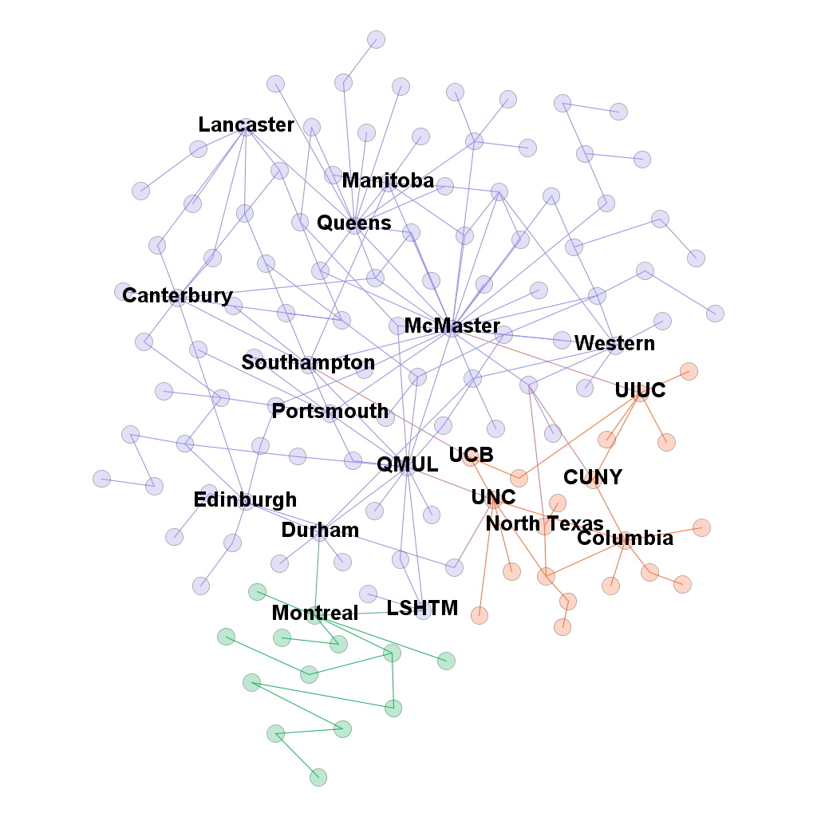

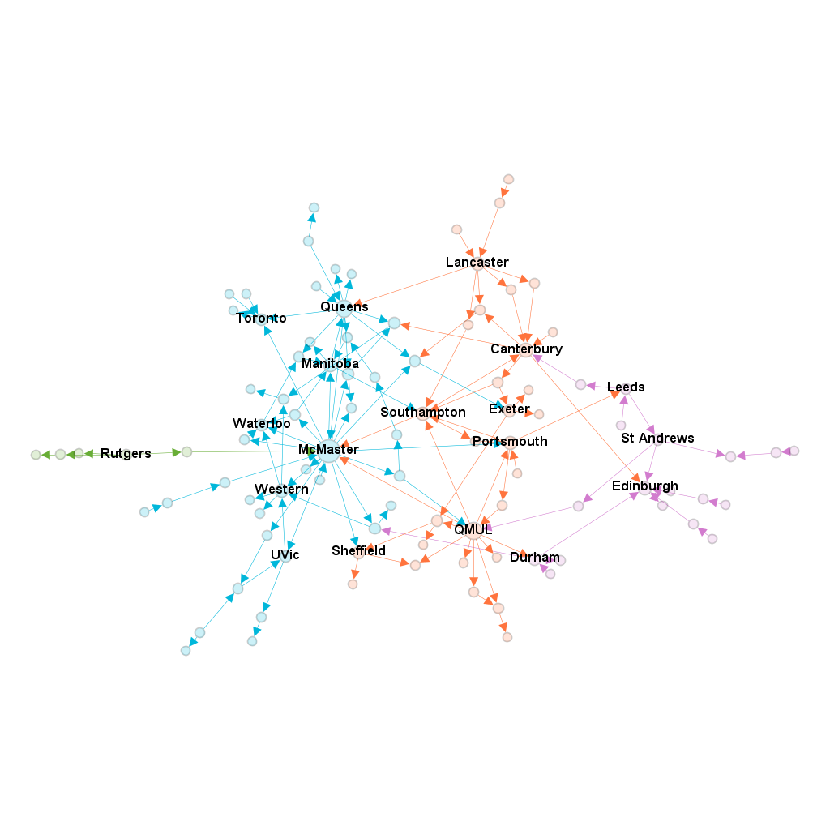

Table 2: First authors over time by institution

 | Symposium
 | 1985 UK | 1986 US | 1988 CA | 1990 UK | 1992 US | 1994 CA | 1996 UK | 1998 US | 2000 CA | 2003 UK | 2005 US | 2007 GER | 2009 CA | 2011 UK | 2013 US | 2015 CA | 2017 FR |  |  | Total  First Authors | Papers per First Author
McMaster | 1 | 3 | 3 | 3 | 3 | 6 | 7 | 6 | 8 | 5 | 6 | 8 | 25 | 17 | 9 | 3 | 3 |  |  | 116 | 1.08
Queen's CA | 1 | 2 | 3 | 3 | 4 | 4 | 1 | 5 | 1 | 4 | 4 | 4 | 7 | 3 | 7 | 9 | 6 |  |  | 68 | 1.07
UEA |  | 2 | 2 | 4 | 1 | 4 | 5 | 4 | 4 | 4 | 2 | 4 | 2 | 9 | 1 | 4 | 7 |  |  | 59 | 1.03
Canterbury |  |  |  | 1 | 1 | 1 | 1 |  | 1 | 3 | 4 | 5 | 4 | 3 | 6 | 7 | 7 |  |  | 44 | 1.11
Durham |  |  |  |  |  | 1 |  | 1 | 1 | 2 |  | 4 | 7 | 14 | 1 | 7 | 5 |  |  | 43 | 1.09
SFU |  |  | 1 |  | 1 | 4 | 4 | 2 |  | 1 |  | 1 | 2 | 5 | 5 | 14 | 1 |  |  | 41 | 1.00
Portsmouth | 2 | 1 | 2 | 1 | 1 | 5 | 3 | 5 | 5 | 4 | 2 | 1 | 1 |  | 2 |  | 3 |  |  | 38 | 1.13
Auckland |  |  |  | 1 | 1 |  |  | 1 | 1 | 1 | 2 | 3 | 5 | 4 | 6 | 7 | 5 |  |  | 37 | 1.32
QMUL | 5 | 2 | 1 | 2 |  |  | 1 | 2 | 4 | 3 | 7 | 2 |  | 4 | 1 | 1 | 2 |  |  | 37 | 1.16
Toronto | 1 |  | 1 |  |  | 2 |  |  |  | 2 | 3 | 3 | 11 | 4 | 6 | 2 | 2 |  |  | 37 | 1.00
Western |  |  |  |  |  |  |  |  |  |  |  | 1 | 11 | 8 | 12 | 2 | 3 |  |  | 37 | 1.08
Montreal | 1 |  | 3 | 1 | 1 | 4 |  | 1 | 4 |  |  | 1 | 1 | 3 | 7 | 4 | 5 |  |  | 36 | 1.08
Lancaster | 2 | 1 | 1 | 1 | 1 | 2 | 3 | 4 | 2 | 3 | 1 | 2 | 1 | 3 |  | 1 | 2 |  |  | 30 | 1.10
North Texas |  |  |  |  |  |  | 1 | 1 | 2 | 1 | 3 | 1 | 5 |  | 10 |  | 3 |  |  | 27 | 1.19
Bonn |  |  |  |  |  |  |  |  | 2 | 3 | 2 | 1 | 2 | 4 | 2 | 5 | 5 |  |  | 26 | 1.04
Exeter | 1 | 1 | 1 | 2 | 2 | 2 |  |  |  |  |  |  |  | 6 | 4 | 3 | 4 |  |  | 26 | 1.08
Southampton |  |  |  | 1 |  |  | 2 |  |  | 2 | 1 | 5 | 2 | 2 | 4 | 2 | 5 |  |  | 26 | 1.19
UNC-CH | 1 | 1 |  | 1 | 3 | 3 | 1 | 3 | 1 |  |  | 1 | 4 | 1 | 2 | 2 | 1 |  |  | 25 | 1.00
Edinburgh |  |  |  |  |  | 1 |  |  |  |  | 2 |  | 1 | 2 | 4 | 6 | 8 |  |  | 24 | 1.21
LSHTM | 1 | 1 |  |  | 1 | 2 |  | 2 |  | 1 |  |  |  | 1 | 6 | 5 | 4 |  |  | 24 | 1.42
UI-UC |  |  |  |  | 1 |  | 2 | 2 |  | 1 | 5 | 2 | 1 | 1 | 4 |  | 2 |  |  | 21 | 1.00
Waterloo |  | 1 | 1 |  | 1 | 1 |  | 1 |  |  |  |  |  | 2 | 5 | 5 | 3 |  |  | 20 | 1.15
Key: UEA: University of East Anglia; QMUL: Queen Mary University of London; SFU: Simon Fraser University; UNC-CH: University of North Carolina, Chapel Hill; LSHTM: London School of Hygiene and Tropical Medicine; UI-UC: University of Illinois, Urbana Champaign. Darker shades indicate more participants

