Scale-dependency in drivers of outdoor recreation in England
Laura J. Graham & Felix Eigenbrod

Abstract
- Managing landscapes for multiple, sometimes conflicting, objectives requires an understanding of the trade-offs and synergies between ecosystem services (ES). These trade-offs and synergies are often the result of drivers acting at different scales. Therefore, in order to understand trade-offs and synergies it is important that we understand the scale dependency in drivers of ES.
- Here, we examine scale dependencies in the drivers of outdoor recreation in England to better understand trade-offs between different aspects of this ES. We focus on outdoor recreation because it is culturally and economically important; it is the result of a range of social and biophysical attributes which vary at different scales; and proxies that are independent of these drivers exist.
- First, we tested the hypothesis that a social media based proxy (photographs from Flickr) represents ‘destination’ recreation (e.g. day trips and overnight visits). We did so by comparing to a survey based proxy, which is known to represent ‘day-to-day’ recreation (e.g. dog walking, visiting local parks). Second, we examined the scale dependencies in the social and biophysical drivers of both types of outdoor recreation.
- Flickr data were best explained by variables capturing supply of recreation; whereas the survey data were best explained by variables capturing demand for recreation. This confirms our hypothesis that Flickr data measure ‘destination’ recreation given that the survey data measure ‘day-to-day’ recreation. In both cases, the importance of demand variables increased with increasing spatial resolution.
- Understanding what a proxy measures provides us with information about how to use it. We conclude that Flickr data may be useful to plan at broad scales, but that to plan for equitable day-to-day recreation, specially designed survey data may be more appropriate. Estimating the scale dependencies in drivers of outdoor recreation gets us a step closer to a mechanistic understanding of the social-ecological system.

Introduction
To manage landscapes for multifunctionality, it is necessary to understand the nature of trade-offs and synergies between ecosystem services (ES) and other land-management goals (Bennett, Peterson, & Gordon, 2009; Manning et al., 2018). For example the use of land for provisioning services such as food or timber production can limit the provision of other services such as climate regulation, water quality or outdoor recreation (Rodriguez et al. 2006), leading to trade-offs. Conversely, when managed appropriately, agricultural landscapes provide habitat for biodiversity conservation (Doxa et al. 2010) and landscapes for aesthetic appreciation (van Zanten, Zasada, et al., 2016). Research into relationships between ecosystem services has primarily focussed on classifying the relationships and understanding what drives the relationships themselves. However, correlations between ES can be determined purely by the scale of analysis (Raudsepp-Hearne, Peterson, & Bennett, 2010; Spake et al., 2017). This is partially because the shape, magnitude and scale dependency of the relationship between ES and their drivers is likely to differ depending on the ES in question (Scholes, Reyers, Biggs, Spierenburg, & Duriappah, 2013). This means that trade offs are primarily driven by different responses to the same external drivers, and synergies by similar responses (van der Plas et al., 2019). Such findings have led to a call for taking a more mechanistic approach to understanding ES trade offs and synergies through identifying how the common drivers differ in terms of the magnitude, shape, and scale of their effect (Spake et al., 2017; Dade, Mitchell, McAlpine, & Rhodes, 2018).
Ecosystem services are the result of complex social-ecological systems, where each interaction and feedback likely has its own scale dependency (Scholes et al., 2013). Realised ES are generated through supply of (the ecological part of the system) and demand for (the social part of the system) an ES (Tallis et al., 2012; Jones et al., 2016). Both supply of and demand for ES operate at multiple, often mismatching, scales (Hein, van Koppen, de Groot, & van Ierland, 2006). However, to date very few studies (but see Spake et al. 2019) specifically test the scale-dependence of different aspects of the complex interplay of the socio-ecological linkages between supply and demand that characterize ES. Estimation of relationships between ES and their drivers at incorrect scales can lead to incorrect and misleading conclusions (Knegt et al., 2010). Incorporating inappropriate mechanism in ES modelling and decision making can lead to costly mistakes (Dade et al., 2018). Therefore, to improve understanding and prediction of the trade-offs and synergies between ecosystem services under global change, an understanding of these scale dependencies is required.
Here, we aim to gain an understanding of such scale dependencies in the drivers of outdoor recreation using England as a case study. We focus on outdoor recreation in this first analysis of its kind for three reasons. First, as a test of the scale dependencies in drivers of ES, outdoor recreation is ideal because its drivers span a range of social (e.g. population density, socio-demographic characteristics) and biophysical (e.g. landscape composition, topography) attributes (Bateman et al., 2013; Paracchini et al., 2014; van Zanten, Van Berkel, et al., 2016; Ridding et al., 2018). Secondly, proxies exist for outdoor recreation which have not been calculated using the drivers of interest, such as land cover. For example, information from social media (Casalegno, Inger, DeSilvey, & Gaston, 2013; Wood, Guerry, Silver, & Lacayo, 2013; Willemen, Cottam, Drakou, & Burgess, 2015; van Zanten, Van Berkel, et al., 2016; Tew, Simmons, & Sutherland, 2019); survey (Natural England, 2018b; Rabe, Gantenbein, Richter, & Grêt-Regamey, 2018; Ridding et al., 2018) and empirical visitation data (Wood et al., 2013) have been used to map and understand outdoor recreation. Proxies for ES based on land cover are far more common than primary data (Stephens, Pettorelli, Barlow, Whittingham, & Cadotte, 2015); however, when the aim is to understand the drivers of ES, this introduces a level of circularity, making such derived variables unsuitable for meaningful statistical analyses. Finally, outdoor recreation is an economically and culturally important service within Europe (van Zanten, Van Berkel, et al., 2016) and therefore contributes to overall landscape multifunctionality.
When aiming to gain an understanding of mechanisms driving ES, it’s key to ensure we know exactly what a proxy is measuring. Assessments of recreational ecosystem services generally consider all types of recreation together, regardless of whether they are day-to-day, overnight, or destination (Daniel et al., 2012). However, it is likely that the different proxies used for measuring outdoor recreation are measuring different types of recreation, each with their own set of drivers and scale dependencies. For example, photographs of the natural world uploaded to Panoramio have been used as a proxy for aesthetic beauty (Casalegno et al., 2013). Photographs from other social media have been used to represent outdoor recreation more broadly (van Zanten, Van Berkel, et al., 2016), with some studies employing the keyword filtering to examine specific outdoor recreation activities (Mancini, Coghill, & Lusseau, 2019). Survey data have been used to discover what people value in landscapes (Plieninger, Dijks, Oteros-Rozas, & Bieling, 2013); where people enjoy going in the landscape (Ridding et al., 2018) or gaining understanding of day-to-day interactions with the natural world (Kaźmierczak, 2013; Natural England, 2018a). Despite the clear differences in proxies, there is limited understanding of how they may differ in terms of the type of outdoor recreation they measure. Van Zanten et al. (2016) compared three social media proxies for outdoor recreation, but the focus was on (a) amount of data; and (b) demographic characteristics of those posting photos. Other studies have compared survey and social media proxies for outdoor recreation, but with the aim of showing the similarities, rather than the differences (Wood et al., 2013). Considering all forms of outdoor recreation together may mask relationships with social and ecological drivers when these differ depending on the type of outdoor recreation. Additionally, understanding what a proxy is actually measuring can provide insight into which proxy should be used for which purpose.
Here, we use our understanding of the scale-dependency of social-ecological drivers of different aspects of outdoor recreation to determine which aspects of outdoor recreation a social media-based proxy (number of photographs from the photo sharing site Flickr) is capturing. We do this by comparison against a survey-based proxy – the Monitor of Engagement with the Natural Environment (MENE) (Natural England, 2018b) representative survey. This proxy is associated with day-to-day recreation, because participants were asked questions about their most recent (past 7 days), rather than favourite, visits to the natural environment. For example, in the 2017-2018 survey, 88% of visits were for the purpose of health and exercise, or walking the dog (Natural England, 2018a). In the data analysed here, people travelled less than 2 miles for 56% of visits, and only 6% travelled more than 40 miles. In fact, using MENE data as a proxy for recreation has shown that the land use (e.g. intensive agriculture, conservation management, urban development) in closer proximity to urban areas has the greatest impact on outdoor recreation (Bateman et al., 2013). Additionally, using this proxy shows that areas with a high nature value do not necessarily have high recreational value (Hornigold, Lake, & Dolman, 2016). Less is known about what photograph data from Flickr are measuring, but we expect that they represent ‘destination’ recreation: where people travel to specific areas. This is because a key motivation for posting photographs to Flickr is to share aesthetic beauty with others, or for the sense of community with other like-minded individuals (Malinen, 2010). In fact, a growth in online communities around outdoor tourism has been seen (Dippelreiter et al., 2008).
The overall aim of this study is to test several fundamental properties of scale in the relationships between ES and their drivers. First, we use an understanding of the scale-dependency of the drivers of the two proxies of outdoor recreation measured here to test which aspects of outdoor recreation social media data are capturing. If the Flickr photograph data is truly measuring destination recreation, we expect that these data will be best explained by drivers of supply at all scales, with demand being less important, particularly at fine scales. This is in contrast to the MENE data, where given this measures day-to-day recreation, we expect that it is much more related to drivers of demand. Second, we test how the relative contributions of supply and demand vary depending on the scale of analysis. We expect that at coarser analysis resolutions, the spatial distribution of these two types of outdoor recreation will become more similar due to increasing heterogeneity at increasing spatial resolutions. Put simply, at coarser resolutions, a single grid cell will contain both the high nature value areas people travel to, and the urban parks used by people on a day-to-day basis. Finally, we explore how the direction and magnitude of the relationships with individual drivers change depending on the proxy used, and the scale of analysis. The understanding of what the proxies are measuring will provide information about the situations in which they are most useful. By gaining an understanding of the scales at which processes are operating, we can make more detailed recommendations on the appropriate scale of management.

Methods

Study area
Opportunities for outdoor recreation in England range from the use of local greenspaces by walkers, dog walkers, community gardeners and families (day-to-day recreation) to planned trips to coastal areas and protected landscapes by hikers, mountain bikers, climbers and other tourists (destination recreation). English legislation offers protected landscapes at many administrative levels. At the local level are Local Nature Reserves: areas of interest to the local community which are managed for people and wildlife. At the national level, large parts of the country (23%) are Areas of Outstanding Natural Beauty and National Parks, which are managed to conserve and enhance natural beauty, wildlife, and cultural history, while also providing recreational outdoor opportunities. England also has protected areas managed primarily for biodiversity, but these are highly fragmented, much smaller in area (6.3% of England), and mostly (60%) nested within Areas of Outstanding Natural Beauty and National Parks (Eigenbrod et al. 2010).

Outdoor recreation data
We used two proxies to measure outdoor recreation: survey data from Natural England’s Monitor of Engagement with the Natural Environment (MENE) (Natural England, 2018b) and information about photos from the photo sharing site Flickr. MENE is a survey on people’s use and enjoyment of the natural environment in which a representative geographical and socio-economic sample was taken. From this survey we obtained georeferenced information on recent visits to the natural environment within England for 2009–2017 (information on ~10,000 visits). We accessed georeferenced metadata about photos on Flickr through the website’s application programming interface (API). The API allows users to specify a search string and return data from the website. We used the API’s search parameters to limit the photographs to those with georeferenced records within England, for 2009–2017, matching the keywords outlined in van Zanten et al. (2016) (Table 1).
Table 1 Keywords used to filter the Flickr photographs. Following van Zanten et al. (2016), filtered photographs to include only those with tags from the unambiguous keywords list; or photographs with at least one tag from each of the ambiguous and landscape keywords lists.
Unambiguous keywords | Ambiguous keywords | Landscape keywords
bike riding, camp, camping, climbing, cycling, fishing, heritage, hike, hiking, historic value, horse riding, hunt, hunting, jogging, mountain biking, mountaineering, outdoor, panorama, recreation, rowing, run, running, sailing, scene, scenery, scenic, skiing, tourism, trekking, view, viewpoint, vista, walk, walking | beautiful, beauty, breathtaking, brilliance, brilliant, cruising, enchanting, enjoying, gorgeous, inspired, inspiring, magnificence, magnificent, outstanding, relax, relaxing, splendour, sublime | basin, beach, brook, bush, canopy, cattle, channel, cliff, coast, corn, countryside, cow, creek, cropland, crops, cultural land, cultural landscape, dike, ditch, dune, estuary, field, forest, glacier, gorge, grassland, grazing, grove, heath, heather, heathland, hedgerow, highland, hill, lake, landscape, livestock, maize, marsh, marshes, marshland, meadow, moor, moorland, moors, mountain, nature, oats, ocean, orchard, park, pasture, peak, peat, peatbog, peatland, pond, prairie, ridge, river, sea, sheep, shore, shrubland, shrubs, swamp, tree, valley, vineyard, waterfall, wetland, wheat, woods

Social-ecological data
We classified predictor variables into demand for outdoor recreation, and supply of outdoor recreation. For each predictor variable, we calculated the value at four spatial resolutions: 5 km, 10 km, 25 km, 50 km. The minimum spatial resolution chosen (5km) represents a reasonable maximum distance that people may travel for day-to-day recreation: in the MENE data, people travelled less than 2 miles for 56% of visits. The maximum spatial resolution chosen (50km) represents the mean size of the average city in the study area (Office for National Statistics, 2017).
Demand for outdoor recreation was represented by population density (per 1km) and distance to nearest major town/city. We used gridded population data from OpenPopGrid (Murdock, Harfoot, Martin, Cockings, & Hill, 2015). In order to get a measure of distance to nearest major town/city, we calculated the distance between the cell centroid at each resolution and the nearest major town or city (Office for National Statistics, 2017).
We defined indicators of supply of outdoor recreation as agricultural %, forest %, coastal %, land-cover diversity (LC diversity), elevation range and protected area %. The land-cover percentages were calculated from the Land Cover Map 2015 data at 25m resolution (Rowland et al., 2017). We defined agricultural land as arable and horticulture (LCM2015 code 3) and improved grassland (4). Forest is classes for broadleaved and coniferous forest (1, 2). Coastal land covers are supra-littoral rock, supra-littoral sediment, littoral rock, saltmarsh (15-19). Land-cover diversity was calculated using Shannon evenness (Pielou, 1976).
$$J' = \frac{-Σ(p_{i }ln(p_{i})}{ln(S)}$$
where $S$ is total number of land covers and $p_{i}$ is the proportion land cover $i$. Elevation range was calculated from the 25 m resolution EU digital elevation map (European Environment Agency, 2017). We calculated the total protected area using boundary datasets for National Parks (Natural England, 2019b) and Areas of Outstanding Natural Beauty (Natural England, 2019a). We compiled a dataset containing the two response variables and the supply and demand predictor variables at each of the four analysis resolutions. The Flickr data contained large outliers; we windsorised these by setting any value greater than the 99th percentile to the value of the 99th percentile (Tukey, 1962).

Statistical models
To test our hypothesis that Flickr photographs measure destination recreation, we fit three models for each proxy at each of the four resolutions. These were the supply model (agriculture %, forest %, coastal %, LC diversity, elevation range); the demand model (population density, distance to city); and a full model (all variables). Due to overdispersed count data, we used a generalised linear model with a negative binomial distribution. We selected the best fitting model for each proxy and resolution using Akaike’s Information Criterion (AIC).
In order to understand how the relative importance of supply or demand on outdoor recreation vary with scale, we used deviance partitioning (Keil & Chase, 2019). We calculated the deviance explained ($D^{2}$) for each model following Guisan and Zimmerman (2000). The independent contribution of supply and demand were calculated as $D_{full}^{2}-D_{demand}^{2}$ and $D_{full}^{2}-D_{supply}^{2}$respectively. The shared variance explained was the difference between the total deviance explained and the independent contributions of the two submodels.

Results

Proxies for outdoor recreation
We obtained records on 8151 visits to the natural environment from the MENE survey data, and 736,882 unique photographs per-user-per-day from Flickr. After aggregating to the four resolutions, and windsorising the 99th percentile of the Flickr data, the highest count of photographs/visits were 443 (Flickr) / 72 (MENE) (5 km); 1,113 / 126 (10 km); 2707 / 528 (25 km); 1027 / 15566 (50 km). In the MENE data, the highest concentrations of visits are around cities. By contrast, the highest concentrations of Flickr photographs outside of London are in the Lake District and Peak District National Parks (Figure 1).
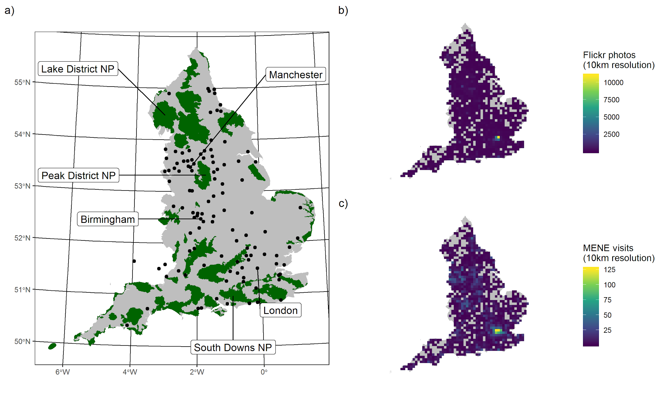
Figure 1 Map of England showing distribution of designated landscapes (National Parks and Areas of Outstanding Natural Beauty; green) and major towns/cities (points) (a). Spatial distribution of the density of (b) photographs from the Flickr photo sharing website; and (c) visits from the Monitor of Engagement with the Natural Environment survey. Spatial resolution is 10 km x 10 km in both (b) and (c).
The two proxies are minimally correlated, with correlation increasing with analysis resolution (Figure 2). The areas in which there are disproportionately more Flickr photographs than MENE visits are in the national parks, on the coast and in London (Figure 3)
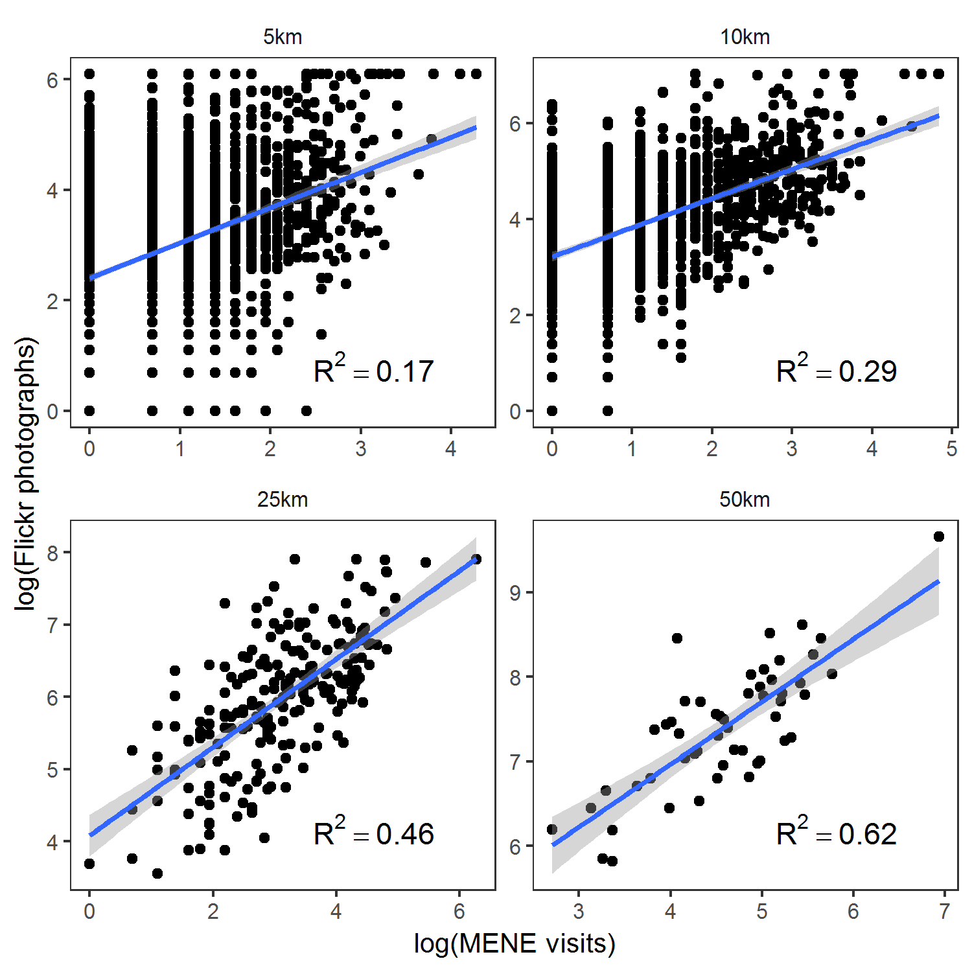
Figure 2 Relationship between Flickr photographs and MENE visits (both log transformed) at the four analysis scales. Fitted line shows the results of a linear regression and R2 the variance explained by this fit.
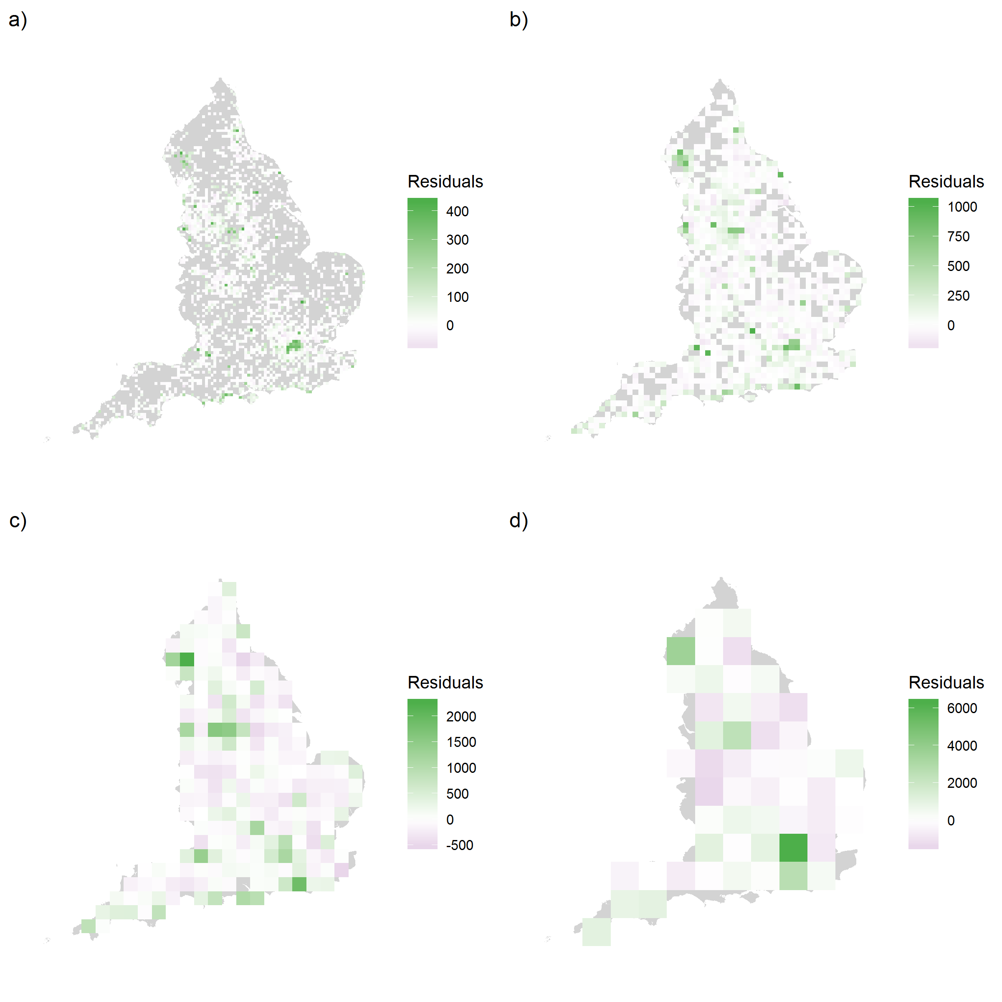Figure 3 Residuals of the linear regression with Flickr photos as the response variable and MENE visits as the explanatory variable (both log transformed). Residuals have been transformed to the scale of the response variable. Purple cells show areas with higher number of MENE visits than expected based on the Flickr photographs. Green cells show lower number of MENE visits than expected.

Drivers of outdoor recreation
We found that there was the most support for the full model for both proxies at all resolutions when judged by AIC (Table 2). When only comparing supply and demand models, we found that for the model with MENE visits as the response, the demand model had most support except at the finest resolution (5km). When Flickr was the response, the supply model had the most support except at the coarsest resolution (50km). This supports our hypothesis that if MENE visit data measures day-to-day recreation, then the Flickr photograph data measures destination recreation.
Table 2 Results of the model comparison. We fit a demand (population density, distance to nearest major town/city), supply (agricultural land cover %, natural land cover %, land-cover diversity, elevation range, protected area coverage) and full (all variables) model for each proxy at each analysis resolution. The best fitting model was defined as that with the lowest Akaike Information Criteria (AIC) for each proxy/resolution combination.

Resolution | Proxy | AIC
 |  | Full | Demand | Supply
5km | Flickr photos | 19326 | 20405 | 19401
10km | Flickr photos | 11222 | 11726 | 11330
25km | Flickr photos | 3019 | 3074 | 3057
50km | Flickr photos | 892 | 891 | 901
5km | MENE visits | 9566 | 9812 | 9602
10km | MENE visits | 5775 | 5864 | 5906
25km | MENE visits | 1793 | 1799 | 1859
50km | MENE visits | 596 | 586 | 607

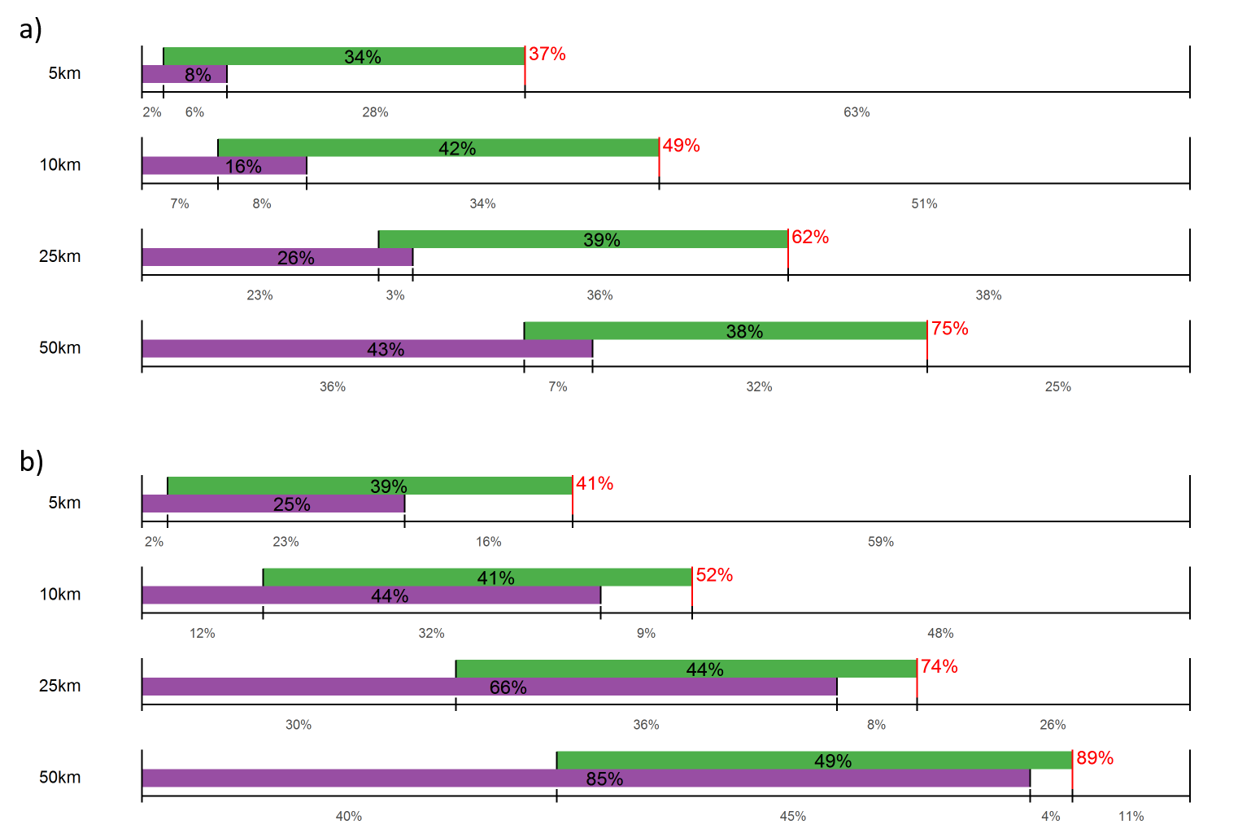
Figure 2 Deviance partitioning for the (a) Flickr photograph data; and (b) MENE visits data. In both cases, we show the total variance explained by the supply model (green bars) and by the demand model (purple bars). The deviance is partitioned into unique and shared (overlapping) components.

The deviance partitioning (Figure 2) shows that when taking Flickr photographs as a proxy for outdoor recreation, the majority of the deviance is explained by supply variables (28% – 36% independent variance explained) with very little shared deviance (3% – 8%; Figure 2a).
Conversely, when we use MENE visits as a proxy, for most analysis resolutions most deviance is explained by the independent contribution of the demand model (12% – 40%, 10 km – 50 km) or shared deviance (23% – 45%). The exception being at 5 km resolution where supply independently accounts for 15% of the total deviance, but demand only independently accounts for 2% (Figure 2b).
Further support for our hypothesis that Flickr photographs measure destination recreation, is provided by the greater independent contribution by supply variables at all scales for the Flickr data (Figure 2a).
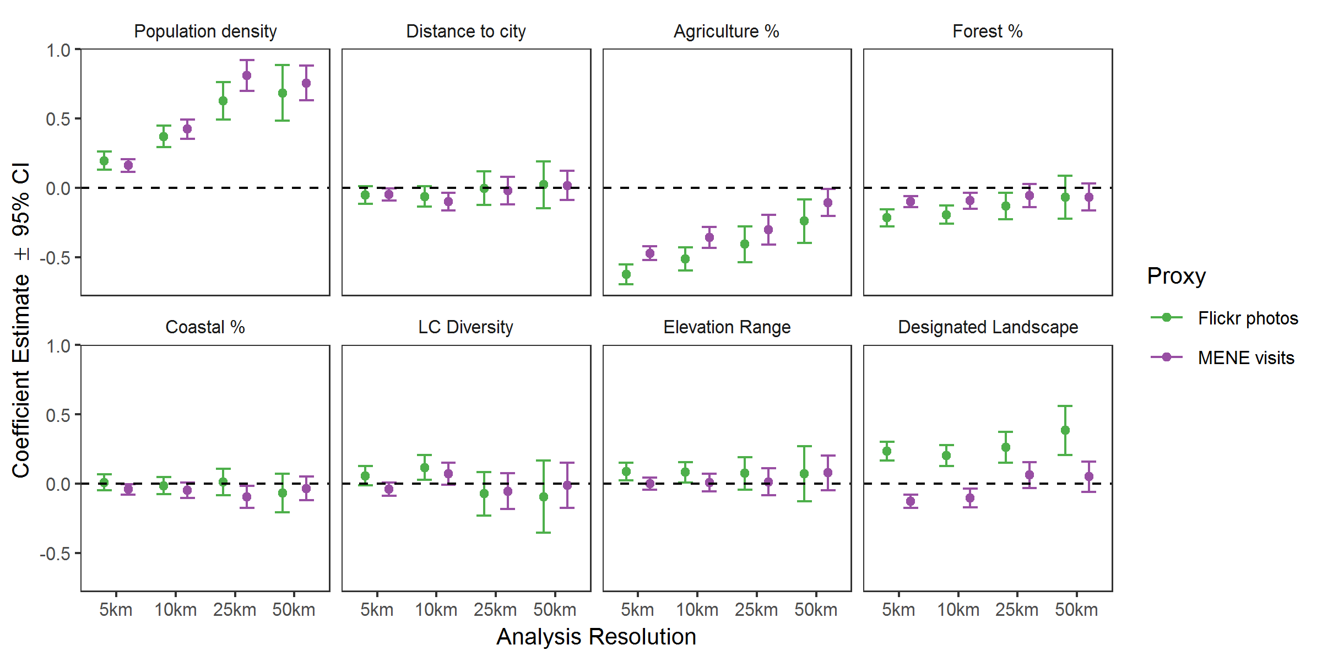
Figure 3 Coefficient estimates from a negative binomial GLM with Flickr photograph density (top row) and MENE visit density (bottom row) as the response variable.

Scale dependency in drivers of outdoor recreation
We can also use the results from the deviance partitioning to gain an understanding of the scale dependency in variable importance. We expected the two proxies to converge with coarser analysis resolution, and the importance of demand variables to increase.
For the Flickr photo analysis, the amount of deviance explained by the supply model, and the shared deviance between supply and demand, remain fairly constant across spatial scales. However, the importance of demand variables increases (Figure 2a). The variables driving supply are a negative relationship with agricultural land %, LC diversity at fine resolutions (5 km, and particularly 10 km), and protected areas (Figure 3). The effect of agricultural land % decreases with an increase in grain size, and the effect of designated landscape % is strongest at 50 km resolution. We also see a negative effect of Forest %: this is likely because heavily visited areas like National Parks generally have low amounts of forest cover (Figure 3).
Similarly, the deviance explained by the supply model remains reasonably constant across spatial scales for the MENE visit analysis (Figure 2b). In this case, however, the increase in the deviance explained by the demand variables is shared with that of the deviance explained by supply variables, meaning there is a decrease in the independent contribution of supply variables at coarser resolutions. For the MENE visit dataset, the supply model is driven by avoidance of agriculture, and a negative effect of designated landscapes at fine resolutions (Figure 3).
For both response variables, the demand model is driven by population density, with distance to nearest major town/city having relatively little effect. This effect increases with spatial grain, although not linearly (Figure 3).

Discussion
Using readily available proxies for outdoor recreation, we were able to gain a deeper understanding of the drivers of different kinds of outdoor recreation; and how the proxies for outdoor recreation can be used. We showed that the drivers of ‘day-to-day’ and ‘destination’ recreation differed in identity, strength and scale. This clearly demonstrates that it is important to classify the type of recreation being assessed prior to analysis, rather than using a composite measure. Well-designed representative surveys such as MENE provide an important source of data for understanding local use of nature, and can provide insight to local greenspace planning. The results from the analysis of the MENE data show us that local planners should focus on ecological characteristics at fine spatial scales. By contrast, social media data, such as Flickr, can provide a more national picture of why people travel for outdoor recreation, but must be used with caution to avoid perpetuating biases in access and use of the natural environment to that characterize such ‘big data’.
Our results supported the hypothesis that photographs from the Flickr photo sharing site measured ‘destination’ recreation given that visits from the MENE survey measure ‘day-to-day’ recreation. We found that ‘destination’ recreation – measured using density of photographs from the Flickr photo sharing site – was most closely related to ecological drivers. In contrast, ‘day-to-day’ recreation – measured using survey data from Natural England’s MENE project – was more closely related to social drivers. Additionally, we found that the importance of drivers changed with scale: in both cases, the importance of variables associated with demand increased with increasing analysis resolutions. Gaining this understanding is crucial, because it allows us to draw conclusions on the scale at which managing ecological systems is likely to be effective. If amount of outdoor recreation is driven by population density at coarse resolutions, then it is key that ecological spaces are managed for outdoor recreation within a reasonable distance of where people live. However, this finding may be specific to regions similar to England with few wilderness areas.
Ecosystem service assessments often consider all types of outdoor recreation together (Daniel et al., 2012), regardless of whether they are day-to-day, overnight, or destination. Our findings show that there are different drivers depending on what kind of outdoor recreation is being analysed. Therefore it is important to first classify what kind of outdoor recreation is being measured and separate out before analysis. In our study, we used keywords to reduce the data on photographs from Flickr to those relevant for outdoor recreation. These keywords could be further utilised to gain an understanding of the specific kind of outdoor recreation (e.g. active recreation such as mountain-biking and hiking; or more passive recreation such as aesthetic appreciation) (Mancini et al., 2019).
Understanding what kind of outdoor recreation is measured by a proxy also helps us identify its potential uses. For example, for local green-space planning, it is much more sensible to use the results from surveys such as MENE than widely available social media data. Conversely, the Flickr data can provide a more national understanding of why people travel for outdoor recreation. For example, our results show that managing diverse and designated landscapes has positive implications for English nature tourism.
It is also important to fully consider the socio-demographic characteristics that are catered for through different proxies. The MENE survey was designed to be a representative sample; however, it is likely that the Flickr data captures a specific demographic. High Flickr photograph density is correlated with high densities of well-educated white people (Li, Goodchild, & Xu, 2013), and many Flickr users are nature enthusiasts with specific taxonomic interests (Hausmann et al., 2018). This suggests that if Flickr data were to be used in planning as a proxy for all forms of outdoor recreation, it’s likely that existing biases in access to and use of the natural environment could be perpetuated. A study of the socio-demographic characteristics of infrequent users of the natural environment in the MENE survey showed that they tend to be female, older, and in poor health, with area deprivation and individual income predictive of lack of interest in visiting the natural environment (Boyd, White, Bell, & Burt, 2018). Visitors to English protected areas tend to be over-represented by white, middle class males and under-represented by minority groups (Booth, Gaston, & Armsworth, 2010). Similar findings about gender, race, and socio-economic status having a constraint on outdoor recreation have also been found in North America (Shores, Scott, & Floyd, 2007; Ghimere et al. 2015). That these existing biases are likely to be reflected in the data collected from Flickr highlights a shortcoming of using ‘big data’ approaches from social media. Combining multiple platforms may limit the socio-demographic biases (Gliozzo, Pettorelli, & Haklay, 2016; Hausmann et al., 2018), but will still not capture those groups who do not use social media (van Zanten, Van Berkel, et al., 2016; Blank & Lutz, 2017)
We can, however, use the Flickr data to investigate the mechanisms behind destination recreation, but we need to be clear about the biases involved. The key drivers of supply of destination recreation were the amount of agricultural land, land-cover diversity, and protected area coverage. The negative relationship with agricultural land cover suggests a trade off between agriculture and outdoor recreation, which is supported by earlier studies (Maes, Paracchini, Zulian, Dunbar, & Alkemade, 2012; Bateman et al., 2013). Previous studies have found that there are positive preferences for some agricultural landscape features, such as linear features, livestock presence and diversity of agricultural practices, but that these preferences are often context specific (van Zanten, Zasada, et al., 2016). The positive effect of land-cover diversity reflects findings from other studies in the UK (Ridding et al., 2018) and further afield (Schirpke, Meisch, Marsoner, & Tappeiner, 2018). The effect was strongest at intermediate resolutions. This is likely to be related to the scale at which humans perceive the landscape either through viewsheds, or distance covered during outdoor recreation. Additionally, there is likely an artefact of scale. Land-cover diversity is unlikely to be captured at fine resolutions (Wu, 2004), but in a country like England with limited coarse-grain variability in land-covers, any variation in LC diversity is likely to be lost at coarser resolutions. The positive effect of designated landscape coverage was strongest at coarse resolutions; reflecting the national importance of these areas (MacEwen & MacEwen, 1987).
Our results provide crucial information about drivers of outdoor recreation and their scale dependencies within England. Extending the study beyond England will likely introduce further scale dependencies. We found that demand variables, in particular population density, had increasing importance within increasing spatial resolution. However, destination tourism within England to protected landscapes likely has a shorter ‘willingness to travel’ distance than for activities such as safari tourism, and visits to wild and unmanaged natural parks (Martín-López, Gómez-Baggethun, Lomas, & Montes, 2009). As such, there will likely be a weaker signal of demand for such forms of outdoor recreation, and in particular, local population density because travel distance is no longer a consideration. Additionally, broadening the extent of study will increase socio-cultural context dependency. Differences in preference for landscape attributes have been found to be dependent on the socio-cultural context of those surveyed (van Zanten, Zasada, et al., 2016). Extending beyond a small extent will increase the diversity of cultural contexts. For example, in a previous study, country identity explained a greater amount of variance in outdoor recreation than any other socio-economic or ecological predictor (van Zanten, Van Berkel, et al., 2016)
Our results provide a first step towards understanding how the drivers of different types of outdoor recreation vary with scale. By broadening the analysis to continental or global scales, we will be able to (a) examine how context dependency changes the results; (b) fully investigate the scale-dependency of the strength and direction of these relationships; and (c) gain an understanding of where we can and cannot predict outdoor recreation. Estimates of relationships when carried out at inappropriate scales can lead to misleading conclusions (Knegt et al., 2010), therefore a mechanistic understanding of how social-ecological systems drive ecosystem services, and thus multifunctionality, will require a fully integrated multi-scale approach (Graham, Spake, Gillings, Watts, & Eigenbrod, 2019). Results from studies conducted at multiple scales such as this one provide the first steps towards gaining an integrated multi-scale and mechanistic understanding of what drives landscape multifunctionality.

Implications for planning policy and practice

Given limited resources for local services, our results can help efficiently target interventions to improve people’s interactions with nature. For example, the results from the MENE analysis show that within urban areas, we need to focus on ecological characteristics at very local scales (~5km from where people live). These kind of results can influence national policies such as the Accessible Natural Greenspace Standards outlined by Natural England (2011), by defining the scales at which supply of green space have most effect. A particular characteristic of the relationship between day-to-day recreation and ecological factors is avoidance of agriculture and heavily forested areas: as such a focus on maintaining parks and mixed natural areas is key. This echoes the findings of previous studies which recommend a focus on mixed management and open spaces (Tew et al. 2019), and earlier work using similar data in England that showed that protected landscapes and protected areas are under-represented in terms of day-to-day recreation visits (Eigenbrod et al. 2009). We also found that the relationship between agriculture and outdoor recreation was strongest at fine resolutions. This suggests that within local planning policy, a focus needs to be on understanding the specific agricultural landscape features for which people have a negative preference and promoting those with a positive preference.

The results of the Flickr analysis show that protected landscapes are key drivers at all scales in England, and that maintaining landscape diversity at intermediate scales (~10km) is important for destination recreation. Further investigation is required to understand if these relationships also hold for other types of conservation strategies (e.g. strict protected areas), and the specific characteristics of these protected landscapes which drive this relationship in order to understand applicability outside of protected areas. It is, however, important that consideration of the socio-demographic make up of Flickr users is considered and controlled for in order to avoid perpetuating existing biases in terms of the users of the natural world.

Acknowledgements
We thank Monica Turner, Helen Hoyle and one anonymous reviewer for helpful comments on an earlier version of this manuscript. We also thank Nathan Fox for help with the Flickr API. This research was funded by the ERC Starting Grant ‘SCALEFORES’ (grant no. 680176), awarded to FE.

Authors’ contributions
LJG and FE conceived the ideas. LJG designed the analysis and led the writing of the paper. LJG and FE interpreted the results and wrote the manuscript.

References
Bateman, I. J., Harwood, A. R., Mace, G. M., Watson, R. T., Abson, D. J., Andrews, B., … Termansen, M. (2013). Bringing Ecosystem Services into Economic Decision-Making: Land Use in the United Kingdom. Science, 341(6141), 45–50. doi:10.1126/science.1234379
Bennett, E. M., Peterson, G. D., & Gordon, L. J. (2009). Understanding relationships among multiple ecosystem services. Ecology Letters, 12(12), 1394–1404. doi:10.1111/j.1461-0248.2009.01387.x
Blank, G., & Lutz, C. (2017). Representativeness of Social Media in Great Britain: Investigating Facebook, LinkedIn, Twitter, Pinterest, Google+, and Instagram. American Behavioral Scientist, 61(7), 741–756. doi:10.1177/0002764217717559
Booth, J., Gaston, K., & Armsworth, P. (2010). Who Benefits from Recreational Use of Protected Areas? Ecology and Society, 15(3). doi:10.5751/ES-03450-150319
Boyd, F., White, M. P., Bell, S. L., & Burt, J. (2018). Who doesn’t visit natural environments for recreation and why: A population representative analysis of spatial, individual and temporal factors among adults in England. Landscape and Urban Planning, 175, 102–113. doi:10.1016/j.landurbplan.2018.03.016
Casalegno, S., Inger, R., DeSilvey, C., & Gaston, K. J. (2013). Spatial Covariance between Aesthetic Value & Other Ecosystem Services. PLOS ONE, 8(6), e68437. doi:10.1371/journal.pone.0068437
Dade, M. C., Mitchell, M. G. E., McAlpine, C. A., & Rhodes, J. R. (2018). Assessing ecosystem service trade-offs and synergies: The need for a more mechanistic approach. Ambio. doi:10.1007/s13280-018-1127-7
Daniel, T. C., Muhar, A., Arnberger, A., Aznar, O., Boyd, J. W., Chan, K. M. A., … von der Dunk, A. (2012). Contributions of cultural services to the ecosystem services agenda. Proceedings of the National Academy of Sciences, 109(23), 8812. doi:10.1073/pnas.1114773109
Dippelreiter, B., Grün, C., Pöttler, M., Seidel, I., Berger, H., Dittenbach, M., & Pesenhofer, A. (2008). Online Tourism Communities on the Path to Web 2.0: An Evaluation [Text]. doi:info:doi/10.3727/109830508788403132
Doxa, A., Bas, Y., Paracchini, M. L., Pointereau, P., Terres, J. M., & Jiguet, F. (2010). Low‐intensity agriculture increases farmland bird abundances in France. Journal of Applied Ecology, 47(6), 1348-1356.
Eigenbrod F., Anderson B. J., Armsworth P. R., Heinemeyer A., Jackson S. F., Parnell M., Thomas C. D., and Gaston K. J. (2009). Ecosystem Service Benefits of Contrasting Conservation Strategies in a Human-Dominated Region. Proceedings of the Royal Society B: Biological Sciences 276, 2903–11. https://doi.org/10.1098/rspb.2009.0528.
Eigenbrod, F., Anderson, B. J., Armsworth, P. R., Heinemeyer, A, Gillings, S., Roy, D. B., Thomas, C. D., and Gaston, K. J. (2010). Representation of Ecosystem Services by Tiered Conservation Strategies. Conservation Letters, 3, 184–91. https://doi.org/10.1111/j.1755-263X.2010.00102.x.
European Environment Agency. (2017). EU Digital Elevation model (EU-DEM V1.1). Retrieved from https://land.copernicus.eu/user-corner/publications/eu-dem-flyer
Ghimire, Ramesh, Gary T. Green, Neelam C. Poudyal, and H. Ken Cordell (2014). An Analysis of Perceived Constraints to Outdoor Recreation. Journal of Park and Recreation Administration 32

Gliozzo, G., Pettorelli, N., & Haklay, M. (Muki). (2016). Using crowdsourced imagery to detect cultural ecosystem services: a case study in South Wales, UK. Ecology and Society, 21(3). doi:10.5751/ES-08436-210306
Graham, L. J., Spake, R., Gillings, S., Watts, K., & Eigenbrod, F. (in press). Incorporating fine-scale environmental heterogeneity into broad-extent models. Methods in Ecology and Evolution.
Guisan, A., & Zimmermann, N. E. (2000). Predictive habitat distribution models in ecology. Ecological Modelling, 135(2), 147–186. doi:10.1016/S0304-3800(00)00354-9
Hausmann, A., Toivonen, T., Slotow, R., Tenkanen, H., Moilanen, A., Heikinheimo, V., & Minin, E. D. (2018). Social Media Data Can Be Used to Understand Tourists’ Preferences for Nature-Based Experiences in Protected Areas. Conservation Letters, 11(1), e12343. doi:10.1111/conl.12343
Hein, L., van Koppen, K., de Groot, R. S., & van Ierland, E. C. (2006). Spatial scales, stakeholders and the valuation of ecosystem services. Ecological Economics, 57(2), 209–228. doi:10.1016/j.ecolecon.2005.04.005
Jones, L., Norton, L., Austin, Z., Browne, A. L., Donovan, D., Emmett, B. A., … Willis, G. F. (2016). Stocks and flows of natural and human-derived capital in ecosystem services. Land Use Policy, 52, 151–162. doi:10.1016/j.landusepol.2015.12.014
Kaźmierczak, A. (2013). The contribution of local parks to neighbourhood social ties. Landscape and Urban Planning, 109(1), 31–44. doi:10.1016/j.landurbplan.2012.05.007
Keil, P., & Chase, J. M. (2019). Global patterns and drivers of tree diversity integrated across a continuum of spatial grains. Nature Ecology and Evolution. doi:10.1038/s41559-019-0799-0
Knegt, H. J. de, Langevelde, F. van, Coughenour, M. B., Skidmore, A. K., Boer, W. F. de, Heitkönig, I. M. A., … Prins, H. H. T. (2010). Spatial autocorrelation and the scaling of species–environment relationships. Ecology, 91(8), 2455–2465. doi:10.1890/09-1359.1
Li, L., Goodchild, M. F., & Xu, B. (2013). Spatial, temporal, and socioeconomic patterns in the use of Twitter and Flickr. Cartography and Geographic Information Science, 40(2), 61–77. doi:10.1080/15230406.2013.777139
MacEwen, A., & MacEwen, M. (1987). Greenprints for the Countryside?: The Story of Britain’s National Parks. Allen & Unwin.
Maes, J., Paracchini, M. L., Zulian, G., Dunbar, M. B., & Alkemade, R. (2012). Synergies and trade-offs between ecosystem service supply, biodiversity, and habitat conservation status in Europe. Biological Conservation, 155, 1–12. doi:10.1016/j.biocon.2012.06.016
Malinen, S. (2010). Photo Exhibition or Online Community? The Role of Social Interaction in Flickr. In 2010 Fifth International Conference on Internet and Web Applications and Services (pp. 380–385). doi:10.1109/ICIW.2010.63
Mancini, F., Coghill, G. M., & Lusseau, D. (2019). Quantifying wildlife watchers’ preferences to investigate the overlap between recreational and conservation value of natural areas. Journal of Applied Ecology, 56(2), 387–397. doi:10.1111/1365-2664.13274
Manning, P., Plas, F. van der, Soliveres, S., Allan, E., Maestre, F. T., Mace, G., … Fischer, M. (2018). Redefining ecosystem multifunctionality. Nature Ecology & Evolution, 2(3), 427. doi:10.1038/s41559-017-0461-7
Martín-López, B., Gómez-Baggethun, E., Lomas, P. L., & Montes, C. (2009). Effects of spatial and temporal scales on cultural services valuation. Journal of Environmental Management, 90(2), 1050–1059. doi:10.1016/j.jenvman.2008.03.013
Murdock, A. P., Harfoot, A. J. P., Martin, D., Cockings, S., & Hill, C. (2015). OpenPopGrid: an open gridded population dataset for England and Wales. Geodata, University of Southampton. Retrieved from http://openpopgrid.geodata.soton.ac.uk/
Natural England. (2011). Accessible Natural Green Space Standards in Towns and Cities: A Review and Toolkit for their Implementation. Retrieved from http://publications.naturalengland.org.uk/publication/65021
Natural England. (2018a). Monitor of Engagement with the Natural Environment: Headline report 2018. Retrieved from https://assets.publishing.service.gov.uk/government/uploads/system/uploads/attachment_data/file/738891/Monitorof_Engagementwiththe_Natural_Environment_Headline_Report_March_2016to_February_2018.pdf
Natural England. (2018b). Monitor of Engagement with the Natural Environment: Headline reports and technical reports 2016-2017 to 2017-2018. Retrieved from https://www.gov.uk/government/statistics/monitor-of-engagement-with-the-natural-environment-headline-reports-and-technical-reports-2016-2017-to-2017-2018
Natural England. (2019a). Areas of Outstanding Natural Beauty (England). Retrieved from https://data.gov.uk/dataset/8e3ae3b9-a827-47f1-b025-f08527a4e84e/areas-of-outstanding-natural-beauty-england
Natural England. (2019b). National Parks (England). Retrieved from https://data.gov.uk/dataset/334e1b27-e193-4ef5-b14e-696b58bb7e95/national-parks-england
Office for National Statistics. (2017). Major Towns and Cities (December 2015) Boundaries. Retrieved from https://data.gov.uk/dataset/7879ab82-2863-401e-8a29-a56e264d2182/major-towns-and-cities-december-2015-boundaries
Paracchini, M. L., Zulian, G., Kopperoinen, L., Maes, J., Schägner, J. P., Termansen, M., … Bidoglio, G. (2014). Mapping cultural ecosystem services: A framework to assess the potential for outdoor recreation across the EU. Ecological Indicators, 45, 371–385. doi:10.1016/j.ecolind.2014.04.018
Pielou, E. C. (1976). Ecological diversity. New York.
Plieninger, T., Dijks, S., Oteros-Rozas, E., & Bieling, C. (2013). Assessing, mapping, and quantifying cultural ecosystem services at community level. Land Use Policy, 33, 118–129. doi:10.1016/j.landusepol.2012.12.013
Rabe, S.-E., Gantenbein, R., Richter, K.-F., & Grêt-Regamey, A. (2018). Increasing the credibility of expert-based models with preference surveys – Mapping recreation in the riverine zone. Ecosystem Services, 31, 308–317. doi:10.1016/j.ecoser.2017.12.011
Raudsepp-Hearne, C., Peterson, G. D., & Bennett, E. M. (2010). Ecosystem service bundles for analyzing tradeoffs in diverse landscapes. Proceedings of the National Academy of Sciences, 107(11), 5242–5247. doi:10.1073/pnas.0907284107
Ridding, L. E., Redhead, J. W., Oliver, T. H., Schmucki, R., McGinlay, J., Graves, A. R., … Bullock, J. M. (2018). The importance of landscape characteristics for the delivery of cultural ecosystem services. Journal of Environmental Management, 206, 1145–1154. doi:10.1016/j.jenvman.2017.11.066
Rodríguez, J. P., Beard, Jr., T. D., Bennett, E. M., Cumming, G. S., Cork, S., Agard, J., Dobson, A. P., and Peterson, G. D.. (2006). Trade-offs across space, time, and ecosystem services. Ecology and Society 11(1): 28. [online] URL: http://www.ecologyandsociety.org/vol11/iss1/art28/
Rowland, C. S., Morton, R. D., Carrasco, L., McShane, G., O’Neil, A. W., & Wood, C. M. (2017). Land Cover Map 2015 (25m raster, GB). NERC Environmental Information Data Centre. Retrieved from https://doi.org/10.5285/bb15e200-9349-403c-bda9-b430093807c7
Schirpke, U., Meisch, C., Marsoner, T., & Tappeiner, U. (2018). Revealing spatial and temporal patterns of outdoor recreation in the European Alps and their surroundings. Ecosystem Services, 31, 336–350. doi:10.1016/j.ecoser.2017.11.017
Scholes, R., Reyers, B., Biggs, R., Spierenburg, M., & Duriappah, A. (2013). Multi-scale and cross-scale assessments of social–ecological systems and their ecosystem services. Current Opinion in Environmental Sustainability, 5(1), 16–25. doi:10.1016/j.cosust.2013.01.004
Shores, Kindal A., David Scott, and Myron F. Floyd (2007). Constraints to Outdoor Recreation: A Multiple Hierarchy Stratification Perspective. Leisure Sciences 29(3), 227–46. https://doi.org/10.1080/01490400701257948.

Spake, R., Bellamy, C., Graham, L. J., Watts, K., Wilson, T., Norton, L. R., … Eigenbrod, F. (2019). An analytical framework for spatially targeted management of natural capital. Nature Sustainability, 2(2), 90–97. doi:10.1038/s41893-019-0223-4
Spake, R., Lasseur, R., Crouzat, E., Bullock, J. M., Lavorel, S., Parks, K. E., … Eigenbrod, F. (2017). Unpacking ecosystem service bundles: Towards predictive mapping of synergies and trade-offs between ecosystem services. Global Environmental Change, 47, 37–50. doi:10.1016/j.gloenvcha.2017.08.004
Stephens, P. A., Pettorelli, N., Barlow, J., Whittingham, M. J., & Cadotte, M. W. (2015). Management by proxy? The use of indices in applied ecology. Journal of Applied Ecology, 52(1), 1–6. doi:10.1111/1365-2664.12383
Tallis, H., Mooney, H., Andelman, S., Balvanera, P., Cramer, W., Karp, D., … Walz, A. (2012). A Global System for Monitoring Ecosystem Service Change. BioScience, 62(11), 977–986. doi:10.1525/bio.2012.62.11.7
Tew, E. R., Simmons, B. I., & Sutherland, W. J. (2019). Quantifying cultural ecosystem services: Disentangling the effects of management from landscape features. People and Nature, 0(0). doi:10.1002/pan3.14
Tukey, J. W. (1962). The Future of Data Analysis. The Annals of Mathematical Statistics, 33(1), 1–67. doi:10.1214/aoms/1177704711
van der Plas, F., Allan, E., Fischer, M., Alt, F., Arndt, H., Binkenstein, J., … Manning, P. (2019). Towards the development of general rules describing landscape heterogeneity–multifunctionality relationships. Journal of Applied Ecology, 56(1), 168–179. doi:10.1111/1365-2664.13260
van Zanten, B. T., Van Berkel, D. B., Meentemeyer, R. K., Smith, J. W., Tieskens, K. F., & Verburg, P. H. (2016). Continental-scale quantification of landscape values using social media data. Proceedings of the National Academy of Sciences, 113(46), 12974–12979. doi:10.1073/pnas.1614158113
van Zanten, B. T., Zasada, I., Koetse, M. J., Ungaro, F., Häfner, K., & Verburg, P. H. (2016). A comparative approach to assess the contribution of landscape features to aesthetic and recreational values in agricultural landscapes. Ecosystem Services, 17, 87–98. doi:10.1016/j.ecoser.2015.11.011
Willemen, L., Cottam, A. J., Drakou, E. G., & Burgess, N. D. (2015). Using Social Media to Measure the Contribution of Red List Species to the Nature-Based Tourism Potential of African Protected Areas. PLOS ONE, 10(6), e0129785. doi:10.1371/journal.pone.0129785
Wood, S. A., Guerry, A. D., Silver, J. M., & Lacayo, M. (2013). Using social media to quantify nature-based tourism and recreation. Scientific Reports, 3, 2976. doi:10.1038/srep02976
Wu, J. (2004). Effects of changing scale on landscape pattern analysis: scaling relations. Landscape Ecology, 19(2), 125–138. doi:10.1023/B:LAND.0000021711.40074.ae

https://www.flickr.com/
https://www.flickr.com/services/api/

