Ignoring the spatial structure of the sea cucumber *Isostichopus fuscus* distribution when granting quotas can be costly

Luis E. Calderon-Aguilera1*, Laura J. Graham2, Felix Eigenbrod2

1Centro de Investigación Científica y de Educación Superior de Ensenada, Baja California, México. *corresponding author leca@cicese.mx

2Geography and Environment, University of Southampton, Highfield Campus, Southampton SO17 1BJ, United Kingdom

Highlights

* Abundance estimation of sea cucumber using state-of-the-art modelling techniques
* Analysis of the most intensive and longest sampling effort ever conducted in the region
* Awareness that ignoring its spatial distribution can lead to overestimate abundance
* Granting quotas on the basis of flawed estimations can lead to population decrease

Abstract

There is an increasing demand for fisheries resources worldwide. For example, the Asian markets have traditionally consumed sea cucumber as a delicacy and their buoyant economies have promoted demand for it in recent years. The brown sea cucumber *Isostichopus fuscus* is the most valuable species from the Eastern Pacific and it has been almost depleted due to overfishing. In this work, we analyzed data of sea cucumber abundance collected monthly (October 2014 – December 2016) along the west coast of the Gulf of California (29.95 oN – 28.05 oN) in 1,107 swath (25 x 2m) quadrats performed at 118 sites with the goal of determining if current fishing quotas are sustainable. We applied a Bayesian hierarchical modelling approach with integrated nested Laplace approximation (INLA) to this data to account for spatial structure in the data when calculating densities. The observed density ranged from a minimum of 0 to a maximum of 0.58 ind/m2, with an average of 0.03 ind/m2 in suitable habitat, defined as the habitat less than 30 m deep and with hard substrate. There are large spatial variations in abundance, but the overall mean suitable habitat is 15.7% (min = 7.8%, max = 28.8%) of the total fishing area. Current quotas are usually higher than 5% of the lower bounds of population density estimates. We propose, among other management measures, that quotas should be granted taking into account the spatial structure of sea cucumber densities as well as the proportion of suitable area within each estate. Given the high levels of illegal fishing within the Gulf of California, it is imperative that quotas are based on the lower bounds of spatially explicit density estimates – along with increased surveillance and enforcement – if the long-term commercial sustainability of the fishery is to be maintained.

Keywords: *beche-de-mer*; spatial pattern; marine protected area; Gulf of California; spatial modelling; INLA

Introduction

The traditional preferences of Asian consumers as well as the buoyancy of southeast Asian economies has increased the pressure on high-valued resources such as the sea cucumber and has led to overexploitation of more than 70 of these fisheries worldwide (Purcell et al., 2013). These echinoderms are a high-price commodity in the Asian market where they can reach prices of up to US$1,030 per kilo of dried product (Purcell et al., 2014), known as trepang or *beche de mer*. The main markets are Hong Kong, Singapore and Taiwan (Conand, 2017; To et al., 2018). The brown sea cucumber *Isostichopus fuscus* (Ludwig, 1975) is distributed along the Eastern Pacific from the Gulf of California in Mexico to the Galapagos in Ecuador and is the most commercially valuable species in Latin America (Conand, 2017).

The brown sea cucumber *I. fuscus* fishery in the Gulf of California, as with many other sea cucumber fisheries (see Conand, 1990; Purcell et al., 2012, Purcell et al., 2013; Uthicke et al., 2009), is characterized by a boom-and-bust cycle: it peaked in 1991 and three years later it was closed and *I. fuscus* was listed as endangered (DOF, 1994).

More recently, five species of sea cucumber from the Mediterranean and NE Atlantic have gone from being classified as a new fisheries resource to over-exploitation in less than ten years (Gonzalez-Wanguemert et al., 2018). The brown sea cucumber is very vulnerable to overfishing because it is a slow-growing species with late sexual maturity and low mobility, and it is found in shallow areas, making it easy to fish. Bahía de los Ángeles, our study area, has historically contributed most of the catch in the Gulf of California (Glockner-Fagetti et al., 2016). As January 2019, there are three active permits for a total of 41,264 pieces (approximately 13.58 tonnes). However, in spite of its economic, social, and ecological importance, there has been limited published research on this species in this area. This research has focussed on population density declines (Glockner-Fagetti et al., 2016); life-history traits (Pañola-Madrigal et al., 2017a; Reyes-Bonilla et al., 2018); and genetic diversity (Ochoa-Chavez et al., 2018). So far, no attempt to identify sustainable fishing quotas has been made.

The overfishing of the sea cucumber may have consequences to the whole ecosystem. Purcell et al (2016) reviewed the ecological roles of exploited sea cucumber in regards to sediment health, recycling nutrients, seawater chemistry, and in terms of bolstering biodiversity through symbiotic associations and as a link in the food chain. These authors emphasize that an ecosystem based management approach is necessary due to the cascading effects due to over-exploitation of sea cucumbers (Purcell et al., 2016). The Galapagos Marine Reserve adopted an ecosystem-based spatial management (EBSM) approach at the end of the 1990s but so far has this has been unsuccessful in meeting its goals (Castrejón and Charles, 2013). In Bahía de los Ángeles, Pañola-Madrigal et al (2017b) estimated the role of sea cucumber in the flow of carbonates in the sediments, concluding that unless some protection measures are urgently implemented, exhaustion of this echinoderm may affect the seawater chemistry.

In Mexico, the management of fishery resources is the responsibility of the National Fisheries Commission (CONAPESCA) which depends on the Secretariat of Agriculture, Livestock, Rural Development, Fisheries and Food (SAGARPA). The two most valuable sea cucumber species harvested in Mexico are *I. badionotus* in the Gulf of Mexico and Caribbean, and *I. fuscus* in the Pacific, but *Parastichopus parvimensis*, *Holothuria floridiana* and other species are also fished (DOF, 2018). In 2015, 762 tonnes of sea cucumber were landed in Mexico, with a value of $30,434,000 Mexican Pesos (around US$1,623,146) (Anonymous, 2018). Although *I. badionotus* is managed by CONAPESCA, the special protection status of *I. fuscus* under official Mexican regulation NOM-059 (DOF, 2010) means that its management is the responsibility of another Secretariat (Secretariat of Environment and Natural Resources – SEMARNAT). Specifically, it is the responsibility of the General Directorate of Wildlife (DGVS). The regulations of general wildlife law do not provide for the use of fishing logbooks; therefore, it is more difficult to keep track of the catches. As this species is CITES Appendix III-listed, the Mexican government is committed to ensure that sea cucumber harvesting for export ‘will not be detrimental to the survival of that species’, and ‘export of specimens of any such species should be limited in order to maintain that species throughout its range at a level consistent with its role in the ecosystems’ (CITES, 2017).

To obtain a fishing permit, the interested party (called *permisionario*) must first apply for the concession of an estate (the sea is federal property) and carry out an assessment of the abundance of cucumber on that estate. The applicants of an estate will seek it to be as large as possible because they will have exclusive fishing rights and because the authority grants the exploitation quotas based on a certain percentage (usually 10%) of the total abundance of the resource. In 2008 the first harvesting permits were granted in the area of Bahia de los Angeles (Glockner-Fagetti et al., 2016). Those permits were granted under the assumptions that the arithmetic mean density of sea cucumber from *in situ* sampling was a good estimator of the total abundance in a certain area and that the sea cucumber was uniformly distributed in certain proportion of the whole estate.

However, this assumption of a uniform distribution is almost certainly an overestimate, because it is based on two flawed assumptions: 1) the arithmetic mean abundance of samples is representative of the total abundance; and 2) the substrate is homogenous in the whole area. Benthic species are usually found in patches and therefore abundance data are highly skewed (Pennington, 1996). Habitat heterogeneity is the rule rather than the exception and this species is found in hard substrate (Maluf, 1988; Pañola-Madrigal et al., 2017a; Hermosillo-Nuñez et al., 2015). Indeed, the quotas granted in 2008 assumed minimum estimated densities of 0.68 (1.26 org per square meter), which is 2.5 times as high the observed average density (0.27) from 20 sampling sites (Glockner-Fagetti et al., 2016; supplementary material figure S1).

In this work we estimate sea cucumber densities across fishing estates in the Gulf of California within areas of suitable habitat (< 30m depth). We compare estimates from an approach which assumes uniform distributions (the non-spatial approach used to assign quotas), and one which takes into account the spatial structure of the distribution of this species. We hypothesise that a modelling approach which takes into account the spatial structure of sea cucumber density will perform better than a non-spatial approach. We use our estimated densities to calculate sea cucumber abundance within estates, and compare these estimates to granted quotas.

Methods

Study site

The Gulf of California is a large marine ecosystem (*sensu* NOAA, <https://www.st.nmfs.noaa.gov/ecosystems/lme/>). It is a semi-enclosed sea widely recognized for its high productivity and biodiversity (Lluch-Cota et al., 2007). This high productivity, mainly in the Midriff Island region, is due to intense tidal currents with high rates of tidal energy dissipation (up to >0.3 W m-2, Argote et al. 1995 cited by Alvarez-Borrego, 2008) because this intense water mixing generates nutrient-rich upwelling. The west coast of the Gulf of California is part of the Baja California peninsula, which politically belongs to the Mexican states of Baja California and Baja California Sur. It is less populated than the east coast in mainland Mexico, with only some scattered towns (Figure 1). Nevertheless, the whole area is heavily fished by small-scale fishers from San Felipe and the Mexican mainland who fish clams, octopus, sea lobsters and sea cucumber, among many other high value species. Most of the study area is included in the biosphere reserve Bahia de los Angeles and Canales de Ballenas y Salsipuedes (Anonymous, 2007). Bahia de los Angeles itself is an impoverished small village with less than 1,000 habitants (590 persons in 2010, according to official figures; only 35% born there; Mexico’s National Institute of Statistics and Geography INEGI <http://www.beta.inegi.org.mx/proyectos/ccpv/2010/>). The main economic activity is small-scale fishing and seasonal tourism, including ecotourism (for example whale shark watching; Rodríguez-Dowdell et al., 2007). However, the village is blighted by conflicts for land, delinquency, and drug consumption and trafficking. Additionally, it has low levels of literacy and poor telecommunication links.

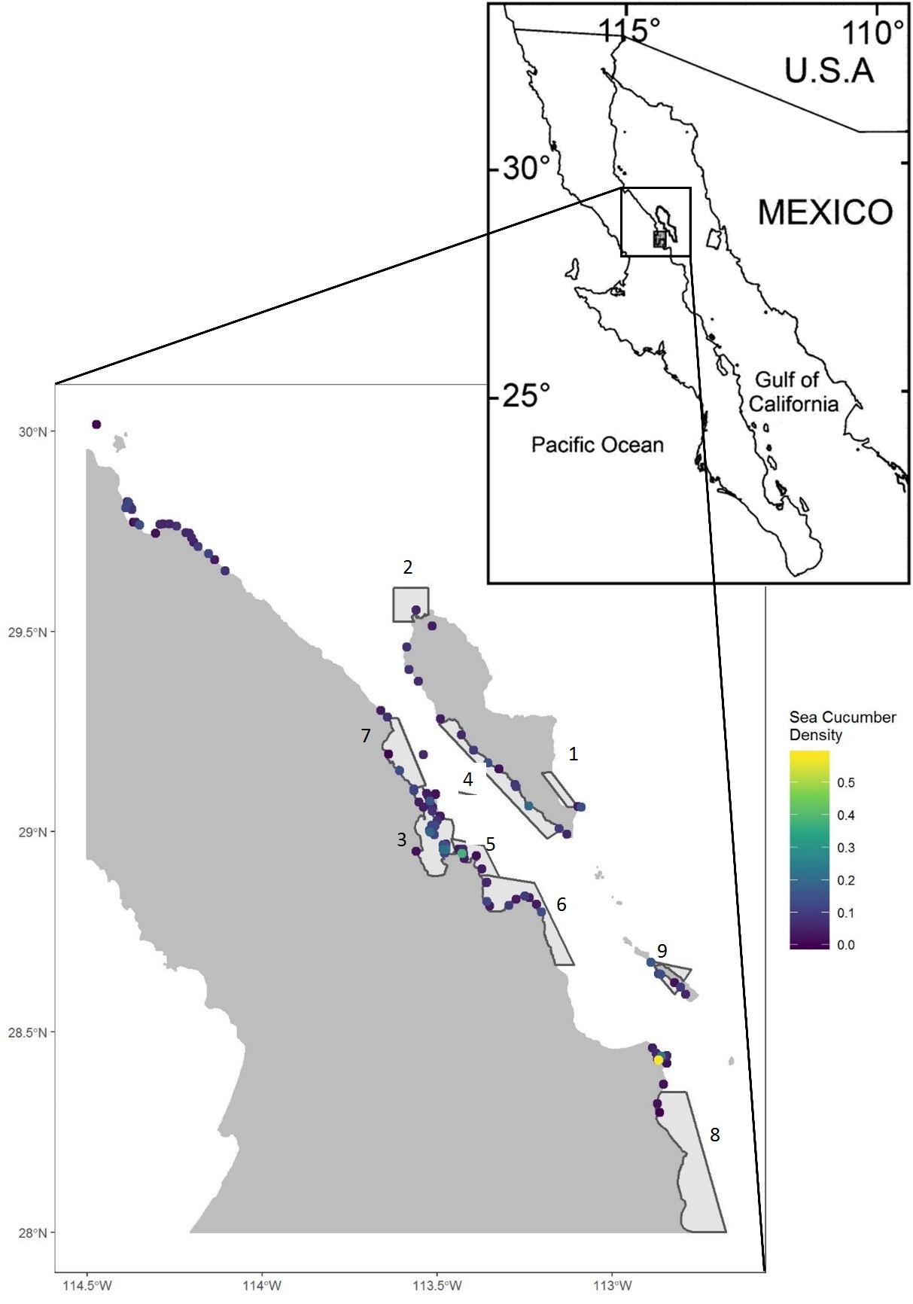

Figure 1. Study area showing the surveyed locations and measured densities. Current and/or last concessioned estates for sea cucumber harvesting are shown as light grey polygons with black outlines.

Data

In order to assess the stock abundance of the sea cucumber, monthly surveys were conducted from October 2014 to December 2016 along the west coast of the Gulf of California (29.95 oN – 28.05 oN). Sampling followed a stratified sampling design in which strata were those places previously surveyed with a recorded presence of sea cucumber (Glockner-Fagetti et al., 2016). This approach was taken to avoid the large areas with a sandy substrate, as this species is only found on hard substrate (Maluf, 1988). Nevertheless, many sites included areas with soft substrate (sand, pebbles, and mud). At each site, we recorded spatial coordinates, air temperature, wind velocity, sea-water temperature, dissolved oxygen and depth. The abundance of sea cucumber was estimated by conducting two swath quadrats (25 x 2m) at three different depths (0-9 m; 10- 17; 18 -30 m) and this was repeated three times at each location. Collection was performed at night by professional well-trained divers using torches because during daylight sea cucumbers hide at crevices and are missed (Reyes-Bonilla et al, 2016). As such, 18 quadrats were performed per location for each visit, except when extreme meteorological conditions impeded the survey. In total, 118 locations were surveyed during the study period.

Historical quota data of 16 permit holders, the total area of the concessioned estate, as well as the locations of the last-permit holders were provided by the National Commission for Protected Areas (CONANP).

Statistical analysis

Our goal here is to understand whether spatial modelling of sea cucumber densities provides a more reliable model than taking a uniform mean across the study area. In order to do this, we use a Bayesian hierarchical modelling approach with integrated nested Laplace approximation (INLA). The INLA approach is computationally efficient and allows us to fit models with a spatial effect (Rue et al., 2009) and has increased in popularity in species population models (see Martínez-Minaya et al., 2018 for a review). The random spatial field (modelled as a Gaussian random field) is a spatially indexed stochastic process that represents the unobserved spatial processes driving sea cucumber densities, such as variation in substrate type and sea cucumber gregariousness. This approach is a Bayesian equivalent to kriging (Banerjee et al., 2004). Spatial modelling in INLA has been successfully used in the marine realm to estimate bycatch hotspots (Cosandey-Godin et al., 2015), predator–prey interactions (Sadykova et al., 2017), fish distributions (Muñoz et al., 2013), and stable isotope concentrations in jellyfish (St John Glew et al., 2019).

There were a large number of zero sea cucumber densities. In order to deal with this, we estimated sea cucumber density using a hurdle model where the hurdle was set at zero (Sadykova et al., 2017). The hurdle model allows us to separately estimate density (*yijk*) and occurrence (*zijk*) of sea cucumber on date *i* at transect *j* of site *k*. We estimated *zijk* using a binomial error family and *yijk* using a Gamma error family. We fitted two models: with (spatial, equation 1) and without (null, equation 2) a spatial random effect.

$$z_{ijk}\sim Binomial(π_{ijk})$$

$$logit\left(π_{ijk}\right)=α^{z}+f\left(i\right)+f\left(j\right)+f(k)+S_{ijk}$$

$$y_{ijk}\sim Gamma(a_{ijk},b_{ijk})(1)$$

$$\log\left(μ_{ijk}\right)= α^{y}+ f\left(i\right)+f\left(j\right)+f\left(k\right)+{βS}_{ijk}+W_{ijk}$$

$$z_{ijk}\sim Binomial\left(π_{ijk}\right)$$

$$logit\left(π_{ijk}\right)=α^{z}+f\left(i\right)+f\left(j\right)+f\left(k\right)$$

$y_{ijk}\sim Gamma\left(a_{ijk}, b_{ijk}\right)$ (2)

$$\log\left(μ_{ijk}\right)= α^{y}+ f\left(i\right)+f\left(j\right)+f\left(k\right)$$

Here, abundance $μ_{ijk}= \frac{a_{ijk}}{b_{ijk}}$; $α^{z}$ and $α^{y}$ are the intercepts for the occurrence and abundance models, respectively. To account for structure in the data collection, we fitted site ($f\left(k\right)$) and transect within site ($f\left(j\right)$) as unstructured Gaussian random effects. Additionally, we included date ($f\left(i\right)$) as a Gaussian random effect with a random walk structure. This accounted for multiple samples within the nested site/transect structure and uneven sampling across dates.

Residual spatial correlation was modelled as a Gaussian random effect with Matérn structure. We used the barrier formation of the spatial Gaussian field (Bakka et al., 2019) to avoiding smoothing over land, and to take into account the barrier effect of islands. This was modelled using the stochastic partial differential equation (SPDE) approach (Lindgren et al., 2011). The spatial effect of the occurrence model ($S_{ijk}$) was included as a covariate in the abundance model with coefficient $β$. The abundance model also had its own spatial effect ($W_{ijk}$). This approach allows us to make predictions which take into account the spatial structure of sea cucumber densities. For the spatial field, we used penalised complexity priors (Fuglstad et al., 2018) with $p\left(ρ<1000m\right)=0.05$ and $p\left(σ<30\right)=0.05$. We compared models using Watanabe’s information criterion (WAIC), which is a generalisation of Akaike’s information criterion (AIC) suitable for hierarchical Bayesian models (Watanabe, 2010). A smaller WAIC suggests a better model, with a difference of 10 or more providing strong evidence for the model with smallest WAIC.

We used the resulting spatial model to estimate sea cucumber density into a 100 x 100 m resolution representation of all areas < 30 m depth. The 30 m depth was chosen because no sampling was conducted below 30 m depth for safety reasons, and because it is proposed as management measure to keep part of the stock unfished (see below). Bathymetry was obtained from GEBCO (<https://www.gebco.net/>; last visited on 12/06/2018) and fine-tuned by López (pers. com). Therefore, we consider as suitable habitat for harvesting purposes and abundance estimation the area within an estate that is shallower than 30 m.

Using our estimated sea cucumber densities at 100 x 100 m resolution, we calculated the total estimated abundances within nine estates and compared this to the granted.

All analyses were performed in R version 3.5.0 (R Core Team 2018) using the INLA package (Rue et al., 2009). For fixed effects and non-spatial random effects, we used default priors. Code required to replicate these analyses are available at [www.github.com/laurajanegraham/sea_cucumber](http://www.github.com/laurajanegraham/sea_cucumber).

Results

The observed density of *I. fuscus* ranged from a minimum of 0 to a maximum of 0.58 org· m2, with an average of 0.03 org· m-2. The mean suitable fishing zones within the estates (defined as areas with a depth < 30 m) was 15.7% (minimum = 7.8%, maximum = 28.8%) of the total concession area (Table 1). If quotas were granted under the assumptions that the habitat is homogenous in the whole estate (i.e. ignoring bathymetry and type of substrate), and that the overall mean density (0.03 org· m-2) holds true for the whole study area, current quotas might be unsustainably large.

**Table 1.** Total area (ha) of each estate, total area < 30 m and estimated sea cucumber abundance (number of individuals) based on both the spatial and non-spatial models. Estimated sea cucumber abundance is the posterior mean from the spatial INLA model, LCI and UCI are the lower and upper limits of the 95% credible interval.

|  |  |  |  |  |  |  |  |  |
| --- | --- | --- | --- | --- | --- | --- | --- | --- |
|  |  |  | **Spatial model** | | | **Non-spatial model** | | |
| **Estate** | **Total area (ha)** | **Total area < 30m (ha)** | **Estimated abundance** | **LCI** | **UCI** | **Estimated abundance** | **LCI** | **UCI** |
| 1 | 2730 | 791 | 256329 | 81270 | 613743 | 258715 | 228531 | 291928 |
| 2 | 8276 | 900 | 291548 | 100177 | 672912 | 294366 | 260023 | 332156 |
| 3 | 17364 | 2344 | 929029 | 403279 | 1862389 | 766660 | 677215 | 865081 |
| 4 | 14141 | 1119 | 418475 | 149425 | 948772 | 365995 | 323295 | 412980 |
| 5 | 6577 | 1201 | 426698 | 169417 | 894961 | 392815 | 346986 | 443243 |
| 6 | 17135 | 2368 | 766617 | 274795 | 1731653 | 774510 | 684149 | 873938 |
| 7 | 10100 | 1575 | 440176 | 142204 | 1027565 | 515141 | 455040 | 581272 |
| 8 | 34744 | 3125 | 872695 | 268488 | 2107759 | 1022105 | 902857 | 1153318 |
| 9 | 2861 | 520 | 159560 | 54347 | 370257 | 170078 | 150235 | 191912 |

There was more support for the spatial (WAIC = -3382 for the density model and WAIC = 1289 for the occurrence model) than the null model (WAIC = -3327 for the density model and WAIC = 1324 for the occurrence model) which suggests that spatial pattern of sea cucumber density should be accounted for when making predictions (Table 2).

**Table 2** Watanabe’s Information Criterion (WAIC) for the occupancy and density models. Occupancy was modelled with a binomial distribution, and density with a Gamma distribution. Both null and spatial models included site, transect and date as random effects. The spatial model included an additional spatial random effect using the Gaussian random effect with Matérn structure.

|  |  |  |
| --- | --- | --- |
| **Model** | **Occupancy** | **Density** |
| Null (*site, transect and date as random effects*) | 1324 | -3327 |
| Spatial (*site, transect, date and spatial random effects*) | 1289 | -3382 |

We used the spatial model to estimate sea cucumber density across all 30m depth zones in the study area (Figure 2; estimates of occurrence are shown in Supplementary Material 1 Figure 2).

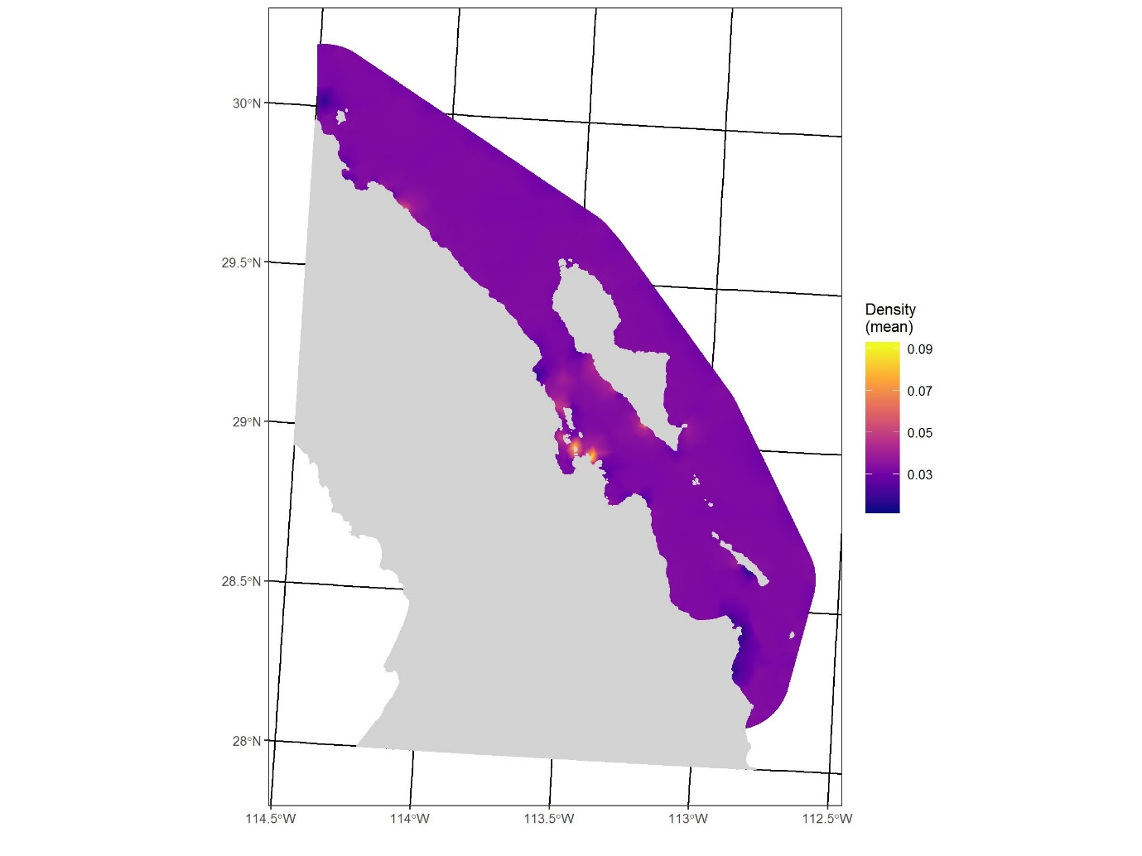

Figure 2. Mean density of sea cucumber (org·m-2).

Using the non-spatial model, all granted quotas are reasonable. However, when using the spatial model, three of the nine estates (6, 7, 9) have a greater quota than the lower credible interval of 10% of the total estimated abundance, while in three of them the quota is close to this limit (1, 2, 8).

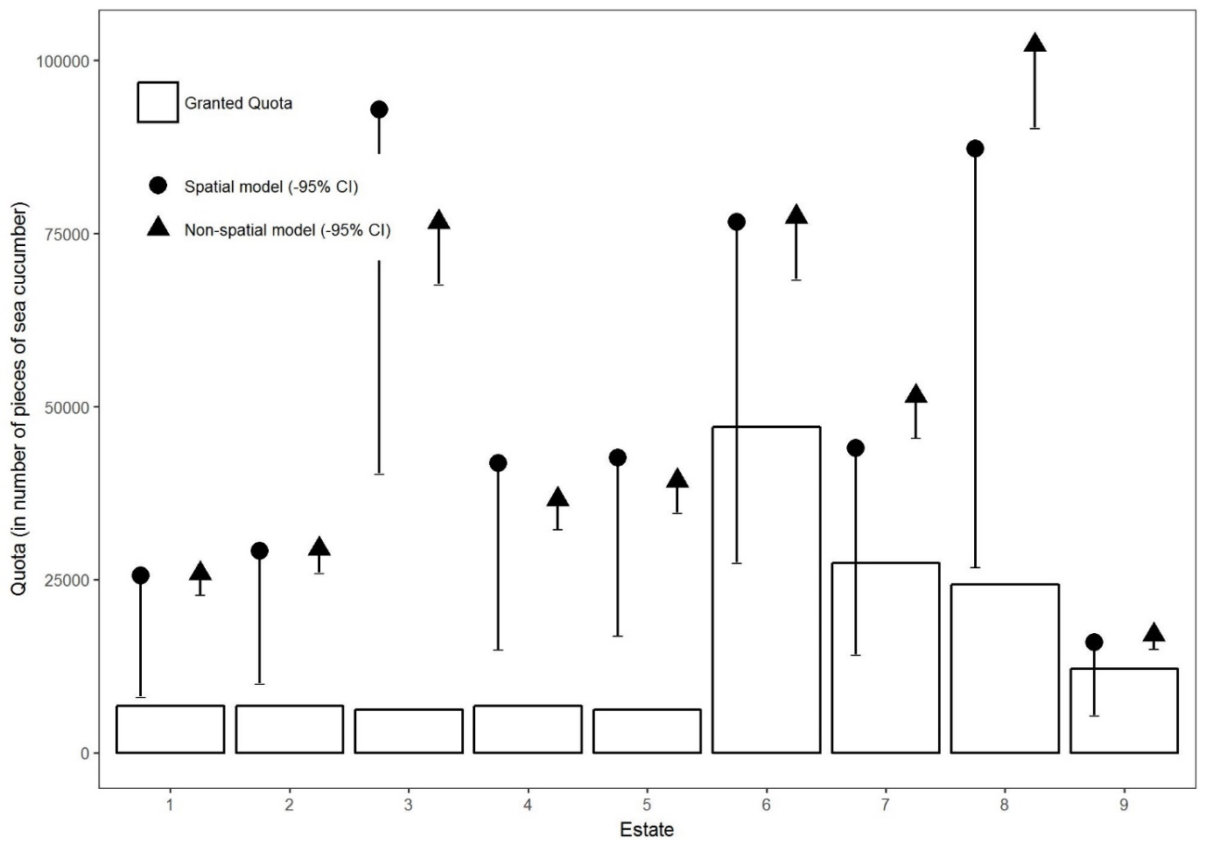

Figure 3. Quota (in number of pieces of sea cucumber) granted to each estate (see figure 1 for location of each estate). The estimated quota from the spatial (circles) and non-spatial (triangles) models assuming that the quota is 10% of total abundance. Lower 95% credible intervals for both models are shown for each estate as error bars. Under a precautionary approach allowable catch should consider the lowest estimate of abundance, so the upper 95% credible interval is not shown.

Discussion

The analysis of the spatial patterns of benthic organisms is not novel (Andrew and Mapstone, 1987). Indeed, Orenzans et al (2005) defined most sea cucumber fisheries as "S-fisheries": small-scale, spatially-structured and targeting sedentary stocks.

However, accounting for spatial patterns in abundance estimates is often missing from stock assessment of fishery resources, such as clams and sea cucumber. In fact, the total abundance (or biomass, *β*) of the resource in a certain area (*A*) is estimated assuming that the arithmetic mean $\tilde{x}$ of some replicates of the density holds for the whole area, i.e., $β=\tilde{x}∙A$. If CPUE (catch per unit effort) data is used as an index of abundance (N) assuming that CPUE = *q*N, where q = catchability coefficient, the abundance is frequently overestimated in the case for diving fisheries in which the fisher can actually see the target, because catchability (*q*) is close to 100% of available stock which is not the case for trawling nets and other non-selective methods of fishing (King, 2007).

In this work we have shown that extrapolation of the mean abundance from sampling to the whole area of the concessioned estate (non-spatial model estimates) may lead to overestimation of the sea cucumber abundance. If quotas are granted on the basis of a certain proportion of the total abundance without taking into account that just a fraction of the estate area is suitable for harvesting (i.e, less than 30 m deep), they will result in overfishing. Indeed the huge quotas granted in 2008 (2,110,240 pieces to 10 permit holders) may be responsible of the drastic decline of the population which forced severe reductions in quotas as well as the number of permit holders thereafter. Moreover, Purcell (2010) pointed out that because most sea cucumber species are long-lived and with low productivity as is the case for *I. fuscus*, removing a very small fraction (2-4%) may deplete breeding stocks. Uthicke (2004) documented that annual catches < 5% of virgin biomass depleted populations of *Holothuria nobilis* in the Great Barrier and suggested an extremely cautious approach in the management of *beche-de-mer* fisheries.

An important additional issue in the Gulf of California that needs to be considered when setting quotas is illegal fishing. Brown sea cucumber commercial harvesting was forbidden between 2000 and 2007 (Glockner-Fagetti et al., 2016). However, evidence exists to suggest that illegal fishing has always occurred in the region. Unreported and illegal fishing is by far the most important threat to sea cucumber fisheries. Poaching is rampant all over the region, in part because there are many isolated, scattered and uninhabited islands where poachers, who predominantly come from mainland, prepare the product for the market (Cisneros-Montemayor et al., 2013). During the surveys that were conducted to gather abundance data, we frequently saw poachers camping at the islands. Illegal, unreported and unregulated fishing is a significant issue all over the world (Agnew et al., 2009). The high value of sea cucumber makes it a target for illegal fishing globally (Conand, 2018; Gonzalez-Wanguemert et al., 2018). In Mexico, it is estimated that illegal fishing accounts for twice the reported catches (Cisneros-Montemayor et al., 2013). Between 2013 and 2018, 1,024,813 pieces of sea cucumber were confiscated in the region (Calderon-Aguilera, 2019), which suggests the illegal catch is certainly much larger. This illegal activity means it is crucial that conservative estimates of total abundance are used in setting sea cucumber quotas in the Gulf of California. We therefore argue for the use of lower bounds, rather than means, of modelled estimates in setting quotas. While current quotas are more reasonable than those set in 2008, most are still above sustainable levels of harvesting as estimated by the lower credible interval from the spatial models.

A further reason to err on the side of caution when setting these quotas is that both in current system and in our models, it is assumed that all areas contain suitable substrate. In our modelling approach, we did not have data on substrate type for the full study area, only the sampled locations. This means that although substrate type will play a part in driving species abundances, we were unable to use knowledge of the relationship with substrate type to make predictions. Based on our observations, this species is only found in hard substrate. However, Kerstitch (1989) reported it on reefs, rocks, coralline algae, coral, sand and mud too. Future study focus on the substrate – abundance relationship would give valuable information on this issue.

A possible explanation for the very large confidence intervals in our density estimates is due to temporal variation of abundance due to harvesting. The fishing season regularly goes from September to April, so surveys conducted close to the end of the season might result in lower abundances and vice versa at the beginning of the season. Due to logistic constraints, surveys were not conducted randomly, but rather from north to south, with 4 months between repeats of sampling at any given a site. As such, there is a potentially an additional spatial harvest-driven signal in the data that we are unable to statistically correct for, which reduces the certainty around our density estimates. In addition, all surveys were conducted at night because the sea cucumber hides inside crevices during daylight (Reyes-Bonilla et al., 2016). As such, some individuals could have been missed, but we estimate that this accounted for less than 5% of individuals.

Setting sufficiently conservative quotas is not the only management action that is required to ensure the long-term sustainability of the sea cucumber fishery in the Gulf of California. This should be considered along with a diversity of additional management actions. Firstly, a suggestion has been made to restrict harvesting to daylight and prosecute anyone fishing at night (Glockner-Fagetti et al., 2016). Fishing during daylight would ensure that around 15% of the stock remains untouched, as concluded by a study comparing quadrats between day and night surveys (Reyes-Bonilla et al., 2016). They found that during daylight 15% of sea cucumber was not sampled because they were hidden between crevices.

Secondly, limiting harvesting to 30 m depth would have two-fold benefits: (1) it would preserve part of the sea cucumber population for reproduction and recruitment; (2) it would ensure the safety of the fishers. The assumption is that below harvestable depths, the remaining stock may act as a consistent reservoir to replenish the shallows with recruits. Conducting surveys deeper than 30m using remotely operated vehicles (ROVs) to estimate abundance of sea cucumber would give a more accurate idea of how depleted is the population as well as taking samples for genetic analysis. A recent work found that the genetic diversity of this species in the study region is high in spite of the drastic reduction in abundance (Ochoa-Chavez et al 2018). The most plausible explanation is that there must be some part of the stock deeper that replenishes the population, as predicted by the ‘deep reef refugia’ hypothesis. (Bongaerts, Ridgway, Sampayo, & Hoegh-Guldberg, 2010)(Bongaerts et al., 2010). Moreover, diminished shallow stocks have resulted in collectors adopting increasingly deeper high-risk bounce diving. There are no official figures of the number of fatalities and permanently disabled fishers, but this is a matter of local concern. In the sea cucumber fishery in the Yucatan peninsula, a 35-old dive fisher died due to cardiopulmonary decompression sickness. This incident suggests that fishers should have formal dive training (Mendez et al., 2017).

Thirdly, we propose that quotas should be ≤ 2% of the lower credible interval of the estimated abundance at each estate and considering the spatial distribution of this species. That quota might be not profitable for the fisher but it is critical for the conservation of this resource.

Finally, a management strategy currently under consideration is sea ranching of this species. As a part of this project, suitable locations for mariculture were identified in the area, selected based on substrate, primary productivity and accessibility. At present, artificial fertilization has succeeded but total mortality occurs at later larval stages (S. Gonzalez, pers. comm.). Therefore, smaller individuals could be collected and kept in semi-enclosed conditions for growing and later harvesting.

Understanding the potential causes of sea cucumber loss and/or current population structure in the Gulf of California requires further research on reproduction, settlement and recruitment success, as well as of ecological and environmental parameters. This species is listed as endangered by the IUCN, which points to the need for more research (Mercier et al., 2013). Taking into account the spatial structure of this species will improve the process of granting quotas, but still more research must be conducted in order to achieve sustainable management of this species.

Acknowledgments

LECA thanks CONACYT (Ref. 0291769) for partial financial support and ERC (SCALEFORES project ID 680176 to FE). Field data gathered with support of CONACYT-SAGARPA (grant 0225235 to LECA) under the permits SGPA/DGVS/08368/14 and SGPA/DGVS/14216/15. We are grateful to O. Pedrin (CONANP) for providing quotas data and M. Lopez for bathymetric data.

Compliance with ethical standards

Conflict of interest

The authors have no conflicts of interest to declare.

Literature cited

Bongaerts, P., Ridgway, T., Sampayo, E. M., & Hoegh-Guldberg, O. (2010). Assessing the “deep reef refugia” hypothesis: Focus on Caribbean reefs. *Coral Reefs*, *29*(2), 1–19. https://doi.org/10.1007/s00338-009-0581-x

Agnew, D.J., Pearce J., Pramod, G., Peatman, T., Watson, R., Beddington, J.R., Pitcher, T.J., 2009. Estimating the worldwide extent of illegal fishing. PLoS One 4. doi:10.1371/journal.pone.0004570.

Álvarez-Borrego, S., 2008. Oceanografía de la región de las grandes islas. In: G.D. Danemann y E. Ezcurra, editor. Bahía de Los Ángeles: recursos naturales y comunidad. Línea Base 2007. Mexico City: Pronatura Noroeste A.C. – SEMARNAT –INE y Museo de Historia Natural de San Diego. p. 45–65.

Andrew, N. L., Mapstone, B. D., 1987. Sampling and the description of spatial pattern in marine ecology. Oceanogr. Mar. Biol., 25, 39-90.

Anonymous. 2007. DECRETO por el que se declara área natural protegida, con la categoría de reserva de la biosfera, la zona marina conocida como Bahía de los Ángeles, canales de Ballenas y de Salsipuedes, comprendiendo la zona federal marítimo terrestre correspondiente a l. :11.

Anonymous. 2018. Anuario Estadístico de Pesca y Acuicultura 2015. Mazatlán.

Bakka, H., Vanhatalo, J., Illian, J. B., Simpson, D., & Rue, H. (2019). Non-stationary Gaussian models with physical barriers. Spatial Statistics, 29, 268–288. https://doi.org/https://doi.org/10.1016/j.spasta.2019.01.002

Banerjee, S., Carlin, B. P., Gelfand, A. E., 2004. Hierarchical modeling and analysis for spatial data. Chapman and Hall/CRC.

Calderon-Aguilera, L.E. 2019. Illegal fishing of the sea cucumber *Isostichopus fuscus* is rampant in the Gulf of California, Mexico. SPC Beche-de-mer Inf. Bull. 39: 42-49.

Castrejón, M., Charles, A., 2013. Improving fisheries co-management through ecosystem-based spatial management: The Galapagos Marine Reserve. Mar Policy. 38:235–245. doi:10.1016/j.marpol.2012.05.040.

Cisneros-Montemayor, A.M., Cisneros-Mata, M.A., Harper, S., Pauly, D., 2013. Extent and implications of IUU catch in Mexico’s marine fisheries. Mar. Policy 39:283–288. doi:10.1016/j.marpol.2012.12.003.

CITES. 2017. Convention on International Trade of Endangered Species of Wild Fauna and Flora. <https://www.cites.org/>

Conand, C. 1990. The fishery resources of Pacific Island countries. Part 2: Holothurians. F.A.O. Fish. Tech. Pap., N.º 272.2, 143 pp. Available at: http://www.fao.org/docrep/pdf/008/t0293e/t0293e03.pdf

Conand, C. 2017. Expansion of global sea cucumber fisheries buoys exports. Rev. Biol. Trop. 65:S1–S10. https://doi.org/10.15517/rbt.v65i1-1.31661

Conand, C. 2018. Recent information on worldwide illegal fisheries for sea cucumbers. SPC Beche-de-mer Inf. Bull. 38:68–71.

Cosandey-Godin, A., Krainski, E. T., Worm, B., Flemming, J. M., 2015. Applying Bayesian spatiotemporal models to fisheries bycatch in the Canadian Arctic. Canadian Journal of Fisheries and Aquatic Sciences, 72(2), 186–197. https://doi.org/10.1139/cjfas-2014-0159

DOF. 1994. NORMA Oficial Mexicana NOM-059-ECOL-1994, que determina las especies y subespecies de flora y fauna silvestres terrestres y acuáticas en peligro de extinción, amenazadas, raras y las sujetas a protección especial, y que establece especificaciones para su protección. 16 de mayo de 1994. Diario Oficial de la Federación, México. Available at: http://www.dof.gob.mx/nota_detalle.php?codigo=4695637&fecha=16/05/1994

DOF. 2010. Norma Oficial Mexicana. NOM-059-SEMARNAT-2010, Protección ambiental Especies nativas de México de flora y fauna silvestres – Categorías de riesgo y especificaciones para su inclusión, exclusión o cambio – Lista de especies en riesgo, 27 de noviembre de 2010. Diario Oficial de la Federación, México. Available at: <http://dof.gob.mx/nota_detalle_popup.php?codigo=5173091>

DOF. 2018. Acuerdo por el que se da a conocer la actualización de la Carta Nacional Pesquera. Diario Oficial de la Federación, México. 106 pp.

Fuglstad, G.-A., Simpson, D., Lindgren, F., & Rue, H. (2018). Constructing Priors that Penalize the Complexity of Gaussian Random Fields. Journal of the American Statistical Association, 1–8. https://doi.org/10.1080/01621459.2017.1415907

Glockner-Fagetti, A., Calderon-Aguilera, L.E., Herrero-Pérezrul, M.D., 2016. Density decrease in an exploited population of brown sea cucumber *Isostichopus fuscus* in a biosphere reserve from the Baja California peninsula, Mexico. Ocean Coast. Manag. 121:49–59. doi:10.1016/j.ocecoaman.2015.12.009.

Gonzalez-Wanguemert, M., Dominguez-Godino, J. A., Canovas, F., 2018. The fast development of sea cucumber fisheries in the Mediterranean and NE Atlantic waters: From a new marine resource to its over-exploitation. Ocean Coast. Manag. 151, 165–177. https://doi.org/10.1016/j.ocecoaman.2017.10.002

Hermosillo-Nuñez, B., Rodríguez-Zaragoza, F., Ortiz, M., Galván-Villa, C., Cupul-Magaña, A., Ríos-Jara, E., 2015. Effect of habitat structure on the most frequent echinoderm species inhabiting coral reef communities at Isla Isabel National Park (Mexico). Community Ecol. 16:125–134. doi:10.1556/168.2015.16.1.14.

Kerstitch, A. (1989). Sea of Cortez marine invertebrates. A guide for the Pacific Coast, Mexico to Ecuador. Sea Challengers. Monterey, California, USA.

Lindgren, F., Rue, H., Lindström, J., 2011. An explicit link between Gaussian fields and Gaussian Markov random fields: the stochastic partial differential equation approach. J. R. Stat. Soc. Ser. B (Statistical Methodol. 73:423–498. doi:10.1111/j.1467-9868.2011.00777.x.

Lluch-Cota, S.E., Aragon-Noriega, E.A., Arreguin-Sanchez, F., Auriles-Gamboa, D., Bautista-Romero, J.J., Brusca, R.C., Cervantes-Duarte, R., Cortes-Altamirano, R., Del Monte-Luna, P., Esquivel-Herrera, A., et al., 2007. The Gulf of California : Review of ecosystem status and sustainability challenges. Prog. Oceanogr. 73:1–26. doi:10.1016/j.pocean.2007.01.013.

Maluf, L.Y., 1988. Composition and distribution of the central eastern Pacific echinoderms. 6th ed. Los Angeles, California: Natural History Museum of Los Angeles County.

Martínez-Minaya, J., Cameletti, M., Conesa, D., & Pennino, M. G. (2018). Species distribution modeling: A statistical review with focus in spatio-temporal issues. Stochastic Environmental Research and Risk Assessment, 32(11), 3227–3244.

Mendez, N., Huchim-Lara, O., Rivera-Canul, N., Chin, W., Tec. J, Cordero-Romero, S., 2017. Fatal cardiopulmonary decompression sickness in an untrained fisherman diver in Yucatan, Mexico: a clinical case report. UNDERSEA Hyperb. Med. 44:279–281.

Mercier, A., Hamel, J.F., Toral-Granda, T.G., Alvarado, J.J., Ortiz, P.E., Benavides, M., 2013. *Isostichopus fuscus*. The IUCN Red List of Threatened Species 2013: e.T180373A1621878. Available at <https://www.iucn.org/resources/conservation-tools/iucn-red-list-threatened-species>

Muñoz, F., Pennino, M. G., Conesa, D., López-Quílez, A., Bellido, J. M., 2013. Estimation and prediction of the spatial occurrence of fish species using Bayesian latent Gaussian models. Stochast. Environ. Res. Risk Assess. 27(5), 1171-1180.

Ochoa-Chávez, J.M., Del Río Portilla, M.A., Calderon-Aguilera, L.E., Rocha-Olivares, A., 2018. Genetic connectivity of the endangered brown sea cucumber *Isostichopus fuscus* in the northern Gulf of California revealed by novel microsatellite markers. Revista Mexicana de Biodiversidad. <http://dx.doi.org/10.22201/ib.20078706e.2018.2.2294>

Orensanz, J.M., Parma, A.M., Jerez, G., Barahona, N., Montecinos, M. and I. Elias. 2005. What are the key elements for the sustainability of “S-fisheries”? Insights from South America. Bull. Mar. Sci. 76(2): 527–556

Pañola-Madrigal, A., Calderon-Aguilera, L.E., Aguilar-Cruz, C.A., Reyes-Bonilla, H., Herrero-Pérezrul, M.D., 2017a. Reproductive cycle of the sea cucumber (*Isostichopus fuscus*) and its relationship with oceanographic variables at its northernmost distribution site. Rev. Biol. Trop. 65:S180–S196. doi:10.15517/rbt.v65i1-1.31687.

Pañola-Madrigal, A., Galaviz-López, J.M., Castañeda-Rivero, F., Calderon-Aguilera, L.E., 2017b. El papel del pepino de mar en el flujo de carbono orgánico de los sedimentos. P. 307-312. En: Paz, F., R. Torres y A. Velázquez (Editores). 2017. Estado Actual del Conocimiento del Ciclo del Carbono y sus Interacciones en México: Síntesis a 2017. Serie Síntesis Nacionales. Programa Mexicano del Carbono en colaboración con el Centro de Investigación Científica y de Educación Superior de Ensenada y la Universidad Autónoma de Baja California. Texcoco, Estado de México, México.

Pennington, M., 1996. Highly Skewed Marine Data. Fish. Bull. 94:498–505.

Purcell, S. W., Polidoro, B. A., Hamel, J.-F., Gamboa, R. U., Mercier, A., 2014. The cost of being valuable: predictors of extinction risk in marine invertebrates exploited as luxury seafood. Proceedings. Biological Sciences, 281(1781), 20133296. <https://doi.org/10.1098/rspb.2013.3296>

Purcell, S., Samyn, Y., & Conand, C. 2012. *Commercially important sea cucumbers of the world, FAO Species Catalogue for Fishery Purposes No. 6*. *FAO Species Catalogue for Fishery Purposes No. 6*.

Purcell, S.W., Conand, C., Uthicke, S., Byrne, M., 2016. Ecological roles of exploited sea cucumbers. Oceanogr. Mar. Biol. An Annu. Rev. 54:367–386.

Purcell, S.W., Mercier, A., Conand, C., Hamel, J.F., Toral-Granda, M.V., Lovatelli, A., Uthicke S. 2013. Sea cucumber fisheries: Global analysis of stocks, management measures and drivers of overfishing. Fish Fish. 14:34–59. doi:10.1111/j.1467-2979.2011.00443.x.

Purcell, S.W., Ngaluafe, P., Lalavanua, W., Ceccarelli, D. M., 2018. Market price trends of Latin American and Caribbean sea cucumbers inform fisheries management. Reg. Mar. St. Mar. Sci., 17, 127–132. https://doi.org/10.1016/j.rsma.2017.12.003

Purcell, S.W., Samyn, Y. & CONAND, C. 2012. Commercially important sea cucumbers of the world.FAO Species Catalogue for Fishery Purposes.No. 6. Rome, FAO. 150 pp.

R Core Team. 2018. R: A language and environment for statistical computing. Vienna, Austria.

Reyes Bonilla, H., Ramírez Ortiz, G., Herrero Pérezrul, M.D., Calderon Aguilera, L.E., 2016. Subestimación de la abundancia del pepino café Isostichopus fuscus (Holothuroidea: Echinodermata), en muestreos diurnos con respecto a nocturnos en el Golfo de California. Rev. Mex. Biodiv. 87, 519-522 http://dx.doi.org/10.1016/j.rmb.2016.05.004.

Reyes-Bonilla, H., L. E. Calderon-Aguilera, J. M. Galaviz-López and M. D. Herrero-Pérezrul. 2018. Size and relative condition of the brown sea cucumber *Isostichopus fuscus* in the northern Gulf of California, Mexico. Lat. Amer. J. Aquat. Res. 46: 831-836. doi: 10.3856/vol46-issue4-fulltext-21

Rodríguez-Dowdell, N., Enríquez-Andrade, R., Cárdenas-Torres, N., 2007. Property rights-based management: Whale shark ecotourism in Bahia de los Angeles, Mexico. Fish. Res. 84, 119–127. <https://doi.org/10.1016/j.fishres.2006.11.020>

Rue, H., Martino, S., Chopin, N., 2009. Approximate Bayesian inference for latent Gaussian models by using integrated nested Laplace approximations. J R Stat Soc Ser b (statistical Methodol. 71:319–392. <https://doi.org/10.1111/j.1467-9868.2008.00700.x>

Sadykova, D, Scott, B.E., De Dominicis, M., Wakelin, S.L., Sadykov, A., Wolf, J., 2017. Bayesian joint models with INLA exploring marine mobile predator–prey and competitor species habitat overlap. Ecol Evol. 7:5212–5226. <https://doi.org/10.1002/ece3.3081>

Spiegelhalter, D. J., Best, N. G., Carlin, B. P., Van Der Linde, A., 2002. Bayesian measures of model complexity and fit. J. Royal Stat. Soc. Series B (Statistical Methodology), 64(4), 583-639.

St John Glew et al., 2019. Spatial Models of Carbon, Nitrogen and Sulphur Stable Isotope Distributions (Isoscapes) across a Shelf Sea. Methods in Ecology and Evolution, 10, 518–531. <https://doi.org/10.1111/2041-210X.13138>

To, A.W.L., Shea, S.K.H. & Conand, C. 2018. Trade patterns of bêche-de-mer at the global hub for trade and consumption – an update for Hong Kong. SPC Bêche-de-mer Information Bulletin, 38: 64-67.

Uthicke, S., Schaffelke, B., Byrn, M., 2009. A boom–bust phylum? Ecological and evolutionary consequences of density variations in echinoderms. Ecol. Monogr. 79(1), 3–24. <https://doi.org/10.1890/07-1861.1>

Watanabe, S., 2010. Asymptotic equivalence of Bayes cross validation and widely applicable information criterion in singular learning theory. J. Mach. Learn. Re., 11: 3571-3594.