Perspectives in Public Health Special Issue on Mental Health
Current Topics and Opinion
Katherine Newman-Taylor, Tess Maguire & Amber Bowen

Why are we not measuring what matters in mental health in the UK?
The case for routine use of recovery outcome measures
It is widely agreed that we need to establish safe and effective mental healthcare as a priority^{1,2} – a complex task that is particularly difficult in the current economic climate³. The use of accurate outcome data is critical to the delivery of decent quality care^{4,5}; routine measurement of target outcomes allows us to benchmark services, identify areas that fall short of expected standards, and drive improvements by focusing our collective attention on these priorities. We know this and yet we repeatedly fail to monitor key mental health outcomes^{3,6}.
The ‘recovery agenda’ is identified nationally and internationally as the preferred framework for service improvement, particularly for people with severe and complex mental ill-health^{1,7}. In addition to clinical outcomes, this approach emphasises personal recovery – building a valued and socially engaged life – and specifically the experience of hope, agency and opportunity for purposeful activity and social inclusion, irrespective of mental health status^{8,9}. Notwithstanding criticism of the failure to recognise social determinants of mental health and examples of poor implementation^{10,11}, few would argue with the core principles of recovery.
In the UK, National Health Service (NHS) provision is typically staffed by committed and skilled individuals who seek to support the wellbeing of people struggling with mental ill-health. It is dismaying, then, that we often fail to deliver effective recovery-based care^{3,12}. The Five Year Forward View² and corresponding implementation plans^{13,14} raise serious concerns about current provision, and require us to develop services that are recovery and outcome focused, as a matter of urgency. ‘Patient reported outcome measures’ (PROMs) of personal recovery are therefore essential if we are to develop and evidence recovery-based services. However, busy NHS clinicians do not use outcome measures consistently, largely due to validity and resource concerns⁶. This has to change.

Implementation of a routine measure of recovery
We now have a number of validated measures of recovery, though as most frontline clinicians will testify, these are not used with any consistency. A recent ESRC funded project (University of Southampton, project code, 514695154) sought to disseminate a brief measure of recovery across NHS settings as a means of improving routine assessment of these outcomes. The ‘Hope, Agency and Opportunity’ tool (HAO) was co-produced by clinicians and people with lived experience of mental ill-health as a brief measure for use in usual clinical care¹⁵.

Figure 1: The Hope, Agency and Opportunity tool – A simple measure of mental health recovery
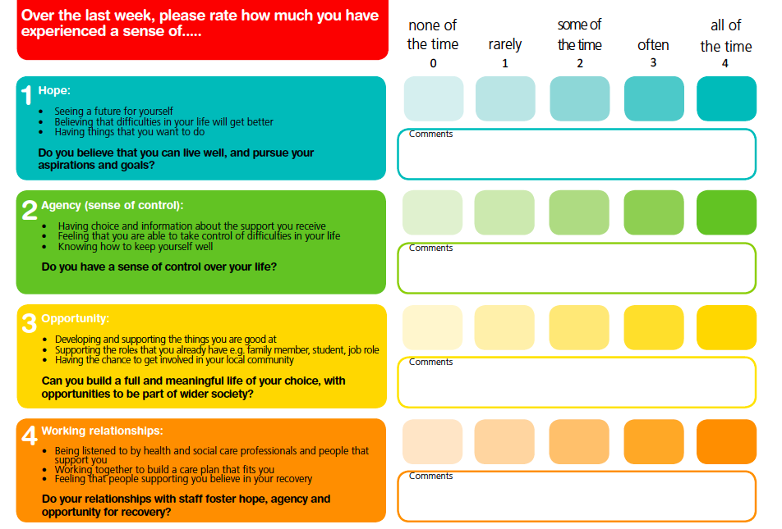
The ESRC grant resulted in the development and dissemination of video resources to illustrate the use and impact of the tool in line with health policy priorities: https://www.southampton.ac.uk/psychology/research/impact/hope-agency-and-opportunity-measure-of-recovery.page#media. Data subsequently gathered from a local NHS Trust identified adult mental health in-patient, community and rehabilitation teams that increased their use of the HAO over a four-year period. Discussion with members of these teams identified reasons for introducing the measure, and the impact of doing so (see Table 1).

Conclusion
It is essential that we start measuring what matters in mental health services, and do so consistently. Implementation is likely to depend on organisational and managerial commitment. If we claim to provide recovery-focused care, we now need to evidence and shape this by embedding measures of recovery in routine clinical practice.

Table 1: Case studies of adult mental health teams that have introduced routine measurement of recovery outcomes
Team | Case study 1: Rowan community mental health team | Case study 2: Elder acute in-patient mental health team | Case study 3: Evergreen Hollyoak mental health rehabilitation team | Case study 4: Recovery College for users, family and staff of local Trust services
Reason for introducing recovery measure | To facilitate collaborative engagement and care planning. | To assess people’s needs, plan in-patient care, and work towards discharge from admission. | To monitor change when this can be slow and personal, and other tools may lack sensitivity. | To assess the impact of Recovery College courses.
Impact | The HAO prompts recovery focused conversations, yielding well-structured care plans that have been developed jointly and focus on personal recovery goals. | Ward managers now describe the HAO as ‘business as usual.’  The measure is routinely offered as part of the admission process – the team have developed a template* to be completed jointly with service users to plan for discharge from the point of admission. | The team supports people with severe and enduring conditions, which have a considerable impact on everyday functioning.  Measures of recovery can identify early and internal gains which may otherwise go unnoticed, and this in turn fosters motivation when progress takes time. | Routine use of these measures demonstrates impact of attendance at Recovery College courses.  This is valuable for the College team as a means of evaluating courses, and evidencing impact to the Trust Board, who make funding decisions.
Learning | Care plans based on measures of recovery are more likely to be developed in genuine collaboration with people using services, and therefore remain relevant. | Leadership commitment has been key to successful implementation.  The team report that the HAO care plan has been instrumental in developing and maintaining a recovery ethos on the acute ward, prompting staff to remain attentive to people’s needs and goals throughout their admission. | Recovery measures can be used flexibly – the team Art Therapist uses the HAO to inform the focus of her work, facilitate reflection on progress over the course of therapy, and assess personal outcomes. | The Recovery College lead prioritises evaluation of courses, and the administrator is key to effective implementation.  Routine collection of data requires a named person to take responsibility for ensuring measures are taken, collated and reviewed regularly.
*available on request

References
¹Department of Health. (2014). Closing the gap: priorities for essential change in mental health. London,
UK: The Stationery Office.
²The Mental Health Taskforce. (2016). The five year forward view for mental health. https://www.england.nhs.uk/wp-content/uploads/2016/02/Mental-Health-Taskforce-FYFV-final.pdf accessed 22 June 2018.
³The Kings Fund. (2015). Briefing: Mental health under pressure. https://www.kingsfund.org.uk/sites/default/files/field/field_publication_file/mental-health-under-pressure-nov15_0.pdf accessed 22 June 2018.
⁴Dormon, F. (2015). Is mental health care improving? London: The Health Foundation.
⁵Royal College of Psychiatrists. (2013). Driving quality implementation in the context of the Francis report (occasional paper OP92).
⁶Gilbody, S.M., House, A.O. & Sheldon, T.A. (2002). Psychiatrists in the UK do not use outcomes measures: National survey. British Journal of Psychiatry, 180, 101–3.
⁷Piat, M., Sabetti, J., Bloom, D. (2010). The transformation of mental health services to a recovery-orientated system of care: Canadian decision maker perspectives. International Journal of Social Psychiatry, 56, 168–177.
⁸Repper, J, & Perkins, R. (2003). Social Inclusion and Recovery. Edinburgh: Baillière Tindall.
⁹Shepherd, G., Boardman, J., Rinaldi, M., et al. (2014). Supporting recovery in mental health services: Quality and outcomes.
¹⁰Rose, D. (2014). The mainstreaming of recovery. Journal of Mental Health 23(5), pp 217-218.
¹¹Recovery in the Bin. https://recoveryinthebin.org accessed 22 June 2018.
¹²Care Quality Commission. (2017). The state of care in mental health services 2014-2017. https://www.cqc.orh.uk/sites/defaults/files/20170720_stateofmh_report.pdf accessed 22 June 2018.
¹³NHS England. Implementing the five year forward view for mental health. https://www.england.nhs.uk/wp-content/uploads/2016/07/fyfv-mh.pdf accessed 22 June 2018.
¹⁴Department of Health. (2017). The government’s response to the five year forward view for mental health. https://www.gov.uk/government/uploads/system/uploads/attachment_data/file/582120/FYFV_mental_health__government_response.pdf accessed 22 June 2018.
¹⁵Newman-Taylor, K., Garner, C., Vernon-Wilson, E., Paas, K. H., Herbert, L., & Au-Yeung, S. K. (2017). Psychometric evaluation of the hope, agency and opportunity (HAO); A brief measure of mental health recovery. Journal of Mental Health, 26(6), 562-568.

