A FUZZY-BASED RISK ASSESSMENT FRAMEWORK FOR
AUTONOMOUS UNDERWATER VEHICLE UNDER-ICE MISSIONS

Tzu Yang Loh,^{1*} Mario P. Brito,² Neil Bose,³ Jingjing Xu,⁴ and Kiril Tenekedjiev^{1,5}

¹ Australian Maritime College, University of Tasmania, Australia
² Southampton Business School, University of Southampton, United Kingdom
³ Memorial University of Newfoundland, Canada
⁴ Faculty of Business, University of Plymouth, United Kingdom
⁵ Nikola Vaptsaroy Naval Academy – Varna, Bulgaria

* Address correspondence to Tzu Yang Loh, Australian Maritime College, University of Tasmania, 1 Maritime Way, 7250 Launceston TAS, Australia; tel: +61 0475450348; Tzuyang.loh@Utas.edu.au

ABSTRACT
The use of Autonomous Underwater Vehicles (AUVs) for various scientific, commercial and military applications has become more common with maturing technology and improved accessibility. One relatively new development lies in the use of AUVs for under-ice marine science research in the Antarctic. The extreme environment, ice-cover and inaccessibility as compared to open water missions can result in a higher risk of loss. Therefore, having an effective assessment of risks before undertaking any Antarctic under-ice missions is crucial to ensure an AUV’s survival. Existing risk assessment approaches predominantly focused on the use of historical fault log data of an AUV and elicitation of experts’ opinions for probabilistic quantification. However, an AUV program in its early phases lacks historical data and any assessment of risk may be vague and ambiguous. In this paper, a fuzzy-based risk assessment framework is proposed for quantifying the risk of AUV loss under-ice. The framework utilises the knowledge, prior experience of available subject matter experts and the widely used semi-quantitative risk assessment matrix, albeit in a new form. A well-developed example based on an upcoming mission by an ISE-Explorer class AUV is presented to demonstrate the application and effectiveness of the proposed framework. The example demonstrates that the proposed fuzzy-based risk assessment framework is pragmatically useful for future under-ice AUV deployments. Sensitivity analysis demonstrates the validity of the proposed method.

200 Character Summary
A fuzzy-based risk assessment framework for autonomous underwater vehicle operations is presented. It accounts for uncertainties and overcomes the lack of data to quantify the risk of loss. An example demonstrates its application.

Keywords: Autonomous Underwater Vehicle; Fuzzy Set Theory; Risk Assessment; Under-Ice

1. INTRODUCTION
1.1 Autonomous Underwater Vehicle
Autonomous Underwater Vehicles (AUVs) are best described as self-powered robotic devices that are piloted and overall controlled by onboard computer systems. Sometimes also referred to as unmanned underwater vehicle (UUV) or named under model aliases, they are untethered and are pre-programmed to perform various underwater data acquisition missions. First developed in the late 1950s by Stan Murphy, Bob Francois, and later Terry Ewart from the University of Washington (Dixit, Hazarika, & Davim, 2017), the use of AUVs have grown with maturing technology and improved accessibility. Today, they are the tool of choice for many scientific, commercial and military applications such as mine clearing operations, feature tracking, cable or pipeline inspection, deep ocean exploration and even in air crash investigations (Le Hardy & Moore, 2015)(Naeem, 2002). AUVs come in different shapes and sizes depending on its built purpose. They can have depth ability of 100m to more than 5000m (Bellingham, 2010) and cost anything from a hundred to hundreds of thousands of dollars to construct.
When the first AUV, the Unmanned Arctic Research Submersible (UARS) vehicle was deployed under Arctic’s ice in 1972 (Francois & Nodland, 1972), it demonstrated not only the feasibility but also the potential of deploying AUVs in the Antarctic for research applications. Concealed under the Antarctic’s ice lies one of the more unique ecological, geological and physical oceanographic ecosystems on the planet (Kunz et al., 2008). It harbours not only valuable information necessary for better understanding of the Earth’s climate system and biogeochemical cycles, but also offers insights into other similar extreme environments such as that of Jupiter’s moon, Europa (Lorenz et al., 2011).
However, under-ice AUV missions in the Antarctic present a new set of challenges as compared with open water missions. The extreme environment tests not only the technological limits of the AUV, but it also challenges the on-site AUV team both physiologically and psychologically (Gunderson, 1967). In addition, considerations are needed to account for ice cover, inaccessibility and emergency abort procedures during missions. It is not surprising, then, that the risk of AUV loss during under-ice missions in the Antarctic is higher when compared with open water missions (Mario Paulo Brito, Griffiths, & Challenor, 2010). The term ‘AUV loss’, usually associated with the complete loss of an AUV, can also represent an AUV being destroyed or damaged beyond economic repair. The risk of AUV loss, therefore, refers to the likelihood that, during a mission, the AUV will be rendered unusable for future missions.
Previous risk analysis on the Autosub 3, an AUV developed and owned by the National Oceanography Centre, Southampton, United Kingdom, showed the median probability of AUV loss for under sea-ice missions to be 4.9 times higher than that of open water missions. Risk of loss for under ice-shelf missions is even higher, with a median probability 9.4 times higher than open water missions (Mario Paulo Brito et al., 2010). As a result, the loss of AUV in the Antarctic is not without its precedence: one of which was that of Autosub2, lost in 2005 under the Fimbulisen ice-shelf with unknown exact cause of loss (Gwyn Griffiths & Collins, 2006). A subsequent board of inquiry established that the cause of Autosub2 loss was most likely due to a fault introduced during the manufacturing/assembly phase (Strutt, 2006). Seaglider SG522, owned by the University of East Anglia, United Kingdom, was lost at the Weddell Sea in the Antarctic in 2012. The subsequent inquiry panel concluded that an erroneous command script placed Seaglider SG522 in an unsafe state which eventually resulted in its loss (Mario P. Brito, Smeed, & Griffiths, 2014).
The loss of an AUV is not only financially costly due to the resulting higher insurance premium for all (if it is insured, or loss/rebuild costs if it is not), it can also delay research projects, damage the reputation of the AUV community, cause the loss of valuable research data and there is a possibility of harming the delicate Antarctic environment (Gwyn Griffiths & Collins, 2006). As each Antarctic deployment consists of several missions, the risk of loss for individual missions may accumulate beyond the pre-determined acceptable risk level for the entire deployment. Therefore, quantifying risk of loss prior to under-ice missions in the Antarctic has important implications for decision-making, which may also influence the outcome of insurance coverage. In this paper, a fuzzy-based risk assessment framework is proposed.

1.2 Risk Assessment Methodologies
Although debate exists over the precise definition for the term “Risk”, the most widely adopted definition is that risk is a combination of the severity of an event (or scenario) and the likelihood of that scenario occurring (Kaplan & Garrick, 1981). The systematic process to comprehend the nature of risk and to express the risk, under given circumstances, is often called risk assessment (“Glossary - The Society for Risk Analysis,” 2015), the intent of which, is to enhance the ability of an organisation to achieve its objectives. Over years of development, myriad risk assessment methodologies have been proposed in adaptation to different systems, industry, environments, components or stages of processes. However, there is no single method that suits all needs and multiple methods are often adopted for the assessment of risks. The choice of method has often depended on a variety of factors, such as the purpose of analysis, nature of risk, and the availability and quality of data.
Within the AUV domain, Griffiths and Brito (M. Brito & Griffiths, 2016)(G Griffiths & Brito, 2008)(Gwyn Griffiths, Brito, Robbins, & Moline, 2009)(G Griffiths & Brito, 2011) carried out extensive studies that laid the necessary groundwork for structured, quantitative risk assessment of AUV deployment. Probabilistic models such as the Kaplan-Meier estimator, Bayesian Belief Network (BBN) and Markov chains were applied on historical failure fault log data of the AUV and, in synthesis with experts’ judgements to predict the probability of AUV loss. Thieme (Thieme & Schjølberg, 2015) and colleagues proposed a risk assessment framework consisting of human reliability analysis, fault tree analysis, and event tree analysis which also depended on professional judgement. Griffiths and Trembanis (Gwyn Griffiths & Collins, 2006) established a risk management process to support decision making with regard to AUV deployment. The framework starts with the establishment of a risk acceptance level by the AUV owner and setting of campaign requirements. In the risk assessment step, the probability of AUV loss is derived from independent experts’ opinion through prior experience and the track record of the AUV (Fig. 1).
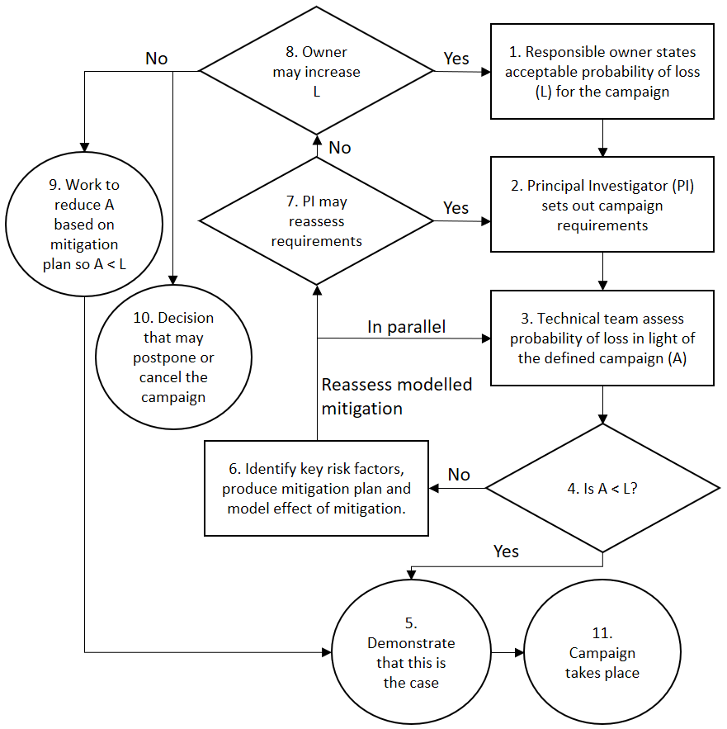
Fig. 1. Risk management process for AUV operations, presented by Griffiths and Trembanis (Gwyn Griffiths & Collins, 2006). (Permission granted to reproduce)
The origin of risk stems from uncertainties (Leveson, 2011), which can be broadly classified into aleatory and epistemic uncertainties. Aleatory uncertainty, also known as irreducible uncertainty, arises from the inherent variability associated with the physical system or the environmental context (Oberkampf, DeLand, Rutherford, Diegert, & Alvin, 2002). For example, despite knowing the Mean Time Between Failure (MTBF) for a specific AUV component, the precise moment of component failure is still uncertain. Epistemic uncertainties, also known as reducible uncertainty, exists due to a lack of knowledge, incomplete information, limited data or ambiguity and vagueness attached to experts’ judgement (Oberkampf et al., 2002). An AUV which has yet to be commissioned or relatively new in operation will have a higher level of risk arising from epistemic uncertainties. With the operation of the AUV over time, the inflow of information and gaining of experience will result in a gradual reduction of epistemic uncertainties (Fig. 2). Although generic data from other AUVs can be used as a reference to reduce epistemic uncertainties, the difference in specifications, manufacturers, design and systems can result in inaccurate risk assessment outcomes.
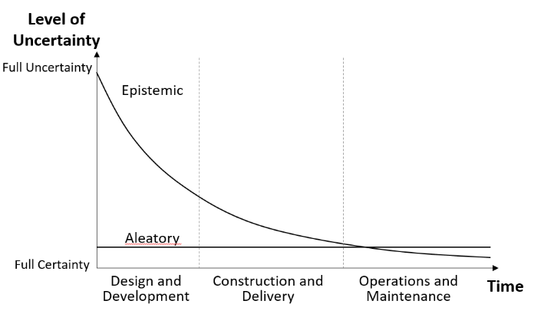
Fig. 2. The level of epistemic and aleatory uncertainties throughout an AUV program lifecycle.
Probabilistic approaches are often applied to assess both aleatory and epistemic uncertainties, typically the relative-frequency approach for the former and the subjective probability approach for the latter (Li, Chen, & Feng, 2013). As a result, there are many established probabilistic methodologies such as Monte Carlo simulation or Bayesian Belief Networks used for the assessment of risk (Li et al., 2013). For handling the vagueness and ambiguity of risk assessment, a fuzzy-based approach is still the method of choice (Purba, Sony Tjahyani, Ekariansyah, & Tjahjono, 2015)(Helton, Johnson, Oberkampf, & Sallaberry, 2010)(Unwin, 1986), although the use of interval probabilities may also provide a solution (Fletcher & Davis, 2002).
1.3 Fuzzy Set Theory
The concept of multivalued logic was introduced by Lukasiewicz (Cignoli, 2007). Later, this concept was generalised by Zadeh (Zadeh, 1965) with mathematical logic, establishing the fuzzy set theory. One key difference between fuzzy set theory and classical probability theory lies in its ability to account for vagueness and ambiguity by representing a proposition with a degree of ignorance.
Fundamental to the theory are the two main concepts of linguistic variables and fuzzy sets. Linguistic variables are used in day to day conversations to represent opinions, which are independent of the measuring system and are easily comprehensible by most listeners. For instance, ‘weather condition’ during AUV deployment is a linguistic variable if it is described in linguistic terms of ‘bad’, ‘average’ and ‘good’.
The second fundamental concept is fuzzy sets. In contrast with traditional set theory where an object either belongs to a set or not, every object (in the universe of discourse) belongs to a fuzzy set but with different membership function of 0 to 1 (Zadeh, 1965). To illustrate this, consider the ‘five by five’ risk assessment matrix, which is a commonly used semi-quantitative tool for assessing risks. The matrix, with an example from the University of Tasmania shown in Fig. 3, defines risk level by considering the likelihood of occurrence and severity of consequence. It is a practical and simple tool with widespread usage across industries to assess risk and assist management in decision making.
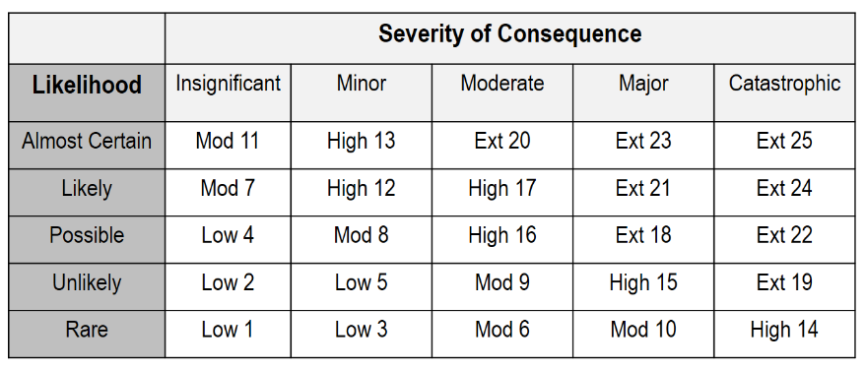
Fig. 3. A ‘Five by five’ risk matrix with the risk level of low, moderate, high and extreme, represented by risk ratings of 1-25. (Source: University of Tasmania)
Based on traditional set theory, the risk assessment matrix presents crisp boundaries between risk level categories, with the term ‘crisp’ referring to quantitative or countable data (Ross, 2004). In the matrix presented in Fig. 3, each risk rating number from 1 to 25 belongs to a specific category of either ‘Low’, ‘Moderate’, ‘High’ or ‘Extreme’. Adopting this strict interpretation means that two risks with ratings of 11 and 12 will belong to two separate risk levels of ‘Moderate’ and ‘High’ despite being only one rating apart. On the contrary, two risks with ratings of 12 and 17 will belong to the same risk level of ‘High’ despite being five ratings apart. The graphical representation in Fig. 4 shows an example of such crisp boundary. Such an approach cannot represent vague concepts and can be unnatural, as it does not match a human’s perception due to the sharply fixed boundaries (Werro, Stormer, & Meier, 2006).
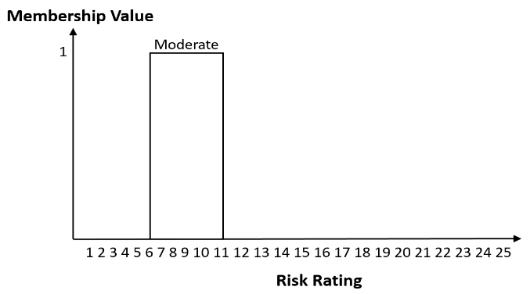
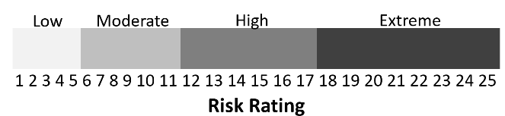
Fig. 4. An example of membership value for ‘moderate’ risk (Top) and graphical representation of the risk assessment matrix shown in Fig. 3, illustrating the crisp boundaries between risk level categories (Bottom).
In contrast, fuzzy set theory takes a less rigid view and reflects more naturally each element’s association with a particular set. It does so by using membership function $μ\left(x\right)$ which assigns membership values of between 0 and 1 to its elements $x$, defined as:
$μ\left(x\right):X→[0,1]$ ---- (1)
Applying fuzzy set theory to the risk assessment matrix in Fig. 3 resulted in a gradual and smooth transition between risk level categories as illustrated in Fig. 5. A risk rating of 11 under the new fuzzy risk assessment matrix now belongs to both risk level categories of ‘Moderate’ and High’ with membership function of 0.6 and 0.4 respectively.

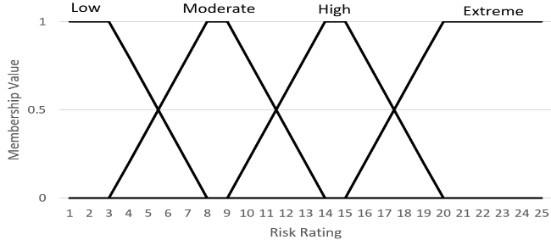
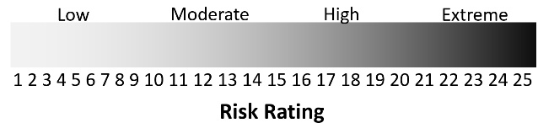
Fig. 5. Graphical representations of the risk assessment matrix (Fig. 3) after application of fuzzy set theory. Membership values (Top) and smooth transition between risk level categories (Bottom).
The application of fuzzy set theory for risk assessments has garnered attention over the years with application in various domains from nuclear power plants (Rastogi & Gabbar, 2013) through construction (Zhang, Wu, Qin, Skibniewski, & Liu, 2016) to medical fields (Steimann & Adlassnig, 1998)(C.-S. Lee & Wang, 2011). It is also often used in synthesis with other methodologies such as Bayesian network (BN) (Eleye-Datubo, Wall, & Wang, 2008)(Zhang et al., 2016), system dynamics (Tessem & Davidsen, 1994) or fault and event tree analyses (Ferdous, Khan, Sadiq, Amyotte, & Veitch, 2011) to improve assessment of risks. In the AUV domain, Bian et al. (Bian, Mou, Yan, & Xu, 2009) proposed the use of a fuzzy fault tree for technical reliability analysis of AUVs. The incorporation of fuzzy set theory into fault tree analysis copes with the lack of data and accounts for uncertainties in AUV’s subsystem failure. Although the study focused solely on technical reliability and not on deployment risks, it demonstrated the potential for application of fuzzy set theory in risk assessment of AUV deployments. This work aims to present and demonstrate the use of fuzzy set theory in a risk assessment framework for AUV under-ice deployment. In section 2, the details of the fuzzy-based risk assessment framework are presented. Section 3 demonstrates application of the framework, with a sensitivity analysis. Lastly, section 4 concludes the paper with a discussion of the benefits, drawbacks, implications and potential areas of continuing research.

2. METHODOLOGY
2.1 Overview
The proposed fuzzy-based risk assessment framework incorporates the generic architecture of a fuzzy expert system (Mendel, 2001) with the risk assessment process presented in widely used international standards such as ISO31000 (Risk Management) (International Standards Organisation, 2009) and ISO45001 (Occupational Health and Safety) (“ISO 45001-Occupational Health and Safety,” n.d.). Based primarily on experts’ judgement, the three steps iterative framework requires extensive discussion with subject matter experts. The overview of the framework is presented in Fig. 6.

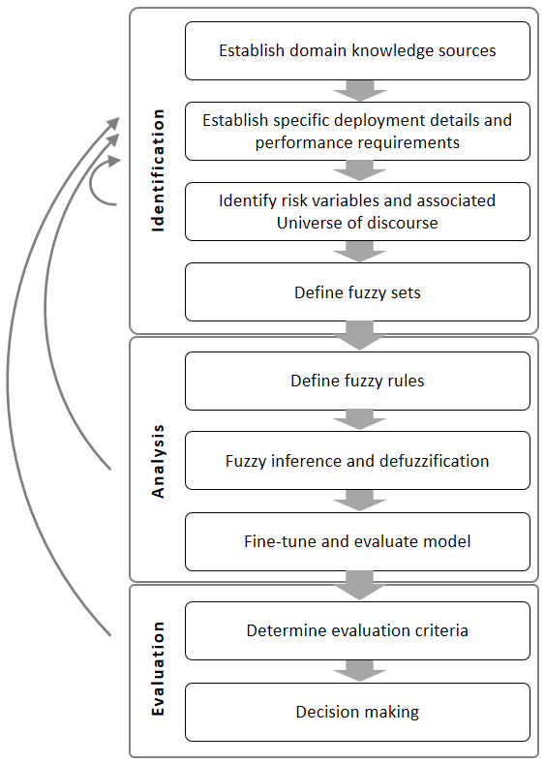
Fig. 6. Overview of the steps involved in the fuzzy-based risk assessment framework. Curved arrows represent the iterative nature of the steps.

2.2 Scenario identification
Adopting and referencing international standards (International Standards Organisation, 2009) (“ISO 45001-Occupational Health and Safety,” n.d.), the scenario identification phase lays the foundation for risk assessment by finding, recognising and describing sources of risk. It consists of several tasks and should be executed iteratively to ensure that objectives of the risk assessment are met.
The first task aims to establish the available sources of knowledge. In the early stages of an AUV program, expert knowledge is often the only source of information, and this can come from AUV engineers, AUV program owners as well as manufacturer or contractors. Additional information can also be sought indirectly from experts in the form of documentation such as technical specifications of the AUV, safe work procedures, fault logs, risk assessment records, program schedules, budget plans, previous audit findings, online articles or publications, organisation charts or incident reports. For instance, examining a budget plan can reveal budget priorities and the AUV program’s financial condition. This may be relevant to the risk assessment in terms of infrastructure investment, human resources and technical maintenance. In addition, specific deployment plans and expected performance requirements can also hold important information about possible risk variables influencing the risk of AUV loss.
The second task involves the identification of risk variables in the form of linguistic variables and the universe of discourse. The universe of discourse is the numerical range of possible values associated with the risk variable. There are two ways to accomplish this task:
- Through semi-structured interviews and discussion with subject matter experts, and
- Through the extraction of information from texts in documentation.
Important considerations for interviews are the choice and number of experts necessary to capture both spatial and temporal risk variables of interest. While there is no formal guidance tailored specifically to risk assessment of AUV operations, guidance can be taken from the recommended selection criteria published by Pulkkinen and Simola (Pulkkinen & Simola, 2000) and Kotra et al. (Kotra, Lee, & Dewispelare, 1996) The number of experts to interview lies between 6 - 12 as recommended by Cooke and Probst (Cooke & Probst, 2006). The eventual outcome of this task is a comprehensive list of risk variables relevant to the AUV under assessment. Using published risk studies, some risk variables influencing the risk of AUV loss during under-ice mission in the Antarctic and their possible associated universe of discourse are presented in Table I.
Table I. An example of risk variables and their associated universe of discourse.
Risk Variable | Reference(s) | Possible Universe of Discourse [Units]
Situation Awareness | (Ho, Pavlovic, & Arrabito, 2011)(Wu, Stuck, Rekleitis, & Beer, 2015)(Parasuraman, Sheridan, & Wickens, 2008) | 1-3 [Dimensionless, Level (Endsley, 1995)]
Annual Insurance Premium | (G Griffiths, Bose, Ferguson, & Blidberg, 2010) | 0 – 12 [Dimensionless, % Capital Cost]
Trust on the AUV | (Ho et al., 2011)(Wu et al., 2015)(Johnson, Patron, & Lane, 2007)(Parasuraman, 1997) | Arbitrary - 0 to 10 [Dimensionless]
Distance of Mission | (Mario Paulo Brito et al., 2010) | 0 to 400 [Kilometres]
Maximum Depth of Mission | (Mario P. Brito, 2015) | 0 to 5000 [Meters]
Weather Condition | (Bolstad, Cuevas, Gonzalez, & Schneider, 2005)(M. Brito & Griffiths, 2016) | Arbitrary - 0 to 10 [Dimensionless]
Average Experience of AUV Team with Under-Ice Missions. | (Utne & Schjolberg, 2014) | 0 to 30 [Years]
Operator Stress and Fatigue Level | (Bolstad et al., 2005)(Palinkas, 1992) | Arbitrary - 0 to 10 [Dimensionless]
Level of Interactions within AUV Team | (Bolstad et al., 2005) | Arbitrary - 0 to 10 [Dimensionless]
Technical Reliability | (Ruff, Narayanan, & Draper, 2002)(Mario P. Brito, 2015)(G Griffiths, Millard, McPhail, Stevenson, & Challenor, 2003) | 0 – 20 [MTBF, Years]
Level of Automation | (Ruff et al., 2002) | 0 – 10 [Automation Level (Endsley & Kaber, 1999)]
Mental Workload | (Ho et al., 2011)(Wu et al., 2015)(Parasuraman, 1997) | Arbitrary - 0 to 10 [Dimensionless]
Operator Complacency Level | (Endsley & Kiris, 1995) | Arbitrary - 0 to 10 [Dimensionless]
Time Duration Under-Ice | (M P Brito, Griffiths, & Trembranis, 2008) | 0 to 48 [Hours]

The next task involves the definition of fuzzy sets and membership functions using same sources of information as the previous task. To ascertain fuzzy set, a list of typical adjectives associated with each risk variable is identified. Using some of the risk variables from Table I as an example, this task will result in an output similar to one shown in Table II.
Table II. Example of risk variables and their associated fuzzy sets.
Risk Variable | Fuzzy Set
Situation Awareness | Poor, Normal, Good
Distance of Mission | Short, Average, Long
Maximum Depth of Mission | Shallow, Intermediate, Deep
Weather Condition | Good, Average, Bad, Severe
Average Experience of AUV Team with Under-Ice Missions. | Inexperience, Average, Experienced
Operator Stress and Fatigue Level | Low, Average, High, Extreme
Time Duration Under-Ice | Short, Medium, Long

To define the membership functions, experts’ opinion can be elicited using matrices, which are dependent on the adopted distribution shapes. For instance, bell-shaped, Gaussian, triangular or trapezoidal (Jang, Sun, & Mizutani, 1997). The choice of distribution shape is problem dependent and reflects how experts relate the range of possible values to the fuzzy set. However, both triangular and trapezoidal shapes are most commonly used because of their effectiveness in capturing subjective and imprecise information, as well as being simple to compute (Chang, Yeh, & Wang, 2007)(Kannan, De Sousa Jabbour, & Jabbour, 2014)(Barua, Mudunuri, & Kosheleva, 2014). A triangular membership function is defined by a lower limit a, an upper limit c, and a most likely value b, as shown in Fig. 7a. A trapezoidal membership function is defined by a lower support margin a, a lower core margin b, an upper core margin c, and an upper support margin d, as shown in Fig. 7b. Table III shows an example of a matrix to define membership function for the risk variable ‘Maximum Depth of Mission’, with the graphical representation shown in Fig. 8.
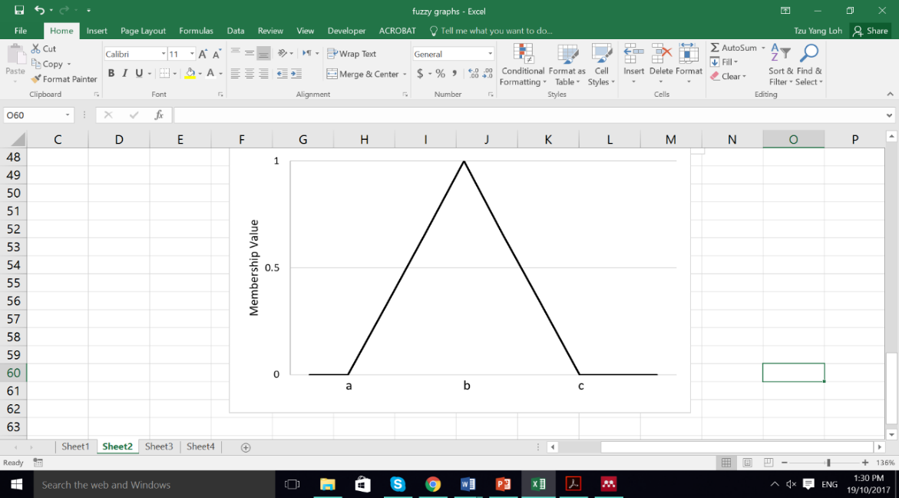
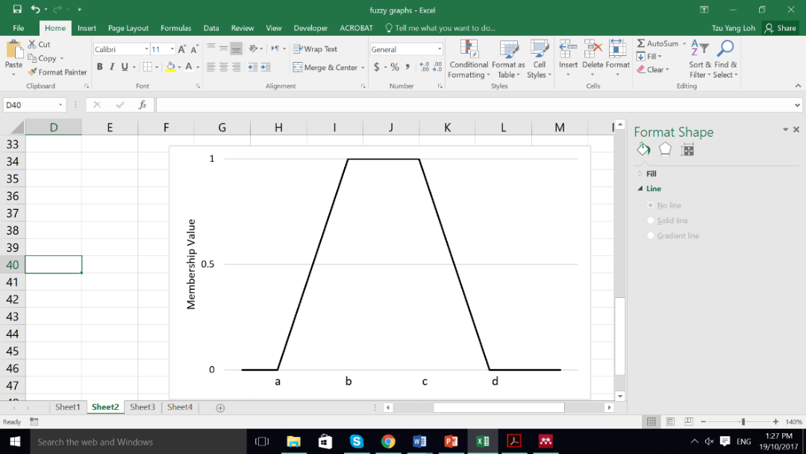
a
b

Fig. 7. Types of membership functions. a. Triangular membership function. b. Trapezoidal membership function.
Table III. Matrix to elicit experts’ opinion for risk variable ‘Maximum Depth of Mission '.
Maximum Depth of Mission (0 – 5000m)
 | Membership Functions
Fuzzy Sets | Min (m) | Most Likely (m) | Max (m)
Shallow | 0 | 500 | 750
Intermediate | 250 | 750 | 1500
Deep | 750 | 1500 | 5000

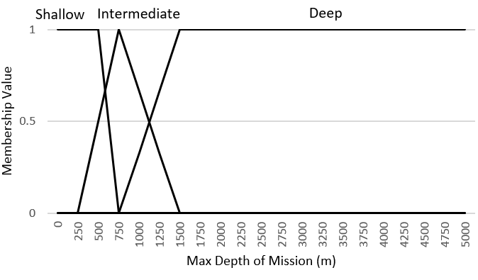
Fig. 8. Membership function for the risk variable ‘Maximum Depth of Mission’.
Lastly, if more than one expert is elicited in the earlier described tasks, aggregation of different opinions will be required. Several aggregation methods have been proposed in the literature, a summary of which are described below:
- For each fuzzy set, use the lowest and greatest value provided by experts as the lower bound and upper bound. The average value is then used as the modal value (Tadic, Milanovic, Misita, & Tadic, 2011).
- The similarity aggregation method (SAM) (Hsi-Mei Hsu & Chen-Tung Chen, 1996) which utilises a similarity index to measure the consistency of each opinion from others. Other aggregation methods based on SAM can also be used, such as the consistency aggregation method (CAM) (Lu, Lan, & Wang, 2006) and the optimal aggregation method (OAM) (H. S. Lee, 2002).
- The Delphi method (Rowe & Wright, 1999) where opinions of experts are made to converge through iteration until it meets predefined criteria. The Fuzzy Delphi Method (FDM) draws ideas from fuzzy theory in synthesis with the original Delphi method. It utilises a similarity function to assess the level of consistency between experts. The similarity coefficient is then used to derive the fuzzy evaluation value of all experts. (Ishikawa et al., 1993).

2.3 Analysis
The analysis step aims to understand the nature, effects and relationships of risks variables by eliciting and constructing fuzzy rules. A fuzzy rule infers information using linguistic variables and fuzzy sets to derive an output. While there are several forms of fuzzy rules, one of the simplest representation uses If-Then rule statements in the form of:
IF $Risk Variable is x$ THEN $Risk of Loss is y$
where$x$ and $y$ are adjectives associated with the risk variable and risk of loss respectively. The fuzzy rule can also be in the form of AND and OR statement, such as:
IF weather condition is bad, AND the AUV team is inexperienced,
THEN risk of AUV loss is high.
For intuitive elicitation of fuzzy rules based, a hypercube matrix can be used. A hypercube is a geometric shape of n-dimensions, determined by the number of input risk variables (McNeil & Thro, 1994). For instance, a 4D hypercube can be used for a fuzzy system consisting of four input risk variables and a 3D hypercube for a three-input risk variable fuzzy system. While fuzzy rules can be established using the same sources of information as earlier steps in the risk assessment framework, the process can become increasingly complex with the number of identified risk variables. This phenomenon, where the number of fuzzy rules increases exponentially with the number of inputs, is known as the ‘curse of dimensionality’ (Kosko & Isaka, 1993). One common method to overcome the curse of dimensionality is to implement the use of a hierarchical fuzzy system (Raju, Zhou, & Kisner, 1991). The idea is to decompose a large fuzzy logic unit (Fig 9a) into several smaller, related fuzzy logic units which are then interconnected according to a given topology (Raju et al., 1991) (Fig 9b and 9c). Each single fuzzy logic unit consists of a fuzzifier, membership functions, a fuzzy rule base, an inference engine and a defuzzifier (Ross, 2004). Adopting a hierarchical fuzzy system reduces the total number of fuzzy rules which consequently reduces computational time and increases the efficiency of the system (Raju et al., 1991). As an example, an aggregated hierarchical fuzzy system is presented in Fig 10 using some risk variables from Table I.

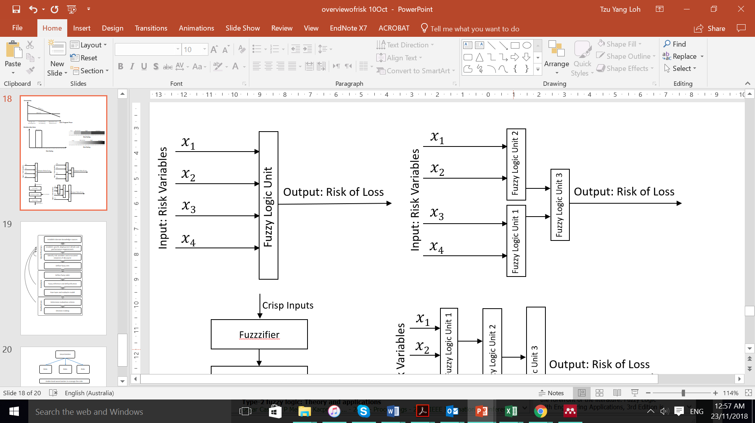
Fig. 9a. A single layer fuzzy system consisting of four risk variables as input and risk of loss as output.
Fig. 9b. An aggregated hierarchical fuzzy system based on Fig.9a.
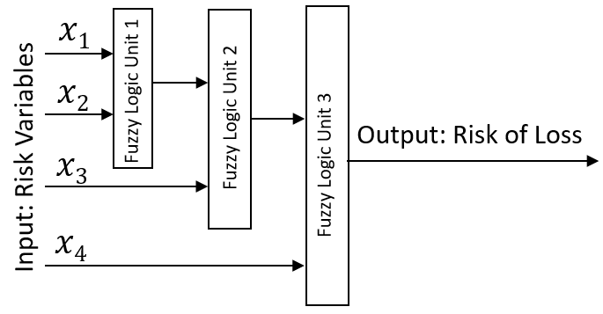
Fig. 9c. An incremental hierarchical fuzzy system based on Fig.9a.
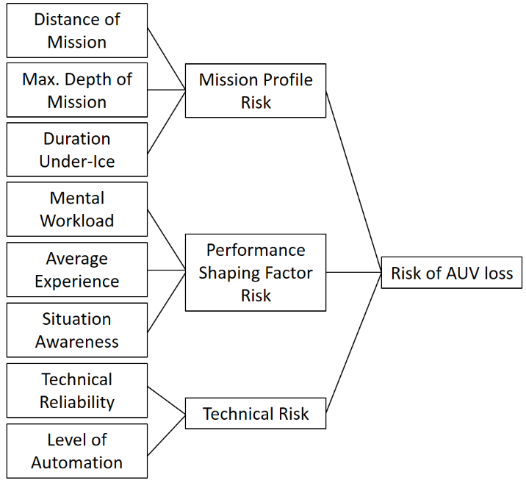
Fig. 10. Example of an aggregated hierarchical fuzzy system.
In the process of establishing of fuzzy rules, experts may provide differing opinions resulting in redundant, inconsistent or conflicting rules. This can affect the risk assessment outcome and interpretability of the model (Alcalá, Casillas, Cordón, González, & Herrera, 2005). Several methods had been proposed in the literature to overcome this, such as; complexity reduction with fuzzy clustering techniques, rule reduction by orthogonal transformation methods, algorithms based on similarity measures and genetic optimisation (Roubos & Setnes, 2000).
Upon establishment of fuzzy rules, the next task is to formulate the mapping from inputs to output in a process called fuzzy inference. Two most commonly used fuzzy inference methods are the Mamdani (Mamdani & Assilian, 1975) and Sugeno (Sugeno, 1985) inference. The fundamental difference between these two methods lies in the way outputs are represented and determined (Kaur & Kaur, 2012)(Ying, Ding, Li, & Shao, 1999). Mamdani inference uses defuzzification of a fuzzy output to generate a crisp output while Sugeno inference uses a weighted average to compute the crisp output (Mamdani & Assilian, 1975)(Sugeno, 1985). The Mamdani method is widely accepted for capturing expert knowledge and is more intuitive while the Sugeno method works well with optimization and adaptive techniques, particularly for dynamic non-linear systems (Kaur & Kaur, 2012)(Ying et al., 1999). An example of the fuzzy inference process is presented in section 3.3. Defuzzification is the process of deriving a quantifiable output from the fuzzy system. Consider the following rule:
IF weather condition is bad, THEN risk of AUV loss is high.
Defuzzification translates ‘high’ into a quantifiable risk level, such as a risk rating value based on the organisational risk matrix (Fig 3.). There are several defuzzification methods such as the centroid method, weighted average method, centre of sums, centre of largest area, mean-max membership and max-membership principal (Zhao & Govind, 1991)(Leekwijck & Kerre, 1999). Each method has its advantages and disadvantages, and the appropriate defuzzification method should be chosen based on nature of the problem, the number of input and output variables and sensitivity of the method (Wojciech Z. Chmielowski, 2015).
The final task of the risk analysis step is to evaluate and fine-tune the system. Despite being a time-consuming process, proper execution of this task improves reliability of the risk assessment and ensures that original objectives are met. Carried out in close consultation with experts and decision-makers, this task involves one or more adjustments of fuzzy rules and fuzzy sets (Table IV).
Table IV. List of fine-tuning actions.
Fuzzy Rules Adjustment
- Add, reduce or optimise fuzzy rules.
- Add hedge operators by using adverbs such as “Very”, “Somewhat” or “Indeed”.
- Adjust rule execution weights to increase or reduce the force of any fuzzy rules.
Fuzzy Sets Adjustment
- Add fuzzy sets.
- Widen or narrow existing sets by reviewing membership functions.
- Shift existing fuzzy sets to ensure sufficient overlaps.
- Review and adjust the shape of existing fuzzy sets.

2.4 Evaluation
The objective of the risk evaluation step is to support decision making through significance of the results derived from the risk analysis step. The significance of which is based on its acceptability in relation to pre-determined evaluation criteria set by the AUV owner, higher management of the organisation or external groups. External groups who may exhibit interest in the results of the risk assessment may include insurance companies and the regulators. An acceptable probability of AUV loss based on the capital and operating cost of the AUV (Gwyn Griffiths & Collins, 2006) is an example of evaluation criteria. However, for an AUV program in its early phases, the evaluation criteria may be uncertain and yet to be established. In such circumstances, the organisational Safety and Health standard can be used as a good starting reference for criteria setting.

At the fundamental level, the risk of AUV loss will be either acceptable or unacceptable, as decided by the AUV owner. If deemed acceptable, the Antarctic under-ice mission can proceed under close monitoring and regular review to ensure that risk remains acceptable. if unacceptable, the AUV owner has to make decisions taking into consideration available resources and time constraints, which may include:
- Whether the deployment should proceed by accepting a higher risk of loss.
- Whether treatments are required, taking into consideration the adequacy of existing control measures.
- The priorities for risk treatment.
Although risk evaluation is the last step of the proposed risk assessment framework (Fig. 6), analysis of new information and filling of data gaps needs to be performed on a regular basis. This iterative process helps ensure relevancy and effectiveness of the risk assessment.

3. EXAMPLE OF APPLICATION
3.1 Description
To demonstrate application of the fuzzy-based risk assessment framework, an example based on the nupiri muka AUV program is presented. The program was funded by the Antarctic Gateway Partnership, an Australian government initiative to build further polar research capability in Tasmania. The Explorer-class AUV was named nupiri muka, which means ‘Eye of the Sea’ in palawa kani, the language of Tasmanian Aborigines (UTAS, 2017). The program aims to acquire high-resolution data under sea ice and ice shelves in Antarctic regions. Capable of exploring depths of up to 5,000 meters and with a present cruising range of 140km, the AUV is able to conduct long-range under-ice operations with its diverse scientific payload. Delivered in May 2017, the AUV was relatively new at the time of writing and has very limited historical failure fault log data. Initial semi-quantitative risk assessment was performed in accordance to the Work Health and Safety Policy stipulated by the University of Tasmania (“Work Health and Safety Policy - University of Tasmania,” 2013) and leveraging on prior experience of the AUV team.
To apply the proposed fuzzy-based risk assessment framework, the risk assessment matrix recommended under the University of Tasmania’s Work Health and Safety Policy (Fig. 3) was converted to a fuzzy risk assessment matrix (Fig. 5) as the output of the risk model. Assessment on risk of AUV loss was carried out on a planned deployment to the Sørsdal Glacier in Antarctica (Fig. 11), expected to take place between December 2018 and February 2019. While the exact details of the marine scientific research missions have yet to be decided at the time of writing, there will likely be 5 to 6 missions comprising of both open water and under-ice operation. One of the proposed mission requires the nupiri muka to travel approximately 100 kilometres from launch to recovery, with 6 hours under ice-shelf at a maximum depth of around 800 meters. Likely the longest mission for this deployment in terms of both distance and time duration, the fuzzy-based risk assessment framework was applied to determine the risk level of this mission.
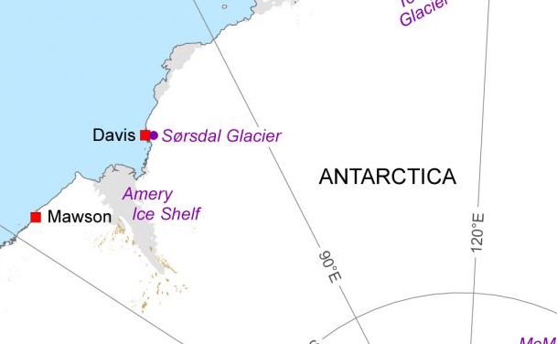
Fig. 11. Map showing location of the Sørsdal Glacier in the Antarctic (Photo: AADC).

3.2 Scenario Identification
In this initial step, five risk variables, their associated universe of discourse and fuzzy sets were identified (Table V). These were based on best available deployment information at the time of writing, as well as through available sources of knowledge and information, which included in-house AUV engineers, technical specifications of the AUV, safe work procedures, risk assessment records and literature.
Table V. Identified risk variables, universe of discourse and fuzzy sets.
Risk Variable | Universe of Discourse | Fuzzy Set
Distance of Mission | 0 to 140 (Kilometres) | Short, Average, Long
Maximum Depth of Mission | 0 to 5000 (Meters) | Shallow, Intermediate, Deep
Time Duration Under-Ice | 0 to 24 (Hours) | Short, Medium, Long
Weather Condition | 0 to 10 (Dimensionless) | Good, Average, Bad, Severe
Average Experience of AUV Team with Under-Ice Missions. | 0 to 10 (Years) | Short, Average, Long

To define membership functions, a mixture of triangular and trapezoidal membership functions was used for elicitation after considering their advantages (Section 2.2). The resultant membership functions are represented graphically and presented in Fig. 12a – 12e. For the risk variable ‘Weather Condition’, there are existing weather classification systems being used, such as the classification by McMurdo Weather Office (Mac Weather) (McCormick & Mastro, 2002) for Antarctica. However, an arbitrary scale of 0-10 was in this case used for simplicity, where 0 represents excellent weather and 10 represents extreme weather.
b
a
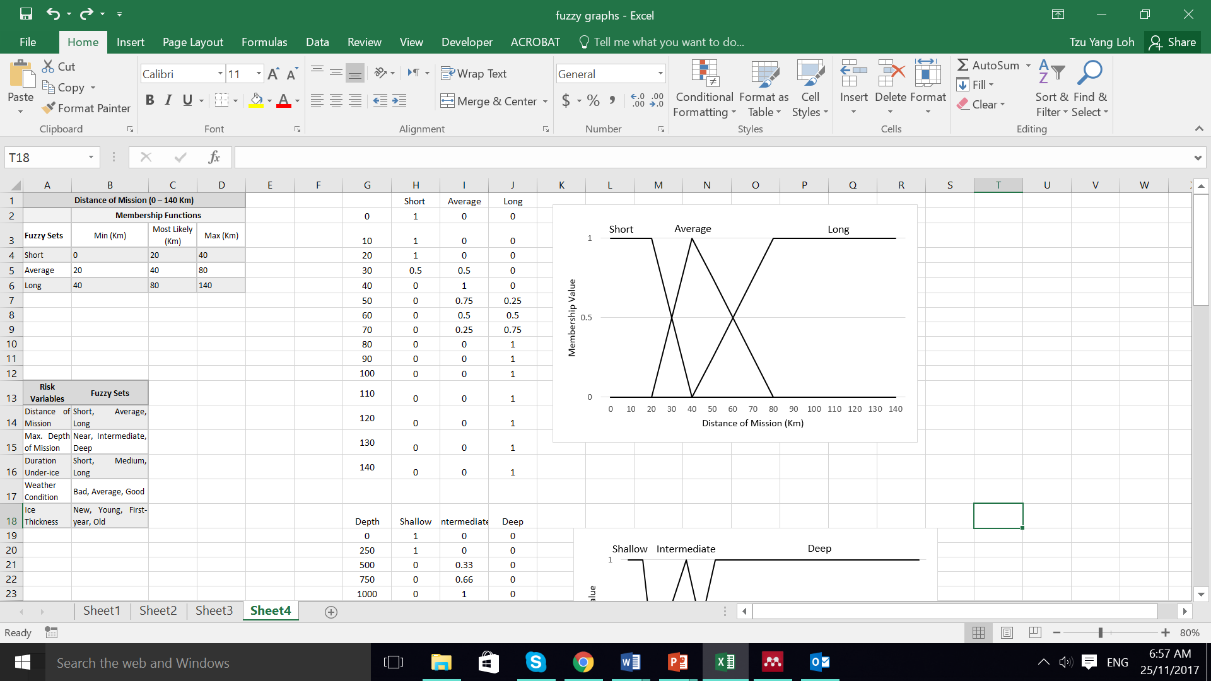
d
c
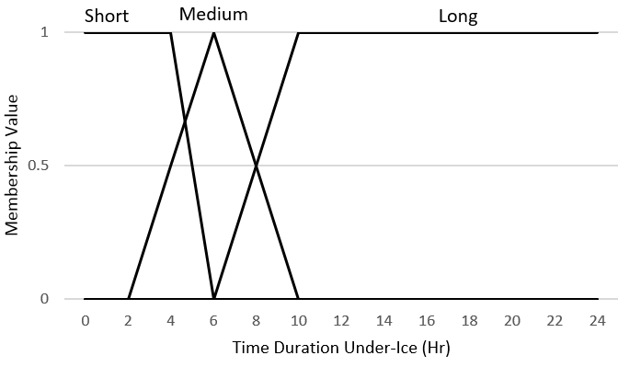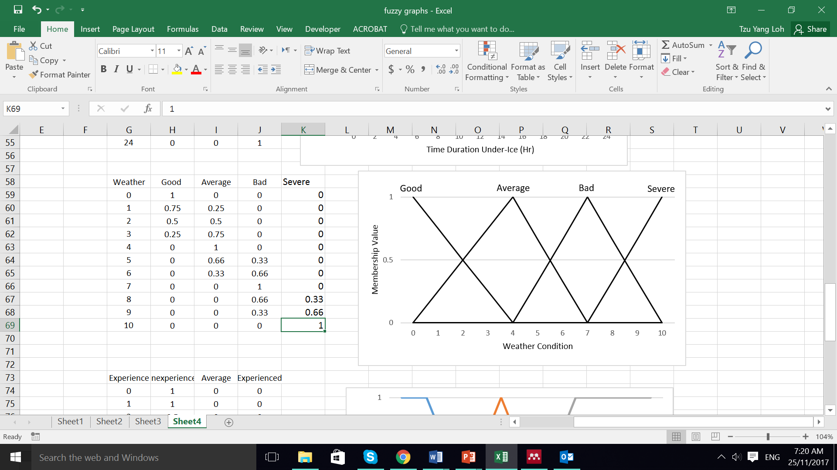
e
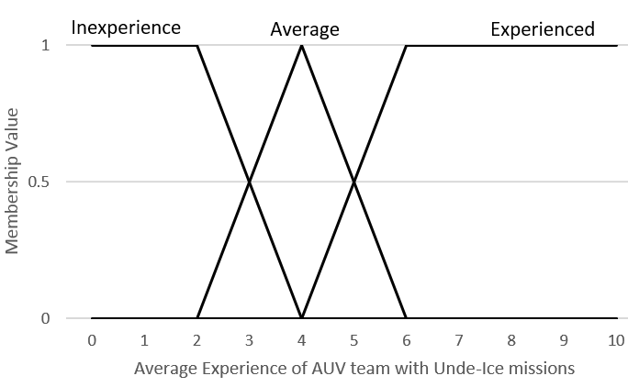
Fig.12. Membership function for the identified risk variables. a. ‘Distance of Mission’. b. ‘Maximum Depth of Mission’. c. ‘Time Duration Under-Ice’. d. ‘Weather Condition’. e. ‘Average Experience of AUV team with Under-Ice missions’.
3.3 Analysis
To facilitate the construction of fuzzy rules, an incremental hierarchical fuzzy system as shown in Fig. 13 was used. ‘Distance of Mission’, ‘Maximum Depth of Mission’ and ‘Time Duration Under-Ice’ were grouped under ‘Mission Profile Risk’ while ‘Weather Condition’ and ‘Average Experience of AUV Team with Under-ice Missions’ were separate input to ‘Risk of AUV Loss’.
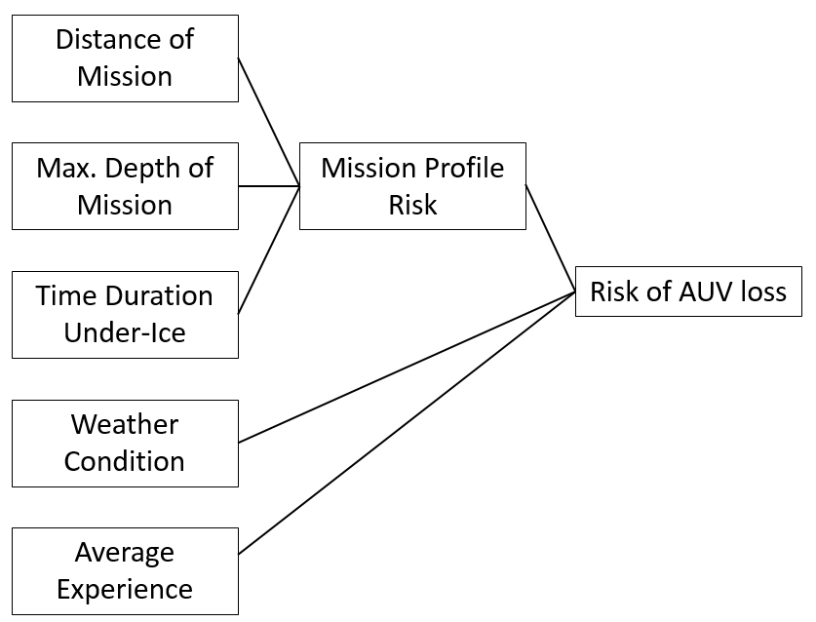
Fig. 13. The risk variables in an incremental hierarchical fuzzy system.
For intuitive elicitation of fuzzy rules based, a 3D hypercube matrix consisting of three input risk variables and one risk level output were used (Fig. 14). The cube was further sliced into separate tables as shown in Table VI(a), where there are three slices and Table VI(b), where there are four slices. These tables represent a series of IF-THEN rules such as:
IF Distance of Mission is Short AND Time Duration Under-Ice is Short AND Max. Depth of Mission is Shallow THEN Mission Profile risk is Low.
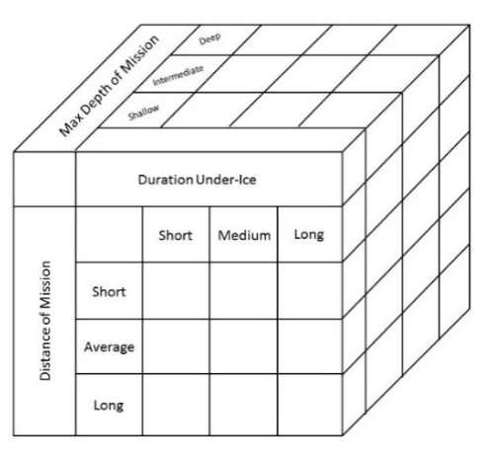
Fig. 14. A 3D hypercube matrix to elicit experts’ opinion on the construction of fuzzy rules for ‘Mission Profile Risk’.
Table VI(a). Fuzzy rule table for ‘Mission Profile Risk’.
 |  | Time Duration Under-Ice
 |  | Short | Medium | Long
Maximum Depth of Mission – Shallow
Distance of Mission | Short | Low | Low | Mod
Distance of Mission | Average | Low | Mod | High
Distance of Mission | Long | Mod | High | Ext
Maximum Depth of Mission - Intermediate
Distance of Mission | Short | Low | Mod | High
Distance of Mission | Average | Low | High | Ext
Distance of Mission | Long | Mod | High | Ext
Maximum Depth of Mission – Deep
Distance of Mission | Short | Mod | High | High
Distance of Mission | Average | High | High | Ext
Distance of Mission | Long | High | Ext | Ext

Table VI(b). Fuzzy rule table for ‘Risk of AUV Loss’.
 |  | Average Experience of AUV Team
 |  | Experienced | Average | Inexperience
Weather Condition – Good
Mission Profile Risk | Low | Low | Low | Mod
Mission Profile Risk | Mod | Low | Low | Mod
Mission Profile Risk | High | Mod | Mod | High
Mission Profile Risk | Ext | High | High | Ext
Weather Condition – Average
Mission Profile Risk | Low | Low | Low | Mod
Mission Profile Risk | Mod | Mod | Mod | Mod
Mission Profile Risk | High | Mod | High | High
Mission Profile Risk | Ext | High | High | Ext
Weather Condition – Bad
Mission Profile Risk | Low | Mod | Mod | High
Mission Profile Risk | Mod | Mod | High | High
Mission Profile Risk | High | High | High | Ext
Mission Profile Risk | Ext | Ext | Ext | Ext
Weather Condition – Severe
Mission Profile Risk | Low | High | High | Ext
Mission Profile Risk | Mod | High | Ext | Ext
Mission Profile Risk | High | Ext | Ext | Ext
Mission Profile Risk | Ext | Ext | Ext | Ext

For the next task of fuzzy inference, the Mamdani method was adopted as it is widely accepted for capturing experts’ knowledge (Kaur & Kaur, 2012). Many methods exist for the composition of fuzzy relations for use in Mamdani inference. Examples include min-max, max-max, min-min, max-min and max-product. Among these, the max-min and max-product inference are the most commonly used (Nasr, Rezaei, & Barmaki, 2013). In max-min inference, the inferred output of each rule is a fuzzy set chosen from the minimum firing strength, which is the degree to which the rule matches the input (Mamdani & Assilian, 1975). The resultant output set has its membership function cut off at the top, resulting in some information loss. In the max-product inference, the inferred output of each rule is a fuzzy set scaled down by its firing strength via an algebraic product (Mamdani & Assilian, 1975). This way, the original shape of the fuzzy set is preserved, resulting in less information loss as compared to max-min inference (A.V. Senthil Kumar, 2014)(Zimmermann, 2001). Therefore, the max-product inference was adopted for this example. To apply the max-product inference, consider two rules with three risk variables (RV) inputs and one risk level (RL) output of the following form:
IF RV1 is L_{A} and RV2 is L_{B} and RV3 is L_{C} THEN RL = P_{D}
IF RV1 is L_{W} and RV2 is L_{X} and RV2 is L_{Y} THEN RL = P_{Z}
$L$ and $P$ are adjectives of the fuzzy set associated with the risk variables and risk level respectively. The alphabetical subscripts differentiate different values of $L$ and $P$. The aggregated output membership function µ_{Q}(RV,RL), which is a function of both the input risk variables and output risk levels can then be calculated as follow:
$Max\left\{\begin{aligned}min⁡(µ\text{L}\text{A} \left(RV1\right),{µ\text{L}\text{B}}\left(RV2\right), µ\text{L}\text{C} \left(RV3\right))µ\text{P}\text{D }\left(RL\right), \\ min⁡(µ\text{L}\text{W} \left(RV1\right),{µ\text{L}\text{X}}\left(RV2\right), µ\text{L}\text{Y} \left(RV3\right))µ\text{P}\text{Z} \left(RL\right)\end{aligned}\right\}$
To demonstrate the Mamdani max-product inference, two fuzzy rules were extracted from Table VI(a), of the following form:
IF Distance of Mission is Long and Maximum Depth of Mission is Intermediate and Time Duration Under-Ice is Medium, THEN Mission Profile Risk = High
IF Distance of Mission is Long and Maximum Depth of Mission is Deep and Time Duration Under-Ice is Medium, THEN Mission Profile Risk = Extreme
Using the max-product inference, the aggregated output membership function µ_{Q} can be calculated as:
$$\text{Max}\left\{\begin{aligned}min(µ\text{Long }\left(Dist\right),{µ\text{Int}}\left(Depth\right), µ\text{Med }(Time)) µ\text{High }\left(Risk\right), \\ min(µ\text{Long }\left(Dist\right),{µ\text{Deep}}\left(Depth\right), µ\text{Med }(Time)) µ\text{Ext }\left(Risk\right)\end{aligned}\right\}$$
The graphical representation in Fig. 15 shows the aggregation of output membership functions for each rule to result in µ_{Q}. Essentially, µ_{Q} comprises of the outer envelopes of the individuals truncated membership forms for each rule.
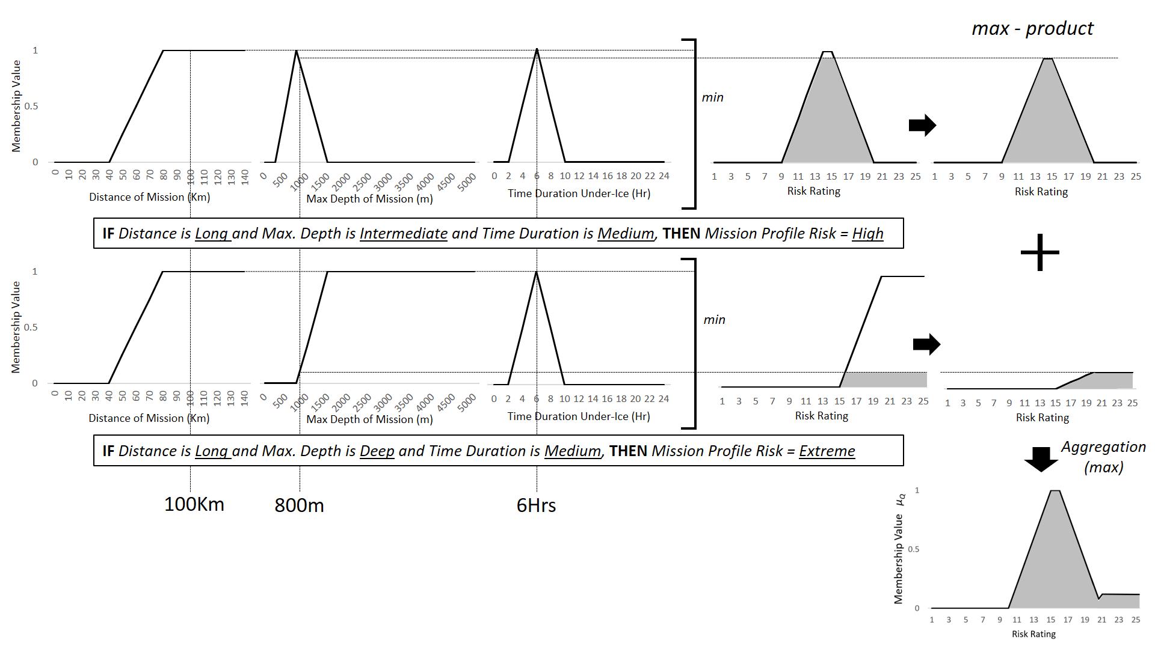Fig. 15. The graphical representation of Mamdani max-product inference.
For defuzzification, the commonly used centroid method was chosen for this example. It has the advantage of being well-balanced, sensitive to the height and width of the fuzzy output and providing consistent results (Negnevitsky, 2005). The centroid method defuzzify by finding a point representing the centre of gravity of the aggregated fuzzy set. For a fuzzy set A, the centre of gravity ꭓ* can be expressed mathematically as (Fig. 16):
$$ꭓ* = \frac{\int{μ\text{A} \left(x\right) x dx}}{\int{μ\text{A} \left(x\right) dx}}$$

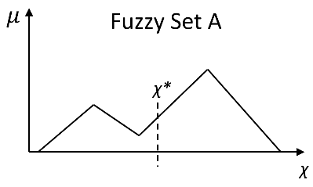
Fig. 16. The centroid method of defuzzification.
The fuzzy inference and defuzzification process were implemented using MATLAB® fuzzy logic toolbox 2017 (“Fuzzy Logic Toolbox User’s Guide,” 2017). An example of the graphical interface is shown in Fig. 17. In the interface, membership functions from Fig. 12a-c and fuzzy rules from Table VI(a) were used as inputs to the model to assess ‘Mission Profile Risk’. The fuzzy risk assessment matrix in Fig. 5 was used as the output. Using the above information, the proposed mission with a distance of 100 Kilometres, Maximum Depth of 800 meters and 6 hours under-ice will have a mission profile risk rating of 14.97. Under the University of Tasmania’s organisation’s risk assessment matrix, a risk rating of 14.97 falls into the ‘High risk’ category.
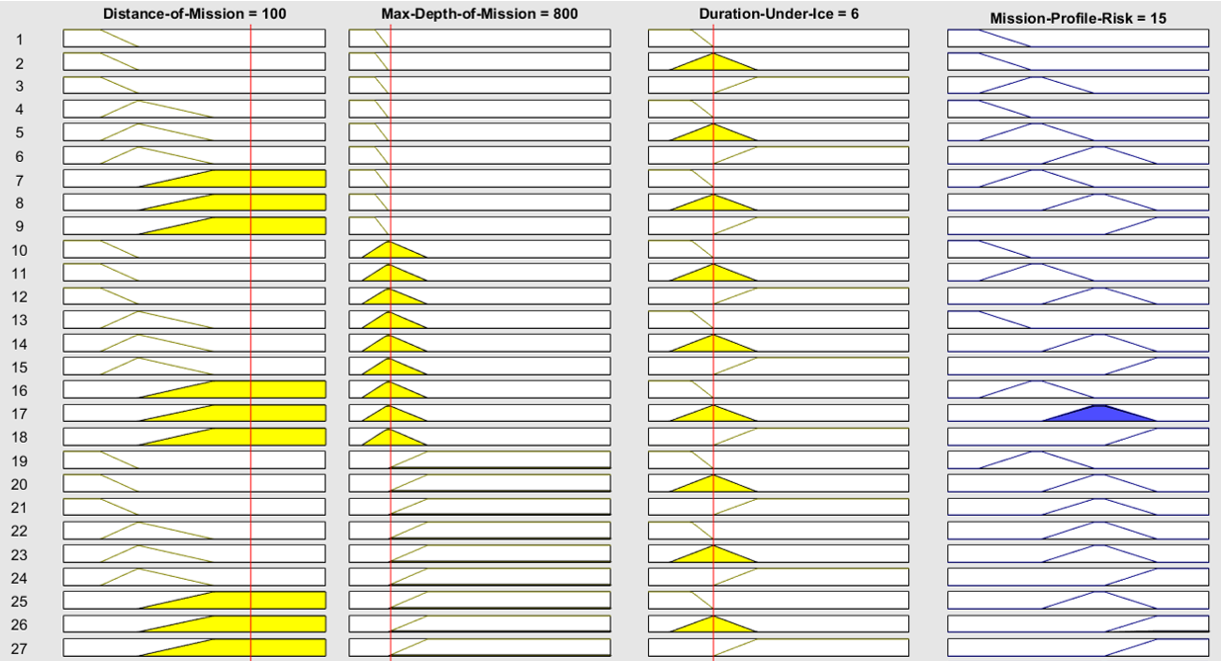

Fig. 17. The graphical interface of MATLAB Fuzzy Logic Toolbox showing ‘Mission Profile Risk’.
In the next level of the hierarchical fuzzy system (Fig. 13), the risk of AUV loss was computed using ‘Mission Profile Risk’, ‘Weather Condition’ and ‘Average Experience of AUV Team with Under-Ice Missions’ as inputs. The average experience of the team is approximately three years, information attained by speaking with the team. December to February is the summer season in the Antarctic with generally lower precipitation and wind speeds as compared to the winter season. Sørsdal Glacier, which is near to Davis Station, has a relatively milder climate due to the surrounding Vestfold Hills (“Australian Antarctic Division - Climate, Weather and Tides at Davis,” 2015). Despite this, the weather conditions in Antarctica can be highly dynamic and unpredictable (Carrkre, 1990). Therefore, it can be assumed at this stage that the weather is ‘Good’ with a rating of 2 out of 10, with 10 being the most extreme weather expected. Using Simulink® software to construct the hierarchical fuzzy system as presented in Fig. 18, it was now possible to estimate the Risk of AUV loss.
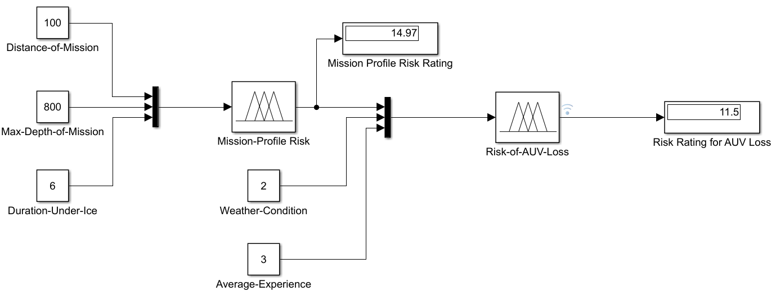
Fig. 18. The hierarchical fuzzy system constructed using Simulink® to assess ‘Risk of AUV Loss
The resultant risk level for the risk of AUV loss has a rating of 11.5. Apart from achieving a numerical risk level, the behaviour of the risk variables and the risk of AUV loss can also be studied using 3-Dimensional plots. An example showing the influence of ‘Mission Profile Risk’ and ‘Weather Condition’ over ‘Risk of AUV loss’ is shown in Fig. 19.
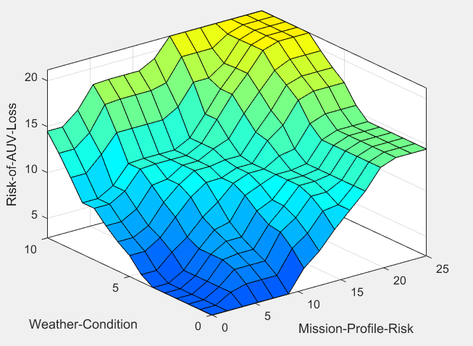
Fig. 19. 3-Dimensional plot showing the behaviour of model output with changes to model inputs.

3.4 Evaluation
In the evaluation step, the significance of the result is used to support decision making. Referring to the University of Tasmania’s ‘five by five’ risk assessment matrix (Fig. 3), the risk rating of 11.5 falls between the ‘moderate’ and ‘high’ risk level category (Fig. 20).
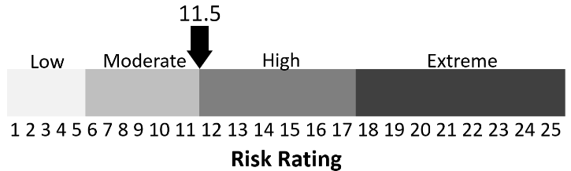
Fig. 20. Risk Rating of 11.5 on The University of Tasmania’s risk matrix.
Consequently, a set of actions can be determined using the Risk Management Standard from the University of Tasmania (Table VII) (“Work Health and Safety Policy - University of Tasmania,” 2013) as the evaluation criteria.
Table VII. The University of Tasmania’s risk management policy. SMT: Senior Management Team.
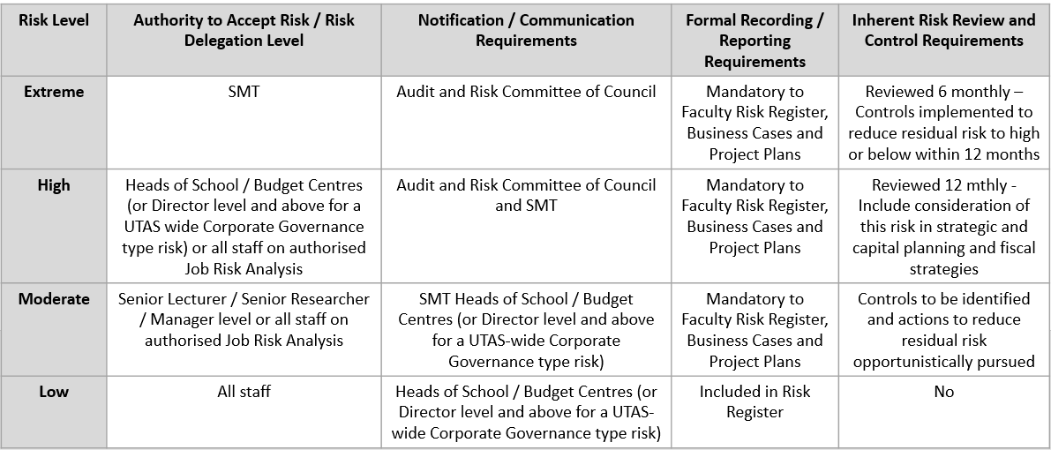

To err on the conservative side, the requirements for ‘high’ risk level should be considered. Under the standard, a mission with ‘high’ risk level requires approval from heads of school, budget centres or staff on authorised job risk analysis. The audit and risk committee of council and senior management team have to be kept informed of the mission and risk control measures reviewed annually. The risk of AUV loss is also to be included in strategic and capital planning and fiscal strategies.

3.5 Sensitivity Analysis
A sensitivity analysis was performed on the model to examine how changes to each risk variable input can affect the risk rating output. Using the established model in Fig. 20 as the base model, each input risk variable was then changed sequentially while the values of other risk variables remained constant. The universe of discourse for each risk variable was divided into ten equal incremental parts for the analysis, starting with minimum value. Graphical representation of the results is shown in Fig. 21.
Fig. 21. Sensitivity analysis of how changes to each risk variable input affect the risk rating output.
The result of the analysis shows that the risk rating output is most sensitive to ‘Time Duration Under-Ice’, with an increase of 215 percent from a risk rating of 5.81 to 18.31 when time duration under-ice increases from 0 to 9.6 hours. This is followed by risk variable ‘Distance of Mission’, ‘Maximum depth of Mission’, ‘Average Experience of AUV team with Under-Ice Missions’ and lastly, ‘Weather Condition’ which risk rating is least sensitive towards. The close similarity of sensitivity between ‘Time Duration Under-Ice’, ‘Distance of Mission’, ‘Maximum depth of Mission’ to risk rating is expected due to some degree of proportionality. The result of the sensitivity analysis can also be used for identification of leverage points setting priorities for risk control. For instance, a reduction of ‘Time Duration Under-Ice’ from 6 hours to 5 hours reduces the eventual risk rating for AUV loss from 11.5 to 9.9.
It is difficult to validate the model at this stage without actual under-ice deployment and a lack of historical data record for the nupiri muka AUV. However, when results of the sensitivity analysis were compared to the risk and reliability analysis of Autosub 6000 AUV (Mario P. Brito, 2015), the findings were found to be quite similar. In the report on Autosub 6000 AUV, mission distance and depth were analysed against risk of AUV loss. The result shows the probability of loss increasing at a near constant rate before plateauing off at about 90 kilometres. For depth of mission, the probability of loss remains nearly constant from 1000 meters to 2500 meters before a large increase in risk occurs at greater than 2500 meters’ depth. In the sensitivity analysis for nupiri muka AUV, risk level plateaus off at 84 kilometres for distance of mission and remains constant after 1500 meters of mission depth (Fig. 21).

4. DISCUSSION AND LIMITATIONS
The application of fuzzy-based risk assessment has its disadvantages. In this section, we will discuss the approach proposed focusing on its limitations. Subject matter experts can sometimes have incomplete and episodic knowledge, especially when there is a lack of data. This can result in incorrect or incomplete fuzzy rule bases for the inference system, which lowers the model performance. Therefore, it is imperative that a suitable judgment elicitation process is adopted to enable reproducibility of the results. During elicitation of fuzzy rules, circumstances where redundant, inconsistent or conflicting rules may arise. Consequently, a significant amount of time is required to overcome this and fine-tune the model. Therefore similar to formal judgment elicitation methods, the proposed method must be applied iteratively. The inability to self-learn means the model requires consistent regular review of rules and membership functions to ensure relevancy.
To overcome some of these drawbacks and present a better risk assessment approach for the AUV community, further research can follow three tracks: 1. Expand on the list of risk variables as input into the fuzzy-based risk model. This includes having a more robust method for identifying risk variables and the use of both crisp and fuzzy risk variables in the model. 2. Develop and explore risk aggregation methods for the fuzzy-based risk models to establish a risk level for an entire AUV deployment. This usually includes a number of open water missions and under-ice missions during the deployment. Other aspects of the deployment such as launch and recovery as well as transportation of the AUV should also be considered. 3. Identify and quantify potential causal relationships between risk variables to better understand systemic behaviour. This can be performed with fuzzy cognitive maps or synthesising fuzzy logic with system dynamics or structural equation models.
There are different types of AUV. Many faster vehicles (1m/s and more) have an endurance of days whilst slower buoyancy driven vehicles (such as underwater gliders) or propeller driven vehicles (speed less than 1m/s) tend to have an endurance of months. AUVs, also vary in terms of operating depth and the required human effort for operation. Different AUV characteristics imply different membership functions and different risk variables influencing its risk of loss. When using the proposed method one must be aware of this and update the membership functions and potentially the fuzzy rules according to the vehicle characteristics. As a result, the risk profile for different AUVs also differ.

5. CONCLUSION
In this paper, a fuzzy-based risk assessment framework for under-ice AUV missions in the Antarctic is presented. The use of a fuzzy-based approach is especially well-suited for an AUV program in its early phases due to the lack of historical fault log data for precise quantification of risks. It also takes into account the vagueness and ambiguity of many risk variables which are difficult to quantify and are usually described in natural language. The framework facilitates the capturing of knowledge and experience from subject matter experts, to derive a quantifiable risk level output. This output can then be evaluated against a set of risk criteria to aid decision making or to be used relatively to compare risks of different missions. Additionally, the framework can also be applied directly in the field during a deployment to assess risk in response to changes in situation. These benefits are the reasons the proposed fuzzy-based risk assessment framework is pragmatically useful for future under-Ice AUV deployments.
Sensitivity analysis enables the user to tune the model for particular risk scenarios. Our sensitivity analysis has considered five risk variables, but more variables could have been included in this analysis. We could have included other environmental and operational variables such as the distance between the AUV and the seabed, the presence of icebergs and others. We could also have included more detailed characteristics of the launch and recovery systems. The variables considered in this analysis were those deemed more important for the forthcoming deployment under the Sørsdal Glacier in the Antarctic.
Advancement of this work can potentially further its application outside the AUV domain. For complex new technology there is often an absence of hard data and of expertise. This uncertainty is present in risk matrices used by organizations that are now adopting AUVs. We have proposed a method to homogenize the risk assessment used by organizations with those used for quantifying AUV risk. In doing so, a new methodology for AUV under-ice mission risk calculation is proposed. The fuzzy risk assessment framework can be adopted for other complex technologies such as other unmanned marine surface vessels or unmanned aerial vehicles (Porathe, 2013)(Marconato et al., 2016), where there is an apparent lack of data. The difference between the AUV applications and other are in the variables considered and their dependencies. For example, with respect to AUV mission under-ice the mission profile risk must be calculated based on the Distance of mission, Max depth of Mission and Duration under-ice. If we apply this methodology to other technology, for example, to an unmanned ship the mission profile risk would have to consider other variables.

ACKNOWLEDGEMENT
This research was supported by the Australian Research Council’s Special Research Initiative under the Antarctic Gateway Partnership (Project IF SR140300001). The first author also acknowledges the Australian Government Research Training Program Scholarship in support of this higher degree research.

REFERENCES
A.V. Senthil Kumar. (2014). Fuzzy Expert Systems for Disease Diagnosis. Hindusthan College of Arts and Science, India: IGI Global. https://doi.org/10.4018/978-1-4666-7240-6

Alcalá, R., Casillas, J., Cordón, O., González, A., & Herrera, F. (2005). A Genetic Rule Weighting and Selection Process for Fuzzy Control of Heating, Ventilating and Air Conditioning Systems. Engineering Applications of Artificial Intelligence, 18(3), 279–296. https://doi.org/10.1016/j.engappai.2004.09.007

Australian Antarctic Division - Climate, Weather and Tides at Davis. (2015). Retrieved from http://www.antarctica.gov.au/living-and-working/stations/davis/environment/climate-weather-tides

Barua, A., Mudunuri, L. S., & Kosheleva, O. (2014). Why Trapezoidal and Triangular Membership Functions Work so Well: Towards a Theoretical Explanation. Journal of Uncertain Systems, 8(3), 164–168.

Bellingham, J. G. (2010). Platforms: Autonomous Underwater Vehicles. In Encyclopedia of Ocean Sciences. https://doi.org/10.1016/B978-012374473-9.00730-X

Bian, X., Mou, C., Yan, Z., & Xu, J. (2009). Reliability Analysis of AUV Based on Fuzzy Fault Tree. In 2009 IEEE International Conference on Mechatronics and Automation, ICMA 2009 (pp. 438–442). https://doi.org/10.1109/ICMA.2009.5246655

Bolstad, C. a, Cuevas, H. M., Gonzalez, C., & Schneider, M. (2005). Modeling shared situation awareness. In 14th Conference on Behavior Representation In Modeling and Simulation. Los Angeles, CA. Retrieved from http://satechnologies.com/Papers/pdf/Bolstad et al (2005) BRIMS.pdf

Brito, M., & Griffiths, G. (2016). A Bayesian Approach for Predicting Risk of Autonomous Underwater Vehicle Loss during their Missions. Reliability Engineering & System Safety, 146, 55–67. https://doi.org/10.1016/j.ress.2015.10.004

Brito, M. P. (2015). Risk and Reliability Analysis of Autosub 6000 autonomous underwater vehicle. Southampton. Retrieved from http://nora.nerc.ac.uk/id/eprint/511842/

Brito, M. P., Griffiths, G., & Challenor, P. (2010). Risk Analysis for Autonomous Underwater Vehicle Operations in Extreme Environments. Risk Analysis : An Official Publication of the Society for Risk Analysis, 30(12), 1771–88. https://doi.org/10.1111/j.1539-6924.2010.01476.x

Brito, M. P., Griffiths, G., & Trembranis, A. (2008). Eliciting expert judgment on the probability of Loss of an AUV operating in four environments. Southampton. Retrieved from https://eprints.soton.ac.uk/id/eprint/54881

Brito, M. P., Smeed, D. A., & Griffiths, G. (2014). Analysis of Causation of Loss of Communication with Marine Autonomous Systems: A Probability Tree Approach. Methods in Oceanography, 10, 122–137. https://doi.org/10.1016/j.mio.2014.07.003

Carrkre, S. (1990). Physiological and Psychological Patterns of Acute and Chronic Stress during Winter Isolation in Antarctica. University of California, Irvine. Retrieved from http://www.palmerstation.com/history/7585/carrere8.pdf

Chang, Y. H., Yeh, C. H., & Wang, S. Y. (2007). A Survey and Optimization-Based Evaluation of Development Strategies for the Air Cargo Industry. International Journal of Production Economics, 106(2), 550–562. https://doi.org/10.1016/j.ijpe.2006.06.016

Cignoli, R. (2007). The Algebras of Łukasiewicz Many-Valued logic: A Historical Overview. Algebraic and Proof-theoretic Aspects of Non-classical Logics (Vol. 4460). Berlin, Heidelberg: Springer. Retrieved from http://link.springer.com/chapter/10.1007/978-3-540-75939-3_5

Cooke, R., & Probst, K. N. (2006). Highlights of the expert judgment policy symposium and technical workshop. Workshop on the Theory and Practice of Expert Judgment in Risk and Environmental Studies., 31. Retrieved from http://rff.org/Documents/Conference-Summary.pdf

Dixit, U. S., Hazarika, M., & Davim, J. P. (2017). History of Mechatronics. In A Brief History of Mechanical Engineering (pp. 147–164). Cham: Springer International Publishing. https://doi.org/10.1007/978-3-319-42916-8_7

Eleye-Datubo, A. G., Wall, A., & Wang, J. (2008). Marine and Offshore Safety Assessment by Incorporative Risk Modeling in a Fuzzy-Bayesian Network of an Induced Mass Assignment Paradigm. Risk Analysis, 28(1), 95–112. https://doi.org/10.1111/j.1539-6924.2008.01004.x

Endsley, M. R. (1995). Toward a Theory of Situation Awareness in Dynamic Systems. Human Factors: The Journal of the Human Factors and Ergonomics Society, 37(1), 32–64. https://doi.org/10.1518/001872095779049543

Endsley, M. R., & Kaber, D. B. (1999). Level of automation effects on performance, situation awareness and workload in a dynamic control task. Ergonomics, 42(3), 462–492. https://doi.org/10.1080/001401399185595

Endsley, M. R., & Kiris, E. O. (1995). The Out-of-the-Loop Performance Problem and Level of Control in Automation. Human Factors and Ergonomics Society, 37(2), 381–394. https://doi.org/10.1518/001872095779064555

Ferdous, R., Khan, F., Sadiq, R., Amyotte, P., & Veitch, B. (2011). Fault and Event Tree Analyses for Process Systems Risk Analysis: Uncertainty Handling Formulations. Risk Analysis, 31(1), 86–107. https://doi.org/10.1111/j.1539-6924.2010.01475.x

Fletcher, A., & Davis, J. P. (2002). Decision-Making with Incomplete Evidence. In SPE - Asia Pacific Oil and Gas Conference. Melbourne, Australia: Society of Petroleum Engineers. https://doi.org/10.2118/77914-MS

Francois, R. E., & Nodland, W. E. (1972). Unmanned Arctic Research Submersible (UARS) System development and test report. Applied Physics Laboratory, University of Washington.

Fuzzy Logic Toolbox User’s Guide. (2017). The MATH WORKS Inc. The MathWorks, Inc. Retrieved from https://www.mathworks.com/help/pdf_doc/fuzzy/fuzzy.pdf

Glossary - The Society for Risk Analysis. (2015). Retrieved June 1, 2018, from http://www.sra.org/sites/default/files/pdf/SRA_glossary_20150622.pdf

Griffiths, G., Bose, N., Ferguson, J., & Blidberg, D. R. (2010). Insurance for autonomous underwater vehicles. Underwater Technology The International Journal of the Society for Underwater, 27(2), 43–48. Retrieved from http://eprints.soton.ac.uk/46325/

Griffiths, G., & Brito, M. (2008). Predicting Risk in Missions Under Sea Ice with Autonomous Underwater Vehicles. In 2008 IEEE/OES Autonomous Underwater Vehicles, AUV 2008. Woods Hole, MA, USA: IEEE. Retrieved from http://www.scopus.com/inward/record.url?eid=2-s2.0-74349101464&partnerID=40&md5=b87b645e66d85155a98813290c7b2160

Griffiths, G., & Brito, M. (2011). Risk management for autonomous underwater vehicles operating under ice. In OTC Arctic Technology Conference. Houston, Texas: Offshore Technology Conference. https://doi.org/10.4043/22162-MS.pp.8

Griffiths, G., Brito, M., Robbins, I., & Moline, M. (2009). Reliability of Two REMUS-100 AUVs Based on Fault Log Analysis and Elicited Expert Judgment. In Proceedings of the International Symposium on Unmanned Untethered Submersible Technology (UUST 2009) (p. 12). Durham, New Hampshire. Retrieved from http://eprints.soton.ac.uk/69184/

Griffiths, G., & Collins, K. J. (2006). Proceedings of the Masterclass in AUV Technology for Polar Science. Collaborative Autosub Science in Extreme Environments, Masterclass in AUV Technology for Polar Science. Southampton: National Oceanography Centre. https://doi.org/10.3723/ut.28.187

Griffiths, G., Millard, N. W., McPhail, S. D., Stevenson, P., & Challenor, P. G. (2003). On the Reliability of the Autosub Autonomous Underwater Vehicle. Underwater Technology, 25(4), 175–184.

Gunderson, E. K. E. (1967). Mental Health Problems in Antarctica. Archives of Environmental Health: An International Journal, 17(4), 558–64.

Helton, J. C., Johnson, J. D., Oberkampf, W. L., & Sallaberry, C. J. (2010). Representation of Analysis Results Involving Aleatory and Epistemic Uncertainty. International Journal of General Systems, 39(6), 605–646. https://doi.org/10.1080/03081079.2010.486664

Ho, G., Pavlovic, N., & Arrabito, R. (2011). Human Factors Issues with Operating Unmanned Underwater Vehicles. Proceedings of the Human Factors and Ergonomics Society Annual Meeting (Vol. 55). https://doi.org/10.1177/1071181311551088

Hsi-Mei Hsu, & Chen-Tung Chen. (1996). Aggregation of Fuzzy Opinions under Group Decision Making. Expert Systems with Applications, 79, 279–285. https://doi.org/10.1109/FUZZ.2001.1007275

International Standards Organisation. (2009). ISO 31000 - Risk Management. https://doi.org/10.1080/07366981.2012.682494

Ishikawa, A., Amagasa, M., Shiga, T., Tomizawa, G., Tatsuta, R., & Mieno, H. (1993). The Max-Min Delphi Method and Fuzzy Delphi Method via Fuzzy Integration. Fuzzy Sets and Systems, 55(3), 241–253. https://doi.org/10.1016/0165-0114(93)90251-C

ISO 45001-Occupational Health and Safety. (n.d.). Retrieved from https://www.iso.org/iso-45001-occupational-health-and-safety.html

Jang, J.-S. R., Sun, C.-T., & Mizutani, E. (1997). Neuro-Fuzzy and Soft Computing: A Computational Approach to Learning and Machine Intelligence. Prentice Hall.

Johnson, N., Patron, P., & Lane, D. M. (2007). The importance of trust between operator and AUV: Crossing the human/computer language barrier. In OCEANS 2007 - Europe (pp. 1–6). Aberdeen, UK: IEEE. https://doi.org/10.1109/OCEANSE.2007.4302408

Kannan, D., De Sousa Jabbour, A. B. L., & Jabbour, C. J. C. (2014). Selecting Green Suppliers based on GSCM Practices: Using Fuzzy TOPSIS Applied to a Brazilian Electronics Company. European Journal of Operational Research, 233(2), 432–447. https://doi.org/10.1016/j.ejor.2013.07.023

Kaplan, S., & Garrick, B. J. (1981). On The Quantitative Definition of Risk. Risk Analysis, 1(1), 11–27. https://doi.org/10.1111/j.1539-6924.1981.tb01350.x

Kaur, A., & Kaur, A. (2012). Comparison of Mamdani-Type and Sugeno-Type Fuzzy Inference Systems for Air Conditioning System. International Journal of Soft Computing & Engineering, 2(2), 323–325. Retrieved from http://citeseerx.ist.psu.edu/viewdoc/download?doi=10.1.1.486.1238&rep=rep1&type=pdf

Kosko, B., & Isaka, S. (1993). Fuzzy Logic. Scientific American, 269(1), 76–81. https://doi.org/10.1038/scientificamerican0793-76

Kotra, J. P., Lee, M. P., & Dewispelare, A. R. (1996). Branch Technical Position on the use of Expert Elicitation in the High-Level Radioactive Waste Program. Washington DC. Retrieved from https://www.nrc.gov/reading-rm/doc-collections/nuregs/staff/sr1563/sr1563.pdf

Kunz, C., Murphy, C., Camilli, R., Singh, H., Bailey, J., Eustice, R., … Willis, C. (2008). Deep sea underwater robotic exploration in the ice-covered Arctic ocean with AUVs. In 2008 IEEE/RSJ International Conference on Intelligent Robots and Systems, IROS. https://doi.org/10.1109/IROS.2008.4651097

Le Hardy, P. K., & Moore, C. (2015). Deep ocean search for Malaysia Airlines Flight 370. In 2014 Oceans - St. John’s, OCEANS 2014. https://doi.org/10.1109/OCEANS.2014.7003292

Lee, C.-S., & Wang, M.-H. (2011). A Fuzzy Expert System for Diabetes Decision Support Application. IEEE Transactions on Systems, Man, and Cybernetics. Part B, Cybernetics : A Publication of the IEEE Systems, Man, and Cybernetics Society, 41(1), 139–153. https://doi.org/10.1109/TSMCB.2010.2048899

Lee, H. S. (2002). Optimal Consensus of Fuzzy Opinions Under Group Decision Making Environment. Fuzzy Sets and Systems, 132(3), 303–315. https://doi.org/10.1016/S0165-0114(02)00056-8

Leekwijck, W. Van, & Kerre, E. E. (1999). Defuzzification: Criteria and Classification. Fuzzy Sets and Systems, 108(2), 159–178. https://doi.org/10.1016/S0165-0114(97)00337-0

Leveson, N. G. (2011). Engineering a Safer World: Systems Thinking Applied to Safety. Vasa. The MIT Press. https://doi.org/10.1017/CBO9781107415324.004

Li, Y., Chen, J., & Feng, L. (2013). Dealing with Uncertainty: A Survey of Theories and Practices. IEEE Transactions on Knowledge and Data Engineering. https://doi.org/10.1109/TKDE.2012.179

Lorenz, R. D., Gleeson, D., Prieto-Ballesteros, O., Gomez, F., Hand, K., & Bulat, S. (2011). Analog environments for a Europa lander mission. In Advances in Space Research (Vol. 48, pp. 689–696). https://doi.org/10.1016/j.asr.2010.05.006

Lu, C., Lan, J., & Wang, Z. (2006). Aggregation of Fuzzy Opinions under Group Decision-Making Based on Similarity and Distance. Journal of Systems Science and Complexity, 19(1), 63–71. https://doi.org/10.1007/s11424-006-0063-y

Mamdani, E. H., & Assilian, S. (1975). An Experiment in Linguistic Synthesis with a Fuzzy Logic Controller. International Journal of Man-Machine Studies, 7(1), 1–13. https://doi.org/10.1016/S0020-7373(75)80002-2

Marconato, E. A., Pigatto, D. F., Branco, K. R. L. J. C., Branco, L. H. C., Pastor Llorens, E., Barrado Muxí, C., … Qualcomm. (2016). Unmanned Aerial Vehicles: Examining the Safety, Security, Privacy and Regulatory Issues of Integration into U.S. Airspace. 16th AIAA Aviation Technology, Integration, and Operations Conference. https://doi.org/10.1109/ICNSURV.2015.7121263

McCormick, B., & Mastro, J. (2002). Field Manual for the U.S. Antarctica Program. Retrieved from https://www.eol.ucar.edu/system/files/usap-field-manual.pdf

McNeil, F., & Thro, E. (1994). Fuzzy Logic a Pratical Approach. Morgan Kaufmann Pub; Pap/Dskt edition. https://doi.org/10.1016/B978-0-7234-5558-5.00001-4

Mendel, J. M. (2001). Uncertain Rule-based Fuzzy Logic Systems: Introduction and New Directions. IEEE Computational Intelligence Magazine (Vol. 2). Retrieved from http://scholar.google.com/scholar?hl=en&btnG=Search&q=intitle:Uncertain+rule-based+fuzzy+logic+systems:+introduction+and+new+directions#0

Naeem, W. (2002). Model predictive control of an autonomous underwater vehicle. In UKACC Conference on Control.

Nasr, A. S., Rezaei, M., & Barmaki, M. D. (2013). Groundwater Contamination Analysis using Fuzzy Water Quality Index (FWQI): Yazd Province, Iran. Geopersia, 3(1), 47–55, 9 pp.

Negnevitsky, M. (2005). Artificial Intelligence: A Guide to Intelligent Systems (pp. 87–113). Canada: Pearson Education. Retrieved from https://books.google.ae/books/about/Artificial_Intelligence.html?id=1BxYQnrfv9MC&redir_esc=y

Oberkampf, W. L., DeLand, S. M., Rutherford, B. M., Diegert, K. V., & Alvin, K. F. (2002). Error and Uncertainty in Modeling and Simulation. Reliability Engineering & System Safety, 75(3), 333–357. https://doi.org/10.1016/S0951-8320(01)00120-X

Palinkas, L. A. (1992). Going to extremes: The cultural context of stress, illness and coping in Antarctica. Social Science and Medicine, 35(5), 651–664. https://doi.org/10.1016/0277-9536(92)90004-A

Parasuraman, R. (1997). Humans and Automation: Use, Misuse, Disuse, Abuse. Human Factors, 39(2), 230–253. https://doi.org/10.1518/001872097778543886

Parasuraman, R., Sheridan, T. B., & Wickens, C. D. (2008). Situation Awareness, Mental Workload, and Trust in Automation: Viable, Empirically Supported Cognitive Engineering Constructs. Journal of Cognitive Engineering and Decision Making, 2(2), 140–160. https://doi.org/10.1518/155534308X284417.

Porathe, T. (2013). Maritime Unmanned Navigation through Intelligence in Networks: The MUNIN Project. 12th International Conference on Computer and IT Applications in the Maritime Industries. https://doi.org/10.1080/14498596.2013.857382

Pulkkinen, U., & Simola, K. (2000). An Expert Panel Approach to Support Risk-Informed Decision Making. Helsinki. Retrieved from https://inis.iaea.org/search/search.aspx?orig_q=RN:32001787

Purba, J. H., Sony Tjahyani, D. T., Ekariansyah, A. S., & Tjahjono, H. (2015). Fuzzy Probability Based Fault Tree Analysis to Propagate and Quantify Epistemic Uncertainty. Annals of Nuclear Energy, 85, 1189–1199. https://doi.org/10.1016/j.anucene.2015.08.002

Raju, G., Zhou, J., & Kisner, R. (1991). Hierarchical Fuzzy Control. International Journal of Control, 54(5), 1201–1216. https://doi.org/10.1080/00207179108934205

Rastogi, A., & Gabbar, H. A. (2013). Fuzzy-logic-based Safety Verification Framework for Nuclear Power Plants. Risk Analysis, 33(6), 1128–1145. https://doi.org/10.1111/j.1539-6924.2012.01899.x

Ross, T. J. (2004). Fuzzy Logic with Engieering Applications. University of New Mexico (2nd ed.). John Wiley & Sons. https://doi.org/10.1002/9781119994374

Roubos, H., & Setnes, M. (2000). Compact Fuzzy Models through Complexity Reduction and Evolutionary Optimization. Ninth IEEE International Conference on Fuzzy Systems. FUZZ- IEEE 2000 (Cat. No.00CH37063), 2(4). https://doi.org/10.1109/FUZZY.2000.839128

Rowe, G., & Wright, G. (1999). The Delphi Technique as a Forecasting Tool: Issues and Analysis. International Journal of Forecasting, 15(4), 353–375. https://doi.org/10.1016/S0169-2070(99)00018-7

Ruff, H., Narayanan, S., & Draper, M. H. (2002). Human Interaction with Levels of Automation and Decision-Aid Fidelity in the Supervisory Control of Multiple Simulated Unmanned Air Vehicles. Presence: Teleoperators and Virtual Environments, 11(4), 335–351. https://doi.org/10.1162/105474602760204264

Steimann, F., & Adlassnig, K. P. (1998). Fuzzy Medical Diagnosis. Handbook of Fuzzy Computation, G13:1-16.

Strutt, J. E. (2006). Report of the Inquiry into the Loss of Autosub2 under the Fimbulisen. Southampton, 44(12), 43. Retrieved from http://eprints.soton.ac.uk/41098/

Sugeno, M. (1985). Industrial Applications of Fuzzy Control. Elsevier Science Pub. Co., 269.

Tadic, D., Milanovic, D. D., Misita, M., & Tadic, B. (2011). New Integrated Approach to the Problem of Ranking and Supplier Selection under Uncertainties. Proceedings of the Institution of Mechanical Engineers Part B-Journal of Engineering Manufacture, 225(B9), 1713–1724. https://doi.org/10.1243/09544054JEM2105

Tessem, B., & Davidsen, P. I. (1994). Fuzzy System Dynamics: An Approach to Vague and Qualitative Variables in Simulation. System Dynamics Review, 10(1), 49–62. https://doi.org/10.1002/sdr.4260100104

Thieme, C. A., & Schjølberg, I. (2015). A risk management framework for unmanned underwater vehicles focusing on human and organizational factors. In Proceedings of the International Conference on Offshore Mechanics and Arctic Engineering - OMAE 2015 (pp. 1–10).

Unwin, S. D. (1986). A Fuzzy Set Theoretic Foundation for Vagueness in Uncertainty Analysis. Risk Analysis, 6, 27–34. https://doi.org/10.1111/j.1539-6924.1986.tb00191.x

UTAS. (2017). nupiri muka: ‘Eye of the Sea.’ Retrieved from http://www.utas.edu.au/news/2017/9/14/410-nupiri-muka-eye-of-the-sea/

Utne, I. B., & Schjolberg, I. (2014). A Systematic Approach to Risk Assessment - Focusing on Autonomous Underwater Vehicles and Operations in Arctic Areas. Proceedings of the ASME 2014 33rd International Conference on Ocean, Offshore and Arctic Engineering OMAE2014, OMAE2014-23776.

Werro, N., Stormer, H., & Meier, A. (2006). A Hierarchical Fuzzy Classification of Online Customers. In Proceedings - IEEE International Conference on e-Business Engineering, ICEBE 2006 (pp. 256–263). https://doi.org/10.1109/ICEBE.2006.4

Wojciech Z. Chmielowski. (2015). Fuzzy Control in Environmental Engineering. Springer International Publishing.

Work Health and Safety Policy - University of Tasmania. (2013). Retrieved from http://www.utas.edu.au/__data/assets/pdf_file/0004/113809/Work-Health-and-Safety-Policy-April-2013.pdf

Wu, X., Stuck, R. E., Rekleitis, I., & Beer, J. M. (2015). Towards a Framework for Human Factors in Underwater Robotics. In Proceedings of the human factors and ergonomics society 59th Annual meeting 2015 (Vol. 59, pp. 1115–1119). https://doi.org/10.1177/1541931215591161

Ying, H., Ding, Y., Li, S., & Shao, S. (1999). Comparison of Necessary Conditions for Typical Takagi-Sugeno and Mamdani Fuzzy Systems as Universal Approximators. IEEE Transactions on Systems, Man, and Cybernetics Part A:Systems and Humans., 29(5), 508–514. https://doi.org/10.1109/3468.784177

Zadeh, L. A. (1965). Fuzzy Sets. Information and Control, 8(3), 338–353. https://doi.org/10.1016/S0019-9958(65)90241-X

Zhang, L., Wu, X., Qin, Y., Skibniewski, M. J., & Liu, W. (2016). Towards a Fuzzy Bayesian Network Based Approach for Safety Risk Analysis of Tunnel-Induced Pipeline Damage. Risk Analysis, 36(2), 278–301. https://doi.org/10.1111/risa.12448

Zhao, R., & Govind, R. (1991). Defuzzification of Fuzzy Intervals. Fuzzy Sets and Systems, 43(1), 45–55. https://doi.org/10.1016/0165-0114(91)90020-Q

Zimmermann, H. J. (2001). Fuzzy Set Theory and its Applications. London Kluwer Academic Publishers. https://doi.org/10.1007/978-94-010-0646-0

