General Article
Memory Machines: Infrastructural Performance as an Art Method
Samir Bhowmik and Jussi Parikka

Samir Bhowmik (artist, researcher), Aalto University, Aalto Media Lab, PO Box 11000, FI-00076 AALTO, Finland. Email: <samir.bhowmik@aalto.fi>. ORCID: 0000-0001-5830-614X.

Jussi Parikka (Professor in Technological Culture & Aesthetics), University of Southampton, Winchester School of Art, SO17 1BJ, United Kingdom. Email: <j.parikka@soton.ac.uk>.

Abstract: Through a performance tour conducted in a public library, the authors analyze multi-sensory methods, including immersive performance and walking tours, as probes into cultural infrastructures. Combining discussions of media theory and artistic practice, the authors present infrastructural performance as an art method for creative infrastructural research.

Keywords: library, infrastructure, performance, energy, media

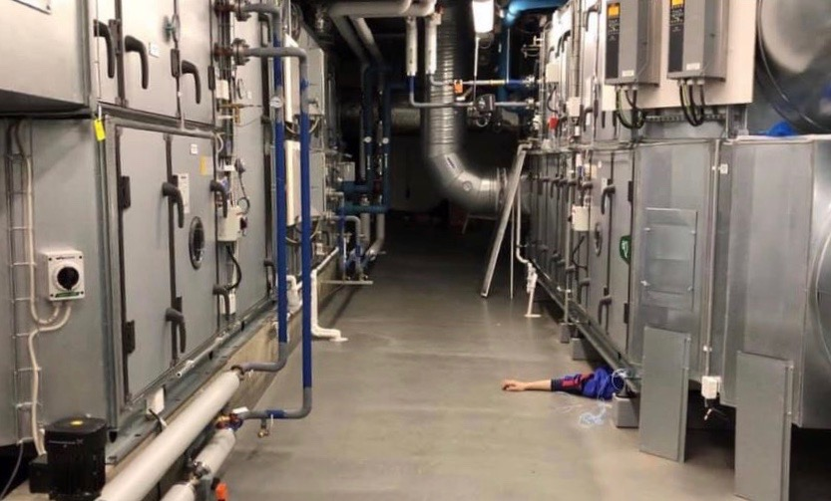
Article Frontispiece: A scene from the Memory Machines performance tour inside a mechanical room in the Helsinki Central Library. Samir Bhowmik and 00100 Ensemble, 2019. (Photo: Henna Tanskanen.)

Narrator:
“[…] the library today has turned into a giant infrastructure, a memory machine. A library patron is barely aware of the invisible infrastructure that supports her engagement with its collections. These infrastructures are easily detected and indiscernible, they seem everywhere and nowhere at once.” [1]

The speaker stands in front of a tour group wearing fluorescent safety vests. The tour begins with a distinctly academic sound to it, but the lecture soon gives way to a performance. Instead of a lecture hall we are in a cargo loading zone, deep under the Helsinki Central Library ‘Oodi’. This scene is part of Samir Bhowmik and 00100 Ensemble’s Memory Machines, an infrastructural performance tour that guided audiences of 20 participants at a time through the newly opened library building designed by Finnish architects ALA [2]. The tour was organized as part of the Library’s Other Intelligences, an exhibition that brought together performance and installation pieces engaging with the other AIs of the library: alien, animal, architectural, ambient and artistic [3].

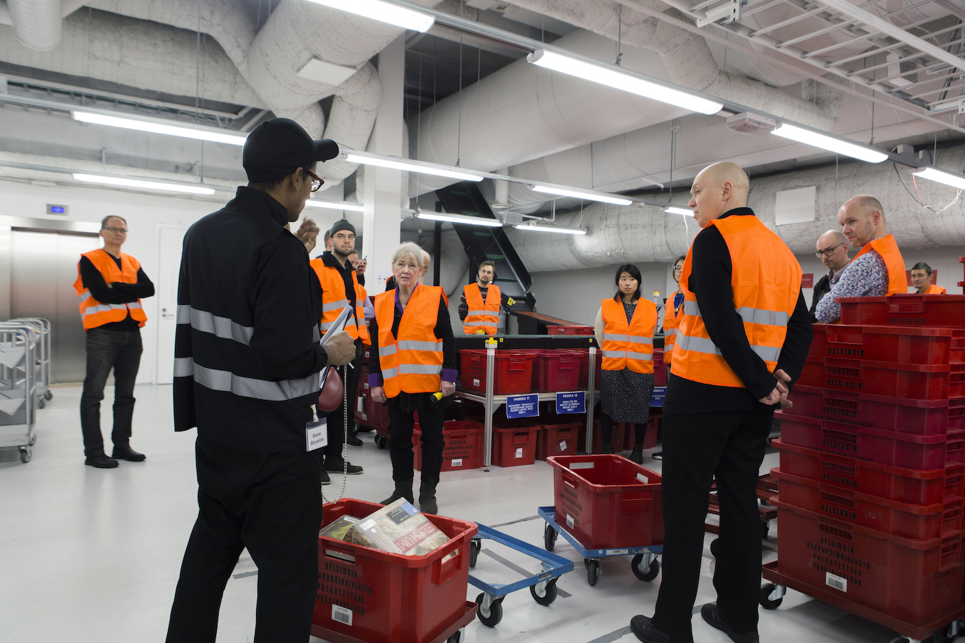
Fig. 1. The artist and the audience in the library's automated book sorting room. (Photo: Juuso Noronkoski.)

The audience is guided from the automated book returns to the sorting room downstairs, through long corridors and past a wall of colorful network cables. The walk descends to the basement and the deepest layers of the library. The group focus on access doors, entries and exits, passages and routes that connect insides and outsides. Instead of merely viewing machine landscapes of air ventilation, heat, electricity and other infrastructural conditions that make the library function, the space is performed [4]: performers in safety gear and hard hats occupy the spaces, in various forms of infrastructural activity with books, trolleys, machines, shelves and more. The performance becomes a method of highlighting, temporalizing and activating space that is not only a machinic landscape of non-human automated actions, but includes the various sets of human labor of a memory institution [5].

In this article, we discuss the infrastructural performance tour as an artistic method for creative infrastructural research. We mimic the structure of the tour itself to remediate, into words and sentences, its rhythmic flow of talks and performances. We contextualize the piece in current discussions in media theory and artistic work dealing with infrastructures of knowledge, and we contribute to the discussion of methods for art and infrastructure of cultural and memory institutions. This article draws on our joint work in the Memory Machines project led by Samir Bhowmik and the Library's Other Intelligences exhibition co-curated by Jussi Parikka and Shannon Mattern.

<1> Pipes and Ducts: Expert Territories

The audience is guided to the delivery zone located a few doors beyond the main sorting room. It is the arrivals and departures lounge of the library---a vast concrete bunker that soars to a height of six meters. They are asked to meditate on their surroundings, to gaze at the electrical and mechanical systems that run through the place and all of the objects embedded and enmeshed in it: the ceiling encrusted with massive ducts and pipes, the walls overlaid with electric cables and humming exhaust fans. The first in a series of performances begin.

Infrastructures are both visible and invisible and though there are hints everywhere, their legibility is often limited to architectural experts; it is through their interfaces that infrastructures make themselves seen [6]. In a seemingly mundane space such as a library the observable sprinkler-head, recessed in the ceiling, is the public-facing interface of a giant fire control infrastructure comprised of pipes and ducts, water pumps and tanks. A wireless router fixed to a wall is the sign of networks, the public-facing interface of a vast infrastructure of telecommunications. The air supply vents, camouflaged in ceilings and walls, are outposts of the multiple heat, ventilation and air-conditioning (HVAC) mechanical rooms scattered throughout the building.

These technical areas form a considerable proportion of cultural buildings; infrastructures of heating, cooling, communication and logistics can consume up to 50 percent of the gross floor area. Technical areas can also be described through their energy consumption, including the embodied energy of their various machines and components, supply-chains, logistics and impacts on the environment. The media of knowledge institutions extend deep into their energetic infrastructures [7].

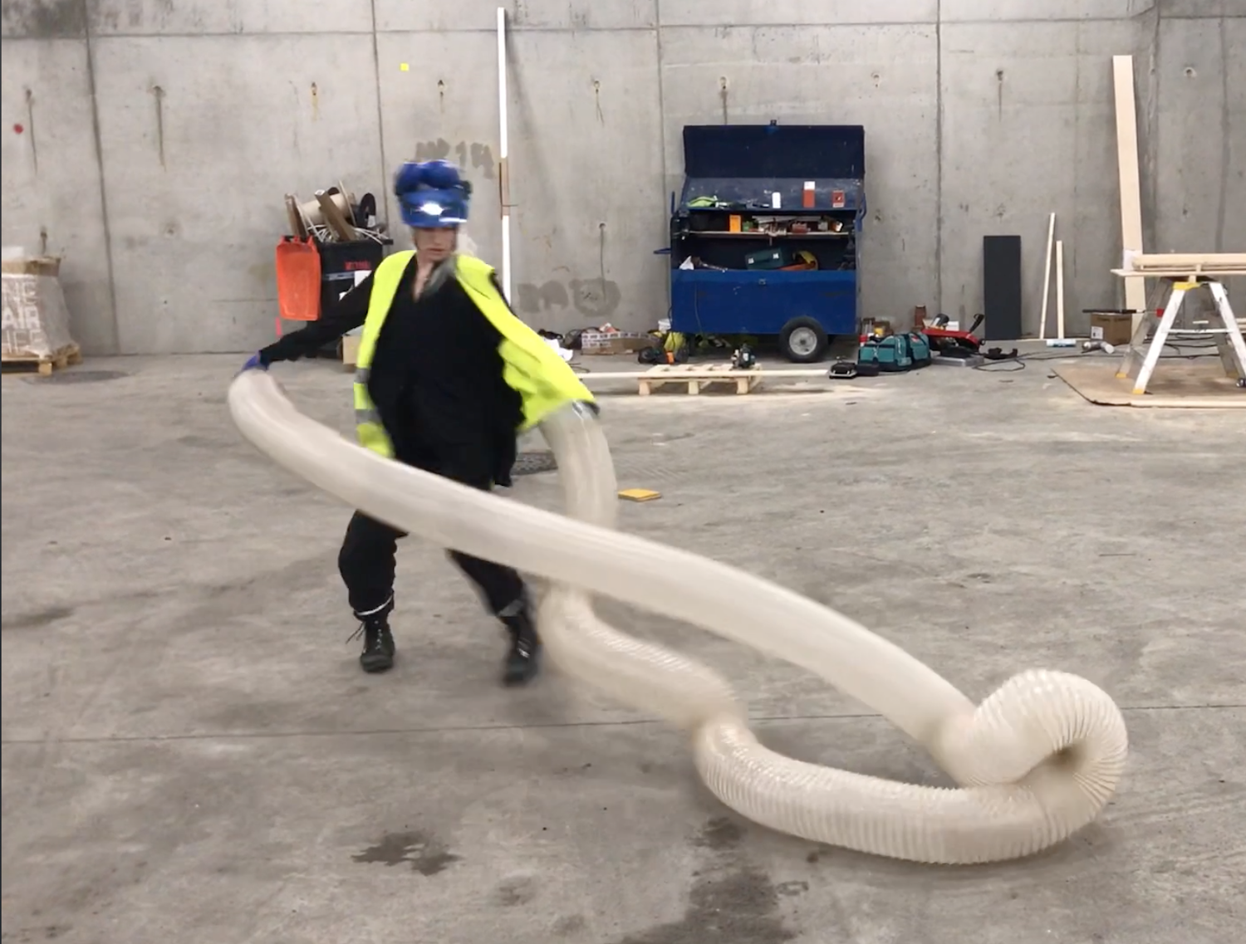

Fig. 2. A performer plays with an air supply pipe in the delivery zone as part of the Memory Machines tour. (Photo: Ilari Laamanen.)

The extended media of cultural institutions are the foci of the tours: to make sense, by artistic methods, of the architectures and infrastructures of cultural memory, we followed their embodied, performative, laboring ecologies in which the hidden aspects of such work takes place. Drawing on the performance tours, our argument begins by following the interfaces of these infrastructures down to their very being; tracing flows of heat, energy and data from their carefully aestheticized outward appearances to the (sometimes) brutal yet robust machines that form the bedrock of the library’s infrastructure. By singling out infrastructural elements and treating them as “flat” interfaces to be excavated, the tour enables an appreciation of the multiple volumes, spaces and depth of infrastructures.

Depth is often obscured or flattened by design and most of what is functional or technical is concealed by the prevailing aesthetics of appearance or style. The Centre Pompidou (1977) is one of the few cultural buildings where technical services are displayed like precious ornaments, its famous facade draped in pipes and ducts. Circulation systems are woven along the building envelope, wrapping it in a continuous flow of human bodies while the structural systems including columns, beams and floors are visible throughout. Its machine rooms are like crowns, perched on its roof. It is a building that is (infrastructurally) legible---reading its infrastructure tells us how it performs: “The building is inside out, making it both technically easier to adapt, clip on or remove components, and giv[es] the building scale, transparency and movement” [8,9].

The new Oodi works differently than the Pompidou. There is nothing on the facade hinting at the presence of the distributed HVAC system, the twin electrical transformers or the structural systems like the transverse steel beams, 2 meters tall, running the length of the building on which one could walk from end to end. Things that are so evident on the elevations of the Pompidou are concealed within Oodi's curvy folds; it masquerades as a sculptural object, placed within Citizen’s Park in Helsinki's cultural building district.

Oodi's carefully constructed façade denies all relations to its sustenance, and the energy-intensive infrastructures that power the building are concealed in its basement and hidden floors. This is the conundrum of the aesthetics of contemporary architecture and infrastructure: condemned to visibility and invisibility at the same time. To unravel the ecologies of its energies and infrastructure, one is forced to venture into expert territory.

<1> Performance Space: Infrastructural Methodologies

The audience is led to an HVAC room. Inside, a monumental steel entity squats in the middle of the space. It is one of the climate control machines of the library. The surface of the machine is covered with meters, switches, knobs and hatches. A performer is reading a book while sitting on top of a nearby panel. He hops down from his perch to join another performer; both lead the audience around the machine, pointing at different controls and glass peep-holes through which one is able to see a myriad of high-speed fans moving the air within.

Engaging the Oodi library through performance emerged from the pedagogical realization that it is difficult to discuss infrastructure in a classroom. The performance wanted to convey what lies behind, under and beyond the sprinkler-head or web router: as interfaces they are useful in identifying points of entry to abstract and invisible yet material worlds of infrastructures and megastructures.

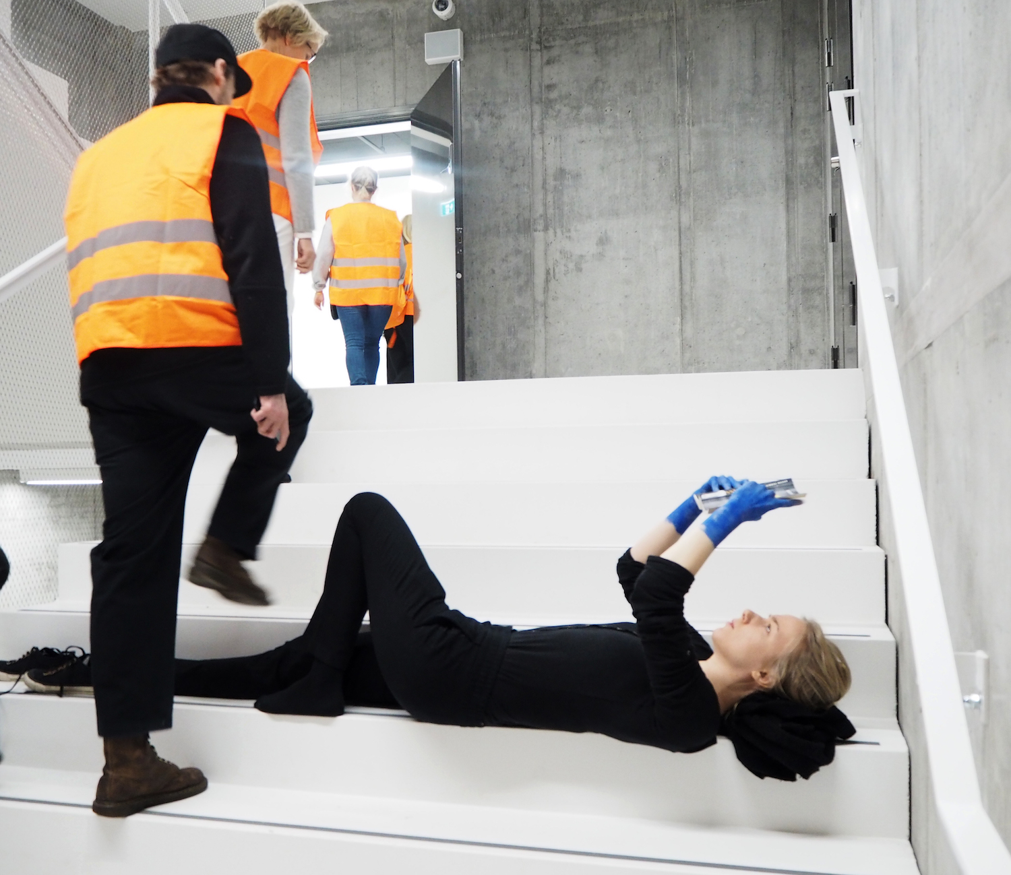

Fig. 3. The touring audience steps over a performer inside a stairwell. (Photo: Laura Boxberg.)

While two-dimensional surfaces play a central role in the cultural techniques of design and architecture [10], infrastructural proliferation happens in particular spaces and temporal contexts that add further layers of embodied complexity to any instance of their actualization. This is present in current examples of mapping complex systems, such as the “Anatomy of an AI system” [11] which implies other layers of reality, formative of the large-scale megastructures behind visible interfaces [12]. While such an exercise of mapping the supply-chains, dependencies and affordances of AI is insightful, we wanted to map the lived abstractions [13] of infrastructure.

Walking tours as a research and artistic method allow movement to become a means by which to map such lived abstractions, materiality and perception of places not evident in popular culture (such as sites of storage and transmission). But such maps and diagrams also “run the risk of reifying and essentializing information, even depoliticizing it” [14]. This is why the mere aesthetics of wires and cables remains an insufficient entry point to the political significance of infrastructure. Mattern (ibid.) suggests we expand our gaze when investigating infrastructures of data to the “human, institutional, and technological creators, its curators, its preservers, its owners and brokers, its “users,” its hackers and critics” [15]. We argue this also applies to energy, heat and other infrastructures [16].

Mattern’s point implies a shift in focus from objects to their relations, from infrastructural hardware to how they activate particular processes, how they connect with multiple levels of infrastructure outside the building, and how these connect and enact an ecology of relations. We need to look not only at the infrastructural object, but its processes, witness the personnel and bodies who operate them, handle the protocols and instruction manuals, tread upon the sites they inhabit, and experience the ecologies within which they function. The intellectual labor of a library is always sustained by manual labor which offers a longer historical view to automated systems, one that incorporates human and technological parts [17].

<1> Infrastructural Immersion and the Multi-sensorial

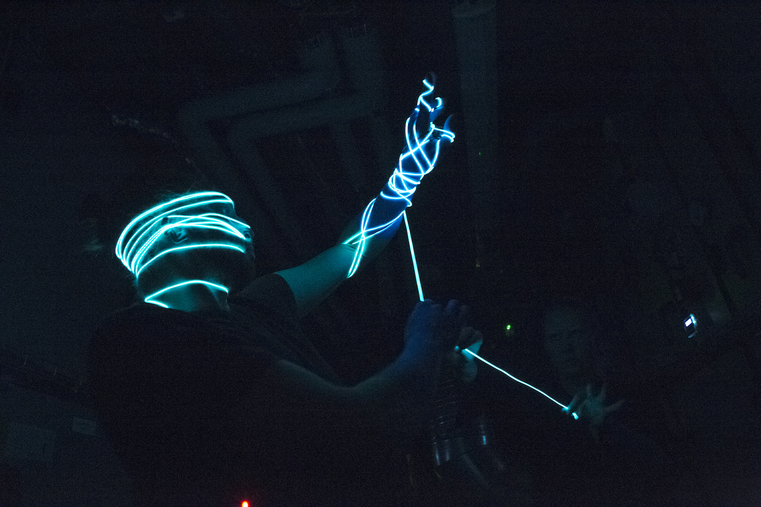

Fig. 4. A light and sound performance during Memory Machines in one of the mechanical rooms. (Photo: Juuso Noronkoski.)

While we collaborated with the Helsinki-based 00100 Ensemble, known for their immersive performances, we are aware of other performance-based explorations of used and unused urban spaces. For example, Sleep No More, a production by Punchdrunk, has been running for several years in adjoining warehouses in New York. In their non-linear performances participants explore various floors, rooms, cabinets of curiosities, etc., where costumed actors and dancers are engaged in a script: it is an immersive exploration of a Shakespearean world brushed with strokes of film noir [18] and it is a spatial exploration, catalyzing vertical and horizontal movement between architecture and period-based interiors, objects and artifacts, and interactions between audience members. Sleep No More presents a prototype of a set of methods that could be tuned to site-specific explorations, to investigate how sites are occupied in order to exhibit machines and convey knowledge and practices.

Sleep No More is set in a fictional hotel: it does not respond to the site’s history or context. This is the same issue that arises with other examples of immersive theater, including Shunt’s Tropicana. Held underneath the London Bridge Station, Tropicana creates the illusion of a descent into the city’s subterranean infrastructure. As White (2012) remarks: “To be immersed is to be surrounded, enveloped, and potentially annihilated, but it also is to be separate from that which immerses” [19].

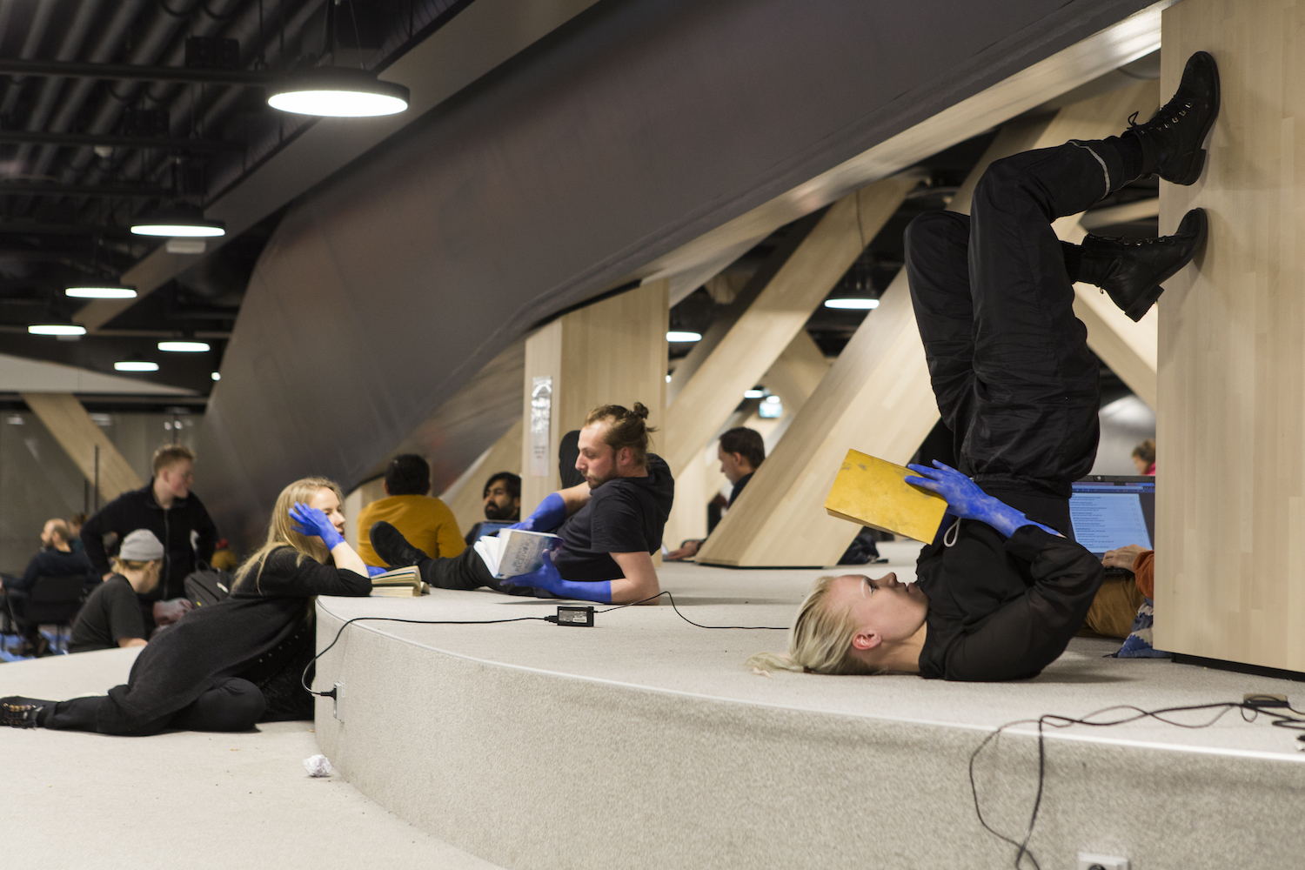

Fig. 5. A performance in Oodi's amphitheater. (Photo: Juuso Noronkoski.)

If one of the main takeaways from immersive theater is how the audience engages with the on-site experience of the body, then how are meanings generated via performative actions and spatial relations? Hence, our question: how can we develop an art method that investigates infrastructure through immersive theater while maintaining awareness of its potential shortcomings? Immersion is multi-modal and allows for multi-sensory methods that speak to the aural, graphic, textual, electroacoustic, digital and haptic approaches to infrastructure [20]. Multi-sensory methods work particularly well in infrastructural research as they tease out the complexity of layered visibilities, invisibilities and other modalities of this reality and how it is entangled in performative socio-cultural-technical-economical systems [21]. Assuming infrastructures are constantly dynamic, time-critical entities on a large-scale, we propose that to understand them requires a multi-scalar and multi-disciplinary method: a kind of reverse-engineering. This methodological stance not only derives its sustenance from theory and its strength from the history of the site, it also allows one to approach infrastructure through human and other bodies.

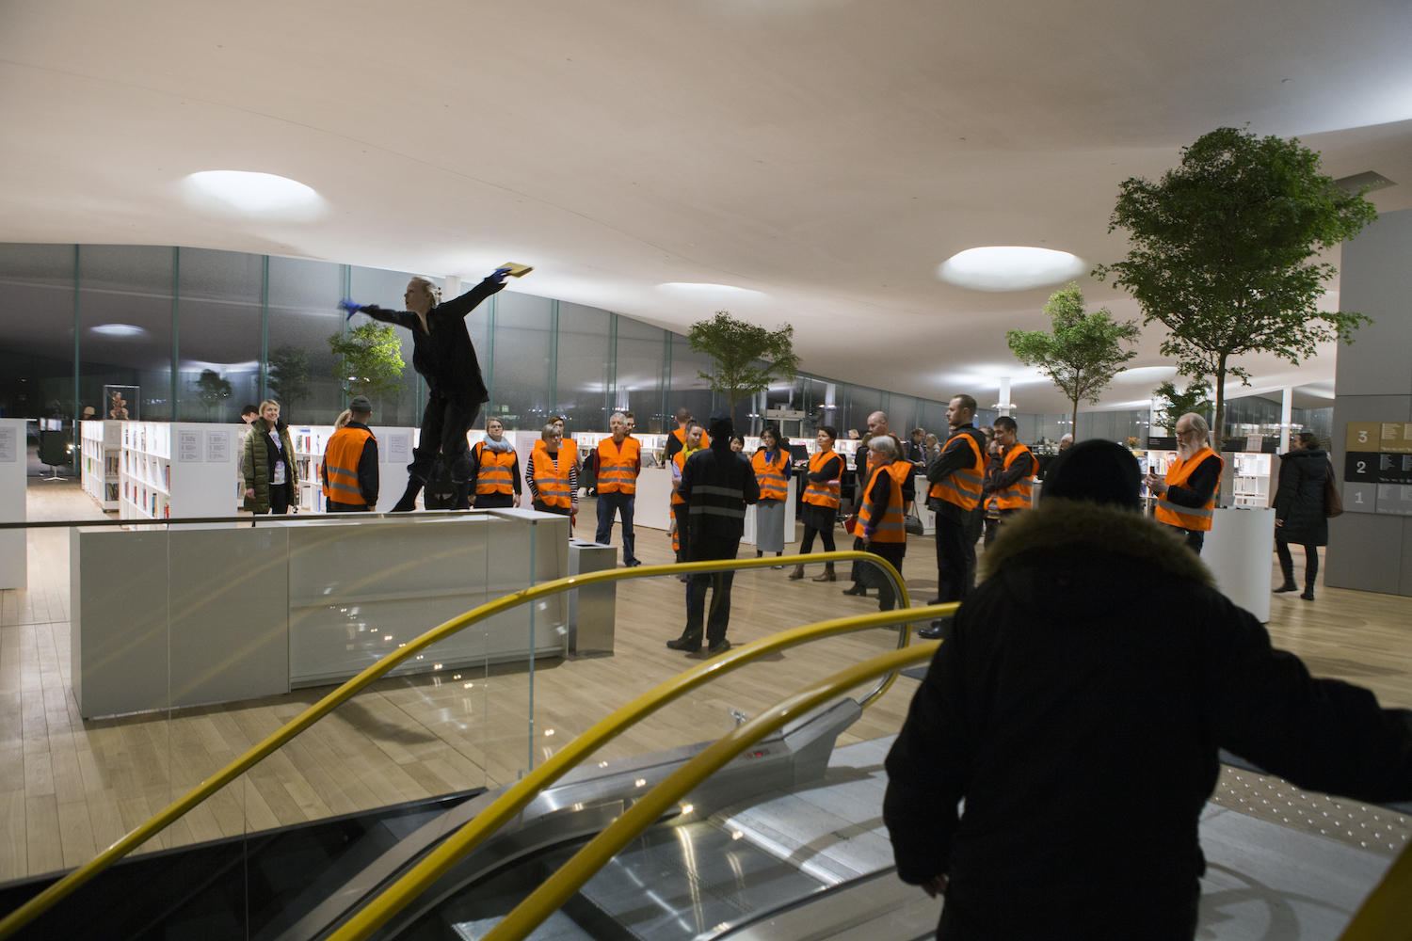

Fig. 6. A dance performance among the stacks in Oodi's Book Heaven. (Photo: Juuso Noronkoski.)

Memory Machines can be considered an experimental method: a lecture combined with a guided tour punctuated by immersive performances that bring academic topics to a broader set of post-studio environments with heterogeneous audiences. Enacted as a multi-sensorial journey through the infrastructure of the library, it involves an interplay between the performers, the audience, the machines and their processes. As one of the tour participants observes on his blog:

“A walk or a tour is a great format for a performance, because in motion groups begin to make sense of themselves as an organization. Our group stretched into a think belt [following] Bhowmik, like a fermented milk strain. People took their time to experience the site and [...] we could witness how the library-culture-factory performed with us. […] We formed a temporary co-agency with the site.” [22].

The impressions, realizations and arguments formed while moving through the site---from the mechanical spaces to the traditional library stacks, from the projector room to the sound studios and the maker labs---are central to experiencing its architecture and its machines and bodies through carefully selected media theoretical narratives and sequenced performances. Instead of visualizations or videos as lecture aids, the machinic processes and immersive performances are backdrops and catalysts to a moving narrative about automation, digitization, mechanization and thermocultures. The roaming classroom is operationalized into a ‘think-belt’ as it traverses and experiences the narrative that unfolds as the site performs its own processes.

<1> Library’s Other Intelligences: Conclusions

Narrator:
[…] The library has become a memory machine. The fine modulation and regulation of the architectural container comes into being with the balancing of natural light, heat, and humidity for various machines, objects and bodies. The flow of material-energy-data through the medium of the library becomes as significant as the flow of books and information. The message is of their materialities that affect the conception and preservation of cultural memory.

Towards the end of the tour, the speaker leads the audience to the attic, a landscape of concealed technics, machines and technologies above the reading hall. Here, electrical wiring, sound insulation, fire systems and network cables weave around the casings of Oodi's skylights. The audience moves through the attic on a wooden catwalk that traverses the length of the building, expecting performances to erupt, and yet, there are none. Instead they are confronted with only the dense heat and deep hum of the machines, who themselves have turned into performers.

In the midst of debates about smart cities and libraries, we must consider what forms of materiality---other than the vague “digital”---contribute to the technological infrastructures of contemporary culture. What alternative approaches to the media of automated systems allow us to appreciate and understand the hybrid status of these architectural intelligences? We can begin to answer this question through the other AIs that occupy architectural materials and cultural institutions, and the infrastructures that are a means by which to grasp the distributed nature of heat, energy, liquids and people. Automation does not begin with digital systems, but is part of the longer legacy of the technological institution that we call the library, and has for some time already acted much like a proto-computer, made of humans and machines, trolleys and address systems [23].

We are interested in the ‘deep times’ of the library and cultural institutions, and the performance tour interprets these architectural and infrastructural entities through a careful consideration of both human and non-human elements, linking academic discussions of infrastructure to contemporary art methods. While there exists extensive critical discourse on immersive theater in contemporary art and performance and the relations between artistic methodologies and pedagogy, Memory Machines probes new methods to uncover the library's and the cultural institution's inherent intelligences and futures, laying the groundwork for further research.

Acknowledgments
We would like to thank Hanna Tanskanen, Onni Hämäläinen and Sade Risku from 00100 Ensemble. Our gratitude to the Helsinki Central Library, Finnish Cultural Institute of New York and the Kone Foundation for their support. Finally, we thank Shannon Mattern (New School, New York) for her advice and guidance in the Memory Machines project.

Jussi Parikka’s research for this article has been supported by the Czech Science Foundation funded project 19-26865X "Operational Images and Visual Culture: Media Archaeological Investigations".

References and Notes
1. Jamie Allen, “Critical Infrastructure,” APRJA Post-Digital Research 3, No. 1 (2014), <www.aprja.net/?p=1677>, accessed 26 March 2016.
2. See project video at <vimeo.com/317268065>, accessed 26 June 2019; see architecture of Helsinki Central Library at <www.oodihelsinki.fi/en/what-is-oodi/architecture/>, accessed 26 June 2019.
3. This alliteration of AI into many alternatives of “artificial intelligence” discourse was used as a key curatorial theme and as part of the narrative of the Library's Other Intelligences exhibition, in general.
4. Jane Birkin, “Art, work, and archives: performativity and the techniques of production,” Archive Journal 5 (2015) pp. 1--14.
5. Liam Young, ed., “Machine Landscapes: Architectures of the Post-Anthropocene,” Architectural Design 89, No.1, 1--144, (2019).
6. Ingrid Burrington, Networks of New York: An Illustrated Field Guide (New York: Melville House, 2016).
7. Samir Bhowmik, Deep Time of the Museum/The Materiality of Media Infrastructures, PhD Thesis, Aalto University, 2016. See also: Samir Bhowmik, “Thermocultures of Memory,” Culture Machine 17, 1--20 (2019), <culturemachine.net>, accessed 21 March 2019.
8. Reyner Banham and John Partridge, Architectural Review, 2 March 2012 (1977), <www.architectural-review.com/buildings/may-1977-pompidou-cannot-be-perceived-as-anything-but-a-monument/8627187.article>, accessed 21 March 2019.
9. See Banham [8].
10. Bernhard Siegert, Cultural Techniques. Grids, Filters, Doors, and Other Articulations of the Real, trans. Geoffrey Winthrop-Young (New York: Fordham University Press, 2015) pp. 121--146.
11. Kate Crawford and Vladan Joler, “The Anatomy of an AI System,” ShareLab and AI Now Institute, 2018, <anatomyof.ai>, accessed 21 March 2019.
12. Benjamin Bratton, “Can the Bot Speak? The Paranoid Voice in Conversational UI,” in Across and Beyond. A Transmediale Reader on Postdigital Practices, Concepts, and Institutions, eds. Ryan Bishop, Kristoffer Gansing, Jussi Parikka and Elvia Wilk (Berlin: Sternberg Press, 2016), pp. 306--324.
13. Brian Massumi, Semblance and Event. Activist Philosophy and the Occurrent Arts (Cambridge, MA: The MIT Press, 2011).
14. Shannon Mattern, “The City is not a Computer,” Places Journal, February 2017, <placesjournal.org/article/a-city-is-not-a-computer/>, accessed 20 March 2019. See also Mattern, “Infrastructural Tourism,” Places Journal, July 2013, <placesjournal.org/article/infrastructural-tourism/>, accessed 25 March 2019.
15. See Mattern [14].
16. According to Starosielski, heat exchanges are not confined to communications systems, but move across and through infrastructure, ecologies and bodies. See Nicole Starosielski, “The Materiality of Media Heat,” International Journal of Communication 8, 2504--25083 (2014).
17. Markus Krajewski, The Server: A Media History from the Present to the Baroque, trans. Ilinca Iurascu (New Haven: Yale University Press, 2018).
18. Sebastian Chan, “On Sleep No More, Magic and Immersive Storytelling,” Fresh and New(er), 23 May 2012, <www.freshandnew.org/2012/05/sleep-more-magic-immersive-storytelling/>, accessed 20 March 2019.
19. Gareth White, “On Immersive Theatre,” Theatre Research International 37, No. 3, 221--235 (2012).
20. Shannon Mattern, Code and Clay, Data and Dirt: Five Thousand Years of Urban Mediation (Minneapolis: University of Minnesota Press, 2017).
21. Lisa Parks, “Mediating Animal-Infrastructure Relations,” a keynote lecture at Transmediale 2017 Festival, Berlin, February 2017.
22. Eero Yli-Vakkuri, “20190118,” Doc & Art, 18 January 2019, <eero.storijapan.net/docfolio/20190118-2/>, accessed 27 January 2019.
23. Jussi Parikka, “Situated Data: On Art Methods, Cultural Institutions and Infrastructure,” MediArXiv, 22 February 2019 <doi:10.31219/osf.io/2ar4n>, accessed 20 March 2019.

Bibliographical Information
Samir Bhowmik is an artist, architect and researcher. He received a PhD in Art and Design from Aalto University, Finland and holds a Master of Architecture from the University of Maryland, United States.

Jussi Parikka is Professor in Technological Culture and Aesthetics at Winchester School of Art (University of Southampton). He is also a visiting scholar and project leader at FAMU, Academy of Performing Arts, Prague.

