Vulnerable road users in low-, middle-, and high-income countries: Validation of a Pedestrian Behaviour Questionnaire
McIlroy, R.C., Plant, K.A., Jikyong, U., Nam, V.H., Bunyasi, B., Kokwaro, G.O., Wu, J., Hoque, M.S., Preston, J.M., & Stanton, N.A.

Abstract
The primary aim of this study was to validate the short version of a Pedestrian Behaviour Questionnaire across six culturally and economically distinct countries; Bangladesh, China, Kenya, Thailand, the UK, and Vietnam. The questionnaire comprised 20 items that asked respondents to rate the extent to which they perform certain types of pedestrian behaviours, with each behaviour belonging to one of five categories identified in previous literature; violations, errors, lapses, aggressive behaviours, and positive behaviours. The sample consisted of 3423 respondents across the six countries. Confirmatory factor analysis was used to assess the fit of the data to the five-factor structure, and a four-factor structure in which violations and errors were combined into one factor (seen elsewhere in the literature). For some items, factor loadings were unacceptably low, internal reliability was low for two of the sub-scales, and model fit indices were generally unacceptable for both models. As such, only the violations, lapses, and aggressions sub-scales were retained (those with acceptable reliability and factor loadings), and the three-factor model tested. Although results suggest that the violations sub-scale may need additional attention, the three-factor solution showed the best fit to the data. The resulting 12-item scale is discussed with regards to country differences, and with respect to its utility as a research tool in cross-cultural studies of road user behaviour.

Introduction
In the UK, huge improvements in road safety have been made over the past 30 years; however, since 2010, fatality figures have changed little (DfT, 2018). Although the global road safety picture appears to be improving when considered in terms of the injury and fatality rates per 10,000 motorised vehicles (e.g., WHO, 2018), continued increases in the motorisation of low- and middle-income countries (LMICs; e.g., Sustainable Mobility for All, 2017) has meant that the number of people killed on the roads each year is increasing (GRSF & IHME, 2014; WHO, 2018).
Vulnerable road users, of whom pedestrians represent the majority, are over-represented in national and global accident statistics (e.g., WHO, 2018). Those that use the world’s road systems on foot account for 35% of road injury deaths; in East and Central Sub-Saharan Africa, over 50% of road fatalities are pedestrians (GRSF & IHME, 2014). In 2016 in the UK, a country with one of the safest road systems in the world, 448 pedestrians were killed on the roads, a 10% increase on 2015; measured in deaths per billion passenger miles (i.e., in terms of exposure), the pedestrian fatality rate is second only to that of motorcyclists (DfT, 2018). Building an understanding of pedestrian behaviour is therefore a necessary precursor to any successful national or global road safety strategy.
There have, of course, been many attempts to observe and understand pedestrian behaviour in different situations. These have used a variety of methods, including virtual reality laboratory studies (e.g., Tapiro et al. 2016; 2018), travel diary and location data (e.g., Quistberg et al. 2017), road traffic collision data (e.g., Obeng-Atuah et al. 2017), vehicle-based video recordings (e.g., Jha et al. 2017), and, most commonly, static video recordings and direct observations (e.g., Alhajyaseen & Iryo-Asano, 2017; Brosseau et al 2013; Hamman et al., 2017; Koh et al. 2014; Larue et al. 2018; Pešić et al. 2016; Read et al. 2018; Shaaban et al. 2018; Zhuang et al. 2018). It has been suggested, however, that these methods give results that are not readily generalisable beyond the context in which the data was gathered (Granié et al. 2013). Hence the use of self-report questionnaires.
There are myriad examples in the extant literature of the use of questionnaires in studies of pedestrian behaviour around the globe. Recent contributions include Holm et al.’s (2018) investigation of 6th grade children in Estonia; Koekemoer et al.’s (2017) study of children’s knowledge and behaviour in Cape Town; Lennon et al.’s (2017) work on mobile phone use while walking in Australia, and; Oviedo-Trespalacios and Scott-Parker’s (2017) research on footbridge use in Barranquilla, Colombia (to name just a few). Most studies have not, however, attempted to classify the various pedestrian behaviours into a system of behavioural factors. It is also less common to see an agreed upon framework for the measurement of pedestrian behaviour, in particular the propensity to perform risky behaviours. Such frameworks have a relatively long history in driving research, the most well-known being Reason et al.’s (1990) Driver Behaviour Questionnaire (DBQ).
The DBQ sought to classify on-road violations in line with both Reason and Norman’s work in the wider field of human error (Norman, 1983; Reason, 1990), and with Jens Rasmussen’s work on human performance levels (Rasmussen, 1983). In this underlying literature, ‘errors’ are sub-divided into a number of categories; ‘mistakes’ refer to a situation in which an intended action is performed successfully, but is not the right action for that situation (i.e., correct execution, failure in intention); ‘slips’ and ‘lapses’ refer to situations where the correct action is chosen, but is performed unsuccessfully (i.e., correct intention, failure in execution), the difference being that ‘slips’ are related to attention failure, while ‘lapses’ are more related to memory failure. In Reason et al.’s (1990) discussions on driver behaviour, attention was drawn primarily to the differences between two main categories of risky driver behaviour; violations (i.e., intentional actions) and errors (i.e., unintentional actions).
The DBQ has received a significant amount of use since its first description almost thirty years ago, across a wide variety of nations and cultures (see de Winter and Dodou, 2010, for review of 174 studies); however, not all members of a population are car drivers, particularly in low- and middle-income countries, where car ownership is far less common. Research on use of the road system that only takes into account driver behaviour may not be as useful in these settings, as it can only capture a relatively small, predominantly wealthy sub-section of society. Almost all adult members of a population will, at some point and to a greater or lesser extent, interact with the road system as a pedestrian. Similar work can therefore be undertaken into pedestrian behaviour, and be useful in low- and middle-income setting. Such research is, however, far less abundant, with the first attempt (to our knowledge) reported by Moyano Díaz and colleagues (Moyano Díaz et al. 1997; Moyano Díaz, 1997; 2002). They developed a questionnaire that separated aberrant pedestrian behaviour into what they termed ‘violations’, ‘errors’, and ‘lapses’ in their home country of Chile, suggesting that pedestrian behaviour was at least in part responsible for the high accident rates seen at that time (Moyano Díaz, 2002). The measure was then validated in Turkey (Yıldırım, 2007) and Brazil (Torquato & Bianchi, 2010).
In the UK, around a similar time as Moyano Díaz and colleagues were developing their scale, Evans and Norman (2003) were investigating the behaviours of adolescents. Through Elliott and Baughan (2004) this work grew into the Adolescent Road User Behaviour Questionnaire (ARBQ), a questionnaire expressly based on Reason et al.’s (1990) DBQ. Elliot and Baughan (2004) undertook their research in England; the tool has subsequently been applied in France (Abou et al. 2008), New Zealand (Sullman & Mann, 2009), Spain (Sullman et al. 2011), Belgium (Sullman et al. 2012), and Iran (Nabipour et al. 2015).
To bring these research strands together, Granié and colleagues developed what they termed the ‘Pedestrian Behaviour Scale’ (Granié et al. 2013). One aim of the work was to adapt the ARBQ for use with people of all ages (Granié 2008; 2009) and for pedestrians only (the ARBQ included questions on cycling). Moreover, although the ARBQ differentiated between violations and mistakes (i.e., intentional rule breaking and mistaken rule breaking), Granié et al. (2013) argued that it did not allow for a distinction between what they termed ‘errors’ and ‘lapses’; the first being “failures in intent, ill-suited to the situation” (p. 831), the second being “involuntary deviations in the action, ill-suited to the original intent” (p.831). The other primary aim of the work was to build upon and validate, in a western context, work done by Moyano Díaz (2002), Yıldırım (2007), and Torquato and Bianchi (2010). In addition to items from scales developed by Moyano Díaz (2002) and Elliott and Baughan (2004), Granié et al.’s Pedestrian Behaviour Scale included items based directly on the DBQ (Reason et al. 1990), on Lawton et al.’s (1997) work on aggressive driver behaviours, and on Özkan and Lajunen’s (2005) measures of positive driver behaviours.
The scale tested by Granié et al. (2013) included 47 items that had respondents indicating, on a six-point Likert scale, the frequency with which they performed given injury risk behaviours when interacting with the road system as a pedestrian. Their factor analysis resulted in four axes; transgressions (including legal offences and errors), lapses, aggressive behaviour, and positive behaviour. Those questions that loaded most strongly onto the each of the four factors were singled out and compiled to make a shorter, 20-item version; this was also found to have high internal reliability (Granié et al. 2013). Modified versions of the short scale have subsequently been used in Turkey (without positive behaviours included; Nordfjærn & Şimşekoğlu, 2013; Şimşekoğlu, 2015), Greece (with a five-point scale rather than six; Papadimitriou et al. 2016), Iran and Pakistan (using Granié et al.’s groupings, with positive behaviours removed; Nordfjærn & Zavareh, 2016), Serbia (Antić et al. 2016), and China (combining modifications made in the aforementioned Turkish studies with Granié et al.’s original work; Qu et al. 2016).
In all of these examples it was a modified version of the short version of the questionnaire that was used. None compared with the original, long version, nor used the same factors as Granié et al. (2013). To address this gap, and to validate the tool in a North American setting, Deb et al. (2017) surveyed 425 members of the US population with the long version of the questionnaire, calling it the Pedestrian Behaviour Questionnaire (PBQ); it is this term that we shall use henceforth. The researchers found that the PBQ differentiated risky pedestrian behaviour into five categories; violations (intentional deviation from social rules), errors (intentional actions resulting from deficiency in knowledge of the rules), lapses (unintentional deviation from rules due to attention failure), aggressive behaviours, and positive behaviours. The short version used four items to measure each of the five factors, and was also found to be both reliable and valid for all factors except positive behaviours (which it was argued requires additional work). Results from Deb et al. (2017) largely corresponded with those reported by Granié et al. (2013) with the exception that in Deb et al., violations and errors were separated into two factors, whereas in Granié et al. they had been combined into one factor, ‘transgressions’.
The current study builds upon this body of work, using the 20-item Pedestrian Behaviour Questionnaire (PBQ) described by Deb et al. (2017). The aims of this study are twofold; first, to test the factor structure of the short PBQ in settings different to those already seen in the literature, and second, to investigate differences between the self-reported pedestrian behaviours of respondents in Bangladesh, China, Kenya, the UK, Thailand, and Vietnam. In terms of pedestrian behaviour, Nordfjærn and Zavareh (2016) present, to our knowledge, the only cross-cultural comparison; they found respondents in Pakistan (a country with a less ‘safe’ road system) to score higher on attention violations and aggressive behaviours, and respondents in Iran (with a more ‘safe’ road system) to score higher on transgressions (i.e., intentional rule violations). Results are similar in the driver behaviour domain; Özkan et al. (2006) looked at differences across six countries, finding that those from “safe” Northern and Western European countries scored higher on ordinary violations (intentional rule breaking), while those from “dangerous” Southern European and Middle Eastern countries scored higher on aggressive violations and errors (unintentional risky behaviours).
The countries included in the present study represent a relatively wide array of “safety”, at least in terms of the accident statistics reported by the World Health Organisation (WHO, 2018; see Table 1, below). Given the literature outlined above, we hypothesise that those from countries with more dangerous road systems will report performing fewer intentional rule violations but more aggressive behaviours and unintentional risky behaviours than those from countries with safer road systems.
An additional aim of the current research was to assess the relationship PBQ results have with self-reported, past involvement in on-road accidents, and with age and gender. Deb et al. (2017) found relationships between intentional rule violations and previous crash involvement, while a whole host of research links DBQ results with past involvement in accidents (see de Winter & Dodou, 2010). Given these results, and results closely linking risky behaviour as a driver and as a pedestrian (Şimşekoğlu, 2015), we hypothesise that those that report having been involved in on-road accidents in the past will also report performing more risky on-road behaviours as a pedestrian. Regarding age and gender, there is extensive literature suggesting that males over females, and younger individual over older individuals, are more likely to perform, and report performing riskier behaviours (e.g., Byrnes et al. 1999; Steinberg, 2008). As such, we hypothesise that males will score more highly on the PBQ than females, and that younger age groups will score more highly than older age groups.

Setting
The research presented in this article represents one aspect of a larger project that takes a sociotechnical perspective of global road safety, specifically focussing on road safety in low- and middle-income countries (see NIHR, 2017). The project involves researchers from universities in Bangladesh, China, Kenya, the UK, and Vietnam, and an additional researcher from Thailand. These countries have diverse cultural, geographical, political, and economic backgrounds, and distinctly unique road safety landscapes, with different types and volumes of road users, different motorisation levels, and different fatality and injury rates.

Table 1. Summary of WHO (2018) estimated fatality rates by population and by motorisation for countries involved in the research.
 | Bangladesh | China | Kenya | Thailand | UK | Vietnam
Fatality rate per 10,000 vehicles | 86.7 | 8.7 | 45.2 | 6.0 | 0.53 | 4.9
Fatality rate per 100,000 population | 15.3 | 18.2 | 27.8 | 32.7 | 3.1 | 26.4
Notes: All data come from WHO (2018) and are for the year 2016. ‘Vehicles’ include motorised two- and three-wheelers, cars and four-wheeled light vehicles, trucks, buses, and other motorised vehicles (WHO, 2018).

The UK has a long road safety research history, and was the original context in which Reason et al.’s (1990) DBQ was developed. It was also the context for the development of Elliot and Baughan’s (2004) ARBQ, on which the PBQ is partly based. As aforementioned, Qu et al. (2016) applied a modified version of the PBQ in a Chinese setting. To our knowledge there have been no such studies in Bangladesh, Kenya, Vietnam, or Thailand, and no studies comparing results across these countries.

Method

Survey instrument
The PBQ used in this study was part of a larger survey comprising sections on demographics, transport choices and experience, attitudes to traffic safety, beliefs, and (of interest here) self-reported pedestrian behaviours. The PBQ section began by stating:
By making a mark in one of the boxes under the headings, from ‘extremely infrequently or never’ to ‘extremely often or always’, please indicate how often you would do the following as a pedestrian
Then followed presentation of the 20 items (see Table 4, below). In Deb et al.’s 20-item version, one of the questions refers to crossing a road when the pedestrian light is red. This is not a violation of law in many countries, and is not appropriate in countries where pedestrian traffic lights are very uncommon and very rarely found to be fully functional (e.g., in Bangladesh or Kenya). As such, following discussions with researchers in the countries involved, this question was exchanged with another (from the larger set described by Deb et al. 2017) that concerns the non-use of pedestrian footbridges or underpasses, a common theme in many low- and middle-income countries. Like Granié et al. and Deb et al., a six-point Likert scale was used to record respondents’ responses (from ‘extremely infrequently or never’ to ‘extremely frequently or always’). Respondents were also asked a number of demographic questions (including age and gender) and were asked ‘Have you, as any type of road user (e.g., pedestrian, cyclist, driver, etc.), ever been involved in an accident on the roads where anyone (you or someone else) was injured badly enough to need to go to hospital?’, with three possible responses: ‘No, never’, ‘Once’, and ‘More than once’.
For use in non-English speaking areas, translation of the survey items was carried out in accordance with Brislin (1970). The questionnaire was first developed in English. It was then translated by native speakers of the target language into Swahili, Bengali, Chinese, Thai, and Vietnamese. The non-English translation was then translated back to English by a different bi-lingual individual. The two English versions were then compared and discussed between researchers in the UK and in the non-English speaking country. Any inconsistencies were worked out until a satisfactory translation was attained.

Survey administration
The collection of data proceeded in different ways in the different countries. In the UK, the questionnaire was administered online and on paper. For the online version, the University of Southampton’s iSurvey platform was used. A link was sent out using social media, passed on through people known to the researchers, and advertised through a wide variety of online forums and groups (including, but not unlimited to, road user, local community, and professional groups). The online questionnaire was available from April to September, 2018. Paper-based questionnaires were obtained via convenience sampling; researchers went to commercial centres in and around the UK city of Southampton and handed out surveys to willing passers-by, and to shops and cafés for staff members and customers to complete. Empty questionnaires were also left with shop and café staff members, and completed ones collected on later visits to those places. All paper based questionnaires were distributed and collected between June and August, 2018.
In Bangladesh, all responses were collected using a paper-based version of the questionnaire. Responses were collected from 13 different districts outside of Dhaka, and from within Dhaka city itself. Respondents were given questionnaires which were either completed in the presence of an enumerator or completed and collected at a later date, or the individuals were interviewed, with the researcher marking answers on the paper forms for the respondent (in cases where participants were illiterate or simply desired for it to be undertaken this way). Data collection outside Dhaka city took place between March and April, 2018. In the city, data collection took place between August and September, 2018.
In China the survey was hosted on the Wenjuanxing online survey platform (www.wjx.cn) and the link advertised through social media and through the wjx platform itself. All respondents completed the questionnaire online, and all data were collected between April and September, 2018. Similarly in Thailand only online questionnaires were used, again hosted using the University of Southampton’s iSurvey platform. A link to the survey was advertised on social media, both in public access and closed groups, with data collection continuing from May to July, 2018.
In Kenya, online and paper versions of the questionnaire were used. All paper versions were collected in Nairobi city. Students and employees of Strathmore University were approached and briefed on the project. They were given either hard copies of the questionnaire and asked to return them once complete, or were given access to online questionnaires. A link to the online version was advertised using social media. All data were collected between April and September, 2018.
In Vietnam, all responses were recorded using paper versions of the questionnaire. Researchers in Hanoi went out to public places and handed out questionnaires to passers-by. Researchers also gave questionnaires to their acquaintances to complete themselves, and to pass on to friends and family members. Individuals either completed the questionnaires themselves while the researcher waited, were ‘interviewed’ (i.e. questions read out to them, and responses recorded on paper by the researcher), or questionnaires were handed out to be taken away, and an appointment made for collection of the completed forms at a later date. Data were gathered from April to September, 2018.
The full survey (including sections not discussed in this article) took 15 to 20 minutes to complete. All participants provided fully informed consent, and ethical approval was sought from, and granted by the University of Southampton’s ethics board (ID: 40682). Additional ethical approval was sought from, and granted by the Strathmore University Ethics Committee and the National Commission for Science and Technology, in Kenya (ID: SU-IRB 0214/18). Participants were not paid for their time.

Participants
Across the six countries, 3467 responses were gathered; 695 in the UK (222 on paper, 473 online), 532 in Bangladesh (229 from rural areas, 303 from within Dhaka city), 544 in China, 544 in Kenya (250 on paper, 294 online), 317 in Thailand, and 835 in Vietnam. Data from 44 respondents had to be removed from the Kenya sample due to excessive numbers of missing items. Gender and age range splits for 3391 respondents are displayed in Table 2; of the 3423 sufficiently complete responses, 22 did not include answers to one or both of the age and gender questions, and to the gender question six respondents indicated ‘Prefer not to say’ (two in Thailand, four in the UK) and four marked the option ‘Other’ (one each in China and Thailand, two in the UK).
Due to technical problems, no data on crash involvement were recorded for any of the rural Bangladeshi sample (229 respondents), nor for the first 46 UK sample respondents. A further 85 participants, across all countries, did not answer the question. Data for the remaining 3063 respondents are summarised in Table 3.

Table 2. Age and gender characteristics of the samples from each of the six countries. Percentages are with respect to the total number of people in each country sample that both answered the age question and indicated identifying as male or female (rounded to the nearest full percentage point).
 |  | 18-24 | 25-34 | 35-44 | 45-54 | Over 54 | Total
Bangladesh | Male | 161 (30%) | 111 (21%) | 61 (11%) | 49 (9%) | 37 (7%) | 419 (79%)
 | Female | 55 (10%) | 29 (5%) | 10 (2%) | 12 (2%) | 7 (1%) | 113 (21%)
China | Male | 23 (4%) | 113 (21%) | 78 (14%) | 12 (2%) | 3 (<1%) | 229 (42%)
 | Female | 60 (11%) | 189 (35%) | 51 (9%) | 13 (2%) | 1 (<1%) | 314 (58%)
Kenya | Male | 159 (32%) | 48 (10%) | 16 (3%) | 5 (1%) | 5 (1%) | 233 (47%)
 | Female | 172 (34%) | 49 (10%) | 31 (6%) | 13 (3%) | 2 (<1%) | 267 (53%)
Thailand | Male | 6 (2%) | 46 (15%) | 31 (10%) | 11 (4%) | 25 (8%) | 119 (38%)
 | Female | 3 (1%) | 85 (27%) | 62 (20%) | 19 (6%) | 26 (8%) | 195 (62%)
UK | Male | 64 (10%) | 55 (8%) | 45 (7%) | 54 (8%) | 85 (13%) | 303 (45%)
 | Female | 103 (15%) | 116 (19%) | 47 (7%) | 45 (7%) | 53 (8%) | 364 (55%)
Vietnam | Male | 178 (21%) | 105 (13%) | 81 (10%) | 74 (9%) | 54 (6%) | 492 (59%)
 | Female | 80 (10%) | 89 (11%) | 77(9%) | 64 (8%) | 33 (4%) | 343 (41%)
Total | Male | 591 (17%) | 478 (14%) | 312 (9%) | 205 (6%) | 209 (6%) | 1795 (53%)
 | Female | 473 (14%) | 557 (16%) | 278 (8%) | 166 (5%) | 122 (4%) | 1596 (47%)
 | All | 1064 (31%) | 1035 (31%) | 590 (17%) | 371 (11%) | 331 (10%) | 3391

Table 3. Crash involvement responses by country. Percentages are with respect to the total number of people in each country that answered this question (rounded to the nearest full percentage point).
 | Never | Once | More than once | Total
Bangladesh | 141 (63%) | 58 (26%) | 25 (11%) | 224
China | 400 (74%) | 110 (20%) | 34 (6%) | 544
Kenya | 353 (71%) | 113 (23%) | 34 (7%) | 500
Thailand | 157 (50%) | 83 (26%) | 77 (24%) | 317
UK | 448 (70%) | 138 (21%) | 57 (9%) | 643
Vietnam | 502 (60%) | 187 (22%) | 146 (17%) | 835
Total | 2001 (65%) | 689 (22%) | 373 (12%) | 3063

Statistical treatment
Statistical analyses were performed using SPSS version 24 and AMOS version 24. To measure the reliability (or internal consistency) of each sub-scale, Cronbach’s Alpha values were calculated. Satisfactory values are generally accepted as 0.7 < α < 0.9 (e.g., Nunally, 1978; Tavakol & Dennick, 2011).
To assess the suitability of the factor structures confirmatory factor analysis (CFA) was undertaken. Cases with missing values were deleted listwise; as such, the CFA was conducted on data from 3355 respondents. Maximum likelihood estimation was used, in line with previous work (Granié et al. 2013; Deb et al. 2017). Following Deb et al.’s (2017) results, two model structures were assessed; a first-order model and a second-order model (Figures 1 and 2, below). We also tested the structure described by Granié et al. (2013), a model with four first-order factors (combining ‘Errors’ and ‘Violations’ into ‘Transgressions’; Figure 3). Just as was reported in Deb et al. (2017), modification indices were consulted to guide revision and refinement of the models. Following application of CFA on the data together as one sample, all country samples were then tested individually.
To assess model fit, there is no single index that is universally agreed to give a reliable measure across situations; the accepted advice is that multiple indices should be reported (Hooper et al. 2008). We therefore report the following indices (with threshold levels coming from Hooper et al.’s (2008) review); relative chi-square (x² / degrees of freedom) acceptable at less than three; Root Mean Square Error of Approximation (RMSEA), acceptable at less than .07; Comparative Fit Index (CFI) acceptable at over .95; Parsimonious CFI (PCFI) has no suggested threshold, with higher figures indicating better model fit; Tucker-Lewis Index (TLI; also known as the Non-Normed Fit Index; NNFI) acceptable at over .95; Adjusted Goodness-of-Fit Index (AGFI) acceptable at over .95; and Standardised Root Mean Square Residual (SRMR) acceptable and less than .08.
Convergent validity (using average variance extracted; AVE) and composite reliability (CR) were also assessed for Model Four (below), using all countries’ data. These measures give an indication of construct validity, i.e., the extent to which the factors are distinct and uncorrelated, and that items relate more to their own factor than to others. Generally, a CR of over 0.6 and an AVE of over 0.5 are considered acceptable (e.g., Hair et al. 2009).

Results
Table 4 displays the means and standard deviations for each of the 20 items included in the PBQ, clustered according to the behavioural categories described in Deb et al. (2017). Numbers on the left indicate the order in which items appeared in the questionnaire. Positive behaviour items (questions 1, 5, 6, and 20) were reverse-scored such that a high score indicates a less frequent exhibition of the behaviour, hence for all items, higher scores indicate riskier or more undesirable behaviours.

Table 4. Means and standard deviations of the PBQ items (How often do you…, score 1 to 6) and Cronbach’s alphas values for each original sub-scale for all countries together (All) and individually (Bd = Bangladesh, Ch = China, Ke = Kenya, Th = Thailand, UK = UK, Vn = Vietnam
 |  | M | SD
 | Positive Behaviours (α: All = .466, Bd = .398, Ch = .544, Ke = .484, Th = .378, UK = .521, Vn = .495)
1 | I thank a driver who stops to let me cross | 3.01 | 1.576
5 | When I am accompanied by other pedestrians, I walk in single file on narrow pavements so as not to bother the pedestrians I meet | 2.86 | 1.365
6 | I walk on the left-hand side of the pavement so as not to bother the pedestrians I meet | 2.89 | 1.433
20 | I let a car go by, even if I have the right-of-way, if there is no other vehicle behind it | 3.36 | 1.498
 | Errors (α: All = .580, Bd = .482, Ch = .681, Ke = .543, Th = .515, UK = .641, Vn = .642)
2 | I cross between vehicles stopped on the roadway in traffic jams | 3.52 | 1.354
8 | I cross even if vehicles are coming because I think they will stop for me | 2.20 | 1.264
11 | I walk on cycling paths when I could walk on the pavement | 2.12 | 1.231
18 | I run across the street without looking because I am in a hurry | 1.80 | 1.139
 | Violations (α: All = .689, Bd = .545, Ch = .812, Ke = .715, Th = .690, UK = .591, Vn = .716)
3 | I cross diagonally to save time | 2.94 | 1.414
4 | I cross outside the pedestrian crossing even if there is one (e.g., a crosswalk or zebra crossing) less than 50m away | 2.73 | 1.373
7 | I avoid using pedestrian bridges or underpasses for convenience, even if one is located nearby | 2.52 | 1.374
10 | I take passageways forbidden to pedestrians to save time | 1.93 | 1.234
 | Aggressive Behaviours (α: All = .785, Bd = .687, Ch = .887, Ke = .675, Th = .778, UK = .766, Vn = .858)
9 | I get angry with another road user (pedestrian, driver, cyclist, etc.), and I yell at them | 1.90 | 1.196
12 | I cross very slowly to annoy a driver | 1.50 | 1.006
14 | I get angry with another road user (pedestrian, driver, cyclist, etc.), and I make a hand gesture | 1.81 | 1.188
19 | I have gotten angry with a driver and hit their vehicle | 1.45 | .973
 | Lapses (α: All = .852, Bd = .843, Ch = .863, Ke = .835, Th = .842, UK = .867, Vn = .838)
13 | I realize that I have crossed several streets and intersections without paying attention to traffic | 2.10 | 1.237
15 | I forget to look before crossing because I am thinking about something else | 2.01 | 1.162
16 | I cross without looking because I am talking with someone | 1.91 | 1.110
17 | I forget to look before crossing because I want to join someone on the pavement on the other side | 1.83 | 1.143

PBQ Structure Validation
Following consultation of modification indices in CFA, error covariances were added between questions 3 and 4, 4 and 7, 9 and 14, and 15 and 16 for the three models initially tested (Models One and Two from Deb et al., Model Three from Granié et al.), reflecting similarities in question content and wording. In Model One (Figure 1) the ‘Errors’ sub-scale covaried to an unacceptable degree with ‘Violations’ and ‘Lapses’, hence the AMOS software returned a message stating that the solution was not admissible; nevertheless, model fit indices are presented for completeness. In Model Two (Figure 2), the error variance for the ‘Errors’ sub-scale had to be constrained at the lower bound. Following analysis using all data together, all country samples were then tested individually on the models (with the inclusion of the aforementioned error covariances, and the constraint on error variance for ‘Errors’ in Model Two); results are summarised in Table 5.

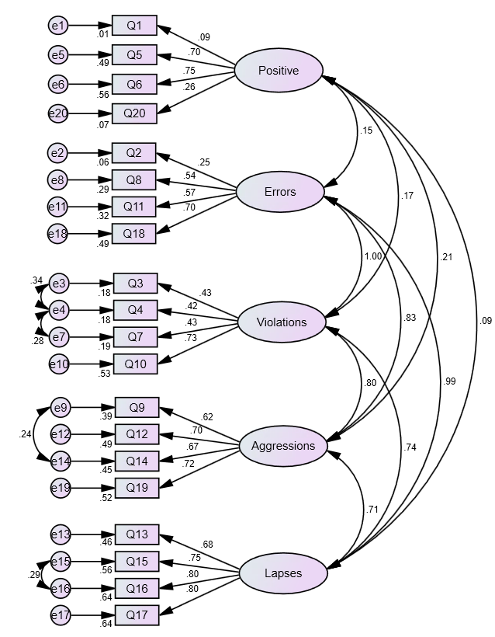
Figure 1. Standardised solution for Model One for data from all countries (see Table 5 for fit indices).
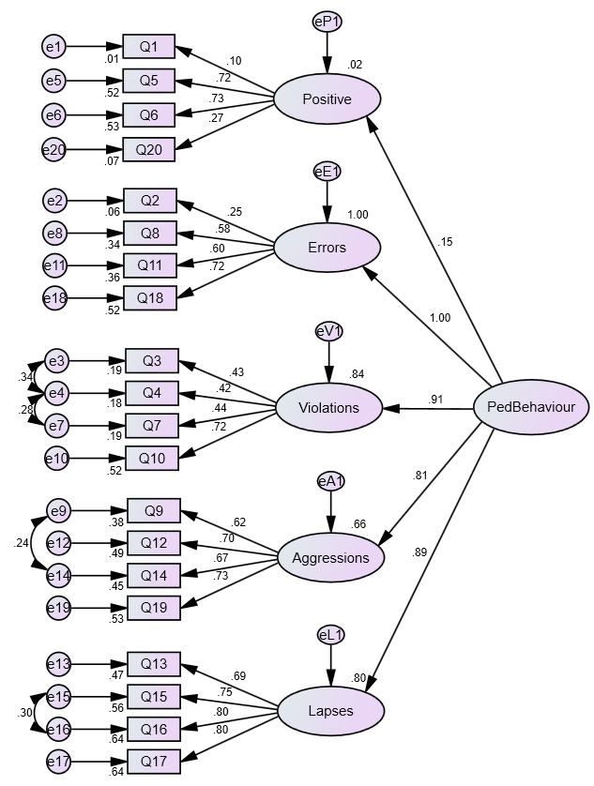
Figure 2. Standardised solution for Model Two (see Table 5 for fit indices).

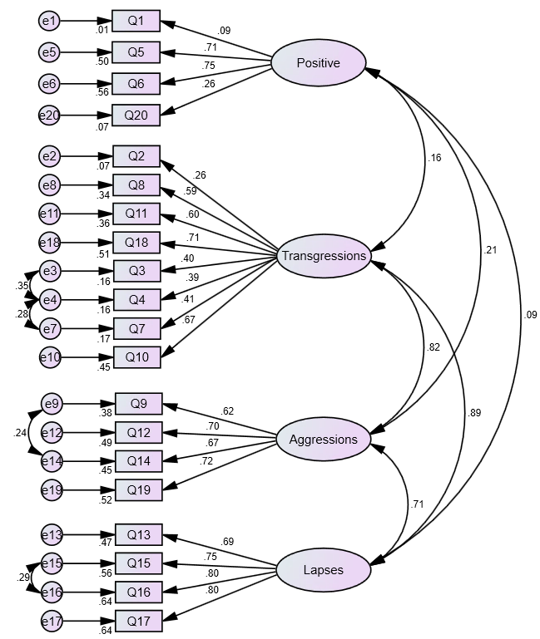
Figure 3. Standardised solution for Model Three (see Table 5 for fit indices).
Across all three models, many of the model fit indices (summarised in more detail in Table 5, below) and factor loadings were not acceptable. Furthermore, a very low standardised regression weight for ‘Positive Behaviours’ was found in Model Two (at .15), and it returned an unacceptably low Cronbach alpha value (at .466; Table 3). Given these results, the ‘Positive Behaviours’ scale was removed to create Model Four (see Figure 4).
Model Four therefore initially used a first-order factor structure. This model was inadmissible as the ‘Errors’ sub-scale co-varied to an unacceptably high degree with both ‘Violations’ and ‘Lapses’. Given similarities in question phrasing (i.e., many concerned with crossing the road without looking or in a hurry), the fact that question two returned a very low factor loading (.25; perhaps reflective of the reality in many urban settings, particularly in LMICs, that crossing between vehicles stopped in a traffic jam is the only way to cross the road, and therefore does not necessarily reflect an error), and the sub-scale’s low Cronbach’s alpha (at .580; Table 4), the ‘Errors’ factor was also removed. Model Four therefore consisted of twelve items, loading onto three first-order factors; ‘Violations’, ‘Aggressions’, and ‘Lapses’. Model Five (also in Figure 4) tested the same structure, with the addition of a second-order ‘Pedestrian Behaviour’ factor (similar to Model Two, above). As the models had three factors, they were just-identified, hence AMOS returned identical fit indices for both the first-order and the second-order solutions. It can be seen from Figure 4 that factor inter-correlations are high in Model Four, and loadings onto the second-order Pedestrian Behaviour factor are high in Model Five.

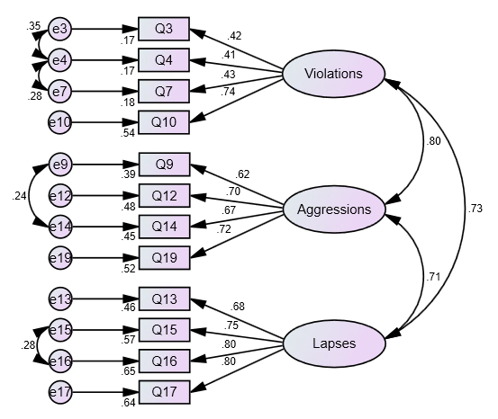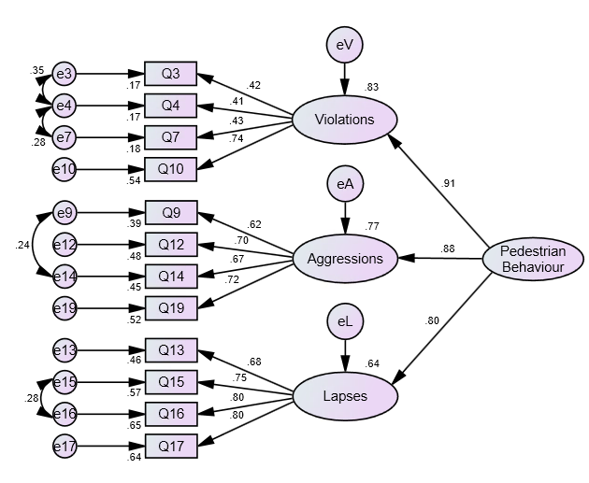
Figure 4. Standardised solutions for Models Four and Five for data from all countries; x²/df = 9.994, RMSEA = .052, CFI = .972, GFI = .977, df = 160.

Table 5. Summary of CFA results for the two models for all countries, together and individually
 |  | x²/df | RMSEA | CFI | PCFI | TLI | AGFI | SRMR
Model One: Five first-order factors (Deb et al. 2017)  df = 156 | All Countries | 16.320 | .068 | .897 | .736 | .874 | .900 | .0548
 | Bangladesh | 3.743 | .073 | .848 | .696 | .815 | .863 | .0644
 | China | 2.778 | .057 | .949 | .779 | .938 | .898 | .0454
 | Kenya | 3.740 | .074 | .862 | .707 | .831 | .849 | .0698
 | Thailand | 2.400 | .067 | .912 | .749 | .893 | .852 | .0634
 | UK | 5.875 | .087 | .850 | .698 | .817 | .837 | .0823
 | Vietnam | 7.441 | .088 | .855 | .702 | .823 | .817 | .0805
Model Two: One second-order, five first-order factors (Deb et al. 2017)  df = 162 | All Countries | 17.317 | .070 | .886 | .755 | .866 | .891 | .0568
 | Bangladesh | 3.781 | .073 | .840 | .716 | .812 | .857 | .0670
 | China | 3.024 | .061 | .940 | .801 | .929 | .889 | .0474
 | Kenya | 3.880 | .076 | .849 | .724 | .823 | .840 | .0718
 | Thailand | 2.486 | .069 | .903 | .770 | .886 | .848 | .0657
 | UK | 6.040 | .089 | .838 | .715 | .811 | .828 | .0822
 | Vietnam | 7.687 | .090 | .843 | .719 | .816 | .801 | .0824
Model Three: Four first-order factors  (Granié et al. 2013)  df = 160 | All Countries | 18.295 | .070 | .886 | .746 | .864 | .888 | .0562
 | Bangladesh | 3.805 | .073 | .841 | .708 | .811 | .855 | .0662
 | China | 3.028 | .061 | .940 | .792 | .929 | .890 | .0467
 | Kenya | 4.035 | .078 | .843 | .710 | .813 | .836 | .0716
 | Thailand | 2.527 | .070 | .901 | .759 | .883 | .842 | .0650
 | UK | 6.064 | .089 | .840 | .707 | .810 | .828 | .0817
 | Vietnam | 7.568 | .089 | .848 | .714 | .820 | .812 | .0818
Model Four: Three first-order factors  Model Five: Three first-order factors and one second-order factor  df = 47 | All Countries | 9.994 | .052 | .972 | .692 | .961 | .962 | .0327
 | Bangladesh | 2.601 | .055 | .956 | .681 | .939 | .938 | .0398
 | China | 3.007 | .061 | .976 | .695 | .966 | .930 | .0289
 | Kenya | 2.982 | .063 | .953 | .678 | .933 | .924 | .0399
 | Thailand | 2.898 | .078 | .947 | .675 | .926 | .881 | .0405
 | UK | 4.468 | .074 | .948 | .675 | .927 | .916 | .0447
 | Vietnam | 6.394 | .080 | .946 | .673 | .924 | .907 | .0559

The p of Close Fit (PCLOSE) tests the null hypothesis that RMSEA equals .05, i.e., it is a close fitting model. A non-significant value therefore indicates that the model is indeed ‘close’, i.e., a good fit. For Models One to Three, all analyses returned a PCLOSE of less than .001, suggesting poor model fit in all cases. For Models Four and Five, PCLOSE was above .05 for all countries together and for Bangladesh, China, and Kenya individually (suggesting good model fit). For Thailand PCLOSE was .002, and for the UK and Vietnam it was below .001 (indicating issues with model fit in those countries).
Finally, the convergent validity (using average variance extracted; AVE) and composite reliability (CR) of Model Four was assessed using all countries’ data. For ‘Lapses’, both were measures acceptable (CR = .845, AVE = .578); for ‘Aggressions’, although AVE was lower than the suggested 0.5 threshold (at .461), CR was over 0.7 (at .773), hence this sub-scale is acceptable (following Malhotra, 2010). For ‘Violations’, CR was .576 and AVE was .268, suggesting potential reliability and validity issues with this scale.
In addition to these low CR and AVE values, factor loadings for three ‘Violations’ items were quite low, at .41, .42, and .43. Although these are below the oft used 0.5 threshold (e.g., Hulland, 1999; Chen & Tsai, 2007; Truong & McColl, 2011), other researchers have suggested 0.4 as an acceptable cut-off (e.g., Field, 2018; Ertz et al. 2016). There have also been suggestions that AVE can be overly conservative, and in some cases an AVE of .25 can be acceptable (Hair et al. 2009). Finally, Cronbach’s alpha for this scale was .689. This is just lower than the .7 suggested by Nunally (1978); however, the ‘Violations’ sub-scale was still included in subsequent analyses. Note, therefore, that results should be interpreted cautiously.

Group differences
Following the analyses presented above, average scores for each of the sub-scales in Models Four and Five (‘Violations’, ‘Aggressive Behaviours’ and ‘Lapses’) were calculated for each participant. To determine if there were differences in the three self-reported pedestrian behaviour factors based on age and gender, a multivariate analysis of variance (MANOVA) was conducted. Only males and females were included (i.e., those respondents that had indicated ‘Prefer not to say’ or ‘Other’ were excluded from this analysis, resulting in n = 3385). Although both Box’s and Levene’s tests for equality of variance were significant, given the large sample size this was not considered overly problematic (see Allen & Bennett, 2007). Nevertheless, Pillai’s trace statistic was used. The MANOVA revealed significant main effects of age (V = .032, F_{(3, 3373)} = 9.08, p < .001, partial η² = .011) and gender (V = .008, F_{(3, 3373)} = 8.85, p < .001, partial η² = .008), but no significant interaction effect (V = .002, F_{(12, 10125)} = 0.570, p = .868, partial η² = .001). Subsequent pairwise comparisons, with Bonferroni correction for multiple comparisons, showed that males reported performing significantly more risky behaviours than females (for all three PBQ factors at p < .001).
Subsequent univariate analyses revealed that scores on all three PBQ factors differed significantly across age groups. Jonckheere-Terpstra tests for ordered alternatives showed statistically significant trends for all three factors; as respondent age increases, self-reported performance of risky behaviours decreases. Results are summarised in Table 6.

Table 6. Group means, post-MANOVA between-subject effects test results, and Jonckheere-Terpstra test results (with standardized statistic) for the effect of age group on PBQ factor scores.

 | Group Means |  |  |  |  | ANOVA |  |  | J-T Test
 | 18-24 | 25-34 | 35-44 | 45-54 | Over 54 | F | Sig. | Partial η² | Std. Statistic | Sig.
Violations | 2.71 | 2.54 | 2.41 | 2.36 | 2.30 | 18.58 | < .001 | .022 | -8.66 | < .001
Aggressions | 1.75 | 1.68 | 1.62 | 1.59 | 1.48 | 7.62 | < .001 | .009 | -5.20 | < .001
Lapses | 2.13 | 2.01 | 1.86 | 1.82 | 1.64 | 20.43 | < .001 | .024 | -10.04 | < .001

A second MANOVA was conducted to assess further group differences in the pedestrian behaviour factors, with two independent factors; country (six groups; Bangladesh, China, Kenya, the UK, Thailand, and Vietnam) and self-reported previous involvement in an accident as any type of road user (three groups; never, once, and more than once). Box’s and Levene’s tests were again significant; Pillai’s trace statistic was again used. The analysis revealed significant main effects for country (V = .126, F_{(15, 9117 )} = 26.18, p < .001, partial η² = .041) and for crash involvement (V = .012, F_{(6, 6076)} = 5.90, p < .001, partial η² = .006), and a significant interaction of crash involvement and country (V = .018, F_{(30, 9117)} = 1.86, p = .003, partial η² = .006). Results of subsequent between-subject tests are presented in Table 7, and group means are shown in Figure 5, 6, and 7.

Table 7. Subsequent between-subject effects test results
 |  | F | Sig. | Partial η²
Country | Violations | 21.421 | .000 | .034
 | Aggressions | 15.459 | .000 | .025
 | Lapses | 18.430 | .000 | .029
Crash Involvement | Violations | 2.315 | .099 | .002
 | Aggressions | 15.211 | .000 | .010
 | Lapses | 4.835 | .008 | .003
Country x Crash Involvement | Violations | 1.271 | .241 | .004
 | Aggressions | 2.286 | .011 | .007
 | Lapses | .917 | .517 | .003

Subsequent pairwise comparisons, with Bonferroni correction applied, showed that those that had never been involved in an accident scored significantly lower on ‘Aggressions’ than those that had been involved in one (p < .001) or more than one (p < .001). It was also found that those that had never been involved in an accident scored significantly lower on ‘Lapses’ than those that had been involved in one accident (p = .008). No other significant differences were found for crash involvement.
Regarding the differences between countries on responses to the questionnaire, multiple significant differences (after Bonferroni correction) were found for the three pedestrian behaviour sub-scales; results are graphically represented in Figures 5 to 7.
For ‘Violations’, Bangladesh respondents scored significantly higher than those from any other country (all comparisons significant at the p < .001 level). Respondents in the UK scored significantly higher than those in Vietnam, Thailand, or China (p < .001 for all comparisons); this was the same for respondents in Kenya (Kenya and UK respondents did not differ for this measure). Finally, respondents in Vietnam scored significantly higher (p = .008) than those in China. No other significant differences were found. For ‘Aggressions’, respondents in both Vietnam and Thailand scored significantly lower than all other countries (all at p < .001, except for the UK-Thailand pairing at p = .001). Vietnamese and Thai respondents did not differ from each other on this score. Respondents in the UK, China, Kenya, and Bangladesh also did not differ significantly from each other. For ‘Lapses’, respondents in Thailand scored significantly lower than those in any other country (p < .001 for all comparisons) except the UK (no significant differences between respondents in these two countries). No other significant country differences were found for the ‘Lapses’ measure.
To assess the extent to which the pattern of self-reported risky behaviour results across countries was associated with the on-road fatality rates in those countries, six Jonckheere-Terpstra tests were performed. Three were based on the order of road system ‘safety’ in terms of WHO (2018) estimated fatalities per 10,000 registered vehicles, three on the order based on WHO (2018) estimated fatalities per 100,000 population in each of the countries. Results are summarised in Table 8. In addition to presenting the standardised Jonckheere-Terpstra test result, Kendall’s Tau non-parametric correlation analysis coefficients are also presented (significance values being identical for the two statistical tests). As can be seen, although four of the six tests indicated significant trends, correlation coefficients are low, and in opposite directions for two of the three PBQ factors when looking at the two methods of how ‘safety’ order is determined (i.e., fatalities by motorisation rates or by population figures).

Table 8. Standardised Jonckheere-Terpstra test statistic, Kendall’s tau correlation statistic, and significance values for the relationships between PBQ factors and the order of countries based on fatalities per 10,000 vehicles and per 100,000 population members.
 | Order based on fatalities per 100,000 popn. |  |  |  | Order based on fatalities per 10,000 vehicles.
 | Std. J-T Statistic | Kendall’s Tau | Sig. | Std. J-T Statistic |  | Kendall’s Tau | Sig.
Violations | 8.51 | .109 | < .001 | -6.59 |  | -.084 | < .001
Aggressions | 6.77 | .050 | < .001 | -1.33 |  | -.018 | .185
Lapses | -.236 | -.003 | .813 | -9.87 |  | -.129 | < .001
Note: Country order based on fatalities per 100,000 population is: Thailand, Kenya, Vietnam, China, Bangladesh, UK. Country order based on fatalities per 10,000 vehicles is: Bangladesh, Kenya, Vietnam, China, Thailand, UK. All fatality data come from WHO (2018) and are for the year 2016.

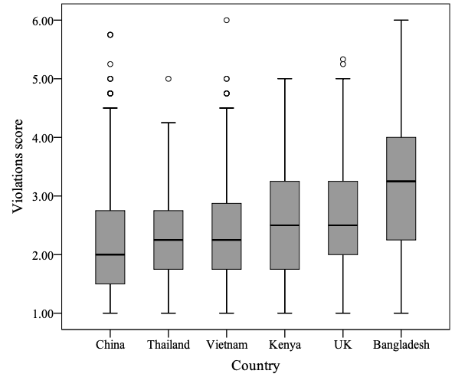
Figure 5. Violations score by country. Circles above box and whisker plots indicate outliers (as defined by SPSS). Countries ordered by mean for ease of interpretation.

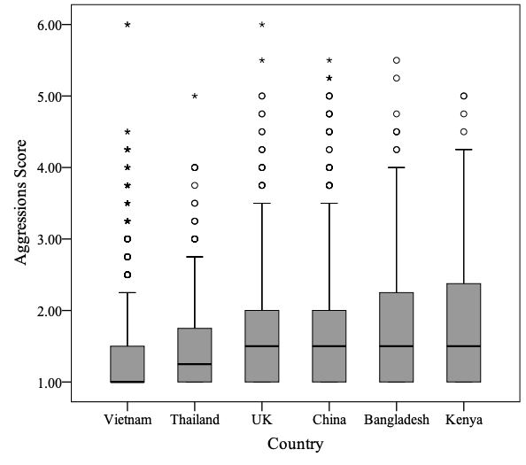
Figure 6. Aggression scores by country. Circles and asterisks above box and whisker plots indicate outliers and extreme outliers (as defined by SPSS) respectively. Countries ordered by mean for ease of interpretation.

Given the literature outlined above, we hypothesise that those from countries with more dangerous road systems will report performing fewer intentional rule violations but more aggressive behaviours and unintentional risky behaviours than those from countries with safer road systems.

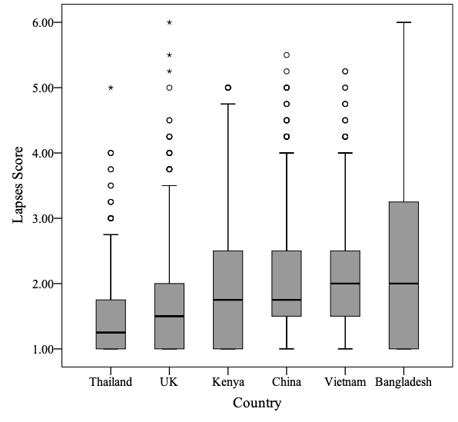
Figure 7. Lapse scores by country. Circles and asterisks above box and whisker plots indicate outliers and extreme outliers (as defined by SPSS) respectively. Countries ordered by mean for ease of interpretation.

The only significant interaction effects were found for the ‘Aggressions’ sub-scale, indicating that differences between crash involvement groups differed across countries for that sub-scale. These results are graphically displayed in Figure 8. Univariate ANOVAs were preformed to test for group differences on the crash involvement variable in each country. These are summarised in Table 9. Regarding individual pairwise comparisons, a number of statistically significant results were found (after Bonferroni correction was applied). In Bangladesh, those that had been involved in more than one crash scored significantly higher on ‘Aggressions’ than those that had never been involved a crash (p = .011). For Vietnamese respondents, those that had been involved in one crash, and those that had been involved in more than one, both scored significantly higher on ‘Aggressions’ than those that had not been involved in a crash (p = .014 and p = .007, respectively). The same pattern was found for UK respondents; those that had been involved in one (p = .003) or more than one crash (p < .001), both scored higher on ‘Aggressions’ than those that had never been involved in a crash.
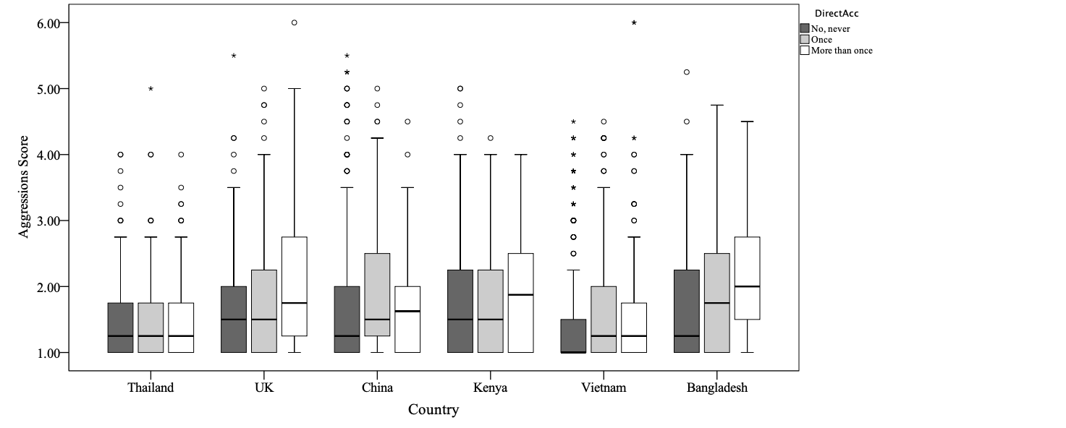
Never
Once
More than once
Figure 8. Aggression scores by country and crash involvement group (never, once, more than once).

Table 9. ANOVAs results for the test of crash involvement group differences on the ‘Aggressions’ variable in each country
 | F | Sig. | Partial η²
Bangladesh | 4.677 | .010 | .041
China | 2.411 | .091 | .009
Kenya | 0.192 | .825 | .001
Thailand | 2.661 | .071 | .017
UK | 12.747 | <.001 | .039
Vietnam | 7.00 | .001 | .017

Discussion
The two main aims of this article were to validate the short version of the Pedestrian Behaviour Questionnaire across multiple countries, and to look at differences between those countries based on the factors measured by the questionnaire. Regarding the first, we found both of Deb et al.’s (2017) five-factor structures (one first-order, one second-order) to fit the data better than Granié et al.’s (2013) four-factor model (in which ‘Errors’ and ‘Violations’ were grouped as one factor; ‘Transgressions’); however, all three models returned goodness-of-fit indices that were, in the majority of cases, not acceptable. This was true for all countries’ data together, and each country individually.
The ‘Positive Behaviours’ sub-scale was found to have unacceptably low internal consistency; this is entirely in agreement with previous work (Granié et al. 2013; Deb et al. 2017). In addition, significant problems with the ‘Errors’ sub-scale were found; it is difficult to theoretically justify the constraining of its error variance at the lower bound in the second order model (which was necessary here to test the model), and the extremely high covariance among factors in the five-factor, first-order models meant results were deemed inadmissible. Additionally, this sub-scale returned a Cronbach’s alpha lower than would be normally be accepted (at .580). Given these findings, both sub-scales were removed and fourth and a fifth models were tested. Both had 12-items and three first-orders (‘Violations’, ‘Aggressions’, and ‘Lapses’); Model Four had only the three first-order factors, Model Five included a single, second-order factor (‘Pedestrian Behaviour’). Both factor structures had identical fit indices (given the three-factor nature resulting in just-identification); these indicated substantially better fit than the three other models, across all countries together and individually, for all fit measures except one (parsimonious comparative fit index, considered the most difficult to interpret, and not suitable for use on its own; Mulaik et al. 1989).
Lower than ideal factor loadings on the ‘Violations’ factor meant issues with construct validity (measured using Average Variance Explained) and composite reliability, and Cronbach’s alpha for this scale was quite low for the Bangladesh and UK samples (at α = .545 and .591, respectively); however, given overall good model fit, good alpha scores in the other countries, and consistent use in the literature (discussed below), the questionnaire was considered sufficiently validated, and this factor retained and included in subsequent analyses. Finally, although our data do not distinguish between a first-order and a second-order factor structure (with three first-order factors, the degrees of freedom are identical in both situations, hence fit indices are identical), given high inter-correlations between the three first-order factors, and high factor loadings onto the second-order, ‘Pedestrian Behaviour’ factor, we tentatively suggest the second-order model to be the most suitable (similar to Deb et al. 2017).
Regarding the second aim, significant differences between countries in self-reported pedestrian behaviours were indeed found for all three pedestrian behaviour factors; people in different countries report significantly different tendencies to perform aggressive behaviours, lapses, and violations of on-road (or on-pavement) rules. These differences do not, however, have clear relationships with the ‘safety’ of a country’s road system (as measured by World Health Organisation estimated fatality rates). In addition to these country differences, differences were found between people when grouped by their self-reported involvement in on-road crashes in the past. Generally speaking, those who reported performing more risky pedestrian behaviours were more likely to have reported being involved in one or more accidents in the past. The extent to which this was the case varied across countries for aggressive behaviours. In some, the relationship was in the expected direction; more aggressive behaviour related to more involvement in accidents. In other countries the relationships were found not to be significant. Finally, age and gender differences were found; as hypothesised, males tended to report performing more risky behaviours than females, and younger respondents reported performing more risky behaviours than older respondents.

PBQ Factors across countries
Although the two previous investigations of the Pedestrian Behaviour Questionnaire (i.e., Granié et al. 2013 and Deb et al. 2017) were carried out in different cultural settings (namely France and the US), it could be argued that neither setting was very different from the other. Both France and the US are highly developed, high-income countries with relatively organised, safe road systems (the US at 12.4 fatalities per 100,000 population per year, France with 5.5, according to WHO, 2018). In each country, particularly in the major cities, pedestrian infrastructure is generally of good order, and enforcement of and compliance with traffic laws is high; one would fully expect traffic lights to work, pavements to be largely available for pedestrian use, and traffic cameras to act as an effective deterrent to driver rule breaking. This is not necessarily the case in many cities in low- and middle-income countries. Given the very different environments (social, cultural, and physical), one might expect different pedestrian behaviours. It is perhaps unsurprising therefore that we did not find the same five-factor structure to be suitable across the settings used in the current research.
As described above, one question of the 20-item scale described by Deb et al. (2017) was changed before the outset; that which concerned crossing when the pedestrian traffic light is red. Such pedestrian infrastructure is extremely uncommon in many places (particularly Dhaka and Nairobi), and even if it is present at a particular junction, and functioning, adherence by vehicular traffic is by no means guaranteed, hence to fully rely on it to guide crossing behaviour would itself be a risky strategy. As such, we would suggest that that kind of question cannot reliably measure pedestrians’ propensity to behave in a risky manner across cultural settings. This is also true for two of the questions in the ‘Errors’ sub-scale; one item refers to crossing between vehicles in traffic jams, another to walking in cycle lanes. The latter is an inappropriate cross-cultural measure of risky behaviour due to the non-existence of that kind of infrastructure in many settings. The former is related to the practicalities of crossing the road in highly congested cities without formal pedestrian facilities. Although it might be considered a risky strategy in (for example) the UK, in many settings around the world it is the only way one can cross the road at rush hour, hence cannot truly be considered ‘risky’ in the same way. The motivation to perform the behaviour is not related to underlying tendency to behave in a ‘risky’ way, but is driven by necessity.
Conceptually, a number of the ‘Errors’ items are similar to ‘Lapses’ items in that they represent unintentional deviations from lawful, safe behaviour. In her study of pedestrian behaviour and culture in a Turkish setting, Yıldırım (2007) did not distinguish between the two factors, using the term ‘error’ for behaviours referring to a lack of attention (conceptually related to ‘Lapses’ in the current study). Additionally, in her work six items were used to measure ‘ordinary violations’ and four to measure ‘aggressive violations’, conceptually the same as the ‘Violations’ and ‘Aggressions’ scales used in the current study. Our work therefore more closely reflects that of Yıldırım (2007) than that of Deb et al. (2017) or Granié et l. (2013), at least in terms of the types of items used; the three factors represent intentional violations, aggressive behaviours, and unintentional ‘mistakes’, to use the language of Reason et al. (1990).
Reason et al. (1990), in their seminal work on the Driver Behaviour Questionnaire, focused on the distinction between unintentional errors and intentional violations, not on the distinction between different types of unintentional errors. Conceptually, the distinction between the two is far clearer (i.e., intentional versus unintentional deviation from safety) than the distinction between errors, slips, and lapses, where it can be somewhat blurred. As an example, the item ‘I run across the street without looking because I am in a hurry’, from the ‘Errors’ sub-scale, is conceptually quite similar to the item ‘I cross diagonally to save time’, from the ‘Violations’ sub-scale. Intentionality is implied, with time constraints being the motivation for the behaviour. This is perhaps what guided Granié et al.’s combination of ‘Errors’ and ‘Violations’ into one scale. Our recommendation is related; however, we would argue that removal of the problematic ‘Errors’ scale, rather than using it in combination with ‘Violations’, is more appropriate for a PBQ that is to be valid and useful across cultures. It is also the same three-factor structure that Özkan et al. (2006) used in their six-country study using the Driver Behaviour Questionnaire.
Additionally, Nordfjærn & Şimşekoğlu (2013) revealed the same three-factor approach to modelling risky pedestrian behaviours (not considering positive behaviours; discussed below) in their factor analysis of the PBQ in Turkey. In their work, factors were termed ‘Transgression’ (intentional, deliberate violations), ‘Attentional violation’ (conceptually the same as the ‘Lapses’ scale reported above), and ‘Aggressive behaviour’. The same questionnaire, with the same three-factor structure, was used in Iran and Pakistan by Nordfjærn & Zavareh (2016); although in that instance factor analysis was not performed, reliability scores for the three dimensions were acceptable. Finally, Qu et al. (2016), again found the same factor structure in a Chinese version of the questionnaire; undesirable pedestrian behaviours were split into three categories, namely ‘transgressions’, ‘lapses, and ‘aggressive behaviours’, conceptually the same as the ‘Violations’, ‘Lapses’, and ‘Aggressions’ scales used in the current research. Our research therefore follows these results more closely than those of Deb et al. (2017), suggesting that a three-factor approach to measuring self-reported risky pedestrian behaviours is most suitable.
The preceding discussion has completely omitted reference to the positive behaviours sub-scale. In all countries included in the current research, together and individually, models including it returned poor fit indices, factor loadings were very low for two of the four items, and latent factor covariances were lower than one would expect. Additionally, this measure had low internal consistency in all countries. In Granié et al.’s (2013) work, alpha for this scale was .53; in our investigation, only in the China sample did we see a higher value, at a nevertheless unacceptably low .544. Although Deb et al. (2017) found slightly higher reliability, it was still unacceptable at .58. Not one of the studies discussed in the three previous paragraphs used this sub-scale. Even though Özkan and Lajunen (2005) (on whose ‘Positive Drive Behaviour Scale’ the PBQ sub-scale used here and in Deb et al. and Granié et al. was based) found positive driver behaviours to be negatively correlated with aggressive driver behaviours, they found no such relationships with traffic offences or crashes. We therefore conclude the sub-scale is not suitable for inclusion in a questionnaire measure of pedestrian behaviour, particularly one that aims to be valid across cultures. Whether this is a particular problem with the formation of the questions, or is a wider issue around what positive, or socially acceptable behaviour actually consists of in different cultural settings, and in the minds of different individuals, is a question we do not attempt to answer here.
It is worth making a brief point specifically about the aggressive behaviours scale, as this was not part of the original Driver Behaviour Questionnaire (Reason et al. 1990), but added by Lawton et al. (1997; involving members of the same research team involved in the original DBQ work). In Lawton et al.’s work, upon addition of questions related to aggressive behaviours, their factor analysis returned the same three factors seen in the current research, namely errors (conceptually the same as ‘Lapses’, above), highway code violations (‘Violations’), and aggressive violations (‘Aggressions’). Strong relationships were found between these types of behaviour and the other two factors, something repeated here and seen in Deb et al. (2017) and Granié et al. (2013). As such, we conclude that this factor strongly merits inclusion in the questionnaire; it captures types of behaviour that are not captured in the other two factors, and as was seen in the comparison of groups, is significantly linked with involvement in self-reported past accidents.

Group differences
A number of significant differences in the three pedestrian behaviour factors were found between respondents from the different countries, between those that reported that they had or had not been involved in accidents in the past, between those of different age groups, and between males and females.
In line with the existing literature on pedestrian behaviour, and the extensive corpus of work on risk taking (as a driver and more widely), we found males to report performing more risky pedestrian behaviours than females, and younger respondents to report performing more risky pedestrian behaviours than older people. This was as expected, being entirely in line with the existing pedestrian behaviours questionnaire research on which the current study was largely based (Deb et al. 2017; Granié et al. 2013; Moyano Díaz et al. 2002). Our hypotheses with respect to these group differences were therefore fully supported by the results obtained.
We also found that those that reported performing more lapses or aggressive behaviours were more likely to report having been involved in an accident. This is as was expected; it appeals to common sense that those people that are more likely to make memory or attention errors on the roads, and those that tend to behave more aggressively when interacting with the road system, are the same people that are more likely to get involved in on-road collisions. This finding, that performing risky behaviours are linked with involvement in accidents, mirrors those seen elsewhere in the field of driver behaviour (e.g., Iversen & Rundmo, 2004). In the current research, respondents were asked if they had been involved in an accident “as any type of road user (e.g., pedestrian, cyclist, driver, etc.)”, hence we are unable to confirm the specific hypothesis that a self-reported tendency to perform risky pedestrian behaviours is linked with involvement in accidents as a pedestrian. Our results are, however, in line with the argument made by Şimşekoğlu (2015) that the relationship between the propensity to perform risky on-road behaviours and an involvement in road collisions is not dependent on the role that the road user takes. The tendency towards performing risky on-road behaviour as a pedestrian to be very closely related to the tendency to do so as a driver (ibid.); just as a tendency to act riskily as a driver is linked with involvement in on-road accidents, so is the tendency to act riskily as a pedestrian.
Differences were not found, however, in the ‘Violations’ sub-scale. These results contrast with those of Deb et al. (2017), who found crash involvement group differences in aggressive behaviours and lapses, but not in violations. This could be because a tendency to intentionally violate the rules as a pedestrian does not necessarily reflect a tendency towards ‘risky’ behaviour. An example described above illustrates this; in some settings, relying on a pedestrian light to guide crossing behaviour can itself be a risky strategy, as it may not work properly, and not all drivers may adhere to it. Similarly, the choice not to use a pedestrian bridge or underpass even if one is nearby (item seven in our questionnaire) may not be driven by an underlying tendency to behave in a risky manner, but by other motivations, such as fear of crime or avoidance of the products of the unhygienic use of such spaces (e.g., Painter, 1996; Kumar, 2007). It is therefore quite possible that a generally ‘safe’ road user who has never been involved in any type of accident could yet score highly on pedestrian ‘Violations’. This could help to explain the low internal consistency found for this sub-scale (particularly for the UK and Bangladesh sample), and the poor construct validity and composite reliability scores.
In terms of country differences, these did not always reflect what might be expected given differences in the road safety statistics of the countries investigated or the existing literature. We hypothesized that those from countries with more dangerous road systems would report performing fewer intentional rule violations, but more aggressive behaviours and unintentional risky behaviours than those from countries with safer road systems. That was not the case; although statistically significant relationships between PBQ scores and road safety across countries (measured either by fatalities per 100,000 people or per 10,000 registered vehicles) were found, these were small, and were in contrasting directions for the two different measures of a country’s road safety. Although significant differences were found between groups (hence we can conclude that pedestrians in different countries reporting behaving differently), we cannot conclude that these differences relate directly to the overall safety of a given road system.
There is a temptation to think that road users in countries with higher accident and casualty rates might tend to perform riskier behaviours (hence giving rise to the higher accident and casualty rates); however, this is not necessarily the case. Respondents in the UK, the country with the safest road system out of those investigated (in terms of World Health Organisation statistics; WHO, 2018), reported performing significantly more aggressive behaviours than those in Thailand or Vietnam, and significantly more violations than those in Vietnam, Thailand, or China. Özkan et al. (2006) found something similar in terms of driver behaviour violations, but the opposite for aggressive driver behaviours; in ‘safer’ countries (i.e., the UK, Finland, and The Netherlands) more violations but fewer aggressions were reported, the opposite being true in more ‘dangerous’ countries (Iran, Greece, and Turkey). As aforementioned, although statistically significant trends were found across the countries when ordered by fatalities by population and motorization rates, these trends were not large and were in opposing directions depending on how countries were ordered. We cannot conclude, with this data, that those in ‘safer’ countries will report performing more intentional rule violations but fewer unintentional errors and fewer aggressive behaviours than those in countries with more ‘dangerous’ road system.
Although there does appear to be a general pattern of results suggesting that respondents in Bangladesh and Kenya reported performing more risky behaviours than those in other countries (see Figures 4 to 6), we cannot conclude that this is the cause of the poor road safety records in those countries. A great many factors contribute to the relative safety of a road transport system (e.g., McIlroy et al. 2019); human behaviour is certainly one of those factors, but that itself is also shaped by a great many factors (cultural, economic, and social environment playing significant roles). Although still of interest, it is not the differences in self-reported behaviour alone that should be the focus of attention, but the relationships between self-reported behaviours, the social-cognitive and socioeconomic determinants of that behaviour, and involvement in accidents, and, importantly, how these relationships differ across countries and cultures. In this way, the PBQ is a valuable research tool in the field of pedestrian (and wider traffic) safety. By understanding these relationships we can better inform road safety interventions tailored to the social and cultural environment in which they will be implemented.

Limitations and future work
Although the first aim of this article was to validate a self-reported measure of pedestrian behaviour, one could argue that the process of validation is somewhat subjective. There is no single measure of construct validity, there is no single metric that tells us whether a model is correct or incorrect, and there is often no fully agreed upon threshold value for any given metric. As such, researchers aiming to use the tool we have ‘validated’ above should always perform, as a minimum, their own internal consistency checks; ideally, the factor structure would also be tested. Indeed, one could argue that any validation process that does occur can only truly be said to apply to the sample used. A limitation of the current study was that, with limited resources, a less than ideal sampling method was used. The places in which data was gathered, in the physical and digital worlds, were chosen largely through convenience and necessity rather than driven purely by the requirement for equal representation across demographic groups. Indeed, with a questionnaire that can be completed only voluntarily, this would be impossible anyway; however, we accept that this sampling method introduces bias into the results. It also contributes significantly towards the most significant limitation of the current study; the non-representative nature of the samples obtained.
Across all countries, the samples were weighted somewhat towards the younger, more educated, more affluent end of the spectrum (note that not all demographics collected were presented above, for reasons of brevity). The demographic make-up of pedestrians across the countries investigated is weighted toward the younger generation, with these groups also more likely to be involved in road traffic collisions (e.g., GRSF & IHME, 2014), hence the sample is not entirely non-representative in this respect; however, issues remain with education levels and affluence. This makes it difficult to generalise beyond the populations sampled, particularly in Kenya, Thailand, and China, where this weighting was most pronounced.
There is also an additional issue when making cross-country comparisons, as the samples did not all differ from the true population characteristics to the same extent. For example, in Thailand, the majority of respondents were female, whereas in Bangladesh, 78% were male. Although the Bangladeshi sample does broadly reflect the demographic make-up of the pedestrian in Dhaka, this cannot be said for the Thai sample. Although this affects the strength with which conclusions can be drawn with regards to cross-cultural differences, we would argue that this is not overly problematic concerning the validation of the PBQ. This point can also be made for the collection of data from both urban and rural populations, and using both online, paper, or verbally-recorded versions. It is possible that rural respondents differed from city-dwellers in their responses to the PBQ, and that respondents answering one version may have differed from those responding to another. These mixed methods were chosen to gather as wide a sample as possible; however, we must accept this as a limitation of the study.
Another possible issue is the significant reduction in questionnaire size, not only in the removal of the ‘Errors’ and ‘Positive behaviours’ sub-scales, but in the choice to use the shorter, 20-item version rather than the longer, 36-item questionnaire described by Deb et al. (2017). We would argue, however, that the reduced size of the questionnaire represents a benefit rather than a limitation or disadvantage. Such a questionnaire would rarely be used on its own, rather its utility lies in the ability to provide a score for pedestrian behaviour that can be analysed in relation to other factors (e.g., socioeconomic, cultural, cognitive, etc.). It will more often be one part of a larger questionnaire; in this context, parsimony is a positive attribute, as the longer a questionnaire becomes, the lower people’s willingness to complete it (Galesic & Bosnjak, 2009).
It is also worth briefly discussing the inexact art of translation. We cannot claim that the translations used in our research are the only possible translations; many different ways of translating the same sentence into a given language exist. Furthermore, language is not only a means of communication, but a unique reflection of culture (Kramsch & Widdowson, 1998). There are some words and concepts that simply cannot be translated directly, and others for which, while translations exist, interpretations are not necessarily be identical; “the worlds in which different societies live are distinct worlds, not merely the same world with different labels attached” (p.209; Sapir, 1929). This twofold problem, i.e., that many potentially ‘correct’ translations exist, and that no translation will ever result in truly identical meaning for some words and concepts, represents a barrier to cross-cultural questionnaire research., Although this limitation is difficult to surmount entirely, there is a long history of such work being undertaken (particularly in sociology and psychology), and our process of translating the English questionnaire into other languages was done in accordance with best practice in that domain (Brislin, 1970). As such, we would argue that the results of the research presented above are still meaningful and useful.
Although the six countries chosen for inclusion in the current study represent a relatively wide variety (in terms of economies, cultures, and locations), all are low- or middle-income countries except the UK. Although direct comparisons are difficult to make (given some differences in wording and factor structure), our results are broadly in line with those of Deb et al. (2017) and Granié et al. (2013) in the US and France, respectively. Overall average scores for Violations, Aggressions, and Lapses were reported as 2.4, 1.49, and 1.57 respectively (out of six) in Deb et al. (2017), and 2.8, 1.78, and 1.76 in Granié et al. (2013). In the results presented above, country averages varied between 2.18 and 3.11 for Violations, 1.47 and 1.83 for Aggressions, and 1.70 and 2.28 for Lapses. It would be worthwhile to test these similarities / differences directly (using the PBQ version described in the current research) in France and the US, as well as extending the research into additional culturally and / or geographically distinct high-income countries. Moreover, it would be beneficial to include countries from the Americas (i.e., North, Central, and South), a large global region not represented in the current study.
Finally, just as with the majority of questionnaire research, potential biases arising from question order and self-reporting must be accepted. The questions on crash involvement, as well as sections on road safety attitudes and risk perceptions (not analysed here), came before the PBQ section, hence we cannot rule out the possibility that earlier questions influenced responses to latter questions. Question order was identical for all participants, hence any effects should have been the same across groups; however, this must be accepted as a limitation. Regarding self-reporting, crash involvement group classification and pedestrian behaviour sores were based on responses to the questionnaire, not observed data. It is quite possible that the behaviours respondents perform on the roads (or pavements) could be different to those that they report performing using the PBQ. This limitation can only be addressed by research that also collects actual accident involvement statistics (which would be highly valuable, but highly challenging, especially in LMIC settings) and uses direct observation (which has potentially serious ethical implications).

Conclusions
This study has applied the Pedestrian Behaviour Questionnaire (PBQ) across six culturally distinct settings, with a sample of over 3400 individuals, in order to arrive at a validated research tool that can be used to assess the extent to which an individual reports performing certain classes of on-road (or on-pavement) behaviours. In this regard, we conclude that the PBQ has significant value in the measurement of the tendency towards performing three classes of pedestrian behaviour; aggressive behaviours, intentional violations of rules, and unintentional risky behaviours. This three-factor structure holds across all six countries included in this study, and although the intentional violations of rules sub-scale requires additional attention to improve reliability and validity in some settings, the 12-item PBQ as recommended here is succinct, and its factors clearly defined and delineated, important characteristics if it is to be widely adopted as a research tool for use across cultural settings.
We found aggressive behaviours and unintentional risky behaviours to be significantly related to self-reported previous involvement in on-road accidents, and we found significant differences across countries in the three factors. We would argue, however, that the true merit of the PBQ is in the ability to combine it with other measures (e.g. socioeconomic, cultural, social cognitive, etc.) in order to better understand relationships between behaviour and the antecedents of that behaviour across cultural settings; this represents the focus of a short series of forthcoming articles.

Acknowledgements
This research was commissioned by the National Institute for Health Research using Official Development Assistance (ODA) funding. The views expressed are those of the authors and not necessarily those of the NHS, the NIHR, or the Department of Health and Social Care. We would like to thank Omar Faruqe Hamim, Shahnewaz Hasnat-E-Rabbi, Mithun Debnath, Kezhen Hu, Linyang Wang, Mingyu Liu, James Oyoo, Sylvia Anyika, Dinh Do Duy, Rish Arora, and Tayyib Goolamallee for all their help in gathering data.

References

Abou, A., Granié, M.A., & Mallet, P. (2008). Recherche de sensations, attachement aux parents et prise de risque dans l’espace routier chez l’adolescent piéton. In: Granié, M.A., Auberlet, J.-M. (Eds.), Le piéton et son environnement: quelles interactions? Quelles adaptations? Actes n◦115. Les collections de l’INRETS, Arcueil, pp. 121–133.

Alhajyaseen, W.K. & Iryo-Asano, M. (2017). Studying critical pedestrian behavioural changes for the safety assessment at signalized crosswalks. Safety Science, 91, 351-360.

Allen, P. & Bennett, K. (2007). SPSS for the health and behavioural sciences. Cengage Learning Australia: Melbourne, Australia.

Antić, B., Pešić, D., Milutinović, N., & Maslać, M. (2016). Pedestrian behaviours: Validation of the Serbian version of the pedestrian behaviour scale. Transportation Research Part F: Traffic Psychology and Behaviour, 41, 170-178.

Brislin, R. (1970) Back-translation for cross-cultural research. Journal of Cross-Cultural Psychology, 1, 185–216.

Byrnes, J.P., Miller, D.C., & Schafer, W.D. (1999). Gender differences in risk taking: a meta-analysis. Psychological Bulletin, 125, 367.

Chen, C.F. & Tsai, D. (2007). How destination image and evaluative factors affect behavioral intentions?. Tourism Management, 28, 1115-1122.

De Winter, J.C.F., & Dodou, D. (2010). The Driver Behaviour Questionnaire as a predictor of accidents: A meta-analysis. Journal of Safety Research, 41, 463-470.

Deb, S., Strawderman, L., DuBien, J., Smith, B., Carruth, D.W., & Garrison, T.M. (2017). Evaluating pedestrian behavior at crosswalks: Validation of a pedestrian behavior questionnaire for the US population. Accident Analysis & Prevention, 106, 191-201.

DfT (2018). Reported Road Casualties Great Britain: 2017 Annual Report. Accessed on the 26th of November, 2018. https://assets.publishing.service.gov.uk/government/uploads/system/uploads/attachment_data/file/744077/reported-road-casualties-annual-report-2017.pdf.

Elliott, M.A., & Baughan, C.J. (2004). Developing a self-report method for investigating adolescent road user behaviour. Transportation Research Part F: Traffic Psychology and Behaviour, 7, 373-393.

Ertz, M., Karakas, F., & Sarigöllü, E. (2016). Exploring pro-environmental behaviors of consumers: An analysis of contextual factors, attitude, and behaviors. Journal of Business Research, 69, 3971-3980.

Evans, D., & Norman, P. (2003). Predicting adolescent pedestrians’ road-crossing intentions: an application and extension of the Theory of Planned Behaviour. Health Education Research, 18, 267-277.

Field, A. (2018). Discovering Statistics Using SPSS, 5th Ed. Sage Publications.

Galesic, M., & Bosnjak, M. (2009). Effects of questionnaire length on participation and indicators of response quality in a web survey. Public Opinion Quarterly, 73, 349-360.

Granié, M.A. (2008). Influence de l’adhésion aux stéréotypes de sexe sur la perception des comportements piétons chez l’adulte. Recherche – Transports – Sécurité, 101, 253–264.

Granié, M.A. (2009). Sex differences, effects of sex-stereotype conformity, age and internalization on risk-taking among pedestrian adolescents. Safety Science, 47, 1277–1283.

Granié, M.A., Pannetier, M., & Gueho, L. (2013). Developing a self-reporting method to measure pedestrian behaviors at all ages. Accident Analysis & Prevention, 50, 830-839.

GRSF & IHME (2014). Transport for Health: The Global Burden of Disease from Motorized Road Transport.
Seattle, WA: IHME; Washington, DC: The World Bank.

Hair, J.F., Black, W.C., Babin, B.J., Anderson, R.E., & Tatham, R.L. (2009). Multivariate data analysis, 7th, Ed. Pearson Prentice Hall Upper Saddle River, NJ.

Hamann, C., Dulf, D., Baragan-Andrada, E., Price, M., & Peek-Asa, C. (2017). Contributors to pedestrian distraction and risky behaviours during road crossings in Romania. Injury Prevention, 23, 370-376.

Holm, A., Jaani, J., Eensoo, D., & Piksööt, J. (2018). Pedestrian behaviour of 6th grade Estonian students: implications of social factors and accident-prevention education at school. Transportation Research Part F: Traffic Psychology and Behaviour, 52, 112-119.

Hooper, D., Coughlan, J., & Mullen, M. (2008). Structural Equation Modelling: Guidelines for Determining Model Fit. The Electronic Journal of Business Research Methods, 6, 53-60.

Hulland, J. (1999). Use of partial least squares (PLS) in strategic management research: A review of four recent studies. Strategic Management Journal, 20, 195-204.

Jha, A., Tiwari, G., Mohan, D., Mukherjee, S., & Banerjee, S. (2017). Analysis of pedestrian movement on Delhi roads by using naturalistic observation techniques. Transportation Research Record: Journal of the Transportation Research Board, 2634, 95-100.

Koekemoer, K., Van Gesselleen, M., Van Niekerk, A., Govender, R., & Van As, A.B. (2017). Child pedestrian safety knowledge, behaviour and road injury in Cape Town, South Africa. Accident Analysis & Prevention, 99, 202-209.

Koh, P.P., Wong, Y.D., & Chandrasekar, P. (2014). Safety evaluation of pedestrian behaviour and violations at signalised pedestrian crossings. Safety Science, 70, 143-152.

Kramsch, C., & Widdowson, H.G. (1998). Language and culture. Oxford University Press.

Kumar, P. (2007). The value of design: A study of pedestrian perception in New Delhi, India (Doctoral dissertation).

Lajunen, T., & Summala, H. (2003). Can we trust self-reports of driving? Effects of impression management on driver behaviour questionnaire responses. Transportation Research Part F: Traffic Psychology and Behaviour, 6, 97-107.

Larue, G.S., Naweed, A., & Rodwell, D. (2018). The road user, the pedestrian, and me: Investigating the interactions, errors and escalating risks of users of fully protected level crossings. Safety Science, in press, https://doi.org/10.1016/j.ssci.2018.02.007.

Lawton, R., Parker, D., Manstead, A.S., & Stradling, S.G. (1997). The role of affect in predicting social behaviors: The case of road traffic violations. Journal of Applied Social Psychology, 27, 1258-1276.

Lennon, A., Oviedo-Trespalacios, O., & Matthews, S. (2017). Pedestrian self-reported use of smart phones: positive attitudes and high exposure influence intentions to cross the road while distracted. Accident Analysis & Prevention, 98, 338-347.

Malhotra, N.K. (2010). Marketing Research: An Applied Orientation, 6th Ed. Pearson Education.

McIlroy, R.C., Plant, K.A., Hoque, M.S., Jianping, W., Kokwaro, G.O., Vũ, N.H., & Stanton, N.A. (2019). Who is responsible for global road safety? A cross-cultural comparison of Actor Maps. Accident Analysis & Prevention, 122, 8-18.

Moyano Díaz, E. (1997). Teoría del Comportamiento Planificado e intención de infringir normas de transito en peatones. Estudos de Psicologia, 2, 335-348.

Moyano Díaz, E. (2002). Theory of planned behaviour and pedestrians' intentions to violate traffic regulations. Transportation Research Part F: Traffic Psychology and Behaviour, 5, 169-175.

Moyano Díaz, E., Mena, L., & Olivos, P. (1997). Escalas para evaluar la actitud y el comportamiento infractor de normas de tránsito en peatones. V Congreso Nacional de Psicología, Noviembre, Centro de Extensión PUC, Santiago de Chile.

Mulaik, S.A., James, L.R., Van Alstine, J., Bennet, N., Lind, S., & Stilwell, C.D. (1989) Evaluation of Goodness-of-Fit Indices for Structural Equation Models. Psychological Bulletin, 105, 430-45.

Nabipour, A.R., Nakhaee, N., Khanjani, N., Moradlou, H.Z., & Sullman, M.J. (2015). The road user behaviour of school students in Iran. Accident Analysis & Prevention, 75, 43-54.

Nordfjærn, T., & Şimşekoğlu, Ö. (2013). The role of cultural factors and attitudes for pedestrian behaviour in an urban Turkish sample. Transportation Research Part F: Traffic Psychology and Behaviour, 21, 181-193.

Nordfjærn, T., & Zavareh, M.F. (2016). Individualism, collectivism and pedestrian safety: A comparative study of young adults from Iran and Pakistan. Safety Science, 87, 8-17.

Norman, D.A. (1983). Design rules based on analyses of human error. Communications of the ACM, 26, 254-258.

NIHR (2017). NIHR Global Health Research Group on Road Safety, University of Southampton. https://www.nihr.ac.uk/funding-and-support/documents/global-health/groups/NStanton-Plain%20English%20summary.pdf. Accessed on the 25th of May, 2018.

Nunnally, J. (1978). Psychometric methods. New York: McGraw-Hill.

Obeng-Atuah, D., Poku-Boansi, M., & Cobbinah, P. B. (2017). Pedestrian crossing in urban Ghana: Safety implications. Journal of Transport & Health, 5, 55-69.

Oviedo-Trespalacios, O., & Scott-Parker, B. (2017). Footbridge usage in high-traffic flow highways: the intersection of safety and security in pedestrian decision-making​. Transportation Research Part F: Traffic Psychology and Behaviour, 49, 177-187.

Özkan, T., & Lajunen, T. (2005). A new addition to DBQ: Positive Driver Behaviours Scale. Transportation Research Part F: Traffic Psychology and Behaviour, 8, 355–368.

Özkan, T., Lajunen, T., Chliaoutakis, J.E., Parker, D., & Summala, H. (2006). Cross-cultural differences in driving behaviours: A comparison of six countries. Transportation Research Part F: Traffic Psychology and Behaviour, 9, 227-242.

Painter, K. (1996). The influence of street lighting improvements on crime, fear and pedestrian street use, after dark. Landscape and Urban Planning, 35, 193-201.

Papadimitriou, E., Lassarre, S., & Yannis, G. (2016). Introducing human factors in pedestrian crossing behaviour models. Transportation Research Part F: Traffic Psychology and Behaviour, 36, 69-82.

Pešić, D., Antić, B., Glavić, D. & Milenković, M. (2016). The effects of mobile phone use on pedestrian crossing behaviour at unsignalized intersections–Models for predicting unsafe pedestrians behaviour. Safety Science, 82, 1-8.

Qu, W., Zhang, H., Zhao, W., Zhang, K., & Ge, Y. (2016). The effect of cognitive errors, mindfulness and personality traits on pedestrian behaviour in a Chinese sample. Transportation Research Part F: Traffic Psychology and Behaviour, 41, 29-37.

Quistberg, D.A., Howard, E.J., Hurvitz, P.M., Moudon, A.V., Ebel, B.E., Rivara, F.P. & Saelens, B.E. (2017). The relationship between objectively measured walking and risk of pedestrian–motor vehicle collision. American Journal of Epidemiology, 185, 810-821.

Rasmussen, J. (1983). Skills, rules, and knowledge; signals, signs, and symbols, and other distinctions in human performance models. IEEE Transactions on Systems, Man, and Cybernetics, 3, 257-266.

Read, G.J., Stevens, E.L., Lenné, M.G., Stanton, N.A., Walker, G.H., & Salmon, P.M. (2018). Walking the talk: Comparing pedestrian 'activity as imagined' with 'activity as done'. Accident Analysis and Prevention, 113, 74-84.

Reason, J. (1990). Human error. Cambridge University Press.

Reason, J., Manstead, A., Stradling, S., Baxter, J., & Campbell, K. (1990). Errors and violations on the roads: a real distinction? Ergonomics, 33, 1315-1332.

Sapir, E. (1929). The status of linguistics as a science. Language, 207-214.

Shaaban, K., Muley, D. and Mohammed, A. (2018). Analysis of illegal pedestrian crossing behaviour on a major divided arterial road. Transportation Research Part F: Traffic Psychology and Behaviour, 54, 124-137.

Şimşekoğlu, Ö. (2015). How do attitudes, personality traits, and driver behaviours relate to pedestrian behaviours?: A Turkish case. Traffic Injury Prevention, 16, 84-89.

Steinberg, L. (2008). A social neuroscience perspective on adolescent risk-taking. Developmental Review, 28, 78-106.

Sullman, M.J., & Mann, H.N. (2009). The road user behaviour of New Zealand adolescents. Transportation Research Part F: Traffic Psychology and Behaviour, 12, 494-502.

Sullman, M.J., Gras, M.E., Font-Mayolas, S., Masferrer, L., Cunill, M., & Planes, M. (2011). The pedestrian behaviour of Spanish adolescents. Journal of Adolescence, 34, 531-539.

Sullman, M.J., Thomas, A., Stephens, A.N. (2012). The road user behaviour of school students in Belgium. Accident Analysis & Prevention, 48, 495–504.

Sustainable Mobility for All (2017). Global Mobility Report 2017: Tracking Sector Performance. Washington DC, License: Creative Commons Attribution CC BY 3.0.

Tapiro, H., Oron-Gilad, T. & Parmet, Y. (2016). Cell phone conversations and child pedestrian’s crossing behaviour; a simulator study. Safety Science, 89, 36-44.

Tapiro, H., Oron-Gilad, T. & Parmet, Y. (2018). The effect of environmental distractions on child pedestrian's crossing behavior. Safety Science, 106, 219-229.

Tavakol, M., & Dennick, R. (2011). Making sense of Cronbach's alpha. International Journal of Medical Education, 2, 53.

Torquato, R.J. & Bianchi, A.S.A. (2010). Comportamento de risco do pedestre a atraversaar a rua: Um estudo com universitarios. Transporte: Teoria e Aplicação, 2. 19–41.

Truong, Y. & McColl, R. (2011). Intrinsic motivations, self-esteem, and luxury goods consumption. Journal of Retailing and Consumer Services, 18, 555-561.

WHO (2018). Global Status Report on Road Safety 2018. World Health Organisation: Geneva.

Yıldırım, Z. (2007). Religiousness, conservatism and their relationship with traffic behaviours. Middle East Technical University. Thesis.

