Champagne: The Challenge of Value Co-creation through Regional Brands

Martin Kunc
Warwick Business School, University of Warwick
Coventry, UK
martin.kunc@wbs.ac.uk

David Menival
'School of Wine & Spirits Business, Burgundy School of Business,
Dijon, France
dmenival@free.fr

Steve Charters
'School of Wine & Spirits Business, Burgundy School of Business,
Dijon, France
Steve.Charters@bsb-education.com

Keywords: Value Creation; Competitive Strategy; France; Territorial Branding; Resource-based View

Accepted for publications in the International Journal of Wine Business Research

Abstract
Purpose: The traditional view of the process of value creation suggests that it occurs inside the firm through its activities or resources. However, there are special cases where firms create value using external shared resources, e.g. a territorial brand. In this situation, value creation is both internal and external when the process of co-creating value involves all firms using the same resource.
Design/methodology/approach: An in-depth case study of nine firms covering different co-creation processes in Champagne, France. The selection of interviews was designed to cover the diversity of firms within the area with different market positioning. Most firms in the region have been selling champagne for more than 50 years so they have established long standing relationships with their markets.
Findings: While there is only one value, Champagne, firms create many different values based on owners’ perceptions with diverse effects on the process of value co-creation in the territorial brand. Some firms have strategies which could deteriorate the value of shared resource. This threat needs institutional changes with unknown consequences on the territorial brand.
Research limitations/implications: The research only involved one case study with a highly developed territorial brand system. There are multiple wine regions that have considered managing either implicitly or explicitly their shared strategic resources (e.g. a territorial brand). Consequently, the findings may not be applicable to all wine regions but it can provide a ‘gold standard’ for regions and wineries that do not realize the impact that their value creation actions can have on the wine region.
Practical implications: Collective management of shared strategic resources, such as a territorial brand, can be a powerful action to sustain competitive advantage rather than individual actions to develop individual brands. However, it can work only with an institutional organization managing the collective process.
Originality/value: The paper offers lessons from a comprehensive and well-known case study where resource bundles co-create value with a territorial brand.
Keywords: Value Co-creation; Competitive Strategy; Champagne; France; Territorial Branding, Resource-based View.

Introduction
Brands are traditionally seen as belonging to a firm. The traditional marketing view indicates that brands provide value to products and their producers (Kotler et al., 1994). However, the concentration on defining the product and on the producer has been criticized as being one sided, and lacking a consumer focus (Aaker, 2009). Aaker (2009) talks about a ‘brand personality’ sought by the consumer; meanwhile Sheth, Newman and Gross (1991) define a brand as an asset which mirrors the consumer’s core values . De Chernatony (2009) defines brands as an intangible asset which adds value for the consumer, a perspective providing a balance to the earlier dominant producer-focus. An additional perspective also adds to the equation a shared vision, engaging all employees in an enterprise (de Chernatony and MacDonald, 2003). While a brand may lead to value creation for not only producers but also consumers and stakeholders, the impact is not direct and it forms part of multiple organizational and institutional processes.
The traditional view of the process of value creation from the strategic management literature suggests that value creation occurs inside the firm through its activities or resources. For example, the resource-based view (RBV) of the firm suggests that combining a unique set of valuable, rare and inimitable resources and capabilities leads to value creation (Penrose, 1959; Barney,1991; Peteraf, 1993). However a more modern stream in the strategic management literature considers value creation as a result of strategic networks (Amit and Zott, 2001), which is at the core of value co-creation theory. Whilst there are still ongoing debates about an accepted definition, co-creation is the joint, collaborative, concurrent process of producing new value, both materially and symbolically (Galvagno and Dalli, 2014). However, there are several issues in value co-creation. On the one hand, the process of value co-creation may not be sustainable because firms belonging to the strategic network, as defined by Amit and Zott (2001, can evolve following new consumers’ needs and finally leave the network (Fyrberg and Jüriardo, 2009). On the other hand, there can be some confusion about the value co-created because firms involved in the co-creation process can have different target values and strategies (Prahalad and Ramaswamy, 2004).
All these issues point to the need for a dynamic and holistic view to understand the process of value co-creation. Correspondingly, our paper analyzes the process of value co-creation through a special case existing (inter alia) in the wine industry: the territorial brand (Charters and Spielmann, 2014). A territorial brand is a form of location-related brand where the product is directly linked to its origin and the environmental factors provided by that origin, together with the network of firms exploiting it (Charters and Spielmann, 2014). Territorial brands have the characteristics suggested for strategic resources (Barney, 1991): value (it can command higher prices), rareness (there can be no two similar locations), inimitability (it is impossible to imitate) and organizational orientation (it has to be combined with additional organizational resources to generate value). Territorial brands can support the creation of value for each individual firm in the strategic network if firms also contribute to its sustainability and use it correctly when they are conceptualizing their resource-based strategies (Kunc and Morecroft, 2010). However, there is still limited empirical evidence of the processes employed in value creation using a bundle of resources which comprises internal and shared resources in the wine industry even though many wineries use shared location-based resources (e.g. terroir or a controlled designation (AOC)). Thus, our research question is: What is the process of value creation for wineries employing a territorial brand to co-create value?
For the purpose of our study, we employed the case of Champagne as a highly developed territorial brand because Champagne is both a geographical region (territory) and a product category (brand) within the wine industry. Champagne is an ideal case study since it relies on a shared strategic resources to generate value: location-related brands, such as Bordeaux (France), Napa Valley (USA), Barossa Valley (Australia), and Colchagua Valley (Chile), that is strongly managed by a local institution, The Interprofessional Committee for the Wines of Champagne (CIVC), guarding the territorial brand (Charters and Spielmann, 2014; Kunc, 2014). While hedonic pricing models demonstrate that different places of origin (e.g. regional reputation) can command diverse prices in the market for wines made with similar grapes and quality (Cross, Plantinga and Stavins, 2011; Schamel and Anderson, 2001), the process followed by local firms to employ the regional reputation to build a competitive advantage is not well studied. Our contribution to knowledge is to identify the processes which determine value co-creation considering the existence of heterogeneous firms that employ a bundle of shared and internal strategic resources. We are interested in understanding how internal resources are nested and configured with the external, shared, strategic resource in order to generate value for their wineries and command higher prices.

Literature Review

Value creation using shared strategic resources
The existence of unique resources, such as brand reputation, can influence the creation of value (de Chernatony, 2009; Holt, 2002), as well as the orientation of the organization towards consumers, which is reflected in nurturing certain resources and organizational capabilities (Homburg and Pflesser, 2000). In addition to strategic internal resources, there may be an important role for external resources in defining the process of value creation. For example, social networks that are externally directed to detect the needs of customers can have potential for value creation (Smith, Collins and Clark, 2005) as can territorial brands, such as an AOC.

A territorial brand as a process of value co-creation
The seminal works of some authors (e.g., Prahalad and Ramaswamy , 2000, 2004; Vargo and Lusch, 2004) established the notion that companies and customers generate value through their interactions. While the role of a brand, as a key entity within a seller-buyer relationship, is not denied, we also have to consider brands a result of a process of co-creation arising from the collective meaning it is given (Stern, 2006). Thus, branding can be considered as an ongoing process where firms work on creating collective meanings and on managing them (Conejo and Wooliscroft, 2014). For Gregory (2007), stakeholders, internal and external, are active actors in the continuous process of value creation through brands. Brands result from a continuous, social, highly dynamic and interactive process between firms, consumers and all stakeholders (Merz, He and Vargo, 2009).
One special case of branding and value co-creation is a territorial brand. Charters et al. (2013) and Charters and Spielmann (2014) defined environment-based ‘territorial branding’ as the value generated by a natural product when it is inextricably linked to its origin. The characteristics of territorial brands reflect a collective meaning obtained through an interaction between firms, consumers and stakeholders located in a similar geographical area and organized in strategic networks. This interaction leads to the creation of value for the local actors which results in the existence of a territorial brand (Charters and Spielmann, 2014). Additionally, there is a necessary management of the added-value, performed by a territorial brand manager, essential to maintain the continuous process of co-creation (Schau, Muñiz and Arnould, 2009).
Therefore, when we analyze the major factors which characterize a territorial brand we can find evidence of value co-creation (Charters et al., 2013; Menival, Charters and Han, 2013; Charters and Spielmann, 2014). Firstly, there is co-opetition (Nalebuff and Brandenburger 1997) which means the existence of both competition and cooperation of all actors exploiting the territorial brand. Many times they share one vision which is underpinned by a common culture, history, story and mythology. This is fundamental if individual demands and expectations are to be subsumed into a common territorial resource. Thus, collective resource building becomes a clear source of added value for producers, consumers and other stakeholders. Secondly, there is a territorial brand ‘manager’ who can support individual firms’ marketing and promotional activities to avoid damage to the territorial brand. This brand manager ensures the success of the territorial brand by managing stakeholders and developing a common vision for the overarching brand.

A territorial brand as a shared strategic resource within resource bundling processes
A territorial brand can be considered “a scale free resource” (Levinthal and Wu, 2010) because more than one firm can potentially use it at the same time and obtain a competitive advantage. However, one important issue to consider is that the value of the shared resource is not independent of its use in the product market environment (Priem and Butler, 2001). For example, product market rivals with different value propositions can use the resource in diverse bundles against each other in competition for similar markets, thus affecting the perception of the territorial brand. The economic value of a territorial brand may depend on the synergies between the shared resource and the other resources the firm is using, the type of market rivalry, the actions of other firms in the shared resource, and the existing asymmetries in the resource endowments of competing firms (Asmussen, 2015). In other words, value is not created by an individual resource but through the synergies generated by the combination of multiple resources in resource bundles defined through subjective assessments of their values (Kraaijenbrink et al, 2010; Kunc and Morecroft, 2010).
Recent perspectives in the RBV of the firm suggest the relevance of managers’ decision making processes, and their implications over time, in the configuration and use of strategic resources. For example, Kraaijenbrink et al (2010) conclude the RBV may not be useful for firms whose managers are satisfied that their competitive positions match their aspirations and intentions. Moreover, there is an implicit path dependency within the RBV since past investments in resources define the present and future performance of the firm and condition the development of additional resources (Kraaijenbrink et al, 2010; Kunc and Morecroft, 2010). The path dependency may be strongly influenced by the resource conceptualization processes of managers during the development of their strategies that will lead to diverse resource bundles combining the shared resource with internal resources (Kunc and Morecroft, 2010). Therefore, strategies will generate value through diverse combinations of shared and internal resources as well as the complexity of the firm in terms of relationships between resources. We propose a framework based on two dimensions: resource bundle orientation (internal vs. shared resource orientation) and resource bundle complexity (simple vs. complex). Resource bundle orientation evaluates the predominance of the territorial brand compared with internal resources. The former could include the use of a single regional cellar door to sell wine, or cooperative vinification. The latter would include domaine vinification, the strength of the winery’s proprietary brand, and the value of relationships with customers. Thus, are customers tending to buy into the territorial or winery brand? Resource bundle complexity indicates the amount of resources and capabilities, their characteristics (intangible vs. tangible), and their uniqueness with respect to the territorial brand employed to generate further value. Figure 1 shows our proposed framework to evaluate the linkage between the orientation and complexity of the firm and the proportion of the value created within the territorial brand. We suggest the size of the resource bundle, as a measurement of the resource endowment of the firms, and its complexity, as a measure of strategic sophistication, influence on the value created by a winery in a competitive environment dominated by territorial brand. This framework is explored empirically through the analysis of the firms selling champagne where the shared resource is Champagne, as a territorial brand.
INSERT FIGURE 1 HERE

Research Methodology
We employed a case study approach (Eisenhardt and Graebner, 2007; Siggelkow, 2007. A case study design was chosen for several reasons. First, the territory selected, Champagne, France, has a rich history in value co-creation and as a territorial brand (Charters, 2011). Second, Champagne firms have a long history in their markets so case study research can help to understand the path-dependent development processes related to their value proposition (Beverland, 2005). Third, understanding the conceptualization of value requires revealing the way that managers’ perceptions motivate their strategic behavior; these can only be reached by close interaction between the researcher and participant through direct contact (Arnould and Wallendorf, 1994). Fourth, previous researchers have employed qualitative methods to identify resources and capabilities underpinning value creation processes (Tripsas and Gavetti, 2000; Hoopes et al., 2003).
The case: Champagne. Champagne has been produced as a sparkling wine for over 350 years, and in that, time has obtained an international reputation for its purported quality. It was established as an elite drink by the middle of the 19th century (Guy 2003) and offered sufficient added value that trademark cases were being launched to protect individual producers’ reputations from 1849 onwards in the United Kingdom (Duguid 2003), something that was latter extended to the collective brand (Faith 1988). Champagne brands remain the most recognized brands of all sparkling wines and their positioning implies the creation of complex products involving myths to generate images of authenticity and long term (‘classic’) wine styles (Beverland, 2004).
According to Charters and Spielmann (2014) we can easily find the characteristics of territorial brand in the champagne wine industry. First, the actors in Champagne have purpose and common story thanks to the development of local co-opetition. This situation has origins which go back several centuries and are based on the idea of the mutual reliance of growers (who provide the raw materials) and the houses (the merchants who market the high-volume brands); these two groups have a common heritage and vision of their wines as the international medium of celebration par excellence (Charters, 2011). This all contributes to maintain and reinforce the territorial brand. Second, there is a territorial manager: the CIVC which markets the product, carries out research and development into production, protects its intellectual property, mediates between the conflicting parts of the (regional) enterprises, and has responsibility for quality control (Kunc, 2011, 2014). It is also used as a means of controlling the flow of wine onto the market in response to demand, in order to avoid surpluses. The final evidence of the territorial brand in Champagne comes from the use of the Champagne name. It is often argued by producers that Champagne is not a brand rather it is a Protected Designation of Origin (Charters et al., 2013). But that name is used as a guarantee of quality by many consumers worldwide who cannot name a specific individual brand of champagne. However, Champagne is not a uniform set of actors. (see table 1).

INSERT TABLE 1 HERE

The selection of firms for our case study intends to cover the diversity of firms within the territorial brand and provide a theoretical sample to understand the process of value creation. The selection was based on few principles. First, following Beverland (2004), who studied luxury wines, we chose firms that have an established history in their positioning and are not subject to short-term influences, to understand their strategies and the evolution of resources and capabilities. Second, in the case of Champagne, most firms have been in the region selling champagne for more than 50 years (and often for more than 200 years) so they have established long standing relationships with their markets and are not subject to short-term influences. Third, selling champagne wine is a long term business given multiple factors including long production processes (minimum 18 months) determined by the region’s regulations. Consequently, the firms selected represent the different and extreme positioning existing in the champagne wine category – polar type cases (Eisenhardt and Graebner, 2007) (see table 2 for a list of firms studied and a list of people interviewed from each firm). The respondents were selected due to their long term involvement with the firm and Champagne.

INSERT TABLE 2 HERE

Each interview involved a semi-structured interview lasting 45-60 minutes. We prepared a set of themes, which were based on the framework presented in figure 1, to guide the data collection process with our informants although the respondents had ample opportunities to add to or to develop each aspect. The initial set involved the following aspects related to the creation of value: economic dimensions such as the price of the champagne (Hoopes et al., 2003), customer dimensions such as the type of customer relationship (Cholette, 2004; Beverland, 2004; Hall and Mitchell, 2007) and organizational dimensions in terms of resources (uniqueness, type) and capabilities (Kunc, 2007, 2011). The data collection was supplemented with secondary data from the CIVC such as prices, volumes and production techniques suggested to producers of champagne.

Champagne as a territorial brand: Value creation behavior from different firms
The findings are summarized in table 3 and the next sections explore them in more detail.

INSERT TABLE 3 HERE

Value co-creation in the territorial brand
From a value realization perspective, the range of prices (exchange value) of the most popular product sold by the firms in each category is wide, as table 3 illustrates, reflecting different conceptualizations of value creation. The global houses clearly command the highest price for their product (average price 36€ per bottle) given their sophisticated value creation process through a complex production function involving brand building (in addition to the territorial brand), high quality wine production and widespread distribution. The global houses perceive that creating economic value implies increasing the use value above the value created by the territorial brand. For global houses, branding is a continuous, social and dynamic process performed with their customers in order to maintain exclusiveness. This strategy requires high revenue streams to pay for the complex resource bundles responsible for creating value.
“[BrandX] opens new markets by investing a lot and expecting a payback in 20/30 years. They focus on the on-trade because customers follow their experience in the off-trade. However, there is a danger to over promote the brand on the on-trade. BrandX was positioned as a trendy brand in most restaurants in … but after a while people get fed up with the brand” (interviewee 9)
The family house follows the global house in terms of price (average price 25€ per bottle). While it has a recognized brand and high quality wine production, it does not have as widespread distribution as the global houses. The cooperative has increased its price in recent years once it started developing a recognized brand through the purchase of a long established family brand. The average price of its product is 22€ per bottle. These three companies compete in similar market segments, champagne as a premium product, but they also cooperate in building an image of exclusiveness for champagne.
“[BrandY] created value through its brand and image (“creating personalities) but the value is also created by a differentiation due to its regional location Cote de Bar: soil is chalk and clay in small valleys not great plains like Reims/Epernay…” (interviewee 5)
Both the cooperative and the family house consider that creating economic value involves increasing use value through distinctive branding rather than offering a product under the territorial brand at a lower price. A similar concept is followed by the medium grower (average price 20€ per bottle) but using a different strategy. The medium grower believes in the development of a reputation of uniqueness in niche segments. Thus, the medium grower increases the perception of exclusiveness by highlighting that the wine is coming from a specific area within Champagne rather than the whole region and charging a high price for its uniqueness. The small (average price 13€ per bottle) and large growers (average price 15€ per bottle) sell the product at a lower price than the previous companies because they recognize their production function is relative simple and they perceive that their consumers will only be willing to choose a product representing the territorial brand at a lower unit price.
“If it is too expensive, the product will not be sold even it may be good! This is a growers’ wine that is directly sold to customers without intermediaries. [We] prefer small direct consumers because they pay directly and especially old fashioned consumers with large cars because they buy more.” (interviewee 4)
“[This type of producer are] very traditional. ‘Demi-sec’ is the product that identifies them. Low price and loyalty … always afraid of losing loyal clients” (interviewee 2)
Finally, the low price house (average price 10€) occupies a market segment that is strongly price sensitive, such as large retailers that compete strongly on price through their own brands. It recognizes that it can only sell the product at the lowest possible price. Therefore, the low price house implements a low-price strategy using a simple production function where bargaining with growers (low costs for inputs) and simple aging processes (using technology and the minimum time defined by the laws of AOC) are important aspects in maintaining low costs. This is a satisfying behavior in terms of configuring a simple resource bundle.
“Some houses are specialized in lower price…high volume even though they buy grapes at normal price. One of the aspects of their strategy is the low aging time (15 months) and the low investment in image and quality, [together with] sourcing from different areas[that] offered similar quality” (interviewee 8)

From these situations, we can notice the added value to the territorial brand is unequal according to the kind of firm. The low price house only appropriates the value created by the uniqueness of the region and its quality developed through innovation in the areas of viticulture and vinification generated by the CIVC, the territorial brand manager. The low price house considers champagne a commodity produced in large volume for large retailers. Its strategy for value creation can clearly impact on the value perceived for all the wine created in Champagne, damaging the territorial brand. Thus, it is not contributing to value co-creation.
“[they command low prices]…using one vinification and aging less (within the limits) 15 months (aging takes a lot of cash)…less 20% production costs compared with superpremium. They also don’t spend in marketing and they have low overhead.” (interviewee 8)
The medium grower considers that producing champagne is differentiating their product by highlighting its uniqueness generated from a specific location within the territorial brand and different varieties of the grapes than those used more generally in champagne. While being within the territorial brand is an important factor in creating value for its product, the medium grower believes that uniqueness is at the level of the location of the vineyard and its own personal style for champagne.
“The buyers are connoisseurs who will want to show their passion for wine” (interviewee 3)
While the value of the territorial brand is diminished by highlighting the specific characteristics and uniqueness of the product (reduction in value co-creation), it also increases the value of the territorial brand as a set of unique places, the reputation of the village where the grower is located and its categorization as premium champagne producing area (thus an increase in value co-creation). This case highlights coopetition.
“The family is the image. [Consumers] don’t like production technology because they like the artisan aspect of wine growers” (interviewee 1)
The Cooperative may generate the highest value for one of the key stakeholders in the territorial brand, small growers, because its members (small growers, non-equity owners known as adherents) are the owners of cooperatives and benefit from any profit that the cooperative makes by adding value to the champagne. Additionally, the sourcing of inputs for the champagne can only be from the adherents, which provides certainty in their rents from the production of grapes. The cooperative, by nature, cooperates to increase value for growers but also compete for market positioning with houses.
“Even though it is a co-operative, the firm has to be profitable at market prices for their grapes… Journalists [are] talking about the good quality of the brand but [we] don’t rush things because as a co-op you have more time to establish the brand….a vineyard is for 40 years.” (interviewee 5)
While the cooperative sells high volume champagne through retailers, selling champagne through a recognized brand has allowed it to increase price and profits for its adherents. In terms of value co-creation, the cooperative generates the highest value. This can be compared with the family house and the global houses which have a long-term perspective on maintaining the reputation of their individual brands through high quality champagne; thus they may be eroding the territorial brand, on the one hand, but increasing the prestige of the product category on the other hand.
“[We] look in the market for new trends. To show something interesting in the long term. Time [taken] to develop a new product 5 years! Latest product: no dosage, purity…” (interviewee 5)
However, their quest for high quality champagne implies that they compete for grape supply, in turn generating value for the local growers and, as a consequence, co-creating value for the territorial brand. Additionally, their product positioning as high quality and high-priced champagne improves the reputation of the territorial brand as a source of high quality wines. Moreover, the use of their heritage and myths also contributes to increasing the reputation of the territorial brand benefiting other producers. On the other hand, their strong investment in their own brands partially diminishes the value of Champagne as a territorial brand. In that context it is worth noting that the global houses also produce similar sparkling wine in places outside Champagne under their individual brand, which can also diminish the territorial brand. Therefore, the impact on value co-creation is balanced.

Resource bundling strategies for value creation
We observed clear linkages between strategies and investments in resources and capabilities to the processes of value creation and co-creation discussed previously. While there is only one value, Champagne, firms create many different values based on owners’ perceptions with diverse effects on the process of value co-creation in the territorial brand.
The simplest organization is the small grower because it only concentrates on one aspect of value creation intrinsically related to the territorial brand: viticulture. The vinification process is not performed by the small grower since the wine is produced in a small cooperative located in the same village as the grower is located, which means that the small grower does not have a distinct wine style. The wine produced only follows the quality requirements of the territorial brand. Sales usually occur in their own cellars to consumers who come to buy champagne.
“They make champagne as a by-product of having vineyards. No specific resources for them…their grapes are mixed with the rest to product the wine, no identifiable brand” (interviewee 2)
Therefore, the small grower does not have a complex bundle of unique internal resources to create additional value to the value obtained from the territorial brand. It does not have a sophisticated strategy.
Medium and large growers manage the vinification process within their companies controlling the quality and, thus, developing idiosyncratic wine styles. Managing the vinification processes allows them to create more specific champagne and adapt their product to the requirements of local and foreign consumers. In this sense, they expand the value obtained from the territorial brand with the value generated by internal resources. They target consumers through the development of special champagnes that highlight specific characteristics of their vineyards (special cuvées) or the production of a certain year (vintage or millesime). Special champagnes are produced in small quantities to increase the sense of scarcity and cater for specialist consumers who are prepared to pay more for unique products. To sustain this reputation, the medium grower also develops complex distribution networks through specialized wine shops, restaurants and hotels. Compared with the small grower, they have more sophisticated strategy.
For those growers that export, the complexity increases since they need to identify and control distributors and maintain contact with their consumers in those markets. The medium grower clearly develops an idiosyncratic resource, its reputation among wine lovers because of the product and its integration towards customers to increase the value generated.
“[We are] more dynamic people … export, improve growing techniques, sell through wine shops/on trade, request support and have consultants.” (interviewee 3)
The large grower seems to be trapped with traditional, local consumers who require simple wines because it has not developed a unique internal resource, such as its own brand, to attract other consumers. However, the large grower owns a hotel, a completely different resource, to attract consumers. While the strategy is simple in terms of champagne, it is a more encompassing strategy by investing in other assets that support the value co-creation.
“[We] also have a hotel as a way of “contributing to the region”. The hotel creates value by giving a good reputation and meeting more people to promote the winery as well as giving information about the product. The hotel allows[us] to contact journalists as well” (interviewee 4).

The low price house has a mixed operation: it has its own vinification process responsible for part of the production and it also buys wine from small growers to complement its volume. It does not have any contact with consumers and its focus is on champagne production technology and low cost operations (including the bargaining process with small growers) within the norms of the industry and complying with the quality requirements of the territorial brand. This organization has developed internal resources; its own vinification and bargaining processes with growers, to achieve a low cost operation aimed at their main buyer, retailers.
“[We] buy grapes for 3.5 million [bottles] and ‘sur lattes’ for 2 million. [We] don’t have contact with final customers…[our clients are] supermarket, large distributors and specialized off-trade” (interviewee 6)
The cooperative manages the vinification process of the grapes supplied by its adherents. In terms of organizational dimensions its main function is the production of wine and champagne for grape growers and houses but the addition of its own champagne brand implies the adoption of a market oriented organization with sales representatives. Primarily, the bundle of resources is conditioned by the needs of the growers; a vinification process which benefits all adherents, to add value to growers’ production.
“One of the reasons for selling at low prices is because they have invested a lot of money in facilities whose payoff is 20-30 years …” (interview 9)
With the development of an individual brand positioned in the market, the bundle of resources becomes more complex.
“Through tastings, inviting consumers, be close to the consumers by “trying to be part of events”, pushing through Sales Force (Four full-time and 60 representatives), to show the quality of the wine but not advertising because the products are not available everywhere.” (interviewee 5)
The family house needs to source grapes and wine from growers due to its large sales volume, creating competition in securing the best resources as it is not fully integrated towards grape production. The institutional arrangements of the territorial brand (e.g. laws governing land ownership) hamper the accumulation of land within the AOC by a house. Its top range products are created using its own vineyards and highlighting their specific characteristics to the consumers, as a differentiation from the territorial brand. It maintains quality and style through carefully controlling the wine making processes, which differentiates from the base quality required by the territorial brand. Its unique resource resides on its long-term reputation among aspirational consumers, who become loyal to the brand. While the organizational dimension is complex due to its multiple dimensions, the involvement of the family in all management aspects helps to simplify decision making processes. There is an important level of strategic sophistication that in underpinned by the family involvement in the business.
The global houses consider the vinification process as a key strategic resource which is managed through long tenured cellar masters, who are responsible for maintaining the consistent style of the wines and are a key knowledge-based resource. Given its global reach and limited land ownership, it needs to source grapes from a large number of growers creating competition in securing the best supplies. However, top range products are created using their own vineyard sites and highlighting their specific characteristics to the consumers. As it positions its champagne as a symbol of luxury consumption, the company builds reputation through careful association with key events and arts and launching products that are linked with the traditional positioning of the house. Luxury brand management is its key organizational capability so it has a long-term perspective on maintaining and building the brands, creating a complex portfolio of them. Their resource bundles are highly complex which require different management skills from the other organizations.
Figure 2 shows the distribution of the organizations considering their resource bundles complexity and the creation of value

INSERT FIGURE 2 HERE

Discussion
Territorial brands belong to the category of resources that are “scale free” (Levinthal and Wu, 2010) so that more than one firm can potentially use them at the same time. However, the economic value of such a resource varies across firms when it is combined in resource bundles allowing heterogeneity among the firms in terms of rents obtained. Barney (1991) argued that resources are valuable because they facilitate certain product market strategies. Therefore, we observe the value of a territorial brand is dependent of its use in a product market environment (Priem and Butler, 2001), where competition occurs in some dimensions of the territorial brand, e.g. grape sourcing, and cooperation in other dimensions such as adhering to rules of CIVC or investing in branding that denotes a premium positioning for champagne.
The interviews demonstrate that some managers see their firms as serving ‘no frills’ consumers so their investments in resources are limited to exchange value, which is the value required by their customers. Given their long tenure selling a similar product under the territorial brand, there seems to be path dependency in the process of building resource bundles which leaves firms with a competitive position that seems to perpetuate low level aspirations. The path dependency is only broken in rare exceptions (e.g. the medium grower or the cooperative) and it usually occurred with the arrival of new management, which confirms the existence of path dependent subjective perceptions affecting the design of resource bundles supporting businesses. The new management, influenced by the success of other companies, promoted more sophisticated resource bundles to create more value and upgraded the company to another market position. It is clear territorial brands are collective resources where coopetition is norm.
Shared resources can be subject to important dynamic processes that can enhance or devalue their value over time, co-creating the value of the resource. While firms within territorial brands need to achieve cohesion in terms of quality of outputs, the process of value co-creation using a shared resource can be highly heterogeneous given the existence of heterogeneous perceptions about its value (Charters and Spielmann, 2014). For example, some firms can enhance their value by delivering high quality products that contribute to the image of the territorial brand and other firms may share innovations in some areas with rival firms also co-creating value. In the opposite situation, firms exploit the shared resource to achieve a minimum performance but their strategies erode the value of the shared resource over time due to inconsistent product market positioning. Here we have stagnant industries. The interviews suggest that currently the low price house do not contribute to value co-creation and consider champagne a commodity produced in large volume for large retailers. This can clearly influence the value perceived for all the wine produced in Champagne, damaging the territorial brand and leading to a stagnant industry.
The key issue is the resilience of the institutional system supporting the shared strategic resources. The value of a territorial brand varies with the institutional context (Holburn and Zelner, 2010). Strong institutions (e.g. the laws protecting the Denomination of Origin in the wine industry (AOC)) are widely used within the “old world” of wine, and can increase the value of a territorial brand. On the other hand, when institutions are weak (e.g. Denomination of Origin is often not strongly enforced in the “new world” of wine), internal firm resources, such as an oenologist’s reputation, become key substitutes for institutions (Khanna and Palepu, 1997, 2000; Kunc, 2007). In the new world, there is a role for marketing agents, who act as informal institutions, promoting the brand such as Brand New Zealand Wine (Brodie et al, 2016). Consequently, the value of a territorial brand, as a shared strategic resource, is not similar across competing regions and its final contribution to value creation depends on a network of relationships among the shared resource and internal resources (Black and Boal, 1994). Sometimes, institutional changes aimed at invigorating stagnant industries can destroy shared strategic resources leaving the whole industry worse off. For instance, the Champagne industry launched a long process to redefine the production area in 2003. The official aim of this is to counter crucial issues relating to the rising price of land and grapes. Such rises are both obstacles to maintaining the long-term margin of champagne sellers and the development of more wine growers and co-operatives, as grape-growers prefer to sell high priced grapes without the need to market wine. However, the likelihood of a larger area of production could encourage the development of low price houses which use large volume of unlabeled bottles produced by other champagne firms.
Consequently, entrepreneurial friendly policies need to leverage existing shared strategic resources (e.g. a pool of skilled workers and territorial brands) rather than destroy them. This will have implications for their impact on the shared resource and likely institutional changes.

Conclusion
Our paper addresses one of the problems of the co-creation of value in a territorial brand as an intangible shared resource with all forms of possible complementarities and interactions with internal resources. In comparison with tangible elements, intangible elements such as territorial brands are less flexible and difficult to expand or contract; they can have multiple uses at the same time, serve simultaneously as inputs and outputs of firms’ activities, and are not consumed when in use. Shared resources, such as territorial brands, are not valuable in their own right but they are only valuable when they serve to co-create value through strategies involving other internal resources. Consequently, the choice of resources to bundle with a shared resource can have strong implications on the value created by the firms. Conversely, the interaction between the tangible resources of firms and the territorial brand to create value has an impact on the shared resource.

Implications
Territorial brands require important commitments in terms of resources and institutions that take years to become reality. This factor can become a key constraint on territorial brand management. However, collective management of a shared strategic resource, such as a territorial brand, can be a powerful lever in sustaining competitive advantage that benefits not only the region but also individual brands. From the perspective of local wineries, value creation can be strongly associated with their set of internal resources that complement and/or enhance the territorial brand.
Additionally, as noted above, there is a danger that free-riders or firms with less commitment to collective reputation can, over the long term, erode the value of the territorial brand. The brand manager needs to be aware of this and work to minimize the impact of this; usually this has to be by persuasion, as even in the more regulated European environment there is not the ability to coerce on marketing or pricing issues.

Limitations, and recommendations for future research
Our research has some limitations. One of the most important is the specificity of territorial brands to industries based on location advantages. While competitive advantage in the wine industry strongly depends on a shared strategic resource: terroir that has heterogeneous value is unique, and inimitable. There are different grades of sophistication of the management of the shared resource; the territorial brand being the most sophisticated requiring an effective brand manager, co-opetition, common mythology and local engagement (Charters and Spielmann, 2014). The application of shared location-based resources is important in other industries such as tourism, other beverages (e.g. Scottish whisky) and food – as well as some primary resources such as Connemara or Vermont marble. Therefore, more research can be performed in other location-based industries exploring the diverse levels of sophistication on the management of their shared resources. Moreover, the case study only considered a highly developed territorial brand system so other wine regions with different and less mature territorial brand management systems need to be investigated. Another limitation is the lack of empirical evidence demonstrating the strength of links between subjective assessment and firm performance. In this sense, experimental research (e.g. Kunc and Morecroft, 2009; Torres, Kunc and O’Brien, 2017), with managers from a region, could provide stronger evidence of the impact of the subjective assessment and perceptions on the performance obtained.

References
Aaker D. 1991. Managing brand equity: Capitalizing on the value of a brand name. Free Press: New York.
Amit R, Zott C. 2001. Value Creation in E-Business, Strategic Management Journal, 22(6‐7), 493-520..
Arnould EJ, Wallendorf M. 1994. Market-Oriented Ethnography: Interpretation Building and Marketing Strategy Formulation, Journal of Marketing Research, 484-504..
Asmussen, C.G., 2015. Strategic factor markets, scale free resources, and economic performance: The impact of product market rivalry. Strategic Management Journal, 36(12), pp.1826-1844.
Barney J. 1991. Firm Resources and Sustained Competitive Advantage. Journal of Management 17(1): 99.
Beverland M. 2004. Uncovering "theories-in-use": building luxury wine brands. Aufdeckung von handlungsleitenden Theorien ("theories-in-use"): der Aufbau von Luxus-Weinmarken. 38(3/4): 446-466.
Beverland MB. 2005. Crafting brand authenticity: The case of luxury wines. Journal of Management Studies 42(5): 1003-1029.
Black, J.A. and Boal, K.B. 1994. Strategic resources: Traits, configurations and paths to sustainable competitive advantage. Strategic Management Journal, 15(S2):131-148.
Brodie, R.J., Benson-Rea, M. and Medlin, C.J., 2016, February. Diagnosing the Success of Brand New Zealand Wine. In 9th Academy of Wine Business Research Conference (p. 332-341).
Charters S. 2011. The Business of Champagne: A Delicate Balance. Routledge/Taylor and Francis: London.
Charters S, Menival D, Senaux B, Serdukov S. 2013. Value in the territorial brand: The case of champagne. British Food Journal 115(10): 1505-1517.
Charters S, Spielmann N. 2014. Characteristics of strong territorial brands: The case of champagne. Journal of Business Research 67: 1461-1467.
Cholette S. 2004. A Tale of Two Wine Regions. International Journal of Wine Marketing 16(2): 24-48.
Conejo F, Wooliscroft B. 2014. Brands Defined as Semiotic Marketing Systems. Journal of Macromarketing, 35(3), 287-301.
Cross, R., Plantinga, AJ, Stavins RN. 2011. The value of terroir: Hedonic estimation of vineyard sale prices. Journal of Wine Economics, 6(01), pp.1-14.
de Chernatony L. 2009. Towards the holy grail of defining 'brand'. Marketing Theory 9(1): 101-105.
de Chernatony L, Macdonald M. 2003. Creating Powerful Brands. Butterworth Heinemann: Oxford.
Duguid, P. 2003. Developing the brand: the case of alcohol, 1800–1880, Enterprise and Society 4(3), 405–441.
Eisenhardt KM, Graebner ME. 2007. Theory Building From Cases: Opportunities And Challenges. Academy of Management Journal 50(1): 25-32.
Faith, N. (1988). The story of Champagne. Hamish Hamilton, London
Fyrberg A, Jüriado R. 2009. What about interaction?: Networks and brands as integrators within service-dominant logic. Journal of Service Management 20(4): 420-432.
Galvagno M, Dalli D. 2014. Theory of value co-creation: A systematic literature review. Managing Service Quality 24(6): 643-683.
Gregory A. 2007. Involving Stakeholders in Developing Corporate Brands: the Communication Dimension. Journal of Marketing Management 23(1/2): 59-73.
Guy, K. M. (2003). When Champagne Became French: Wine and the Making of a National Identity. Baltimore, MD: Johns Hopkins University Press
Hall M, Mitchell R. 2007. Wine marketing: a practical guide. Butterworth-Heineman: Oxford.
Holburn G, Zelner B. 2010. Political capabilities, policy risk, and international investment strategy: evidence from the global electric power generation industry. Strategic Management Journal 31(12): 1290–1315.
Holt DB. 2002. Why Do Brands Cause Trouble? A Dialectical Theory of Consumer Culture and Branding, The University of Chicago Press.
Homburg C, Pflesser C. 2000. A Multiple-Layer Model of Market-Oriented Organizational Culture: Measurement Issues and Performance Outcomes, Journal of Marketing Research, 37(4), 449-462..
Hoopes DG, Hadsen TL, Walker G. 2003. Guest Editors' Introduction To The Special Issue: Why Is There A Resource-Based View? Toward A Theory Of Competitive Heterogeneity. Strategic Management Journal 24(10): 889.
Khanna T, Palepu K. 1997. Why focused strategies may be wrong for emerging markets. Harvard Business Review 75(4): 41–48.
Khanna T, Palepu K. 2000. Is group affiliation profitable in emerging markets? An analysis of diversified Indian business groups. Journal of Finance 55(2): 867–891.
Kotler P, Chandler PG, Brown L, Adam S. 1994. Marketing (4th edn ed.). Prentice-Hall.: Sydney.
Kunc M 2007. A Survey of Managerial Practices in the Small to Medium Chilean Wineries. Journal of Wine Research 18(2): 113-119.
Kunc, M 2011. Creating and sustaining a competitive advantage over time: Managing a delicate balance between value creation and value appropriation as a regional capability. In Charters, S. The Business of Champagne: A Delicate Balance, Routledge / Taylor and Francis.
Kunc, M 2014. Mapping Value Creation In Champagne / Representer La Creation De Valeur Dans Le Champagne. In Charters, S and V Michaux Stratégies des territoires vitivinicoles : Clusters, gouvernance et marque territoriale, Management & Prospective, MPE / EMS
Kunc, M and Morecroft, J.D., 2009. Resource-based strategies and problem structuring: Using resource maps to manage resource systems. Journal of the Operational Research Society, 60(2): 191-199.
Kunc M, Morecroft JDW 2010. Managerial decision making and firm performance under a resource-based paradigm Strategic Management Journal 31: 1164-1182.
Kraaijenbrink, J., Spender, JC. Groen, A.J., 2010. The resource-based view: a review and assessment of its critiques. Journal of Management, 36(1), pp.349-372.
Levinthal DA, Wu B. 2010. Opportunity costs and non-scale free capabilities: profit maximization, corporate scope, and profit margins. Strategic Management Journal 31(7): 780–801.
Menival D, Charters S, Han HY. 2013. The territorial brand: an advantage in opening new markets? Paper presented at the ANZMAC, Engaging in Our Future, The University of Auckland, New Zealand.
Merz MA, He Y, Vargo SL. 2009. The evolving brand logic: A service-dominant logic perspective. Journal of the Academy of Marketing Science 37(3): 328-344.
Nalebuff BJ, Brandenburger AM. 1997). Co-opetition: Competitive and cooperative business strategies for the digital economy. Strategy and Leadership 25(Nov/Dec): 28-35.
Penrose ET. 1959. The Theory of the Growth of the Firm. Blackwell: Oxford.
Peteraf MA. 1993. The Cornerstones of Competitive Advantage: A Resource-Based View. Strategic Management Journal 14(3): 179-191.
Prahalad CK, Ramaswamy V. 2000. Co-opting Customer Competence. Harvard Business Review 78(1): 79.
Prahalad CK, Ramaswamy V. 2004. Co-creation experiences: The next practice in value creation. Journal of Interactive Marketing 18: 5-14.
Priem RL, Butler JE. 2001. Is the resource-based “view” a useful perspective for strategic management research? Academy of Management Review 26(1): 22–40.
Schamel, G. and Anderson, K.scale, 2001. Wine Quality and Varietal, Regional and Winery Reputations: Hedonic Prices for Australia and New Zealand. Centre for Economic Studies, University of Adelaide
Schau HJ, Muñiz AM, Arnould EJ. 2009. How Brand Community Practices Create Value, Journal of marketing, 73(5): 30-51..
Sheth JN, Newman BI, Gross BL. 1991. Why We Buy What We Buy: A Theory of Consumption Values. Journal of Business Research 22(2): 159-170.
Siggelkow, N., 2007. Persuasion with case studies. The Academy of Management Journal, 50(1): 20-24.
Smith K., Collins C., Clark K. 2005. Existing knowledge, knowledge creation capability, and the rate of new product introduction in high-technology firms. Academy of Management Journal, 48: 346–357.
Stern BB. 2006. What does brand mean? Historical-analysis method and construct definition. Journal of the Academy of Marketing Science 34(2): 216-223.
Torres, J.P., Kunc, M. and O'Brien, F., 2017. Supporting strategy using system dynamics. European Journal of Operational Research, 260(3), 1081-1094.
Tripsas M, Gavetti G. 2000. Capabilities, Cognition, and Inertia: Evidence from Digital Imaging, Strategic management journal, 21(10-11), 1147-1161..
Vargo SL, Lusch RF. 2004. Evolving to a new dominant logic for marketing. Journal of Marketing 68: 1-17.

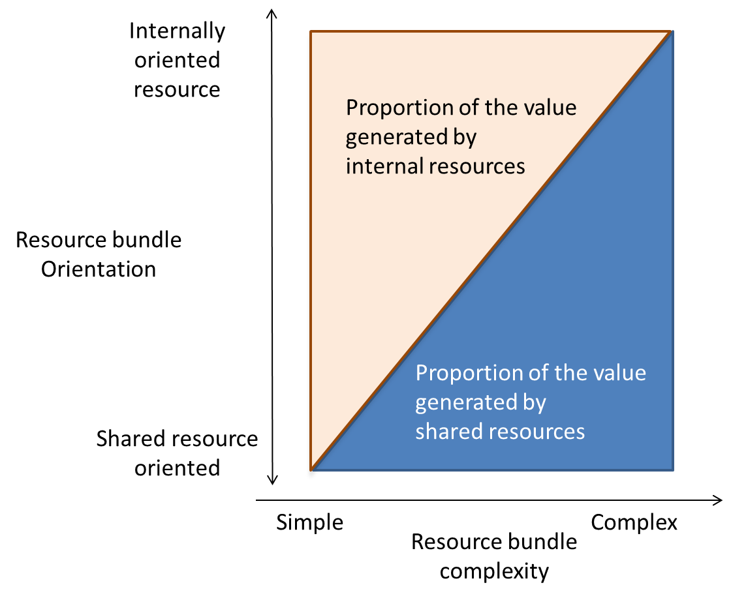

Figure 1. Resource bundle configuration

 | Growers | Co-operatives | Houses
Firms | 15,800 | 135 | 364
Champagne sellers | 4,512 | 42 | 364
Shipments (millions of bottles) | 60.9 | 28.1 | 223.5
People employed | 9,970 | 1,015 | 4,000

Table 1. Main characteristics of Champagne industry - CIVC

Organization | Characteristics | People Interviewed | Number of interviewee
Small Grower | 30,000 bottles sold only in France to direct customers. | Owner | 1
Union of Growers | Industry association. Inter alia it represents more than 1000 small growers who sell their own champagne | Marketing Manager | 2
Medium Grower | 80,000 bottles mainly exported to distributors and specialist wine shops in the world. | Owner | 3
Large Grower | 180,000 bottles sold mainly in France through direct sales to customers. | Owner | 4
Brand subsidiary of a Cooperative | 0.5 million bottles sold in France and abroad mainly through on-trade channel (restaurants and hotels) | Managing Director | 5
Low Price House | 5.5 million bottles sold mostly in France through supermarkets’ brands and abroad using distributors’ brands. | Owner | 6
Family House | More than 1 million bottles sold mostly in France with its own brands through supermarkets and large distributors. Super premium brand is sold through on trade. | Adviser to the Owner | 7
Global House (A) | More than 6 million bottles sold mostly abroad through on-trade and supermarkets. | Marketing Director | 8
Global House (B) | More than 6 Million bottles sold mainly abroad through supermarkets and on-trade. | Finance Director | 9

Table 2. Champagne firms covered in the study

Type of Firm | Price (major product) | Resource bundle orientation |  | Resource bundle complexity |  |  |  |  | Proportion of shared resource in value creation
 |  | Base for the value creation process | Customer relationship | Internal Organization Capabilities | Tangible/ Intangible Resources | Internal Resource | Resource bundle complexity
Small grower | 13 € | Based on territorial brand and price | Cellar-door sales | Grape production | Vineyard (T) | No | No |  | Shared resource > >> Internal resources
Medium Grower | 20 € | Based on specific location within Territorial brand | Assisted sales through specialized channels | Grape and specific wine production | Reputation among wine lovers (I) | Wine specificity/ vineyards | Limited |  | Internal resource > Shared resource
Larger Grower | 15 € | Based on territorial brand and loyalty | Cellar-door sales + Repeat customers | Grape and specific wine production | Reputation among loyal customers (I) | Loyalty/ vineyards | Limited |  | Shared resource > Internal resources
Cooperative | 22 € | Based on long established brand and Territorial brand | Sales force for retail and on-trade customers | Wine production | Production facilities (T) | Brand | Increasingly complex |  | Shared resource > Internal resource
Low price House | 10 € | Based on territorial brand and low price | No direct contact - Large retailers are main customers | Wine production  Bargaining with growers | Production facilities (T) | Low cost production system | Limited |  | Shared resource >> Internal resource
Family House | 25 € | Based on long established brand and Territorial brand | On-trade and specialized channels | Grape and specific wine production | Family brand (I) | Family brand | Complex |  | Internal resource >> Shared resource
Global Houses | 36 € | Specific individual brand connected with luxury | On-trade, special events and large retailers | Multi-portfolio wine production | Multi-portfolio brands (I) | Brand portfolio | Extremely complex |  | Internal resource >>> Shared resource
Type of resource: |  |  |  |  | (T) =Tangible  (I) = Intangible
Table 3. Value creation and firms’ resource bundles

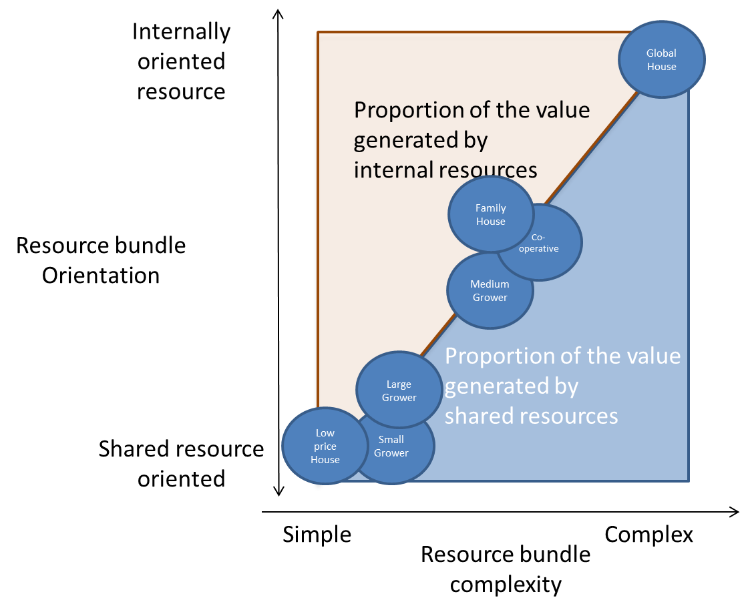
Figure 2. Value creation and resource bundle orientation and complexity

Scale free resources may also have characteristics similar to public goods but they, especially brands, are not pure public goods because their application in one product can affect the value of another product (Levinthal and Wu, 2010)
This is a sub-region of Champagne about 120 kilometres from Reims and Epernay
The primary focus of the growers as a group is the production and sale of grapes to the houses or cooperatives. However, approximately one-third of them also sell wine, mainly in small volumes, on the domestic market.
A medium-dry champagne
Which has gone through second fermentation made by other producers.

