Aerodynamic and Aeroelastic Uncertainty Quantification of NATO STO AVT-251 Unmanned Combat Aerial Vehicle
Andrea Da Ronch, and Jernej Drofelnik
Engineering and Physical Sciences, University of Southampton, SO17 1BJ, Southampton, U.K.
Michel P.C. van Rooij, and Johan C. Kok
Netherlands Aerospace Centre, Anthony Fokkerweg 2, 1059 CM, Amsterdam, The Netherlands
Marco Panzeri
Noesis Solutions N.V., 3001 Leuven, Belgium
Arne Voß
German Aerospace Center, 37073 Göttingen, Germany
Turbulence models based on Reynolds-averaged Navier-Stokes (RANS) equations remain the workhorse in the computation of high Reynolds-number wall-bounded flows. While these methods have been deployed to design the configuration developed within the NATO STO AVT-251 Task Group, their deficiencies in modelling complex flows are well-documented. However, an understanding of the sources of errors and uncertainties in RANS solvers, arising for example from different numerical schemes and flow modelling techniques, is missing to date. The aim of this work is to establish and quantify the impact that epistemic uncertainties within RANS solvers have on the aerodynamic and aeroelastic response of the combat aerial vehicle. This will produce a range of all possible values of interest due to the inherent uncertainty of RANS solvers, which is expected to be highly dependent on the flow conditions and geometry configuration. This information, in turn, is used to establish the robustness of the AVT-251 design and its performance metrics considering a high-g pull-up manoeuvre used for structural sizing. It is found that the static aeroelastic analysis without aerodynamic uncertainty (deterministic analysis) under predicted the largest generalised force, with an immediate consequence on the structural design.
- Nomenclature
c_{ref} = reference chord
$C_{L}$ = lift coefficient
$C_{D}$ = normal force coefficient
$C_{m}$ = pitch moment coefficient
$C_{Z}$ = normal force coefficient
$d$ = minimum distance from the field point to the wall
h = altitude
m_{ref} = reference weight
M = Mach number
n_{z} = normal load factor
$Re$ = Reynolds number based on unit reference length
S_{ref} = reference surface
$S_{ij}$ = mean strain rate tensor
$t$ = time
$T$ = temperature
$u$ = velocity
$W_{ij}$ = vorticity
$x$ = deterministic vector

Greek
$α$ = angle of attack
$μ$ = molecular dynamic viscosity
$μ_{t}$ = turbulent eddy viscosity
$ν$ = molecular kinematic viscosity
$ν_{t}$ = turbulent kinematic viscosity
$ρ$ = density
$σ_{k1}, σ_{ω1},σ_{k2}, σ_{ω2}, β_{1}, β_{2},β^{*},k , a_{1},γ$ = shear-stress model closure coefficients
$τ_{ij}$ = Reynolds stress tensor
$ϕ$ = shear-stress model blending constant
$Ω_{ij}$ = mean rotation tensor
$Ω$ = vorticity magnitude
$ω$ = dissipation per unit turbulence kinetic energy

I. Introduction
T
HE NATO STO AVT-251 Task Group, “Multi-Disciplinary design and performance assessment of effective, agile NATO Air Vehicles”, was established to support the design of an Unmanned Combat Air Vehicle (UCAV) by developing and applying advanced numerical tools within a collaborative and multi-disciplinary environment [1]. Specific aspects of the design were assigned to four sub-groups: Design Specification and Assessment Group (DSAG); Aerodynamic Shaping Group (ASG); Engine Integration Group (EIG); Control Concept Group (CCG); and Structural Concept Group (SCG).
The main activities of the ASG involved the development and application of advanced numerical techniques for flow predictions around the full-scale UCAV at flight conditions [1]. These activities included assessing different fidelity aerodynamic tools ([2]-[5]), establishing the effectiveness of control devices [6], investigating propulsion/airframe integration effects [7], and implementing state-of-the-art reduced order modelling techniques for rapid manoeuvres [8]. The work detailed in this paper falls within the remit of the ASG. It contributes towards assessing the uncertainty of computational fluid dynamics (CFD) predictions due to the epistemic uncertainty in the closure coefficients of a commonly-used turbulence model. The benefits of carrying out uncertainty quantification of aerodynamic loads extends beyond the aerodynamic design, as this information may drive a more robust structural sizing process.
The ability to simulate aerodynamic flows using CFD has progressed rapidly during the last several decades and has fundamentally changed the aerospace design process. Advanced simulation capabilities not only enable reductions in ground-based and in-flight testing requirements, but also provide added physical insight, enable superior designs at reduced cost and risk, and open new frontiers in aerospace vehicle design and performance. Despite considerable success, reliable use of CFD has remained confined to a small but important region of the operating design space due to the inability of current methods to reliably predict turbulent-separated flows. Sustaining future advances in CFD and related multi-disciplinary analysis and optimization tools will be critical for keeping industry competitive, meeting the stringent environment constraints, and advancing aerospace engineering in general. The improvement of a simulation-based engineering design process in which CFD plays a critical role is a multifaceted problem that requires a comprehensive long-term, goal-oriented research strategy.
This work concerns uncertainty quantification and sensitivity analysis of a commonly-used turbulence model in Reynolds-averaged Navier-Stokes (RANS) codes due to epistemic uncertainties in the closure coefficients. This aspect requires a large amount of computational resources, and this is the first study in the open literature to consider a three-dimensional configuration at realistic flight conditions. All analyses were run on high-performance computing (HPC) facilities. In particular, the University of Southampton is home to IRIDIS that is in the world’s top 500 ranking and the largest HPC facility in the UK after the national supercomputer. Analyses at the Netherlands Aerospace Centre (NLR) were run on NLR’s SGI ICE cluster.
The aim of this paper is to bring about a paradigm shift in our approach to understanding and modelling aerodynamic flows using CFD, including automated management of errors and uncertainties, and their interaction with flexible structures by addressing the following inter-related objectives: 1) quantify the uncertainty of two CFD solvers and their sensitivity to the closure coefficient of a turbulence model; 2) establish an efficient and accurate machine learning approach requiring a minimal number of deterministic model evaluations; and 3) address relevant challenges in realistic scenarios. A project of this ambition and magnitude requires collaboration with complementary teams. In addition to collaborative efforts with colleagues at the NLR on turbulence modelling, studies are carried out in close liaison with Noesis Solutions N.V. supporting the deployment of machine learning techniques for rapid uncertainty quantification and sensitivity analysis.
There is a limited work on uncertainty quantification of the closure coefficient of a turbulence model, and this is restricted to a set of two-dimensional model problems (e.g. airfoils, bumps). The reader is referred to Refs. [9] and [10], and references therein, for the state-of-the-art and a comprehensive literature review on the topic. The ambition of the current work is to go beyond these studies, and to investigate a three-dimensional configuration in realistic flight conditions, and to assess the potential impact of predictions uncertainty on the structural design. To address the third objective related to a realistic study, the work is carried out for the full-scale, three-dimensional UCAV designed within the NATO STO AVT-251 Task Group. More details about the UCAV are given at a later stage in this paper.
The paper continues in Section II with a description of the computational tools used in this work. Section III presents the MULDICON configuration and the flight condition chosen for the assessment, and results are discussed in Sections IV and V. Lessons learnt are summarised in Section VI and conclusions are finally given in Section VII.
- Computational Framework
To ensure generality in the findings, two CFD solvers are used for the aerodynamic and aeroelastic uncertainty analyses. All calculations assume fully turbulent flow. Menter Shear Stress Transport (SST) two-equation model [11] was employed. The same computational grid was used for the two solvers to remove the influence of spatial discretization errors on the aerodynamic and static aeroelastic uncertainty results.
- Computational Fluid Dynamics Solvers
DLR-Tau is a finite volume based CFD flow solver used by several aerospace industries across Europe [12]. The solver uses an edge-based vertex-centred scheme, where the convective terms are computed via several first and second-order schemes, including central and upwind types. In this work, the discretization of the convective fluxes was based on 2nd order Roe’s flux-difference splitting scheme. For the turbulent convective flux components a second order upwind scheme has been used as well.” The viscous terms are computed with a second-order central scheme. Time integration is performed either with various explicit Runge-Kutta schemes or with the Lower-Upper Symmetric Gauss-Seidel (LU-SGS) implicit approximate factorization scheme. In this work the latter scheme was used. For time accurate computations, the dual time stepping approach of Jameson [13] is employed. Convergence is improved with a multi-grid acceleration technique based on agglomerated coarse grids. Several models for turbulence closure are available.
NLR’s in-house CFD solver ENSOLV is an advanced CFD code with which three-dimensional steady or time-dependent, incompressible or compressible flows around complex aerodynamic configurations can be computed [14]-[16]. These configurations can be either fixed or moving relative to an inertial reference frame, either rigid or flexible, and they can consist of multiple bodies moving relative to one other. In case of flexible configurations, the required elasto-mechanical input data for carrying out analysis involving fluid/structure interaction are derived from finite element models in the form of mode shapes. ENSOLV has been applied extensively to aerodynamic, aeroelastic and aero-acoustic applications. The Euler and RANS equations are discretized following a cell-centred finite-volume method. The numerical scheme is fourth-order accurate on curvilinear meshes with zero dissipation and low dispersion errors. Convergence acceleration is provided by a full approximation storage multi-grid method and a line relaxation method in the boundary layer regions. The flow solver has been optimized for the High-Performance Computing facilities at NLR and applies a hybrid MPI/OpenMP parallelization for efficient parallelization on multi-core processors.
- Turbulence Modelling
Compared to structural uncertainty which can be reduced via ground vibration tests and static loading tests, aerodynamic uncertainty is more difficult to mitigate by testing in wind tunnel or flight. Furthermore, it entails major challenges due to the substantial computational efforts needed to capture physical flow behaviours, such as shock-induced separation and vortical structures. In this study, turbulence is modelled using Menter SST two-equation model [11], whose original model is available in DLR-Tau. ENSOLV, on the other hand, implements a slight variation of the standard 1994 model with an adaptation from SST 2003 [17] that uses the strain invariant rather than the magnitude of vorticity in the definition of turbulent viscosity.
Menter’s $k-ω$ SST turbulence model [11] is a combination of the standard $k-ϵ$ model and Wilcox’s $k-ω$ model. The$k-ω$ model is employed to accurately resolve the laminar sublayer of the turbulent boundary layer and the logarithmic part of the boundary layer. The $k-ϵ$ model is instead employed in the wake and farfield regions, due to low sensitivity of freestream values of $ϵ$. The transport equations of $k$ and $ω$ are, respectively:
$$\frac{∂(ρk)}{∂t}+\frac{∂(ρu_{j}k)}{∂x_{j}}=P-β^{*}ρωk+\frac{∂}{∂x_{j}}\left[\left(μ+σ_{k}μ_{T}\right)\frac{∂k}{∂x_{j}}\right]$$ | (1)

$$\frac{∂(ρω)}{∂t}+\frac{∂(ρu_{j}ω)}{∂x_{j}}=\frac{γ}{ν_{t}}P-βρω^{2}+\frac{∂}{∂x_{j}}\left[\left(μ+σ_{ω}μ_{T}\right)\frac{∂ω}{∂x_{j}}\right]+2(1-F_{1})\frac{ρσ_{ω2}}{ω}\frac{∂k}{∂x_{j}}\frac{∂ω}{∂x_{j}}$$ | (2)
where:
$$P=τ_{ij}\frac{∂u_{i}}{∂x_{j}};{ τ}_{ij}=μ_{t}\left(2S_{ij}-\frac{2}{3}\frac{∂u_{k}}{∂x_{k}}δ_{ij}\right)- \frac{2}{3}ρkδ_{ij}; S_{ij}=\frac{1}{2}\left(\frac{∂u_{i}}{∂x_{j}}+\frac{∂u_{j}}{∂x_{i}}\right)$$ | (3)
and the turbulent viscosity is computed as:
$$μ_{t}=\frac{ρa_{1}k}{max⁡(a_{1}ω, ΩF_{2})}$$ | (4)

Each of the constants is a blend of an inner (sub index 1) and outer (sub index 2) constant:
$$ϕ=F_{1}ϕ_{1}+\left(1-F_{1}\right)ϕ_{2}$$ | (5)
where:
$$F_{1}=tanh⁡(\arg_{1}^{4}{)}; \arg_{1}{=min\left[max\left(\frac{\sqrt{k}}{β^{*}ωd},\frac{500ν}{d^{2}ω}\right),\frac{4ρσ_{ω2}k}{CD_{kω}d^{2}}\right]}$$  $$ν_{t}=\frac{μ_{t}}{ρ}; CD_{kω}=\max\left(2ρσ_{ω2}\frac{1}{ω}\frac{∂k}{∂x_{j}}\frac{∂ω}{∂x_{j}}, {10}^{-20}\right)$$  $$F_{2}=\tanh\left(\arg_{2}^{2}\right); \arg_{2}{=\max\left(2\frac{\sqrt{k}}{β^{*}ωd},\frac{500ν}{d^{2}ω}\right)}$$ | (6)

and $Ω=\sqrt{2W_{ij}W_{ij}}$ with $W_{ij}=\left(\frac{∂u_{i}}{∂x_{j}}-\frac{∂u_{j}}{∂x_{i}}\right)$.
ENSOLV uses in its implementation a slight variation of the standard 1994 model with an adaptation from SST 2003 [17], that uses the strain invariant in the definition of turbulent viscosity:
$$μ_{t}=\frac{ρa_{1}k}{max⁡(a_{1}ω, SF_{2})}$$ | (7)
where $S=\sqrt{2S_{ij}S_{ij}}$ and the strain rate tensor is defined as:
$$S_{ij}=\frac{1}{2}\left[\frac{∂u_{i}}{∂x_{j}}+\frac{∂u_{j}}{∂x_{i}}\right]$$ | (8)

In total, nine closure coefficients of the SST turbulence model were considered uncertain. A list of the uncertain closure coefficients of the SST turbulence model is presented in Table 1. Closure coefficients are treated as epistemic uncertain variables due to the lack of a complete physical understanding of turbulence, and are assumed to be distributed uniformly within the associated intervals. However, scarce information is available regarding plausible ranges for the SST closure coefficients. As a consequence, epistemic intervals in this study are similar to those used in Ref. [9]. It is worth noting that the standard value of $a_{1}$ is set at the lower end of the epistemic range. This reflects the fact that $a_{1}$can only increase, as decreasing it interferences with the log layer calibration [18].
In addition to nine closure coefficients, $γ_{1}$ and $γ_{2}$ have been recomputed each time that closure coefficients were modified to ensure the log law was captured with slope $1/κ$:
$$γ_{1}=\frac{β_{1}}{β^{*}}-σ_{w1}\frac{κ^{2}}{\sqrt{β^{*}}}$$ | (8)

$$γ_{2}=\frac{β_{2}}{β^{*}}-σ_{w2}\frac{κ^{2}}{\sqrt{β^{*}}}$$ | (9)

Table 1 SST closure coefficients and associated epistemic intervals
Coefficient | Standard Value | Lower Bound | Upper Bound
$$σ_{k1}$$ | 0.85 | 0.7 | 1.0
$$σ_{k2}$$ | 1.0 | 0.8 | 1.2
$$σ_{w1}$$ | 0.5 | 0.3 | 0.7
$$σ_{w2}$$ | 0.857 | 0.7 | 1.0
$$β^{*}$$ | 0.09 | 0.0784 | 0.1024
$$β_{1}$$ | 0.075 | 0.0687 | 0.07563
$$β_{2}$$ | 0.0828 | 0.0621 | 0.0857
$$κ$$ | 0.41 | 0.38 | 0.42
$$a_{1}$$ | 0.31 | 0.31 | 0.4
- Process Integration and Design Optimization
The Process Integration and Design Optimization (PIDO) software platform Noesis’ Optimus [19] was used to automate the execution of the aerodynamic analyses performed with DLR-Tau. Optimus’s capabilities were also used to analyse the summary tables created by this tool, to build a set of surrogate models, to run probabilistic analyses aimed at assessing the sensitivity of the system outputs uncertainty on the input variances, and to characterize the probability density functions of the aerodynamic coefficients of interest.
- MULDICON Configuration

Configuration
The MULti-DIsciplinary Configuration (MULDICON) was created at the start of the NATO STO AVT-251 Task Group. It is based on a previous planform [1], with the same span and leading edge sweep angle but with the trailing edge sweep angle reduced to 30 deg to improve the control effectiveness of the trailing edge devices and to increase the surface area for lift generation. The aerodynamic shape herein consideration is designated as Design 3, and it represents the final design release of the ASG that meets fully the specified design requirements [19]. Reference values of the MULDICON configuration are included in Table 2.

Computational Grid
A multi-block structured grid for half-span of the MULDICON Design 3 geometry was generated using NLR’s in-house tools for domain modelling and grid generation. These tools employ a semi-automatic Cartesian grid mapping technique that creates automatically a multi-block domain decomposition around a complex aircraft configuration by exploiting Cartesian space [20]-[23]. This enables a fast and efficient three-dimensional construction of a multi-block domain topology and high-quality structured grid. An O-type mesh envelopes the aircraft geometry. The grid used in the computations described here contained 12 million cells, with 112 cells distributed along the chord, 128 cells along the span, and 32 across the trailing edge and wing tip. The average Y+ in the first cell was 0.75 ($α=0$ deg). An impression of the grid can be obtained from Figure 1.
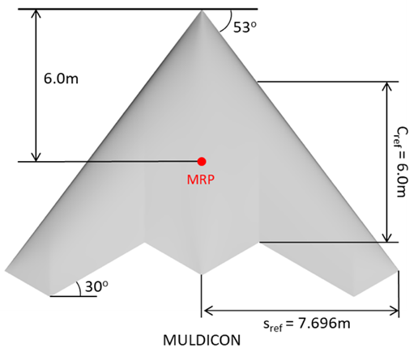  (a) Wing planform | 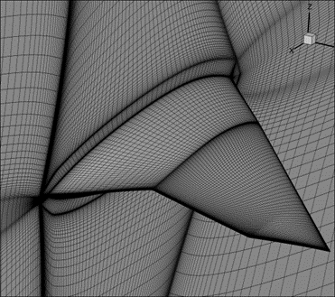  (b) Rear three-quarter view
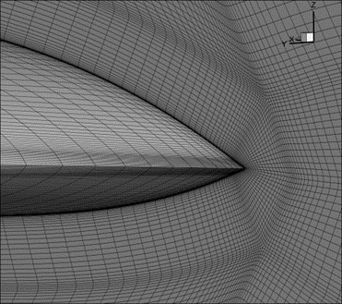  (c) Close-up of leading edge apex region | 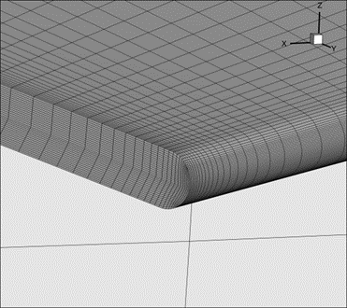  (d) Close-up of wing tip leading edge
Figure 1 MULDICON Design 3 configuration
This grid was used in all computations carried out using ENSOLV and was converted to unstructured for use with DLR-Tau. Having the same computational grid ensures removing further sources of discretization errors that could affect in an uncontrolled way the assessment of the turbulence model closure coefficients. Notwithstanding, one has to consider that gradients in a vertex-centred (i.e. DLR-Tau) and a cell-centred (ENSOLV) solver are computed differently on the same grid, generating intrinsically some discrepancies which were out of the scope of this work to be assessed.
Table 2 Reference values of the MULDICON Design 3 configuration
Parameter | Value
c_{ref} [m] | 6.0
m_{ref} [kg] | 10,749.0
S_{ref} [m²] | 77.8
- Aerodynamic Characteristics
A preliminary study was carried out to compare the CFD predictions obtained by using DLR-Tau and ENSOLV solvers. To remove other sources of errors, additional effort was addressed at choosing appropriate settings to ensure having identical or similar numerical schemes.
The aerodynamic coefficients were computed at Mach 0.8 and 11 km altitude with Reynolds number based on reference chord of 36.3 million. Integrated aerodynamic coefficients computed using DLR-Tau and ENSOLV are compared in Figure 2. The pitch moment coefficient is based on the reference chord, c_{ref}, and is taken at six meters from the aircraft nose. Discrepancies are limited to the higher angles of attack, where the combination of shocks and separated flow represents a challenging condition for predictions and depends highly on implementation details, often unknown even to the most experienced users of the software tools.
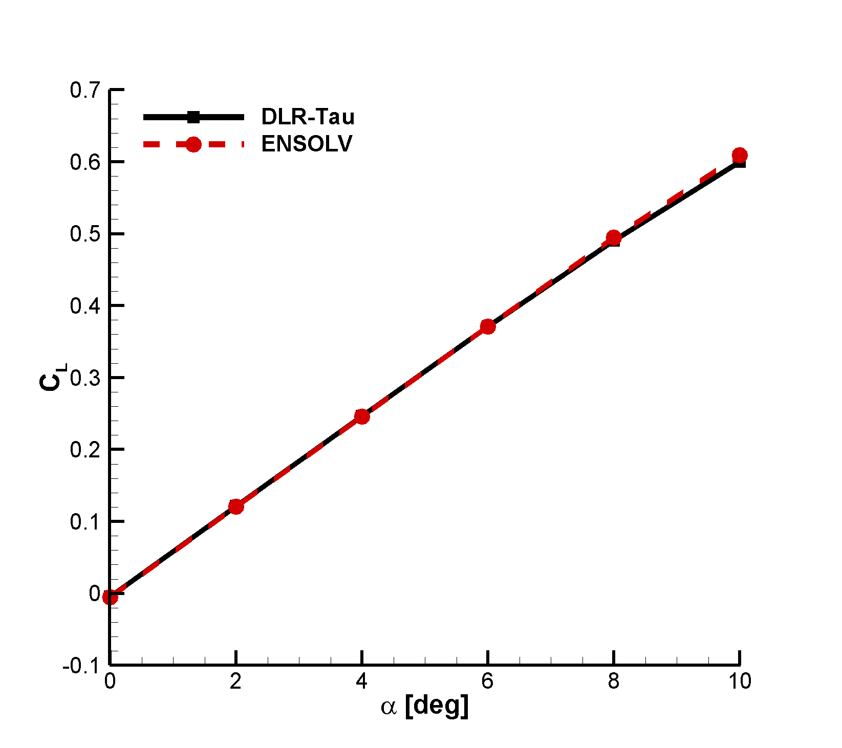  (a) Lift coefficient | 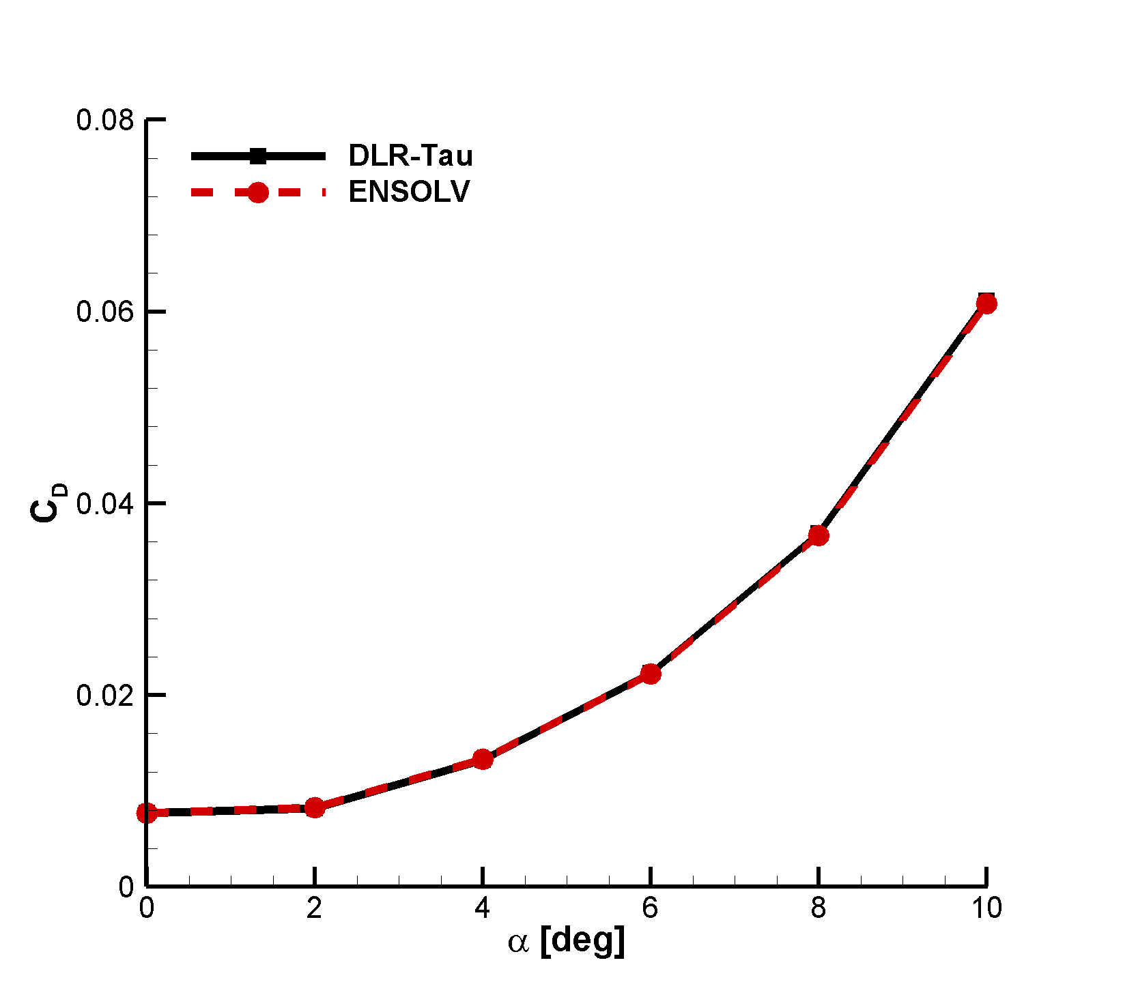  (b) Drag coefficient
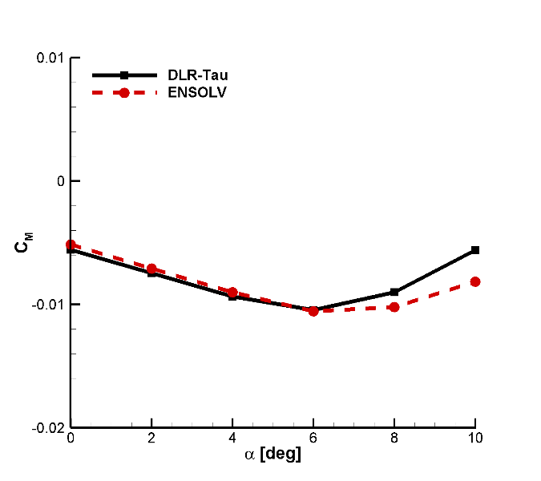  (c) Pitch moment coefficient | 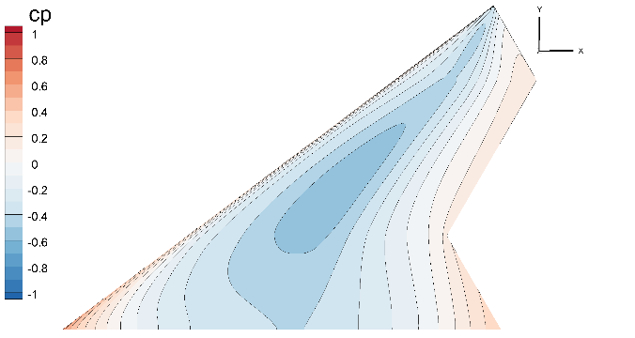  (d) Pressure coefficient distribution from DLR-Tau, $α=2.21$ deg (upper surface)
Figure 2 Integrated aerodynamic coefficients without uncertainty in the closure coefficients ($M=0.8$, $h=11$ km, $Re=36.3⋅10^{6}$)
- Flight Condition
A representative flight condition was chosen to run the aerodynamic and static aeroelastic analyses with epistemic uncertainties. This condition is relevant as it constitutes a critical point for the structural design, and it was identified in close liaison with the SCG group. With some simplifications as to work with a clean wing configuration to avoid unnecessary complications with deflecting control surfaces in the computational grid, the flight condition is specified in Table 3. The calculated normal force coefficient to generate the target load factor, $n_{z}=4.5$, is $C_{z}=0.1346$, which is obtained at a freestream angle of attack of 2.21 deg (for both DLR-Tau and ENSOLV flow solvers). The angle of attack at which the target normal load factor is generated was calculated by performing, first, an interpolation between neighbouring values of calculated angles of attack (the initial discretisation in Figure 2 is $Δα=2$ deg), and then verifying that the interpolated normal force coefficient matched the target value.
Table 3 Reference values of the high-g, transonic pull-up manoeuvre
Parameter | Value
$$Re$$ | $$36.6⋅{10}^{6}$$
h [m] | 0.0
M | 0.8
n_{z} | 4.5

- Uncertain Aerodynamic Results

Design Space Exploration
A total of 160 CFD runs was performed to explore the design space and to investigate the dependence of the aerodynamic coefficients of interest (lift, drag and pitch moment coefficients) on the 9 design variables listed in Table 1. The Design of Experiments (DOE) plan was realized according to the following two sequential steps:
- a fractional full factorial plan was coupled with a Latin Hypercube plan with 30 points each to create an initial summary table containing the results of 60 system evaluations;
- the results obtained at Step 1 were employed to generate an additional set of 100 samples through an approach based on the Adaptive DOE (ADOE) algorithm [24]. The ADOE is an iterative, machine learning based technique that analyses available data, generally produced by previous iterations or previous DOE runs, to distribute the design points of the next iteration in areas of the parameter space considered of interest. The ADOE approach was proved to be effective in the identification of critical areas of the design space, such as nonlinearities and discontinuities, and in the capability to build more accurate surrogate models than the ones created by using only traditional DOE plans [24].

Surrogate Model Generation
The Optimus platform was used to analyse the results produced through the DOE plan described above and to build a set of surrogate models between the SST closure coefficients and the aerodynamic coefficients of interest. Different types of interpolating surrogate models approaches were investigated such as Radial Basis Function (RBF) with cubic or linear interpolating functions and Kriging. No significant differences were observed among these surrogate model types and the cubic RBF was chosen to perform the sensitivity and probabilistic analyses described in the following paragraphs. A critical aspect in the selection and usage of these surrogate models is related to the assessment of their quality and of their ability to accurately mimic the system dynamics. In this work, these aspects were assessed by conducting two separate studies.
A first investigation entailed the evaluation of the $R_{PRESS}^{2}$ metric for each surrogate model. $R_{PRESS}^{2}$ is a quantity used in cross-validation and is evaluated using the same formula employed to calculate the coefficient of determination, $R^{2}$, but considering prediction residual errors obtained through a leave-one-out approach. The closer $R_{PRESS}^{2}$ is to 1, the better is the surrogate model accuracy in predicting output values that were not included in the interpolating data set. In our case, $R_{PRESS}^{2}$ was found to be equal to 0.95, 0.96 and 0.89 for the lift, drag and pitch moment coefficients, respectively. This indicates an overall good quality of the underlying surrogate models.
A second investigation was performed by randomly splitting the original set of 160 design points into a validation set and a training set of 10 and 150 points, respectively, following a non-exhaustive leave-10-out approach. The surrogate models built on top of the training points were then used to predict the outputs of the validation set and to calculate the root mean squared errors (RMSE) of the corresponding prediction residuals. The same analysis was repeated by considering three different training sets and by taking into account the outputs obtained by DLR-Tau and ENSOLV. No significant differences were observed among the results produced by these different scenarios. The scatter plots obtained from one of these analyses are displayed in Figure 3. In this case, the (averaged over the three different training sets) RMSE was found to be equal to ${3.86⋅10}^{-4}$, ${1.75⋅10}^{-4}$ and ${1.63⋅10}^{-4}$ for the lift, drag and pitch moment coefficients, respectively, indicating a mean error that is at least one order of magnitude smaller than the order of magnitude of the output themselves. Table 4 reports the full set of metric values for the different types of surrogate models considered.
Table 4 Cross-validation metrics for the considered surrogate model types
 | R2_PRESS |  |  | Averaged RMSE
Surrogate model type | CL | CD | CMy | CL | CD | CMy
RBF - cubic | 0.95 | 0.96 | 0.90 | 3.86E-04 | 1.75E-04 | 1.63E-04
RBF – linear | 0.94 | 0.96 | 0.91 | 4.32E-04 | 1.49E-04 | 1.64E-04
Kriging | 0.97 | 0.98 | 0.96 | 6.96E-04 | 3.23E-04 | 2.47E-04
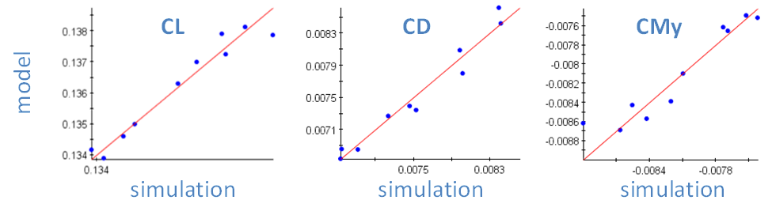
Figure 3 Scatter plots of model outputs belonging to a validation set of 10 points evaluated through DLR-Tau (x-axis) and predicted with surrogate models (y-axis) created by interpolating the 150 design points of the training set.

Nonlinear Sensitivity and Uncertainty Quantification Analyses
A global sensitivity analysis was performed to quantify the impact of the input variables’ variance on the uncertainty of the output variables. Table 5 reports the first order Sobol’ indices evaluated using the surrogate models built on top of the data set created using DLR-Tau and ENSOLV. Table 5 highlights that the input parameters having the largest influence on the outputs uncertainty are $σ_{w1}$ and $κ$. The Sobol’ indices observed for the lift and drag coefficients are well aligned among the two flow solvers. The largest differences are observed for the indices related to the pitch moment coefficient: in this case, the first-order term related to $σ_{w1}$ is larger for ENSOLV than for DLR-Tau. Moreover, the larger value of the residual, which is a measure of the interdependency among input variables, observed for DLR-Tau indicates that higher-order effects, related to the interactions between input variables, play a more important role on the contribution to the total output variance of $C_{M}$. Extending the sensitivity analysis for the output $C_{M}$ and for the DLR-Tau solver to the second-order terms allows: a) reducing the value of the residual from 0.41 to 0.07; and b) identifying that the most significant contribution (amongst all second-order terms) is associated with the interaction between the two inputs $β^{*}$ and $a_{1}$, yielding a Sobol’ index equal to 0.09.
The pitch moment coefficient is a combination of the lift and drag coefficients and its output is therefore more sensitive than that of $C_{L}$ and $C_{D}$ taken separately. Most likely, the observed differences in $C_{M}$ between the two solvers occur due to different definitions of turbulent eddy viscosity in DLR-Tau and ENSOLV. It is also worth noting that as a default DLR-Tau limits production terms of both $k$ and $ω$, as proposed by Menter [11], whereas ENSOLV turns off those limiters as a default, which was done for these cases as well. Production limiters eliminate the occurrence of spikes in the eddy viscosity as well as eliminate its unphysical build-up in the stagnation region. For relatively simple problems the differences in solution are therefore small. However, in more complex flow regimes the solutions obtained with and without production limiters may differ significantly [31].
Table 5 First order Sobol’ indices of the SST closure coefficients with respect to lift, drag and pitch moment coefficients
Coefficient | $$C_{L}$$ |  | $$C_{D}$$ |  | $$C_{M}$$
 | DLR-Tau | ENSOLV | DLR-Tau | ENSOLV | DLR-Tau | ENSOLV
$$σ_{k1}$$ | 0.00 | 0.00 | 0.00 | 0.00 | 0.01 | 0.00
$$σ_{k2}$$ | 0.00 | 0.01 | 0.00 | 0.00 | 0.01 | 0.00
$$σ_{w1}$$ | 0.45 | 0.58 | 0.72 | 0.73 | 0.21 | 0.61
$$σ_{w2}$$ | 0.11 | 0.05 | 0.00 | 0.00 | 0.08 | 0.00
$$β^{*}$$ | 0.02 | 0.03 | 0.01 | 0.01 | 0.10 | 0.03
$$β_{1}$$ | 0.01 | 0.00 | 0.00 | 0.00 | 0.03 | 0.01
$$β_{2}$$ | 0.01 | 0.01 | 0.00 | 0.00 | 0.01 | 0.00
$$κ$$ | 0.09 | 0.16 | 0.20 | 0.20 | 0.08 | 0.20
$$a_{1}$$ | 0.03 | 0.02 | 0.03 | 0.03 | 0.07 | 0.02
Residual | 0.28 | 0.13 | 0.04 | 0.04 | 0.41 | 0.12

The variance associated with the system outputs was assessed by relying on the available surrogate models and by adopting an uncertainty propagation approach based on Monte Carlo with a population size equal to 10,000. The input probability density functions were assumed to be uniformly distributed within the low and high bounds reported in Table 1. Figure 4 depicts the output histograms obtained from the uncertainty quantification analyses, underlining a good agreement between the two codes in terms of output mean and standard deviation values (these values are reported in the figure caption). Furthermore, one observes that the distributions obtained using DLR-Tau and ENSOLV flow solvers as sources of the aerodynamic predictions have a significant overlapping. Similar features of the distributions are also found, such as the clear tendency of the pitch moment coefficient distribution towards the right tail.
(a) Lift coefficient (DLR-Tau: $\overline{μ}=0.1349$, $σ=0.0005$; ENSOLV: $\overline{μ}=0.1342$, $σ=0.0006$) | (b) Drag coefficient (DLR-Tau: $\overline{μ}=0.0085$, $σ=0.0004$; ENSOLV: $\overline{μ}=0.0086$, $σ=0.0004$)
(c) Pitch moment coefficient (DLR-Tau: $\overline{μ}=-0.0077$, $σ=0.0001$; ENSOLV: $\overline{μ}=-0.0074$, $σ=0.0002$)
Figure 4 Histograms approximating the probability density functions of the output quantities of interest using data from DLR-Tau and ENSOLV; symbols $\overline{μ}$ and $σ$ indicate, respectively, the mean and standard deviation
- Uncertain Static Aeroelastic Results

Structural Concept and Finite Element Model
A structural model of the MULDICON was prepared at the DLR Institute of Aeroelasticity. An overview of the general modelling strategies and related studies is given in [25]. The focus on aeroelastic aspects led to a number of requirements which differ from a classical finite element model (FEM) for stress analysis. The structure should be as realistic as possible because global elastic characteristics such as wing bending and twist are of major interest. Local effects like stress concentrations at sharp edges or at holes are neglected. This means that all primary structural components, such as spars, ribs, stringers and skin, need to be modelled. The structural model is set-up using a parametric modelling approach described by Voß et al. [26] in Section 2.
The resulting FEM, shown in Figure 5, consists primarily of shell elements. A right-hand side and a corresponding symmetric left-hand side FEM are joined at the centreline through RBE2 elements. The spars, ribs and skins are modelled as shell elements and are equipped with stiffening elements to keep the buckling fields sufficiently small and to reduce local mode-shapes. For the stringers, a hat profile is selected. The control surfaces are structurally modelled as well and attached to the wing elastically.
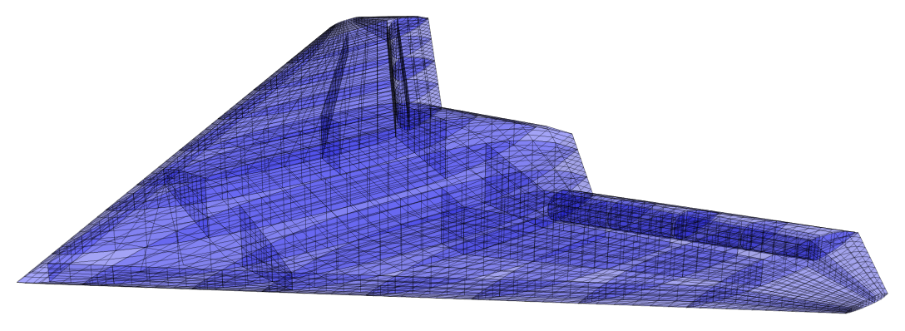
Figure 5 MULDICON structural finite element model
For all structural components, suitable carbon fibre composite properties are chosen (details given in [26], Table 1). For the skin, the 0° plies are aligned along the leading edge using a local coordinate system to define the orientation. Material properties for unidirectional layers are provided by the DLR Institute of Composite Structures and Adaptive Systems. The material properties of the complete laminate setup are then calculated as described in [27]. The approach is based on the classical laminate theory and on the calculation of stiffness matrices $A$ and $D$ of the complete laminate set-up.
In addition to the structural stiffness aspects, the mass model shown in Figure 6 with properly distributed mass entities (e.g., structure, systems, payload, fuel) is important to conduct dynamic calculations. The dynamic analysis of the stiffness and mass model should result in only global modes for a specified frequency range. Local modes are to be avoided. Because the configuration is rather stiff, the lowest 15 modes were used in this work, following the recommendation advanced in [26].
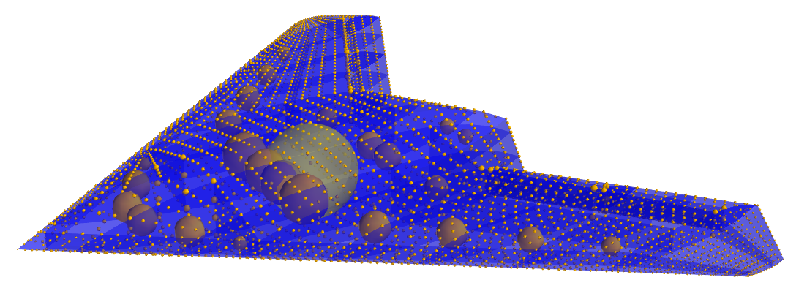
Figure 6 Discretisation of structural and lumped masses
The lowest eight mode-shapes and associated frequencies are listed in Table 6. The structural FEM is for the full-scale configuration, and mode-shapes are classified into symmetric and asymmetric. Owing to the symmetry of the load case considered herein (see Table 3), the aeroelastic response is symmetric with no participation from the asymmetric mode-shapes.
Available data extracted from the complex structural model included the modal stiffness matrix, $K_{m} (15×15)$, the modal matrix, $ϕ$, whose columns correspond to each mode-shape, and the coordinates of the FEM grid points.
Table 6 Lowest eight mode-shapes and frequencies of the modal basis used for the aeroelastic analysis
Mode | Description | Frequency [Hz]
1 | 1st asymmetric bending | 14.24
2 | 1st symmetric bending | 18.50
3 | 2nd symmetric bending | 26.66
4 | 2nd asymmetric bending | 28.23
5 | 3rd symmetric bending | 30.77
6 | 1st asymmetric torsion | 42.19
7 | 1st symmetric in-plane bending | 42.63
8 | 4th symmetric bending | 48.57

Spatial Coupling Algorithm
The aeroelastic system is mathematically partitioned into equations for the aerodynamic and structural unknowns derived from independent solvers, each one developed for its purpose by specialist people. The adoption of a partitioned approach requires the definition of an interface scheme to exchange displacements, velocities (although these are not used in the current work) and loads between the structural grid and the CFD boundary surfaces.
The algorithm used to build the aeroelastic interface operator consists of an interpolation scheme based on a Moving-Least Square (MLS) patches technique [30]. This method: a) retains the conservation of momentum and energy transfer between the aerodynamic and structural fields in a weak sense, through the use of the Principle of Virtual Work; b) it is independent of the formulation of the aerodynamic and structural solvers; and c) it is sufficiently flexible to treat complex configurations in which aerodynamic and structural meshes are not compatible because they differ in terms of geometry, topology and discretisation (refer to Figure 1 and Figure 5).
The fluid-structure interaction (FSI) matrix was obtained using linear weight functions to avoid numerical instabilities and smooth $C^{2}$ compactly supported radial basis functions (RBFs). The determination of the RBF local support allows adapting the support radius to ensure that enough points are covered, and that far away points have no influence. These two parameters influence the quality and efficiency of the MLS approximation, and the sparsity of the final FSI matrix. For the present case, the radius of the support was set to 1.5 m with the maximum number of points within the support limited to 300. As an example of the robustness and quality of the MLS scheme, the lowest eight flexible mode-shapes mapped onto the CFD surface grid are shown in Figure 7. It is worth observing the smoothness of the reconstructed aerodynamic surface is maintained even for the higher frequencies, and more spatially localised, mode-shapes. The effect of the rotation is accounted for by the displacements of the structural FEM grid points and the FSI matrix is computed using displacements only. Then, the conservation of momentum and energy transfer was evaluated by comparing the total nodal loads on the aerodynamic surface grid with the total nodal loads reconstructed onto the structural nodes. It was found that the difference between the two load sets was down to machine accuracy.
To quantify the computational effort in the generation of the FSI matrix, $H$, the full scale configuration consists of a structural mesh with 5,747 grid points coupled with an aerodynamic mesh with 71,938 surface grid points. In principle, the size of the $H$ matrix in full form is 71,938 x 5,747, which results in more than 400 million elements in total. In practice, the full matrix is converted into sparse form by squeezing out any element that corresponds to points placed at a distance greater than the chosen RBF local support. With the above numerical settings, the $H$ matrix in sparse form contains 7,131,328 non-zero elements, corresponding to 1.7% when compared with the full form matrix. The calculation of the FSI matrix required 26 seconds on a standard laptop computer (Intel CORE i7, 2.20 GHz). This operation was done once and then the matrix was stored on disk (71 Mb) for future use. For the uncertain static aeroelastic results herein reported, a matrix-vector operation involving the $H$ matrix was performed 10,000 times during the Monte Carlo simulations.
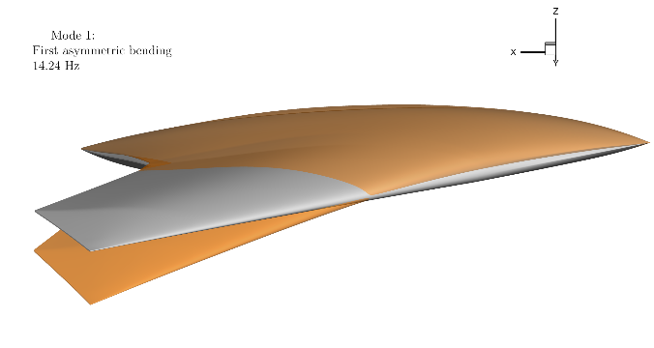  (a) Mode 1: 1st asymmetric bending (14.24 Hz) | 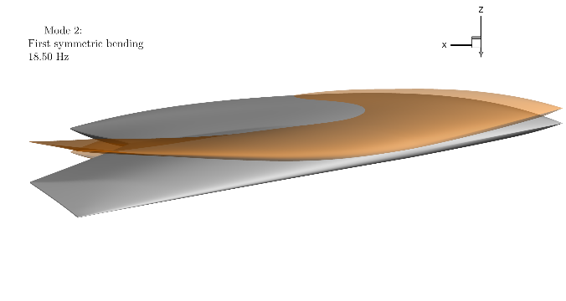  (b) Mode 2: 1st symmetric bending (18.50 Hz)
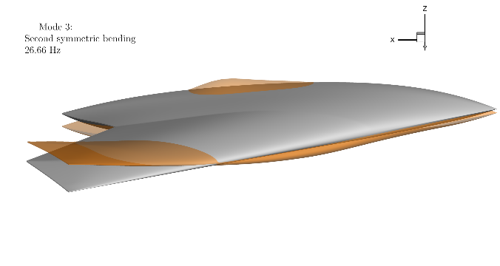  (c) Mode 3: 2nd symmetric bending (26.66 Hz) | 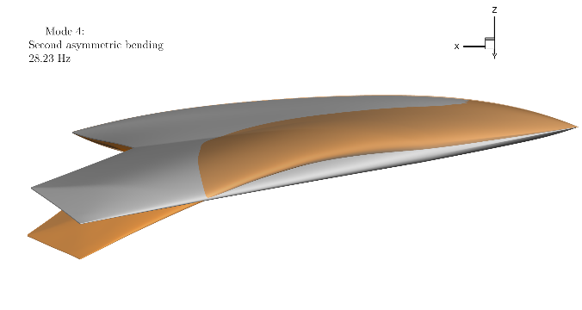  (d) Mode 4: 2nd asymmetric bending (28.23 Hz)
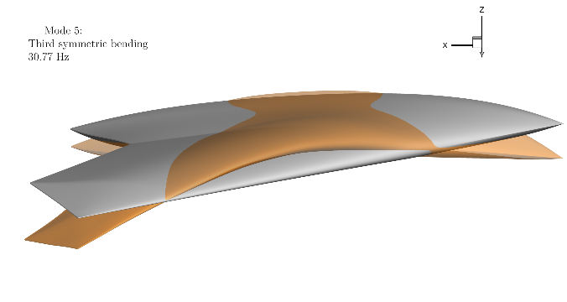  (e) Mode 5: 3rd symmetric bending (30.77 Hz) | 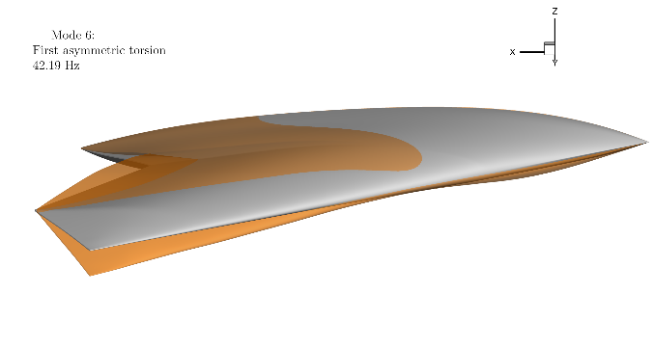  (f) Mode 6: 1st asymmetric torsion (42.19 Hz)
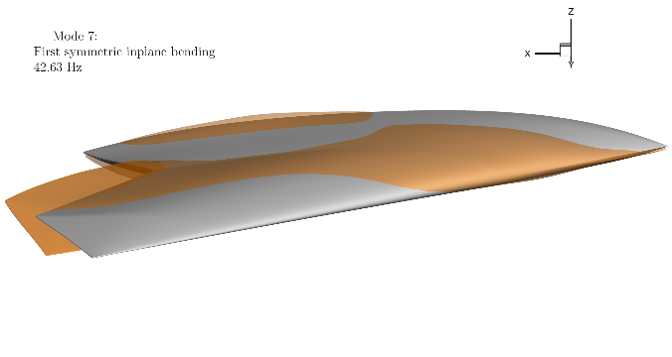  (g) Mode 7: 1st symmetric inplane bending (42.63 Hz) | 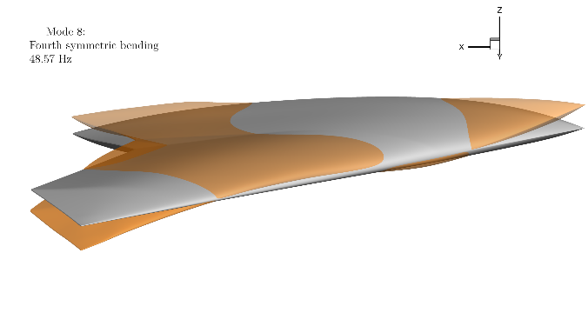  (h) Mode 8: 4th symmetric bending (48.57 Hz)
Figure 7 Mode-shapes mapped on CFD surface grid; reference configuration in grey colour
A static aeroelastic analysis was performed with the baseline aerodynamic model without epistemic uncertainties in the turbulence model closure coefficients. A one-way coupling method was adopted to transfer the fluid pressure onto the structural model. The advantage of the one-way coupling is that it requires a lower computational cost compared to a two-way coupling approach, as the fluid volume grid is not modified to account for the changes in the wall boundaries. The disadvantage of the one-way coupling is that it is only valid for small deformations of the structure [31]. The deformed shape at $M=0.8$ and $n_{z}=4.5$ is shown in Figure 8. One can observe the high rigidity of the MULDICON configuration which displays a tip deflection in the order of the wing thickness. Therefore, the adoption of the one-way coupling approach, restricted in validity to small structural deformations, is reasonable for the present work. The static aeroelastic results, which are taken hereafter as reference results before adding uncertainties, preserves the symmetry of the loading condition (symmetric pull-up manoeuvre). As a result, only the values of the generalised forces associated with symmetric mode-shapes are listed in Table 7, and in the remainder of this paper.
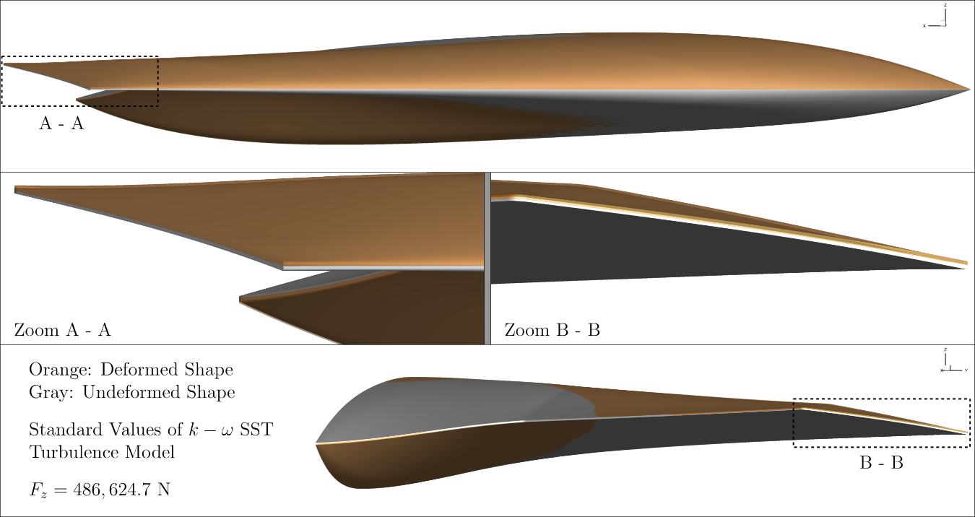
Figure 8 Reference static aeroelastic shape using the aerodynamic model without uncertainties
Table 7 Generalised forces associated with symmetric mode-shapes for the reference static aeroelastic analysis
Value
[Nm $×10^{3}$]
Generalised Force | DLR-Tau | ENSOLV
2 | 3.85331 | 4.0214
3 | -1.77808 | -1.5605
7 | -0.73858 | -1.4300
8 | -1.50285 | -1.3714
10 | 0.99385 | 0.4236
13 | -0.40293 | -0.6032
14 | -0.92339 | -2.3689
15 | 1.21746 | 2.4117

Aeroelastic Response to Uncertainty of the Turbulence Model Closure Coefficients
The uncertainty in the turbulence model closure coefficients is added to the static aeroelastic analysis. A Monte Carlo simulation with 10,000 runs was performed, and the histograms of the distribution of selected generalised forces associated with symmetric mode-shapes are shown in Figure 9. Histograms were normalised to have the sum of the bar areas less than or equal one. The vertical solid line represents the value of the generalised forces for the reference aeroelastic analysis without aerodynamic uncertainties (refer to Table 7). Although the epistemic uncertainty of the closure coefficients is modelled to be uniformly distributed within the epistemic range (refer to Table 1), the distribution of the generalised forces, including those not reported herein as less relevant to the discussion, follows to a certain degree the trend of normal distributions. Nonetheless, it appears that distributions are skewed away from a symmetric shape, with a tendency to be tilted to either the left or the right tail.
With reference to Figure 9, the distributions of generalised forces derived from DLR-Tau and ENSOLV data have no overlapping in general. The closest match between the two sets of distributions was found for the generalised force 8, which is considered purely case-dependent. This finding is interesting, particularly in contrast with the agreement of the distribution of integrated aerodynamic coefficients, as shown in Figure 4. Aerodynamic coefficients are integral quantities and, as such, differences appearing in the distribution of flow features tend to disappear in the integration process. In contrast to this global representation of the flow, generalised forces are associated with specific mode-shapes, which are dependent on distributed surface flow features. Differences in flow predictions become more apparent when represented in terms of generalised forces or displacements than purely aerodynamic coefficients.
Table 8 summarises the statistics of the distribution of generalised forces. The largest discrepancy in terms of average value and standard deviation is found for generalised force 1. This is not unexpected, as this is the largest contribution in the static aeroelastic response. Finally, it is worth noting that the difference between the reference and the distributed mean values exceeds one standard deviation for all symmetric generalised forces. Based on Table 8, generalised forces not included in Figure 9 appear either to have a small standard deviation, leading to a narrow distribution, or to be associated with localised mode-shapes (7, 13, 14, 15). In particular, mode-shape 7 is the 1st symmetric in-plane bending that is irrelevant for the stiff configuration here considered.
Table 8 Mean and standard deviation of the distribution of symmetric generalised forces
 | Distributed Mean  [Nm $×10^{3}$] |  | Standard Deviation  [Nm]
Generalised Force | DLR-Tau | ENSOLV | DLR-Tau | ENSOLV
2 | 3.8697 | 4.0161 | 13.08 | 5.31
3 | -1.7801 | -1.5569 | 11.46 | 11.37
7 | -0.7375 | -1.4286 | 6.28 | 1.59
8 | -1.5095 | -1.3744 | 16.96 | 15.97
10 | 0.9984 | 0.4316 | 16.46 | 17.81
13 | -0.4005 | -0.5991 | 13.64 | 3.79
14 | -0.9257 | -2.3677 | 4.24 | 1.10
15 | 1.2180 | 2.4078 | 6.10 | 3.42

(a) Generalised force 2 | (b) Generalised force 3
(c) Generalised force 8 | (e) Generalised force 10
Figure 9 Histogram of selected symmetric generalised forces; reference solution (without aerodynamic uncertainty) shown in black line
- Lessons learned on turbulence model implementation
Although modifying the closure coefficients of Menter Shear Stress Transport two-equation model seems trivial, one needs to be extremely cautious to properly modify all relations that depend on new closure coefficients, as strong dependence on implementation details has been observed. The initial implementation of DLR-Tau used hardwired values of $γ_{1}$ and $γ_{2}$, which is acceptable if turbulence closure coefficients are also hardwired. When changing the turbulence closure coefficients, it becomes important to maintain the relations of $γ_{1}$ and $γ_{2}$ (refer to Eqs. 8 and 9) as this ensures that the logarithmic law is captured with the slope $1/κ$. Neglecting those expressions would affect significantly the observations.
- Conclusions
This work investigated the impact that epistemic uncertainties in the closure coefficients of Menter Shear Stress Transport two-equation model have on the aerodynamic and aeroelastic analysis of a full-scale, three-dimensional combat aerial vehicle. The investigation was carried out using two flow solvers, DLR-Tau and ENSOLV, employed on the very same computational grid. To overcome the prohibitive computational costs of exploring a large design space (nine closure coefficients) using a large computational grid, a combination of adaptive design of experiments and surrogate modelling techniques was employed through Noesis’s Optimus software platform. It was found that the implementation of Menter Shear Stress Transport turbulence model in both flow solvers is sensitive to specific closure coefficients ($σ_{w1}$ and $k$) as highlighted by a nonlinear sensitivity analysis based on Sobol’s indices. Although this observation is dependent on the flow conditions considered, which are a high-g manoeuvre at transonic conditions for the present work, it highlights an important issue that has remained largely unexplored to date. Furthermore, the journal continued to investigate the static aeroelastic response of the aerial vehicle under critical loading for the structural sizing. It is found that the distributions of the generalised forces derived from the two flow solvers differ substantially. This is an interesting finding when compared with the good agreement previously observed between the distributions of the integrated aerodynamic coefficients. The uncertainty in the closure coefficients has a larger impact on the static aeroelastic response than on the aerodynamic response for the rigid configuration. This observation reflects the fact that the generalised forces are associated with specific mode-shapes, which are local and so dependent on the spatial distribution of the flow. The finding therefore highlights the importance of propagating the uncertainty of the aerodynamics on the aeroelastic analysis, to the detriment of neglecting an important component that may affect the structural sizing process.
- Acknowledgments
The authors acknowledge the use of the IRIDIS High Performance Computing Facility, and associated support services at the University of Southampton, in the completion of this work. Dr Da Ronch acknowledges the financial support from Horizon 2020 funded HOMER (Holistic Optical Metrology for aero-Elastic Research) project. Furthermore, Dr Da Ronch and Dr Drofelnik gratefully acknowledge the financial support from the Engineering and Physical Sciences Research Council (grant number: EP/P006795/1).
Data supporting this study are openly available from the University of Southampton repository (DOI: 10.5258/SOTON/D0906).
- References
- Van Rooij, M.P.C., Cummings, R. M., “Aerodynamic design of an Unmanned Combat Air Vehicle in a collaborative framework”, Aviation and Aeronautics Forum and Exposition, AIAA, Atlanta GA, June 2018
- Cummings, R.M., Liersch, C., Schuette, A., “Multi-Disciplinary Design and Performance Assessment of Effective, Agile NATO Air Vehicles”, Aviation and Aeronautics Forum and Exposition, AIAA, Atlanta GA, June 2018.
- Nangia, R., Coppin, J., Ghoreyshi, M., “UCAV Wing Design, Assessment and Comparisons”, Aviation and Aeronautics Forum and Exposition, AIAA, Atlanta GA, June 2018
- Schuette, A., Vormweg, J., Maye, R.G, Jeans, T.L., “Aerodynamic shaping design and vertical flow design aspects of a 53deg swept flying wing configuration”, Aviation and Aeronautics Forum and Exposition, AIAA, Atlanta GA, June 2018
- Karakoç, A., Kaya, H., “A Multi-objective Multi-disciplinary Optimization Methodology for NATO AVT 251 UCAV – MULDICON”, Aviation and Aeronautics Forum and Exposition, AIAA, Atlanta GA, June 2018
- Loechert, P., Liersch, C., Schuette, A., “Control Device Studies for Yaw Control Without Vertical Tail Plane on a 53° Swept Flying Wing Configuration”, Aviation and Aeronautics Forum and Exposition, AIAA, Atlanta GA, June 2018
- Jirasek, A., Aref, P., Ghoreyshi, M., Satchell, M., Cummings, R.M., “Propulsion Airframe Integration of the NATO AVT-251 Multi-Disciplinary Configuration”, Aviation and Aeronautics Forum and Exposition, AIAA, Atlanta GA, June 2018
- Allen, J. D., Ghoreyshi, M., Jirásek, A., Rubini, R., Da Ronch, A., Lasagna, D., “Aerodynamic Loads Identification and Modeling of UCAV Configurations with Control Surfaces Using Prescribed CFD Maneuvers”, Aviation and Aeronautics Forum and Exposition, AIAA, Atlanta GA, June 2018
- Schaefer, J.A., “Uncertainty quantification of turbulence model closure coefficients for transonic wall-bounded flows”, MSc Thesis, Missouri University of Science and Technology, 2015
- Da Ronch, A., Panzeri, M., Drofelnik, J., d’Ippolito, R., “Sensitivity and calibration of turbulence model in presence of epistemic uncertainties”, CEAS Aeronautical Journal, (2019), pp. 1-15.
- Menter, F.R., “Two-Equation Eddy-Viscosity Turbulence Models for Engineering Applications,” AIAA Journal, Vol. 32, No. 8 (1994), pp. 1598-1605
- Schwamborn, D., Gerhold, T., Heinrich, R., “The DLR-Tau code: recent applications in research and industry”, Proceedings of the European Conference on Computational Fluid Dynamics, ECCOMAS, 2006
- Jameson, A., Schmidt, W., Turkel, E., “Numerical solutions of the Euler equations by finite volume methods using Runge-Kutta time-stepping schemes”, 14th Fluid and Plasma Dynamics Conference, Fluid Dynamics and Co-located Conferences, Palo Alto, CA, 1981
- Kok, J.C., Prananta, B. B., “User guide of ENSOLV version 7.60. A flow solver for aerodynamic, aeroelastic, and aeroacoustic applications using 3D multi-block structured grids”, NLR, July 2016
- Kok, J.C., “A high-order low-dispersion symmetry-preserving finite-volume method for compressible flow on curvilinear grids”, Journal of Computational Physics, Vol. 228 (2009), pp. 6811-6832
- Kok, J.C., “A symmetry and dispersion-relation preserving high-order scheme for aeroacoustics and aerodynamics”, proceedings of ECCOMAS CFD 2006, Egmond aan Zee, The Netherlands, 5-8 September 2006, NLR-TP-2006-525
- Menter, F.R., Kuntz, M., Langtry, R., “Ten Years of Industrial Experience with the SST Turbulence Model”, Turbulence, Heat and Mass Transfer 4, ed: K. Hanjalic, Y. Nagano, M. Tummers, Begell House, Inc. 2003, pp. 625-632
- Georgiadis, N.J., Yoder, D.A., “Recalibration of the Shear Stress Transport Model to Improve Calculation of Shock Separated Flows,” AIAA Paper 2013-0685, January 2013.
- Noesis Solutions, “Optimus Rev 10.20 - User’s Manual”, Technical Report, 2017
- Spekreijse, S. P., Nijhuis, G. H., “User Guide of Endomo Version 2.60, A Graphical Interactive Domain Decomposer For Multi-Block Domain Decomposition of Arbitrary Flow Domains”, NLR-CR-98436, 1999.
- Spekreijse, S. P., Nijhuis, G. H., “User Guide of Engrid, Version 4.20, A Graphical Interactive Grid Generator For Arbitrary Multi-Block Domains”, NLR-CR-98436, 1998.
- Spekreijse, S.P., Boerstoel, J.W., “An algorithm to check the topological validity of multi-block domain decompositions”, 6th International Conference on Numerical Grid Generation in Computational Field Simulations, University of Greenwich, London, England, 6th-9th July 1998, NLR-TP-1998-198.
- Spekreijse, S.P., Kok, J.C, “Semi-automatic domain decomposition based on potential theory”, 7th International Conference on Numerical Grid Generation in Computational Field Simulations, Whistler, Canada, 25-28 September 2000, NLR-TP-2000-366.
- Da Ronch, A., Panzeri, M., Abd Bari, M. A., d’Ippolito, R., Franciolini, M., “Adaptive design of experiments for efficient and accurate estimation of aerodynamic loads”, Aircraft Engineering and Aerospace Technology, Vol. 89, No. 4 (2017), pp. 558-569. doi: 10.1108/AEAT-10-2016-0173
- Voß, A., Klimmek, T., Bramsiepe, K., “Design, Structural Optimization and Loads Assessment for a Flying Wing,” Deutscher Luft- und Raumfahrtkongress, Friedrichshafen, 2018.
- Voß, A., Klimmek, T., “Design and sizing of a parametric structural model for a UCAV configuration for loads and aeroelastic analysis,” CEAS Aeronautical Journal, Vol. 8, No. 1 (2017), pp. 67-77.
- Schürmann, H., Konstruieren mit Faser-Kunststoff-Verbunden. Berlin; Heidelberg; New York: Springer, 2007.
- Bramsiepe, K., Voß, A., Klimmek, T., “Design and Sizing of an Aeroelastic Composite Model for an UCAV Configuration with Maneuver, Gust and Landing Loads,” Deutscher Luft- und Raumfahrtkongress, München, 2017.
- Campobasso, M.S., Drofelnik, J., Gigante, F., “Comparative assessment of the harmonic balance Navier–Stokes technology for horizontal and vertical axis wind turbine aerodynamics”, Computers & Fluids, Vol. 136, No. 10 (2016), pp. 354-370.
- Quaranta, G., Masarati, P., Mantegazza, P., “A conservative mesh-free approach for fluid-structure interface problems”, International Conference on Computational Methods for Coupled Problems in Science and Engineering, Barcelona, Spain, 2005
- Benra, F.-K., Dohmen, H.J., Pei, J., Schuster, S., Wan, B. “A comparison of one-way and two-way coupling methods for numerical analysis of fluid-structure interactions”, Journal of Applied Mathematics, Vol. 2011, No. 853560.

Lecturer, Aerodynamics and Flight Mechanics, Senior Member AIAA.
Research Associate, Aerodynamics and Flight Mechanics.
Research and Development Engineer, Department of Flight Physics and Loads, AIAA Member.
Senior Scientist, Department of Flight Physics and Loads.
Research and Innovation Manager.
Research Engineer, Institute of Aeroelasticity.

