Improving the stability and discharge capacity of nanostructured Fe₂O₃/C anodes for iron-air batteries and investigation of 1-octhanethiol as an electrolyte additive

R.D. McKerracher ^{a =}, H.A. Figueredo-Rodriguez ^{a =}, C. Alegre ^{b, c}, A.S. Aricò^{b}, V. Baglio^{b}, C.
Ponce de Leόn ª *

- Electrochemical Engineering Laboratory, Energy Technology Research Group, Engineering Sciences and the Environment, University of Southampton, Southampton, SO17 1BJ, UK.
- Istituto di Tecnologie Avanzate per l’Energia, Nicola Giordano, CNR-ITAE,
Salita Santa Lucia sopra Contesse, 5, 98126, Messina (Italy)
- Laboratorio de Investigación en Fluidodinámica y Tecnologías de la Combustión, LIFTEC, CSIC-Univ. of Zaragoza, María de Luna 10, 50018 – Zaragoza (Spain) * Author for correspondence; R.D.McKerracher@soton.ac.uk

Abstract
Iron-based aqueous batteries, such as the iron-air and nickel-iron chemistries, are limited by passivation and hydrogen evolution at the iron anode, especially at high current densities. In this paper, strategies to minimise these issues are investigated with iron electrodes composed of 20-50 nm Fe₂O₃ nanoparticles produced by the Adams and Oxalate methods. The strategies include ball milling the Fe₂O₃ with Ketjenblack carbon to improve conductivity, addition of bismuth sulphide to the electrode and 1-octanethiol to the electrolyte, and addition of potassium carbonate as a pore-forming agent. The ratio of Fe/C in the electrode and the 1-octanethiol additive have the greatest impact on the electrode capacity. The Fe/C ratio should be below 2.0 to ensure conductivity of the discharged electrode. The presence of 1-octanethiol can protect the electrodes from passivation during discharge; at very high 2C discharge rates adding 1-octanethiol increases the electrode specific capacity from 17 to 171 mAh/g_{Fe}. The synthesis method and use of pore former do not have a significant effect on the capacity. In all electrodes, the Fe₂O₃ nanoparticles are in the same crystalline phase after cycling and do not undergo significant crystal growth and passivation, demonstrating the stability and suitability of these materials for iron-based batteries.
Keywords: Fe₂O_{3;} iron-air batteries; iron electrodes;
⁼ These authors contributed equally to the manuscript

1. Introduction
Alkaline iron-based rechargeable batteries such as the iron-air or iron-nickel-oxide systems are appealing due to the low cost, relative abundancy, recyclability and eco-friendliness of their components [1–4]. Iron is the fourth most abundant element in the earth’s crust, and has the lowest carbon footprint of all metals to produce. [5]
Iron has various oxidation states, two of which can be used to develop an aqueous alkaline battery whilst staying within to the potential window of a strong aqueous alkaline electrolyte solution ([-0.95, 0.28] V vs. Hg/HgO at pH 14). Therefore, during its operation, two discharge plateaus can be observed at the iron anode: one at -1.00 V vs. Hg/HgO, corresponding to the oxidation of metallic Fe to Fe(OH)₂ (Eq. 1) and a second plateau at -0.88 V vs. Hg/HgO corresponding to a further oxidation of the hydroxide to Fe₃O₄ (Eq. 2):
𝐹𝑒 + 2𝑂𝐻⁻ ↔ 𝐹𝑒(𝑂𝐻)₂ + 2𝑒⁻ 𝐸⁰ = −1.00 V 𝑣𝑠. 𝐻𝑔/𝐻𝑔𝑂 (1)
3𝐹𝑒(𝑂𝐻)₂ + 2𝑂𝐻⁻ ↔ 𝐹𝑒₃𝑂₄ + 4𝐻₂𝑂 + 2𝑒⁻ 𝐸⁰ = −0.88 V 𝑣𝑠. 𝐻𝑔/𝐻𝑔𝑂 (2)
It is important to be aware that reaction (2) does not always proceed exactly as written here; any iron(III) oxides can be formed by discharging iron electrodes, including Fe₃O₄, Fe₂O₃ and FeOOH [6]. Considering reactions (1) and (2), the predicted specific capacity of the iron-air battery (IAB) could reach up to 1273 mAh/g_{Fe} (960 mAh/g_{Fe} of the first discharge reaction, equation (1) and an additional 313 mAh/g_{Fe} from the second reaction, equation (2). Although this is very promising, developing a practical battery from this chemistry has proven a formidable challenge, as has been highlighted by the initial research carried out during the 70s [1]. In recent publications we have reported advances related to the use of different bifunctional catalysts at the air cathode [7–10]. Following this, we turn our attention towards improving the performance of the iron anode.

The main challenges related to the iron electrode performance in alkaline batteries are: (1) low coulombic efficiency during charge-discharge cycling, (2) passivation of the iron electrode at high cycling rates, and (3) slight self-discharge of the iron electrode over long periods [1,3,9,11–13]. The low coulombic efficiency and passivation of the iron electrode have been attributed to: (i) the close proximity of the hydrogen evolution (-0.95 vs. Hg/HgO) and reduction of iron hydroxide (-1.00 V vs. Hg/HgO) potentials, and (ii) the potential drop associated with the low electrical conductivity of some of the iron oxides formed during the discharge processes [1,9,14,15].
An additional challenge is the self-discharge of the battery as a consequence of the iron corrosion reaction over time:
𝐹𝑒 + 2𝐻₂𝑂 → 𝐹𝑒(𝑂𝐻)₂ + 𝐻₂ (3)
Accordingly, the iron electrode will slowly lose some capacity over long periods. Without any preventative measures, this may cause up to 1-2% capacity loss per day [3]. It has been reported that the presence of small amounts of bismuth oxide or sulphide may help to reduce the hydrogen evolution reaction (HER) rate and also diminish the capacity losses due to the selfdischarge of the iron electrode [16,17]. According to [16], the following reaction takes place in the presence of bismuth oxide.
𝐵𝑖₂𝑂₃ + 3𝐻₂𝑂 + 3𝐹𝑒 → 2𝐵𝑖 + 3𝐹𝑒(𝑂𝐻)₂ (4)
Since the potential for the reduction of bismuth oxide (-0.56 V vs. Hg/HgO) is more positive than the potential of the reduction of iron hydroxide to iron (Eq. 1), then during the charge, the electro-reduction of bismuth and iron will occur simultaneously, and the presence of elemental bismuth will increase the H₂ over-potential. [16] The elemental bismuth could be produced from either Bi₂O₃ (as in reaction 4 above) or Bi₂S₃ via a similar reaction pathway; experimental results suggest the two materials act in a similar way [16,18]
It has also been discovered that the presence of sulphides at the electrode-electrolyte interface can diminish the passivation of the iron electrode by improving conductivity (FeS is more conductive than iron oxides). These additives include iron sulphide and bismuth sulphide in the solid electrode and sodium sulphide and alkanethiols in the electrolyte [18,19]. Additionally, alkanethiols are found to inhibit hydrogen evolution by forming a hydrophobic layer that reduces the rate at which water can access the electrode. [20]
An important macroscopic design consideration for iron electrodes is the significant volume change expected during their operation, as can be seen from
Table 1 [1,4]. This is particularly evident during the first discharge plateau caused by the oxidation of Fe to iron hydroxide, Fe(OH)₂ (Eq. 1). Since there will be a 272% volume increase when oxidising from metallic iron to iron hydroxide, and a further increase to a 329% greater volume when oxidising to Fe₂O₃, it is important to make the iron electrode porous enough to avoid blockage of the cavities upon discharging that could prevent the electrolyte reaching the iron electrode active material [4].
One strategy suggested to overcome this problem is to add a sacrificial material that will dissolve in the electrolyte, such as potassium carbonate (K₂CO₃) [4]. The extra pores created on the dissolution of this material will help to avoid passivation caused by the volume change of the iron active material when cycling.
Additional techniques used to improve the performance of iron electrodes have involved nanostructuring a high surface area Fe/C composite material with an even distribution of the iron active material around the carbon particles to enhance reactivity and conductivity [21– 23,24,27]. Also, high-energy ball milling can be used to modify grain size or chemical state of the iron active material [24–26].
In summary, the use of pore forming agents, bismuth and sulphur containing additives, and intimate mixing of the iron with a conductive carbon substrate have all been used to improve the performance of iron electrodes. In previously published work, we reported a study into the suitability of five iron-containing materials, carbonyl iron, FeS, Fe₂O₃ Fe₃O₄ and FeOOH for use as active materials in iron electrodes, with K₂CO₃ added as a pore forming agent and 4-7 wt % Bi₂Si₃ added to enhance conductivity and inhibit hydrogen evolution. The materials were mixed either manually or via ball milling. The results [6] suggested that better initial distribution of the iron materials over the conductive carbon support could significantly enhance the performance of the electrode over multiple cycles, and counteract the high rate of passivation observed in particular for Fe₂O₃.
In this paper, we study the electrochemical performance of electrodes containing Fe₂O₃ nanoparticles that have been synthetized by the Adams and Oxalate methods, to establish whether the synthesis method can have any effect on the electrochemical behaviour, particularly, in the mean discharge capacity of Fe₂O₃/C hot pressed iron electrodes. The effect of the Fe to carbon ratio was studied for the samples produced using the Adams method. The effect of an additive (1-octanethiol) to the electrolyte was also investigated, to establish the effect of simultaneously using sulphides in both the electrode and the electrolyte, which has not been reported before.

2. Experimental

2.1. Materials and Methods
2.1.1. Synthesis of Fe₂O₃/C composite by the Adams method (A)
Fe₂O₃ (A) nanoparticles were synthetized by a molten-salt fusion method [27,28] where the iron precursor FeCl₂ was dispersed in iso-propanol under magnetic stirring, followed by addition of the necessary amount of NaNO₃. The mixture was left to evaporate for several hours and the resulting powder was calcined in air at 500 ºC for 1 h. The fused salt-oxide obtained after calcination in air was washed with distilled water to remove the remaining salts, filtered and dried in an oven at 80 °C for 12 h. The iron oxide obtained was then mixed in a planetary ball-milling apparatus for 4 h at 100 rpm with a corresponding amount of carbon (Ketjenblack, from Azkonobel) (see Table 2) in the presence of ethanol to favour the mixing of the solid ingredients. In order to suppress hydrogen evolution, 4 wt % Bi₂S₃ was also added to the Fe₂O₃/C composite during ball milling.

2.1.2. Synthesis of Fe₂O₃/C by the oxalate method (O)
Fe₂O₃ (O) nanoparticles were synthetized by an organic colloidal preparation that consisted in the formation of colloidal particles by the use of oxalic acid. The iron precursor, iron nitrate, was dissolved in a solution containing the oxalic acid at pH ≈ 6.5 and at 80 °C. Subsequently H₂O₂ was added to decompose the complex and form a precipitate that was collected by filtration, dried and subsequently calcined in air at 600 °C for 1 h in a ventilated furnace to obtain Fe₂O₃. This iron oxide was subsequently blended in the planetary ball-mill with Ketjenblack and Bi₂S₃ in the desired proportions (Table 2) for 4 h at 100 rpm in the presence of ethanol.
Therefore, four different active powders containing Fe₂O₃ + carbon black+ Bi₂S₃ were synthetized and are summarized in Table 2. The main variables are the carbon to iron ratio, the synthesis method (including two different calcination temperatures). In all cases, 4 wt. % of Bi₂S₃ was added into the powders.

2.2. Formation of iron electrodes by hot-pressing
Using the powders listed in table 2, hot-pressed iron electrodes were produced by mixing them with PTFE (60 wt. % aqueous dispersion, Sigma Aldrich) corresponding to 10 wt. % of the mass of the active paste as a binder, along with enough distilled water, to form a thick spreadable paste (active material to distilled water in a proportion ca. 1:4). In all cases, the resulting paste was hot-pressed at 140 ºC and 625 kPa between two stainless steel meshes (The Mesh Company, 500 mesh, 0.025 mm wire diameter, SS316 grade) for 10 minutes (MTI hydraulic hot press). Afterwards, the resulting electrode was treated at 285 ºC in a furnace for 10-15 minutes in order for the binder to melt and bind the Fe/C particles together.
The exact percentages, including the PTFE binder used for each electrode paste, are presented in Table 3. Two further electrodes, Fe/C-250A-K and E7 Fe/C-250A-KO, were also tested, the former with 10 wt % K₂CO₃ added to the paste, [29] and the later with 1-octanethiol also added to the electrolyte.

2.3. Electrochemical characterisation
The iron electrodes were tested in a three-electrode 3D printed cell using a nickel metal plate counter electrode, and a Hg|HgO (1M KOH) reference electrode (+0.115 V vs. SHE), in a concentrated alkaline solution 6 mol dm⁻³ KOH, as shown in Figure S1 (see supplementary information. The only exception was E-250A-KO where 0.1 mol dm⁻³ of 1-octanethiol (Sigma Aldrich >98.5%) was added into the electrolyte.
All the electrodes were galvanostatically cycled at the C/5 rate with a -0.55 V vs. Hg/HgO cutoff potential applied during discharge, and the discharge capacity for each cycle was measured. After cycling the electrodes E-465A, E-250A, E105A and E465O for one week at the C/5 rate, additional studies were carried out to compare the electrode E-465 with the additives E-250AK and E-250A-KO to clarify the effect of pore forming agents and 1-octanethiol as an electrolyte additive. Firstly, the five initial cycles at the C/5 rate were compared with a voltage cut-off at -0.55 V vs. Hg/HgO. Then, the electrodes were subjected to galvanostatic chargedischarge for 5 further cycles at various discharge rates C/10, C/5, C/2, C and 2C, with constant charging at the C/5 rate. Finally, polarisation curves were performed during 10 minutes, equivalent to a ca. 250 mA/min.g_{Fe} scan rate, on fully charged electrodes (overcharged up to 2546 mAh/g_{Fe}). This was repeated 3 times for both electrodes.

3. Results and Discussion

3.1. Characterisation of the synthetic iron materials

The synthetic iron materials produced via the Adams and Oxalate methods were analysed prior to their incorporation in the iron electrode using XRD and electron microscopy to confirm particle size and formation of the Fe₂O₃ phase (see supplementary information Figures S2, S3 and S4a). Histograms produced via TEM gave a particle size of 20-100 nm for the Adams method (with a maximum centred at 60 nm) and 10-50 nm for the oxalate method (with the maximum centred at 20 nm).The XRD results (Figure S4a) confirmed the crystalline phase as α-Fe₂O₃ (hematite) in both samples, and gave crystallite sizes of 35-36 and 27-28 nm for the Adams and Oxalate methods respectively, via line broadening analysis. It is therefore likely that what appears as single particles on the TEM may be two or three crystallites joined together. The average particle size determined by TEM of the Oxalate Fe₂O₃ is approximately half of the sample produced by the Adams method, with the oxalate method particles showing more particles with an elongated rather than spherical morphology. The different ligand employed in each synthesis is most likely responsible for the differences in particle size and morphology.

3.2. Influence of the iron to carbon ratio
One of the main problems associated with the performance of the iron electrode in alkaline batteries is the passivation of the iron electrode [4,17,29, 30]. Iron oxides, formed during discharging, possess a low conductivity, in particular Fe₂O₃ (hematite). Nevertheless, Fe₂O₃ is still an attractive option when compared with other iron oxides as it can be synthesised with relatively small particle sizes < 50 nm, and unlike Fe₃O₄ it is not necessary to carefully control the oxygen content during synthesis. The small nanoparticles provide a large electrochemical surface area, but this may also accelerate unwanted side-reactions such as the passivation process leading to continuous growth of larger non-conducting crystallites of Fe₂O₃ and FeOOH materials [6].
One method to overcome the low conductivity is by mixing the Fe₂O₃ particles with a conductive support material such as carbon black [22,31]. Following this approach, the question arises of how much the ratio of Fe/C (Ketjenblack) affects the performance of the Fe₂O₃/C electrodes.
Three electrodes E-465A, E-250A, E105A with different Fe/C ratios by weight of 0.7, 2.0 and 5.7, respectively, were galvanostatically cycled at the C/5 rate (255 mA/g_{Fe}). In Figure 1a, a representative charge cycle for electrode E-250A is presented: this galvanostatic chargedischarge cycle was repeated for at least 20 cycles for each electrode over a period of at least one week. The figure demonstrates a clear two-stage charging and discharging processes, with the oxidation states of iron changing from Fe to Fe³⁺ on discharge. The discharge plateaus occur at -0.97 and -0.75 V vs. Hg/HgO respectively, which gives an overpotential of -30 mV for the oxidation of Fe⁰ to Fe²⁺, and an overpotential of -130 mV for the oxidation of Fe²⁺ to Fe³⁺ with respect to the standard potentials (see Figure S5 for cyclic voltammetry of electrode E-465A showing the peaks corresponding to the charging and discharging plateaus. Charging is associated with reduction of the iron and discharging is associated with iron oxidation.). The overpotential for the first discharge plateau may be much lower because the conductivity of the starting material, metallic iron should be significantly higher that than of its oxides (Fe₂O₃ has conductivity of the order of magnitude 10⁻⁷ S/cm compared to ca. 10⁹ S/cm for iron as a metal [32]).
In Figure 1b, the profiles of cycles recorded for each of the electrodes E-465A, E-250A, E105A are presented (E-250A at cycle 4, the other two at cycle 3). For E-465A the highest capacity cycle observed was 910 mAh/g_{Fe}, for E-250A the highest capacity was 905 mAh/g_{Fe}, and for E-105A it was 600 mAh/g_{Fe}. It is clear that the maximum capacity per gram of iron increases with a higher carbon content of the sample. Also, the overpotential recorded for the charging plateaus increases in the same pattern; E-465A containing 46.5% carbon undergoes the first charging plateau at -0.92 V vs. Hg/HgO whereas E-105A containing only 10.5% carbon undergoes the same plateau at -1.05 V vs. Hg/HgO. The discharging plateau slope for E-105A is also greater, which suggests that the iron available to react is depleted more rapidly.
In order to demonstrate the consistency of the electrode performance over multiple cycles, Figure 2a shows histograms of the discharge capacity for the electrodes E-465A, E-250A, E105A. The discharge capacity of the first discharge plateau (cut-off voltage, V_{co} = -0.75 V vs. Hg/HgO) is shown in indigo-blue, and the capacity associated with the second plateau (voltage from -0.75 V up to V_{co =} -0.55 V vs. Hg/HgO) is shown in orange. The total capacity is the value corresponding to the top of both the stacked bars.
The corresponding descriptive statistics of electrodes E-465A, E-250A, E105A are shown in Figure 2b. From these statistics, it is evident that the maximum discharge capacity per gram of iron was achieved with E-465A (915 mAh/g_{Fe}) but the highest mean discharge capacity (MDC) was achieved by E-250A (650 mAh/g_{Fe}). However, the difference in capacity between these samples is small. We can infer that changing the Fe/C ratio within the range 0.7 to 2.0 has little effect on electrode performance, whereas increasing the ratio further to 5.7 had a detrimental effect. It is desirable to have as high a Fe/C ratio as possible without compromising capacity, because a smaller fraction of low-density carbon is added (this will affect the final thickness and volume of the electrode, for example E-465A had a thickness of 0.7 mm, compared to around 0.4 mm for the other electrodes). So it would be recommended to use the electrode E250A with Fe/C = 2.0 in an iron-air battery.

3.3. Influence of the synthesis method
Experiments were carried out to compare Fe₂O₃ dispersed over Ketjenblack by the two different synthesis methods: E-465A prepared by the Adams method, and electrode E-465O prepared by the oxalate method. Note that the proportion of iron to carbon in this set of experiments was held at 0.7, ensuring a high electrical conductivity.
After continuous galvanostatic charge-discharge at the C/5 rate (255 mA/g_{Fe.}), the charge discharge profiles of the maximum capacity cycle (cycle 3 for E465A and cycle 8 for E465O) are shown in Figure 3. The capacities of the electrodes produced by the two methods are very similar, but the potentials at the electrode E-465A produced by the Adams method are slightly less negative, for both the charging and discharging plateaus. This is most likely due to the smaller average crystallite size for the particles produced by the Oxalate method (27 nm versus 35 nm crystallite size for the Adams method); they would present a higher surface area to the electrolyte and therefore slightly lower the onset potential for discharging (oxidation) at E465O compared to E-465A.
In Figure 4, histograms showing the capacity of each cycle were produced in the same way to Figure 2. When comparing the histograms, it can be seen that the performance of both E-465A and E-465O reached similar discharge capacity values, but there is a larger variation from cycle to cycle observed in E-465A, i.e. from the 7th to the 8th cycle there is variation as high as 400 mAh/g_{Fe.}.. However, this variation seems to occur mostly during cycles 6-11, and after this, the two electrodes follow a very similar pattern in terms of their discharge capacity.
The electrodes E-465A and E-465O are further described by statistics (Figure 4b). The mean discharge capacities (MDC) of E-465A and E-465O are 650 mAh/g_{Fe} and 725 mAh/g_{Fe} respectively. Although the MDC is higher for E-465O, the absolute maximum capacity was achieved by E-465A (915 mAh/g_{Fe}) followed closely by electrode E-465O with 900 mAh/g_{Fe}. From these results it seems that formulations prepared by the Adams 500 and the oxalate method have very similar performances, the only difference being a dip in capacity around cycles 6-11 for the Adams method electrode. However, since the electrode performance recovered afterwards this may not have been due to the electrode material, it may have been caused by hydrogen gas bubbles trapped within the internal structure of the electrode that then escape later, a phenomenon we have observed before with similar electrodes [6,33]. To investigate further what happened during cycling, SEM and XRD were performed on the electrodes both before and after the cycling treatment. On the SEM images (Figure S2 supplemental information), bright particles of Fe₂O₃ around 50 nm in size can be seen, along with darker smaller particles of Ketjenblack carbon ≤ 20 nm in size. There was little appreciable difference in particle size in any of the samples after 1 week of cycling; the particles appear more agglomerated in the SEM images produced after cycling, and in E-250A a small number of sheet-like particles of around 200 nm width were observed in the sample. Other than this, there is no evidence of particle ripening and growth, which is a leading cause of iron electrode passivation [9].

The XRD results (Figure S4) show how the Fe₂O₃ phase material in the electrodes changes at different stages of charge. After cycling for one week, the electrode E-465O was stopped in the fully discharged state, E-250A was partly charged (to 50 % SOC), and E-465A was fully charged. It appears that almost all of the material is converted to metallic iron on charge, with negligible Fe₂O₃ peaks visible. Partly charged electrodes show an intermediate state with both species present, and for the fully discharged electrode the metallic iron peak has disappeared. It appears that the crystalline phase present in the discharged electrodes is no longer α-Fe₂O₃ (hematite) as in the original iron materials. There is some evidence to suggest that the cycled electrode contains some γ-Fe₂O₃ (maghemite), but with only two strong peaks visible in the XRD patterns is it difficult to distinguish from Fe₃O₄ (magnetite) [34].

From the SEM and XRD data we can conclude that after at least one week of cycling, the electrode materials are still in the Fe₂O₃ phase with some changes to crystallinity, and have not undergone significant crystal growth and passivation. This is in contrast to previous results obtained for Fe₂O₃ nanoparticles, which were used as purchased rather than synthesised via a chemical method [6]. In the previous paper, the Fe₂O₃ ball milled with carbon underwent a conversion to the FeOOH phase and formed large, needle-like agglomerates that were no longer well mixed with the carbon. In this work, the materials did not show this change. Although the electrode capacity decreased by up to 40 % during the week of cycling for all of the electrodes except E-105A, the electrode with the highest Fe/C ratio, it does not show the extreme decrease to less than 10 % of the original capacity, which was observed for the electrodes in the previous publication [6].

3.4. Influence of pore former
It has been reported that the addition of small quantities, ca. 5-10%, of potassium carbonate as a pore former can improve the performance of iron electrodes. [13] To test this statement, an electrode E-250A-K was produced that contained 10% w/w of K₂CO₃ as a pore forming agent but was otherwise identical to the electrode E-250A. Both electrodes were galvanostatically cycled, and their respective charge-discharge profiles for the first five formation cycles were compared as can be seen in Figure 5.
The inclusion or absence of pore former does not appear to make much difference to the electrode performance. The hot-pressed iron electrodes must have been porous enough from the beginning to allow the electrolyte to permeate the iron structure easily. Besides, these iron electrodes were relatively thin, (ca. 1 mm), which could be the reason why the presence of the pore former does not have a strong effect, since OH⁻ ions can quickly permeate to the centre of the electrode in any case. However, it seems that K₂CO₃ may have slightly improved the discharge potential, which is 20 - 50mV more negative, so a very small effect caused by the pore former can be observed.

3.5. Influence of 1-octanethiol as electrolyte additive
It appears that, although the electrodes in this work show improved performance compared with those previously produced using Fe₂O₃ [6], they still undergo some variability in their capacity between cycles, and coulombic efficiency ≤ 75 %. It has been reported that straightchain alkanethiols, particularly those with chain length C₆ to C₁₂, are effective as electrolyte additives in improving charging efficiency by decreasing the rate of parasitic hydrogen evolution [20,35]. In these experiments, we decided to use 1-octanethiol, because from the previous results a C8 chain length appears to represent a “sweet spot”, between the alkyl chain being long enough to inhibit hydrogen evolution at the electrode surface, but not so long as to dramatically increase the charge-transfer resistance [20].
So far, all the electrodes had been cycled at the C/5 rate, but it is also useful to know if they can be discharged at higher current densities, because for example in off-grid renewable energy storage sometimes power needs to be added back into the grid very quickly. With this in mind, two electrodes E-250-K and E-250-KO with and without 0.1 mol dm⁻³ 1-octanethiol as an electrolyte additive were charged at the C/5 rate and then discharged at various rates [C/10, C/5, C/2, C and 2C].
Without 1-octanethiol added to the electrolyte, the discharge capacities at the slowest rates (C/10 and C/5 rate) are very large (Figure 6), with specific capacities greater than 650 mAh/g_{Fe}. At the C/2 discharge rate, the capacity is at least 225 mAh/g_{Fe}. However, at the 1C rate, the capacity is 113 mAh/g_{Fe} and at 2C the capacity falls to almost zero.
The experimental setup was repeated adding 1-octanethiol to the electrolyte; it is clear that, at low discharge rates, the use of 1-octanethiol reduces the capacity of the electrode. For example, at the C/10 rate the capacity decreased to just 450 mAh/g_{Fe} compared to 900 mAh/g_{Fe} for the experiment without additive. On the other hand, the performance at higher current densities improved greatly, to 420 mAh/g_{Fe} at the 1C rate (Figure 6), almost four times the electrode capacity without the octanethiol. Even at 2C the E-250A-KO electrode capacity is still 171 mAh/g_{Fe}. Similar work carried out with di-thiol additives 3,6-dioxa-1,8-octanedithiol and 1,2ethanedithiol demonstrated that thiol additives in the electrolyte had a de-passivating effect on commercial iron electrodes which allowed them to be cycled at higher current densities [35]. Without the presence of thiol additives, the commercial electrode almost completely passivated above the C/2 rate, similar to what was observed here. The authors suggested from their results that adding thiols to the electrolyte produced a similar effect to adding Bi₂S₃ to the electrode materials. However, since both of our electrodes already contain Bi₂S₃, we note that 1octanethiol has an effect in improving capacity at high discharge rates that is beyond the effect produced by Bi₂S₃.
A significant difference between the two curves is that for the electrode cycled with 0.1 mol dm⁻³ 1-octanethiol, the first discharge plateau almost completely disappears, and the discharge capacity is dominated by the second discharge plateau. A reason for this could be that alkanethiols form a compact self-assembled monolayer on the iron electrode surface [20], which could be both preventing some of the Fe²⁺ species from fully reducing to iron, and also could delay the arrival of OH⁻ ions to the surface of the electrode. Both effects would supress the first discharge plateau. Why this does not also happen to the second plateau is yet unclear; the iron electrode discharge reactions are very complex [1] and may proceed via a variety of different reaction pathways.
To further the characterisation of the electrodes with and without 1-octanethiol, three polarisation curves were obtained for each electrode. A potentiodynamic procedure was set up for a fully charged electrode to increase the current density from 0 to 2500 mAh/g_{Fe} over the space of 10 minutes. The polarisation curves for E-250-K and E-250-KO are presented in Figure 7. The curves confirm the results from Figure 6 that the presence of 1-octanethiol improves the discharge performance of the electrodes. At a discharge current density of 2000 mA/g_{Fe} the average potential at the E-250-K electrode without octanethiol was -0.57 V vs. Hg/HgO, whereas for the electrode E-250-KO with octanethiol the potential was -0.67 V vs. Hg/HgO at the same current density. The presence of octanethiol decreases the discharge rate of the electrodes at high current densities. It is likely that this is due to two factors: presence of S^{n-} species at the surface of iron electrodes has been shown to decrease the amount of passivation during discharge by improving conductivity [11], and the presence of the alkane chain of the thiol may have decreased the rate of hydrogen evolution during charging by limiting the approach of water molecules, allowing a more efficient charging. This is evidenced by the initial potential of the electrode E-250-KO being around 100 mV more negative than for the electrode E-250-K (Figure 7).

In conclusion, the inclusion of 0.1 mol dm⁻³ 1-octanethiol in the electrolyte has enabled the electrodes to be discharged at higher current densities. A similar result of the enhancing effect of sulphides has been noted previously with 0.01 mol dm⁻³ K₂S added to the electrolyte of
Fe₂O₃/C millimetre-sized disk electrodes. [24] Those electrodes held most of their capacity at current densities equivalent to almost 900 mA/g_{Fe}. Cyclic voltammetry showed in this case that the presence of S²⁻ species lowered the potential at which hydrogen evolution occurs, allowing for improved efficiency of electrode charging. This is also borne out by the results of this study, which was carried out with thicker, large electrodes containing more than ten times the amount of iron. However, the capacity of the first discharging plateau did not disappear with the K₂S additive [24]. It appears that K₂S and 1-octanethiol may have different effects during cycling at high current densities and a future comparative study would be useful.

3.6. Comparison with electrodes in the literature
There have been several previous attempts to make iron electrodes with a high capacity composed of Fe₂O₃. The mean and maximum discharge capacity results of two successful previous attempts are presented in Figure 8. The first electrode (labelled as LR1) was composed of Fe₂O₃ loaded on carbon nanofibres [31] and the second (labelled as LR2) was composed of Fe₂O₃ nanoparticles loaded on graphite [22]. In table 4, additional details such as the current rate or discharge current density are included for selected electrodes from this study, and compared with previous literature results including our previous work with electrodes made from commercial Fe₂O₃ powders.

The best performing electrodes, E-465A, E-250A and E-465O mean discharge capacities significantly outperform the 215 mAh/g_{Fe} reported in [22] and are also higher than the 579 mAh/g_{Fe} reported in [31] , and at double the current density. In references [22] and [31] the Fe/C ratio was 0.125, which was small compared to our ratios of 0.7 and 2.0, so the electrodes in this study represent a higher mass loading of iron per unit volume, which will decrease the final volume of the battery system and thus increase the energy density. The best performing electrode was E-465O with a MDC of 730 mAh/g_{Fe} and the maximum value achieved was with the E-465A electrode with a discharge capacity of 927 mAh/g_{Fe} on the 3rd discharge cycle. Importantly, the electrodes also vastly outperformed E4, an electrode made in previous work with commercial Fe₂O₃ powder, [6] (see Table 4) verifying that the Adams and Oxalate methods are superior methods to synthesise Fe₂O₃ for iron electrodes.

4. Conclusions and future work

This study compares the performance of different hot-pressed iron-carbon electrodes made from an iron (III) oxide mixture, Fe₂O₃/C, with 4 wt% bismuth sulphide added to inhibit hydrogen evolution. The effects of the iron to carbon ratio, the synthesis method of iron oxide (Adams or Oxalate), the use of pore-forming agent K₂CO₃, and addition of 1-octanethiol as a hydrogen evolution and passivation inhibitor were examined.
The results showed that Fe₂O₃/C electrodes with a medium-low iron to carbon ratio (0.7 or 2.0) provided equally good discharge capacity of around 650 mAh/g_{Fe}. The Fe/C ratio of 2.0 would be preferable for the battery design, since having a larger percentage of high density iron versus low density carbon decreases the overall volume occupied by the electrode (also meaning an increase in thickness of the electrode). Increasing the ratio to Fe/C = 5.7 decreased the capacity of the electrode, probably due to the lower amount of conductive carbon added.
The chemical synthesis method (Adams or Oxalate) was not shown to have a large effect on the final discharge capacity of the electrode. The as-synthesised particles were in the same size range in both methods and were equally well mixed with the carbon support material. XRD showed the reversibility of cycling, with the iron materials returned to iron oxides upon discharge in both cases, with little evidence of particle size increase. Such stability was not demonstrated in previous work with commercial Fe₂O₃, so the chemical synthesis of this material via the Adams and Oxalate methods clearly confers an advantage. The oxalate method produced the electrode with a slightly higher MDC of 730 mA h gr⁻¹_{Fe}.
The effect of the K₂CO₃ pore former was negligible (a very modest increase in capacity of 10 mAh/g_{Fe} was observed between E-250A and E-250K). The electrodes were only 1 mm thick, so the OH⁻ could penetrate quickly into the core of the electrode even without the pore former. For scale-up of the electrode, use of a pore former may still be important.
Addition of 1-octanetiol to the electrolyte had a benefit on the electrode performance at high current densities, increasing the discharge capacity at the 1C rate almost fourfold, and more than tenfold at the 2C rate (171 mAh/g_{Fe}). Such impressive capacities at high discharge rates make octanethiol worthy of consideration as an electrolyte additive for iron-based batteries. Further studies should be done to determine how the addition of 1-octanethiol to the electrolyte would affect the other components of the battery, especially the cathode. A long-term investigation over many cycles would be useful, as well as studies on how the 1-octanethiol additive can affect the other components of the battery such as the cathode.

5. Acknowledgements
This work was enabled by an EU grant FP7 (NECOBAUT grant agreement no. 314159). H.A.F-R. acknowledges financial support from CONACYT, Mexico. CNR-ITAE authors acknowledge funding from the “Accordo di Programma CNR-MiSE, Gruppo tematico Sistema
Elettrico Nazionale – Progetto: Sistemi elettrochimici per l’accumulo di energia”. C.A. thanks the Short-Term Mobility project of CNR.

6. References
- R.D. McKerracher, C. Ponce de Leon, R.G.A. Wills, A.A. Shah, F.C. Walsh, A review of the iron–air secondary battery for energy storage, Chempluschem. 80 (2015) 323– 335. doi:10.1002/cplu.201402238.
- E. Shangguan, F. Li, J. Li, Z. Chang, Q. Li, X.-Z. Yuan, H. Wang, FeS/C composite as high-performance anode material for alkaline nickel–iron rechargeable batteries, J. Power Sources. 291 (2015) 29–39. doi:10.1016/j.jpowsour.2015.05.019.
- S.R. Narayanan, G.K.S. Prakash, A. Manohar, B. Yang, S. Malkhandi, A. Kindler, Materials challenges and technical approaches for realizing inexpensive and robust iron–air batteries for large-scale energy storage, Solid State Ionics. 216 (2012) 105– 109. doi:10.1016/j.ssi.2011.12.002.
- C. Yang, A.K. Manohar, S.R. Narayanan, A high-performance sintered iron electrode for rechargeable alkaline batteries to enable large-scale energy storage, J. Electrochem. Soc. 164 (2017) A418–A429. doi:10.1149/2.1161702jes.
- T.G. Worrell, S. Gutowski, J.M. Sahni, M.F. Allwood, E. Ashby, T.G. Gutowski, S. Sahni, J.M. Allwood, M.F. Ashby, E. Worrell, Parameters of demand constraints on energy-intensity improvements, The energy required to produce materials, Philos. Trans. R. Soc. A. 371 (2013) 20120003. doi:10.1098/rsta.2012.0003.
- H.A.F. Rodríguez, R.D. McKerracher, C.P. de Leόn, F.C. Walsh, Improvement of Negative Electrodes for Iron-Air Batteries: Comparison of Different Iron Compounds as Active Materials, J. Electrochem. Soc. 166 (2019) A107–A117. doi:10.1149/2.1071816jes.
- R.D. McKerracher, H.A. Figueredo-Rodríguez, C. Ponce de León, C. Alegre, V. Baglio, A.S. Aricò, F.C. Walsh, A high-performance, bifunctional oxygen electrode catalysed with palladium and nickel-iron hexacyanoferrate, Electrochim. Acta. 206 (2016) 127–133. doi:10.1016/J.ELECTACTA.2016.04.090.
- R.D. McKerracher, C. Alegre, V. Baglio, A.S. Aricò, C. Ponce de León, F.
Mornaghini, M. Rodlert, F.C. Walsh, A nanostructured bifunctional Pd/C gas-diffusion electrode for metal-air batteries, Electrochim. Acta. 174 (2015) 508–515. doi:http://dx.doi.org/10.1016/j.electacta.2015.06.001.
- H.A. Figueredo-Rodríguez, R.D. McKerracher, M. Insausti, A.G. Luis, C.P. de Leόn, C. Alegre, V. Baglio, A.S. Aricò, F.C. Walsh, A Rechargeable, Aqueous Iron Air Battery with Nanostructured Electrodes Capable of High Energy Density Operation, J. Electrochem. Soc. 164 (2017) A1148–A1157. doi:10.1149/2.0711706jes.
- R.D. McKerracher, H.A. Figueredo-Rodríguez, J.O. Avila-Alejo, K. Kwasnicki, C.P.
de Leόn, C. Alegre, V. Baglio, A.S. Aricò, F.C. Walsh, A Comparison of Pd/C, Perovskite, and Ni-Fe Hexacyanoferrate Bifunctional Oxygen Catalysts, at Different Loadings and Catalyst Layer Thicknesses on an Oxygen Gas Diffusion Electrode, J. Electrochem. Soc. 165 (2018) A1254–A1262. doi:10.1149/2.0321807jes.
- Q. Wang, Y. Wang, Overcoming the limiting step of Fe2O3 reduction via in situ sulfide modification, ACS Appl. Mater. Interfaces. 8 (2016) 10334–10342. doi:10.1021/acsami.6b01737.
- J.O.G. Posada, P.J. Hall, Towards the development of safe and commercially viable nickel-iron batteries: improvements to Coulombic efficiency at high iron sulphide electrode formulations, J. Appl. Electrochem. 46 (2016) 451–458. doi:10.1007/s10800015-0911-3.
- J.O. Gil Posada, P.J. Hall, Post-hoc comparisons among iron electrode formulations based on bismuth, bismuth sulphide, iron sulphide, and potassium sulphide under strong alkaline conditions, J. Power Sources. 268 (2014) 810–815. doi:10.1016/j.jpowsour.2014.06.126.
- S. Narayanan, P. Albertus, A robust and inexpensive iron-air rechargeable battery for grid-scale energy storage, Off. Sci. Tech. Inf. Tech. Reports. (2010) 1. doi:ark:/67531/metadc840399.
- L. Öjefors, L. Carlsson, An iron—air vehicle battery, J. Power Sources. 2 (1978) 287– 296. doi:10.1016/0378-7753(78)85019-8.
- A.K. Manohar, C. Yang, S. Malkhandi, G.K.S. Prakash, S.R. Narayanan, Enhancing the performance of the rechargeable iron electrode in alkaline batteries with bismuth oxide and iron sulfide additives, J. Electrochem. Soc. 160 (2013) A2078–A2084. doi:10.1149/2.066311jes.
- B.T. Hang, S.-H. Yoon, S. Okada, J. Yamaki, Effect of metal-sulfide additives on electrochemical properties of nano-sized Fe2O3-loaded carbon for Fe/air battery anodes, J. Power Sources. 168 (2007) 522–532. doi:10.1016/J.JPOWSOUR.2007.02.067.
- A.K. Manohar, C. Yang, S.R. Narayanan, The role of sulfide additives in achieving long cycle life rechargeable iron electrodes in alkaline batteries, J. Electrochem. Soc. 162 (2015) A1864–A1872. doi:10.1149/2.0741509jes.
- B.T. Hang, D.H. Thang, Effect of additives on the electrochemical properties of Fe2O3/C nanocomposite for Fe/air battery anode, J. Electroanal. Chem. 762 (2016) 59–65. doi:10.1016/j.jelechem.2015.12.012.
- S. Malkhandi, B. Yang, A.K. Manohar, G.K.S. Prakash, S.R. Narayanan, SelfAssembled Monolayers of n -Alkanethiols Suppress Hydrogen Evolution and Increase the Efficiency of Rechargeable Iron Battery Electrodes, J. Am. Chem. Soc. 135 (2013) 347–353. doi:10.1021/ja3095119.
- B.T. Hang, H. Hayashi, S.-H. Yoon, S. Okada, J. Yamaki, Fe2O3-filled carbon nanotubes as a negative electrode for an Fe–air battery, J. Power Sources. 178 (2008) 393–401. doi:10.1016/J.JPOWSOUR.2007.12.012.
- B.T. Hang, T. Watanabe, M. Eashira, S. Okada, J. Yamaki, S. Hata, S.-H. Yoon, I. Mochida, The electrochemical properties of Fe2O3-loaded carbon electrodes for iron– air battery anodes, J. Power Sources. 150 (2005) 261–271. doi:10.1016/j.jpowsour.2005.02.028.
- A. Ito, L. Zhao, S. Okada, J. Yamaki, Synthesis of nano-Fe3O4-loaded tubular carbon nanofibers and their application as negative electrodes for Fe/air batteries, J. Power Sources. 196 (2011) 8154–8159. doi:10.1016/j.jpowsour.2011.05.043.
- H. Kitamura, L. Zhao, B.T. Hang, S. Okada, J. Yamaki, Effect of charge current density on electrochemical performance of Fe/C electrodes in alkaline solutions, J. Electrochem. Soc. 159 (2012) A720–A724. doi:10.1149/2.049206jes.
- N. Randrianantoandro, A.. Mercier, M. Hervieu, J.. Grenèche, Direct phase transformation from hematite to maghemite during high energy ball milling, Mater. Lett. 47 (2001) 150–158. doi:10.1016/S0167-577X(00)00227-5.
- J.-S. Lee, C.-S. Lee, S.-T. Oh, J.-G. Kim, Phase evolution of Fe2O3 nanoparticle during high energy ball milling, Scr. Mater. 44 (2001) 2023–2026. doi:10.1016/S13596462(01)00855-7.
- R. Adams, R.L. Shriner, Platinum oxide as a catalyst in the reduction of organic compounds. Preparation and properties of the oxide of platinum obtained by the fusion of chloroplatinic acid with sodium nitrate., J. Am. Chem. Soc. 45 (1923) 2171–2179. doi:10.1021/ja01662a022.
- S. Siracusano, N. Van Dijk, E. Payne-Johnson, V. Baglio, A.S. Aricò, Nanosized IrOx and IrRuOx electrocatalysts for the O2 evolution reaction in PEM water electrolysers, Appl. Catal. B Environ. 164 (2015) 488–495. doi:10.1016/j.apcatb.2014.09.005.
- A.K. Manohar, C. Yang, S. Malkhandi, B. Yang, G.K. Surya Prakash, S.R. Narayanan, Understanding the factors affecting the formation of carbonyl iron electrodes in rechargeable alkaline iron batteries, J. Electrochem. Soc. 159 (2012) A2148–A2155. doi:10.1149/2.021301jes.
- A.K. Manohar, S. Malkhandi, B. Yang, C. Yang, G.K. Surya Prakash, S.R. Narayanan, A High-Performance Rechargeable Iron Electrode for Large-Scale Battery-Based Energy Storage, J. Electrochem. Soc. 159 (2012) A1209–A1214. doi:10.1149/2.034208jes.
- B.T. Hang, D.H. Thang, N.T. Nga, P.T.L. Minh, E. Kobayashi, Nanoparticle Fe2O3loaded carbon nanofibers as iron-air battery anodes, J. Electrochem. Soc. 160 (2013) A1442–A1445. doi:10.1149/2.066309jes.
- S. Ito, Y. Yui, J. Mizuguchi, Electrical Properties of Semiconductive-Fe 2 O 3 and Its Use as the Catalyst for Decomposition of Volatile Organic Compounds, Mater. Trans. 51 (2010) 1163–1167. doi:10.2320/matertrans.M2010064.
- H.A. Figueredo-Rodríguez, R.D. McKerracher, M. Insausti, A.G. Luis, C.P. De León, C. Alegre, V. Baglio, A.S. Aricò, F.C. Walsh, A rechargeable, aqueous iron air battery with nanostructured electrodes capable of high energy density operation, J. Electrochem. Soc. 164 (2017). doi:10.1149/2.0711706jes.
- M. Aliahmad, N. Nasiri Moghaddam, Synthesis of maghemite (γ-Fe 2 O 3 ) nanoparticles by thermal-decomposition of magnetite (Fe 3 O 4 ) nanoparticles, Mater. Sci. 31 (2013) 264–268. doi:10.2478/s13536-012-0100-6.
- B. Yang, S. Malkhandi, A.K. Manohar, G.K. Surya Prakash, S.R. Narayanan, Organosulfur molecules enable iron-based battery electrodes to meet the challenges of largescale electrical energy storage, Energy Environ. Sci. 7 (2014) 2753. doi:10.1039/C4EE01454E.

Figure Captions
Figure 1. (a) Typical charge-discharge cycle of Fe₂O₃/C iron electrode E-250A at the C/5 rate, (b) examples of capacity profiles for charge and discharge of the electrodes with different Fe/C ratios: for E-465A Fe/C=0.7, E-250A Fe/C = 2.0, and E-105A Fe/C =5.7.
Figure 2. (a) Discharge capacity of electrodes E-465A, E-250A and E-105A. These electrodes only differ in the proportion of iron to carbon, being Fe/C = 0.7, 2.0 and 5.7, respectively, (b) descriptive statistics of the discharge capacity of hot pressed Fe₂O₃/C electrodes at the C/5 rate (mA/g_{Fe}). Left: Fe/C = 0.7 Center: Fe/C 2.0 Right: Fe/C = 5.7.
Figure 3. Maximum capacity charge-discharge cycles of Fe₂O₃/C electrodes performed at the C/5 rate (255 mA/g_{Fe.}) synthetized by the Adams method (E-465A) the Oxalate method (E-465O).
Figure 4. (a) Discharge capacity of Fe₂O₃/C electrodes at the C/5 rate (255 mA/g_{Fe}) synthetized by the Adams method (E-465A) and the Oxalate method (E-465O), (b) descriptive statistics of the discharge capacity at the C/5 rate of electrodes E-465A, and E-465O prepared by the Adams and Oxalate methods respectively (Fe/C = 0.7 for both electrodes).
Figure 5. Formation cycles for electrodes without (E-250A) and with (E-250A-K) the addition of potassium carbonate as pore former.
Figure 6. Performance of electrodes E250-K and E-250-KO at various C rates (. i=1C = 1273 mA/g_{Fe})
Figure 7. Polarisation curves without (E-250-K) and with (E-250-KO) addition of 0.1 mol dm³ 1-octanethiol into the electrolyte.
Figure 8. Mean and maximum discharge capacities observed in each electrode, compared with previous literature results LR1 [31], LR2 [22] and E4 [6].

Figures
(a) 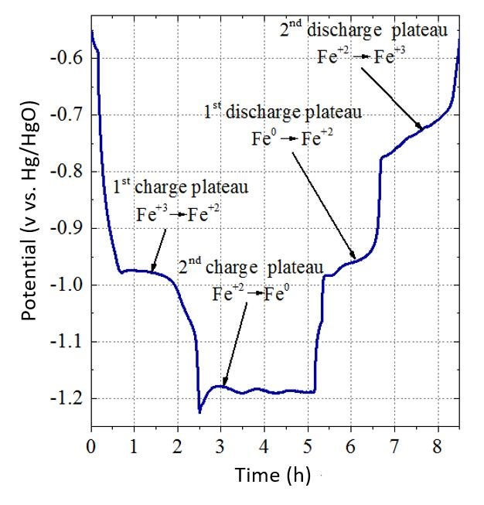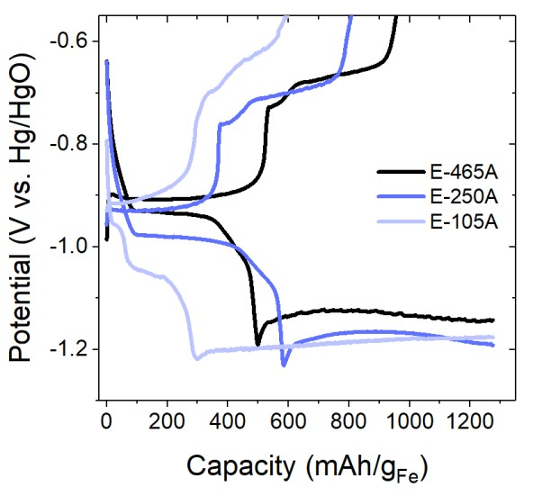

(
b
)

Figure 1 (a) 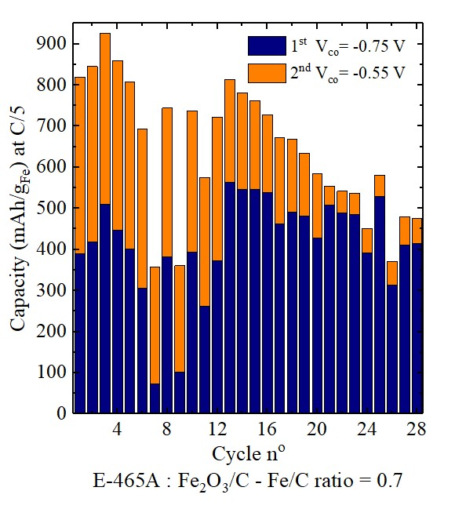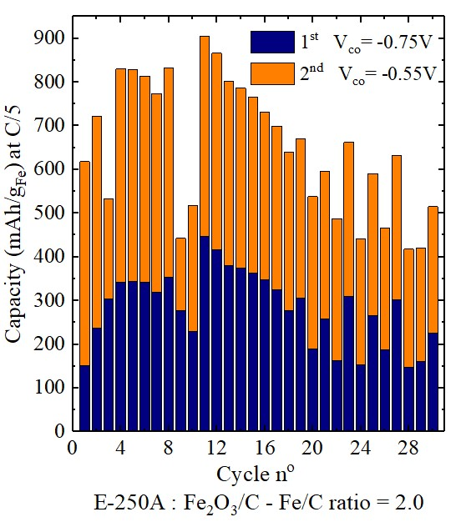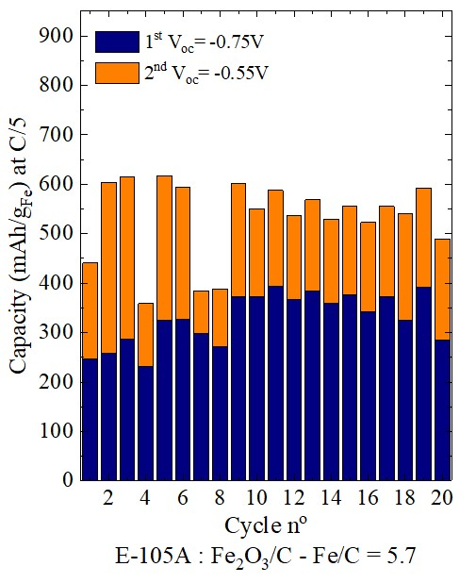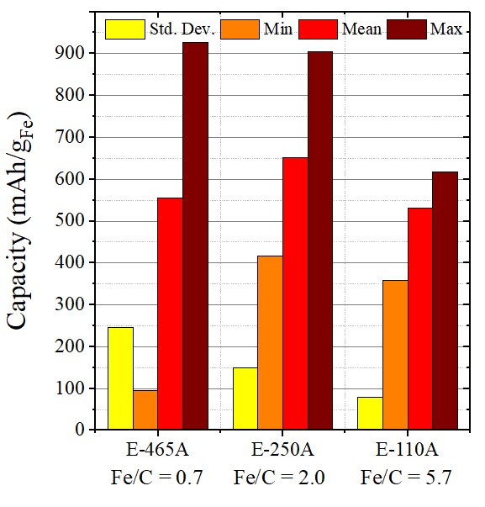Figure 2
(
b
)

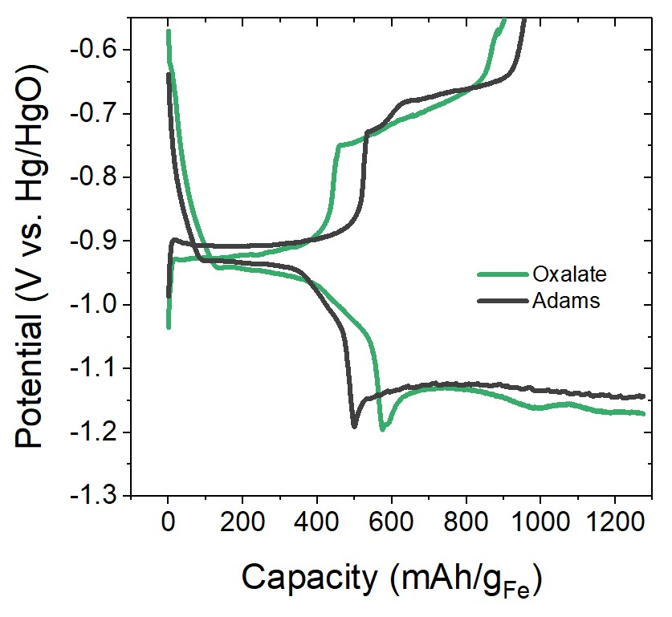

Figure 3

(a)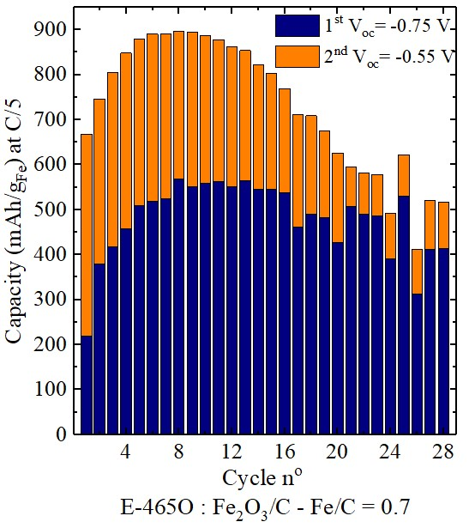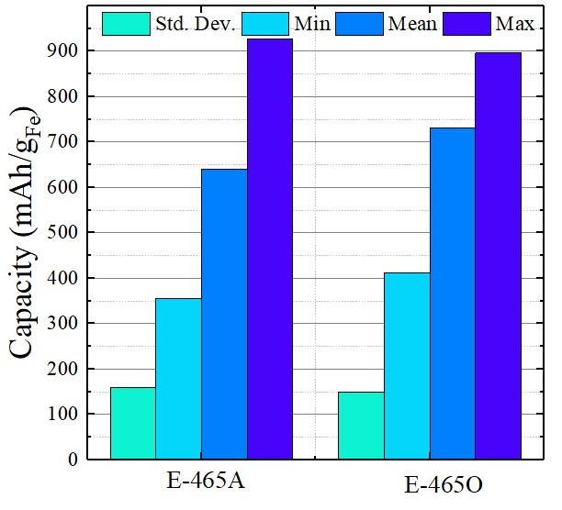
(
b
)

Figure 4

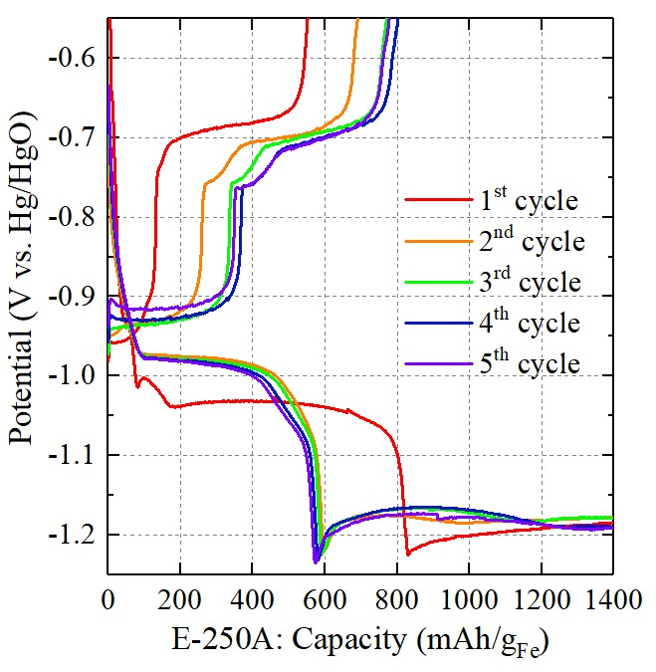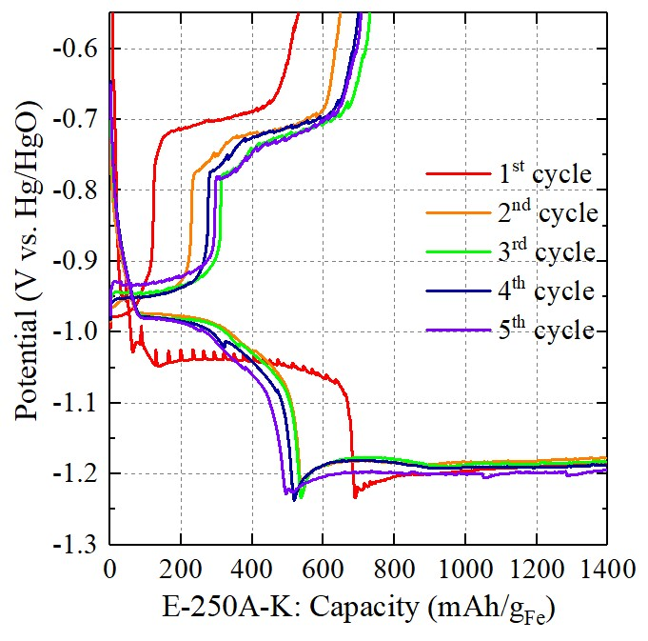

Figure 5

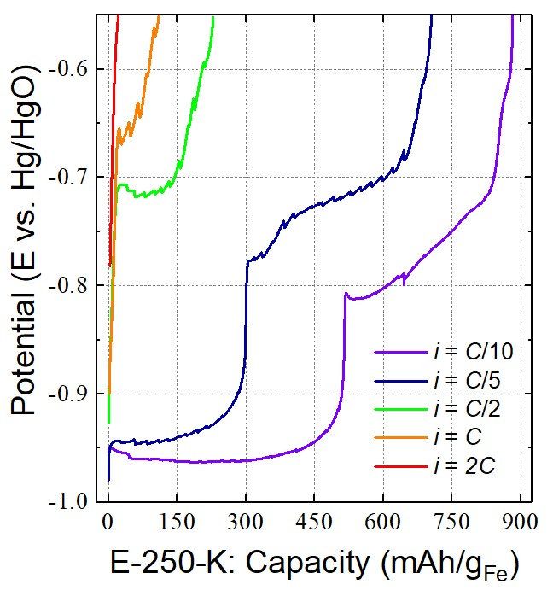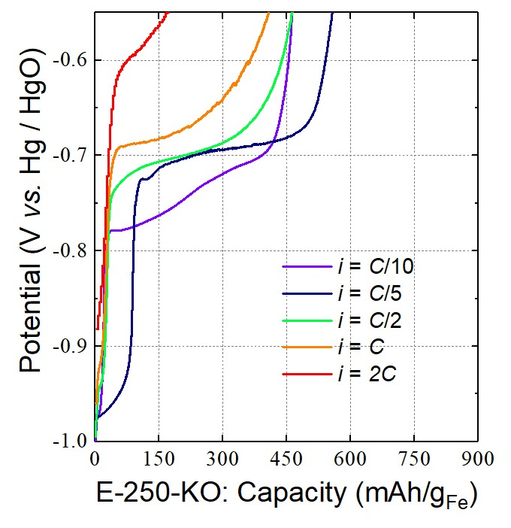

Figure 6

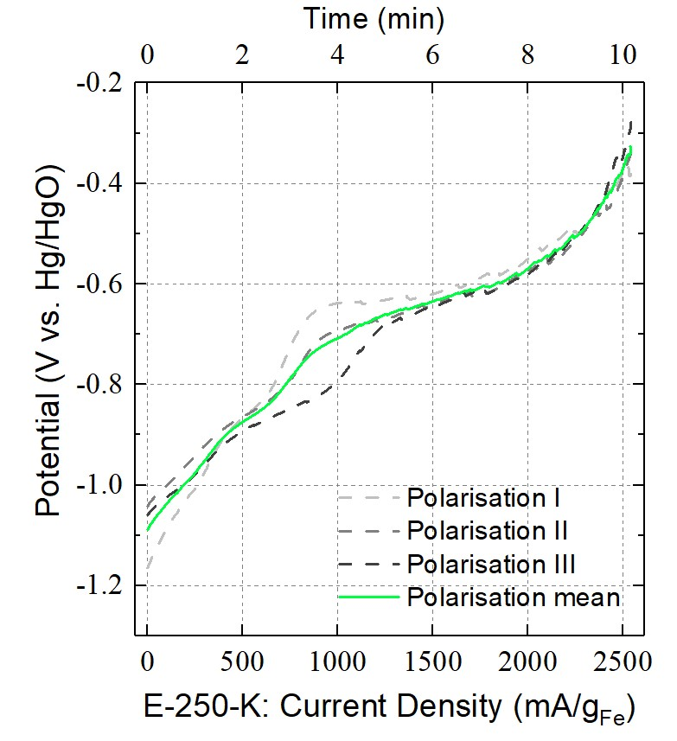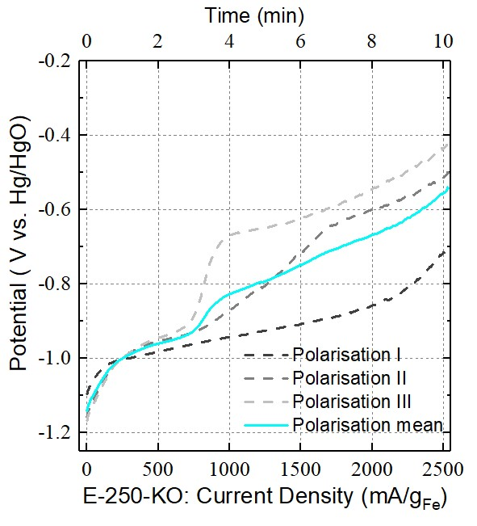

Figure 7

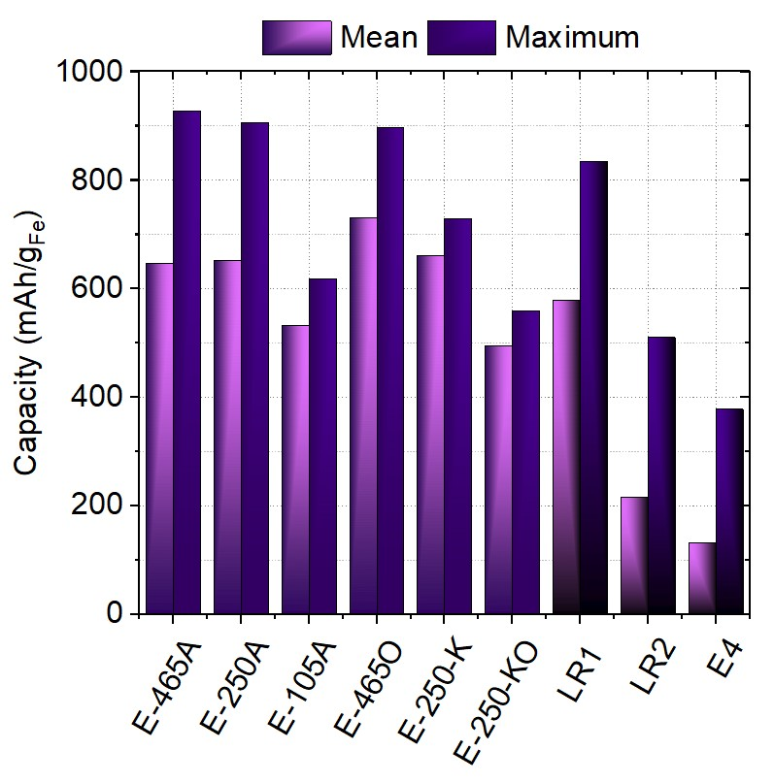
Figure 8

Table Captions

Table 1. Progressive volume change of iron electrode during discharge. (V_{o} volume of 1 mol of Fe)[1,4]
Table 2. Synthesis details for iron electrode powders (% refers to weight percentage). The electrodes were numbered after the wt % of carbon that they contain.
Table 3. Formulation details for the iron electrodes. The percentages given are percentages by weight (wt%). The electrodes were numbered after the wt% of carbon that they contain.
Table 4. Data for the best-performing electrodes E-465A, E-250 A and E-465O compared with literature results

Tables

 | Molar Mass (g/mol) | Density (g/cm³) | Volume (cm³) | Volume Change from Fe (%)
Fe | 56 | 7.87 | 7.12 | 0%
Fe(OH)₂ | 90 | 3.4 | 26.47 | +272%
Fe₂O₃ | 160 | 5.24 | 30.53 | +329%

Table 1

Powder Electrodes
Fe/C-465A E-465A 49.5% 4.0%
Fe
2
O
3

Ketjenblack

Bi
2
S
3

46.5
%

Fe/C-250A | E-250A | 71.0% | 25.0% | 4.0%
Fe/C-105A | E-105A | 85.5% | 10.5% | 4.0%
Fe/C-465O | E-465O | 49.5%  Table 2 | 46.5% | 4.0%

Electrode | Synthesis method | Fe/C ratio | Fe (mg) | Fe₂O₃ (mg) | Carbon black ( mg) | Bi₂S₃ (mg) | PTFE  (mg) | K  2  CO  3 | octanethiol
E-465A | Adams | 0.7 | 85 | 122 (45%) | 114 (42%) | 10 (4%) | 25 (9%)
E-250A | Adams | 2.0 | 85 | 121 (64%) | 43 (23%) | 7 (4%) | 17 (9%)
E-250A-K | Adams | 2.0 | 100 | 141 (64%) | 51 (23%) | 8 (4%) | 21 (9%) | yes
E-250A-KO | Adams | 2.0 | 100 | 143(64%) | 50 (23%) | 8 (4%) | 21 (9%) | yes | yes
E-105A | Adams | 5.7 | 85 | 143 (78%) | 15 (10%) | 6 (4%) | 14 (9%)
E-465O | Oxalate | 0.7 | 85 | 122 (45%) | 114 (42%) | 10 (4%) | 25 (9%)

Table 3

Electrode | No. cycles | Mean discharge capacity (mAh/g_{Fe}) | Max. discharge capacity (mAh/g_{Fe}) | Discharge rate | Discharge current density, J (mA/cm²)
E-465A | 28 | 646 | 927 | C/5 | 4
E-250A | 28 | 651 | 906 | C/5 | 4
E-465O | 28 | 730 | 896 | C/5 | 4
LR1 [31] | 50 | 579 | 836 | not given | 2
LR2 [22] | 29 | 215 | 510 | not given | 0.2
E4 [6] | 23 | 131 | 377 | C/5 | 6

Table 4

