Use of acoustics to enhance the efficiency of physical screens designed to protect downstream moving European eel (Anguilla anguilla)

Abstract
European eel (Anguilla anguilla) are vulnerable to entrainment at a variety of man-made intakes, including those that lead to hydropower turbines or other abstraction points. Two experiments were conducted to investigate the potential for acoustic stimuli to improve the efficiency of a vertical bar-screen to guide downstream moving eel. Three underwater speakers were installed along the channel wall of an external flume, upstream of the screen. In first experiment (1), screen guidance efficiency recorded in the presence (treatment) and absence (control) of a continuous broadband stimulus was individually compared between fish from to respective groups. Adopting a “before-after” design, the second experiment (2) assessed individually the guidance of control eel from the group previously used in experiment 1 when exposed to a 100 Hz pulse. The majority of eel reached the bypass in both experiments with only three passing through the screen during the controls against one during each acoustic treatment. Rejection of the area adjacent to the speakers was more common during the acoustic treatment with eel moving past the speakers more rapidly in the presence of sound. The results suggest that employing acoustic stimuli enhances the guidance efficiency of physical screens.

Keywords: Eel / Downstream passage / Screen / Acoustics / Mitigation / Anguilla

- Introduction
Historically, the European eel (Anguilla anguilla) sustained a large number of small-scale fisheries throughout its range (Dekker 2003), and thus was highly valued for its socio-economic importance. Over recent decades, stocks have declined to levels considered to be outside safe biological limits (Astrom and Dekker 2007). Some estimate that glass eel recruitment declined to 5% of the pre-1980 level (EIFAC 2006), while others suggest that the abundance of seaward migrating adult silver eel decreased by as much as 90% between 1975 and 2010 (Bevacqua et al. 2015). Concerns over the potential extinction of the European eel led to its protection under international legislation. This included the European Council Regulation (EC 1100/2007) which established a framework for the protection and sustainable use of stocks in the member states through administration of local eel management plans. European eel is also listed under appendix II of the Convention on International Trade in Endangered Species of Wild Fauna and Flora (CITES), which places controls on international exports.

Several contributory factors for the decline of eel have been proposed (Feunteun 2002), including changes in oceanic currents (Baltazar-Soares et al. 2014), habitat loss (Bevacqua et al. 2015), pollution (Maes et al. 2005), non-native parasites (Wielgoss et al. 2008; Newbold et al. 2015), overfishing (Aalto et al. 2015), and river engineering (Piper et al. 2013). Water and energy infrastructure, in particular, has received much attention, with concerns over the loss of migratory juveniles and adults at intakes to water supply facilities, pumping stations, fish farms, power station cooling systems, and hydroelectric turbines (Calles et al. 2012; Piper et al. 2013). In response, regulatory agencies have imposed stringent guidelines and criteria for eel protection at these points of abstraction (Sheridan et al. 2014). Increased interest in constructing new, or replacing existing, energy infrastructure that depend on water use, largely associated with a drive towards renewables (e.g. small-scale hydropower), highlights the need for a parallel advance of environmental impact mitigation strategies so that adverse effects of resource development on other ecosystem services are minimised.

Traditional fish protection approaches at water intakes have tended to focus on physical and mechanical screens (Kemp 2016). Unfortunately, these screens can negatively impact the fish they are designed to protect. Fish may become impinged and suffocate on the screen surface if the local current velocities are greater than their burst swimming capabilities (Calles et al. 2012), or they may suffer physical abrasion after making contact (Swanson et al. 2005), potentially leading to secondary infection and delayed mortality. Inefficient screens installed to guide fish to alternative bypass routes, but that fail to do so, can have negative consequences in terms of elevated energetic costs and predation risk associated with a delayed migration (Schilt 2007). For eel, screens can be particularly problematic. They have an elongated body morphology and relatively low burst swimming capability, both of which may increase the probability of impingement. Further, owing to their small size as juveniles, and low aspect ratio, eel are more easily entrained through some screen types than many other species, resulting in calls to retrofit existing facilities with extremely narrow spaced designs (1-2 mm mesh size: Sheridan et al. 2014). This is of concern to industry because of the economic implications, both in terms of the installation and maintenance costs. Therefore, the provision of alternative less costly options that have been validated is a subject of great interest.

Devices that employ behavioural stimuli (e.g. acoustics, lights, bubbles, hydrodynamics or combinations of these) to induce an avoidance response and so deter fish from entering dangerous areas, such as intakes, may provide an alternative to, or enhance the efficiency of, traditional screens. The development of behavioural deterrents for eel is not new, and devices that are based on a range of stimuli, such as infrasound (Sand et al. 2000; Sand et al. 2001) and strobe lights (Patrick et al. 1982), are commercially available. Unfortunately, in many instances they have been developed through a process of trial-and-error and their effectiveness seldom quantified by robust experimental studies; when evaluation has taken place, the results are often contradictory and inconclusive (Schilt 2007, Katopodis & Williams 2012). As a result, behavioural deterrents are generally considered less efficient than physical and mechanical screens. Nevertheless, behavioural screening devices remain appealing, should high efficiencies be attainable, as they represent a much sought-after solution to the challenge of developing sustainable water and electricity generating infrastructure systems in a cost-effective manner.

There are several possible explanations for the ambiguous results obtained when the efficiency of behavioural deterrents are evaluated. One of the most important is the highly heterogeneous nature of the sound field in shallow water environments, e.g. as a result of reflection from walls, the sediment and the air/water interface. The exact nature of the sound field can be difficult to predict, in part, as a consequence of complex geometries and the poorly characterised acoustic properties of the sediment boundaries (Bass et al. 2003, Ainslie & Jong, 2016). Recognition of the variation in the acoustic fields generated by a source varies between studies, some authors completely fail to define the sound field (Maes et al. 2004), while others conduct mapping, but with insufficient resolution to guarantee that they capture key variations in intensity that are likely to occur (Nestler et al. 1993; Ross et al. 1993). This is problematic because the assumption that an active sound source will create a predictable acoustic field is likely to be incorrect, especially in relatively shallow river or estuary environments, or near infrastructure such as intake channels. Further, in field studies, it can be challenging to control for potential confounding factors, such as temporal effects (daily and seasonal effects), water quality, flow conditions and lighting. This complexity may explain, at least in part, why different studies report conflicting results. There is a need to conduct robust, replicable and controlled experiments in which fish response to a well-defined acoustic gradient is quantified.

This study adopted an experimental approach to test the potential of acoustic stimuli to improve the efficiency of traditional physical screens to guide downstream migrating silver eel to a bypass channel, a commonly installed structure at many in-river barriers. The behaviour of eel in response to encountering the sound field was quantified, in terms of avoidance (rejection) and time taken to pass the area of acoustic influence. During the design of the study we addressed two key challenges to real world application of an acoustic deterrent. First, many previous studies focus on marine species of fish and their response to acoustics propagation under relatively deep-water conditions (Fewtrell and McCauley 2012). In comparison, the downstream fluvial migration of eel occurs in shallow water in which acoustic fields are strongly influenced by the river bed and banks. We, therefore, conducted the study in a large open-channel external flume. Second, although infrasound (<20 Hz) has long been promoted as a potential deterrent for eel (Sand et al. 2000), there are several limitations. Expensive commercial devices capable of generating infrasound at amplitudes sufficient to deter fish have needed to be large, and thus challenging to deploy in shallow water environments. Further, the zone where the infrasound is loud enough to act as a deterrent is often limited to within a couple of metres from the source (Popper and Carlson 1998, Piper et al. 2019). Based on an audiogram constructed for European eel (Jerko et al. 1989), hearing ranges between 60 and 400 Hz, with a peak in sensitivity at around 80 Hz. In the interest of developing a small and relatively cost-effective deterrent, two experiments were conducted in which we presented: 1) a continuous broadband stimulus (CBS) with frequencies ranging from 60 to 1000 Hz, and 2) a 100 Hz pulsed stimulus. The amplitude of the two test signals reached a maximum of 160 dB re 1 µPa at the measurement point closest to the sound source, decreasing to 135 dB re 1 µPa at 50 cm from the source with an attenuation of almost 5 dB every 10 cm. In experiment 1, the behaviour of downstream moving eel under the continuous broadband treatment was compared with that obtained under a control (ambient background sound only). In line with the principles of ethical science that challenges the researcher to reduce the number of individuals used in experimental studies, experiment 2 adopted a “before-after” design in which the control fish used in experiment 1 were exposed to the pulsed treatment. Individual fish from two groups were respectively tested in Control and CBS trials in Experiment 1. Fish from the group tested in Control trials were then re-used in Experiment 2 in presence of a Pulsed stimulus. The results of this study provide important insight into the use of acoustics to supplement traditional technologies designed to protect downstream moving eel at river infrastructure.

- Materials and methods
  - Fish collection and maintenance:
European eel (N= 157, length: 305–815 mm; mass: 57-1352 g) were caught during their seaward migration using a fixed eel trap on the River Stour near Longham, United Kingdom (50°46'31.6"N 1°54'38.1"W), in November 2015. Fish were transported to the International Centre for Ecohydraulics Research Facility, University of Southampton (50° 57’42.6”N, 1°25’26.9”W), in two large transportation tanks filled with aerated river water. The fish were maintained in four separate 3000 litre holding tanks equipped with individual filtration systems and separate air pumps. Water was monitored daily and maintained through regular water changes (50% weekly) using dechlorinated tap water (pH = 7.8, Nitrate: <40ppm). Mean water temperature was 10.5 °C (S.D. ± 0.9 °C).

  - Experimental setup:
A concrete block channel (5.28 m length, 1.66 m width, 0.56 m depth) was constructed within an outdoor recirculatory flume (Figure 1). Wire mesh screens (13 x 13 mm mesh, 1 mm gauge) were installed at either end of the channel to prevent escape of the subject fish. A concrete block wall (1.32 m length) longitudinally divided the downstream section of the channel to create a 0.52 m wide bypass. A vertical bar screen (bar-spacing 12 mm) was installed between the channel wall and bypass entrance at an angle of 45° to the direction of flow (Russon et al. 2010; Figure 1).
An array of three underwater speakers (ElectroVoice UW30) were installed within the channel wall immediately upstream of the screen (Figure 1). Because previous experiments indicate downstream moving silver eel maintain position at, or close to, the substrate (Russon et al. 2010), the speakers were positioned close to the channel floor at a depth of 0.5m. During treatments, the speakers generated a continuous broadband sound (CBS: 60 - 1000 Hz) (experiment 1) and a 100 Hz pulsed (experiment 2) acoustic field (Figure 2), and were turned off during the control trials. The sound production system consisted of a laptop (Dell © Latitude E6430) linked to a National Instruments Data Acquisition Box (National Instruments © USB-6251) connected to a Power Amplifier (SkyTronic © Mini AV Digital Surround Amplifier 103.100) to which all three speakers were connected. The acoustic field was measured using a calibrated hydrophone (Brüel & Kjær © 8105) at a depth of 3 cm (S.D. ± 2 cm due to channel floor irregularities) above the floor (Figure 2).
Fish movements were recorded using a series of five CCTV cameras with integrated infrared light units (AV-TECH 245 Sony Effio 580TVL CCD) mounted 2.9 m above the channel floor. Four additional 15.0 W infrared lights provided additional illumination to enhance the contrast of the video recordings.
During trials a constant flow (48-50 cm depth; 0.1 m s⁻¹ mean velocity S.D. ± 0.01 m s⁻¹) was maintained using three centrifugal pumps. Depth and velocity was measured using a rule and a Nortek Vectrino+ Acoustic Doppler Velocimeter (Figure 3). Mean flume water temperature during the experimental period was 10.2 °C (S.D. ± 0.8 °C).

  - Experimental trials:
During experiment 1, a total of 78 control and 79 treatment (CBS) trials were conducted during hours of darkness (between 17.00 and 02.00). Adopting a “before-after” experimental design and in-line with the principles of reducing the numbers of individuals of a threatened species used in research, the 78 control fish used in experiment 1 were exposed to the 100 Hz treatment in experiment 2. Eel were introduced into a submerged container situated upstream of the experimental area and allowed to acclimatise for at least one hour prior to the start of the trials. A trial commenced when an individual fish was released from the container close to the upstream end of the right wall and allowed to move volitionally downstream towards the speakers. The trial ended once the fish had passed downstream either via the bypass channel or through the screen. At the end of each trial, the eel was recaptured, measured and weighed.

  - Fish behaviour:
Video recordings of the downstream movements of eel was analysed. The selected passage route (through the screen or via the bypass) was recorded. On approaching the screen, a rejection was deemed to occur if on reaching the area immediately adjacent (< 20 cm) to the speakers the eel exhibited a clear change in direction and moved towards the opposite channel wall, swam backwards in a reverse direction to the flow, or turned around and swam back upstream. A Pearson chi-square (X²) test was used to determine whether there was a difference between the frequency of rejections for the control and treatments. The time to pass the speakers area (1.32 m longitudinal distance, Figure 1) was recorded for each fish. Each dataset was tested for normality by using the Shapiro–Wilk-test. When data were not normally distributed, the Mann–Whitney-U-test was used to test for differences between the treatments.

- Results
  - Experiment 1:
The number of fish that exhibited a rejection was higher during the treatment trials (N = 13, 16.4% of the fish) than during the controls (N = 2, 2.5% of the fish) (Pearson X² = 7.231, df = 1, p = 0.007).
Multiple rejections within the same trial were observed for two individuals in the acoustic treatment, with fish respectively exhibiting 2 and 4 rejections before passing through the bypass channel. Eel that did not display a rejection continued downstream from the speakers to encounter the screen, where the majority then entered the bypass channel. Three (3.9%) and one (1.3%) individuals passed through the screen under the control and treatment trials, respectively.
The median time to pass the speakers was significantly higher under the control (8.1, Interquartile Range (IQR) = 6.58 sec) than treatment (6.8, IQR = 5.54 sec) (Mann–Whitney-U-test: W = 2325.5, p = 0.008) (Figure 4).

  - Experiment 2:
During the 100Hz pulsed treatment, one eel passed through the screen (98.7% of the fish reached the bypass). All the other fish that did not reject the acoustic stimulus and encountered the screen swam to the bypass channel.
The number of fish that exhibited a rejection was higher during the treatment trials (N = 10, 12.8% of the fish) than during the controls (N=2, 2.5% of the fish) (Pearson X² = 8.55, df =1, p = 0.014).
One fish exhibited two rejections during a single trial under the acoustic treatment.
Time to pass was significantly higher under the control condition (8.1, IQR = 6.58 sec) than under treatment (5.6, IQR = 3.86 sec) (Mann–Whitney-U-test: W = 2878, p <0.001) (Figure 5).

- Discussion
In this study we investigated the potential of using acoustic stimuli, continuous broadband (CBS: 60 -1000 Hz) and 100 Hz pulsed sound, to enhance the efficiency of a physical screen to guide European eel away from water intakes towards an alternative bypass route. The effects of sound on overall guidance efficiency were subtle under the experimental conditions described, with the majority of eel entering the bypass independent of treatment. Nevertheless, differences in behaviour provide an explanatory mechanism for improved guidance efficiency observed under the acoustic treatments. Eel tended to avoid the acoustic field encountered, either by exhibiting a rejection response during which they altered their swim path to a direction away from the sound source, or by moving downstream rapidly to the bypass entrance. As a consequence, and despite higher rejection behaviour, the time to pass the zone of influence was shorter and the probability of interacting with the screen lower during the acoustic treatments, resulting in reduced passage through the screen and enhanced guidance to the bypass channel.

This study built on efforts to enhance protection of European eel at river infrastructure. Using a screen configuration and angle observed to effectively guide downstream migrating silver eel to a bypass channel under similar experimental settings (Russon et al., 2010), we added acoustic stimuli in an attempt to enhance screen efficiency still further. In essence, this approach combined multimodal stimuli (hydrodynamic and acoustic) in an effort to improve guidance. Compared to other families, such as the salmonids and clupeids (Popper and Carlson 1998), there has been limited published research related to the development of acoustic deterrents for eel. A notable exception is the work conducted by Sand et al. (2000) that focused on the application of infrasound for this purpose. In their study, a single 11.8 Hz infrasound source was used to manipulate the trajectories of downstream migrating European eel in the River Imsa, Norway. Avoidance of infrasound appeared clear, with the number of eel trapped close to the sound source during exposure reduced to 43% of that obtained during a control period, with a corresponding increase of 144% for eel collected in a trap farthest away. However, contradictory results have also been obtained indicating no (e.g. MacNamara 2012) or limited (Piper et al. 2019) avoidance response exhibited by silver eel migrating in an Irish and English river, respectively. This highlights the need for rigorous controlled experiments in which eel response to well defined acoustic fields are quantified at appropriate scales of resolution.
To overcome the size and limited effective range of infrasound sources, one potential method is to use acoustics to guide eel is to employ low-frequency, rather than infrasonic, sounds: an approach which has received little attention in the scientific literature. Some preliminary experimental results for American eel (Anguilla rostrata) indicate that, under some situations, low frequency sound (<1000 Hz) might act as an attractant for both juveniles and adults (Patrick et al. 2001), although to the best of our knowledge no further follow up work has been published to date. Considering the wider body of research that includes investigation of potential environmental impact of sound on fish behaviour, interesting insight is gained from controlled experimental studies that expose European eel to sound of anthropogenic origin. Juvenile eel are less likely to startle in response to a looming predatory stimulus during exposure to playback of recordings of ships passing through harbour (frequency range 100 to 10 000 Hz) when compared to control treatments that used recordings of the same harbours without ships (Simpson et al. 2015). The depressed startle response is relatively short lived, however, as indicated in a follow up study in which recovery occurred within 2 min after the noise stopped (Bruintjes et al. 2016). Such findings demonstrate the potential to manipulate eel behaviour through exposing them to higher frequency sound than that used by Sand et al. (2000).

Returning to a focus on protecting eel, our experiments used higher frequency acoustic stimuli that encompass the range of sensitivity defined by the Jerko et al. (1989) audiogram for European eel, and that might be more easily applied to field settings than infrasound devices. In an effort to identify frequencies and temporal structure of sound that elicit a behavioural response in eel, we used two different sound types; continuous broadband (60 -1000 Hz) sound and an intermittent pulsed stimulus (100 Hz). Previous studies have demonstrated that response and recovery can differ depending on frequency and intermittency of exposure. For example, groups of four European seabass (Dicentrarchus labrax) were exposed to either continuous or intermittent sound of consistent or fluctuating amplitude in an outdoor basin (Neo et al. 2014). Fish exhibited slower recovery to pre-exposure levels of behaviour under the intermittent sound treatment. In our study, both sound treatments resulted in similar responses, with greater rejection and lower passage through the screen when compared to the control, although eel exposed to the continuous broadband sound exhibited shorter passage times. More research is needed to test a wider variety of frequencies, intensities, and temporal patterns of sound to help select those most appropriate to advance eel protection technology.

The European Commission’s Eel Regulations (Council Regulation No. 1100/2007) requires EU Member States to establish measures for the recovery of the stock of European eel. In England and Wales this requirement is brought into law through The Eel (England & Wales) Regulations 2009, and as part of these there is a requirement to install effective eel screens at any water intake capable of abstracting >20 m³ day⁻¹ from a water body where eel may be present. In England and Wales, the guidance provided by the regulatory authority, the Environment Agency, is that where glass eel or elvers may be present a mesh size of 1-2 mm is required (Sheridan et al. 2014). This increases to 15-20 mm for silver eel. From the perspective of water supply and electricity generating industries, retrofitting existing infrastructure and maintaining such fine meshed screens will be costly, and potentially unviable under some circumstances due to the risk of blockage. Improving the efficiency of existing physical screens by combining them with appropriate behavioural deterrents may provide an alternative approach if they can be demonstrated to work as well as, or better than, the fine meshed alternatives proposed.

Combined physical and behavioural guidance systems that employ multimodal stimuli (e.g. in this case hydrodynamics and acoustics) are likely to be more efficient than those that employ a single factor operating in isolation because they enhance detection and increase the probability of a response by operating on more than one sensory modality. For example, downstream moving juvenile Chinook salmon (Oncorhynchus tshawytscha) were more likely to avoid a section of experimental flume when hydrodynamic (velocity gradient) and visual cues were employed in combination, than when hydrodynamics were manipulated in isolation (when dark) (Vowles et al. 2014). In the current study, acoustic stimuli enhanced the efficiency of a physical screen to guide eel to the bypass and reduced the number that passed through the screen itself. The improvement in efficiency were relatively small, indicating subtle modifications in behaviour, but significant. We propose that further enhancement will be achieved by investigating the influence of a wider range of frequency, intensity, and temporal structure of sounds used. Rather than simply replacing physical screens with behavioural deterrents as is commonly proposed, it is likely that fish protection technology will progress by following the principles of aggregation of marginal gains (e.g. James 2012), a common approach adopted in elite sports engineering in which small incremental improvements of multiple aspects of the whole system lead to substantial advance. In addition to acoustics, the combined used of other deterrents should also be considered, including those that have previously been developed for the purpose of deterring eel, such as strobe lights (Patrick et al. 1982, 2001 for American eel) and electric fields (Alex Haro, USGS, pers. comm.; International Centre for Ecohydraulics Research unpublished data), while recognising the advantage of sound fields that extend over larger spatial scales and can remain effective under turbid conditions that are common in many river systems during the eel migration.

This study has shown that an acoustic signal can be used to deflect a percentage (13 to 16%) of fish from a physical screen. Under the experimental conditions created, the majority of the fish that did not respond to the acoustic stimulus were diverted to the bypass by the physical screen. Further research and development is needed to improve the guidance efficiency of such a combined acoustic and physical screening device.

Acknowledgements
This project was funded by the Environment Agency, Cefas and the University of Southampton. The authors thank the funders of the project but also all the members of the International Center for Ecohydraulics Research (ICER) who kindly helped during the trials and provided precious suggestions to improve this manuscript. All data supporting this study are openly available from the University of Southampton repository at : http://....

References

Aalto, E., Capoccioni, F., Terradez Mas, J., Schiavina, M., Leone, C., De Leo, G., & Ciccotti, E. (2015). Quantifying 60 years of declining European eel (Anguilla anguilla L., 1758) fishery yields in Mediterranean coastal lagoons. ICES Journal of Marine Science, 73(1), 101-110.

Ainslie, M. A., & de Jong, C. A. (2016). Sources of underwater sound and their characterization. In The Effects of Noise on Aquatic Life II (pp. 27-35). Springer, New York, NY.

Amaral, S., Giza, D., Sullivan, L., Timko, M., Jacobson, P., & Perry, E. (2016). Eels III: Evaluation of Behavioral Cues for Guiding Silver Eels at Hydro Projects.

Åström, M., & Dekker, W. (2007). When will the eel recover? A full life-cycle model. ICES Journal of Marine Science, 64(7), 1491-1498.

Baltazar-Soares, M., Biastoch, A., Harrod, C., Hanel, R., Marohn, L., Prigge, E., ... & Eizaguirre, C. (2014). Recruitment collapse and population structure of the European eel shaped by local ocean current dynamics. Current Biology, 24(1), 104-108.

Bass, A. H., & Clark, C. W. (2003). The physical acoustics of underwater sound communication. In Acoustic communication(pp. 15-64). Springer, New York, NY.

Bevacqua, D., Melià, P., Gatto, M., & De Leo, G. A. (2015). A global viability assessment of the European eel. Global change biology, 21(9), 3323-3335.

Bruintjes, R., Purser, J., Everley, K. A., Mangan, S., Simpson, S. D., & Radford, A. N. (2016). Rapid recovery following short-term acoustic disturbance in two fish species. Royal Society open science, 3(1), 150686.

Calles, O., Olsson, I. C., Comoglio, C., Kemp, P. S., Blunden, L., Schmitz, M., & Greenberg, L. A. (2010). APPLIED ISSUES: Size‐dependent mortality of migratory silver eels at a hydropower plant, and implications for escapement to the sea. Freshwater Biology, 55(10), 2167-2180.

Cannon, W. B. (1929). Bodily changes in pain, hunger, fear and rage.

Dekker, W. (2003). On the distribution of the European eel (Anguilla anguilla) and its fisheries. Canadian Journal of Fisheries and Aquatic Sciences, 60(7), 787-799.

EIFAC, J. (2006). Report of the 2006 session of the Joint EIFAC/ICES Working Group on EELS. Rome, Italy, 23-27 January 2006.

Feunteun, E. (2002). Management and restoration of European eel population (Anguilla anguilla): an impossible bargain. Ecological engineering, 18(5), 575-591.

Fewtrell, J. L., & McCauley, R. D. (2012). Impact of air gun noise on the behaviour of marine fish and squid. Marine pollution bulletin, 64(5), 984-993.

Gessel, M. H., Williams, J. G., Brege, D. A., Krcma, R. F., & Chambers, D. R. (1991). Juvenile salmonid guidance at the Bonneville Dam second powerhouse, Columbia River, 1983–1989. North American Journal of Fisheries Management, 11(3), 400-412.

Jerkø, H., Turunen-Rise, I., Enger, P. S., & Sand, O. (1989). Hearing in the eel (Anguilla anguilla). Journal of Comparative Physiology A, 165(4), 455-459.

Katopodis, C., & Williams, J. G. (2012). The development of fish passage research in a historical context. Ecological Engineering, 48, 8-18.

Kemp, P. S. (2015). Impoundments, barriers and abstractions. Freshwater fisheries ecology, 717-769.

Knudsen, F. R., Enger, P. S., & Sand, O. (1992). Awareness reactions and avoidance responses to sound in juvenile Atlantic salmon, Salmo salar L. Journal of Fish Biology, 40(4), 523-534.

Knudsen, F. R., Schreck, C. B., Knapp, S. M., Enger, P. S., & Sand, O. (1997). Infrasound produces flight and avoidance responses in Pacific juvenile salmonids. Journal of Fish Biology, 51(4), 824-829.

Leighton, T. G. (2012). How can humans, in air, hear sound generated underwater (and can goldfish hear their owners talking)?. The Journal of the Acoustical Society of America, 131(3), 2539-2542.

MacNamara, R. (2012). Conservation biology of the European eel (Anguilla anguilla) on a hydropower-regulated Irish river (Doctoral dissertation).

Maes, J., Turnpenny, A. W. H., Lambert, D. R., Nedwell, J. R., Parmentier, A., & Ollevier, F. (2004). Field evaluation of a sound system to reduce estuarine fish intake rates at a power plant cooling water inlet. Journal of Fish Biology, 64(4), 938-946.

Neo, Y. Y., Seitz, J., Kastelein, R. A., Winter, H. V., Ten Cate, C., & Slabbekoorn, H. (2014). Temporal structure of sound affects behavioural recovery from noise impact in European seabass. Biological Conservation, 178, 65-73.

Nestler, J. M., Ploskey, G. R., Pickens, J., Menezes, J., & Schilt, C. (1992). Responses of blueback herring to high-frequency sound and implications for reducing entrainment at hydropower dams. North American Journal of Fisheries Management, 12(4), 667-683.

Newbold, L. R., Hockley, F. A., Williams, C. F., Cable, J., Reading, A. J., Auchterlonie, N., & Kemp, P. S. (2015). Relationship between European eel Anguilla anguilla infection with non‐native parasites and swimming behaviour on encountering accelerating flow. Journal of fish biology, 86(5), 1519-1533.

Patrick, P. H., Poulton, J. S., & Brown, R. (2001). Responses of American eels to strobe light and sound (preliminary data) and introduction to sound conditioning as a potential fish passage technology. In Behavioral Technologies for Fish Guidance: American Fisheries Society Symposium (p. 1).

Patrick, P. H., Sheehan, R. W., & Sim, B. (1982). Effectiveness of a strobe light eel exclusion scheme. Hydrobiologia, 94(3), 269-277.

Piper, A. T., Wright, R. M., Walker, A. M., & Kemp, P. S. (2013). Escapement, route choice, barrier passage and entrainment of seaward migrating European eel, Anguilla anguilla, within a highly regulated lowland river. Ecological Engineering, 57, 88-96.

Piper, A. T., White, P. R., Wright, R. M., Leighton, T. G., & Kemp, P. S. (2019). Response of seaward-migrating European eel (Anguilla anguilla) to an infrasound deterrent. Ecological Engineering, 127, 480-486.

Popper, A. N., & Carlson, T. J. (1998). Application of sound and other stimuli to control fish behavior. Transactions of the american fisheries society, 127(5), 673-707.

Radford, C. A., Montgomery, J. C., Caiger, P., & Higgs, D. M. (2012). Pressure and particle motion detection thresholds in fish: a re-examination of salient auditory cues in teleosts. Journal of Experimental Biology, 215(19), 3429-3435.

Romero, M. L., & Butler, L. K. (2007). Endocrinology of stress. International Journal of Comparative Psychology, 20(2).

Ross, Q. E., Dunning, D. J., Thorne, R., Menezes, J. K., Tiller, G. W., & Watson, J. K. (1993). Response of alewives to high-frequency sound at a power plant intake on Lake Ontario. North American Journal of Fisheries Management, 13(2), 291-303.

Russon, I. J., Kemp, P. S., & Calles, O. (2010). Response of downstream migrating adult European eels (Anguilla anguilla) to bar racks under experimental conditions. Ecology of Freshwater Fish, 19(2), 197-205.

Sand, O., Enger, P. S., Karlsen, H. E., Knudsen, F., & Kvernstuen, T. (2000). Avoidance responses to infrasound in downstream migrating European silver eels, Anguilla anguilla. Environmental Biology of Fishes, 57(3), 327-336.

Sand, O., Enger, P., Karlsen, H. E., & Knudsen, F. R. (2001). To Intense Infrasound In Juvenile Salmonids. In American Fisheries Society Symposium (Vol. 26, pp. 183-193).

Schilt, C. R. (2007). Developing fish passage and protection at hydropower dams. Applied Animal Behaviour Science, 104(3), 295-325.

Sheridan, S., Turnpenny, A., Horsfield, D., Bamford, D., Bayliss, B., Coates, S., ... & Trudgill, N. (2014). Screening at intakes and outfalls: measures to protect eel (Anguilla anguilla). International Fish Screening Techniques, 201117.

Simpson, S. D., Purser, J., & Radford, A. N. (2015). Anthropogenic noise compromises antipredator behaviour in European eels. Global change biology, 21(2), 586-593.

Swanson, C., Young, P. S., & Cech, J. J. (2005). Close encounters with a fish screen: integrating physiological and behavioral results to protect endangered species in exploited ecosystems. Transactions of the American Fisheries Society, 134(5), 1111-1123.

Vowles, A. S., Anderson, J. J., Gessel, M. H., Williams, J. G., & Kemp, P. S. (2014). Effects of avoidance behaviour on downstream fish passage through areas of accelerating flow when light and dark. Animal Behaviour, 92, 101-109.

Wielgoss, S., Taraschewski, H., Meyer, A., & Wirth, T. (2008). Population structure of the parasitic nematode Anguillicola crassus, an invader of declining North Atlantic eel stocks. Molecular ecology, 17(15), 3478-3495.

Table 1. Contingency table summarising the number of observed versus expected rejections exhibited by downstream moving adult European eel on encountering either a continuous broadband sound field (treatment) or ambient background noise (control).
 | Treatment
Behaviour | Continuous Broadband Sound  (CBS) | Control (Sound Off)
Rejections (observed counts)  Rejections (expected counts) | 13  7.55 | 2  7.45
No Rejections (observed counts)  No Rejections (expected counts) | 66  71.45 | 76  70.55
Total observed | 79 | 78

Table 2. Contingency table summarising the number of observed versus expected rejections exhibited by downstream moving adult European eel on encountering either a pulsed 100 Hz sound field (treatment) or ambient background noise (control).
 | Treatment
Behaviour | Treatment  100Hz pulsed | Control
Rejections (observed counts)  Rejections (expected counts) | 10  6.00 | 2  6.00
No Rejections (observed counts)  No Rejections (expected counts) | 68  72.00 | 76  72.00
Total observed | 78 | 78

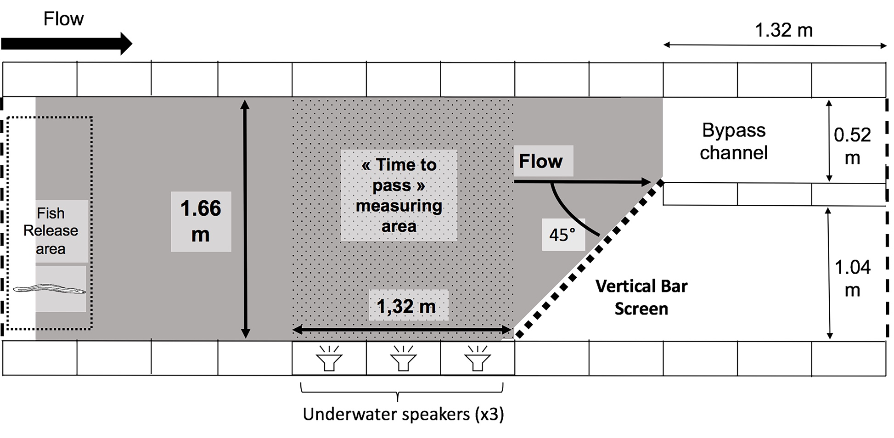
Figure 1. Plan of a concrete block channel installed within an outdoor recirculating flume. The dashed lines indicate the position of wire mesh screens that contained adult silver European eel (Anguilla anguilla) within the experimental area. A bar screen installed at 45° to the direction of flow (bold dotted line) was designed to guide fish to the entrance of a bypass channel. The shaded zone represents the area where the acoustic (Figure 2) and hydrodynamic (Figure 3) fields were mapped using a hydrophone and acoustic Doppler velocimeter (ADV), respectively. The speakers were installed in a horizontal series at the channel floor. The dotted zone represents the area for which “time to pass” was measured.

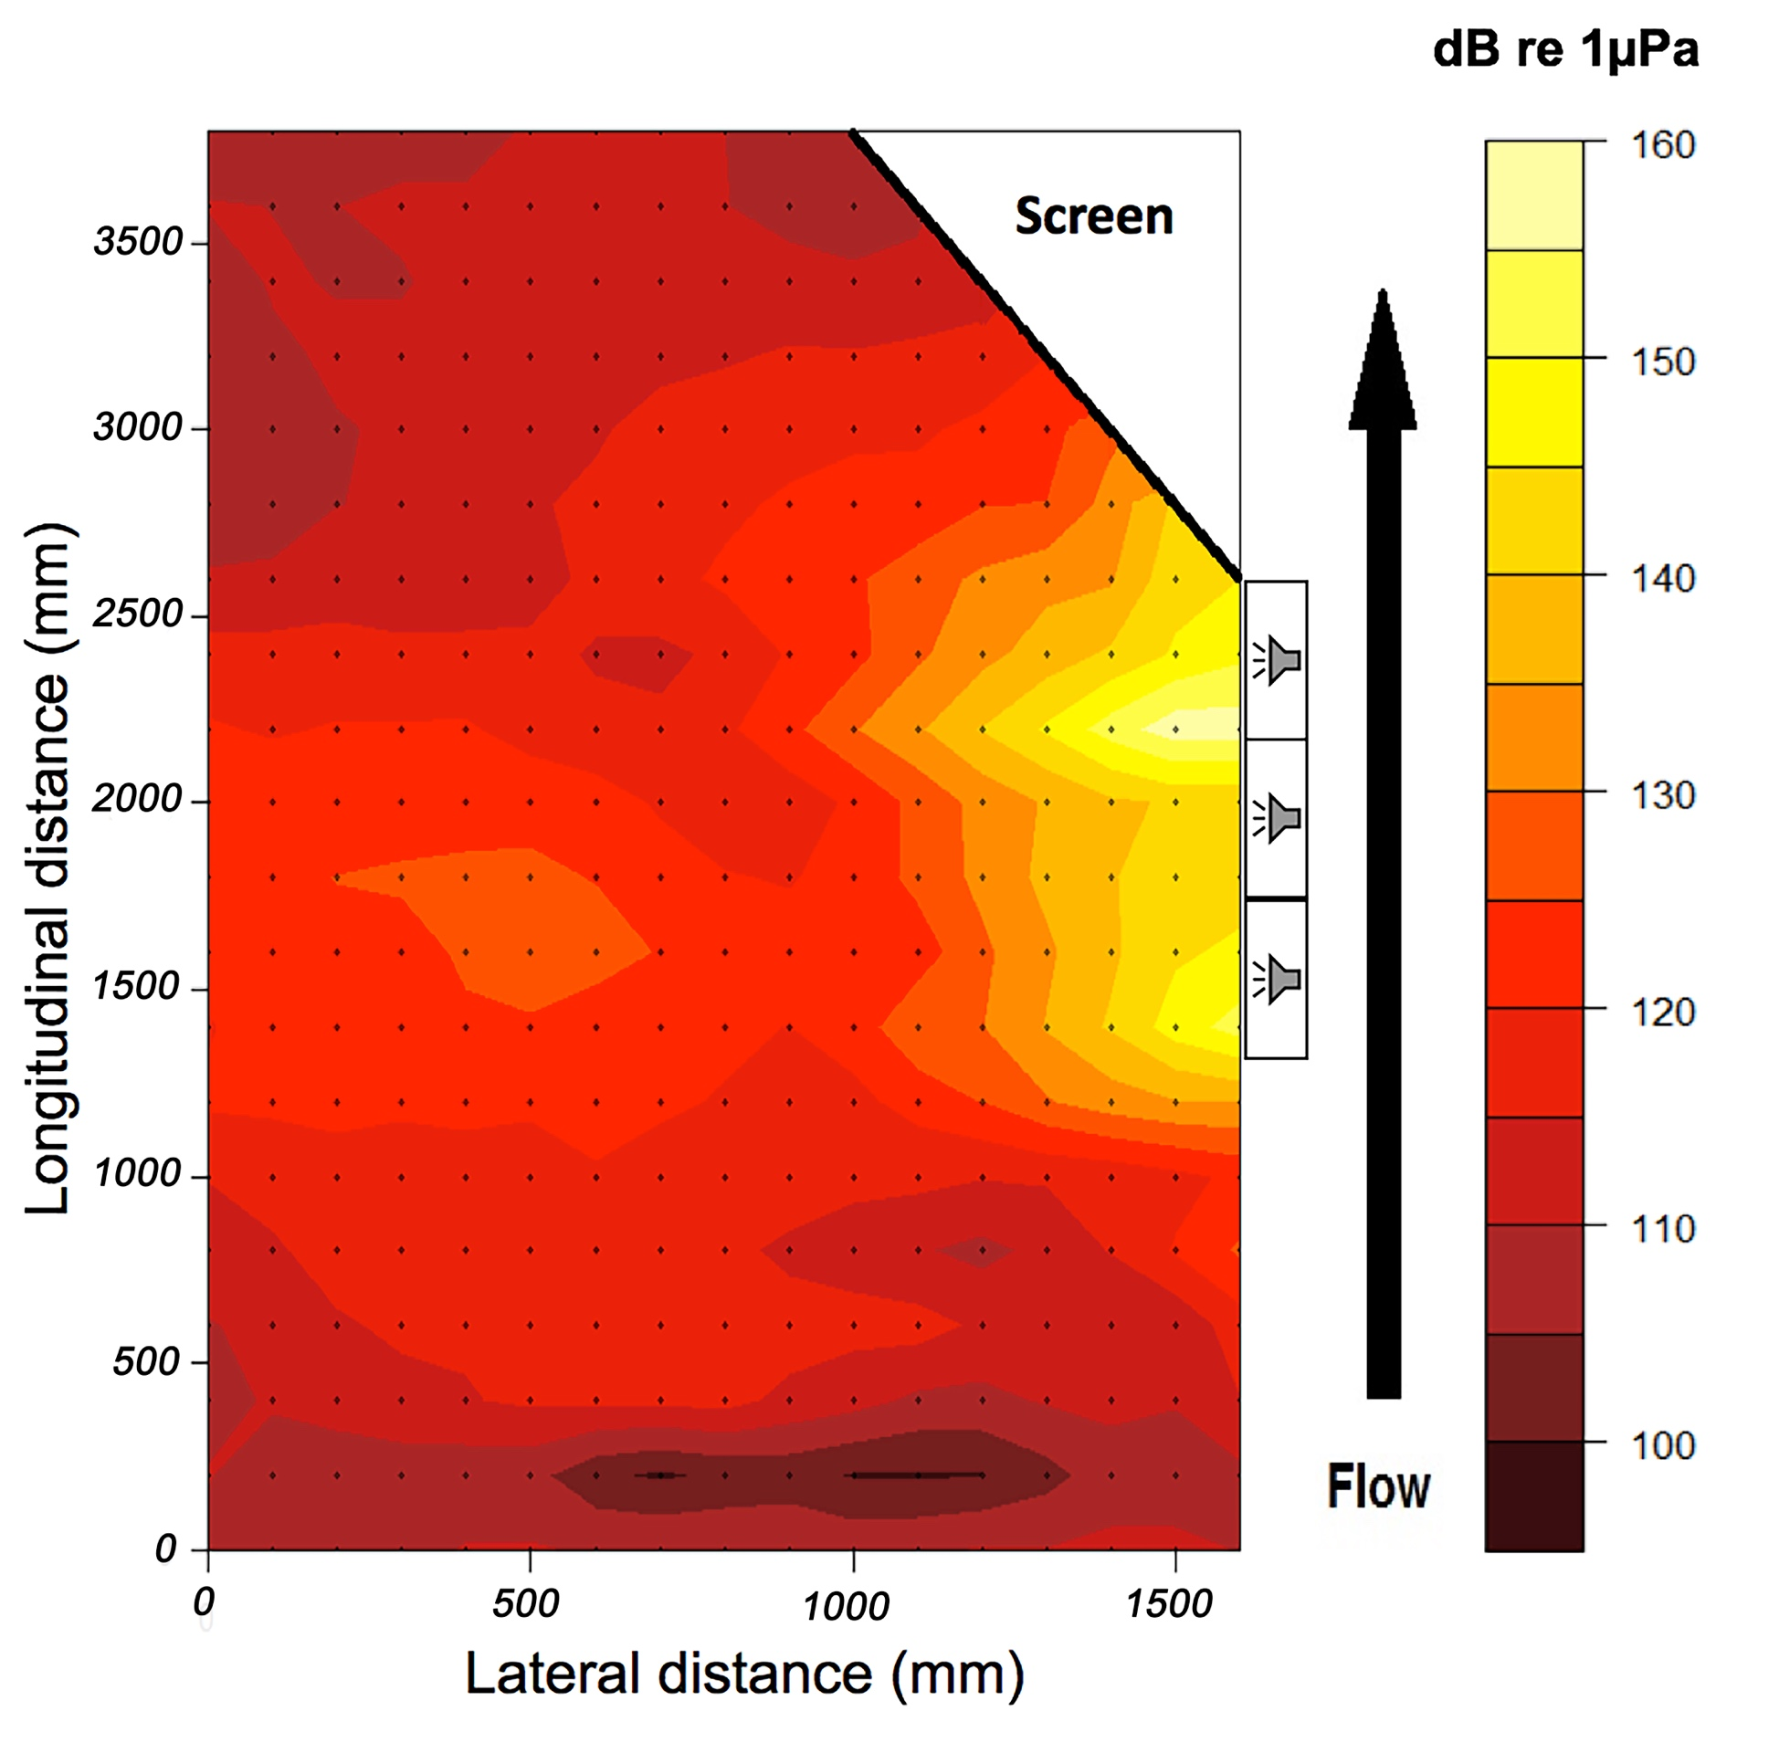
Figure 2. Acoustic field generated in the experimental area upstream of the bar screen using continuous broadband noise (CBS). Sound was recorded at regular intervals (dots) along 20 cm transects at 17 equidistant points 10 cm apart using a hydrophone. The position of the speakers is indicated by the three boxes on the right side of the map. Note: High intensities in the sound field are localised to the vicinity of the speakers. This is because the water depth is much less than one quarter of a wavelength and therefore the propagation modes excited are evanescent (White 2004).
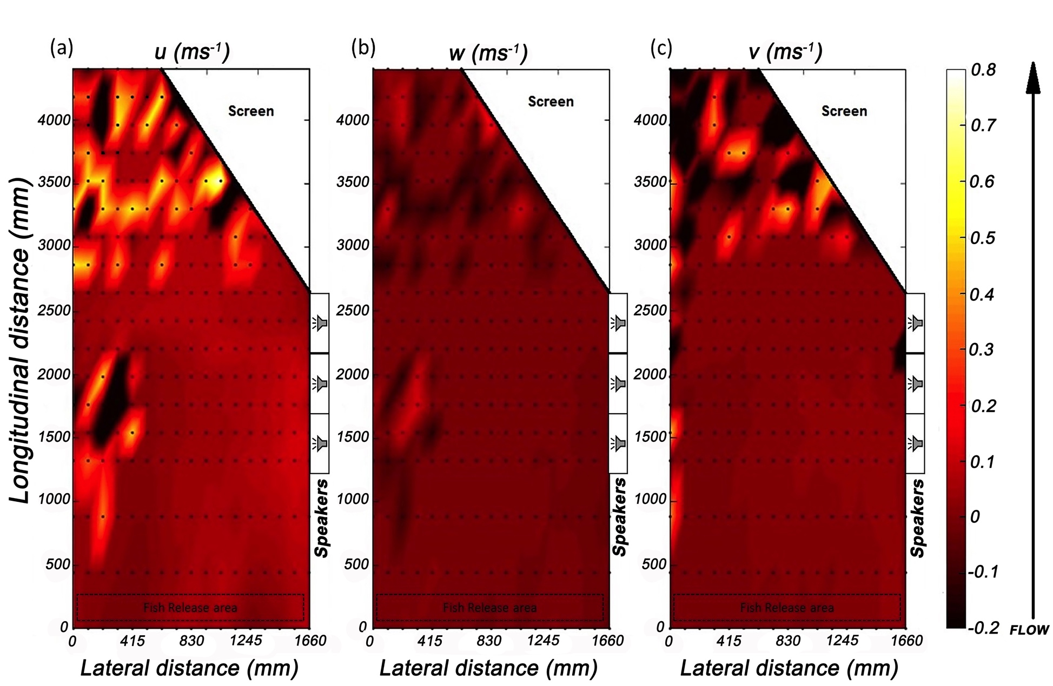Figure 3. Colour maps of water velocity recorded in an experimental channel used to investigate the response of European eel to acoustic fields encountered upstream of a bar screen. a, b and c illustrate the longitudinal (u), vertical (w) and lateral (v) components of the flow, respectively. Dots indicate the positions of velocity measurements. The scale is expressed in m s⁻¹.

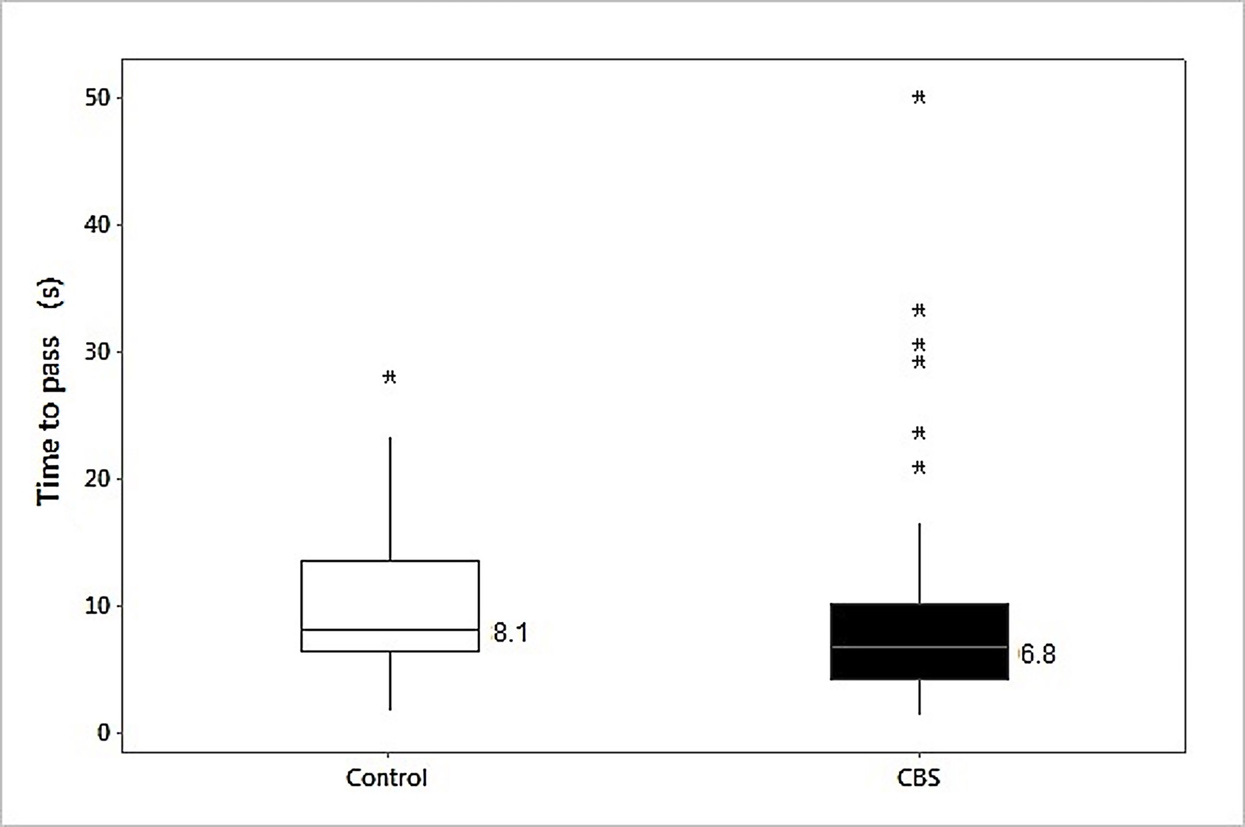
Figure 4. Time taken by downstream moving European eel to pass three speakers positioned immediately upstream of a bar screen in an experimental flume when continuous broadband sound was on (treatment: solid box) or off (control: clear box). The boxes represent the interquartile range, with the bottom and top indicating 25% and 75% quartile. The horizontal line in the middle of the box indicates the median with its value labelled. The whiskers span the highest and lowest observations with the exceptions of outliers indicated by asterisks.

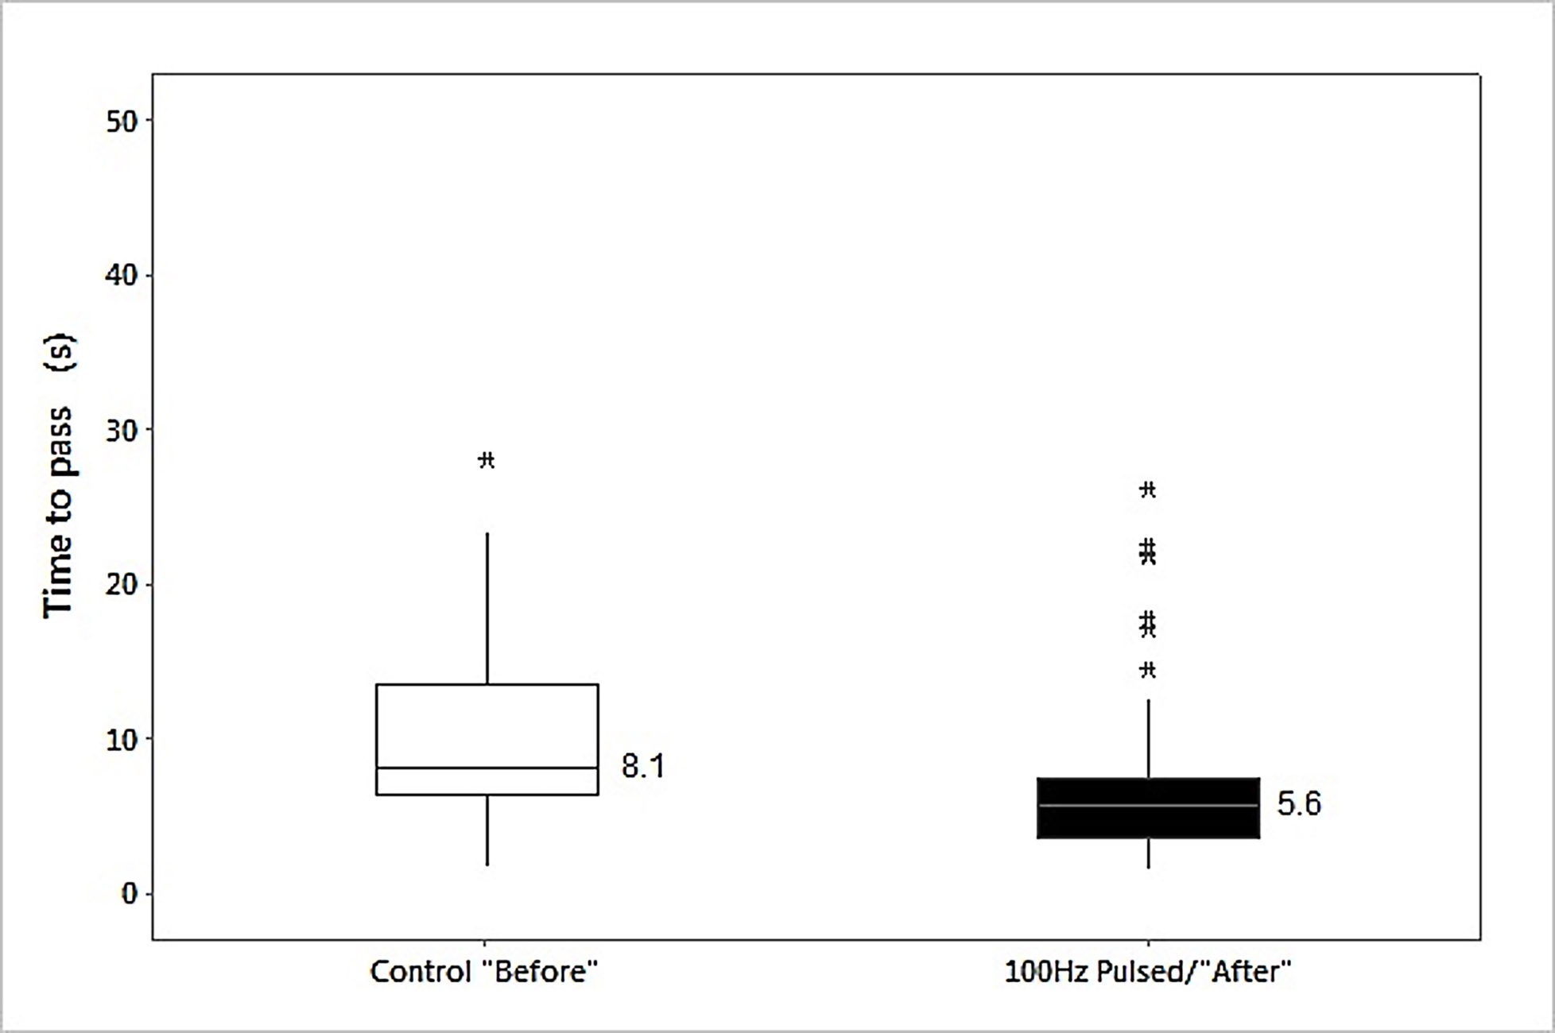
Figure 5. Time taken for downstream moving eel to pass three speakers positioned immediately upstream of a bar screen in an experimental flume in the absence (control: clear box) and presence (treatment: solid box) of a 100 Hz pulsed sound field during Experiment 2. The same fish were used twice in this experiment using a before (control) and after (treatment) design. The boxes represent the interquartile range, with the bottom and top indicating the 25% and 75% quartile, respectively. The horizontal line in the middle of the box indicates the median with its value labelled. The whiskers span the highest and lowest observations with the exceptions of outliers indicated by asterisks.

