A Tm³⁺-doped ZrF₄-BaF₂-YF₃-AlF₃ glass microsphere laser in the 2.0 μm wavelength region
H Y Zhao¹, A Z Li¹, Y T Yi¹, M Tokurakawa², G Brambilla³, S J Jia¹, S B Wang^{1*}, P F Wang^{1,4*}
¹State Key Laboratory of In-fiber Integrated Optics of Ministry of Education, College of Science, Harbin Engineering University, Harbin 150001, China
²Institute for Laser Science, University of Electro-Communications, 1-5-1 Chofugaoka Chofu Tokyo 182-8585, Japan
³Optoelectronics Research Centre, Southampton, Hampshire SO17 1BJ, U.K.
⁴Key Laboratory of Optoelectronic Devices and Systems of Ministry of Education and Guangdong Province, College of Optoelectronic Engineering, Shenzhen University, Shenzhen, 518060, China
* Corresponding author: shunbinwang@hrbeu.edu.cn and pwang@hrbeu.edu.cn

Abstract. This work reports a microsphere laser at ~ 2.0 μm in a Tm³⁺-doped ZrF₄-BaF₂-YF₃-AlF₃ (ZBYA) fluoride glass. The ZBYA glass microsphere was fabricated by reflowing the tip of a 1.0 mol% Tm³⁺-doped ZBYA glass fiber with a CO₂ laser. By using a fiber taper for input and output coupling in the Tm³⁺-doped ZBYA microsphere, single and multi-mode laser outputs at around 2.0 μm were observed under 808 nm laser excitation. The radiation lifetime and emission cross-section of Tm³⁺ ions in ZBYA glass were calculated to be 6.42 ms and 5.86×10⁻²¹ cm², respectively. Our results indicate that the Tm³⁺-doped ZBYA fluoride glass has potential applications for 2.0 µm lasers.
Key words: fluoride glass; microsphere laser; NIR emission; radiation lifetime
1. Introduction

- Recently, lasers at wavelengths around λ~2.0 μm have attracted extensive interest because of their applications in medical surgery, remote sensing, and eye-safe lidar [1-4]. Common rare earth ions capable of producing a 2.0 μm laser include Thulium (Tm³⁺) and Holmium (Ho³⁺) [5, 6]. The ³F₄ → ³H₆ transition in Tm³⁺ is often employed for the laser emission in the spectral region around λ~2.0 µm, as it can be excited by λ~793 nm or λ~808 nm light sources, which are inexpensive, common and readily available commercially. Extensive research has been conducted on Tm³⁺-doped 2.0 μm fiber lasers [4, 7]. Additionally, high optical quality (high-Q) Whispering-Gallery Mode (WGM) microcavities have been a subject of intense study because of their potential applications, including low-threshold and narrow-linewidth lasers [8] and Raman light sources [9]. Microsphere resonators have the potential to realize lasers with low threshold and high coupling efficiency due to their strong light confinement [10], with modal volumes of the order of 100 μm³. Microsphere lasers have mainly focused on tellurite [11], phosphate [12], silica [13], and fluoride glasses [14]. Compared with other glasses, fluorozirconate glass has the advantages of low phonon energy, wide transparency window, high solubility to rare earths, large stimulated emission cross section, resulting in a high gain effect. Additionally, microspheres can be prepared at low temperatures because of its low glass transition temperature.
- Currently, mid-infrared luminescence can be observed in a few glass such as fluorozirconate, fluoroaluminate [15], fluoroindate [16], fluorotellurite [17] fluorophosphate [18], germinate [19] glass. While, although fluorotellurite, fluorophosphates and germinate glass have good chemical stability, it has not yet achieved mid-infrared laser output in these matrix glass fibers because of their high phonon energy. Up to now, mid-infrared fiber laser output is obtained only in fluoroaluminate [20], fluoroindate [21], and fluorozirconate [22] fibers with low phonon energy, among them, ZBLAN fiber has the best performance in the mid-infrared range [23]. ZBLAN (ZrF₄-BaF₂-LaF₃-AlF₃-NaF) is a well-known fluorozirconate glass that has been extensively studied in the context of mid-IR fiber lasers due to its wide transparency window (λ~0.22-6 μm) and low phonon energy (565 cm⁻¹) [24]. ZBLAN fibers have been commercialized and ZBLAN fiber-based mid-infrared lasers have been widely researched [25-27]. ZBLAN microspheres have been fabricated to realize microcavity lasers: in 1999, W. von Klitzing reported a 120 μm diameter Er³⁺ doped ZBLAN microsphere laser at 540 nm with very low threshold, with only 30 μW of absorbed power [28]; F. Lissillour reported an Er: ZBLAN microsphere laser with several narrow bandwidth (50-100 kHz) laser lines around λ~1.55 μm [29]; in 2012, B. Way demonstrated a simple and reliable method for fabricating high-Q WGM optical microcavities from ZBLAN glasses using cylindrical electrical heating [30]. Yet, the chemical stability of ZBLAN glass is often considered poor, which greatly limits the practical application of ZBLAN glass devices [31].
- ZBYA (ZrF₄-BaF₂-YF₃-AlF₃) fluoride glass, an alternative type of fluorozirconate glass, has better chemical stability and thermal stability than ZBLAN glasses [32-36]. Since NaF is not part of the composition, ZBYA fluoride glass is expected to show better resistance to water compared to the ZBLAN (ZrF₄-BaF₂-YF₃-LaF₃-AlF₃-NaF) glass, and its transition temperature (T_{g}) can reach 330 ºC, so that is able to withstand higher laser powers [37]. Many studies on rare-earth doped ZBYA glasses have been reported in the literature: F. Huang observed fluorescence at λ~2.7 μm at high Erbium-doping concentrations [38]; H. Ebendorff-Heidepriem investigated the upper limits of the HoF₃ and EuF₃ concentrations supported by ZBYA glass [34]. However, there is no demonstration of ZBYA fluoride glass lasers.
- In this letter, a Tm³⁺-doped ZBYA glass was prepared, and a Tm³⁺-doped microsphere was obtained by reflowing the glass of a Tm³⁺-doped ZBYA fiber with a CO₂ laser single mode and multi-mode microsphere lasers at λ~1.897 μm were observed by using a laser at λ~808 nm as the pump source. This is the first report on the ZBYA fluoride glass microsphere laser in the λ~2.0 μm region.

2.Experiments
The glass samples of Tm³⁺-doped ZBYA were prepared by using high-purity ZrF₄, BaF₂, YF₃, AlF₃ and TmF₃ powders in the molar ratio 50 ZrF₄ – 33 BaF₂ – 9 YF₃ – 7 AlF₃ -1 TmF₃. The raw materials were weighed and mixed in dry air, and then melted within platinum crucibles in an electric furnace at the temperature T~850 ºC in a glove box. The melts were then poured onto a preheated copper plate and glass filaments were from this glass. The tip of a glass filament was heated by a CO₂ laser beam until it softened and a microsphere was created on account of the surface tension of the glass, as shown in Figure 1(a). The micrograph image of the ZBYA microsphere sample with a diameter of 63.27 µm is shown in Figure 1(b).
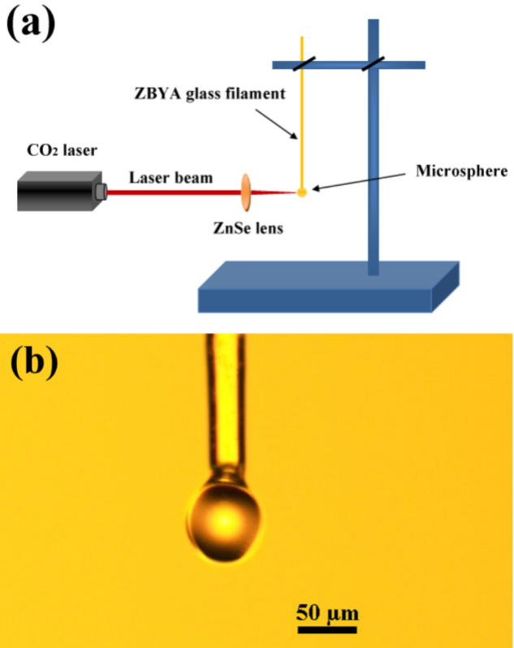
Fig.1. (a) Glass microsphere fabrication set-up; (b) Optical microscope image of the ZBYA glass microsphere.
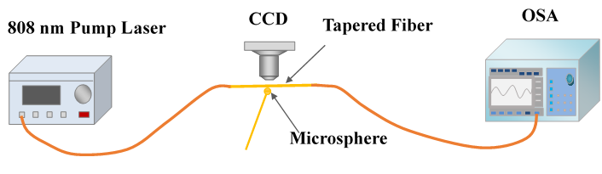
Fig.2. Experimental setup for characterizing the Tm³⁺-doped ZBYA glass microsphere laser.
A microsphere laser based on the Tm³⁺-doped ZBYA fluoride glass at λ~2 μm was obtained by using a micro-nano fiber taper for input/output coupling through the evanescent field. By changing the relative coupling position of the tapered fiber with respect to the microsphere cavity, different modes can be excited in the microsphere cavity. Figure 2 shows the schematic representation of the experimental setup used to achieve the ZBYA microsphere laser. The microsphere was coupled with a tapered fiber, fabricated by heating a strand of 1060XP single-mode fiber using a ceramic microheater (CMH-7-19, NTT-AT) and simultaneously stretching it at both ends [39]. The waist diameter of the tapered silica fibers used was in the range 1.0 to 1.5 µm.
A laser diode at λ~808 nm was used as the excitation source and was connected to one end of the tapered silica fiber, while the other end of the fiber was connected to an optical spectrum analyzer (OSA) (AQ-6375, Yokogawa, Japan), which could monitor the output spectrum from the Tm³⁺-doped ZBYA microsphere. The coupling position between the tapered fiber and microsphere was observed from two directions using two 20× microscope eyepieces attached to CCD cameras.
3. Results and Discussions
To characterize the optical properties of the Tm³⁺-doped ZBYA fluoride glass (10mm×10mm×1.4 mm), absorption and luminescence spectra were recorded. Figure 3 shows the absorption spectrum of a 1.0 mol% Tm³⁺-doped ZBYA glass at room temperature in the range λ~200-3000 nm. Absorption bands of Tm³⁺ are observed at 686, 793, 1211, and 1665 nm, due to the corresponding transitions from the ³H₆ ground state to the ³F₂, ³H₄, ³H₅ and ³F₄ levels. The energy-level diagrams of Tm³⁺ are shown in the inset. The broadband emission around λ~2.0 μm belongs to the transition ³F₄→³H₆. In this work we used a λ~808 nm pump to excite Tm³⁺ ions from the ³H₆ ground state to the ³H₄ level.
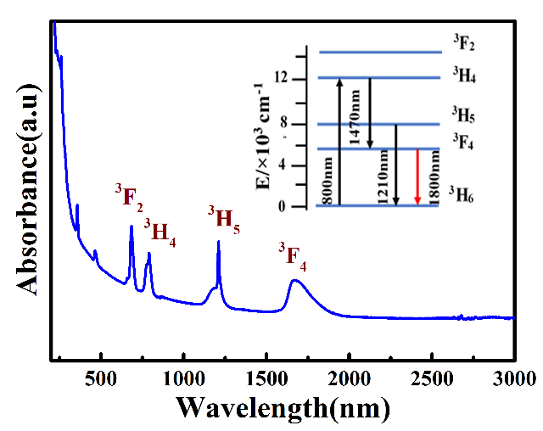
Fig.3. Absorption spectrum of 1.0 mol% Tm³⁺ ZBYA glass at room temperature. The inset reports the energy-level diagram of Tm³⁺ ions.
Figure 4 displays the transparency measurements on a 1.5 mm thick undoped ZBYA glass. A maximum transmittance as high as 90% is observed in the region λ~1000-6000 nm, with an infrared cutoff edge at ~9 μm. The ultra-wide transmission spectrum indicates that ZBYA glasses have a great potential for applications in UV-visible and infrared laser devices. The presence of absorption near λ~3 μm, associated to the vibration of OH⁻ groups, is attributed to the fabrication process used in the glove box. The OH⁻ content in a 20 mm×12 mm×9 mm ZBYA glass (in ppm, parts per million) was determined using the following equation [40]:
(1)
where d is the glass thickness, T₀ is the maximum transmittance of the glass, T is the transmittance at λ~3.0 µm (the peak wavelength of OH⁻ absorption) and the factor 1000 includes the conversion factor between molar absorption at λ~3 µm and the OH⁻ concentration. Results show that the OH⁻ content is ~0.43 ppm, which is significantly lower than that commonly recorded in fluorophosphate glasses (~26.4 ppm) [40], germanate glasses (50-420 ppm) [41] and silicate sol-gel glasses (40-1200 ppm) [42].

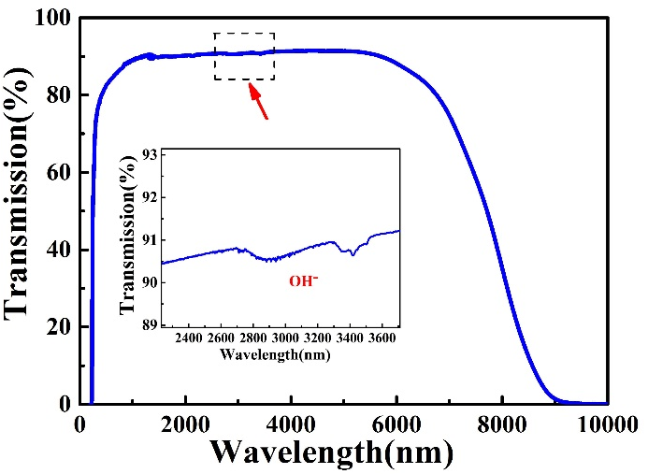
Fig.4. Transmittance spectrum of the 1.5 mm thick ZBYA glass in the range 200-10000 nm. ( The inset image shows the amplification of the absorption of OH⁻ at 3.0 µm.)

The fluorescence spectra in the λ~2.0 μm regions under excitation at λ~808 nm is shown in Figure 5. A relatively broad NIR emission in the range λ~1500 nm to λ~2100 nm is observed. The center wavelength is located at λ~1816 nm, and the FWHM of the emissions is about 200 nm.

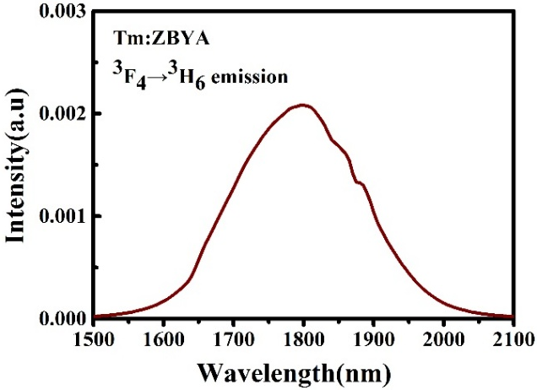
Fig.5. Emission spectrum of the Tm³⁺-doped ZBYA glass in the λ~2.0 μm region.

The fluorescence spectra in the λ~2.0 μm regions under excitation at λ~808 nm is shown in Fig. 5. A relatively broad NIR emission in the range λ~1500 nm to λ~2100 nm is observed. The center wavelength is located at λ~1816 nm, and the full width at the half maximum (FWHM) of the emissions is about 200 nm.
Figure 6 presents the fluorescence decay at λ~2.0 μm corresponding to the ³F₄→³H₆ emission band, resulting in a fluorescence lifetime of 6.42 ms. Compared to other glasses such as ZBLAN (7.93 ms) [43] and silicates (460 μs) [44], the lifetime of the ³F₄→³H₆ transition in ZBYA is a little shorter than that in ZBLAN while much longer than that in silicates. The mean reason may be that the phonon energy of ZBYA (~580 cm⁻¹) (as shown in Figure 6(b)) is a little higher than ZBLAN (~565 cm⁻¹) [24] while much lower than silicates (~1080 cm⁻¹) [44]. Generally, the relatively longer radiation lifetime is beneficial to reduce the laser oscillation threshold.
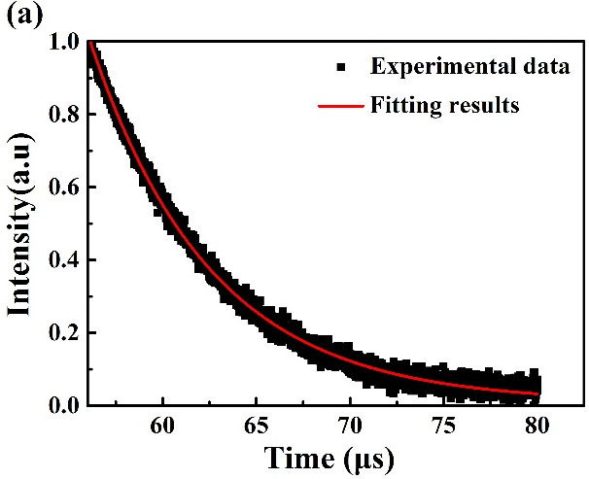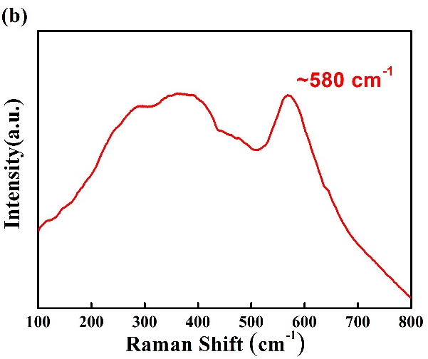
Fig.6(a). (Color on line) Decay curve of the Tm³⁺-doped ZBYA sample. Squares show the experimental data, while the solid red line indicates the fitting curve. (b). Raman spectrum of ZBYA-fluoride glass sample.

Assuming that the time to establish thermal equilibrium in the energy level multi-configuration is less than its radiation lifetime, according to the McCumber theory [45], the absorption cross-section σ_{abs} and the emission cross-section σ_{emi} of rare earth ions in ZBYA glass can be calculated by the following formulas:
(2)
(3)
where I₀(λ) and I(λ) represent the light intensity before and after light passes through the tested sample, respectively. N is the density of the rare earth ions, D(λ) is the material absorbance, d represents the sample length, and h, ν, K, and T represent the Planck constant, photon frequency, the Boltzmann constant, and the room temperature, respectively. ε is the temperature-dependent excitation energy corresponding to the peak frequency of the absorption spectrum. The calculated absorption cross-section and emission cross-section spectra are presented in Figure 7. The peak value of the emission cross-section is estimated to be 5.86×10⁻²¹ cm² at λ~2.0 µm, indicating that the ZBYA glass can achieve high laser gains.

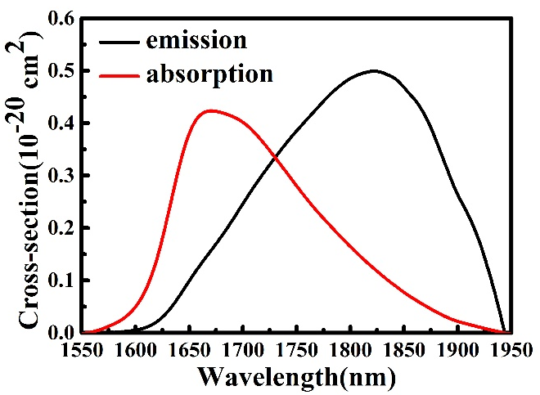
Fig.7. The absorption σ_{abs} and the emission σ_{emi} cross-sections of the optical transition Tm: ³F₄→³H₆.

As shown in Figure 8(a), a multi-mode laser at λ~ 2.0 μm was observed when the pump power of the λ~808 nm laser was set as 5.8 mW. The spectrum was recorded by the OSA with a spectral resolution of 0.05 nm. By adjusting the coupling position of the Tm³⁺-doped ZBYA microsphere with respect to the silica fiber taper, single-mode lasing emission was generated (Figure 8(b)). The center wavelength of this single-mode laser is λ~1897.76 nm, with a peak power of 18.87 nW and a linewidth of 0.05 nm when the pump power reached 5.6 mW.
Figure 9 presents the relation between laser output power and pump power of the single-mode laser at λ~1897.76 nm. During the measurements, the microsphere was kept in continuous contact with the fiber taper to reduce the power variations due to coupling gap instabilities. The emission presented as spontaneous radiation when the power is below the threshold power of 4.5 mW. The pump power reported here is the value of the pump source setting, and it includes both contributions of absorbed and scattered powers, so the actual threshold pump power is lower than 4.5 mW. The low threshold power indicates that this kind of laser is suitable as a miniaturized optical source for a large number of applications including gas sensing and surgery in medicine. In order to improve the power conversion efficiency, the coupling efficiency between the Tm³⁺-doped ZBYA microsphere and the silica fiber taper requires further improvement and optimization.
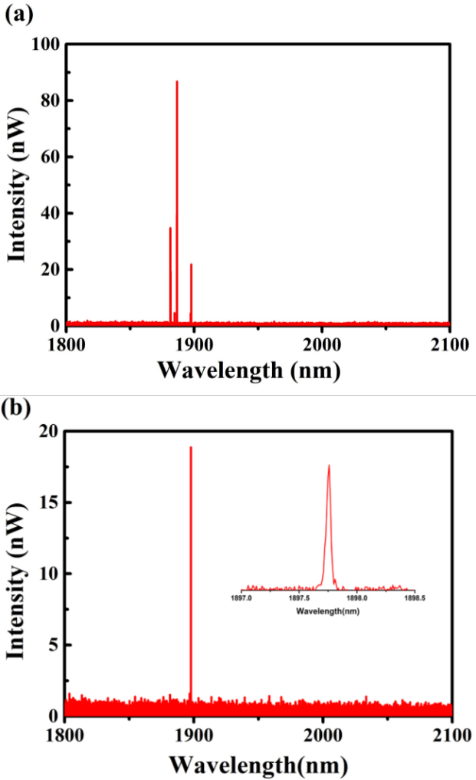
Fig.8. (a) Laser emission spectra from the Tm³⁺-doped ZBYA glass microsphere when the pump power was set to 5.8 mW; (b) Single mode laser emission spectrum from the microsphere when the pump power reached 5.6 mW. The inset is the enlargement of the laser peak.
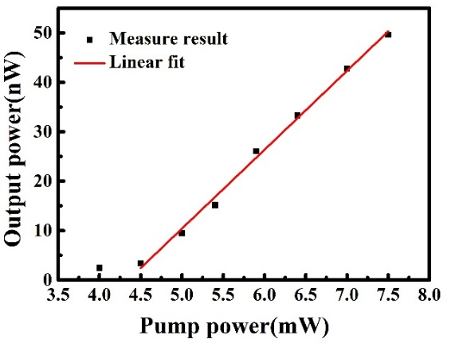
Fig.9. Output power of the single-mode laser at λ~1897.76 nm as a function of the λ~808 nm pump power.
- Conclusion
In conclusion, a Tm³⁺-doped ZBYA fluoride glass microsphere laser in the λ~2.0 μm wavelength regions was investigated. The λ~2.0 μm spectral properties of Tm³⁺-doped ZBYA glass were characterized and analyzed. By using a traditional fiber taper-microsphere coupling method, single mode and multi-mode laser operation at λ~2.0 μm were observed, with a low threshold power of ~4.5 mW. Results demonstrated that the Tm³⁺-doped ZBYA fluoride glass could find applications into integrated optics and fiber laser devices in the λ~2.0 μm region.

Acknowledgments
The work was supported by the National Natural Science Foundation of China (NSFC) under grant 61575050; National Key R&D Program of China under grant 2016YFE0126500; The fundamental research funds for the central universities (HEUCFG201841); Key Program for Natural Science Foundation of Heilongjiang Province of China under grant ZD2016012; Open Fund of the State Key Laboratory on Integrated Optoelectronics (IOSKL2016KF03); this work was also supported by the 111 project (B13015) to the Harbin Engineering University.
References
- Z. Zhang, D. Y. Shen, A. J. Boyland, J. K. Sahu, W. A. Clarkson, and M. Ibsen, "High-power Tm-doped fiber distributed-feedback laser at 1943 nm," Optics Letters, vol. 33, no. 18, pp. 2059-61, 2008.
- X. Wang, P. Zhou, X. Wang, H. Xiao, and L. Si, "100-W-level monolithic single frequency Tm-doped fiber MOPA," High Power Laser & Particle Beams, vol. 21, no. 26, pp. 32386-92, 2014.Zhang Z, Boyland A, Sahu J, Clarkson W, and Ibsen M 2011 IEEE Photonics Technology Letters 7 417-419
- Z. Zhang, A. J. Boyland, J. K. Sahu, W. A. Clarkson, and M. Ibsen, "High-Power Single-Frequency Thulium-Doped Fiber DBR Laser at 1943 nm," IEEE Photonics Technology Letters, vol. 23, no. 7, pp. 417-419, 2011.Fusari F, Lagatsky A, Richards B, Jha A, Sibbett W, and Brown C 2008 Optics Express 23 19146
- R. E. Tench, C. Romano, and J. M. Delavaux, "Broadband 2 W Output Power Tandem Thulium-doped Single Clad Fiber Amplifier at 2 μm," IEEE Photonics Technology Letters, vol. PP, no. 99, pp. 1-1, 2018.Perry I, Hanna D, Lincoln J, and Mccarthy M 2002 in Optical Sources IEEE Colloquium on 3/1-3/2.
- F. Fusari, A. A. Lagatsky, B. Richards, A. Jha, W. Sibbett, and C. T. Brown, "Spectroscopic and lasing performance of Tm³⁺- doped bulk TZN and TZNG tellurite glasses operating around 1.9 microm," Optics Express, vol. 16, no. 23, p. 19146, 2008.Matsko A 2009 Information Optics & Photonics Algorithms 7486
- Q. Wang, J. Geng, Z. Jiang, T. Luo, and S. Jiang, "Mode-locked Tm-Ho Fiber Laser with a Sb-based SESAM," in CLEO: 2011 - Laser Science to Photonic Applications, 2011, pp. 1-2.Sasagawa K, Kusawake K, Ohta J, and Nunoshita M 2003 in High-Power Lasers and Applications 21-26
- I. R. Perry, D. C. Hanna, J. R. Lincoln, and M. J. Mccarthy, "High power operation of a CW 2 μm thulium-doped fibre laser," in Optical Sources, IEE Colloquium on, 2002, pp. 3/1-3/2.
- M. Cai, O. Painter, K. J. Vahala, and P. C. Sercel, "Fiber-coupled microsphere laser," Optics Letters, vol. 25, no. 19, p. 1430, 2000.
- A. Matsko, "Practical Applications of Microresonators in Optics and Photonics," Information Optics & Photonics Algorithms, vol. 7486, 2009.
- S. M. Spillane, T. J. Kippenberg, and K. J. Vahala, "Ultralow-threshold Raman laser using a spherical dielectric microcavity," Nature, vol. 415, no. 6872, pp. 621-3, 2002.
- K. Sasagawa, K. Kusawake, J. Ohta, and M. Nunoshita, "Nd³⁺-doped tellurite glass microsphere laser," in High-Power Lasers and Applications, 2003, pp. 21-26.
- C. H. Dong, Y. F. Xiao, Z. F. Han, G. C. Guo, X. Jiang, L. Tong, C. Gu, and H. Ming, "Low-Threshold Microlaser in Er : Yb Phosphate Glass Coated Microsphere," IEEE Photonics Technology Letters, vol. 20, no. 5, pp. 342-344, 2008.
- A. Pal, S. Y. Chen, S. Das, A. Bhattacharya, T. Sun, R. Sen, and K. T. V. Grattan, "Low threshold fiber taper coupled silica microsphere laser in the 2 µm wavelength region," in Lasers and Electro-Optics Europe (CLEO EUROPE/EQEC), 2011 Conference on and 12th European Quantum Electronics Conference, 2011, pp. 1-1.
- O'Shea, G. D., Ward, M. J., Shortt, J. B., Mortier, and Féron, "Upconversion channels in Er³⁺:ZBLALiP fluoride glass microspheres," European Physical Journal Applied Physics, vol. 40, no. 2, pp. 181-188, 2007.
- Wang, T., et al., Broadband 2.9 μm emission and high energy transfer efficiency in Er3+/Dy3+ co-doped fluoroaluminate glass. Optical Materials, 2018. 75: p. 875-879.
- Gomes, L., et al., The basic spectroscopic parameters of Ho3+-doped fluoroindate glass for emission at 3.9 μm. Optical Materials, 2016. 60: p. 618-626.
- Guo, Y., et al., Effect of Fluorine Ions on 2.7 μm Emission in Er3+/Nd3+-Codoped Fluorotellurite Glass. Journal of Physical Chemistry A, 2012. 116(116): p. 5571-5576.
- Zhang, J., et al., Observation of 2.7μm emission from diode-pumped Er3+/Pr3+-codoped fluorophosphate glass. Optics Letters, 2011. 36(2): p. 109-11.
- Xu, R., et al., Enhanced emission of 2.7 μm pumped by laser diode from Er3+/Pr(3+)-codoped germanate glasses. Optics Letters, 2011. 36(7): p. 1173.
- Jia, S., et al., Ho3+ doped fluoroaluminate glass fibers for 2.9 µm lasing. Laser Physics, 2017. 28(1): p. 015802.
- Jia, S., et al., 2875 nm lasing from Ho3+-doped fluoroindate glass fibers. IEEE Photonics Technology Letters, 2017. PP(99): p. 1-1.
- Sójka, L., et al., Experimental Investigation of Mid-Infrared Laser Action From Dy 3+ Doped Fluorozirconate Fiber. IEEE Photonics Technology Letters, 2018. 30(12): p. 1083-1086.
- Aydin, Y.O., et al., Towards power scaling of 2.8 μm fiber lasers. Optics letters, 2018. 43(18): p. 4542-4545.
- Stuart D. Jackson., Towards high-power mid-infrared emission from a fibre laser., Nature Photonics, vol 6, pp.423–431, 2012.
- M. Hashida, M. Murakami, S. Shimizu, S. Tokita, and S. Sakabe, "Liquid-cooled 24 W mid-infrared Er:ZBLAN fiber laser," Optics Letters, vol. 34, no. 20, pp. 3062-4, 2009.
- B. M. Walsh and N. P. Barnes, "Comparison of Tm: ZBLAN and Tm: silica fiber lasers; Spectroscopy and tunable pulsed laser operation around 1.9 μm," Applied Physics B, vol. 78, no. 3-4, pp. 325-333, 2004.
- T. Sumiyoshi, H. Sekita, T. Arai, and S. Sato, "High-power continuous-wave 3- and 2-μm cascade Ho³⁺: ZBLAN fiber laser and its medical applications," IEEE Journal of Selected Topics in Quantum Electronics, vol. 5, no. 4, pp. 936-943, 1999.
- W. V. Klitzing, E. Jahier, R. Long, F. Lissillour, V. Lefevre-Seguin, J. Hare, J. M. Raimond, and S. Haroche, "Very low threshold lasing in Er³⁺ doped ZBLAN microsphere," Electronics Letters, vol. 35, no. 20, pp. 1745-1746, 1999.
- F. Lissillour, R. Gabet, P. Féron, P. Besnard, and G. Stéphan, "Linewidth narrowing of a DFB semiconductor laser at 1.55 μm by optical injection of an Er:ZBLAN microspherical laser," Acta Chirurgiae Orthopaedicae Et Traumatologiae Cechoslovaca, vol. 69, no. 3, pp. 175-8, 2001.
- B. Way, R. K. Jain, and M. Hossein-Zadeh, "High-Q ZBLAN microcavities for mid-infrared applications," in IEEE Photonics Conference, 2012, pp. 143-144.
- S. Liu, X. Zhu, G. Zhu, K. Balakrishnan, J. Zong, K. Wiersma, A. ChavezPirson, R. A. Norwood, and N. Peyghambarian, "Graphene Q-switched Ho³⁺-doped ZBLAN fiber laser at 1190 nm," Optics Letters, vol. 40, no. 2, p. 147, 2015.
- Poulain, M., Halide glasses. Journal of Non-Crystalline Solids, 1983. 56(1): p. 1-14.
- Subhash H. Risbud and Wallace L.Vaughn., Thermal Stability and Crystallization of Nitrogen Containing ZBYA Fluoride Glasses, Materials Science Forum .1987.19:p. 515-522.
- H. Ebendorff-Heidepriem, I. Szabó, and Z. E. Rasztovits, "Crystallization behavior and spectroscopic properties of Ho³⁺-doped ZBYA-fluoride glass," Optical Materials, vol. 14, no. 2, pp. 127-136, 2000.
- Z. E. Rasztovits, I. Szabó, and G. H. Frischat, "DTA study of rare earth doped ZBYA-type fluoride glasses," Zeitschrift Elektrochemie Berichte Der Bunsengesellschaft Physikalische Chemie, vol. 100, no. 9, pp. 1642-1645, 2010.
- F. Huang, Y. Tian, S. Xu, and J. Zhang, "Spectroscopic and energy transfer mechanism of Er³⁺, Pr³⁺-codoped ZBYA glass," Ceramics International, vol. 42, no. 7, pp. 7924-7928, 2016.
- S. H. Risbud and W. L. Vaughn, "Thermal Stability and Crystallization of Nitrogen Containing ZBYA Fluoride Glasses," in Materials Science Forum, 1987.
- F. Huang, Y. Guo, Y. Ma, L. Zhang, and J. Zhang, "Highly Er³⁺-doped ZrF4-based fluoride glasses for 2.7 μm laser materials," Applied Optics, vol. 52, no. 7, p. 1399, 2013.
- J. M. Ward, A. Maimaiti, V. H. Le, and S. N. Chormaic, "Contributed review: optical micro- and nanofiber pulling rig," Review of Scientific Instruments, vol. 85, no. 11, p. 043902, 2014.
- Y. Tian, R. Xu, L. Hu, and J. Zhang, "Synthesis and infrared photoluminescence around 2.9 μm from Dy³⁺/Tm³⁺ codoped fluorophosphate glass," Materials Letters, vol. 69, pp. 72-75, 2012/02/15/ 2012.
- H. Sun, L. Zhang, L. Wen, M. Liao, J. Zhang, L. Hu, S. Dai, and Z. Jiang, "Effect of PbCl₂ addition on structure, OH⁻ content, and upconversion luminescence in Yb3⁺ /Er³⁺ -codoped germanate glasses," Applied Physics B, vol. 80, no. 7, pp. 881-888, 2005.
- A. Biswas, G. S. Maciel, R. Kapoor, C. S. Friend, and P. N. Prasad, "Er³⁺-doped multicomponent sol-gel-processed silica glass for optical signal amplification at 1.5 μm," Applied Physics Letters, vol. 82, no. 15, pp. 2389-2391, 2003.
- J. L. Doualan, S. Girard, H. Haquin, J. L. Adam, and J. Montagne, "Spectroscopic properties and laser emission of Tm doped ZBLAN glass at 1.8 μm," Optical Materials, vol. 24, no. 3, pp. 563-574, 2003/12/01/ 2003.
- M. Li, G. Bai, Y. Guo, L. Hu, and J. Zhang, "Investigation on Tm³⁺-doped silicate glass for 1.8 μm emission," Journal of Luminescence, vol. 132, no. 7, pp. 1830-1835, 2012/07/01/ 2012.
- D. E. Mccumber, "Einstein Relations Connecting Broadband Emission and Absorption Spectra," Physical Review, vol. 136, no. 4A, pp. A954-A957, 1964.

