Title: Exploring Nurses’ knowledge, attitudes and feelings towards organ and tissue donation after circulatory death within the paediatric intensive care setting: a qualitative content analysis study.

Author Name and Affiliations:

Sophie Dopson BSc, PGDip Nursing- Child, MSc1 Tracy Long-Sutehall, PhD, CPsycol2

1 Great Ormond Street Hospital, Great Ormond Street, London, WC1N 3JH Email: sophie.dopson@gosh.nhs.uk

2 School of Health Sciences, Faculty of Environmental and Life Sciences, University of Southampton, Highfield, Southampton, SO17 1BJ

Corresponding Author: Sophie Dopson

Acknowledgements

The researchers would like to thank the participants for their time and cooperation throughout the project. We would also like to acknowledge NHSBT for use of their illustrations and tables.

Conflicts of Interest:

Employment of primary researcher within trust in which research was undertaken.

Funding:

Not applicable.

Ethical Approval:

The study was approved by the University of Southampton’s Ethics and Research Governance Committee (ERGO submission ID: 22998), NHS Health Research Authority, Clinical Research Adoptions Committee (IRAS ID: 216356/ REC ID: IG/HRA/5736) and the local trust’s Research and Development Committee (CRAC/R&D ID: 16HC25).

Abstract

Objective: This study explored nurses’ knowledge, attitudes and feelings towards donation after circulatory death identifying these domains as barriers andfacilitators to nurses effectively undertaking their role in the donation after circulatory death donationprocess.

Design: A single-phase qualitative study design.

Setting: One paediatric cardiac intensive care unit in a tertiary paediatric hospital in England.

Methods: Data was collected from eight paediatric cardiac intensive care nurses using semi-structured face to face or telephone interviews facilitated by a clinical vignette. Qualitative content analysis was undertaken adopting both inductive and deductive lenses.

Key findings: Three categories were deductively generated within which eleven inductively generated themes were situated. Barriers included: knowledge deficits of both process and resources; assumptions about parental views and reluctance to facilitate sensitive discussions, facilitators included positive attitudes toward donation aligned with a strong professional ethos and family-centred values.

Conclusions: The paper identifies barriers to the donation after circulatory death process including nurses feeling unprepared for their role, anxiety over family approach and communication methods and support. Highlighted is the need for specific educational interventions, appropriate resources and development of paediatric focussed policy to guide practice. Facilitators to donation include timely, sensitive and appropriate family discussions, trusting nurse-family relationships and improved public awareness.

Key Words

Donation after circulatory death (DCD), Nursing attitudes, Nursing knowledge, Organ and tissue donation, Paediatric Intensive Care Unit (PICU), Qualitative research.

Recommendations for Clinical Practice

- Provision of more DCD education for both pre- and post-registration nurses.
- Education should include: information on the process of DCD donation, resources available for families, typical questions families may ask and how best to respond to these.
- Education should be delivered as: written guidance and information (provided at national level), including the distribution of information for staff on how and when to appropriately contact organ donation services; SN-OD training days, including scenario-based simulation practice provided by hospital trusts, SN- OD drop-in sessions with the trust, and annual updates delivered through newsletters and internet sources.
- Availability of appropriate resources for staff and families to provide support through the donation process. Suggested resources include: information leaflets and availability of wider MDT support (including family liaison, psychology and chaplaincy services).

Introduction

Daily in the UK, approximately 176 infants, children and young adults are waitingfor a transplant operation due to the shortage of paediatric organs (NHSBT, 2017). The number of children waiting is neither static nor definitive as: patients are movedonto and off lists in response to changes in their clinical situation, and the fact that some children are not listed for transplantation when their medical practitioner considers the chance of an organ becoming available to be negligible (Rodrigue et al, 2008).

According to National Health Service Blood and Transplant (NHSBT) figures, due to the shortage of paediatric donors, over 900 children have waited for a kidney transplant over the past 10 years with an average waiting time of 2.5 years. Children waiting for a heart transplant will wait on average 2.5 times longer than an adult who is waiting (NHSBT, 2018). Low rates of paediatric organ donation is not only anissue for the UK as figures available for paediatric heart and lung donation from the Global Observatory on Donation and Transplantation (GODT,2018) clearly report the discrepancy between the number of adult andpaediatric transplant operations undertaken globally. GODT report that in 2018, 662 paediatric heart transplants took place as opposed to 7,626 adult transplants with 99 paediatric lung transplants taking place as opposed to 5,497 adult lung transplants.

The process of Paediatric Organ Donation

In the UK and internationally Paediatric Organ Donation (POD) is facilitated within the context of paediatric intensive or critical care environments (from here on referred to as PICU). The reason for this is that the potential donor will be requiring life-sustaining interventions for example mechanical ventilation and multi organ support.

There are two donation trajectories, the first leading to donation following the determination of death following the irreversible cessation of brain stem function (DBD) and the second being donation following confirmation of death following permanent cessation of cardiorespiratory function (DCD) (ODTC, 2018). Donation following circulatory death (DCD) remains controversial in some paediatric institutions as this is a relatively new initiative introduced to try and increase the supply of organs for use in transplant operations. Internationally, some countries with donation programmes do not have DCD programmes, or focus on uncontrolled DCD. Currently the UK, Netherlands and Australia have well developed programmes with DCD in the UK currently suppling 39% of the organs needed in the adult programmes (ODTC, 2018).
The process of organ donation in both adult and paediatric programmes relies on: identification of a potential donor, (by health care professionals working in ITU/PICU), referral to the specialist team (Specialist Nurses in Organ Donation, SN-OD), approaches to relatives/decision-makers to discuss donation, gaining consent/authorisation for donation (from relatives/decision-makers), confirmation of death (DBD or DCD), donor management, the retrieval of organs and the post death care of the body. There is the potential for the loss of potential donors at each point along these donation trajectories (Figure 1) resulting in very different numbers of paediatric donors with DCD (2017/18 = 17 donors) lagging behind DBDdonation 2017/18 =23 donors).

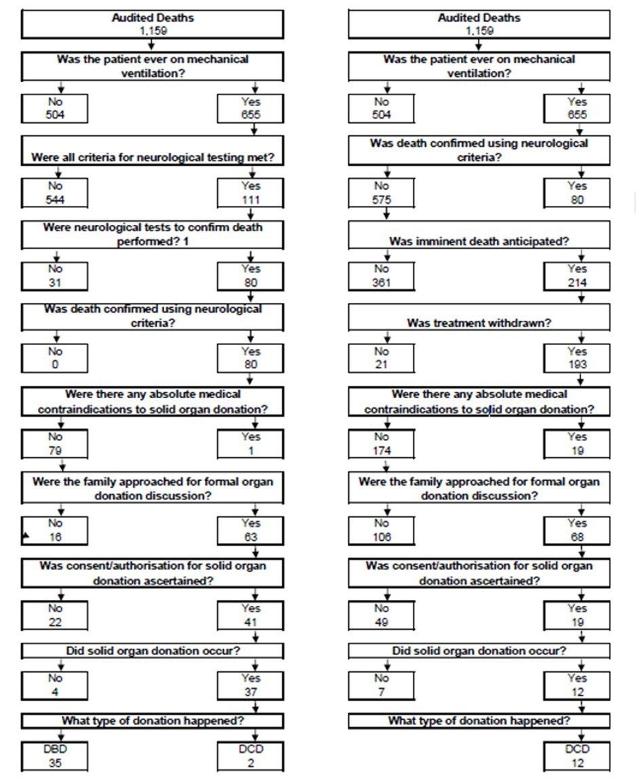Figure 1: Paediatric deaths in UK PICUs between 1st April 2016 and 31st March 2017 (NHSBT, 2018)

Trajectory for DBD donation. Trajectory for DCD donation.

Why is paediatric DCD lagging behind DBD?

A consistent finding from a limited body of knowledge is that there is a perceived lack of knowledge and guidance, around Paeditric Organ Donation (POD), and DCD in particular, despite national organisations; NHSBT, NICE, UKDEC, generating guidance over the past 5 years. Research, predominantly undertaken in the USA, has demonstrated that PICU healthcare professionals (HCPs) feel unprepared for their role in the DCDprocess. Reported barriers to facilitating donation via the DCD route include: concerns over poor knowledge of DCD protocols (Curley, 2007; Mathur, 2008; Kurz, 2014; Weiss, 2016), concerns regarding approaching family members and supporting them through donation (Mathur, 2008), communicating with families and other HCPs to gain consent to donation (Kurz, 2014; Weiss, 2016).

Authors in the Netherlands report generally positive attitude amongst nurses towards DCD (Siebelink et al, 2011), however the option of DCD raises personal conflicts for some nurses.
Curley et al (2007) surveyed paediatric clinical staff in the USA
seeking their views about whether a DCD program would be consistent with the mission and core values of a children's hospital. Data from 88 staff members gained from eight focus groups articulated concerns including the personal/professional tension that the issue of organ donation can trigger. One participant illustrated this tension: “On one extreme I feel like we are being asked to set up an organ bank business and on the other side…. Protecting and saving life….. a conflict of interest” (P: 214).

Empirical work carried out by Mathur et al (2008) in the USA exploring the perceptions, level of knowledge, and understanding of DCD in Paediatric Critical Care Nurses (PCRNs) surveyed 123 nurses with 93 (76%) PCRNs supporting organ donation, 69% reporting that donation gives meaning and worth to death, and 76% of participants reporting that they felt that donation contributes positively to thedonating family's grieving process. However, 11% feared that the DCD donor feels pain and suffering and 14% felt that a 5-minute observation period after asystole isinsufficient to pronounce death, and 8% feared legal repercussions.

Other concerns reported to act as barriers to DCD from US studies include: perceiving withdrawal of treatment as a professional failure (Harrison and Laussen, 2008), staff reluctance to accept DCD protocols due to ethical concerns over the protection of children; in particular that the decision to donate may lead to a premature decision to withdraw life-

sustaining treatment (Antommaria and Bratton, 2008; Weiss et al, 2016).

A further barrier is the perceived lack of clinical guidelines and protocols to support health care professionals in their decision-making and engagement with family members and other health care professionals despite published guidance (Weiss et al, 2016).
In view of the evidenced challenges to increasing paediatric donation rates viathe DCD route, and in completion of a Master in Advanced Nursing Practice the following qualitative study was conducted with the aim of exploring nurses’ knowledge, attitudes and feelings towards DCD within one paediatric cardiac intensive care unit in the South of England.

Research Question

What knowledge, attitudes and feelings inform the practice of PICU nurses when donation after circulatory death is an option at end of life?

Study Objectives

- To map critical care nurses’ knowledge, attitudes and feelings towards paediatric DCD
- To identify barriers and facilitators to: identification of potential donors, referral to specialist teams and discussing the option of DCD with family members.
- To determine what support, education and organisational interventions, paediatric critical care nurses’ need to confidently ensure consideration of DCD at end of life.

Study Design

A single-phase study applying qualitative methods of inquiry was carried out with data collection being undertaken over a one-month period (February 2017).

Participants and recruitment

Nurses from one cardiac PICU in a tertiary paediatric hospital were invited to participate in the study. As nursing experience and knowledge have been identified as factors that may impact confidence a stratified sample (by nursing band 5 and 6 with less than one year and more than one year experience) was sought. The aim of recruitment was to gain a sample

that included a maximum of eight nurses (sample size constrained by time line to undertake the study for a master’s dissertation, and the intention to carry out a rigorous and trustworthy study) who were most likely to have patient and family involvement. Current staffing levels indicated that 104 nurses held Band 5 and 6 positions and therefore the poster advertising the study clearly indicated the sample size being sought and the clarification that the first two respondents under each category would be included (if willing to continue post discussion with the researcher).
Thirty recruitment packs, including invitation letters and participant information sheets, were placed in the PICU staff room resulting in sixteen responses (15%). Table 1 illustrates participant demographic data. Participants’ ages ranged from 21 to 44 years, all were female with at least a degree in nursing education. One participant (12%) had received formal DCD training as a nursing student and four (50%) had received this training post-registration.

Table 1. Participant demographic data

Participant no. | Band | Years in role | Age | Gender | Level of Nursing Qualification | Formal Pre- Registration DCD  training | Formal Post- Registration DCD  training
OD1 | 5 | 2 years | 24 | Female | Degree | No | Yes
OD2 | 5 | 6 months | 22 | Female | Degree | Yes | No
OD3 | 5 | 2 years | 22 | Female | Degree | No | No
OD7 | 5 | 6 months | 21 | Female | Degree | No | No
OD4 | 6 | 10+  years | 44 | Female | Masters | No | Yes
OD5 | 6 | 6 months | 31 | Female | Degree | No | Yes
OD6 | 6 | 6 months | 29 | Female | Degree | No | Yes
OD8 | 6 | 10+  years | 43 | Female | Degree | No | No

Data Collection

Interviews (lasting on average 30 minutes) either face to face (n = 2) or telephone (n
= 6)(participant preference) were conducted by author SD afterparticipants had provided written or verbal consent. Prior to interview, participants were asked to read a clinical vignette (Figure 2) that had been developed to encourage exploration of this sensitive topic from a hypothetical perspective (Reynold, 2002). The semi- structured interview schedule (Figure 1 was developed from literature and expert opinion and focussed on eliciting three domains: knowledge, feelings and attitudes towards DCD.

Data Analysis

Interviews were transcribed verbatim by SD with transcripts undergoing qualitative content analysis (QCA) (Elo and Kyngäs, 2008) by SD and TLS. The method was chosen as Krippendorff (2004) suggests this method facilitates the development of new knowledge and insights by building a conceptual map developed from applying both inductive and deductive reasoning. Deductive reasoning is informed by pre- determined themes and knowledge gained from literature reviewed, whilst inductive reasoning generates themes and categories from the raw data (Bengtsson, 2016).

Rigour and Trustworthiness

Trustworthiness was enhanced by maintaining a detailed audit trail throughout the project, comprising of field notes from initial thoughts through to analysis, accurate transcriptions, reduction and synthesis of raw data, and evidence of the analytical process. Researcher reflexivity was facilitated by maintenance of a reflective diary of methodological decisions and reasoning for discussion in supervision. Finally efforts were made to seek participant validation of findings via email communication of a summary of the eleven key themes identified. This process of data analysis is summarised in Table 2.

