Thermo-Elasto-Hydrodynamic analysis and optimization of rubber-supported water-lubricated thrust bearings with polymer coated pads
Xingxin Liang^{a,d}, Xinping Yan^{a,b,c}, Wu Ouyang^{a,b,c}, Robert J.K.Wood^{d}, Zhenglin Liu^{a,b,c}
ª School of Energy and Power Engineering, Wuhan University of Technology, Wuhan 430063, China
^{b}National Engineering Research Center for Water Transportation Safety(WTSC), MOST, 430063, China
^{c} Key Laboratory of Marine Power Engineering Technology, MOT, 430063, China
^{d}national Centre for Advanced Tribology at Southampton (nCATS), University of Southampton, Highfield, Southampton, SO17 1BJ, UK
Corresponding author: Xinping Yan, xpyan@whut.edu.cn

Abstract: In order to study the lubrication performance of rubber-supported water-lubricated thrust bearings (RWTBs) with polymer coated pads and optimize the offset ratio of rubber cushions, a Thermo-Elasto-Hydrodynamic lubrication performance computational model is proposed. Case studies show that there are concave and convex deformations on the polymer surface under certain load and speed conditions. Deformations decrease the minimum film thickness by 10.9% compared with that calculated without considering deformation. Optimization indicates that the optimum offset ratios of the rubber cushion are 0.585 ~0.59 in circumferential and 0.49 ~0.5 in radial direction, and both of them are independent of speed and load. The research verifies that the proposed model is an effective tool for studying lubrication performance and optimizing of RWTBs.
Keywords: Thermo-Elasto-Hydrodynamic; rubber-supported; water-lubricated; tilting pad thrust bearing
1. Introduction
In underwater vehicles or some large submersible pumps, oil-lubricated thrust bearings are widely used to afford axial thrust. Therefore, there is a risk of environmental pollution caused by oil leakage. In the long term, water-lubricated thrust bearings have more potential applications in the underwater working environment [1-2]. However, the application of water-lubricated bearings still faces many problems. First, one of the most commonly used water-lubricated friction pairs is polymer/metal. Compared with oil-lubricated metal/metal friction pairs, the polymer bearings carry a relatively low normal pressure [3-5]. Second, water has a very low viscosity and is not piezoviscous compared to oil lubricants at the same temperature [6]. The bearing load capacity generated by hydrodynamic pressure is small and cannot satisfy the bearing capacity demand for large-scale industrial equipment. Third, the water environment is corrosive to metallic materials. The pivots of Michel or Kingsbury types thrust bearings need to be properly redesigned before they can be used in the water environment. For instance, the pivot or its support with the greatest stress may be corroded and worn quickly in the marine environment. An alternative design scheme is to replace the pivot with a rubber cushion. Rubber can not only maintain the adaptive tilting ability and load sharing ability of bearing pads, but also resist seawater corrosion.

Rubber-supported oil-lubricated tilting pad thrust bearings have been successfully used in hydro generators [7-8]. The structure of this bearing has the potential to be applied in a water environment. However, only a few literatures have reported the performance simulation, optimization design or experiments research of them. Van Beck et al. [9-10] and Van Ostayen et al. [9] developed mathematical models for calculating the lubrication performance of a water-lubricated hydrostatic thrust bearing connected to a navigation lock-gate by a rubber hinge. Liang et al. [12] designed a rubber-supported thrust bearing and studied it lubrication performance based on a fluid-solid interaction model. In addition, the lubrication performance analysis methods of spring-supported thrust bearings [13-15] also provide some reference, because except for the non-linear stress-strain performance of rubber, there are similarities between rubber and spring. A Japanese hydropower company had developed a big water-lubricated thrust bearing to support up to 450 kN axial load of a vertical hydraulic turbine generator. The specific pressure load for a pad is 3.0 MPa and the linear velocity is 20.7 m·s⁻¹. After a series of test, they believed the bearing was technically applicable to the actual power plant [16]. Nevertheless, up to now, there is far less research on water-lubricated tilting pad thrust bearings than oil-lubricated ones, especially in the field of Thermo-Elasto-Hydrodynamic (TEHD) lubrication performance research.

In hydrodynamic lubricated bearings, the fluid shear movement produces hydrodynamic pressure and internal frictional heat. The former results in elastic deformation of the bearings, while the latter leads to variation in thermal deformation and fluid viscosity. The direct or indirect interaction between pressure, temperature, deformation, and viscosity also affects the lubrication performance. Therefore, in order to obtain accurate bearing performance prediction, these factors need to be taken into account in the performance equations. The simulation models considering all of the above-mentioned factors are called TEHD models. Previous experiments and simulations [17-21] have proved that thermal effects on bearing performance cannot be neglected. Especially the ‘thermal crowning’ of large thrust pads, whose hundreds of microns of convex deformation is detrimental. PTFE (polytetrafluoroethylene) layers have been successfully applied on the pad surface to replace the white metal to reduce the ‘thermal crowning’ effect [22-23]. However, it is difficult to incorporate thermal effects into the simulation analysis of thrust bearings performance. The main reason is that the complexity of the flow field makes it difficult to obtain thermal boundary conditions [24-25]. Three methods have been used to build TEHD models to calculate lubrication performance of tilting pad thrust bearings. They are:
- FDM (Finite Difference Method);
- FDM-FEM (Finite Difference Method coupled with Finite Element Method);
- CFD- FEM (Computational Fluid Dynamics method coupled with the Finite Element Method).
In the FDM method [26], the elastic deformation equation, heat conduction equation, energy equation, film thickness equation, density-temperature and viscosity-temperature characteristics of lubricants, and the Reynolds equation are solved simultaneously within the computing code based on the finite difference method. Since a semi-infinite solid model or Winkler model is used to calculate elastic deformation and the thrust collars are treated as isothermal, so the accuracy of the calculation results is relatively low.

The FDM-FEM method [19, 21, 24, 27-28] is claimed to improve computation accuracy. In this simulation method, the FDM method was applied to simulated film pressure, friction heat and viscosity variation in the fluid model, while the FEM method was used to calculated thermal and elastic deformation of the solid structures. In fact, these two methods have flaws in the calculation of thermal effects. For the FDM method used in [26] and the FDM-FEM method applied in [19], the heat convective coefficient, one of the most important parameters, is defined based on empirical formulas and may differ greatly from the actual value. The calculated temperature field of pads may vary greatly due to the different assignment of this coefficient. Moreover, both methods simplify the bearing structure. For example, the hydrostatic recess on the pad surface was not included in the modeling. The depth of the hydrostatic recess is larger than gap thickness between the thrust collar and pad surface and has an influence on the lubrication performance. So the discrepancies between the measurements of a real thrust bearing and simulated results of a simplified modeling are considerable [24, 29]. Subsequently, a thermohydrodynamic (THD) model was presented to analyze the influence of the hydrostatic recess on the main bearing characteristics [30]. In the THD model, the elastic and thermal deformations of the structure under pressure and thermal load are not considered.

The CFD- FEM method [8, 31-34] seems to be one with greatest promise possibilities for theoretical analysis of lubrication problems. In this method, the fluid was modeled in a CFD module and the solid structures models were built in a FEM module. Both fluid and solid models were solved simultaneously while the pressure, heat flux and deformation data exchanged between their boundaries and interacted with each other. The heat generated by fluid internal friction was carried away by the ‘real’ flow of fluid between pads, so there is no need to set the heat transfer coefficient. Complex pad shapes and initial flow field models can be modeled separately in two modules, such as the hydrostatic recess and the hydraulic oil supply hole. Even the hot oil ‘carry over’ effect can also be simulated [8]. The experimental results of several tilting pad thrust bearings at steady [31-32] and transient [33] condition were reported to validate this method. However, the high requirements for computing capacity and grid quality, long solving time and the difficulty in obtaining convergent solutions limit the application of this method. Especially for the performance calculation of textured thrust bearing which needs a high density grid mesh, it’s better to only utilize the THD simulation function of the CFD module [35-37].

For rubber-supported water-lubricated tilting pad thrust bearings (RWTBs) with polymer coated pads, the application of CFD-FEM method in TEHD performance simulation is confronted with several difficulties. First, the magnitude of the minimum water film thickness is in the order of microns rather than tens or hundreds of microns. However, the compression deformation of the rubber cushion may be in the order of millimeters. Coupling these two scales which are thousands of times different to a CFD-FEM solver, the mesh of water flow field will be distorted too much and the convergent solution cannot be obtained. Second, rubber is a non-linear viscoelastic material. The force and moment balance conditions of the rubber-supported pad become more complex compared with pivot-supported one. The equilibrium state of the pad is affected by the nonlinear elastic force and restoring moment of rubber due to its compression and inclination. In addition, the polymer materials generally have a relatively large thermal expansion coefficient and low elastic modulus. A small temperature and stress rise will lead to a relatively large deformation and will exacerbate the mesh distortion of the water film, which makes calculation difficult.

The aim of this paper is to propose a method for analyzing the TEHD lubrication performance of RWTBs with polymer coated pads and to optimize the offset position of the rubber cushion. A FDM-FEM mothod based on the combination of MATLAB and ADINA [38] software is developed to carry out the above-mentioned research followed by an experimental test. First, the forces and moments acting on the rubber-supported thrust pad in an equilibrium state are analyzed, and several equilibrium conditions for the pad to reach equilibrium state under the water film pressure are proposed. Next, the restoring forces and moments of a rubber cushion acting on the thrust pad at different compression and inclination angles are calculated by a FEM method, and the relationship of the restoring forces and moments with compression and inclination angles are fitted. Then, the FDM-FEM method is introduced and a TEHD lubrication performance case study of a RWTB is carried out. A bearing test rig is designed and a durability test is launched to verify whether the RWTB is in hydrodynamic lubrication regime as simulated based on the TEHD model. Finally, the offset ratio of the rubber cushion under different loads and speeds is optimized.

2. The TEHD model of RWTBs

2.1 The structure of RWTBs with the polymer pad surface

A 3-D view of a sector thrust pad of the RWTB is shown in Fig.1 (a). The polymer material (Thorden SXL) is adhered to a steel plate (Stainless steel 316L) by strong water-resistant glue. A rubber cushion offset at the bottom of the steel plate and their contact surfaces are not bonded. There are two pinholes in the rubber cushion and the steel plate. A 2-D sectional view of the rubber-supported pad is shown in Fig.1 (b). The thrust pad is installed on a support. Two dowel pins limit both the circumferential and radial movement of the steel plate and rubber. Clearance fit between dowel pins and pin holes to ensure the pad can tilt freely in any direction under water film pressure. Dimensions and material properties of the pad are listed in Table 1.
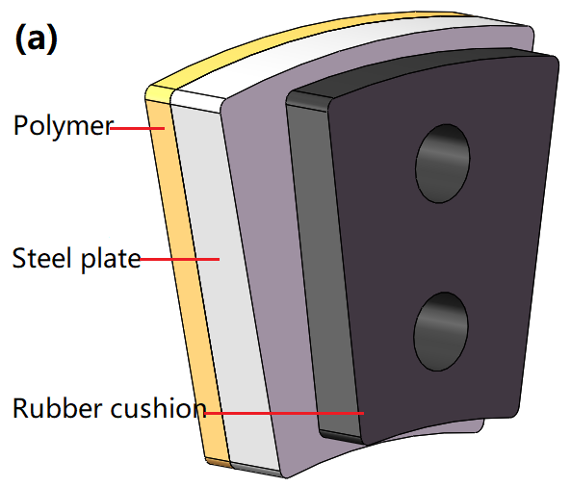
Fig.1 The pad model of a RWTB. (a) 3-D view; (b) 2-D view

Table 1 Dimensions and material properties of the RWTB
Parameters | Steel plate | Polymer | Rubber
Inner radius / mm | 62 | 62 | 63
Outer diameter / mm | 98 | 98 | 96
Thickness / mm | 4 | 2 | 6.2
Pad angle / ° | 24 | 24 | 18
Elastic modulus / MPa | 2.07e5 | 605 | 5.5 ~6
Density / kg·m⁻³ | 7850 | 1160 | 1320
Poisson's ratio | 0.3 | 0.45 | 0.47
Thermal conductivity / W·(m·K)⁻¹ | 46 | 0.25 | 0.22
Specific heat capacity / J·(kg·K)⁻¹ | 502.4 | 1500 | 1640
Thermal expansion coefficient / K⁻¹ | 12e-6 | 15.1e-5 | 7e-5

2.2 Force analysis of the rubber-supported tilting pad in an equilibrium state

Before analyzing the force equilibrium state of the rubber-supported tilting pad, the pivot-supported tilting pad is analyzed first. It is instructive to do the force analysis of the rubber-supported one. As shown in Fig.2 (a), distributed film pressure and a concentrated pivot supporting force act on the pad. The pad tilts around the pivot. Two conditions (as shown in Eq. (1)) must be satisfied for the pad to achieve an equilibrium state.
(1)
Where F_{f} is the integrated film force; F_{p} is the pivot support force; M_{fl} and M_{fr} are the tilting moments of the pad around the pivot produced by water film pressure on both sides of the pivot.

For the rubber-supported tilting pad, as shown in Fig.2 (b), the distributed film pressure on pad surface is balanced by the distribution stress of the compressed rubber cushion, rather than a concentrated force. The distributed rubber stress will cause an extra moment on the pad. Therefore, the conditions (as shown in Eq. (2)) it needs to reach at equilibrium state are different from those of pivot-supported tilting pad.
(2)
Where F_{r} is the integrated rubber force; M_{f} is the tilting moment on the pad produced by water film pressure; M_{r} is the restoring moment on the pad produced by the rubber stress.

Since the rubber-supported tilting pad has no fixed pivot, it is necessary to set a reference point for the convenience of calculating the moments M_{f} and M_{r}. As shown in Fig.2(c), a virtual pivot is defined on the contact surface of the rubber cushion. The virtual pivot can move axially with the compression of the rubber cushion. The compression of the rubber cushion d_{r} can be defined as the axial displacement of the virtual pivot. The pad can also be considered to be tilted around the virtual pivot so the moments M_{f} and M_{r} can be calculated. In an equilibrium state, both forces F_{f} and F_{r} do not necessarily pass through the virtual pivot. This is different from the pivot-supported pad as shown in Fig.2 (a) which the force F_{f} must pass through the pivot. In theory, under an equilibrium state, the compression of rubber cushion and tilting angle of the pad calculated based on the virtual pivot are uniquely determined. For a 2-D rubber-supported pad, both F_{r} and M_{r} are functions of compression d_{r} and tilting angle β.
(c)
(b)
(a)
Fig.2 Force analysis of 2-D tilting pad thrust bearings. (a) Pivot-supported thrust bearing; (b) Rubber-supported thrust bearing; (c) The definition of a virtual pivot

For a 3-D rubber-supported pad, there has an additional tliting direction (radial direction). Therefore, three factors need to be taken into account in its equilibrium state: the axial force (F_{r}), the rotating moments around the x-axis (M_{x}) and y-axis (M_{y}), as shown in Fig.3. The geometric centre of the contact surface of the rubber cushion is defined as the virtual pivot (It can be any point on this surface in theory, but be set at the geometric centre of the surface to improve the accuracy of the force F_{r}). The x-axis and y-axis intersect at this point. The equilibrium state can be described by three parameters: axial displacement of the virtual pivot d_{r}, circumferential and radial tilting angle β and γ. The conditions required for the pad to reach an equilibrium state are as Eq. (3):
(3)
Where M_{fx} and M_{rx} are the tilting and restoring moments of the pad around x-axis produced by water film pressure and the distributed rubber stress, respectively, M_{fy} and M_{ry} are those around the y-axis, respectively.

The defined virtual pivot is of great significance because it brings convenience to the description and calculation of the above parameters of the pad equilibrium state. In addition, the offset positions of the rubber cushion relative to the pad can also be defined. According to Fig.3, the offset ratios can be defined as:
(4)
(5)
Where E_{c} and E_{r} are the offset ratios of the rubber cushion in circumferential and radial direction, respectively; θ_{p} and B_{p} are the pad angle and width, θ_{e} and B_{e} are the offset values in the circumferential and radial directions, respectively.

Fig.3 Force analysis of a 3-D rubber-supported tilting pad

2.3 A calculation method of the F_{r}, M_{rx} and M_{ry} of the rubber cushion

The F_{f}, M_{fx} and M_{fy} produced by water film can be easily obtained by integral of water film pressure. However, the F_{r}, M_{rx} and M_{ry} caused by the compressed rubber cushion are difficult to calculate by an analytical method. Because the shape of the rubber cushion is irregular (a sector-shape with rounded corners and pinholes). What's worse is the non-linear stress-strain relationship of the rubber cushion, which is closely related to the contact state between it and the steel plate. As shown in Fig.4, the rubber cushions are compressed with the same force in wet and dry conditions. But their axial compressions are different. For the case of the rubber cushion compressed with water on both surfaces, the compression is larger than that of dry one (d_{rw} > d_{rd}). Because the water film reduces friction between the rubber cushion and steel plate, which makes the rubber easier to expand horizontally.
Fig.4 Compression of rubber materials with different surface conditions. (a) Wet compressed; (b) Dry compressed

Compression tests of six rubber cushions used in the thrust bearing are launched under dry and wet conditions. The elastic modulus of this rubber material is about 5.5 ~6 MPa@25℃ and the RMS roughness S_{q} of the steel plates is 0.036 μm. The compression force versus compression displacement is shown in Fig. 5 (a). With the same amount of compression displacement, the compression force in the dry state is nearly twice that in the wet state. Under the same surface condition, the force-displacement relationships of different rubber cushions are also different. According to the tests, the average compressive stress-strain relationship of rubber pad under different conditions is calculated. The stress-strain relationship can be used as a rubber material property input in the FEM software ADINA. The nonlinear Mooney-Rivlin rubber material model is applied and the generalized Mooney-Rivlin constants from C1 to C9 are computed. The comparison between the simulated compression force-displacement relationship and the experiment results of the rubber cushion is shown in Fig. 5 (b). The results show that the simulated force-displacement relationship is in good agreement with the average experimental results when the compression is less than 0.9 mm (14.5% of rubber cushion thickness). The design load of each water-lubricated pad is less than 0.5 MPa (602 N), so the maximum compression of the rubber cushion is less than 0.9 mm. This demonstrates that under small compression condition the simulation method and the Mooney-Rivlin rubber material model used to simulate the mechanical properties of the rubber cushion are feasible. The FEM method can be used to analyze the stress and deformation of complex structures conveniently, so the F_{r}, M_{rx} and M_{ry} of the rubber cushion will be calculated based on FEM simulations.
Fig.5 The compression force versus the compression displacement of the rubber cushion. (a) Comparison between dry and wet compression test; (b) Comparison between wet compression test and simulation

A FEM model for calculating the F_{r}, M_{rx} and M_{ry} of the rubber cushion is shown in Fig.6 (a). The rubber cushion and a steel plate are modeled. The degree of freedom (DOF) of the upper surface of the rubber is fixed in Z-Translation and its lower surface is in contact with the steel plate. A point coincides with the virtual pivot of the rubber cushion is modeled on the contact surface of the steel plate. The nodes on the contact surface of the steel plate are constrained as a rigid link to this point. The point works as the virtual pivot as defined previously and its DOFs are set to be free in Z-Translation, X- and Y-Rotation. The Z-displacement (d_{r}), X- and Y-Rotation (β and γ) loads are applied and the steel plate follows its movement. A simulation result for d_{r} of 0.7 mm, β of 0.004 rad and γ of – 0.004 rad is shown in Fig.6 (b). The F_{r}, M_{rx} and M_{ry} obtained easily from the virtual pivot are 479.57 N, 221 and 73 mN·m, respectively. Since the F_{r}, M_{rx} and M_{ry} are functions of d_{r}, β and γ, therefore, their values can be calculated at the given values of d_{r}, β and γ.
(b)
(a)
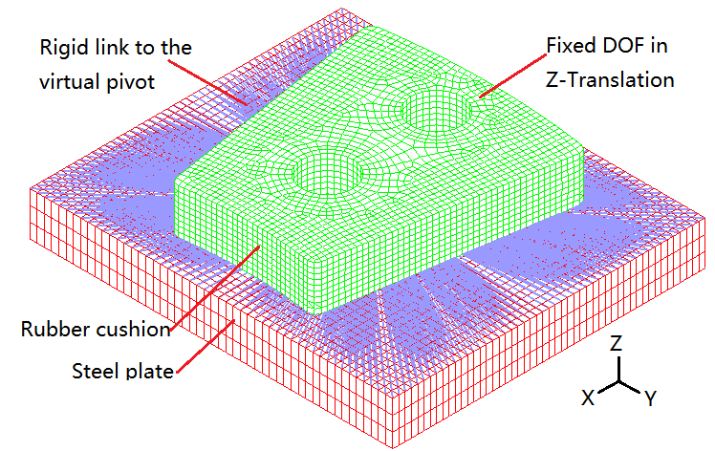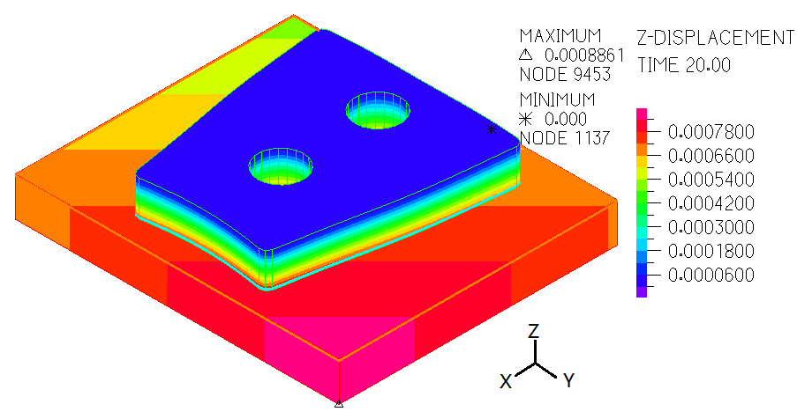
Fig.6 A calculation model of the F_{r}, M_{rx}, and M_{ry}. (a) The calculation model; (b) The displacement result of a case study

The F_{r}, M_{rx}, and M_{ry} of the rubber cushion versus the displacement (d_{r}), circumferential and radial tilting angles (β and γ) are shown in Fig.7. d_{r} has a greater effect on F_{r}, while β and γ have a smaller effect on it. As can be seen from Fig.7 (a), the F_{r} increases nonlinearly with the increase of d_{r}, but almost keeps constant with the change of γ (from – 0.002 to 0.002 rad). As β increases from 0 to 0.002 rad at an equal interval of 0.0004 rad, six F_{r} curved surfaces are plotted. However, because the F_{r} varies very little with β, the six curved surfaces are almost overlapped. Therefore, only one surface can be seen in Fig.7 (a). The reason is that the virtual pivot is at the geometric centre of the contact surface of the rubber cushion. The X-axis is the symmetrical axis of the rubber cushion. Under the compression condition, when the thrust pad inclines at an angle β around the X-axis, the rubber materials on both sides of the axis are compressed and expanded equally, so the force F_{r} nearly remains constant. When the thrust pad inclines at an angle γ around the Y-axis, it is similar to the previous case. But because the Y-axis is not a symmetrical axis, so the influence of γ is higher than β on F_{r}. For instance, when the d_{r} and γ equal 0.75 mm and 0, respectively, with the β increases from 0 to 0.002 rad, the F_{r} increases only 0.023% (from 526.03 N to 526.15 N). While when the d_{r} and β equal 0.75 mm and 0, respectively, with the γ increases from 0 to 0.002 rad, the F_{r} increases 0.309% (from 526.03 N to 527.66 N). When the d_{r} decreases, the discrepancy also decreases. It should be emphasized that an appropriate virtual pivot location in beneficial to reduce the change of the F_{r} with the γ varies.

Fig.7 (b) shows the M_{rx} versus d_{r}, β and γ. Both d_{r} and β have a greater effect on M_{rx}, while the influence of γ is smaller. The eleven M_{rx} curved surfaces are almost overlapped at γ increases from –0.002 rad to 0.002 rad. For instance, when the d_{r} and β equal 0.75 mm and 0.002 rad, respectively, with the γ increases from 0 to 0.002 rad, the M_{rx} increases only 0.847% (from 118 mN·m to 119 mN·m). In Fig.7(c), similar to the case of M_{rx}, both d_{r} and γ have a greater effect on M_{ry}, while the influence of β is smaller. The six M_{ry} curved surfaces are almost overlapped at β increases from 0 to 0.002 rad. When the d_{r} and γ equal 0.75 mm and 0.002 rad, respectively, with the β increases from 0 to 0.002 rad, the M_{ry} increases only 0.085% (from 590.2 mN·m to 590.7 mN·m). Overall, d_{r} has the greatest influence on the F_{r}, M_{rx}, and M_{ry}, because the variation of d_{r} is in millimeter scale, while the compression or expansion caused by β and γ are in micron scale.
(c)
(b)
(a)
Fig.7 The F_{r}, M_{rx} and M_{ry} versus d_{r}, β and γ. (a) F_{r} versus d_{r}, β and γ; (b) M_{rx} versus d_{r}, β and γ; (c) M_{ry} versus d_{r}, β and γ.

The relationships of F_{r}, M_{rx} and M_{ry} versus d_{r}, β and γ in Fig.7 can be fitted into mathematical expressions that are shown in Eqs. (6) ~(8). Poly 2D function is used and the Adj. R-Square values of the three fitted equations are all larger than 0.999, which means the selection of the Poly 2D function and the fittings are successful (The closer the Adj. R-Square is to 1, the more successful the function selection and fitting are).
(6)
(7)
(8)
The fitting Eqs. (6) ~(8) are very useful because they can be used to calculate the restoring moments M_{rx} and M_{ry} in the condition Eq. (3) of equilibrium state in the following TEHD lubrication performance calculation model of the RWTBs.

2.4 The TEHD model of the RWTBs

Pajaczkowski [6] elaborated a TEHD simulation model (by using the CFD-FEM method) of a pivot-supported thrust bearing in detail. Because the pad had DOF constraints only at the pivot, it was in an unstable state of motion in the calculation process. The unstable movement of the pad (incline in any direction) and the associated axial movement of the thrust collar caused mesh distortion of the fluid model, which makes the calculation impossible. In order to solve this problem, spring-damper elements were applied additionally to support the thrust pad and the thrust collar to obtain stability while not influence the results. But for the rubber-supported pad, the axial displacement of the rubber cushion is in the millimeter-scale and will cause a more serious mesh distortion of the water film. So even the application of spring-damper elements will not help to solve this problem.

The FDM-FEM method is a good alternative to analyze the TEHD performance of RWTBs. In this method, the water film model and bearing structure model are established in MATLAB and ADINA, respectively. The water film model based on the solution of the Reynolds equation, energy equation, viscosity-temperature equation is solved with the FDM method. The calculated pressure and temperature are applied to the FSI (fluid structure interaction) boundary on the FEM model of the thrust pad in ADINA to calculate the thermal and elastic deformations. Pressure, temperature, and deformations are transferred between the two models. The grid for both models are 31×31 in radial and circumferential directions, which makes the average element length is about 1 mm in both directions.

The FEM model of the pad is shown in Fig.8. Dimension and material properties of the pad are listed in Table 1. Surfaces around the pad are defined as heat convection boundaries. Since the heat conductive coefficient of the polymer material is very low, only 0.25 W·(m·K)⁻¹, so the polymer material is like an insulating layer. Most of the frictional heat is carried away by the water film flow on the FSI boundary rather than transferring to the cooling water through the heat convection boundaries. In addition, water has low viscosity, the heat generated by internal friction and the temperature rise of the pad is small. Therefore, the heat convective coefficient has little influence on the thermal effect. Calculation results show that increase the heat convective coefficient from 10 W·(m²·K)⁻¹ to 60 W·(m²·K)⁻¹, the variation of the maximum temperature is less than 1%. So the heat convective coefficient on the heat convection boundaries is set to 30 W·(m²·K)⁻¹ in this paper.
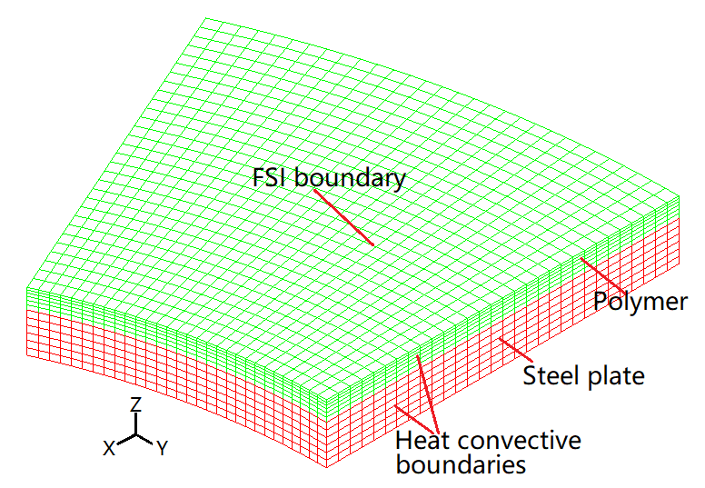
Fig.8 FEM model of the thrust pad

The restoring moment of rubber cushion under compression and inclination have been calculated separately and characterized in Eqs. (7) and (8), and they will be used directly in the convergence criterion of the pad equilibrium state. So the rubber cushion is not included in this FEM model.

The Reynolds equation, film thickness equation, energy equation and the viscosity-temperature equation of water film used in the FDM model are as Eqs. (9) ~(12), respectively:
(9)
(10)
(11)
(12)

The boundary condition of the Eq. (9) is that the water film pressure on the boundary is 0. In the Eq. (10), h_{p} is the film thickness at the virtual pivot, r_{p} is the radius at the virtual pivot; θ and θ_{e} are the pad angle and the angle of the virtual pivot in the circumferential direction, respectively. The boundary condition of the Eq. (11) is that the water film temperature at the inlet boundary is the same as the supply water temperature. In the Eq. (12), µ is the dynamic viscosity of water, Pas; the range of water film temperature T is 20 ~70 ℃, and a, b, c equals 1.39e-3, 32.84 and 2.438e-4, respectively.

The conditions for the pad to reach an equilibrium state in the TEHD performance calculation are in the Eq. (3). The F_{f}, M_{fx}, and M_{fy} produced by the water film pressure can be obtained by numerical integration. The M_{rx} and M_{ry} of the rubber cushion acting on the pad can be calculated based on Eq. (7) and (8). The convergence criteria of temperature, pressure, force, moment and deformation are as Eqs. (13) ~(18), respectively.

(13)
(14)
(15)
(16)
(17)
(18)

A flow chart of the TEHD calculation model is shown in Fig.9. The variation ranges of the tilting angles β and γ are pre-set in the FDM model. Their values are automatically renewed according to the simulation code. Only when the convergence criteria as Eqs. (13) ~(18) are satisfied simultaneously, the simulation results are considered acceptable.

Fig.9 Flow chart of the TEHD simulation model for the RWTBs.

3. The test rig and experimental procedure

A special test rig for investigating the lubrication performance of the RWTBs was designed, manufactured and assembled by the Wuhan University of Technology. The key aspects of the rig are presented in Fig. 10. It is composed of four main parts: a converter motor, a torque meter, a bearing test section and a loading device. The bearing test section is installed on the left side of the mounting plate, consisting of a thrust shaft, a thrust collar, a seal drum, a seal, a support ring, and several thrust pads, etc. The loading devices are installed on the right side of the mounting plate. It consists of a guide cylinder, a sliding sleeve, a rolling thrust bearing, a loading screw/nut/spring and a load cell, etc. The loading screw is screwed in the thread hole of the load cell. When loading, turn the loading nut in clockwise direction to tension the spring, then the load cell will be pulled by the loading screw, meanwhile, the axial force will be transmitted to thrust pads through the load cell, sliding sleeve, rolling thrust bearing, thrust shaft and thrust collar. The plum blossom coupling between the torque meter and the thrust shaft ensures that the thrust shaft moves freely in the axial direction and does not transmit axial force to the torque meter.
Fig. 10 A sectional view of the test rig

In order to verify whether the designed is in hydrodynamic lubrication regime as simulated based on the TEHD model and meet the practical requirements, a 200-hour durability test is launched. The specific pressure load and the rotation speed of the thrust collar is the same as in the TEHD simulation. The 200-hour test consist of three stages:
- 12 hours of the running-in test (load increased from 0 to 0.3MPa and speed increased from 100 r·min⁻¹ to 600 r·min⁻¹ gradually);
- 10 hours of performance test (load increased from 0.1 MPa to 0.5 MPa at an interval of 0.1 MPa, and speed increased from 100 r·min⁻¹ to 600 r·min⁻¹ under each load at 20 minutes interval);
- 178 hours of durability test (at a constant load of 0.5 MPa and speed of 600 r·min⁻¹).

The specific pressure load is calculated as Eq. (19):
(19)
Where p is the specific pressure; F is axial force measured by the load cell; p_{w} is cooling water pressure; S_{c} is the area encircled by the outer circle of thrust collar; n is the number of pads; S_{p} is the pad surface area. Filtered tap water (filtered by a 500 meshes gauze filter) was directly supplied to the seal drum with an inlet pressure of 4 kPa and temperature between 20 ~25 ℃.
4. Results and discussion
4.1 A case study of the RWTB
Based on the TEHD calculation model of the RWTBs proposed in this paper, a case study was carried out. The relevant parameters are set as follows: the offset ratios of the rubber cushion are E_{c}=0.579 and E_{r}=0.486, the load is 0.5 MPa, the rotation speed of the thrust collar is 600 r·min⁻¹ and the inlet water temperature is 25 ℃.

The film pressure, film temperature, film thickness and the deformation of the pad surface are shown in Fig.11. As can be seen from Fig.11 (d), there are two kinds of deformation on the pad surface: convex (positive values) and concave (negative values) deformation. The concave deformation is caused by the water film pressure while the convex deformation is caused by the pad temperature rise.

Fig.11 Calculation results of the RWTB based on the TEHD model (offset ratios of the rubber cushion E_{c}=0.579 and E_{r}=0.486, the rotation speed of 600 r·min⁻¹, load of 0.5 MPa, inlet water temperature of 25 ℃). (a) Film pressure distribution; (b) film temperature distribution; (c) film thickness distribution; (d) the deformation of pad surface.

There are three classical models for calculating hydrodynamic lubrication performance of thrust bearings: Hydrodynamic model (HD model), Thermo-Hydrodynamic model (THD model) and TEHD model (adopted in this paper). The HD model does not consider the viscous-temperature effect of lubricant and bearing deformation, while the THD model does not consider bearing deformation. In order to understand the influence of the deformation of the polymer material on the lubrication performance of the RWTB, the THD lubrication performance was also calculated and compared with the TEHD one. The THD model is simplified by setting the deformation δ in the TEHD model to 0. Comparisons of the calculated results at mean pad radius based on the two methods are shown in Fig.12. From Fig.12 (a) it can be seen that the maximum film pressure calculated by the TEHD model is lower than that calculated by the THD model. This is because in the high-pressure area the concave deformation increases the film thickness, so the pressure reduces. It further reduces the load carrying capacity of the water film. In order to balance the external load, the tilting angle of the pad needs to be adaptively changed and the film thickness needs to reduce to improve the loading capacity. Therefore, from Fig.12 (c) we can see that the film thickness calculated by the TEHD model is thinner than that of the THD model. The decrease of the overall film thickness distribution causes an increase of internal shear friction in the water film, further leading to an increase of temperature as shown in Fig.12 (b). The increase of water film temperature leads to the decrease of water viscosity, which is also one of the reasons for the decrease of water film thickness. Fig.12 (d) shows the variation of pad surface deformation. The negative values represent the concave deformation caused by film pressure and the positive values are convex deformation caused by temperature rise.
Fig.12 Comparison of calculated results at mean pad radius based on the TEHD and THD models. (a) Film pressure distribution; (b) Temperature distribution; (c) Film thickness distribution; (d) Pad surface deformation.

Comparisons of the calculated results along the x-axis of the pad surface in radial direction are shown in Fig.13. Those results show the effect of deformation on pressure, temperature, and film thickness in radial direction. From Fig.13 (c) it can be seen that the film thickness at the inner edge is thinner than that at the outer edge. This means that in the case of long-term testing, if the pad wears, the wear will start from the inner edge. This conclusion has been verified by the 200-hour experimental test.

Fig.13 Comparison of calculated results along x-axis (as shown in Fig.3) of the pad surface in radial direction based on the TEHD and THD models. (a) Film pressure distribution; (b) Temperature distribution; (c) Film thickness distribution; (d) Pad surface deformation.

Comparisons of the maximum pressure (p_{max}), the maximum temperature (T_{max}), the minimum film thickness (h_{min}) and the film thickness at virtual pivot (h_{p}) are listed in Table 2. The p_{max} calculated by the TEHD model is reduced 6.9% compared with that of the THD model, and the h_{min} also reduced 10.9%. The maximum concave and convex deformation is -0.21μm and 0.65μm respectively.

Table 2 Comparison of the results based on TEHD and THD model
Parameters | TEHD | THD | Difference
p_{max} / MPa | 1.08 | 1.16 | 6.9 %
T_{max} / ℃ | 27.71 | 27.06 | 2.4 %
h_{min} /µm | 3.77 | 4.23 | 10.9 %
h_{p} /µm | 5.96 | 6.76 | 11.8 %
δ_{max} /µm | -0.21/0.65 | 0 | ~

4.2 The experimental test results of a RWTB
The purpose of the experiment is to verify whether the RWTB is in hydrodynamic lubrication regime under the given load and speed conditions as simulated based on the TEHD model. In engineering, the ratio of the minimum film thickness to the roughness λ [39] is usually used to judge and characterize the lubrication regime of sliding bearings. The ratio is expressed as Eq. (20):
(20)
Where λ denotes the ratio of the minimum film thickness to roughness; h_{min} is the minimum film thickness; R_{q1} and R_{q2} are the RMS roughness of the thrust collar and the thrust pad. The criterion for judging the lubrication regime is as follows:

(1) When λ＞3, the bearing is in hydrodynamic lubrication regime;
(2) When 1≤ λ ≤3, the bearing is in mixed lubrication regime;
(3) When λ＜1, the bearing is in boundary lubrication regime.

In the experiment, the thrust collar is made of aluminum bronze ZCuAl9Mn4 with a RMS roughness about 0.2μm, and the polymer with a RMS roughness of 0.518μm. Based on the Eq. (20), when h_{min}＞1.67, the RWTB is in hydrodynamic lubrication regime. According to the TEHD simulation, the h_{min} is 3.77μm, which means the bearing is in hydrodynamic lubrication regime.

Measuring the film thickness is an important part of experimental research on thrust bearing. However, it is difficult to measure the film thickness of this kind of small bearing with polymer coated pad surface. On the one hand, the polymer material is not conductive, so the commonly used eddy current displacement sensor can not be used; on the other hand, if the sensor can be used and is installed on the thrust pad, the influence of the polymer deformations on film thickness can not be accurately measured. In addition, the dimensions of the thrust pad also limits the installation space of sensors. Therefore, the film thickness is not directly measured in the test. Instead, a 200-hour test (performance and durability) of the RWTB is carried according to the experimental procedure in section 3. The load, speed and offset ratios of the rubber cushion are same as the TEHD calculation. The inlet water temperature is between 20 ~25℃. According to the experimental phenomena and results, the lubrication regime can be predicted and it also can verify the feasibility of the TEHD model.

The friction coefficient and outlet water temperature rise, ΔT, where ΔT is the water temperature difference between inlet and outlet, are measured during the test. The friction coefficient is calculated based on Eq. (21):
(21)
Where f is the friction coefficient of bearing; M is friction torque measured during experiment; M₀ is friction torque of seals and guiding bearing in no-load state (the friction torque under no-load condition from 100 ~ 600 r·min⁻¹ was measured and acquired); r is the mean radius of the thrust pad (0.08 m in this paper).

The variation of the friction coefficient with respect to speed and load is shown in Fig.14 (a). It can be seen that the friction coefficient is larger at low speed (100 r·min⁻¹) condition, which is caused by contact friction. At heavy load 0.5 MPa, the friction coefficient reaches 0.1. The friction coefficient is relatively stable under different loads when the rotational speed increases from 200 r·min⁻¹ to 600 r·min⁻¹. Within this speed range, the friction coefficient decreases with the increase of load. Under the condition of 0.5 MPa load and 600 r·min⁻¹ speed, the friction coefficient is maintained at about 0.01. Under this testing condition, the test was continued (durable test) for an additional 178 hours (without interruption), and the variations of the friction coefficient and cooling water temperature rise were recorded, as shown in Fig.14 (b). The friction coefficient increases slowly from 0.01±0.0013 to 0.017±0.0009 before 100 hours, followed by a slight reduction to 0.015±0.0012 at 124 hours, and then fluctuated until the end of the experiment. ΔT decreases from 1.8 ℃ to 1.4 ℃ in the initial stage (60 hours), and then continues to increase to 4 ℃ with increased fluctuations at the end of the experiment. During the durable test, the friction torque M₀ of the lip seals and the guiding bearing may be different from the pre-measured value due to wear, which may affect the accuracy of the friction coefficient of the tested RWTB. However, due to the uninterrupted durable test, it is impossible to measure the M₀. Therefore, it is assumed that M₀ remains constant, which may make the friction coefficient of the tested RWTB smaller than the actual value. In fact, the variation of M₀ with speed was re-measured after the 200-hour test. Their values are slightly lower than their previous values measured at the beginning of the test under the corresponding speed condition.
Fig.14 The variation of the friction coefficient f and cooling water temperature rise ΔT during the test. (a) The variation of f with respect to speed and load in the performance test (10 hours); (b) The variation of f and ΔT during the durable test (178 hours)

The seal drum of the test rig and the surface profile of one thrust pad and the thrust collar are shown in Fig.15. The thrust pad shown in Fig.15 (b), after the 200-hour testing has visible scratches at the inner edge area. The wear area of the other three pads is very similar but the extent of wear varies slightly. Generally, the severity of wear increases gradually from the upper right corner to the lower left corner. The maximum depth of the scratch is about 50 μm. All of the pads are dried and weighed to measure their wear amount after the test (cleaned in distilled water and warmed for 24 hours in an 80ºC electric oven). The height reduction of each pad was also measured (the thickness near four vertices of each pad are measured before and after the test, and the average reduction of the pad thickness was calculated). The average mass loss and height reduction of the thrust pads is 29.6±0.1 mg and 42.4±10 µm, respectively. The thrust collar is shown in Fig.15 (c) and had wear scratches up to 33.8 μm deep. The lubricating water was filtered by a 500-mesh gauze filter with four layers of gauze and can be considered free of particulate impurities. Therefore, scratches indicate that partial contact occurred between the friction pairs during the test.
From the trend seen in the friction coefficient in Fig.14 (b) we can infer that the bearing is in a mixed lubrication regime during this test rather than a hydrodynamic lubrication regime. According to the wear condition of the pad in Fig.15 (b), the serious scratches appear near the inner edge of the pad surface, where the thinnest film thickness calculated by the TEHD model is also close to this region (the minimum film thickness is at the lower left corner of of the pad). This means that the water film is not enough to maintain a stable hydrodynamic lubrication state, but a mixed lubrication state when the minimum film thickness of the RWTB is in the order of 3μm. The test results also demonstrate that the polymer material used in this bearing cannot bear the 0.5 MPa load when the rotation speed of the thrust collar is 600 r·min⁻¹(Average linear velocity is 5 m·s⁻¹), or the offset position of rubber cushion needs to be optimized. In addition, there are many other factors can affect the experimental results, such as the installation tolerances of test rig, vibration, impurities in water, etc. The TEHD simulation is carried out under ideal conditions without considering roughness and the above-mentioned factors. The location of the scratches is close to the calculated minimum film thickness, which indirectly demonstrates that the calculated results based on the TEHD model have certain significance and can provide reference for design of RWTBs.
4.3 Optimization of the offset ratios E_{c} and E_{r} of the rubber cushion
Taking the minimum film thickness (h_{min}) as the objective parameter and the maximum value of it as the objective of optimization, the range of the optimum offset ratios E_{c} and E_{r} was solved. The THD model is used in the optimization calculation in this paper because it has higher computational efficiency. There are hundreds of calculating cases and large amount of calculation needed in optimization design. The TEHD model can be used to obtain a more accurate range of offset ratios based on the optimization results of the THD model with fewer calculating cases.

(c)
(a)
(b)
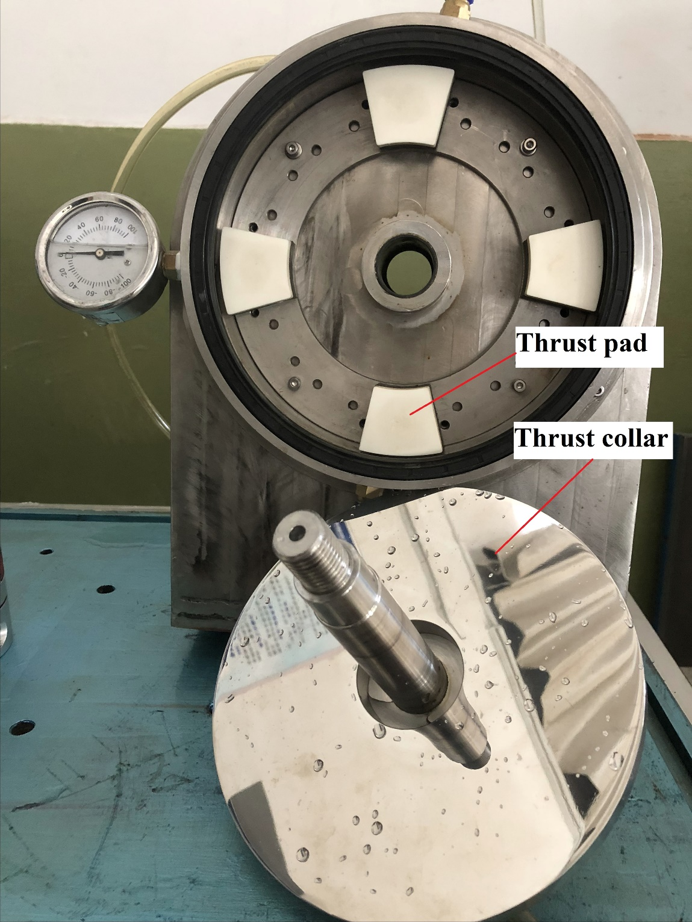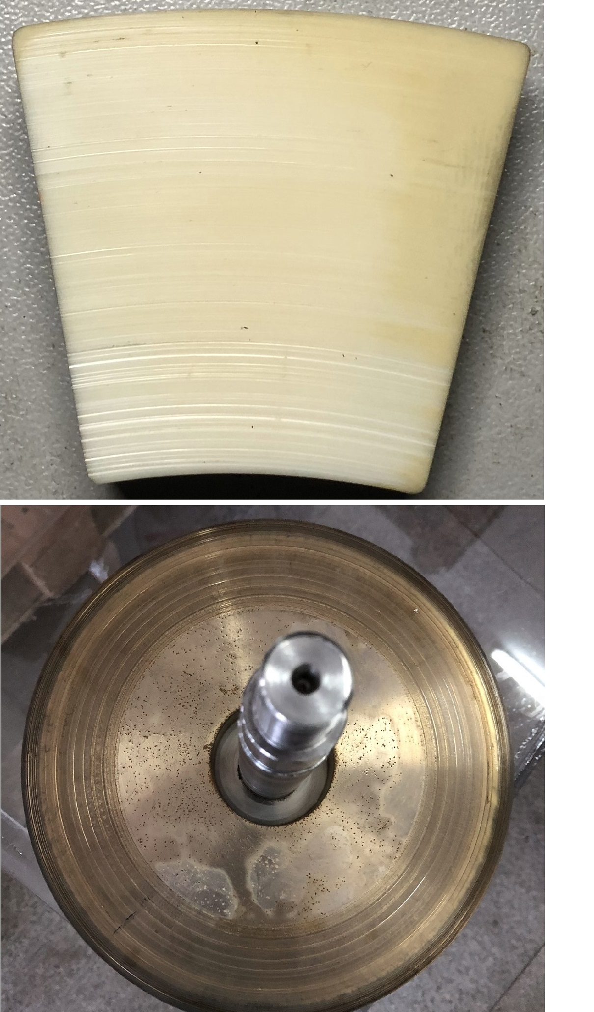
Fig.15 The thrust pad and the thrust collar. (a) The seal drum of the test rig with 4 thrust pads installed before test; (b) One of the thrust pad after 200-hour test; (c) The thrust collar after 200-hour test.

The optimum offset positions of the rubber cushion under 0.5 MPa load at the speed of 600 r·min⁻¹ are solved firstly. The variations of the h_{min} with E_{c} and E_{r} are shown with contour figure in Fig.16 (a). It illustrates that when the offset ratios range are 0.57 < E_{c} < 0.6, 0.49 < E_{r} < 0.5, the value of the h_{min} is around its maximum value; otherwise, it tends to decrease when the E_{c} and E_{r} are away from that range. The results also demonstrate that the radial offset value E_{r} of rubber pad is unreasonable in the previous test (the value of E_{r} is 0.486 in the test).

Fig.16 (b) shows the change trends of the maximum temperature (T_{max}) of the water film versus E_{c} and E_{r}. The T_{max} is decreased with increasing of E_{c} and decreasing of E_{r} simultaneously. Fig.16 (c) and (d) indicate the variations of the film thickness at the virtual pivot (h_{p}) and the mean film thick (h_{mean}) respectively. Both of them have similar change trends. Their values increase with the increase of the circumferential offset value E_{c} while are less affected by the E_{r}. The variation of T_{max}, h_{p}, and h_{mean} can also be referred for optimum design of E_{c} and E_{r}.
Fig.16 The variation of the minimum film thickness (h_{min}), maximum temperature (T_{max}), the film thickness at the virtual pivot (h_{p}) and the mean film thickness (h_{mean}) with offset ratios E_{c} and E_{r} under the load of 0.5 MPa and speed of 600 r·min⁻¹. (a) The minimum film thickness (h_{min}); (b) The maximum temperature (T_{max}); (c) The film thickness at the virtual pivot (h_{p}); (d) The mean film thickness (h_{mean})

In order to investigate whether the optimum E_{c} and E_{r} are related to the load, the variations of the h_{min} with the E_{c} and E_{r} under different loads are solved. Fig.17 (a) ~(c) show the variation of the h_{min} with the E_{c} and E_{r} values under 0.2, 0.3 and 0.4 MPa load at speed of 600 r·min⁻¹, respectively. These three graphs reveal very similar change trends of the h_{min} as that of 0.5 MPa load. This proves that the optimum E_{c} and E_{r} are independent of the load.
Fig.17 The variation of the minimum film thickness (h_{min}) with offset ratios (E_{c} and E_{r}) under different load at speed of 600 r·min⁻¹. (a) At load of 0.2 MPa; (b) At load of 0.3 MPa; (c) At load of 0.4 MPa;

Further verification of the optimal E_{c} and E_{r} is considered by introducing the concept of film thickness ratios, k_{c} and k_{r}. They are calculated as Eq. (22) and (23).
(22)
(23)
where h_{co} and h_{ci} are the film thickness at the outlet and the inlet along the rotating direction of the thrust collar. h_{ro} and h_{ri} are the film thickness at the outer edge and the inner edge of the pad along the x-axis. They are shown in Fig.18. Cameron [40] reports that for an inclined hydrodynamic thrust pad with a width to length ratio of 1 (i.e. of equal size in both the circumferential and radial directions), the optimum film thickness ratio (k_{c}) at which the load support is maximized for any given size, viscosity, entrainment speed or film thickness, lies between k_{c}=1.3 ~1.4. However, for k_{r}, there is no relevant literature to study its optimum range previously. It is defined and discussed in this paper.
Fig.18 Demonstrate of the tilting angle and film thickness of the thrust pad. (a) β, h_{co} and h_{ci} in circumferential direction; (b) γ, h_{ro} and h_{ri} in radial direction.

Fig.19 (a) shows the film thickness distributions along the y-axis under different load at speed of 600 r·min⁻¹. The offset ratios for these cases are E_{c}= 0.585 and E_{r}= 0.495, and the width to length ratio of the pad is 1.07 (the ratio of the arc length at the average radius of pad to the width). The figure illustrates that the circumferential inclination angle β of the pad decreases with the increase of load. If the film thickness values at both ends of the y-axis are taken as the film thickness at the inlet and outlet, then the film thickness ratio k_{c} for the different load can be calculated. From Fig.19 (a) it can be seen that with the load increases from 0.2 MPa to 0.5 MPa, k_{c} slightly increases from 1.29 to 1.31, which are near the optimal range of 1.3 ~1.4. This proves that the optimal offset value is desirable. The influence of rotational speed on k_{c} is also studied. Fig.19 (b) shows the film thickness distributions along the y-axis at different rotation speed under a constant load of 0.5 MPa. It can be seen that with the speed increases from 600 r·min⁻¹ to 1200 r·min⁻¹, the inclination angle β increases from 0.01° to 0.0141°, while k_{c} remains constant at 1.31. Fig.19 demonstrate that when the RWTB works with the rubber cushion at the optimal E_{c} and E_{r}, the film thickness ratio k_{c} will also be in the optimum range and its value is almost independent of speed and load. Fig.16 ~Fig.19 present that the optimum values of E_{c} and E_{r} are also independent of speed and load.
Fig.19 The film thickness distribution along the y-axis (as shown in Fig.3). (a) Under different loads at speed of 600 r·min⁻¹; (b) At different speeds under a constant load of 0.5 MPa.

In reference [40] the thickness ratio k_{r} was not studied since the pad was of rectangular shape and centrally supported in radial direction, so the tilting angle γ is 0. However, for a sector shape thrust pad in this paper, the tilting angle γ has influence on bearing performance. So the film thickness ratio parameter k_{r} is also defined and studied.

Fig.20 (a) shows the film thickness distributions along the x-axis under different load at speed of 600 r·min⁻¹. It illustrates that with the load increases from 0.2 MPa to 0.5 MPa, the radial inclination angle γ of the pad decreases while the film thickness ratio k_{r} keeps constant at 0.18. Fig.20 (b) shows the film thickness distributions along the y-axis at different rotation speed under a constant load of 0.5 MPa. It can be seen that with the speed increases from 600 r·min⁻¹ to 1200 r·min⁻¹, the inclination angle γ increases while k_{r} still remains constant at 0.18. Both figures demonstrate that the film thickness ratio k_{r} is also independent of speed and load. Since the E_{c} and E_{r} are the optimum ones in these cases, we can conclude that the film thickness ratio k_{r} also has an optimum range of values, and 0.18 is within this range.
Fig.20 The film thickness distribution along the x-axis (as shown in Fig.3). (a) Under different loads at speed of 600 r·min⁻¹; (b) At different speeds under a constant load of 0.5 MPa.

The relationships of the film thickness ratios k_{c} and k_{r} with the offset ratios E_{c} and E_{r} are also studied. As can be seen in Fig.21 (a), k_{c} is mainly influenced by the circumferential offset ratio E_{c}. Considering the optimum value range of k_{c} is 1.3 ~1.4, we can narrow the optimum value range of E_{c} to 0.585 ~0.59 (which is more precise than the previous value range of 0.57 < E_{c} <0.6). In Fig.21 (b), we can see that k_{r} is mainly affected by the radial offset ratio E_{r}. According to the optimum value range of E_{r} (0.49 ~0.50), the optimum range of k_{r} can be determined to be 0.13~0.22. This conclusion may also be applicable to pivot-supported tilting pad thrust bearings.
Fig.21 The variation of the film thickness ratio with offset ratios (E_{c} and E_{r}) under 0.5 MPa at speed of 600 r·min⁻¹. (a) The film thickness ratio k_{c}; (b) The film thickness ratio k_{r}. (Dash dot lines are the boundaries of the optimum range of k_{c} and k_{r})

5. Conclusions
In order to study the lubrication performance of RWTBs with polymer pad surface and optimize the offset ratios of the rubber cushion, a TEHD calculation model based on the combination of MATLAB and ADINA software is proposed and descripted in detail in this pater. A bearing test rig is designed and a 200-hour test is launched to verify whether the RWTB is in hydrodynamic lubrication regime as calculated based on the TEHD model. Taking the minimum film thickness as the objective parameter and the maximum value of it as the objective of optimization, the offset ratio of the rubber cushion is optimized. Some meaningful conclusions have been obtained.
(1). A virtual pivot is defined for a rubber-supported thrust pad, which is of great significance for subsequent analysis, such as the forces and moments analysis of the thrust pad, quantifying the offset ratios of the rubber cushion, etc. The results of this paper verified that the proposed TEHD model is an effective tool for calculating the lubrication performance and optimizing the rubber cushion’s offset ratios of RWTBs.
(2). For water-lubricated bearings with ‘soft’ materials such as polymer materials with relatively small elastic modulus and large thermal expansion coefficients, elastic deformation and thermal deformation are important factors affecting the lubrication performance, which should be considered in performance analysis. For the RWTH in this paper, there are concave and convex deformations on the pad surface. The concave deformation is caused by the hydrodynamic pressure of the water film, and the convex deformation is caused by the frictional heat. Under 0.5 MPa load, 600 r·min⁻¹ speed and with the rubber cushion’s offset ratios of 0.579 in circumferential and 0.486 in radial direction, the maximum concave and convex deformation is 0.21 μm and 0.65 μm, respectively, which is 5.57% and 17.5% of the minimum film thickness. The minimum film thickness is 3.77μm, which is 10.9% thinner than that calculated by THD model without considering the deformations. The minimum film thickness is located at the inner corner of the outlet of the thrust pad.
(3). After the 200-hour test, there are some visible scratches at the inner edge area of the pad surface. The maximum scratch depths on the pad surface and thrust collar are about 50 μm and 33.8 μm, respectively. The average mass loss and height reduction of the thrust pads is 29.6 mg and 42.4 µm, respectively. The test results demonstrate that the bearing is in mixed lubrication regime and the polymer material used in RWTBs cannot bear the 0.5 MPa load at speed of 600 r·min⁻¹. The location of the scratches is close to the calculated minimum film thickness, which indirectly demonstrates that the calculated results by the TEHD model have certain significance and can provide reference for design of RWTBs.
(4). The offset ratio of the rubber cushion has great influence on bearing performance. The optimum offset ratios of the rubber cushion are 0.585 ~0.59 in circumferential and 0.49 ~0.5 in radial direction. Beyond the optimum range, increasing or decreasing the offset ratio in any direction will result in a decrease of the minimum film thickness. The optimum offset ratio of the rubber cushion is independent of load and speed, but whether it is related to bearing size, thickness, shape and elastic modulus of the rubber cushion needs further study.
(5). The water film thickness ratio of thrust bearings is also one of the important parameters to judge the lubrication performance. In addition to the optimum film thickness ratio k_{c} in circumferential direction of 1.3 ~1.4, the film thickness ratio in radial direction, k_{r}, also has an optimum range of 0.13 ~0.22. When the rubber cushion is located in the optimum offset ratio ranges, the film thickness ratios k_{c} and k_{r} are also in their optimum ranges and vice versa. The optimum film thickness ratios in both directions are also independent of rotational speeds and loads.

Acknowledgments
This work was financially supported by the National Natural Science Foundation of China (Grant No. 51609191).

References
- Yan X, Liang X, Ouyang W, Liu Z, Liu B, Lan J. A review of progress and applications of ship shaft–less rim–driven thrusters. Ocean Engineering, 2017, 144: 142–156.
- Sun Y, Yan X, Yuan C, Bai X. Insight into tribological problems of green ship and corresponding research progresses. Friction, 2018, 6(4): 472–483.
- Wong J, Granick S. Open questions about polymer friction. Journal of Polymer Science Part B Polymer Physics, 2007, 45(24): 3237–3239.
- Dong C, Yuan C, Bai X, Qin H, Yan X. Investigating relationship between deformation behaviours and stick-slip phenomena of polymer material. Wear, 2017, 376: 1333-1338.
- Dong C, Yuan C, Bai X, Yang Y, Yan X. Study on wear behaviours for NBR/stainless steel under sand water-lubricated conditions. Wear, 2015, 332: 1012-1020.
- Wang H, Liu Z, Zou L, Yang J. Influence of both friction and wear on the vibration of marine water lubricated rubber bearing. Wear, 2017, 376-377: 920–930.
- You Z, Liu D, Geng Z, Cai W. Structure analysis of thrust bearing with rubber spring plate support in Xiluodu hydropower station. Water Power, 2013, 39 (8): 42–44.
- Pajaczkowski P. Simulation of transient states in large hydrodynamic thrust bearings. PhD Thesis, Gdansk University of Technology, Gdansk, Poland, 2010.
- Van Beck A, Segalt A. Rubber supported hydrostatic thrust bearings with rigid bearing surface. Tribology International, 1997, 30(1): 47–52.
- Van Beck A, Lepic L. Rubber supported hydrostatic thrust bearings with elastic bearing surfaces of infinite length. Wear, 1996, 201(1-2): 45–50.
- Van Ostayen R, Van Beek A, Ros M. A mathematical model of the hydro–support: an Elasto-hydrostatic thrust bearing with mixed lubrication. Tribology International, 2004, 37(8): 607–616.
- Liang X, Yan X, Liu Z, Ouyang W, Jin Y, Fu Y. Design and performance analysis of a water lubricated tilting pad thrust bearing. Journal of Traffic and Transportation Engineering, 2017, 17(4): 89–97.
- Wang X, Zhang Z, Zhang G. Improving the performance of spring–supported thrust bearing by controlling its deformations. Tribology International, 1999, 32(12): 713–720.
- Yuan J, Medley J, Ferguson J. Spring–supported thrust bearings used in hydroelectric generators: comparison of experimental data with numerical predictions. ASLE Transactions, 2001, 44(1): 27–34.
- Brown A, Ferguson J. Spring–supported thrust bearings used in hydroelectric generators: Finite element analysis of pad deflection. Tribology and Interface Engineering Series, 2001, 39(39): 99–110.
- Inoue K, Deguchi K, Okude K, Fujimoto R. Development of the water–lubricated thrust bearing of the hydraulic turbine generator. 2012 IOP Conf. Ser.: Earth Environ. Sci. 15 072022.
- Dadouche A, Fillon M, Bligoud J. Experiments on thermal effects in a hydrodynamic thrust bearing. Tribology International, 2000, 33(3): 167–174.
- Neal P. Heat transfer in pad thrust bearings. Proc. Ins. Mech. Eng., 1982, 196(1): 217–228.
- Glavatskih S, Fillon M. TEHD analysis of thrust bearings with PTFE-faced pads. Journal of Tribology, 2006, 128(1): 49–58.
- Vijayaraghavan D, Brewe D. Effect of rate of viscosity variation on the performance of journal bearings. ASME J. Tribol., 1998, 120: 1–7.
- Glavatskih S, Fillon M, Larsson R. The significance of oil thermal properties on the performance of a tilting-pad thrust bearing. Journal of Tribology, 2002, 124(2): 377–385.
- Ettles C, Knox R, Ferguson J, Horner D. Test results for PTFE–faced thrust pads, with direct comparison against babbitt–faced pads and correlation with analysis. ASME. J. Tribol. 2003, 125(4): 814–823.
- Dabrowski L, Pajaczkowski P, Rotta G, Wasilczuka M, Wodtke M. Improving performance of large thrust bearings through modeling and experimentation. Mechanics & Industry, 2013, 14(4): 267–274.
- Wodtke M, Fillon M, Schubert A, Wasilczuk M. Study of the influence of heat convection coefficient on predicted performance of a large tilting-pad thrust bearing. Journal of Tribology, 2013, 135(2): 021702-1-11.
- Heinrichson N, Santos I, Fuerst A. the influence of injection pockets on the performance of tilting-pad thrust bearings—part I: Theory. ASME J. Tribol., 2007, 129(4): 895–903.
- Jiang X, Wang J, Fang J. Thermal Elastohydrodynamic lubrication analysis of tilting pad thrust bearings. Proc. IMechE, Part J: J. Engineering Tribology, 2011, 225: 51–57.
- Markin D, McCarthy D, Glavatskih S. A FEM approach to simulation of tilting–pad thrust bearing assemblies. Tribology International, 2003, 36: 807–814
- Huang B, Wu Z, Wu J, Wang L. Numerical and experimental research of bidirectional thrust bearings used in pump-turbines. Proc Inst Mech Eng, Part J: J Eng Tribol 2012; 226: 795–806.
- Wodtke M, Schubert A, Fillon M, Wasilczuk M, & Pajaczkowski P. Large hydrodynamic thrust bearing: Comparison of the calculations and measurements. Proc. IMechE, Part J: J. Engineering Tribology, 2014, 228(9): 974–983.
- Fillon M, Wodtke M, Wasilczuk M. Effect of presence of lifting pocket on the THD performance of a large tilting–pad thrust bearing. Friction, 2015, 3(4): 266–274.
- Zhai L, Luo Y, Liu X, Chen F, Xiao Y, Wang Z. Numerical simulations for the fluid–thermal–structural interaction lubrication in a tilting pad thrust bearing. Engineering Computations, 2017, 34(4): 1149–1165.
- Hemmi M, Hagiya K, Ichisawa K, Fujita S. Computation of thermal deformation of thrust bearing pad concerning the convection by non–uniform oil flow. ASME World Tribology Congress III–Washington, D.C. USA (Sep.12–16, 2005), 2005: 61–62.
- Pajaczkowski P, Schubert A, Wasilczuk M, Wodtke M. Simulation of large thrust–bearing performance at transient states, warm and cold start–up. Proc. IMechE, Part J: J. Engineering Tribology, 2014, 228(1): 96–103.
- Wodtke M, Olszewski A, Wasilczuk M. Application of the fluid–structure interaction technique for the analysis of hydrodynamic lubrication problems. Proc. IMechE, Part J: J. Engineering Tribology, 2013, 227(8): 888–897.
- Zouzoulas V, Papadopoulos C. 3-D Thermohydrodynamic analysis of textured, grooved, pocketed and hydrophobic pivoted–pad thrust bearings. Tribology International, 2017, 110: 426–440.
- Fouflias D, Charitopoulos A, Papadopoulos C, Kaiktsis L Thermohydrodynamic analysis and tribological optimization of a curved pocket thrust bearing. Tribology International, 2017, 110: 291–306.
- Lin X, Jiang S, Zhang C, Liu X, Thermohydrodynamic analysis of high speed water–lubricated spiral groove thrust bearing considering effects of cavitation, inertia and turbulence. Tribology International, 2018, 119: 645–658.
- ADINA R&D, Inc.: Theory and modelling guide volume III: ADINA CFD & FSI, 2013.
- Wellauer E, Holloway G. Application of EHD oil film theory to industrial gear drives. Journal of Engineering for Industry, 1976, 98(2): 626-631.
- Cameron A. Basic lubrication theory. Longman, Harlow, UK, 1971.

Nomenclature |  | M_{f}, M_{r} | Moments of water film pressure and the rubber cushion acting on the thrust pad (N/m)
 |  | M_{fl}, M_{fr} | Moments of water film pressure acting on both sides of the pivot (N/m)
B_{e} | Radial offset value of rubber cushion (mm) | M_{fx}, M_{fy} | Moments of water film pressure acting on the thrust pad along x and y axes (N/m)
B_{p} | The width of the thrust pad (mm) | M_{rx}, M_{ry} | Moments of the rubber cushion acting on the thrust pad along x and y axes (N/m)
c_{v} | Specific heat capacity of water (J/( kg· K)) | n | Number of thrust pads
d_{r} | Compression of the rubber cushion (mm) | p | Water film pressure (Pa)
d_{rw}, d_{rd} | Compression of the rubber cushion in wet and dry condition (mm) | p_{w} | Inlet water pressure (Pa)
E_{c} | Circumferential offset ratio of rubber cushion | R_{q1}, R_{q2} | Roughness of thrust pads and the thrust collar (µm)
E_{r} | Radial offset ratio of rubber cushion | S_{c} | The outer circle area of the thrust collar (m²)
F | Force (N) | S_{p} | The pad surface area (m²)
F_{f} | the integrated force of water film (N) | T | Temperature (ºC)
F_{p} | the support force of the pivot (N) | v | Speed (m/s)
F_{r} | the support force of the rubber cushion (N)
h | Film thickness (µm) | β | Tilting angle of thrust pad along x-axis (rad)
h_{min} | The minimum film thickness (µm) | γ | Tilting angle of thrust pad along y-axis (rad)
h_{mean} | The mean film thickness (µm) | δ | Deformation of the pad surface (µm)
h_{p} | The film thickness at the pivot position (µm) | λ | Film thickness to roughness ratio
h_{ci}, h_{co} | Inlet and outlet film thickness along y-axis (µm) | µ | Viscosity of water (Pas)
h_{ri}, h_{ro} | Inlet and outlet film thickness along x-axis (µm) | θ_{e} | Circumferential offset value of the rubber cushion (º)
k_{c}, k_{r} | Film thickness ratios | θ_{p} | The thrust pad angle (º)

