[Please make your further revisions on the changes-accepted version.
Please check all the editor’s modifications and pay special attention to the yellow-highlighted editor’s modifications.
Please check all the blue-highlighted words or sentences that seem to need revision or your explanation.]
--------------------------------------------------------------------------------
Running Title of first page: Pedosphere 29(??): ???--???, 2019
doi:10.1016/S1002-0160(19)60823-4
ISSN 1002-0160/CN 32-1315/P
© 2019 Soil Science Society of China
Published by Elsevier B.V. and Science Press

Running Title of even pages: M. HERNÁNDEZ et al.
Running Title of odd pages: MICROBIAL COMMUNITIES IN VOLCANIC SOILS

Analysis of the Microbial Communities in Soils of Different Ages Following Volcanic Eruptions

Marcela HERNÁNDEZ^{1,}∗, Marcela CALABI², Ralf CONRAD¹ and Marc G. DUMONT³

¹Max Planck Institute for Terrestrial Microbiology, Karl-von-Frisch-Str. 10, Marburg 35043 (Germany)
²Scientific and Technological Bioresource Nucleus, Universidad de La Frontera, Temuco ???[zip code please-] (Chile)
³School of Biological Sciences, University of Southampton, Southampton SO17 1BJ (UK)

(Received , 2019; revised , 2019)

ABSTRACT

Volcanism is a primary process of land formation. It provides a model for understanding soil-forming processes and the role of pioneer bacteria and/or archaea as early colonizers in those new environments. The objective of this study was to identify the microbial communities involved in soil formation. DNA was extracted from soil samples from the Llaima volcano in Chile at sites destroyed by lava in different centuries (1640, 1751, and 1957). Bacterial and archaeal 16S rRNA genes were analyzed using quantitative polymerase chain reaction (qPCR) and Illumina MiSeq sequencing. Results showed that microbial diversity increased with soil age, particularly between the 1751 and 1640 soils. For archaeal communities, Thaumarchaeota was detected in similar abundances in all soils, but Euryarchaeota was rare in the older soils. The analysis of bacterial 16S rRNA genes showed high abundances of Chloroflexi (37%), Planctomycetes (18%), and Verrucomicrobia (10%) in the youngest soil. Proteobacteria and Acidobacteria were highly abundant in the older soils (16% in 1640 and 15% in 1751 for Acidobacteria; 38% in 1640 and 27% in 1751 for Proteobacteria). The microbial profiles in the youngest soils were unusual, with a high abundance of bacteria belonging to the order Ktedonobacterales (Chloroflexi) in the 1957 soil (37%) compared with the 1751 (18%) and 1640 soils (7%). In this study, we show that there is a gradual establishment of the microbial community in volcanic soils following an eruption and that specific microbial groups can colonize during the early stages of recovery.

Key Words: 16S rRNA gene, extreme environment, high-throughput sequencing, Ktedonobacterales, microbial diversity, pioneer microbe, recolonization, soil formation, volcanic deposit

Citation: Hernández M, Calabi M, Conrad R, Dumont M G. 2019. Analysis of the microbial communities in soils of different ages following volcanic eruptions. Pedosphere. 29(?): ???--???.

INTRODUCTION

Volcanic eruptions provide a model for understanding soil-forming processes, including microbiological components. After lava solidifies, microbes begin colonizing the rock surface, presumably by photosynthesis or from the chemical energy in reduced gases such as methane (CH₄), hydrogen sulfide (H₂S), hydrogen (H₂), and carbon monoxide (CO). A number of studies have shown that microorganisms are among the first colonizers on volcanic deposits, contributing to early ecosystem development (King, 2003a; Ohta et al., 2003; Sato et al., 2004; Gomez-Alvarez et al., 2007; Fujimura et al., 2012; Guo et al., 2014; Kim et al., 2018). As volcanic environments are widely distributed on Earth (Cockell et al., 2011), it is important to understand the microbial communities that play important roles in colonizing these extreme environments. Volcanic environments can be used as models to understand the pioneer colonizing species.
The pioneer microbes colonizing early volcanic deposits include those able to fix nitrogen (N) and carbon (C) from the atmosphere and contribute to the organic matter addition into the deposits (Crews et al., 2000; Kurina and Vitousek, 2001; Dunfield and King, 2004; Sato et al., 2006; King and Weber, 2008; King et al., 2008; Sato et al., 2009; Weber and King, 2010b, 2017; King and King, 2014). Previous studies have shown that the class Ktedonobacteria, which belongs to the phylum Chloroflexi, is predominant in non-vegetated volcanic soils (Gomez-Alvarez et al., 2007; Weber and King, 2010b), while Proteobacteria dominate vegetated sites (Weber and King, 2010b). Some of these Ktdenobacteria, among other microbial groups, have been associated with CO and H₂ consumption in both young, organic matter-poor volcanic deposits, and older (more mature) deposits with well-developed plant communities (King, 2003a; King and Weber, 2008; Weber and King, 2010b).
The colonization of volcanic deposits by plants also plays an important role in soil formation, as their roots enhance rock weathering and plant material contributes to soil organic matter accumulation. Some studies have shown that relatively young volcanic deposits harbor distinct microbial communities when plants are present (Ohta et al., 2003; Dunfield and King, 2004; Guo et al., 2014). The interaction, and potential co-dependence, of plants and microbes in volcanic soils has not been specifically investigated, but plant diversity is known to affect microbial diversity, function, and soil carbon accumulation (Leff et al., 2018). The soil community, including bacteria, fungi, and invertebrates, is also important for the establishment and growth of plants (Philippot et al., 2013; Lange et al., 2015; Wubs et al., 2016). These types of interactions have been demonstrated in some mature soils but have not been investigated in the early stages of soil formation, for example in volcanic soils.
The Llaima volcano is one of the largest and most active volcanoes in Chile. It has had three detailed lava eruptions at different sites of the volcano and plants have colonized these zones. The 1640 and 1751 lava flow sites are now mostly colonized by understory. In contrast, only 5% of the soil sites from the 1957 eruption have been colonized by lichens and consist of soil in the early stage of formation (Fig. S1) (Hernández et al., 2014). These sites have very low levels of organic matter (especially sites 1640 and 1751), C/N ratios, and phosphorus (P) (Hernández et al., 2014).
Previously, we sampled soils from the Llaima volcano at sites destroyed by lava in different centuries (1640, 1751, and 1957). We hypothesized that autotrophic microorganisms were important in soil formation and indeed found large numbers and high activities of autotrophic ammonia-oxidizing bacteria and archaea in those soils, the values being particularly high in young soils (Hernández et al., 2014). In the present study, we aim to evaluate the structure of the total microbial community composition at these three sites with different defined age and soil characteristics, to obtain information regarding recolonization by bacteria and archaea after a lava event.

MATERIAL AND METHODS

DNA extraction and quantitative polymerase chain reaction (qPCR)

DNA was extracted from soil samples from the Llaima volcano (38.697407° S, 71.730445° W) in Chile. Sampling and DNA extraction have been previously described (Hernández et al., 2014). Briefly, samples were taken from three sites according to lava eruptions (Naranjo and Moreno, 2005), named 1640, 1751, and 1957 (Fig. S1), in February 2011. Samples were taken using a triangle pattern (Gomez-Alvarez et al., 2007) and triplicates were taken at each point, with a total of nine replicates per site. All soil samples were stored in polyethylene bags at 4 °C until their transport to Germany. The abundance of bacterial and archaeal 16S rRNA genes was determined by qPCR using an iCycler instrument (BioRad, Germanycountry here please]). For all assays, standards containing a known number of DNA copies of the target gene were used. The qPCR conditions were based on dual-labeled probes described by Yu et al. (2005). Primer sets Bac338F/Bac805R/Bac516P and Arc787F/Arc1059R/Arc915P were used for bacterial- and archaeal-16S rRNA genes, respectively. The conditions for both runs were as follows: 0.5 μmol L⁻¹ of each primer, 0.2 μmol L⁻¹ of the dual-labeled probe, 3 µL template, 4 mmol L⁻¹ MgCl₂ (Sigma-Aldrich, Germanycountry here please]), and 12.5 µL of JumpStart Ready Mix (Sigma-Aldrich, Germanycountry here please]). Also, 1 µL bovine serum albumin (BSA) (0.8 µg µL⁻¹) was added to archaeal 16S rRNA gene reactions. The program used for both assays: 94 °C for 5 min, 35 cycles of 95 °C for 30 s and 62 °C for 60 s, extension, and signal reading. Efficiencies of 91.2% and R² of 0.994 for bacterial 16S rRNA genes and 93.1% and R² of 0.994 for archaeal 16S rRNA genes were obtained.

Illumina library preparation and sequencing

MySeq Illumina sequencing was performed for the total bacterial 16S rRNA gene. The PCR primers 515F/806R were used (Bates et al., 2011). The PCR conditions for bacterial 16S rRNA gene amplification were as follows: 94 °C for 5 min, followed by 28 cycles of 94 °C for 30 s, 50 °C for 30 s, and 68 °C for 30 s, and a final elongation at 68 °C for 10 min (Hernández et al., 2015). Individual PCRs contained a 6-bp molecular barcode integrated into the forward primer. Amplicons were purified using a PCR cleanup kit (Sigma-Aldrich, Germany[country here please]) and quantified using a Qubit 2.0 fluorometer (Invitrogen, Germanycountry here please]). Equimolar concentrations of the samples were pooled and sequenced on MiSeq using a 2 × 300 bp paired-end protocol. Library preparation and sequencing was performed at the Max Planck Genome Centre, Cologne, Germany.

Bioinformatics and data processing

Quality filtering and trimming forward and reverse adaptors from the sequences were carried out using cutadapt (Martin, 2011). Forward and reverse reads were merged using the usearch fastq_mergepairs command (Edgar, 2013). The downstream processing was performed using UPARSE (Edgar, 2013) and UCHIME pipelines (Edgar et al., 2011), following the steps detailed in Reim et al. (2017).

Taxonomy analysis and data accession

A representative sequence of each operational taxonomic unit (OTU) was classified with the naïve Bayesian classifier using the SILVA-132 16S rRNA gene database (bootstrap confidence threshold of 80%) in mothur (Schloss et al., 2009). Sequence data were deposited in the National Center for Biotechnology Information (NCBI) Sequence Read Archive (SRA) under the accession number PRJNA496066.

Statistical analyses

Multivariate statistics for bacterial 16S rRNA Illumina data was mostly performed with phyloseq (McMurdie and Holmes, 2013) and vegan (Oksanen et al., 2018) packages in R software version 3.5.1. Alpha diversity indexes were determined using the estimate_richness command in the phyloseq package. Evenness indexes were determined using the vegan package. The relative abundance was calculated by removing taxa not seen more than three times in at least 20% of the samples by using the filter_taxa command, and figures were constructed using the ggplot2 package (Wickham, 2016). For beta diversity analyses, non-metric multidimensional scaling (NMDS) analysis was carried out using the decostand function for the ordination of Hellinger distances in the vegan package. Heatmaps were constructed with the gplots (Warnes et al., 2016), vegetarian (Charney and Record, 2012), and vegan (Oksanen et al., 2018) packages. Principal components analysis (PCA) of the Hellinger transformed data was performed using the prcomp function. The OTUs explaining most of the differences between samples were defined as the 20 OTUs contributing to the largest absolute loadings in the first and second dimensions of the PCA, obtained from the rotation output file (Hernández et al., 2017). Hierarchical clustering of the distance matrix used the “ward.D2” method and was performed with the hclust function. The heatmap was constructed using the heatmap.2 function in the gplots package.

RESULTS

Microbial abundance

The abundance of bacterial 16S rRNA genes was higher than that of archaeal 16S rRNA genes (Fig. 1). Copy numbers of bacterial 16S rRNA genes were in the range of 10⁸ copies per gram of soil for all three sites, and no significant differences were found between the sites (P = 0.184). Copy numbers of archaeal 16S rRNA genes were in the range of 10⁶ copies per gram of soil in site 1957 and 10⁵ copies per gram of soil in the sites 1640 and 1751, and no significant differences were found between the sites (P = 0.479).

Fig. 1
Fig. 1 Copy numbers of bacterial and archaeal 16S rRNA genes in three soils (1640, 1751, and 1957) sampled from the Llaima volcano in Chile at three sites according to lava eruptions in different centuries. The error bars are standard deviations (n = 9).

Diversity of bacterial communities

Overall, significant differences were found between soils for all the diversity indexes, i.e., observed species, and Shannon and evenness indexes (P < 0.01). Tukey post hoc tests indicated that the youngest soil (1957) is significantly different when compared with the other soils (Table S1). On average, the observed species were 7 575 OTUs for site 1640, 7 116 for site 1751, and 4 593 for site 1957 (Fig. S2a and Table S1). The Shannon diversity indexes were between 5.21 (youngest soil: 1957) and 6.99 (older soils: 1640 and 1751) (Fig. S2b and Table S1). Species evenness had the same behavior as the Shannon indexes, being higher in the older sites (0.71 in site 1640 and 0.76 in site 1751) than in the newest site 1957 (0.62) (Fig. S2c and Table S1).
For beta diversity, NMDS analysis showed that the composition of the bacterial 16S rRNA genes changed across soil age (P < 0.05) (Fig. 2). The youngest soils (1957) clustered separately from the two older soils (1640 and 1751) (Fig. 2).

Fig. 2
Fig. 2 Non-metric multidimensional scaling (NMDS) analysis of bacterial community structure in the three soils (1640, 1751, and 1957) sampled from the Llaima volcano in Chile at three sites according to lava eruptions in different centuries.

Diversity of archaeal communities

Significant differences were found only for observed species (P < 0.01) between soils. Tukey post hoc tests indicated that the youngest soil (1957) was significantly different when compared with the other soils (Table S2). On average, the observed species were 17 OTUs for site 1640, 15 for site 1751, and 5 for site 1957. The Shannon and evenness diversities did not change significantly between soil ages (Table S2).

Analysis of microbial communities

The archaeal community encompassed mostly the phylum Thaumarchaeota in all the sites, with relative abundances of 82.6%, 95.8%, and 97.7% for the sites 1640, 1751, and 1957, respectively. Site 1640 had the highest abundance of the phylum Euryarchaeota (16.4%) (data not shown). Within the archaeal classes, Nitrososphaera and soil group 1.1c mainly dominated sites 1751 and 1957, but was also found in site 1640 (Fig. S3). A higher relative abundance of the class Thermoplasmata was found in site 1640 (12.6%) than in the other sites (2.4% in 1751 and 0.4% in 1957) (Fig. S3).
The bacterial community at the different sites included Acidobacteria, Actinobacteria, Chloroflexi, Planctomycetes, Proteobacteria, and Verrucomicrobia (Fig. 3). Site 1640 had a high relative abundance of Acidobacteria (16.2%), Actinobacteria (11.4%), Planctomycetes (12.4%), and Proteobacteria (38.5%). The relative abundances of the phyla Acidobacteria, Actinobacteria, and Planctomycetes were similar in the sites 1751 and 1640 (15.4%, 11.7%, and 13.2%, respectively).. For site 1751, high abundance of Chloroflexi (18.0%) and lower abundance of Proteobacteria (27.4%) were recorded when compared with site 1640. On the other hand, site 1957 had the highest relative abundance of the phyla Chloroflexi (37.8%), Planctomycetes (18.3%), and Verrucomicrobia (10.7%). Within the phylum Chloroflexi, abundance of the class Ktedonobacteria was higher in site 1957 (97.0%) than in the other sites (23.9% in 1640 and 55.9% in 1751) (Fig. 4).

Fig. 3
Fig. 3 Mean relative abundances of bacterial phyla based on bacterial 16S rRNA genes in the three soils (1640, 1751, and 1957) sampled from the Llaima volcano in Chile at three sites according to lava eruptions in different centuries. Taxa not seen more than three times in at least 20% of the samples were removed using the phyloseq package in R.

Fig. 4
Fig. 4 Mean relative abundances of classes from the phylum Chloroflexi in the three soils (1640, 1751, and 1957) sampled from the Llaima volcano in Chile at three sites according to lava eruptions in different centuries.. Taxa not seen more than three times in at least 20% of the samples were removed using the phyloseq package in R.

Phylogenetic analysis of bacterial communities

Clustering analyses show distinct differences in bacterial 16S rRNA genes among the sites, with fewer differences between the older soils (1640 and 1751) (Fig. 5). Many OTUs were highly abundant in the youngest soil (site 1957) and belong mostly to the family Ktedonobacteraceae in the phylum Chloroflexi (specially OTU-62, OTU-176, OTU-370, OTU-478, OTU-84, OTU-549, OTU-385, and OTU-697), and two genera from the phylum Acidobacteria: Bryobacter (OTU-175) and Acidipila (OTU-893).

Fig. 5
Fig. 5 Heatmap showing the relative abundance of the most relevant operational taxonomic units (OTUs) derived from bacteria in the three soils (1640, 1751, and 1957) sampled from the Llaima volcano in Chile at three sites according to lava eruptions in different centuries. The samples and OTUs were clustered according to Euclidean distances between all Hellinger transformed data.

Several OTUs belonging to Ktedonobacteraceae (OTU-597, OTU-2070, OTU-697, OTU-2608, OTU-6103, OTU-352, OTU-3584, OTU-5162154, and OTU-1418) were also abundant in the soil 1751. The site 1751 also had a high abundance of Actinobacteria. The heatmap also shows that some OTUs were abundant in all the soils, especially OTUs belonging to the phylum Proteobacteria, such as OTU-150 which belongs to Xanthobacteracea (Alphaproteobacteria). Proteobacteria was, in general, more abundant in the old site 1640. Finally, we also identified OTUs belonging to the phylum Verrumomicrobia, which were abundant in all the sites (Fig. 5).

DISCUSSION

Microbial abundance in volcanic soils

Soil coverage differed at each of the study sites, which is consistent with the difference in microbial diversity observed in each of the soils. The youngest soil (1957) accumulated mostly between rocks and was covered by moss. In contrast, the oldest soil was more extensive and colonized by trees (Hernández et al., 2014). Despite these differences, the absolute abundance of bacterial 16S rRNA genes was constant across the samples of different ages, suggesting that the abundance of bacteria was high even in the youngest soil. The bacterial 16S rRNA abundance in the range of 10⁸ copies per gram of soil (Fig. 1) is similar to earlier studies from volcanic deposits. Weber and King (2010a) reported 2.6 × 10⁸ bacterial 16S rRNA gene copy number per gram of dry soil in unvegetated patches on a 1959 Hawaiian volcanic deposits in the Kilauea volcano. In another study, by doing total direct microscopic counts of bacteria, abundances of bacteria in the range of (1--4) × 10⁸ cells per gram of dry soil were found at volcanic deposits in Miyake-jima volcano in Japan, which was affected by a lava eruption in the year 2000 (Guo et al., 2014). Similar cell numbers (in the range 10⁷--10⁸) were found in poorly to fully vegetated volcanic deposits of different ages (32-, 35-, and 39-year old) in Iceland (Byloos et al., 2018).
In contrast to bacteria, the archaeal 16S rRNA genes decreased with soil age (Fig. 1). Very little is known about the colonization of volcanic deposits by archaea. The majority of the sequences belonged to the Thaumarchaeota. Nitrosphaera were the dominant Thaumarchaeota in our soil samples and were most abundant in the youngest soil. These organisms are able to grow autotrophically by ammonia oxidation, suggesting that this process is important in the early formation of volcanic soils (Hernández et al., 2014). This is consistent with a previous study on lava-formed forest soils in Korea, where archaeal clones affiliated to the Thaumarchaeota group were more abundant (96.2%) than the clones affiliated to the Euryarchaeota group (3.8%) (Kim et al., 2014). The oldest soil (1640) had a higher relative abundance of Euryarchaeota, particularly the Thermoplasmatales (between 3%--30% of archaeal 16S rRNA genes, Fig. S3). Whereas methanogenic members of the Euryarchaeota are abundant in wetland soil (Reim et al., 2017), the Thermoplasmatales have been previously reported in upland soils (Kemnitz et al., 2007; Hu et al., 2013, Hernández et al., 2017). Most characterized Thermoplasmata are acidophilic and/or thermophilic (Golyshina et al., 2016). However, those in upland soils are poorly characterized and we assumed them to be mesophilic.

Diversity of bacterial microbial communities

Higher numbers of OTUs were present in the older soils than in the 1957 soil (Fig. S2a). In general, Shannon diversity and evenness indexes were higher at older sites (1640 and 1751) (Fig. S2b and c). The results presented here support those already published, indicating that as the soil recovers, diversity increases. A study by King (2003a) indicated that the diversity of substrates utilized in Biolog plate assays increased with soil age in Hawaiian volcanic deposits (18--300 years old), indicating changes in the microbial communities. Analyzing the same deposits, Gomez-Alvarez and colleagues (2007) showed that the diversity is higher in older, moderately vegetated deposits (Shannon index H = 3.87 in site 1790) than in the youngest soil (Shannon index H = 2.62 in site 1921). The diversity indexes calculated in our study in the Llaima volcano are higher than those in the Kilauea volcano; however, it is important to note that the results of Gomez-Alvarez and colleagues (2007) were from cloning-based analyses and thus sampling intensity was lower. The diversity in the vegetated areas of the Llaima volcano (in sites 1640 and 1751) (Fig. S2b and Table S1) is also higher than those in lava-formed Gotjawal forest soils in South Korea (Kim et al., 2018), in which the authors found indexes below 5.5 for bacterial 16S rRNA genes based on Illumina sequencing analyses. The diversity was also higher than in vegetated areas from Iceland volcanic deposits, in which diversity increased as the area became fully vegetated (Byloos et al., 2018). The microbial communities in the vegetated areas (sites 1640 and 1751) clustered together, and in a separate cluster we can identify members of the unvegetated site (1957) (Fig. 2). This is corroborated by the diversity indexes being similar for the vegetated areas.

Phylogenetic analysis of bacterial communities

The abundance of Acidobacteria, Actinobacteria, and Proteobacteria increased with soil age (Fig. 3). Our study found that Acidobacteria and Actinobacteria are stable in the vegetated sites 1640 and 1751. Acidobacteria and Actinobacteria, among others, have been found to be abundant in soils from the Kilauea volcano (Gomez-Alvarez et al., 2007). Actinobacteria has been identified as an abundant phylum from Icelandic volcanic rocks of different compositions (Cockell et al., 2013). Within the Proteobacteria, a study looking at microbial communities from lava-formed Gotjawal forest soils in South Korea indicated that members of the class Rhizobiales are abundant in these sites (Kim et al., 2015). Proteobacteria was also found to be the most abundant phylum in young deposits of volcanic ash from Miyake-jima in Japan (Guo et al., 2014), from Icelandic volcanic deposits of different ages and vegetation (Byloos et al., 2018), and from vegetated deposits from the Kilauea volcano (Weber and King, 2010b). In our study, within Alphaproteobacteria, the abundance of Rhizobiales was high in the vegetated old sites compared with the youngest soil (Fig. S4). Members of the class Rhizobiales, known for their ability to fix N among other traits, have been identified in old volcanic deposits in the Kilauea Volcano (Nüsslein and Tiedje, 1998).

Ecological significance

Carbon monoxide-oxidizers, and N₂- and H₂-fixers are present in volcanic deposits of different ages and vegetation conditions. For example, coxL genes, which encode the large subunit of CO dehydrogenase (CODH), were found in members of Proteobacteria in vegetated sites in the Kilauea (Gomez-Alvarez et al., 2007; Weber and King, 2010b) and Miyake-jima volcanoes (King et al., 2008). Burkholderia, Paraburkholderia (Weber and King, 2017), Stenotrophomonas, and Pseudomonas among others encode coxL genes associated with the CODH enzyme responsible for CO-oxidation (King, 2003b). Hydrogen-oxidizing members of Proteobacteria were isolated from volcanic mudflow deposits from Mt. Pinatubo, Philippines (Sato et al., 2006). Although we did not study the abundance and distribution of coxL genes in this study, we detected many of these organisms in our soils. In particular, we obtained exceptionally high abundances (37%) of bacteria belonging to the order Ktedonobacterales (Chloroflexi) in the youngest soil (Figs. 4 and 5). Relatively high abundances of Ktedonobacteria were also found in a 1959 cinder deposit (Weber and King, 2010b). In our study we observed a decrease in the relative abundance of Ktedonobacterales with soil age, suggesting that they play an important role in early soil formation.
The capacity of Ktedonobacteria (Chloroflexi) for CO uptake has been previously proposed. Only about 14 strains able to either consume CO and/or harbor coxL genes have been characterized (King and King, 2014). So far, the class Ktedonobacteria contains only six species (Yabe et al., 2017). The order Ktedonobacterales contains the species Ktedonobacter racemifer SOSP1-21^{T} (Chang et al., 2011), which has the largest bacterial genome reported and contains a cox operon conferring it potential for CO oxidation (King and King, 2014). Future studies should be conducted to establish the importance of this group of bacteria as pioneer organisms, possibly utilizing atmospheric trace gases as energy sources for the colonization of new environments in volcanic deposits.

CONCLUSIONS

In the present study, we show that there is a gradual reestablishment of the microbial community in volcanic soils following an eruption, with specific microbial groups playing important roles in the early stages of recovery. Some Ktedonobacterales are carboxydotrophs and hydrogenotrophs (i.e., CO and H₂ oxidizers), which provides intriguing evidence that CO and H₂ might be important energy sources for the microbial community during the reestablishment of these soils. To our knowledge, this study is the first to examine the recovery of microbial diversity in volcanic soils of defined age and suggests that specific groups of prokaryotes play important functional roles in early soil formation.

ACKNOWLEDGEMENTS

MH acknowledges the research fellowships from the Alexander von Humboldt Foundation and the Max Planck Society, Germany.

REFERENCES

Bates S T, Cropsey G W G, Caporaso J G, Knight R, Fierer N. 2011. Bacterial communities associated with the lichen symbiosis. Appl Environ Microbiol. 77: 1309--1314.
Byloos B, Monsieurs P, Mysara M, Leys N, Boon N, Van Houdt R. 2018. Characterization of the bacterial communities on recent Icelandic volcanic deposits of different ages. BMC Microbiol. 18: 122.
Chang Y J, Land M, Hauser L, Chertkov O, Del Rio T G, Nolan M, Copeland A, Tice H, Cheng J F, Lucas S, Han C, Goodwin L, Pitluck S, Ivanova N, Ovchinikova G. 2011. Non-contiguous finished genome sequence and contextual data of the filamentous soil bacterium Ktedonobacter racemifer type strain (SOSP1-21^{T}). Stand Genomic Sci. 5: 97--111.
Charney N, Record S. 2012. Vegetarian: Jost diversity measures for community data. R package version 1.2. Available online at https://cran.r-project.org/web/packages/vegetarian/index.html (verified on July 23, 2019).
Cockell C S, Kelly L, Summers S. 2011. Microbiology of volcanic environments. In Horikoshi K (ed.) Extremophiles Handbook. Springer Verlag, Berlin. pp. 917--933.
Cockell C S, Kelly L C, Marteinsson V. 2013. Actinobacteria---An ancient phylum active in volcanic rock weathering. Geomicrobiol J. 30: 706--720.
Crews T E, Farrington H, Vitousek P M. 2000. Changes in asymbiotic, heterotrophic nitrogen fixation on leaf litter of Metrosideros polymorpha with long-term ecosystem development in Hawaii. Ecosystems. 3: 386--395.
Dunfield K E, King G M. 2004. Molecular analysis of carbon monoxide-oxidizing bacteria associated with recent Hawaiian volcanic deposits. Appl Environ Microbiol. 70: 4242--4248.
Edgar R C. 2013. UPARSE: Highly accurate OTU sequences from microbial amplicon reads. Nat Methods. 10: 996--998.
Edgar R C, Haas B J, Clemente J C, Quince C, Knight R. 2011. UCHIME improves sensitivity and speed of chimera detection. Bioinformatics. 27: 2194--2200.
Fujimura R, Sato Y, Nishizawa T, Nanba K, Oshima K, Hattori M, Kamijo T, Ohta H. 2012. Analysis of early bacterial communities on volcanic deposits on the island of Miyake (Miyake-jima), Japan: A 6-year study at a fixed site. Microbes Environ. 27: 19--29.
Golyshina O V, Lünsdorf H, Kublanov I V, Goldenstein N I, Hinrichs K U, Golyshin P N. 2016. The novel extremely acidophilic, cell-wall-deficient archaeon Cuniculiplasma divulgatum gen. nov., sp. nov. represents a new family, Cuniculiplasmataceae fam. nov., of the order Thermoplasmatales. Int J Syst Evol Microbiol. 66: 332--340.
Gomez-Alvarez V, King G M, Nüsslein K. 2007. Comparative bacterial diversity in recent Hawaiian volcanic deposits of different ages. FEMS Microbiol Ecol. 60: 60--73.
Guo Y, Fujimura R, Sato Y, Suda W, Kim S W, Oshima K, Hattori M, Kamijo T, Narisawa K, Ohta H. 2014. Characterization of early microbial communities on volcanic deposits along a vegetation gradient on the island of Miyake, Japan. Microbes Environ. 29: 38--49.
Hernández M, Conrad R, Klose M, Ma K, Lu Y H. 2017. Structure and function of methanogenic microbial communities in soils from flooded rice and upland soybean fields from Sanjiang plain, NE China. Soil Biol Biochem. 105: 81--91.
Hernández M, Dumont M G, Calabi M, Basualto D, Conrad R. 2014. Ammonia oxidizers are pioneer microorganisms in the colonization of new acidic volcanic soils from South of Chile. Environ Microbiol Rep. 6: 70--79.
Hernández M, Dumont M G, Yuan Q, Conrad R. 2015. Different bacterial populations associated with the roots and rhizosphere of rice incorporate plant-derived carbon. Appl Environ Microbiol. 81: 2244--2253.
Hu H-W, Zhang L-M, Yuan C-L, He J-Z. 2013. Contrasting Euryarchaeota communities between upland and paddy soils exhibited similar pH-impacted biogeographic patterns. Soil Biol Biochem. 64: 18--27.
Kemnitz D, Kolb S, Conrad R. 2007. High abundance of Crenarchaeota in a temperate acidic forest soil. FEMS Microbiol Ecol. 60: 442--448.
Kim J S, Jung M Y, Lee K C, Kim D S, Ko S H, Lee J S, Rhee S K. 2014. The Archaea community associated with lava-formed Gotjawal forest soil in Jeju, Korea. J Agric Chem Environ. 3: 96--102.
Kim J S, Kim D S, Lee K C, Lee J S, King G M, Kang S. 2018. Microbial community structure and functional potential of lava-formed Gotjawal soils in Jeju, Korea. PLoS ONE. 13: e0204761.
Kim J S, Lee K C, Kim D S, Ko S H, Jung M Y, Rhee S K, Lee J S. 2015. Pyrosequencing analysis of a bacterial community associated with lava-formed soil from the Gotjawal forest in Jeju, Korea. Microbiologyopen. 4: 301--312.
King C E, King G M. 2014. Description of Thermogemmatispora carboxidivorans sp. nov., a carbon-monoxide-oxidizing member of the class Ktedonobacteria isolated from a geothermally heated biofilm, and analysis of carbon monoxide oxidation by members of the class Ktedonobacteria. Int J Syst Evol Microbiol. 64: 1244--1251.
King G M. 2003a. Contributions of atmospheric CO and hydrogen uptake to microbial dynamics on recent Hawaiian volcanic deposits. Appl Environ Microbiol. 69: 4067--4075.
King G M. 2003b. Molecular and culture-based analyses of aerobic carbon monoxide oxidizer diversity. Appl Environ Microbiol. 69: 7257--7265.
King G M, Weber C F. 2008. Interactions between bacterial carbon monoxide and hydrogen consumption and plant development on recent volcanic deposits. ISME J. 2: 195--203.
King G M, Weber C F, Nanba K, Sato Y, Ohta H. 2008. Atmospheric CO and hydrogen uptake and CO oxidizer phylogeny for Miyake-jima, Japan volcanic deposits. Microbes Environ. 23: 299--305.
Kurina L M, Vitousek P M. 2001. Nitrogen fixation rates of Stereocaulon vulcani on young Hawaiian lava flows. Biogeochemistry. 55: 179--194.
Lange M, Eisenhauer N, Sierra C A, Bessler H, Engels C, Griffiths R I, Mellado-Vázquez P G, Malik A A, Roy J, Scheu S, Steinbeiss S, Thomson B C, Trumbore S E, Gleixner G. 2015. Plant diversity increases soil microbial activity and soil carbon storage. Nat Commun. 6: 6707.
Leff J W, Bardgett R D, Wilkinson A, Jackson B G, Pritchard W J, De Long J R, Oakley S, Mason K E, Ostle M J, Johnson D, Baggs E M, Fierer N. 2018. Predicting the structure of soil communities from plant community taxonomy, phylogeny, and traits. ISME J. 12: 1794--1805.
Martin M. 2011. Cutadapt removes adapter sequences from high-throughput sequencing reads. EMBnet J. 17: 10--12.
McMurdie P J, Holmes S. 2013. Phyloseq: An R package for reproducible interactive analysis and graphics of microbiome census data. PLoS ONE. 8: e61217.
Naranjo J A, Moreno H. 2005. Geología del Volcán Llaima. Servicio Nacional de Geología y Minería, Carta Geológica de Chile, No.88, escala 1: 50. 000. (????[please provide the translation]) (in ???[language please])
Nüsslein K, Tiedje J M. 1998. Characterization of the dominant and rare members of a young Hawaiian soil bacterial community with small-subunit ribosomal DNA amplified from DNA fractionated on the basis of its guanine and cytosine composition. Appl Environ Microbiol. 64: 1283--1289.
Ohta H, Ogiwara K, Murakami E, Takahashi H, Sekiguchi M, Koshida K, Someya T, Morishima W, Rondal J D, Concepcion R N, Yoshida M, Watanabe M. 2003. Quinone profiling of bacterial populations developed in the surface layer of volcanic mudflow deposits from Mt. Pinatubo (the Philippines). Soil Biol Biochem. 35: 1155--1158.
Oksanen J, Blanchet F G, Friendly M, Kindt R, Legendre P, McGlinn D, Minchin P R, O'Hara R B, Simpson G L, Solymos P, Stevens M H H, Szoecs E, Wagner H . 2018. Vegan: Community ecology package. R package version 2.5-2. Available online at https://cran.r-project.org/web/packages/vegan/index.html (verified on July 23, 2019).
Philippot L, Raaijmakers J M, Lemanceau P, Van Der Putten W H. 2013. Going back to the roots: The microbial ecology of the rhizosphere. Nat Rev Microbiol. 11: 789--799.
Reim A, Hernández M, Klose M, Chidthaisong A, Yuttitham M, Conrad R. 2017. Response of methanogenic microbial communities to desiccation stress in flooded and rain-fed paddy soil from Thailand. Front Microbiol. 8: 785.
Sato Y, Hosokawa K, Fujimura R, Nishizawa T, Kamijo T, Ohta H. 2009. Nitrogenase activity (acetylene reduction) of an iron-oxidizing Leptospirillum strain cultured as a pioneer microbe from a recent volcanic deposit on Miyake-jima, Japan. Microbes Environ. 24: 291--296.
Sato Y, Nishihara H, Yoshida M, Watanabe M, Rondal J D, Concepcion R N, Ohta H. 2006. Cupriavidus pinatubonensis sp. nov. and Cupriavidus laharis sp. nov., novel hydrogen-oxidizing, facultatively chemolithotrophic bacteria isolated from volcanic mudflow deposits from Mt. Pinatubo in the Philippines. Int J Syst Evol Microbiol. 56: 973--978.
Sato Y, Nishihara H, Yoshida M, Watanabe M, Rondal J D, Ohta H. 2004. Occurrence of hydrogen-oxidizing Ralstonia species as primary microorganisms in the Mt. Pinatubo volcanic mudflow deposits. Soil Sci Plant Nutr. 50: 855--861.
Schloss P D, Westcott S L, Ryabin T, Hall J R, Hartmann M, Hollister E B, Lesniewski R A, Oakley B B, Parks D H, Robinson C J, Sahl J W, Stres B, Thallinger G G, Van Horn D J, Weber C F. 2009. Introducing mothur: Open-source, platform-independent, community-supported software for describing and comparing microbial communities. Appl Environ Microbiol. 75: 7537--7541.
Warnes G R, Bolker B, Bonebakker L, Gentleman R, Liaw W H A, Lumley T, Maechler M, Magnusson A, Moeller S, Schwartz M, Venables B. 2016. gplots: Various R programming tools for plotting data. R package version 3.0.1. Available online at https://cran.r-project.org/web/packages/gplots/index.html (verified on July 23, 2019).
Weber C F, King G M. 2010a. Quantification of Burkholderia coxL genes in Hawaiian volcanic deposits. Appl Environ Microbiol. 76: 2212--2217.
Weber C F, King G M. 2010b. Distribution and diversity of carbon monoxide-oxidizing bacteria and bulk bacterial communities across a succession gradient on a Hawaiian volcanic deposit. Environ Microbiol. 12: 1855--1867.
Weber C F, King G M. 2017. Volcanic soils as sources of novel CO-oxidizing Paraburkholderia and Burkholderia: Paraburkholderia hiiakae sp. nov., Paraburkholderia metrosideri sp. nov., Paraburkholderia paradisi sp. nov., Paraburkholderia peleae sp. nov., and Burkholderia alpina sp. nov. a member of the Burkholderia cepacia complex. Front Microbiol. 8: 207.
Wickham H. 2016. ggplot2: Elegant Graphics for Data Analysis. Springer-Verlag, New York.
Wubs E R J, Van Der Putten W H, Bosch M, Bezemer T M. 2016. Soil inoculation steers restoration of terrestrial ecosystems. Nat Plants. 2: 16107.
Yabe S, Sakai Y, Abe K, Yokota A. 2017. Diversity of Ktedonobacteria with actinomycetes-like morphology in terrestrial environments. Microbes Environ. 32: 61--70.
Yu Y, Lee C, Kim J, Hwang S. 2005. Group-specific primer and probe sets to detect methanogenic communities using quantitative real-time polymerase chain reaction. Biotechnol Bioeng. 89: 670--679.
Fig. 1
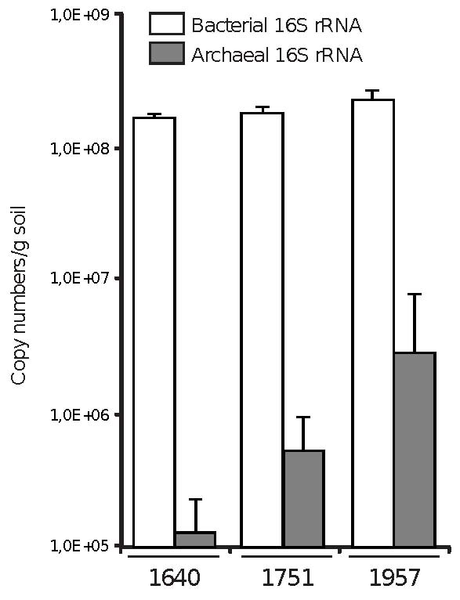

Fig. 2
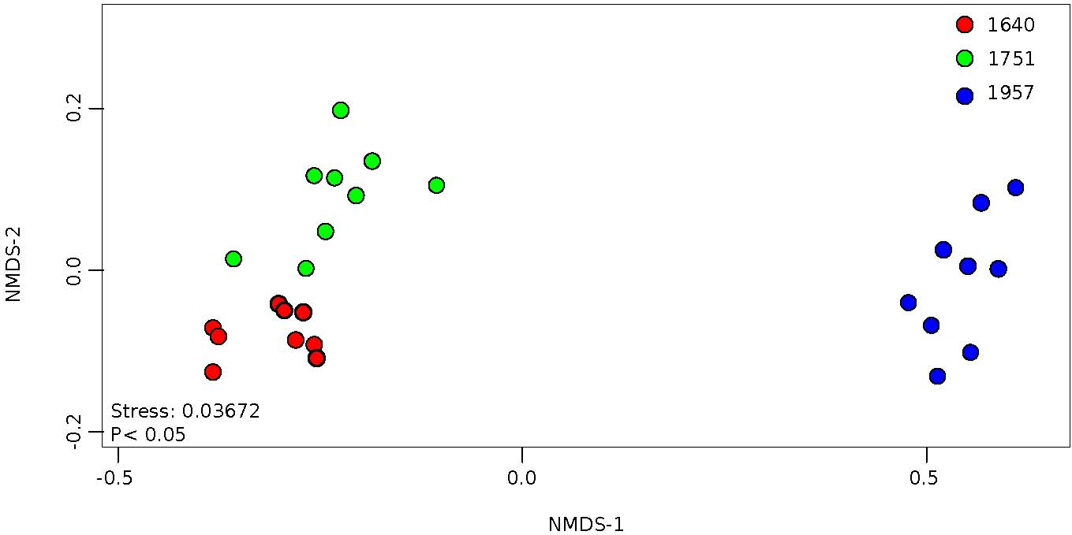

Fig. 3
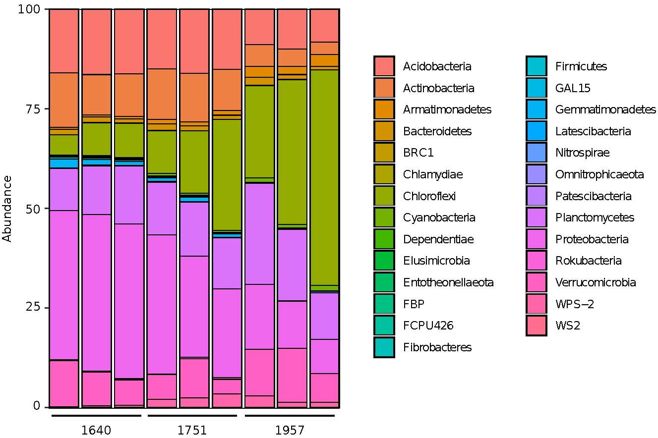

Fig. 4
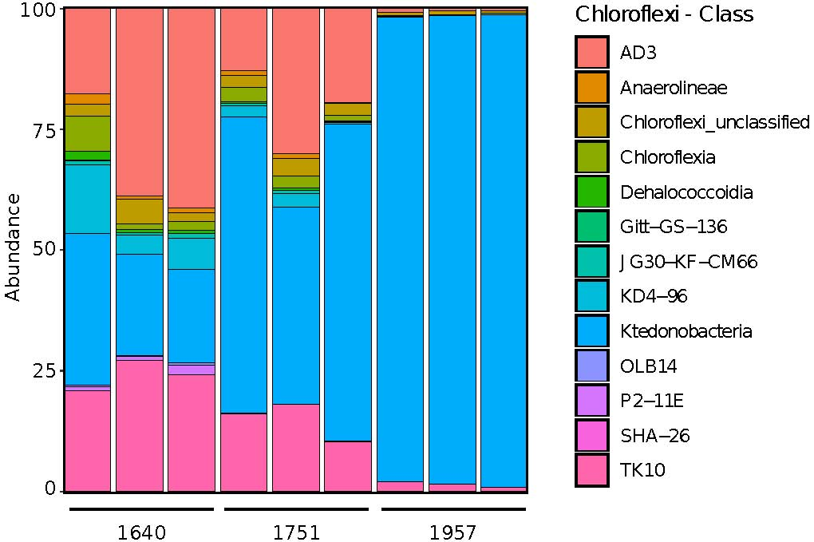

Fig. 5
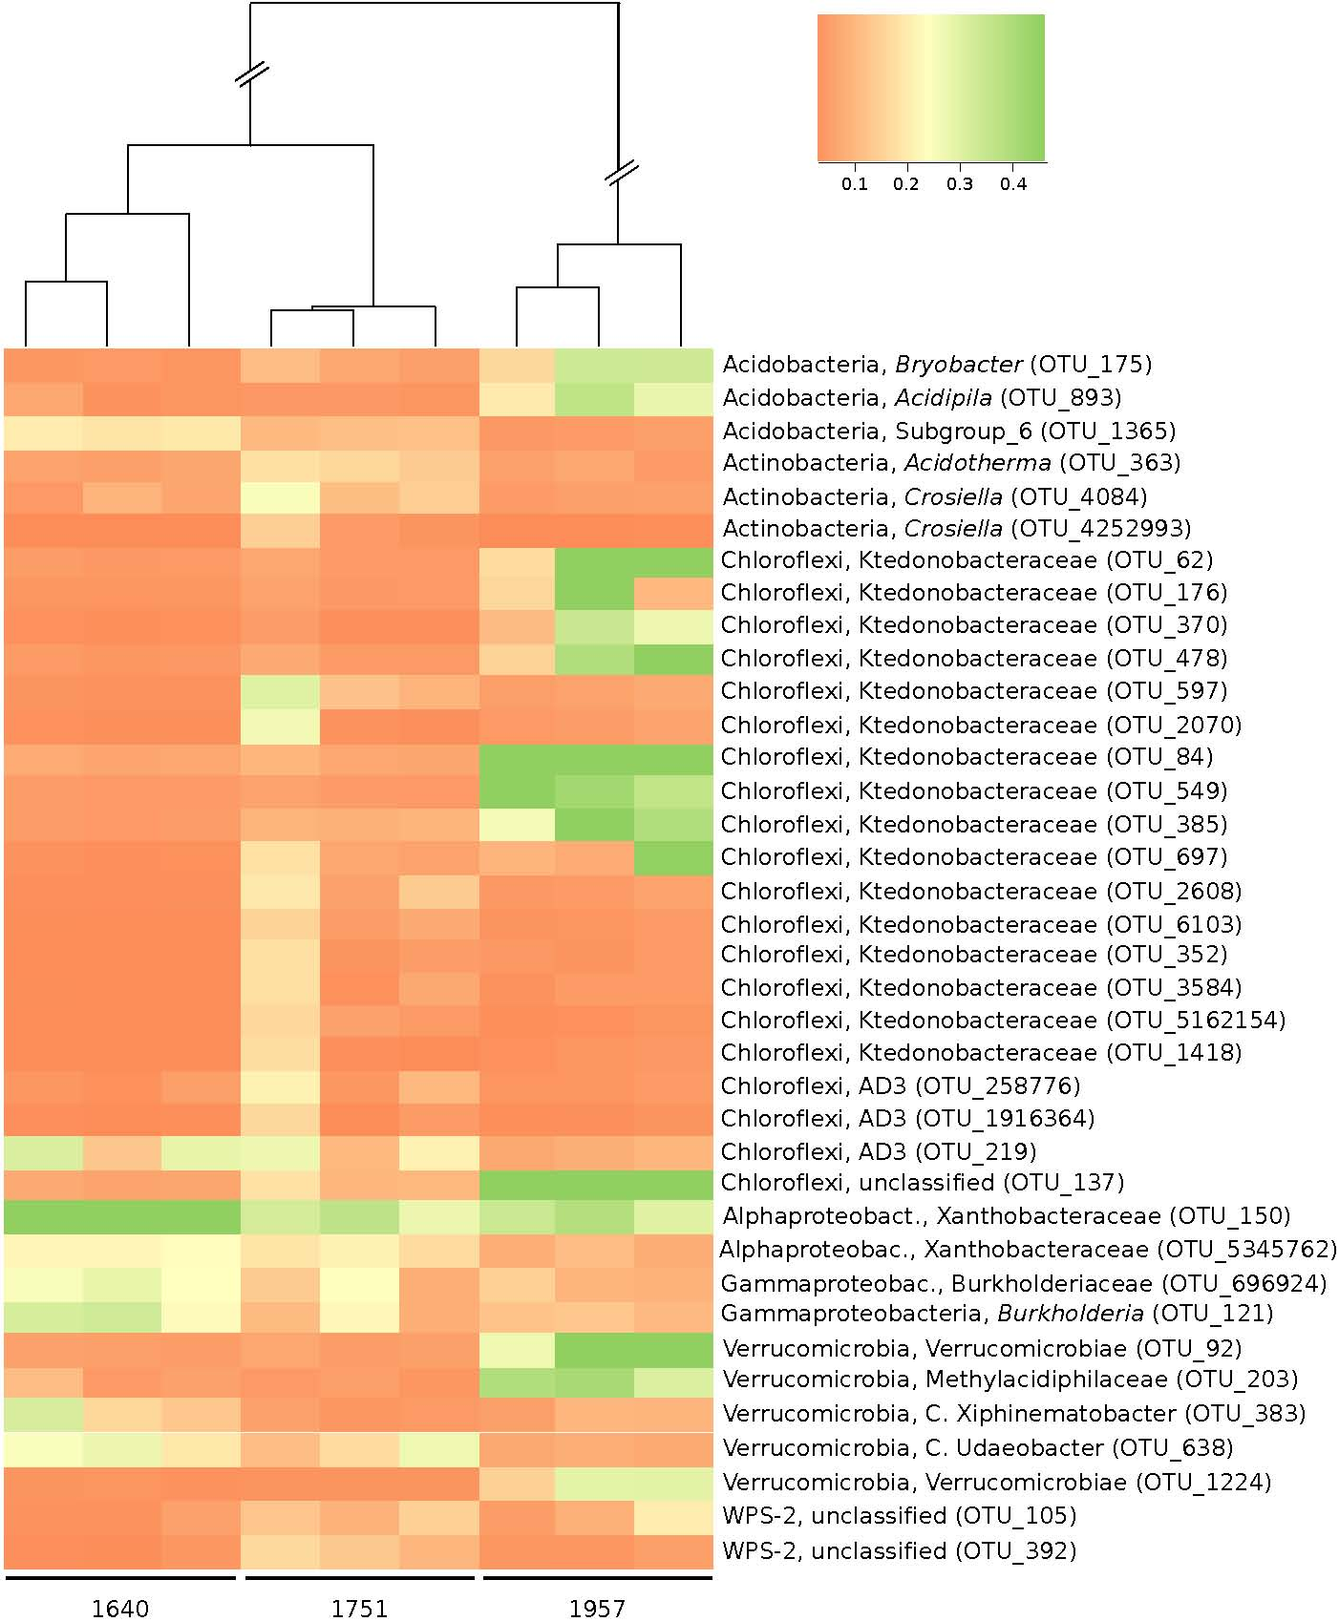

∗Corresponding author. E-mail: m.t.hernandez-garcia@soton.ac.uk. Present address: University of Southampton, Southampton, SO17 1BJ, UK.

