Supplemental Figure 1: Tracking of the misclassification rates (y-axis) across iterations (x-axis) of the recursive RF feature selection.
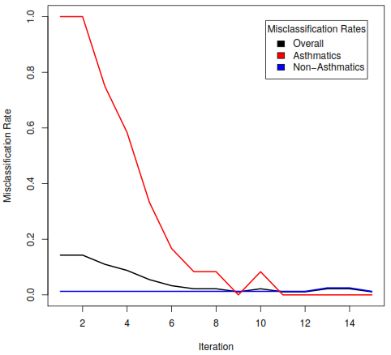

Supplemental Figure 2: Correlations (Spearman) between estimated cell-proportions in blood and DNAM M-values for the 10 CpGs that were identified as candidates for the replication study. Statistically significant correlations are designated at p-values < 0.05 (*), p-values < 0.001 (**), and p-values < 0.001 (***).
