Asymmetric Dependence in International Currency Markets

Nikos Paltalidis
Durham University Business School, Durham University

Victoria Patsika
Southampton Business School, University of Southampton

Forthcoming: European Journal of Finance

Nikos Paltalidis is from: Durham University Business School, Durham University, Mill Hill Lane, DH1 3LB, U.K., E-mail: nikos.e.paltalidis@durham.ac.uk, Victoria Patsika is from: Department of Accounting, Southampton Business School, University of Southampton, 12 University Road, Highfield, Southampton, SO17 1BJ, UK, E-mail: v.patsika@soton.ac.uk; We are grateful to Ioannis Chatziantoniou, Alan Collins, Arief Daynes, Manthos Delis, Philip Dennis, Everton Dockery, Chirstos Floros, Dimitrios Gounopoulos, Christos Ioannidis, David Newton, Renatas Kizys, Sotirios Kokas, Alex Kontonikas, Alex Michaelides, Anamaria Nicolae, Gioia Pescetto, Judy Rich, Petros Sekeris, Lazaros Symeonidis, Abderrahim Taamouti, Alessia Testa, Andy Thorpe, Julian Williams, Ansgar Wohlschegel as well as participants at the 2nd International Workshop on Financial Markets and Nonlinear Dynamics, the Essex Finance 2017 Conference in Banking and Finance, seminar participants at the University of Portsmouth, and three anonymous referees for their detailed and insightful comments on improving our manuscript. All remaining errors are our own. This article is an improved version of the Third Essay (chapter five) of Nikos Paltalidis’ Ph.D. thesis entitled “Essays on Applied Financial Econometrics and Financial Networks: Reflections on Systemic Risk, Financial Stability & Tail Risk Management”. Corresponding Author: Nikos Paltalidis, Tel.: +44 191 334 0113.
Asymmetric Dependence in International Currency Markets

Abstract
We find new channels for the transmission of shocks in international currencies, by developing a model in which shock propagations evolve from domestic stock markets, liquidity, credit risk and growth channels. We employ symmetric and asymmetric copulas to quantify joint downside risks and document that asset classes tend to experience concurrent extreme shocks. The time-varying spillover intensities cause a significant increase in cross-asset linkages during periods of high volatility, which is over and above any expected economic fundamentals, providing strong evidence of asymmetric investor induced contagion. The critical role of the credit crisis is amplified, as the beginning of an important reassessment of emerging currencies which lead to changes in the dependence structure, a revaluation and recalibration of their risk characteristics. By modelling tail risks, we also find patterns consistent with the domino effect.

JEL Classification: C5, F31, F37, G01, G17.
Keywords: Asymmetric Foreign Exchange Volatility, Tail Risk, Domino Effect, Copula Functions.

- Introduction
Over the last decade, emerging markets have been a magnet for global investors. Even pension funds and sovereign wealth funds have increased their allocations to emerging market assets in order to take advantage of the world’s fastest growing economies. However, the global financial crisis which began in developed countries during 2008 and quickly spread to emerging markets, deteriorated the environment for capital flows and triggered deep sell offs in emerging economies (see also Alsakka and Gwilym, (2012)). Motivated by the lack of evidence that macroeconomic fundamentals serve as the determinants of co-movements in international markets as documented by Fair (2002) and later by Baur (2012) among others, we examine how external shocks, such as the 2008 credit crisis, affect the behavior of the most liquid and fastest growing international currency markets. These studies find unequal responses from foreign exchange markets to sovereign credit signals and to macroeconomic developments. In contrast, we propose four new channels via which emerging currencies are sensitive to global credit, liquidity and commodity conditions. An additional innovation is that, we employ copula theory which allows high degree of asymmetric coefficient variability among the proposed channels and the foreign exchange markets.
As mentioned by Meese and Rogoff (1983), a puzzling characteristic of these currencies is that spectacular exchange rate movements and fluctuations are difficult to predict using standard economic models. Their fluctuations are not always triggered by fundamental news announcements. Therefore, understanding the relationship between different assets and international currencies is an essential component to reduce foreign exchange risk for portfolio investors, and companies that hedge their currency risk when doing trade with emerging countries.
To assess the impact of the credit crunch we test for structural changes in the tail behavior of the unconditional distribution. Specifically, we evaluate the role that liquidity shocks, fluctuations in equity markets, in credit risk and, in commodities have on the exchange rates. Allowing for the influence of these factors we endeavour to answer the following questions: what is the impact of global financial shocks in emerging currencies? Are there any risk factors which have acted as channels of risk transfer on emerging currency markets? Is there any structural change in the tail behaviour of the unconditional distribution? Is there any extreme value dependence with other financial assets?
To answer these questions, this study employs a distinct approach on emerging currency markets to determine new channels for the transmission of shocks on emerging foreign exchange markets. We then construct four channels of risk transfer on emerging market currencies. In particular, we suggest that regardless of the macroeconomic fundamentals, investors substantially alter their investments in emerging currency markets in response to shocks experienced in the following four channels: developments in liquidity, credit risk, growth and the information contained in domestic stock markets.
Through these channels, cross-asset rebalancing and contagion is transmitted to international currencies and therefore, they become the source of shocks that leads to instability. We use as a proxy for the liquidity channel, the iTraxx Senior Financial Index (i.e. the spread of Banks’ Credit Default Swaps), and for the domestic stock markets we use the most liquid domestic stock index. The growth channel is interpreted by developments in major commodity markets (i.e. S&P Goldman Sachs Commodity Index). The Volatility Index (VIX) represents changes in credit market conditions (i.e. credit risk channel) in line with Alexander and Kaeck (2008) and with Brunnermeier et al. (2008) who use the VIX to measure global credit risk conditions.
We examine volatility spikes, similar in spirit with Ederington and Ha Lee (1993), where volatility is substantially higher than the normal average and has the greatest impact on foreign exchange markets. Moreover, we test for the existence of any extreme value dependence, symmetries and asymmetries in the dependence structure by employing several copula functions with different dependence structures (i.e. Gaussian, Student – t, and Joe-Clayton) to capture the risk in a large set of risk factors. The findings of our study reveal that in periods of crisis several financial assets experience synchronically dramatic losses.
In response to the questions raised, we find that emerging currency movements are the result from the interaction received by global liquidity and credit risk shocks and hence there is increased co-movement and extreme tail dependence during the crisis period. The significance of the tail dependence implies that these asset classes tend to experience concurrent extreme shocks. This finding has important risk and asset pricing implications, since risk measures which omit fatness of tails lead to serious underestimation of downside risk. Second, our findings imply that accelerated decreases and large variations in the domestic stock markets, in the growth (i.e. commodities), liquidity (BCDS) and credit channels (i.e. VIX) lead to accelerated decreases and increased fluctuations in the emerging market foreign exchanges. This joint downside risk among these asset classes observed via the growth channel has not been documented in the literature of emerging foreign exchange markets and contributes on the works of Yuan (2005), Boyer et al., (2006), and Jotikasthira et al., (2012).
Moreover, we observe that dependence remains significant but weaker after the financial crisis when emerging foreign exchange markets become more pronouncedly heavy-tailed in downward moves than in upward moves. As a result, on the post crisis period, emerging foreign exchange markets are more susceptible to speculative attacks. The increased likelihood of extreme joint losses suggests a higher than normal Value at Risk. These findings imply that currencies respond asymmetrically when the volatility increases in equity and liquidity channels. This asymmetry is documented for first time in this literature and contributes on the works of Aloui et al., (2011), Sirr et al., (2011), Tsai (2012) Wang et al., (2013), and Ibragimov et al., (2013) who investigate spillovers between emerging currencies and stock markets via the liquidity channel. Finally, we find that the local contagion channels spread the crisis in a domino fashion in the emerging market currencies, contributing on the work of Markwat et al., (2009) who observe domino effects among international stock markets only.
This study increases our understanding on the relationship between global equity, liquidity conditions, commodity and emerging currency markets. This relationship is a critical component of international portfolio management, since investments in foreign emerging markets inevitably involve investments in foreign currencies. The increase in cross-asset dependence diminishes rapidly diversification and hedging opportunities, while also it renders traditional portfolio theory fruitless. Furthermore, the presence of risk spillovers among these asset classes, increases portfolio risk and magnifies the volatility of the expected returns in emerging currencies. Notably, in the post-crisis period we observe the existence of a structural shift in the transmission of shocks that divides the behaviour of these currencies. emerging currencies are more susceptible to financial crisis and speculative attacks. These findings affect the pricing of emerging market currencies in the post-crisis period for safety-first investors, since risk-averse investors favour investments with low dependence which hedge portfolio risks.
The remainder of the manuscript is organized as follows. Section 2 reviews the relevant literature. In Section 3 we set our theoretical framework and modelling strategy. We describe our dataset in Section 4 and report the empirical results in Section 5. Section 6 provides robustness checks. Finally, section 7 presents the concluding remarks.

- Literature Review
- Theoretical Framework
According to the traditional portfolio theory, investors can improve the performance of their portfolios by allocating their investments into different asset classes (Markowitz, (1952)). However, during turmoil periods, cross-market co-movements increase rendering traditional theory fruitless and advancing to contagion. As described by Forbes and Rigobon (2002), contagion occurs when there is a significant cross-asset or cross-market increase in comovement due to a shock. This extreme dependence is the aftermath of forced sales or “fire sales” by wealth-constrained investors (Yuan (2005); Boyer et al., (2006); and Jotikasthira et al., (2012)). As these authors argue, uninformed rational investors are not able to distinguish between selling based on liquidity shocks and selling based on fundamental shocks. Thus, when investors suffer a large loss in an investment, they are forced to liquidate their positions in other investments, triggering cross-market portfolio rebalancing. We build on and extend these approaches to identify how shocks are propagated in emerging market currencies.
Severe financial conditions, like the recently experienced credit crunch, play an important role in driving economic activity in emerging economies (Akinci (2013)). Global financial shocks increase uncertainty and fluctuations, and thus, the business climate deteriorates causing increased uncertainty for future growth prospects. Following Colin-Dufresne et al., (2001), Alexander and Kaeck, (2008), and Annaert et al. (2013), the higher the uncertainty the higher the volatility, and thus, the Volatility Index can be used as a proxy for business and credit market conditions. During periods of uncertainty, credit markets squeeze and liquidity abruptly dries up. Financial institutions suffer unanticipated outflow of deposits and experience funding and liquidity issues, and thus the spread in Banks’ Credit Default Swaps increases (see also Jorion and Zhang, (2007); and Alexander and Kaeck, (2008); for the effects of credit events on credit default swaps).
Contagion refers to the risk that a shock in an asset leads to increased volatility and co-movements of other assets (see also Forbes and Rigobon, (2002); Boyson et al. (2010); and Allen et al. (2012)). Indeed, the performance of global emerging market currencies shifted and altered contemporaneously during the peak of the financial crisis as never before in the recent history (see also Dias (2014); and Tolikas (2014) for informative readings on financial assets dramatic losses), providing anecdotal evidence for and resembling to contagion.
Our study builds on and extends a growing literature which emphasizes on the role of forced sales, caused by the recent credit crisis. Boyer et al. (2006) propose a model where limits to arbitrage facilitate stock market crises to spread globally through asset holdings. Building on this approach, Aloui et al. (2011) examine the contagion effect and how cross market linkages increased during the recent global crisis between the US and BRIC stock markets. Boyson et al. (2010) and Jotikasthira et al. (2012) find strong evidence of contagion across hedge funds and that forced and fire sales in developed market funds perform as channels of risk and contagion on emerging market funds. Moreover, our study extends the work of Brunnermeier and Pedersen (2009) on liquidity spirals. Precisely, we find a positive return and a negative skewness in some emerging currencies caused by the asymmetric response to shocks from other assets. The asymmetric response can be explained by the liquidity spiral theory where speculators’ losses increase due to funding constraints, depressing prices further, and this in turn enlarges the funding problems, and so on.
- Empirical Framework
The literature on volatility transmission and contagion literally exploded since the thought-provoking studies by Allen and Gale (2000), Forbes and Rigobon (2002) and Barberis and Shleifer (2003). However, studies that aim at the interaction between foreign exchanges and stock markets are less frequent than those covering equity markets. Indeed, Bekaert and Harvey ((1995), and (2000)) identify cross border linkages of emerging stock markets. Chen et al. (2002) observe regional emerging stock markets interlinkages and spillovers in Latin American stock exchanges and Yang et al. (2006) find evidence of integration and co-movements at Central and Eastern European stock Indices.
Among the first researchers that examine spillovers between the developed U.S. stock market and foreign exchanges are Bartov and Bodar (1994), Karolyi and Stulz (1996), Bodard and Reding (1999). They find no evidence of volatility spillovers between the foreign exchange and the stock market returns. In particular, they observe that the value of dollar is negatively related to changes in US stock markets in the long run. Bodnar and Gentry (1993) investigate the Japanese and Canadian foreign exchange and stock markets and find no evidence of spillovers. On the other hand, Francis et al. (2002), attribute cross-currency differences in U.S. and European markets and observed that stock market return differentials are positively related to bilateral exchange rates.
Kearney and Patton (2000) employ a series of multivariate GARCH models on the members of the former European Monetary System (EMS) prior to their complete monetary unification and find that less volatile weekly data exhibit a significantly smaller tendency to transmit volatility compared to more volatile daily data. Menkhoff et al. (2012) study the curry trades and Ning (2010) observes significant symmetric upper and lower tail dependence between stock markets and foreign exchanges for the U.S., the U.K., Germany, Japan, and France.
A copula function connects the marginal distributions to restore the joint distribution. In the extant literature, most studies observe and model co-movements focusing on stock indices with the use of copulas (Ning (2010); and Kenourgios et al. (2011)) omitting to study foreign exchange volatility. Wang et al. (2013) develop a dependence switching copula model to describe the dependence structure between the stock and foreign exchange for six major industrial countries: France, Germany, Italy, Canada, Japan and the U.K.. They observe asymmetric tail dependence in a negative correlation regime and symmetric dependence in a positive correlation regime.
While there is extensive literature studying the co-movements between the international equity markets and studies on modelling the dependence structure between the exchange rates via copulas, there is no literature on using copulas to study the comovement of exchange rates with different asset classes. To address the above mentioned concerns Patton (2006) uses normal (Gaussian) copula and the Symmetrised Joe-Clayton (SJC) copula to identify that the mark–dollar and yen–dollar exchange rates are more correlated when they are depreciating against the dollar than when they are appreciating. Moreover, the author observes asymmetries in the upper and lower tail dependences in the pre and post euro periods.
- Methodology
3.1 Marginal distributions
In this study, we use the time-varying nature of the copula functions to examine the structural dependence between emerging currencies, emerging stock markets, commodities, the iTraxx Senior Financial Index (Banks’ Credit Default Swaps or BCDS) the Volatility Index and commodities. A copula is a multivariate cumulative distribution function whose marginal distributions are uniform on the interval [0,1]. Copulas are suitable to describe interrelations and to model dependence of several random variables. As described by Harvey (2010), copulas separate the marginal behaviour of variables from the dependence structure through the use of distribution functions. Thus, copula functions are more appropriate to adequately capture fat tails and higher moments. By using copulas we are able to isolate the dependence structure from the marginal distributions. Consequently, copulas can be applied with any marginal distributions, and the marginal can be different from each other. Furthermore, the copula function can directly model the tail dependence (see also Patton (2006)). As described by Ning (2010) it is a succinct and exact representation of the dependencies between underlying variables, irrespective of their marginal distributions.
A thorough review of copulas may be found in Patton and Sheppard (2009). Methodologically, we begin with capturing the linear measures of rank dependence with Kendall’s τ and Spearman’s ρ. Due to the drawbacks of linear measures, we then model the margins of the return series by fitting the appropriate ARMA-GARCH specifications to the actual data set and extract the standardised residuals, similar to Patton (2006), Kenourgios et al. (2011), and Aloui et al. (2011), in order to capture dependences and tail risks with three copula functions.
Based on the work of Bollerslev (1986), Nelson (1991), and Patton (2006), we estimate the dependence described above, with a AR(k)-t-GARCH(p,q) model which detects conditional heteroscedastic errors. Thus, the daily return is expressed as:
$R_{t}=μ_{t}+ε_{t}=μ_{t}+σ_{t}z_{t}$, $z_{t}$~iid(0,1)
$σ_{t}^{2}=ω+αε_{t-1}^{2}+βσ_{t-1}^{2}$, (1)
where $μ_{t}$ denotes the conditional mean which is assumed to be constant and $σ_{t}^{2}$ is the conditional variance with parameter restrictions ω > 0, α >0, β >0, and α+β >1. In order to verify that the marginal distributions are not normal, we employ the Jarque-Bera normality tests for each asset return. The order of the autoregressive terms is specified at a maximum of 10.
We assume that the variables of interest in our model are X and Y with marginal distribution functions F and G. Thus the coefficient of lower tail dependence $λ_{L}$ is represented as:
$λ_{L}=\lim_{t→0^{+}}{Pr⁡[Y≤G^{-1}(t)⎸X≤F^{-1}}(t)]$ (2) which quantifies the probability of observing a lower Y assuming that X is lower itself.
Similarly, the coefficient for the upper tail dependence $λ_{U}$ is defined by:
$λ_{U}=\lim_{t→1^{+}}{Pr⁡[Y>G^{-1}(t)⎸X>F^{-1}}(t)]$ (3)
Thus, symmetry occurs when the lower tail dependence equals the upper tail dependence coefficient, otherwise there is asymmetry.
The Gaussian copula symmetry occurs when$λ_{l}=λ_{u}$.
As a result, the Gaussian normal copula can be expressed as:
$C\left(u,v\right)=Φ_{θ}\left(Φ^{-1}\left(u\right),Φ^{-1}\left(v\right)\right)=\int_{-∞}^{Φ^{-1}(u)}{\int_{-∞}^{Φ^{-1}(v)}{\frac{1}{2π\sqrt{1-θ^{2}}}exp⁡(-\frac{s^{2}-2θst+t^{2}}{2\left(1-θ^{2}\right)})}dsdt}$ (4)
where $Φ_{θ}$ is the standard bivariate normal distribution with linear correlation coefficient θ restricted to the interval (-1,+1), and Φ represents the univariate standard normal distribution function.
Similarly, the Student-t copula can be defined as:
$C\left(u,v\right)=\int_{-∞}^{{t_{u}}^{-1}(u)}{\int_{-∞}^{{t_{u}}^{-1}(v)}{\frac{1}{2π\sqrt{1-θ^{2}}}exp⁡(1+\frac{s^{2}-2θst+t^{2}}{u\left(1-θ^{2}\right)})^{-\frac{u+2}{2}}}dsdt}$ (5)
where ${t_{u}}^{-1}$(u) denotes the inverse of the cumulative distribution function of the standard univariate Student-t distribution with u degrees of freedom.
In the extant literature, it is well documented that the co-movement between assets usually have positive lower dependence (i.e. left tail dependence) depending on the strength of the volatility chasing effect. Hence, to capture the above dependence switching, this study follows Chen et al., (2009) and employs the flexible Joe-Clayton copula:
$C_{JC}\left(u,\overset{⃓}{v}τ^{U},τ^{L}\right)=1-(1-\{[1-(1-u)^{κ}]^{-γ}+[1-(1-v)^{κ}]^{-γ}-1\}^{-1/γ})^{1/κ}$ (6)
where $κ=1/\log_{2}(2-τ^{U})$
$γ=-1/\log_{2}(τ^{L})$
and $τ^{U}ϵ \left(0,1\right), τ^{L}ϵ (0,1)$ (7)
From equations (6) and (7) the Joe-Clayton copula has two parameters, $τ^{U} and τ^{L}$, which are measures of tail dependence. Following Patton (2006), the Joe-Clayton copula symmetry occurs when $τ^{U}= τ^{L}$.
Moreover, in order to compare the copula models we use the goodness of fit test based on a comparison of the distance between the estimated and the empirical copulas (Genest et al. (2009)). Therefore:
$C_{n}=\sqrt{n}(C_{n}-C_{θ_{n}})$ (8)
The test statistic considered is based on Cramer-Von Mises criterion which indicates that large values of the statistic $S_{n}$ lead to the rejection of the null hypothesis that the copula C belongs to a class $C_{0}$. In particular, the Cramer-Von Mises criterion can be defined as:
$S_{n}=\int{C_{n}(u)^{2}dC_{n}(u)}$ (9)

3.2 The Hypotheses
Following Acharya et al. (2014), a systemic financial crisis gives rise to a business-cycle recession, which weakens public finances and leads to a higher default risk (i.e. spreads in Banks’ Credit Default Swaps accelerate). Financial institutions that suffer unanticipated outflow of deposits and experience funding and liquidity issues in the wholesale market are forced to reduce their lending activity (see also Boubaker et al., (2017, 2018a, 2018b)). If funding and liquidity problems become a commonplace in the banking sector, money supply will decrease as less credit will become available in the economy. Thus, liquidity abruptly dries up and credit risk soars (see also Paltalidis et al. (2015)). This is likely to have a recessionary effect on investment, consumption, income, and thus leads to severe downturns in the commodity prices (see also Arezki et al. (2014) for informative readings on commodity price fluctuations). Under these conditions, investors withdraw capital from risky investments and increase their exposures in safe assets such as government bonds issued by developed countries in a flight to quality (see also Kizys et al., (2016)). This signals net capital outflows in the emerging stock markets and point to a higher financial risk for investments in emerging countries. Thus, we formulate our first hypothesis:
Hypothesis 1 (Existence of contagion channels): Due to global shocks in liquidity, credit and growth constraints and in emerging stock markets, there is a significant cross-asset increase in the comovement and the dependence with emerging currencies, resembling to contagion.
Uninformed rational investors are not able to distinguish between selling based on liquidity shocks and selling based on fundamental shocks. Thus, when investors suffer a large loss in an investment, they are forced to liquidate their positions in the most vulnerable investments (i.e. emerging stock markets, according to Ibragimov et al. (2013)) triggering cross-market portfolio rebalancing (see also Yuan (2005); Boyer et al., (2006); and Jotikasthira et al., (2012), for informative readings on forced sales and investor-induced contagion). Based on these we formulate our second hypothesis:
Hypothesis 2 (Investor – Induced Hypothesis and Asymmetric Contagion): The documented increase in the dependence (hypothesis 1) is triggered by cross-asset rebalancing, which is consistent with investor induced contagion. If the crisis spreads through cross-asset rebalances, then dependence should be asymmetrically higher during market downturns than in market upturns, pointing also to asymmetric contagion.
Local crashes and shocks in liquidity, credit and demand constraints spillover to emerging market currencies and thus evolve into global crashes, resembling to a domino pattern (see also Markwat et al., (2009)). Based on this rationale we identify if emerging currency market contagion occurs as a domino effect.
Hypothesis 3 (Domino Effect Hypothesis): Shocks in the contagion channels evolve into global crashes and significantly increase the probability of more severe crashes, resembling to a domino effect.
Emerging market currencies have been among the worst performing assets over the last years. The Indian Rupee and the Brazilian Real have underperformed the US dollar by about 20%, similarly the Russian Ruble, the Mexican Peso and the South African Rand dropped over 10%. In line with these downdrafts, realized and implied volatility in emerging currencies doubled. Thus, we are searching if this is a cyclical downturn or a structural shift in the risk characteristics of these assets, based on Gravelle et al. (2006)
Hypothesis 4 (Structural Shift in Risk Determinants): If the structure of the simultaneous transmission of shocks to any pair of currencies is fundamentally altered by the crisis (i.e. post-crisis dependence is not the same with pre-crisis dependence), then there is a permanent change in the structural transmission of shocks to emerging market currencies, which implies a permanent shift in their risk characteristics.
To formally test these implications, we employ copula functions to describe the distribution similar to Gounopoulos and Paltalidis (2018), tail coefficients and the dependence structure between the foreign exchange market, the financial market (local stock indices), the growth channel (the commodity market, represented by the S&P Goldman Sachs Commodity Index), the liquidity channel (i.e. Banks’ Credit Default Swaps) and the credit channel represented by the Volatility Index. Notably, the Volatility Index (VIX) represents fluctuations in credit market conditions as used by Alexander and Kaeck (2008) and Brunnermeier et al. (2008).
To address the relative importance of each component, we decompose co-movements to separate out the effects on the emerging markets exchange rates movements.

- Data description and descriptive statistics
Our data set is from Bloomberg and Datastream and consists of the five most liquid and rapidly developed emerging markets and five Asian emerging markets (i.e. Brazil, Russia, India, Mexico, South Africa, Vietnam, Indonesia, Thailand, Malaysia and Philippines). These emerging economies constitute the epitome of -and benefited the most from- the macroeconomic tailwinds that boosted growth in the 2003 – 2008 period, fuelled by declining interest rates in the developed world, the commodity supercycle of rising prices and higher commodity investments. In particular, we use ten emerging market foreign exchanges vis-à-vis the U.S. Dollar: the Brazilian Real (BRE), the Russian Ruble (RUB), the Indian Rupee (INR), the Mexican Peso (MXN), the South African Rand (ZAR), the Vietnam Dong, the Indonesian Rupiah, the Thailand Baht, the Malaysian Riggit, and the Philippine Pisso. Also, we use data for the following ten stock markets: Bovespa (Brazil), RTS (Russia), BSE Sensex (India), IPC (Mexico), the Johannesburg Top 40 Index (South Africa, henceforth JSE Top 40), the VNI Index (Vietnam), the Jakarta Composite Index (Indonesia), the Bangkok SET Index (Thailand), the FTSE Bursa KLCI (Malaysia), and the Manilla Composite Index (Philippines). In addition, we use the following indices: (i) the S&P Goldman Sachs Commodity Index (S&P GSCI); (ii) iTraxx Senior Financials Index (Banks’ Credit Default Swaps); and (iii) the Chicago Board Options Exchange Market Volatility Index (VIX) as a proxy of the business and credit climate. For our empirical analyses, we use a dataset of daily closing prices. The sample period is daily from March, 21, 2005 till December, 31, 2015 and excludes bank holidays. The nominal exchange rates are expressed as the number of units of national currency per US dollar. Also, all indexes are in U.S. dollars.
Figure 1 presents the movement of the emerging currencies from 2005 to 2015. The base currency is the U.S. Dollar and the area below zero represents a depreciation for the emerging currency (or depreciation of the U.S. Dollar against the emerging currency), while the area above zero represents appreciation of the emerging currency against the U.S. Dollar. The Figure shows that all emerging currencies were appreciated for the whole time period, whilst around the 2008 crisis period the US Dollar recovered strongly against all emerging currencies.
- Please Insert Figure 1 about here –
Table 1 depicts the summary statistics with the tests for normality. Over the sample period, the mean of the emerging currencies is closed to zero. All emerging currencies are leptokurtic implying that the distribution departs from symmetry. Stock and commodity (S&P GSCI) returns were less volatile, as suggested by the range of variation and the standard deviation. Indeed, daily percentage stock and commodity returns were positive during the sample period. Consistent with empirical evidence on skewness and kurtosis, returns are negatively skewed and leptokurtic, suggesting that big negative events in the stock and commodity markets are more likely than big positive events. Furthermore, the resulting distribution of returns is non-normal. Changes in the volatility index VIX and in the Banks’ Credit Default Swap spreads have a positive mean, suggesting that the expectations of market volatility and the spread of the BCDS were increasing over the sample period.
- Please Insert Table 1 about here –
- Empirical Results
In order to compare the impact of the crisis on emerging market foreign exchanges, and to detect time-variation and structural breaks, we analyse dependence and tail dependence separately for the period from March 2005 to August 2007 (Pre-crisis Period), for the period from August 2007 to September 2009 (Crisis Period), and for the period from September 2009 to December 2015 (Post-crisis Period).
5.1 Linear correlations
We start by interpreting the results of the rank correlation coefficients as applied to the emerging market foreign exchanges. Our estimation results are displayed in Table 2. We observe that for the overall sample period the Kendall’s tau and Spearman’s rho statistics are positive, implying positive dependence between emerging market foreign exchanges, domestic stock market indices and the growth channel (S&P GSCI commodity index). This finding indicates that the probability of concordance is significantly higher than the probability of discordance. Additionally, our findings imply that the Brazilian Real and the Russian Ruble appear to be particularly susceptible to changes in the growth channel, indicating that the response of these currencies is significantly quicker to changes and fluctuations in commodity prices. In particular, for the Brazilian Real and the Russian Ruble, the strongest dependence is observed with the S&P GSCI. Positive dependence indicates that the booming demand for commodities has underpinned these currencies. Contrarily, the Indian Rupee, the Mexican Peso and the South African Rand are more susceptible to changes in the domestic stock markets, than with changes in the growth channel.
During the crisis period, the results suggest a strong and sudden increase in the cross-asset synchronization of fluctuations and volatilities. The dependence structure changes and increases substantially - Kendall’s τ and Spearman’s ρ rise to higher levels for all considered pairs-, implying that shocks in the domestic stock markets and the growth channel lead to increased crash likelihood in emerging currencies. For instance, during the crisis period the dependence between the Brazilian Real and the growth channels increases to 0.136 for the Kendall’s τ and 0.171 for the Spearman’s ρ respectively. This finding indicates that these currencies display a significant reversal, following shocks to financial and commodity markets.
Adversely, in the post crisis period the dependence structure weakens- Kendall’s τ and Spearman’s ρ decrease for all considered pairs-, reflecting a structural break or a regime shift that divides the behaviour of the emerging currencies. Notably, in the post-crisis period emerging currencies share stronger comovement with the domestic stock markets, while in the crisis and the pre-crisis period they share a stronger comovement with the growth channel (i.e. S&P GSCI).
On the other hand, the results reveal a very different picture for the dependence between emerging currencies, the Volatility Index and the Banks’ Credit Default Swaps. In particular, for the overall sample, both Kendall’s tau and Spearman’s rho statistics are negative between emerging market foreign exchanges and the Volatility Index, and Banks’ Credit Default Swaps, implying that there is no co-movement. By contrast, during the crisis period the dependence becomes positive indicating that during high volatility periods, where uncertainty increases, liquidity abruptly dries up and credit markets squeeze, changes in the Volatility Index and in the spread of Banks’ Credit Default Swaps are followed by changes in emerging market currencies. Indeed, during the financial crisis the Volatility index and BCDS increased substantially while fluctuations soared in emerging market currencies.
The results for the post-crisis period suggest that emerging market exchange rates become more pronouncedly heavy-tailed in downward moves than in upward moves. This finding indicates statistically decreases in the tail indices and structural breaks to these exchange rates due to the recent financial crisis that correspond to the increase in the likelihood of large fluctuations. As a result, on the post crisis period, emerging market foreign exchanges are more susceptible to financial crisis and speculative attacks. The increased likelihood of extreme joint losses suggests a higher than normal Value at Risk. The above results are intuitively in line to some extent with the findings of Sirr et al. (2011), and Aloui et al. (2011) who document directional spillovers between financial assets (i.e. stock and foreign exchange markets). On the contrary, for the five Asian emerging currencies the financial channels do not provide strong evidence of interaction. This may be due to the peg that these currencies have with the U.S. dollar, which affects daily fluctuations to a great extent.
- Please Insert Table 2 about here –
Table 3 reports the estimated AR(k)-t-GARCH(p,q) model for each asset return series. We experiment on AR and GARCH terms of up to 2 lags and we find that the asset returns experience a short memory with a significant AR (2). Also, GARCH (2,2) is capable to capture the conditional heteroscedasticity. The p-values of the Jarque-Bera test are less than 0.0001 indicating existence of non-normality. Furthermore, the degrees of freedom of the t distribution are all small, ranging from 2 to 7, implying that the error terms are not normal and indicating the existence of contemporaneous extreme co-movements and tail dependences in emerging market currencies. Furthermore, the significance of the degrees of freedom suggests that the Gaussian copula is not sufficient in modelling the dependence between the four contagion channels and the emerging currencies.
- Please Insert Table 3 about here –

5.2 Copula dependence
We report the estimation results of the dependence parameters for each pair of emerging market currency in Table 4 and Figures 2 and 4. The copula parameter estimates are significant for all emerging market currencies, when the Gaussian, Student – t and Joe-Clayton copulas are applied. The pairwise dependences are significantly positive for the domestic stock markets and the growth channel. Thus, positive (or negative) changes in stock market and commodity returns are followed by positive (or negative) changes in the emerging market currencies. Again, the growth channel shares the strongest dependence with the Brazilian Real and the Russian Ruble, while the domestic stock markets have the strongest co-movement with the Indian Rupee, the Mexican Peso and the South African Rand. By contrast, as expected, there is a negative dependence structure between emerging currencies, the changes in the Volatility Index and the changes in the Banks’ Credit Default Swaps.
- Please Insert Table 4 about here –
- Please Insert Figure 2 and Figure 4 about here -
During the financial meltdown, the results reported in Table 5 and Figure 3 suggest strong and sudden increases in the cross market synchronization, consistent with the notion of contagion. This verifies that, given an extreme negative value in the four variables, there is a significantly positive probability to observe increased fluctuations and high volatility in emerging currencies at the same period. Indeed, the dependence during the crisis period increases substantially for all considered emerging market currencies, supporting hypothesis 1. Consequently, the dynamics of volatility transmission is not structurally stable and constant over time. During severe financial conditions dependence increases, shocks and fluctuations in the domestic stock markets, commodity, credit and liquidity variables perform as contagion channels whose extreme adverse realisations are associated with a slump of the emerging market currencies. This finding sheds new light on the propagation of large negative cross-asset returns. Furthermore, the presence of risk spillovers among asset classes increases portfolio risk and magnifies the volatility of the expected returns in emerging market currencies.
Since the relations between the variables and the crash probabilities are stronger in times of turmoil, this can be interpreted as excessive dependence. Thus, we observe extreme value dependence over and above what one would expect from economic fundamentals, pointing to contagion. Fluctuations and elevated volatility strengthens informational contents of the contagion channels and raises uncertainty. Consequently, investors demand higher risk premium in order to invest in the emerging market currencies, triggering deep sell offs (see for example Boyer at. al., 2006),. The increase in cross-asset co-movements diminishes rapidly diversification opportunities and renders traditional portfolio theory fruitless. These results are intuitively in line with Kodres and Pritsker (2002), Yuan (2005), and Jotikasthira et al., (2012), who provide empirical evidence for contagion among asset holdings.
After finding empirical evidence in support of the contagion hypothesis, we investigate how the financial crisis was spread through the four contagion channels which represent asset holdings of investors. Table 5 and Figures 3 and 5 show that the tail dependence when these markets are booming (upper and right tail) is not the same as that when markets are crashing (lower and left tail). Consequently, since lower tail dependence increases, co-movements increase under severe financial conditions causing asymmetry between upper and lower tails. These findings support the investor-induced contagion (i.e. hypothesis 2) which is sourced by cross-asset rebalancing and assumes asymmetric tail dependence and asymmetric contagion during high volatility periods. These results corroborate the works of Kyle and Xiong, (2001), Ang and Chen (2002), and Boyer at. al., (2006) who document asymmetric investor induced contagion, which is stronger during market downturns for international financial markets.
In addition, the results imply that accelerated decreases in the stock market, in the growth channel (commodity index) and large variations in credit (i.e. Volatility Index) and liquidity (BCDS) markets lead to accelerated decreases and increased fluctuations in emerging market foreign exchanges. During the crisis period the stronger relationship is observed with the Volatility Index. This finding confirms that the Volatility Index captures fluctuations and adverse behaviour of the emerging market currencies and thus its derivative (i.e. Volatility Futures Index) can be used as a hedging proxy, complementing the work of Ning (2010), who study the dependence structure in the foreign exchange markets and global currency hedging strategies, respectively.
- Please Insert Table 5 about here –
– Please Insert Figure 3 and Figure 5 about here –
5.3 Goodness of fit test
Following Genest et al. (2009) we compare the distance of the goodness-of-fit test to select the most appropriate copula function. For this test, the null hypothesis states that the estimated copula provides the best fit to the data for the p-values that are higher than the conventional significance level (equations 14 and 15). The results presented in Table 6 and Figure 6 show that for all considered pairs, the Joe-Clayton Copula yields the smallest distance for the conducted goodness-of-fit test, indicating that the Gaussian and the t- copulas are not sufficient in modelling the tail dependence. The t- Copula provides an approximation which is much better than the normal copula, but still underestimates the tail of losses considered. As described above, the Joe-Clayton copula distribution allows for heavy-tails (i.e. high frequency of heavy losses) which help to overcome the “normality” assumption of the Gaussian copula which underestimates the probability of large losses. Moreover, the model assumes asymmetric tail dependence in the distribution, implying that upper and lower tail dependence is not equal supporting hypothesis 2.
- Please Insert Table 6 about here –
– Please Insert Figure 6 about here –
5.4 The domino pattern
As discussed in the previous sections, shocks in the commodity prices, large variations in Banks’ Credit Default Swaps and in the Volatility Index significantly increase the comovement and spillover to emerging market currencies. Indeed, the significance of the crash variables suggests that currencies depreciated heavily, following the developments of these variables. This is consistent with the notion of the domino pattern, supporting hypothesis 3 (see also Markwat et al., (2009) for informative readings). Particularly, a domino effect exists when past occurrences of local crashes evolve via regional crashes into global crashes. Furthermore, on the post crisis period emerging market foreign exchanges become more pronouncedly heavy-tailed (i.e. l_{λ} is higher compared with the pre-crisis period) in downward moves, increasing the likelihood for more explicit currency crashes. This result is also consistent with the domino effect which is present when past occurrences of local crashes increase the probability of more severe crashes.

5.5 How the credit crunch altered the structural transmission of emerging currencies
To capture upper and lower tail risks, we compute the tail dependence coefficients implied by the Joe-Clayton Copula which provides the ability to better capture the fat tails. As discussed in the methodology section, λ_{l} (λu) quantify the dependence structure between the four contagion variables and emerging currencies, when they are in extremely small (large) values. It is evident from Table 7 that the dependence structure is significant, indicating that shocks (booms) in the contagion channels spillover to the emerging market currencies. Furthermore, the results imply that the structure of the dependence is asymmetric, i.e. lower tail and upper tail dependence is not exactly equal λ_{l} ≠ λu. Under symmetry, this difference would be equal or fairly closed to zero. Comparing the dependence before and after the financial meltdown, the Joe-Clayton copula results suggest that in the pre and post crisis period the corresponding appreciation is not experienced with the similar magnitude, given that emerging currencies were depreciated heavily during the recent credit crisis. Indeed, in the post-crisis period, the smooth of the upper tail dependence (λ_{u}) drops systematically, rendering dynamics of conditional dependence, and the dependence between structures asymmetric, consistent with asymmetric investor induced contagion and supporting the argument that the credit crisis caused a structural shift in the transmission of shocks in these currencies (i.e. hypothesis 4). This finding compliments the work of Gravelle et al., (2006) who study currency and bond markets to identify changes in the structural transmission of shocks across countries.
Moreover, the empirical results reported in Table 7 document significant and symmetric lower tail dependence during the financial crisis, indicating an increased likelihood of extreme joint losses. Indeed, λ_{l} is between 0.48 and 0.51 for all considered emerging currencies. This result, also confirms that the four contagion variables are more dependent with emerging currencies at the time of crashing than booming. These findings have important risk and asset pricing implications, since left tail dependence indicates the potential of simultaneous large losses and higher probability of extreme co-movements and contagion. Tail dependence implies higher than normal joint risk, a tendency to experience concurrent extreme shocks, and thus, higher than normal Value-at-Risk. Furthermore, the existence of joint tail risk alters the pricing of the emerging currencies over time. These results extend the works of Wang et al., (Wang, Wu and Lai 2013) and Ibragimov et al., (2013) who study tail dependencies for emerging market foreign exchanges.
- Please Insert Table 7 about here –
5.6 Economic implications: The symptoms of acute liquidity withdrawal
In the previous sections we described how the dependence structure of the emerging market currencies changes from the pre-crisis to the crisis and then to the post-crisis period. We document strong and sudden increase in cross-asset synchronization, consistent with the notion of investor induced contagion which is sourced by cross-asset rebalancing. These findings imply that emerging currencies display a significant reversal, following shocks to financial, commodity, liquidity and credit channels. The increase in cross-asset dependence diminishes rapidly diversification opportunities and renders traditional portfolio theory fruitless. Furthermore, the presence of risk spillovers among these asset classes, increases portfolio risk and magnifies the volatility of the expected returns in emerging market currencies.
In the post-crisis period we observe the existence of a structural shift in the transmission of shocks that divides the behaviour of these currencies. Emerging market exchange rates become more pronouncedly heavy-tailed in downward moves than in upward moves. As a result, on the post crisis period, emerging currencies are more susceptible to financial crisis and speculative attacks. These findings affect the pricing of emerging market currencies in the post-crisis period for safety-first investors, since risk-averse investors favour investments with low dependence which hedge portfolio risks. Emerging currencies benefited the most from the macroeconomic tailwinds that boosted growth in the pre-crisis period. However, it is evident that the credit crunch was the catalyst for the change in the structure of the transmission of shocks to emerging currencies and more concretely played a critical role for the reassessment of emerging market currencies which lead to a revaluation and a recalibration of their risk characteristics, indicating that this multi-year underperformance in emerging assets is not a cyclical downturn. Thus, less liquidity in the developed world affects severely emerging markets, leaving them to compete for scarce resources by offering cheaper currencies and more attractive asset valuations.

6. Robustness checks
In order to check the sensitivity of our results, we employ an alternative GARCH model and the bivariate hit and joint hit tests proposed by Patton (2006) and Ning (2010). These tests approve the suitability of our proposed approach for modelling the relationships between emerging market currencies, local stock markets, growth, liquidity and credit channels. In particular: (i) we employ a non-linear extension of GARCH, the Exponential GARCH (2,2) model and (ii) we divide the support of the copula into seven regions, so that regions one and two represent the lower and upper joint 10% tails for each variable and measure the probability of all variables. Regions three and four correspond to moderately large up and down days. Region five denote days where the exchange rates were in the middle 50% of their distributions. Regions six and seven correspond to the extremely asymmetric days. Additionally, we perform a joint hit test which represents the regions that are not covered by regions one to seven.

6.1 Alternative GARCH approach
Table 8 presents the results for the dependence coefficients with respect to the EGARCH (2,2) model. For the overall sample period we observe that there is significant positive dependence and comovement with the domestic stock markets and the growth channel supporting our proposed approach. Again, the strongest relationship for the Brazilian Real and the Russian Ruble is observed between the emerging currencies and the growth channel (i.e. commodity index), implying that developments in the commodity prices lead the movement of these currencies. By contrast, the Indian Rupee, the Mexican Peso, and the South African Rand have the strongest dependence with the domestic stock markets. Positive dependence indicates that a change in the contagion channels is followed by a significant change in the emerging currencies.
However, the pattern of comovement over the crisis period differs from the whole sample. Consistent with our initial results, during the crisis period the dependence increases substantially, implying that negative shocks in the stock market and the commodity index have a stronger effect on the currencies. The strongest relationship during the crisis period stands with the Volatility Index.
- Please Insert Table 8 about here –

  - Hit test
In order to evaluate the copula models we employ the hit tests, as proposed by Patton (2006). In particular, we decompose the density model into a separate set of region models $K$, each of which should be correctly specified under the null hypothesis that the density model is correctly specified. The model is adequately specified in each of the $K+1$ separate regions via the null hypotheses which states
H₀:${Hit}_{t}^{j}$ ~ Bernoulli${(p}_{jt})$ vs H₁:${Hit}_{t}^{j}$ ~ Bernoulli${(π}_{jt})$, with $π_{jt}$ defined as a function of both $p_{jt}$ and other elements of time $t-1$.
The results in Table 9 verify if the models are well-specified in all regions simultaneously (i.e. joint hit test). The p-values are higher than 0.05 implying that the models are well-specified. We also employed the following tests: (i) if the models are well specified in the joint lower and upper 10% regions; (ii) if the models are well specified in moderately up and down days; (iii) if the models are well specified when all exchange rates are in the middle 50% of their distributions; (iv) if the models are well specified during extremely asymmetric days. The results suggest that the Joe-Clayton copula is the most appropriate model to capture fluctuations and volatility spikes in emerging market currencies. Indeed, the p – value is higher than 0.05 for all considered currencies in all regions. By contrast, the Gaussian and t-Copulas are rejected by the hit test is some regions, for some currency pairs.
- Please Insert Table 9 about here –
- Conclusion
Understanding international currency movements remains an issue of heated debate in the international literature. This is the case due to limitations of the empirical models to forecast with accuracy the long-term movement of currencies (Rossi 2013; Byrne et al. 2018). In this study, we examine asymmetric tail dependence for the most rapidly developed emerging market foreign exchanges. We use four alternative measures to investigate the transmission mechanism and explore how shocks propagate emerging currencies. In contrast to the existing empirical literature we employ Gaussian, Joe-Clayton and t-Copula functions in order to identify spillovers across markets of different types. We also analyse the extent to which shocks in stock, commodity, liquidity and credit channels are transmitted to fluctuations in emerging currencies.
Our results yield robust evidence to explain the movements of international currencies. More precisely, we find that cross-asset linkages during periods of high volatility are over and above any economic fundamentals. We capture synchronically the behaviour of emerging currencies and the interactions with other assets and risk factors. Thus, we provide empirical evidence that large adverse shocks in the four channels described above, spillover to emerging market currencies, resembling to investor induced contagion and supporting the hypothesis that the recent credit crisis was spread through these contagion channels and cross-asset portfolio constraints. Our explicit distinction between the four contagion channels and our modelling for the evolution of these crashes sheds new light on the propagation of large negative cross-asset returns. The presence of risk spillovers among these asset classes, increases portfolio risk and magnifies the volatility of the expected returns in emerging currencies.
Notably, in the post-crisis period we observe the existence of a structural shift in the transmission of shocks that divides the behaviour of these currencies. emerging currencies are more susceptible to financial crisis and speculative attacks. These findings affect the pricing of emerging market currencies in the post-crisis period for safety-first investors, since risk-averse investors favour investments with low dependence which hedge portfolio risks.
Furthermore, we find that during the crisis period, there is a significant genuine increase in the cross-asset asymmetric synchronisation and the dependence with emerging currencies, advancing to asymmetric contagion. Additionally, we observe that past occurrences of local crashes evolve via regional crashes into global crashes, indicating that the crisis was spread in a domino fashion into emerging market currencies. Our empirical results document that during the financial crisis dependence among assets increased significantly, resembling to extreme tail dependence. The dependence in the extremes is generated by the idiosyncratic contagion channels, which are the outcome of several shocks and wealth constraints. The significance of the tail dependence implies that these asset classes tend to experience concurrent extreme shocks.
Moreover, we observe that accelerated decreases and large variations in the domestic stock markets, in the growth (i.e. commodities), liquidity (BCDS) and credit channels (i.e. VIX) lead to accelerated decreases and increased fluctuations in the emerging market foreign exchanges. Finally, we document that in the post-crisis period, emerging market foreign exchanges are more susceptible to financial crises and speculative attacks, implying the existence of a structural shift in the transmission of shocks that divides the behaviour of these currencies. The importance that external shocks and liquidity hoarding have in shaping the movement of these emerging currencies is amplified and shows that the symptoms of liquidity withdrawal in the developed markets lead to a revaluation and a recalibration of the risk characteristics of emerging currencies.

References
Acharya, V. V., I. Drechsler, and P. Schnabl, 2014. A pyrrhic victory? - Bank bailouts and sovereign credit risk, Journal of Finance 69, 2689-2739.
Akinci, O., 2013. Global financial conditions, country spreads and macroeconomic fluctuations in emerging countries, Journal of International Economics 91, 358-371.
Alexander, C., and A. Kaeck, 2008. Regime dependent determinants of credit default swap spreads, Journal of Banking & Finance 32, 1008 - 1021.
Allen, F., A. Babus, and E. Carletti, 2012. Asset commonality, debt maturity and systemic risk, Journal of Financial Economics 104, 519-534.
Allen, F., and D. Gale, 2000. Financial contagion, Journal of Political Economy 108, 1-34.
Aloui, R., B. Aïssa, and D. K. Nguyen, 2011. Global financial crisis, extreme interdependences, and contagion effects: The role of economic structure?, Journal of Banking & Finance 35, 130-141.
Aloui, R., M. S. Ben Assa, and D. K. Nguyen, 2013. Conditional dependence structure between oil prices and exchange rates: a Copula-GARCH approach, Journal of International Money and Finance 32, 719-738.
Alsakka, R., and O. Ap Gwilym, 2012. Foreign exchange market reactions to sovereign credit news, Journal of International Money and Finance 31, 845-864.
Annaert, J., M. De Ceuster, P. Van Roy, and C. Vespro, 2013. What determines Euro area bank CDS spreads?, Journal of International Money and Finance 32, 444-461.
Arezki, R., P. Loungani, R. Van Der Ploeg, and A. J. Venables, 2014. Understanding international commodity price fluctuations, Journal of International Money and Finance 42, 1-8.
Barberis, N., and A. Shleifer, 2003. Style investing, Journal of Financial Economics 68, 161-199.
Bartov, E., and G. Bodnar, 1994. Firm valuation, earnings expectations and the exchange rate effect, Journal of Finance 49, 1755-1785.
Baur, D. G., 2012. Financial contagion and the real economy, Journal of Banking & Finance 36, 2680-2692.
Bekaert, G., and C. Harvey, 1995. Time-varying world market integration, Journal of Finance 50, 403-444.
Bekaert, G., and C. R. Harvey, 2000. Foreign speculators and emerging equity markets, Journal of Finance 55, 565-614.
Bodart, V., and P. Reding, 1999. Exchange rate regime, volatility and international correlations on bond and stock markets, Journal of International Money and Finance 18, 133-151.
Bodnar, G., and W. Gentry, 1993. Exchange rate exposure and industry characteristics: evidence from Canada, Japan and the USA, Journal of International Money and Finance 12, 29-45.
Bollerslev, T., 1986. Generalized autoregressive conditional heteroskedasticity, Journal of Econometrics 31, 307-327.
Boubaker, S., Gounopoulos, D., Nguyen, D.K., Paltalidis, N., 2017. Assessing the effects of unconventional monetary policy and low interest rates on pension fund risk incentives, Journal of Banking and Finance 77, 35-52.
Boubaker, S., Gounopoulos, D., Nguyen, D.K., Paltalidis, N., 2018a. Reprint of: Assessing the effects of unconventional monetary policy and low interest rates on pension fund risk incentives, Journal of Banking and Finance 92, 340-357.
Boubaker, S., Nguyen, D.K., Paltalidis, N., 2018b. Fiscal policy interventions at the zero lower bound. Journal of Economic Dynamics and Control 93: 297-314.
Boyer, B. H., T. Kumugai, and K. Yuan, 2006. How do crisis spread? Evidence from accessible and inaccessible stock indices. , Journal of Finance 71, 957-1003.
Boyson, N. M., C. W. Stahel, and R. M. Stulz, 2010. Hedge fund contagion and liquidity shocks, Journal of Finance 65, 1789-1816.
Brunnermeier, M.K., Nagel, S., Pedersen, L.H., 2008. Carry trades and currency crashes. NBER Macroeconomics Annual 23(1), 313-348.
Brunnermeier, M.K., Pedersen, L.H., 2009. Market liquidity and funding liquidity. Review of Financial Studies 22(6): 2201-2238.
Byrne, J.P., Korobilis, D., Ribeiro, P.J., 2018. On the sources of uncertainty in exchange rate predictability, Inrernational Economic Review 59(1), 329-357.
Chen, G. M., M. Firth, and O. M. Rui, 2002. Stock market linkages: evidence from Latin America, Journal of Banking & Finance 26, 1113-1141.
Collin-Dufresne, P., and R. Goldstein, 2001. Do credit spreads reflect stationary leverage ratios?, Journal of Finance 56, 1929-1957.
Dias, A., 2014. Semi-parametric estimations of multi-asset portfolio tail risk, Journal of Banking & Finance 49, 398-408.
Ederington, L.H., Ha Lee, J., 1993. How markets process information: News releases and volatility. Journal of Finance 48(4): 1161-1191.
Fair, R.C., 2002. Events that shook the market. Journal of Business 75: 713-732.
Forbes, K. J., and R. Rigobon, 2002. No contagion, only interdependence: Measuring stock market comovements, Journal of Finance 57, 2223-2261.
Francis, B. B., I. Hasan, and D. M. Hunter, 2002. Return-volatility linkages in international equity and currency markets, Bank of Finland Discussion Paper No. 9-2002.
Genest, C., Gendron M., and M. Bourdeau-Brien, 2009. The advent of copulas in finance, European Journal of Finance, 609-618.
Gravelle, T., M. Kichian, and J. Morley, 2006. Detecting shift-contagion in currency and bond markets, Journal of International Economics 68, 409-423.
Gounopoulos, D., Paltalidis, N., 2018. Tail risks in credit commodities and shipping markets. In Finance and Risk Management for International Logistics and the Supply Chain, Elsevier Oxford: U.K.
Harvey, A. C., 2010. Tracking a changing Copula, Journal of Empirical Finance 17, 485-500.
Ibragimov, M., R. Ibragimov, and P. Kattuman, . 2013. Emerging markets and heavy tails, Journal of Banking & Finance 37, 2546-2559.
Ibragimov, R., and J. Walden, 2007. The limits of diversification when losses may be large, Journal of Banking & Finance 31, 2551-2569.
Jobst, A. A., 2013. Multivariate dependence of implied volatilities from equity options as measure of systemic risk, International Review of Financial Analysis 28, 112-129.
Jotikasthira, C., C. Lundblad, and T. Ramadorai, 2012. Asset fire sales and purchases and the international transmission of funding shocks, Journal of Finance 67, 2015-2050.
Karolyi, G. A., and R. M. Stulz, 1996. Why do markets move together? an investigation of U.S. Japan stock return comovements., Journal of Finance 51, 951-986.
Kearney, C., and A. Patton, 2000. Multivariate GARCH modelling of exchange rate volatility transmission in the european monetary system, The Financial Review 41, 29-48.
Kenourgios, D., Samitas A., and Paltalidis N., 2011. Financial crisis and stock market contagion in a multivariate time-varying asymmetric framework, Journal of International Financial Markets, Institutions & Money 21, 92-106.
Kizys, R., Paltalidis, N., Vergos, K., 2016. The quest for banking stability in the euro area: The role of government interventions. Journal of International Financial Markets, Institutions and Money 40: 111-133.
Kodres, L. E., and M. Pritsker, 2002. A rational expectations model of financial contagion, Journal of Finance 57, 769-799.
Kyle, A. S., and W. Xiong, 2001. Contagion as a wealth effect, Journal of Finance 56, 1410-1440.
Markowitz, H., 1952. Portfolio selection, Journal of Finance 7, 77-91.
Markwat, T., E. Kole, and D. Van Dijk, 2009. Contagion as a domino effect in global stock markets., Journal of Banking & Finance 33, 1996-2012.
Meese, R., Rogoff, K., 1983. Empirical exchange rate models of the seventies: Do they fit out of sample? Journal of International Economics 14, 167-180.
Menkhoff, L., L. Sarno, M. Schmeling, and A. Schrimpf, 2012. Carry trades and global foreign exchange volatility, Journal of Finance 67, 681-718.
Nelson, D. B., 1991. Conditional heteroskedasticity in asset returns: a new approach, Econometrica 59, 347-370.
Ning, C., 2010. Dependence structure between the equity market and the foreign exchange market - a copula approach., Journal of International Money and Finance 29, 743-759.
Paltalidis, N., Gounopoulos, D., Kizys, R., Koutelidakis, Y., 2015. Transmission channels of systemic risk and contagion in the European financial network. Journal of Banking and Finance 61: S36-S52.
Patton, A., 2006. Modelling asymmetric exchange rate dependence, International Economic Review 47, 527-556.
Patton, A., and K. Sheppard, 2009. Optimal combinations of realised volatility estimators, International Journal of Forecasting 25, 218-238.
Rossi, B., 2013. Exchange rate predictability, Journal of Economic Literature 51, 1063-1119.
Sirr, G., J. Garvey, and L. Gallagher, 2011. Emerging markets and portfolio foreign exchange risk: An empirical investigation using a value-at-risk decomposition technique, Journal of International Money and Finance 30, 1749-1772.
Susmel, R., 2001. Extreme observations and diversification in Latin American emerging equity markets, Journal of International Money and Finance 20, 971-986.
Tolikas, K., 2014. Unexpected tails in risk measurement: Some international evidence, Journal of Banking & Finance 40, 476-493.
Tsai, I.-C., 2012. The relationship between stock price index and exchange rate in Asian markets:A quantile regression, Journal of International Financial Markets, Institutions and Money 22, 609-621.
Wagner, N., 2005. Autoregressive conditional tail behavior and results on Government bond yield spreads, International Review of Financial Analysis 14, 247-261.
Wang, Y.-C., C.-W. Wang, and C.-H. Huang, 2015. The impact of unconventional monetary policy on the tail risks of stock markets between U.S. and Japan, International Review of Financial Analysis 41, 41-51.
Wang, Y.-C., J.-L. Wu, and Y.-H. Lai, 2013. A revisit to the dependence structure between the stock and foreign exchange markets: A dependence switching copula approach, Journal of Banking & Finance 37, 1706-1719.
Yang, J., C. Hsiao, Q. Li, and Z. Wang, 2006. The emerging market crisis and stock market linkages: further evidence, Journal of Applied Econometrics 21 727-744.
Yuan, K., 2005. Asymmetric price movements and borrowing constraints: A rational expectations equilibrium model of crisis, contagion, and confusion, Journal of Finance 60, 379-411.

Appendix A. Sklar’s theorem: Estimation method
According to the copula theorem for a joint distribution function, the marginal distributions and the dependence structure can be separated as described by Patton (2006):
$F_{XY}\left(x,y\right)=C\left(F_{X}\left(x\right), F_{Y}\left(y\right)\right),$ or (A1)
$f_{xy}\left(x,y\right)=f_{x}\left(x\right)∙f_{y}\left(y\right)∙c(F_{X}\left(x\right), F_{Y}\left(y\right))$ (A2)
The central result in copula theory states that any continuous N-dimensional cumulative distribution function $F$, evaluated at point $x=(x_{1},…,x_{N})^{(5)}$ can be represented as:
$F\left(x\right)=C(F_{1}\left(x_{1}\right),…F_{N}\left(x_{N}\right))$ (A3)
where $C$ is a copula function and $F_{i}i=1,…,N$ are the margins.
Copulas are very flexible in analysing co-movement and modelling dependence. Various copulas represent different dependence structure between variables, a property which provide us with more options in model specification and estimation.
Formally, a two – dimensional copula is a function $C :\left[0,1\right]×\left[0,1\right]→\left[0,1\right],$ such that
- $C\left(u,0\right)=C\left(0,v\right)=0 (C$is grounded),
- $C\left(u,1\right)=u$and $C\left(1,v\right)=v,$ (consistent with margins)
- for any$u_{1},u_{2},v_{1},v_{2}∈\left[0,1\right]$with $u_{1}≤u_{2} and v_{1}≤v_{2},$
$C\left(u_{2},v_{2}\right)+C\left(u_{1}{,v}_{1}\right)-C\left(u_{1}{,v}_{2}\right)-C(u_{2},v_{1})≥0$ (2-increasing)
Copulas are more informative measures of dependence between many variables than linear correlation, since they provide us with the degree and the structure of the dependence among financial assets. The copula function can directly model the tail dependence, while linear correlation does not provide information about it and for the symmetrical property of the co-movement. Hence, any copula function has a lower and an upper bound, $C^{-}$ and $C^{+}$, which are known as the minimum and the maximum copula, respectively. For any point ($u,v)∈\left[0,1\right]×[0,1]$ the copula must lie in the interval as follows:
$$C^{-}\left(u,v\right)≡\max\left(u+v-1,0\right)≤C\left(u,v\right)≤\min\left(u,v\right)≡C^{+}\left(u,v\right).$$
As with standard distribution functions, copulas have associated densities which exist in the interior domain (Patton 2006) as given by:
$c\left(u,v\right)=\frac{d^{2}C(u,v)}{dudv}$ (A4)
The above permits the canonical representation of a bivariate density $f(u,v)$ as the product of the copula density and the density functions of the margins as given by:
$f\left(u,v\right)=c\left(F_{1}\left(u\right),F_{2}\left(u\right)\right)f_{1}\left(u\right)f_{2}(v)$ (A5)
Equation (5) indicates how the product of two marginal distributions will fail to properly measure the joint distribution of two asset prices unless they are in fact independent. The dependence information captured by the copula density, $c\left(F_{1}\left(u\right), F_{2}\left(u\right)\right),$ is normalised to unity and shows that copula functions are an alternative dependence measure that is reliable when correlation is not.
In order to estimate the parameters of the copula, we use the Inference for the Margins
approach which is modified appropriately for the use of this study. This approach imposes optimality criteria on the functions in the estimating equations rather than the estimators obtained from them. Thus, we define that the copula C has the dependence parameter as (θ) and the marginal parameters as (α_{1,}α_{2,....} α_{d}). Hence, the estimators ${\hat{α}}_{i}^{IFM}$of the parameter α_{i} are evaluated from the log-likelihood L_{i} of each margin in equations (8) – (12), so that:
${\hat{α}}_{i}^{IFM}=arg\max_{α_{i}}L_{i}(α_{i})$. Consequently, (${\hat{α}}_{1}^{IFM}, {\hat{α}}_{2}^{IFM}, …, {\hat{α}}_{d}^{IFM})$ is defined to be the MLE of the model parameters under conditions of independence. In the second step, the estimator ${\hat{θ}}^{IFM}$of the copula parameter $θ^{IFM}$is computed by maximizing the copula likelihood contribution, (i.e. $L_{C})$ with the marginal parameters $α_{i}$ in the likelihood function replaced by the first-stage estimators: ${\hat{α}}_{i}^{IFM}$ : ${\hat{θ}}^{IFM}$= $arg\max_{θ }L_{C}$ ${\hat{(α}}_{1}^{IFM}, {\hat{α}}_{2}^{IFM}, …, {\hat{α}}_{d}^{IFM}, θ)$. Thus, the two-stage IFM estimator ${\hat{α}}_{1}^{IFM}, {\hat{α}}_{2}^{IFM}, …, {\hat{α}}_{d}^{IFM}, {\hat{θ}}_{}^{IFM})$ solves:
$\frac{{∂L}_{1}}{{∂α}_{1}},\frac{{∂L}_{2}}{{∂a}_{2}},…,\frac{{∂L}_{d}}{{∂α}_{d}},\frac{∂L}{∂θ}=0$ (A6)
Similar to the MLE, the IMF estimator is consistent and asymptotically normal under regular conditions. Patton (2006) and Ning (2010) propose the IMF method as often more efficient than the ML. They also argue that the IMF approach is more appropriate for models which involve a large number of parameters, similar to our approach.

Appendix B. Linear Correlations
It is very common with the Copula functions to employ also various other measures of dependence (see also Patton 2007, Ning 2010, Aloui et al. 2011). Our returns are not assumed to have an elliptical distribution, thus Pearson’s linear correlation is an inaccurate and misleading measure. In order to measure the association between two continuous random variables X and Y denoted (x_{1,}y₁) and (x_{2,}y₂) we assume that the pairs are concordant if (x₁-x₂) has the same sign as (y₁-y₂). Hence, the pairs are concordant if:
(x₁-x₂) (y₁-y₂) > 0 (b1)
and discordant if:
(x₁-x₂) (y₁-y₂) > 0 (b2)
In this study we develop Kendall’s t and Spearman’s ρ to measure the proportion of the concordant pairs. Both methods represent rank correlations (i.e. are non parametric measures of dependence), do not depend on marginal distributions and are the difference between the probability of the concordance and the probability of the discordance, so that:
$tαυ \left(X,Y\right)=P\left[\left(X_{1}-X_{2}\right)\left(Y_{1}-Y_{2}\right)>0\right]-P\left(X_{1}-X_{2}\right)\left(Y_{1}-Y_{2}\right)<0]$ (b3)
for tαυ ∊ [-1,1].
The higher the tαυ value, the stronger is the dependence. Thus:
Similarly, we estimate the Spearman’s ρho rank correlation by:
$ρ=1-\frac{6D}{n(n^{2}-1)}$ (b4)
Where n is the paired observations (x_{i,}y_{i}) and D is the sum of the squared differences between the ranks.

Figures
Figure 1.
This figure presents the movement of the emerging currencies from 2005 to 2015. The base currency is the U.S. Dollar and the area below zero represents a depreciation for the emerging currency (or depreciation of the U.S. Dollar against the emerging currency), while the area above zero represents appreciation of the emerging currency against the U.S. Dollar.

Figure 2. Copula Functions Observations for the overall sample period.
This figure presents a sample of the results from the tests for symmetric and asymmetric copulas.

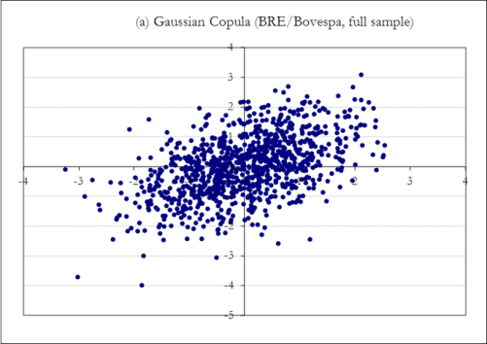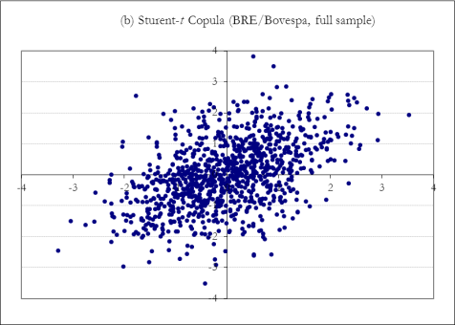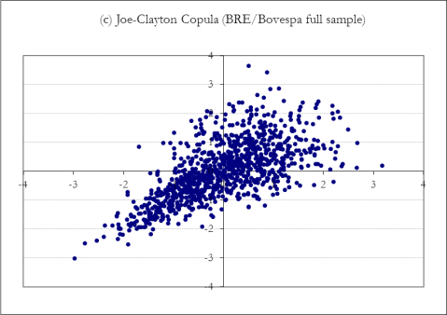
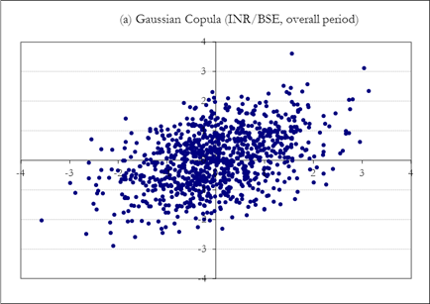
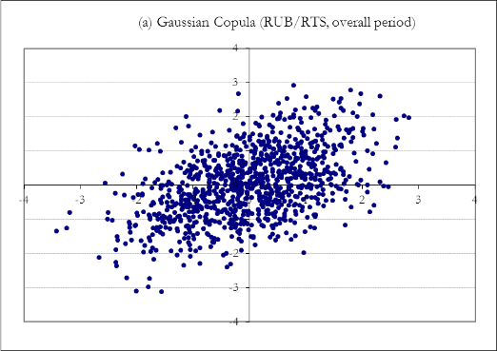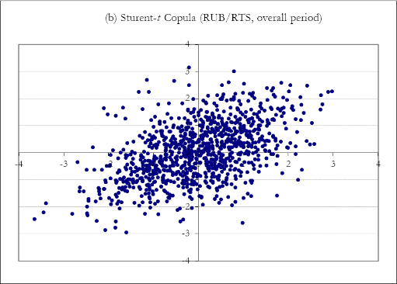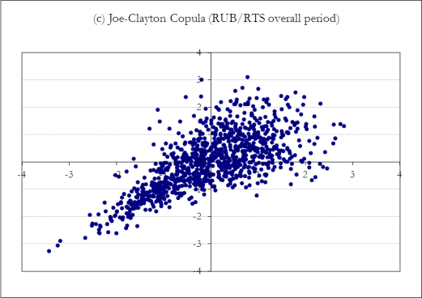
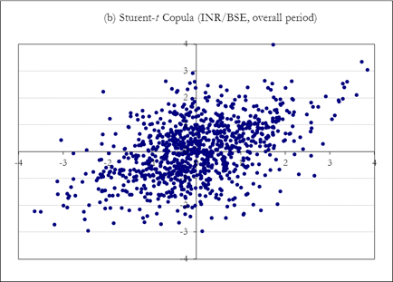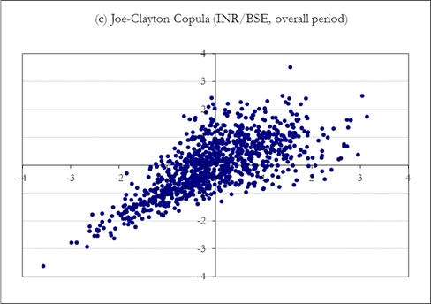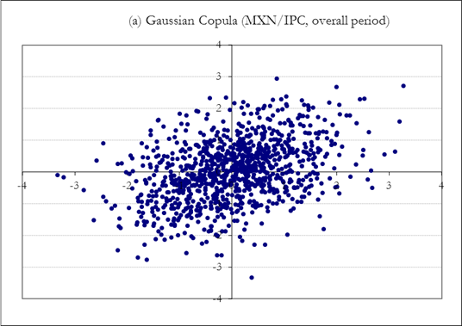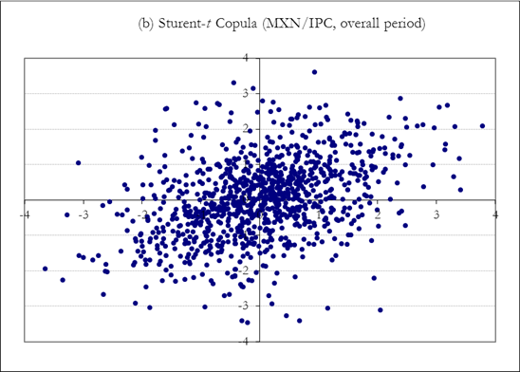
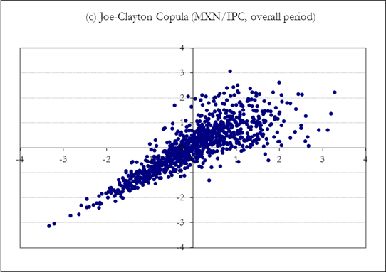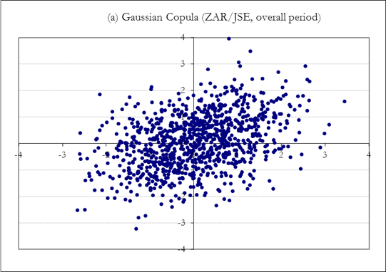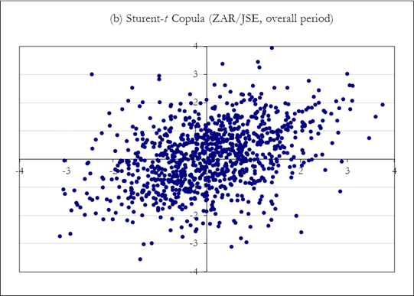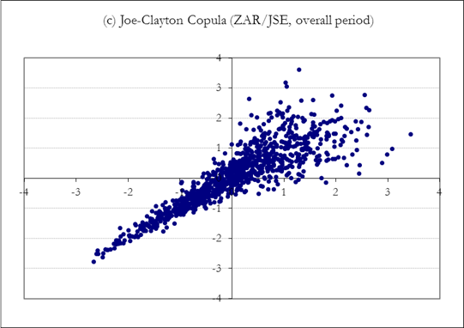

Figure 3. Copula Functions Observations for the crisis period.
This figure presents a sample of the results from the tests for symmetric and asymmetric copulas during the crisis period only.
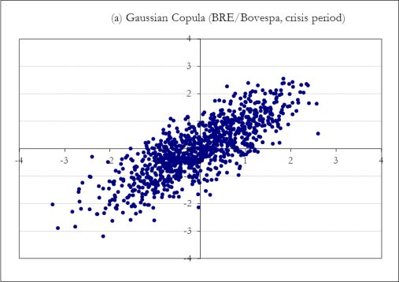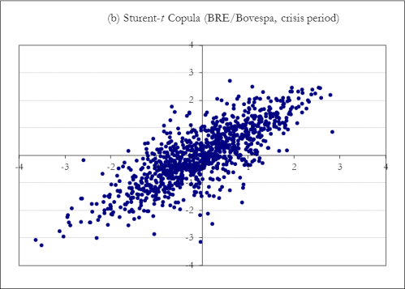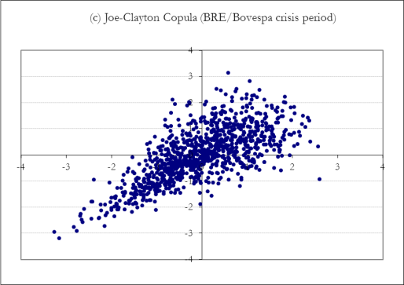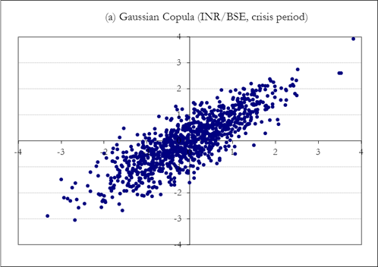
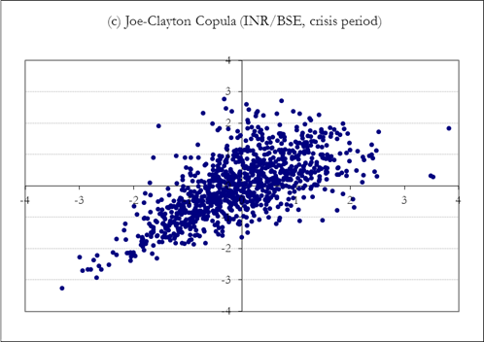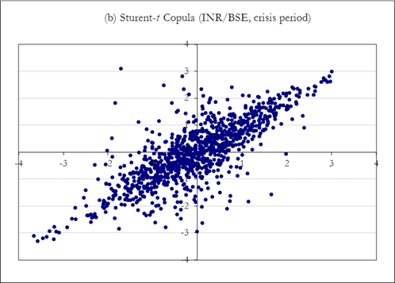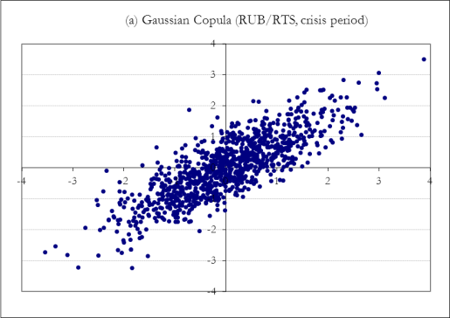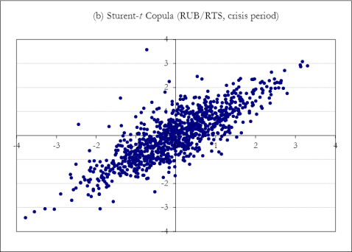
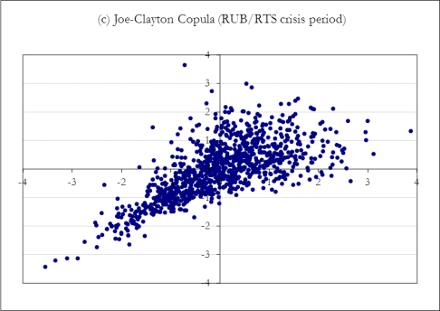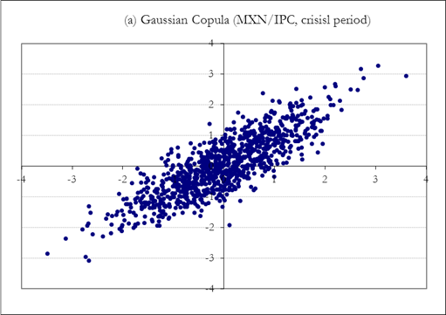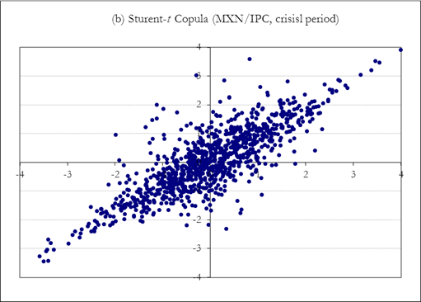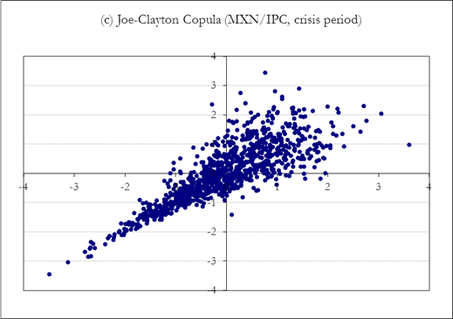

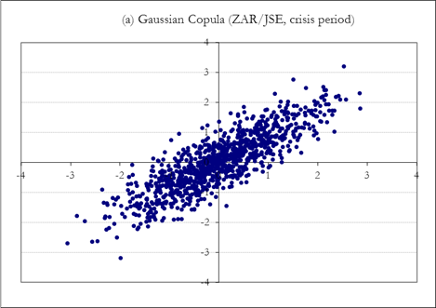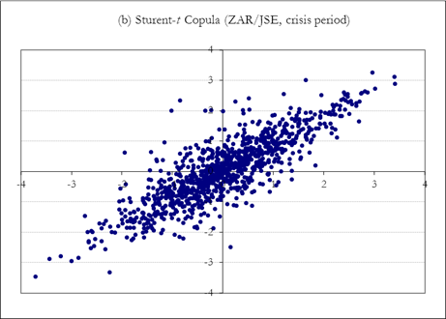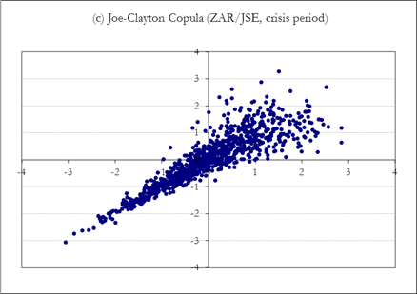
Figure 4. Copula Densities for the overall sample period.
Gaussian Copula Densities, BRE/S&P GSCI. Student –t Copula Densities, BRE/S&P GSCI. Joe-Clayton Copula Densities, BRE/S&P GSCI.
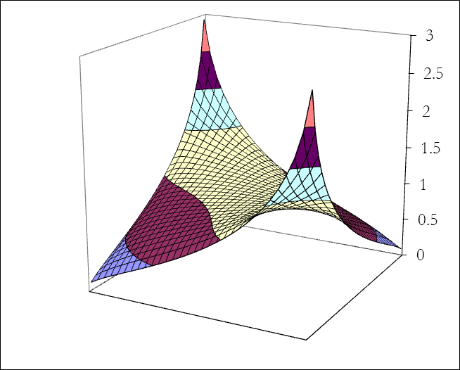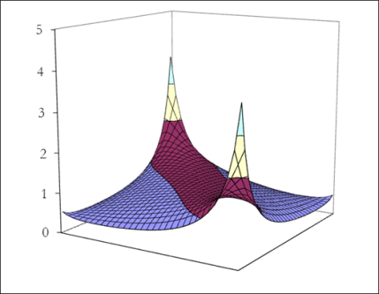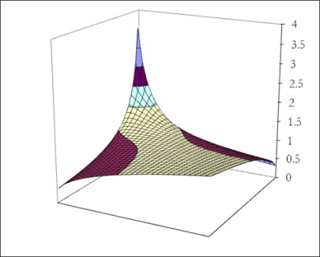

Figure 5. Copula Densities for the crisis period.
Gaussian Copula Densities, BRE/S&P GSCI. Student –t Copula Densities, BRE/S&P GSCI. Joe-Clayton Copula Densities, BRE/S&P GSCI.
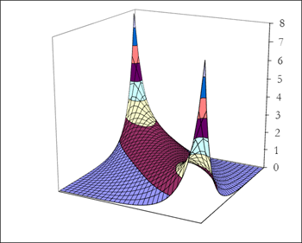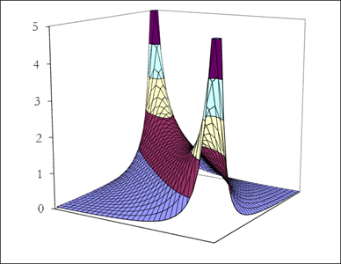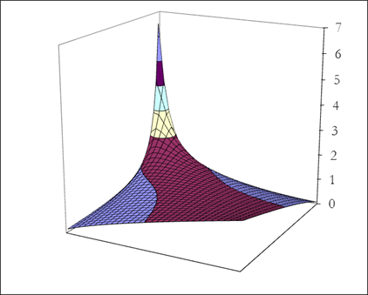

Figure 6. Comparison between Symmetrized Joe-Clayton (red line) and t- Copula (green line) for the model that fits best the data (blue line).
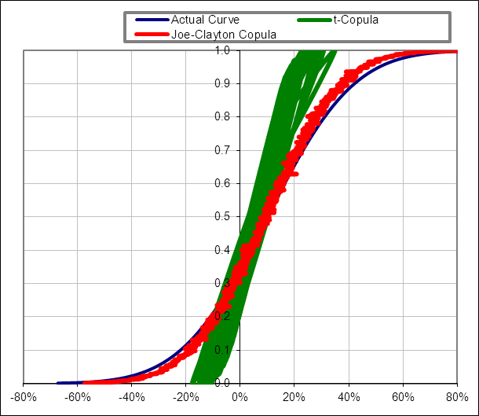
Table 1. Summary Statistics.
Variables | Obs | Mean | Median | Max | Min | Std | Skew | Kurt | JB | Prob
Brazilian Real | 2396 | 0.02 | -0.001 | 8.49 | -7.09 | 0.998 | 0.638 | 8.472 | 36763 | 0.0000
Russian Ruble | 2396 | 0.04 | 0.000 | 15.34 | -14.23 | 0.896 | 1.294 | 62.954 | 7812 | 0.0000
Indian Rupee | 2396 | 0.02 | 0.000 | 3.30 | -3.02 | 0.461 | 0.277 | 4.947 | 1610 | 0.0000
Mexican Peso | 2396 | 0.02 | -0.001 | 7.90 | -4.68 | 0.696 | 0.786 | 12.898 | 10911 | 0.0000
South African Rand | 2396 | 0.04 | 0.000 | 10.38 | -6.28 | 0.103 | 0.558 | 5.885 | 13247 | 0.0000
Vietnam Dong | 2396 | 0.01 | 0.000 | 7.18 | -0.79 | 0.209 | 18.289 | 533.786 | 18323 | 0.0000
Indonesian Rupiah | 2396 | 0.01 | 0.000 | 8.39 | -7.23 | 0.504 | 1.072 | 49.091 | 12940 | 0.0000
Thailand Baht | 2396 | 0.00 | 0.000 | 9.72 | -6.45 | 0.393 | 3.697 | 160.362 | 14982 | 0.0000
Malaysian Ringgit | 2396 | 0.01 | 0.000 | 1.98 | -3.47 | 0.417 | -0.290 | 4.976 | 9385 | 0.0000
Philippine Pisso | 2396 | 0.00 | 0.000 | 1.34 | -1.28 | 0.352 | 0.143 | 0.964 | 9224 | 0.0000
Bovespa | 2396 | 0.02 | 0.05 | 18.37 | -16.43 | 2.316 | 5.990 | 714.546 | 1316 | 0.0000
RTS | 2396 | 0.01 | 0.06 | 33.10 | -24.06 | 2.788 | 32.670 | 1473.853 | 4239 | 0.0000
BSE Sensex | 2396 | 0.04 | 0.00 | 20.98 | -11.22 | 1.757 | 41.544 | 1016.380 | 1918 | 0.0000
IPC | 2396 | 0.04 | 0.07 | 16.45 | -10.15 | 1.667 | 18.129 | 842.232 | 2005 | 0.0000
JSE Top 40 | 2396 | 0.03 | 0.09 | 13.85 | -12.05 | 1.889 | -4.841 | 519.640 | 713 | 0.0000
Vietnam VNI | 2396 | 0.03 | 0.00 | 4.82 | -7.26 | 1.552 | -12.558 | 136.221 | 3028 | 0.0000
Indonesia Jakarta Comp. | 2396 | 0.04 | 0.06 | 13.51 | -13.55 | 1.649 | -39.783 | 831.259 | 1825 | 0.0000
Thailand Bangkok SET | 2396 | 0.03 | 0.00 | 10.14 | -14.93 | 1.408 | -65.716 | 1035.051 | 2944 | 0.0000
Malaysia FTSE Bursa KLCI | 2396 | 0.02 | 0.00 | 5.35 | -10.44 | 0.968 | -44.443 | 772.675 | 2081 | 0.0000
Philippines Manilla Comp. | 2396 | 0.05 | 0.01 | 10.66 | -12.93 | 1.522 | -36.228 | 556.483 | 3728 | 0.0000
S&P GSCI | 2396 | -0.8204 | 5.15 | 10898 | 3116 | 1417 | -0.2271 | 4.53 | 1865 | 0.0000
VIX | 2396 | 0.0021 | 18.36 | 80 | 9.89 | 10.47 | 0.5491 | 17.11 | 26389 | 0.0000
BCDS | 2396 | 106 | 101 | 353 | 7.0 | 81.98 | 0.5518 | 2.50 | 131 | 0.0000
Note. This table presents summary statistics. All variables are expressed in U.S. dollar terms. The sample period is 22/03/2005 – 31/12/2015 and contains a total of 2396 daily observations.
Table 2
Correlation estimates of exchange rates and the four contagion channels.
PANEL A - Most Liquid Currencies
 | Variables | Overall Sample |  | Pre-Crisis Period |  | Crisis Period |  | Post Crisis Period
 |  | Kendall-τ | Spearman-ρ | Kendall -τ | Spearman-ρ | Kendall-τ | Spearman-ρ | Kendall-τ | Spearman-ρ
Brazilian | Bovespa | 0.103 | 0.115 | 0.071 | 0.076 | 0.127 | 0.155 | 0.091 | 0.097
Real | S&P GSCI | 0.104 | 0.120 | 0.073 | 0.088 | 0.136 | 0.171 | 0.088 | 0.093
 | VIX | -0.051 | -0.044 | -0.109 | -0.101 | 0.072 | 0.094 | 0.015 | 0.021
 | BCDS | -0.076 | -0.062 | -0.121 | -0.113 | 0.065 | 0.082 | 0.009 | 0.015
Russian | RTS | 0.131 | 0.167 | 0.103 | 0.117 | 0.201 | 0.274 | 0.082 | 0.098
Ruble | S&P GSCI | 0.166 | 0.179 | 0.127 | 0.154 | 0.214 | 0.303 | 0.080 | 0.088
 | VIX | -0.134 | -0.111 | -0.262 | -0.227 | 0.078 | 0.094 | 0.012 | 0.016
 | BCDS | -0.143 | -0.128 | -0.274 | -0.250 | 0.061 | 0.079 | 0.002 | 0.005
Indian | BSE Sensex | 0.135 | 0.166 | 0.121 | 0.135 | 0.217 | 0.311 | 0.060 | 0.073
Rupee | S&P GSCI | 0.097 | 0.140 | 0.089 | 0.126 | 0.185 | 0.214 | 0.041 | 0.061
 | VIX | -0.141 | -0.128 | -0.268 | -0.231 | 0.086 | 0.105 | 0.008 | 0.010
 | BCDS | -0.158 | -0.165 | -0.270 | -0.246 | 0.062 | 0.090 | 0.002 | 0.002
Mexican | IPC | 0.155 | 0.187 | 0.127 | 0.135 | 0.239 | 0.336 | 0.115 | 0.129
Peso | S&P GSCI | 0.071 | 0.085 | 0.071 | 0.080 | 0.159 | 0.203 | 0.039 | 0.051
 | VIX | -0.110 | -0.101 | -0.146 | -0.131 | 0.058 | 0.074 | 0.003 | 0.004
 | BCDS | -0.122 | -0.103 | -0.152 | -0.140 | 0.052 | 0.071 | -0.006 | -0.002
South | JSE Top 40 | 0.140 | 0.173 | 0.125 | 0.139 | 0.237 | 0.276 | 0.144 | 0.159
African | S&P GSCI | 0.073 | 0.088 | 0.051 | 0.063 | 0.119 | 0.138 | 0.067 | 0.082
Rand | VIX | -0.130 | -0.115 | -0.197 | -0.142 | 0.074 | 0.091 | 0.001 | 0.003
 | BCDS | -0.134 | -0.122 | -0.176 | -0.138 | 0.060 | 0.073 | 0.004 | 0.007

PANEL B - Asian Currencies
 | Variables | Overall Sample |  | Pre-Crisis Period |  | Crisis Period |  | Post Crisis Period
 |  | Kendall-τ | Spearman-ρ | Kendall -τ | Spearman-ρ | Kendall-τ | Spearman-ρ | Kendall-τ | Spearman-ρ
Vietnam | Vietnam VNI | 0.004 | 0.004 | 0.001 | 0.000 | 0.006 | 0.005 | 0.001 | 0.001
Dong | S&P GSCI | 0.029 | 0.028 | 0.002 | 0.001 | 0.031 | 0.029 | 0.001 | 0.002
 | VIX | -0.006 | -0.002 | -0.001 | -0.001 | -0.008 | -0.010 | -0.002 | -0.003
 | BCDS | -0.032 | -0.009 | -0.001 | -0.002 | -0.034 | -0.010 | -0.003 | -0.003
Indonesian | Jakarta Comp. | 0.081 | 0.040 | 0.001 | 0.001 | 0.091 | 0.044 | 0.001 | 0.004
Rupiah | S&P GSCI | 0.028 | 0.029 | 0.002 | 0.001 | 0.032 | 0.030 | 0.001 | 0.002
 | VIX | -0.039 | -0.030 | -0.001 | -0.001 | -0.141 | -0.031 | -0.001 | -0.001
 | BCDS | -0.042 | -0.032 | -0.002 | -0.001 | -0.167 | -0.033 | -0.002 | -0.002
Thailand | Bangkok SET | 0.055 | 0.001 | 0.001 | 0.001 | 0.061 | 0.002 | 0.000 | 0.002
Baht | S&P GSCI | 0.009 | 0.002 | 0.001 | 0.001 | 0.062 | 0.003 | 0.001 | 0.001
 | VIX | -0.011 | -0.005 | -0.002 | -0.001 | -0.022 | -0.009 | -0.003 | -0.001
 | BCDS | -0.085 | -0.009 | -0.003 | -0.001 | -0.094 | -0.020 | -0.003 | -0.001
Malaysian | FTSE Bursa | 0.004 | 0.003 | 0.003 | 0.000 | 0.005 | 0.004 | 0.001 | 0.000
Riggit | S&P GSCI | 0.009 | 0.003 | 0.002 | 0.000 | 0.012 | 0.004 | 0.001 | 0.002
 | VIX | -0.023 | -0.017 | -0.001 | -0.001 | -0.031 | -0.021 | -0.002 | -0.003
 | BCDS | -0.046 | -0.028 | -0.001 | -0.001 | -0.050 | -0.030 | -0.002 | -0.006
Philippine | Manilla Comp. | 0.008 | 0.002 | 0.001 | 0.002 | 0.010 | 0.002 | 0.001 | 0.001
Pisso | S&P GSCI | 0.010 | 0.003 | 0.001 | 0.002 | 0.013 | 0.004 | 0.002 | 0.003
 | VIX | -0.009 | -0.001 | -0.001 | -0.001 | -0.018 | -0.002 | -0.003 | -0.005
 | BCDS | -0.022 | -0.009 | -0.001 | -0.002 | -0.029 | -0.011 | -0.003 | -0.006
Note: This table summarizes Kendall’s τ and Spearman’s ρ rank correlation estimates for each exchange rate return pair. The sample is divided in four periods, the overall
period and three sub-periods, in order to show the effects of the recent credit crunch. Positive significance implies co-movements and dependence. All variables are
expressed in U.S. dollar terms. The sample period is 22/03/2005 – 31/12/2015 and contains a total of 2396 daily observations.

Table 3
Estimation of marginal models.
Variables | Intercept | AR1 | AR2 | ARCH1 | ARCH2 | GARCH1 | GARCH2 | JB test | DoF
Brazilian Real | 0.005 (0.012) | 0.042 (0.021) | 0.042 (0.018) | 0.053 (0.014) | 0.053 (0.140) | 0.922 (0.013) | 0.922 (0.013) | 0.0000 | 7
Russian Ruble | 0.004 (0.011) | 0.043 (0.021) | 0.043 (0.018) | 0.057 (0.014) | 0.057 (0.014) | 0.937 (0.012) | 0.937 (0.012) | 0.0000 | 5
Indian Rupee | 0.003 (0.106) | 0.043 (0.021) | 0.043 (0.018) | 0.041 (0.010) | 0.041 (0.011) | 0.928 (0.013) | 0.092 (0.013) | 0.0000 | 4
Mexican Peso | 0.002 (0.102) | 0.046 (0.021) | 0.046 (0.018) | 0.069 (0.014) | 0.069 (0.014) | 0.958 (0.010) | 0.958 (0.010) | 0.0000 | 7
South African Rand | 0.003 (0.104) | 0.047 (0.020) | 0.047 (0.019) | 0.068 (0.013) | 0.067 (0.013) | 0.959 (0.010) | 0.958 (0.010) | 0.0000 | 2
Bovespa | 0.049 (0.013) | 0.050 (0.023) | 0.050 (0.019) | 0.037 (0.007) | 0.037 (0.007) | 0.940 (0.011) | 0.940 (0.010) | 0.0000 | 6
RTS | 0.061 (0.013) | 0.051 (0.023) | 0.051 (0.019) | 0.043 (0.008) | 0.043 (0.080) | 0.958 (0.010) | 0.957 (0.010) | 0.0000 | 5
BSE Sensex | 0.052 (0.013) | 0.051 (0.023) | 0.051 (0.019) | 0.060 (0.013) | 0.060 (0.013) | 0.953 (0.010) | 0.953 (0.010) | 0.0000 | 4
IPC | 0.073 (0.014) | 0.053 (0.023) | 0.053 (0.019) | 0.073 (0.013) | 0.072 (0.013) | 0.963 (0.010) | 0.963 (0.010) | 0.0000 | 6
JSE Top 40 | 0.075 (0.014) | 0.056 (0.023) | 0.056 (0.019) | 0.082 (0.013) | 0.082 (0.013) | 0.972 (0.010) | 0.972 (0.009) | 0.0000 | 2
S&P GSCI | 0.048 (0.013) | 0.051 (0.023) | 0.050 (0.192) | 0.042 (0.008) | 0.041 (0.078) | 0.962 (0.010) | 0.961 (0.010) | 0.0000 | 7
VIX | -0.012 (0.022) | 0.043 (0.020) | 0.043 (0.185) | 0.036 (0.007) | 0.036 (0.006) | 0.914 (0.013) | 0.914 (0.013) | 0.0000 | 7
BCDS | -0.012 (0.022) | 0.041 (0.020) | 0.040 (0.019) | 0.035 (0.006) | 0.034 (0.006) | 0.912 (0.014) | 0.912 (0.013) | 0.0000 | 6
Note: This table presents the estimation of the AR(k)-t-GARCH (p,q) models for each foreign exchange return, with significant level at 5%. In parentheses are
the standard errors. DoF refers to the degrees of freedom of T distributions. All variables are expressed in U.S. dollar terms.
The sample period is 22/03/2005 – 31/12/2015 and contains a total of 2396 daily observations.

Table 4
Estimates of copula dependence parameters, overall sample.
 | Variables | Gaussian | Standard Error | Student-t | Standard Error | Joe-Clayton | Standard Error
Brazilian Real | Bovespa | 0.223 | 0.020* | 0.229 | 0.019* | 0.256 | 0.022*
 | S&P GSCI | 0.232 | 0.020* | 0.240 | 0.021* | 0.270 | 0.024*
 | VIX | -0.006 | 0.010 | -0.004 | 0.010 | -0.003 | 0.010
Russian Ruble | BCDS  RTS | -0.005  0.192 | 0.010  0.017 | -0.002  0.196 | 0.010  0.017 | -0.002  0.247 | 0.010  0.021*
 | S&P GSCI | 0.214 | 0.020* | 0.203 | 0.018 | 0.263 | 0.023*
 | VIX | -0.007 | 0.010 | -0.005 | 0.010 | -0.003 | 0.010
Indian Rupee | BCDS  BSE Sensex | -0.006  0.211 | 0.010  0.020* | -0.004  0.215 | 0.010  0.019* | -0.003  0.251 | 0.010  0.022*
 | S&P GSCI | 0.127 | 0.012 | 0.199 | 0.017 | 0.228 | 0.019*
 | VIX | -0.008 | 0.010 | -0.006 | 0.010 | -0.006 | 0.010
Mexican Peso | BCDS  IPC | -0.008  0.263 | 0.010  0.023* | -0.005  0.270 | 0.010  0.024* | -0.004  0.273 | 0.010  0.024*
 | S&P GSCI | 0.140 | 0.013 | 0.148 | 0.013 | 0.216 | 0.019*
 | VIX | -0.009 | 0.010 | -0.007 | 0.010 | -0.006 | 0.010
 | BCDS | -0.007 | 0.010 | -0.003 | 0.010 | -0.001 | 0.010
South African | JSE Top 40 | 0.239 | 0.021* | 0.242 | 0.022* | 0.282 | 0.025*
Rand | S&P GSCI | 0.222 | 0.019* | 0.227 | 0.019* | 0.237 | 0.020*
 | VIX | -0.006 | 0.010 | -0.004 | 0.010 | -0.004 | 0.010
 | BCDS | -0.008 | 0.010 | -0.007 | 0.010 | -0.006 | 0.010
Note: This table presents the estimated copula dependence parameters for the Gaussian, Student-t and Joe-Clayton copula functions for
the overall sample period. The symbol* indicates significance of coefficients at the 5% level. All variables are expressed in U.S. dollar
terms. The sample period is 22/03/2005 – 31/12/2015 and contains a total of 2396 daily observations.

Table 5
Estimates of copula dependence parameters, crisis period (08/2007 – 09/2009).
 | Variables | Gaussian | Standard Error | Student-t | Standard Error | Joe-Clayton | Standard Error
Brazilian Real | Bovespa | 0.227 | 0.020* | 0.253 | 0.022* | 0.311 | 0.030*
 | S&P GSCI | 0.241 | 0.021* | 0.267 | 0.023* | 0.320 | 0.031*
 | VIX | 0.222 | 0.020* | 0.227 | 0.020* | 0.317 | 0.030*
 | BCDS | 0.218 | 0.019* | 0.221 | 0.020* | 0.293 | 0.027*
Russian Ruble | RTS | 0.219 | 0.019* | 0.229 | 0.020* | 0.314 | 0.030*
 | S&P GSCI | 0.223 | 0.020* | 0.238 | 0.020* | 0.328 | 0.031*
 | VIX | 0.218 | 0.019* | 0.226 | 0.020* | 0.327 | 0.031*
 | BCDS | 0.216 | 0.019* | 0.224 | 0.010* | 0.259 | 0.022*
Indian Rupee | BSE Sensex | 0.224 | 0.020* | 0.231 | 0.020* | 0.308 | 0.029*
 | S&P GSCI | 0.219 | 0.019* | 0.226 | 0.020* | 0.281 | 0.026*
 | VIX | 0.237 | 0.020* | 0.244 | 0.021* | 0.295 | 0.027*
 | BCDS | 0.218 | 0.019* | 0.222 | 0.020* | 0.247 | 0.021*
Mexican Peso | IPC | 0.278 | 0.024* | 0.302 | 0.028* | 0.293 | 0.028*
 | S&P GSCI | 0.246 | 0.021* | 0.247 | 0.021* | 0.275 | 0.026*
 | VIX | 0.280 | 0.020* | 0.309 | 0.029* | 0.304 | 0.029*
 | BCDS | 0.218 | 0.019* | 0.226 | 0.020* | 0.260 | 0.023*
South African | JSE Top 40 | 0.250 | 0.022* | 0.295 | 0.028* | 0.342 | 0.033*
Rand | S&P GSCI | 0.234 | 0.020* | 0.242 | 0.021* | 0.256 | 0.022*
 | VIX | 0.243 | 0.021* | 0.266 | 0.023* | 0.305 | 0.029*
 | BCDS | 0.221 | 0.019* | 0.232 | 0.020* | 0.249 | 0.021*
Note: This table presents the estimated copula dependence parameters for the Gaussian, Student-t and Joe-Clayton copula functions for
the crisis period. The symbol * indicates significance of coefficients at the 5% level. All variables are expressed in U.S. dollar terms.

Table 6
Distance between empirical and estimated copulas.
 | Variables | Gaussian | P-Value | Student-t | P-Value | Joe - Clayton | P-Value
Brazilian Real | Bovespa | 0.042 | 0.041 | 0.038 | 0.039 | 0.031 | 0.035
 | S&P GSCI | 0.043 | 0.041 | 0.041 | 0.040 | 0.028 | 0.033
 | VIX | 0.049 | 0.047 | 0.047 | 0.045 | 0.041 | 0.040
 | BCDS | 0.049 | 0.047 | 0.047 | 0.045 | 0.042 | 0.041
Russian Ruble | RTS | 0.044 | 0.043 | 0.040 | 0.039 | 0.033 | 0.036
 | S&P GSCI | 0.045 | 0.044 | 0.040 | 0.039 | 0.034 | 0.037
 | VIX | 0.048 | 0.047 | 0.042 | 0.041 | 0.036 | 0.038
 | BCDS | 0.049 | 0.047 | 0.043 | 0.042 | 0.037 | 0.039
Indian Rupee | BSE Sensex | 0.050 | 0.049 | 0.042 | 0.041 | 0.032 | 0.035
 | S&P GSCI | 0.052 | 0.051* | 0.048 | 0.047 | 0.036 | 0.038
 | VIX | 0.052 | 0.051* | 0.047 | 0.045 | 0.035 | 0.038
 | BCDS | 0.054 | 0.052* | 0.050 | 0.049 | 0.049 | 0.047
Mexican Peso | IPC | 0.040 | 0.038 | 0.034 | 0.037 | 0.017 | 0.024
 | S&P GSCI | 0.049 | 0.047 | 0.048 | 0.047 | 0.045 | 0.044
 | VIX | 0.048 | 0.047 | 0.039 | 0.040 | 0.021 | 0.027
 | BCDS | 0.053 | 0.052* | 0.045 | 0.044 | 0.043 | 0.042
South African | JSE Top 40 | 0.040 | 0.038 | 0.031 | 0.035 | 0.014 | 0.023
Rand | S&P GSCI | 0.053 | 0.051* | 0.050 | 0.049 | 0.050 | 0.049
 | VIX | 0.050 | 0.049 | 0.045 | 0.044 | 0.046 | 0.045
 | BCDS | 0.055 | 0.054* | 0.052 | 0.051* | 0.050 | 0.049
Note: This table presents the distance between the empirical and the estimated copulas according to Cramer-Von Mises statistic. The
symbol * indicates the rejection of the copula model at the 5% level. All variables are expressed in U.S. dollar terms. The sample period is
22/03/2005 – 31/12/2015 and contains a total of 2396 daily observations.

Table 7
Tail dependence coefficients.
 | Variables | _{Overall Sample} |  | _{Pre-Crisis Period} |  | _{Crisis Period} |  | _{Post-Crisis Period}
 |  | λ_{l} | λ_{u} | λ_{l} | λ_{u} | λ_{l} | λ_{u} | λ_{l} | λ_{u}
Brazilian Real | Bovespa | 0.039 | 0.044 | 0.030 | 0.054 | 0.051 | 0.036 | 0.047 | 0.049
 | S&P GSCI | 0.042 | 0.046 | 0.039 | 0.057 | 0.050 | 0.025 | 0.046 | 0.031
 | VIX | 0.038 | 0.019 | 0.026 | 0.012 | 0.051 | 0.067 | 0.053 | 0.024
 | BCDS | 0.029 | 0.012 | 0.023 | 0.008 | 0.049 | 0.028 | 0.036 | 0.021
Russian Ruble | RTS | 0.042 | 0.045 | 0.037 | 0.059 | 0.051 | 0.039 | 0.042 | 0.044
 | S&P GSCI | 0.046 | 0.049 | 0.042 | 0.067 | 0.052 | 0.037 | 0.045 | 0.036
 | VIX | 0.037 | 0.018 | 0.029 | 0.008 | 0.050 | 0.053 | 0.041 | 0.021
 | BCDS | 0.032 | 0.014 | 0.026 | 0.005 | 0.050 | 0.034 | 0.046 | 0.025
Indian Rupee | BSE Sensex | 0.043 | 0.045 | 0.037 | 0.053 | 0.051 | 0.036 | 0.040 | 0.042
 | S&P GSCI | 0.034 | 0.030 | 0.031 | 0.038 | 0.049 | 0.022 | 0.032 | 0.030
 | VIX | 0.042 | 0.016 | 0.039 | 0.009 | 0.051 | 0.055 | 0.043 | 0.019
 | BCDS | 0.029 | 0.010 | 0.021 | 0.004 | 0.048 | 0.030 | 0.030 | 0.013
Mexican Peso | IPC | 0.049 | 0.048 | 0.046 | 0.055 | 0.050 | 0.041 | 0.049 | 0.045
 | S&P GSCI | 0.026 | 0.022 | 0.023 | 0.029 | 0.048 | 0.018 | 0.024 | 0.028
 | VIX | 0.048 | 0.037 | 0.045 | 0.013 | 0.051 | 0.058 | 0.047 | 0.034
 | BCDS | 0.023 | 0.012 | 0.018 | 0.003 | 0.048 | 0.013 | 0.029 | 0.026
South African | JSE Top 40 | 0.050 | 0.051 | 0.048 | 0.061 | 0.051 | 0.043 | 0.049 | 0.053
Rand | S&P GSCI | 0.028 | 0.030 | 0.024 | 0.032 | 0.048 | 0.027 | 0.026 | 0.029
 | VIX | 0.039 | 0.018 | 0.030 | 0.010 | 0.049 | 0.040 | 0.033 | 0.035
 | BCDS | 0.023 | 0.011 | 0.013 | 0.003 | 0.048 | 0.016 | 0.031 | 0.024
Note: This table presents the estimates of the lower and upper tail dependence parameters documented from the best fitting copula model for each currency pair.
The sample is divided into four categories: overall, pre-crisis, crisis and post-crisis periods in order to provide a better description for the effects of the credit crunch and
the change in the dependence in the pre and post-crisis periods. All variables are expressed in U.S. dollar terms. The sample period is 22/03/2005 – 31/12/2015 and
contains a total of 2396 daily observations.

Table 8
Estimates of Copula Dependence Coefficients with EGARCH specification.
 |  |  | Variables | EGARCH – overall period |  | EGARCH – crisis period
 |  |  |  | Student – t Copula | Joe-Clayton Copula | Student – t Copula | Joe-Clayton Copula
Brazilian Real |  | Bovespa |  | 0.143* | 0.167* | 0.159* | 0.186*
 | S&P GSCI |  |  | 0.152* | 0.189* | 0.203* | 0.238*
 | VIX |  |  | -0.005 | -0.002 | 0.205* | 0.243*
 | BCDS |  |  | -0.011 | -0.009 | 0.118* | 0.125*
Russian | RTS |  |  | 0.124* | 0.131* | 0.170* | 0.192*
Ruble | S&P GSCI |  |  | 0.146* | 0.173 | 0.202* | 0.245*
 | VIX |  |  | -0.007 | -0.005 | 0.206* | 0.248*
 | BCDS |  |  | -0.010 | -0.009 | 0.124* | 0.146*
Indian Rupee | BSE |  |  | 0.138* | 0.159 | 0.153* | 0.180*
 | S&P GSCI |  |  | 0.120* | 0.126* | 0.138* | 0.155*
 | VIX |  |  | -0.007 | -0.003 | 0.162* | 0.189*
 | BCDS |  |  | -0.009 | -0.008 | 0.126* | 0.132*
Mexican Peso | IPC |  |  | 0.157* | 0.184* | 0.196* | 0.243*
 | S&P GSCI |  |  | 0.113* | 0.117* | 0.128* | 0.135*
 | VIX |  |  | -0.013 | -0.008 | 0.201* | 0.284*
 | BCDS |  |  | -0.017 | -0.015 | 0.120* | 0.122*
South African | JSE Top 40 |  |  | 0.161* | 0.193* | 0.219* | 0.256*
Rand | S&P GSCI |  |  | 0.118* | 0.124* | 0.135* | 0.141*
 | VIX |  |  | -0.013 | -0.010 | 0.220* | 0.267*
 | BCDS |  |  | -0.029 | -0.018 | 0.112* | 0.116*
Note: This table presents the estimated Student-t and Joe-Clayton dependence coefficients using the alternative EGARCH specification. * indicates significance
at the 5% level. The sample is divided in two categories: overall and crisis period in order to provide a better description for the effects of the credit crunch. All
variables are expressed in U.S. dollar terms. The sample period is 22/03/2005 – 31/12/2015 and contains a total of 2396 daily observations.
Table 9
Hit Test.
 |  |  | Variables | Overall period |  |  |  | Crisis period
 |  |  |  | Gaussian copula |  | t-copula | Joe-Clayton Copula | Gaussian copula |  | t-copula | Joe-Clayton Copula
Brazilian Real |  | Bovespa |  | 0.0830 | 0.2528 |  | 0.3593 | 0.1434 | 0.2859 |  | 0.3750
 | S&P GSCI |  |  | 0.0872 | 0.2930 |  | 0.4580 | 0.1683 | 0.3657 |  | 0.4116
 | VIX |  |  | 0.0532 | 0.0766 |  | 0.1023 | 0.1095 | 0.3503 |  | 0.4059
 | BCDS |  |  | 0.0511 | 0.0604 |  | 0.0938 | 0.0857 | 0.1594 |  | 0.1993
Russian | RTS |  |  | 0.0923 | 0.3550 |  | 0.5076 | 0.1684 | 0.4039 |  | 0.5285
Ruble | S&P GSCI |  |  | 0.0980 | 0.3879 |  | 0.5892 | 0.1958 | 0.4768 |  | 0.6020
 | VIX |  |  | 0.0529 | 0.0720 |  | 0.1031 | 0.0909 | 0.3059 |  | 0.5003
 | BCDS |  |  | 0.0508 | 0.0624 |  | 0.7553 | 0.0753 | 0.1108 |  | 0.1387
Indian Rupee | BSE |  |  | 0.0821 | 0.3081 |  | 0.5020 | 0.1395 | 0.5391 |  | 0.6188
 | S&P GSCI |  |  | 0.0804 | 0.3005 |  | 0.3756 | 0.1108 | 0.3886 |  | 0.4205
 | VIX |  |  | 0.0523 | 0.0671 |  | 0.8990 | 0.9536 | 0.5049 |  | 0.6009
 | BCDS |  |  | 0.0511 | 0.0603 |  | 0.7014 | 0.7422 | 0.1052 |  | 0.1305
Mexican Peso | IPC |  |  | 0.1420 | 0.4412 |  | 0.6520 | 0.1953 | 0.6952 |  | 0.8536
 | S&P GSCI |  |  | 0.0528 | 0.1582 |  | 0.2057 | 0.1004 | 0.2209 |  | 0.2995
 | VIX |  |  | 0.0746 | 0.2540 |  | 0.3588 | 0.1582 | 0.3958 |  | 0.5098
 | BCDS |  |  | 0.0503 | 0.0627 |  | 0.0890 | 0.0829 | 0.1053 |  | 0.1759
South African | JSE Top 40 |  |  | 0.1552 | 0.7399 |  | 0.8009 | 0.2040 | 0.8938 |  | 0.9953
Rand | S&P GSCI |  |  | 0.0842 | 0.2427 |  | 0.3005 | 0.1105 | 0.2774 |  | 0.3590
 | VIX |  |  | 0.0506 | 0.6360 |  | 0.8523 | 0.1302 | 0.2039 |  | 0.5663
 | BCDS |  |  | 0.0501 | 0.5104 |  | 0.5949 | 0.08472 | 0.1053 |  | 0.1884
Note: This Table presents the p-values of the joint hit test. The sample is divided in two categories: overall and crisis period in order to provide a better description for the effects of the credit crunch. A number over 0.05implies that the model is well – specified in the region. All variables are expressed in U.S. dollar terms. The sample period is 22/03/2005 – 31/12/2015 and contains a total of 2396 daily observations.

We also use the 3 month Libor rate as a proxy for liquidity, however BCDS provide a better fit for the dependence structure with emerging currencies and hence we analyse the findings from this index in this study.
We also employ Extreme Value Theory (EVT) to capture downside tail risks in these currencies (built in a portfolio structure) and their interaction with other risk factors. The ability of EVT to fit the fat tailed returns’ distribution was poor (the p-value was low). Results are not presented due to space limitations, and are available upon request by the authors.
Periods of higher (lower) global financial risk are typically associated with higher (lower) borrowing spreads and hence credit default swaps’ prices tend to soar (decrease). See also Akinci (2013) for informative reading on this relationship.
Higher financial risk leads to lower economic activity, and thus lower demand for commodities (i.e. prices tend to decline).
More results for all hit tests are available upon request by the authors.
The simultaneous maximisation of the log-likelihood function is available upon request.

