Coal mining-derived ochres in the UK: a potential selenium trap
Liam A. Bullock^{1,2}, John Parnell¹, Magali Perez¹, Joseph G.T. Armstrong¹
¹University of Aberdeen, Dept. of Geology & Petroleum Geology, Meston Building, King’s College, Aberdeen, AB24 3UE, UK
²University of Southampton, Ocean and Earth Science, National Oceanography Centre, Southampton, SO17 1BJ, UK

Abstract
Thanks to the pioneering research of Professor Paul Younger over the past 20 years, acid mine drainage in the UK has become major environmental important issue. Acid mine drainage and hydro ferric oxide deposition are environmental hazards resulting from centuries of extensive coal mining activities across the UK. Oxidative weathering of pyrite in coal from spoil heaps and exposed bedrock can liberate trace elements, releasing them into local water systems. As well as posing an environmental threat through water and ground contamination, ochres can also act as a remediation material, trapping elements such as selenium. Trace elements with a close association to iron oxides, such as selenium, may fix to the fine grained ochre materials, resulting in hyper enriched ochres. Selenium in coals has been known to form an environmental issue in areas of North America, but is also an important commodity for solar cells and nanotechnologies. Coal-bearing areas of the UK such as Northumberland are known to contain high selenium content, and coal-derived ochres in these regions also contain significant selenium. These ochres trap selenium and become hyper concentrated, preventing the element from entering the environment. The widespread occurrence of ochres in UK coal mining regions may therefore present a unique ‘E tech’ trace element source, and prevent a toxicity problem that they were once thought to be responsible for.

UK coal mining legacy
The UK has a long, storied history of coal mining, dating as far back as medieval times, and peaking in the 19th and 20th centuries. However, since the 1960’s, the UK’s coal industry has been on the decline, culminating in the end of deep excavation mining in 2013. Despite this decline, there are still a number of operational opencast surface mines across the country, but perhaps a greater legacy is the extensive areas of excavation, pits and spoil left behind from centuries of coal extraction. Efforts have been made to restore land to areas of green space, housing and development, but the environmental consequences of intensive mining remain across coal mining regions. One such issue is polymetallic contamination from surface water run-off of former coal mines and spoil. The prolonged weathering of waste spoil heaps and coal-bearing bedrock, and subsequent oxidation of sulphides such as pyrite, has led to the development of acidic waters that drain into streams, rivers and standing water bodies (Fig. 1). These waters lead to the development and build-up of precipitated fine particles of hydro ferric oxide, commonly known as ochre, which turn the water and sediments a distinctive orange colour. Potentially toxic levels of metals in ochres derived from coal mines (as well as base metal mining sites such as Parys Mountain in North Wales; Fig. 1) pose a risk to surface and groundwater systems, vegetation and fish life. Historically, ochre streams and sediments have been intensively treated or buried in landfill in order to avoid ground and water contamination.
Much of our knowledge of the nature, extent and preventative strategies of minewater pollution in the UK came from the pioneering research of internationally-renowned hydrogeologist and environmental engineer Professor Paul Younger, who sadly passed away recently. Paul’s work has led to an increasing focus on contaminated minewater discharges and resultant ochre streams. Thanks to Paul, environmental issues relating to ochres are well established, and efforts have now been made to mitigate their threat. However, in the last 10 years, attention has been turned to the potential for ochres to be used as an ideal material for ground remediation projects. Ochres may act as a replacement for ferric sulphate in waste water treatment, and can be used as an iron oxide pigment due to its high iron oxide content. The Coal Authority has begun to find uses for thousands of tonnes of ochre to immobilise contaminants, such as arsenic, lead and cadmium. A trace element that is now a commodity of increasing importance is selenium, and may also be immobilised by ochres. Over recent years, selenium has become a critical ‘E tech’ element, used in alloys, photovoltaic products and nanotechnologies. Coal has been specifically identified as a promising source for future prospects by the UK Energy Research Centre, and pyrite has been noted as a potential source of economic interest for selenium. This is because selenium has a close chemical affinity to sulphur, found in pyrite and organic matter. As such, pyritic, organic-rich coals may contain significant amounts of selenium. Conversely, high selenium coals can pose environmental threat to local soils, surface and groundwater systems, and has affected coal mining regions such as West Virginia, and Elk Valley, British Columbia. Therefore, understanding how selenium concentrates in ochre deposits is of great economic and environmental importance to UK conservation and resource authorities, and warrants further investigation.

Selenium in coal and the environment
Selenium is a naturally occurring semi-metal that can be found in the majority of rocks and soils, though its abundance is typically low (0.05–0.09 ppm in the Earth’s crust as determined by Yudovich and Ketris, 2006). The name “selenium” comes from the Greek word “Selene” (the Greek goddess of the moon), and was was first discovered by Jöns Jakob Berzelius and Johan Gottlieb Gahn in 1817. Selenium occurs rarely in crystal form, and elemental selenium is often sourced as a trace element from copper sulphide refining operations.
The most common sedimentary rock types that contain elevated selenium content are organic-rich rocks, such as coal and black shale. In numerous studies, the world mean selenium content of coals has been estimated in the range of 1-3 ppm. Selenium is commonly held within sulphide minerals, such as iron pyrite, or bonds with organic matter. Selenium is immobile under reducing conditions, where oxygen is not freely available, so will remain fixed within sulphides or to organic matter. However, if rocks are exposed at the surface to the atmosphere and weathering processes, the change in conditions from reduced to oxidised (combining with oxygen) results in the separation of iron and sulphur, and selenium becomes highly mobile, transported in mine waters. Therefore, in regions where coals that contain high pyrite content are dumped or stockpiled, weathering of the pyrite can free and mobilise the selenium content. This results in the dissolution and movement of sulphur-, iron- and selenium-rich fluids from the coal. The iron and selenium remain dissolved while the waters are acidic, but when the water is neutralised, iron combines with oxygen to form a red-orange ochre precipitate. Selenium can bind to these ochres, so the presence of fine ochre precipitates may provide a natural trap for selenium-rich waters. There are a number of regions across the UK which host potentially selenium-rich Carboniferous Coal Measures and resultant weathered products, including extensive exposures across the Midlands, South Wales, the Midland Valley of Scotland and northern England (Figs. 1 and 3). For effective mitigation against the toxic hazards posed by mine water-derived selenium to the environment, it is important to understand how, why and where selenium concentrates from coal heaps to nearby stream and river systems.

A pilot study from Northumberland
An ideal case study area to investigate the liberation, transport and final residence of selenium in coal heaps and streams is in the coal mining region near south east Northumberland coast. Coal mining has taken place here since medieval times (both on land and under the seabed), and continues in the region to this day. The coals of Northumberland are Carboniferous in age (roughly 304 to 313 million years old), and are known to contain high concentrations of pyrite, rich in sulphur and selenium (documented by Turner and Richardson, 2004 and Bullock et al., 2018 in the International Journal of Coal Geology). The village of Lynemouth on the Northumberland coast (Fig. 3) was built close to coal mines, and is today the location for the coal-fired Lynemouth Biomass Power Station. The station burns 1,200,000 tonnes of coal a year, with a large coal tip next to the premises. This has led to the development of a natural ochre stream, visible by Google Earth imagery (Fig. 3), outflowing into the North Sea, with ochre coating the local sediments (Figs. 4-5).
In order to better understand how selenium moves from source to ochre, two coals (one containing abundance pyrite, one generally free of visible pyrite), and four extracted pyrite crystals were chemically analysed for their total selenium content. The selenium content of Lynemouth stream water and fine ochre sediment were also measured. The sampled coals were sampled from a spoil heap next to a local stream (connecting to the North Sea which is approximately 100 m to the east). The exposure of the coal to the oxygen and weathering processes of the atmosphere (Fig. 6) frees the sulphur, iron and selenium from the pyrite, which later precipitate to form fine ochre particles (in this instance, on beach quartz grains; Fig. 7a), as shown in the element maps in Fig. 7b-d.
Beach sediments alter to form new pyrite (Fig. 7e), or in some instances, baryte (barium sulphate mineral) or sphalerite (zinc sulphide; Fig. 7f). At the source, the Lynemouth coal which contained visible pyrite has a selenium content of 1.2 ppm, while the non-pyritic coal contains 0.8 ppm selenium. These values are quite low compared to mean world coal selenium contents (1-3 ppm), and are much lower than other Northumberland coals from the nearby Shotton opencast mine, where coals contain selenium of up to 65 ppm. The four measured pyrite crystals contain 6.4 to 13 ppm selenium. The Lynemouth stream water, which transports the dissolved elements, contains a low selenium concentration of 0.4 ppb. However, the eventual final residence of the selenium, the fine ochre sediment, contains a high content of 18.1 ppm. The anomalously high selenium content can be put into context by comparison with coals which are regarded as problematic because of their selenium content. For instance, the mean contents of coal in West Virginia, and Elk Valley, British Columbia, both of which are held responsible for environmental selenium contamination, are 3.6 ppm and 2.6 ppm respectively. However, ongoing monitoring and treatment programmes by the Coal Authority limit the threat posed to water and ground systems at former coal mining sites across the UK.
Results show a notable enrichment of selenium in the ochres at Lynemouth. This likely reflects the high selenium which may have once been held in the coals before exposure and weathering at the surface. The low concentrations of selenium in the coals (both with visible and non-visible pyrite) at Lynemouth may indicate that selenium has been freed from the pyrite due to oxygenation and weathering over a prolonged time period. Selenium is low in the stream water, but high in the ochre sediment, suggesting that selenium was liberated from the pyrite, transported by the stream, and then removed from the water and fixed to the ochre sediment. This case study shows that ochres can act as a sink for selenium (Fig. 8). Therefore, ochres may form an ideal material for immobilising selenium, similar to the Coal Authority operations aimed at fixing arsenic, lead and cadmium in land remediation projects. With former and operational coal mining sites, widely distributed ochres and local coal treatment facilities, areas of Northumberland such as Lynemouth may be a unique economic and environmentally beneficial opportunity for land remediation, and possibly a selenium source, particularly as demand continues to rise and means of efficient extraction improve.

Summary
Many former coal mining sites and spoil heaps across the UK host spatially extensive red-orange ochre deposits. Though these sites can pose an environmental threat due to containing toxic levels of trace element content, they have been adequately managed to prevent dangerous levels of ground and water contamination by UK authorities. In more recent years, the practical uses of ochres has been reviewed, and instead of causing environmental threats, they may in fact prevent them. Ochres can be used to immobilise trace elements, and can act as a sink for environmentally and economically important elements such as selenium. Selenium can be liberated from a pyritic coal source at the surface, and be transported to local water systems as a dissolved substance (Fig. 7). The high iron oxide content of ochres can trap and bind selenium, resulting in high concentrations in ochre sediments. Ochres can therefore act as ground remediation materials in coal mining areas of high selenium content, such as in Northumberland, and may provide a unique source of selenium for uses as a commodity in the years to come.

Acknowledgments
This research forms part of the NERC-funded Tellurium and Selenium Cycling and Supply (TeaSe) project, part of the Security of Supply of Mineral Resources programme (grant NE/L001764/1).

Suggestions for further reading
Bowell, R.J., Bruce, I., 1995. Geochemistry of iron ochres and mine waters from Levant Mine, Cornwall. Applied Geochemistry, 10, 237-250
Bullock, L.A., Parnell, J., Perez, M., Feldmann, J., Armstrong, J.G., 2017. Selenium and Other Trace Element Mobility in Waste Products and Weathered Sediments at Parys Mountain Copper Mine, Anglesey, UK. Minerals 7(11), 229.
Bullock, L.A., Parnell, J., Perez, M., Armstrong, J.G., Feldmann, J., Boyce, A., 2018. High selenium in the Carboniferous Coal Measures of Northumberland, North East England. International Journal of Coal Geology, 195, 61-74.
Turner, B.R., Richardson, D., 2004. Geological controls on the sulphur content of coal seams in the Northumberland Coalfield, Northeast England. International Journal of Coal Geology, 60, 169-196.
Younger, P.L., 1993. Possible environmental impact of the closure of two collieries in County Durham. Journal of the Institution of Water and Environmental Management 7, 521-531.
Younger, P.L., 1995. Hydrogeochemistry of mine waters flowing from abandoned coal workings in County Durham, UK. Quarterly Journal of Engineering Geology and Hydrogeology 28, S101-S113.
Younger, P.L., Bradley, K.M., 1994. Application of geochemical mineral exploration techniques to the cataloguing of problematic discharges from abandoned mines in north-east England. In: Reddish D.J. (ed) Proceedings of the 5th International Mine Water Congress, Nottingham, UK, International Mine Water Association 2, 857-871.
Younger, P.L., Jenkins, D.A., Rees, S.B., Robinson, J., Jarvis, A.P., Ralph, J., Johnston, D.N., Coulton, R.H., 2004. Mine waters in Wales: pollution, risk management and remediation. In: Nichol, D., Bassett, M.G., Deisler, V.K. (eds), Urban Geology in Wales. National Museums and Galleries of Wales Geological Series Number 23. Cardiff, September 2004. 138 – 154.
Younger, P.L., Potter, H.A.B., 2012. Parys in Springtime: Hazard Management and Steps Towards Remediation of the UK's Most Polluted Acidic Mine Discharge. In: 9th International Conference on Acid Rock Drainage (ICARD), 20th-26th May 2012, Ottawa, Canada.
Younger, P.L., Sherwood, J.M., 1993. The cost of decommissioning a coalfield: potential environmental problems in County Durham. Mineral Planning 57, 26-29.

Figures

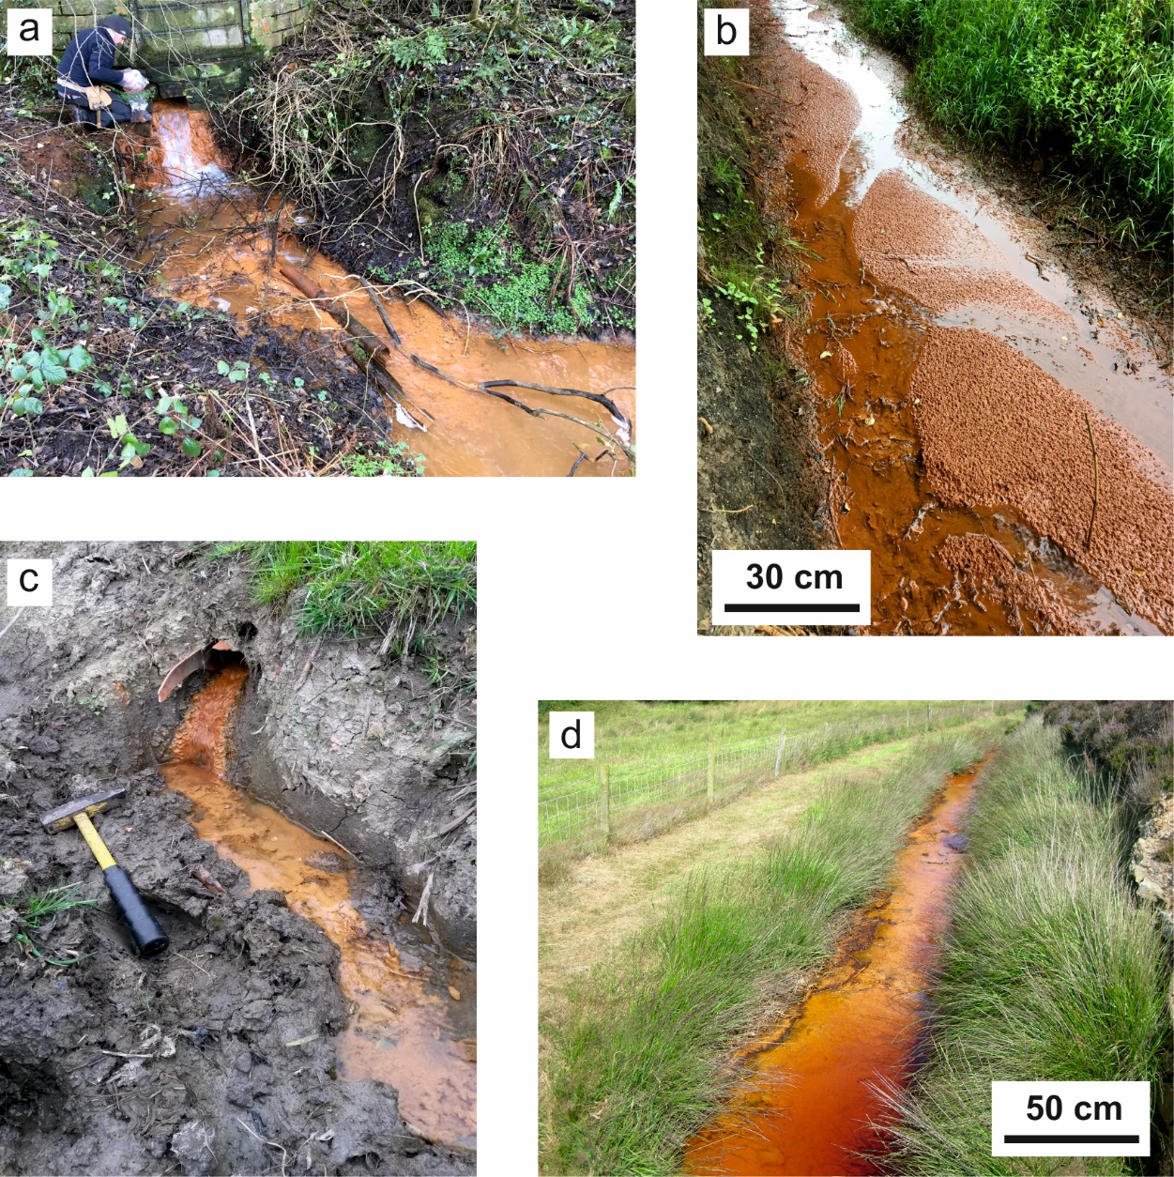
Fig. 1. Coal mining-derived ochre streams from (a) Flimby, Cumbria, (b) Talke, Staffordshire, and (c) Manor Powis, Stirling. (d) Ochre stream associated with copper mining at Parys Mountain, Anglesey.
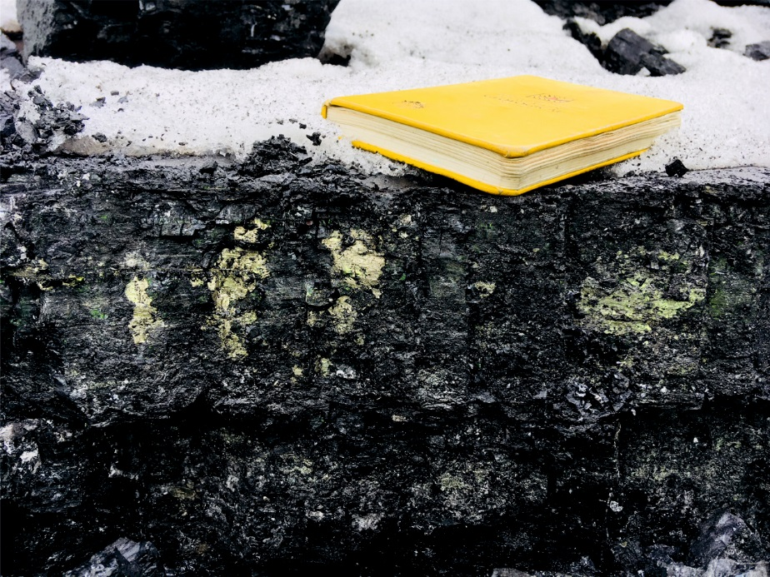
Fig. 2. Pyritic coal bedrock from the Shotton opencast site, Northumberland.

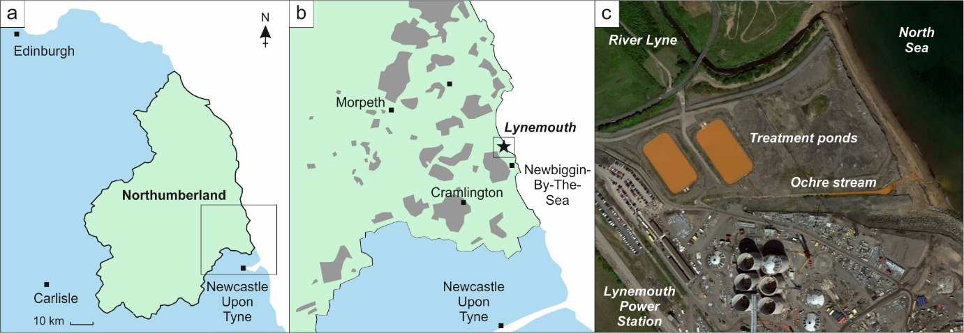
Fig. 3. (a) Northumberland, (b) the village of Lynemouth on the Northumberland coast (grey = coal subsurface workings and surface exposures), and (c) visible ochre stream and treatment works next to the Lynemouth Power Station (Google Earth image; Map data ©2018 Google).

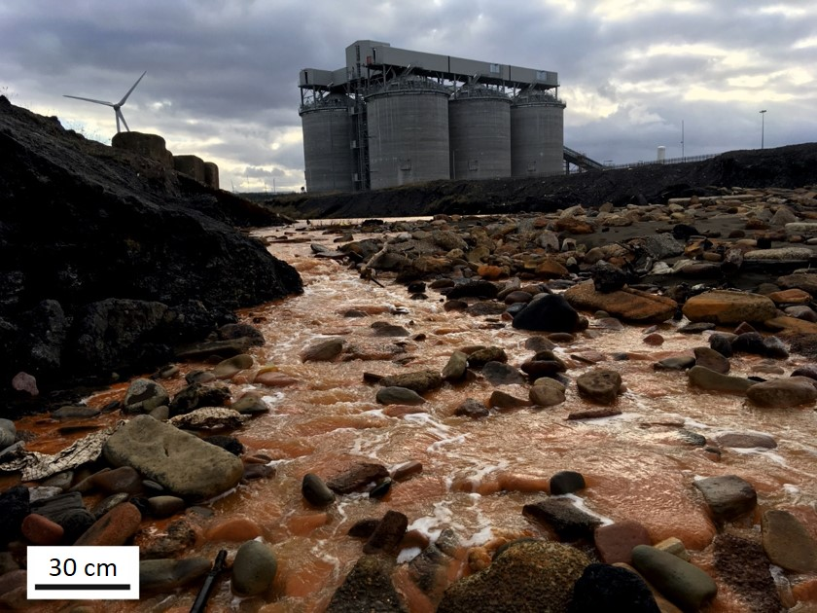
Fig. 4. Orange ochre run-off stream from coal tip (right side of image). Lynemouth Power Station in background.
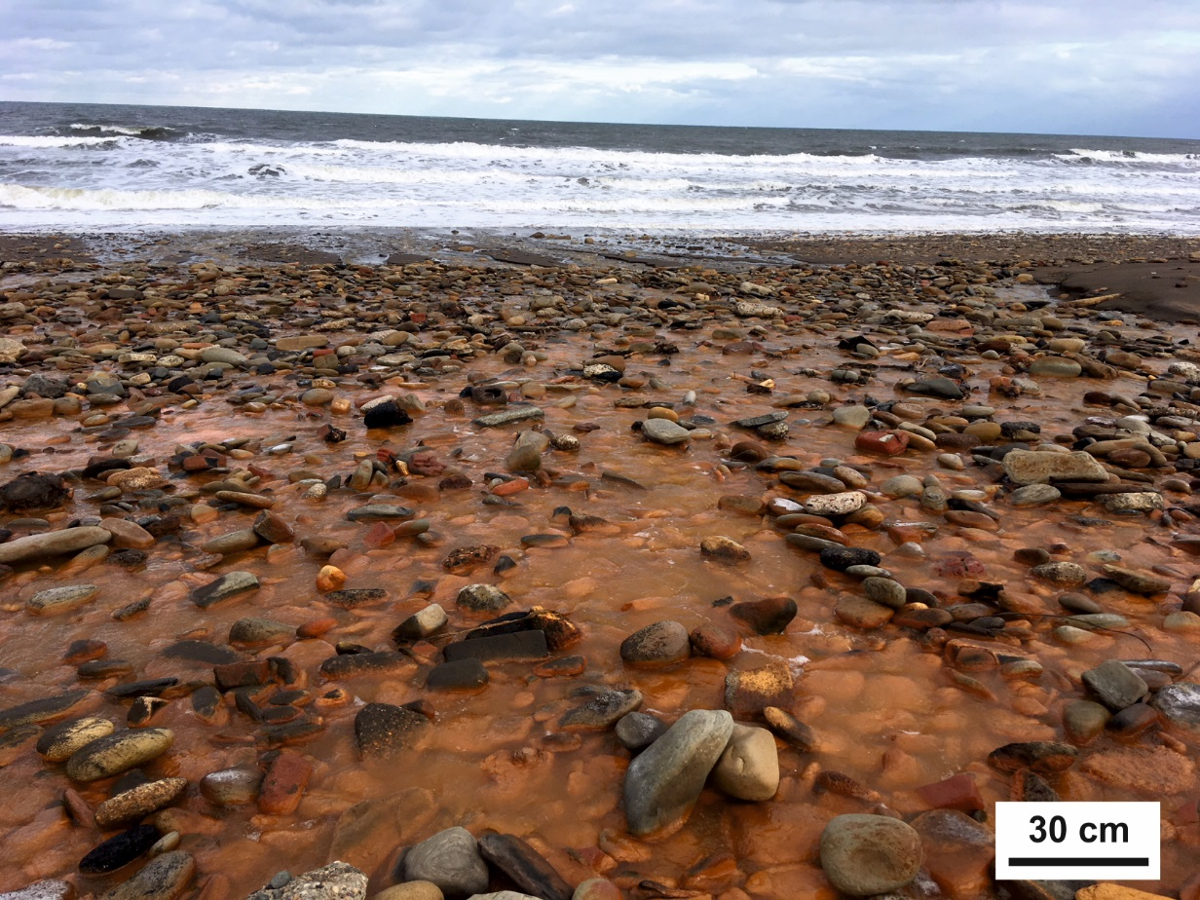
Fig. 5. Orange stained beach sands from iron-rich ochre material on Northumberland coast where the ochre stream enters the North Sea (background).
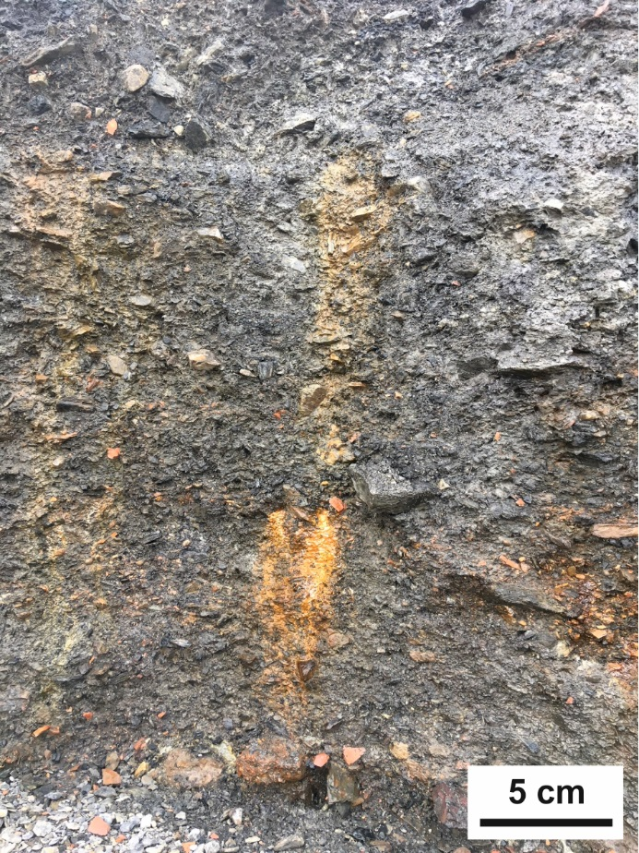
Fig. 6. Active seepage of orange acidic waters from coal tip.

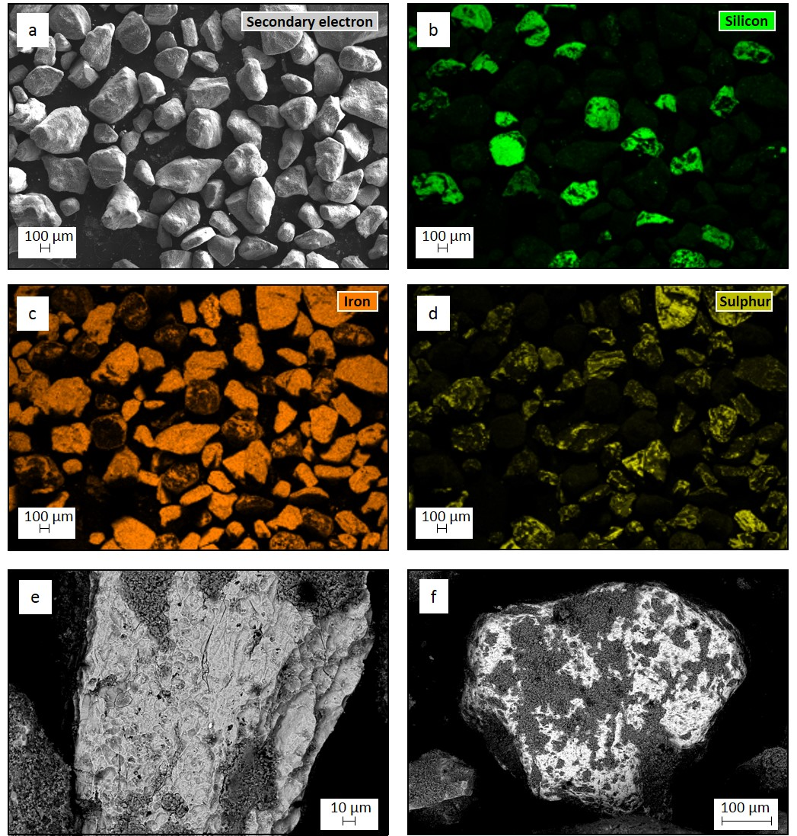
Fig. 7. Microscopic images of Lynemouth ochre sediment: (a) Altered beach quartz grains; (b) Unaltered quartz grains shown by green colour; (c) iron (orange) coating all grains; (d) sulphur (yellow) variably coating grains; (e) Altered quartz grain (light grey shows alteration to pyrite, darker grey patches are unaltered quartz); (f) altered quartz grain (light grey-white shows alteration to sphalerite, darker grey patches are unaltered quartz).

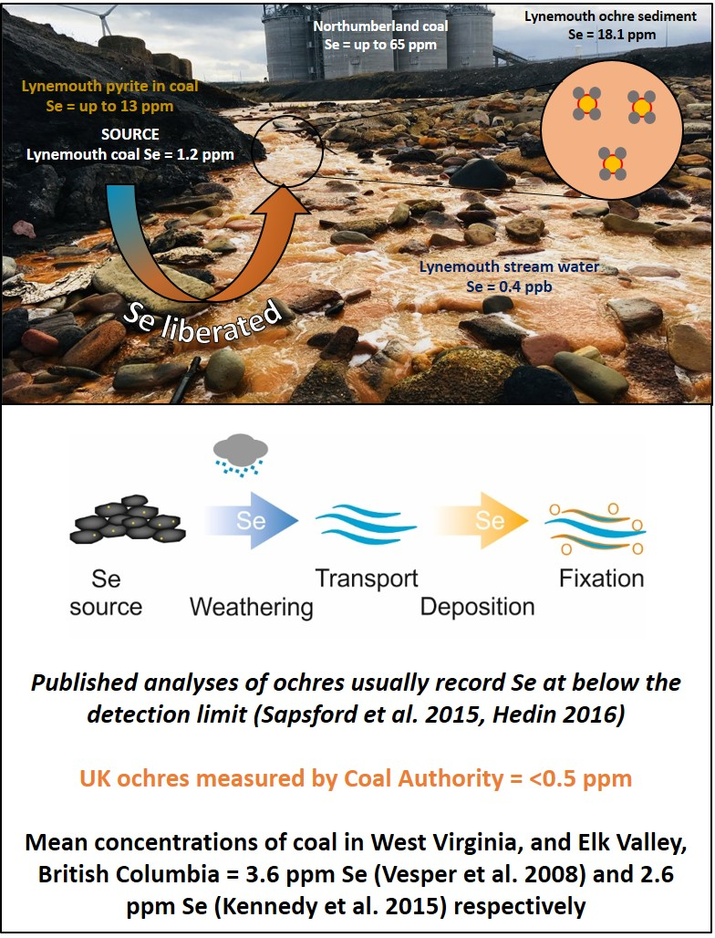
Fig. 8. Summary model of selenium liberation, transport and fixation from pyritic coal source to ochre materials.

