Was there a ‘Youthquake’ in the 2017 general election?

Patrick Sturgis, University of Southampton
Will Jennings, University of Southampton

Forthcoming in Electoral Studies (accepted 6th August 2019)

Abstract
Studies using data from the British Election Study and the British Social Attitudes survey have concluded that the case for a significant rise in turnout amongst young people at the 2017 general election remains unproven. A limitation of these data sets for assessing the so-called Youthquake thesis is the small number of younger voters they contain. In this research note we use data from the UK Household Longitudinal Survey to produce more robust estimates of turnout amongst people aged under thirty between the 2010, 2015, and 2017 general elections. Our findings support the claim that turnout increased markedly among voters in this age group in 2017. They also demonstrate that the increase in youth turnout was not specific to 2017 but, rather, represented a continuation of a change between 2010 and 2015. Our analysis confirms the heightened importance of age as a predictor of vote choice in 2017, with younger voters significantly more likely to vote Labour compared to 2010 and 2015.

Key words: elections, survey methodology, UK general elections

The UK’s 2017 ‘snap’ general election saw a substantial reconfiguration of party support during the short campaign from 18th April to Election Day on 8th June. From polling as low as 25% in mid-April, the Labour Party rose to as high as 40% in the final polls, an estimate that matched their actual vote share. While not historically unprecedented, such large shifts in voting preferences are rare during the course of British general election campaigns (Jennings, 2018).

Commentators have offered a variety of explanations for the surge in Labour support in 2017. These include disaffected Conservative Remainers switching to Labour (Bush 2017; Merrick 2017), weaknesses in the Conservative manifesto and campaign strategy – in particular the so-called ‘Dementia Tax’ (Heaven 2017; Hunt and Wheeler 2017), and tactical voting as a means of preventing the Conservatives winning by a landslide (Mellon and Prosser, 2017a). In the weeks after the election, however, the most widely held view was that Jeremy Corbyn had particularly appealed to young people, who were repelled by Theresa May’s strongly pro-Brexit, technocratic approach. By way of contrast, Labour’s ‘constructive ambiguity’ on Brexit, a focus on delivering a new kind of politics and policies targeted at younger voters such as scrapping tuition fees and subsidising rail travel led this group to turn out to vote at historically unprecedented levels – the so-called ‘Youthquake’ (Travis and Barr 2018).

The Youthquake theory was supported by an analysis of constituency level vote shares carried out shortly after the election by Heath and Goodwin (2017), who found the largest increases in turnout were situated in constituencies containing larger numbers of young people. This constituency level pattern was also noted by Curtice et al. (2018) although the relationship was largely explained in both studies by controlling for the size of the Leave vote, which was itself associated with lower turnout. Pre- and post-election polls conducted by The Stream for the music magazine NME (Morgan Britton 2017) and by Ipsos MORI also showed large increases in turnout amongst 18 to 30 year olds between the 2015 and 2017 elections. YouGov’s own polling, as well as polls it carried out for the Essex Continuous Monitoring Survey, provided further credence to the idea that there had been a large increase in voting amongst those aged under thirty (Clarke and Whiteley 2017). As these estimates all tallied with anecdotal evidence, such as Corbyn’s ecstatic reception at the Glastonbury music festival, the idea that Labour’s rapid electoral gains in 2017 were driven by young voters soon became established as conventional wisdom (see Mortimore (2018) for a review of data sources on turnout in the 2017 election).

The British Election Study (BES) team, however, were not convinced. In a widely reported study (Prosser et al. 2018), they showed that there was no relationship between the proportion of 18 to 30 year olds in a constituency and the level of increase in turnout, once controls were introduced for population density. Turnout just happened to have increased most in constituencies with more young people, and it could not be concluded from this constituency-level evidence that more young people had actually turned out to vote.

Prosser and colleagues also noted serious limitations of opinion polls for studying voting behaviour, particularly that they substantially over-estimate turnout. This is for two reasons. First, UK polls employ non-random sampling procedures which result in too few non-voters being included in the samples (Sturgis et al. 2016; 2017; Mellon and Prosser 2017b). Second, a substantial minority of respondents report having voted in surveys, when they in fact did not, as a result of recall error and pressure to conform to social norms of civic responsibility (Belli et al. 1999; Bernstein et al. 2001).

Prosser et al. (2018) undertook an individual-level analysis of turnout amongst young people using the 2015 and 2017 waves of the face-to-face BES. The BES is a post-election cross-sectional survey that has been fielded at every election since 1964. It adheres to the highest methodological standards, using face-to-face in-home interviewing and strict random sampling at all stages (Moon et al. 2017). The survey also includes a vote validation component, in which respondents’ turnout self-reports are cross-checked against electoral records. The match rate between respondent self-reports and validated votes was 90% in 2017, meaning there was little scope for mis-classification error affecting turnout estimates.

Using these higher quality data sets, Prosser et al. found no change in voting patterns for the under-30s between 2015 and 2017, concluding, “there is no evidence to suggest the relationship between age and turnout changed substantially between 2015 and 2017” (2018, p. 17). Indeed, for those aged 18-24, the BES actually showed a 5 point decline in turnout using the validated vote records, although this was not statistically significant. Independently, the same conclusion was drawn by Curtice and Simpson (2018) in their analysis of the 2015 and 2017 British Social Attitudes (BSA) survey, which also employs random sampling and face-to-face interviews. While the BSA showed a 5 point increase in turnout (from 56% to 61%) for the 18 to 24 group between 2015 and 2017, this was not statistically distinguishable from no change. In short, using the best data available at the time, there was little in the way of support for the Youthquake thesis.

However, while the quality of BES and BSA data sets is undoubtedly superior to opinion polls, they have a key weakness – the small sample sizes on which the comparisons between elections are based. For the BES, the validated vote samples for 18 to 24 year olds were 157 and 109 in 2015 and 2017 respectively, while the corresponding figures for self-report were 209 and 151. For the BSA, the 18 to 24 year old sample sizes were 289 in 2015 and 162 in 2017. These small samples mean that population parameters are imprecisely estimated and the probability of failing to reject a true null hypothesis of even quite substantial change in turnout between elections is high. For example, the BES has power of just 0.37 to detect an increase in turnout amongst 18 to 24 year olds from 50% in 2015 to 60% in 2017. This implies that in around two thirds of samples drawn using the BES design, nearly two thirds would find no statistically significant change in turnout even when turnout had in fact increased by ten percentage points. Indeed, the ‘noisy’ nature of the BES and BSA estimates is well illustrated by the fact that the BES finds a 5 point decline in turnout, while the BSA finds an increase of the same magnitude. In practice the true power of this test is likely to be even lower because complex features of the sample design such as weighting and clustering tend to increase sampling variance relative to a simple random sample of the same size (Sturgis 2004).

The UK Household Longitudinal Survey
In this research note, we use wave 8 of the UK Household Longitudinal Survey (UKHLS) to produce more precise estimates of change in turnout amongst young people between the 2010, 2015, and 2017 general elections. The UKHLS is a multi-purpose household panel survey covering topics such as health, work, education, income, family and social life, as well as political attitudes and voting (Scott and Jessop 2013). The survey has a stratified, multistage design with a sample of postcode sectors selected with probability proportional to size and households selected at random within each sector. All household members aged 16 and over are invited to provide an individual interview, with interviews carried out face-to-face in respondents’ homes using computer-assisted personal interviewing (CAPI). Hard-to-reach respondents are interviewed over the phone at the end of fieldwork in order to boost response rates. We use respondents from the UKHLS General Population sample only, dropping those from the Ethnic Minority Boost, Immigrant, and British Household Panel Survey sub-samples.

In UKHLS Waves 2, 7, and 8 (corresponding to the 2010, 2015 and 2017 general elections, respectively) respondents were asked whether they had voted in the most recent election and, if they had, which party they voted for. The number of 18 to 24 year olds who were asked the turnout question and provided a valid response was 1,897 in Wave 2, 1,363 in Wave 7, and 919 in Wave 8.

Figure 1 plots smoothed kernel-weighted local polynomial regression estimates of the relationship between age and turnout, with 95% confidence intervals, in each of the past three general elections. The dark blue line which represents turnout in 2017, is clearly and substantially higher for the youngest voters, aligning with 2015 turnout at around the age of 35. Interestingly, the figure also reveals a significant increase in turnout for voters aged under thirty between 2010 and 2015, a change which was also observed by Curtice and Simpson (2018) in their analysis of the British Social Attitudes survey time series. This suggests that the increase in turnout amongst younger voters in 2017 was a continuation of a broader secular trend, rather than a response to the specific context of the 2017 election.

FIGURE 1 HERE

The estimates in Figure 1 are unweighted, so do not account for the greater tendency of non-voters to drop out of the UKHLS over time. We therefore also compare turnout proportions within age-bands using a weighted estimator and Taylor-series linearization for variance estimation (Wolter 1985). The results, reported in Table 1, show there was an 9 point increase in turnout for 18-24 year olds and a 13 point increase for 25-29 year olds between 2015 and 2017, with both differences significant at the 95% level of confidence. Changes in turnout across the older age bands are smaller in magnitude and none is statistically significant. Table 1 also confirms the pattern evident in Figure 1 for changes in turnout between 2010 and 2015; there was a statistically significant 9 point increase for the 18-24 year old age group, although for 25-29 year olds the increase was only 3 percentage points, a non-significant difference.

This increase in turnout amongst the under thirties, combined with the greater tendency of young people to vote Labour in 2017, means that the party drew particularly heavily on the support of younger voters in this election. This can be seen in Figure 2, which plots smoothed kernel-weighted local polynomial regression estimates of voting Labour by age in each of the three elections. Strikingly, the probability of someone in their early 20s voting Labour was approximately 60% in 2017, compared to 40% in 2015 and only 30% in 2010. It is thus clear that the combination of increased turnout and a large swing towards Labour among younger voters was consequential in the final result, though was just one of the factors that contributed to Labour’s surge.

FIGURE 2 HERE

Discussion
In this note, we have sought to bring additional high quality evidence to bear on the question of whether turnout amongst young people exhibited a marked increase in the 2017 general election. Our analysis of the UKHLS supports the conclusion that it did, with turnout increasing by 9 percentage points for voters aged under 25 and by 13 points for those aged 25 to 29. Because the UKHLS has a very large sample size these estimates are precisely estimated, so it is unlikely that these differences have arisen due to sampling variability. Our analysis also shows that the increase in turnout amongst younger people was not specific to 2017 but, rather, represented a continuation of a change between 2010 and 2015, where turnout amongst the youngest voters also increased by 9 percentage points. Curtice and Simpson (2018) have shown, using the British Social Attitudes survey, that turnout amongst the youngest voters saw a similar level of increase between 2005 and 2010, a trend which itself is associated with increasing levels of political interest and engagement amongst younger voters (their estimate is of an 18 percentage point increase in youth turnout since 2001). Thus, it would seem that rather than being a specific reaction to the particular context of the 2017 general election, and indeed to Jeremy Corbyn, the unusually high levels of voting amongst younger people in fact represented the continuation of a broader secular trend.

While our attention in this note has been on sample size as the driver of differences in estimates of turnout between the available random probability surveys, we cannot rule out the possibility that some of the difference may also arise from differential nonresponse between the studies. In particular, some of the observed increase in turnout over time may have arisen due to attrition of non-voting young people from the UKHLS across waves. However, while nonresponse bias might in principle be the cause of some of the apparent increase in turnout, this must be weighed against the fact that the between wave response rates for the UKHLS are high and the turnout estimates we have presented are weighted to correct for nonresponse and attrition. We do not, therefore, consider differential nonresponse to be a compelling counter explanation for the turnout changes that we have presented.

The UKHS is not without limitations of its own of course, in addition to those relating to representativeness discussed above. Notably, this includes the use of self-reported turnout rather than validated vote. The survey over-estimates turnout at each of the past three general elections by around ten percentage points, which is no doubt a combination of nonresponse bias and respondent over-reporting. Nevertheless, there are no strong grounds to assume that these errors vary substantially over time. Which is to say that, while the levels of estimated turnout may be too high at each election, we assume that changes in these levels are not subject to systematically different errors. This assumption would be violated if social norms of voting for young people shifted across elections, with more social pressure to report having voted in the later elections. This is at least prima facie plausible in 2017, given the prominence of support for Labour amongst younger voters in media reports of the campaign. However, the vote validation exercises carried out by the British Election Study at the 2010, 2015, and 2017 reveal no evidence of systematic change in over-reporting between these elections, albeit that these estimates are also imprecise due to the small sample size of over-reporters at each election. And while the moniker ‘Youthquake’ no doubt overstates the level of increase, the evidence we have presented here suggests that 2017 did witness a marked increase in turnout amongst young people combined with a large swing towards Labour in that group. These findings hold broader implications for our understanding of the likely shape of future elections in the United Kingdom. While younger people remain considerably less likely to vote than those from older cohorts, the turnout gap has been closing progressively over successive elections, since at least 2010. Evidence of a long-term trend of rising electoral participation combined with the habit-forming effects of voting early in life points to the potential for younger voters to be more electorally lucrative for political parties in the future.

References
Belli, R. Traugott, M. Young, M. and McGonagle M. (1999). ‘Reducing Vote Overreporting in Surveys: Social Desirability, Memory Failure, and Source Monitoring.’ Public Opinion Quarterly 63(1): 90-108.
Bernstein, R., Chadha, A., and Montjoy, R. (2001). ‘Overreporting Voting.’ Public Opinion Quarterly 65(1): 22-44.
Bush, S. (2017). ‘How Remainers cost Theresa May her majority in the 2017 election.’ The New Statesman, 24 October 2017. https://www.newstatesman.com/2017/10/how-remainers-cost-theresa-may-her-majority-2017-election
Curtice, J., Fisher, S.D., Ford, R., and English, P. (2018). ‘An Analysis of the Results.’ In P. Cowley and D. Kavanagh (Eds.), The British General Election of 2017, pp. 449-495. London: Palgrave Macmillan.
Curtice, J. and I. Simpson (2018). Why Turnout Increased in the 2017 General Election And The Increase Did Not Help Labour. NatCen Social Research, London.
Gerber, A.S., Green, D.P., and Shachar, R. (2003). ‘Voting May Be Habit‐Forming: Evidence from a Randomized Field Experiment.’ American Journal of Political Science 47: 540-550.
Heath, O. and Goodwin, M. (2017). ‘The 2017 General Election, Brexit and the Return to Two‐Party Politics: An Aggregate‐Level Analysis of the Result.’ The Political Quarterly 88(3): 345-358.
Heaven, W. (2017). ‘How the dementia tax – a ‘nasty party’ policy – lost Theresa May her majority.’ The Spectator, 10 June 2017. https://blogs.spectator.co.uk/2017/06/dementia-tax-nasty-party-policy-lost-theresa-may-majority/
Hunt, A., and Wheeler, B. (2017). ‘'Theresa May: 10 reasons why the PM blew her majority.’ BBC News, 14 June 2017. https://www.bbc.co.uk/news/election-2017-40237833
Jennings, W. (2018). ‘The Polls in 2017’ in Dominic Wring, Roger Mortimore & Simon Atkinson (eds.) Political Communication in Britain: Campaigning, Media and Polling in the 2017 General Election. Basingstoke: Palgrave Macmillan.
Lynn, P. and Kaminska, O. (2010). Weighting strategy for Understanding Society, Understanding Society Working Paper 2010-05. Colchester: University of Essex
Mellon, J., Evans, G., Fieldhouse, E., Green, J. and Prosser, C. (2018) ‘Brexit or Corbyn? Campaign and Inter-Election Vote Switching in the 2017 UK General Election.’ Parliamentary Affairs 71(4): 719-737.
Merrick, R. (2017). ‘Remain voters destroyed Tory majority by flocking to Labour as 'best bet' to stop a hard Brexit, finds study.’ The Independent, 1 August 2017. https://www.independent.co.uk/news/uk/politics/remain-voters-tory-majority-election-labour-hard-brexit-conservatives-leave-eu-talks-minority-jeremy-a7871541.html
Morgan Britton, L. (2017). ‘Here’s the NME exit poll of how young people voted in 2017 General Election.’ NME, 9 June 2017. https://www.nme.com/news/nme-exit-poll-young-voters-2017-general-election-2086012
Mellon, J. and Prosser, C. (2017a). ‘Mainstream Protest Voting: Did Voters Choose Brexit and Corbyn because they expected them to lose? (August 2, 2017b). Available at SSRN: https://ssrn.com/abstract=3012739 or http://dx.doi.org/10.2139/ssrn.3012739
Mellon, J. and Prosser, C. (2017b). ‘Missing Nonvoters and Misweighted Samples: Explaining the 2015 Great British Polling Miss.’ Public Opinion Quarterly 81(3), 661-687.
Moon, N., Green, A., and Bogdan, A. (2017). British Election Study 2017: Technical Report. British Election Study/GfK. https://www.britishelectionstudy.com/wp-content/uploads/2018/01/GfK-BES2017-technical-report.pdf
Prosser, C., Fieldhouse, E.A., Green, J., Mellon, J., and Evans, G. (2018). ‘Tremors But No Youthquake: Measuring Changes in the Age and Turnout Gradients at the 2015 and 2017 British General Elections.’ Available at SSRN: https://ssrn.com/abstract=3111839.
Sturgis, P. (2004). ‘Analysing Complex Survey Data: Clustering, Stratification and Weights.’ Social
Research Update 43. Available at http://sru.soc.surrey.ac.uk/SRU43.html
Sturgis, P., Baker, N., Callegaro, M., Fisher, S., Green, J., Jennings, W., Kuha, J., Lauderdale, B., and Smith, P. (2016). Report of the Inquiry into the 2015 British general election opinion polls. London: Market Research Society/British Polling Council.
Sturgis, P., Baker, N., Callegaro, M., Fisher, S., Green, J., Jennings, W., Kuha, J., Lauderdale, B., and Smith, P. (2018). ‘An assessment of the causes of the errors in the 2015 UK General Election opinion polls.’ Journal of the Royal Statistical Society: Series A 181(3): 757-781.
Travis, A., and Barr, C. (2017). ‘'Youthquake' behind Labour election surge divides generations.’ The Guardian, 20 June 2017. https://www.theguardian.com/politics/2017/jun/20/youthquake-behind-labour-election-surge-divides-generations
Whiteley, P., and Clarke, H.D. (2017). ‘Understanding Labour’s ‘youthquake’.’ The Conversation, 3 July 2017. https://theconversation.com/understanding-labours-youthquake-80333.
Wolter K.M. (1985). Introduction to Variance Estimation. New York: Springer-Verlag.

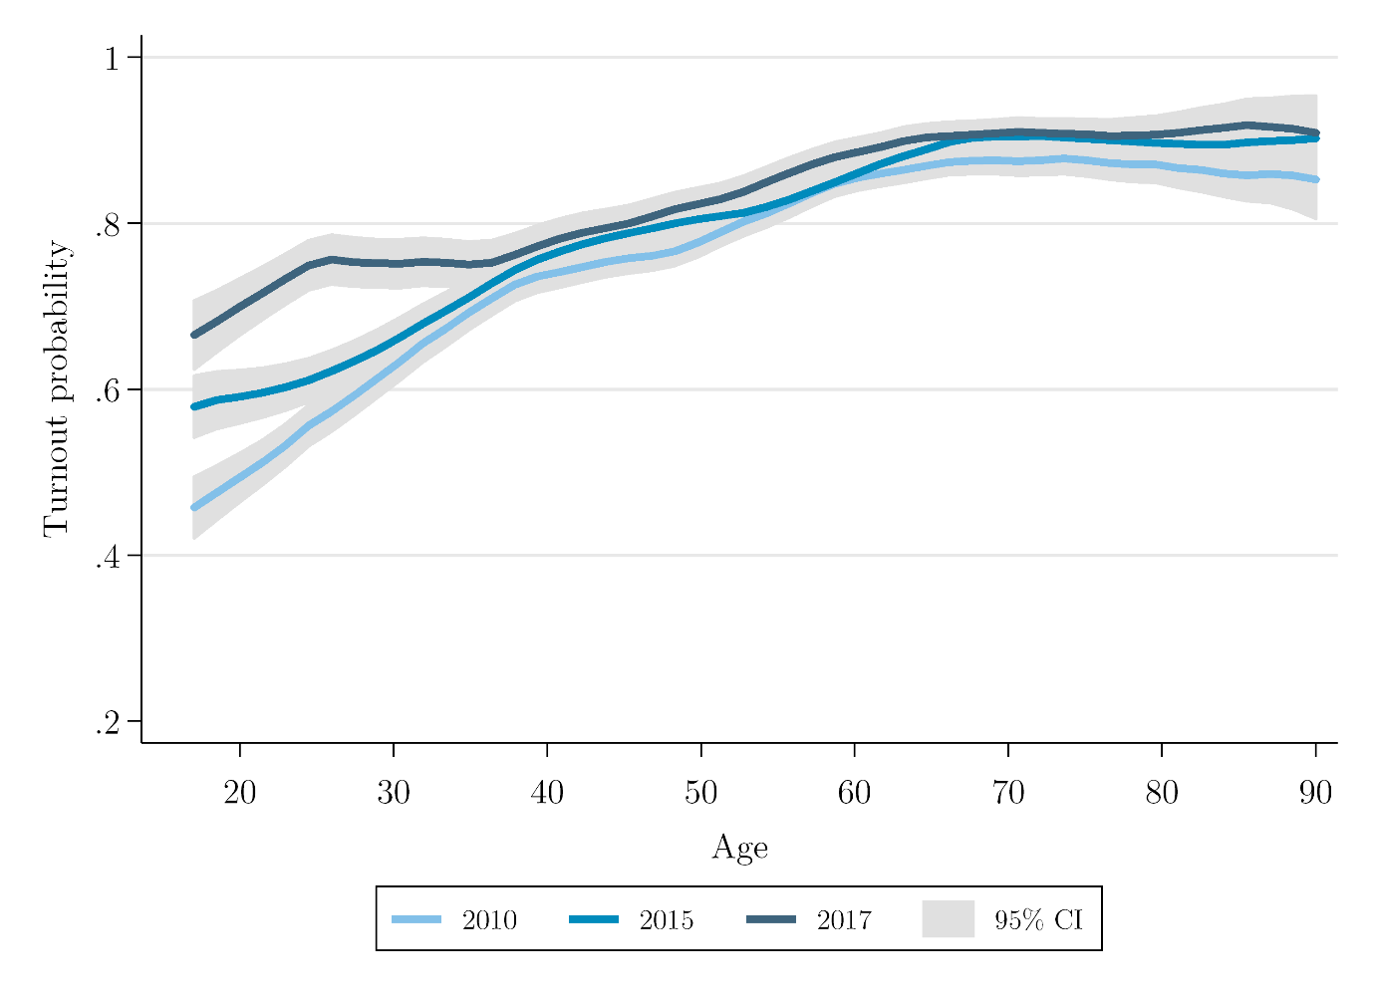
Figure 1. Nonparametric smoothed local polynomial regression probability of turnout by age in years, UKHLS Waves 2, 7 & 8

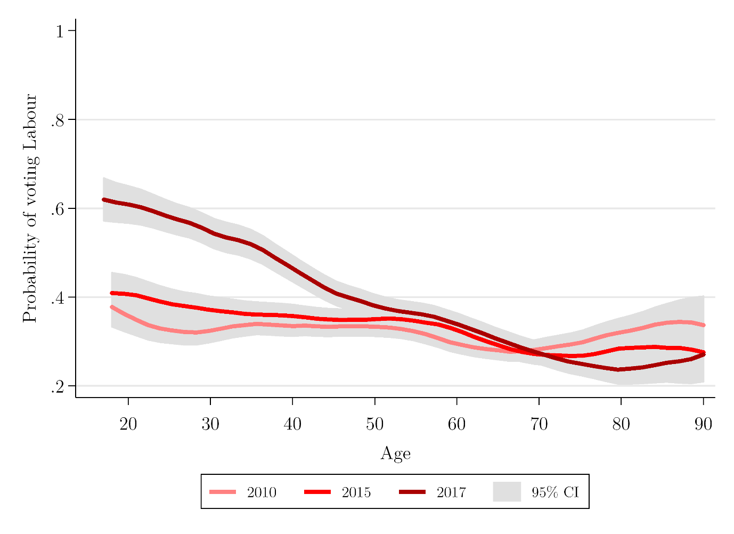
Figure 2. Nonparametric smoothed local polynomial regression probability of Labour vote by age in years, UKHLS Waves 2, 7 & 8

Table 1. UKHLS turnout estimates by age group: 2010, 2015, and 2017 elections using 18-24 age band
 |  | 2010 |  |  | 2015 |  |  | 2017
Age group | Turnout | L95%CI | U95%CI | Turnout | L95%CI | U95%CI | Turnout | L95%CI | U95%CI
18-24 | 51% | 48% | 53% | 60% | 56% | 63% | 69% | 64% | 74%
25-29 | 57% | 54% | 60% | 60% | 56% | 65% | 73% | 65% | 79%
30-34 | 63% | 60% | 66% | 67% | 63% | 71% | 72% | 66% | 78%
35-39 | 71% | 68% | 74% | 74% | 71% | 78% | 77% | 72% | 81%
40-44 | 75% | 72% | 77% | 76% | 73% | 79% | 75% | 69% | 80%
45-49 | 77% | 74% | 79% | 80% | 76% | 82% | 81% | 77% | 85%
50-54 | 78% | 76% | 80% | 80% | 78% | 82% | 82% | 78% | 86%
55-59 | 84% | 82% | 86% | 81% | 79% | 84% | 86% | 82% | 89%
60-64 | 85% | 83% | 87% | 86% | 84% | 88% | 89% | 85% | 92%
65+ | 85% | 83% | 86% | 89% | 88% | 90% | 91% | 89% | 92%
Total | 74%¹ | 73% | 75% | 78%² | 77% | 79% | 81%³ | 80% | 83%

¹ Actual turnout = 65%, ² Actual turnout = 66%, ³ Actual turnout = 69%; standard errors estimated using Taylor-series linearization.

Insofar as classification errors are systematic, they are likely to result in under-estimate turnout due to respondents being registered to vote at more than one address and typographical errors at polling stations.
The sample size is lower in Wave 8 partly due to attrition and partly because some respondents were interviewed before the election, so were not asked whether they voted.
We use the ‘indinub_xw’ weight in the UKHLS data set which adjusts for unequal selection probabilities in the sample design, nonresponse at wave 1 and attrition at subsequent waves (see Lynn and Kaminska 2010).
The total number of votes cast for Labour in 2017 was 12,877,918. Approximately 15% of the electorate is under 30 and our estimate has 60% of this age group voting for Labour in 2017, amounting to 1,159,013 voters $\left(12,877,918×0.15×0.6\right)$. Hypothetically, had Labour’s vote for this age group remained at 40% and turnout 11 points lower at 60%, as in 2015, this would have comprised 652,904 voters $\left(1,159,013×\frac{40}{60}×\frac{60}{71}\right)$. This difference of around half a million votes represents around 4% of its total and thus would have added around 1.6 percentage points to its vote share $\left(\frac{1,159,013-652,904}{32,204,184}\right)$.
Longitudinal individual re-interview rates were 74% at wave 2, 85% at wave 7 and 88% at wave 8.

