**Main Text**

**i. Title: The effects of the peat acid digestion protocol on geochemically and morphologically diverse tephra deposits**

**ii. Running title:** The effects of acid on diverse tephra

**iii. Authors:** Alistair J. Monteath, 1* Alex E. Teuten, 2 Paul D.M. Hughes 1 and Stefan Wastegård3

**iv. Author affiliations:** 1Geography and Environmental Science, University of Southampton, Southampton, UK

2Chemistry, University of Southampton, Southampton, UK

3Department of Physical Geography, Stockholm University, Stockholm, Sweden

**v.** **Acknowledgments and funding:** We would like to thank Dr Chris Hayward and Mr Mike Hall at the Tephrochronology Analytical Unit, University of Edinburgh, for their help and advice with electron probe microanalysis and stub preparation. Dr Rhys Timms kindly supplied materials for tephra separation, and Dr Sandra Nogue and Prof Mary Edwards provided helpful feedback on an earlier draft of the manuscript. Miss Roseanna Mayfield provided field assistance during the coring of Baby Pond Bog. The helpful comments of Dr Tom Roland and an anonymous reviewer improved both clarity and focus of this manuscript.

vi. Abstract and keywords: Tephra shards for electron probe microanalysis are most efficiently extracted from peat using acid digestion, which removes organic material that hinders density separation methods. However, strong acids are known to alter glass chemical compositions, and several studies have examined how acid digestion affects rhyolitic volcanic glass. The focus on rhyolitic tephra in these studies leaves considerable uncertainty, as the dissolution rates of natural glasses (including tephra) are determined by the chemical composition and surface area to volume ratio, both of which vary in tephra deposits. Here, we use duplicate samples of basaltic, trachydacitic and rhyolitic tephra to examine physical and geochemical alteration following acid digestion. Scanning electron microscope imagery reveals no discernible degradation of glass surfaces, and electron probe microanalysis results from duplicate samples are statistically indistinguishable. These findings suggest the acid digestion protocol for organic peats does not significantly alter glass geochemistry regardless of shard morphologies or geochemical compositions.

Tephra; tephra; acid digestion; electron probe microanalysis; peatlands; chemical durability.

**vii. Main Text:**

**Introduction**

Peatlands provide excellent settings for the application of tephrochronology, a powerful chronological tool which uses volcanic ash beds (tephras) and cryptotephra deposits (non-visible volcanic ash) as stratigraphic markers to link sediment sequences (Lowe *et al.,* 2011). This approach relies heavily on the high-precision geochemical characterisation of volcanic glass, in order to ‘fingerprint’ tephras by ratios of elements (Lowe *et al.,* 2017). The compositional differences between tephra deposits may be subtle (e.g. Kuehn *et al.,* 2009; Preece *et al.,* 2014), and therefore it is essential that the geochemical composition of glass shards remain unaltered during laboratory extraction processes for these analyses.

The geochemical composition of volcanic glass is typically measured using electron probe microanalysis (EPMA) or laser ablation inductively coupled plasma-mass spectrometry (LA-ICP-MS). Tephra shards for theses analyses are extracted from peat and lake sediments using density separation (Turney*,* 1998) or acid digestion (Persson, 1966; Dugmore *et al.,* 1995), as high temperatures (>350 °C) risk altering the geochemical composition of the glass (Pilcher and Hall, 1992; van den Bogaard & Schmincke, 2002). Acid digestion provides an efficient means of extracting glass shards from organic peat, and it has been widely used in the development of regional tephrostratigraphies (Pilcher *et al*., 1995; Plunkett *et al*., 2004). However, this method uses strong acids (sulphuric and nitric) which have the potential to cause ionic exchange of cations, and the formation of a leached Si gel at the glass surface (Pollard and Heron, 1996). Density separation does not risk geochemical alteration of the glass, but commonly achieves lower shard recovery rates from peat, as shards can become trapped within the macrofossil-rich solution during floatation or lost during repeated decanting steps. This problem is particularly acute in distal settings where cryptotephra deposits may be formed of a few tens of shards, often with highly vesicular, buoyant, morphologies (e.g. Pyne-O’Donnell *et al.,* 2012; Mackay *et al.,* 2016).

The protocol for the extraction of tephra from peat (Dugmore *et al*., 1995) should not require the prolonged exposure (>3 hrs) of samples to acid, and importantly does not include the use of strong alkalis which cause network dissolution in glasses (Blockley *et al.,* 2005). Therefore, there may be a lower risk of geochemical alteration during this extraction than exists for the acid digestion of minerogenic lake sediments. The effects of the peat acid digestion protocol on the geochemical composition of volcanic glass have been examined before (e.g. Dugmore *et al.,* 1992; Roland *et al.,* 2015; Watson *et al.,* 2016). However, these studies have almost exclusively focused on Icelandic rhyolitic tephras. This restricted sample group leaves considerable uncertainty, since the dissolution rates of natural glasses (including tephra) are determined by the chemical composition of the glass, and may be modified by surface area (Paul, 1977; Jantzen and Plodinec, 1984; Jantzen, 1992; Techer *et al.,* 2001; Wolff-Boenisch *et al.,* 2004; Conradt, 2008). In particular, SiO2 and Al2O3 content determine the chemical durability of glasses, and therefore their resistance to acid solutions. The rhyolitic tephras that have previously been used to test the effects of the acid digestion protocol include high SiO2 values (>69%), and so have a high predicted chemical durability. However, tephrostratigraphies may include tephra (and cryptotephra) deposits from a range of volcanic sources (Mackay *et al*., 2016; Plunkett and Pilcher, 2018) with differing geochemical compositions and shard morphologies (Newton *et al.,* 2007; Bronk Ramsey *et al.,* 2014). These diverse tephra deposits are likely to have variable resistance to the acid solutions used in the acid digestion protocol. Therefore, further tests are needed to ensure the acid digestion protocol does not affect the glass geochemical composition of tephra deposits composed of shards with low chemical durability and/or high surface-volume ratios.

Here, we use electron probe microanalysis (EPMA) and scanning electron microscope (SEM) imagery to test for geochemical and physical alteration in duplicate tephra samples following acid digestion extraction. We use control and test samples from three widespread tephra isochrons with contrasting glass geochemical compositions, shard sizes and morphologies: the (1) White River Ash eastern lobe (WRAe), the Changbaishan (Baitoushan) ‘Millennium’ tephra (B-Tm), and the Saksunarvatn ash (Fig 1.). Together these case study tephra deposits provide new tests of the effects of acid digestion on tephras with low chemical durability and/or high surface-volume ratios.

# Methods

## *Predicted chemical durability and morphological descriptions*

The theoretical chemical durability of each case study tephra was quantified using the empirical approaches applied by Pollard *et al.* (2003) (Fig. 2). These include calculations of the molar ratio of silicon to oxygen (Si:O) (Pollard and Heron, 1996), and number of non-bridging oxygen atoms (NBO) per silicon tetrahedral (White and Minser, 1984), for each tephra deposit. Complete equations are shown in supplementary information (Appendix B).

Shard morphological descriptions were based on long axis measurements, which were taken from 100 glass shards for each sample. These samples were extracted from the host material using ashing (Pilcher and Hall, 1992) and sieving (at 15 µm), as they were not analysed for their geochemical composition.

## *Tephra extraction procedures*

Acid digestion (Dugmore *et al*., 1995): samples were placed in 50 mL of concentrated (98 %) H2SO4, thoroughly mixed, and left to settle for 30 minutes. Three mL of concentrated HNO3 was then added to the solution, which was left for 15 minutes while the reaction subsided. This process was repeated twice more, until no further reaction took place. The samples were then boiled until the solution turned a translucent pale yellow colour, which was diluted with 100 mL of distilled water and left for one hour. Finally, samples were decanted into 1500 mL of distilled water to remove excess acid, and sieved at 15 µm. To assess the effects of acid digestion on differing shard sizes, samples from the B-Tm tephra and Saksunarvatn Ash were sieved at 15 µm and 63 µm following acid digestion. These large (> 63 µm) and small (15-63 µm) fractions were mounted separately for electron probe microanalysis.

Density separation (Eden *et al.,* 1996; Turney*,* 1998; Blockley *et al.,* 2005): samples were subjected to stepped floatation using sodium polytungstate (Na6(H2W12O40).H2O) at 2.0 g/cm3 and 2.5 g/cm3. In order to separate the glass shards from organic matter the 2.0 g/cm3 float was retained in the test tube and carefully stirred between additional centrifuge runs (e.g. Blockley *et al.,* 2015; Roland *et al*., 2015). This process was repeated five times to maximise shard recovery.

## *Electron probe microanalysis*

Glass shards were analysed by electron probe microanalysis (EPMA), with wavelength dispersive spectrometry, on a Cameca SX100 electron probe micro-analyser at the Tephra Analytical Unit, University of Edinburgh. Shards were mounted in epoxy resin stubs and polished to expose the internal glass surface, before carbon coating (Hall and Hayward, 2014). A suite of 11 elements (Si, Ti, Al, Fe, Mn, Mg, Ca, Na, K, P, Cl) were measured using 3 µm and 5 µm beam diameters, with a 10 KeV accelerating voltage, and 5 nA current (Hayward, 2012). Three secondary standards of known composition were run alongside case study samples to check for instrumental drift: i) Lipari rhyolitic obsidian, ii) Old Crow tephra and iii) BHVO-2g basalt (Kuehn *et al.,* 2011). Results are presented as normalised weight percent (wt %) oxides for geochemical composition bi-plots. Raw major-minor oxide data and associated standard measurements are reported in supplementary information (Appendix A: Tables S1 and S2).

# Case study tephra deposits: morphologies and chemical durability

Three Holocene tephra deposits with differing predicted chemical durability (Fig. 2), and shard morphologies (Table 1) were selected as case studies to test the effects of acid digestion on volcanic glass geochemistry: the Changbaishan ‘Millennium’ tephra (B-Tm), from Utasi Bog, Japan (42°38’00.32”N, 140°18’26.79”E; Hughes *et al*., 2013), the Saksunarvatn ash from Havnardalsmyren, Faroe Islands (62°00'57.5"N, 6°51'17.0"W; Wastegård *et al.,* 2018), and the White River Ash eastern lobe (WRAe), from Pound Cove Bog (53°35’44″W, 49°9’59″N; Blundell *et al*., 2018) and Baby Pond Bog (47°25'16.1"N, 53°32'47.2"W; this study), Newfoundland. These case studies are representative of the range of tephra deposits commonly used to construct peatland tephrostratigraphies (Lawson *et al*., 2012), and include both visible tephra beds and ultra-distal cryptotephra.

## Results and Discussion

## *Geochemical outliers*

Analyses with analytical totals of <94% were removed from data sets (B-Tm acid >63 µm, n=1; WRAe acid, n=5; WRAe float, n=2) used for bivariate plots and principle component analysis (PCA), although the majority of these became consistent with remaining data set after normalisation (Table S1). While analyses with analytical totals as low 90% may be acceptable in some tephra deposits (Pearce *et al*., 2008), we use 94% as a cut-off point as it represents an approximate 5% departure from the average analytical totals of the case study tephra deposits (97.5-99%). The majority of these analyses are from WRAe samples, and are likely due to the small shard sizes (x̅ 42 µm) and highly vesicular shard morphologies. Seven outlier analyses were also removed from the *B-Tm float* population because of extremes in the glass major-minor element compositions, which are likely due to partial analysis of mineral inclusions during EPMA. Outlying data points are present in all data sets; however, with the exception of *B-Tm float*, the number of these outliers is consistent between duplicate samples, and there are no observable differences in analytical totals (Appendix A: Table S1).

## *Data interpretation*

Bivariate plots of major-minor element glass compositions show no observable difference between duplicate samples extracted using either acid digestion or density separation (Fig. 3a,b,c; Fig. S1). To test for any statistical differences between these samples the datasets were compared using principle component analysis (PCA) (Fig. 2d,e,f) and similarity coefficients (SC; Borchardt *et al.,* 1972) (Appendix A: Table S3). The use of multi-variate statistics have been advocated (in addition to bivariate plots) as a means of discriminating between tephra deposits (Gonzalez *et al*., 1999; Pollard *et al.,* 2006; Pouget *et al*., 2014), and can be rapidly run using freely available software (e.g. VEGAN, Oksanen *et al.,* 2013; as used here). The results from these analyses show there is no statistical difference between duplicate datasets, and outliers identified using bivariate plots are also identified as outliers by PCA (Fig. 3; Table S3). These results suggest that the acids used during the digestion protocol are not sufficiently aggressive to alter the geochemical composition of glass shards to a degree that is recordable during EPMA.

During the early stages of glass dissolution the outer surface of the glass is degraded (Jantzen *et al.,* 2010) and gel layer formation, re-crystallisation of leached material and pitting corrosion can be observed on the glass surface (e.g. Blockley *et al.,* 2005). Visual inspection of tephra shards from this study using a high-power microscope, and SEM imagery revealed no discernible damage to outer surfaces of the volcanic glass extracted using either acid digestion or density separation (e.g. Fig. 4). Absence of these features in any of the case study samples suggests the extraction methods used here were unable to cause degradation of the glass surfaces.

## Conclusions

This study found duplicate samples of tephra deposits, with differing predicted chemical durability and shard morphologies, were geochemically indistinguishable following either acid digestion or density separation shard extraction methods. Furthermore, visual inspection of the glass surface revealed no evidence of glass degradation. These findings suggest that the acid solutions used during the extraction of tephra from peat are not sufficiently aggressive to significantly alter glass major-minor element geochemistry to a degree that is recordable during EPMA. Therefore, acid digestion can be safely applied in distal settings where cryptotephra deposits are composed of small highly-vesicular glass shards, or in regions where tephra deposits include low silica geochemical compositions.

### *Abbreviations.*

EPMA, electron probe microanalysis; LA-ICP-MS, laser ablation inductively coupled plasma-mass spectrometry; SEM, scanning electron microscope; PCA, principle component analysis; SC, similarity coefficients.

**viii. References**

Blockley SPE, Pyne-O’Donnell SDF, Lowe JJ *et al.* 2005. A new and less destructive laboratory procedure for the physical separation of distal glass tephra shards from sediments. *Quaternary Science Reviews* **24**: 1952–1960.

Blockley SPE, Edwards KJ, Schofield JE *et al.* 2015. First evidence of cryptotephra in palaeoenvironmental records associated with Norse occupation sites in Greenland. *Quaternary Geochronology* **27**: 45–157.

Blundell A, Hughes PDM, Chambers FM. 2018. An 8000-year multi-proxy peat-based palaeoclimate record from Newfoundland: Evidence of coherent changes in bog surface wetness and ocean circulation. *The Holocene* **28**: 791–805.

Borchardt GA, Aruscavage PJ, Millard HT, Jr. 1972. Correlation of the Bishop Ash, a Pleistocene marker bed, using instrumental neutron activation analysis. *Journal of Sedimentary Research* **42**: 301–306.

Bronk Ramsey C, Housley RA, Lane CS *et al*. 2015. The RESET tephra database and associated analytical tools. *Quaternary Science Reviews* **118**: 33–47.

Conradt R. 2008. Chemical durability of oxide glasses in aqueous solutions: A review. *Journal of the American Ceramic Society* **91**: 728–735.

Coulter SE, Pilcher JR, Plunkett G *et al.* 2012. Holocene tephras highlight complexity of volcanic signals in Greenland ice cores. *Journal of Geophysical Research: Atmospheres* **117**.

Davies LJ, Jensen BJ, Froese DG *et al.* 2016. Late Pleistocene and Holocene tephrostratigraphy of interior Alaska and Yukon: Key beds and chronologies over the past 30,000 years. *Quaternary Science Reviews* **146**: 28–53.

Dugmore AJ, Newton AJ, Sugden DE *et al.* 1992. Geochemical stability of fine-grained silicic Holocene tephra in Iceland and Scotland. *Journal of Quaternary Science* **7**: 173–183.

Dugmore A.J, Larsen G, Newton AJ. 1995. Seven tephra isochrones in Scotland. *The Holocene* **5**: 257–266.

Eden DN, Froggatt PC, Zheng H *et al.* 1996. Volcanic glass found in Late Quaternary Chinese loess: A pointer for future studies? *Quaternary International* **34-36**: 107–111.

Gonzalez S, Jones JM, Williams DL. 1999. Characterization of tephras using magnetic properties: an example from SE Iceland. *Geological Society, London, Special Publications* **161**: 125‒145.

Hall M, Hayward C. 2014. Preparation of micro-and crypto-tephras for quantitative microbeam analysis. Geological Society, London, *Special Publications* **398**: 21‒28.

Hayward C. 2012. High spatial resolution electron probe microanalysis of tephras and melt inclusions without beam-induced chemical modification. *The Holocene* **22**: 119–125.

Hughes PDM, Mallon G, Brown A *et al.* 2013. The impact of high tephra loading on late-Holocene carbon accumulation and vegetation succession in peatland communities. *Quaternary Science Reviews* **67**: 160–175.

Jantzen CM, Plodinec MJ. 1984. Nuclear waste glass durability. *Journal of Non-crystalline Solids* **67**: 207–223.

Jantzen CM. 1992. Nuclear waste glass durability. 1. Predicting environmental response from thermodynamic (Pourbaix) diagrams. *Journal of the American Ceramic Society***75**: 2435–2448.

Jantzen CM, Brown KG, Pickett JB. 2010. Durable glass for thousands of years. *International Journal of Applied Glass Science* **1:** 38–62.

Jensen BJ, Pyne-O’Donnell S, Plunkett G *et al.* 2014. Transatlantic distribution of the Alaskan White River Ash. *Geology***42**: 875–878.

Kuehn SC, Froese DG, Carrara PE *et al.* 2009. Major- and trace-element characterization, expanded distribution, and a new chronology for the latest Pleistocene Glacier Peak tephras in western North America. *Quaternary Research* **71**: 201–216.

Kuehn SC, Froese DG, Shane PAR. 2011. The INTAV intercomparison of electron360 beam microanalysis of glass by tephrochronology laboratories: results and recommendations. *Quaternary International* **246**: 19–47.

Kylander ME, Lind EM, Wastegård S *et al.* 2012. Recommendations for using XRF core scanning as a tool in tephrochronology. *The Holocene* **22**: 371–375.

Lawson IT, Swindles GT, Plunkett G *et al*. 2012. The spatial distribution of Holocene cryptotephras in north-west Europe since 7 ka: implications for understanding ash fall events from Icelandic eruptions. *Quaternary Science Reviews* **41**: 57‒66.

Lowe DJ. 2011. Tephrochronology and its application: a review. *Quaternary Geochronology* **6**: 107–153.

Lowe DJ, Pearce NJG, Jorgensen MA *et al.* 2017. Correlating tephras and cryptotephras using glass compositional analyses and numerical and statistical methods: review and evaluation. Quaternary Science Reviews **175**: 1–44.

Mackay H, Hughes PDM, Jensen BJL *et al.* 2015. The foundations of a late Holocene tephrostratigraphic framework for eastern North America. *Quaternary Science Reviews* **132**: 101–113.

McLean D, Albert PG, Nakagawa T *et al.* 2016. Identification of the Changbaishan ‘Millennium’(B-Tm) eruption deposit in the Lake Suigetsu (SG06) sedimentary archive, Japan: synchronisation of hemispheric-wide palaeoclimate archives. *Quaternary Science Reviews* **150**: 301–307.

Newton AJ, Dugmore AJ, Gittings BM. 2007. Tephrabase: tephrochronology and the development of a centralised European database. *Journal of Quaternary Science* **22**: 737–743.

Oksanen J, Blanchet FG, Kindt R *et al.* 2013. Package ‘vegan’. Community ecology package, version, 2(9).

Paul A. 1982. Chemistry of Glasses. Chapman and Hall: London.

Pearce NJ, Bendall CA, JA. 2008. Comment on “Some numerical considerations in the geochemical analysis of distal microtephra” by AM Pollard, SPE Blockley and CS Lane. *Applied Geochemistry* **5**: 1353‒1364.

Persson C. (1966). Försök till tefrokronologisk datering av några svenska torvmossar. *Geologiska Föreningens i Stockholm Förhandlingar* **88**: 361–394.

Pilcher JR, Hall VA. (1992). Towards a tephrochronology for the Holocene of the north of Ireland. *The Holocene* **2**: 255–259.

Pilcher JR, Hall VA, McCormac FG. (1995). Dates of Holocene Icelandic volcanic eruptions from tephra layers in Irish peats. *The Holocene* **5**: 103‒110.

Plunkett GM, Pilcher JR, McCormac FG *et al*. 2004a. New dates for first millennium BC tephra isochrones in Ireland. *The Holocene* **14**: 780–786.

Plunkett G, Pilcher JR. 2018. Defining the potential source region of volcanic ash in northwest Europe during the Mid-to Late Holocene. *Earth-Science Reviews* **179**: 20‒37.

Pollard AM, Heron CP. (1996). Archaeological Chemistry. Royal Society of Chemistry: Cambridge.

Pollard AM, Blockley SPE, Ward KR. (2003). Chemical alteration of tephra in the depositional environment: theoretical stability modelling. *Journal of Quaternary Science* **18**: 385–394.

Pouget S, Bursik M, Cortés JA *et al*. 2014. Use of principal component analysis for identification of Rockland and Trego Hot Springs tephras in the Hat Creek Graben, northeastern California, USA. *Quaternary Research* **81**: 25‒137.

Preece SJ, McGimsey RG, Westgate JA *et al.* (2014). Chemical complexity and source of the White River Ash, Alaska and Yukon. *Geosphere*, GES00953 - 1.

Pyne O’Donnell SDF, Hughes PDM, Froese DG *et al.* 2012. High-precision ultra-distal Holocene tephrochronology in North America. *Quaternary Science Reviews* **52**: 6–11.

Rasmussen SO, Andersen KK, Svensson AM *et al*. 2006. A new Greenland ice core chronology for the last glacial termination. *Journal of Geophysical Research* **111**: D06102. doi: 10.1029/2005JD006079.

Roland TP, Mackay H, Hughes PDM. (2015). Tephra analysis in ombrotrophic peatlands: A geochemical comparison of acid digestion and density separation techniques. *Journal of Quaternary Science* **30**: 3–8.

Sun C, Plunkett G, Liu J *et al.* 2014. Ash from Changbaishan Millennium eruption recorded in Greenland ice: implications for determining the eruption's timing and impact. Geophysical Research Letters 4: 694–701.

Techer I, Advocat T, Lancelot J, Liotard J-M. 2001. Dissolution kinetics of basaltic glasses: control by solution chemistry and protective effect of the alteration film. *Chemical Geology* **176**: 235–263.

Turney CSM. 1998. Extraction of rhyolitic component of Vedde microtephra from minerogenic lake sediments. *Journal of Paleolimnology* **19**: 199–206.

van den Bogaard C, Schmincke, HU. 2002. Linking the North Atlantic to central Europe: a high-resolution Holocene tephrochronological record from northern Germany. *Journal of Quaternary Science* **17**: 3–20.

Wastegård S, Gudmundsdóttir ER, Lind EM *et al.* 2018. Towards a Holocene tephrochronology of the Faroe Islands. *Quaternary Science Reviews* **195**: 195–214.

Watson EJ, Swindles GT, Lawson IT *et al.* 2016. Do peatlands or lakes provide the most comprehensive distal tephra records? *Quaternary Science Reviews* **139**: 110–128.

White WB, Minser DG. 1984. Raman spectra and structure of natural glasses. *Journal of Non-crystalline Solids* **67**: 45–59.

Wolff-Boenisch D, Gislason SR, Oelkers EH *et al.* 2004. The dissolution rates of natural glasses as a function of their composition at pH 4 and 10.6, and temperatures from 25 to 74 °C. *Geochimica et Cosmochimica Acta* **68**: 4843–4858.

**ix. Tables:**

|  |  |  |  |  |  |  |  |  |  |
| --- | --- | --- | --- | --- | --- | --- | --- | --- | --- |
| **Tephra** | **Source**  **Volcano** | **Age (b2k)** | **Reference(s)** | **Geochemical composition** | **x̅** | **σ** | **Max** | **Min** | **Shard type** |
| B-Tm | Changbaishan | 1055±4 | Sun *et al.* (2014) | Rhyolitic-Trachydacite | 77 | 31 | 183 | 28 | Cuspate  /platy |
| WRAe | Mt Bona-Churchill | 1147±1 | Coulter *et al.* (2012)  Jensen *et al.* (2014) | Rhyolitic | 42  41 | 15  10 | 93  73 | 15  18 | Vesicular/foamy |
| Saksunarvatn Ash | Grímsvötn | 10,347±89 | Rasmussen *et al.* (2006) | Basaltic | 75 | 41 | 238 | 25 | Blocky/ cuspate |

Table 1: Details of each case study tephra including shard population statistics. Descriptions include: dominant shard morphology (shard type), minimum (Min), maximum (Max) and mean (x̅) long axis length (µm), as well as standard deviation (σ).

**x. Figure Legends:**

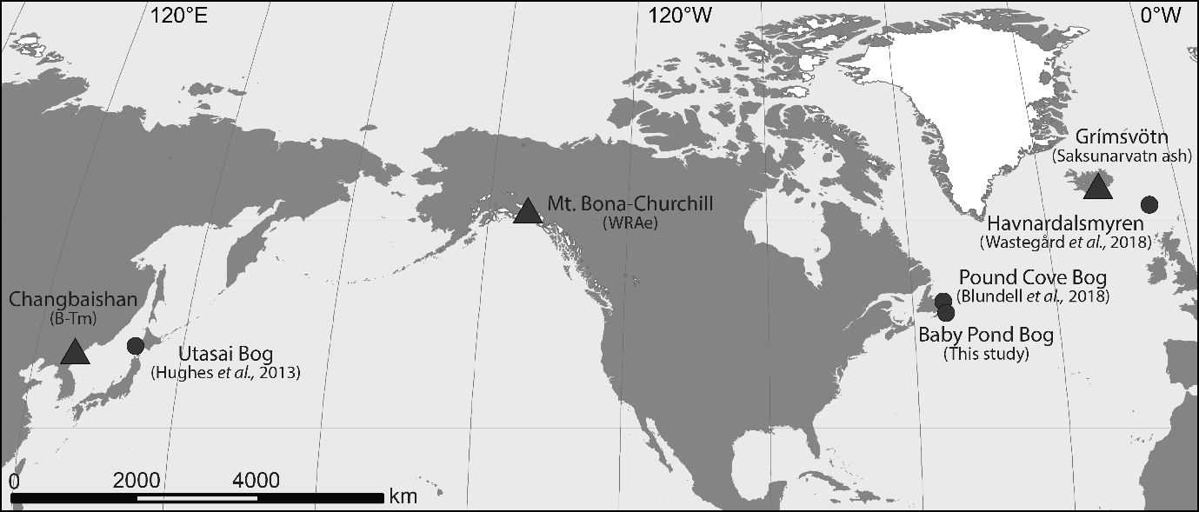

Figure 1: Study site(s) (circles) and source volcano (triangles) for each case study tephra (B-Tm tephra from Utasai Bog; WRAe from Pound Cove Bog and Baby Pond Bog; Saksunarvatn ash from Havnardalsmyren.

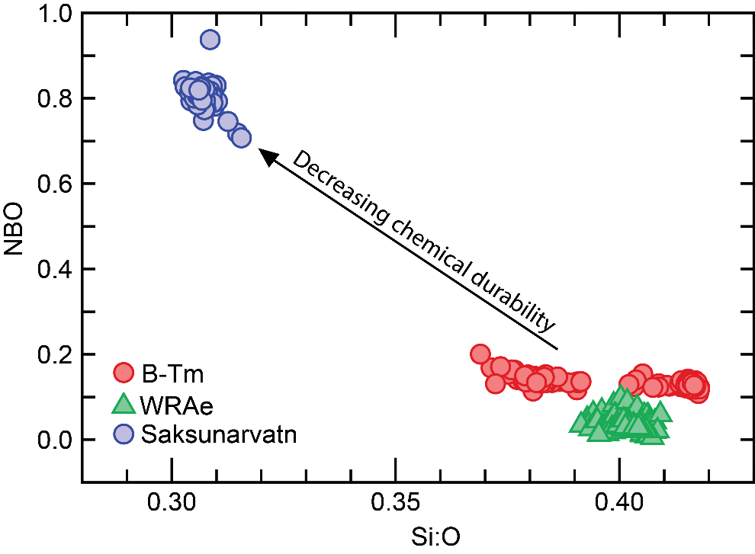

Figure 2: Plot of NBO and Si:O values from the case study tephra deposits. The arrow shows the direction of decreasing chemical durability. Glass major-minor element (wt%) data used to generate Figure 2 includes: (B-Tm) this study; Hughes *et al*. (2013); McLean *et al*. (2016); (WRAe), Pyne-O’Donnell *et al*. (2012); Jensen *et al*. (2014); Davies *et al*. (2016); (Saksunarvatn ash) Wastegård *et al*. (2018). Figure 2 is available in colour at wileyonlinelibrary.com.

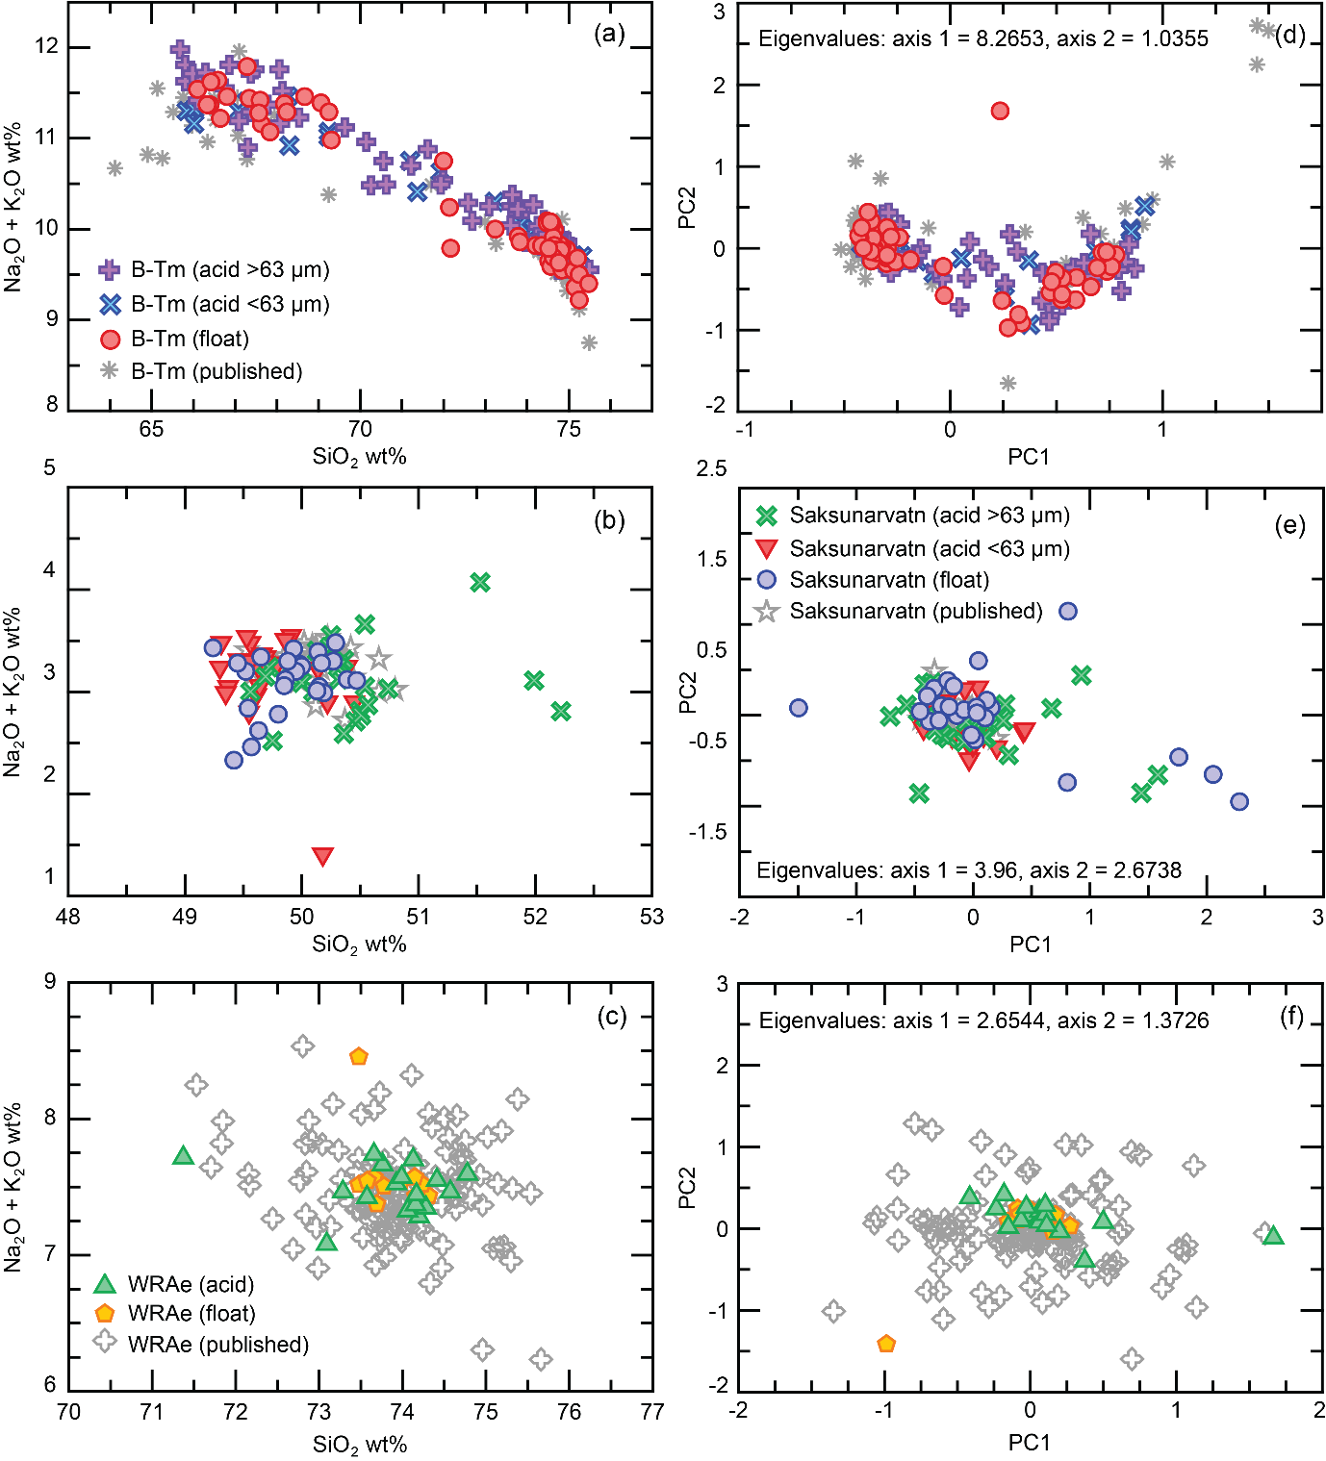

Figure 3: (a,b,c) Bivariate plots of selected major oxide totals (wt%) from case study tephras and comparative published values (B-Tm, Hughes *et al*., 2013; McLean *et al*., 2016, Saksunarvatn ash, Wastegård *et al*., 2018, WRAe, Pyne-O’Donnell *et al*., 2012; Jensen *et al*., 2014; Davies *et al*., 2016). (d,e,f) Scores for principal components analysis. Figure 3 is available in colour at wileyonlinelibrary.com.

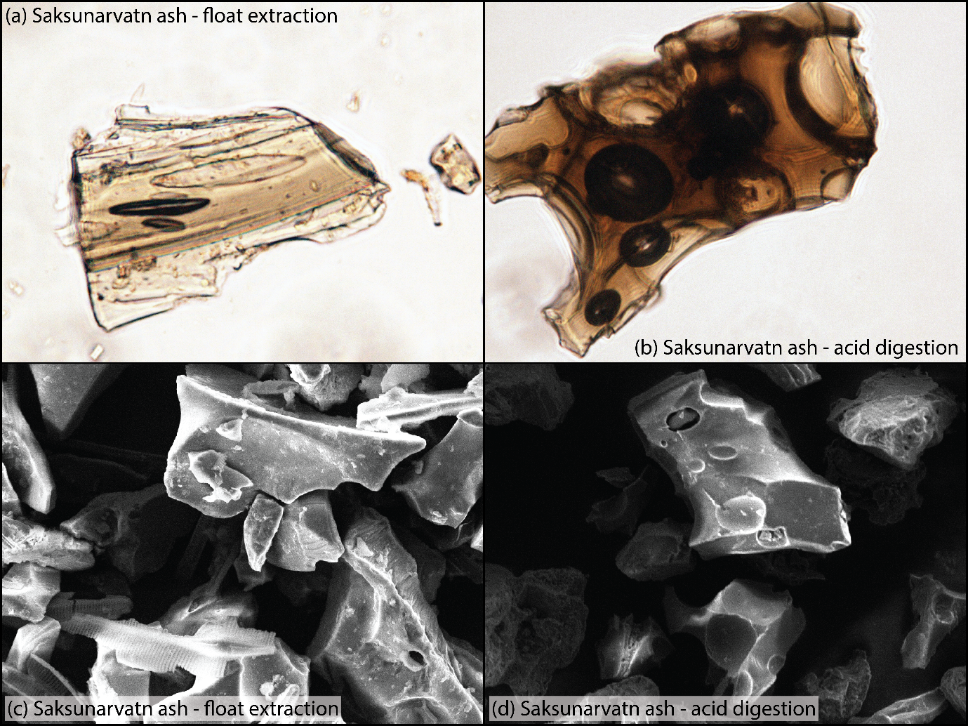

Figure 4: Microscope imagery and SEM images from duplicate samples of the Saksunarvatn ash. Figure 4 is available in colour at wileyonlinelibrary.com.

**xi. Appendices:**

### *Supporting information*

Supporting information can be found with online version of this article:

Appendix A

Table S1. Major-minor oxide compositions (wt%) of individual glass shards from case study tephra deposits.

Table S2. Secondary standards dataset.

Table S3. Similarity coefficients of case study tephra deposits.

Appendix B.

Table S4. Equations and methodology used to predict the chemical durability of tephras.

Figure S1. Additional major-minor element bivariate plots.