Revised Contribution to Surface Engineering and Applied Electrochemistry May 26, 2019

Electrochemical studies of the inhibition of zinc corrosion in hydrochloric acid by phosphonium salts

T.J. Harveyª, F.C. Walsh^{a,b,} , A.H. Nahlé^{c,*}

ª National Centre for Advanced Tribology at Southampton, Engineering Sciences, University of Southampton, Highfield, Southampton, SO17 1BJ, United Kingdom

^{b} Electrochemical Engineering Laboratory and Materials Engineering Research Group, Engineering Sciences, University of Southampton, Highfield, Southampton, SO17 1BJ, United Kingdom.

^{c} Department of Chemistry, College of Sciences, University of Sharjah, Sharjah, PO Box 27272, United Arab Emirates
*Corresponding author; Email: anahle@sharjah.ac.ae

Abstract
The performance of five synthesised phosphonium salts, 4-tolyltriphenyl-phosphonium chloride (TTPPC), 4-phenoltriphenylphosphonium chloride (PTPPC), 4-anilinetriphenylphosphonium bromide (ATPPB), 4-benzyl alcoholtriphenylphosphonium chloride (BATPPC), 4-hlorophenyltriphenylphosphonium bromide (CPTPPB) and two commercially available phosphonium salts, tetraphenylphosphonium bromide (TPPB) and methyltriphenylphosphonium bromide (MTPPB) for the inhibition of zinc corrosion in 1 M HCl at 22 ºC has been quantified using electrochemical techniques. The inhibitor concentration ranged from 110⁻³ to 110⁻⁷ mol dm⁻³. The degree of corrosion inhibition for zinc in 1 M HCl at 22 ºC was found to be in the order: CPTPPB > TTPPC > TPPB > PTPPC > BATPPC > MTPPB > ATPPB.

Key words: adsorption; polarisation, Tafel region, voltammetry.
(Approx. 4,500 words, 3 tables, 16 figures, 4 reactions/equations and 40 references).

- Introduction
Hydrochloric acid is commonly used to remove surface oxides from metals and alloys [1, 2] in industrial cleaning, oil well acidification and petroleum processing [3, 4]. Due to attack on the metal by acid, inhibitors are used to reduce the rate of metal dissolution while facilitating oxide and scale removal from the surface. The most practical method for protecting metals against corrosion in such situations is the use of organic adsorbates as inhibitors [5-7]. The adsorption of these compounds depends mainly on certain physicochemical properties of the inhibitor molecules such as functional groups, steric factors, aromaticity, electron density at the donor atoms, π-orbital character of donating electrons and their electronic structure [8-10].

Organic molecules containing heteroatoms such as nitrogen, sulphur, phosphorus, or oxygen as well as heterocyclic aromatic ring systems containing conjugated double bonds have been reported to be good inhibitors for transition metals [5, 6].

Several authors have synthesised and studied phosphorus‐containing compounds in corrosion inhibition investigations. Such compounds have included phosphonium-​based ionic liquids [11, 12], benzyl triphenyl phosphonium chloride [13], (2-​hydroxyethyl) triphenyl phosphonium bromide [14], phosphonium surfactants [15], P,​P'-​bis (triphenylphosphonio) methyl benzophenone dibromide [16], allyl triphenyl phosphonium bromide [17], and other phosphonium salts [18, 19].

In corrosion studies, the phosphorus atom(s) in the compounds were shown to absorb strongly on the metal surface, the degree of corrosion inhibition increasing to a maximum as the inhibitor concentration was raised. The adsorption of phosphonium species on the metal surface is typically monolayer in nature and follows classical adsorption isotherms [24]. In contrast, the bulk synthesis of solution based and crystallised zinc phosphonium and phosphine complexes has a rich inorganic chemistry literature, e.g., [20].

In this work, the preparation of the tris(triphenylphosphine)nickel catalyst, Ni[P(C₆H₅)₃]₃ and subsequent synthesis of the quaternary aryl phosphonium salts is described. In most cases, tetraphenylphosphonium chloride was used as a reference for comparison purposes since its structure can be considered as the parent of a family of phosphonium salts. Electrochemical techniques were used to determine the inhibitor properties of the synthesised phosphonium salts and two commercially available compounds.

- Experimental Details
2.1 Preparation of Quaternary Aryl Phosphonium Salts
A nickel (0) complex of triphenylphosphine (Fig. 1) is involved in the synthesis of quaternary aryl phosphonium compounds.

The nickel catalyst (2) shown in reaction (1) [21], undergoes oxidative addition in the presence of aryl halide (1) to form the arylnickel complex (3). Oxidative addition has also been reported for the synthesis of other arylnickel (0, II) complexes [22, 23].

(1)

The arylnickel complex (3) formed in reaction (1) reacts with triphenylphosphine to give the phosphonium salt (4) and regenerate the nickel catalyst (2), as indicated in reaction (2).

(2)

The overall reaction can be summarised as:

(3)

The preparation of tris(triphenylphosphine) nickel with a yield of 70% has been described in the literature [24]. It was reported to be extremely oxygen sensitive and tends to trap solvent when precipitated from solution and the compound decomposes in solution over several hours, even under rigorous oxygen-free conditions and on standing the deep-red solution darkens and a black precipitate formed. From the information above, it was decided that isolation of the compound would be impractical and thus preparation of tris(triphenylphosphine)nickel and its subsequent reaction with aryl halides was carried out in-situ, under an inert nitrogen gas blanket.

2.2 Preparation of Tris(triphenylphosphine)nickel Catalysts
Anhydrous nickel chloride (0.0071 mol, 0.99 g) and triphenylphosphine (0.0304 mol, 8.0 g) were placed into a 1000 cm³ quick fit conical flask and refluxed in acetonitrile (240 cm³) for one hour. The reaction mixture was allowed to cool to room temperature then zinc (0.0117 mol, 0.76 g) was added. The mixture was stirred under nitrogen overnight. The red-brown solid formed was used in-situ for the preparation of the phosphonium salt.

2.3 Preparation of Quaternary Aryl Phosphonium Salts [21]
Ethanol (200 cm³), triphenylphosphine (0.05 mol, 13.06 g) and p-aryl halides (0.05 mol) were introduced to Ni[P(C₆H₅)₃]₃ (0.005 mol, 4.23 g) while the apparatus was purged with nitrogen gas. The boiling mixture was stirred for 24 hours. The solution was filtered and the filtrate volume was reduced using a rotary evaporator (under reduced pressure). The remaining solids were then dissolved in water and the solution was filtered to remove any residues. The resulting solution was treated with diethyl ether to remove any non-ionic organics (mainly unreacted triphenylphosphine). The aqueous solution was evaporated to dryness. The crude phosphonium salts were recrystallized from water with the exception of 4-anilinetriphenylphosphonium, which was recrystallized from methanol and dried overnight in a vacuum oven at 70 ºC. Some of the synthesised inhibitors had a restricted solubility in HCl. Table 1 lists the prepared and the commercially available phosphonium salts which were evaluated by electrochemical techniques.

Fast atom bombardment-mass spectroscopy (FAB-MS) data were obtained on a Joel JMS-DX303 GC/Mass Spectrometer. Using fragmentation patterns, the structure of the organic molecule could be elucidated [24]. Infra-red (IR) spectra of the synthesized compounds, were obtained using a Mattson Instrument Research Series 1 FTIR spectrometer [25]. 1H NMR spectra were also obtained on a Joel GSX 270 MHz Fourier transform NMR spectrometer. Proton NMR can reveal information about the protons and the environment they are in, by measurement of the chemical shifts () and coupling constants (J) of each synthesised compound [25]. The melting point and yield for each compound are shown in Table 2.

2.4 Working Electrode Preparation
The 4 mm diameter working electrode disc was punched from a zinc metal sheet (purity 99.95%) supplied by Goodfellow Metals. The working electrode surface was prepared initially with silicon carbide (corundum), grades 200 to 1200 and followed by polishing with progressively finer grades of alumina slurry (grades 5 μm down to 1 μm) with absolute alcohol to achieve a reproducible surface finish and rinsed with absolute alcohol before use.

2.5 Solution Preparation
1 M HCl stock solution was made up in 2 dm³ volumes from Fisons concentrated HCl. Inhibited solutions were prepared by dissolution of the phosphonium salts (Table 1) to produce 500 cm³ of 110⁻³ mol dm⁻³ solutions. Subsequent dilution by factors of 10 allowed a range of inhibitor concentrations from 110⁻³ to 110⁻⁷ mol dm⁻³ to be prepared. All work was performed at a temperature of 22 ºC and solutions were deoxygenated with a fast stream of nitrogen gas bubbles for 25 minutes prior to use.

2.6 Equipment
Tafel extrapolation and linear polarisation data for the inhibition of zinc in deaerated 1 M HCl at 22 ºC are considered for the five synthesized and two commercially available phosphonium salt solutions at concentrations ranging from 110⁻³ to 110⁻⁷ mol dm⁻³.

Electrochemical measurements were performed using an EG & G potentiostat model 273A, interfaced (using the computer's RS232 port) by a National Instruments GPIB-PCII interface board, running NI-488.2 software, to a Viglen PC, model Genie Executive 3SX25 (386SX with a clock speed of 25 MHz and a maths co-processor). A three electrode cell was used, with a working electrode consisting of a zinc disc of circular configuration of 4 mm diameter (geometric surface area 0.1257 cm²), a saturated calomel reference electrode (SCE) and a platinum foil counter electrode with a surface area of 3.4 cm².

Tafel extrapolation experiments were performed over a polarisation range of 350 mV each side of the corrosion potential, E_{corr}, at a linear sweep rate of 0.050 mV s⁻¹. For Tafel measurements, an initial delay of 7 minutes was incorporated before polarisation, to allow the potential to steady. Experiments were performed in triplicate to ensure reproducibility.

- Results & Discussion

3.1 Tafel Extrapolation Data for Zinc in HCl
Tafel extrapolation data for the inhibition of zinc in deaerated 1 M HCl at 22 ºC are considered for the five synthesized and two commercially available phosphonium salt solutions at concentrations ranging from 110⁻³ to 110⁻⁷ mol dm⁻³.

The performance of each of the compounds evaluated by electrochemical techniques is shown graphically, while tables provide the mean values of corrosion current density (j_{corr.}), percentage inhibitor efficiency (%) and corrosion potential (E_{corr}) together with anodic and cathodic Tafel slopes at the inhibitor concentrations involved. The effects of each compound are shown via a figure representing the Tafel data for depicts the mean of triplicate experimental results. Each figure has an insert showing the values of corrosion current density and inhibitor efficiency at each inhibitor concentration tested.

3.2 4-Anilinetriphenylphosphonium Chloride (ATPPB)
At an inhibitor concentration of 110⁻³ mol dm⁻³, the inhibition is close to zero but at lower concentrations, acceleration of corrosion occurs, as seen in Fig. 2. However, a decrease in corrosion acceleration is observed at inhibitor concentrations 110⁻⁴ to 110⁻⁶ mol dm⁻³. Reproducible results were obtained at all studied inhibitor concentrations. The corrosion acceleration is considered to be due to decomposition, probably by cathodic splitting, as considered by Horner et al. [26]:

(4)

The higher potentials encountered for zinc, compared to iron [25], will increase secondary inhibition or acceleration. It is noted that the corrosion potential is polarised about 50 mV in the more noble direction than the uninhibited values at an inhibitor concentration 110⁻³ mol dm⁻³; as inhibitor concentration decreased, it became less polarised.

The first step in inhibition is likely to be the protonation of the aniline group to form an anilinium ion which can be electrostatically adsorbed. This was also suggested by Banerjee and Malhotra [27] who studied the corrosion of mild steel in HCl at 30 ºC inhibited by aniline. The protonated anilinium ion may catalyse the cathodic reaction through cathodic depolarisation similar to the mechanism for corrosion acceleration of carbon steel in 1 mol dm⁻³ sulphuric acid at 30 ºC in the presence of phenylmethylsulphoxide as proposed by Davolio and Soragni [28]. A catalytic effect has been observed for other nitrogen-based inhibitors such as quinolines [29] and amines [30] on the hydrogen evolution reaction for zinc and zinc alloy corrosion in HCl. Foroulis [31] observed stimulation of copper corrosion for aniline and n-butylamine in 4.2M sulphuric acid and aniline and pyridine in 2.6 mol dm⁻³ perchloric acid at 50 ºC.

The nature of the group in the various molecules strongly affected the degree of inhibition. For the NH₂.Br group in ATPPB, the percentage inhibition at an inhibitor concentration of 110⁻³ mol dm⁻³ was -1.4%, whereas at the same concentration with Cl.Br group in CPTPPB the inhibition reached 91.6%.

3.3 4-Benzyl Alcoholtriphenylphosphonium Chloride (BATPPC)
From Fig. 3, inhibition is achieved throughout the concentration range tested and an almost linear decrease in inhibitor efficiency with inhibitor concentration is observed. The highest concentration is polarised approximately 20 mV more noble than the remaining the curves. The anodic behaviour at high inhibitor concentrations is explained by Hoar and Holliday [32] and by West [33] for a predominately blocking mode of inhibition. At high surface coverages (near monolayer), any gaps due to irregular packing, will be small and because of the relative size of the hydrated hydrogen and metal ions, anodic inhibition will always predominate. Both anodic and cathodic Tafel slopes exhibit a decrease in values towards uninhibited values with a fall in inhibitor concentration. Comparison with Tafel extrapolation results for iron [25], shows that no inflection in corrosion current density (and inhibitor efficiency) with inhibitor concentration occurs for zinc.
3.4 4-Chlorophenyltriphenylphosphonium Bromide (CPTPPB)
Fig. 4 shows that inhibition is achieved throughout the concentration range tested and that an almost linear decrease in inhibitor efficiency with inhibitor concentration is observed. The inhibition is higher (91.6% at 110⁻³ mol dm⁻³ to 46.7% at 110⁻⁷ mol dm⁻³) than for BATPPC (74.3% at 110⁻³ mol dm⁻³ to 14.6% at 110⁻⁷ mol dm⁻³). It can also be seen that the highest concentration is polarised ca. 40 mV more noble than the rest of the curves. The 110⁻⁴ mol dm⁻³ solution is less polarised (by ca. 20 mV). This anodic behaviour at high inhibitor concentrations and thus high surface coverages, is indicative of blocking as suggested in the previously. Both anodic and cathodic Tafel slopes exhibit a decrease in values towards uninhibited values with a fall in inhibitor concentration. The presence of two groups in CPTPPB may suggest synergism between Br⁻ and Cl⁻ ion adsorption.

3.5 Methyltriphenylphosphonium Bromide (MTPPB)
Corrosion inhibition is low and corrosion acceleration is achieved at 1 10⁻⁷ mol dm⁻³ as has been observed in other instances [34-36]. From Fig. 5, it is apparent that the relationship between inhibitor efficiency (or corrosion current density) and inhibitor concentration is curved. Corrosion potentials indicate that MTPPB was predominantly a cathodic inhibitor. MTPPB showed an inhibition of 64.4% at an inhibitor concentration of 1 10⁻³ mol dm⁻³, which increased to 88.6% when Br⁻ was replaced by Cl⁻ as shown at the same concentration of 4-tolyltriphenylphosphonium chloride (TTPPC).

Troquet and Pagetti [37] reported an inhibitor efficiency of 95% - 98% at a concentration of 510⁻³ mol dm⁻³ for zinc in 1 M HCl at 20 ºC, measured by weight loss and analytical techniques. The literature indicates that for methyltriphenylphosphonium bromide, inhibition is primary due to a strong electrostatic adsorption [12] and the secondary inhibitor, Ph₂CH₃P, is unstable and readily oxidizes to the phosphine oxide which is less effective towards inhibition [38, 39].

3.6 4-Phenoltriphenylphosphonium Chloride (PTPPC)
Inhibition is achieved throughout the concentration range tested and an almost linear decrease in inhibitor efficiency with falling inhibitor concentration is observed (see Fig. 6). Corrosion potentials exhibit a gradual decrease in anodic behaviour as inhibitor concentration falls unlike the sharp changes observed for BATPPC and CPTPPB. The anodic behaviour exhibited at high inhibitor concentrations, is once more indicative of blocking. Cathodic Tafel slopes showed a decrease in values towards uninhibited values as inhibitor concentration is decreased but the anodic Tafel slope at 110⁻³ mol dm⁻³ was 37 mV per decade and the others were approximately 26 mV per decade.

The possible resonance structures of 4-phenoltriphenylphosphonium chloride are shown in Fig. 7; it is likely that such resonance plays an important part in surface adsorption and inhibition.

Electrostatic adsorption could be initiated by protonation of the phenol group, stabilised by resonance. From the mechanism in Fig. 8 [37, 39-41], it is noted that step 6 involves complex formation and possible precipitation at the metallic surface depending on the solubility of the complex formed. It should also be recognised that a complex can be formed with either the primary or secondary inhibitor. It is proposed that the complex formed with iron is very soluble and does not contribute to inhibition. The zinc complex, however, is less soluble and contributes to inhibition.

3.7 Tetraphenylphosphonium Bromide (TPPB)
A plot of inhibitor efficiency against inhibitor concentration (see the insert in Fig. 9) shows steps at 110⁻³ to 110⁻⁴ mol dm⁻³ and also at 110⁻⁵ to 110⁻⁶ mol dm⁻³. Corrosion potentials indicated mixed inhibition but, for iron corrosion, TPPB, was predominantly an anodic inhibitor. Again, both anodic and cathodic Tafel slopes showed a decrease in values towards uninhibited values as inhibitor concentration decreased.

Troquet and Pagetti [37] reported inhibitor efficiency of 90% - 97.5% at an inhibitor concentration of 510⁻³ mol dm⁻³ for zinc in 1 M HCl at 20 ºC, decreasing to 16% at an inhibitor level of 510⁻⁵ mol dm⁻³. The only secondary inhibitor is triphenylphosphine [37-39]. These values above have been incorporated into Fig. 9 and show close correlation with experimental values at high inhibitor concentrations.

3.8 4-Tolyltriphenylphosphonium Chloride (TTPPC)
Fig. 10 shows that the two highest inhibitor concentrations exhibit the same inhibitor efficiency of 88.6% and inhibition is achieved throughout the concentration range tested. Corrosion potentials indicate that TTPPC is predominantly an anodic inhibitor for zinc, whilst inhibition was mainly mixed in the case of iron. Cathodic Tafel slopes exhibit a decrease in values towards uninhibited values as inhibitor concentration is decreased but the anodic Tafel slopes are all higher in magnitude than uninhibited values. Adsorption of the para-substituted ring is likely to be enhanced due to hyperconjugation of electrons, as indicated in Fig. 11.

Plots of corrosion current density (Fig. 12), the inhibitor efficiency (Fig. 13), cathodic Tafel slope (Fig. 14) anodic and Tafel slope (Fig. 15) against inhibitor concentration plus a corrosion potential against the log of corrosion current density (Fig. 16) [32] are examined to determine any similarities and dissimilarities exhibited between the compounds tested.

Plots of inhibitor concentration against j_{corr.} (Fig. 12) and % (Fig. 13) with a summary of the results in Table 3, show that ATPPB cause acceleration of corrosion while MTPPB exhibited poor corrosion inhibition and exhibited corrosion acceleration at low inhibitor concentrations. It is also seen that the remaining compounds tested displayed a degree of linearity of these variables with concentration except TPPB that shows two steps at 110⁻³ to 110⁻⁴ mol dm⁻³ and at 110⁻⁵ to 110⁻⁶ mol dm⁻³. In addition, MTPPB exhibits curvature throughout the inhibitor concentration range. The best overall inhibition throughout the concentration range examined was for CPTPPB. Compounds that possess bromine as a counter ion exhibited inferior inhibition with the exception of CPTPPB. In contrast, iron exhibits the opposite effect. This would suggest that bromine molecules adsorbing at the zinc surface are in competition with inhibitor molecules while at the iron surface, adsorption is cooperative. With the exception of TTPPC, zinc does not exhibit the doublet effect noted for iron. In the latter, the two highest inhibitor concentrations displayed significantly higher inhibition than the other concentrations tested. The order of inhibition is CPTPPB > TTPPC > TPPB > PTPPC > BATPPC > MTPPB > ATPPB for zinc in 1 M HCl at 22 ºC, as measured by Tafel extrapolation.

In Fig. 16, corrosion potential is plotted against corrosion current density. The majority of the data points are noble to the uninhibited metal with the exception of TPPB which is slightly base. It also noted that three compounds (CPTPPB, MTPPB and BATPPC) become mixed inhibitors at higher corrosion current densities.

The anodic and cathodic Tafel slopes are all higher for inhibited solutions than for the uninhibited one for most of the inhibitors tested. The exception is TPPB which remains a mixed inhibitor throughout the concentration range.

- Conclusions
The order of inhibition for zinc in 1 M HCl at 22 ºC is CPTPPB > TTPPC > TPPB > PTPPC > BATPPC > MTPPB > ATPPB. A plot of inhibitor efficiency or corrosion current density against inhibitor concentration was approximately linear, for all except TPPB and MTPPB. The data showed that all compounds act as mixed inhibitors for Zinc in 1.0 M HCl. Anodic and cathodic Tafel slopes varied with inhibitor concentration: the values were all higher than in uninhibited acid at the highest inhibitor concentration. All values showed a decrease towards uninhibited acid values as inhibitor concentration fell. The order for the number of water molecules replaced for each inhibitor molecule for the phosphonium salts tested is BATPPC > PTPPC > CPTPPB > TTPPC > TPPB. The number of water molecules shows greater diversity than expected from a simple consideration of para-substituent electronic effects.

While simple considerations of mesmeric and inductive effects on electron density within a molecule and polarity of bonding via molecular dipole moments may be a useful tools to rationalise variation of inhibitor efficiency values obtained for the seven compounds, complexity is introduced by adsorption of anions and steric effects.

Acknowledgements
Initial studies formed part of T.J. Harvey’s doctoral studies at the University of Portsmouth, UK. The authors are grateful to Dr B.D. Barker for early encouragement to study inhibitors using practical electrochemical techniques.

Conflict of Interest
The authors declare that they have no conflict of interest.

List of symbols
Symbol Meaning Units
b_{a} Anodic Tafel slope mV per decade
b_{c} Cathodic Tafel slope mV per decade
c Molar concentration mol dm⁻³
E_{cor} Corrosion potential V
j Current density A cm⁻²
j_{cor} Corrosion current density A cm⁻²

Greek
%τ Percentage Inhibitor efficiency Dimensionless
Surface coverage Dimensionless

References
1. Migahed M.A., Nassar I.F. Corrosion inhibition of tubing steel during acidization of oil and gas wells. Electrochimica Acta. 2008, 53(6), 2877-2882.

2. Migahed M.A., Abd-El-Raouf M., Al-Sabagh A.M., Abd-El-Bary H.M. Effectiveness of some nonionic surfactants as corrosion inhibitors for carbon steel pipelines in oil fields. Electrochimica Acta. 2005, 50(24), 4683-4689.
3. Wang H.L., Fan H.B., Zheng J.S. Corrosion inhibition of mild steel in hydrochloric acid solution by a mercapto-​triazole compound. Materials Chemistry and Physics. 2003, 77(3), 655-661.

4. Abd El-Maksoud S.A., Fouda A.S. Some pyridine derivatives as corrosion inhibitors for carbon steel in acidic medium. Materials Chemistry and Physics. 2005, 93(1), 84-90.
5. Bentiss F., Lebrini M., Lagrenee M. Thermodynamic characterization of metal dissolution and inhibitor adsorption processes in mild steel​/2,​5-​bis(n-​thienyl)​-​1,​3,​4-​thiadiazoles / hydrochloric acid system. Corrosion Science. 2005, 47(12), 2915-2931.
6. Zarrouk A., Zarrok H., Salghi R., Hammouti B., Bentiss F., Touir R., Bouachrine M. Evaluation of N-​containing organic compound as corrosion inhibitor for carbon steel in phosphoric acid. Journal of Materials and Environmental Science. 2013, 4(2), 177-192.
7. Cruz J., Martínez R., Genesca J., García-Ochoa E. Experimental and theoretical study of 1-​(2-​ethylamino)​-​2-​methylimidazoline as an inhibitor of carbon steel corrosion in acid media. Journal of Electroanalytical Chemistry. 2004, 566(1), 111-121.
8. Zarrouk A., Hammouti B., Dafali A., Bentiss, F. Inhibitive properties and adsorption of Purpald as a corrosion inhibitor for copper in nitric acid medium, Industrial & Engineering Chemistry Research, 2013, 52(7), 2560-2568.
9. Ben Hmamou D., Salghi R., Zarrouk A., Aouad M.R., Benali O., Zarrok H., Messali M., Hammouti B., Kabanda M.M., Bouachrine M., Ebenso E.E. Weight Loss, Electrochemical, quantum chemical calculation, and molecular dynamics simulation studies on 2-​(benzylthio)​-​1,​4,​5-​triphenyl-​1H-​imidazole as an inhibitor for carbon steel corrosion in hydrochloric acid. Industrial & Engineering Chemistry Research. 2013, 52(40), 14315-14327.

10. Popova A., Christov M., Raicheva S., Sokolova E. Adsorption and inhibitive properties of benzimidazole derivatives in acid mild steel corrosion. Corrosion Science. 2004, 46(6), 1333-1350.
11. Rafat A., Atilhan M., Kahraman R. Corrosion behavior of carbon steel in CO₂ saturated amine and imidazolium-​, ammonium-​, and phosphonium-​based ionic liquid solutions. Industrial & Engineering Chemistry Research. 2016, 55(2), 446-454.
12. Sun J., Howlett P.C., MacFarlane D.R., Lin J., Forsyth M. Synthesis and physical property characterization of phosphonium ionic liquids based on P(O)_{​2}(OR)​₂⁻ and P(O)​2(R)_{​2}⁻ anions with potential application for corrosion mitigation of magnesium alloys. Electrochimica Acta. 2008, 54(2), 254-260.
13. Vashisht H., Bahadur I., Kumar S., Bhrara K., Ramjugernath D., Singh G. Evaluation of Benzyl triphenyl phosphonium chloride as corrosion inhibitor for mild steel in phosphoric acid. International Journal of Electrochemical Science. 2014, 9(6), 2896-2911.
14. Vashisht H., Kumar S., Bahadur I., Singh G. Evaluation of (2-​Hydroxyethyl) triphenyl phosphonium bromide as corrosion inhibitor for mild steel in sulphuric acid. International Journal of Electrochemical Science. 2014, 9(2), 684-699.
15. Aiad I.A., Tawfik S.M., Shaban S.M., Abd-Elaal A.A., El-Shafie M. Enhancing of corrosion inhibition and the biocidal effect of phosphonium surfactant compounds for oil field equipment. Journal of Surfactants and Detergents. 2014, 17(3), 391-401.

16. Nahlé A., Al-Khayat M., Abu-Abdoun I., Abdel-Rahman I. Corrosion inhibition of mild steel by P,​P'-​bis (triphenylphosphonio) methyl benzophenone dibromide in HCl solution. Anti-Corrosion Methods and Materials. 2013, 60(1), 20-27.
17. Bhrara K., Singh G. Effect of allyl triphenyl phosphonium bromide on electrochemical and corrosion behaviour of mild steel in 0.5M sulphuric acid, Corrosion Engineering. Science and Technology. 2007, 42(2), 137-144.
18. Walia M., Singh, G. Corrosion inhibition of pure nickel by some phosphonium compounds in acid medium. Surface Engineering. 2005, 21(3), 176-179.

19. Mutombo P., Hackerman N. The effect of some organophosphorus compounds on the corrosion behavior of iron in 6 M HCl, Anti-Corrosion Methods and Materials, 1998, 45(6), 413-418.
20 Burgess J., Prince R.H. Zinc: Inorganic & Coordination Chemistry. Encyclopedia of Inorganic Chemistry, First Edition. https://doi.org/10.1002/0470862106.ia260.
21. Cassar L., Foa, M. Nickel-​catalyzed synthesis of phosphonium salts. Journal of Organometallic Chemistry. 1974, 74(1), 75-78.
22. Fahey D.R. Bonded hydride and carbon derivatives of nickel. Organometallic Chemistry Reviews, Section A: Subject Reviews. 1972, 7(3), 245-294.
23. Hidai M., Kashiwagi T., Ikeuchi T., Uchida Y. Oxidative additions to nickel(0). Preparation and properties of a new series of arylnickel(II) complexes. Journal of Organometallic Chemistry. 1971, 30(2), 279-282.
24. Tolman C.A., Seidel W.C., Gerlach, D.H. Triarylphosphine and ethylene complexes of zerovalent nickel, palladium, and platinum. Journal of the American Chemical Society. 1972, 94(8), 2669-2676.
25. Nahlé A.H., Harvey T.J., Walsh, F.C. Quaternary aryl phosphonium salts as corrosion inhibitors for iron in HCl. Journal of Alloys and Compounds. 2018, 765, 812-825.
26. Horner L., Hinrichs H., Ertels, H. Corrosion inhibitors. 10. Evidence for the secondary inhibition by allyltriphenylphosphonium and -​arsonium bromides and N-​allylquinaldinium bromide. Werkstoffe und Korrosion. 1971, 22(12), 994-997.
27. Banerjee G., Malhotra S.N. Contribution to adsorption of aromatic amines on mild steel surface from hydrochloric acid solutions by impedance, UV, and Raman spectroscopy. Corrosion (Houston, TX, United States). 1992, 48(1), 10-15.
28. Davolio G., Soragni, E. Kinetics of carbon steel dissolution in sulfuric acid stimulated or inhibited by phenyl methyl sulfoxide. Annali dell'Universita di Ferrara, Sezione 5: Chimica Pura ed Applicata. 1971, Volume Date 1970, (Suppl. 5), 219-235.
29. Abdel-Aal M.S. Ahmed Z.A., Hassan M.S. Inhibiting and accelerating effects of some quinolines on the corrosion of zinc and some binary zinc alloys in hydrochloric acid solution. Journal of Applied Electrochemistry. 1992, 22(11), 1104-1109.
30. Hoar T.P., Khera R.P. Inhibition by formaldehyde, pyridine, polyamines, alkanolamines, and octylamines of the acid dissolution of mild steel. Ann. Univ. Ferrara, Sez.. 1961, 1960, 5(Suppl. No. 3), 73-97.
31. Foroulis Z.A. Molecular designing of organic corrosion inhibitors. Symp. Coupling Basic Appl. Corros. Res. – Dialogue, 1969, 24-37.
32. Hoar T.P., Holliday R.D. The inhibition by quinolines and thioureas of the acid dissolution of mild steel. Journal of Applied Chemistry. 1953, 3, 502-513.
33. West J.M. Inhibition by organic compounds of the acid dissolution of mild steel. II. Distribution of quinolines and thioureas at the metal-​acid interface. Journal of Applied Chemistry. 1960, 10, 250-256.
34. Davolio G., Soraghi, E. Kinetics of carbon steel dissolution in sulfuric acid stimulated or inhibited by phenyl methyl sulfoxide, Annali dell'Universita di Ferrara, Sezione 5: Chimica Pura ed Applicata (1971), Volume Date 1970, (Suppl. 5), 219-235.
35. Annand R.R., Hurd R.M., Hackerman, N. Inhibition of acid corrosion by soluble monomer and polymer amines containing identical functional groups. Journal of the Electrochemical Society. 1965, 112(2), 144-148.
36. Hackerman N., Hurd R.M., Annand R.R. Some structural effects of organic N-​containing compounds on corrosion inhibition. Corrosion (Houston, TX, United States). 1962, 18, 37-42.
37. Troquet M., Pagetti, J. Inhibition of metallic corrosion in an acid medium by means of phosphonium salts: zinc and iron. Werkstoffe und Korrosion. 1983, 34(11), 557-562.
38. Troquet M., Laveissiere B., Labbe J.P., Pagetti J. Mechanism of zinc corrosion inhibition by means of phosphonium ions in a 1N hydrogen chloride solution. Influence of aromatic rings in the inhibiting process, Annali dell'Universita di Ferrara, Sezione 5: Chimica Pura ed Applicata, Supplemento, 7(1980, 3, Eur. Symp. Corros. Inhibitors, 5th), 921-944.
39. Troquet M., Pagetti J. Study of the mechanism of the inhibition of zinc in normal hydrochloric acid by phosphonium salts. Electrochimica Acta. 1982, 27(2), 197-203.
40. Troquet M., Laveissiere B., Pagetti, J. Inhibition of the corrosion of zinc by organophosphorus derivatives in a 1N hydrochloric acid solution. Metaux: Corrosion-Industrie. 1978, 635-636, 235-245.
41. Troquet M., Labbe J.P., Pagetti J. The mechanism of the inhibition of zinc corrosion in 1N hydrochloric acid solution by tetraphenylphosphonium bromide. Corrosion Science. 1981, 21(2), 101-117.

Inhibitor | Structure
4-tolyltriphenyl-phosphonium chloride (TTPPC)
(Synthesized)
4-phenoltriphenylphosphonium chloride (PTPPC)
(Synthesized)
4-anilinetriphenylphosphonium bromide (ATPPB)
(Synthesized)
4-benzyl alcoholtriphenylphosphonium chloride (BATPPC)
(Synthesized)
4-Chlorophenyltriphenylphosphonium bromide (CPTPPB)
(Synthesized)
Tetraphenylphosphonium bromide (TPPB)
(Commercially available)
Methyltriphenylphosphonium bromide (MTPPB)
(Commercially available)

Table 1. Synthesised and commercially available phosphonium salts evaluated by electrochemical techniques in this paper.

Inhibitor |  | Melting point. / ºC | Yield |  | Relative molar mass
R | X |  | / g | / %
CH3 | Cl | 277-2788 | 10.23 | 52.6 | 388.88
OH | Cl | 296-299 | 3.47 | 17.8 | 390.85
CH2OH | Cl | 235-236 | 12.33 | 60.9 | 404.88
Cl | Br | 265-267 | 11.74 | 51.8 | 453.75
NH2 | Br | 338-340 | 14.49 | 66.7 | 434.32

Table 2. Melting point and yield data for synthesised phosphonium salts.

c / mol dm⁻³ | ATPPB | BATPPC | CPTPPB | MTPPB | PTPPC | TPPB | TTPPC
110⁻³ | -1.4 | 74.3 | 91.6 | 64.4 | 87.8 | 90.5 | 88.6
110⁻⁴ | -286.4 | 58.5 | 83.7 | 63.8 | 78.0 | 88.4 | 88.6
110⁻⁵ | -85.0 | 52.6 | 72.2 | 42.1 | 62.2 | 58.5 | 62.4
110⁻⁶ | -5.0 | 32.8 | 64.9 | 16.0 | 53.7 | 57.0 | 49.3
110⁻⁷ | 45.1 | 14.6 | 46.7 | -41.6 | 45.2 | 8.0 | 35.6

Table 3. Percentage inhibitor efficiency for zinc in 1 M HCl at 22 ºC in the presence of various phosphonium salts, measured by Tafel extrapolation.

Fig. 1. Structure of tris(triphenylphosphine)nickel, Ni[P(C₆H₅)₃]₃.



Fig. 2. Tafel polarization curves for 4-anilinetriphenylphosphonium bromide (ATPPB) inhibition of zinc in 1 M HCl at 22 ºC.

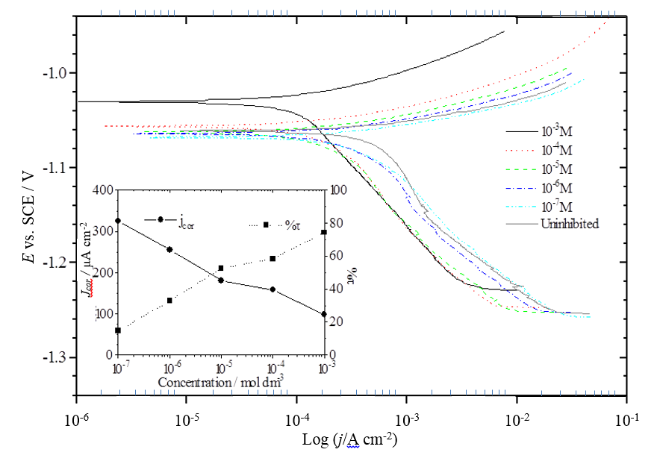

Fig. 3. Tafel polarization curves for 4-benzyl alcoholtriphenylphosphonium chloride (BATPPC) inhibition of zinc in 1 M HCl at 22 ºC.

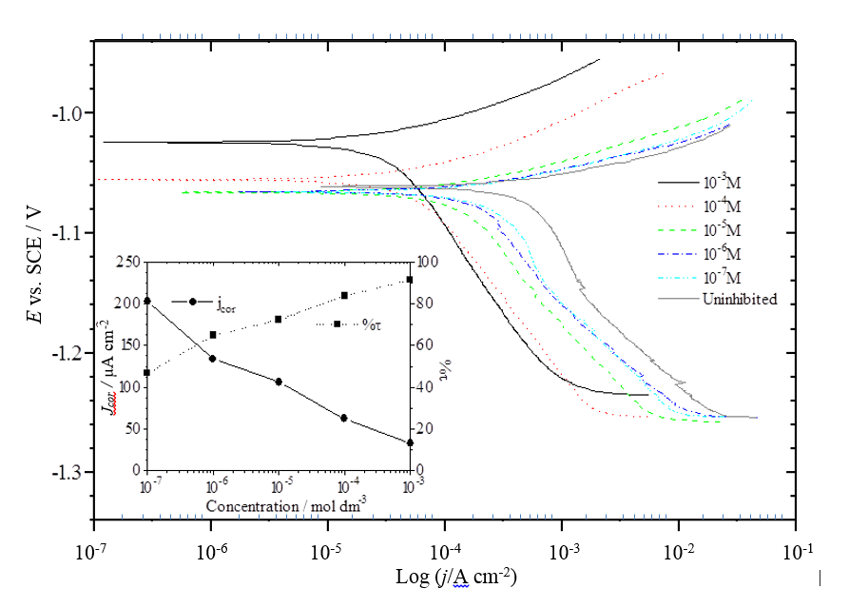

Fig. 4. Tafel polarization curves for 4-chlorophenyltriphenylphosphonium bromide (CPTPPB) inhibition of zinc in 1 M HCl at 22 ºC.

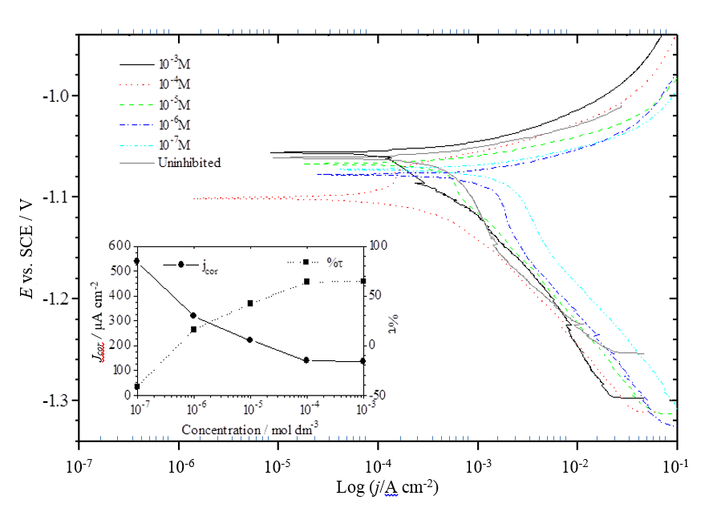

Fig. 5. Tafel polarization curves for methyltriphenylphosphonium bromide (MTPPB) inhibition of zinc in 1 M HCl at 22 ºC.

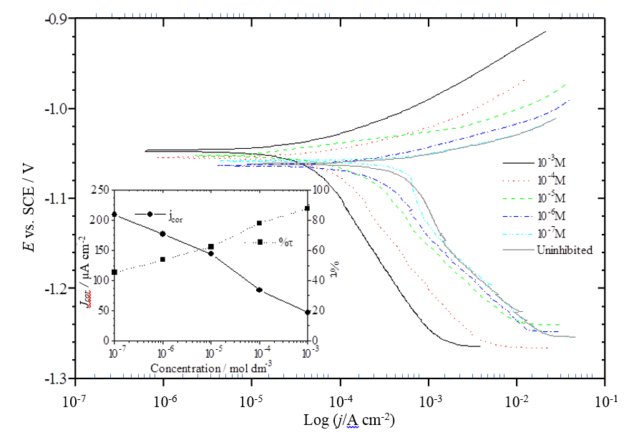

Fig. 6. Tafel polarization curves for 4-phenoltriphenylphosphonium chloride (PTPPC) inhibition of zinc in 1 M HCl at 22 ºC.

Fig. 7. Resonance structures of 4-phenoltriphenylphosphonium chloride.

Fig. 8. A proposed inhibition mechanism for phosphonium salts of formula Ph3PRX where Ph' denotes one or several partly reduced aromatic rings [37, 39-41].

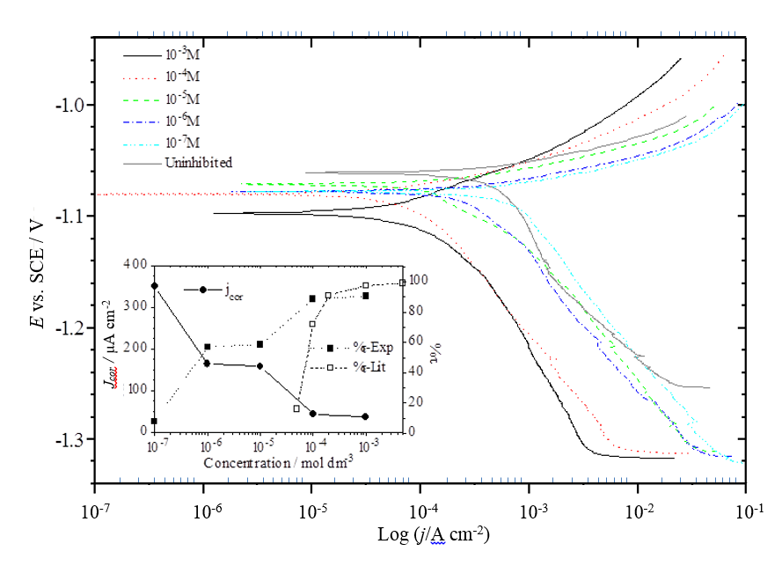

Fig. 9. Tafel polarization curves for tetraphenylphosphonium bromide (TPPB) inhibition of zinc in 1 M HCl at 22 ºC.

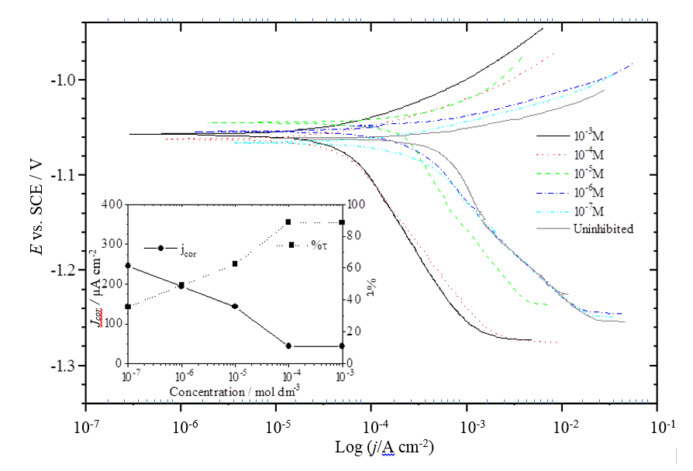

Fig. 10. Tafel polarization curves for 4-tolyltriphenylphosphonium chloride (TTPPC) inhibition of zinc in 1 M HCl at 22 ºC.

Fig. 11. Resonance structures of 4-tolyltriphenylphosphonium chloride (TTPPC).

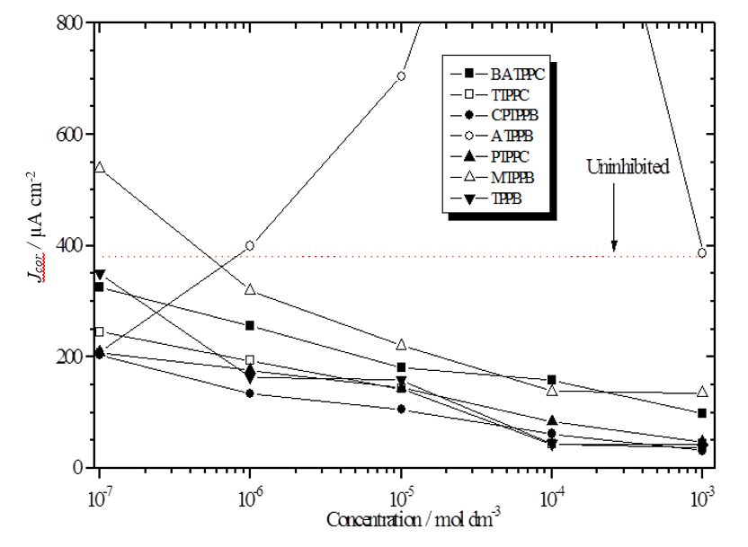

Fig. 12. Variations in Corrosion Current with Inhibitor Concentration as Determined by Tafel extrapolation for zinc in 1 M HCl at 22 ºC in the presence of various phosphonium salts.

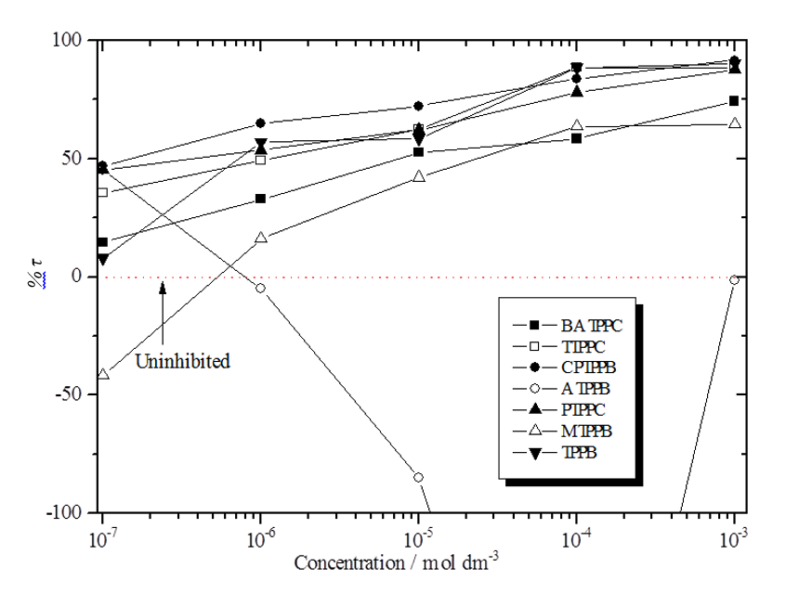

Fig. 13. Variations in inhibitor efficiency with inhibitor concentration as determined by Tafel extrapolation for zinc in 1 M HCl at 22 ºC in the presence of various phosphonium salts.

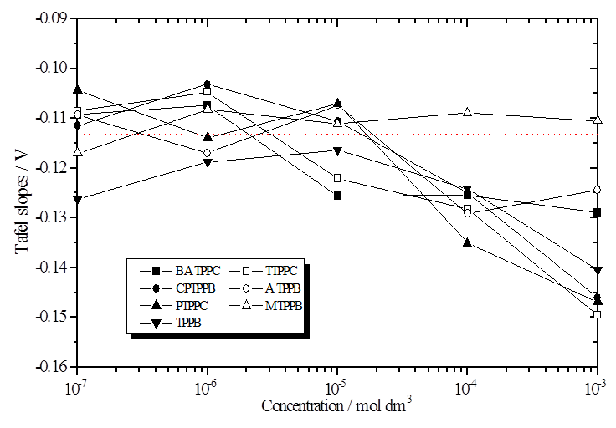

Fig. 14. Variations in cathodic Tafel slope with inhibitor concentration determined by Tafel extrapolation for zinc in 1 M HCl at 22 ºC in the presence of various phosphonium salts (Uninhibited data are shown by dotted lines).

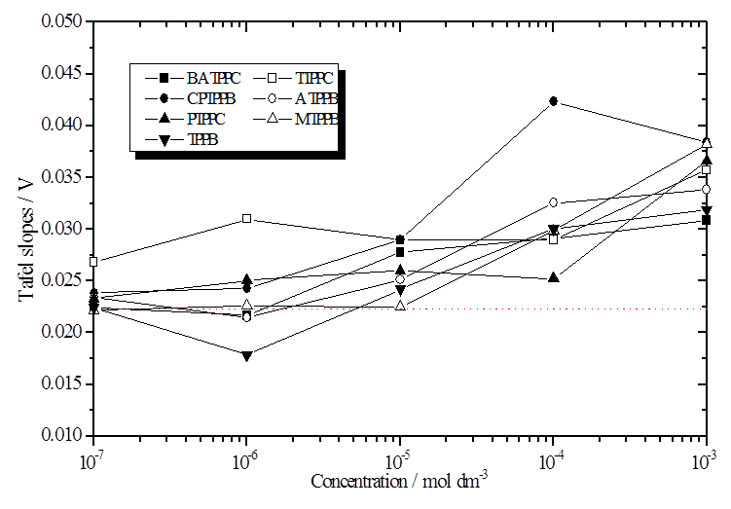

Fig. 15. Variations in anodic Tafel slope with inhibitor concentration determined by Tafel extrapolation for zinc in 1 M HCl at 22 ºC in the presence of various phosphonium salts (Uninhibited data are shown by dotted lines).

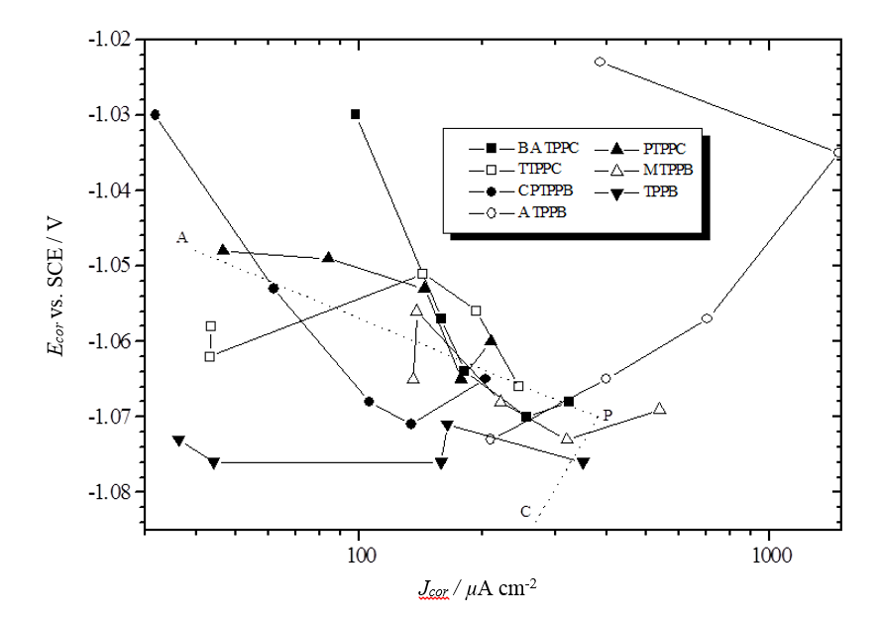
Fig. 16. Variation in corrosion potential with corrosion current determined by Tafel extrapolation for zinc in 1 M HCl at 22 ºC in the presence of various phosphonium salts. (Uninhibited data are shown by dotted lines).

Figure captions

Fig. 1. Structure of Tris(triphenylphosphine)nickel, Ni[P(C₆H₅)₃]₃.

Fig. 2. Tafel polarization curves for 4-anilinetriphenylphosphonium bromide (ATPPB) inhibition of zinc in 1 M HCl at 22 ºC.

Fig. 3. Tafel polarization curves for 4-benzyl alcoholtriphenylphosphonium chloride (BATPPC) inhibition of zinc in 1 M HCl at 22 ºC.

Fig. 4. Tafel polarization curves for 4-chlorophenyltriphenylphosphonium bromide (CPTPPB) inhibition of zinc in 1 M HCl at 22 ºC.

Fig. 5. Tafel polarization curves for methyltriphenylphosphonium bromide (MTPPB) inhibition of zinc in 1 M HCl at 22 ºC.

Fig. 6. Tafel polarization curves for 4-phenoltriphenylphosphonium chloride (PTPPC) inhibition of zinc in 1 M HCl at 22 ºC.

Fig. 7. Resonance structures of 4-phenoltriphenylphosphonium chloride.

Fig. 8. A proposed inhibition mechanism for phosphonium salts of formula Ph₃PRX where Ph' denotes one or several partly reduced aromatic rings [36, 38-40].

Fig. 9. Tafel polarization curves for tetraphenylphosphonium Bromide (TPPB) inhibition of zinc in 1 M HCl at 22 ºC.
Fig. 10. Tafel polarization curves for 4-tolyltriphenylphosphonium chloride (TTPPC) inhibition of zinc in 1 M HCl at 22 ºC.
Fig. 11. Resonance structures of 4-tolyltriphenylphosphonium chloride (TTPPC).
Fig. 12. Variations in Corrosion Current with Inhibitor Concentration as Determined by Tafel extrapolation for zinc in 1 M HCl at 22 ºC in the presence of various phosphonium salts.
Fig. 13. Variations in inhibitor efficiency with inhibitor concentration as determined by Tafel extrapolation for zinc in 1 M HCl at 22 ºC in the presence of various phosphonium salts.
Fig. 14. Variations in cathodic Tafel slope with inhibitor concentration determined by Tafel extrapolation for zinc in 1 M HCl at 22 ºC in the presence of various phosphonium salts (Uninhibited data are shown by dotted lines).
Fig. 15. Variations in anodic Tafel slope with inhibitor concentration determined by Tafel extrapolation for zinc in 1 M HCl at 22 ºC in the presence of various phosphonium salts (Uninhibited data are shown by dotted lines).
Fig. 16. Variation in corrosion potential with corrosion current determined by Tafel extrapolation for zinc in 1 M HCl at 22 ºC in the presence of various phosphonium salts. (Uninhibited data are shown by dotted lines).

