Drivers of mangrove distribution at a high-energy, wave-dominated, southern range limit.
Jacqueline L Rawª*, Jasmin A Godbold^{b}, Lara van Niekerk^{a,c}, Janine B Adamsª
ª DST/NRF Research Chair in Shallow Water Ecosystems, Department of Botany, Institute for Coastal and Marine Research, Nelson Mandela University, Port Elizabeth, South Africa.
^{b} School of Ocean and Earth Science, University of Southampton, National Oceanography Centre Southampton, Southampton, SO14 3ZH, United Kingdom.
^{c} Natural Resources and the Environment, Council for Scientific and Industrial Research (CSIR), Stellenbosch, South Africa.

* Corresponding author email: jackie.raw33@gmail.com

Abstract
Mangrove distribution patterns at regional scales are influenced by additional factors besides temperature and rainfall regimes. This study identified abiotic drivers of mangrove area cover along the high-energy, wave-dominated coastline of South Africa. This is one of the southernmost locations globally for mangroves. A structural equation model (SEM) was used to delineate relationships between multiple variables that represented climatic and geomorphological drivers of current mangrove distribution patterns. Floodplain area, inlet stability, and the flow regime of the estuary were identified as significant predictors of mangrove area. The results of this study confirm that for this region mangrove distribution is controlled by coastal topographical features and estuarine dynamics rather than temperature minima. This is similar to other high-energy, wave-dominated coasts of Australia, Brazil, and New Zealand. Future research should, therefore, incorporate regional-scale factors that restrict current distributions as they could inform on potential limitations to expansion, particularly for southern hemisphere range limits.
Additional keywords
Biogeographic patterns; Geomorphological drivers; Climatic drivers; Structural equation modelling; Estuaries; Southern Africa

1 Introduction
Mangrove forests are iconic features of tropical coasts. The range limits of these ecosystems occur at subtropical/warm-temperate boundaries which are characterized by the 20°C winter isotherm for sea-surface temperature (Duke et al. 1998, Tomlinson 1999). Temperature and precipitation regimes are therefore considered as the most important factors driving contemporary global distribution patterns for mangrove forests (Giri et al. 2011, Osland et al. 2017b). At regional scales, mangrove distribution patterns have been related to particular aspects of climatic regimes (Quisthoudt et al. 2012, Ward et al. 2016, Cavanaugh et al.2018). For example; freeze events, precipitation, and ocean currents have been identified as drivers of mangrove distribution patterns respectively in the eastern United States, Australia, and Brazil (Saintilan & Williams 1999, Stuart et al. 2007, Soares et al. 2012, Cavanaugh et al. 2014, Osland et al. 2017a). However, local physical factors such as coastal hydrology and geomorphology can also influence mangrove distribution patterns (Semeniuk 1983, Schaeffer-Novelli et al. 1990, Stevens et al. 2006, Leong et al. 2018). This mismatch between regional and global drivers could explain why studies carried out at these different scales disagree on whether or not mangroves are already expanding polewards in response to global climate change (Comeaux et al. 2012, Boon 2017, Hickey et al. 2017).
At local scales, factors that drive mangrove establishment and distribution are well-documented and can be categorized in relation to geomorphology, abiotic controls, physical barriers, and biotic interactions (Krauss et al. 2008, Arrivabene et al. 2014). The hydro-geomorphological settings in which mangroves occur are defined in relation to landform and sedimentation patterns (Woodroffe 1992). On wave-dominated coasts mangroves are restricted to occurring in sheltered estuaries or lagoons (Woodroffe 1992, Cooper 2001). The degree to which these coastal embayments have been infilled by fluvial sediments determines the size of the floodplain available for mangrove establishment (Roy et al. 2001). The hydro-geomorphological settings of a mangrove forest also determine local scale variability in physical and abiotic factors, which in turn control vegetation distribution patterns (Berger et al. 2008). Physical barriers to mangrove distribution on wave-dominated coasts are related to the dynamics and stability of the inlet connection to the ocean. Higher nearshore energy promotes marine sediment deposition, the formation of a barrier, and closure of the inlet (Dalrymple et al. 1992, Heap et al. 2004). Prolonged closures cause inundation stress and dieback of estuarine mangroves (Mbense et al. 2016), but this can be prevented by sufficient fluvial inputs to re-instate the inlet connection (van Niekerk et al. 2013). Additionally, fluvial inputs regulate soil salinity and pH and, also transport allochthonous organic matter into mangrove habitats (Urrego et al. 2009, Rajkaran & Adams 2012, Suárez et al. 2015). These processes help maintain suitable ecophysiological conditions for mangroves by preventing salinity stress and promoting nutrient availability through soil microbial activity (Rajkaran et al. 2009, Naidoo 2016). Relating all these factors to larger scale biogeographic patterns for mangroves can however be challenging, as there can be local variability as well as interactions between different factors.
Understanding the regional drivers of mangrove distribution is important for developing management strategies as the potential for range expansion is associated with ecological shifts at the expense of warm-temperate salt marsh habitats (Kelleway et al. 2017). These shifts can result in changes to faunal community composition, sea-level rise vulnerability, and carbon storage capacity (Kelleway et al. 2016, Guo et al. 2017, Hayes et al. 2017, McKee & Vervaeke 2017, Smee et al. 2017). A holistic approach, such as that offered by structural equation modelling, is therefore required. This technique allows for the investigation of complex networks of relationships between variables and the representation of theoretical concepts (Grace et al. 2010). This approach has become increasingly popular in ecological research to incorporate direct and indirect effects between variables, to assess the strength of positive feedbacks, and to investigate changes across different scales (van der Heide et al. 2011, Austin et al. 2017, Ouyang et al. 2017).
This study aimed to apply the structural equation modelling approach to determine the importance of different local drivers of mangrove area patterns along the South African coastline. Here mangroves reach a continental range limit, which is one of the southernmost locations in the global distribution for this ecotype. The high energy, wave-dominated coast restricts the occurrence of mangroves to sheltered estuarine areas, resulting in a discontinuous distribution along the coast. Mangrove expansion has been documented at this range limit and generalizations on the driving factors have been made based on decades of observations (Whitfield et al. 2016, Peer et al. 2018). This study provides the first quantitative assessment of factors influencing current mangrove distribution in this region.
2 Methods
2.1 Conceptual Framework
A Structural Equation Model (SEM) was implemented following the guidelines of Grace et al. (2012). This is a graph-theoretic approach used to understand and delineate causative relationships between multiple variables. Climate and geomorphology are the two most important drivers of mangrove distribution (Woodroffe & Grindrod 1991, Duke et al. 1998). At the most general conceptual level, climate and estuarine geomorphology determine abiotic factors and physical barriers that directly influence mangrove biogeographic patterns (Figure 1). These are the underlying theoretical constructs on which the structural model was built.
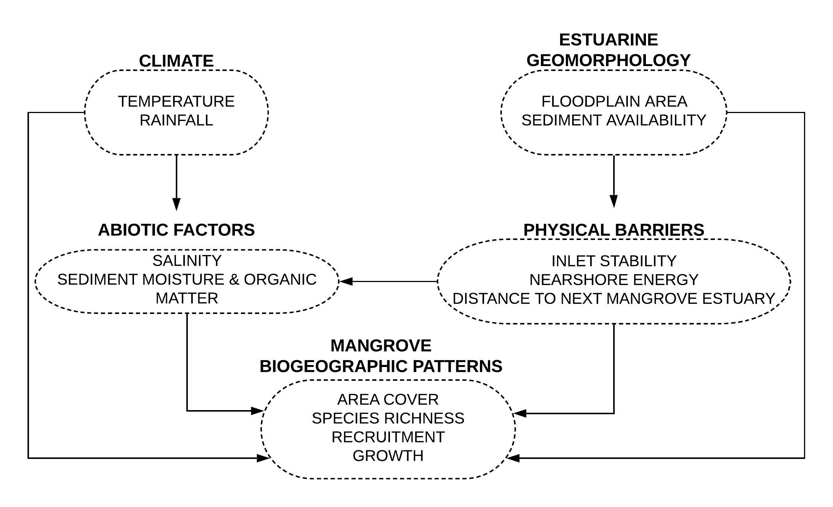
Figure 1. Conceptual diagram of hypothesized links between the theoretical constructs investigated in this study. Each theoretical construct represents a group of observable variables while the links guide the construction of the structural equations.
Following this, a causal diagram summarizing the hypothesized connections among all potential observable variables was generated (Figure S1). Each link in the causal diagram was evaluated as an assumption or hypothesis using a priori ecological knowledge as well as evidence from published scientific research (Table S1). This process allows for consideration of which variables are essential and which variables could be omitted to limit model complexity in the SEM (Grace et al. 2012). A full description of the process to develop the links for the SEM is provided in the Supplementary Material.

2.2 Data Collation
Regional data for mangrove area cover (ha) in South African estuaries were collated from the most recent (2018) version of the National Estuary Botanical Database maintained by the Nelson Mandela University (Adams et al. 2016). Of the ~ 300 estuaries along the South African coastline, mangroves are restricted to occurring along the east coast in 31 systems that fall within the warm-temperate and subtropical to tropical biogeographic regions (Figure 2). The two dominant species are Avicennia marina and Bruguiera gymnorhiza that occur in 27 estuaries, although A. marina covers the largest area (Adams et al. 2016). Rhizophora mucronata occurs in 14 estuaries and is associated with tidal creeks and channels. An additional three species (Ceriops tagal, Lumnitzera racemosa, and Xylocarpus granatum) only occur in the tropical biogeographic zone at the Kosi Estuary.
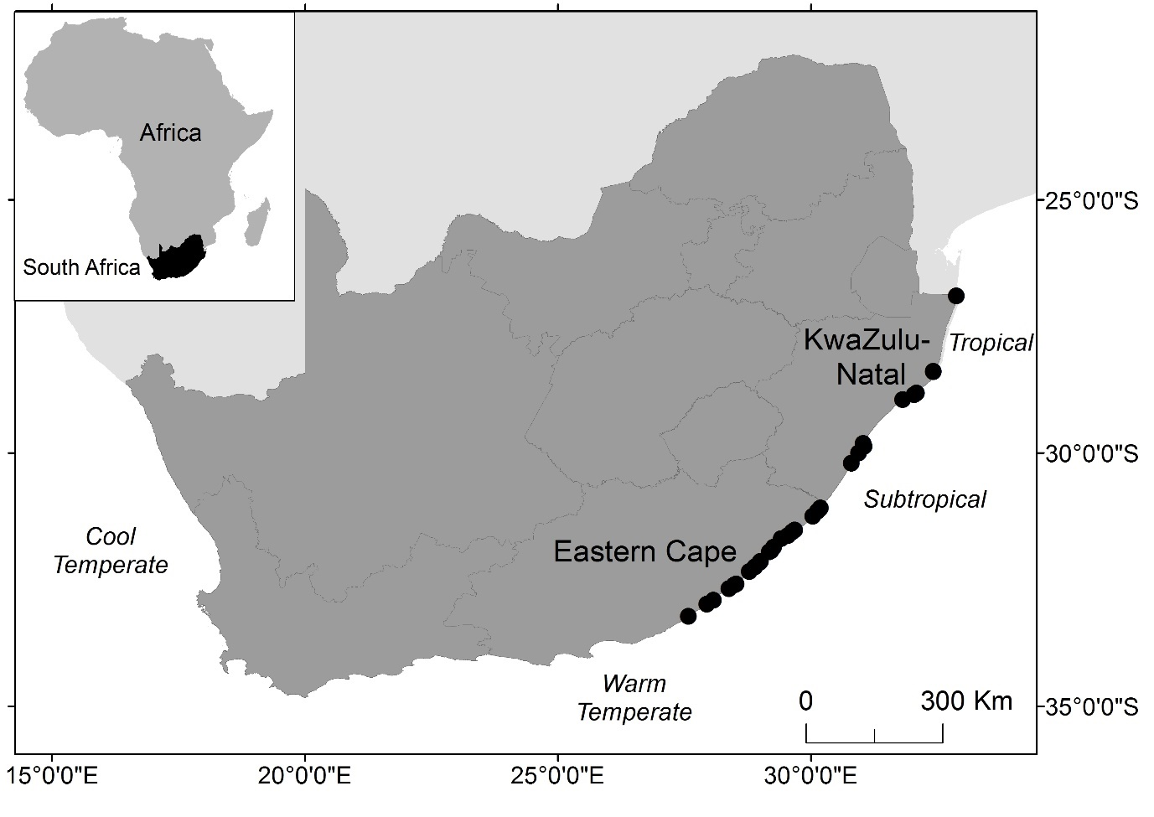
Figure 2. Locations of estuaries that support mangrove forests along the South African coastline.
Estuaries that support mangrove areas greater than 0.5 ha (n = 29) were identified from the botanical database. Data for suitable variables that represent climate and geomorphological drivers were then extracted for these estuaries from the most recent version of the Council of Scientific and Industrial Research (CSIR) National database for the physical characteristics of South Africa’s estuaries (van Niekerk et al. 2017, 2018) (Table 1). The extracted variables were: Average Annual Land Temperature, Catchment Erodibility, Daily Flushing Rate, Distance to Next Mangrove Estuary, Floodplain Area, Inciseness, Inlet Stability, Mean Annual Runoff, Seasonal Difference in Land Temperature, and Surfzone Width. Rainfall data were extracted from the WR2012 hydrology project.
Preliminary data exploration identified two estuaries as significant outliers with Cook’s distance > 1 (Cook 1979). The outliers were based on the data points for mangrove area cover and floodplain size. These two estuaries (Mhlathuze and St Lucia) were excluded from the final analysis. The large mangrove areas supported by these estuaries are not truly representative of the conditions along the South African coastline and, furthermore, both of these estuaries have been transformed from their baseline ecological states. Mhlathuze has been modified to develop an industrial port while the St Lucia estuary was artificially opened for more than 50 years (Whitfield & Taylor 2009, Elliott et al. 2016).

Table 1. Observed variables that were considered for modelling South African mangrove distribution based on the SEM conceptual model.
Theoretical construct | Observed variables | Properties of data
Climatic Variables | Temperature (°C)  Average Annual Land Temperature  - Seasonal Difference in Land Temperature | Continuous  Continuous
 | Rainfall  Mean Annual Precipitation (mm) | 0 to +∞; Continuous
Geomorphological Variables | Floodplain Area (ha)  - the area between the 0 and 5 m contour, minus all open water area, it reflects the estuarine functional zone | 0 to +∞; Continuous
 | Inciseness  - ratio of open water area to floodplain area | 0-1 ratio data, Continuous
 | Catchment Erodibility Index | Categorical (1 (low) to 5 (high))
Abiotic Variables | Salinity Category  - the dominant salinity regime of the estuary which reflects the degree of fluvial input as ranging from freshwater-dominated to marine | Categorical (fresh, mixed, marine)
 | Mean Annual Runoff (m³ x 10⁶) | 0 to +∞; Continuous
Physical Variables | Inlet Stability  - condition of the estuary inlet that reflects periods of altered or low marine connectivity | Binary (1 = open 100% of the time; 0 = experiences closure up to 25% of the time)
 | Daily Flushing Rate (m³ x 10⁶.d) | 0 to +∞; Continuous
 | Distance along the coast to next mangrove estuary (km) | 0 to +∞; Continuous
 | Nearshore Energy  - Surfzone Width (m) | 0 to +∞; Continuous
Response Variables | Mangrove Area (ha) | 0 to +∞; Continuous

2.3 Data Analysis
To specify the initial SEM, a series of equations describing the relationships between predictor and response variables were defined. These relationships were determined using correlations between the variables and the hypothesized links in the causal diagram. The properties of the available data, such as the type and distribution (Table 1), were considered to mathematically specify each relationship as a statistical model. Five models were initially specified for the response variables: Inciseness (topography slope), Mean Annual Runoff, Daily Flushing Rate, Inlet Stability, Mangrove Species Richness, and Mangrove Area (Table 2).
Table 2. Initial models that were specified based on the a priori hypothesized links describing the causative relationships between observed variables.
Model | Response variable | Predictor variables | Statistical model form
(1) | Inciseness | Floodplain Area | Linear regression
(2) | Mean Annual Runoff | Mean Annual Precipitation | Generalized least squares
(3) | Daily Flushing Rate | Floodplain Area, Mean Annual Runoff | Generalized least squares
(4) | Inlet Stability | Daily Flushing Rate, Inceiseness, Surfzone Width | Logistic regression (binomial)
(5) | Mangrove Area | Daily Flushing Rate, Floodplain Area, Inlet Stability, Temperature, | Generalized least squares

Models with continuous response variables (Inciseness, Mean Annual Runoff, Daily Flushing Rate, Mangrove Area) were first specified as linear regression models and model assumptions were verified graphically following Zuur et al. (2009) by assessing (1) the spread in a plot of the standardized residuals and the fitted values (homogeneity of variance); (2) the distribution of the standardized residuals in a frequency histogram (normality); (3) the relationship between the standardized residuals and each of the explanatory variables in the model (independence). When there was evidence of a violation of homogeneity of variances, the data were analysed by incorporating a variance covariate structure and using a generalised least-squares (GLS) estimation procedure (following Zuur et al. 2009, Godbold & Solan 2013) to allow the residual spread to vary within individual explanatory variables. The optimal variance covariate structure was determined using restricted maximum-likelihood (REML) estimation; the initial linear regression model without a variance structure was compared with the equivalent GLS model incorporating specific variance structures using AIC (Aikaike Information criterion) and visualisation of model residuals. The significance of the fixed-effects structure in the GLS models was determined using maximum likelihood (ML) estimation and was on based log likelihood ratios. Non-significant terms were only retained in the model if they improved the model validation graphs (Zuur et al. 2009).
For the model defining Inlet Stability, logistic regression with a logit link was used as this response variable had a binary distribution. The Nagelkerke (1991) method was used to calculate R² for the generalized linear model. Assumptions were validated graphically using the standardized and deviance residuals (Zuur et al. 2009).
The significant models specified for Daily Flushing Rate, Inlet Stability, and Mangrove Area were fit to the SEM using the piecewise estimation method as it allows for the implementation of non-normal distributions, random effects and different correlation structures using local estimation (Lefcheck 2016, Andriuzzi et al. 2018, Campanati et al. 2018). The fit of the equations within the SEM was tested using Fishers goodness of fit and D-separation (Shipley 2013). This allowed for missing links in the specified models to be identified and added to the models accordingly. Variables were only added as predictors if the relationship with the response variable was ecologically sound. The statistical assumptions and fit based on AIC were re-assessed for any models to which predictor variables were added. The refined models were then returned to specify the SEM and the process was repeated until the Fisher’s goodness of fit indicated p > 0.05. A summary of all the models making up the final SEM, the R² values, and the coefficients was then generated and presented in a graphical form.
The beta coefficients allow for an interpretation of the relationships between variables in terms of standard deviation units (Grace & Bollen 2005). In the case of multiple predictors, the standardized coefficients reflect the effect of the variable as well as the variances and covariances of the other variables in the model (Pedhazur 1997). However, standardizing the coefficients permits direct comparisons between the different models, regardless of the units in which the response variables are measured (Grace & Bollen 2005). The estimated coefficients are therefore displayed as path coefficients, and these indicate the difference in the predicted value of the response variable for each unit difference in the predictor variable when all other predictor variables remain constant (Grace & Bollen 2005).
All statistical analyses were performed using R version 3.5.1 (R Core Team 2018). The SEM was performed using the package “piecewiseSEM” (Lefcheck 2016). The “faraway” package (Faraway 2016) was used to test for dispersion in the logistic regression model. The “nlme” package (Pinheiro et al. 2018) was used to specify generalized least squares models.

3 Results
The models defining Inciseness and Mean Annual Runoff were insignificant and, therefore, were not included in the SEM analysis. For the remaining three models, the coefficients indicate the significance of the individual structural paths in the SEM (Table 3).
Significant coefficients (p < 0.05) were found for the models defining Daily Flushing Rate, and Mangrove Area (Table 3, Figure 3). The results show that Floodplain Area and Mangrove Area are closely related. If there is a 1-unit standard deviation change in Floodplain Area, it is predicted that there will be a change in 0.890 standard deviation units for Mangrove Area. A similar relationship occurs for Mean Annual Runoff as a predictor of Daily Flushing Rate. The magnitude of the beta coefficients was used to scale the links between predictor and response variables in the final SEM (Figure 3).
The graphical representation of the final SEM (Figure 3) shows the relationships between all variables defined in the models. For the model defining Mangrove Area (R² = 0.57), Floodplain Area, Inlet Stability, Daily Flushing Rate and Mean Annual Runoff were all found to be significant predictors (p < 0.05) (Table 3, Figure 3, Table S4). The model predicted that larger Floodplain Area and higher Mean Annual Runoff would increase Mangrove Area, while an increase in Daily Flushing Rate is associated with a decrease in Mangrove Area. A 1 ha increase in Floodplain Area is predicted to increase Mangrove Area by 0.0154 ha, while an increase in Mean Annual Runoff of 1 m³ x 10⁶ is predicted to only increase Mangrove Area by 0.00091 ha. In contrast, an increase of Daily Flushing Rate of 1 m³ x 10⁶/d is predicted to decrease Mangrove Area by 6.407 ha. Additionally, if Inlet Stability changes so that there is no longer a permanent connection to the ocean, Mangrove Area is predicted to decrease by 5.350 ha.

Table 3. Summary of the coefficients derived from statistical models defined for climatic and geomorphological drivers of mangrove biogeographic patterns along the South African coastline. Significant (p < 0.05) coefficients are indicated by asterisks. Daggers indicate range standardization of the beta coefficients for categorical predictors. Only models with suitable fit were used in the final Structural Equation Model.

Model 1: Inciseness (R² < 0.01)
Predictor variable | Variance structure | Coefficient | Std Error | df | t | p | Beta coefficient
Floodplain Area | N/A | - 2.28 x 10⁻⁶ | 1.58 x 10⁻⁵ | 25 | -0.145 | 0.886 | -0.0289
Model 2: Mean Annual Runoff (R² = 0.21)
Predictor variable | Variance structure | Coefficient | Std Error | df | t | p | Beta coefficient
Rainfall | Power = 2.371 | 0.3199 | 0.2055 | 27 | 1.557 | 0.133 | 0.1923
Floodplain Area | N/A | 0.0538 | 0.0219 | 27 | 2.450 | 0.022 | 0.3910*
Model 3: Daily Flushing Rate (R² = 0.62)
Predictor variable | Variance structure | Coefficient | Std Error | df | t | p | Beta coefficient
Floodplain Area | N/A | -1.18 x 10⁻⁴ | 3.97 x 10⁻⁵ | 27 | -2.972 | 0.007 | -0.3914*
Mean Annual Runoff | Constant = 1.35 x 10⁻⁵  Power = - 9.645 | 2.08 x 10⁻³ | 2.79 x 10⁻⁴ | 27 | 7.446 | 0.0001 | 0.9474*
Surfzone Width | N/A | -3.14 x 10⁻³ | 9.45 x 10⁻⁴ | 27 | -3.324 | 0.003 | -0.3992*
Model 4: Inlet Stability (R² = 0.50)
Predictor variable | Variance structure | Coefficient | Std Error | df | t | p | Beta coefficient
Daily Flushing Rate | N/A | -1.667 | 1.067 | 23 | -1.562 | 0.118 | -0.388
Surfzone Width | N/A | 0.013 | 0.009 | 23 | 1.445 | 0.148 | 0.370
Model 5: Mangrove Area (R² = 0.57)
Predictor variable | Variance structure | Coefficient | Std Error | df | t | p | Beta coefficient
Mean Annual Runoff | N/A | 9.1 x 10⁻³ | 3.08 x 10⁻³ | 27 | 2.984 | 0.007 | 0.0736*
Temperature | Power = 5.854 | 0.7303 | 1.842 | 27 | 0.396 | 0.696 | 0.0187
Floodplain Area | Power = 0.570 | 0.0154 | 3.79 x 10⁻³ | 27 | 4.066 | 0.0006 | 0.8970*
Marine Connectivity | N/A | -5.350 | 1.5851 | 27 | -3.375 | 0.0029 | -0.0412*†

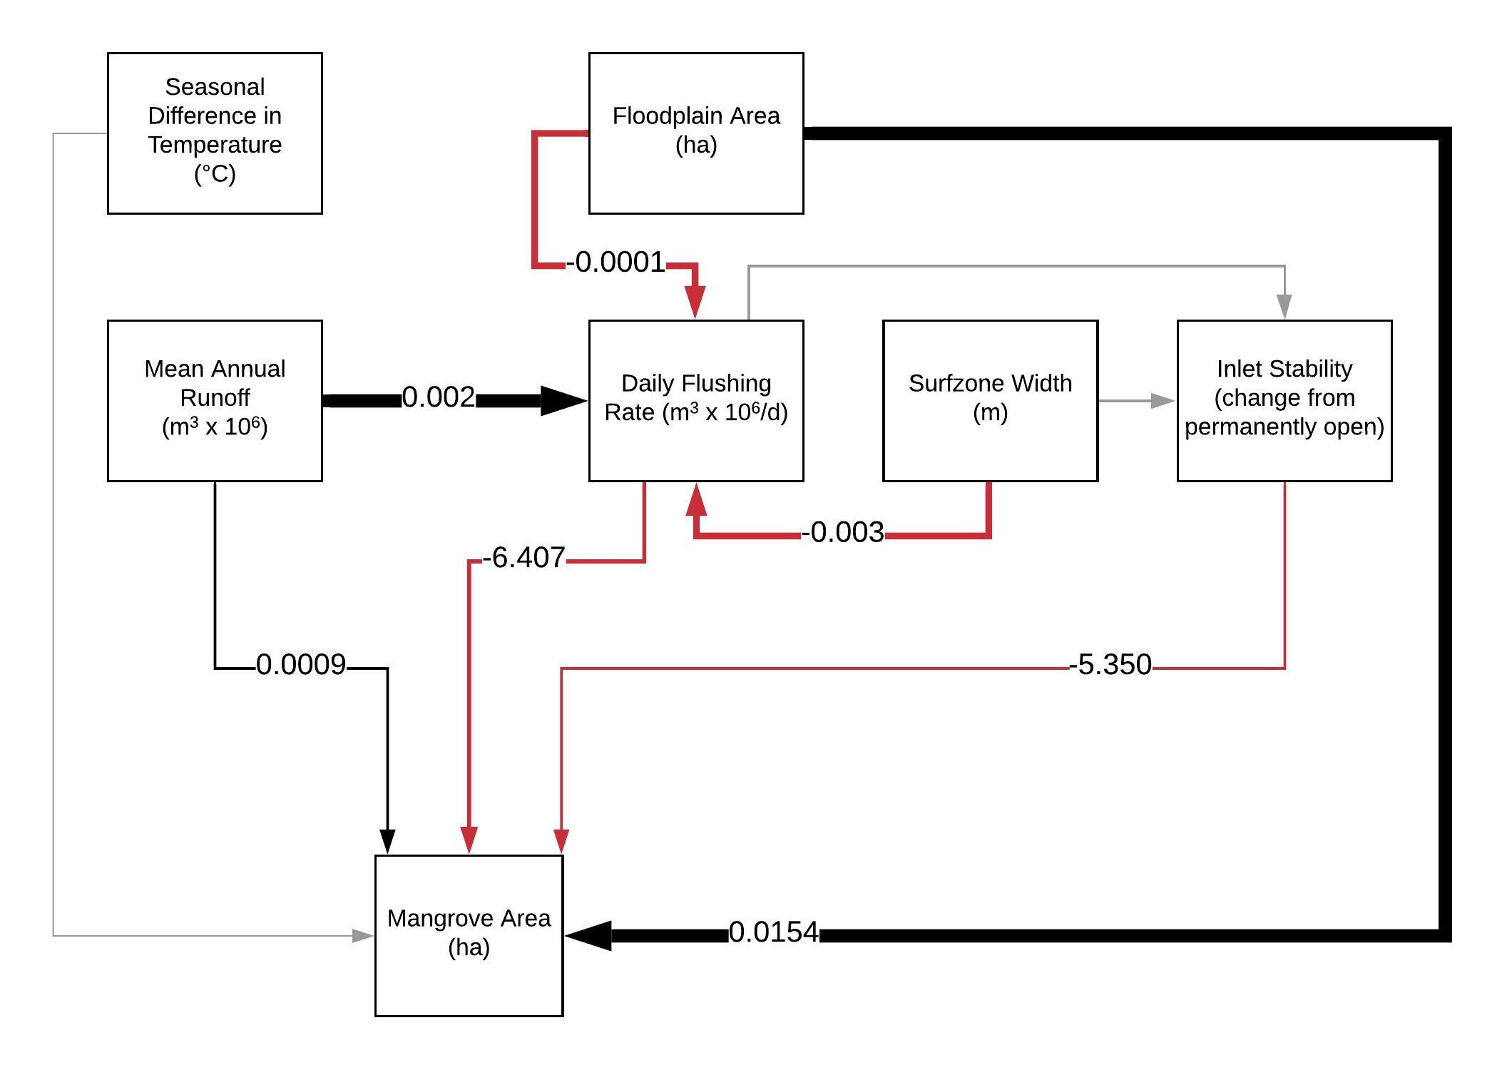
Figure 3. Final Structural Equation Model for variables representing climatic and geomorphological drivers of mangrove distribution patterns along the South African coastline. Path coefficients are estimated values in the units of the respective response variables. Black lines indicate positive significant effects, red lines indicate negative significant effects, and grey lines indicate non-significant effects (p > 0.05). Arrows are scaled by the magnitude of the beta coefficients.

4 Discussion
Global datasets of temperature and rainfall gradients have been used to examine regional biogeographic patterns in mangrove distribution and species richness (Osland et al. 2017b, Hickey et al. 2017). However, regional scale studies have identified that local conditions can have strong control over mangrove biogeographic patterns (Schaeffer-Novelli et al. 1990, Duke et al. 1998, Stevens et al. 2006). Here we provide the first report on the importance of regional and local factors as drivers of mangrove distribution along the coastline of South Africa.

4.1 Importance of geomorphology as a control on mangrove distribution
In this study, Floodplain Area was a significant predictor of Mangrove Area, and these two variables were closely correlated. The gradient of the shoreline significantly influences the development of mangrove forests as different geologic settings and hydrological fluxes drive establishment patterns in relation to species tolerance ranges (Semeniuk 1985, Woodroffe 1992, Balke & Friess 2016). Areas within estuaries that are most suitable for mangrove habitat have low gradients and low energy, and these conditions promote sediment deposition (Boyd et al. 1992, Dalrymple et al. 1992) and facilitate mangrove establishment (Woodroffe 1992, Roy et al. 2001, Krauss et al. 2008). The suitability of these areas to mangroves is determined by the relationship between the surface sediment height and the upper tidal level limit (Woodroffe et al. 2016). This zone is geologically defined in terms of ‘accommodation space’ which is “the space available for potential sediment accumulation” (Jervey 1988).
Tidal and fluvial hydrodynamics affect accommodation space by driving erosion or deposition of sediment, which determines accretion and subsidence dynamics (FitzGerald 1996, Adame et al. 2010). Net sediment accumulation is expected in microtidal estuaries, such as those along the South African coastline, as inputs received from marine and fluvial sources are only periodically scoured by river floods (Cooper 2001). Sediment accumulation can restrict the occurrence of coastal wetlands such as mangroves when high accretion rates build elevations above the suitable intertidal zone (Saintilan et al. 2016). In this study, we attempted to include an index of Catchment Erodibility as a proxy for sediment inputs, but it was not a significant predictor in the mangrove area model. However, the restricted occurrence of mangroves in this region has been attributed to the dominance of coarse-grained terrigenous sediment and limited accommodation space in relation to the stage of geomorphological development of these estuaries (Cooper et al. 2018).
Along the South African coastline, almost all estuaries occur in incised bedrock valleys of drowned rivers following post-glacial sea-level change in the Mid-Holocene 6000-7300 years ago (Whitfield 1992, Cooper et al. 2018). The evolution of modern estuaries from drowned river valleys to mature systems infilled with sediment characterizes the development of the floodplain (Skilbeck et al. 2017). The young geological age of South African estuaries is therefore reflected in the importance of floodplain development as a predictor of mangrove area as the largest forests occur within the few coastal plain estuaries and natural embayments along the KwaZulu-Natal coast (Rajkaran & Adams 2011, Adams et al. 2016).
The transition of an estuary from one geomorphic state to another is determined by sea level, waves, tides, and river processes (Boyd et al. 1992, Dalrymple et al. 1992). In this study, Inlet Stability and Daily Flushing Rate were significant predictors of Mangrove Area. The interplay between nearshore energy as well as tidal and fluvial mechanisms determines whether an estuary is wave-dominated or tide-dominated (Daidu et al. 2013, Skilbeck et al. 2017). Most estuaries along the eastern South African coastline are wave-dominated, as high nearshore energy promotes deposition of sediment as a barrier at the opening, and this reduces the stability of the inlet, particularly if fluvial flows are relatively weak (Whitfield 1992, Cooper 2001, McSweeney et al. 2017). This can lead to prolonged closure, which can significantly impact mangroves as they are sensitive to changes in the inundation regime (Breen & Hill 1969, Adams & Human 2016, Mbense et al. 2016).
Although increased Daily Flushing Rate was hypothesized to maintain Inlet Stability, and therefore indirectly support mangrove habitat persistence, a significant negative direct effect on Mangrove Area was predicted by the model. In this study, Daily Flushing Rate was defined by Mean Annual Runoff, Floodplain Area, and Surfzone Width, and this provides a proxy of the flow regime for an estuary as influenced by both fluvial and marine inputs. The importance of hydrology in maintaining mangrove forests has been highlighted by research on effective mangrove restoration (Lewis 2005, Ferreira et al. 2015, Howard et al. 2017). In confined estuarine settings, the combined effects of fluvial and tidal discharges on sedimentation patterns determine mangrove establishment and persistence (Wolanski 1992). This results in different responses to extreme events in river- and tide-dominated estuaries on high energy coastlines (Cooper 2002, Rogers & Woodroffe 2016). Mangroves that occur in river-dominated estuaries are expected to be more prone to destabilization by flood events as high energy flows erode the length of channels, while in tide-dominated estuaries the flood energy results in erosion of the barrier and tidal delta (Cooper 2002).
In combination, the geomorphological and physical characteristics of estuaries along the South African coastline have a strong influence on mangrove occurrence. Limited accommodation space in conjunction with the stability of the estuary inlet and connection to the marine environment determine which estuaries can support persistent mangrove habitats.

4.2 Climatic controls on mangrove biogeographic patterns
Mangroves occur at a southern continental limit and extend into a warm temperate biogeographic region along the South African coastline. In this study, temperature was not a significant predictor in the model describing Mangrove Area. The use of average minimum temperatures as proxies for climatic thresholds at range limits has been criticized as they are not informative when there is a considerable range in extreme values (Osland et al. 2017b). For mangrove species, freeze events have been documented to control current distribution patterns as these species are not frost-tolerant (Stevens et al. 2006, Stuart et al. 2007, Cavanaugh et al. 2014, Schaeffer-Novelli et al. 2016).
The absolute coldest air temperature that has occurred is recommended for models that predict range expansions for mangroves (Cavanaugh et al. 2015). However, many southern hemisphere range limits have small differences between the lowest absolute minimum temperature and the daily winter minima, and the absolute minima for these range limits are relatively warmer in comparison to those in the northern hemisphere (Osland et al. 2017b, Rogers & Krauss 2018). Mangrove trees at southern hemisphere range limits are therefore not likely to be occurring at their physiological limits. For the southeast African range limit, the lowest absolute minimum temperature over the past four decades has been estimated at -0.5°C using gridded daily minimum air temperature data (Osland et al. 2017b), and this could explain the weak causal link between Temperature and Mangrove Area in our model. The reduced effect of temperature as a control on contemporary mangrove distribution in South Africa is also evident from the success of planted mangroves beyond their natural latitudinal limit (Hoppe-Speer et al. 2015).
Although mangrove distribution is not currently limited by temperature, increases associated with global climate change could still influence mangrove expansion at the southern African distribution limit. Increasing temperature be influencing mangrove expansion at spatial scales within individual estuaries and as the SEM did not consider mangrove areas < 0.5 ha, estuaries where pioneer trees have been reported were not included. Predictive modelling of mangrove species distribution has shown that increased temperature and rainfall will promote mangrove expansion in this region (Quisthoudt et al. 2013). Although individual pioneers have been recently recorded beyond the natural distribution (Whitfield et al. 2016), expansion into salt marsh areas has not occurred at the scales reported on at other range limits in Australia and the eastern United States (Kelleway et al. 2017, Smee et al. 2017). Latitudinal gradients are weakly associated with species diversity of mangrove fauna and flora for this region (Peer et al. 2018) which further indicates that expansion is likely to be limited by dispersal (Whitfield et al. 2016). Investigating the potential for expansion should account for this and also include an assessment of the suitability of estuaries beyond the current distribution in terms of geomorphology and inlet stability.

4.3 Structural equation modelling and future applications
This is the first study to use a quantitative modelling approach to describe mangrove distribution patterns for this region. The SEM approach is used to develop and evaluate models so that underlying causal processes can be represented as a network of relationships among the variables of interest (Grace et al. 2012). This is achieved by using a priori ecological knowledge to provide context to the causal relationships (Grace 2008). One of the strengths of the SEM approach is that additional paths can be added and the effect on the system can be evaluated if more data becomes available (Grace et al. 2012). For this study, the addition of data on sediment characteristics (particle size, moisture content, redox potential), high resolution topography data (<10 cm accuracy), and biological interactions (interspecific competition, predation by crabs), could improve the strength of the models as these factors are known to influence mangrove distribution patterns (Dahdouh-Guebas et al. 1998, Berger et al. 2006, Rajkaran & Adams 2012). The SEM can also be validated by using the models to predict mangrove area for estuaries that have lost mangrove habitat due to anthropogenic disturbances, and the predictions can be compared to historical data.
Conclusion
The conclusive findings on the importance of geomorphology for controlling mangrove distribution in this region can be used as an important baseline for improving climate change predictive models. The results from this study indicate that including floodplain area as part of a geomorphological index for predicting mangrove expansion is essential. The topography of the coast has long been noted as a significant control on mangrove distribution under wave-dominated, high-energy conditions at southern hemisphere range limits. The interplay between geomorphology and hydrodynamic characteristics should not be overlooked when considering potentially suitable habitats for mangroves beyond their current distribution along the South African coastline.

5 Acknowledgements
This research was partially supported by the Water Research Commission (WRC) of South Africa and the 2017 RCUK-NRF Newton Exchange program between the University of Southampton and the Nelson Mandela University. JLR is supported by a National Research Foundation (NRF) Innovation Postdoctoral Fellowship (UID: 111963). The funders had no role in the design of the study, the collection or analysis of the data, writing the manuscript or decision to publish. The authors declare no competing interests.

References
Adame MF, Neil D, Wright SF, Lovelock CE (2010) Sedimentation within and among mangrove forests along a gradient of geomorphological settings. Estuarine, Coastal and Shelf Science 86:21–30
Adams JB, Human LRD (2016) Investigation into the mortality of mangroves at St Lucia Estuary. South African Journal of Botany 107:121–128
Adams JB, Veldkornet D, Tabot P (2016) Distribution of macrophyte species and habitats in South African estuaries. South African Journal of Botany 107:5–11
Andriuzzi WS, Adams BJ, Barrett JE, Virginia RA, Wall DH (2018) Observed trends of soil fauna in the Antarctic Dry Valleys: early signs of shifts predicted under climate change. Ecology 99: 312-321
Arrivabene HP, Souza I, Có WLO, Rodella RA, Wunderlin DA, Milanez CR (2014) Functional traits of selected mangrove species in Brazil as biological indicators of different environmental conditions. Science of The Total Environment 476–477:496–504
Austin ÅN, Hansen JP, Donadi S, Eklöf JS (2017) Relationships between aquatic vegetation and water turbidity: A field survey across seasons and spatial scales. PLoS ONE 12:e0181419
Balke T, Friess DA (2016) Geomorphic knowledge for mangrove restoration: a pan-tropical categorization. Earth Surface Processes and Landforms 41:231–239
Berger U, Adams M, Grimm V, Hildenbrandt H (2006) Modelling secondary succession of neotropical mangroves: Causes and consequences of growth reduction in pioneer species. Perspectives in Plant Ecology, Evolution and Systematics 7:243–252
Boateng I (2018) An Assessment of Vulnerability and Adaptation of Coastal Mangroves of West Africa in the Face of Climate Change. In: Makowski C, Finkl CW (eds) Threats to Mangrove Forests: Hazards, Vulnerability, and Management. Springer International Publishing, Cham, p 141–154
Boon PI (2017) Are mangroves in Victoria (south-eastern Australia) already responding to climate change? Marine and Freshwater Research 68:2366–2374
Boyd R, Dalrymple R, Zaitlin BA (1992) Classification of clastic coastal depositional environments. Sedimentary Geology 80:139–150
Breen CM, Hill BJ (1969) A mass mortality of mangroves in the Kosi Estuary. Transactions of the Royal Society of South Africa 38:285–303
Campanati C, Dupont S, Willams GA, Thiyagarajan V (2018) Differential sensitivity of larvae to ocean acidification in two interacting mollusc species. Marine Environmental Research 141: 66-74
Cavanaugh KC, Kellner JR, Forde AJ, Gruner DS, Parker JD, Rodriguez W, Feller IC (2014) Poleward expansion of mangroves is a threshold response to decreased frequency of extreme cold events. Proceedings of the National Academy of Sciences 111:723–727
Cavanaugh KC, Osland MJ, Bardou R, Hinojosa‐Arango G, López‐Vivas JM, Parker JD, Rovai AS (2018) Sensitivity of mangrove range limits to climate variability. Global Ecology and Biogeography 27:925–935
Cavanaugh KC, Parker JD, Cook-Patton SC, Feller IC, Williams AP, Kellner JR (2015) Integrating physiological threshold experiments with climate modeling to project mangrove species’ range expansion. Global Change Biology 21:1928–1938
Comeaux RS, Allison MA, Bianchi TS (2012) Mangrove expansion in the Gulf of Mexico with climate change: Implications for wetland health and resistance to rising sea levels. Estuarine, Coastal and Shelf Science 96:81–95
Cook RD (1979) Influential observations in linear regression. Journal of the American Statistical Association 74: 169-174
Cooper JAG (2001) Geomorphological variability among microtidal estuaries from the wave-dominated South African coast. Geomorphology 40:99–122
Cooper JAG (2002) The role of extreme floods in estuary-coastal behaviour: contrasts between river- and tide-dominated microtidal estuaries. Sedimentary Geology 150:123–137
Cooper JAG, Green AN, Compton JS (2018) Sea-level change in southern Africa since the Last Glacial Maximum. Quaternary Science Reviews 201:303–318
Dahdouh-Guebas F, Verneirt M, Tack JF, Van Speybroeck D, Koedam N (1998) Propagule predators in Kenyan mangroves and their possible effect on regeneration. Marine and Freshwater Research 49:345–350
Daidu F, Yuan W, Min L (2013) Classifications, sedimentary features and facies associations of tidal flats. Journal of Palaeogeography 2:66–80
Dalrymple RW, Zaitlin BA, Boyd R (1992) Estuarine facies models; conceptual basis and stratigraphic implications. Journal of Sedimentary Research 62:1130–1146
Duke N, Ball M, Ellison J (1998) Factors influencing biodiversity and distributional gradients in mangroves. Global Ecology and Biogeography Letters 7:27–47
Elliott M, Mander L, Mazik K, Simenstad C, Valesini F, Whitfield A, Wolanski E (2016) Ecoengineering with Ecohydrology: Successes and failures in estuarine restoration. Estuarine, Coastal and Shelf Science 176:12–35
Faraway J (2016) faraway: Functions and Datasets for Books by Julian Faraway. R package version 1.0.7 https://CRAN.R-project.org/package=faraway
Ferreira AC, Ganade G, Luiz de Attayde J (2015) Restoration versus natural regeneration in a neotropical mangrove: Effects on plant biomass and crab communities. Ocean & Coastal Management 110:38–45
FitzGerald DM (1996) Geomorphic Variability and Morphologic and Sedimentologic Controls on Tidal Inlets. Journal of Coastal Research:47–71
Giri C, Ochieng E, Tieszen LL, Zhu Z, Singh A, Loveland T, Masek J, Duke N (2011) Status and distribution of mangrove forests of the world using earth observation satellite data. Global Ecology and Biogeography 20:154–159
Godbold JA, Solan M (2013) Long-term effects of warming and ocean acidification are modified by seasonal variation in species responses and environmental conditions. Philosophical Transactions of the Royal Society B: Biological Sciences 368: 20130186
Grace JB (2008) Structural equation modeling for observational studies. Journal of Wildlife Management 72:14–22
Grace JB, Anderson TM, Olff H, Scheiner SM (2010) On the specification of structural equation models for ecological systems. Ecological Monographs 80:67–87
Grace JB, Bollen KA (2005) Interpreting the results from multiple regression and structural equation models. Bulletin of the Ecological Society of America 86:283–295
Grace JB, Schoolmaster DR, Guntenspergen GR, Little AM, Mitchell BR, Miller KM, Schweiger EW (2012) Guidelines for a graph-theoretic implementation of structural equation modeling. Ecosphere 3:1–44
Guo H, Weaver C, Charles SP, Whitt A, Dastidar S, D’Odorico P, Fuentes JD, Kominoski JS, Armitage AR, Pennings SC (2017) Coastal regime shifts: rapid responses of coastal wetlands to changes in mangrove cover. Ecology 98:762–772
Hayes MA, Jesse A, Hawke B, Baldock J, Tabet B, Lockington D, Lovelock CE (2017) Dynamics of sediment carbon stocks across intertidal wetland habitats of Moreton Bay, Australia. Global Change Biology 23:4222–4234
Hickey SM, Phinn SR, Callow NJ, Niel KPV, Hansen JE, Duarte CM (2017) Is climate change shifting the poleward limit of mangroves? Estuaries and Coasts 40:1215–1226
Hoppe-Speer SCL, Adams JB, Rajkaran A (2015) Mangrove expansion and population structure at a planted site, East London, South Africa. Southern Forests 77:131–139
Howard RJ, Day RH, Krauss KW, From AS, Allain L, Cormier N (2017) Hydrologic restoration in a dynamic subtropical mangrove-to-marsh ecotone. Restoration Ecology 25:471–482
Jervey MT (1988) Quantitative geological modeling of siliciclastic rock sequences and their seismic expression. In: Wilgus CK, Hastings BS, Posamentier H, Van Wagoner J, Ross CA, Kendall CGSC (eds) Sea-Level Changes: An Integrated Approach. Society of Economic Paleontologists and Mineralogists (SEPM) Special Publication 42, Tulsa, Oklahoma USA, p 47-69
Kelleway JJ, Cavanaugh K, Rogers K, Feller IC, Ens E, Doughty C, Saintilan N (2017) Review of the ecosystem service implications of mangrove encroachment into salt marshes. Global Change Biology 23:3967–3983
Kelleway JJ, Saintilan N, Macreadie PI, Skilbeck CG, Zawadzki A, Ralph PJ (2016) Seventy years of continuous encroachment substantially increases ‘blue carbon’ capacity as mangroves replace intertidal salt marshes. Global Change Biology 22:1097–1109
Krauss KW, Lovelock CE, McKee KL, López-Hoffman L, Ewe SML, Sousa WP (2008) Environmental drivers in mangrove establishment and early development: A review. Aquatic Botany 89:105–127
Lefcheck JS (2016) piecewiseSEM: Piecewise structural equation modelling in r for ecology, evolution, and systematics. Methods in Ecology and Evolution 7:573–579
Leong RC, Friess DA, Crase B, Lee WK, Webb EL (2018) High-resolution pattern of mangrove species distribution is controlled by surface elevation. Estuarine, Coastal and Shelf Science 202:185–192
Lewis RR (2005) Ecological engineering for successful management and restoration of mangrove forests. Ecological Engineering 24:403–418
Mbense SP, Rajkaran A, Bolosha U, Adams JB (2016) Rapid colonization of degraded mangrove habitat by succulent salt marsh. South African Journal of Botany 107:129–136
McKee KL, Vervaeke WC (2017) Will fluctuations in salt marsh–mangrove dominance alter vulnerability of a subtropical wetland to sea‐level rise? Global Change Biology 24:1224–1238
McSweeney SL, Kennedy DM, Rutherfurd ID, Stout JC (2017) Intermittently closed/open lakes and lagoons: Their global distribution and boundary conditions. Geomorphology 292:142–152
Nagelkerke NJD (1991) A note on a general definition of the coefficient of determination. Biometrika 78:691–692
Naidoo G (1985) Effects of waterlogging and salinity on plant-water relations and on the accumulation of solutes in three mangrove species. Aquatic Botany 22:133–143
Osland MJ, Day RH, Hall CT, Brumfield MD, Dugas JL, Jones WR (2017a) Mangrove expansion and contraction at a poleward range limit: climate extremes and land-ocean temperature gradients. Ecology 98:125–137
Osland MJ, Feher LC, Griffith KT, Cavanaugh KC, Enwright NM, Day RH, Stagg CL, Krauss KW, Howard RJ, Grace JB, Rogers K (2017b) Climatic controls on the global distribution, abundance, and species richness of mangrove forests. Ecological Monographs 87:341–359
Pedhazur EJ (1997) Multiple regression in behavioral research, Third edition. Wadsworth, Belmont, California, USA
Peer N, Rajkaran A, Miranda NAF, Taylor RH, Newman B, Porri F, Raw JL, Mbense SP, Adams JB, Perissinotto R (2018) Latitudinal gradients and poleward expansion of mangrove ecosystems in South Africa: 50 years after Macnae’s first assessment. African Journal of Marine Science 40:101–120
Pinheiro J, Bates D, DebRoy S, Sarkar D, R Core Team (2018) {nlme}: Linear and Nonlinear Mixed Effects Models. R package version 3.1-137 https://CRAN.R-project.org/package=nlme
Quisthoudt K, Adams J, Rajkaran A, Dahdouh-Guebas F, Koedam N, Randin C (2013) Disentangling the effects of global climate and regional land-use change on the current and future distribution of mangroves in South Africa. Biodiversity and Conservation 22:1369–1390
Quisthoudt K, Schmitz N, Randin CF, Dahdouh-Guebas F, Robert EM, Koedam N (2012) Temperature variation among mangrove latitudinal range limits worldwide. Trees 26:1919–1931
R Core Team (2018) R: A language and Environment for Statistical Computing. R Foundation for Statistical Computing, Vienna, Austria https://www.R-project.org/
Rajkaran A, Adams JB (2011) Mangrove forests of Northern Kwa-Zulu Natal: Sediment conditions and population structure of the largest mangrove forests in South Africa. West Indian Ocean Journal of Marine Science 10:25–38
Rajkaran A, Adams JB (2012) The effects of environmental variables on mortality and growth of mangroves at Mngazana Estuary, Eastern Cape, South Africa. Wetlands Ecology and Management 20:297–312
Rajkaran A, Adams JB, Taylor RH (2009) Historic and recent (2006) state of mangroves in small estuaries from Mlalazi to Mtamvuna in KwaZulu-Natal, South Africa. Southern Forests 71: 287-296
Rogers K, Krauss KW (2018) Moving from generalisations to specificity about mangrove –saltmarsh dynamics. Wetlands doi: 10.1007/s13157-018-1067-9
Rogers K, Woodroffe CD (2016) Geomorphology as an indicator of the biophysical vulnerability of estuaries to coastal and flood hazards in a changing climate. Journal of Coastal Conservation 20:127–144
Roy PS, Williams RJ, Jones AR, Yassini I, Gibbs PJ, Coates B, West RJ, Scanes PR, Hudson JP, Nichol S (2001) Structure and function of south-east Australian estuaries. Estuarine, Coastal and Shelf Science 53:351–384
Saintilan N, Rogers K, Toms C, Stein E, Jacobs D (2016) Intermittent estuaries: linking hydro-geomorphic context to climate change resilience. Journal of Coastal Research 75: 133-137
Saintilan N, Williams RJ (1999) Mangrove transgression into saltmarsh environments in south-east Australia. Global Ecology and Biogeography 8:117–124
Schaeffer-Novelli Y, Cintrón-Molero G, Adaime RR, Camargo TM de (1990) Variability of mangrove ecosystems along the Brazilian coast. Estuaries 13:204–218
Schaeffer-Novelli Y, Soriano-Sierra EJ, Vale CC do, Bernini E, Rovai AS, Pinheiro MAA, Schmidt AJ, Almeida R de, Coelho Júnior C, Menghini RP, Martinez DI, Abuchahla GM de O, Cunha-Lignon M, Charlier-Sarubo S, Shirazawa-Freitas J, Cintrón-Molero G (2016) Climate changes in mangrove forests and salt marshes. Brazilian Journal of Oceanography 64:37–52
Semeniuk V (1983) Mangrove distribution in Northwestern Australia in relationship to regional and local freshwater seepage. Vegetatio 53:11–31
Semeniuk V (1985) Development of mangrove habitats along ria shorelines in north and northwestern tropical Australia. Vegetatio 60:3–23
Shipley B (2013) The AIC model selection method applied to path analytic models compared using a d-separation test. Ecology 94:560–564
Skilbeck CG, Heap AD, Woodroffe CD (2017) Geology and Sedimentary History of Modern Estuaries. In: Weckström K, Saunders KM, Gell PA, Skilbeck CG (eds) Applications of Paleoenvironmental Techniques in Estuarine Studies. Springer Netherlands, Dordrecht, p 45–74
Smee DL, Sanchez JA, Diskin M, Trettin C (2017) Mangrove expansion into salt marshes alters associated faunal communities. Estuarine, Coastal and Shelf Science 187:306–313
Soares MLG, Estrada GCD, Fernandez V, Tognella MMP (2012) Southern limit of the Western South Atlantic mangroves: Assessment of the potential effects of global warming from a biogeographical perspective. Estuarine, Coastal and Shelf Science 101:44–53
Stevens PW, Fox SL, Montague CL (2006) The interplay between mangroves and saltmarshes at the transition between temperate and subtropical climate in Florida. Wetlands Ecology and Management 14:435–444
Stuart SA, Choat B, Martin KC, Holbrook NM, Ball MC (2007) The role of freezing in setting the latitudinal limits of mangrove forests. New Phytologist 173:576–583
Suárez JA, Urrego LE, Osorio A, Ruiz, HY (2015) Oceanic and climatic drivers of mangrove changes in the Gulf of Urabá, Colombian Caribbean. Latin American Journal of Aquatic Research 43: 972-985
Tomlinson PB (1999) The Botany of Mangroves. Cambridge University Press, Cambridge, United Kingdom
Urrego LE, Molina EC, Suárez JA (2014) Environmental and anthropogenic influences on the distribution, structure, and floristic composition of mangrove forests of the Gulf of Urabá (Colombian Caribbean). Aquatic Botany 114: 42-49
van der Heide T, van Nes EH, van Katwijk MM, Olff H, Smolders AJP (2011) Positive feedbacks in seagrass ecosystems – Evidence from large-scale empirical data. PLoS ONE 6:e16504
van Neikerk L, Adams JB, Bate GC, Forbes AT, Fores NT, Huizinga P, Lamberth SJ, MackayCF, Petersen C, Taljaard S, Weerts SP, Whitfield AK, Wooldridge TH (2013) Country-wide assessment of estuary health: an approach for integrating pressures and ecosystem response in a data limited environment. Estuarine, Coastal and Shelf Science 130: 239-251
van Niekerk L, Adams JB Lamberth SJ, MacKay FC, Taljaard S, Turpie JK, Ramhukad C-L, Sink K, van Deventer H (2018) South African National Biodiversity Assessment 2018: Technical Report. Volume 3: Estuarine Environment. South African National Biodiversity Institute, Pretoria. Report Number: SANBI/NAT/NBA2018/2019/Vol4/A
van Niekerk L, Taljaard S, Ramjukadh C-L Adams JB, Lamberth SJ, Weerts SP, Petersen C, Audouin M, Maherry A (2017). A multi-sector resource planning platform for South Africa's estuaries. Water Research Commission Report No K5/2464. South Africa.
Ward RD, Friess DA, Day RH, MacKenzie RA (2016) Impacts of climate change on mangrove ecosystems: A region by region overview. Ecosystem Health and Sustainability 2:e01211
Whitfield AK (1992) A characterization of southern African estuarine systems. South African Journal of Science 18:89–103
Whitfield AK, James NC, Lamberth SJ, Adams JB, Perissinotto R, Rajkaran A, Bornman TG (2016) The role of pioneers as indicators of biogeographic range expansion caused by global change in southern African coastal waters. Estuarine, Coastal and Shelf Science 172:138–153
Whitfield AK, Taylor RH (2009) A review of the importance of freshwater inflow to the future conservation of Lake St Lucia. Aquatic Conservation 19:838–848
Wolanski E (1992) Hydrodynamics of mangrove swamps and their coastal waters. Hydrobiologia 247:141–161
Woodroffe C (1992) Mangrove Sediments and Geomorphology. In: Tropical Mangrove Ecosystems. American Geophysical Union (AGU), p 7–41
Woodroffe CD, Grindrod J (1991) Mangrove biogeography: The role of Quaternary environmental and sea-level change. Journal of Biogeography 18:479–492
Woodroffe CD, Rogers KL, McKee K, Lovelock CE, Mendelssohn IA, Saintilan N (2016) Mangrove sedimentation and response to relative sea-level rise. Annual Review of Marine Science 8:243–266
Zuur AF, Ieno EN, Walker NJ, Saveliev AA, Smith GM (2009) Mixed effects models and extensions in ecology with R. Statistics for biology and health. Springer

