Aeroelastic Global Structural Optimization using an Efficient CFD-based Reduced Order Model

Dongfeng Li^{a,b}, Andrea Da Ronch^{c}, Gang Chen^{a,b}, Yueming Li^{a,b}
a: State Key Laboratory for Strength and Vibration of Mechanical Structures, School of Aerospace, Xi’an Jiaotong University, Xi’an, 710049, China
b: Shaanxi Province Key Laboratory for Service Environment and Control of Advanced Aircraft, School of Aerospace, Xi’an Jiaotong University, Xi’an, 710049, China
c: Engineering and the Environment, University of Southampton, Southampton SO17 1BJ, United Kingdom
Abstract
In aeroelastic structure optimization, the structural model needs to be modified repeatedly to meet all targets. Although computational fluid dynamics (CFD) based reduced order models (ROMs) have been successfully applied to transonic aeroelastic analysis, the existing CFD-based ROMs are at a fixed flight condition for a frozen aeroelastic model configuration. The aerodynamic and structural model have to be reconstructed to ensure accuracy, when a structural modification was made. These reconstructions take a considerable time and the computational costs become prohibitive. To overcome the realistic challenge, we have developed an efficient CFD-based ROM, which is robust to aeroelastic system. This paper presents a new optimization process using the efficient method for aeroelastic global structural optimization. The optimization process employs Genetic Algorithms (GAs) as optimization tool. In order to assess the performance of presented optimization process, the AGARD 445.6 wing model is taken as numerical example. The results show that the most feasible and optimal solutions are effectively obtained by the presented optimization process.

Keywords: global structural optimization, genetic algorithms, reduced order model, proper orthogonal decomposition, global structural modification

- Introduction
The pivotal role of advanced aeroelastic design in the process of reducing costs of aircraft manufacturing prompts a demand for efficient aeroelastic structural optimization. One of the important parts of aeroelastic structural optimization processes is to get aeroelastic characteristics for aircraft. Aeroelastic analysis is a multi-disciplinary problem which involves interaction and energy transfer between the elastic structure of an aircraft and the aerodynamic forces acting on it during flight. Transonic aeroelastic analysis is a critical aspect in today’s high-performance aircraft design. In transonic flow, linear aerodynamic theories fail due to the presence of flow nonlinearities (e.g. shocks, separation). Computational fluid dynamics (CFD) has become a feasible alternative method to model flow nonlinearities. Each optimization step requires a number of heavy CFD runs as it requires a huge amount of computational work, and a large number of such steps is needed to reach the optimum. CFD-based aeroelastic methods are usually restricted to few flight conditions and mass configurations , not suitable for aeroelastic structural optimization. Thus the construction of a computationally efficient process is vital for the success of aeroelastic structural optimization processes.
To overcome the cost involved in solving complex and large (many degrees of freedom) fluid model, many researchers have done a great quantity of studies on CFD-based unsteady aerodynamic reduced order models (ROMs). System identification and proper orthogonal decomposition (POD) are among the most popular ROMs for nonlinear aeroelastic analysis. Dowell and Lucia demonstrated ROMs that were conducted to investigate the limit-cycle oscillation (LCO) in transonic flow. They can capture the nonlinear flow characteristics more efficiently than full CFD simulations. Li developed a ROM method is to predict aerodynamic forces of blades caused by periodically time-varying upstream and downstream perturbations. Luo presented a hybrid model method based on POD and its application to aerodynamic design optimization of compressor preliminary designed. Kou developed a hybrid ROM for linear and nonlinear aerodynamics, through constructing mappings between input and output data calculated from the CFD solver and its application to NACA0012 aeroelastic analysis in transonic and viscous flows. The POD method, in particular, have been successfully applied in some coupling systems to expedite the aeroelastic analysis, such as turbine blades ，helicopter rotor blade , wings and complete aircraft configurations . In our research group, POD/ROMs have been applied on transonic aeroelastic analysis , active aeroelastic control , LCO control , gust response analysis , and transonic flutter suppression with control delay .
Unfortunately, the ROMs are only suitable for a frozen aeroelastic model configuration in the studies mentioned above. At the stage of aeroelastic structural optimization process, with the outer shape being frozen, the structural model undergoes multiple changes to guarantee the design target loads are met. Structural modeshapes and associated frequencies are dependent upon the mass and stiffness distribution, and this should be correctly included in the aeroelastic analysis. In aeroelastic analysis, the influence of changes in the structural model will also propagate to the fluid solution, with both mean and unsteady flow components depending upon the structural model. One approach to update the aeroelastic ROM, which is called direct method herewith. Therefore, in the process of aeroelastic structural optimization, for every change of the structural model configuration (e.g. mass, stiffness), ROMs should be reconstructed, which destroys the computational efficiency of the ROMs.
Rather than reconstructing a new POD/ROM, some researchers have been focusing and trying to make up the shortcoming of traditional ROMs. In recent years, some progress has been reported. Fenwick used the modal modification to construct new CFD-based ROM be represented as a linear combination of a set of ROMs, rather than reconstruct a new ROM. This method can predict flutter boundary when local mass distribution (e.g. fuel load distribution) changed. Zhang and Winter demonstrated a method based on original modal shapes to get new modal shapes using radial basis function (RBF) that replace the CFD solver used existing CFD-based ROM when the root boundary condition changed. It has been shown that significant saving in computational time. Wang proposed an improved CFD-based ROM is based on PCA (Principal Component Analysis) basis mode shapes to shorten the duration of training and modeling. Li presented an unsteady aerodynamic model based on LSTM (long short-term memory) network from deep learning theory, and the model can accurately capture the dynamic characteristics of aerodynamic and aeroelastic systems for varying flow and structural parameters. However, these studies have not considered structural modification at global level.
For aeroelastic structural optimization, since there are a large number of design variables for structure to be taken into consideration. To ease the amount of effort involved in analysis and to reduce computational burden during simulation, the aeroelastic structural optimization process can be improved by classifying the design variables into two level optimization procedure: global level and local level . As the first step, the global level analysis initializes all the global quantities and responses and provides information to each of the local level subproblem. At global level , global modifications is taken into account by changing the mass and stiffness distribution of wing to meet design targets. We have been developed and implemented an efficient time domain aeroelastic ROM , which is called approximate method herewith. This approximate method is valid for global structural modifications to investigate the impact of that structural global modifications on aeroelastic analysis, and has been successfully applied to assess aeroelastic characteristics in aeroelastic tailoring process . The approximate methodology avoids the computational burden associated with the direct methods by introducing the structural dynamics reanalysis method, which is then embedded within a CFD-based aeroelastic ROM.
Based on the efficient CFD-based ROM for transonic aeroelastic global structural modifications, this paper presents a new transonic aeroelastic structural optimization process on material properties of aircraft wings. The paper creates an efficient tool of industrial aeroelastic structural optimization, which will allow the reduction of overall cost of the aircraft design and analysis. The design variables for optimization were the material properties of each wing section at global level. The genetic algorithm is selected as optimization tool for its promising global performance . The paper is constructed as follows: Sec. 2 presents a description on the efficient CFD-based ROM, for transonic aeroelastic global structural modifications, which is called approximate method; Sec. 3 gives the introduction to the genetic algorithm, and combining with the efficient CFD-based ROM to present the new optimization process for transonic aeroelastic global structural optimization; In Sec. 4, the optimization process is validated by the AGARD 445.6 aeroelastic wing model with different structural variation cases, initial results show that large improvements in the mass of wing can be obtained by using the presented optimization process. Finally, conclusions are given in Sec. 5. This paper presents a new optimization process for transonic aeroelastic global structural optimization. It can quickly obtain the most feasible and optimal solutions in aeroelastic global structural optimization in transonic regime, which can help aircraft designers finding the better possible configuration in aircraft design process.
- Efficient CFD-based Reduced Order Model
- CFD-based Reduced Order Model for Aeroelastic System
The POD method can provide a compact description of large scale computational models as in the case of unsteady flows for aeroelastic analysis . Here, w is the conservative flow variable, F is the flux, A is the volume of the fluid cell, u is the structural generalized displacements. Denoting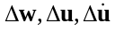 small perturbation around the equilibrium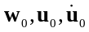, one obtains the linearized flow equations:
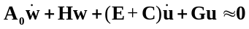 (1)
where
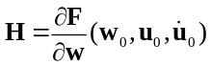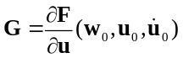
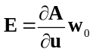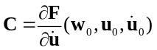
The matrix H is the gradient of the numerical flux function with respect to the vector of fluid variables. Matrices G and C are the gradients of the flux function with respect to the generalized coordinates and their velocities, respectively. Finally, the matrix E indicates the gradient of the cell volumes with respect to the generalized coordinates. Note that the matrices G, E and C need to be recalculated if the structural parameters are changed.
The linearization of the structural dynamic equation around an equilibrium state can be written as follows:
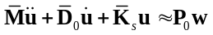 (2)
where
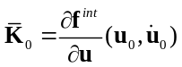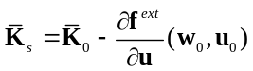
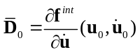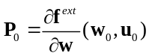
For the analysis of the system stability, the terms 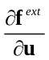 and 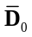 can be neglected, which leads to the structural dynamic equation such as:
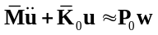 (3)
A ROM of the unsteady flow is considered in this work, based on the POD technique. Denote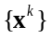 , 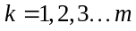, a set of date, with 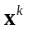 is the n-dimensional space 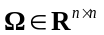, and m is the number of snapshots. The POD method searches an m-dimensional proper orthogonal subspace, 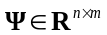, to minimize the mapping errors from :
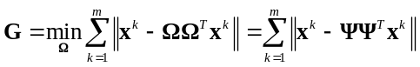 (4)
The minimization problem is equivalent to :
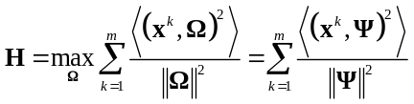, 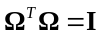 (5)
The constraint optimization problem in Eq. (5) is transformed into the following Lagrange equation
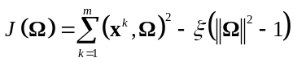 (6)
Solving the partial derivative of the objective function 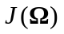 with respect to  gives
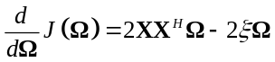 (7)
where 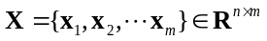 is a matrix containing m snapshots as columns. By setting Eq. (7) to zero; thus, the following equation is obtained:
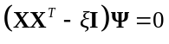 (8)
The problem is transformed into solving the eigenvalue problem of the POD kernel, 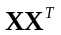. The eigenvalue problem has very large size, as 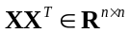. Because and 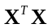 have the same eigenvalues, so we can obtain as following equation:
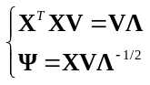 (9)
where 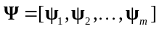, 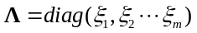, 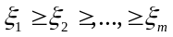. The value of represents the contribution of the i-th snapshot to the original system. To build an aeroelastic ROM, it is typically possible to retain the first r-order POD modes 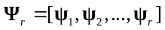while retaining most of the energy of the original system. By projecting the full-order series 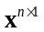 on the r-order POD modes , we can reduced the full order system to a reduced r-order system
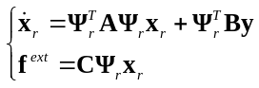 (10)
Where 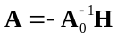, 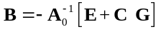, 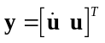, 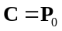. Here, A, B, and y can be considered as the system inputs, and the 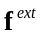 is the system output.
The above steps outline the process of generating an unsteady aerodynamics ROM for a frozen aeroelastic model configuration. The resulting aeroelastic model is obtained by coupling the structural dynamic equations, Eq. (3), with Eq. (10) for the ROM of the fluid.
- Structural dynamic reanalysis method
In many optimizations involving the structural parameter variation, it is very important to recompute the modeshapes and frequencies of modified structures. For each modification, the multiple repeated modal analyses usually involve extensive computational effort, especially for large scale problems. To overcome this challenge, a number of methods have been proposed to ease the eigenvalue reanalysis for the modified structures, instead of performing full structural modal analysis . Generally, these reanalysis methods are classified into two categories. First, direct methods are commonly based on the Sherman-Morrison-Woodbury (SMW) formula that is applicable for large but local (or low-rank) modifications, not suitable for global modifications of the structural parameters. The approximate methods aim at obtaining the modeshapes for modified structures, in which the modeshapes of modified structure are approximated as a linear combination of basic modeshapes. The advantage of approximate methods is that a significant reduction of the computational cost, and the applicability is extended for global (or high-rank) modifications of the structures. The extended Kirsch combined method is an efficient approach for the case of large modifications of the structural parameters. More details relevant to this work are given next.
The extended Kirsch combined method is an efficient approach for the case of modifications of the structural parameters. Consider an initial material with stiffness matrix 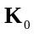 and mass matrix 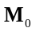. The corresponding modelshapes and modal frequencies 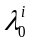 are calculated by solving the set of initial analysis equations:
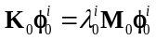 i=1, 2…… number of modes (11)
when the structural parameters are modified, and are perturbed into the form 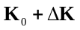 and 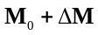, in which and are the perturbations to the original stiffness and mass matrices. The eigenvalue problem for modified structural parameters becomes:
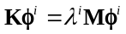 (12)
where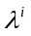is i-th eigenvalue of the modified structure, is i-th eigenvector of the modified structure.
Extended Kirsch combined method use the second-order eigenvector terms as the basis vectors in the following modal shape reduced basis:
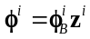, 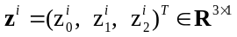 (13)
where
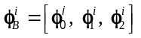 (14)
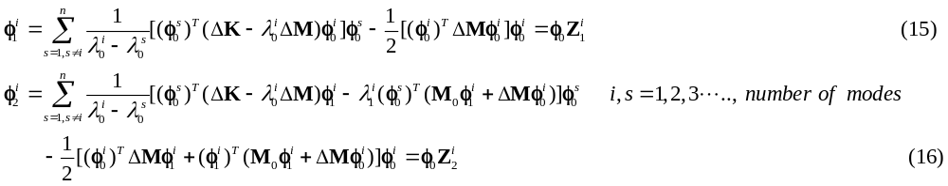
and and are the i-th first-order and second-order eigenvector of the modified structure, respectively. The coefficient vector, 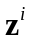, contains three unknowns (for a second-order perturbation). Substituting Eq. (15) and Eq. (16) into Eq. (14), can be written as
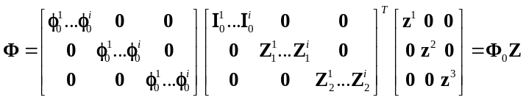 (17)
where
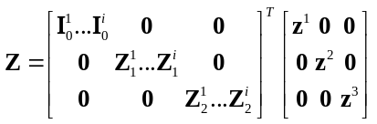 (18)
Substituting Eq. (13) into the modified analysis equations Eq. (12), and premultiplying by 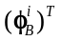, one obtains:
(19)
Introducing the notation
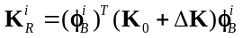 (20)
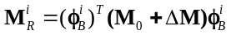 (21)
and substituting Eq. (20) and (21) into Eq. (15), we can obtain a set of (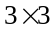) matrix equation
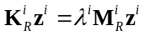 (22)
Thus, the coefficient vectoris evaluated from Eq. (22). The i-th eigenvector of the modified structure is obtained by substituting into Eq. (13) and Z is obtained by substituting into Eq. (18).
Finally, the i-th eigenvalue of the modified structure, 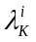, is computed using Rayleigh quotient:
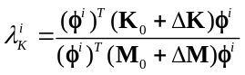 (23)
- Reanalysis algorithm based POD/ROM interpolation method
The modeshapes 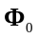 of the original structure is taken as the basic modeshapes for basic POD/ROM construction. For modified structure, the physical displacement of the wing can be written as
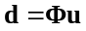 (24)
Substituting Eq. (17) into Eq. (24), the physical displacement of the wing can also be written as
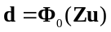 (25)
And 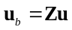, 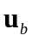is artificially defined as basic generalized displacements.
A change of the structural parameters affects the matrices H, G, E and C of the linearized flow solver, Eq. (1). Substituting the relation , the matrices may be rewritten in terms of the vector of basic generalized displacements:
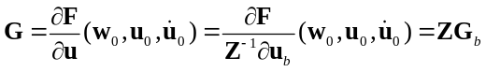
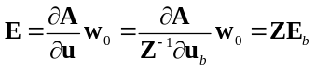 (26)
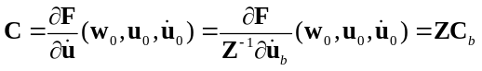
where 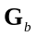, 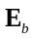, 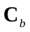 are the first order terms in a Taylor series expansion of the basis reduced r-order system aeroelastic. Now, the reduced fluid model of modified structure is written as
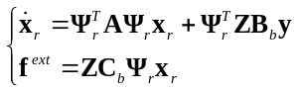 (27)
where , 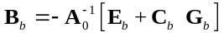, , 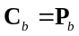.
The structural dynamic equations of modified structure are:
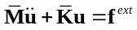 (28)
here, 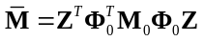, 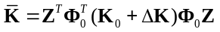. In addition, when 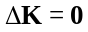, Z is the unit matrix, Eq. (27) and Eq. (28) are equivalent to Eq. (10) and Eq. (3), respectively.
The generalized aerodynamic loads corresponding to the new modeshapesof the global modification structural model can ben rapidly calculated without the expensive time-consuming reconstruction procedure of the new POD basis.
The proposed appropriate structural dynamic reanalysis based proposed approximate aeroelastic characteristics evaluation method is illustrated in Fig. 1.
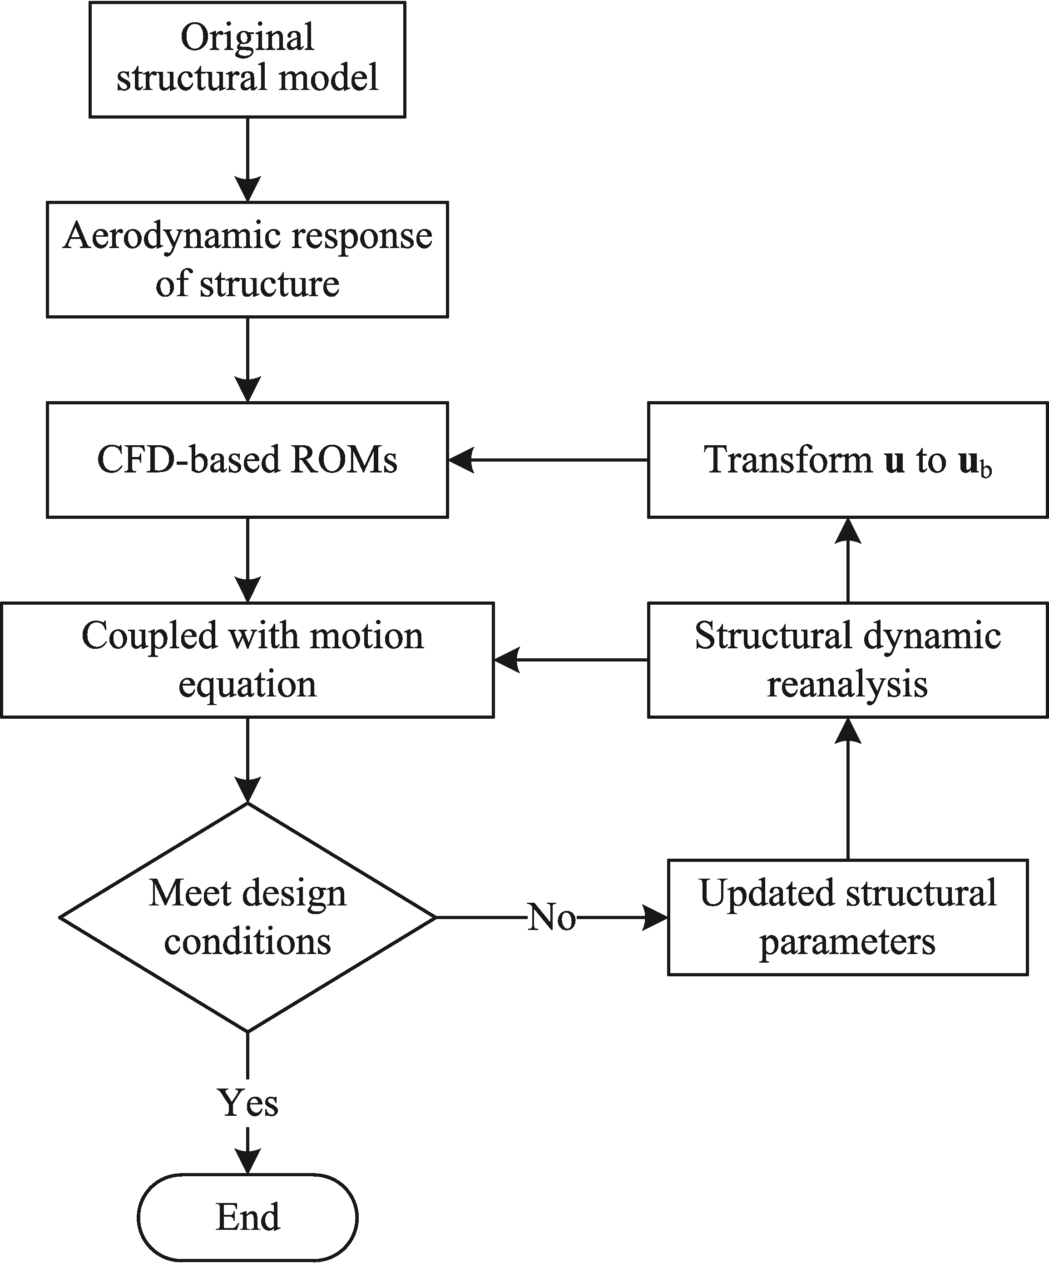
Fig. 1 Flow chart of the approximate method.
The proposed approximate aeroelastic characteristics evaluation method is summarized as followings:
- Establish CFD-based POD/ROMs based on the basis modeshapes;
- Use Extended Kirsch combined method to get Z;
- Per Eq. (25), transform generalized displacements u to the basis generalized displacements 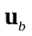;
- Input the basis generalized displacements into POD/ROMs based on the basis modeshapes to obtain the generalized aerodynamic force coefficients ;
- Finally, combining reduced fluid model Eq. (32) and the structural dynamic model Eq. (33) to compute the generalized aerodynamic force coefficients corresponding to the modeshapes .
In the aeroelastic structural optimization process, the structural parameters are modified iteratively. For each structural modification, the proposed algorithm can rapidly prediction of the generalized aerodynamic loads without re-computing the POD basis which is required for generating the unsteady aerodynamics ROM.
- Optimization Algorithm for Aeroelastic Global Structural Optimization
To studies of aeroelastic optimization on material properties of aircraft wings, the genetic algorithm (GA) optimization tool is selected as optimization tool, because its promising global performance . The GA is an ideal approach for complex problems with few design variables . The GAs are semistochastic semideterministic optimization methods based on an analogy to the theory of evolution. The problem to be optimized is parameterized into a set of decision variables (or genes). Each set of variables (a point in the search space) that fully defines one design is called an individual. A set of individuals is called a population (or a generation). Each individual is evaluated using a fitness (objective) function that determines survivability of that individual. During solution advance (or evolution of generations), each individual is ranked according to its fitness. The population is treated with genetic operators: selection, crossover, and mutation. All of these operations include randomness. The probability of survival of new individuals depends on their fitness: the best are kept with a high probability; the worst are rapidly discarded.
In this paper applications the variables can be a series of structural parameters associated with structural material properties at global level. The flowchart of optimization procedure algorithm for aeroelastic global structural optimization is shown in Fig. 2.
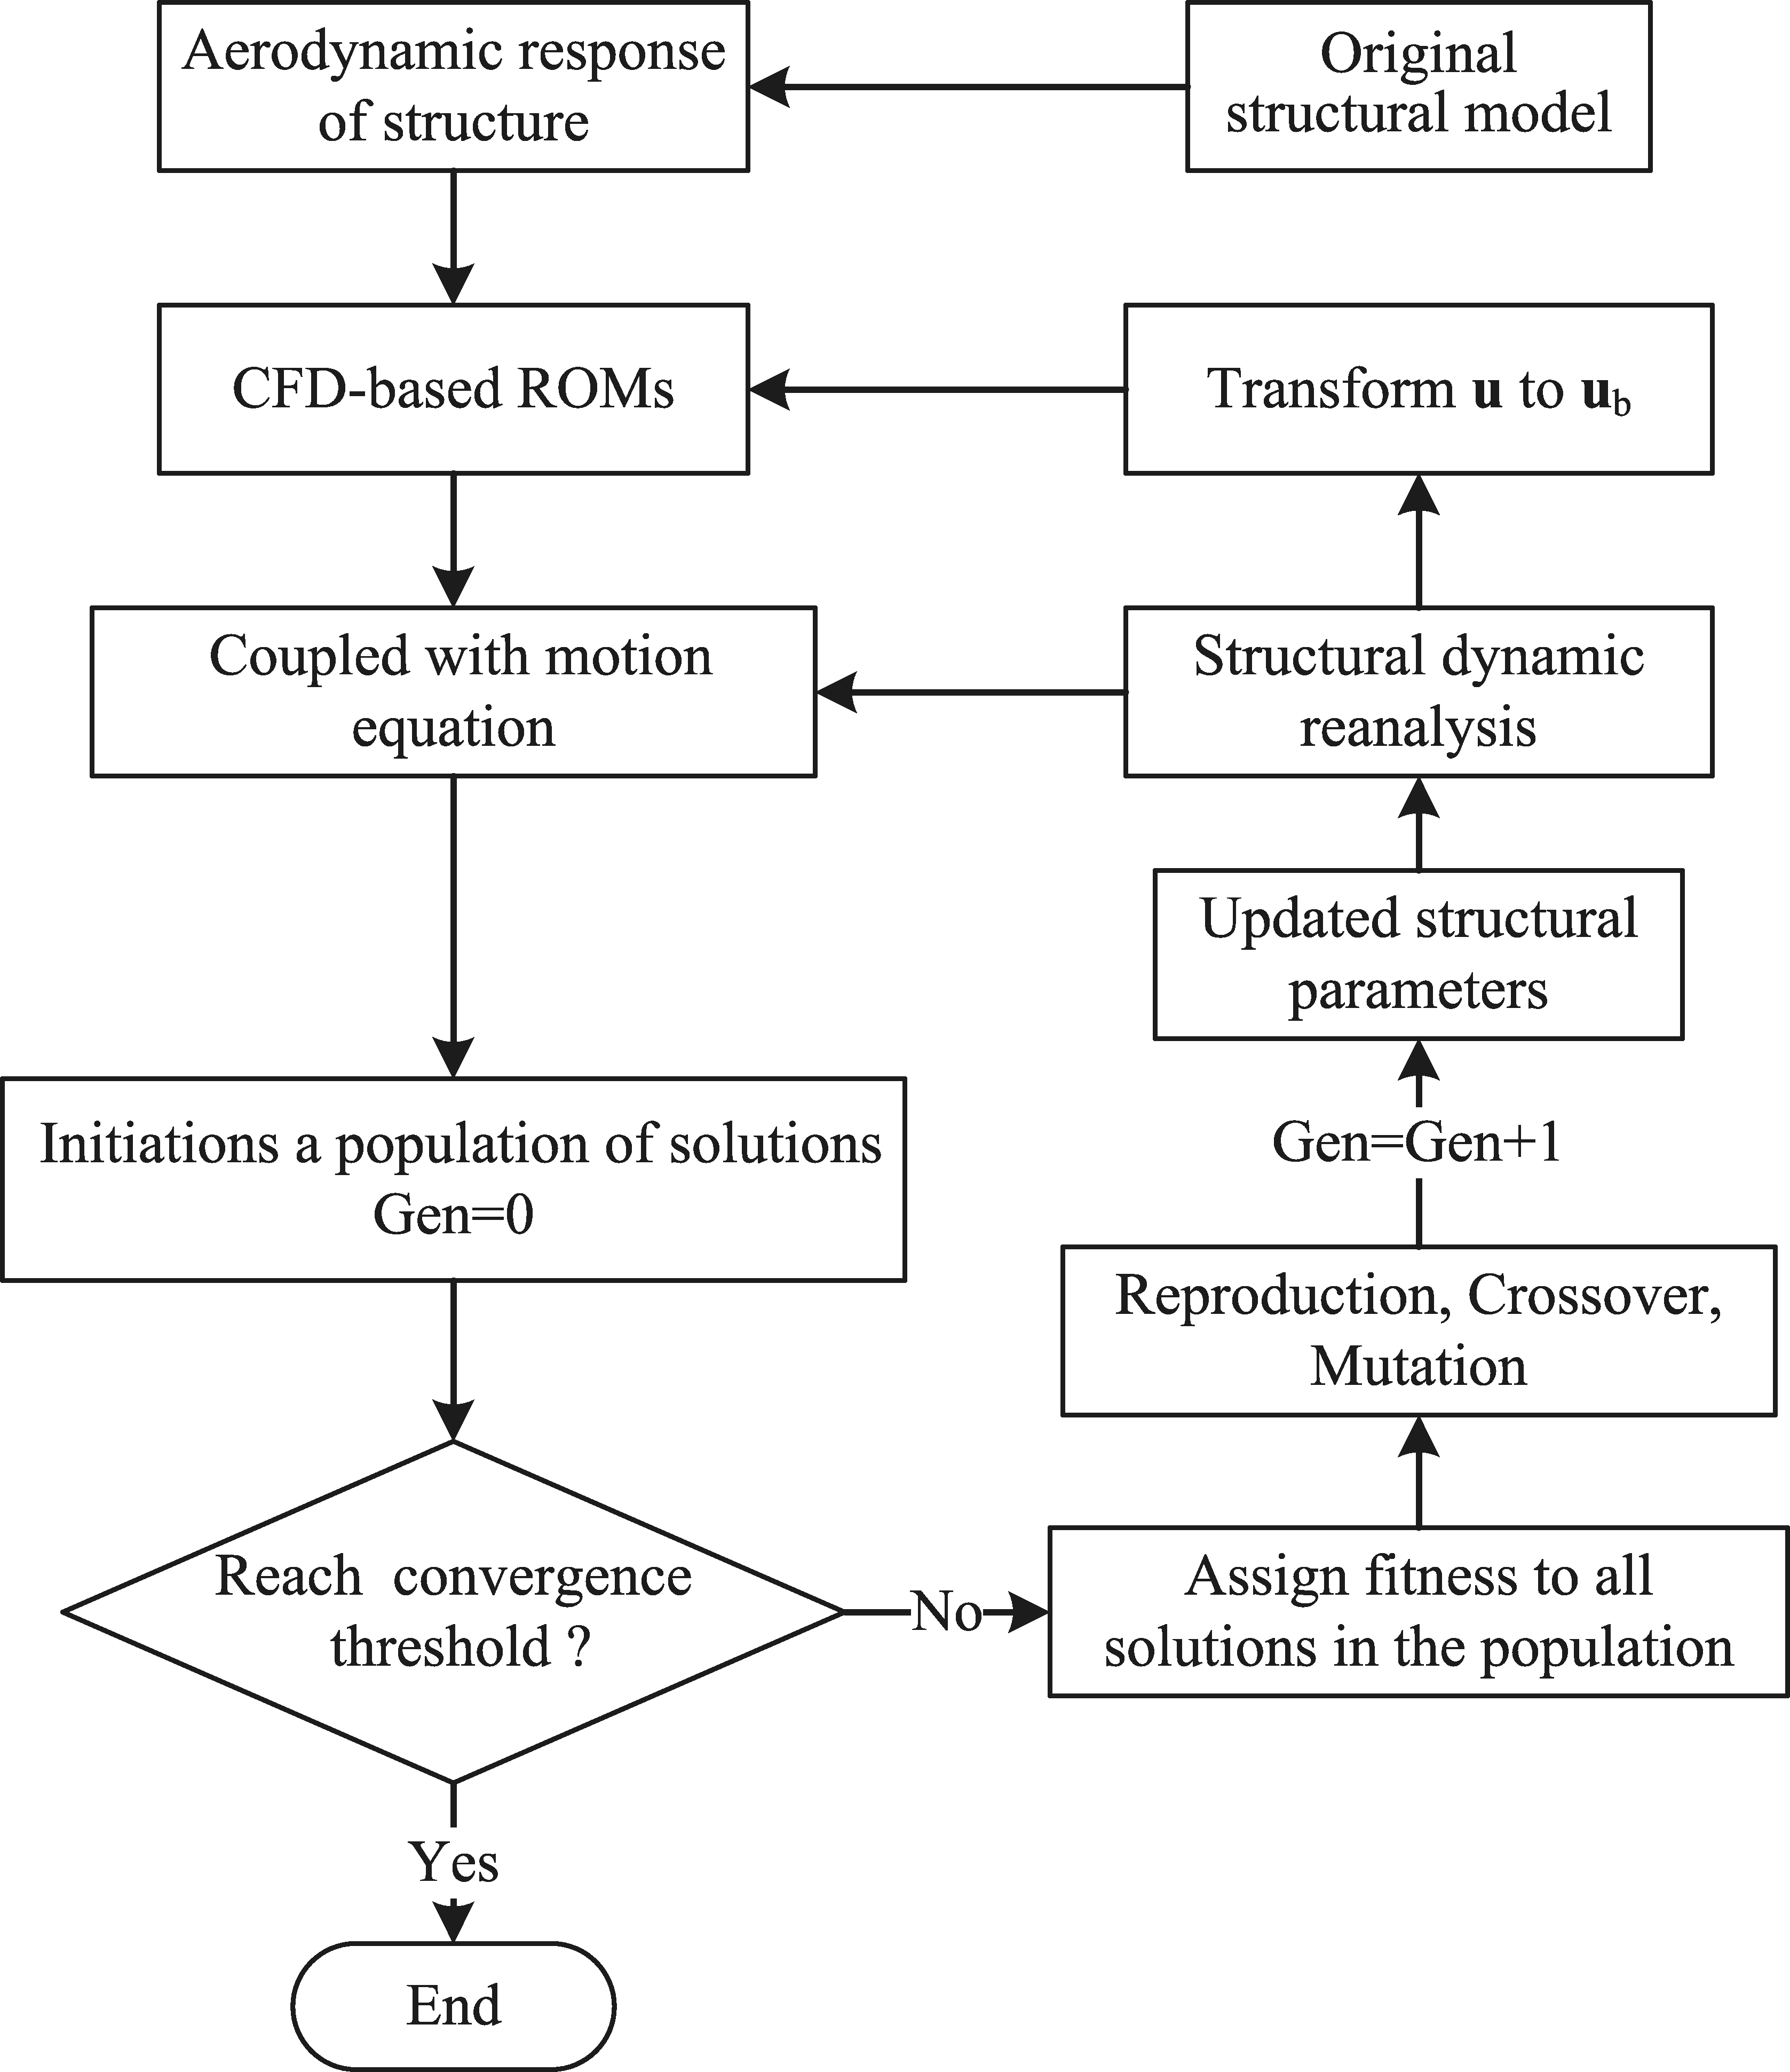
Fig. 2 Flowchart of optimization procedure algorithm for aeroelastic global structural optimization
The steps involved in this optimization process are detailed in Algorithm 1.
Algorithm 1 Genetic algorithm for aeroelastic global structural optimization
1 | Generate a group of individuals randomly as initialization population, choose parameters, and set Gen = 0;
2 | Compute and evaluate individuals. Record the individuals’ information;
3 | Use fitness scaling to generate new generation of excellent individuals;
4 | Perform GA selection operator, crossover operator, and mutation operator. Set Gen=Gen+1;
5 | Update structural parameters, and calculate the generalized aerodynamic force coefficients;
6 | Couple fluid ROM with structural dynamics for the modified structure;
7 | If a stop condition is satisfied, stop the algorithmand out results. Otherwise, go to step 2.
- Numerical results and discussion
- POD/ROM solver validation
The first step is to establish the validity of the proposed aeroelastic CFD-based ROM in predicting the flutter boundary for the AGARD 445.6 wing. The aerodynamic model used here is based on a finite volume discretization of the unsteady Euler equations, and the spatial discretization is based on the second-order Van Leer scheme. For time marching, dual time-stepping and lower-upper symmetric Gauss-Seidel method are used. The comparison was made with results obtained from the large-scale aeroelastic model, which employs the CFD solver rather than the unsteady aerodynamics ROM, and with experimental measurements . The wing material has a density of 381.98 Kg/m³. The elastic moduli in the span-wise and chord-wise direction are 3.151 Gpa and 0.416 GPa, respectively, and the shear modulus is 0.4392 GPa. The Poisson’s ratio is 0.31 . The structural model are shown in Fig. 3(a). A multi-block structured mesh was employed for the flow predictions, as shown in Fig. 4. And surface CFD mesh are shown in Fig. 3(b). The spatial convergence of the CFD mesh was analyzed in Zhou , where a good agreement of the results for both the medium and fine grids was documented. The total number of grid points on the medium grid, herein used, is 223,146 (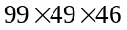, along x -direction, y -direction, z -direction).
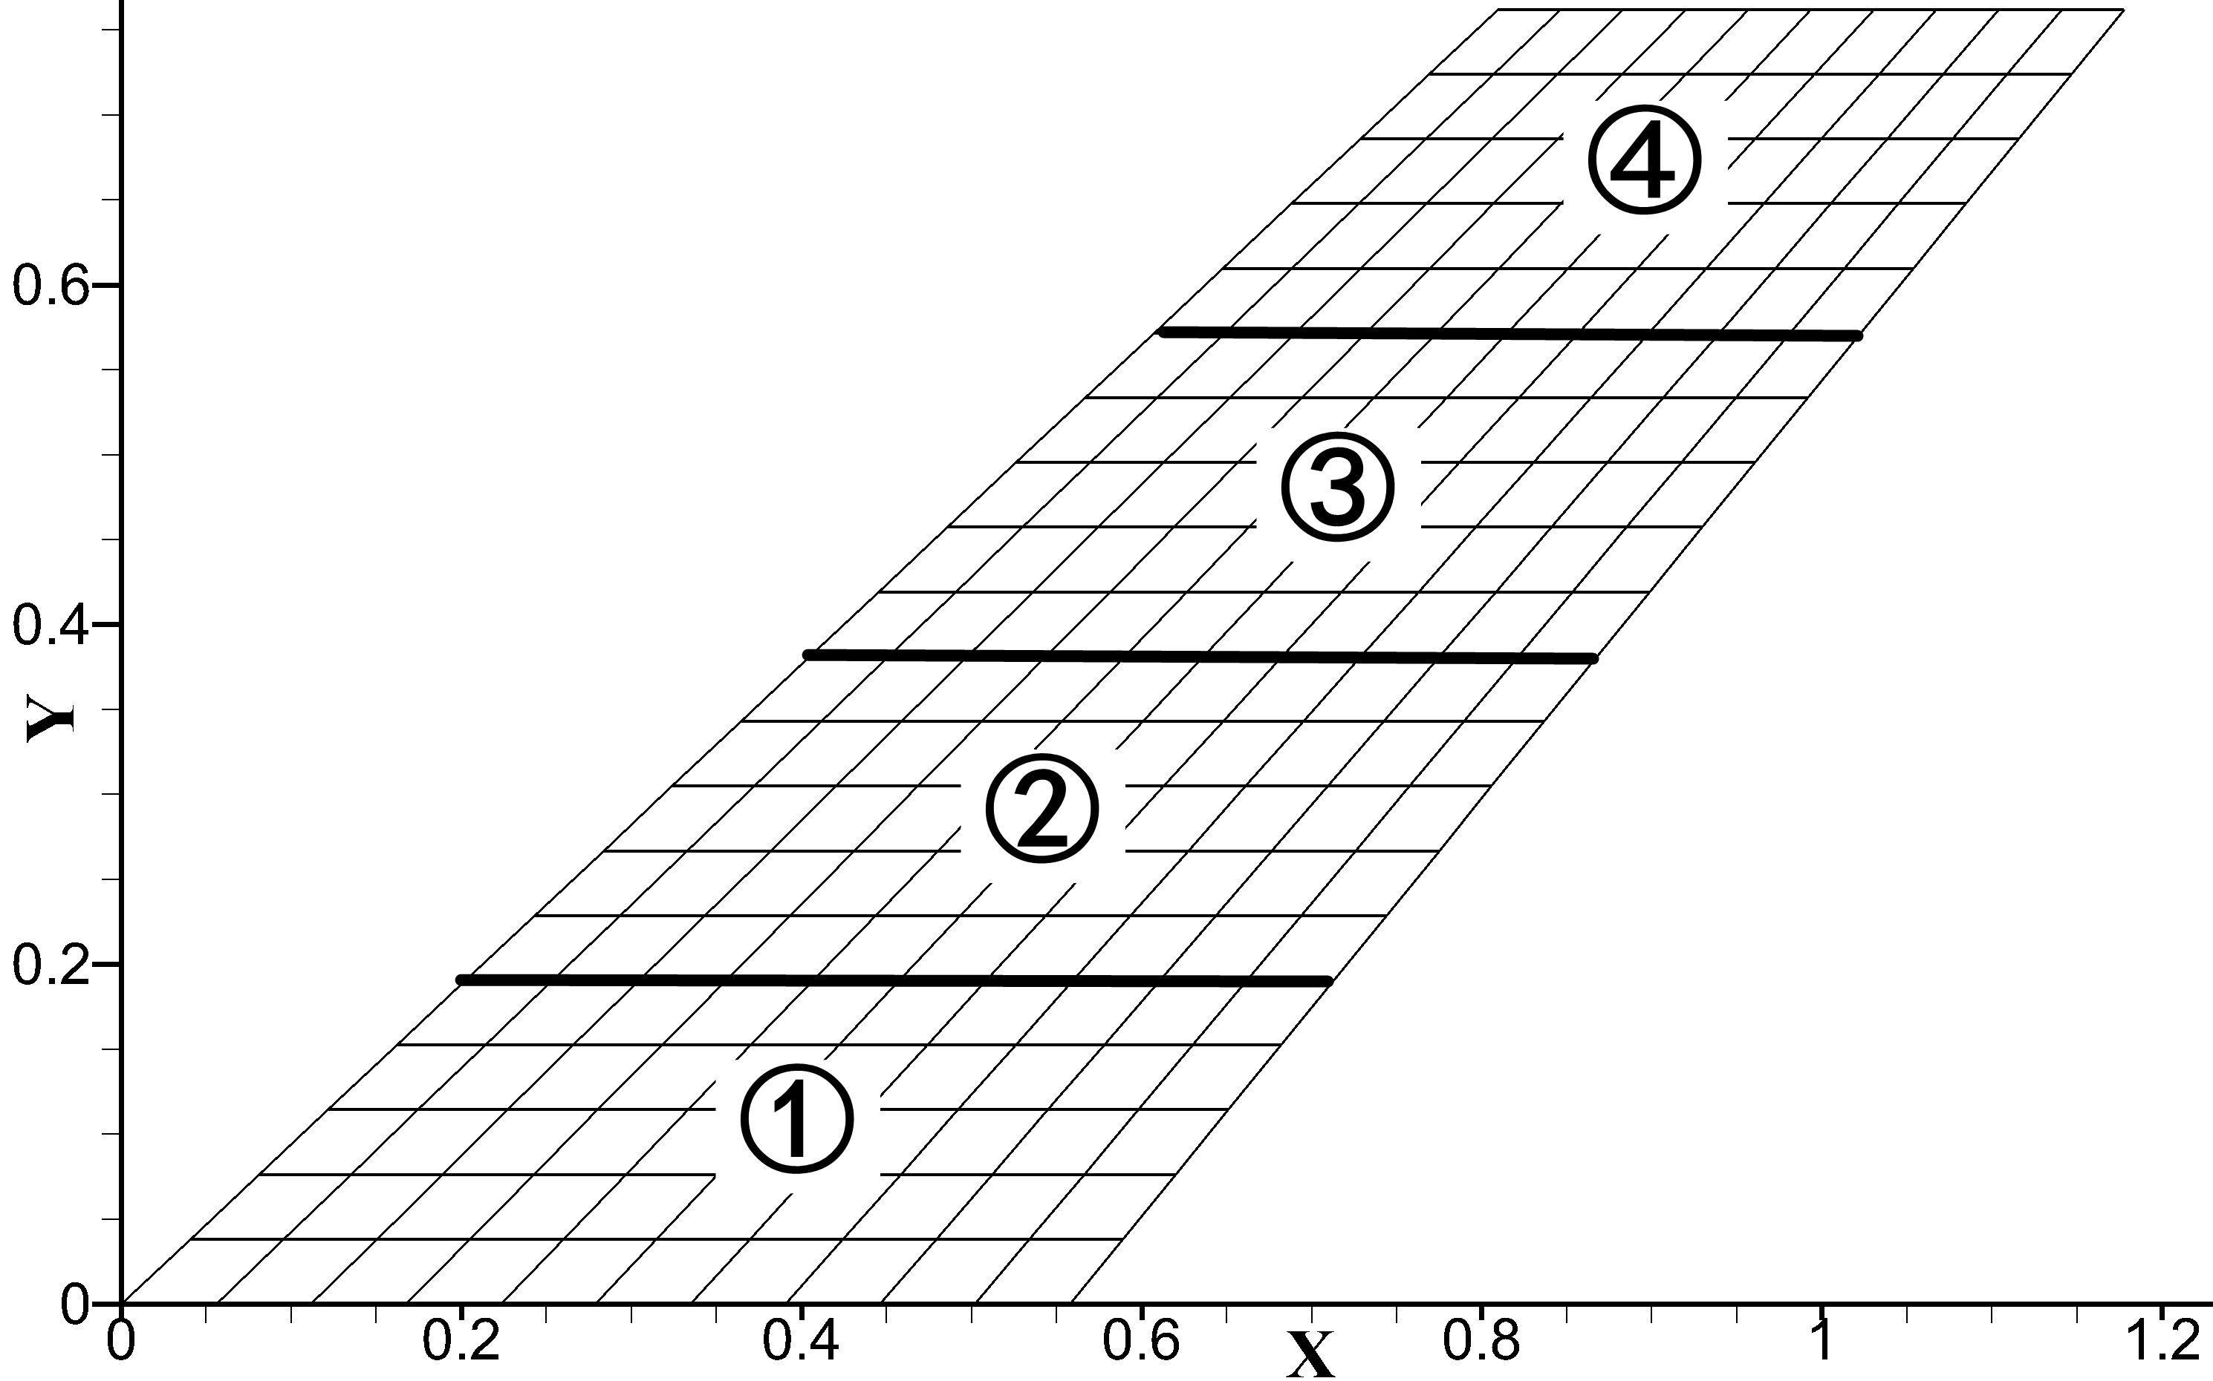 (b)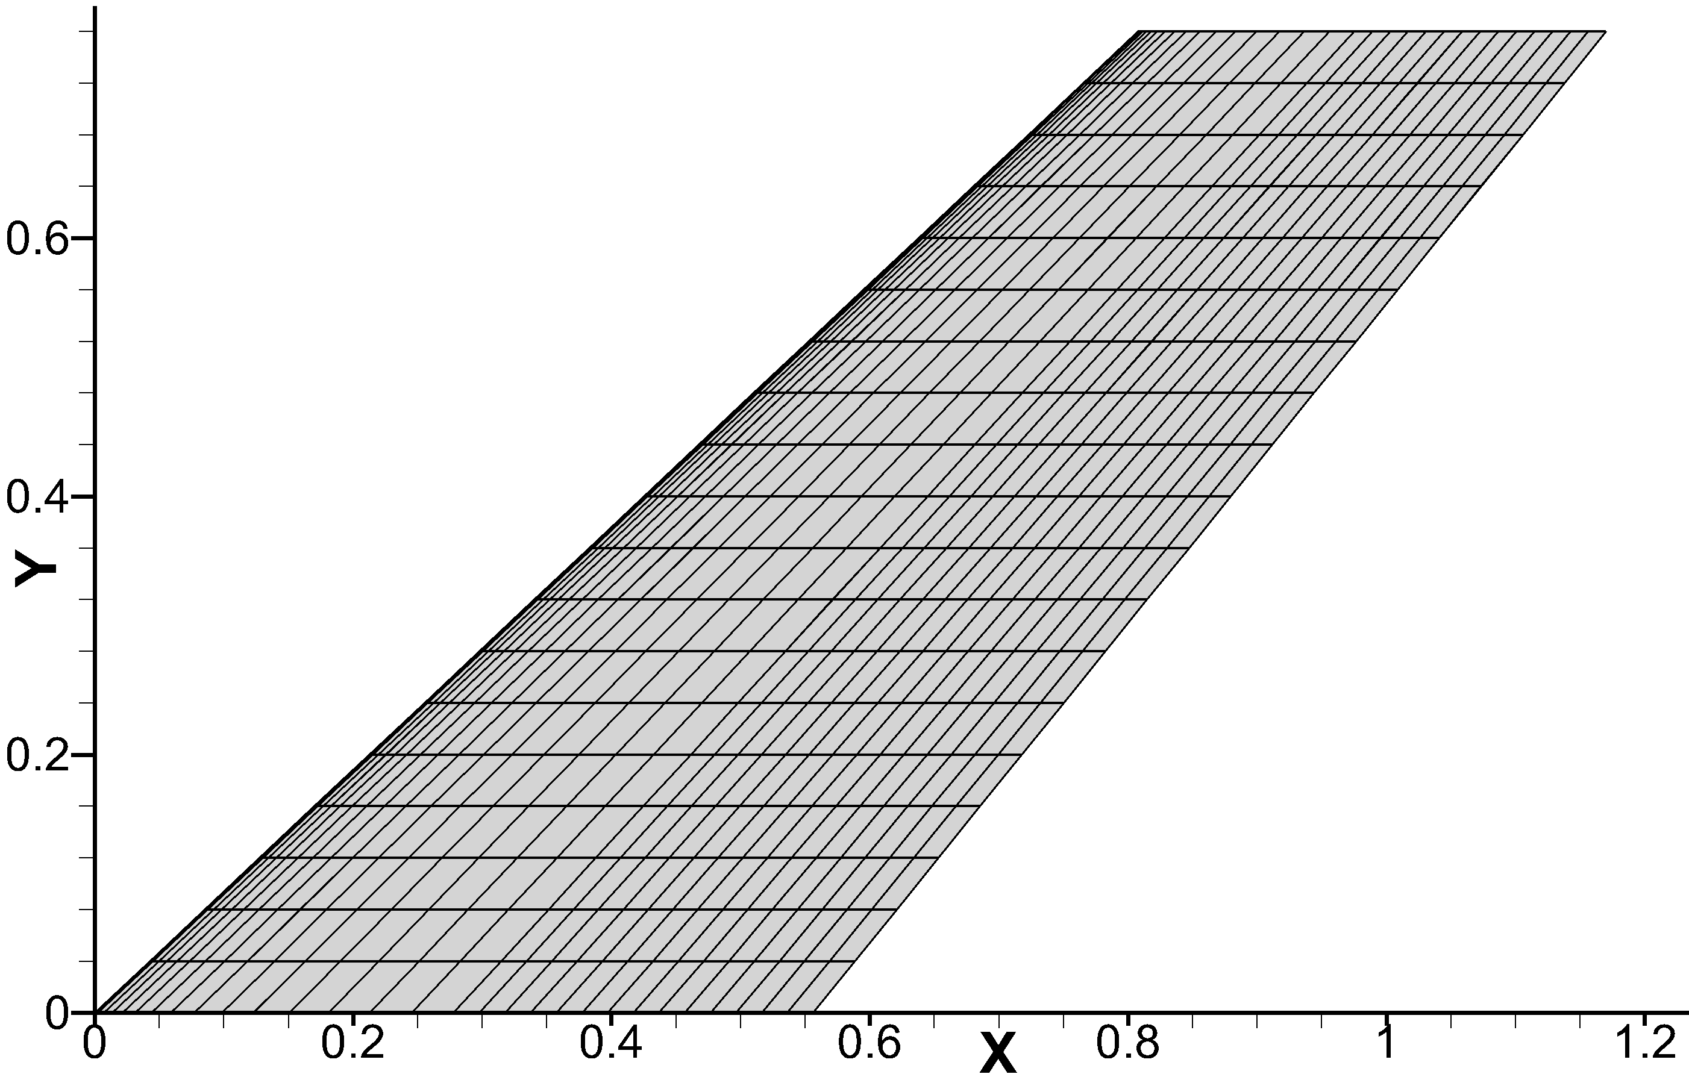
Fig. 3 AGARD 445.6 wing: (a) structural model, and (b) surface CFD mesh.
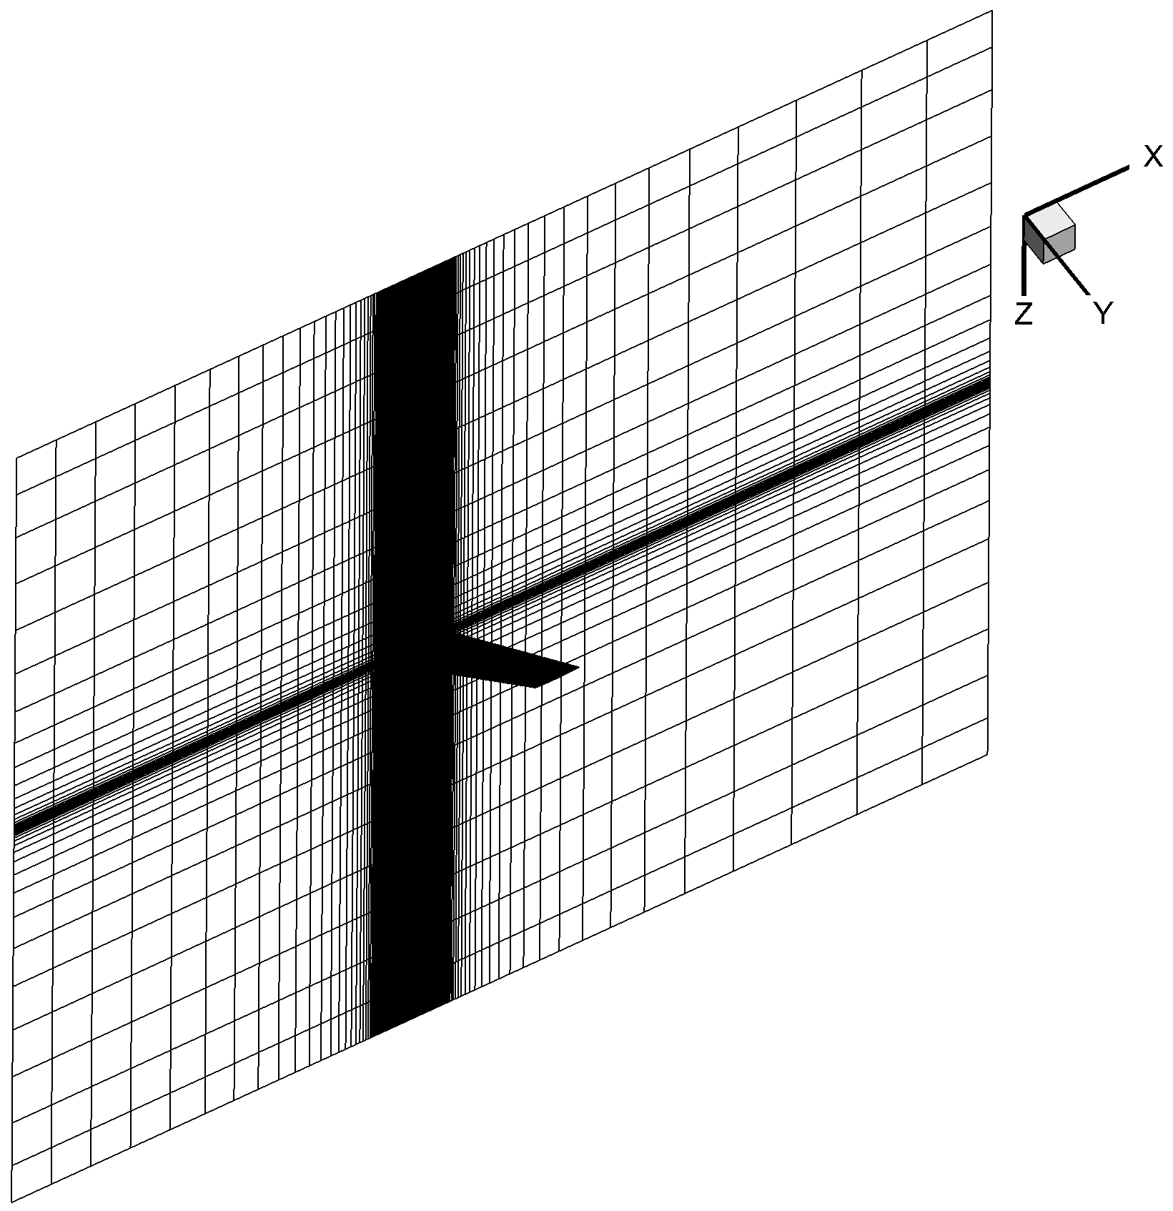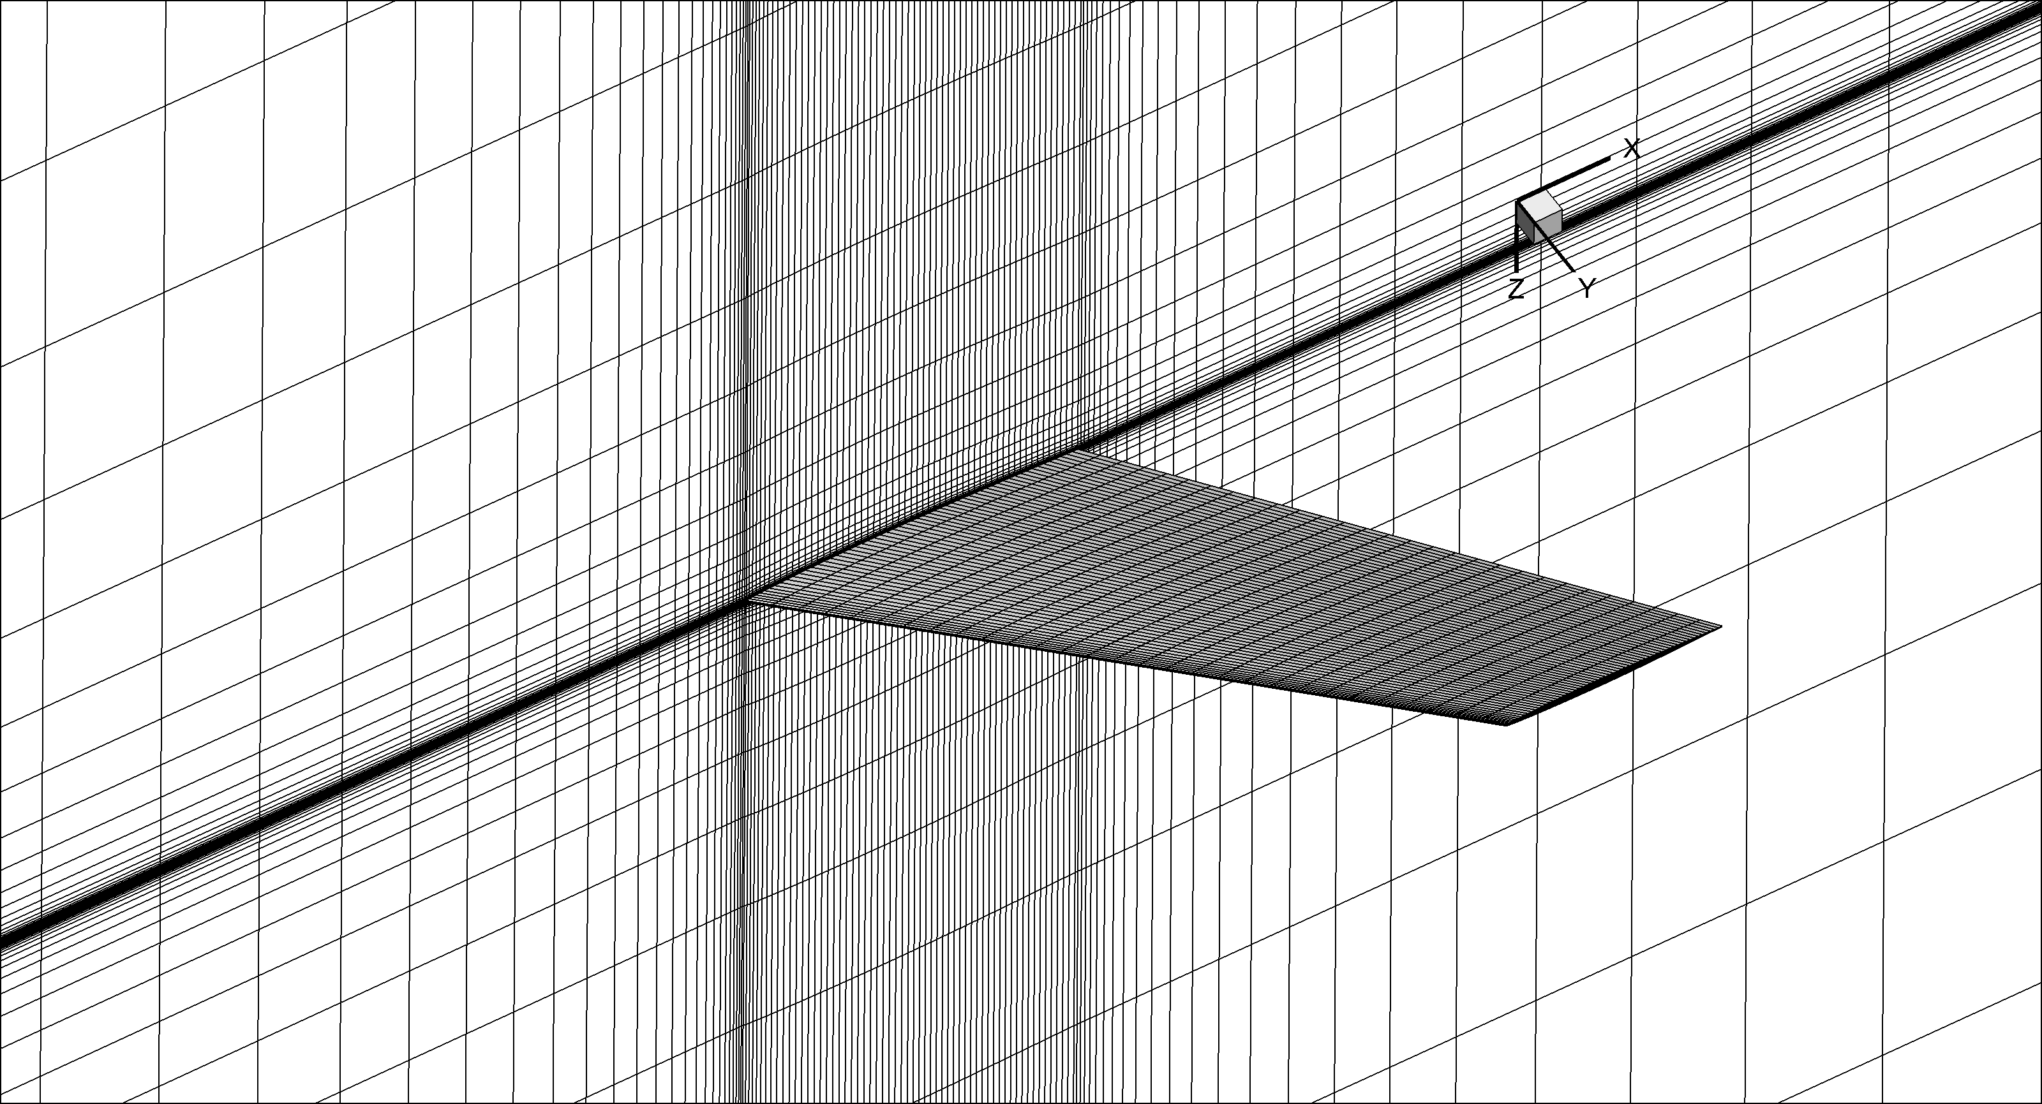
Fig. 4 AGARD 445.6 wing: multi-block structured mesh
Fig. 5 shows the flutter boundary predictions from the large-scale aeroelastic model and the aeroelastic ROM. The ROM results are in good agreement with the reference numerical date under six Mach numbers. The accuracy of both methods was evaluated over the years in a number of aeroelastic studies .

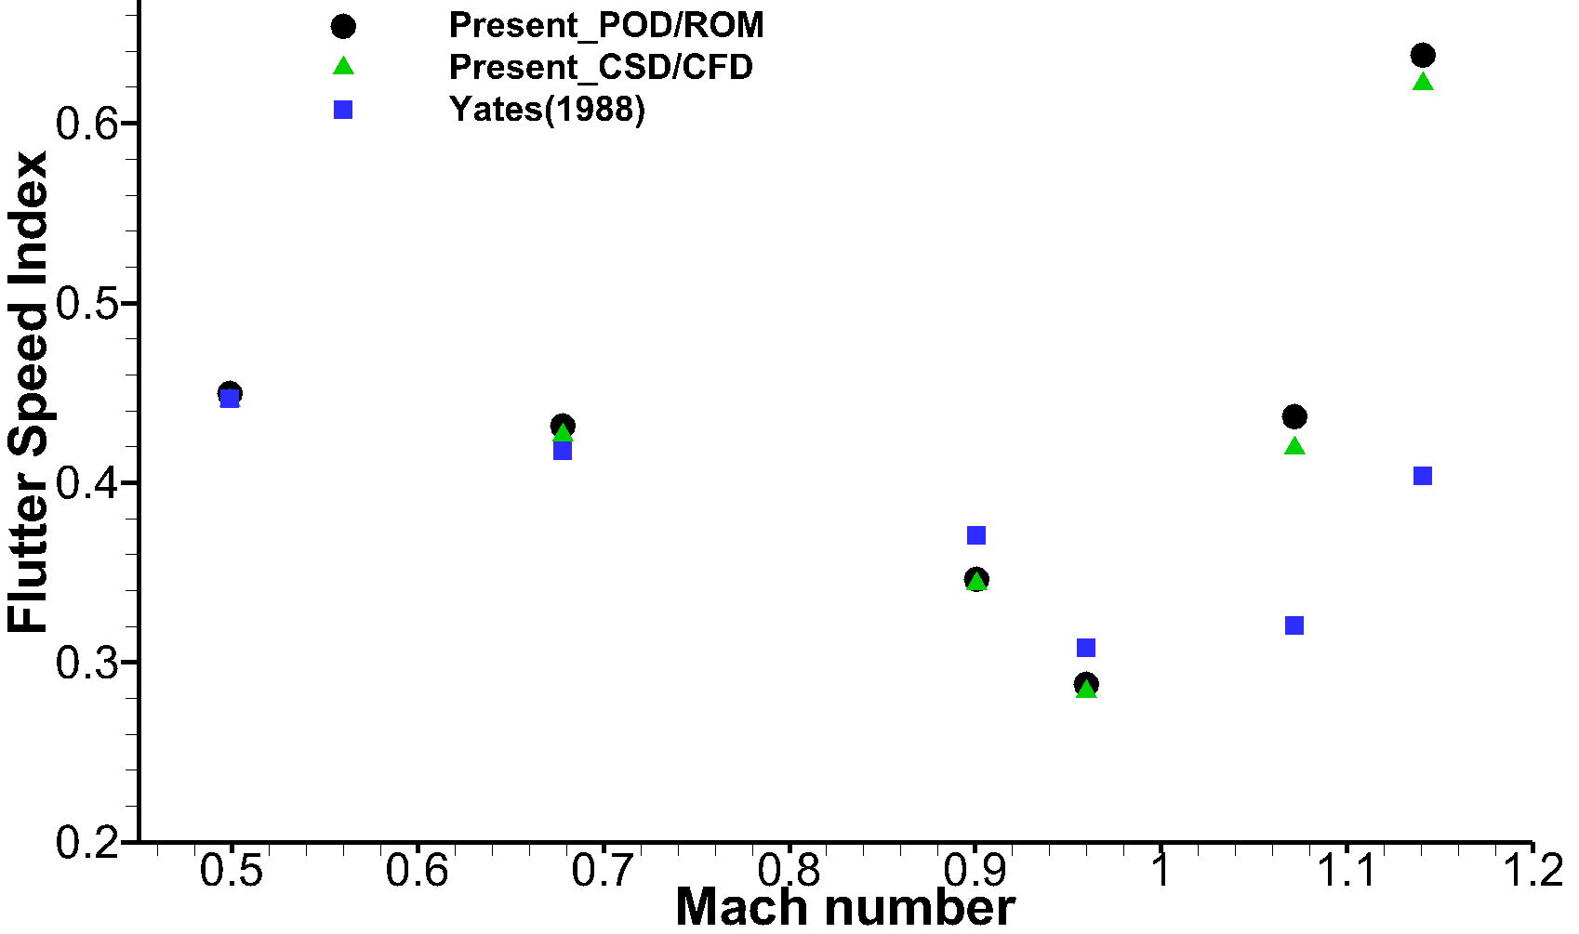
Fig. 5 AGARD 445.6 wing: flutter boundary; experimental date from Ref
- Evaluation of the CFD-based Reanalysic Aeroelastic ROM
In this study, the optimization of the AGARD 445.6 wing configuration will be performed by using the efficient CFD-based ROM. The accuracy and efficiency of the efficient CFD-based ROM in predicting the flutter boundary and aeroelastic responses when a structural modification was made at global level have been verified in . First, the wing was divided into four sections or zones along the span and numbered as 1 to 4 from the wing root to tip as shown in Fig. 3(a), and each with 50 elements, and each section has same material properties. It is assumed that the parameter modifications are given by
Section 1, 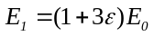, 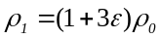
Section 2, 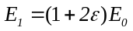, 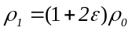
Section 3, 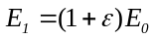, 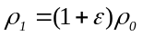
Section 4, 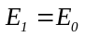, 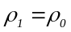
where 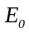 and 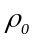 are the Young’s modulus and density , respectively, of the baseline (original) structural model. To assess the accuracy of the ROM in analyzing the modal characteristics of the modified structural model, two criteria are introduced. The first criterion represents the error of the modal frequencies, and the second criterion is the Modal Assurance Criterion (MAC) , defined as:
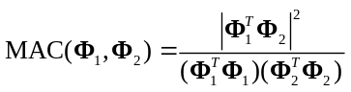
For a perfect match between the exact and approximate modeshape, the MAC is 1. The value of MAC is related to the exact and the approximate modeshapes of modified wing models, and the value of 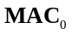 is related to the approximate modeshapes of modified wing model and the exact modeshapes of original wing model.
Three cases for the modified structure are considered: 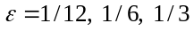. The modal frequencies errors and MACs are listed in Table 1. It is the value of MAC_standard in the upcoming optimization in the next section. It shows that the errors of modal frequencies not more than 1%, even for largest modification (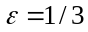).
Table 1 Frequencies from direct and approximate structural reanalysis methods for the modified structural model of the AGARD 445.6 wing.
Parameter | 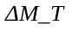 | Mode | Frequency [Hz] |  |  | 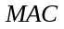 | 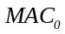
Parameter |  | Mode | Exact | Approximate | Error [%]
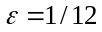 | 0.7376 | 1 | 10.208 | 10.207 | -0.005 | 1.0000 | 0.9997
 | 0.7376 | 2 | 41.228 | 41.232 | 0.010 | 0.9999 | 0.9974
 | 0.7376 | 3 | 50.756 | 50.792 | 0.071 | 0.9998 | 0.9991
 | 0.7376 | 4 | 95.962 | 96.034 | 0.076 | 0.9991 | 0.9992
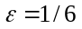 | 1.4752 | 1 | 10.854 | 10.856 | 0.021 | 1.0000 | 0.9990
 | 1.4752 | 2 | 42.457 | 42.470 | 0.030 | 0.9998 | 0.9907
 | 1.4752 | 3 | 51.819 | 51.930 | 0.220 | 0.9993 | 0.9970
 | 1.4752 | 4 | 96.633 | 96.873 | 0.248 | 0.9970 | 0.9972
 | 2.9503 | 1 | 11.933 | 11.943 | 0.082 | 0.9999 | 0.9973
 | 2.9503 | 2 | 44.354 | 44.398 | 0.101 | 0.9994 | 0.9680
 | 2.9503 | 3 | 53.591 | 53.894 | 0.565 | 0.9991 | 0.9912
 | 2.9503 | 4 | 97.712 | 98.412 | 0.716 | 0.9911 | 0.9903
The Mach number is Ma=0.960 and angle of attack is AOA=0deg. A quantification of the error introduced to predict the flutter speed using the efficient CFD-based ROM is presented in Table 2. Reference date is taken from the direct method, as already pointed out. Although the discrepancy between the two methods increase for increasing level of the structural modifications, it is worth observing that the maximum difference is limited to about 2% for the largest modification () of the structure.
Table 2 Flutter speed obtained by direct and approximate method at Ma=0.960.
Model | Parameter | Flutter speed (m/s)
Model | Parameter | Direct method | Approximate method | Error (%)
1 |  | 309.2 | 310.8 | 0.518
2 |  | 327.2 | 330.7 | 1.070
3 |  | 357.7 | 365.6 | 2.210
All analyses were performed on a Windows 7 system PC with Intel® Core (TM) i7-2600 CPU (3.40 GHz, 8 cores, but only one core used) and 16 GB RAM. For the computational cost, the direct method, a set of POD modes is generated for each structural modification, in contract to this, the set of POD modes is calculated only once for the efficient CFD-based ROM. With the ability to treat efficiently modifications to the structural model, the computational advantage of the efficient CFD-based ROM becomes more significant the more changes to the structure are considered. Within an industrial design process, it is reasonable to consider about 1,000 structural modifications and 20 values of the freestream dynamic pressure to assess the aeroelastic stability. With information reported in Table 3, the direct method would require over 16,000 CPU hours (this consists of 16h×1000 and 1.75s×20×1000, totaling 16,009.72h ), whereas the efficient CFD-based ROM just over 26 CPU hours (16h×1 and 1.79s×20×1000, totaling 25.94h).
Table 3 Comparison between the time cost of direct and approximate method.
Method | Process | CPU time
Direct | Construct a new set of POD/ROMs | 16h
Direct | Time histories responses of the generalized displacement for a values of freestream dynamic pressure | 1.75s
Direct | Structure optimization with 1000 structural parameter change | 16,007.72h
Approximate | Construct the initial set of POD/ROMs for original structure | 16h
Approximate | Compute Z use extended Kirsch combined method | 0.76s
Approximate | Time histories responses of the generalized displacement for a values of freestream dynamic pressure based | 1.79s
Approximate | Structure optimization with 1000 structural parameter change | 25.94h
- Flutter Speed Constraint
In this aeroelastic structural optimization case, the design variables for optimization were a series of parameters associated with material properties of each wing section at global level, and the mass increment of wing model was the objective function to be minimised. The objective optimization problem is
minimize
subject to 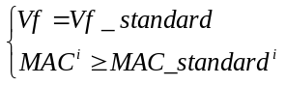
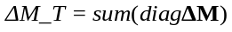is defined as mass increment of wing model, and 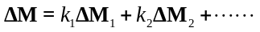, 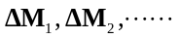 is the unit mass matrix of each section along wing span, so the design variables of mass for the optimization are 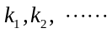. Because structural stiffness and mass changes is synchronized, so the design variables of stiffness for the optimization also are . The design variables represent different material properties of each section, and each section having independent design variables. In this study, each design variables are constrained to lie between 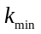 and 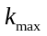, which for this work are set to 0 and 1. The 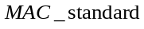 reflects the accuracy range of the efficient CFD-based ROM. In aeroelastic structural optimization process, since the value of the MAC cannot be obtained directly, which can reflects the accuracy range of the efficient CFD-based ROM. The modeshapes of modified structure are approximated as a linear combination of basic modeshapes of original structure, and from Eq. (27) and Eq. (28), the value of MAC₀, which also can reflects the accuracy range of the efficient CFD-based ROM. Vf_standard is define as constraint of critical flutter speed.
To validate the feasibility of current approach for the aeroelastic structural optimization study, the optimization using the efficient CFD-based ROM produced designs guided by three different aeroelastic constraint sets have been mentioned in Sec.4.1, which the structural model with . The wing structure is divided into four spanwise sections as shown in Fig. 3(a), each section has same material properties. For the three different aeroelastic constraint, the MAC_standard equal to the value of MAC₀ of the structural model with , respectively. The three optimization Model, 1, 2 and 3, with different flutter constraints sets listed in Table 2.
In addition, the genetic algorithm of the Matlab® Global Optimization Toolbox is implemented. The size of the population is 50, the number of variables in the fitness function is four for the current problem, and the stall generation is 50 and maximum generation is 400, and the remaining uses default options of the toolbox. Fitness evaluation history of optimization is shown in Fig. 6.
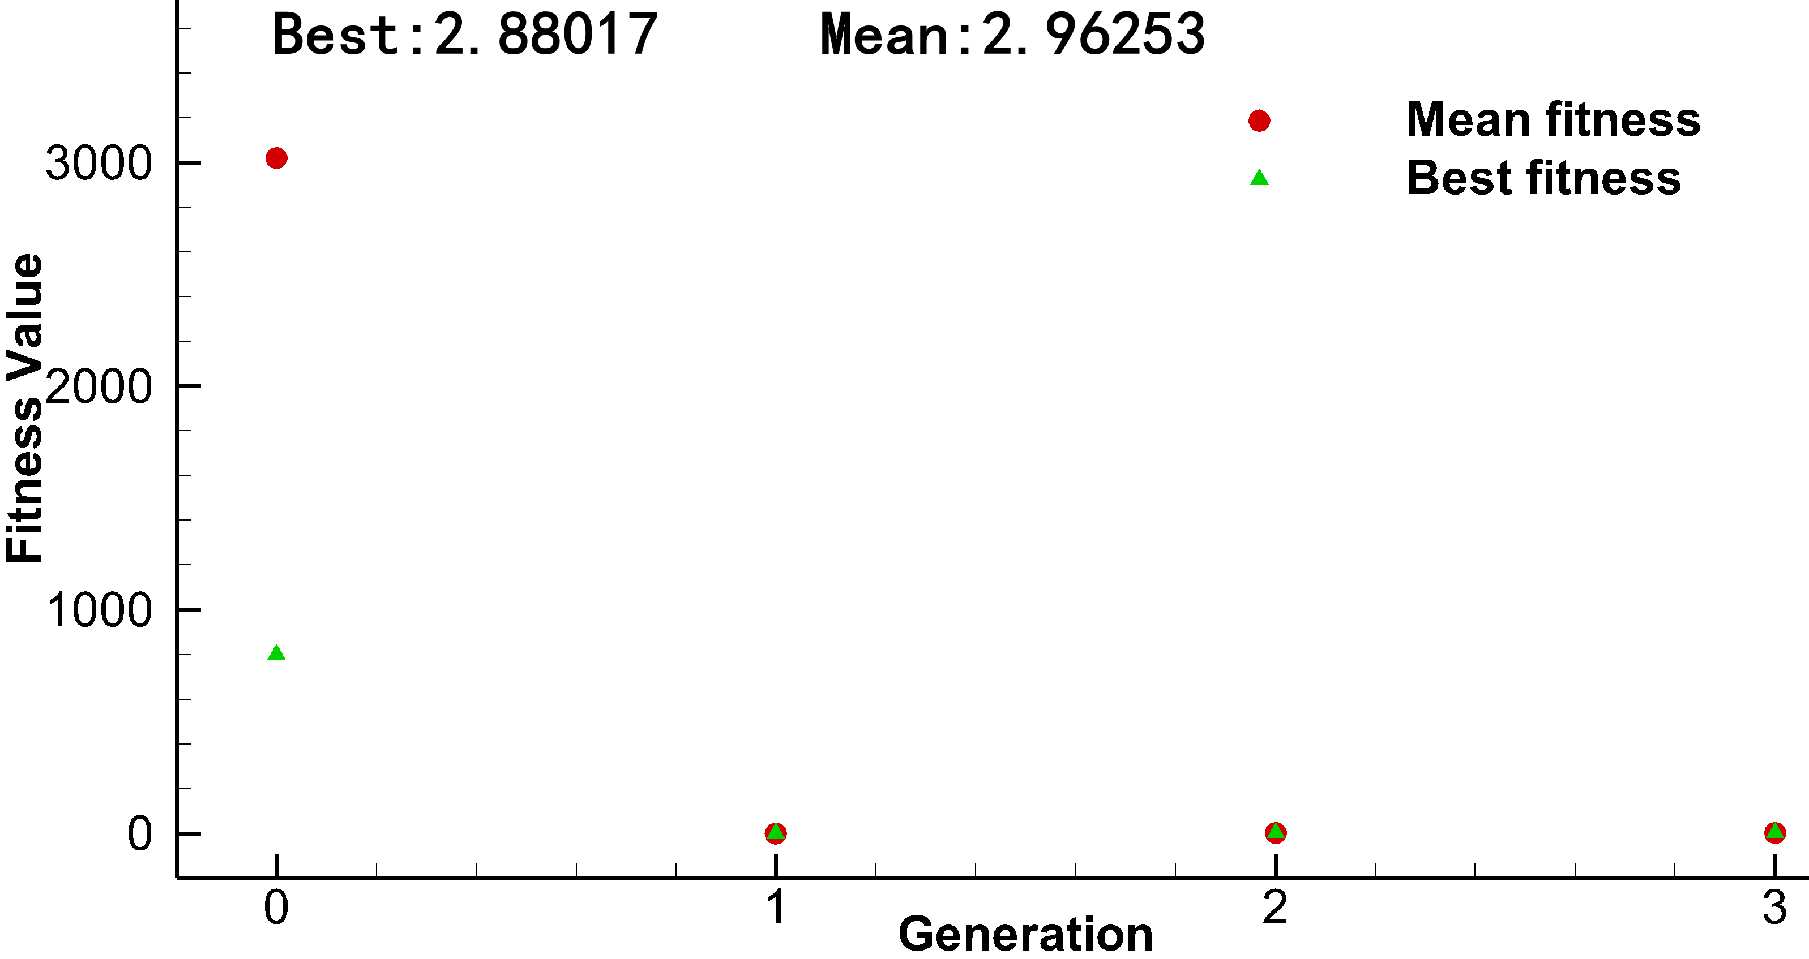
Fig. 6 Fitness evaluation history of optimization
To validate the current process, reference date of are taken from the structural model with , as already pointed out in Table 1. A comparison of ΔM_T between the reference structural model and optimum design are shown in Table 4. In this study, the major role of the optimization is minimize the increase in mass with constraints on flutter speed and MAC_standard. It is observed that mass reduction comparing with reference date in all studies. After optimization process, all the constraint conditions are satisfied. Comparing the reference date to the optimization results, the mass of Model 1, 2 and 3 are reduced by 13.7202%, 15.2928% and 13.0696%, respectively. The details of final design variables after the optimization (red-lines) compared to the reference date (black-dashed lines) of Model 1, 2, and 3 are shown in Fig. 7. As it can be seen, the maximal errors between reference date and optimized of design variables among all sections is the wing root. In summary, the structural weight is reduced significantly comparing with reference date by optimization.
Table 4 Comparison between the ΔM_T of reference and optimized.
 | Vf_standard (m/s) | ΔM_T
 | Vf_standard (m/s) | Reference | Optimized | Mass Reduction (%)
Model 1 | 310.8 | 0.7376 | 0.6364 | 13.7202
Model 2 | 330.7 | 1.4752 | 1.2494 | 15.2928
Model 3 | 365.6 | 2.9503 | 2.5634 | 13.0696
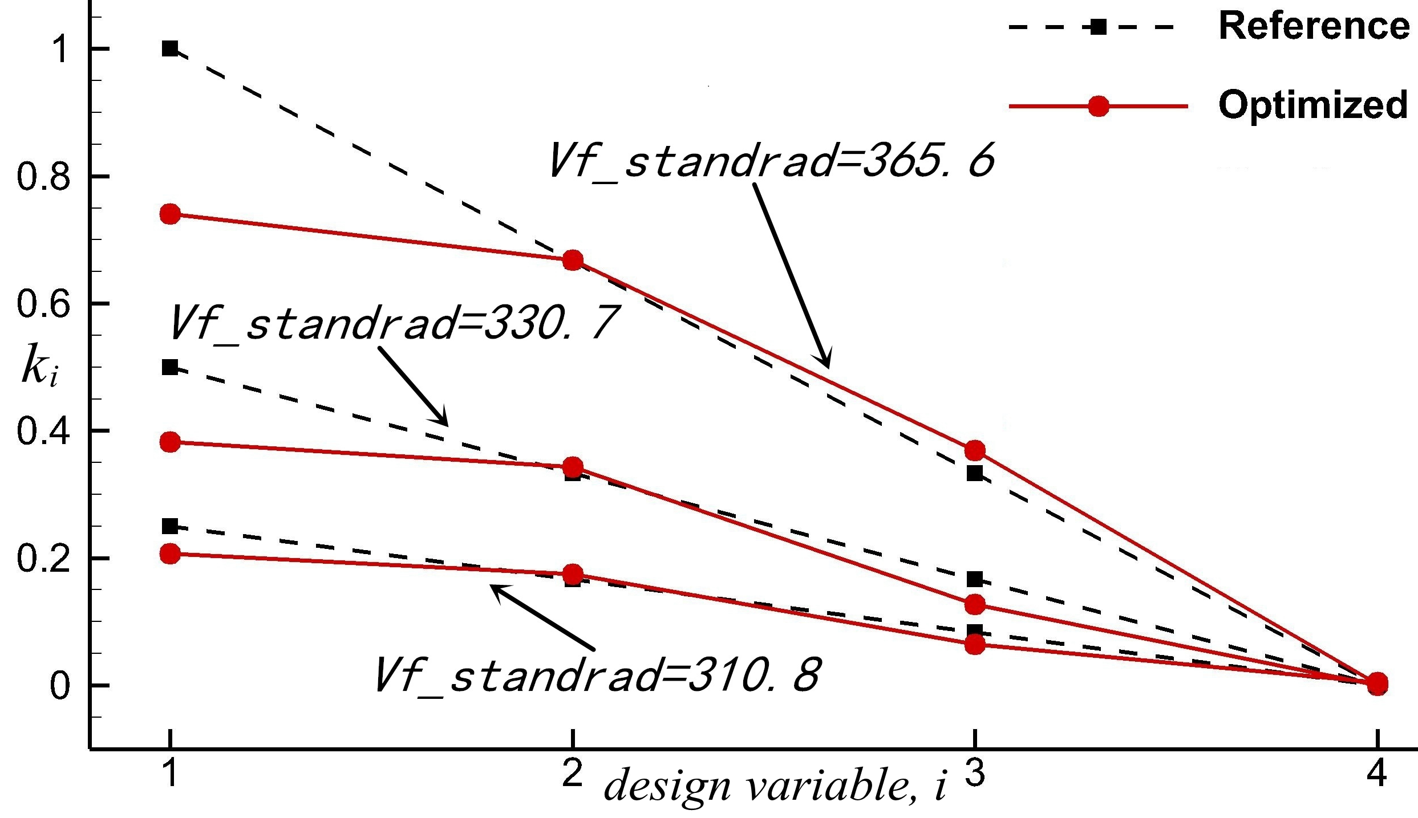
Fig. 7 Comparison between the design variables of reference and optimized
The presented aeroelastic structural optimization process is further used to is used to optimize the aeroelastic structure. In this study, the wing structural model is further divided into a series of sections at global level. The wing were divided into two and three sections along the spanwise, and numbered as 1 to 2 and 1 to 3 from the wing root to tip as shown in Fig. 8(a) and Fig. 8(b), and each section has same material properties.
(a)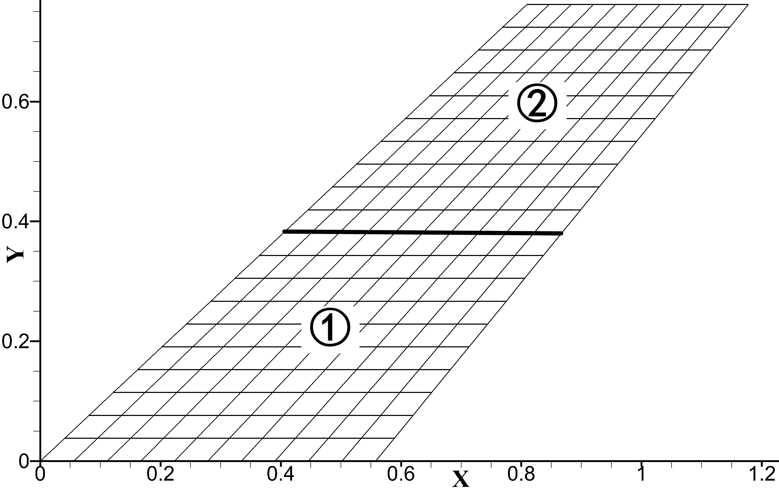 (b)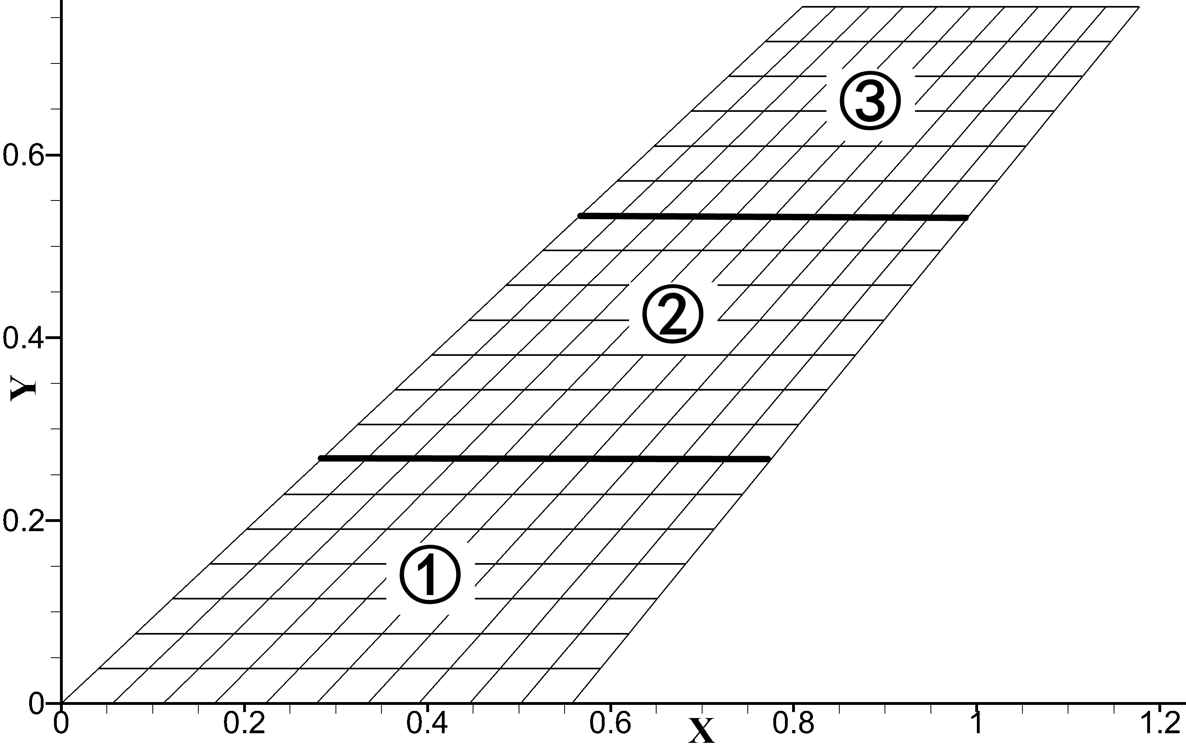
Fig. 8 Structural model: (a) wing divided into two spanwise sections, two design variables, and (b) wing divided into three spanwise sections, three design variables.
After optimization process, all the constraint conditions are satisfied. A comparison of ΔM_T between different divided wing structural model are shown in Table 5. It is observed that with the increase of the number of sections of the divided wing structural model, in overall different flutter speed constraints, the increased mass of the wing structure is decrease. Further, with the increase of flutter speed, the difference of the mass reduction is more obvious. To further illustrate the mass of which position is increased, the details of final design variables after the optimization to two divided wing, three divided wing and four divided wing are also shown in Fig. 9. In addition, the wing structural model can be divided into more sections, but the increase in the number of sections will deviate from the original intention of the aeroelastic global optimization of this paper.
Table 5 Comparison between the ΔM_T of different divided wing.
Vf_standard (m/s) | ΔM_T
Vf_standard (m/s) | Two | Three | Four
310.8 | 0.6986 | 0.6584 | 0.6364
330.7 | 2.9638 | 1.3007 | 1.2494
365.6 | 5.7214 | 2.4825 | 2.5634
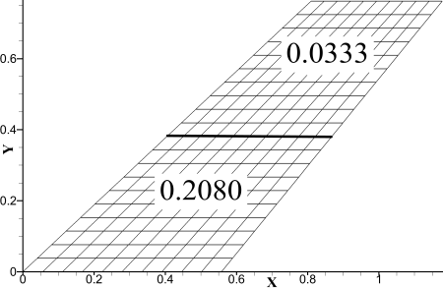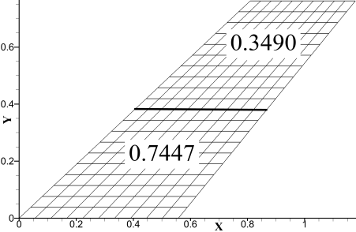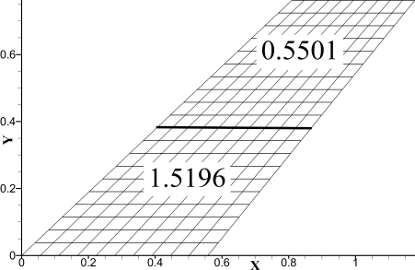
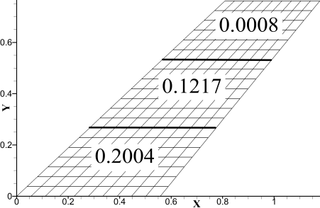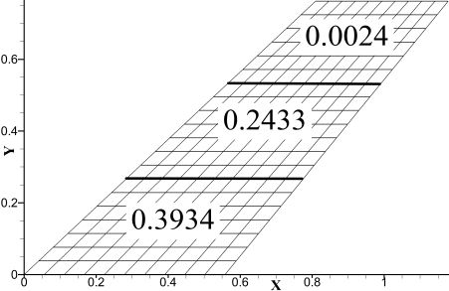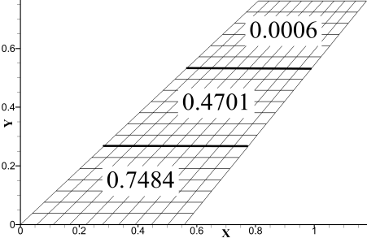
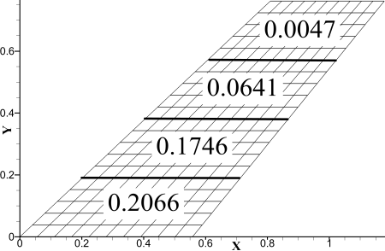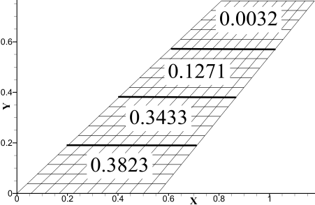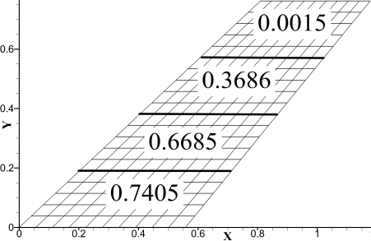
（a）Vf_ standard =310.8m/s （b）Vf_ standard =330.7m/s （c）Vf_ standard =365.5m/s
Fig. 9 The final design variables
The two division methods at global level of wing are shown in Fig. 10, it is different from above mentions. A comparison of ΔM_T between different divided wing structural model are shown in Table 6. It is observed that with the increase of the number of divided sections of the wing structural model, in all different flutter speed constraints, the increased mass of the wing structure is decrease. To further illustrate the mass of which position is increased, the details of final design variables after the optimization to two divided wing and four divided wing are also shown in Fig. 11. In particular for the wing which is divided into two chordwise sections is shown in Fig. 10 (a) cannot satisfy the constraints of Vf_standard=365.6 m/s and MAC_standard at the same time, so the final result is not good. The reason is that when the wing is divided into two sections, the structural gradient is too large in the optimization process, so the accuracy requirement cannot be met. The general trend is that with the increase of the number of divided sections of the wing structural model, the result is better. It should be note that, in the same type of aeroelastic global structural optimization, the wing divided into four sections is sufficient to meet the requirements of global optimization.
(a)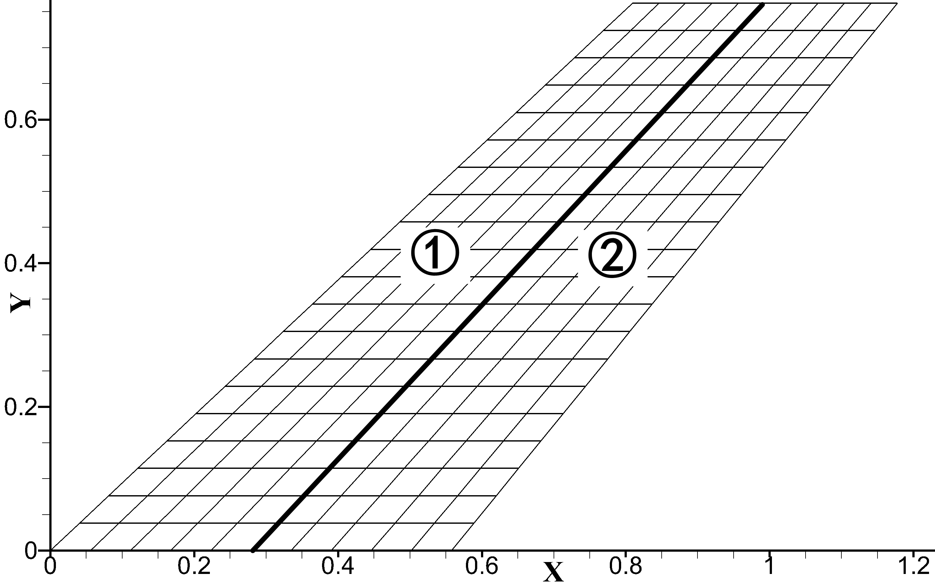 (b)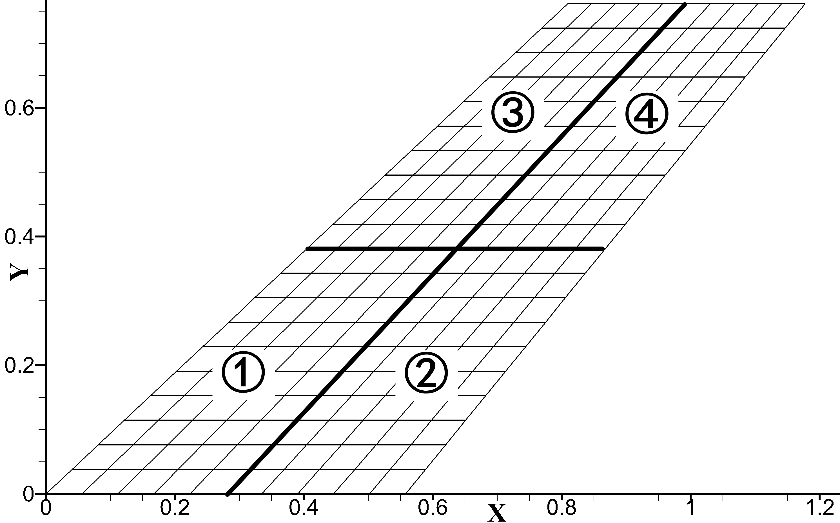
Fig. 10 Structural model: (a) wing divided into two chordwise sections, two design variables, and (b) wing divided into two spanwise and two chordwise sections, four design variables.
Table 6 Comparison between the ΔM_T of different divided wing.
Vf_standard (m/s) | ΔM_T
Vf_standard (m/s) | Two | Four
310.8 | 0.8968 | 0.5766
330.7 | 2.0205 | 1.3435
365.6 | 2.6746 / Vf=336.3 (m/s) | 2.6105
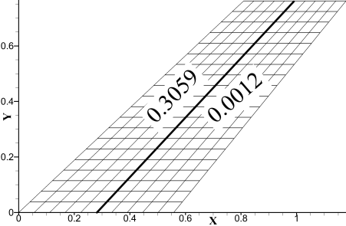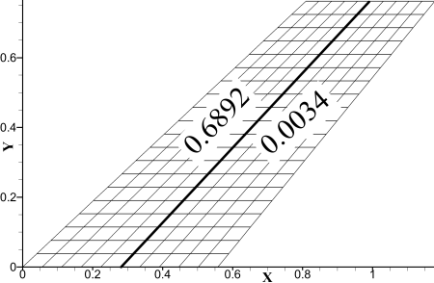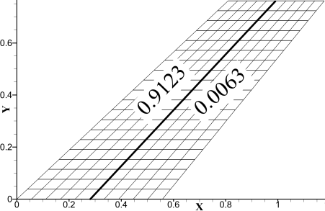
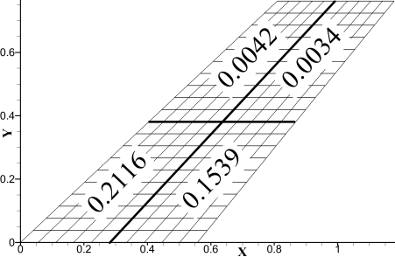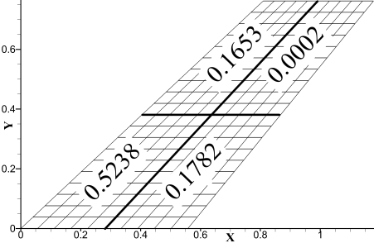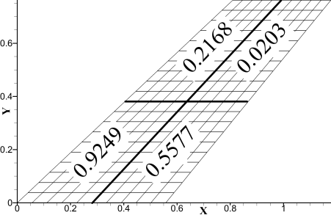
（a）Vf_ standard =310.8m/s （b）Vf_ standard =330.7m/s （c）Vf_ standard =365.5m/s
Fig. 11 The final design variables
- Mass Increment Constraint
In this aeroelastic global structural optimization case, flutter speed was the objective function to be maximized with mass increment constraint. The design variables for optimization are a series of parameters associated with material properties of each wing section at global level. The objective optimization problem is
maximize Vf
subject to 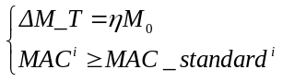
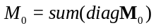is defined as the mass of original wing model, and, is the mass coefficient, in this section 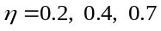. is defined as the mass increment of wing model, and , is the unit mass matrix of each section, so the design variable of mass for the optimization is . In this study, each design variables is constrained to lie between and , which for this work are set to 0 and . In order to search all possible design variables with with mass increment constraint, defined as:
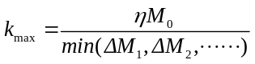
This optimization case adopts a series of structural models have mentioned above in previous section. The wing was divided into two, three and four sections along the spanwise, as shown in Fig. 8(a), Fig. 8(b) and Fig. 3(a), respectively. And each section has same material properties. In this optimization case, the MAC_standard equal to the value of MAC₀ of the structural model with ε =1/ 3, has listed in Table 2.
After the optimization process, all the constraint conditions are satisfied. A comparison of flutter speed between different divided wing structural models are shown in Table 7. It is observed that with the increase of the number of sections of the divided wing structural model, in overall different mass increment constraints. Further, with the increase of mass increment, the difference of the flutter speed faster is more obvious. To further illustrate the mass of which position is increased, the details of final design variables after the optimization to two divided wing, three divided wing and four divided wing are also shown in Fig. 12.
Table 7 Comparison between the flutter speed of different divided wing.
 | Flutter speed (m/s)
 | Four | Three | Two
0.2 | 321 | 322 | 320
0.4 | 346 | 353 | 328
0.7 | 384 | 382 | 346
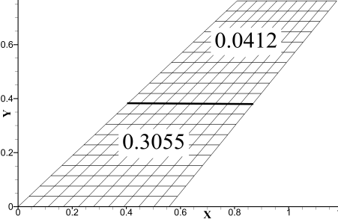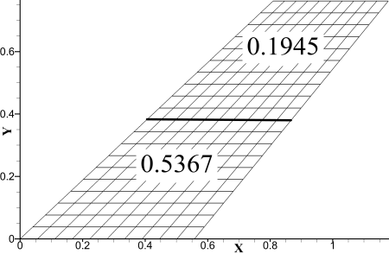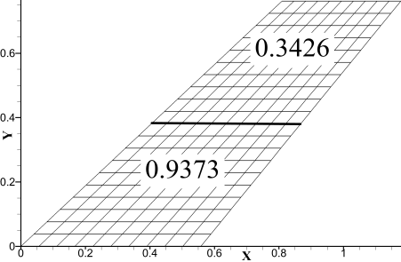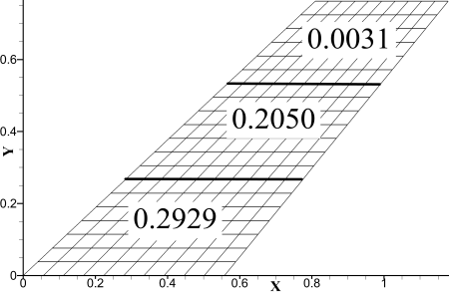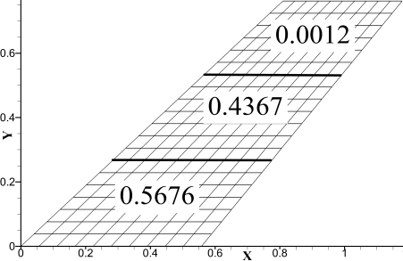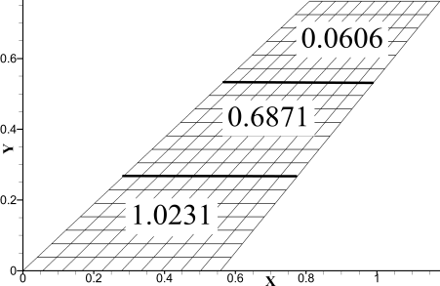
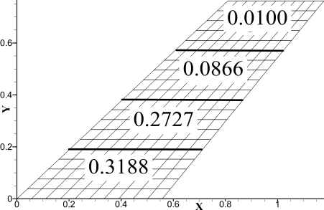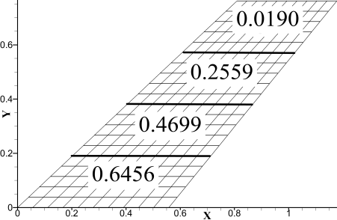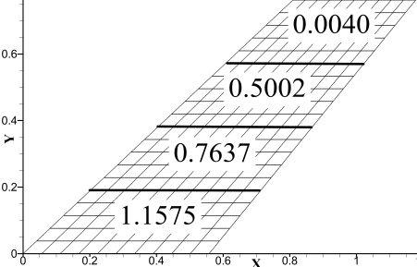
（a）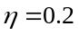 （b）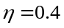 （c）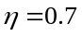
Fig. 12 The final design variables
For another two division methods at global level of wing were shown in Fig. 9, it is different from above mentions. A comparison of flutter speed between different divided wing structural models are shown in Table 8. It is observed that with the increase of the number of divided sections of the wing structural model, in overall different mass increment constraints, the increased flutter of the wing structure is higher. To further illustrate the mass of which position is increased, the details of final design variables after the optimization to two divided wing and four divided wing are also shown in Fig. 13. In particular for the wing which is divided into two chordwise sections is shown in Fig. 10 (a), to satisfy the constraints of 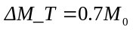 and MAC_standard at the same time, so the final result is not good.
Table 8 Comparison between the flutter speed of different divided wing.
 | Flutter Speed (m/s)
 | Two | Four
0.2 | 313 | 323
0.4 | 331 | 340
0.7 | 319 | 357
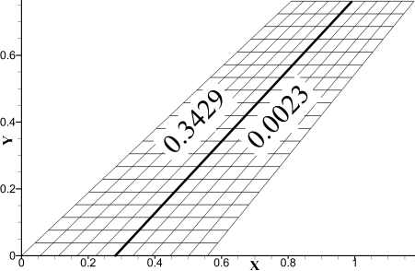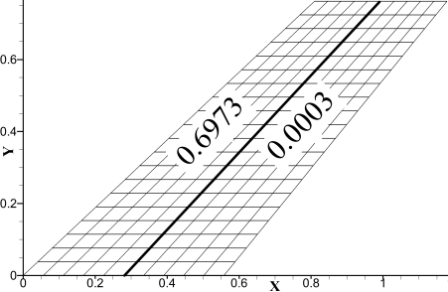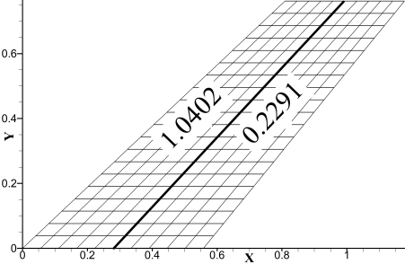
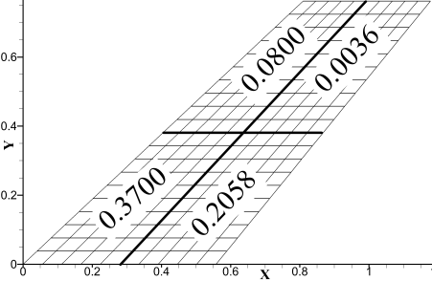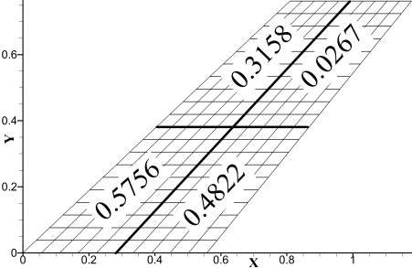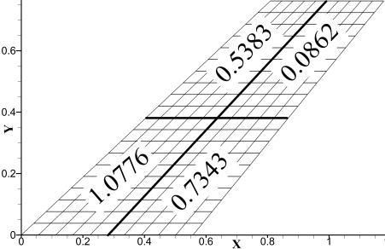
（a） （b） （c）
Fig. 13 The final design variables of two divided wing (a) and four divided wing (b)
- Conclusions
There are a large number of design variables for structure to be taken into consideration in aeroelastic structural optimization. The bi-level approach has become one of the most popular techniques to reduce computational burden during simulation in recent years. This article presents a new optimization process for aeroelastic structural optimization at global level. It create an efficient tool of industrial aeroelastic structural optimization, which will allow the reduction of overall cost of the aircraft optimum design.
The feasibility of the presented optimization process for aeroelastic global structural optimization was demonstrated and evaluated by three different cases. In the three different cases, efforts have been made to optimize a wing structure for a minimum weight subject to aeroelastic constraints. First, this paper has been demonstrated the efficient CFD-based ROM by embedding the structural dynamics reanalysis method into a CFD-based aeroelastic ROM. Second, the optimization process for aeroelastic structural optimization using the efficient CFD-based ROM, and Genetic Algorithms (GAs) as an optimization tool. Third, the optimization process is validated by the AGARD 445.6 aeroelastic wing model with different cases.
The proposed optimization process is applied to the optimization of different divided wing structural model and compared. With the increase of the number of sections of the divided wing structural model, the increased mass of the wing structure is smaller, whether flutter speed or mass increment constraints. However, in the global level, usually three or four parts divided model are good enough for searching the good optimization results. We can also see the selection of an appropriate and reasonable constraint range is advantageous to the improvement of the overall structural performance and the reduction of the structural weight. The optimization process for aeroelastic global structural optimization proposed in this paper provides a useful design tool for solving such a typical wing structure optimization problem, which can help designers find the better possible configuration at global level.
Acknowledgments
This work was partially supported by the National Natural Science Foundation of China (No. 11672225, 11511130053 and 11272005), the National Program on Key Research Projects (No. MJ-2015-F-010), the Shannxi Province Natural Science Foundation (No. 2016JM1007), the Basic Research foundations for the Central Universities (No. 2014XJJ0126), the National Defense Fundamental Research (No. JCKY2016204B102), and the Fundamental Research Funds for the Central Universities (No. G2016KY0302).

References
[1] G.P. Guruswamy, Unsteady aerodynamic and aeroelastic calculations for wings using Euler equations, AIAA journal, 28 (1990) 461-469.
[2] J. Sahu, F. Fresconi, K. Heavey, Unsteady Aerodynamic Simulations of a Finned Projectile at a Supersonic Speed with Jet Interaction, 32nd AIAA Applied Aerodynamics Conference, 2014, pp. 3024.
[3] D.M. Schuster, D.D. Liu, L.J. Huttsell, Computational aeroelasticity: success, progress, challenge, Journal of Aircraft, 40 (2003) 843-856.
[4] R. Yurkovich, Status of unsteady aerodynamic prediction for flutter of high-performance aircraft, Journal of Aircraft, 40 (2003) 832-842.
[5] D.E. Raveh, Reduced-Order Models for Nonlinear Unsteady Aerodynamics, Aiaa Journal, 39 (2011) 1417-1429.
[6] W.A. Silva, R.E. Bartels, Development of reduced-order models for aeroelastic analysis and flutter prediction using the CFL3Dv6.0 code, Journal of Fluids & Structures, 19 (2004) 729-745.
[7] Z. Yang, R. Huang, Y. Zhao, H. Hu, Design of an Active Disturbance Rejection Control for Transonic Flutter Suppression, Journal of Guidance Control & Dynamics, DOI (2017) 1-12.
[8] L.Z. Li, M. Yang, X. Luo, J. Zhang, M.N. Yuan, A spline ROM of blade aerodynamic force to upstream wake, Aerospace Science and Technology, 84 (2019) 650-660.
[9] E.H. Dowell, J.P. Thomas, K.C. Hall, Transonic limit cycle oscillation analysis using reduced order aerodynamic models, Journal of Fluids and Structures, 19 (2004) 17-27.
[10] D.J. Lucia, P.S. Beran, P.I. King, Reduced-order modeling of an elastic panel in transonic flow, Journal of Aircraft, 40 (2003) 338-347.
[11] L. Li, J. Zhang, X. Luo, M. Yuan, X. Wang, An aerodynamic ROM of the blade subjected to wake based on Fourier method for flow, International Journal for Numerical Methods in Fluids, 89 (2019) 162-179.
[12] L. Li, X. Zhang, J. Zhang, M. Yuan, Y. Han, Efficient ROM Method for Calculating Blade Aerodynamic Forces to Upstream and Downstream Perturbations, Journal of Aerospace Engineering, 32 (2019) 04019011.
[13] J. Luo, Design optimization of the last stage of a 4.5-stage compressor using a POD-based hybrid model, Aerospace Science and Technology, 76 (2018) 303-314.
[14] J. Kou, W. Zhang, A hybrid reduced-order framework for complex aeroelastic simulations, Aerospace science and technology, 84 (2019) 880-894.
[15] P.G. A. Cizmas, A. Palacios, Proper orthogonal decomposition of turbine rotor-stator interaction, Journal of propulsion and power, 19 (2003) 268-281.
[16] S.T. Clark, R.E. Kielb, K.C. Hall, Developing a Reduced-Order Model to Understand Non-Synchronous Vibration (NSV) in Turbomachinery, ASME Turbo Expo 2012: Turbine Technical Conference and Exposition, American Society of Mechanical Engineers, 2012, pp. 1373-1382.
[17] S. Mariappan, A.D. Gardner, R. Kai, M. Raffel, Analysis of Dynamic Stall Using Dynamic Mode Decomposition Technique, Aiaa Journal, 52 (2014) 2427-2439.
[18] B. Stanford, P. Beran, Cost reduction techniques for the structural design of nonlinear flapping wings, 50th AIAA/ASME/ASCE/AHS/ASC Structures, Structural Dynamics, and Materials Conference 17th AIAA/ASME/AHS Adaptive Structures Conference 11th AIAA No, 2009, pp. 2414.
[19] L. Demasi, A. Palacios, A reduced order nonlinear aeroelastic analysis of joined wings based on the proper orthogonal decomposition, 51st AIAA/ASME/ASCE/AHS/ASC Structures, Structural Dynamics, and Materials Conference 18th AIAA/ASME/AHS Adaptive Structures Conference 12th, 2010, pp. 2722.
[20] H. Hesse, R. Palacios, Reduced-order aeroelastic models for dynamics of maneuvering flexible aircraft, AIAA journal, 52 (2014) 1717-1732.
[21] T. Lieu, C. Farhat, M. Lesoinne, Reduced-order fluid/structure modeling of a complete aircraft configuration, Computer methods in applied mechanics and engineering, 195 (2006) 5730-5742.
[22] D. Amsallem, C. Farhat, T. Lieu, Aeroelastic analysis of F-16 and F-18/A configurations using adapted CFD-based reduced-order models, 48th AIAA/ASME/ASCE/AHS/ASC Structures, Structural Dynamics, and Materials Conference, 2007, pp. 2364.
[23] Q. Zhou, G. Chen, Y. Li, a Reduced Order Model Based on Block Arnoldi Method for Aeroelastic System, International Journal of Applied Mechanics, 6 (2014) 1450069.
[24] G. Chen, X. Wang, Y. Li, REDUCED-ORDER-MODEL-BASED PLACEMENT OPTIMIZATION OF MULTIPLE CONTROL SURFACES FOR ACTIVE AEROELASTIC CONTROL, International Journal of Computational Methods, 11 (2014) 1350081.
[25] G. Chen, J. Sun, W. Mao, Y. Li, Limit Cycle Oscillation Control for Transonic Aeroelastic Systems Based on Support Vector Machine Reduced Order Model, Transactions of the Japan Society for Aeronautical and Space Sciences, 56 (2013) 8-14.
[26] Q. Zhou, C. Gang, L. Yueming, D.R. Andrea, Aeroelastic Moving Gust Responses and Alleviation based on CFD, AIAA Modeling and Simulation Technologies Conference, 2016, pp. 3837.
[27] Q. Zhou, D.-f. Li, A. Da Ronch, G. Chen, Y.-m. Li, Computational fluid dynamics-based transonic flutter suppression with control delay, Journal of Fluids and Structures, 66 (2016) 183-206.
[28] C. Fenwick, D. Jones, A. Gaitonde, Consideration of ROM Interpolation for Aeroelastic Design using Structural Modification, 18th AIAA Computational Fluid Dynamics Conference, Miami, FL, 2007.
[29] W. Zhang, K. Chen, Z. Ye, Unsteady aerodynamic reduced-order modeling of an aeroelastic wing using arbitrary mode shapes, Journal of Fluids & Structures, 58 (2015) 254-270.
[30] M. Winter, F.M. Heckmeier, C. Breitsamter, CFD-based aeroelastic reduced-order modeling robust to structural parameter variations, Aerospace Science & Technology, 67 (2017) 13-30.
[31] Z. Wang, W. Zhang, X. Wu, K. Chen, A novel unsteady aerodynamic Reduced-Order Modeling method for transonic aeroelastic optimization, Journal of Fluids and Structures, 82 (2018) 308-328.
[32] K. Li, J. Kou, W. Zhang, Deep neural network for unsteady aerodynamic and aeroelastic modeling across multiple Mach numbers, Nonlinear Dynamics, 96 (2019) 2157-2177.
[33] S. Ragon, Z. G-uacute, rdal, R. Haftka, T. Tzong, Bilevel design of a wing structure using response surfaces, Journal of aircraft, 40 (2003) 985-992.
[34] D. Locatelli, A. Yeilaghi Tamijani, S.B. Mulani, Q. Liu, R.K. Kapania, Multidisciplinary optimization of supersonic wing structures using curvilinear spars and ribs (SpaRibs), 54th AIAA/ASME/ASCE/AHS/ASC Structures, Structural Dynamics, and Materials Conference, 2013, pp. 1931.
[35] P. Gasbarri, L.D. Chiwiacowsky, H.F.D.C. Velho, A hybrid multilevel approach for aeroelastic optimization of composite wing-box, Structural & Multidisciplinary Optimization, 39 (2010) 607-624.
[36] P.D. Ciampa, B. Nagel, M.V. Tooren, Global Local Structural Optimization of Transportation Aircraft Wings, Aiaa Structures, Structural Dynamics, and Materials Conference, 2010.
[37] G. Chen, D. Li, Q. Zhou, A. Da Ronch, Y. Li, Efficient aeroelastic reduced order model with global structural modifications, Aerospace Science and Technology, 76 (2018) 1-13.
[38] D. Li, C. Gong, A. Da Ronch, G. Chen, Y. Li, An efficient implementation of aeroelastic tailoring based on efficient computational fluid dynamics-based reduced order model, Journal of Fluids and Structures, 84 (2019) 182-198.
[39] Z.Q. Wan, H. Yan, D.G. Liu, C. Yang, Aeroelastic Analysis and Optimization of High-aspect-ratio Composite Forward-swept Wings, Chinese Journal of Aeronautics, 18 (2005) 317-325.
[40] G. Naik, S. Gyan, R. Satheesh, R. Ganguli, Minimum weight design of fiber-reinforced laminated composite structures with maximum stress and Tsai-Wu failure criteria, Journal of Reinforced Plastics & Composites, 30 (2011) 179-192.
[41] K.C. Hall, J.P. Thomas, E.H. Dowell, Proper orthogonal decomposition technique for transonic unsteady aerodynamic flows, AIAA journal, 38 (2000) 1853-1862.
[42] T. Lieu, C. Farhat, M. Lesoinne, POD-based aeroelastic analysis of a complete F-16 configuration: ROM adaptation and demonstration, 46th AIAA/ASME/ASCE/AHS/ASC Structures, Structural Dynamics and Materials Conference, 2005, pp. 2295.
[43] T. Lieu, Adaptation of reduced order models for applications in aeroelasticity, Colorado: University of Colorado, 2004.
[44] Q. Song, P. Chen, S. Sun, An exact reanalysis algorithm for local non-topological high-rank structural modifications in finite element analysis, Computers & Structures, 143 (2014) 60–72.
[45] M.A. Akgün, J.H. Garcelon, R.T. Haftka, Fast exact linear and non‐linear structural reanalysis and the Sherman–Morrison–Woodbury formulas, International Journal for Numerical Methods in Engineering, 50 (2001) 1587-1606.
[46] G. Huang, H. Wang, G. Li, An exact reanalysis method for structures with local modifications, Structural and Multidisciplinary Optimization, 54 (2016) 499-509.
[47] J.-G. Beliveau, S. Cogan, G. Lallement, F. Ayer, Iterative least-squares calculation for modal eigenvector sensitivity, AIAA journal, 34 (1996) 385-391.
[48] S.H. Chen, X.W. Yang, Extended Kirsch combined method for eigenvalue reanalysis, AIAA journal, 38 (2000) 927-930.
[49] U. Kirsch, M. Bogomolni, I. Sheinman, Efficient Dynamic Reanalysis of Structures, Journal of Structural Engineering, 133 (2007) 440-448.
[50] S. Chen, X. Yang, H. Lian, Comparison of several eigenvalue reanalysis methods for modified structures, Structural and Multidisciplinary Optimization, 20 (2000) 253-259.
[51] S.H. Chen, D.T. Song, A.J. Ma, Eigensolution reanalysis of modified structures using perturbations and Rayleigh quotients, Communications in numerical methods in engineering, 10 (1994) 111-119.
[52] S.M. Zandavi, S.H. Pourtakdoust, Multidisciplinary design of a guided flying vehicle using simplex nondominated sorting genetic algorithm II, Structural and Multidisciplinary Optimization, 57 (2018) 705-720.
[53] D.E. Goldberg, Genetic Algorithms in Search, Optimization and Machine Learning, Addison-Wesley Pub. Co1989.
[54] E.C. Yates, AGARD standard aeroelastic configuration for dynamic response, candidate configuration I, Wing, 445 (1987) 103-129.
[55] W.A. Silva, P. Chwalowski, B. Perry III, Evaluation of linear, inviscid, viscous, and reduced-order modelling aeroelastic solutions of the AGARD 445.6 wing using root locus analysis, International Journal of Computational Fluid Dynamics, 28 (2014) 122-139.
[56] J. Zhong, Z. Xu, Coupled fluid structure analysis for wing 445.6 flutter using a fast dynamic mesh technology, International Journal of Computational Fluid Dynamics, 30 (2016) 531-542.
[57] G. Chen, J. Sun, Y.-M. Li, Adaptive reduced-order-model-based control-law design for active flutter suppression, Journal of Aircraft, 49 (2012) 973-980.
[58] Y. Dai, T.C. Lim, Suppression of brake squeal noise applying finite element brake and pad model enhanced by spectral-based assurance criteria, Applied Acoustics, 69 (2008) 196-214.
[59] W. Yang, Z. Yue, L. Li, P. Wang, Aircraft wing structural design optimization based on automated finite element modelling and ground structure approach, Engineering Optimization, 48 (2016) 94-114.
[60] P.D. Ciampa, B. Nagel, M. Tooren, Global local structural optimization of transportation aircraft wings, 51st AIAA/ASME/ASCE/AHS/ASC Structures, Structural Dynamics, and Materials Conference 18th AIAA/ASME/AHS Adaptive Structures Conference 12th, 2010, pp. 3098.
[61] S. Guo, D. Li, Y. Liu, Multi-objective optimization of a composite wing subject to strength and aeroelastic constraints, Proceedings of the Institution of Mechanical Engineers, Part G: Journal of Aerospace Engineering, 226 (2012) 1095-1106.
[62] W. Wang, S. Guo, W. Yang, Simultaneous partial topology and size optimization of a wing structure using ant colony and gradient based methods, Engineering Optimization, 43 (2011) 433-446.
[63] M. Karpel, L. Brainin, Stress considerations in reduced-size aeroelastic optimization, AIAA journal, 33 (1995) 716-722.

