Winter climate change increases physiological stress in calcareous fen bryophytes

Martin Küttim¹, Anna M. Laine^{2,3}, Liisa Küttim¹, Mati Ilomets¹, Bjorn J.M. Robroek⁴

- Tallinn University, School of Natural Sciences and Health, Institute of Ecology, Uus-Sadama 5, 10120 Tallinn, Estonia.
- University of Oulu, Department of Ecology and Genetics, P.O.Box 8000, FI-90014 Oulu, Finland.
- University of Eastern Finland, School of Forest Sciences, P.O. Box 111, FI-80101 Joensuu, Finland
- University of Southampton, Faculty of Natural and Environmental Sciences, School of Biological Sciences, Highfield Campus, SO17 1BJ Southampton, UK.

Corresponding author: Martin Küttim, Tallinn University, School of Natural Sciences and Health, Institute of Ecology, Uus-Sadama 5, 10120 Tallinn, Estonia. kyttim@tlu.ee. Phone: +372 56935875

ABSTRACT
Calcareous spring fens are among the rarest and most endangered wetland types worldwide. The majority of these ecosystems can be found at high latitudes, where they are affected by above average rates of climate change. Particularly winter temperatures are increasing, which results in decreased snow cover. As snow provides an insulating layer that protects ecosystems from subzero temperatures, its decrease is likely to induce stress to plants. To investigate the sensitivity of the bryophyte community – key to the functioning of calcareous spring fens – to changing climatic conditions, we studied the annual variation in ecophysiology of two dominant bryophytes: Campylium stellatum and Scorpidium scorpioides. Further, a snow removal experiment was used to simulate the effect of changing winter conditions. In both species, we observed lowest efficiency of photosystem II (Fv/Fm) in spring, indicating physiological stress, and highest chlorophyll-a, -b and carotenoid concentrations in autumn. Snow removal exacerbated physiological stress in bryophytes. Consequently Fv/Fm, pigment concentrations and chlorophyll to carotenoids ratios declined, while chlorophyll-a to -b ratios increased. Moreover, these effects of winter climate change cascaded to the growing season. C. stellatum, a low hummock inhabitor, suffered more from snow removal (annual mean decline in Fv/Fm 7.7% and 30.0% in chlorophyll-a) than S. scorpioides, a hollow species (declines 5.4% and 14.5%, respectively). Taken together, our results indicate that spring fen bryophytes are negatively impacted by winter climate change, as a result of longer frost periods and increased numbers of freeze-thaw cycles in combination with higher light intensity and dehydration.

Keywords: mosses, phenology, snow, chlorophyll, peatlands

1. INTRODUCTION
Over the last decades, mean annual air temperatures in Northern Europe have increased; a trend which is expected to continue (Jylhä et al., 2004; IPCC, 2014). Climate warming in the boreal zone, where the majority of peatlands are located, is however unbalanced over the year, with the greatest changes during winter (Kreyling, 2010; IPCC, 2014; Lode et al., 2017). Due to winter warming, it is expected that the amount of snow and the duration of the snow covered period decrease, in parallel with an increase in precipitation that falls as rain (Templer, 2012). The relationships between environmental conditions and plant ecophysiological processes are well understood in the traditional growing season, i.e. in summer (Kreyling, 2010; Hajek, 2014; Glime, 2017), but overlooked in winter. Indeed, these processes are traditionally assumed to halt during winter. As temperature and light availability are the major drivers for plant metabolic processes (Miidla, 1984; Tang et al., 2016), changes in environmental variables during winter are likely to alter plant physiology (Glime, 2017). Decreasing snow cover provides opportunities for evergreen plant species that tolerate low temperatures, as they may profit from increased light availability. On the other hand, reduced or absent snow cover leaves soil and vegetation exposed, increasing the risk of frost (Groffman et al., 2001). In that respect, reduced snow cover may have contrasting effects on plant processes due to a simultaneous alleviation of light constraints and enhancement of frost stress. Previous winter warming and snow removal studies implicate that decreasing snow cover increases plant stress: the physiological performance (declined rate of photosynthesis, change in chemical compounds, mechanical damage etc) of various plants that are abundant in northern ecosystems may be altered, e.g. conifers (Sutinen et al., 2014), deciduous trees (Tateno et al., 2019) and dwarf-shrubs (Taulavuori et al., 2002). Also, Sphagnum mosses express reduced growth, photosynthesis and chlorophyll-a concentration in response to decreased snow cover (Dorrepaal et al., 2004; Genet et al., 2013; Küttim et al., 2017).
For bryophytes – which cover the majority of the surface layer in most peatlands – environmental stress can cause damage to the photosynthetic apparatus, decrease photosystem II (PS II) efficiency, and induce photoinhibition (Hajek, 2014; Bjerke et al., 2016). Such damages may be observed as reduced chlorophyll fluorescence (Fv/Fm) values (Maxwell and Johnson, 2000) or as changes in the amount and stoichiometry of photosynthetic pigments (Gehrke, 1998; Marschall and Proctor, 2004). Photosynthetic pigments act as energy collectors and are known to protect plants against irreversible photoinhibition (Miidla, 1984; Devi et al., 2015). Carotenoids in particular have the shielding function against photodestruction, but together with chlorophyll-b also receive the solar energy and transfer it to chlorophyll-a, the most active photosynthetic pigment, which in addition to energy absorbtion converts it into chemical energy (Miidla, 1984). While photosynthetic capacity in plants is related to high chlorophyll concentrations (Martin, 1980; Gaberscik and Martincic, 1987), plants may reduce the concentrations of these pigments under environmental stress, such as intense solar radiation, water deficiency and sub-zero temperatures (Devi et al., 2015). Species of low-light environments tend to have higher chlorophyll concentration and lower chlorophyll-a:b ratios (Martin, 1980; Marschall and Proctor, 2004). For these reasons, the concentrations and stoichiometry of the photosynthetic pigments, together with Fv/Fm may offer a good proxy for the effect of winter climate change on the physiology of peatland bryophytes.
The majority of studies on the effects of climate change on peatlands have concentrated on bogs. Fens, however, are expected to be more prone to higher temperatures and decreasing water tables (Bridgham et al., 2008). Tufa-forming calcareous spring fens are one of the rarest and most threatened wetland types worldwide (Grootjans et al., 2005). Tufa – a calcareous sediment (CaCO₃) – precipitates from the calcium carbonate saturated ground waters after they enter the fen through the springs, due to a change in temperature, pressure and pH after flowing out from the limestone cracks into the fen (Pentecost, 1996). As Pleistocene remnants, these coldland communities (Grootjans et al., 2005) are likely to be endangered by winter warming. In these ecosystems, the high water table enables the establishment of a diverse and abundant bryophyte layer (Ilomets et al., 2010), which in turn maintains the moisture and provides a seedbed for numerous vascular plants (Clapham, 1940). The absence of a tree layer exposes the vegetation to periodically high solar radiations and to diurnal temperature variations. Potential negative effects of extreme temperatures and high radiation may however be alleviated by the continuous inflow of calcium-rich spring water that provides hydration for bryophytes that grow in hollows (i.e. wet depressions), and can keep the habitat ice-free around the year (Paal, 2004). While calcareous spring fens are recognized as diversity hotspots (Grootjans et al., 2005), little is known about the consequences of projected changes in winter conditions on these plant communities.
Here we assess the response in the physiological performance of the dominant bryophyte species in tufa-forming spring fens to various environmental factors across seasons, and test how they are altered by an experimental change in winter conditions (i.e. snow removal). Over one year, chlorophyll fluorescence (Fv/Fm) rates and photosynthetic pigment concentrations were measured from Campylium stellatum and Scorpidium scorpioides, the dominant bryophyte species in these systems. The relationship between environmental conditions and these physiological traits were analysed. We hypothesize that in winter and spring the concentration of photosynthetic pigments is lower and the physiological stress of bryophytes, indicated by a low Fv/Fm, is higher as compared to summer and autumn. Secondly, we performed a snow manipulation experiment to simulate a decrease in snow cover due to winter climate change. We hypothesize that the removal of the snow cover subjects the plant community to subzero-temperatures, resulting in physiological stress and negative impacts on the chlorophyll concentration in bryophytes. The duration of the possible effect of that treatment is assessed over the growing season.

2. MATERIALS AND METHODS

2.1. Study site
The study site – an open calcareous-rich spring fen with a tufa (CaCO₃) precipitation – is located in the north-eastern part of Paraspõllu fen (N 59° 18´; E 25° 7´; altitude 41.5 m asl). The fen is located in the Paraspõllu Nature Reserve (253 ha), a Natura 2000 site situated in the south-eastern part of the larger Peningi mire complex (7552 ha), N-Estonia (Fig. 1). The water table at the site is near the surface, with a small annual fluctuation (<10 cm), and negligible microtopography (c. 25 cm max.). pH of the water is slightly alkaline (c. 7.8) and electric conductivity ~200 μS·cm⁻¹. These conditions enable the distribution of tufa across the site. The vascular plant vegetation is dominated by sedges, of which Carex panicea L. is the most dominant. Schoenus ferrugineus L. and Menyanthes trifoliata L. commonly occur in the system. The bryophyte layer is dominated by Campylium stellatum (Hedw.) Lange & C. E. O. Jensen, Scorpidium scorpioides (Hedw.) Limpr., S. cossonii (Schimp.) Loeske and Meesia triquetra (L. ex Jolycl.) Ångstr. We focus on C. stellatum and S. scorpioides, which both have a boreal distribution (Rikkinen, 2008), and are representatives of the low hummock and wet hollow microhabitats, repectively. A full list of plant species (Ilomets et al., 2010) is given in the Appendix 1.

2.2. Experimental design
We established 28 experimental plots (Ø = 50 cm) with either C. stellatum (n =14) or S. scorpioides (n = 14) as the dominant bryophyte species (i.e. ≥ 90% cover of the bryophyte layer), along a 100 m transect in the center of the study area (Fig. 1). While larger and loosely growing S. scorpioides prefers flooded hollows, C. stellatum with small and compactly growing shoots can mostly be found from low hummocks. Specifically, the relative height of the microforms above the water table (H) ranged from –1 to 10 cm in C. stellatum plots (H_{mean} = 4.5 ± 3.9 cm), and from –9 to 5 cm in S. scorpioides plots (H_{mean} = 0.2 ± 4.5 cm). Per species, three replicates were assigned to the snow removal experiment. These plots were kept snow-free throughout the winter period, by careful removal (i.e. brushing off) of snow prior to each sampling and measurement campaign.

2.3. Bryophyte ecophysiological traits
During the study period (October 2013 – October 2014; 387 days), we measured chlorophyll fluorescence (F_{v}/F_{m}) – a measure of the maximum quantum yield of the photosystem II (PSII) – and chlorophyll contents. Chlorophyll fluorescence measurements were performed on the apical parts of five bryophyte shoots from each plot roughly every third week during all day, using a fluorometer (Hansatech Handy PEA, England). F_{v} was calculated as a difference between the maximum and minimum fluorescence yield (F_{m} – F₀), after which the maximum quantum yield of PSII was calculated as F_{v}/F_{m} (Maxwell and Johnson, 2000). The saturation pulse was 3 s, with an intensity of 3000 μmol m⁻² sec⁻¹. All bryophyte shoots were dark adapted prior to the measurements. Time for dark adaptation varied between 5 min in winter to 30 mins in summer, and was defined by pre-measurement trials.
To measure chlorophyll concentrations, bryophytes were collected from the snow removal treatments, and its corresponding controls (n =3), at each F_{v}/F_{m} measurement campaign. These samples were kept dark, and subsequently stored at -24°C. Analyses were performed within two weeks after collection. Chlorophyll-a (Ch-a), chlorophyll-b (Ch-b), total chlorophyll (Ch) and total carotenoid (Car) concentrations from apical (0-1 cm) bryophyte segments were determined by the standard 80% acetone method (Porra et al., 1989). Briefly, the frozen bryophyte samples were ground in quarz sand and buffer-acetone (1:4, 10 mM) solution, centrifuged (Kubota 5400, Tokyo, Japan) 6000x·min⁻¹ for 30 min, and measured spectrophotometrically (Shimadzu UV-1800, Japan) at 470 nm, 647 nm, 664 nm and 750 nm. Pigment concentrations were calculated according to Porra et al. (1989).

2.4. Environmental data
We measured several environmental parameters during the measurement period to analyse against the ecophysiological traits of the bryophytes. The cloudiness of the sky was estimated visually. Air temperature (T_{air}) was measured at each measument campaign (i.e. every three weeks) at 1.5 m height above each plot. In parallel, temperature of the bryophyte surface (T_{S}) was measured at five locations in each plot (IF-thermometer Laserliner CondenseSpot Pro, Germany). These values were averaged to get a plot-level T_{S}-value. In case of a snow cover, T_{S} was measured by a syringe thermometer (Testo 905-T2). By a laboratory testing we made sure that the values of the two thermometers were in line.
Snow cover depth (S) was measured from all plots. As a proxy for the effect of the snow cover on ecophysiological traits, we also measured light intensities (L) at the bryophyte surface (LI-COR Li-189, USA). The depth of the ground frost was measured from PVC frost gauges (n = 2, one on the hummock and one in the hollow). Gauges (Ø = 2 cm, length = 2 m) were carefully inserted into the peat layer, and then filled with an interior plastic tube, which was subsenquently filled with a water solution containing few drops of methyl-blue for higher visibility. We assumed that the ground frost depth is equal to the freezing depth of the water inside the tube (Eurola, 1975).
Meteorological data of the mean air temperatures, precipitation and snow cover were attained from a weather station (Estonian Weather Service, Kehra; 55 m asl) 14 km NE from the fen, and light intensity data from a weather station 44 km NW from the fen (Estonian Weather Service, Tallinn-Harku; 33 m asl). From these data, minimum (T_{min}) and maximum air temperatures (T_{max}) of two weeks prior to each measurement campaign were calculated, and together with the precipitation sums (P) of the same period used in the analyses against the ecophysiological traits of the bryophytes. The remaining parameters were used to illustrate the annual mean values (Table 1) variation in environmental conditions (Fig. 2), as we conducted measurements merely during the measurement campaigns.

2.5. Data handling and analyses
Prior to analyses, plot-level (pseudo-)replicated data on F_{v}/F_{m} and T_{S} (n = 5) were pooled and averaged, resulting in a plot level value per measurement campaing. Measurements of the photosynthetic pigments are absent for the first two measurement campaings (October 3 and 23, 2013). Additionally, due to sampling constraints from frozen soil/vegetation, some winter F_{v}/F_{m} values are missing. The number of missing values was roughly even between the two species, allowing further species comparisons. However, we were able to measure at least some plots with both treatments each time.
The data were tested for normality and equality of variances prior to statistical analyses. The ecophysiological traits were tested with RM-ANOVA, with the date of the measurement as within-subject factor, and species and treatment as between-subject factors. The ground frost depth was analysed with paired samples t-test, and snow depth with one-way ANOVA. Redundancy analysis (RDA) with interactive forward selection was applied to test the effects of environmental factors on ecophysiological traits. Ch-b, Car and Ch were highly correlated with Ch-a (Pearson r ≥ 0.93 in both species; Appendix 2), hence only Ch-a was brougth forward in further anayses. The significance of the model and of all the explanatory variables included in the model were tested by 10,000 permutations. RDA ordinations were performed by Canoco 5.0. All other data analyses were carried out using SPSS 20 (IBM Statistics).

3. RESULTS

3.1. Environmental conditions
Mean air temperature in winter 2013/14 was several degrees higher than in the preceding years, but the annual precipitation was rather similar (Table 1). The period with snow cover was over two times shorter than on five previous years, on average. In addition, the snow cover was discontinuous and over two times shallower (10.2 cm) than on average (23.3 cm). The soil frost occurred earlier (t_{1,13} = -2.16; p < 0.05; Fig. 2) and the snow cover was slightly thinner (F_{1,387} = 4.57; p < 0.05) on the hummocks (10.5 cm), as compared to the hollows (11.2 cm).

3.2. Ecophysiological traits and snow removal
Annual mean Fv/Fm under ambient condions was slightly higher in S. scorpioides (0.558 ± 0.139) than in C. stellatum (0.519 ± 0.141; p > 0.05; Fig. 3, Table 2 and 3). Fv/Fm varied seasonally in both species, with generally higher values in late summer and autumn, and lower values during the late winter and spring (Fig. 3). Snow removal decreased Fv/Fm values of both species significantly (Fig. 3; Table 2 and 3). Differences between the treatments were the largest in mid-winter for S. scorpioides, and in early-winter and spring for C. stellatum.
The annual mean Ch-a and Ch-b concentrations as well as Ch-a:b and Ch:Car ratios were higher in C. stellatum than in S. scorpioides, while the annual mean Car concentration of S. scorpioides exceeded that of C. stellatum (Table 2 and 3). Concentrations of all photosynthetic pigments increased in the autumn (Fig. 4) with threefold values compared to annual averages. Ch-a, for example, increased up to 3.9 ± 0.3 μmol g⁻¹ in C. stellatum and to 2.8 ± 0.3 μmol g⁻¹ in S. scorpioides, whilst the annual means were 1.5 ± 0.9 μmol g⁻¹ and 1.2 ± 0.9 μmol g⁻¹, respectively. In contrast, the concentrations of Ch-a, Ch-b and Car were particularly low during winter and spring in S. scorpioides, but the period of low-pigment concentrations was postponed to spring and summer in case of C. stellatum.
Snow manipulation altered the concentration of all the photosynthetic pigments and pigment ratios (Fig.4; Table 2). On average, the annual Ch-a concentration declined roughly 30% in C. stellatum and 15% in S. scorpioides as a response to snow removal. Interestingly, the effects of snow treatment on ecophysiological traits cascaded to the growing season, and were more severe in C. stellatum.

3.3. The effect of environmental conditions
While the total traits values between the snow treatments differed, the responses to environmental conditions did not (Fig. 5). Precipitation and temperatures appeared to be the main controls over Fv/Fm, suggesting that higher temperatures and abundant precipitation positively influence Fv/Fm.
The ecophysiological traits differed more between the species and treatments in winter (Fig. 5). Precipitation increased Fv/Fm also in winter, and was particularly important if snow was not present. Precipitation influenced Ch-a positively as well, except in the ambient plots of C. stellatum. Light appeared to decrease Fv/Fm and Ch-a. In the winter, Ch-a:b of both species had a negative correlation with Precipitation and positive with light, whilst in summer Ch-a:b was increased by high temperatures. Ch:Car had the strongest positive connection with T_{min} in both species throughout the year. The height from the water table did not alter ecophysiological traits significantly.

4. DISCUSSION

4.1. Phenology of ecophysiological traits
In our study, both bryophyte species exhibited seasonal variation in Fv/Fm level and pigment concentrations, with pigment concentrations – similarly to Granath et al. (2009) - being often correlated to Fv/Fm. Both of these ecophysiological traits are impacted by the physical environment: by the frost in winter (especially without snow), by freeze-thaw cycles and simultaneous intense light in early spring, which is shortly after it followed by the drought in late spring and summer. Accordingly, our results show that the transition from one stress factor to another, and their combinations, kept Fv/Fm relatively low in bryophytes for the majority of the year. Although photosynthetic pigment concentrations in C. stellatum and S. scorpioides remained fairly stable almost throughout the year, we observed a rapid increase in chlorophyll and carotenoid concentrations for both species in autumn. Moreover, in autumn these concentrations were triple the values in spring and summer, likely initiated by decreased day length and overall low light intensity (Marschall and Proctor, 2004; Hyyryläinen et al., 2015). Similar peaks in photosynthetic pigments concentrations in autumn have been noted before in many bryophyte species, and have been associated both with a need to increase the photon capture and photoprotection (Kershaw and Webber, 1986; Gaberscik and Martincic, 1987; Devi et al., 2015). Photodestruction in autumn is unlikely, as light levels are generally low. In spring, to the contrary, light intensities increase rapidly. Together with wide diurnal temperature intervals – that may cause freeze-thaw cycles – and low rates of precipitation, intense light may have adverse effect on plant performance (Glime, 2017; Küttim et al., 2017). Our data underpin the suggestion that spring conditions can be stressfull to bryophyte communities, but more importantly that progressive advancement of the spring thaw period extends the period in which plants experience stress. Indeed, bryophytes desiccate easily in the wind of open areas and direct sunshine, and are sensitive to photodamage (Bukhov et al., 2001; Marschall and Proctor, 2004; Hajek, 2014). The upper limit of excessive excitation – the maximum amount of solar energy plants can use for the photosynthesis (Müller et al., 2001) – is fairly low in bryophytes, especially in combination with low temperature (Glime, 2017). Therefore, even moderate light intensities in early spring can result in photo-oxidative damage, if temperatures are still low (Deltoro et al., 1998; Glime, 2017). This is increasingly likely to happen under changing winter climate with a decrease in snow cover. Low Fv/Fm values and large deviation in plots with snow removal suggest that it probably happened during winter in our study as well.
Our data indicates that water deficiency in autumn induced a physiological stress in bryophytes Low Fv/Fm levels of C. stellatumin the dry autumn 2014, compared to autumn 2013 with abundant precipitation, indicate physiological stress and low PS II efficiency due to insufficient precipitation. Similarly, Nijp et al. (2014) have found Sphagnum photosynthesis to depend on precipitation. They also highlighted the differences between species and their position on the microtopographic gradient. Indeed, in dry autumn 2014, Fv/Fm of S. scorpioides dropped even lower than that of C. stellatum did. As indicated by Nijp et al. (2014), hollow species have an advantage when moist, but with water table draw-down they quickly dessicate. Moreover, in 2014 the pigment concentrations of C. stellatum were considerably higher than in 2013, but no difference was observed in S. scorpioides. Similarly to Fv/Fm, the inter-annual difference in pigments could be explained with precipitation in a combination with light and temperature regime, but the difference between the species remain not fully understood.

4.2. Winter climate change and snow manipulation effects
The experimental decrease in snow cover resulted in a decline in the concentration of photosynthetic pigments, and increased the level of physiological stress in spring fen bryophytes. Likely, this is a response to a combination of several factors that are detrimental to plant performance. First, the bryophytes in the snow removal plots were likely to experience increased number of freeze-thaw cycles (Robroek et al., 2013), causing environmental stress to plants (Kennedy, 1993; Deltoro et al., 1999; Küttim et al., 2017). Second, due to the absence of snow plants are exposed to light in the early spring. When combined, these two causes may induce severe stress and ultimately photosynthetic pigment degradation in bryophytes (Huner et al., 1993; Glime, 2017). Indeed, in the snow removal plots mid-winter photosynthetic pigment concentrations of C. stellatum declined, while an increase was observed in the ambient plots. Lastly, the absence of snow cover in early spring reduces a significant source of water that has been shown to be essential for the physiological changes in plants at the onset of the growing season (Kershaw and Webber, 1986).
Interestingly, the effects of snow removal on bryophyte ecophysiology rippled into to the summer. It is possible that the disappearance of the spring peak of water table desiccated the bryophytes in the spring and early summer, with impacts on their ecophysiological traits. Perhaps frequent and abundant precipitation could have compensated the lack of snow melt water for the bryophyte layer, but that was not the case in spring 2014 at our site. Moreover, the legacy of warm winters is reported to hinder bryophyte performance (segment growth, photosynthesis and Fv/Fm) many years after the winter warming events (Bjerke et al., 2016). Considering that numerous authors have related decrease in both Fv/Fm and chlorophyll-a concentration to decrease in photosynthesis and gross primary production (Gaberscik and Martincic, 1987; Bogdanovic et al., 2009; Hajek, 2014; Devi et al., 2015; Küttim et al., 2017), the absence of snow is likely to lower the carbon sequestration of these calcareous fens (Gavazov et al., 2017).
Compared to an average year, the field period of 2013/14 can be characterised by relatively warm average temperatures and decreased snowpack. Consequently, probably the effect of snow removal could have been even stronger on an average year, as a short period of snow cover and intermittent snowmelts interrupted subzero temperature balance on the ground and snow subsurface. However, we still encountered substantial alterations in the ecophysiology of bryophytes in a response to snow removal, thus highlighting the role of snow for the overwintering success.

4.3. Conclusions
We showed that decreased snow cover constrains bryophyte performance in the winter, and this effect cascades to the growing season. Even though precipitation has a major role on relieving these impacts, the altered temporal distribution of precipitation events desiccate seasonally the bryophytes and the topmost peat layer. These effects are more severe on hummocks, and thus C. stellatum is more threatened by the changing climate than S. scorpioides, and is likely to be partly replaced by vascular plants. Our results within the winter climate change predictions suggest that declined PS II efficiency (Fv/Fm) and pigment concentrations of bryophytes are likely to suppress their photosynthetic capacity. That in turn will probably result in an overall shift in the composition of vegetation, and losses in a carbon gain of calcareous spring fens.

ACKNOWLEDGEMENTS
This study was supported by the Centres of Excellence „Studies of Natural and Man-Made Environments“ and „Natural Sciences and Sustainable Development“ at Tallinn University. MK and LK were supported by the Institutional Grant “Enchanted” (IUT 18-9). Kone Foundation and the Academy of Finland (project code 287039) supported AML. The authors would like to thank Estonian Weather Service for providing the environmental data of the field site, and Uko Umbleja and Martin Jaanus (Tallinn University of Technology) for providing the technical support concerning the field equipment. Raimo Pajula helped to create the site map. The valuable comments on the manuscript by Shinya Sugita, Anna-Helena Purre and Marko Vainu are acknowledged.

Author contributions: MK originally formulated the idea, and planned the study with MI. MK and LK conducted fieldwork and laboratory analyses. MK, LK and BJMR analysed the data and created the figures. MK, AML and BJMR wrote the manuscript; other authors provided advice on editing and reviewing the manuscript.

Conflict of Interest: The authors declare that they have no conflict of interest nor competing interests.

Ethical approval: This article does not contain any studies with human participants or animals performed by any of the authors.

REFERENCES
Bjerke, J.W., Bokhorst, S., Callaghan, T.V., Phoenix, G.K., 2016. Persistent reduction of segment growth and photosynthesis in a widespread and important sub-Arctic moss species after cessation of three years of experimental winter warming. Funct. Ecol. 31, 127-134. doi: 10.1111/1365-2435.12703.
Bogdanovic, M., Sabovljević, M., Sabovljević, A., Grubišić, D., 2009. The influence of gypsiferous substrata on bryophyte growth: are there obligatory gypsophilous bryophytes? Bot. Serbica 33(1), 75-82.
Bridgham, S.D., Pastor, J., Dewey, B., Weltzin, J.F., Updegraff, K., 2008. Rapid carbon response of peatlands to climate change. Ecology 89(11), 3041–3048. doi:10.1890/08-0279.1.
Bukhov, N.G., Heber, U., Wiese, C., Shuvalov, V.A., 2001. Energy dissipation in photosynthesis: does the quenching of chlorophyll fluorescence originate from antenna complexes of photosystem II or from the reaction center? Planta 212, 749-758.
Clapham, A.R., 1940. The role of bryophytes in the calcareous fens of the Oxford district. J. Ecol. 28, 71-80. doi: 10.2307/2256163.
Deltoro, V.I., Calatayud, A., Gimeno, C., Barreno, E., 1998. Water relations, chlorophyll fluorescence, and membrane permeability during desiccation in bryophytes from xeric, mesic, and hydric environments. Can. J. Bot. 76, 1923–1929. doi: 10.1139/b98-167.
Deltoro, V.I., Calatayud, A., Morales, F., Abadia, A., Barreno, E., 1999. Changes in net photosynthesis, chlorophyll fluorescence and xanthophyll cycle interconversions during freeze-thaw cycles in the Mediterranean moss Leucodon sciuroides. Oecologia 120, 499–505. doi: 10.1007/s004420050.
Devi, K., Kapila, S., Rao, A., 2015. Seasonal variations in photosynthetic pigments of three species of Marchantiaceae. Int. J. Adv. Pharm. Biol. Chem. 4(3), 713-718.
Dorrepaal, E., Aerts, R., Cornelissen, J.H.C., Callaghan, T.V., Van Logtestijn, R.S.P., 2004. Summer warming and increased winter snow cover affect Sphagnum fuscum growth, structure and production in a sub-arctic bog. Glob. Change Biol. 10, 93–104. doi: 10.1111/j.1365-2486.2003.00718.x.
Eurola, S., 1975. Snow and ground frost conditions of some Finnish mire types. Ann. Bot. Fennici 12, 1-16.
Gaberšcik, A., Martincic, A., 1987. Seasonal dynamics of net photosynthesis and productivity of Sphagnum papillosum. Lindbergia 13, 105-110.
Gavazov, K., Ingrischm J., Hasibeder, R., Mills, R.T.E., Buttler, A., Gleixner, G., Pumpanen, J., Bahn, M., 2017. Winter ecology of a subalpine grassland: Effects of snow removal on soil respiration, microbial structure and function. Sci. Total Environ. 590-591, 316-324.
Gehrke, C., 1998. Effects of enhanced UV-B radiation on production-related properties of a Sphagnum fuscum dominated subarctic bog. Funct. Ecol. 12, 940-947. doi: 10.1046/j.1365-2435.1998.00273.x.
Genet, H., Oberbauer, S.F., Colby, S.J., Staudhammer, C.L., Starr, G., 2013. Growth responses of Sphagnum hollows to a growing season lengthening manipulation in Alaskan Arctic tundra. Polar Biol. 36, 41-50. doi: 10.1007/s00300-012-1236-x.
Glime, J.M., 2017. Bryophyte Ecology, Vol. 1. Physiological Ecology. Ebook. IAB, Michigan.
Granath, G., Strengbom, J., Breeuwer, A., Heijmans, M.M.P.D., Berendse, F., Rydin, H., 2009. Photosynthetic performance in Sphagnum transplanted along a latitudinal nitrogen deposition gradient. Oecologia 159(4), 705–715. doi 10.1007/s00442-008-1261-1.
Groffman, P.M., Driscoll, C.T., Fahey, T.J., Hardy, J.P., Fitzhugh, R.D., Tierney, G.L., 2001. Colder soils in a warmer world: a snow manipulation study in a northern hardwood forest ecosystem. Biogeochem. 56, 135-150. doi: 10.1023/A:101303983.
Grootjans, A., Alserda, A., Bekker, R., Janáková, M., Kemmers, R.H., Madaras, M., Stanova, V., Ripka, J., van Delft, B., Wolejko, L., 2005. Calcareous spring mires in Slovakia; jewels in the crown of the mire kingdom. Stapfia 85, 97-115.
Hajek, T., 2014. Physiological Ecology of Peatland Bryophytes. In: Hanson DT, Rice SK (eds) Photosynthesis in Bryophytes and Early Land Plants. Springer, Dordrecht, pp. 233-252.
Huner, N.P.A., Öquist, G., Hurry, V.M., Krol, M., Falk, S., Griffith, M., 1993. Photosynthesis, photoinhibition and low temperature acclimation in cold tolerant plants. Photosynth. Res. 37, 19–39. doi: 10.1007/BF02185436.
Hyyryläinen, A., Rautio, P., Turunen, M., Huttunen, S., 2015. Seasonal and inter-annual variation in the chlorophyll concentration of three co-existing Sphagnum species exceeds the effect of solar UV reduction in a subarctic peatland. Springerplus 4, 478. doi: 10.1186/s40064-015-1253-7.
Ilomets, M., Truus, L., Pajula, R., Sepp, K., 2010. The species composition and structure of vascular plants and bryophytes on the water level gradient within a calcareous fen in north Estonia. Estonian J. Ecol. 59, 19-38.
IPCC, 2014. Summary for policymakers. In: Field, C.B., Barros, V.R., Dokken, D.J., et al. (eds) Climate Change 2014: Impacts, Adaptation, and Vulnerability. Part A: Global and Sectoral Aspects. Contribution of Working Group II to the Fifth Assessment Report of the Intergovernmental Panel on Climate Change. Cambridge University Press, Cambridge, United Kingdom/New York, USA, pp. 1–32
Jylhä, K., Tuomenvirta, H., Ruosteenoja, K., 2004. Climate change projections for Finland during the 21st century. Boreal Environ. Res. 9, 127–152.
Kennedy, A.D., 1993. Photosynthetic response of the Antarctic moss Polytrichum alpestre Hoppe to low temperatures and freeze-thaw stress. Polar Biol. 13, 271–279. doi: 10.1007/BF00238763.
Kershaw, K.A., Webber, M.R., 1986. Seasonal changes in the chlorophyll concentration and quantum efficiency of the moss Brachythecium rutabulum. J. Bryol. 14, 151–158. doi: 10.1179/jbr.1986.14.1.151.
Kreyling, J., 2010. Winter climate change: a critical factor for temperate vegetation performance. Ecology 91(7), 1939–1948. doi: 10.1890/09-1160.1.
Küttim, M., Hofsommer, M.L., Robroek, B.J.M., Signarbieux, C., Jassey, V,E.J., Laine, A.M., Lamentowicz, M., Buttler, A,, Ilomets, M., Mills, R.T.E., 2017. Freeze-thaw cycles simultaneously decrease peatland photosynthetic carbon uptake and ecosystem respiration. Boreal Environ. Res. 22, 267-276.
Lode, E., Küttim, M., Kiivit, I.-K., 2017. Indicative effects of climate change on groundwater levels in Estonian raised bogs over 50 years. Mires Peat 19(15), 1-21. doi: 10.19189/MaP.2016.OMB.255.
Marschall, M., Proctor, M.C.F., 2004. Are Bryophytes Shade Plants? Photosynthetic Light Responses and Proportions of Chlorophyll a, Chlorophyll b and Total Carotenoids. Ann. Bot. 94, 593–603. doi:10.1093/aob/mch178.
Martin, C.E., 1980. Chlorophyll a/b Ratios of Eleven North Carolina Mosses. Bryologist 83, 84-87.
Maxwell, K., Johnson, N., 2000. Chlorophyll fluorescence – a practical guide. J. Experim. Bot. 51(345), 659-668. doi: 10.1093/jexbot/51.345.659.
Miidla, H., 1984. Taimefüsioloogia õpik kõrgkoolidele. Valgus, Tallinn. (in Estonian)
Müller, P., Li, X., Niyogi, K.K., 2001. Non-Photochemical Quenching. A Response to Excess Light Energy. Plant Physiol. 125(4), 1558–1566. doi: 10.1104/pp.125.4.1558.
Nijp, J.J., Limpens, J., Metselaar, K., van der Zee, S.E., Berendse, F., Robroek, B.J., 2014. Can frequent precipitation moderate the impact of drought on peatmoss carbon uptake in northern peatlands? New Phytol. 203(1), 70-80. doi: 10.1111/nph.12792.
Paal, J., 2004. „Loodusdirektiivi“ elupaigatüüpide käsiraamat. Digimap OÜ, Tallinn (in Estonian)
Pentecost, A., 1996. Moss growth and travertine deposition: the significance of photosynthesis, evaporation and degassing of carbon dioxide. J. Bryol. 19, 229-234. doi: 10.1179/jbr.1996.19.2.229.
Porra, R.J., Thompson, W.A., Kriedemann, P.E., 1989. Determination of accurate extinction coefficients and simultaneous equations for assaying chlorophylls a and b extracted with four different solvents: verification of the concentration of chlorophyll standards by atomic absorption spectroscopy. Biochim. Biophys. Acta 975, 384-394. doi: 10.1016/S0005-2728(89)80347-0.
Rikkinen, J., 2008. Jäkälät ja sammalet Suomen luonnossa. Otava, Helsinki. (in Finnish)
Robroek, B.J.M., Heijboer, A., Jassey, V.E.J., Hefting, M.M., Rouwenhorst, T.G., Buttler, A., Bragazza, L., 2013. Snow cover manipulation effects on microbial community structure and soil chemistry in a mountain bog. Plant Soil 369, 151–164. doi: 10.1007/s11104-012-1547-2.
Sutinen, S., Roitto, M., Lehto, T., Repo, T., 2014. Simulated snowmelt and infiltration into frozen soil affected root growth, needle structure and physiology of Scots pine saplings. Boreal Environ. Res. 19, 281–294.
Tang, J., Körner, C., Muraoka, H., Piao, S., Shen, M., Thackeray, S.J., Yang, X., 2016. Emerging opportunities and challenges in phenology: a review. Ecosphere 7(8):e01436. doi: 10.1002/ecs2.1436.
Tateno, R., Imada, S., Watanabe, T., Fukuzawa, K., Shibata, H., 2019. Reduced snow cover changes nitrogen use in canopy and understory vegetation during the subsequent growing season. Plant Soil 438, 157–172. doi: 10.1007/s11104-019-04011-2.
Taulavuori, E., Hellström, E.-K., Taulavuori, K., Laine, K., 2001. Comparison of two methods used to analyse lipid peroxidation from Vaccinium myrtillus (L.) during snow removal, reacclimation and cold acclimation. J. Exp. Bot. 52(365), 2375-2380. doi: 10.1093/jexbot/52.365.2375.
Templer, P.H., 2012. Changes in winter climate: soil frost, root injury, and fungal communities. Plant Soil 353, 15–17. doi 10.1007/s11104-011-1064-8.

Figure captions

Fig. 1 The aerial photograph of the location of the study site, Paraspõllu calcareous rich fen in Estonia, and the transect of the experimental plots in the study site (Estonian Land Board)

Fig. 2 Seasonal weather statistics in the study site during October 2013 – October 2014. The weather data is derived from the Estonian Weather Service, exept for the ground frost depth that is measured by the authors in the field. The latter is given separately in the hollow (Ho) and in the hummock (Hu)

Fig. 3 Seasonal variation of chlorophyll fluorescence (Fv/Fm) in Campylium stellatum and Scorpidium scorpioides during October 2013 – October 2014. Data are mean values ± standard deviation

Fig. 4 Seasonal variation of chlorophyll-a concentration, chlorophyll-a:b and total chlorophyll : total carotenoids ratios of Campylium stellatum and Scorpidium scorpioides in the study site (ambient and snow removal plots, n = 28) during November 2013 – October 2014. Data are mean values ± standard deviation

Fig. 5 RDA ordination diagram of the ecophysiological parameters (Fv/Fm – PS II efficiency, Ch-a – chlorophyll-a concentration, Ch-a:b – chlorophyll-a:b ratio, Ch:Car – total chlorophyll : total carotenoids ratio) of Campylium stellatum and Scorpidium scorpioides explained by the environmental factors (Tair – air temperature, Tmin – minimum air temperature of the last two weeks, L – light intensity, P – precipitation of last two weeks), on semiannual basis: the summer half-year lasted from May to October, and the winter half-year from November to April

Figures
Fig. 1
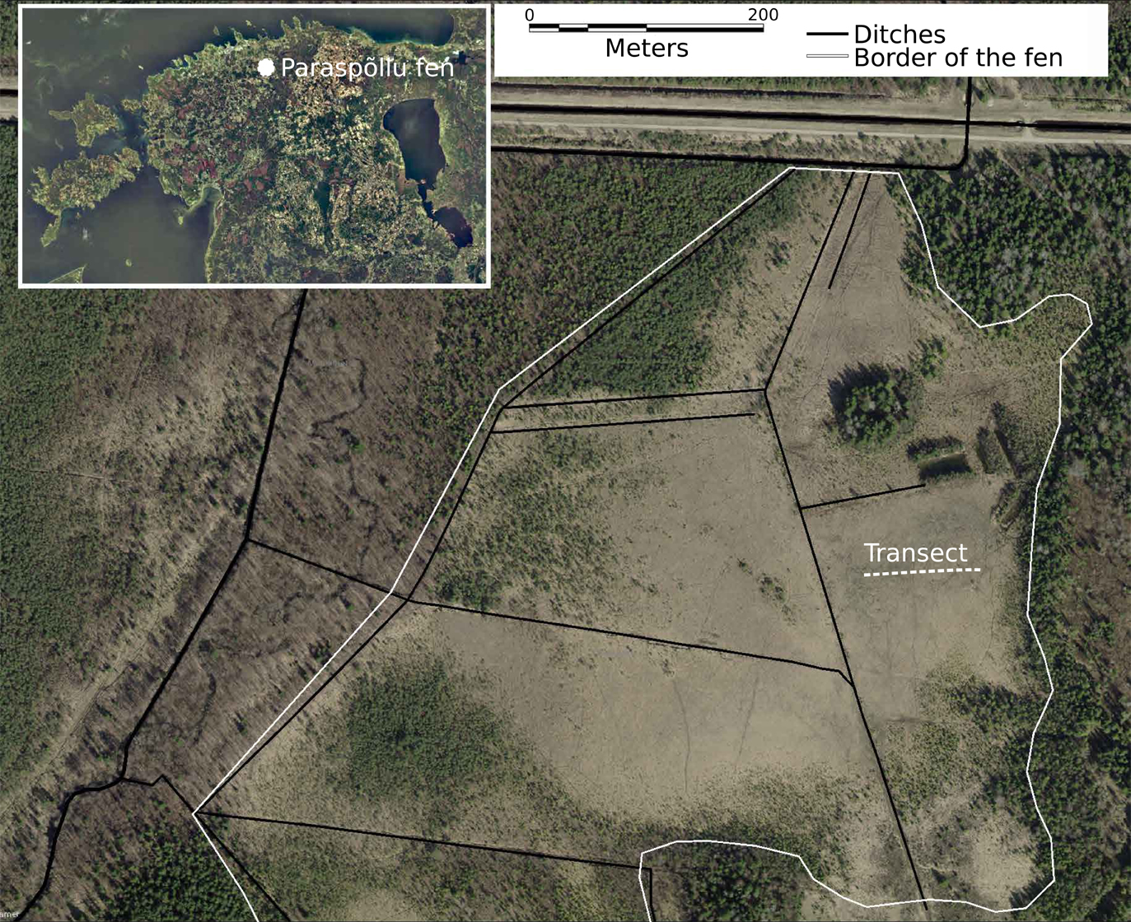

Fig. 2
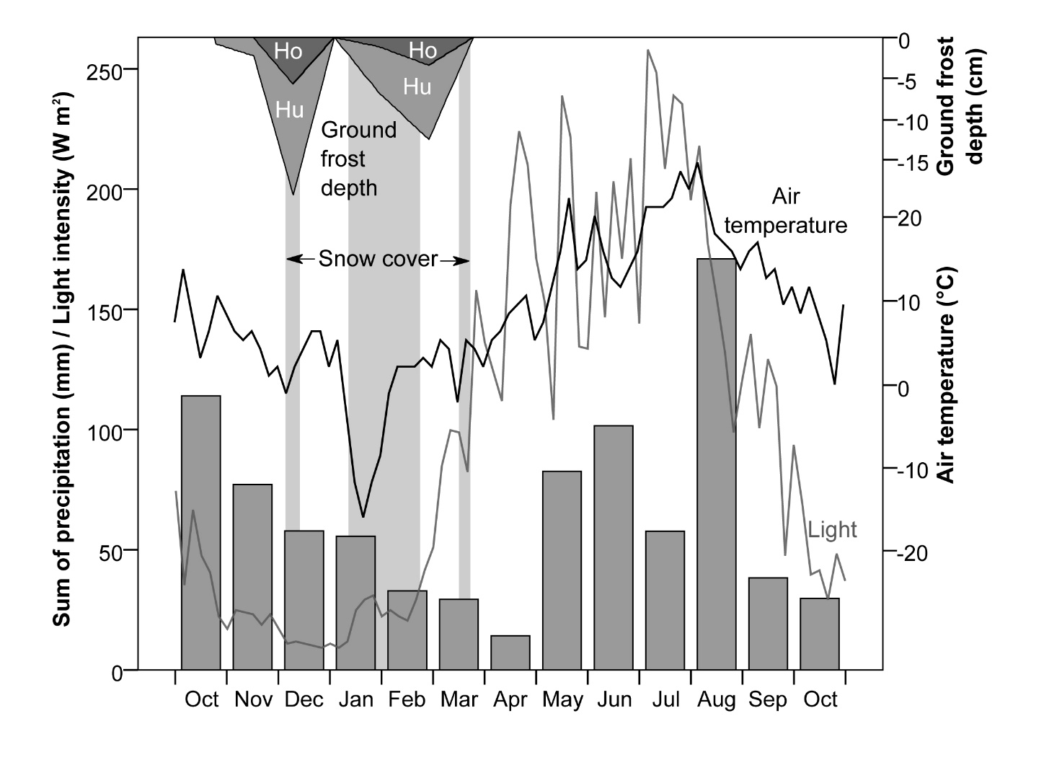

Fig. 3
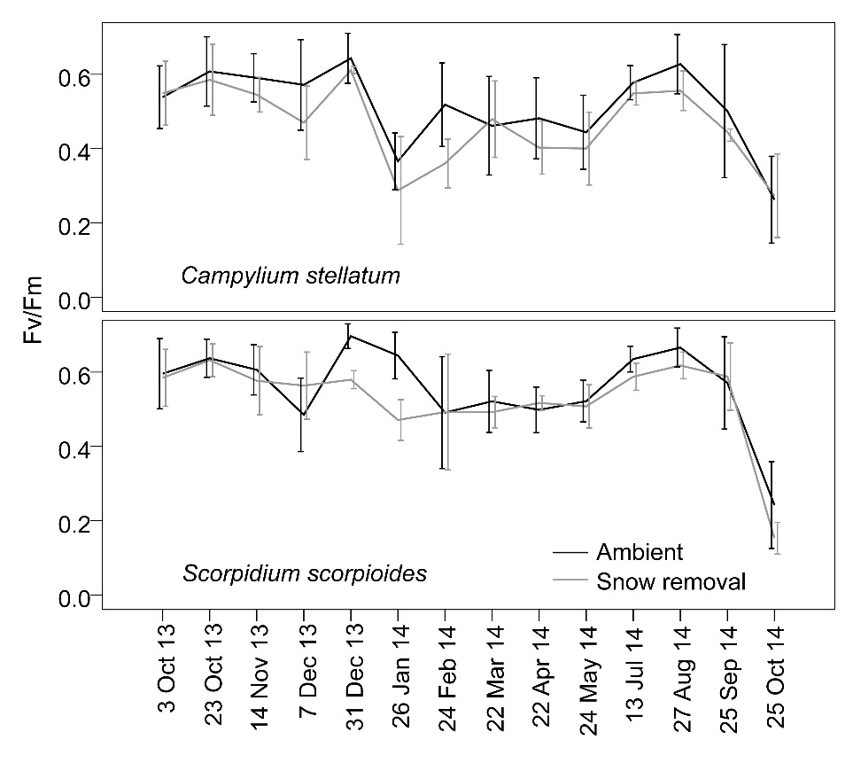

Fig. 4
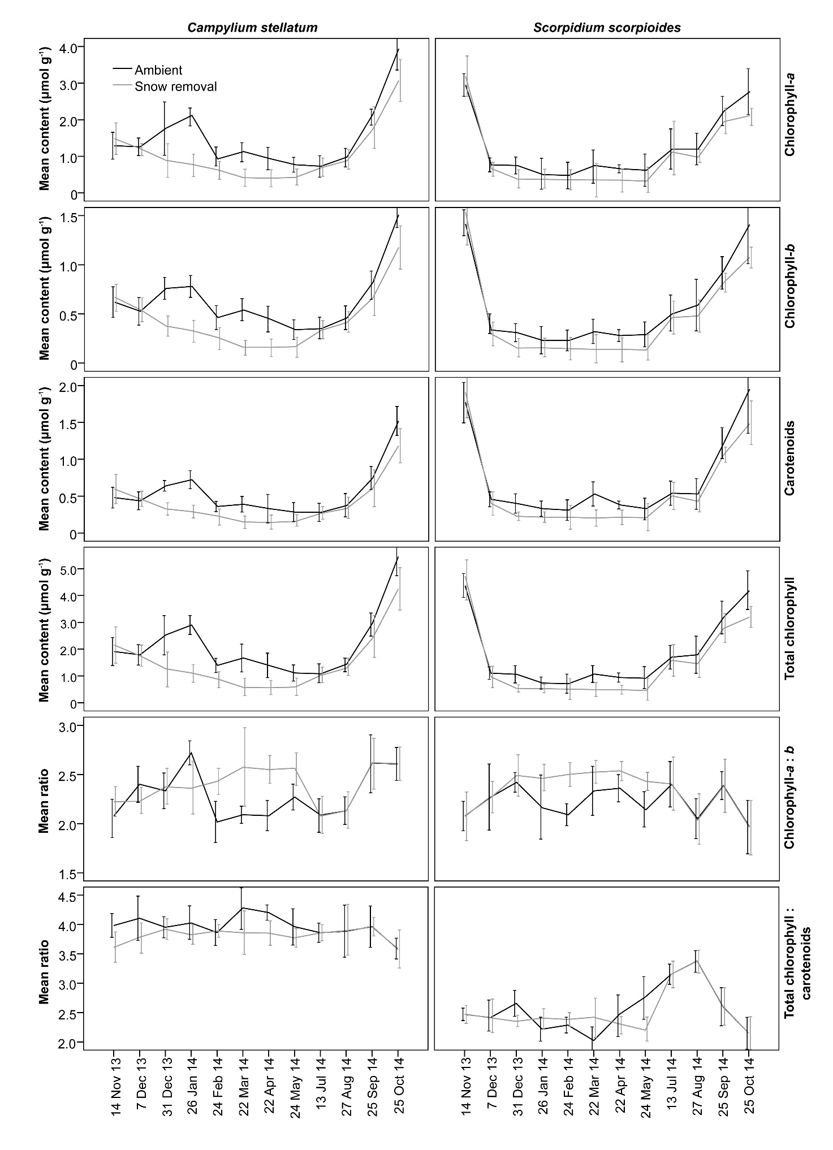
Fig. 5
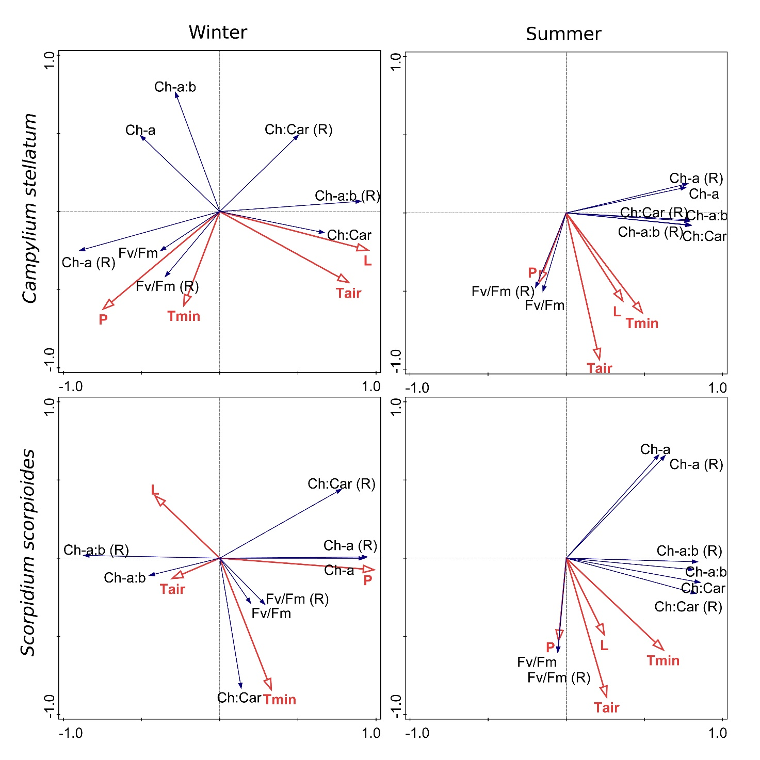

Graphical Abstract
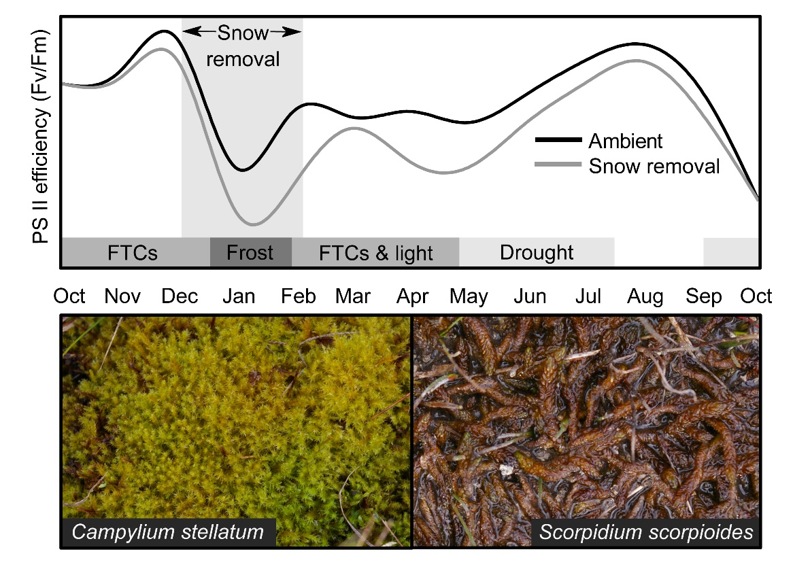

Appendixes

Appendix 1 A list of vascular plant and bryophyte species with mean coverages in Paraspõllu calcareous fen (Ilomets et al. 2010)
Nr. | Species | Cover (%) | Nr. | Species | Cover (%)
1. | Betula humilis Schrank | < 1 | 26. | Salix rosmarinifolia L. | < 1
2. | Betula pubescens Ehrh. | < 1 | 27. | Schoenus ferrugineus L. | 5
3. | Carex davalliana J. E. Sm. | < 1 | 28. | Selaginella selaginoides (L.) Beauv. ex Schrank & Mart* | < 1
4. | Carex flacca Schreb. | 1 | 29. | Sesleria caerulea (L.) Ard. | 1
5. | Carex flava L. | < 1 | 30. | Succisa pratensis Moench | < 1
6. | Carex lasiocarpa Ehrh. | 1 | 31. | Tofieldia calyculata (L.) Wahlenb. | < 1
7. | Carex panicea L. | 6 | 32. | Utricularia intermedia Hayne | < 1
8. | Carex rostrata Stokes | 1 | 33. | Aneura pinguis (L.) Dumort. | < 1
9. | Dactylorhiza incarnata (L.) Soó* | < 1 | 34. | Pellia endiviifolia (Dicks.) Dumort. | < 1
10. | Deschampsia cespitosa (L.) P. Beauv. | < 1 | 35. | Preissia quadrata (Scop.) Nees | < 1
11. | Epipactis palustris (L.) Crantz* | < 1 | 36. | Bryum sp. | < 1
12. | Equisetum palustre L. | < 1 | 37. | Bryum pseudotriquetrum (Hedw.) P. Gaertn. et al.. | < 1
13. | Frangula alnus Mill. | < 1 | 38. | Calliergonella cuspidata (Hedw.) Loeske | < 1
14. | Galium palustre L. | < 1 | 39. | Campylium elodes (Lindb.) Kindb. | < 1
15. | Gymnadenia conopsea (L.) R. Br.* | < 1 | 40. | Campylium stellatum (Hedw.) Lange & C. E. O. Jensen | 8
16. | Linum catharcticum L. | < 1 | 41. | Campylium stellatum (Hedw.) Lange & C. E. O. Jensen var. protensum (Brid.) Bryhn ex Grout | < 1
17. | Menyanthes trifoliata L. | 2 | 42. | Catoscopium nigritum (Hedw.) Brid.* | < 1
18. | Molinia caerulea (L.) Moench | 1 | 43. | Cinclidium stygium Sw. | < 1
19. | Parnassia palustris L. | < 1 | 44. | Ctenidium molluscum (Hedw.) Mitt. | < 1
20. | Peucedanum palustre (L.) Moench | < 1 | 45. | Fissidens adianthoides Hedw. | < 1
21. | Phragmites australis (Cav.) Trin. ex Steud. | < 1 | 46. | Meesia triquetra (L. ex Jolycl.) Ångstr. | 3
22. | Picea abies (L.) H. Karst. | < 1 | 47. | Plagiomnium elatum (Bruch & Schimp.) T. J. Kop. | < 1
23. | Pinguicula vulgaris L. | < 1 | 48. | Plagiomnium ellipticum (Brid.) T. J. Kop. | < 1
24. | Potentilla erecta (L.) Räusch. | < 1 | 49. | Scorpidium cossonii (Schimp.) Loeske | 19
25. | Primula farinosa L. | < 1 | 50. | Scorpidium scorpioides (Hedw.) Limpr. | 5

Appendix 2 Pearson correlations between the pigment concentrations and ratios in Campylium stellatum (bottom left of the table, n = 116) and Scorpidium scorpioides (top right of the table, n = 115); p < 0.001; in the parentheses p ≥ 0.05
 |  | Ch-a | Ch-b | Car | Ch | Ch-a:b | Ch:Car
Campylium stellatum | Chlorophyll-a |  | 0.93 | 0.97 | 0.99 | -0.41 | (-0.11) | Scorpidium scorpioides
 | Chlorophyll-b | 0.95 |  | 0.96 | 0.97 | -0.50 | (-0.13)
 | Carotenoids | 0.97 | 0.95 |  | 0.92 | -0.46 | -0.28
 | Total chlorophyll | 0.99 | 0.98 | 0.98 |  | -0.44 | (-0.11)
 | Chlorophyll-a : b | 0.79 | 0.73 | 0.76 | 0.79 |  | (0.06)
 | Total chlorophyll : carotenoids | -0.59 | -0.58 | -0.63 | -0.59 | -0.39

