Novel nanostructured iron oxide cryogels for arsenic (As(III)) removal

Lila Otero-Gonzálezª, Sergey V. Mikhalovsky^{b,c}, Miroslava Václavíková^{d}, Mikhail V. Trenikhin^{e}, Andrew B. Cundy^{a,1} and Irina N. Savina^{f,*}

ªSchool of Environment & Technology, University of Brighton, Brighton BN2 4GJ, UK
^{b}ANAMAD Ltd, Sussex Innovation Centre Science Park Square, Falmer, Brighton BN1 9SB, UK
^{c} Chuiko Institute of Surface Chemistry, 17, General Naumov street, Kyiv, 03164, Ukraine
^{d}Institute of Geotechnics, Slovak Academy of Sciences, 040 01 Košice, Slovakia
^{e}Center of New Chemical Technologies of the Federal Research Center Boreskov Institute of Catalysis of Siberian Branch of the Russian Academy of Sciences, Omsk 644040, Russia
^{f}School of Pharmacy & Biomolecular Sciences, University of Brighton, Brighton BN2 4GJ, UK

*Corresponding author: Tel. +44 1273 642034; Fax. +44 1273 642674
E-mail: i.n.savina@brighton.ac.uk

Present address:
¹Ocean and Earth Science, National Oceanography Centre Southampton, University of Southampton, Southampton SO14 3ZH, UK
ABSTRACT
Novel macroporous iron oxide nanocomposite cryogels were synthesized and assessed as arsenite (As(III)) adsorbents. The two-step synthesis method, by which a porous nanonetwork of iron oxide is firstly formed, allowed a homogeneous dispersion of the iron oxide in the cryogel reaction mixture, regardless of the nature of the co-polymer forming the cryogel structure. The cryogels showed excellent mechanical properties, especially the acrylamide-based cryogel. This gel showed the highest As(III) adsorption capacity, with the maximum value estimated at 118 mg/g using the Langmuir model. The immobilization of the nanostructured iron oxide gel into the cryogel matrix resulted in slower adsorption kinetics, however the cryogels offer the advantage of a stable three-dimensional structure that impedes the release of the iron oxide nanoparticles into the treated effluent. A preliminary toxicity evaluation of the cryogels did not indicate any apparent inhibition of human hepatic cells activity, which together with their mechanical stability and high adsorption capacity for As(III) make them excellent materials for the development of nanoparticle based adsorption devices for drinking water treatment.
Keywords: Iron oxide nanoparticles; Adsorbent; Arsenic; Water remediation; Polymer cryogel

1. Introduction

Arsenic is a highly toxic metalloid ubiquitously present in the environment. Arsenic can cause severe health effects including skin problems, nerve damage and increased cancer risk, especially for lung, bladder, kidney and liver cancers [1]. Arsenic pollution in groundwater—originating from both anthropogenic and natural causes—is a concern in many regions of the world, including Bangladesh, India, Mexico and the United States (US), among others [2, 3]. The groundwater in these regions can contain arsenic concentrations as high as several mg/L [3], while both the guideline value proposed by the World Health Organization and the safe drinking water level set by the US Environmental Protection Agency is as low as 10 µg/L [4, 5]. As a result, the population in these regions are continuously exposed to levels of arsenic that can lead to chronic health conditions.
The removal of arsenic, and particularly arsenite (As(III)) from water, to concentrations below the maximum allowed level remains a challenge. There are a number of different approaches for arsenic remediation including adsorption, membrane filtration, coagulation-flocculation and ion exchange [6, 7]. Among these, adsorption has been reported as the most widely used technique for arsenic removal because of several advantages such as high arsenic removal efficiency, easy operation, and cost-effectiveness [3, 6, 8].
Advances in nanotechnology have allowed the development of a range of engineered nanomaterials (ENMs) for the remediation of contaminated water [9]. The increased specific surface area of ENMs significantly improves their adsorption capacity compared with bulk materials [10-12]. Specifically, Fe-based nanoparticles (NPs) are an effective adsorbent of a wide range of organic compounds, metals and metalloids including arsenic [3, 8, 13-17]. However, the use of free, or unbound, NPs in water treatment creates an extra technological challenge because of the need for subsequent NP separation from the treated effluent. Moreover, potential risks of NPs to human health and the environment raise concerns regarding their application in water treatment [18]. Nanocomposites may overcome these limitations as they retain the advantages of free NPs while facilitating their application (and recovery) in water treatment [19, 20].
Different nanocomposites have been developed based on the immobilization of Fe-containing NPs on various matrices [21]. Among these, polymeric nanocomposites offer advantageous properties such as large porosity, mechanical strength and diverse geometries [22-25]. In particular, iron oxide (IO) NPs incorporated in polymeric beads are commercially available for use in packed bed configurations [26-29]. Cryogelation is a versatile technique that allows the preparation of mechanically robust polymer gels in various shapes (e.g., monoliths, discs or beads). More importantly, cryogelation creates a network of highly interconnected large macropores, up to 200 µm in diameter, in the polymer gels, resulting in materials with high permeability and low flow-through resistance.
Dispersing NPs homogeneously in the support matrix without a loss of reactivity remains a challenge for polymeric and other nanocomposite systems [30]. Previously, Fe₂O₃ and Fe₃O₄ NP were successfully dispersed as agglomerates, at relatively low IO loadings of 0.059–0.095 g/g hydrated gel, in a poly(hydroxyethyl- methacrylate) cryogel, in which the presence of poly(ethylene glycol) diacrylate possibly improved the NP dispersion [31]. However, a direct synthesis route proved unsuitable for other types of cryogels (e.g., acrylamide cryogels) [30]. Innovative synthetic methods are therefore needed to improve the loading, dispersion and reactivity of NPs embedded into polymer nanocomposites [30].
The objective of this study was the synthesis of an Fe-based nanocomposite using a two-step method: synthesis of an IO-nanostructured gel followed by its dispersion in a cryogel matrix. This method was developed to achieve a homogeneous dispersion of IO gel particles in the material. The resulting cryogels were assessed for their potential application in water treatment, particularly for the removal of an important groundwater pollutant, As(III).

2. Materials and Methods

2.1. Chemicals

N,N’-methylenebisacrylamide (MBAA, 96%), 2-hydroxyethyl methacrylate (HEMA, 97%), N,N,N’,N’-tetramethylethylenediamine (TEMED, 99%), iron(III) chloride hexahydrate (FeCl₃·6H₂O, >99%), and As(III) trioxide (As₄O₆) were obtained from Acros Organics (New Jersey, NJ, USA). Acrylamide (AAm, 97%), poly(ethylene glycol) diacrylate (PEGDA, Mn ~ 250), and ammonium persulfate (APS, >98%) were sourced from Sigma-Aldrich (St. Louis, MO, USA). Propylene oxide (>99%) was from Fisher Chemical (Waltham, MA, USA).

2.2. Synthesis of iron oxide gel

FeCl₃·6H₂O (4.35 g) was dissolved in ethanol (50 mL). Polypropylene oxide (16.65 g) was added and the gel was left to age for 24 h at room temperature. Then, the gel was stirred with a spatula and strained through a 500-µm net. The IO gel particles were washed three times each with ethanol and deionized (DI) water by repeating cycles of mixing and centrifugation (4,400 rpm for 10 min). Finally, excess water was removed by centrifugation and the gel particles were used in subsequent experiments. The dry weight content of the IO gel varied from 2.5 to 8.5% for different batches.

2.3. Synthesis of macroporous monolithic cryogels

Monolithic macroporous hybrid cryogels were prepared by co-polymerization of the main monomer (AAm or HEMA) with a crosslinker (MBAA or PEGDA) under cryogenic conditions. Two types of cryogels were prepared: AAm with MBAA and HEMA with PEGDA. The monomers were dissolved in DI water with the monomer ratio given in Table 1. Different amounts of hydrated IO gel were mixed with the monomer solution and the mixture was degassed in an ultrasonic bath for 10 min. Then, TEMED and APS (1.2 wt.% of monomers) were added. Aliquots (1–2 mL) of the reaction solution were quickly added into separate glass tubes (80 × 11 mm ID) closed at the bottom with a silicone cap. The solution in the tubes was frozen in a thermostatic ethanol bath (Julabo F34-ED, Seelbach, Germany) at -12 °C for ca. 18 h and then thawed at room temperature. The caps were removed and the cryogels were washed by passing an excess of DI water through each sample.

2.4. Transmission and scanning electron microscopy

For transmission electron microscopy (TEM) imaging of IO gel, a freeze-dried sample was ground to fine powder in an agate mortar and dispersed in ethanol. The dispersion was sprayed over a copper TEM grid with a lacey carbon film. Electron diffraction of the selected area (SAED) was carried out using a TEM instrument (JEM-2100, JEOL Ltd, Tokyo, Japan) operating at 200 kV using a LaB₆ filament (the point-to-point resolution of the microscope was 0.2 nm). The energy dispersive spectroscopy (EDS) analysis was done with an X-ray spectrometer INCA (Oxford Instruments, Abingdon, UK). The electron diffraction patterns and Fourier electron diffraction patterns were obtained and processed using the Digital Micrograph software (Gatan Inc., Pleasanton, CA, USA). The calibration was carried out using the crystal lattice of gold NPs. In addition, the X-ray powder diffraction (XRD) pattern of the IO gel sample was carried out on a Bruker D8 Advance X-ray diffractometer with monochromatized Cu Kα radiation, voltage and incandescent current of 40kV and 40mA, respectively, and scan step of 0.02º (2θ) (Figure S1.

Alternatively, IO cryogels were dehydrated by washing with ethanol solutions of increasing concentration (10, 20, 30, 50 and 75%) for 20 min each and dried in absolute ethanol. Then, ethanol was replaced with propylene oxide, which was further replaced with a low viscosity resin (TAAB Laboratories Equipment Ltd, Reading, UK). After complete replacement, the resin was polymerized at 60 °C. Thin sections (100 nm) were cut using an ultramicrotome (Leica Microsystems, Wetzlar, Germany), collected on nickel support grids and examined by TEM (Hitachi-7100, Hitachi, Tokyo, Japan) at 100 kV. Images were acquired digitally with an axially mounted (2K × 2K pixel) camera (Gatan Ultrascan 1000 CCD, Gatan Inc.).

Samples for scanning electron microscopy (SEM) were freeze-dried overnight. Specimens were mounted on aluminum stubs fitted with adhesive carbon pads, sputter coated with platinum and examined using a Zeiss NTS EVO or Zeiss NTS Sigma FEG scanning electron microscope (Zeiss, Oberkochen, Germany).

2.5. Specific surface area

Samples were freeze-dried overnight and nitrogen adsorption-desorption isotherms were measured using an Autosorb-1 gas sorption system (Quantachrome Instruments, Boynton Beach, FL, USA) at 77.4 K. The data were analyzed using the Quantachrome ASiQwin software. The specific surface area and pore volume were calculated using the Brunauer-Emmett-Teller (BET) equation (Figure S2).

2.6. Permeability measurements

The flow rate of DI water passing through the column was measured at a constant hydrostatic pressure equal to a 100-cm head of water-column, which corresponds to a pressure of ca. 0.01 MPa on the cryogel composite [32].

2.7. Mechanical properties

The mechanical properties of the cryogels were tested using a TA.XTPlus Texture Analyzer (Stable Micro Systems, Godalming, UK). The gels (9-mm diameter cylinders) were placed between two compression plates and compressed with a steadily increasing compression pressure of 5 N/min to the maximum loading of 18 N. All samples were tested at room temperature. The compression modulus at 0.1 strain was calculated using the TA.XTPlus software.

2.8. As(III) solution preparation

A stock solution of As(III) was prepared by dissolving As₄O₆ (2.5 g) in a sodium hydroxide solution (2 g in 20 mL of DI water), which was then diluted with DI water to 200 mL. The pH was adjusted to 6.5 and 2 g of sodium bicarbonate were added. The final volume was made up to 500 mL. The stock solution was used throughout all experiments for preparation of As(III) solutions of varying dilutions.

2.9. As(III) adsorption isotherms

As(III) adsorption capacity of the IO gel and cryogels was evaluated in batch assays, which were carried out in polypropylene tubes containing either 500 ± 20 mg of IO gel or 150 ± 20 mg of 2-mm square pieces of cryogels, and 40 or 20 mL of As(III) solution (pH = 7.5 ± 0.3), respectively. The tubes were shaken horizontally in an orbital shaker (150 rpm) at room temperature (24 ± 1 °C) for at least 48 h to ensure that equilibrium was reached. Then, the tubes were centrifuged (4,400 rpm for 10 min) and liquid samples were withdrawn and filtered through a 0.2-µm membrane before As analysis. Assays were performed in duplicate. Control experiments with cryogels prepared without the addition of IO were performed to evaluate the background As(III) adsorption on the polymers.
The amount of As adsorbed was calculated from the difference between the initial and equilibrium aqueous As concentration per 1 gram of adsorbent. The experimental data were fitted to the Freundlich and Langmuir isotherm models.

2.10. As(III) adsorption kinetics

The kinetics of As(III) adsorption were evaluated in batch assays carried out in glass flasks containing either 0.50 ± 0.01 g of IO gel or 1.40 ± 0.01 g of 2-mm square pieces of IO/AAm/MBAA cryogel, and 200 mL of As(III) solution (ca. 9.5 mg/L, pH = 7.5 ± 0.3). The flasks were shaken in an orbital shaker (150 rpm) at room temperature (24 ± 1 °C). Liquid samples were periodically withdrawn, filtered through a 0.2-µm membrane and analyzed for As concentration. Assays were performed in duplicate. The experimental data for As(III) adsorption kinetics on the IO/AAm/MBAA cryogel were analyzed using several models of adsorption (i.e., pseudo-first order, pseudo-second order, intraparticle diffusion, and liquid film diffusion) to obtain more information on the adsorption mechanism [33].

2.11. Toxicity analysis

The toxicity of the gel and cryogels was assessed on human liver hepatocellular carcinoma cells (HepG2). IO gel and cryogel leachates were prepared by incubation of 200 mg of gel or cryogel in 6 mL of minimum essential medium (MEM) supplemented with 10% (v/v) fetal bovine serum (FBS) for 24 h at room temperature (24 ± 1 °C) and shaking at 150 rpm. The leachates were filtered through a 0.2-µm membrane before dosing to the cells.
HepG2 cells were routinely cultured in MEM with 10% (v/v) FBS at 37 °C in a 5% CO₂ humidified atmosphere. Subsequently, the cells were transferred to 24-well plates at a cell density of ca. 100,000 cells/cm² (ca. 200,000 cells per well) and incubated (37 °C, 5% CO₂) for 24 h. The spent medium was removed and the cells were dosed with 1 mL of leachate. After 24 h of incubation, the cell viability and membrane damage were assessed with the 3-(4,5-dimethylthiazol-2-yl)-2,5-diphenyltetrazolium bromide (MTT) and lactate dehydrogenase (LDH) assays, respectively. The MTT assay was performed as described elsewhere [34] and the LDH test as recommended by the kit manufacturer (CytoTox 96® Non-Radioactive Cytotoxicity Assay, Promega, Madison, WI, USA).

2.12. Analytical methods

As and Fe were analyzed by inductively coupled plasma-optical emission spectroscopy (ICP-OES Optima 2100 DV, Perkin Elmer, Waltham, MA, USA) at wavelengths of 188.979 and 238.204 nm and with detection limits of 1–10 and <0.1 µg/L, respectively. The Fe content in the gel and cryogels was determined after acid digestion with 6 M HCl.

3. Results and Discussion
3.1. Nanostructured iron oxide gel

Nanostructured IO hydrogels were prepared by a sol–gel process using a Fe(III) salt as a precursor and propylene oxide as a gelation promoter. The propylene oxide acts as an acid scavenger extracting protons from the hydrated Fe(III) species (Scheme 1). Contrary to strong bases, propylene oxide increases the pH of the Fe(III) solution slowly and uniformly. The slow reaction leads to the precipitation of uniform small IO particles forming a porous monolithic IO gel structure [35, 36].
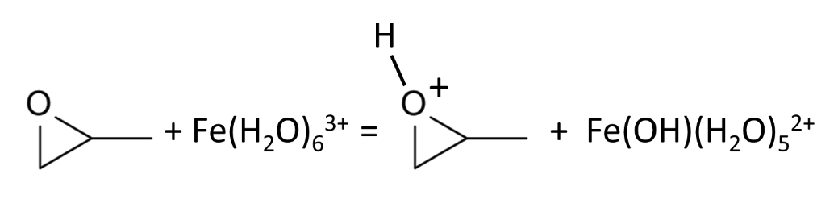 (1)

SEM images showed that the IO gel contained nanometer sized particles that formed agglomerates with a size in the range of a few micrometers (Figure 1). TEM imaging revealed that the IO gel particles measured approximately 5 nm (Figure 2A and B). The particles had some degree of crystallinity, with the lattices in a d-spacing of ∼2.53 Å (Figure 2C), which fits well to that of the (311) lattice plane of maghemite (γ-Fe₂O₃). The SAED analysis detected three well-resolved diffraction rings (Figure 2D) indexed as the (220), (311) and (400) planes and corresponding to the distances of 2.95, 2.52 and 2.09 Å, respectively, in the crystal lattice of γ-Fe₂O₃. XRD analysis confirmed the presence of maghemite (Figure S1). X-ray elemental mapping showed homogeneous distribution of Fe and O in the IO gel (Figure 3).
The analysis of the IO gel surface showed a high specific surface area (S_{BET}) of 250 m²/g and a total pore volume of 0.29 cm³/g, of which 6.45 × 10⁻² cm³/g were nanopores (Figure S2). The high S_{BET} value results from the sol–gel synthesis technique. The slow polymerization leads to formation of a nanostructured gel, with a similar surface area to that of free IO NPs [37].

3.2. Macroporous monolithic composites with iron oxide gel

The mechanical weakness of the IO gel hampers its direct application in water treatment. The gel remains fragile after drying and lacks any defined permeable structure, which makes it unsuitable for the design of water filtration devices. Thus, the IO gel was embedded in a 3D scaffold using the cryogelation technique and forming a composite monolithic polymer with high permeability and robust mechanical properties. Cryogelation, defined as the formation of gels in a semi-frozen reaction solution, allows the production of macroporous monolithic polymers with an interconnected porous structure [38]. During cryogelation, the ice crystals formed at -12 °C expel the polymerization reagents and the IO gel particles dispersed in the monomer mixture to the remaining non-frozen liquid. The polymerization continues in these non-frozen regions, where reagents are highly concentrated. After thawing, the voids left by the ice crystals form an interconnected pore system, resulting in a highly porous polymer monolith. Because of the relative slow freezing rate of the solution, large ice crystals form, leaving pores with a size range of 1–100 µm [39]. The large interconnected pores provide high permeability and allow effective flow-through of aqueous solutions through the cryogel monolith, which could be used as a filter for water purification.
SEM imaging showed the macroporous structure of IO/HEMA/PEGDA and IO/AAm/MBAA cryogel monoliths (Figure 4), with pore sizes of 20–100 µm and thin polymer walls where the IO gel particles are embedded. The incorporation of IO in the form of a nanostructured gel resulted in an even distribution of IO particles inside the polymer walls, as shown in TEM images (Figure 5), and prevented agglomeration of the IO NPs that was previously observed during IO cryogel composites preparation [31]. The increase in the IO gel content resulted in a higher density of uniformly distributed IO particles in the matrix (Figure 5C).
The IO composite cryogels had good mechanical properties, maintained their shape and had low water flow resistance. The mechanical properties, assessed based on the compression of the monoliths, depend on the monomer composition and the IO gel content (Table 2). In general, the AAm/MBAA cryogels were less compressible, as their Young's moduli were up to 10-times higher than those of the HEMA/PEGDA cryogels. The addition of IO gel resulted in a decrease in the Young's modulus value of both types of cryogels. The Young's moduli of IO/AAm/MBAA cryogels were between 41 and 82 kPa, while the blank counterpart ranged between 67 and 156 kPa. Significantly, the IO/AAm/MBAA composites were stronger than the blank HEMA/PEGDA cryogels. This indicates that AAm/MBAA cryogels will perform mechanically better under pressure in a flow-through column system.
Macropores create a system of interconnected channels that provide low resistance to the flow-through of liquid. The water flow through a column of IO/AAm/MBAA cryogel was linear to the pump setting and no significant head loss was observed up to a flow rate of 15 mL/min (Figure 6). Then, the flow rate decreased rapidly, although the column was not visibly compressed. The decrease in the flow rate is probably the result of the intrinsic compression and closure of the smallest channels in the cryogel.

3.3. As(III) adsorption
The total As(III) adsorption capacity of the IO gel and cryogels was assessed at different monomer and IO gel concentrations (Table 3). The embedding of the IO gel inside the cryogel matrix resulted in a 50% decrease of the original adsorption capacity of the IO gel. The adsorption capacity of the IO/HEMA/PEGDA cryogels with maximal IO load was 1.5-1.78 mg/g while for the IO gel it was 3.0 mg/g. The As(III) adsorption increased with the concentration of IO gel in the cryogels. At a similar IO gel concentration (ca. 70%), IO/HEMA/PEGDA and IO/AAm/MBAA showed a similar As(III) adsorption capacity (1.30 ± 0.05 and 1.18 ± 0.10 mg/g of swollen cryogel, respectively). Higher concentrations of IO gel could be reached in the HEMA/PEGDA cryogel, but the poor mechanical properties of the IO/HEMA/PEGDA cryogels at these high IO gel concentrations (Table 2) make them unsuitable for practical application. Overall, the proposed method for the preparation of the IO cryogel composites produces materials with much higher As(III) adsorption capacity compared to previously published results [31]. The α-Fe₂O₃/HEMA/PEDGA and Fe₃O₄/HEMA/PEDGA cryogels prepared by embedding α-Fe₂O₃ and Fe₃O₄ NPs (20 nm) inside a HEMA/PEDGA cryogel containing 0.08% dry weight IO [31] showed a maximum As(III) adsorption capacity of 0.2 mg/g of swollen cryogel (Table 3). Thus, this new method allows the synthesis of nanocomposite cryogels with significantly higher IO NP loading and improved mechanical characteristics for As(III) adsorption.

3.4. Maximum As(III) adsorption capacity

Figure 7 shows the equilibrium isotherms of As(III) adsorption on the IO gel and cryogels. The free IO gel displayed the highest As(III) adsorption capacity per dry weight (Figure 7A). For example, the amount of As(III) adsorbed on the IO gel was between 2- and 3-fold larger than that on the IO/AAm/MBAA cryogel and between 5- and 8-fold larger than that on the IO/HEMA/PEGDA cryogel (Figure 7A). The IO gel had a larger Fe content per dry weight (58–63%) compared with the IO/AAm/MBAA (19%) and IO/HEMA/PEGDA (10%) cryogels, which explains the higher As(III) adsorption on the free IO gel.
Based on the low As(III) adsorption observed in control cryogels without IO (Table 3), most of the As(III) adsorption is assumed to occur on IO sites, so the As(III) capacity was normalized by the Fe content of each material to compare the IO performance. When normalized per Fe mass, the As(III) adsorption capacity of the three materials was similar (Figure 7B). For example, the amount of As(III) adsorbed on the IO gel was in the range of 1.0- to 1.5-times the amount of As(III) adsorbed on the IO/AAm/MBAA cryogel. In the case of the IO/HEMA/PEGDA cryogel, the As(III) adsorption was comparable to that of the IO gel and IO/AAm/MBAA cryogel at equilibrium As(III) concentrations below 100 mg/L. However, due to the lower Fe content, the IO/HEMA/PEGDA cryogel reached saturation at As(III) concentrations lower than the other two materials (Figure 7B). The similar As(III) adsorption capacity per Fe mass is indicative of the near full availability of the embedded IO as adsorption sites in the cryogels.
The adsorption isotherms have the shape of Type I adsorption isotherms. The experimental data were fitted to the Langmuir and Freundlich adsorption models. In general, the data fitted better to the Langmuir model indicating the formation of a homogeneous monolayer (Table 4). Additionally, the estimated maximum adsorption values (q_{max}) confirmed the similar As(III) capacity per Fe mass of the IO gel and IO/AAm/MBAA cryogel. Specifically, the q_{max} values obtained were 625 and 588 mg As(III) per g of Fe for the IO gel and the IO/AAm/MBAA cryogel, respectively (Table 4).
IO-based materials typically show remarkable As adsorption capacities, although the reported values vary by several orders of magnitude among materials (Table 5). For example, previous studies reported As(III) adsorption capacities of Fe₃O₄ NPs as low as 8.2 mg/g and as high as 175 mg/g [40, 41]. The variability depends most likely on iron species, size, geometry, and carrier material, among other factors [8, 15]. Carbon materials such as activated carbon and graphene oxide have been widely used as carriers for IO nanomaterials, possibly because activated carbon is a material with high surface area well established as a water treatment technology [42-44]. Other researchers opted for natural materials such as sand and diatomite as IO carriers [45, 46]. Polymers such as chitosan, alginate, poly(vinyl alcohol) and cellulose have also been used, with As adsorption capacities ranging from 7.24 to 66.7 mg/g of material [47-50]. Typically, the immobilization of the IO into the composite material decreases the As adsorption capacity per IO mass, resulting in a tradeoff between high capacity and structural properties [31, 49].

3.5. Kinetics of As(III) adsorption

The kinetics of As(III) adsorption were evaluated on the IO gel and IO/AAm/MBAA cryogel, which was the cryogel with the highest adsorption capacity and best mechanical properties. As(III) adsorption was very fast on the IO gel and about 90% As(III) removal was achieved after only 15 min (Figure 8). On the other hand, adsorption kinetics were slower on the IO/AAm/MBAA cryogel. For instance, 55% As(III) removal was attained after 15 min. After 24 h, the As(III) removal was comparable between the two adsorbents (ca. 96.5%, data not shown).
Slower adsorption kinetics are typically reported for cryogel-embedded particles [51-54]. For example, the equilibrium of cadmium adsorption was reached four times more slowly on titanate nanotubes embedded in a polyacrylamide cryogel compared with free nanotubes [52]. Similarly, lead adsorption onto cryogel-embedded TiO₂ NPs was ca. 4-fold slower than using free NPs before it reached equilibrium [54]. The slower adsorption kinetics on cryogel nanocomposites are attributed to restricted accessibility of the adsorption sites, which are dispersed in the polymeric matrix [31].
The analysis of the kinetic data of As(III) adsorption on the IO/AAm/MBAA cryogel shows that the pseudo-second order model fits the experimental data better than any other model (Table 6). Previously, it was shown before that the pseudo-second order equation for adsorption kinetics is more similar to the rate law for a chemical reaction, thus the fitting of our experimental data to this model could indicate that the adsorption occurs mainly via a simple chemical reaction between As(III) and functional groups on the IO surface. The data were also analyzed using intraparticle diffusion and liquid film diffusion models to establish the rate determining step for As(III) adsorption (Table 6). The intercept values were 6.34 mg/g with R² = 0.913 and 0.901 mg/g with R² = 0.953 for intraparticle diffusion and liquid film diffusion models, respectively, suggesting that the adsorption process might follow intraparticle diffusion as well as film diffusion, with the latter playing a more significant role.
The adsorption of As(III) by IO gel was confirmed by an FT-IR study of the IO gel before and after adsorption of As(III) (Figure S3). The wave number assigned to the hydroxyl group at 3348 cm⁻¹ for the IO gel shifted to 3226 cm⁻¹ after the adsorption of As(III) by the IO gel, as result of interaction with As(III). A new band appeared around 775 cm⁻¹, contributed by the As-O vibration. Other studies have shown that the adsorption of As(III) by IO proceeds through formation of inner-sphere complexes between arsenite and iron oxides [33].

3.6. Toxicity analysis

Nanocomposites intended for water treatment should be safe for human health and the environment. Particularly, the release of toxic components during application is a potentially serious issue both in terms of leaching of toxic gel components (e.g., acrylamide) and of nanoparticles [55]. Thus, the environmental and health risks of the materials were assessed by generating a leachate and evaluating its toxicity to human hepatic cells (HepG2), one of the most widely used human cell models for toxicity studies. In general, none of the leachates exhibited cell toxicity (Figure 9). The viability of HepG2 cells treated with the leachates was similar or even higher than that of the untreated control (Figure 9A). Moreover, none of the treatments suggests a negative effect of the leachates on the cell membrane (Figure 9B). Although an exhaustive risk assessment would be needed to ensure the safety of the cryogels, these preliminary results suggest a low risk of releasing toxic substances from the materials.

4. Conclusions
A novel two-step method enabled the synthesis of highly permeable macroporous nanocomposite cryogels with improved mechanical properties and adsorption capacity for As(III). The IO gel prepared by a sol-gel process has a well-developed nanostructure that was preserved during its embedding inside the 3D porous matrix of AAm/MBAA and HEMA/PEGDA cryogels, resulting in an even distribution of IO NPs in the cryogel matrix. The IO gel preserved its adsorption capacity after embedding inside the polymer. The analysis of adsorption data could be best described by a pseudo-second order kinetic model and the Langmuir adsorption isotherm. The maximum As(III) adsorption capacity (q_{max}) of the IO/AAm/MBAA and IO/HEMA/PEGDA cryogels was 588 and 345 mg/g Fe or 118 and 35.7 mg/g of dried composite, respectively, which is considerably higher than that of α-Fe₂O₃/HEMA/PEDGA and Fe₃O₄/HEMA/PEDGA cryogels reported before. The adsorption kinetics of the IO/AAm/MBAA cryogel were slower than those of the IO gel. Although fast adsorption kinetics are advantageous, the use of free IO gel in water treatment is impractical because of the complications that would arise from the separation of the gel from the treated effluent. Their mechanical stability, low toxicity and low flow-through resistance make the cryogels excellent candidates for the development of nanocomposite adsorption devices for drinking water treatment.

Acknowledgments

This work was funded by the European Union’s Seventh Framework Programme FP7-IAPP under grant agreement 612250 (project WasClean). Dr. Natalya N. Leont’eva, of the Center of New Chemical Technologies BIC (Omsk, Russia) is acknowledged for the XRD analysis.

REFERENCES
[1] M.F. Hughes, B.D. Beck, Y. Chen, A.S. Lewis, D.J. Thomas, Arsenic exposure and toxicology: A historical perspective, Toxicol. Sci., 123 (2011) 305-332.
[2] A. Sarkar, B. Paul, The global menace of arsenic and its conventional remediation - A critical review, Chemosphere, 158 (2016) 37-49.
[3] S.I. Siddiqui, M. Naushad, S.A. Chaudhry, Promising prospects of nanomaterials for arsenic water remediation: A comprehensive review, Process Saf. Environ. Prot., 126 (2019) 60-97.
[4] Environmental Protection Agency, Drinking water standard for arsenic, 2001.
[5] World Health Organization, Guidelines for drinking-water quality: fourth edition incorporating the first addendum, Geneva, 2017.
[6] N. Nicomel, K. Leus, K. Folens, P. Van Der Voort, G. Du Laing, Technologies for arsenic removal from water: Current status and future perspectives, Int. J. Env. Res. Public Health, 13 (2016) 62.
[7] D. Mohanty, Conventional as well as emerging arsenic removal technologies—a critical review, Water, Air, Soil Pollut., 228 (2017) 381.
[8] S.I. Siddiqui, S.A. Chaudhry, Iron oxide and its modified forms as an adsorbent for arsenic removal: A comprehensive recent advancement, Process Saf. Environ. Prot., 111 (2017) 592-626.
[9] P.J.J. Alvarez, C.K. Chan, M. Elimelech, N.J. Halas, D. Villagrán, Emerging opportunities for nanotechnology to enhance water security, Nat. Nanotechnol., 13 (2018) 634−641.
[10] M. Hua, S. Zhang, B. Pan, W. Zhang, L. Lv, Q. Zhang, Heavy metal removal from water/wastewater by nanosized metal oxides: A review, J. Hazard. Mater., 211–212 (2012) 317-331.
[11] M. Nagpal, R. Kakkar, Use of metal oxides for the adsorptive removal of toxic organic pollutants, Sep. Purif. Technol., 211 (2019) 522−539.
[12] Y. Wu, H. Pang, Y. Liu, X. Wang, S. Yu, D. Fu, J. Chen, X. Wang, Environmental remediation of heavy metal ions by novel-nanomaterials: A review, Environ. Pollut., 246 (2019) 608-620.
[13] P. Saharan, G.R. Chaudhary, S.K. Mehta, A. Umar, Removal of water contaminants by iron oxide nanomaterials, J. Nanosci. Nanotechnol., 14 (2014) 627−643.
[14] K.K. Kefeni, B.B. Mamba, T.A.M. Msagati, Application of spinel ferrite nanoparticles in water and wastewater treatment: A review, Sep. Purif. Technol., 188 (2017) 399-422.
[15] L. Hao, M. Liu, N. Wang, G. Li, A critical review on arsenic removal from water using iron-based adsorbents, RSC Adv., 8 (2018) 39545−39560.
[16] Y. Chen, W. Liang, Y. Li, Y. Wu, Y. Chen, W. Xiao, L. Zhao, J. Zhang, H. Li, Modification, application and reaction mechanisms of nano-sized iron sulfide particles for pollutant removal from soil and water: A review, Chem. Eng. J., 362 (2019) 144-159.
[17] G.N. Hlongwane, P.T. Sekoai, M. Meyyappan, K. Moothi, Simultaneous removal of pollutants from water using nanoparticles: A shift from single pollutant control to multiple pollutant control, Sci. Total Environ., 656 (2019) 808-833.
[18] M.S. Mauter, I. Zucker, F. Perreault, J.R. Werber, J.-H. Kim, M. Elimelech, The role of nanotechnology in tackling global water challenges, Nat. Sustain., 1 (2018) 166-175.
[19] B. Pan, B. Pan, W. Zhang, L. Lv, Q. Zhang, S. Zheng, Development of polymeric and polymer-based hybrid adsorbents for pollutants removal from waters, Chem. Eng. J., 151 (2009) 19-29.
[20] G. Lofrano, M. Carotenuto, G. Libralato, R.F. Domingos, A. Markus, L. Dini, R.K. Gautam, D. Baldantoni, M. Rossi, S.K. Sharma, M.C. Chattopadhyaya, M. Giugni, S. Meric, Polymer functionalized nanocomposites for metals removal from water and wastewater: An overview, Water Res., 92 (2016) 22−37.
[21] W. Wong, H.Y. Wong, A.B.M. Badruzzaman, H.H. Goh, M. Zaman, Recent advances in exploitation of nanomaterial for arsenic removal from water: A review, Nanotechnology, 28 (2017) 042001.
[22] M.J. DeMarco, A.K. SenGupta, J.E. Greenleaf, Arsenic removal using a polymeric/inorganic hybrid sorbent, Water Res., 37 (2003) 164−176.
[23] M. Hua, B. Yang, C. Shan, W. Zhang, S. He, L. Lv, B. Pan, Simultaneous removal of As(V) and Cr(VI) from water by macroporous anion exchanger supported nanoscale hydrous ferric oxide composite, Chemosphere, 171 (2017) 126-133.
[24] X. You, C. Valderrama, V. Soldatov, J.L. Cortina, Phosphate recovery from treated municipal wastewater using hybrid anion exchangers containing hydrated ferric oxide nanoparticles, J. Chem. Technol. Biotechnol., 93 (2018) 358−364.
[25] S. Tandorn, O.-a. Arqueropanyo, W. Naksata, P. Sooksamiti, I. Chaisri, Adsorption of arsenate from aqueous solution by ferric oxide-impregnated Dowex Marathon MSA anion exchange resin: application of non-linear isotherm modeling and thermodynamic studies, Environ. Earth Sci., 78 (2019) 136.
[26] P. Sylvester, P. Westerhoff, T. Möller, M. Badruzzaman, O. Boyd, A hybrid sorbent utilizing nanoparticles of hydrous iron oxide for arsenic removal from drinking water, Environ. Eng. Sci., 24 (2006) 104−112.
[27] T. Möller, P. Sylvester, Effect of silica and pH on arsenic uptake by resin/iron oxide hybrid media, Water Res., 42 (2008) 1760-1766.
[28] M.R. Boldaji, R. Nabizadeh, M.H. Dehghani, K. Nadafi, A.H. Mahvi, Evaluating the performance of iron nanoparticle resin in removing arsenate from water, J. Environ. Sci. Health A, 45 (2010) 946-950.
[29] Y. Jiang, M. Hua, B. Wu, H. Ma, B. Pan, Q. Zhang, Enhanced removal of arsenic from a highly laden industrial effluent using a combined coprecipitation/nano-adsorption process, Environ. Sci. Pollut. Res., 21 (2014) 6729−6735.
[30] I.N. Savina, G.C. Ingavle, A.B. Cundy, S.V. Mikhalovsky, A simple method for the production of large volume 3D macroporous hydrogels for advanced biotechnological, medical and environmental applications, Sci. Rep., 6 (2016) 21154.
[31] I.N. Savina, C.J. English, R.L.D. Whitby, Y. Zheng, A. Leistner, S.V. Mikhalovsky, A.B. Cundy, High efficiency removal of dissolved As(III) using iron nanoparticle-embedded macroporous polymer composites, J. Hazard. Mater., 192 (2011) 1002-1008.
[32] F.M. Plieva, I.N. Savina, S. Deraz, J. Andersson, I.Y. Galaev, B. Mattiasson, Characterization of supermacroporous monolithic polyacrylamide based matrices designed for chromatography of bioparticles, J. Chromatogr. B, 807 (2004) 129-137.
[33] S.I. Siddiqui, S.A. Chaudhry, Nanohybrid composite Fe₂O₃-ZrO₂/BC for inhibiting the growth of bacteria and adsorptive removal of arsenic and dyes from water, J. Clean. Prod., 223 (2019) 849-868.
[34] L. Otero-González, R. Sierra-Álvarez, S. Boitano, J.A. Field, Application and validation of an impedance-based real time cell analyzer to measure the toxicity of nanoparticles impacting human bronchial epithelial cells, Environ. Sci. Technol., 46 (2012) 10271-10278.
[35] A.E. Gash, T.M. Tillotson, J.H. Satcher, J.F. Poco, L.W. Hrubesh, R.L. Simpson, Use of epoxides in the sol−gel synthesis of porous iron(III) oxide monoliths from Fe(III) salts, Chem. Mater., 13 (2001) 999-1007.
[36] J.D. Walker, R. Tannenbaum, Characterization of the sol−gel formation of iron(III) oxide/hydroxide nanonetworks from weak base molecules, Chem. Mater., 18 (2006) 4793-4801.
[37] M. Auffan, J. Rose, O. Proux, D. Borschneck, A. Masion, P. Chaurand, J.-L. Hazemann, C. Chaneac, J.-P. Jolivet, M.R. Wiesner, A. Van Geen, J.-Y. Bottero, Enhanced adsorption of arsenic onto maghemites nanoparticles: As(III) as a probe of the surface structure and heterogeneity, Langmuir, 24 (2008) 3215-3222.
[38] V.M. Gun'ko, I.N. Savina, S.V. Mikhalovsky, Cryogels: Morphological, structural and adsorption characterisation, Adv. Colloid Interface Sci., 187–188 (2013) 1-46.
[39] I.N. Savina, V.M. Gun'ko, V.V. Turov, M. Dainiak, G.J. Phillips, I.Y. Galaev, S.V. Mikhalovsky, Porous structure and water state in cross-linked polymer and protein cryo-hydrogels, Soft Matter, 7 (2011) 4276-4283.
[40] S. Luther, N. Borgfeld, J. Kim, J.G. Parsons, Removal of arsenic from aqueous solution: A study of the effects of pH and interfering ions using iron oxide nanomaterials, Microchem. J., 101 (2012) 30-36.
[41] C.T. Yavuz, J.T. Mayo, W.W. Yu, A. Prakash, J.C. Falkner, S. Yean, L. Cong, H.J. Shipley, A. Kan, M. Tomson, D. Natelson, V.L. Colvin, Low-field magnetic separation of monodisperse Fe₃O₄ nanocrystals, Science, 314 (2006) 964-967.
[42] H. Su, Z. Ye, N. Hmidi, R. Subramanian, Carbon nanosphere–iron oxide nanocomposites as high-capacity adsorbents for arsenic removal, RSC Adv., 7 (2017) 36138-36148.
[43] H. Su, Z. Ye, N. Hmidi, High-performance iron oxide–graphene oxide nanocomposite adsorbents for arsenic removal, Colloids Surf. Physicochem. Eng. Aspects, 522 (2017) 161-172.
[44] Z. Wu, W. Li, P.A. Webley, D. Zhao, General and controllable synthesis of novel mesoporous magnetic iron oxide@carbon encapsulates for efficient arsenic removal, Adv. Mater., 24 (2012) 485-491.
[45] D. Afzali, M. Rouhani, F. Fathirad, T. Shamspur, A. Mostafavi, Nano-iron oxide coated on sand as a new sorbent for removal of arsenic from drinking water, Desalin. Water Treat., 57 (2016) 13030-13037.
[46] Y. Du, H. Fan, L. Wang, J. Wang, J. Wu, H. Dai, α-Fe₂O₃ nanowires deposited diatomite: highly efficient absorbents for the removal of arsenic, J. Mater. Chem. A, 1 (2013) 7729-7737.
[47] S. Hasan, A. Ghosh, K. Race, R. Schreiber, M. Prelas, Dispersion of FeOOH on chitosan matrix for simultaneous removal of As(III) and As(V) from drinking water, Sep. Sci. Technol., 49 (2014) 2863-2877.
[48] N. Mahanta, S. Valiyaveettil, Functionalized poly(vinyl alcohol) based nanofibers for the removal of arsenic from water, RSC Adv., 3 (2013) 2776-2783.
[49] A. Sigdel, J. Park, H. Kwak, P.-K. Park, Arsenic removal from aqueous solutions by adsorption onto hydrous iron oxide-impregnated alginate beads, J. Ind. Eng. Chem., 35 (2016) 277-286.
[50] X. Yu, S. Tong, M. Ge, J. Zuo, C. Cao, W. Song, One-step synthesis of magnetic composites of cellulose@iron oxide nanoparticles for arsenic removal, J. Mater. Chem. A, 1 (2013) 959-965.
[51] L. Önnby, V. Pakade, B. Mattiasson, H. Kirsebom, Polymer composite adsorbents using particles of molecularly imprinted polymers or aluminium oxide nanoparticles for treatment of arsenic contaminated waters, Water Res., 46 (2012) 4111-4120.
[52] L. Önnby, K. Harald, I.A. Nges, Cryogel-supported titanate nanotubes for waste treatment: Impact on methane production and bio-fertilizer quality, J. Biotechnol., 207 (2015) 58-66.
[53] R. Busquets, A.E. Ivanov, L. Mbundi, S. Hörberg, O.P. Kozynchenko, P.J. Cragg, I.N. Savina, R.L.D. Whitby, S.V. Mikhalovsky, S.R. Tennison, H. Jungvid, A.B. Cundy, Carbon-cryogel hierarchical composites as effective and scalable filters for removal of trace organic pollutants from water, J. Environ. Manage., 182 (2016) 141-148.
[54] Y. Shu, R. Huang, X. Wei, L. Liu, Z. Jia, Pb(II) removal using TiO₂-embedded monolith composite cryogel as an alternative wastewater treatment method, Water, Air, Soil Pollut., 228 (2017) 375.
[55] L. Önnby, C. Svensson, L. Mbundi, R. Busquets, A. Cundy, H. Kirsebom, γ-Al₂O₃-based nanocomposite adsorbents for arsenic(V) removal: Assessing performance, toxicity and particle leakage, Sci. Total Environ., 473–474 (2014) 207-214.
[56] V. Fierro, G. Muñiz, G. Gonzalez-Sánchez, M.L. Ballinas, A. Celzard, Arsenic removal by iron-doped activated carbons prepared by ferric chloride forced hydrolysis, J. Hazard. Mater., 168 (2009) 430-437.
[57] A. Gupta, V.S. Chauhan, N. Sankararamakrishnan, Preparation and evaluation of iron–chitosan composites for removal of As(III) and As(V) from arsenic contaminated real life groundwater, Water Res., 43 (2009) 3862-3870.
[58] V. Lenoble, O. Bouras, V. Deluchat, B. Serpaud, J.-C. Bollinger, Arsenic adsorption onto pillared clays and iron oxides, J. Colloid Interface Sci., 255 (2002) 52-58.
[59] S. Lin, D. Lu, Z. Liu, Removal of arsenic contaminants with magnetic γ-Fe₂O₃ nanoparticles, Chem. Eng. J., 211–212 (2012) 46-52.
[60] W. Tang, Q. Li, S. Gao, J.K. Shang, Arsenic (III,V) removal from aqueous solution by ultrafine α-Fe₂O₃ nanoparticles synthesized from solvent thermal method, J. Hazard. Mater., 192 (2011) 131-138.
[61] N. Gerard, R. Santhana Krishnan, S.K. Ponnusamy, H. Cabana, V.K. Vaidyanathan, Adsorptive potential of dispersible chitosan coated iron-oxide nanocomposites toward the elimination of arsenic from aqueous solution, Process Saf. Environ. Prot., 104 (2016) 185-195.

Table 1. Monomer molar ratio and total monomer content in the reaction mixture used for the synthesis of the polymer cryogels.
Cryogel | Monomer molar ratio | Total monomer content  in solution (wt.%)
AAm:MBAA | 8:1 | 6 | 8 | 12
HEMA:PEGDA | 6:1 | - | 8 | 12

Table 2. Mechanical properties of the iron oxide composite cryogels.
 | Monomer  (wt.%) | Iron oxide gel  (swollen wt.%) | Iron oxide gel  (dry wt.%) | Young’s modulus  (kPa)
HEMA/PEGDA | 8 | 0 | 0 | 16 ± 7
HEMA/PEGDA | 12 | 67 | 1.68 | 11 ± 5
AAm/MBAA | 6 | 0 | 0 | 66 ± 20
AAm/MBAA | 6 | 50 | 1.25 | 56 ± 6
AAm/MBAA | 6 | 70 | 1.75 | 40 ± 6
AAm/MBAA | 8 | 0 | 0 | 155 ± 16
AAm/MBAA | 8 | 50 | 1.25 | 81 ± 2
α-Fe₂O₃-HEMA/PEDGA† | 8 | NA‡ | 0.08 | 4.6 ± 1.3
Fe₃O₄-HEMA/PEDGA† | 8 | NA‡ | 0.08 | 6.0 ± 1.0
† Data from [31]
‡ Contain iron NPs α-Fe₂O₃ (20 nm) or Fe₃O₄ (30 nm)

Table 3. Equilibrium As(III) adsorption by the iron oxide gel and cryogels. Data for control cryogels without iron oxide are included for comparison. Initial As(III) concentration was 10 mg/L.
 | Monomer  (wt.%) | Iron oxide gel  (swollen wt.%) | Iron oxide gel  (dry wt.%) | As(III) adsorption  (mg/g swollen cryogel)
IO gel | NA | 100 | 2.50 | 3.0 ± 0.2
control HEMA/PEGDA | 8 | NA | NA | 0.04 ± 0.03
IO/HEMA/PEGDA | 8 | 33 | 0.83 | 0.87 ± 0.05
IO/HEMA/PEGDA | 12 | 67 | 1.68 | 1.30 ± 0.05
IO/HEMA/PEGDA | 8 | 100 | 2.50 | 1.50 ± 0.10
IO/HEMA/PEGDA | 12 | 100 | 2.50 | 1.78 ± 0.03
control AAm/MBAA | 8 | NA | NA | 0.17 ± 0.12
IO/AAm/MBAA | 6 | 50 | 1.25 | 0.92 ± 0.03
IO/AAm/MBAA | 8 | 50 | 1.25 | 0.96 ± 0.05
IO/AAm/MBAA | 6 | 70 | 1.75 | 1.18 ± 0.10
α-Fe₂O₃-HEMA/PEDGA† | 8 | NA‡ | 0.08 | 0.21 ± 0.03
Fe₃O₄-HEMA/PEDGA† | 8 | NA‡ | 0.08 | 0.23 ± 0.02
† Data from [31]
‡ Contain iron NPs α-Fe₂O₃ (size = 20 nm) or Fe₃O₄ (size = 30 nm)

Table 4. Fitting parameters of Freundlich and Langmuir isotherm models for As(III) adsorption onto iron oxide gel and composite cryogels (IO/AAm/MBAA: 8% monomer and 50% IO gel; IO/HEMA/PEGDA: 8% monomer and 25% IO gel). The data are fitted based on As(III) adsorption per dry weight and Fe weight. R² indicates goodness of fit.
 | Freundlich model |  |  |  | Langmuir model
 | n | K_{F}  (mg/g)(L/mg)^{1/n} | R² |  | K  (L/mg) | q_{max}  (mg/g) | R²
IO gel
Dry weight | 3.22 | 54.6 | 0.968 |  | 0.048 | 357 | 0.978
Fe weight | 3.43 | 113 | 0.952 |  | 0.057 | 625 | 0.989
IO/AAm/MBAA
Dry weight | 3.44 | 21.9 | 0.943 |  | 0.035 | 118 | 0.950
Fe weight | 3.38 | 99.5 | 0.943 |  | 0.027 | 588 | 0.960
IO/HEMA/PEGDA
Dry weight | 3.92 | 10.5 | 0.851 |  | 0.118 | 35.7 | 0.966
Fe weight | 4.76 | 131 | 0.777 |  | 0.195 | 345 | 0.991

Table 5. Comparative maximum As(III) adsorption capacity of hybrid nanocomposites.
Adsorbent | Maximum capacity for As(III) adsorption (mg/g) | Reference
Fe-doped activated carbon | 0.028 | [56]
Sand coated with magnetic IO NPs | 0.285 | [45]
Hydrous IO-impregnated alginate beads | 6.21 | [49]
Chitosan beads with FeOOH NPs | 7.24 | [47]
Fe–chitosan composites | 16.2 | [57]
Fe₂O₃ NP cellulose composites | 23.2 | [50]
Hydrated ferric hydroxide | 28 | [58]
α-Fe₂O₃ nanowires deposited diatomite | 60.2 | [46]
Fe-functionalized poly(vinyl alcohol) based nanofibers | 66.7 | [48]
Magnetic γ-Fe₂O₃ NPs | 74.8 | [59]
Ultrafine α-Fe₂O₃ NPs | 95 | [60]
IO/AAm/MBAA cryogel | 118 | This study
IO–graphene oxide nanocomposites | 147 | [43]
Chitosan coated with IO nanocomposites | 267 | [61]

Table 6. Fitting parameters of different kinetic models for As(III) adsorption onto an iron oxide composite cryogel (IO/AAm/MBAA: 8% monomer and 50% IO gel). The initial As(III) concentration was ca. 10 mg/L. Values are presented as mg/g of dry weight. R² indicates goodness of fit.
Pseudo-first order |  | Pseudo-second order |  | Intraparticle  diffusion |  | Liquid film diffusion
k₁  (1/min) | 0.012 | k₂  (g/min·mg) | 0.007 | k_{ipd}  (mg/g·min^{0.5}) | 0.454 | k_{fd}  (mg/g·min) | 0.010
q_{e}  (mg/g) | 7.55 | q_{e}  (mg/g) | 12.7 | C  (mg/g) | 6.34 | C  (mg/g) | 0.901
R² | 0.880 | R² | 0.999 | R² | 0.913 | R² | 0.953

FIGURE CAPTIONS
Figure 1. SEM images of the iron oxide gel at different magnifications: 5k × magnification (A) and 250k × magnification (B).
Figure 2. TEM images of an iron oxide gel particle (A) and higher magnification of the area enclosed in the square (B). TEM image of the crystal lattice of an individual γ-Fe₂O₃ particle pointed by an arrow (C). Selected area electron diffraction (D) and X-ray spectrum of the individual γ-Fe₂O₃ particle (E).
Figure 3. TEM image of the iron oxide gel (A) and distribution of elemental iron (B) and oxygen (C).
Figure 4. SEM images of the IO/HEMA/PEGDA cryogel with a 100% IO gel content (A) and IO/AAm/MBAA cryogel with a 33% IO gel content (B).
Figure 5. TEM image of a cross section of the IO/HEMA/PEGDA cryogel with a 33% IO gel content (A and B) and with a 100% IO gel content (C).
Figure 6. Water flow rate through a 2-mL column of IO/AAm/MBAA cryogel compared with the flow rate set in the pump.
Figure 7. Isotherms of As(III) adsorption on the IO gel (■), IO/AAm/MBAA cryogel (○) and IO/HEMA/PEGDA cryogel (◊) expressed per dry weight (A) and Fe weight (B). Solid/liquid contact was performed at neutral pH (7.5 ± 0.3) and room temperature (24 ± 1 °C). Dotted lines represent the Langmuir fitting of experimental data.
Figure 8. Kinetics of As(III) adsorption on the IO gel (■) and IO/AAm/MBAA cryogel (○) at neutral pH (7.5 ± 0.1) and room temperature (24 ± 1 °C). The initial As(III) concentration was ca. 9.5 mg/L.
Figure 9. Cell viability (A) and cell lysis (B) of HepG2 cells exposed for 24 h to leachates of the IO gel and cryogels. Cell viability is expressed as percentage of non-exposed (-) control. Cell lysis is expressed as percentage of completely lysed cells (1% (v/v) Tryton X-100, (+) control).
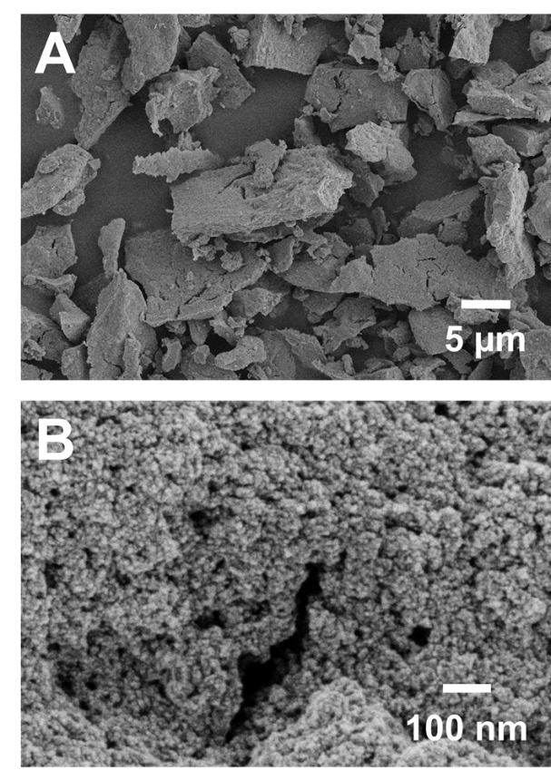

Figure 1

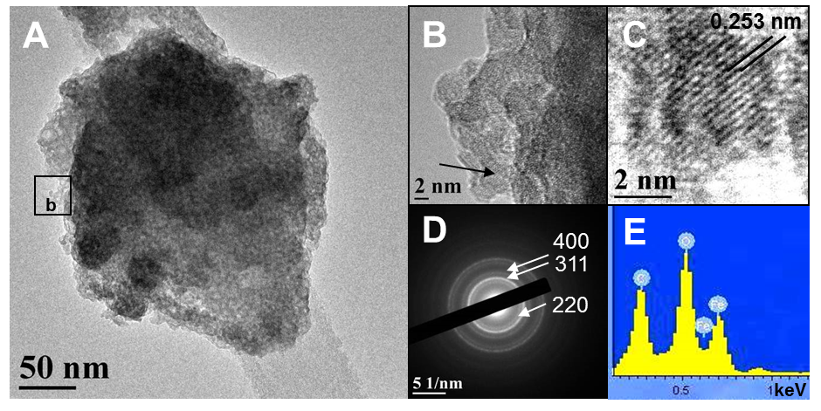

Figure 2

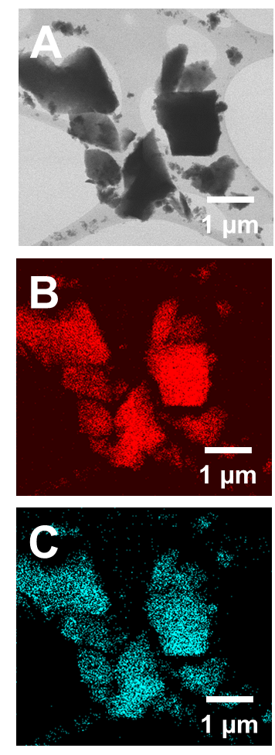

Figure 3

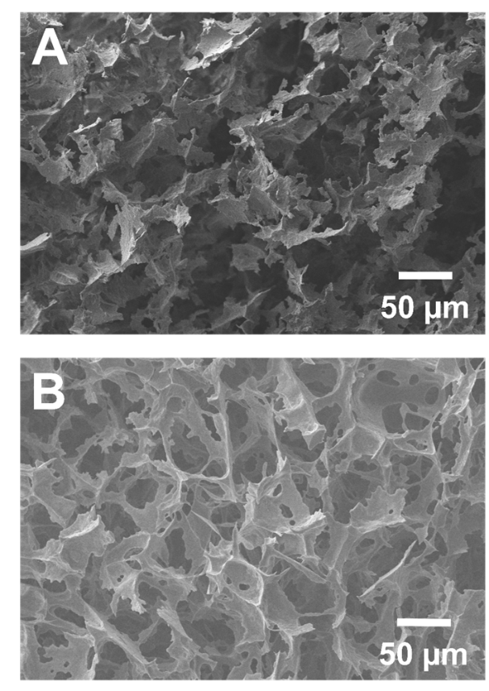

Figure 4

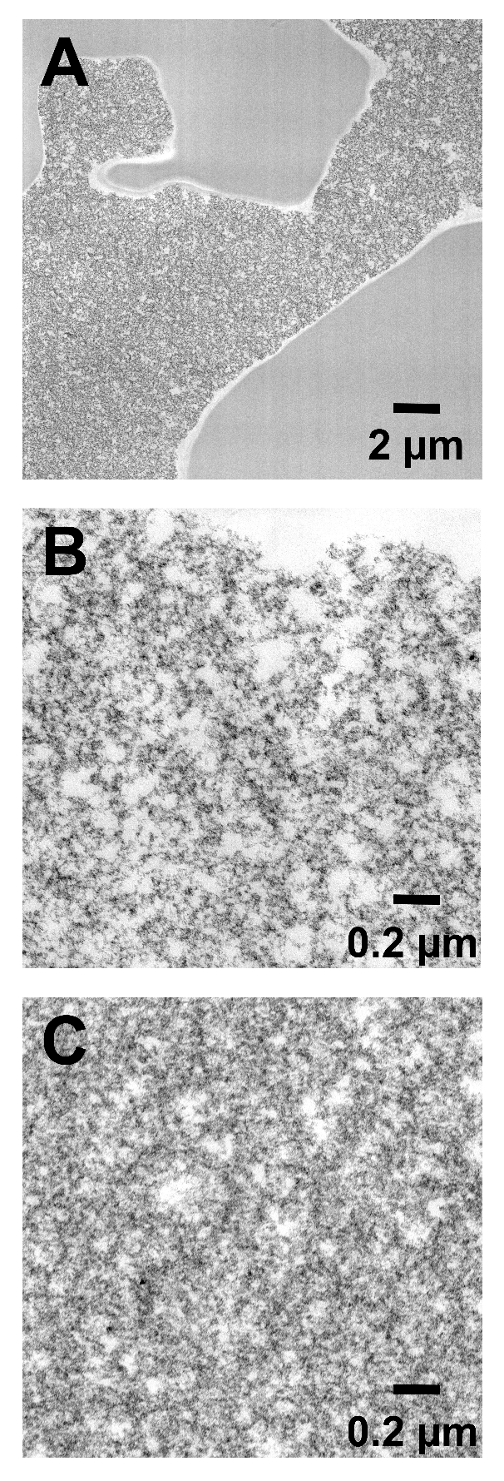
Figure 5
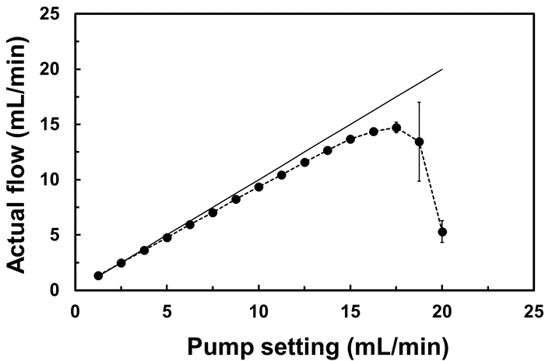

Figure 6

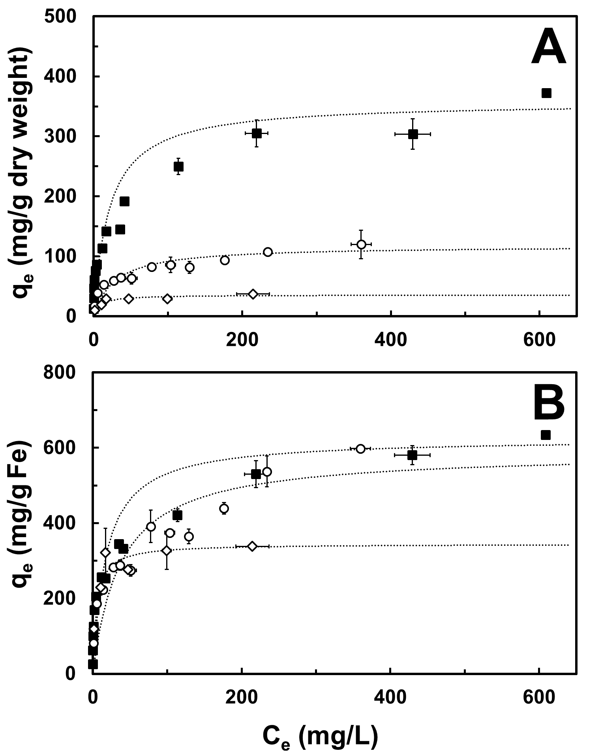

Figure 7

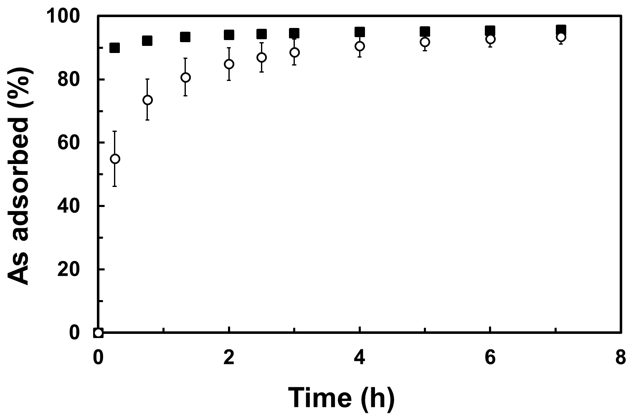

Figure 8

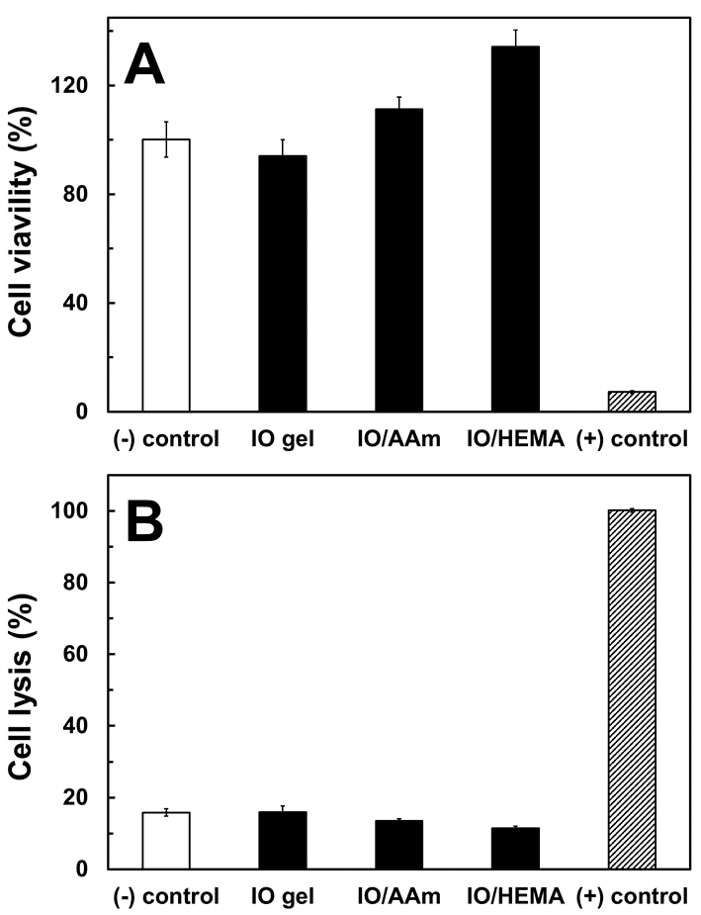

Figure 9

