Characterization of Atomic Layer Deposited Alumina Thin Films on Black Silicon Textures Using Helium Ion Microscopy
Tudor E. Scheul^{a)}, Edris Khorani, Tasmiat Rahman and Stuart A. Boden
Electronics and Computer Science, University of Southampton, UK, SO17 1BJ
^{a)}Corresponding Author: tes1g13@soton.ac.uk
Abstract. Black silicon (b-Si) refers to the nanoscale texturing of a silicon surface to reduce the reflectivity across a broad wavelength range. We fabricate b-Si using a metal assisted chemical etch (MACE) process and then electrically passivate the surface using atomic layer deposition (ALD) of alumina. A crucial step towards effective passivation is the necessity of uniform and conformal coverage of the nanostructures by the alumina film, which can be achieved by inserting a diffusion step for the precursors during the ALD process. We demonstrate excellent alumina coverage of b-Si nanostructures through high resolution imaging of texture cross-sections using helium ion microscopy. The images confirm conformal and uniform coverage, even in the narrow trenches between the nanostructures. Moreover, the thickness of the alumina coating is found to be the same for samples with two different nanostructure lengths indicating that precursor supply is sufficient to not limit growth on high surface area structures. Further morphological characterisation is carried out by milling into the nanostructures with a Ne ion beam to reveal the structure in cross-section.

INTRODUCTION
Optical losses, such as reflectance in silicon solar cells, drastically affect carrier generation inside the cell and thus have a negative impact on the power conversion efficiency of the device. In recent years, nanoscale ‘black silicon’ (b-Si) has been of interest as an effective approach to reducing surface reflection across a broad wavelength range and improving light-trapping inside the substrate [1-2]. Furthermore, metal-assisted chemical etching (MACE) has emerged as a cheap and scalable wet-etching method of fabricating these nanostructures, using an aqueous solution of AgNO₃ and HF to both nucleate and catalyze the reaction in one step. MACE consists of deposition of silver nanoparticles on to the substrate, followed by oxidation of the Si surface and the vertical propagation of the metal particles into the bulk. Details on the kinetics of the reactions occurring during this process can be found in earlier studies [2-4]. The resulting surfaces exhibit reflectance as low as 2% across a broad wavelength range and appear visually black, hence the term ‘black silicon’. However, these nanostructured specimens present massive electrical losses associated with surface recombination of the minority carriers because of the increase of surface area. There is therefore a need for effective surface passivation to reduce surface recombination velocity to acceptable levels. This has traditionally been addressed by deposition of a thin layer of SiO₂ or SiN_{x}, but the nanostructures can be difficult to passivate with conventional CVD techniques because of the high surface area and high aspect ratio of the texture features. [5-6] A suitable alternative for controlled thin film deposition is atomic layer deposition (ALD), a self-limiting surface process, which can provide conformal coverage inside narrow structures. As only a monolayer of material is grown per process cycle, excellent coverage can be achieved in a controlled manner by ensuring long enough precursor exposure in the process chamber. Alumina has become an especially interesting candidate as a silicon passivating material, mostly due to its large negative fixed charges that can be activated during a post-deposition anneal. [7] Effective surface passivation with ALD alumina is affected by the layer thickness and as such, having a conformal coverage of uniform thickness across these structures is crucial [8-9].
Helium ion microscopy (HIM) [10] offers advantages over traditional scanning electron microscopy, such as higher resolution and larger depth of field, which are useful in characterizing the morphology of the b-Si nanostructures. Furthermore, the latest HIM tools also feature a neon ion capability, enabling localised milling of surface features to reveal cross-sections.In this work, we use both the imaging and the milling capabilities of HIM to analyze the conformality and uniformity of ALD films on MACE-fabricated black silicon nanotextures.

EXPERIMENTAL
The one-step MACE process uses of an aqueous AgNO₃ solution and a diluted HF solution of 14 M. Silicon wafer samples (4 cm × 4 cm, <100>, n-type CZ, 1-5 Ωcm, 260 μm thick) are first cleaned using a 3:1 Piranha solution to remove organic particles, followed by a thorough de-ionised (DI) water rinse and finally dipped into a 7:1 HF bath for native oxide removal. The samples are then submerged into the MACE solution for the desired etch time (5 or 10 minutes in this study), then thoroughly rinsed with DI water. A fuming nitric acid solution is used to remove the silver residue on the samples after the etching process.
Alumina (AlO_{x}) deposition was carried out using thermal ALD with a Cambridge Nanotech Savannah tool and trimethylaluminium (TMA) and water as precursors at a process temperature of 250° C. A 15 seconds diffusion step was added to each deposition cycle to allow the precursors to settle inside the deep and narrow trenches followed by sufficiently long purge steps to clean the chamber of leftover precursors and reactants. Unless otherwise stated, the ALD recipe consisted of 150 deposition cycles. This is followed by an anneal at 425° C for 30 minutes in a nitrogen atmosphere [6]. Surface recombination was assessed by quasi steady state photo-conductance (QSSPC) decay lifetime measurements in a Sinton WCT-120 instrument with a known calibration wafer [13]. Lifetime samples were prepared by producing the same surface morphology on the front and back surfaces of the silicon.
HIM imaging was carried out using a Zeiss Orion Nanofab He/Ne ion microscope. This features a Gas Field Ion Source (GFIS) which produces a picoamp beam of helium or neon ions that can be focused to a nm sized spot on a sample in the chamber [10][11]. Pixel-by-pixel image formation is achieved by raster scanning of this focused ion beam across the sample and detecting the resultant secondary electron emission. Higher areal doses of the ion beam achieved by increasing the dwell time per pixel can be used for localised milling of surface material. The textured and coated samples were cleaved to expose fresh cross-sections and imaged at various tilt angles and magnifications, with a He ion beam current of ~0.5 pA and an accelerating voltage of 30 kV. The milling of the nanostructures was carried out in-situ using a Ne ion beam current of 3 pA perpendicular to the nanowires’ long axis to expose their bases, with a variety of scan patterns, process times and dosages.

RESULTS AND DISCUSSION

Passivation Quality of ALD AlO_{x}
The electrical properties of the samples under study were monitored at all stages of the fabrication flow. Thus, Fig. 1 shows the minority carrier lifetimes for various specimens as a function of excess minority carrier density (MCD). The flat, bare wafer exhibits an effective lifetime of 5.91 μs (blue trace) at MCD = 10¹⁵ cm⁻³, a value which decreases after MACE processing to 3.07 μs (yellow trace), due to the increased silicon surface area and therefore surface recombination. Following AlO_{x} deposition and annealing, the lifetimes are boosted by at least two orders of magnitude, resulting in values of 790 μs and 661 μs for 5 min MACE and 10 min MACE samples, respectively (purple and green traces). These results are comparable to the passivation levels of the annealed AlO_{x} layer of same thickness on top of flat silicon, where effective lifetimes close to 1 ms are measured (red trace). The minority carrier lifetime values can be converted into the surface recombination velocity (SRV), by assuming an infinite bulk lifetime, using Eq. (1) [1], where W is the thickness of the silicon wafer in cm and τ_{eff} is the minority carrier lifetime in seconds.

SRV = $\frac{W}{{2τ}_{eff}}$ (1)

Thus, the corresponding recombination velocities are 16.5 cm/s and 19.7 cm/s for the alumina coated 5 min MACE and 10 min MACE samples, respectively. These results are to be treated as upper limits in SRV, because of the assumptions made when calculating them and they indicate that ALD alumina provides effective passivation for the MACE textured silicon surfaces.
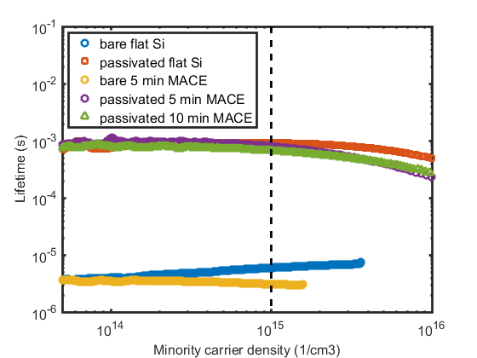
FIGURE 1: Minority carrier lifetimes at various stages of fabrication. Vertical dashed line slices through at an MCD = 10¹⁵ cm⁻³

Imaging with He Ion Beam
Both alumina coated and uncoated MACE-processed silicon samples were imaged using the helium ion microscope, as shown in Fig. 2. The MACE process leads to a randomly distributed dense layer of vertically-aligned nanowires with diameters in the 20-50 nm range. As the stage was tilted at 45°, the entire population of nanostructures is clearly visible and in focus due to the superior depth of field that HIM provides when compared to standard SEM [10]. The nanostructures on both samples experience significant bunching towards their tips due to the high aspect ratio of their features, as well as other nanoscopic forces at play such as van der Waals forces and surface tension forces, commonly noted in MACE nanostructures [12]. This leads to agglomeration and a slight change in the nanowire distribution, increasingly so for longer structures. Initially, the nanowires are very thin and sharp towards their tips, but they become morphologically smoother and more rounded after they have been subjected to the ALD process, as shown by the insets of Fig. 2.

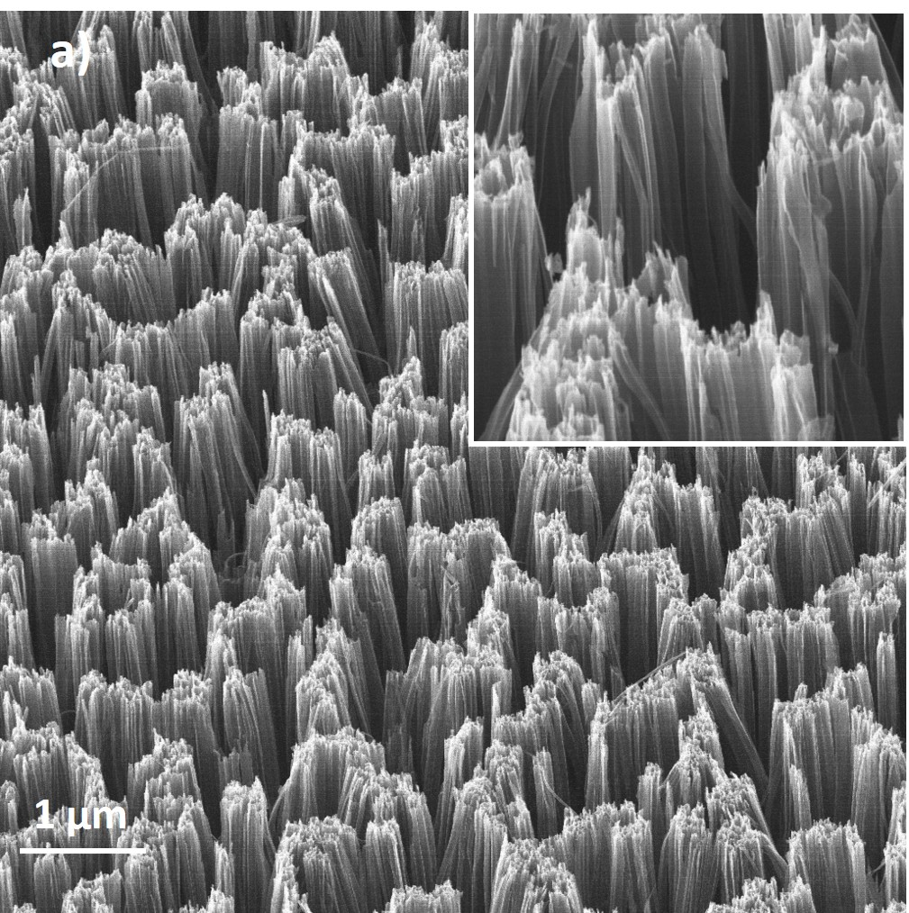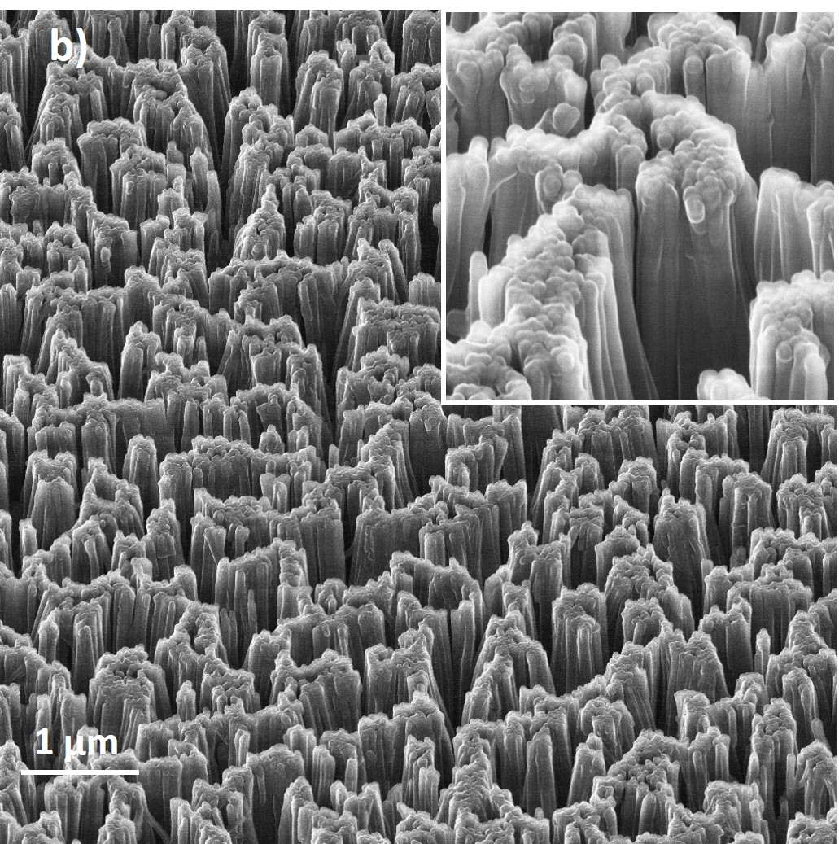
FIGURE 2: HIM image of a) uncoated and b) ALD coated AlO_{x} 10-minute MACE-processed black silicon, field of view 7 μm (insets: field of view 1 μm)

Both samples were then cleaved to expose fresh cross-sections for imaging and mounted in such a way that the structures are perpendicular to the incoming He beam. Fig. 3 a) and b) show cross-sectional HIM images of uncoated and coated nanowires, respectively, at a field of view of 3 μm. The b-Si layer is uniform in length across the entire surface of the specimen and found to be consistent between the two samples. The ALD alumina coating is visible as a bright thin layer in Fig. 3b) as opposed to the darker silicon substrate, showing good coverage down to the bases of the pillars and on top of the smallest intricate features.

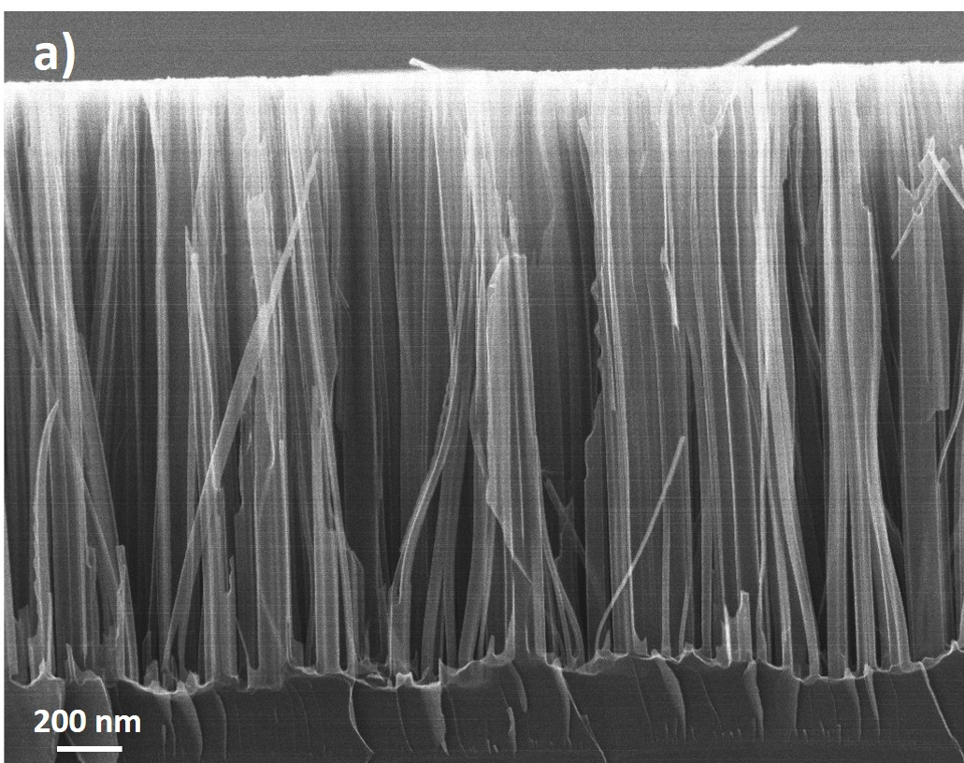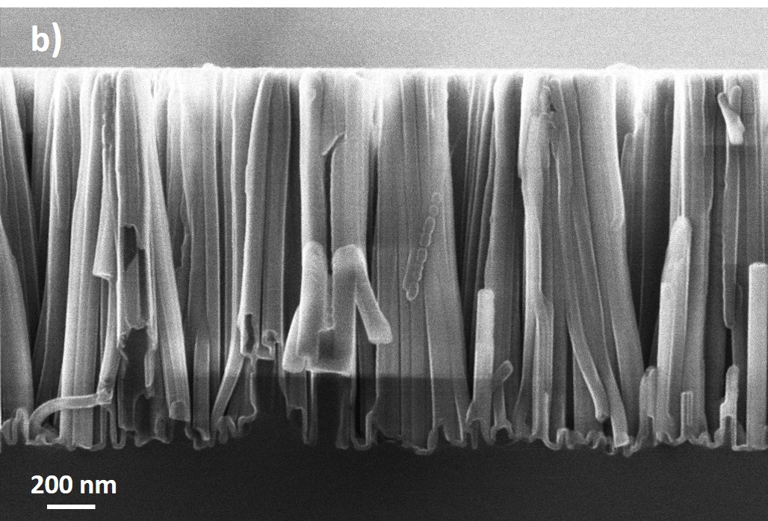
FIGURE 3: Cross-sectional HIM images of a) uncoated and b) ALD AlO_{x} coated 10- minute MACE-processed black silicon (field of view 3 μm)

Images of two sets of ALD coated nanowires etched for different times are shown in Fig. 4 (a,b). The feature heights were directly measured from the images, giving ~414 nm and ~1508 nm for the two arrays, respectively. The magnification was increased to form clear images of the bases of the nanostructures in cross-section (Fig. 4 (c,d)). In regions where the cleave has sliced through nanostructures, the alumina coating is easily distinguished from the silicon core due to the clear contrast difference between the two materials. Most of the nanostructures were cleaved parallel to their long axis but in some regions (e.g. see arrow in Fig. 4d), individual nanowires lying at an angle to the cleavage plane were sliced along their short axis, revealing a darker silicon core surrounded by the lighter alumina cladding. The alumina coating is seen to uniformly clad the walls and the bases of the structures, even in the narrow crevasses between nanostructures. Direct measurements of the average thickness of the alumina coating at various points on the images gives 17.9 nm ± 1.3 nm for Fig. 4 a) and 18.4 nm ± 1.0 nm for Fig. 4 b), in good agreement with expectations from the ALD recipe. This shows that coating thickness is the same (within measurement uncertainty) for samples with two different nanostructure lengths, indicating that ALD precursor supply is sufficient to not limit growth on these high aspect ratio structures, even with such a large surface area increase.

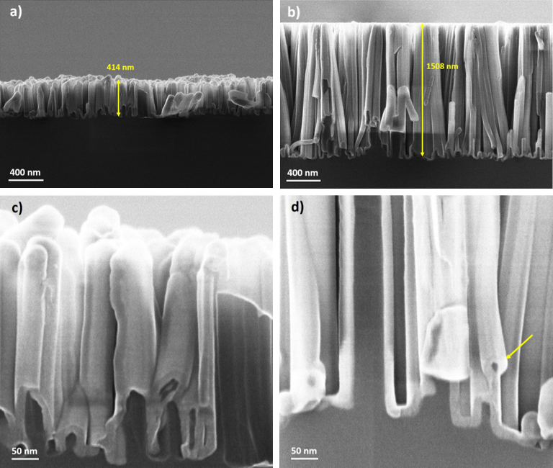

FIGURE 4: Cross-sectional HIM images of MACE-processed and ALD coated b-Si surfaces (a, c) 5 minute MACE; (b,d) 10 minute MACE. The field of view is 3 µm for images (a) and (b) and 0.5 µm for (c) and (d).

Milling with Ne Ion Beam
There is a possibility that the bunching of the nanowires experienced in the MACE samples could prevent sufficient ALD precursor penetration between these agglomerations and neighbouring fallen wires, resulting in poor levels of surface passivation and low minority carriers lifetimes. It is of interest, therefore, to assess the conformality level of the alumina layer in these regions, just below the joined tips of the wires. Thus, the milling capabilities of the Orion Nanofab tool were used to prepare cross-sections through bunches of nanowire structures. The milling of these nanostructures was carried out perpendicular to their long axis using a Ne ion beam current of 3 pA and an aperture of 40 μm. The 1 nm spot size allows for precise milling at this scale, enabling further morphological characterisation along the length of the wire. Various dosages and dwell times were tried resulting in different process durations and pattern repeats, with the best conditions to fully cut through these nanowires being a single scan with a dose of 2 nC/μm² and a dwell time of 2 ms.
Ne ion beam images of the same area taken before and after this milling procedure are shown in Fig. 5 a) and b) for direct comparison. The process removed about 270 nm from the top of the bunched nanowires as measured directly from the images and affected only the first few rows of wires. Fig. 5 c) is an image taken during the milling process and shows the milling box (orange), defined as 300 nm x 500 nm for this work. The images in Fig. 5 a) and c) were captured using the Ne beam rather than the He beam, resulting in lower quality images than Fig. 5 b) and d).

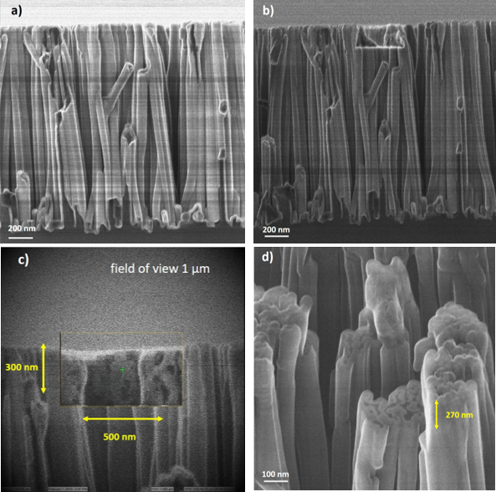
FIGURE 5: Cross-sectional Ne ion beam images before (a) and after (b) the milling process, indicating the same region (field of view 2 μm); c) image taken during the milling process showing initial milling of the alumina coating; d) HIM image of milled area taken with a stage tilt of 45°

Fig. 5 d) shows the same region magnified (field of view 1 μm) and tilted at 45° to allow the milled cross-section to be imaged. The exposed bright alumina coating is seen to uniformly surround the silicon cores. The milling process does not reveal the individual roots of the nanowires, but still shows the bunching of these structures. Rather than upright cylindrical individual nanowires, in some cases, the milling reveals continuous ‘grass-leaf’ morphologies in the middle of an agglomeration. The images show that the ALD precursors have penetrated into the agglomerated nanowire bunches to coat the surfaces within, demonstrating that this coating technique is highly effective for conformal coverage of large surface area structures. The morphological detail presented in these images could potentially be useful when modelling these nanostructures for electrical or optical simulations on top of a silicon device.

CONCLUSIONS
Helium ion microscopy is used to investigate the uniformity and conformality of ultra-thin films of alumina, deposited by ALD, on MACE-textured black silicon. Top-view images show the dense array of vertically-aligned nanowires and cross-sectional images show highly conformal and uniform deposition to a thickness of ~18 nm on samples with nanostructure heights of ~414 nm and 1508 nm, an important step towards achieving good electrical and chemical surface passivation on these high-surface area structures. The Orion Nanofab tool can also be used in focused neon ion beam milling mode to cross-section these nanostructures perpendicular to their long axis, enabling further characterisation of their morphology. Initial milling reveals that nanowire agglomerations can be characterised as ‘grass-leaf’ morphologies rather than individual structures. However, the presence of the alumina coating is confirmed even between bunched features, demonstrating that ALD alumina deposition with a long exposure step in the recipe is an effective way to conformally coat high surface area structures for passivation purposes.

ACKNOWLEDGMENTS
The authors would like to acknowledge the Leverhulme PicoFIB network and the EPSRC funded Black Silicon Photovoltaics project (EP/R005303/1). The authors would also like to thank Suguo Huo from the London Centre of Nanotechnology for useful discussions.

REFERENCES
- H. Savin, P. Repo, G. von Gastrow, P. Ortega, E. Calle, M. Garín, and R. Alcubilla, “Black silicon solar cells with interdigitated back-contacts achieve 22.1% efficiency. Nature Nanotechnology, 10(7), 624–628. (2015)
- X. Liu, P. R. Coxon, M. Peters, B. Hoex, J. M. Cole & D. J. Fray, “Black silicon: fabrication methods, properties and solar energy applications”. Energy Environ. Sci., 7(10), 3223–3263 (2014)
- Srivastava, S. K., Kumar, D., Schmitt, S. W., Sood, K. N., Christiansen, S. H., & Singh, P. K. (2014). Large area fabrication of vertical silicon nanowire arrays by silver-assisted single-step chemical etching and their formation kinetics. Nanotechnology, 25(17), 175601. https://doi.org/10.1088/0957-4484/25/17/175601
- T. Scheul, E. Khorani, T. Rahman and S. A. Boden, “Metal-assisted chemically etched black silicon for crystalline silicon solar cells”, Proceedings of the 14th Photovoltaic Science Application and Technology Conference (PVSAT-14), April 2018
- Schmidt, J., Peibst, R., & Brendel, R. (2018). Surface passivation of crystalline silicon solar cells: Present and future. Solar Energy Materials and Solar Cells, 187(July), 39–54. https://doi.org/10.1016/j.solmat.2018.06.047
- Bonilla, R. S., Hoex, B., Hamer, P., & Wilshaw, P. R. (2017). Dielectric surface passivation for silicon solar cells: A review. Physica Status Solidi (A), 214(7), 1700293. https://doi.org/10.1002/pssa.201700293
- Dingemans, G., Seguin, R., Engelhart, P., Sanden, M. C. M. van de, & Kessels, W. M. M. (2010). Silicon surface passivation by ultrathin Al ₂ O ₃ films synthesized by thermal and plasma atomic layer deposition. Physica Status Solidi (RRL) - Rapid Research Letters, 4(1–2), 10–12. https://doi.org/10.1002/pssr.200903334
- Dingemans, G., & Kessels, W. M. M. (2012). Status and prospects of Al ₂ O ₃ -based surface passivation schemes for silicon solar cells. Journal of Vacuum Science & Technology A: Vacuum, Surfaces, and Films, 30(4), 040802. https://doi.org/10.1116/1.4728205
- Hoex, B., Gielis, J. J. H., Van De Sanden, M. C. M., & Kessels, W. M. M. (2008). On the c-Si surface passivation mechanism by the negative-charge-dielectric Al2 O3. Journal of Applied Physics, 104(11). https://doi.org/10.1063/1.3021091
- B. Ward, J. A. Notte, N. P. Economou, Helium-Ion Microscopy (2007)
- G. Hlawacek and A. Golzhauser, Helium Ion Microscopy, Springer International Publishing, 2016.
- S. Togonal, L. He, P. Roca i Cabarrocas, and Rusli, “Effect of Wettability on the Agglomeration of Silicon Nanowire Arrays Fabricated by Metal-Assisted Chemical Etching,” Langmuir, 30, 34, 10290–10298, (2014).
- R.A. Sinton, A. Cuevas, M. Stuckings, Quasi-steady-state photoconductance, a new method for solar cell material and device characterization, in: Photovolt. Spec. Conf. 1996., Conf. Rec. Twenty Fifth IEEE, 1996: pp. 457–460. doi:10.1109/PVSC.1996.564042

