A body-force model to assess the impact of a swimmer’s arm on propelled swimming resistance

J. Banks, A.B. Phillips, D.A. Hudson, S.R. Turnock
Abstract
The dynamic forces acting on a swimmer’s body are notoriously difficult to measure experimentally, thus motivating many researchers to use computational fluid dynamics to assess the propulsion and resistance forces. To assess both the thrust generated and the self-propelled resistance, fully dynamic simulations are required, including the large range of body motions involved in swimming. This comes with a heavy computational cost and often limits the ability of the method to resolve detailed flow features associated with resistance force. This paper applies a body force approach to propelled swimming simulations by combining an unsteady RANS simulation of the passive resistance with momentum source terms which accelerate the fluid in the location of the arm to represent the impact the arm has on the flow. Both passive and active towed swimming experiments were conducted and compared with the simulations. Despite observing a 24% variation in the pressure resistance associated with the arm entry, the arms had no significant effect on the mean propelled resistance of a swimmer. The passive resistance methodology agreed well with experimental data.

Introduction
Elite athletes are always striving to improve their performance and the winning margins within swimming are often only tenths or even hundredths of a second. Increasing a swimmer’s speed through the water requires either an increase in the propulsive force generated or a reduction in the resistance. The resistance acting on the body is composed of skin friction, due to the viscous boundary layer, and pressure resistance, containing form drag and wave resistance (1). The resistance force can be investigated in isolation by passively towing the swimmer through the water. However, during freestyle swimming, the resistance has to be balanced by the propulsive forces generated by the arms and legs. The associated body motion and complex interaction between propulsive and resistive flow features requires a reduction in the propelled resistance (or active drag) to achieve a performance gain.

It is currently impossible to experimentally measure the forces on the body without altering the stroke in some way (2). Increasingly, researchers are turning to Computational Fluid Dynamics (CFD) to simulate the forces acting on a swimmer’s body and assess the physical mechanisms behind them. In order to assess the propelled resistance, active swimming simulations are required with a dynamically moving geometry. This poses significant challenges from a numerical perspective due to the large range of movement and complex flow features associated with the arm’s motion. It is to be expected that the unsteady body motions of the torso will create fluctuations in the resistance forces acting on the body, however, it is unclear what effect the arms have on the propelled resistance through modifying the local flow, both ahead and around the body. This poses the question which aspects of the unsteady flow around a freestyle swimmer need to be included to assess potential reductions in resistance? The aim of this study is to develop an efficient active freestyle CFD methodology, capable of determining the impact of the arms on the propelled resistance of a swimmer.

Lyttle and Keys (3) first attempted active simulations of underwater fly-kick using re-meshing to provide the body movements, a computationally expensive process. More recently, a fully unsteady underwater fly-kick simulation was performed using an immersed boundary method (4). This method uses a fixed cartesian grid, through which the surface of the geometry moves, removing the need to adapt the mesh. This requires a very high mesh density over a large region of the domain, but still limits the near wall cell size that can be used to resolve the boundary layer over the body. A wider study on underwater fly-kick was conducted using a smooth particle hydrodynamics (SPH) methodology, removing the need for a computational mesh (5). This method has since been applied to full body freestyle simulations with the focus on assessing the propulsive forces generated by both the arms and legs (6). SPH methods are in their infancy compared to finite volume methods and are limited in their ability to resolve the complex viscous boundary layers important to predicting resistance due to a fixed particle size and the small scales required in this region.

To date, the focus of most active swimming simulations has been on the net force acting on the body or how the propulsive forces are generated. Very little focus has been given to the propelled resistance acting on the swimmer during swimming and how this differs from a passive (towed) resistance. The challenge of simulating the resistance and propulsion acting on a body moving through water is one that the Naval Architecture community has been working on for many decades. A series of CFD workshops have focused on this challenge and have shown that finite volume (mesh based) methods with detailed boundary layer resolution provide the best solutions for the resistance around complex geometries (7,8). However, if the full kinematic motion of the arms is included in the meshed geometry, the computational costs can become prohibitive. This is mainly due to the small cell size and reduced time step required to resolve the unsteady flow over an arm moving significantly faster than the body. Additional complexity and cost is associated with incorporating the arm’s extensive range of motion throughout the domain, where simple mesh deformation is inadequate. However, it would seem logical that the majority of the resistance force comes from the head and torso, whilst the arms and legs produce mainly thrust. This appears to be confirmed by the assessment of propulsion in the full body simulations of freestyle (6). Therefore, to accurately assess the propelled resistance, the methodology first needs to be able to assess the passive resistance.

The passive resistance of a fully submerged swimmer was simulated by Bixler et al. (9) and compared against the experimental resistance of an athlete and mannequin in a flume. The total resistance from CFD was within 4% of that measured for the mannequin, establishing the ability of CFD to simulate the flow around the complex geometry of a swimmer’s body. However, the resistance of the athlete within the flume was significantly higher than the mannequin based on a laser scan of the athlete’s body. This was attributed to differences in body and hand position and potentially surface roughness. CFD has also been used to assess the resistance of different glide positions used during a breaststroke pull-down (10). A similar numerical study has extended this to include a comparison to experimental glide tests, where the swimmer’s deceleration was used to estimate the drag forces acting on the body in different glide positions (11). In general, this showed that similar trends with speed were determined, but significant differences in absolute resistance were observed. Further studies have discussed the relative merits of empirical approximations, experimental tests and CFD methods for investigating the resistance force acting on a submerged swimmer (12, 13), again highlighting the need for accurate scanned geometries to obtain accurate results. CFD studies allow the resistance to be split into frictional and pressure drag, providing greater insight into the physical mechanisms of swimming resistance. Sato and Hino (14) provide the most comprehensive numerical study of the resistance of a swimmer, both on the surface and deeply submerged. A detailed description of the implemented numerical methodology and mesh structure is provided along with a breakdown of the resistance components and free surface interactions. Unfortunately, there was no experimental data on the free surface with which to compare the results.

A range of studies have investigated the propulsive forces generated by the arms during swimming. Bixler and Riewald (15) performed 3D steady Reynolds Averaged Navier-Stokes (RANS) simulations of a hand and forearm at varying flow speeds and angles of attack and showed good correlation to experimental data. Sato and Hino (16) simulated the unsteady forces acting on a hand following a typical freestyle trajectory for the first time, highlighting the impact of accelerations on the forces generated. The impact of accelerations was also estimated using empirical relationships for measured kinematics (17). Other studies have used CFD to highlight the importance of local hand geometry and orientation on the forces generated (18,19,20). All of these studies highlight the importance of accurate local geometry and kinematics to obtain accurate force distributions over the arm. More recently, Lauer et al. (21,22) performed CFD simulations of the forces generated by a swimmer’s arms whilst performing vertical sculling. These simulations were based on experiments conducted with an athlete supporting a ballast weight providing a known net vertical force that the simulated forces can be compared against.

As the focus of this research is not the detailed flow around the arm, but instead the impact of the arm on the resistance, a body force approach can be adopted to replicate the effect the arms will have on the fluid. Body force models have previously been used to model propeller-hull interactions (23,24), tidal turbine arrays (25) and the impact a kayak paddle has on the propelled resistance of a sprint kayak (26). This approach allows the effect of the free surface and unsteady arm motion to be simulated whilst ignoring the detailed local effects of the arm’s boundary layer. If the focus is on investigating the effect of the arm-induced flow velocities, instead of the accompanying torso motion, a rigid mesh can be used around a static swimmer geometry for the CFD simulation. Whilst this approach will not capture the effect of torso motions on the propelled resistance, it will allow the time varying impact of the arm on the hydrodynamic forces to be assessed for the first time. For a typical ship, the local acceleration of water by the propeller increases the resistance of the ship, therefore it is hypothesised that a similar effect will be observed with a swimmer.

This paper will first introduce the numerical methodology behind a body force model before developing a mathematical model for determining the forces on an arm. Finally, the mathematical model will be combined with a passive resistance free surface methodology to perform propelled freestyle simulations to determine the effect of the arms on the active drag.

Methodology
In order to investigate the effect of the arms of the propelled resistance of a swimmer, a simplified test case of arms only freestyle was used so as to remove the effect of the leg kick. An experiment was conducted with an instrumented tow winch providing the same athlete velocity as their free-swimming speed whilst only providing propulsion from their arms. This test case was then replicated using CFD to assess the forces acting on the body.

The methodology adopted to perform propelled simulations was based on numerical methods developed to simulate the propelled resistance of a ship. The complex propulsive forces generated by the arms were approximated by a mathematical force model based on the measured kinematic data of a freestyle swimmer and previously published data. A CFD methodology was then developed to accurately predict the resistance forces acting on a swimmer on the free surface. A finite volume unsteady RANS methodology was selected to provide a computationally efficient approach to modelling the resistance components of a swimmer on the free surface. Such methods have been shown to adequately replicate the complex flow features around ships (7).

The swimmer’s arms can be represented within a CFD simulation by adding momentum sources into the simulation domain that represent the impact the arm has on the fluid. This approach aims to accelerate the fluid to create a similar global flow field as would be created by an actual swimmer’s arm without having to simulate the detailed local flow interactions around the surface of the arm. The strength and direction of these source terms are determined from the force exerted on the water by the arm. This force will be equal and opposite to the force acting on the arm itself.

Numerical approach

The simulations were performed using the open source CFD package OpenFOAM-2.01 (27). The fluid domain around the swimmer was modelled using a finite volume method with the unsteady incompressible RANS equations for momentum and mass continuity, shown in Eqs. (1) and (2), respectively.

(1)

(2)
External forces applied to the fluid, such as the influence of the arm, are represented using momentum source terms f_{i} (force per unit volume).

A volume of fluid approach is adopted for the free surface with the volume fraction transport equation defined by Eq. (3)

$\frac{∂φ}{∂t}+\frac{∂(φU_{j})}{∂x_{j}}=0$, | (3)
where φ is the volume fraction calculated as the volume ratio of water to air in a given cell (28).The fluid density, ρ, and viscosity, µ, can then be calculated as shown in Eqs. (4) and (5).

$$ρ=ρ_{air}(1-φ)+ρ_{water}φ$$ | (4)

$$μ=μ_{air}(1-φ)+μ_{water}φ$$ | (5)

The effect of turbulence is represented in Eq. (1) by the Reynolds stress tensor and is modelled using the k-omega SST turbulence model contained within OpenFOAM-2.01 (27). The SST model blends a variant of the k-omega model in the inner boundary layer and a transformed version of the k-epsilon model in the outer boundary layer and the free stream (29). This has been shown to be better at replicating the flow around the stern of a ship, than simpler models such as k-epsilon, single and zero equation models (30,31).

Simulation method

An unstructured hexahedral mesh around the swimmer was created using the snappyHexMesh utility within the open source CFD package OpenFOAM-1.6 (27). First, a coarse block mesh creates a domain with dimensions 14 x 7.5 x 2 [m³], with a base cell size of 0.2 m in each direction. This provides approximately one body length upstream of the swimmer and five body lengths downstream, minimising any effects of the outlet boundary on the flow around the swimmer. Regions were defined with up to six levels of isotropic refinement (recursively halving in all three local cell dimensions), gradually increasing the mesh density near the body, whilst maintaining a cell aspect ratio of approximately one. Unidirectional refinement was applied perpendicular to the free surface to provide better free surface resolution, whilst minimising the total number of cells. Boundary layer elements were grown out from the body surface mesh to provide a y⁺ of 1. This places approximately 10 cells within an estimated y⁺ of 40, allowing the viscous boundary layer to be resolved (32). A comparison with a wall function boundary layer mesh with y⁺ equal to 40 showed significant differences in skin friction and separation points compared to the fully resolved case. The resultant mesh structure can be seen in Fig 1.

Figure 1– Mesh Structure for Passive resistance validation case. Longitudinal plane along the body centreline (left) and a horizontal plane on the free surface (right).
A global mesh refinement study was conducted by altering the base cell size whilst maintaining the levels of refinement, resulting in meshes with a total number of cells equal to 0.72, 1.85, 5.7 and 14.6 million. The passive resistance was then assessed for each mesh, showing monotonic convergence and a difference of less than 2% between the two finest meshes. As this small change in total resistance came with a six-fold increase in computational cost, the mesh settings associated with the 5.7 million cell mesh were adopted for future simulations. The numerical settings used for the CFD solver and the applied boundary conditions were based on previous experience from simulating ship resistance (8). These settings and the computing resource used can be seen in Table 1.

Table 1 - Numerical settings for passive resistance simulation
Property | Mesh
Type of mesh | Unstructured (Hexahedral)
No. of elements | 5.7M for Passive resistance
y+ on the body | Approximately 1
 | Domain physics:
Fluid | Homogeneous water/air multiphase, kOmegaSST turbulence model
Inlet | Free stream velocity of 1.86m/s, buoyant Pressure, k = 0.1 m²s⁻², omega = 2 s⁻¹
Outlet | U=Zero gradient, P=static pressure
Bottom/sides | Wall with velocity set to free stream value U₀ , buoyant pressure
Top | Opening
body | Wall with no slip condition, buoyant pressure, automatic kqRWallFunction and omegaWallFunction
 | Solver settings (interFoam):
Transient scheme | 1st order Euler
Grad (U) Scheme | cellLimited Gauss linear 1
Div (U) | Gauss linearUpwind grad(U)
Pressure coupling | PIMPLE (in PISO mode)
Convergence criteria | P 1e-7, U 1e-8, k 1e-8, omega 1e-8
Multiphase control | Volume fraction coupling
Timestep control | max Courant No = 0.4, max Volume fraction Courant No = 0.4, No of alpha sub-cycles = 2.
 | Processing Parameters:
Computing System | IRIDIS High Performance Computing Facility (University of Southampton)
Run type | Parallel (108 Partitions run on 9x12 core nodes each with 22 Gb RAM)
Wall Clock time | 72 hours for 3.89 seconds of passive free surface simulation

Estimating the forces on an arm
The forces acting on an object moving through a fluid are dependent on the geometry and orientation of the object, fluid properties and local flow velocity. In order to estimate these forces a swimmer’s arm can be viewed as a lifting surface, or foil, capable of generating both lift and drag as it moves through the water. Using a quasi-steady blade element approach, this foil is split up into a series of n elements of length δl. The hydrodynamic forces acting on each blade element can be seen in Fig. 2, where F_{L} is the lift force and F_{D} is the drag force.
Figure 2 - Forces acting on an individual blade element.
The lift and drag vectors acting on each blade element (normal to the blade) are defined as shown in Eqs. (6) and (7).
$$δ\overline{F_{L}}=\left(\frac{1}{2}ρ{\left|V_{n}\right|}^{2}C_{l}cδl\right)\left(\hat{V_{n}}×\hat{AB}\right)$$ | (6)
$$δ\overline{F_{D}}=\left(\frac{1}{2}ρ{\left|V_{n}\right|}^{2}C_{d}cδl\right)\hat{V_{n}}$$ | (7)
V_{n} is the velocity vector of the fluid (normal to the blade’s span), c is the blade chord and $\hat{AB}$ is the unit vector along the blade’s span (or down the arm). Therefore, $\left(\hat{V_{n}}×\hat{AB}\right)$ provides a unit vector perpendicular to both the normal velocity and the blade’s span.
The lift and drag coefficients, C_{l} and C_{d}, are defined by the angle of attack (α) of the individual blade element to the normal velocity vector. The force vector normal to the blade is shown in Eq. (8).
$${\overline{F}}_{n}=\sum_{i=1}^{n}{δ\overline{F_{n}}}=\sum_{i=1}^{n}{δ\overline{F_{L}}}+δ\overline{F_{D}}$$ | (8)
The effect of flow along the arm’s axis (from elbow to fingers) is not included in this model. The normal velocity observed by each blade section is calculated from the relative motion of the arm and the fluid and is described in more detail later.

Freestyle arm kinematics

The swimmer’s arm kinematics were determined using underwater video footage from the side and ahead of a freestyle swimmer whilst performing arms-only freestyle in the experimental test case. The experimental methodology used is described in the study by Webb et al. (2). The position of the shoulder relative to the surface of the water and the relative angle of the upper and lower arm were manually digitised as seen in Fig. 3. The resulting shoulder and elbow joint angles were used along with the shoulder location to recreate the stroke kinematics for the right arm, as can be seen in Fig. 4.

Figure 3 - Manual digitisation process for acquiring joint angles
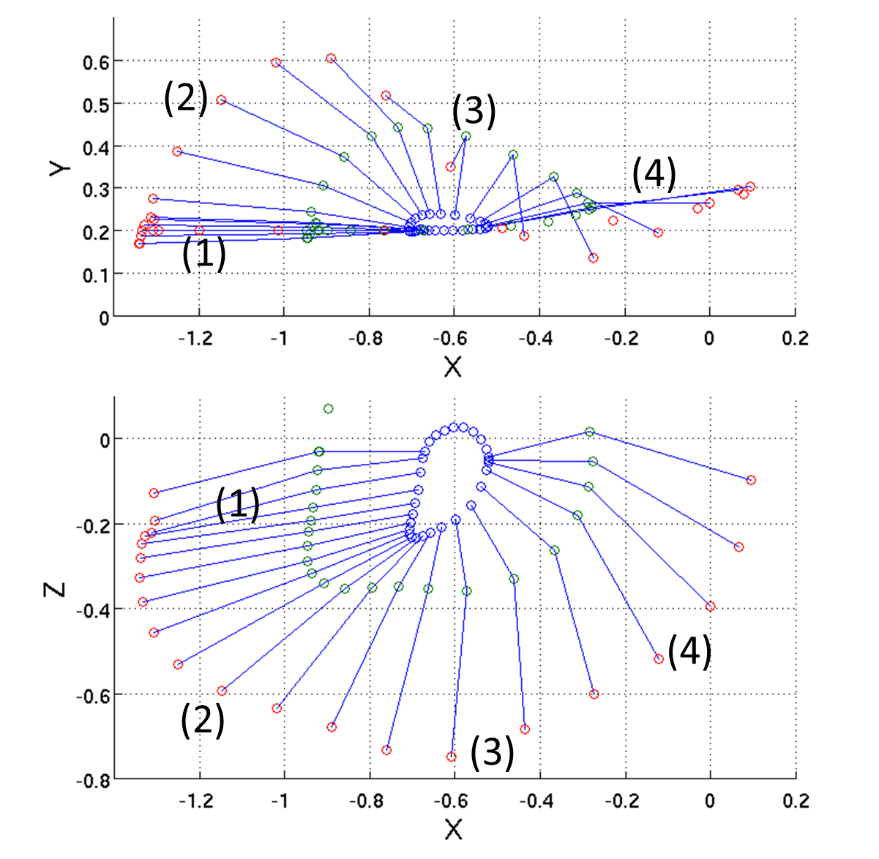
Figure 4 - Arm segment locations for the right arm viewed from above (top) and the side (bottom).
The different stroke phases can be defined in terms of the arm position (labelled in Fig. 4):
- Hand entry. The hand enters the water moving at a significant velocity after the arm recovery. The arm then slows down and remains roughly aligned to the flow as the body roll increases the right shoulder depth.
- Outward sweep. The arm moves out to the side and down as it starts to move backwards.
- Inward sweep. The forearm sweeps back in underneath the upper arm whilst both the shoulder and upper arm move backwards.
- Hand exit. The hand pushes back towards its exit from the water.
- Arm Recovery. The arm moves through the air, back to the beginning of the stroke cycle.
The hand and forearm generate the majority of the propulsive forces due to the increased velocity of the hand (33). Therefore, to simplify the freestyle propulsion model, only the forearm and hand were simulated as a single foil section defined by two points in space (A and B representing the elbow and the fingertips, respectively) and the unit vector α₀ providing the orientation. The unit vector α₀ is aligned with the chord of the blade section and is positive in the direction of the leading edge, defined as the thumb for a swimmer’s hand. The left arm kinematics were created by mirroring those of the right arm in the x-z plane and shifting their phase by 180 degrees.

Local flow velocity

To calculate the lift and drag force acting on each blade element (Eqs. (6) and (7)), the local velocity normal to the arm axis is required. For each time step within the simulation, the body force model calculates the relative stroke time t/T_{stroke} , where T_{stroke} is the stroke period of one complete cycle. This is then used to interpolate the position vectors A and B, along with the unit vector α₀ from the input kinematic data using a 3rd order interpolation method. The change in position of the elbow (A) and the finger tips (B) from the previous time step provides the velocity vectors V_{A} and V_{B}. Linear interpolation provides the velocity of each blade element between A and B relative to the swimmer V_{armRel}. As the swimmer moves through the water, the actual fluid velocity observed by the blade is given by Eq. (9)

$V_{arm}=V_{armRel}-U_{0}$, | (9)
where U₀ is the swimmer’s velocity, represented by a free-stream velocity of the fluid in the simulation domain. The component of the observed fluid velocity normal to the blade is given by Eq. (10)
$V_{n}=V_{arm}-\left(V_{arm}∙\hat{AB}\right)\hat{AB}$, | (10)
where $\hat{AB}$ is the unit vector from A to B (i.e. along the blade span). This effectively removes the component of flow along the arm.

The orientation and therefore angle of attack of a given blade element relative to the normal velocity vector is provided by Eq. (11)
$$α=\cos^{-1}\left(\frac{V_{n}∙\hat{α_{0}}}{\left|V_{n}\right|}\right) ,$$ | (11)
with the sign of α provided by the sign of $\left(V_{n}∙\left(\hat{α_{0}}×\hat{AB}\right)\right)$. The resultant local flow properties from the measured kinematics are presented in Fig. 5.

(a) | (b)
Figure 5 – Local flow properties at the finger tips based on measured kinematics. Normal velocity magnitude (a) and angle of attack (b). The stroke phases defined in Fig. 4 are highlighted at the top.

Lift and drag coefficients

To include the effect of arm geometry and orientation on the forces generated, force coefficients are used. Lift and drag coefficients for a hand at various angles of attack were taken from the study by Bixler and Riewald (15). These values, along with estimated values for negative angles of attack, can be seen in Fig. 6. The appropriate value for each coefficient can be determined based on the calculated angle of attack of the local flow vector.

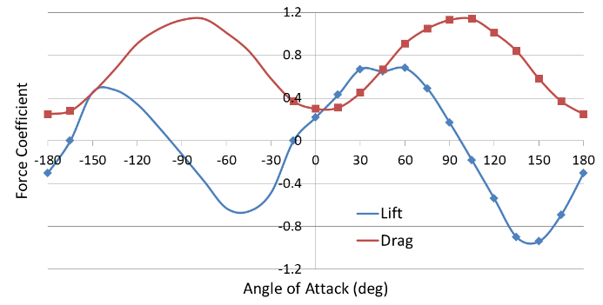
Figure 6 – Lift and drag coefficients for a hand taken from the study by Bixler and Riewald (15) are indicated by data points, with estimated values for negative angles of attack depicted with lines.
The decision to apply coefficients for a swimmer’s hand to the entire fore arm was made on the basis that the hand experiences a larger normal velocity than the arm, causing it to generate a greater proportion of the total force. Therefore, it was more important to correctly simulate the hand over the forearm. The effect of this, however, is that the forces generated near the elbow will be artificially large, particularly the lift force, due to the arm having a significantly reduced lift coefficient (15). It would be possible to modify the force model in the future to include different coefficients at different points along the arm.

The final parameters needed to evaluate the force components (Eqs. (6) and (7)) are the blade chord c and the length of each blade (δl). The blade chord was selected as 0.1 m as this visually approximated the average arm width of the tested participant. The blade element length was defined by the distance between the elbow and finger tips (0.4 m) divided by the number of blade elements n. The number of blade elements was increased until the generated forces changed by less than 0.1%, resulting in eight elements being used.

A visual representation of the relative force magnitudes generated by the arm propulsion model is provided in Fig. 7. During both the outward and inward sweep, a significant amount of lift is generated.

Figure 7 - Force vectors for combined hand and forearm, plotted at the fingertip location, viewed from above (top) and the side (below).
Applying momentum sources within OpenFOAM

The blade forces are applied to a propulsive domain, representing the region of fluid the arm is acting on during that time step. Its location and size is determined by the arm’s location (provided by the kinematic model) and is represented as a cylinder with a diameter equal to the blade chord c. This propulsive domain is then divided up into sectors of length δl, representing individual blade elements.

The coordinates of each cell within the fluid domain are calculated relative to the coordinate system of the arm kinematics, determining which cells are within a given sector of the propulsive domain to provide accurate sector volumes. The current simulation time is used to calculate the position of the blade, based on kinematic data for a single stroke cycle and a defined stroke rate. The normal force (δFn) is then calculated for a blade element, with length and chord equal to the sector dimensions. The momentum source term for each cell within that sector is calculated by Eq. (12)
$$f_{i}=\frac{δ{\overline{F}}_{n}φ}{V_{s}} ,$$ | (12)
where φ is the cell’s volume fraction and V_{s} is the sector volume. Therefore source terms are only applied while the blade is in the water (φ=1), automatically taking account of the dynamic free surface. The source terms are stored within a volume vector field, with each cell outside the propulsive domain set to zero. These are then added to the momentum equation (Eq. 1).

The total blade force is determined for each time step by multiplying each cell’s source term with its cell volume and summating over the propulsive domain. The instantaneous thrust is then acquired by resolving this force vector into the direction of the swimmer’s motion (equal and opposite to the free stream velocity vector (U₀)).

Simulation test cases
Both a passive resistance and propelled test case were selected for this study, however, it was not possible to scan the tested athletes. Therefore, the athlete’s geometry was created from a generic body scan of a human with their arms by their sides, which was transformed in several ways to represent the desired test case. Firstly, variable scale factors were applied along the body to match a specific athlete’s body shape to pictures of the participant. Secondly, joint rotations were performed to match the athlete’s attitude and posture from the video footage acquired during the experiment. This process is described in more detail in the study by Banks et al. (34) and the generated athlete geometries can be seen in Figs. 8 & 9.

Passive resistance

The passive resistance test case was selected to check the validity of the presented CFD methodology. The athlete was towed on the surface with their arms by their side at a speed of 1.86 m/s. An instrumented tow winch provided the total tow force required to maintain the desired speed. This was calibrated before each experimental session by applying 20 kg in the direction of the tow line with a typical measurement uncertainty of less than 0.5% determined from repeat calibrations. Underwater cameras were used to capture the body position. This test case was selected as the total tow force and a series of wave cuts were measured experimentally, allowing the total resistance and the wave resistance to be determined. A comparison of the simulated geometry and the experiment is provided in Fig. 8.

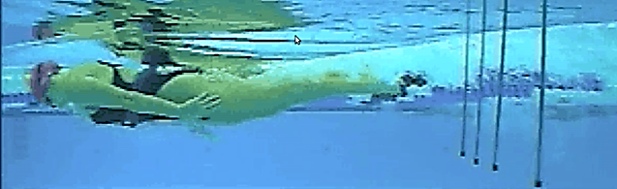
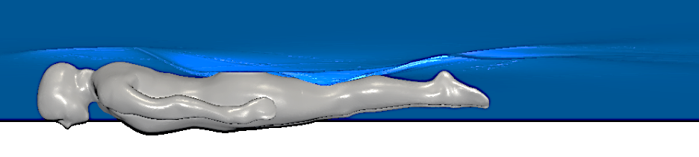
Figure 8- Simulated athlete geometry and experimental comparison for passive validation case.

Propelled resistance

For the propelled freestyle simulation, a simplified experimental test case of arms only freestyle was selected using a different athlete. The athlete’s legs were strapped together and a pull-buoy was used to create a similar attitude in the water compared to freestyle swimming. The instrumented tow winch provided the same athlete velocity as their free-swimming speed (1.56 m/s), whilst the tow force required to maintain this speed was measured. In the experiment, the towed velocity had a standard deviation of 0.022 m/s due to the variation in tow force required to compensate for the unsteady arm propulsion.

As the presence of the arms will be simulated using the body force model, the arms were removed from the simulated geometry below the shoulders. A comparison between the simulated geometry and the experimental athlete position is also provided in Fig. 9. The athlete geometry remained fixed during the simulation. From the video analysis, little variation in pitch (longitudinal orientation) was observed, however, significant body roll motion was observed.

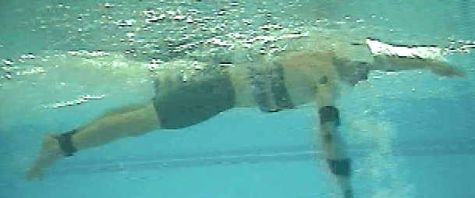
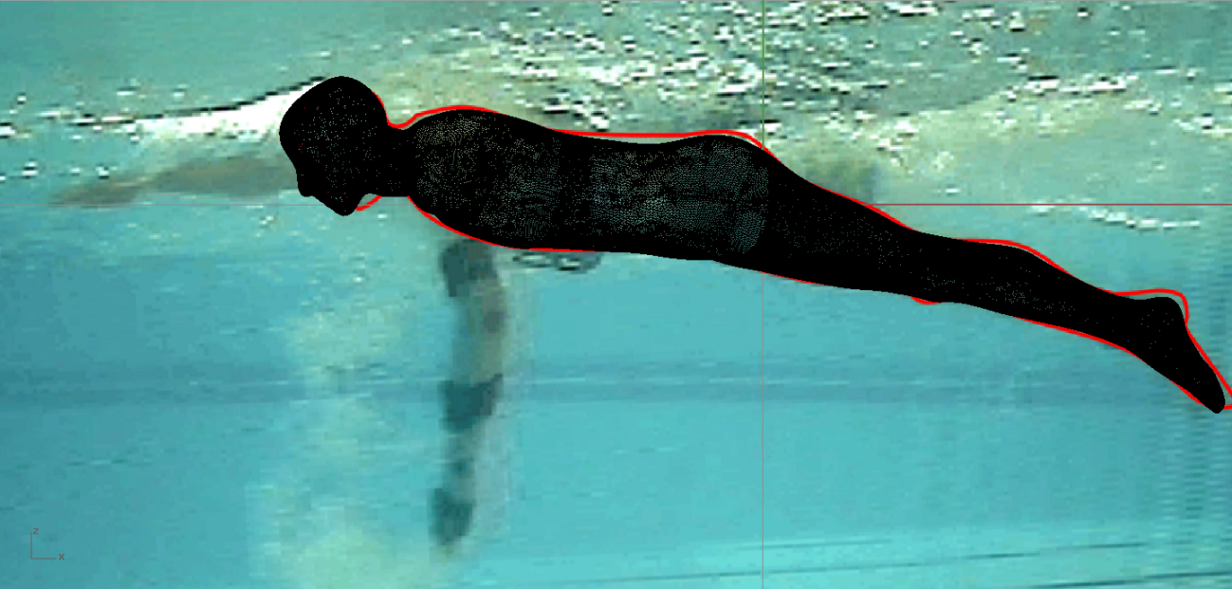
Figure 9 – Simulated athlete geometry and experimental comparison for propelled test case.
A summary of the key athlete parameters associated with the two test cases, along with details of the tested geometries, are provided in Table 2. Without scanning the tested athletes, the exact geometries could not be replicated. In addition, detailed body measurements were not obtained from the athletes, thus it was difficult to quantify the differences.

Table 2 – Overview test case parameters and simulated geometries
 |  | Passive Resistance | Propelled Resistance
Geometry length L (m) |  | 1.86 | 1.93
Mean velocity V (ms⁻¹) |  | 1.86 | 1.56
Reynolds number Rn |  | 3.46 x10⁶ | 3.01 x10⁶
Froude number Fn |  | 0.43 | 0.36
Estimated depth of athlete below the undisturbed free surface* (m) |  | 0.17 | 0.17
Athlete height (m) |  | 1.71 | 1.78
Athlete mass (kg) |  | 62 | 66
Surface area (m²) |  | 1.727 | 1.625 (no arms)
Volume (m³) |  | 0.0809 | 0.0736 (no arms)
 | *measured from the hip joint or groin

Results
The results from the passive resistance simulation, the arm propulsion model and the combined self-propelled test case will be presented and compared with the experimental data.

Validation of passive resistance method

A comparison between the simulated resistance components and the experimental values are presented in Table 3. It was not possible to directly evaluate the wave pattern resistance from the simulation, however as the local free surface flow features were well replicated the experimental wave resistance was subtracted from the total simulated pressure resistance to provide an estimate of the simulated form drag (shown in red).

Table 3 - Comparison of passive CFD resistance components with experimental data. The values in red are derived based on the experimental wave pattern resistance and are not directly simulated.
Resistance component |  | Experiment | CFD
 |  |  | Simulated | Derived
 |  | (N) | (N) |  | %
Skin Friction |  |  | 9.566 |  | 8.28
Pressure: | Viscous-pressure (Form) |  |  | 71.64 | 61.97
 | Wave pattern | 34.36 |  |  | 29.72
 | Total Pressure |  | 106 |  | 91.7
Total Resistance |  | 116.9 | 115.6 |  | 100

Although this appears to indicate a very good level of agreement with experiments, other passive resistance simulations presented by Banks et al. (34) indicate a difference of approximately 20% between simulations and experiments. Despite every effort being made to replicate the different athlete geometries through the scaling and deforming process, the exact athlete geometry will not have been recreated. There will also be a degree of variability in athlete position and attitude during a towed run which will not be captured within the CFD. Indeed, Bixler et al. (9) showed considerable difference between the experimental resistance of an athlete and a mannequin created from a laser scan of the same athlete trying to adopt the same position. Therefore, a certain degree of caution should be taken regarding the absolute resistance values obtained, however, it appears that the main flow features and different resistance components were adequately captured by the CFD methodology. The mesh structure and numerical settings were subsequently maintained for the propelled simulations.

Obtaining the correct thrust magnitude

The use of empirical force coefficients, along with measured kinematics, will ensure that both lift and drag forces will be generated by the arm during the correct phases of the stroke. The implementation of this as body forces within the simulation will ensure that these are applied to the correct region of fluid based on the measured kinematics. However these generic force coefficients will not capture the exact geometry of the athlete’s arm or the unsteady effects of accelerations which previous studies have shown to have a significant effect on the forces generated (16,18,20). Therefore, to ensure that the correct thrust magnitude is generated, the net forces acting on the swimmer need to be compared with the experimental tow force measured in the propelled test case.

In the propelled experiment, the athlete was towed at their free swimming speed, but without using their legs, thus reducing the thrust generated, changing their attitude in the water and increasing their resistance (see Fig. 9). The measured tow force is the propelled resistance minus the generated thrust (R-T). This value was compared to the simulated forces for this case in Table 4. The initial body force model described previously generated 33N of thrust (case B), resulting in a significantly higher R-T value than the experiments. As good agreement has previously been found between simulated and experimental passive resistance, it was assumed that this discrepancy was likely due to the arm model not generating sufficient thrust. This discrepancy could be due to a range of factors such as uncertainty regarding the arm orientation, variable chord length down the arm, different lift and drag coefficients associated with the tested athlete’s arm or unsteady effects not captured in the quasi-steady approach adopted. Indeed, the unsteady forces measured on a rotating kayak paddle were found to be significantly higher than a similar quasi-steady approximation presented by Banks et al. (26). Therefore, to include the athlete specific unsteady effects into the body force model, a factor of two was applied to the forces generated by the arm model, so as to replicate the mean tow force (R-T) measured during the experiment. This should ensure that the correct magnitude of thrust is applied to the fluid around the swimmer, despite some uncertainty regarding the exact distribution in time. As the location of the body force propulsive domain is determined from the experimental footage, this provides confidence that the flow is being accelerated in the correct locations. This final simulation generated 66 N of thrust (case A) providing a much closer agreement with the measured R-T.

Table 4 – Comparison of mean tow force and forces from self-propelled simulations.
Case | Resistance, R (N) | Thrust, T (N) | Tow force, R-T (N)
Experiment |  |  | 58.69
Initial arm model (B) | 125.7 | 32.75 | 93.01
Modified arm model (A) | 127.4 | 65.59 | 61.95

Propelled resistance

The position of the arm’s propulsive domain and the simulated free surface is presented in Fig. 10 at key times throughout the right arm’s propulsive cycle. A large region of accelerated flow is formed during the inward sweep, which travels down the body and past the legs. As the left arm enters the water, there is significant deformation of the free surface, creating a void ahead of the swimmer’s head. This free surface disturbance propagates along the swimmer interacting with the wave pattern generated by the swimmer.
t/T_{stroke}= 0.3
t/T_{stroke}= 0.4
t/T_{stroke}= 0.5
t/T_{stroke}= 0.6
t/T_{stroke}= 0.7
Figure 10 – Position of the arms at key times throughout a stroke cycle for simulation A. Cells contained within the arm’s propulsive domains are shown in red. Accelerated axial velocity indicated by dark blue iso-surface (u/U₀=1.4) and local free surface position provided in light blue.
The time history of the forces acting on the body throughout a stroke cycle are presented in Fig. 11. The thrust generated by the arm model can be seen to peak at a t/T_{stroke} = 0.5 during the in sweep of the right arm. The effect of the arm model on the propelled resistance can be observed by comparing the total resistance for the passive simulation to the propelled simulation for the same test case. The average force values presented on the right of Fig. 11 indicate that the arm model causes only a 0.5% increase in total resistance acting on the body compared to a passive towed condition. This result is predominantly due to a 4% increase in skin friction observed from the accelerated flow speeds down the body. However, as skin friction accounts for less than 10% of the total resistance, this increase has a very small impact overall.

Figure 11 – Thrust produced and hydrodynamic forces acting on the body over one stroke cycle are presented for both propelled simulations (Thrust = 66N (A), 33N (B)) and the passive resistance (C). The vertical lines represent the snapshots in time during the right arm’s propulsive stroke represented in Fig. 10.

Despite very little change in the average force values, the freestyle arm model has been shown to cause a variation of approximately 24% in the total resistance associated with changes in the pressure field around the body. The largest variations occur halfway through the stroke cycle and are associated with the left arm’s entry into the water. The force applied to the water and the associated free surface deformation, observed in Fig. 10 at t/T_{stroke} = 0.5, cause a high pressure region around the head and shoulders of the athlete, which can be observed in Fig. 12. Shortly after, the air cavity collapses, creating a large reduction in pressure observed at t/T_{stroke} = 0.55 as shown in Fig. 12.

t/T_{stroke} = 0.5 | t/T_{stroke} = 0.55

Figure 12 – Change in pressure coefficient (Cp) for propelled simulation (A) compared to the passive simulation (C). A change in Cp of ±0.4 represents ±24% of the total variation in pressure observed over the body in the passive simulation
The free surface deformations associated with the arm entry propagate downstream, interacting with the free-surface features around the body, causing local changes to the hydrodynamic forces. This highlights the importance of the arm entry, as it has the potential to affect the flow over the rest of the body. The magnitude of the arm entry’s impact should be viewed with some caution due to the potential error associated with the current arm model’s accuracy in capturing the arm entry phase. The arm’s kinematics were not measured above the water, which provides a degree of uncertainty regarding the arm’s entry velocity. The impact of an object with the free-surface is a complex and highly non-linear problem, which steady lift and drag coefficients will not represent. Despite these uncertainties regarding the arm forces during an arm entry, visual observations of freestyle swimmers indicate that the arm entry can have a significant impact on the free surface. The fact that these free surface features are then propagated downstream over the body only increases the significance of the arm entry on the hydrodynamic forces.

The main focus of this investigation was to understand the impact of arm induced flow velocities on the unsteady resistance acting on a swimmer. It should be highlighted however that other unsteady aspects of freestyle swimming are not included in this work and are likely to affect the resistance forces acting on a swimmer. The athlete geometry remained fixed, removing any dynamic motions and deformations of the body. The roll motion of a swimmer is significant and is likely to change the local flow features that develop around the body, especially in the free surface region. The simulated forces also highlight that there are significant variations in the side force and vertical heave force observed due to the freestyle arm model. These changes will affect the balance of the athlete in the water and could induce other dynamic motions. Based on the presented results, it would seem logical that these motions would create significant variations in resistance and should be investigated further, as it is not clear if this would lead to a net increase in resistance or not.

The body force methodology increased the computational cost by up to 28% compared to a passive resistance simulation, mainly due to the accelerated flow and dynamic free surface features affecting the time step. This is a relatively minor increase compared to the cost of fully resolving the local flow around the arms and has enabled the impact of arm induced flow on resistance to be assessed for the first time.

Conclusions
A propelled simulation of a freestyle swimmer has been performed by combining a passive free surface RANS methodology with a body-force representation of the arms. The passive resistance of a towed swimmer on the free surface was simulated and compared to an experimental test case, showing excellent agreement in total force. The simulated force components indicate 8% skin friction, 62% form drag and 30% wave pattern resistance. A body force model was included to replicate the effect of the arms on the flow based on a mathematical force model for a swimmer’s arm, developed using measured kinematics and previously published lift and drag coefficients. The mean thrust generated by the mathematical arm force model was adjusted to achieve the same mean tow force as measured experimentally for an athlete performing arms only freestyle at their normal free swimming speed. This ensured that the correct total force was applied to the fluid domain around the swimmer, despite simplifications of the mathematical propulsion model. The developed methodology has allowed the impact of the arms on the propelled resistance of a swimmer to be quantified for the first time.

The variation in the total resistance due to the arm motions was approximately 24% throughout a stroke cycle. A 4% increase in skin friction was observed over a stroke cycle, however, the average resistance was found to only increase by 0.5%. It is therefore concluded that for the simulated athlete and stroke kinematics, the arm induced flow velocities have no significant effect of the average propelled resistance of a freestyle swimmer. The variation in force throughout the stroke cycle was predominantly associated with the arm’s entry into the water and the associated free surface deformations propagating downstream over the body. This indicates the importance of local free surface features on a swimmer’s resistance and the impact the arm entry phase can have on the flow further down the body. It would appear logical that athletes should try to minimise the water disturbance during arm entry, but these effects should be investigated more, including the impact of body roll and head motions on unsteady resistance in swimming.
Acknowledgements
The authors would like to acknowledge the University of Southampton’s IRIDIS High Performance Computing Facility.
Ethical approval has been provided by the ethics committee of the Faculty of Engineering and the Environment (Approval Number: RGO7207) covering the measurements conducted on swimmers and the acquisition of film and still photography.
Funding Statement
This research was funded as part of a EPSRC CASE studentship in conjunction with UK Sport.

References
1. Molland AF, Turnock SR, Hudson DA. Ship Resistance and Propulsion [Internet]. Cambridge: Cambridge University Press; 2017 [cited 2018 Jul 17]. Available from: http://ebooks.cambridge.org/ref/id/CBO9781316494196
2. Webb A, Banks J, Phillips C, Hudson D, Taunton D, Turnock S. Prediction of Passive and Active Drag in Swimming. Procedia Eng. 2011;13:133–40.
3. Lyttle, A. & Keys M. The application of computational fluid dynamics for technique prescription in underwater kicking. Port J Sport Sci. 2006;6(2):233–5.
4. von Loebbecke A, Mittal R, Mark R, Hahn J. A computational method for analysis of underwater dolphin kick hydrodynamics in human swimming. Sports Biomech [Internet]. 2009 Mar [cited 2012 Jul 17];8(1):60–77. Available from: http://www.ncbi.nlm.nih.gov/pubmed/19391495
5. Cohen RCZ, Cleary PW, Mason BR. Simulations of dolphin kick swimming using smoothed particle hydrodynamics. Hum Mov Sci [Internet]. 2012 Jun [cited 2012 Aug 2];31(3):604–19. Available from: http://www.ncbi.nlm.nih.gov/pubmed/21840077
6. Cohen RCZ, Cleary PW, Mason BR, Pease DL. Forces during front crawl swimming at different stroke rates. Sport Eng. 2018;21(1):63–73.
7. Larsson L, Stern F, Visonneau M, Hirata N, Hino T. Tokyo 2015 A workshop on CFD in Ship Hydrodynamics. In Tokyo: National Maritime Research Institute; 2015.
8. Larsson L, Stern F, Visonneau M. A Workshop on Numerical Ship Hydrodynamics. In: Gothenburg 2010 Proceedings, Volume II. Gothenburg; 2010.
9. Bixler B, Pease D, Fairhurst F. The accuracy of computational fluid dynamics analysis of the passive drag of a male swimmer. Vol. 6, Sports Biomechanics. 2007. p. 81–98.
10. Marinho DA, Reis VM, Alves FB, Vilas-Boas JP, Machado L, Silva AJ, et al. Hydrodynamic drag during gliding in swimming. J Appl Biomech [Internet]. 2009 Aug;25(3):253–7. Available from: http://www.ncbi.nlm.nih.gov/pubmed/19827475
11. Costa L, Mantha VR, Silva AJ, Fernandes RJ, Marinho DA, Vilas-Boas JP, et al. Computational fluid dynamics vs. inverse dynamics methods to determine passive drag in two breaststroke glide positions. J Biomech [Internet]. 2015 Jul 16 [cited 2019 Jan 14];48(10):2221–6. Available from: https://www.sciencedirect.com/science/article/pii/S0021929015001748?via%3Dihub
12. Barbosa TM, Morais JE, Forte P, Neiva H, Garrido ND, Marinho DA. A Comparison of Experimental and Analytical Procedures to Measure Passive Drag in Human Swimming. PLoS One [Internet]. 2015 Jul 24;10(7):e0130868. Available from: https://doi.org/10.1371/journal.pone.0130868
13. Barbosa TM, Ramos R, Silva AJ, Marinho DA. Assessment of passive drag in swimming by numerical simulation and analytical procedure. J Sports Sci [Internet]. 2018 Mar 4;36(5):492–8. Available from: https://doi.org/10.1080/02640414.2017.1321774
14. Sato Y, Hino T. CFD simulation of flows around a swimmer in a prone glide position. Japanese J Sci Swim Water Exerc. 2010;13(1):1–9.
15. Bixler B, Riewald S. Analysis of a swimmer’s hand and arm in steady flow conditions using computational fluid dynamics. J Biomech [Internet]. 2002 May;35(5):713–7. Available from: http://www.ncbi.nlm.nih.gov/pubmed/11955512
16. Sato Y, Hino T. Estimation of Thrust of Swimmer’ s Hand Using CFD. Second Int Symp Aqua Bio-Mechanisms. 2003;71–5.
17. Gourgoulis V, Boli A, Aggeloussis N, Antoniou P, Toubekis A, Mavromatis G. The influence of the hand’s acceleration and the relative contribution of drag and lift forces in front crawl swimming. J Sports Sci. 2015;33(7):696–712.
18. Marinho DA, Silva AJ, Reis VM, Barbosa TM, Vilas-Boas JP, Alves FB, et al. Three-dimensional CFD analysis of the hand and forearm in swimming. J Appl Biomech. 2011;27(1):74–80.
19. Bilinauskaite M, Mantha VR, Rouboa AI, Ziliukas P, Silva AJ. Computational fluid dynamics study of swimmer’s hand velocity, orientation, and shape: contributions to hydrodynamics. Biomed Res Int. 2013;2013.
20. Marinho DA, Barbosa TM, Reis VM, Kjendlie PL, Alves FB, Vilas-Boas JP, et al. Swimming propulsion forces are enhanced by a small finger spread. J Appl Biomech [Internet]. 2010 Feb;26(1):87–92. Available from: http://www.ncbi.nlm.nih.gov/pubmed/20147761
21. Lauer J, Rouard AH, Vilas-Boas JP. Upper limb joint forces and moments during underwater cyclical movements. J Biomech [Internet]. 2016;49(14):3355–61. Available from: http://dx.doi.org/10.1016/j.jbiomech.2016.08.027
22. Lauer J, Rouard AH, Vilas-Boas JP. Modulation of upper limb joint work and power during sculling while ballasted with varying loads. J Exp Biol. 2017;220(Pt 9):1729–36.
23. Phillips AB, Furlong M, Turnock SR. Accurate capture of rudder-propeller interaction using a coupled blade element momentum-RANS approach. Sh Technol Res (Schiffstechnik),. 2010;57(2):128–39.
24. Phillips AB, Turnock SR, Furlong ME. Evaluation of manoeuvring coefficients of a self-propelled ship using a blade element momentum propeller model coupled to a Reynolds averaged Navier Stokes flow solver. Ocean Eng. 2009;36(15–16):1217–25.
25. Turnock SR, Phillips AB, Banks J, Nicholls-Lee R. Modelling tidal current turbine wakes using a coupled RANS-BEMT approach as a tool for analysing power capture of arrays of turbines. Ocean Eng. 2011 Aug;38(11–12):1300–7.
26. Banks J, Phillips AB, Turnock SR, Hudson DA, Taunton DJ. Kayak blade-hull interactions: A Body-Force approach for self-propelled simulations. Proc Inst Mech Eng Part P, J Sport Eng Technol (accepted Publ. 2014;
27. OpenFOAM®. OpenFOAM – The Open Source CFD Toolbox- User Gide, Version 2.01. [Internet]. 2011. Available from: www.openfoam.org
28. Ferziger, J.H. & Peric, M. Computational Methods for Fluid Dynamics. 3rd ed. Berlin: Springer; 2002.
29. Menter FR. Two-equation eddy-viscosity turbulence models for engineering applications. AIAA-Journal. 1994;32(8):1598–605.
30. Larsson L, Stern F, Bertram V. Benchmarking of computational fluid dynamics for ship flows: The Gothenburg 2000 workshop. J Sh Res. 2003;47(19):63–81.
31. Hino T. CFD Workshop Tokyo 2005. In: Hino T, editor. Tokyo: Natinal Maritime Research Institute; 2005.
32. WS Atkins Consultants. Best Practice Guidelines for Marine Applications of Computational Fluid Dynamics. 2003.
33. Keys M, Lyttle A, Blanksby BA, Cheng L. A Full Body Computational Fluid Dynamic Analysis of the Freestyle Stroke of a Previous Sprint Freestyle World Record Holder. In: 11th International symposium of Biomechanics and Medicine in Swimming. Oslo, Norway.; 2010. p. 105–7.
34. Banks J, James M, Hudson D, Taunton D, Turnock SR. An analysis of a swimmer’s passive wave resistance using experimental data and CFD simulations. In: Biomechanics and Medicine in Swimming XII. 2014. p. 355–62.

