Supply chain performance measurement and improvement system: A MCDA-DMAIC methodology

Tahaur REHMAN
Industrial and Manufacturing Engineering Department
NED University of Engineering and Technology
Karachi- Pakistan
Email: s.taharehman@gmail.com

Sharfuddin Ahmed KHAN
Industrial Engineering and Engineering Management Department
University of Sharjah
Sharjah-UAE
Email: skhan@sharjah.ac.ae

Simonov KUSI-SARPONG (Corresponding Author)
Eco-Engineering and Management Consult Limited
No. 409 Abafum Avenue
Ti’s - Adentan, Accra-Ghana
Email: simonov2002@yahoo.com

Syed Mehmood HASSAN
Director ORIC and Assistant Professor
Industrial and Manufacturing Engineering Department
NED University of Engineering and Technology
Karachi- Pakistan
Email: syed.m.hasan@hotmail.co.uk

Supply chain performance measurement and improvement system: A MCDA-DMAIC methodology

Abstract:
Purpose: The purpose of this paper is to adopt a supply chain performance measurement (SCPM) framework as proposed by Dweiri and Khan (2012) to model a novel supply chain performance measurement indexing (SCPMI) system to measure and improve supply chain performance.

Design/methodology/approach: The adopted SCPM framework developed by Dweiri and Khan (2012) is used to model a generic SCPMI framework aided by Analytic Hierarchy Process (AHP) method and inputs from industrial experts. To exemplify the applicability and efficiency of the generic SCPMI system, an automobile assembling company from an emerging economy was utilized. This SCMPI system is used to measure, improve and measure post-improvement supply chain performance (SCP) guided by DMAIC (Define, Measure, Analyze, Improve and Control) methodology.

Findings: The study’s initial measurement results showed an average SCP of the case company over a four month period as 82%. DMAIC methodology was utilized to identify inherent problems and proposed improvements. The post-improvement SCP measurement saw an improvement from an average of 82% to 83.82% over a four month period.

Practical Implications: The proposed generic SCPMI framework aided by AHP-DMAIC has been successfully implemented in a case company. After implementation, managers and decision makers saw an improvement in their SCP. The proposed SCPMI system and results can be useful for benchmarking by manufacturing organizations for continuous SCP improvement.

Originality: An original SCPMI framework proposed is general in nature and can be applied in any organization.

Keywords: Supply chain management; Performance measurement; Analytical Hierarchal Process; AHP; DMAIC
- Introduction
Typically, supply chain procures raw materials from suppliers and value added to them at production facilities transported to warehouses for transitional storage, and thereafter shipped to retailers or customers (Simchi-Levi, Kaminsky and Simchi-Levi, 2008; Chopra and Meindl, 2016). Therefore, for cost reduction and improved customer service, effective supply chain strategies must take into consideration the various supply chain elements. Supply Chain (SC) is a system that encompasses many intra- and inter-organizational activates ranging from purchasing to logistics/distribution and manufacturing to warehousing etc. The performance of these activities can be determined once all elements are well-defined. For example, freight cost per unit and delayed shipment rate of raw materials.

Supply Chain Management (SCM) can be defined as the use of set of tools and techniques for controlling and managing SC activities for effective SC coordination with the aim of improving over supply chain performance (SCP) (Bai, Kusi-Sarpong, and Sarkis 2017; Kusi-Sarpong, Sarkis, and Wang 2016a; Croxton et al.,. 2001) SCM takes into consideration all aspect of the chain that have cost implications and plays a significant role in ensuring the conformance of customer orders, thus from supplier to retailers and stores (Simchi-Levi, Kaminsky and Simchi-Levi, 2008; Chopra and Meindl, 2016). Since the objective of SCM is to ensure efficient and cost-effective supply chains, there’s the need for the focal firms to extend their SCM focus as much as they can beyond only the first tier suppliers and customers (Kusi-Sarpong, Sarkis, and Wang 2016b; Handfield, Robert et al.,. 1999; Simchi-Levi, Kaminsky, and Simchi-Levi 2008). As stated earlier, measurement is important as it directly affects the behavior that impacts SCP (Gunasekaran, Patel and Tirtiroglu, 2001). Therefore it is essential for organizations to know their overall SC performance (Khan, 2013).Thus, supply chain performance measurement (SCPM) provides a means to help firms assess whether or not their supply chains is doing well (Saad and Patel, 2006; Agami, Saleh and Rasmy, 2012).

Firms are willing to evaluate the performance of the systems they implement within their organizations such as lean thinking and total quality management systems etc. but develop performance measurement and management systems that are internally focused. However, the performance of these systems depends on actions and decisions taken by other players within their supply chains. That is, for businesses to compete successfully in the current competitive globalized business environment, there’s the need to integrate their operations with that of their suppliers and customers to minimize unnecessary costs and inefficiencies, and ensuring the best value for the final consumer (Naude and Badenhorst-weiss, 2011; Madhani, 2013). This means that, the disintegrated and internally focused measurement and management approach by organizations to evaluate their performances cannot aid in addressing their supply chain-based problems holistically. Therefore, much more attention and consideration should be given to all aspects of the chain when managing the supply chain for achieving best decisions. Also, these systems performance evaluation are usually completed based on subjective opinions that are mostly biased. This evaluation processes mostly lack the appropriate frameworks or factors to aid in developing these frameworks. Therefore, there is the need to have a framework that is capable of measuring and managing performances locally but have a global supply chain focus. This study therefore adopt a SCPM framework that is usable locally but have a global supply chain focus and integrates a scientific approach in the SCP evaluation process. This SCPM framework is used to model a novel Supply Chain Performance Measurement Index (SCPMI) with the aid of Analytic Hierarchy Process (AHP), and Define, Measure, Analyze, Improve and Control (DMAIC), to measure, improve and measure post-improvement SCP.

The general objective of this paper is to adopt a SCPM framework as proposed by Dweiri and Khan (2012) for the manufacturing sector, and introduces an integrated AHP and DMAIC methodology to aid in modeling a novel SCPMI. The SCPMI system is applied to an automotive manufacturing company to measure, improve and measure post-improvement SCP.

The specific objectives of this study are as below:

- To adopt a SCPM framework to model a novel SCPMI system/framework using an automotive company’s managers aided by AHP.
- To measure and analyze overall SCP of an automotive company using the novel SCPMI system/framework.
- To improve the overall SCP of the automotive company by implementing DMAIC approach.
- To measure overall post-improvement SCP of the automotive company.

The contributions of this paper are manifold. First, the issue of supply chain performance measurement and improvement in an integrated fashion has only seen limited discussion in the literature. This paper contributes to this discussion. Second, a focused investigation of supply chain performance measurement and improvement in the Pakistan automobile manufacturing industry context is non-existent; this work is the first to investigate this issue. Third, the focus of Pakistan represents an emerging economy nation focus on supply chain performance measurement and improvement, an area that has not seen significant supply chain research in general or specifically to the automobile manufacturing industry. Fourth, for the first time, this paper proposes a hybrid methodological framework based on AHP and DMAIC methodology for aiding supply chain performance measurement and improvement in the automobile manufacturing, contributing to decision making application.

The reminder of the paper is organized as follows. Section 2 provides brief overview of the literature on SCP, SCPMI and, research gaps and highlights. The methodological backgrounds of AHP and DMAIC cycle are discussed in Section 3. Section 4 presents the proposed methodological steps and its implementation in a case company in Section 5. The results are discussed and conclusion is elaborated in Section 6.

- Literature Review
- Supply Chain Performance (SCP) Models
There are many SCPM systems that have been developed over the last two decades. Different authors classified SC performance measurement in different perspective such as balance scorecard, SC link etc (Gunasekaran and Kobu, 2007). Financial Performance Measurement Systems (FPMS) that are basically centered on financial indicators, have received heavy criticisms for it incompleteness and neglect of some more imperative and strategic non-financial measures (Neely, Adams and Crowe, 2001; Kennerley and Neely, 2003; Agami, Saleh and Rasmy, 2012). Economic Value Added (EVA) is a method for assessing a firm’s capital return or economic value added (Bahri, St-Pierre and Sakka, 2011). Supply Chain Balanced Scorecard (SCBS) consists of four key areas that firms ought to measure including the following: Financial; Customer; Internal Business Processes; and Innovation and Learning perspectives (Kaplan and Norton, 1992). Supply Chain Operations Reference (SCOR) Model argues that a SC consists of five key main interrelated processes: Plan, Source, Make, Deliver and Return. The process performance is measured from five areas, namely: cost, reliability, flexibility, responsiveness, and asset (Sharahi, and Abedian 2009; Leończuk 2016). Dimension-based Measurement System (DBMS) defines three categories of measures as the main elements of SCP measurement systems, namely: resources (R), output (O) and flexibility (F) (Rezaei, Çelik and Baalousha, 2011; Agami, Saleh and Rasmy, 2012).

Interface-based Measurement System (IBMS) is a framework for guiding the performance measurement and linking each stage within the supply chain (Lambert and Pohlen, 2001). Perspective-based Measurement System (PBMS) identify six main perspectives of SCP including: Logistics, Strategy, Marketing, Operations Research, Organization and System Dynamics. Hierarchical-based Measurement Systems (HBMS) measures are classified as strategic, tactical or operational. Function-based Measurement System (FBMS) is a performance measurement system that combines the measures of the various SC functional processes across the chain. Efficiency-based Measurement System (EBMS) is a system that measures the SCP in terms of efficiency. However, most EBMS are DEA-based.

  - Supply Chain Performance Measurement Index (SCMPI)
SCPM is essential for organizational success. However, the measurement process sometimes lacks the key ingredients to cover the focus areas. What cannot be measured cannot be improved and so much more attention should be placed on the measurement framework to aid in the improvement and management. Nowadays competition has shifted from between organizations to between supply chains and is on the basis of SCP. Digitalization and ever rising customers demand have forced many organizations to come up with different ways of doing business and delivering products or services more rapidly to their customers. Over the years, many authors have developed different SCPM systems such as Balance Scorecard (BSC), Supply chain operations reference (SCOR) model etc. emphasizing that SCPM is a key concern to practitioners and researcher. To measure the overall SCP, there is the need for a proper model that can help in the evaluation. This SCPM framework should be capable of capturing and utilizing the knowledge and experience of experts in making decisions as well as includes essential criteria. There is also an important need for a unit-free indexing framework for benchmarking purpose.

  - Research Gaps and Highlights
A recent attempt was made by (Dweiri and Khan 2012) to develop a SCPMI. The proposed SCPMI was implemented in a lube oil blending company. Unfortunately, the criteria importance of the proposed SCPMI was determined based on expert’s direct ratings without any scientific tool to analysis the ratings, which can be biased. Due to the lack of scientific tools and techniques, the biasness among the experts and decision makers were not addressed. Therefore, this study adopts the SCMP framework as developed by ( Dweiri and Khan 2012) and apply an integrated AHP and DMAIC methods capable of dealing with the biasness among the expert group to model a novel SCMPI system/framework to measure, improve and measure post-improvement overall SCP of an automobile manufacturing company. Although some studies have used the joint AHP-DMAIC methodology, none have applied it to companies in the automobile manufacturing industry from emerging economy nation context in general and specifically to companies in Pakistan. For example, Fırat et al. (2017) proposed the use of the AHP-DMAIC methodology in the service industry of Turkey while (Thakkar, Deshmukh and Kanda, 2006) in the service (education) sector of India, utilized the AHP-DMAIC methodology for aiding the decision and improvement. Rimantho et al. (2017) in their study applied AHP-DMAIC methodology to analyze the variable lead time calibration process instrumentation in the pharmaceutical industry of Indonesia, Chakrabortty and Biswas, (2013) in their paper, applied the AHP-DMAIC approach to reduce process variability of a food processing industry in Bangladesh, among others. The fact that the AHP-DMAIC methodology has seen many applications and heavy presence in the literature shows and reinforces it robustness and successful outcomes. Thus, the application of the AHP-DMAIC methodology to the automobile manufacturing industry from an emerging economy nation, Pakistan, is novel and warranted.

- Methodological Background
  - AHP Methodology
AHP is a well-known and widely used mulit-criteria decision making (MCDM) technique that utilizes mutli-echon hierarchical categoriztion of criteria to deal with complex decision problems. For numerical examples and step by step approach on how AHP works, readers can refer to (Dweiri et al.,., 2016; Khan, Dweiri, and Jain, 2016; Saaty, 2008). Steps of AHP are illustrated in figure 3.1 below:

[Insert Figure 3.1 about here]

AHP has been widely applied in areas such as project evaluation and selection (Dey 2004, 2006), performance assessment (Jagdev, Brennan, and Browne 2004), automotive parts supplier selection (Dweiri et al.,. 2016; Khan, Dweiri, and Jain 2016b), production planning forecasting methods selection (Dweiri, Khan, and Jain 2015), reverse logistics supplier selection (Jain and Khan, 2017), operational performance measurement (Dey, Hariharan, and Clegg 2006), and warehouse performance evaluation (Khan, Dweiri and Chaabane, 2016).

  - DMAIC Methodology
DMAIC cycle is a continuous improvement technique which is used to identify and improve specific areas of a process (Qureshi et al.,., 2014). For a discussion of the DMAIC cycle readers can refer ( Gijo, Scaria, and Antony 2011; Gejdoš 2015; Jirasukprasert et al.,. 2014; Pyzdek and Keller 2010).
DMAIC process consists of five phases and brief introduction of these steps are mentioned below.

- The first phase is a “Define” phase where the team’s role; project scope and boundary; customer requirements and expectations; and the goals of selected projects are defined.

- The second phase is a “Measure” phase where measurement factors are selected to be improved, providing a structure to evaluate current performance, and assessing, comparing and monitoring subsequent improvements and their capability.

- The third phase is an “Analyze” phase where the root cause of problems (defects) are determined, understanding why defects have taken place, comparing and prioritizing opportunities for advance betterment.

- The fourth and fifth phases are “Improve” and “Control” phases. In improve phase, experimentation and statistical techniques are used to generate possible improvements to reduce the amount of quality problems and/or defects. The main objective of this step is to implement proposed solution and evaluate results. Once the results of proposed solutions are acceptable, future problems of implemented solutions are controlled.

Figure 3.2 below shows the schematic view of DMAIC process.

[Insert Figure 3.2 about here]

DMAIC methodology has been effectively implemented in many applications such as supply chain management performance (Yeh, Cheng and Chi, 2007), SC quality management (Wang, Huang, and Dismukes 2004), human and process factor in Six Sigma implementation (Antony, Kumar and Madu, 2005), internationalization of higher education (Qureshi et al.,., 2014), design process improvements (Eldin and Hamza, 2008), among others.

- Proposed Methodology
In order to measure and improve SCP using AHP and DMAIC, a systematic step-by-step approach has been proposed in figure 4.1 below:

[Inset Figure 4.1 about here]

Performance Measurement Phase
Step 1: Form Experts’ Group
In the step, a group of supply chain experts is formed.

Step 2: Validate SCPM Criteria through Demographic Survey
In this step, a survey among the expert group is conducted to determine what criteria are used to evaluate their SCP.

Step 3: Perform Pair-wise Comparison to Rank SCPM Criteria
In this step, pair-wise comparisons are conducted on the expert group and data collected are entered into the Expert Choice (AHP) software to compute the criteria weights.

Step 4: Formulate SCPMI Equation
In this step, the criteria weights obtained in the previous step are used to formulate an index equation to measure SCP.

Step 5: Data Collection
The relevant data for the criteria defined in the model are collected and used in the equation for performance measurement. Secondary data was collected from the case company database as this data collection technique is time-saving and cost-efficient.

Step 6: Measure SCP
The results of the equation provide the SCP.

Performance Analysis and Improvement Phase
Step 7: Performance Analysis and Improvement using DMAIC
The results of the performance are then used to analyze the loop holes in the SC so the underperformed criteria are highlighted and worked upon to improve overall SCP. DMAIC approach will be used to improve the underperformed criteria.

Step 8: Recollection of Data after Improvement
Data is recollected for SCP to confirm improvement.

Step 9: Measure SCP after Improvement
The recollected data is then used to measure SCP.

- Implementation of Proposed Methodology

Company Overview
In order to implement our proposed methodology to measure and improve overall SCP, a leading automobile company from an emerging economy that assembles SUV cars was utilized. This case company was established in early 1990’s and is located in one of the biggest city of Pakistan. The case company has world class plant with a production capacity of around 250 cars / day. Their production plant is located within a 100 acre site and produces all sort of cars including passenger cars, commercial vehicles etc.

Step 1: Form Experts’ Group
The experts group formed consisted of ten (10) respondents composed of a senior SC manager with 7years working experience, three SC executives with 7years, 5years and 5years working experience, a warehouse manager with 5years working experience, two production managers with 6years and 5years working experience, a marketing manager with 9years working experience, finance manager with 10years working experience, and a logistics manager with 4years working experience. These respondents have worked with the case company for a minimum of 5years. They were selected based on a combination of purposive, convenience and self-selection approaches. Purposive in the sense that they are knowledgeable, convenience as they are easily accessible and self-selection based on their willingness to participate in the study. This combined approach helped to reaffirms their commitments to the study. All of them were at least graduates in their respective field and having been trained locally and internationally.

Step 2: Validate SCPM Criteria through Demographic Survey
In this stage of the study, a SCPM framework as proposed by Dweiri and Khan (2012) was adopted. This framework consists of six major criteria and twenty-seven sub-criteria. Table 4.1 presents a summary of the SCPM major criteria with brief descriptions of the sub-criteria.

[Insert Table 4.1 about here]

Step 3: Perform Pair-wise Comparison to Rank SCPM Criteria
A survey was developed which consisted of all six major criteria and their sub-criteria as depicted in Table 4.1. The respondent managers were given instructions on how to complete the questionnaire. Their responses received were entered into the Expert Choice™ software to compute the weights of the criteria. Figures 4.2 to 4.8 show the weights of the major criteria and sub-criteria of SCPM

[Insert Figures 4.2-4.8 about here]

Step 4: Formulate SCPMI Equation
The criteria weights obtained from previous step are used to formulate SCPMI equation as below:

SCMPI= 0.164*(0.261X₁₁ + 0.451X₁₂ + 0.169X₁₃ + 0.119X₁₄ ) + 0.151*( 0.307X₂₁ + 0.187X₂₂ + 0.094X₂₃ + 0.167X₂₄ + 0.245X₂₅) + 0.082*(0.218X₃₁ + 0.173X₃₂ + 0.275X₃₃ + 0.138X₃₄ + 0.109X₃₅ + 0.087X₃₆) + 0.108*(0.213X₄₁ + 0.120X₄₂ + 0.266X₄₃ + 0.147X₄₄ + 0.141X₄₅ + 0.113X₄₆) + 0.276*(0.195X₅₁ + 0.276X₅₂ + 0.138X₅₃ + 0.391X₅₄) + 0.219*(0.5X₆₁ +0.5X₆₂)

Step 5: Data Collection
In this step, we collected data from the case company over a four month period and are shown in Table 4.2 below.

[Insert Table 4.2 about here]

Step 6: Measure SCP
Using SCPMI equation developed in step 4 and data collected form the case company mentioned in Table 4.2, an average four months SCMPI achieved is 82.72%. Each month’s SCP outcome is plotted in Figure 4.9 below.

Step 7: Performance Analysis and Improvement using DMAIC
Since manufacturing is the core activity of the case company’s SC, it was selected as the focal/starting point to improve the overall SCP.

After selecting “manufacturing” for improving the overall SCP of the case company using the SCMPI, it was then mandatory to choose one of the sub-criteria within manufacturing to work on, again, as the starting point. From Figure 4.5, it was found that, the ‘rejection rate’ was the highest ranked sub-criteria within the manufacturing cluster/group. This graph/figure is transformed into Table 4.3 below.

[Insert Table 4.3 about here]

Since manufacturing line consists of various processes understanding material properties and inspection activity are important for quality reasons. Even if a task is accurately completed, product rejection can still occur. Material, design, parts coming from different suppliers and processing method all contributes to the cause of products rejection. Accordingly, finding the root cause is vital to prevent the continuity of the problem. Product quality affects manufacturing cost, profit and company’s image. From engineering perspective, problems related to product rejection could be analyzed by using statistical methods, visual inspection, and various engineering techniques.

Product rejection can be loosely defined as the unreasonable danger of a product. Lack of quantification, assessment and attention for the products rejection should be a thing of the past. Zero rejection of products never existed in actual manufacturing. Therefore, defective products should be a standard rejection that does not put the user in danger/risk. Product rejection can be divided into four main categories including design rejection, manufacturing rejection, lack of warning, and instruction rejection. Mostly, rejections are from manufacturing processes that are possibly caused by low quality of raw material and operational mistakes. Therefore, tracking down products rejection during process inspection is important to prevent the harm/problem to occur during usage.

- Define Phase
ABC Engineering Limited has supplied Part “A” to case company over the past twenty years. Because of the high rejection rate in case company’s Part “A”’s feed production line, the company is interested in minimizing this rejection rate. Therefore, to minimize the rejection rate of case company, ABC Engineering rejection rate must first be minimized. Part “A” manufacturing involves six key steps. These include blanking, compound die bending-I and piercing, punching, restrike, flanging/bending-II, and incoming. Defects are observed more at two stages mainly punching stage and incoming. The defects occurring at “punching” stage were studied in details, and the main reasons were identified with fishbone diagram, and suggestions were made and implemented to reduce these defects. At “punching” stage, mainly the causes of the defects include punching in an improper way, incorrect position of component, and punching out in open die. Punching machine is used for punching operations at the end of the component which is the third stage for the manufacturing of the component. Because the components were not held in the proper way during operation, more components were going to waste. The part is mounted on the bed for bending and the punching machine is inserted into both ends of part and held securely. When a bend is made too close to a hole, the hole doesn’t alien properly.

The objectives for DMAIC approach implementation at the case company are as follows:
1. To ascertain the root cause factors of the defects.
2. To enhance the quality by decreasing the defects.

This study focuses on the elimination/lessening of foundry (shop floor) defects with the application DMAIC approach.

- Measure
In this stage, considerable amount of data are collected (measured) and can be seen in Figures 4.10 and 4.11 below. The “X”-axis of both figures shows the number of samples. In both part A (RH and LH), 40 samples were collected. The “Y”-axis shows the accuracy level in terms of percentage.

[Insert Figures 4.10 & 4.11 about here]

- Analyze:
This stage analyses the data measured in the above stage. The data shows 40 samples, and in each sample, 36 points were to be measured whether they are in the specified limits or exceeding it. Each part is accepted if it is 90% accurate. Out of 40 left hand (LH) parts measured, 6parts were below 90% accuracy level, so were rejected (see figure 4.10). Again, out of 40 right hand (RH) parts measured, 5 parts were below 90% accuracy level, so were rejected (see figure 4.11). Figures 4.12 and 4.13 show the distribution of accepted and rejected parts.

[Insert Figures 4.12 – 4.13 about here]

The percent rejection rate of Left Hand part was 18%, while the Right Hand part was 14%. Histograms of selected parts are shown in Figures 4.14 to 4.19 and Pareto charts of selected parts are also shown in Figures 4.20 and 4.21. Figure 4.14 shows the measurement points of RH parts at different locations including 1A, 1B, 1C, [. . .], 4K. Similarly, figure 4.17 represent the combined histogram for all the considered measured locations. Figure 4.18 and 4.19 follows the same description for LH parts.

[Insert Figures 4.14 – 4.19 about here]

A fishbone (cause-and-effect) diagram shows the possible causes of a problem. The problem (effect) is displayed on the right end while the list of causes is on the left end in a “tree-liked” structure. Figures 4.20 and 4.21 illustrate the fishbone diagram of selected parts.

[Insert Figures 4.20 – 4.21 about here]

Table 4.4 below shows the Defect & Cause

[Insert Table 4.4 about here]

Step 8: Recollection of Data after Improvement
- Improvement
Key findings from the analyze phase are that poor condition of die are making it tough for the workers who themselves lack training to be able to produce a defect free Part “A”.

After implementation of the suggestions, the rejection rate of part “A” reduced on an average from 16% to 8% as shown in Figure 4.22. Similarly, the SCP raised to 83.82% in four months September - December (as it took four months to implement DMAIC and measure SCP) as mentioned in Figure 4.23.

[Insert Figures 4.22 & 4.23 about here]

Step 9: Measure SCP after Improvement
- Control
To ensure sustenance of the proposed improvement methods, there’s the need to implement some control measures to equip them to be more proactive in managing future process variations and unexpected deviations. Several tools are available for their use given their circumstances.

One useful way is to make some best practices when companies are subcontracting part of their manufacturing to their strategic partners. Many end user products are produced in foreign markets transported with the help of multiple logistics providers through air, ocean, and trucks. It may take weeks or even months for an end product to get to the shelves of a store from a supplier. Additionally, many of these manufacturers have simplified their supply chains and executed lean inventory techniques. As such, any issue with regards to suppliers (e.g. quality) can easily create stock outs. Organizations that sell industrial products are required to maintain their preferred supplier status to be continuously considered for future business. Therefore, they are under some level of pressure to make sure their products continuously meet or exceed the acceptable parts per million (PPM) and Corrective Action (CA) thresholds set by their customers. Hence, the topmost agenda of these companies is the managing of their own supplier’s quality. Here there are a few of the best practices that maybe implemented for controlling.

Most organizations aren’t tracking and measuring the cost of poor supplier quality (COPQ) attributed to their suppliers. Such COPQ may amount to over 10% of the revenue of the firm. Some organizations just track supplier COPQ through scrap measuring and material review board (MRB) inventory increase. The purpose of MRB is to electronically document, manage and track discrepancies in the inventory (raw material, in-process or finish goods). Quality Management Systems (QMS) can be used to track any of the above costs incurred as a result of supplier quality issues. Renowned manufacturers are utilizing the above tools to track COPQ that are actual supplier-related.

Total COPQ is COPQ of OEM plus suppliers inherited COPQ. Therefore, organizations must work with their suppliers to enhance their quality, to enable them reduce their total COPQ. Introducing a cost-recovery system where suppliers are surcharged for offering low quality components, is an effective way of bringing discipline and accountability into the supply chains.

There is a general view that less than 50% of organizations follow up with their suppliers cost recovery (Oren, 2000; MacCormack et al.,., 2010). Many of these firms just recover cost of material. A recent report by advanced market research (AMR) stated that, about 65% of the costs due to poor supplier quality are non-material related. If a firm establishes QMS to agglomerate such costs and surcharge it suppliers, they may not only be able to recover fully their suppliers’ poor quality costs, but will be able to also institute discipline to enhance products quality.

One of the ways to go is through supplier audit ensuring that a supplier follows an agreed processes and procedures during the selection and negotiation stages. The supplier audit determines non-conformances in supplier’s invoicing process, shipment process, manufacturing process, engineering change process, and quality process. After the audit, corrective actions are jointly identified which ought to be executed by the supplier within a stipulated timeframe. A future audit is conducted to ensure that the corrective actions were and have been implemented successfully.

Manufacturers ensuring their suppliers implement best practices ensure an effective and efficient audit process and allow them to conduct a supply-base audit at least yearly while maintaining a lean staff of auditors. Supplier Scorecards is one of the best techniques in using facts to rank the supplier’s relative performance within the supply-base and tracking improvement in supplier’s quality over time. Scorecards also provide a data point into any future business negotiations.

- Discussion and conclusion
- Discussion and summary of findings
SCM plays a very important role in organizational competitiveness and enhances productivity and profitability (Gunasekaran, Patel and McGaughey, 2004). To remain highly competitive, organizations are required to measure and evaluate SCP for possible improvement. Many frameworks and indexing systems have been proposed over the years for this purpose but lack comprehensiveness. Therefore, this paper adopts a comprehensive SCPM framework as proposed by Dweiri and Khan (2012) to model a novel SCPMI system aided by AHP model. After developing the SCPMI equation, data was collected from the case company over a four (4) month period (May-August), computed and measured the overall SCP. The initial result showed that, the average SCP for the four (4) month period of the case company was 82%. Therefore, for an upward spiral, the DMAIC methodology was applied to help improve the overall SCP. After improvement, data again was collected over a four (4) month period (September-December) to measure the overall SCP. The results showed that post-implementation of DMAIC cycle, overall SCP has improved to 83.82%. Overall, this paper contributes in the following ways: (1) discussion on the measurement and improvement of supply chain performance from in an integrated fashion is limited in the literature. This paper helps to advance this discussion; (2) the focus of Pakistan automobile manufacturing industry in the investigation of supply chain performance measurement and improvement has never occurred; this paper takes the first step to address this issue; (3) the focus of Pakistan represents an emerging economy nation focus on supply chain performance measurement and improvement, an area that has not seen significant supply chain research in general or specifically to the automobile manufacturing industry; and (4) for the first time, this paper proposes an integrated methodological framework based on AHP and DMAIC methodology for aiding supply chain performance measurement and improvement in the automobile manufacturing, contributing to decision making application.

- Limitations of the study
Although this study does provide some contributions, there exist a number of limitations. Yet, these limitations provide room for further research into this subject. One limitation of this study is the use of fewer managers to develop the SCMPI system. Broader set of organizations and homogeneous set of respondents, manufacturing sectors and regions are required. Another limitation is the use of AHP approach for developing the SCPMI system and DMAIC approach for measuring and improving SCP. These tools although novel in their integration and application to the manufacturing sector, and potentially useful, a more detailed comparative analysis with other tools, is necessitated. Due to data scarcity, this study unfortunately used a shorter period (4 months) data set to test and exemplify the applicability of the proposed methodological framework to the case company. We therefore acknowledge this as one of the limitations to our study. We do recommend future researchers to use other tools to aid in developing the SCPMI systems, and measuring and improving SCP and compare their outcomes with that of this study.

- Academic and managerial implications
Academically, the SCPM framework can serve as a theoretical basis for further empirical studies. This framework can be used to evaluate other strategic and tactical decisions such as broader business processes. It also provides some unique approach for managers to measure and improve overall SCP. This work provides researchers and industrial managers with an understanding of how to measure and improve supply chain performance. Researchers and industrial managers can also use this work to help determine how to identify specific low performing areas of supply chain process to propose possible improvement strategies such as improved operational practices and supply chain synergies. The results can serve as a benchmark for continuous performance improvement by case company and other industrial players. Thus, the results are useful for managing overall supply chain performance highlighting the areas of the chain that have to be dealt with to improve the supply chain performance. After having practical implementation in the automobile manufacturing company in Pakistan, it can be argued that this study would make a fruitful impact on managerial decision making for reducing different types of supply chain performance challenges. This work sets the stage for additional research investigation and practical application of the framework within the manufacturing sector.

Acknowledgements:
The authors are grateful to the referees for their constructive comments that have helped in shaping the format and content of this manuscript.

References

Adams, C. W., Gupta, P. and Wilson, C. E. (2003), Six Sigma Deployment, pp.79-104. doi: 10.1016/B978-0-7506-7523-9.50011-8.

Agami, N., Saleh, M. and Rasmy, M. (2012), "Supply Chain Performance Measurement Approaches: Review and Classification", The Journal of Organizational Management Studies, Vol. 2012, pp. 1–20. doi: 10.5171/2012.872753.

Antony, J., Kumar, M. and Madu, C. N. (2005), "Six sigma in small‐ and medium‐sized UK manufacturing enterprises", International Journal of Quality & Reliability Management, Vol 22 No. 8, pp. 860–874. doi: 10.1108/02656710510617265.

Bahri, M., St-Pierre, J. and Sakka, O. (2011), "Economic value added: a useful tool for SME performance management", International Journal of Productivity and Performance Management, Vol 60 No. 6, pp. 603–621. doi: 10.1108/17410401111150779.

Chopra, S. and Meindl, P. (2016), Supply Chain Management: Strategy, Planning, and Operation. 6th edn. Pearson Prentice Hall.

Croxton, K. L., Garcia-Dastugue, S. J., Lambert, D. M. and Rogers, D. S. (2001), "The Supply Chain Management Processes", The International Journal of Logistics Management, Vol 12 No. 2, pp. 13–36. doi: 10.1108/09574090110806271.

Dey, P. K. (2004), "Analytic hierarchy process helps evaluate project in Indian oil pipelines industry", International Journal of Operations & Production Management, Vol 24 No. 6, pp. 588–604. doi: 10.1108/01443570410538122.

Dey, P. K. (2006), "Integrated project evaluation and selection using multiple-attribute decision-making technique", International Journal of Production Economics, Vol 103 No. 1, pp. 90–103. doi: 10.1016/j.ijpe.2004.11.018.

Dey, P. K., Hariharan, S. and Clegg, B. T. (2006), "Measuring the operational performance of intensive care units using the analytic hierarchy process approach", International Journal of Operations & Production Management, Vol 26 No. 8, pp. 849–865. doi: 10.1108/01443570610678639.

Dweiri, F. and Khan, S. A. (2012), "Development of a universal supply chain management performance index", International Journal of Business Performance and Supply Chain Modelling, Vol.4 No. (3/4), pp. 232–236.
doi: 10.1504/IJBPSCM.2012.050387.

Dweiri, F., Khan, S. A. and Jain, V. (2015), "Production planning forecasting method selection in a supply chain: A case study", International Journal of Applied Management Science, Vol 7 No. 1, pp. 38–58. doi: 10.1504/IJAMS.2015.068056.

Dweiri, F., Kumar, S., Khan, S. A. and Jain, V. (2016), "Designing an integrated AHP based decision support system for supplier selection in automotive industry", Expert Systems with Applications,Vol 62, pp. 273–283.

Eldin, S. and Hamza, A. (2008), "Design process improvement through the DMAIC Six Sigma approach: a case study from the Middle East", Int. J. Six Sigma and Competitive Advantage J. Six Sigma and Competitive Advantage, Vol 4 No.1, pp. 35–47. doi: 10.1504/IJSSCA.2008.018419.

Fırat, S. Ü. O., Akan, M. Ö. A., Ersoy, E., Gök, S. and Ünal, U. (2017) ‘A Six Sigma DMAIC Process for Supplier Performance Evaluation using AHP and Kano’s Model’, International Journal of Business Analytics, 4(2), pp. 37–61. doi: 10.4018/IJBAN.2017040103.

Gejdoš, P. (2015), "Continuous Quality Improvement by Statistical Process Control", Procedia Economics and Finance,Vol 34 No. 15, pp. 565–572. doi: 10.1016/S2212-5671(15)01669-X.

Gijo, E. V., Scaria, J. and Antony, J. (2011), "Application of six sigma methodology to reduce defects of a grinding process", Quality and Reliability Engineering International, Vol. 27 No. 8, pp. 1221–1234. doi: 10.1002/qre.1212.

Gunasekaran, A., Patel, C. and McGaughey, R. E. (2004), "A framework for supply chain performance measurement", International Journal of Production Economics, Vol 87 No. 3, pp. 333–347. doi: 10.1016/j.ijpe.2003.08.003.

Gunasekaran, A., Patel, C. and Tirtiroglu, E. (2001) Performance measures and metrics in a supply chain environment, International Journal of Operations & Production Management. doi: 10.1108/01443570110358468.

Gunasekaran and Kobu (2007) ‘Performance measures and metrics in logistics and supply chain management: a review of recent literature (1995–2004) for research and applications’, International Journal of Production Research, 45(12), pp. 2819–2840.
doi: 10.1080/00207540600806513.

Handfield, Robert B. and Ernest L. Nichols, Jr. (1999) Introduction to Supply Chain Management. New Jersey: Prentice Hall, Inc., Upper Saddle River,.

Jagdev, H., Brennan, A. and Browne, J. (2004) Strategic Decision Making in Modern Manufacturing. Massachusetts, MA: Kluwer Academic Publishers.

Jain, V. and Khan, S. A. (2017),"Application of AHP in reverse logistics service provider selection: A case study", International Journal of Business Innovation and Research, Vol 12 No. 1, pp. 94–119. doi: 10.1504/IJBIR.2017.080711.

Jirasukprasert, P., Arturo Garza-Reyes, J., Kumar, V. and K. Lim, M. (2014), "A Six Sigma and DMAIC application for the reduction of defects in a rubber gloves manufacturing process", International Journal of Lean Six Sigma, Vol 5 No. 1, pp. 2–21. doi: 10.1108/IJLSS-03-2013-0020.

Kaplan, R. S. and Norton, D. P. (1992), "The balanced scorecard--measures that drive performance", Harvard Business Review, Vol 70 No 1, pp. 71–79. doi: 00178012.

Kennerley, M. and Neely, A. (2003), "Measuring performance in a changing business environment", International Journal of Operations & Production Management, Vol 23 No. 2, pp. 213–229. doi: 10.1108/01443570310458465.

Khan, S. A., Dweiri, F. and Chaabane, A. (2016), "Fuzzy-AHP approach for warehouse performance measurement", IEEE International Conference on Industrial Engineering and Engineering Management, pp. 871–875. doi: 10.1109/IEEM.2016.7798001.

Khan, S. A. (2013) ‘Importance of Measuring Supply Chain Management Performance’, Industrial Engineering & Management, 2(5), pp. 1–2. doi:10.4172/2169-0316.1000e120

Khan, S. A., Dweiri, F. and Jain, V. (2016), "Integrating analytical hierarchy process and quality function deployment in automotive supplier selection", International Journal of Business Excellence, Vol 9 No. 2, pp. 156–177. doi: 10.1504/IJBEX.2016.074851.

Kusi-Sarpong, S., Sarkis, J. and Wang, X. (2016a), "Green supply chain practices and performance in Ghana’s mining industry: a comparative evaluation based on DEMATEL and AHP", International Journal of Business Performance and Supply Chain Modelling, Vol 8 No. 4, p. 320. doi: 10.1504/IJBPSCM.2016.081290.

Kusi-Sarpong, S., Sarkis, J. and Wang, X. (2016b), "Assessing green supply chain practices in the Ghanaian mining industry: A framework and evaluation", International Journal of Production Economics, Vol 181, pp. 325–341. doi: 10.1016/j.ijpe.2016.04.002.

Lambert, D. M. and Pohlen, T. L. (2001), "Supply Chain Metrics", The International Journal of Logistics Management, Vol 12 No. 1, pp. 1–19. doi: http://dx.doi.org/10.1108/09574090110806190.

Leończuk, D. (2016), "Categories of Supply Chain Performance Indicators: an Overview of Approaches", Business, Management and Education, Vol 14 No. 1, pp. 103–115. doi: 10.3846/bme.2016.317.

MacCormack, J., Hollis, A., Zareipour, H. and Rosehart, W. (2010), "The large-scale integration of wind generation: Impacts on price, reliability and dispatchable conventional suppliers"’, Energy Policy, Vol 38 No. 7, pp. 3837–3846. doi: 10.1016/j.enpol.2010.03.004.

Madhani, P. M. (2013), "Demand Chain Management : Integrating Marketing and Supply Chain Management for Enhancing Customer Value Proposition ", Changing Paradigms in Services Marketing, pp. 261–275.
Montgomery, D. C. and Woodall, W. H. (2008), "An overview of six sigma", International Statistical Review, pp. 329–346. doi: 10.1111/j.1751-5823.2008.00061.x.

Naude, M. J. and Badenhorst-weiss, J. A. (2011), "The effect of problems on supply chain wide efficiency", Journal of Transport and Supply Chain Management, Vol 5 No. 1, pp. 278–298.

Neely, A., Adams, C. and Crowe, P. (2001), "The performance prism in practice", Measuring Business Excellence, Vol 5 No. 2, pp. 6–13. doi: 10.1108/13683040110385142.

Omachonu, V. K., Ross, J. E. and Swift, J. a. (2004), "Principles of Total Quality". http://books.google.com/books?id=Qie6Cc_IUpsC&pgis=1%5Cnhttps://imchekedu.files.wordpress.com/2013/09/total-quality-management.pdf.

Oren, S. S. (2000), "Capacity Payments and Supply Adequacy in Competitive Electricity Markets", Symposium of Specialists in electric operational and expansion planning, pp. 1–8.

Pyzdek, T. and Keller, P. (2010), "Building the Responsive Six Sigma Organization", in The SIx Sigma Handook. A complete guide for Green Belts, Black Belts and Managers at all levels, pp. 3–36.

Qureshi, M. I., Janjua, S. Y., Zaman, K., Lodhi, M. S. and Tariq, Y. Bin (2014),"Internationalization of higher education institutions: Implementation of DMAIC cycle", Scientometrics, Vol 98 No. 3, pp. 2295–2310. doi: 10.1007/s11192-013-1163-9.

Rezaei, A. R., Çelik, T. and Baalousha, Y. (2011) ‘Performance measurement in a quality management system’, Scientia Iranica, 18(3 E), pp. 742–752. doi: 10.1016/j.scient.2011.05.021.

Rimantho, D., Rahman, T. A., Cahyadi, B. and Tina Hernawati, S. (2017) ‘Application of six sigma and AHP in analysis of variable lead time calibration process instrumentation’, in AIP Conference Proceedings. doi: 10.1063/1.4975969.

Ripon Kumar Chakrabortty, Tarun Kumar Biswas, I. A. (2013) ‘Reducing Process Variability By Using Dmaic Model: a Case Study in Bangladesh’, International Journal for Quality Research, 7(1), pp. 127–140.

Saad, M. and Patel, B. (2006), "An investigation of supply chain performance measurement in the Indian automotive sector" Benchmarking: An International Journal, Vol 13 No. 1/2, pp. 36–53. doi: 10.1108/14635770610644565.

Saaty, T. (2008), "Decision making with the analytic hierarchy process" Int. J. Services Sciences, Vol 1 No. 1, pp. 83–98. http://www.colorado.edu/geography/leyk/geog_5113/readings/saaty_2008.pdf.

Sharahi, S. and Abedian, M. (2009), "Supply Chain and Logistics in National, International and Governmental Environment", in Supply Chain and logistics in National, International and Governmental Environement, pp. 21–42.

Simchi-Levi, D., Kaminsky, P. and Simchi-Levi, E. (2008), "Designing and managing the supply chain: concepts, strategies, and case studies", Book.

Thakkar, J., Deshmukh, S. G. and Kanda, A. (2006) ‘Implementing Six Sigma in service sector using AHP and Alderfer’s motivational model - A case of educational services’, International Journal of Six Sigma and Competitive Advantage, 2(4). doi: 10.1504/IJSSCA.2006.011565.

Wang, G., Huang, S. H. and Dismukes, J. P. (2004), "Product-driven supply chain selection using integrated multi-criteria decision-making methodology", International Journal of Production Economics, Vol 91 No. 1, pp. 1–15. doi: 10.1016/S0925-5273(03)00221-4.

Yeh, D. Y., Cheng, C. H. and Chi, M. L. (2007), "A modified two-tuple FLC model for evaluating the performance of SCM: By the Six Sigma DMAIC process", Applied Soft Computing , Vol 7 No. 3, pp. 1027–1034. doi: 10.1016/j.asoc.2006.06.008.

Define Alternative

Develop Hierarchy

.
Perform Pairwise Comparison

No
Check Consistency
CR≤0.1?

.
Yes

Ranking of Alternative

Figure 3.1: Steps of AHP

Define
Yes
Redesign
No
Control
Measure
Improve
Modify Design
Analyze

Fig 3.2: DMAIC Process

Start
Step 1: Form Experts’
Group

Step 2: Validate SCPM Criteria through Demographic Survey

Performance Measurement Phase
Step 3: Perform Pair-wise Comparison to Rank SCPM Criteria

Step 4: Formulate SCPMI Equation

Step 5: Data Collection

Step 6: Measure SCP

Yes
End
Is SCP Acceptable?

End
Performance Analysis and Improvement Phase
No
Step 9: Measure SCP after Improvement
Step 8: Recollection of Data after Improvement
Step 7: Performance Analysis and Improvement using DMAIC

Figure 4.1: Proposed Methodology

Fig 4.2 Weight of Major Criteria

Fig 4.3: Weight of Sub criteria (X3) Fig 4.4: Weight of Sub criteria (X4)

Fig 4.5: Weight of Sub criteria (X1) Figure 4.6: Weight of Sub criteria (X2)

Fig 4.7: Weight of Sub criteria (X6) Fig 4.8: Weight of Sub criteria (X5)

Average Performance = 82%
Figure 4.9: SCP of Case Company

Accuracy Level in Terms of %
Fig. 4.10: Data of Part – A (LH)

Accuracy Level in Terms of %
Number of Samples
4.11: Data of Part – A (RH)

4.12: Part - A (LH) Rejection

Fig 4.13: Part - A (RH) Rejection

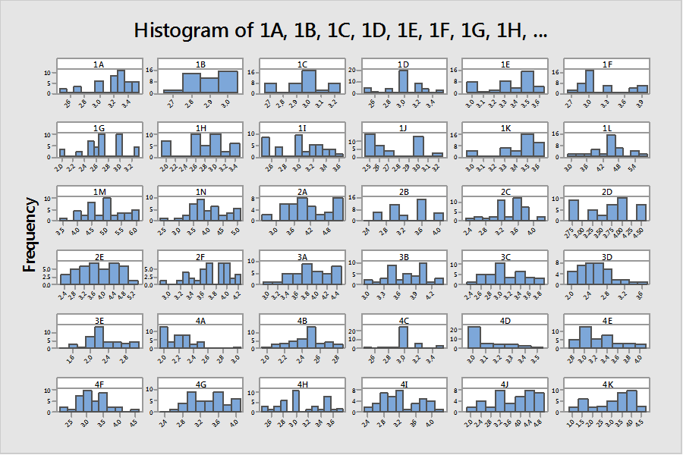
Fig 4.14: Histogram (RH)

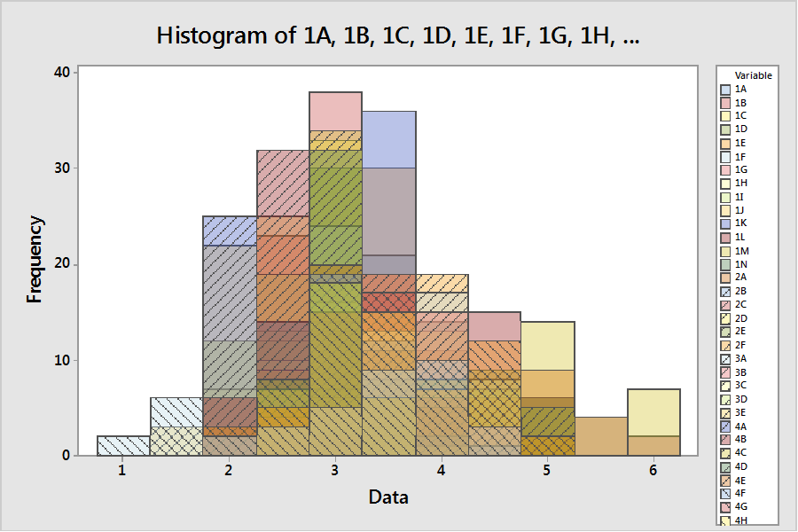
Fig 4.15: Histogram Combined (RH)
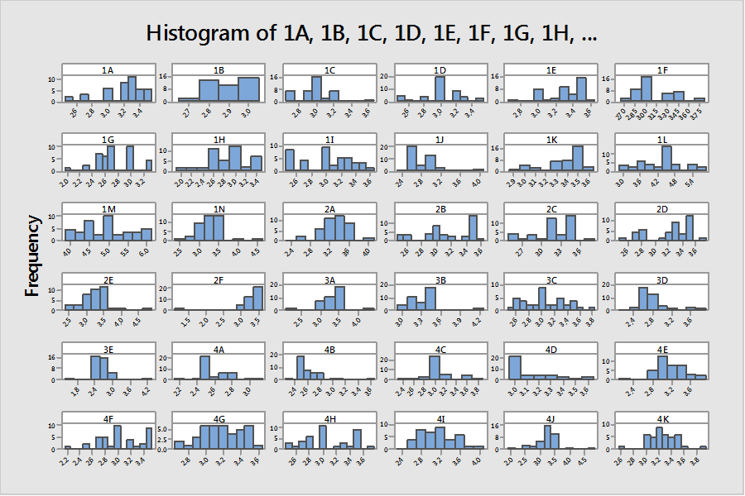
Fig 4.16: Histogram (LH)

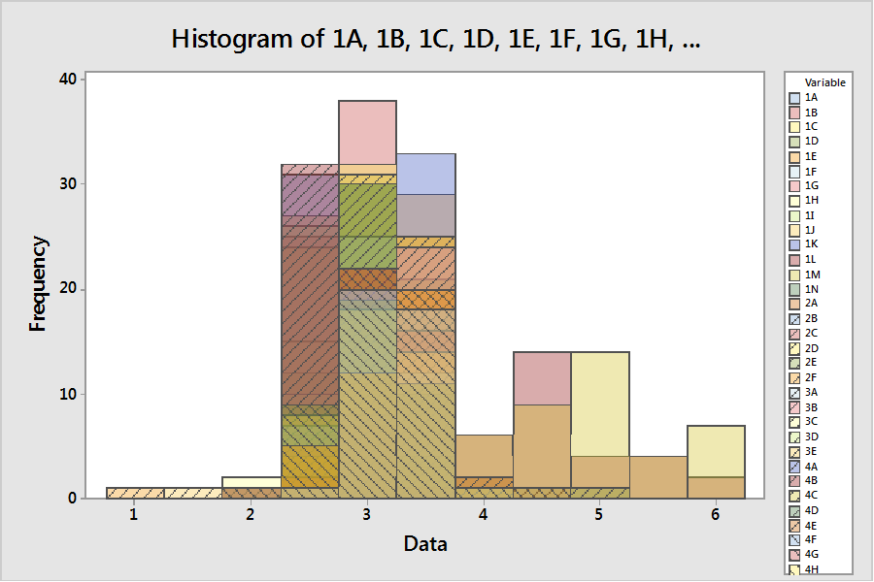
Fig 4.17: Histogram (LH)
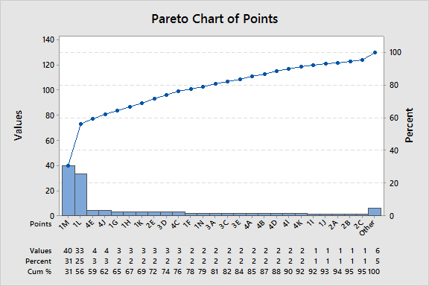
Figure 4.18: Pareto Chart (LH)

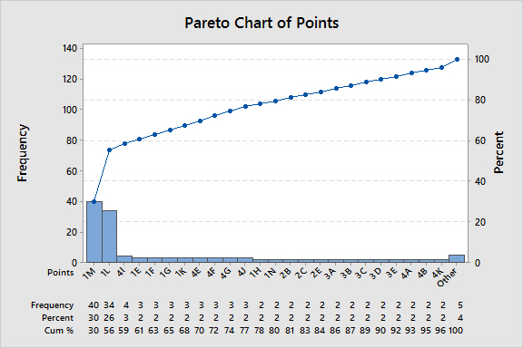
Fig 4.19: Pareto Chart (RH)
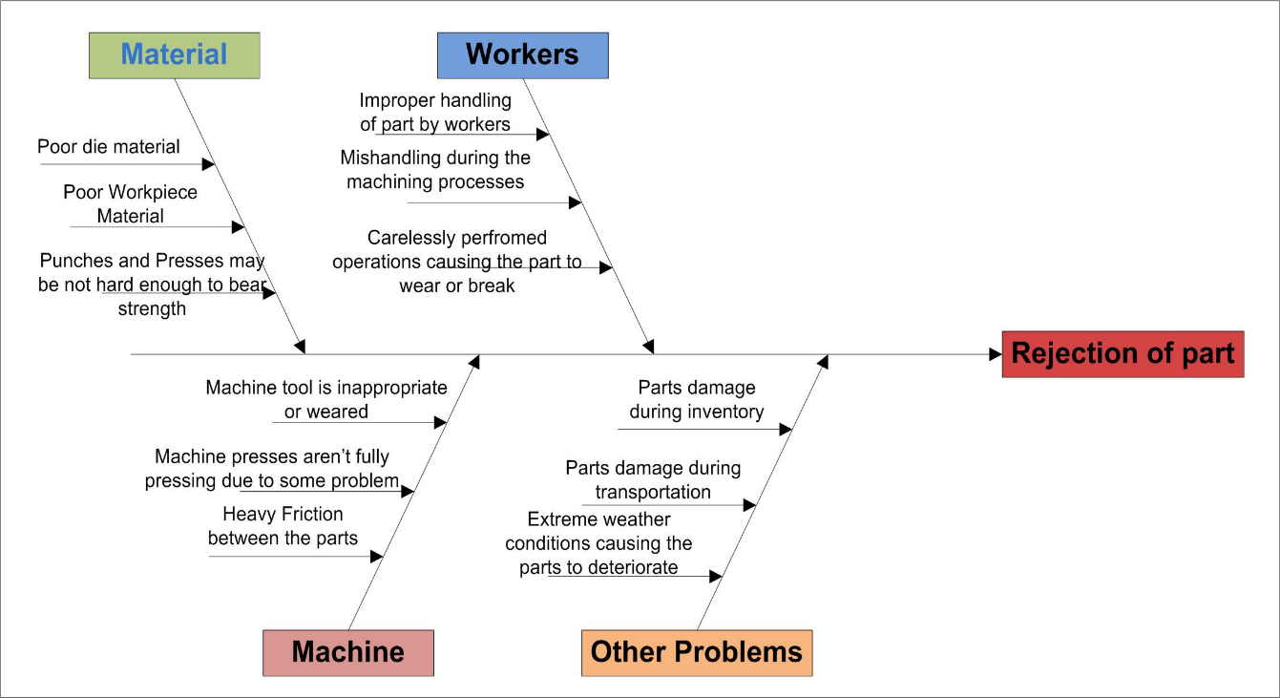
Fig: 4.20: Fishbone Diagram for rejection of part

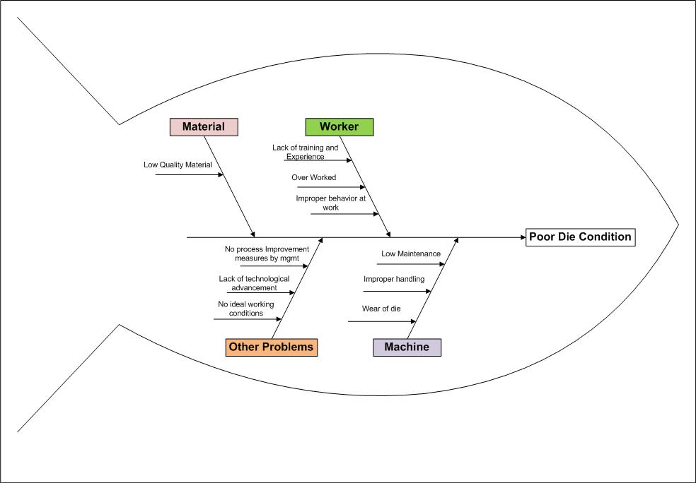
Fig 4.21: Fishbone Diagram for poor dies condition

Fig 4.22: Part - A Rejection rate (overall)

Avg. Performance before Improvement = 82%
Avg. Performance after Improvement = 83.82%
Fig 4.23: Improved Performance of Case Company

Table 4.1 SCPM framework (criteria and their sub-criteria)
No. | SCPM Criteria and Sub-criteria |  | References | Short Description
1 | Manufacturing (X1)
Sub-criteria | X11 | Manufacturing lead time | Gunasekaran et al. (2004)  Gaudenzi & Borghesi (2006)  Bhagwat & Sharma (2007)  Chang, Wysk & Wang (2006) | “Timeframe between the arrival time of material used for product development and product completion time”
 | X12 | Rejection rate |  | “The percentage of processed parts that are rejected for a fixed period of time or lot of pieces”
 | X13 | Machine downtime |  | “Time of a factory or a machinery not in operation as a result of a malfunction or inoperative”
 | X14 | Overtime rate |  | “Time required to fulfill a task beyond the allocated time”
2 | Purchasing/Procurement (X2)
Sub-criteria | X21 | Order receiving on time | Shepherd & Günter (2011)  Bhagwat & Sharma (2007)  Kaplan & Norton (1992)  Gunasekaran et al. (2004)  Supply Chain Council (2012) | “No. of orders received within the lead time”
 | X22 | Purchasing cost |  | “The direct and in direct cost associated in purchasing”
 | X23 | Ordering cost |  | “Cost associated with issuing the purchase order”
 | X24 | Lot rejection rate |  | “Percentage of items received from customer not meeting specification”
 | X25 | Late deliveries |  | “No. of orders that are received beyond the required time”
3 | Warehousing (X3)
Sub-criteria | X31 | Order fulfillment rate (warehousing) | Gunasekaran et al. (2004)  Supply Chain Council (2012)  Gaudenzi & Borghesi (2006)  Beamon (1999) | “A combination of delivery reliability and order completeness (warehouse perspective)”
 | X32 | Reconciliation error |  | “The difference in inventory between actual and in system”
 | X33 | Inventory turns |  | “Number of times a company sells and replaces its inventory within a given period”
 | X34 | Inventory aging |  | “Inventory not utilized for a long period of time”
 | X35 | Damages in warehouse |  | “Damage products during handling and not able to deliver”
 | X36 | Overtime in warehouse |  | “Time required to fulfill the task in a warehouse beyond the allocated time”
4 | Logistics/Transportation (X4)
Sub-criteria | X41 | Freight cost/unit | Gaudenzi & Borghesi (2006)  Shepherd & Günter (2011)  Gunasekaran et al. (2004)  Gunasekaran et al. (2001) | “Transportation cost that are incurred for delivering goods from warehouse to customers”
 | X42 | Damages during transportation |  | “Damaged inventory (raw or finished goods) during transportation”
 | X43 | On time delivery |  | “Percentage of order that are/can delivered on time without any damage from warehouse to customer”
 | X44 | Delayed shipment rate |  | “Delay in delivery due to transporter”
 | X45 | Back order rate (logistic) |  | “No. of orders that cannot be delivered due to unavailability of raw material or finish good”
 | X46 | Claims due to wrong deliver |  | “Complain from customers due to miss handling or products not as per specifications”
5 | Customer Satisfaction/Service Level (X5)
Sub-criteria | X51 | Order fill rate (customer) | Closs, Nyaga, & Voss, (2010)  Ouyang & Chuang,(2001)  Huang, Sheoran, & Keskar(2005) | “A combination of delivery reliability and order completeness (customer perspective)”
 | X52 | Back order rate (customers) |  | “No. of orders that cannot be delivered due to unavailability of raw material or finish good”
 | X53 | Meeting deadlines |  | “Orders delivered on time”
 | X54 | Correct delivery rate |  | “Orders delivered to customer as per specification”
6 | Financial Measure/Financial Ratio (X6)
Sub-criteria | X61 | Earnings before interest and tax (EBIT) | Goldstein, Ju, & Leland (2001)  Poston & Grabski (2001)  Eljelly, (2004) | “Indicator of a company’s profitability, calculated as revenue minus expenses, excluding tax and interest. EBIT = Revenue – Operating Expenses”
 | X62 | Cost of goods sold |  | “Cost of final products includes financial cost, direct and indirect cost, overtime, manufacturing cost, profit etc.”

Source: Put together from Dweiri and Khan (2012)

Table 4.2: Data of Case Company
Major Criteria | Sub-Criteria |  | May | June | July | Aug
Manufacturing | Manufacturing or process cycle time or production lead time = actual / standard lead time | X₁₁ | 0.77 | 0.57 | 0.67 | 0.69
 | Rejection rate (%) (defects) | X₁₂ | 0.84 | 0.84 | 0.84 | 0.91
 | Machine downtime due to maintenance/unavailability of raw material | X₁₃ | 0.77 | 0.76 | 0.67 | 0.69
 | Overtime rate (%) | X₁₄ | 0.55 | 0.36 | 0.488 | 0.47
Purchasing | On time order receive (%) = no. of orders received on time / total orders due | X₂₁ | 0.91 | 0.94 | 0.98 | 0.97
 | Procurement cost ($) (%) = current / last cost of procurement | X₂₂ | 0.15 | 0.21 | 0.33 | 0.26
 | Ordering cost | X₂₃ | 0.26 | 0.12 | 0.36 | 0.21
 | Lot rejection rate (due to wrong delivery etc.) | X₂₄ | 0.84 | 0.84 | 0.84 | 0.91
 | Delay in receiving order | X₂₅ | 0.79 | 0.89 | 0.96 | 0.89
Warehouse | Order fulfilment rate (%) for the warehouse = order delivered to internal customer / total order received | X₃₁ | 0.99 | 0.94 | 1.00 | 0.91
 | Inventory turns / year (%) = current / last inventory turns | X₃₂ | 0.84 | 0.86 | 0.91 | 0.92
 | Reconciliation error (difference between actual and inventory system quantity) (%) | X₃₃ | 0.07 | 0.02 | 0.03 | 0.1
 | Inventory aging (%) | X₃₄ | 0.60 | 0.70 | 0.49 | 0.66
 | Damages (%) | X₃₅ | 0.90 | 0.80 | 0.91 | 0.77
 | Overtime (%) | X₃₆ | 0.45 | 0.36 | 0.30 | 0.60
Logistics | On time delivery (to customer) (%) = order delivered on time / total order handled by transporter | X₄₁ | 0.97 | 0.91 | 0.81 | 0.86
 | Delayed Shipment rate | X₄₂ | 0.79 | 0.65 | 0.57 | 0.59
 | Freight Cost ($./unit) = current / last freight cost /unit | X₄₃ | 0.93 | 1.00 | 0.91 | 1.00
 | On time delivery (%) | X₄₄ | 0.77 | 0.74 | 0.88 | 0.89
 | Backorder rate (% or in terms of no. of order) | X₄₅ | 0.88 | 0.88 | 0.87 | 0.86
 | Claims due to transportation (damages or delay) ($ value or %) | X₄₆ | 1.00 | 0.90 | 0.91 | 0.96
Customer Satisfaction | Order fill rate (%) = no. of orders fulfil / no. of orders received | X₅₁ | 0.99 | 0.91 | 0.98 | 0.91
 | Meet promised date (%) | X₅₂ | 0.94 | 0.84 | 0.88 | 0.81
 | Backorder rate (%) | X₅₃ | 0.90 | 0.88 | 0.84 | 0.848
 | Correct delivery rate (%) = order delivered on time / total orders received by customer | X₅₄ | 0.83 | 0.80 | 0.99 | 0.91
Financial Ratio | Earnings before interest and tax (EBIT) = current / last revenue | X₆₁ | 0.97 | 0.91 | 0.94 | 0.95
 | Cost of goods sold (COGS) = current / last cost of products | X₆₂ | 1.00 | 0.99 | 0.93 | 0.92

Table 4.3: Data for Process Improvement
Cycle Time | 0.261
Rejection Rate | 0.451
Machine Downtime | 0.169
Overtime | 0.119

Table 4.4: Defect and Cause
No. | Defect | Cause | Remedies
1 | Burr collection at draw die | Thickness of the component | Polish the draw die and punch. Use good lubricants. For every three strokes remove the burr on the draw
2 | Thinning | Clearance is insufficient, improper radius on punch & die, drawing speed is more | Appropriate clearance is required on each draw in punch & die, check the radius on draw die & punch and reduce the drawing
3 | Cracking | Insufficient clearance,  lubrication problems.  Insufficient draw radius  on punch & die. Drawing speed is more. | Appropriated clearance is required on each draw, used good lubricants,  Check the radius on punch & die reduce the drawing speed & check the reduction ratio.
4 | Spring back | During bending, after bending pressure is released, the elastic stresses remain in the bend area causes slight decrease in the bend angle (spring back). | Lesser angle is provided than the required angles.
5 | Notching edge pull-up | Due to excessive cutting clearance between the punch & stripper plate. | Welding is done to stripper plate and  maintained the clearance between the punch and stripper plate
6 | Pitch variation | Due to more clearance in  Strip guides | Fitted the pilot and maintained the pilot dimensions accurately
7 | Dent mark on blanked component | Burr on lower surface of  the floating stripper plate | Spotting is done throughout the floating stripper plate (Blue  matching)
8 | Strip is sticking to  the blanking punch | Less stripping force due to  short length of  polyurethane rubber | New more length polyurethane rubbers add in between floating  stripper plate and support plate
9 | Slug was jammed in  piercing die blocks | Less draft in piercing die  Blocks | Increased the draft angle of the piercing die blocks
10 | Tight strip movement | Clearance in strip guide  not correct | Clearance provided as per  requirement

