Social Sustainable Supplier Evaluation and Selection: A Group Decision Support Approach

Chunguang Bai
School of Management and Economics
University of Electronic Science and Technology of China
No.2006, Xiyuan Ave, West Hi-Tech Zone, 611731, Chengdu, P.R.China
Tel: 86-13664228458
E-mail: Cbai@uestc.edu.cn

Simonov Kusi-Sarpong (Corresponding Author)
Eco-Engineering and Management Consult Limited
Ti’s – Adentan, Accra - Ghana

Portsmouth Business School
University of Portsmouth
Portland Building, Portland Street
Portsmouth PO1 3AH, United Kingdom
E-mail: simonov2002@yahoo.com

Hadi Badri Ahmadi
School of Management Science and Engineering
Dalian University of Technology
No .2 Linggong Road, Ganjingzi District
Dalian Liaoning Province (116023) P.R of China
Tel: (86188) 0428 3152
E-mail: hadi@mail.dlut.edu.cn

Joseph Sarkis
Foisie School of Business
Worcester Polytechnic Institute
100 Institute Road
Worcester, MA 01609-2280, USA
Tel: (508) 831-4831
E-mail: jsarkis@wpi.edu

Social Sustainable Supplier Evaluation and Selection: A Group Decision Support Approach

Abstract - Organizational and managerial decisions are influenced by corporate sustainability pressures. Organizations need to consider economic, environmental and social sustainability dimensions in their decisions to become sustainable. Supply chain decisions play a distinct and critical role in organizational good and service outputs sustainability. Sustainable supplier selection influences the supply chain sustainability allowing many organizations to build competitive advantage. Within this context, the social sustainability dimension has received relatively minor investigation; with emphasis typically on economic and environmental sustainability. Neglecting social sustainability can have serious repercussions for organizational supply chains. This study proposes a social sustainability attribute decision framework to evaluate and select socially sustainable suppliers. A grey-based multi-criteria decision-support tool composed of the ‘best-worst method’ (BWM) and TODIM (TOmada de Decisão Interativa e Multicritério – in Portuguese “Interactive and Multicriteria Decision Making”) is introduced. A grey-BWM approach is used to determine social sustainability attribute weights, and a grey-TODIM method is utilized to rank suppliers. This process is completed in a group decision setting. A case study of an Iranian manufacturing company is used to exemplify the applicability and suitability of the proposed social sustainability decision framework. Managerial implications, limitations, and future research directions are introduced after application of the model.

Keywords: sustainability; social sustainability; sustainable supply chains; best worst method; BWM; TODIM

- Introduction
Regulatory demands and stakeholder awareness, have increased pressures and caused organizations to explicitly consider sustainability in their decisions (Luthra et al., 2017; Mathivathanan et al., 2017; Rezaei et al., 2016; Shi et al., 2017; Zhang et al., 2016). Firms are not only reacting to pressures, but have also started to recognize the benefits and importance of sustainability initiatives to build competitive advantage (Wolf, 2014; Bai et al., 2017; Kusi-Sarpong et al., 2016a, b; Agyemang et al., 2018).
Various initiatives are adopted for these organizations to remain competitive including supply chain decisions such as low-cost sourcing (D'Eusanio et al., 2018). But organizations have been faced with social issues resulting from their supply chain operations; typically from their suppliers (upstream) (Morais and Silvestre, 2018). For example, poor testing of materials by a supplier may result in dangerous and harmful products flowing to consumers with higher costs, poorer reputation, and lowered revenue as outcomes (Klassen and Vereecke, 2012).
These suppliers’ serious social consequences range from strike actions due to poor work, health and safety conditions, to employee rights related to poor employment practices such as pay inequities and slave labor conditions (Badri Ahmadi et al., 2017a, b). These supplier actions result in production losses and the inability to meet buying firms’ deadlines. Large multinational companies such as Nike, Apple, and Wal-Mart have faces all these pressures and are addressing these issues by focusing on the supply chain (Klassen and Vereecke, 2012).
Since suppliers provide raw materials, services and finished products as inputs to organizational supply chains, their activities are critical to helping organizations achieve a sustainable and collaborative competitive edge. Supplier performance directly affects the performance of buying organizations. To more fully address negative societal images a buying organization requires careful supplier evaluation and selection. The resource based view (RBV) (Barney et al., 2001) is a valuable theoretical lens to argue for the need for social sustainability in organizational supply chains (Gold et al., 2010). RBV stipulates that organizations can build competitive capabilities, and advantages, by selecting socially sustainable suppliers. Socially sustainable suppliers offer valuable intangible resources that help improve organizational image, improve business continuity, and reduces cost. Supplier selection is an important and strategic decision in supply chains that can improve overall social sustainability of products and services (Sucky, 2007; Badri Ahmadi et al., 2017a). Selecting and working with socially conscious suppliers is important for maintaining buying organization reputation. Organizations need to consider external sustainable capabilities, practices and strategies, especially with respect to their suppliers (Kusi-Sarpong et al., 2015, 2018a). The sustainable supplier selection process can help determine and balance economic-based supplier capabilities while considering social and environmental capabilities and attributes (Genovese et al., 2010). Thus, using RBV, appropriate sustainable supplier selection can help organizations build or maintain their own social and other sustainability capabilities contributing to their strategic competitive advantages.
Many studies have investigated supplier selection and evaluation; many focusing on traditional business and economic criteria (e.g. Pitchipoo et al., 2013; Sevkli, 2010; Labib, 2011; Dotoli & Falagario, 2012; Rao et al., 2017a). A growing number have incorporated environmental sustainability (green) criteria (e.g. Kuo & Lin, 2012; Genovese et al., 2013; Lu et al., 2007; Büyüközkan, 2012; Rao et al., 2015, 2017b, 2017c) . Other studies have considered supplier selection with broader sustainability criteria (e.g Azadnia et al., 2015; Gualandris and Kalchschmidt, 2016; Dai and Blackhurst, 2012; Moheb-Alizadeh & Handfield, 2017; Fabbe-Costes et al., 2014; Khan et al., 2018; Amindoust, 2018). Few studies have incorporated social sustainability (Badri Ahmadi et al. 2017b; Mani et al., 2016a, b; Sarkis and Zhu, 2018), none of these studies have focused on selecting and evaluating suppliers solely on their social sustainability performance.
Supplier selection is a multi-criteria decision-making (MCDM) situation. Many MCDM models have been proposed and used to support supplier selection including AHP-QFD (Dai and Blackhurst, 2012), FAHP-GRA (Pitchipoo et al., 2013), Fuzzy ELECTRE (Sevkli, 2010), ANP-DEA (Kuo & Lin, 2012), DEA-TOPSIS (Dotoli & Falagario, 2012). Typically these techniques heavily rely on interactive decision maker involvement, with substantial input from decision makers. This reliance may cause greater decision maker fatigue, rendering them less practical.
In this paper, an integrated TODIM, BWM (best-worst method) and grey number MCDM approach is introduced for socially sustainable supplier evaluation and selection. TODIM provides value by solving an MCDM problem that incorporates decision maker behavior. In sustainability-based decision analysis decision makers are often encumbered with subjective and ambiguous linguistic information. Grey-TODIM provides an opportunity to accommodate decision maker psychological behavior under risk while simultaneously capturing sustainability decision environment uncertainty; something that other MCDM approaches do not complete simultaneously.
TODIM requires additional input information, the relative weights of attributes. This requirement limits its application. BWM is can effectively address this TODIM requirement. BWM can generate relative attribute weights. Hence, we extend grey-BWM to determine the relative attribute weights by modifying the objective function and integrating grey numbers. This multistep method can more effectively support socially sustainable supplier selection problems considering decision maker behavior, through prospect theory, in uncertain environments. BWM helps make TODIM more complete, and more effective, to apply. Integrating BWM and TODIM methodologies helps to lessen decision maker input and interaction. This study seeks to address these gaps.
This study adopts and integrates a previously proposed social sustainability attribute framework into the supplier selection decision problem (see Badri Ahmadi et al. (2017b)), with the joint grey BWM and TODIM approach. Even though integration of sustainability triple-bottom-line dimensions (environmental, social and economic) into the supplier selection decision offers a truly sustainable supplier, this study focuses only on the use of social dimensions. This focus offers deeper insights on social sustainability supplier selection and serves as input for comprehensive sustainable supplier selection decisions. The specific objectives of this paper include:
- Introducing a multiple attribute group decision approach integrating grey set theory with BWM and TODIM for the supplier selection decision;
- Investigating a multiple attribute socially sustainable supplier evaluation and selection process within a manufacturing sector context;
- Providing insights in the practical application of this model within an emerging economy context (Iran).
This study makes the following academic and managerial contributions: (1) proposes a social sustainability attributes framework for guiding general social sustainability decision making; (2) evaluates a multi- criteria decision-making (MCDM) model integrating interval grey number based BWM and TODIM. Part of this contribution is a newly formulated BWM model; (3) BWM and interval grey number are jointly used to overcome TODIM limitations using expert uncertainty judgments and behavior. The integration of these psychological risk beliefs extends the literature in this area as well.
The rest of this paper is organized as follows. Section 2 presents background on sustainable supply chain management, sustainability supplier selection, a social sustainability attributes framework, and sustainable supplier evaluation and selection models. The research methodology comprising methods and tools is discussed in Section 3. In Section 4, a practical case application using the proposed tools is provided for evaluating the decision support approach’s practical validity. As part of this practical evaluation a sensitivity analysis is presented in Section 5. Additional discussion and implications including managerial and post-selection benchmarking discussion are presented in Section 6. A summary and conclusion of the study with identified limitations and opportunities for further research are presented in Section 7.
- Background
This section initially presents an overview of sustainable supply chain management and then discusses sustainability supplier selection. Thereafter, a social sustainability attributes framework is introduced. The section concludes with sustainable supplier evaluation and selection decision models background discussion.
2.1. Overview of Sustainable supply chain management
Sustainable supply chain management (SSCM) is the process of managing information and material across the entire supply chain taking into consideration environmental, social and economic attributes simultaneously (Govindan et al., 2013; Lin and Tseng, 2016; Reefke and Sundaram, 2018). SSCM helps minimize supply chain operations negative impacts and improves company efficiency from environmental, economic and social perspectives (Tseng et al., 2008; Wong et al., 2014; Chacón Vargas et al., 2018). Managing these sustainability initiatives requires organizations to balance responsibilities for environmental, social and economic issues (Bai and Sarkis, 2010a; Sarkis and Zhu, 2018). SSCM studies have devised and addressed various industrial typologies and contexts (Christmann and Taylor, 2001;Tseng et al., 2015; Azadnia et al., 2015; Govindan et al., 2016; Gualandris et al., 2016; Ghadimi et al., 2017; and Badri Ahmadi et al., 2017a, b).
Sustainability and sustainable development can enhance organizational supply chain operations performance contributing to general organizational competitiveness (Chardine et al., 2014). Sustainability is usually considered as a mix of economic, environmental and social development (Gauthier, 2005). SSCM initiatives provide a pathway for organizations in achieving a “win-win-win” sustainable outcome (Saberi et al., 2018; Danese et al., 2018; Das, 2018). Firms adopting these initiatives become more focused on promoting sustainable development; preparing themselves for new global sustainability initiatives such as the United Nations’ Sustainable Development Goals (SDG) where sustainable production and consumption are important goals (Griggs et al., 2013).
2.2. Sustainability-based supplier selection
The critical roles played by suppliers in supply chain management and their impacts on organizational, product, and goods, sustainable performance require that their evaluation and selection be rigorous and robust (Ageron et al., 2012; Asadabadi, 2016). With the emergence of sustainable supply chain management, studies have identified the need to incorporate environmental and social attributes into the traditional economic-based supplier selection decisions (Zhu et al., 2007; Bai and Sarkis, 2010a; Song et al., 2017). Many studies on sustainable supplier selection decisions have emerged (e.g. Amindoust et al., 2012; Azadnia et al., 2015; Badri Ahmadi et al., 2017a; Bai and Sarkis, 2010a; Genovese et al., 2010; Govindan et al., 2013; Sarkis and Dhavale, 2015).
Sustainable supplier selection decision tools have focused on environmental and economic dimensions; giving less attention to social dimensions. An increasing rise of social and societal issues are facing supply chains, especially in emerging economy nations. Various issues including labour agitation from abusive practices; poor working conditions; and occupational, health and safety problems inherent in organizations, have warranted the need to focus on the social sustainability dimension when selecting suppliers (Mani et al., 2016a, b).
Using RBV as the theoretical lens, we argue that there exists a relationship between social sustainability practices and building competitive advantage and improved economic performance. For example human resource sustainability has been linked to improved competitive advantages along the supply chain and in supply chain partners (Pullman et al., 2009; Mani et al., 2018). Part of this competitive advantage is through lessened costs where some have found that social sustainability employee practices resulted in reduced costs (Sroufe and Gopalakrishna-Remani, 2018). The argument is that sustainability characteristics of supply chain partners enhance the intangible resources available to a buying organization helping them build a competitive advantage. Thus, effective sustainability-based supplier selection can build necessary competitive resources for buying organizations.
Recent studies (e.g. Badri Ahmadi et al., 2017b; Mani et al., 2016a, b) have attempted to address the gap of focusing only on social sustainability from emerging economies. These initial works have not given as much attention to broader supply chain management social sustainability implementation decisions. Studies have incorporated and investigated social sustainability when selecting emerging economy suppliers (e.g. Ehrgott et al., 2011), but these works focused on drivers and benefits to be realized for organizations from adopting these initiatives. Few studies on social sustainability supplier selection from emerging economies exist. This study expands on previous studies this area by introducing a new typology for investigating social sustainability through supplier selection in an emerging economy nation.
2.3. A social sustainability attributes framework
Few studies have introduced social sustainability attributes frameworks for organizational decision support and promoting sustainability. This study uses a social sustainability attributes decision framework (Badri Ahmadi et al., 2017b) in an emerging economy manufacturing sector. The framework consists of eight attributes including: ‘Work health and safety’; ‘Training education and community influence’; ‘Contractual stakeholder influence’; ‘Occupational health and safety management system’; ‘The interests and rights of employees’; ‘The rights of stakeholders’; ‘Information disclosure’; and ‘Employment practices’. The broader focus of this study is to evaluate, rank and select sustainable suppliers based on organizational social sustainability attributes. The supply chain social sustainability attributes are summarized with brief explanations in Table 1.

Table 1: The social sustainability attributes of supply chains
Attributes | References | Short description
Work health and safety (SSA1) | Badri Ahmadi et al. (2017a), Azadnia et al. (2015), Amindoust et al. (2012), Aydın Keskin et al. (2010) | This relates to the firms’ focus on both their operation’s and that of potential supplier’s operation’s health and safety practices.
Training education and community influence (SSA2) | Azadnia et al.(2015), Badri Ahmadi et al. (2017a) | This relates to the transfer and impact of knowledge from employer to its employees and the community within which they operate.
Contractual stakeholders’ influence (SSA3) | Presley et al. (2007), Govindan et al. (2013), Badri Ahmadi et al. (2017a) | This relates to the level of attention a potential supplier pays to its stakeholders to get involved in its operations.
Occupational health and safety management system (SSA4) | Bai and Sarkis (2010a), Azadnia et al. (2015), Luthra et al. (2017) | This relates to workers’ health and safety, and welfare at the workplace.
The interests and rights of employees (SSA5) | Luthra et al. (2017), Amindoust et al. (2012),  Kuo et al. (2010) | This has to do with factors that promote employee concerns and related sustainable employment issues.
The rights of stakeholders (SSA6) | Amindoust et al. (2012), Kuo et al. (2010), Luthra et al. (2017) | This relates to the rights of society, which has a stake in the business.
Information disclosure (SSA7) | Kuo et al. (2010),  Luthra et al. (2017), Amindoust et al. (2012) | This has to do with firms providing their clients and stakeholders with related information about the materials being used during the manufacturing process and carbon emissions.
Employment practices (SSA8) | Bai and Sarkis (2010a),  Govindan et al. (2013) | This concerns programs and practices related to employees.
Source: Badri Ahmadi et al. (2017b)
2.4. Sustainable supplier evaluation and selection decision models
Supplier selection, as a multi-criteria decision problem has received much attention in the literature; with an increasing number of decision support techniques applied. A large increase in studies has occurred due to the complexity of sustainable supplier selection. This complexity includes inclusion of numerous dimensions and attributes with varying numerical and factor characteristics, such as tangibility and level of decision making required. The need for MCDM tools in this context is self-evident.
Sustainability or green supplier evaluation and selection MCDM tools have been popular (Bai and Sarkis, 2010a, 2010b; Trapp and Sarkis, 2016). Fuzzy MCDM methods have also been popular. Fuzzy interfaces (Amindoust et al., 2012), fuzzy-TOPSIS (Govindan et al., 2013), integrated fuzzy logic and influence diagrams (Ferreira and Borenstein, 2012) have each been used for assessing and ranking suppliers.
Other, sustainable supplier selection MCDM tools include TOPSIS, VIKOR and Grey Relational Analysis (GRA) (Rezaei et al., 2016; Banaeian et al., 2016). Hybrid methods of AHP, ANP, ELECTREE II and VIKOR have also seen significant investigation (Jeya et al., 2016; Yo and Hou, 2016). A number of literature surveys on supplier selection MCDM approaches exist (de boer et al., 2001; Ho et al., 2010; Chai et al., 2014; Govindan et al., 2015; Asadabadi, 2017).
Most of these MCDM decision support tools are based on the assumption that decision makers are rational (Bai et al., 2016). However, the psychological behavior of the decision maker plays an important role in decision analysis, and should be considered in the decision-making process. TODIM uses prospect theory for solving MCDM problems. Prospect theory considers decision maker psychological behaviors (Zhang and Xu, 2014). Table 2 provides a summary of some recent papers that apply TODIM and their context.
Table 2: Some recent papers that apply TODIM and the context
Method(s) | Context | Author(s)
IF-RTODIM | Generalizing the Fuzzy-TODIM method to deal with intuitionistic fuzzy information | Lourenzutti and Krohling (2013)
Rough set theory-TODIM | Supplier selection and evaluation in sustainable supply chains | Li et al.(2018)
Fuzzy-TODIM | Evaluating green supply chain practices under uncertainty | Tseng et al.(2014)
TOPSIS-TODIM | Investigating groups decision-making with different opinions, heterogeneous types of information and criteria interaction | Lourenzutti et al.(2017)
TODIM-FSE | Introduces a multi-criteria method for solving oil spill classification problems | Passos et al. (2014)
TOPSIS-TODIM | Employing Hellinger distance concept to the MCDM context to assist the models to deal with probability distributions | Lourenzutti and Krohling (2014)
TODIM-PROMETHEE | Selecting waste-to-energy plant site based on sustainability perspective | Wu et al. (2018)
TODIM | Multi-criteria rental evaluation of residential properties in Brazil | Gomes and Rangel (2009)
TODIM | Proposing a risk decision analysis method in emergency response context | Li and Cao (2018)
TIFNs-TODIM | Investigating a renewable energy selection problem | Qin et al. (2017)
Variations in rational and irrational decision-maker preferences and judgments causes greater uncertainty. Assigning exact values to precisely describe decision-maker judgments, may become a fool’s errand. Interval grey numbers are useful for handling ambiguous data and vague linguistic expressions (Bai and Sarkis, 2013). A grey based-TODIM approach can take advantage of behavioral and data variations (Sen et al., 2015).
Most grey MCDM approaches use some heuristics, sometimes unjustified, or they perform a transformation in the dataset. For example, Sen et al. (2015) utilized crisp weights for the evaluation criteria in their grey-TODIM. Dou et al. (2014) applied a grey aggregation method, a variation of the CFCSs (Converting Fuzzy data into Crisp Scores) defuzzification method, which arrives at crisp values. Consequently, in order to consider the decision maker’s psychological behavior, solving an MCDM problem entirely with grey information, without a requirement for transformation to crisp data, can help make these evaluations more efficient.
TODIM requires relative attribute weights to be determined, limiting its application. Using lessened decision-maker input, BWM is capable of computing the attributes’ relative weights; making it easier and more efficient to apply. Fewer decision-maker interactions and inputs can prove more advantageous for MCDM techniques due to lack of time, decision-maker fatigue, and lack of interest in providing information. BWM is extended to incorporate decision-making judgments under various uncertain and grey environments. Table 3 provides a summary of some recent papers that apply BWM and the context.
Table 3: Some recent papers that apply BWM and the context
Method(s) | Context | Author(s)
BWM | Supply chain social sustainability assessment | Badri Ahmadi et al. (2017b)
Fuzzy BWM-COPRAS | Analyzing key factors of sustainable architecture | Mahdiraji et al. (2018)
BWM-ELECTRE | Decision framework for effective offshore outsourcing adoption | Yadav et al .(2018)
BWM | A supply chain sustainability innovation framework and evaluation methodology | Kusi-Sarpong et al.(2018)
BWM-VIKOR | Assessing airline industry service quality | Gupta (2018a)
BWM-Fuzzy TOPSIS | Evaluating the performance of manufacturing organizations using Green Human Resource Management practices | Gupta (2018b)
SERVQUAL-BWM | Assessing the quality of airline baggage handling systems | Rezaei et al.(2018)
Taguchi Loss Function-BWM-VIKOR | Airports evaluation and ranking model | Shojaei et al. (2018)
BWM | Measuring different companies’ R&D performance | Salimi and Rezaei. (2018)
No previous studies have employed BWM approach to handle the MCDM problems using uncertain and grey information. The BWM formulation is also advanced in this study to determine relative weights information for each attribute.
In summary, a Grey-BWM and Grey-TODIM methodology is applied to social sustainable supplier selection and evaluation using decision-maker opinions and behavioral characteristics. These combined tools make the methodology more realistic and flexible.
3. Research Methodology
A case study approach is adopted in this study. The study uses industrial managers from an Iranian manufacturing company. These managers evaluate and select a suitable supplier based on supplier social sustainability implementation levels. The company’s respondent managers were selected based on a combination of purposive and self-selection sampling approaches. The approach and tools utilized to aid this evaluation are first detailed in this section. Details of the case company, suppliers, and respondents are presented in section 4.
3.1. Grey number, BWM and TODIM background
To introduce the proposed social sustainability supplier evaluation and selection decision method, we first describe the interval grey number, followed by BWM and TODIM background and notation.

3.1.1. Interval grey numbers
Grey system theory (Deng, 1989), is used to treat vagueness and ambiguity in the human decision-making process. Scholars have successfully applied interval grey system theory in economics, medicine, geography, agriculture, industry, and supply chain management (Bai and Sarkis, 2013). Interval grey numbers can effectively model decision-maker judgments for social sustainability supplier evaluation and selection decision-making. Definitions and operations of interval grey numbers include the following:
Definition 1: An interval grey number 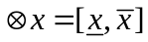 is defined as an interval with known lower and upper bounds, but unknown distribution information. That is,
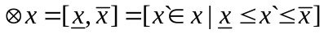 (1)
where is the minimum possible value, is the maximum possible value. Obviously, if 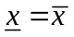 then the interval grey number 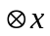 is reduced to a real crisp number.
Definition 2: Given two interval grey numbers 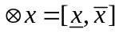 and 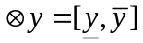, the basic mathematical operations of the interval grey number are defined by the following relationships:
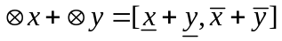 (2)
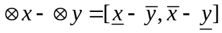 (3)
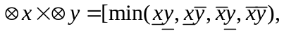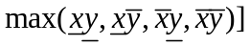 (4)
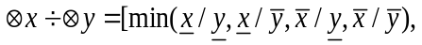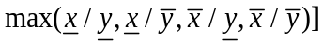 (5)
Definition 3: Given two interval grey numbers and , the Euclidean distance measure between two grey numbers is:
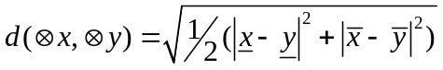 (6)

3.1.2. The best-worst method
BWM (Rezaei, 2015) is a comparison-based MCDM technique for determining attribute weights. BWM needs less pairwise comparison data and inputs than AHP tools. The results produced by BWM are typically more consistent and robust (Rezaei et al., 2016). BWM has been used in several fields, such as transportation, supplier selection, risk identification, and supply chain sustainability innovation (Badri Ahmadi et al., 2017b; Kusi-Sarpong et al., 2018b). BWM (Rezaei, 2015, 2016) requires the following general steps:
Step 1. Determine a set of decision attributes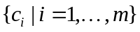.
Step 2. Determine the best attribute (most important) B and the worst attribute (least important) W.
Step 3. Determine the best attribute over all the other attributes. Based on the response given, a resulting vector of Best-to-Others (BO)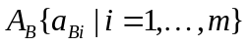 is determined; 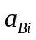 is the preference of the best attribute B over an attribute i.
Step 4. Determine the preference of all attributes over the worst attribute. According to the response given, a resulting vector of Others-to-Worst (OW) 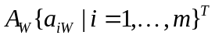is determined. 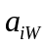 is the preference of an attribute i over the worst attribute W.
Step 5. Compute the optimal weights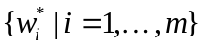. The optimal weights of the attributes will satisfy the following requirements:
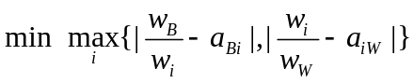 (7)
subject to:
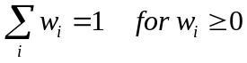
Although BWM has been employed in various real-world problems (e.g. Badri Ahmadi et al., 2017b), a more realistic approach would be to use grey numbers due to decision maker uncertainty and subjectivity. In addition, because TODIM requires relative weights, not weights of attributes, BWM alterations are needed. See section 4.2 expression (12) for the new formulation.

3.1.3. The TODIM method
TODIM (Gomes and Lima, 1992), is a discrete alternative MCDM method based on prospect theory. TODIM is useful for solving MCDM problems that consider decision-maker behaviors (Zhang and Xu, 2014). The method consists of two main stages. In the first stage, the prospect value function is generated to measure the dominance degree of each alternative over other alternatives. It reflects the decision-maker’s behavioral characteristic, such as reference dependence and loss aversion. In the second stage, the overall prospect value of each alternative is calculated and ranked. TODIM has been applied in various fields of MCDM, including green supply chain management (Tseng et al., 2014).
In the TODIM method, initially let 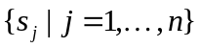 represent the n alternatives, facing the decision-makers, and let be the m attributes. Let 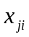 be the performance score for alternative 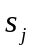 with respect to an attribute. Let 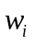 indicate attribute’s weight. The TODIM method has the following steps:
Step 1. Normalize the decision matrix 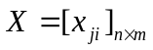 using a normalization method.
Step 2. Calculate the relative weight w_{ir} of attribute c_{i} to the reference attribute c_{r} using expression (8):
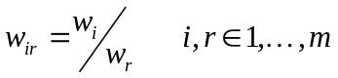 (8)
where 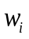 is the weight of the attribute ,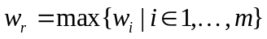.
Step 3. Calculate the dominance degree of over each alternative 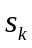 for attribute c_{i} using expression (9):
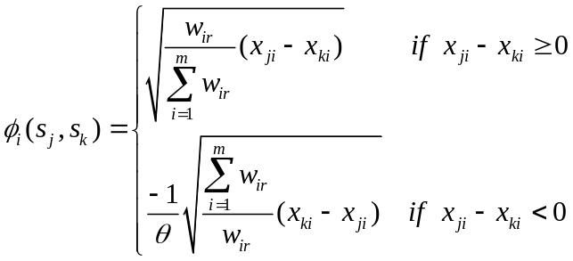 (9)
where is the attenuation factor of the losses. 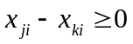 indicates the gain of alternative over alternative for attribute c_{i} , and 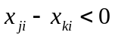 shows the loss of alternative from alternative for attribute c_{i}.
Step 4. Calculate the overall dominance degree of alternative over alternative , for all attributes and alternatives using expression (10):
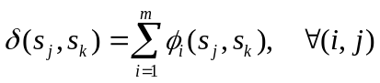 (10)
Step 5. Obtain the global value of alternative using expression (11):
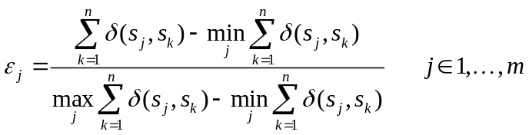. (11)
Step 6: Sort the alternatives by their value 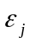.
In order to obtain integrate realistic uncertainties and ambiguities we extend TODIM to incorporate grey numbers. In TODIM method applications, attributes relative importance weights are needed; however, no effective method exists for obtaining these relative weights. This issue limits the TODIM application. To fill this gap, in this paper, we apply grey-BWM for computing the social sustainability attributes relative importance weights.
4. A Case application
4.1. Case problem description
Iran, the case country of this study is an emerging economy nation in Southwestern Asia with relatively early stage sustainable development implementations. The manufacturing sector is especially immature with respect to social sustainability development (Ghadimi et al., 2017; Mani et al., 2016 a, b).
The decision attributes framework and decision support system introduced in this paper is utilized in this case manufacturing company setting. The case company is called “company B” henceforth. Company B (the buying firm) was established in 1966 and after two years in operations initiated production of the Citroen Dyane model vehicle. Company B has recently formed several joint partnerships with a number of automobile manufacturing companies in other countries including Korea and Japan. Different vehicle types are assembled and manufactured by this corporation. Passenger cars and sport utility vehicles (SUVs) in diverse manufacturing sites are manufactured. This firm plays a key role in the Iranian automotive industry. In 2013, company B had a 40 percent market share and became a dominant player in the Iranian passenger vehicle sales market (www.businessmonitor.com/autos/iran).
Company B has planned to improve its social sustainability performance due to a series of concerns and pressures from various local activists (Zailani et al., 2015). Since most automobile parts are outsourced to suppliers; selecting the appropriate suppliers based on social sustainability performance can help improve the buying company’s social performance. Supplier selection is an important starting point to redeem company B’s social image. Building corporate competitive advantage can also occur with appropriate supplier selection. They have taken a strategic stance by focusing on social sustainability supply chain performance. This strategic stance is supported by selecting a socially conscious parts suppliers. Supplier social sustainability implementation levels are used to evaluate the suppliers.
We selected the Iranian automobile manufacturing company (the case company) based on its long existence and operations, which span over 5 decades. Additionally, it has the largest vehicle market share in Iran. Management was interested in this topic as part of its strategic mission. We then purposefully selected experienced and knowledgeable managers who are familiar with the various issues of this study. We identified 14 potential managers and invited them, allowing for self-selection for those who wished to be involved in the study. This self-selection provided us with managers who were willing to commit to the study. This process resulted in 10 of the managers accepting to participate with 4 managers declining.
We then formed a ten member decision making team including a supply manager, assistant supply chain manager, purchasing manager, finance manager, research and development manager, IT manager, production manager, general manager, logistics manager and maintenance manager. We proceeded with this number of managers because we consider it sufficient for providing reliable results; especially from an individual case company. Also when compared to a number of studies in the published literature, there are many that have used 5 or fewer experts (e.g. Dou et al., 2014; Gupta and Barua, 2018). In addition and most recently, Rezaei et al. (2018) in their paper on evaluating quality of baggage handling at airports, made it clear that only 4-10 experts are required for getting reliable data for MCDM analysis. Another recently published paper in IJPR on supply chain sustainability innovation used only 5 experts in their BWM analysis.
Each manager had more than 10 years working experience and was specifically formed to partake in the evaluation process. Table 4 presents the characteristics of managers who were involved in the decision-making process from the case company.

Table 4: Respondent managers from the case company involved in the decision-making process
Expert | Position | Role | Working Experience (Years)
1 | Supply Manager | Management of sourcing contract and warehouse | 10
2 | Assistant Supply Chain Manager | Management of sourcing contract and warehouse | 11
3 | Purchasing Manager | Management of purchasing program implementation and training | 15
4 | Maintenance Manager | Management of maintenance activities | 18
5 | Finance Manager | Management of company's financial budgetary | 17
6 | Research and Development (R&D)Manager | Management of R&D related activities | 20
7 | IT Manager | Management of Information Technology program implementation | 22
8 | Production Manager | Management of different areas of production | 10
9 | General Manager | Management of the firm's marketing and sales functions as well as the daily business operations | 13
10 | Logistics Manager | Management and implementation of complex operations in order to meet customers’ needs | 19

Management then shortlisted five suppliers from their supply-base. These five are Company B’s top suppliers and are evaluated in this study. Characteristics of these suppliers are provided in Table 5.

Table 5: Suppliers characteristics
Supplier | Location | Year of establishment | Workforce size | Turnover ($)/year
Supplier 1 | Tehran | 1999 | 465 | 25,000,000
Supplier 2 | Tehran | 2005 | 352 | 20,000,000
Supplier 3 | Tehran | 1983 | 143 | 30,000,000
Supplier 4 | Tehran | 2009 | 365 | 21,000,000
Supplier 5 | Tehran | 1980 | 215 | 22,000,000

4.2. Applying Grey-BWM and Grey-TODIM to Sustainable Supplier Selection
The Grey-BWM and Grey-TODIM methodology is now applied to the case. The proposed social sustainability supplier evaluation and selection model consists of nine steps. The methodology identifies the ranking of suppliers based on their social sustainability performance.
Step 1: Construct the social sustainability decision system.
The decision system for investment evaluation and selection of the socially sustainable supplier is initially defined. The system is defined by T = (S, C), where S = {s₁, s₂, ..., s_{m}} is a set of m socially sustainable suppliers, and C = {c₁, c₂, ... , c_{n}} is a set of n social sustainability attributes. For this empirical case, let S = {s_{j}, j = 1, 2,...,5} and C = {c_{i}, i = 1, 2,...,8}.
This study uses eight social sustainability attributes using a framework from the literature (Badri Ahmadi et al., 2017b). The framework includes: work safety and labor health (SSA1), training education and community influence (SSA2), contractual stakeholders’ influence (SSA3), occupational health and safety management system (SSA4), the interests and rights of employees (SSA5), the rights of stakeholders (SSA6), information disclosure (SSA7), and employment practices (SSA8), see Table 1.
The ten supply chain managerial decision makers, see the previous section, are denoted by E =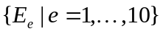. They have been involved to some level with sustainable supplier management.
Step 2: Determine the best and the worst attribute.
In this step, each expert (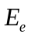) was asked to determine the best and the worst attribute (i), among all 8 social sustainability attributes. As an example, the best and worst attributes identified by each of the ten experts are displayed in Table 6.

Table 6: The best and worst attributes determined by experts 1-10
Experts | Most important attribute | Least important attribute
Expert1 | EP (SSA8) | IRE (SSA5)
Expert2 | RS (SSA6) | ID (SSA7)
Expert3 | WSLH (SSA1) | CSI (SSA3)
Expert4 | ID (SSA7) | EP (SSA8)
Expert5 | WSLH (SSA1) | TECI (SSA2)
Expert6 | CSI (SSA3) | EP (SSA8)
Expert7 | WSLH (SSA1) | ID (SSA7)
Expert8 | OHSMS (SSA4) | TECI (SSA2)
Expert9 | IRE (SSA5) | TECI (SSA2)
Expert10 | CSI (SSA3) | TECI (SSA2)
Step 3: Determine the best attribute preference over all attributes and all attributes preference over the worst attribute.
In the third step, each expert () was asked to specify the best attribute’s preference over all other attributes, using a linguistic measurement ranging from ‘Equal importance’ (EqI) to ‘Extreme importance’ (ExH), which results in a vector of Best-to-Others (BO) 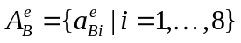. Next, each expert () was also asked to determine the preference of all attributes over the worst attribute, again using a linguistic measurement ranging from ‘Equal importance’ (EqI) to ‘Extreme importance’ (ExH), which results in the vector of Others-to-Worst (OW)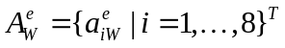.
In our case, this step results in ten BO evaluation matrices and ten OW evaluation matrices for all experts. As an example, the BO evaluation and OW evaluation matrices for expert (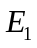) is presented in Table 7 and Table 8. For brevity, the remaining 18 matrices are not shown.

Table 7: The linguistic responses and grey number of the Best-to-Others evaluation matrix for Expert 1.
Type | The best attribute | WSLH | TECI | CSI | OHSMS | IRE | RS | ID | EP
Linguistic | EP | LI | MI | LI | WI | SI | MpI | MI | EqI
Grey | EP | [2.5,3.5] | [3.5,4.5] | [2.5,3.5] | [1,2.5] | [5.5,6.5] | [4.5,5.5] | [3.5,4.5] | [1,1]

Table 8: The linguistic responses and grey number of the Others-to-Worst evaluation matrix for Expert 1.
Type | Linguistic | Grey
The worst attribute | IRE
WSLH | LI | [2.5,3.5]
TECI | WI | [1,2.5]
CSI | LI | [2.5,3.5]
OHSMS | MI | [3.5,4.5]
IRE | EqI | [1,1]
RS | LI | [2.5,3.5]
ID | MI | [3.5,4.5]
EP | SI | [5.5,6.5]

Step 4：Transform linguistic responses into interval grey numbers.
To deal with human judgment obscurity and ambiguity, the linguistic responses are transformed into interval grey numbers. An interval grey numerical scale table and its corresponding linguistic measurements are shown in Table 9.
As an example, the preference value shows little importance (LI) of the EP (SSA8) attribute over the WSLH (SSA1) attribute and is transformed into a grey number for expert to be: 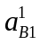= LI = [2.5,3.5]. A grey BO matrix 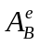 and grey OW matrix  from the linguistic matrix is identified in this step, which can be seen in the third row of Table 7 and the third column of Table 8.

Table 9: Linguistic/Human judgments and their corresponding interval grey numbers.

Linguistic/Human judgments | Interval grey numbers
Equal importance (EqI) | [1,1]
Weak importance (WI) | [1,2.5]
Little importance(LI) | [2.5,3.5]
Moderate importance (MI) | [3.5,4.5]
Moderate plus importance (MpI) | [4.5,5.5]
Strong importance (SI) | [5.5,6.5]
Strong plus importance (SpI) | [6.5,7.5]
Very strong importance (VsI) | [7.5,8.5]
Extreme importance (ExI) | [8.5,10]
Step 5： Calculate the relative weights 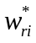 for social sustainability attributes.
TODIM requires relative weight values. To do so, BWM needs adjustment to calculate relative weights rather than absolute weights. The social sustainability attributes relative weights are calculated by solving the Grey-BWM optimization model for each expert using expression (12).
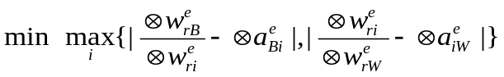 (12)
s.t.
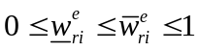
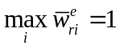
The relative weights of each social sustainability attribute (c_{i} ), from each expert () are computed to obtain a relative weight vector. The value in the first ten columns of Table 10 is the relative weight value for each expert opinion. As can be seen in Table 10, the consistency ratio ( ) is small according to the consistency index table of Rezaei (2015), hence the comparisons are highly consistent and reliable.

Table 10: The social sustainability relative attribute weights for the 10 experts using BWM
Attributes | Expert1 | Expert2 | Expert3 | Expert4 | Expert5 | Expert6 | Expert7 | Expert8 | Expert9 | Expert10 | Average
WSLH | [0.48,0.66] | [0.34,0.41] | [1,1] | [0.47,0.77] | [1,1] | [0.23,0.74] | [1,1] | [0.59,0.67] | [0.46,0.63] | [0.43,0.7] | [0.6,0.76]
TECI | [0.24,0.54] | [0.33,0.54] | [0.45,0.69] | [0.39,0.6] | [0.11,0.12] | [0.46,0.94] | [0.65,0.86] | [0.12,0.13] | [0.12,0.19] | [0.11,0.11] | [0.3,0.47]
CSI | [0.48,0.66] | [0.45,0.65] | [0.12,0.15] | [0.59,0.67] | [0.19,0.57] | [0.94,1] | [0.26,0.55] | [0.38,0.78] | [0.42,0.44] | [0.96,1] | [0.48,0.65]
OHSMS | [0.67,0.75] | [0.49,0.6] | [0.39,0.94] | [0.22,0.75] | [0.47,0.68] | [0.56,0.6] | [0.51,0.71] | [1,1] | [0.66,0.91] | [0.38,0.59] | [0.54,0.75]
IRE | [0.13,0.14] | [0.27,0.48] | [0.26,0.52] | [0.27,0.55] | [0.22,0.52] | [0.17,0.43] | [0.2,0.36] | [0.39,0.55] | [1,1] | [0.47,0.49] | [0.34,0.5]
RS | [0.2,0.34] | [0.94,1] | [0.45,0.69] | [0.33,0.41] | [0.33,0.88] | [0.27,0.54] | [0.24,0.58] | [0.19,0.62] | [0.21,0.33] | [0.63,0.66] | [0.38,0.61]
ID | [0.27,0.49] | [0.13,0.14] | [0.26,0.55] | [0.76,1] | [0.17,0.36] | [0.29,0.54] | [0.14,0.15] | [0.23,0.55] | [0.42,0.44] | [0.23,0.47] | [0.29,0.47]
EP | [0.96,1] | [0.43,0.78] | [0.2,0.35] | [0.11,0.13] | [0.58,0.8] | [0.15,0.16] | [0.26,0.55] | [0.19,0.62] | [0.26,0.5] | [0.37,0.42] | [0.35,0.53]
 | 1.63 | 1.72 | 1.60 | 2.50 | 2.72 | 1.86 | 1.77 | 2.88 | 1.61 | 2.40 | 2.07

We then determine an average relative weight 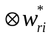 for all the experts using expression (13).
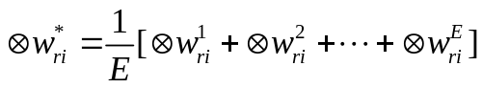 (13)
In our case, as an example, the average relative weight for attribute WSLH (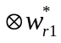) is: 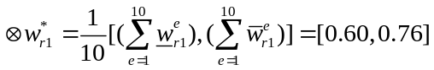.
The average relative weight grey number values are shown in the last column of Table 10.
Step 6: Evaluate the supplier performance for each social sustainability attribute.
In this step, each expert () is asked to evaluate each supplier (s_{j}) with respect to the eight social sustainability attributes (c_{i}). The evaluations for social sustainability attributes are verbal descriptions ranging from 'Very Good (VG)' to 'Very Poor (VP)'. An interval grey numerical scale with its corresponding performance verbal values is given as: Very Good ←→[8, 10], Good ←→[6, 8], Medium ←→[4, 6], Poor ←→[2, 4], Very Poor ←→[0, 2]. This step will result in ten grey matrices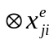. As an example, the evaluation grey matrix of an expert () is presented in Table 11. For brevity, the remaining nine matrices are not shown.

Table 11: The grey number for social sustainability attributes of suppliers for Expert 1.
Suppliers | WSLH | TECI | CSI | OHSMS | IRE | RS | ID | EP
supplier 1 | [4,6] | [0,2] | [4,6] | [2,4] | [8,10] | [8,10] | [0,2] | [2,4]
supplier 2 | [6,8] | [8,10] | [6,8] | [4,6] | [8,10] | [6,8] | [4,6] | [2,4]
supplier 3 | [0,2] | [6,8] | [4,6] | [8,10] | [2,4] | [8,10] | [4,6] | [2,4]
supplier 4 | [4,6] | [2,4] | [6,8] | [0,2] | [2,4] | [8,10] | [2,4] | [0,2]
supplier 5 | [2,4] | [4,6] | [0,2] | [2,4] | [8,10] | [6,8] | [4,6] | [2,4]
In our case, expert thinks that supplier s₁ is a “Medium” level on the WSLH, (SSA1) attribute and then assigns a linguistic value of M (i.e.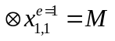); identified as: 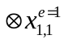= M = [4, 6].
Step 7: Aggregated performance levels of suppliers for each social sustainability attribute.
We seek to arrive at an aggregated performance grey matrix of suppliers for all social sustainability attributes and all experts using expression (14).
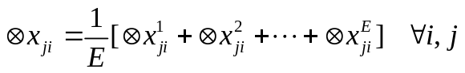 (14)
As an example calculation, the grey value for supplier s₁, attribute c₁ (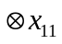) is: 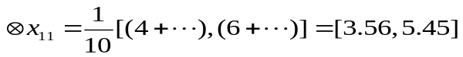. The overall aggregate grey attribute values results for each supplier are presented in Table 12.

Table 12: The aggregate grey values (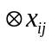) of each suppliers for all experts.
Suppliers | WSLH | TECI | CSI | OHSMS | IRE | RS | ID | EP
supplier 1 | [3.56,5.45] | [4.18,5.74] | [5.32,7.1] | [3.98,5.87] | [4.04,5.71] | [4.7,6.48] | [3.74,5.41] | [4.2,5.87]
supplier 2 | [3.58,5.36] | [2.5,4.39] | [3.8,5.69] | [4,5.78] | [4.48,6.26] | [4.9,6.79] | [4,5.78] | [5.52,7.3]
supplier 3 | [1.98,3.87] | [3.8,5.69] | [3.56,5.56] | [4.92,6.48] | [3.1,4.88] | [4.92,6.7] | [4,6] | [3.98,5.87]
supplier 4 | [3.12,5.01] | [3.54,5.54] | [3.36,5.14] | [4.62,6.4] | [4.42,6.2] | [3.6,5.27] | [2.88,4.66] | [3.3,5.19]
supplier 5 | [2.44,4.33] | [2.9,4.79] | [2.64,4.53] | [4.2,6.09] | [3.82,5.71] | [5.34,7.01] | [4,5.78] | [4.2,5.65]

Step 8: Determine the overall dominance measures of each supplier.
The target of this step is to identify the overall dominance measures of the suppliers. The attenuation factor (), see expression (9), of the losses is set to =12 which has the range of values 0< < 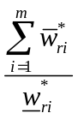.
First, the dominance measure for each social sustainability attribute (c_{i}) is determined by expression (15).
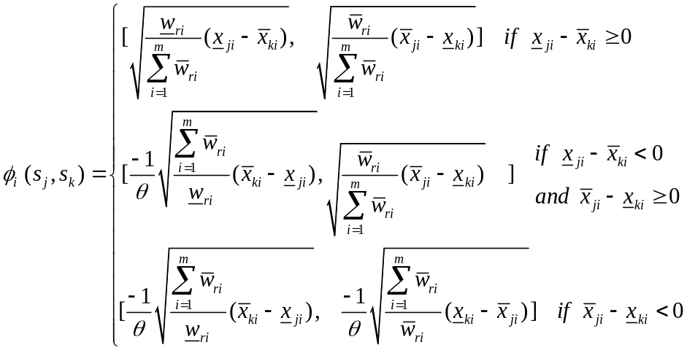 (15)
As an example, the following computational processes of the dominance measures are presented using expression (13), where = 12. The interval grey value of supplier s₁ is [3.56, 5.45] and of supplier s₂ is [3.58, 5.36] for the WSLH (SSA1) attribute. Then we can obtain 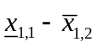 = -1.87 < 0 (a loss) and 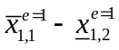= 1.8 (again), 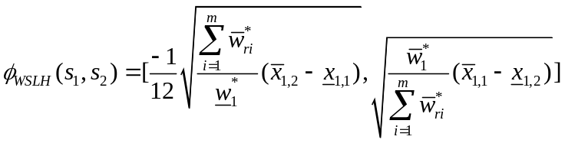= [-0.32, 0.54].
The second sub-step uses expression (10) to determine the overall dominance measures for each supplier.
For example, the dominance measure for all social sustainability attributes between suppliers and are 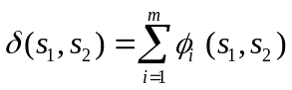= [-0.32, 0.54] + 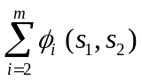= [-3.03, 3.48]. The overall dominance measures for social sustainability attributes between suppliers are shown in Table 13.
Table 13: The overall dominance measures for social sustainability attributes between suppliers.
Suppliers | supplier 1 | supplier 2 | supplier 3 | supplier 4 | supplier 5
supplier 1 | [-3.05,3.72] | [-3.03,3.48] | [-3.33,3.13] | [-3.51,2.76] | [-3.38,2.79]
supplier 2 | [-2.87,3.71] | [-3.14,3.8] | [-3.26,3.23] | [-3.46,2.83] | [-3.4,3.14]
supplier 3 | [-2.66,4.08] | [-2.71,3.98] | [-3.16,3.82] | [-3.23,3.47] | [-3.19,3.62]
supplier 4 | [-2.23,4.25] | [-2.25,4.17] | [-2.81,3.84] | [-3.14,3.8] | [-2.68,3.75]
supplier 5 | [-2.24,4.16] | [-2.62,4.16] | [-2.99,3.87] | [-3.15,3.36] | [-3.11,3.77]
Step 9: Determine the global value for each supplier.
In this step, the global value of the supplier for all social sustainability attributes is determined using expression (16).
. (16)
In our case, the sum of the overall dominance measures of the supplier for the social sustainability attributes are 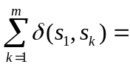[-13.05, 19.92]. The minimum values of the overall dominance measures sums over all suppliers for social sustainability attributes are 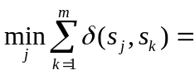[-16.50, 16.22]. The maximum values of the overall dominance measures sums over all suppliers for social sustainability attributes and expert are 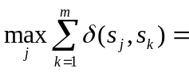[-13.05, 19.92]. Thus, the global value 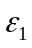 of overall social sustainability attributes is 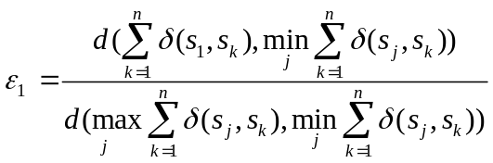= 0.843. The global values and rankings of supplier’s social sustainability are given in Table 14.
Table 14: The global values and rankings of suppliers.
Suppliers | 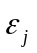 | Ranking
supplier 1 | 0.843 | 2
supplier 2 | 1.000 | 1
supplier 3 | 0.362 | 3
supplier 4 | 0.000 | 5
supplier 5 | 0.183 | 4
The global measures and the ranking order of all suppliers can be found in Table 14. Using Table 14 information, we can conclude that supplier, has the highest social sustainability performance according to managerial opinion with a score of 1.000.
5. Sensitivity Analysis
In this section, the values of the basic TODIM attenuation parameter are altered to investigate the results’ robustness. A sensitivity analysis is also conducted for each expert.

5.1. Sensitivity analysis for the attenuation factor
In the initial results, the losses attenuation factor was set to 12. The different choices of lead to different shapes of the prospect theoretical value function in the negative quadrant. The attenuation factor means how much the losses will contribute to the global value.
We now complete a sensitivity analysis to determine the robustness of the solution. Because 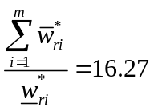, we select ranges of 1 ≤ ≤ 16, in increments of 1. Figure 1 summarizes results of this sensitivity analysis.
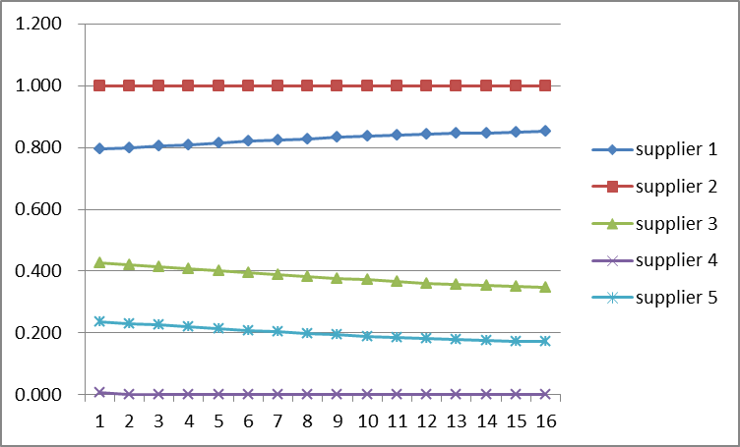
Figure 1. Final global value of suppliers for different values
As can be seen in Figure 1, the supplier is the best supplier for the range of θ values. This result shows that the ranking of suppliers is relatively robust and the managers can be confident of the supplier social sustainability ranking.

5.2. Sensitivity analysis for each expert
Another sensitivity analysis is completed to determine the impact of decision maker/manager (we use the term expert from now on for simplicity) beliefs on the final results. We will compute the global value of each supplier for each responding expert , with the same processes as demonstrated (initially) in the case within section 4.2. The results of this sensitivity analysis can be found in Table 15 and Figure 2.

Table 15: The global value of social sustainability attributes and each expert for suppliers.
Suppliers | Expert1 | Expert2 | Expert3 | Expert4 | Expert5 | Expert6 | Expert7 | Expert8 | Expert9 | Expert10 | Average
supplier 1 | 0.277 | 0.309 | 0.629 | 0.951 | 0.750 | 0.861 | 0.201 | 0.925 | 0.407 | 0.765 | 0.607
supplier 2 | 1.000 | 1.000 | 0.363 | 0.979 | 0.738 | 0.263 | 0.621 | 0.311 | 0.786 | 0.503 | 0.656
supplier 3 | 0.551 | 0.630 | 0.245 | 0.158 | 0.000 | 0.126 | 1.000 | 0.000 | 0.970 | 1.000 | 0.468
supplier 4 | 0.000 | 0.000 | 0.000 | 0.566 | 0.923 | 0.000 | 0.000 | 0.580 | 0.728 | 0.768 | 0.356
supplier 5 | 0.217 | 0.070 | 1.000 | 0.016 | 0.952 | 1.000 | 0.162 | 0.964 | 0.000 | 0.000 | 0.438
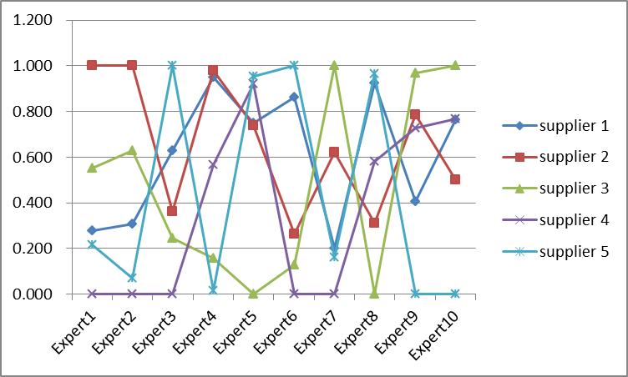
Figure 2: The global value for each supplier and each expert.
The results for the highest ranked supplier do change across each individual expert’s evaluation. Figure 2 shows that all supplier rankings demonstrate inconsistencies and fluctuations according to the ten expert opinions.
Supplier 2, the most preferred socially sustainable supplier for the aggregate case, showed some stability across expert evaluations. Supplier 2 is highest ranked for experts 1, 2 and 4, but is lowest weighted by expert 6 and ranked as the third most important supplier; although it is ranked in fourth place by expert 10.
Supplier 4 is the worst socially sustainable supplier in the initial case and also showed relative stability across expert evaluations. Supplier 4 has the worst ranking based on the opinions of experts 1, 2, 3, 6 and 7. Moreover, the best global value of Supplier 4, belongs to the second ranked supplier according to expert 5.
Supplier 5, ranked as the fourth overall as a socially sustainable supplier, showed the biggest conflicting results across individual expert evaluations. Based on Figure 2, Supplier 5 is identified as the worst ranked supplier three times by experts 4, 9 and 10. Supplier 5 is the best socially sustainable supplier four times, based on the opinions of experts 3, 5, 6 and 8. This volatility and spread will require critical investigation and discussion amongst the experts to more fully comprehend the variations.
Although Supplier 1 was not determined as the best supplier in the overall expert evaluations, it was identified as the second ranked socially sustainable supplier. We may conclude that supplier 1 has a comparatively stable ranking across all expert evaluations.
Supplier 3 also showed some of the most significant conflicting results across expert evaluations. Based on Figure 2, Supplier 3 was twice identified as the worst performer based on the opinions of experts 5 and 8; while being determined as the best socially sustainable supplier according to the opinions of experts 7 and 10.
Practically, these results show the difficulties with maintaining consistency across expert evaluations. It provides insights into possible misapplication issues of the Grey-BWM and Grey-TODIM methodology. The results practically show that including only particular decision-makers into the decision cycle may provide misleading or biased selection results. Thus, care needs to be taken in the determination of decision-makers for the application of this methodology and that a discussion and consensus needs to be formed after some initial evaluations.
The average global values are shown in the last column of Tables 15, and are consistent with the results of the initial case. However, the average global values are more valuable than the global values of the initial case for decision-makers and supply chain managers. Average global values, which are normalized, can more effectively evaluate relative dominance degree or gap between two suppliers.
6. Discussion and Implications
The empirical results of the case illustration of this methodology are summarized in Table 14. These results depict the global values for five potential suppliers, along with their respective rankings. Supplier 2 was ranked the top supplier with a global value of 1. Suppliers 1, 3, 5, and 4 follow, respectively. Even though supplier 2 is considered the best supplier from this result, and is recommended for contracting by the Iranian manufacturing company, there are some social sustainability criteria that had low ratings for supplier 2. For implementation of this selection recommendation, the Iranian manufacturing company may require specific post-selection negotiations with this supplier for possible improvements in these lower rated performance criteria; using the other suppliers as benchmarks.
We now illustrate from the case how managers can use such results as a guide in negotiating with the selected supplier for future performance improvements and supplier development. As a benchmark example, using data from Table 12, Supplier 1 has the highest rated performance criteria amongst the five suppliers for the first three social sustainability criteria, namely: “work health and safety” (WSLH/SSA1), “training education and community influence” (TECI/SSA2) and “contractual stakeholders’ influence” (CSI/SSA3). For these three criteria, supplier 1’s performance ratings can be considered as a benchmark measurement for other suppliers. Therefore, the Iranian manufacturing company can, as part of their post-supplier selection project, consider negotiating with supplier 2 to focus on improving these three performance criteria (WSLH/SSA1, TECI/SSA2 and CSI/SSA3). Given the possibilities of interactions and tradeoffs, care must be taken not to compromise the overall performance of supplier 2. Thus, a supplier development process may be put into place that may help improve supplier 2 in a balanced way.
It is also observed from Table 12 that supplier 3 has the best rated performance for “occupational health and safety management system” (OHSMS/SSA4) and “information disclosure” (ID/SSA7). Using these two highest rated performance criteria of supplier 3 as a benchmark, the Iranian manufacturing company may use this benchmark in their post-selection negotiation with supplier 2 (the optimal supplier), to request improvement in these criteria (OHSMS/SSA4 and ID/SSA7) overtime. Further scanning through Table 12 information depicts that supplier 5 has the highest rated performance for “the right of stakeholders” (RS/SSA6) criteria. The Iranian manufacturing company may, during the post-selection negotiating phase, request supplier 2 to improve overtime its performance on (RS/SSA6). Supplier 2 has the best rated performance for “the interests and rights of employees” (IRE/SSA5) and “employment practices” (EP/SSA8) criteria.
These results and perspectives show that compensatory evaluations may allow some poorly performing results to occur; setting minimum value expectations may be necessary to guarantee better overall performance on factors. A practical concern is that trying to achieve best in class for each metric may not be possible or quite capital intensive. Buyers should take care in making these requested changes without some supportive collaboration and coordination with the selected supplier.
7. Summary and Conclusion
According to RBV, companies can gain competitive advantage by developing resources that help to differentiate themselves from other competitors because it is valuable and difficult to replicate. Social sustainability can be an important intangible resource. Organizational social sustainability can be enhanced by having a socially sustainable supply chain. To help build a socially sustainable effective supply chain supplier evaluation and evaluation is required. This supplier evaluation and selection is where MCDM tools are helpful.
Although a variety of tools have been developed and applied for this purpose, each have their limitations and are context dependent in their effectiveness. In this study, to address a few contextual limitations of other techniques and applications, we utilized an integrated MCDM tool composed of grey numbers, BWM and TODIM to investigate social sustainability supplier evaluation and selection.
This work introduced a comprehensive framework for investigating and supporting social sustainability supplier evaluation and selection. The framework consists of eight social sustainability attributes including: ‘Work health and safety’ (WSLH/SSA1); ‘Training education and community influence’ (TECI/SSA2); ‘Contractual stakeholders’ influence’ (CSI/SSA3); ‘Occupational health and safety management system’ (OHSMS/SSA4); ‘The interests and rights of employees’ (IRE/SSA5); ‘The rights of stakeholders’ (RS/SSA6); ‘Information disclosure’ (ID/SSA7); and ‘Employment practices’ (EP/SSA8). The social sustainability framework was then applied in an Iranian manufacturing company with inputs from ten of their industrial experts (managers) using the introduced decision support tool for assessing and ranking five suppliers.
7.1 The novelty and strengths of the methodology
There are a number of novel contributions which provide advantages of this methodology over most existing methodologies for sustainable supplier evaluation and selection.
First, our proposed method, based on prospect theory (TODIM) and grey system theory (grey number), takes into account decision maker gain or loss psychological behavior within uncertain environments. It can yield more credible results; results that are more in line with decision maker actual opinions. Most methods of sustainable supplier selection fail to simultaneously consider decision maker psychological behavior and sustainability decision uncertainty. The proposed method also allows multiple decision makers to evaluate social sustainable suppliers using their experience and knowledge.
Second, BWM is used to identify the relative weights of attributes and addresses the gap of TODIM requiring this additional information. The relative attribute weights information from BWM are more reasonable and represented by grey numbers. AHP/ANP may also be used to determine the relative attribute weights. BWM is advantageous since it requires less pairwise comparison information and decision maker inputs (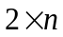) rather than AHP tools () given n attributes.
Third, traditional BWM is used to determine the absolute weights of attributes. It needs additional steps to convert these absolute weights to relative weights; increasing computational complexity. We extended grey-BWM to optimize and determine the relative weights of attributes by modifying the objective function and introducing grey numbers.
This hybrid group decision method can be applied to quantitatively express the psychological behavior of the decision makers in a group decision and in an uncertain environment. Thus, it can strengthen group decision making process comprehensiveness, and can be successfully applied to various sustainability decision making problems.
7.2. Limitations and future research directions
Every study has limitations and this study is no exception. However, these limitations can serve as a basis for future studies. One of the key limitations is that the results are based on a single evaluation tool (grey-based BWM-TODIM), therefore, the findings are sensitive to the assumptions of these models for the case company’s social sustainability supplier selection. More tools and factors (e.g. economic, environmental) can be applied in this case and the results compared, and a final decision made. Another limitation of this study is that, the criteria weights and ranking of the suppliers were determined using grey-BWM and grey-TODIM respectively. We suggest that possible future researches apply other MCDM models to determine the weight of the social sustainability criteria and use a number of other MCDM models including TOPSIS or ANP to evaluate and rank the suppliers.
Acknowledgements: This work is supported by the National Natural Science Foundation of China Project (71472031, 71772032).
References
Ageron, B., Gunasekaran, A., & Spalanzani, A. (2012). Sustainable supply management: An empirical study. International Journal of Production Economics, 140(1), 168-182.
Agyemang, M., Kusi-Sarpong, S., Khan, S.A., Mani, V., Rehman, S. T. & Kusi-Sarpong, H. (2018). Drivers and barriers to circular economy implementation: An explorative study in Pakistan’s automobile industry. Management Decision. 10.1108/MD-11-2018-1178.
Amindoust, A. (2018). A resilient-sustainable based supplier selection model using a hybrid intelligent method. Computers & Industrial Engineering, 126, 122-135.
Amindoust, A., Ahmed, S., Saghafinia, A., & Bahreininejad, A. (2012). Sustainable supplier selection: A ranking model based on fuzzy inference system. Applied Soft Computing, 12(6), 1668-1677.
Amoozad Mahdiraji, H., Arzaghi, S., Stauskis, G., & Zavadskas, E. (2018). A Hybrid Fuzzy BWM-COPRAS Method for Analyzing Key Factors of Sustainable Architecture. Sustainability, 10(5), 1626.
Asadabadi, M. R. (2016). A Markovian-QFD approach in addressing the changing priorities of the customer needs. International Journal of Quality & Reliability Management, 33(8), 1062-1075.
Asadabadi, M. R. (2017). A customer based supplier selection process that combines quality function deployment, the analytic network process and a Markov chain. European Journal of Operational Research, 263(3), 1049-1062.
Autran Monteiro Gomes, L. F., & Duncan Rangel, L. s. A. (2009). An application of the TODIM method to the multicriteria rental evaluation of residential properties. European Journal of Operational Research, 193(1), 204-211.
Azadnia, A. H., Saman, M. Z. M., & Wong, K. Y. (2015). Sustainable supplier selection and order lot-sizing: an integrated multi-objective decision-making process. International Journal of Production Research, 53(2), 383-408.
Badri Ahmadi, H., Hashemi Petrudi, S. H., & Wang, X. (2017a). Integrating sustainability into supplier selection with analytical hierarchy process and improved grey relational analysis: a case of telecom industry. The International Journal of Advanced Manufacturing Technology, 90(9), 2413-2427.
Badri Ahmadi, H., Kusi-Sarpong, S., & Rezaei, J. (2017b). Assessing the social sustainability of supply chains using Best Worst Method. Resources, Conservation and Recycling, 126, 99-106.
Bai, C., & Sarkis, J. (2010a). Integrating sustainability into supplier selection with grey system and rough set methodologies. International Journal of Production Economics, 124(1), 252-264.
Bai, C., & Sarkis, J. (2010b). Green supplier development: analytical evaluation using rough set theory. Journal of Cleaner Production, 18(12), 1200-1210.
Bai, C., & Sarkis, J. (2013). A grey-based DEMATEL model for evaluating business process management critical success factors. International Journal of Production Economics, 146(1), 281-292.
Bai, C., Dhavale, D., & Sarkis, J. (2016). Complex investment decisions using rough set and fuzzy c-means: an example of investment in green supply chains. European journal of operational research, 248(2), 507-521.
Bai, C., Kusi-Sarpong, S., & Sarkis, J . (2017). An implementation path for green information technology systems in the Ghanaian mining industry. Journal of Cleaner Production, 164, 1105-1123
Banaeian, N., Mobli, H., Fahimnia, B., Nielsen, I. E., & Omid, M. (2016). Green supplier selection using fuzzy group decisionmaking methods: A case study from the agri-food industry. Computers & Operations Research, 89, 337-347.
Barney, J., Wright, M., & Ketchen Jr, D. J. (2001). The resource-based view of the firm: Ten years after 1991. Journal of management, 27(6), 625-641.
Büyüközkan, G. (2012). An integrated fuzzy multi-criteria group decision-making approach for green supplier evaluation. International Journal of Production Research, 50(11), 2892-2909.
Chacón Vargas, J. R., Moreno Mantilla, C. E., & de Sousa Jabbour, A. B. L. (2018). Enablers of sustainable supply chain management and its effect on competitive advantage in the Colombian context. Resources, Conservation and Recycling, 139, 237-250.
Chai, J., Liu, J. N. K., & Ngai, E. W. T. (2013). Application of decision-making techniques in supplier selection: A systematic review of literature. Expert Systems with Applications, 40(10), 3872-3885
Chardine-Baumann, E., & Botta-Genoulaz, V. (2014). A framework for sustainable performance assessment of supply chain management practices. Computers & Industrial Engineering, 76, 138-147.
Christmann, P., & Taylor, G. (2001). Globalization and the Environment: Determinants of Firm Self-Regulation in China. Journal of International Business Studies, 32(3), 439-458.
Dai, J., & Blackhurst, J. (2012). A four-phase AHP–QFD approach for supplier assessment: a sustainability perspective. International Journal of Production Research, 50(19), 5474-5490.
Danese, P., Lion, A., & Vinelli, A. (2018). Drivers and enablers of supplier sustainability practices: a survey-based analysis. International Journal of Production Research, 1-23.
Das, D. (2018). Sustainable supply chain management in Indian organisations: an empirical investigation. International Journal of Production Research, 56(17), 5776-5794.
de Boer, L., Labro, E., & Morlacchi, P. (2001). A review of methods supporting supplier selection. European Journal of Purchasing & Supply Management, 7(2), 75-89.
Deng, J.L., (1982). Control problems of grey systems. Systems & Control Letters, 1(5), 288-294.
Deng, Y., & Chan, F. T. S. (2011). A new fuzzy dempster MCDM method and its application in supplier selection. Expert Systems with Applications, 38(8), 9854-9861.
D'Eusanio, M., Serreli, M., Zamagni, A., & Petti, L. (2018). Assessment of social dimension of a jar of honey: A methodological outline. Journal of Cleaner Production, 199, 503-517.
Dotoli, M., & Falagario, M. (2012). A hierarchical model for optimal supplier selection in multiple sourcing contexts. International Journal of Production Research, 50(11), 2953-2967.
Dou, Y., Zhu, Q., & Sarkis, J. (2014). Evaluating green supplier development programs with a grey-analytical network process-based methodology. European Journal of Operational Research, 233(2), 420-431.
Ehrgott, M., Reimann, F., Kaufmann, L., & Carter, C. R. (2011). Social sustainability in selecting emerging economy suppliers. Journal of business ethics, 98(1), 99-119.
Fabbe-Costes, N., Roussat, C., Taylor, M., & Taylor, A. (2014). Sustainable supply chains: a framework for environmental scanning practices. International Journal of Operations & Production Management, 34(5), 664-694.
Fahimnia, B., Sarkis, J., & Davarzani, H. (2015). Green supply chain management: A review and bibliometric analysis. International Journal of Production Economics, 162, 101-114.
Ferreira, L., & Borenstein, D. (2012). A fuzzy-Bayesian model for supplier selection. Expert Systems with Applications, 39(9), 7834-7844.
Gauthier, C. (2005). Measuring Corporate Social and Environmental Performance: The Extended Life-Cycle Assessment. Journal of Business Ethics, 59(1), 199-206.
Genovese, A., Koh, S. L., Bruno, G., & Bruno, P. (2010, October). Green supplier selection: A literature review and a critical perspective. In Supply Chain Management and Information Systems (SCMIS), 2010 8th International Conference on (pp. 1-6). IEEE.
Genovese, A., Lenny Koh, S. C., Bruno, G., & Esposito, E. (2013). Greener supplier selection: state of the art and some empirical evidence. International Journal of Production Research, 51(10), 2868-2886.
Ghadimi, P., Dargi, A., & Heavey, C. (2017). Making sustainable sourcing decisions: practical evidence from the automotive industry. International Journal of Logistics Research and Applications, 20(4), 297-321.
Gold, S., Seuring, S., & Beske, P. (2010). Sustainable supply chain management and inter‐organizational resources: a literature review. Corporate social responsibility and environmental management, 17(4), 230-245.
Gomes, L. F. A. M., & Lima, M. M. P. P. (1992). TODIM: Basics and application to multicriteria ranking of projects with environmental impacts. Foundations of Computing and Decision Sciences, 16(4), 113-127.
Govindan, K., Khodaverdi, R., & Jafarian, A. (2013). A fuzzy multi criteria approach for measuring sustainability performance of a supplier based on triple bottom line approach. Journal of Cleaner Production, 47, 345-354.
Govindan, K., Rajendran, S., Sarkis, J., & Murugesan, P. (2015). Multi criteria decision making approaches for green supplier evaluation and selection: a literature review. Journal of Cleaner Production, 98, 66-83
Govindan, K., Seuring, S., Zhu, Q., & Azevedo, S. G. (2016). Accelerating the transition towards sustainability dynamics into supply chain relationship management and governance structures. Journal of Cleaner Production, 112, Part 3, 1813-1823.
Griggs, D., Stafford-Smith, M., Gaffney, O., Rockström, J., Öhman, M., Shyamsundar, P., . . . Noble, I. (2013). Policy: Sustainable development goals for people and planet. Nature, 495(7441), 305-307.
Gualandris, J., & Kalchschmidt, M. (2016). Developing environmental and social performance: the role of suppliers’ sustainability and buyer–supplier trust. International Journal of Production Research, 54(8), 2470-2486
Gualandris, J., Klassen, R. D., Vachon, S., & Kalchschmidt, M. (2016). Sustainable evaluation and verification in supply chains: Aligning and leveraging accountability to stakeholders. Journal of Operations Management, 38, 1-13.
Gupta, H., & Barua, M. K. (2018). A framework to overcome barriers to green innovation in SMEs using BWM and Fuzzy TOPSIS. Science of The Total Environment, 633, 122-139.
Gupta, H. (2018a). Evaluating service quality of airline industry using hybrid best worst method and VIKOR. Journal of Air Transport Management, 68, 35-47.
Gupta, H. (2018b). Assessing organizations performance on the basis of GHRM practices using BWM and Fuzzy TOPSIS. Journal of Environmental Management, 226, 201-216.
Ho, W., Xu, X., & Dey, P. K. (2010). Multi-criteria decision making approaches for supplier evaluation and selection: A literature review. European Journal of Operational Research, 202(1), 16-24.
Jeya, G., Sekar, V., & Vimal, K. E. K. (2016). Application of interpretative structural modelling integrated multi criteria decision making methods for sustainable supplier selection. Journal of Modelling in Management, 11(2), 358-388
Khan, S. A., Kusi-Sarpong, S., Arhin, F. K., & Kusi-Sarpong, H. (2018). Supplier sustainability performance evaluation and selection: A framework and methodology. Journal of Cleaner Production, 205, 964-979.
Klassen, R. D., & Vereecke, A. (2012). Social issues in supply chains: Capabilities link responsibility, risk (opportunity), and performance. International Journal of Production Economics, 140(1), 103-115.
Kuo, R. J., Wang, Y. C., & Tien, F. C. (2010). Integration of artificial neural network and MADA methods for green supplier selection. Journal of Cleaner Production, 18(12), 1161-1170.
Kuo, R. J., & Lin, Y. J. (2012). Supplier selection using analytic network process and data envelopment analysis. International Journal of Production Research, 50(11), 2852-2863.
Kusi-Sarpong, S., Bai, C., Sarkis, J., & Wang, X. (2015). Green supply chain practices evaluation in the mining industry using a joint rough sets and fuzzy TOPSIS methodology. Resources Policy, 46, 86-100.
Kusi-Sarpong, S., Sarkis, J., & Wang, X. (2016a). Green supply chain practices and performance in Ghana's mining industry: a comparative evaluation based on DEMATEL and AHP. International Journal of Business Performance and Supply Chain Modelling, 8(4), 320-347.
Kusi-Sarpong, S., Sarkis, J., & Wang, X. (2016b). Assessing green supply chain practices in the Ghanaian mining industry: A framework and evaluation. International Journal of Production Economics, 181, 325-341.
Kusi-Sarpong, S., Varela, M.L., Putnik, G., Avila, P. & Agyemang, J.B. (2018a). Multi-criteria supplier evaluation and selection: A group decision-making approach. International Journal for Quality Research, 12(2), 459-485.
Kusi-Sarpong, S., Gupta, H., & Sarkis, J. (2018b). A supply chain sustainability innovation framework and evaluation methodology. International Journal of Production Research, 1-19.
Labib, A. W. (2011). A supplier selection model: a comparison of fuzzy logic and the analytic hierarchy process. International Journal of Production Research, 49(21), 6287-6299.
Lee, A. H. I., Kang, H.-Y., Hsu, C.-F., & Hung, H.-C. (2009). A green supplier selection model for high-tech industry. Expert Systems with Applications, 36(4), 7917-7927.
Lin, Y.-H., & Tseng, M.-L. (2016). Assessing the competitive priorities within sustainable supply chain management under uncertainty. Journal of Cleaner Production, 112, Part 3, 2133-2144.
Li, J., Fang, H., & Song, W. (2018). Sustainability evaluation via variable precision rough set approach: A photovoltaic module supplier case study. Journal of Cleaner Production, 192, 751-765.
Li, M.-Y., & Cao, P.-P. (2018). Extended TODIM method for multi-attribute risk decision making problems in emergency response. Computers & Industrial Engineering. https://doi.org/10.1016/j.cie.2018.06.027
Lourenzutti, R., & Krohling, R. A. (2013). A study of TODIM in a intuitionistic fuzzy and random environment. Expert Systems with Applications, 40(16), 6459-6468.
Lourenzutti, R., & Krohling, R. A. (2014). The Hellinger distance in Multicriteria Decision Making: An illustration to the TOPSIS and TODIM methods. Expert Systems with Applications, 41(9), 4414-4421.
Lourenzutti, R., Krohling, R. A., & Reformat, M. Z. (2017). Choquet based TOPSIS and TODIM for dynamic and heterogeneous decision making with criteria interaction. Information Sciences, 408, 41-69.
Lu, L. Y. Y., Wu, C. H., & Kuo, T. C. (2007). Environmental principles applicable to green supplier evaluation by using multi-objective decision analysis. International Journal of Production Research, 45(18-19), 4317-4331.
Luthra, S., Govindan, K., Kannan, D., Mangla, S. K., & Garg, C. P. (2017). An integrated framework for sustainable supplier selection and evaluation in supply chains. Journal of Cleaner Production, 140, Part 3, 1686-1698.
Mani, V., Gunasekaran, A., & Delgado, C. (2018). Enhancing supply chain performance through supplier social sustainability: An emerging economy perspective. International Journal of Production Economics, 195, 259-272.
Mani, V., Agarwal, R., Gunasekaran, A., Papadopoulos, T., Dubey, R., & Childe, S. J. (2016a). Social sustainability in the supply chain: Construct development and measurement validation. Ecological Indicators, 71, 270-279.
Mani, V., Gunasekaran, A., Papadopoulos, T., Hazen, B., & Dubey, R. (2016b). Supply chain social sustainability for developing nations: Evidence from India. Resources, Conservation and Recycling, 111, 42-52.
Mathivathanan, D., Kannan, D., & Haq, A.N. (2017). Sustainable supply chain management practices in Indian automotive industry: A multi-stakeholder view. Resources, Conservation and Recycling, 128, 284-305.
Moheb-Alizadeh, H., & Handfield, R. (2017). An integrated chance-constrained stochastic model for efficient and sustainable supplier selection and order allocation. International Journal of Production Research, 1-27.
Morais, D. O., & Silvestre, B. S. (2018). Advancing social sustainability in supply chain management: Lessons from multiple case studies in an emerging economy. Journal of Cleaner Production, 199, 222-235.
Passos, A. C., Teixeira, M. G., Garcia, K. C., Cardoso, A. M., & Gomes, L. F. A. M. (2014). Using the TODIM-FSE method as a decision-making support methodology for oil spill response. Computers & Operations Research, 42, 40-48.
Pitchipoo, P. Venkumar, P., and Rajakarunakaran, S. (2013). Fuzzy hybrid decision model for supplier evaluation and selection. International Journal of Production Research, 51(13): 3903-3919.
Pullman, M. E., Maloni, M. J., & Carter, C. R. (2009). Food for thought: social versus environmental sustainability practices and performance outcomes. Journal of Supply Chain Management, 45(4), 38-54.
Qin, Q., Liang, F., Li, L., Chen, Y. W., & Yu, G. F. (2017). A TODIM-based multi-criteria group decision making with triangular intuitionistic fuzzy numbers. Applied soft computing, 55, 93-107.
Rao, C., Goh, M., Zhao, Y., & Zheng, J. (2015). Location selection of city logistics centers under sustainability. Transportation Research Part D: Transport and Environment, 36, 29-44.
Rao, C., Xiao, X., Goh, M., Zheng, J., & Wen, J. (2017a). Compound mechanism design of supplier selection based on multi-attribute auction and risk management of supply chain. Computers & Industrial Engineering, 105, 63-75.
Rao, C., Goh, M., & Zheng, J. (2017b). Decision mechanism for supplier selection under sustainability. International Journal of Information Technology & Decision Making, 16(01), 87-115.
Rao, C., Xiao, X., Xie, M., Goh, M., & Zheng, J. (2017c). Low carbon supplier selection under multi-source and multi-attribute procurement. Journal of Intelligent & Fuzzy Systems, 32(6), 4009-4022.
Reefke, H., & Sundaram, D. (2018). Sustainable supply chain management: Decision models for transformation and maturity. Decision Support Systems, 113, 56-72.
Rezaei, J., Kothadiya, O., Tavasszy, L., & Kroesen, M. (2018). Quality assessment of airline baggage handling systems using SERVQUAL and BWM. Tourism Management, 66, 85-93.
Rezaei, J. (2015). Best-worst multi-criteria decision-making method. Omega, 53, 49-57.
Rezaei, J., Nispeling, T., Sarkis, J., & Tavasszy, L. (2016). A supplier selection life cycle approach integrating traditional and environmental criteria using the best worst method. Journal of Cleaner Production, 135, 577-588.
Salimi, N., & Rezaei, J. (2018). Evaluating firms’ R&D performance using best worst method. Evaluation and Program Planning, 66, 147-155.
Sarkis, J., & Dhavale, D. G. (2015). Supplier selection for sustainable operations: A triple-bottom-line approach using a Bayesian framework. International Journal of Production Economics, 166, 177-191.
Sarkis, J., & Zhu, Q. (2018). Environmental sustainability and production: taking the road less travelled. International Journal of Production Research, 56(1-2), 743-759.
Sen, D. K., Datta, S., & Mahapatra, S. S. (2015). Extension of TODIM combined with grey numbers: an integrated decision making module. Grey Systems: Theory and Application, 5(3), 367-391.
Sevkli, M. (2010). An application of the fuzzy ELECTRE method for supplier selection. International Journal of Production Research, 48(12), 3393-3405.
Shi, L., Wu, K.J., & Tseng, M.L. (2017). Improving corporate sustainable development by using an interdependent closed-loop hierarchical structure. Resources, Conservation and Recycling, 119: p. 24-35.
Shojaei, P., Seyed Haeri, S. A., & Mohammadi, S. (2018). Airports evaluation and ranking model using Taguchi loss function, best-worst method and VIKOR technique. Journal of Air Transport Management, 68, 4-13.
Song, W., Xu, Z., & Liu, H. C. (2017). Developing sustainable supplier selection criteria for solar air-conditioner manufacturer: An integrated approach. Renewable and Sustainable Energy Reviews, 79, 1461-1471.
Sucky, E. (2007). A model for dynamic strategic vendor selection. Computers & Operations Research, 34(12), 3638-3651.
Trapp, A. C., & Sarkis, J. (2016). Identifying Robust portfolios of suppliers: a sustainability selection and development perspective. Journal of Cleaner Production, 112, 2088-2100
Tseng, M. L., Wu, W. W., Lin, Y. H., & Liao, C. H. (2008). An exploration of relationships between environmental practice and manufacturing performance using the PLS path modeling. WSEAS Transactions on Environment and Development, 4(6), 487-502.
Tseng, M. L., Lin, Y. H., Tan, K., Chen, R. H., & Chen, Y. H. (2014). Using TODIM to evaluate green supply chain practices under uncertainty. Applied Mathematical Modelling, 38(11-12), 2983-2995.
Tseng, M., Lim, M., & Wong, W. P. (2015). Sustainable supply chain management: A closed-loop network hierarchical approach. Industrial Management & Data Systems, 115(3), 436-461.
Wang, Y.-M., Chin, K.-S., & Leung, J. P.-F. (2009). A note on the application of the data envelopment analytic hierarchy process for supplier selection. International Journal of Production Research, 47(11), 3121-3138.
Wolf, J. (2014). The relationship between sustainable supply chain management, stakeholder pressure and corporate sustainability performance. Journal of business ethics, 119(3), 317-328.
Wong, W. P., Tseng, M.-L., & Tan, K. H. (2014). A business process management capabilities perspective on organisation performance. Total Quality Management & Business Excellence, 25(5-6), 602-617.
Wu, Y., Wang, J., Hu, Y., Ke, Y., & Li, L. (2018). An extended TODIM-PROMETHEE method for waste-to-energy plant site selection based on sustainability perspective. Energy, 156, 1-16.
Yadav, G., Mangla, S. K., Luthra, S., & Jakhar, S. (2018). Hybrid BWM-ELECTRE-based decision framework for effective offshore outsourcing adoption: a case study. International Journal of Production Research, 56(18), 6259-6278.
Yu, Q., & Hou, F.(2016). An approach for green supplier selection in the automobile manufacturing industry, Kybernetes, 45 (4),571-588
Zailani, S., Govindan, K., Iranmanesh, M., Shaharudin, M. R., & Chong, Y. S. (2015). Green innovation adoption in automotive supply chain: the Malaysian case. Journal of Cleaner Production, 108, 1115-1122.
Zhang, X., & Xu, Z. (2014). The TODIM analysis approach based on novel measured functions under hesitant fuzzy environment. Knowledge-Based Systems, 61, 48-58.
Zhang, M., Tse, Y.K., Doherty, B., Li,S., & Akhtar, P.(2016). Sustainable supply chain management: Confirmation of a higher-order model. Resources, Conservation and Recycling, 128, 206-221.
Zhu, Q., Sarkis, J., & Lai, K.-h. (2007). Initiatives and outcomes of green supply chain management implementation by Chinese manufacturers. Journal of Environmental Management, 85(1), 179-189.

TOmada de Decisão Interativa e Multicritério – in Portuguese “Interactive and Multicriteria Decision Making”

