Supplementary Materials for

Guided-wave Optical Biosensors Based on Refractometric Sensing Schemes: A Review

Yangyang Chen1,2, Jinchuan Liu1, Zhenchuan Yang2, James S Wilkinson3*, Xiaohong Zhou1,4**

*Corresponding authors: *jsw@soton.ac.uk; **xhzhou@mail.tsinghua.edu.cn

This file includes:
Note S1. Overview of principles.
Note S2. Basic principle of SP, coupling methods to excite SPs and resonance conditions.
Note S3. Optimum choice of material and geometry of NPs on performance enhancement of LSPR.
Note S4. Physisorbed surface functionalization.
Note S5. Example of surface functionalization on silica.
Note S6. Selective surface functionalization of a silicon nitride-based nanosubstrate.

Figure S1. Schematic illustration of total internal reflection.
Figure S2. (a) Modal electric field distributions of the first two TE polarised modes; (b) Modal effective indices for the first three modes in both polarisations vs t_{norm}.
Figure S3. Interrogation modes of commercial SPR devices.
Figure S4. Coupling methods to excite SPs: (a) prism, (b) waveguide, and (c) grating coupling.
Figure S5. Different materials, structures and applications of SPR-based biosensors.
Figure S6. Absorption (red), extinction (black), and scattering (blue) spectra simulated for AgNPs with various shapes using discrete dipole approximation method.
Figure S7. Illustration of PC categories utilized for biosensors: (a) 1D PCs, (b) PC slabs, (c) PC waveguides, and (d) PC microcavities.
Figure S8. Schematic illustration of the chemical structure and fabrication of the poly[(N-(2-hydroxypropyl) mechacrylamide)-co-(carboxybetaine methacrylamide)] polymer brush (left) and the post-modification of protein receptor onto gold surface with tethered brush (right).
Figure S9. Surface functionalization of mesoporous silica glass materials with various functional groups.
Figure S10. Schematic of surface functionalization for microRNA detection, including silanization of APTES, treatment with glutaraldehyde, covalent functionalization of amine-modified DNA probes and detection of miRNA by hybridization.
Figure S11. Schematic representation of biochemically modified silicon substrates by utilizing the linkers of APTES and glutaraldehyde.
Figure S12. Chemical reaction mechanism for the direct glutaraldehyde modiﬁcation of silicon nitride surface.

Note S1 Overview of principles
1 Sensitivity and limit of detection (LoD)
Refractometric optical biosensors exploit the phase change caused by the product of a change in RI (or effective RI) and the propagation length (or effective propagation length). The change in RI typically comes about by partially replacing a (usually aqueous) matrix with higher-index target molecules bound to a film of receptor molecules attached to the transducer surface. The phase change (and hence sensitivity) may be increased with the increase in the propagation length at the expense of compactness or by using a multi-pass or resonant configuration, which may lead to smaller footprint, lower sample volume and greater ease of miniaturization and multisensor integration for multiplexing. This phase change must be transformed into a signal measurable on a photodetector, detector array or spectrum analyser, as an intensity, angle or spectral change, respectively. The role of the transducer then reduces to providing high sensitivity to small changes in RI with small footprint. In biosensors, the LoD is generally defined as the minimum detectable concentration of the target in the presence of noise and other fluctuations, and quantified as the concentration which yields a signal three times the standard deviation of blank measurements (containing no target). Comparison between biosensors is complicated by the very many different analytical targets, protocols and operating regimes used. Refractometric transducer evaluation may be achieved independently of optimization of the surface chemistry and assay protocols by maximizing the signal in response to either bulk solution RI changes or to thin film RI or thickness changes, enabling simple device comparisons (Lambeck 1992). Equivalently, as protein monolayers generally have rather similar refractive indices and densities, a minimum detectable surface density of bound molecules (pg/mm²) is sometimes used for comparisons.
Instrumental detection limit can then be defined as the change in RI, thickness or surface density which results in a signal change of three times the system noise. Noise reduction, though sometimes neglected, is thus as important as sensitivity enhancement. While noise reduction is often independent of the transducer (eg reducing noise bandwidth or using phase-sensitive detection) some sources of noise and fluctuations should be considered in the transducer design (eg signal power dependent shot noise, and thermal fluctuations and light source fluctuations which may potentially be compensated on chip).
2 Evanescent wave transduction
In most refractometric transducers, an evanescent wave approach is used, as in the case of conventional ATR (attenuated total reflection) elements. Light incident from the transducer medium on its interface with a target of lower RI is totally reflected but undergoes a phase change which is dependent on the RI of the solution to be analysed within the evanescent field.
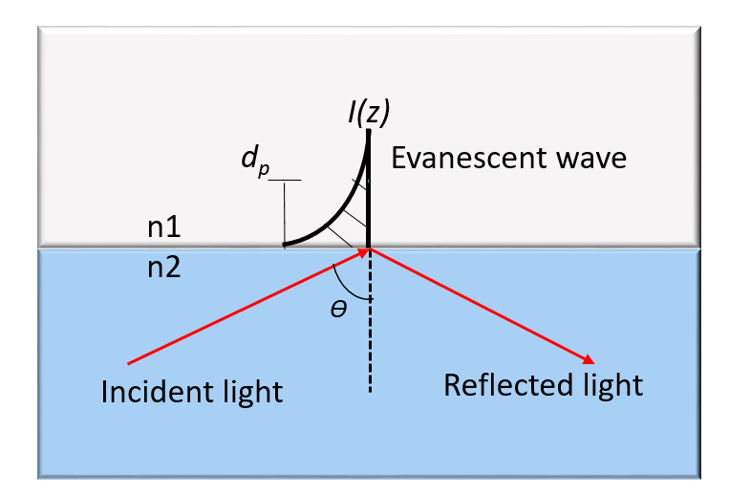
Figure S1. Schematic illustration of total internal reflection.
The evanescent wave, shown in Figure S2, propagates along the interface and decays in the z direction normal to the interface, accompanied by an intensity penetration depth given by (Andrade et al. 1985)
where Eqn (2.1)
where I₀ is the surface intensity, n₁ and n₂ are the refractive indices of target sample and transducer medium, respectively, λ is the operating wavelength. Evanescent interrogation is convenient for biosensors because (i) receptor molecules can be robustly and controllably assembled on the transducer surface, (ii) the light probes a thin region near the transducer surface and does not go across, often turbid, the bulk sample matrix, (iii) the intensity distribution close to the surface can be very precisely controlled and (iv) multiple reflections can be used to build up the phase change on reflection (Brandenburg et al. 2000), which is dependent on the RI of the thin film or bulk medium in the evanescent field.
3 Optical waveguides as transducers
Transformation of an expensive and bulky ATR element into a highly sensitive, miniaturized transducer with an intensity output (including intensity vs angle or vs wavelength) rather than a phase output is often achieved using monomode optical waveguides. Specifically, these allow precise control of intensity distribution over the surface yielding high stability, maximization of the number of reflections per unit length for high contrast waveguide designs, long interaction lengths by photolithographic path definition, integration of interferometric structures to transform phase changes into intensity changes, and of reference branches to compensate source fluctuations. More generally, in principle they can be massively produced cheaply using microelectronic fabrication techniques and offer a robust “solid-state” approach and ready multisensor integration.
In its simplest form, an optical waveguide comprises a high-RI dielectric film deposited on a low-RI substrate. Rays can be trapped by total internal reflection at both of the film-substrate and the film-solution interfaces. The number of reflections per unit length increases as the film thickness reduces, increasing sensitivity to RI changes at the surface. As the film becomes very thin, this ray picture breaks down and an electromagnetic analysis of the waveguide modes must be performed. The highest sensitivity to surface RI changes occurs for waveguides which only support one propagating mode and, for thin-film detection, whose thickness and indices (film and substrate) are optimized for maximum intensity at the waveguide surface. The electromagnetic analysis of these structures yields a modal field distribution across the waveguide, with a cosine dependence across the film and exponential decay (evanescent field) in the substrate and the dielectric medium to be analysed, as shown in Figure S2a. It also yields the effective RI of the mode, n_{eff}, which gives the phase velocity as v_{p} = c/n_{eff}. In approximate terms, the effective index is an average of the physical refractive indices of the waveguide core, waeguide substrate and target solution, weighted according to the proportion of power travelling in each medium. The effective index for a typical waveguide structure vs core thickness normalized to wavelength (t_{norm} = a/λ) is shown in Figure S2b.
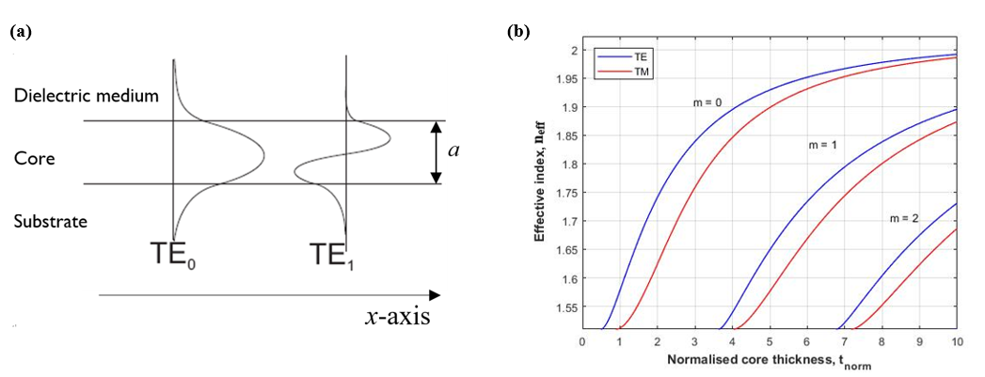
Figure S2. (a) Modal electric field distributions of the first two TE polarised modes; (b) Modal effective indices for the first three modes in both polarisations vs t_{norm}. Substrate, core and target indices are 1.51, 2.03 and 1.33, respectively. Note that in this case the waveguide is monomode for t_{norm} between approximately 0.45 and 7.3.
In terms of a ray description, the angle θ in Figure S1 is associated with the effective index by n_{eff} = n₂ sin(θ), so that the penetration depth of the evanescent field increases with the decreased film thickness and effective index. This interplay contributes in a maximum in surface intensity (for a given modal power) at a specific thickness, and high RI films yield higher surface intensity and shorter penetration depth, rendering them ideal for refractometry of thin biological films at their surfaces. Perhaps the most significant benefits of waveguide transducers are that, (i) despite the small fraction of the modal field interacting with the biological film, a very strong interaction may be achieved by confining the optical fields tightly at the surface, without diffraction, over centimetres of length while the biological film is likely nanometers in thickness, and (ii) that this may be easily wrapped into a sub mm² area (Liu et al. 2013). Despite their name, the majority of monomode planar waveguides support one independent mode in each of two polarisations, having different field distributions and effective indices. Normally waveguide transducers are designed to operate in one of these polarisations alone.

Note S2 Basic principle of SP, coupling methods to excite SPs and resonance conditions
1 Basic principle of SP
The effective index of the SP that propagates along the interface of metal and a semi-infinite dielectric medium, n_{sp}, is given by (Homola et al. 1999):
 |  | Eqn (2.2)
  ,
Where ε_{s} represents the dielectric constant of the dielectric medium. and ε_{m} represents the dielectric constant of metal (ε_{m}=ε_{mr}+iε_{mi}). The velocity of the mode is given by v_{p} = c/Re{n_{sp}}; n_{sp} is complex because ε_{m} is complex for an (absorbing) metal. For the SP to exist the metal must exhibit a negative real part of permittivity. SP waves only exist in the TM or p-polarisation with the magnetic field in the plane of the interface. As the effective index of the SP is greater than unity, light cannot escape to free-space, nor be coupled into the SP directly from free-space. Thus, excitation of SP modes requires an enhancement of the wave vector component of the incident light that is in parallel with the interface to match that of SPs (k_{sp} = k₀n_{sp}, k₀ denotes the free space wave number, k_{sp} is the propagation constant of the SP wave). To excite the SP, several strategies, such as prism, waveguide or optical grating coupling, have been adopted. Figure S3 shows the most common configuration (Kretschmann) where a thin metal film is deposited at the bottom of the prism. If the prism RI, n_{p}, is higher than n_{sp} , then velocity matching is achieved when (Fan et al. 2008):
 | 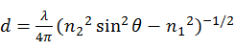, | Eqn (2.3)
where k_{x} is the wave vector of incident light in the x-axis direction, θ is the incident angle, and λ₀ is the vacuum wavelength of incident light. Away from this angle most of the light is reflected by the near-total internal reflection. At this angle light tunnels through the metal film (if it is sufficiently thin) and strongly excites the SP, leading to strong attenuation of light reflected from the film. The SP resonance (SPR) may be interrogated by (i) launching broadband light and tracking the shift in the minimum reflectance wavelength, by (ii) launching focused light and tracking the shift in the minimum reflectance angle or (iii) simply by monitoring reflected power at fixed angle and wavelength. SPR devices can be devided into four categories: wavelength, angle, intensity, and phase interrogation on the basis of the modulation approach (Figure S3).
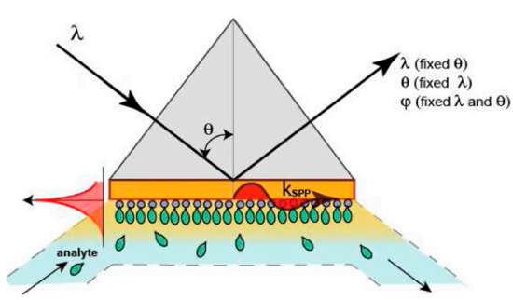
Figure S3. Interrogation modes of commercial SPR devices. (reprinted from Ref. (Puiu and Bala 2016) with permission)
Although the prism approach shown in Figure S4a is simple, it suffers from difficulty in miniaturization and integration. An alternative coupling method is a waveguide coupling shown in Figure S4b which matches the n_{eff} of a waveguide mode to the n_{sp} of an SP(Harris and Wilkinson 1995). In this case the transmission of the dielectric waveguide loaded by the SP is monitored. Waveguide coupling is more stable than prism coupling, and adaptable to miniaturization, thus simplifying its integration with other optical and electrical components. Another prevalent coupling method is grating coupling, shown in Figure S4c, which can be implemented with low cost. Note that in this configuration the incident light passes through the (potentially absorbing or turbid) dielectric medium to be analysed and the metal film is not required to be thin. Effective velocity-matching or wavevector-matching is achieved by using an order of the diffraction grating. The resonance condition is as follows (Fan et al. 2008):
 | , | Eqn (2.4)
where, n_{d} is the RI of the dielectric medium, m (an integer) and Λ are the diffraction order and grating period, respectively.
Figure S4. Coupling methods to excite SPs: (a) prism, (b) waveguide, and (c) grating coupling (reprinted from Ref. (Homola 2008) with permission).

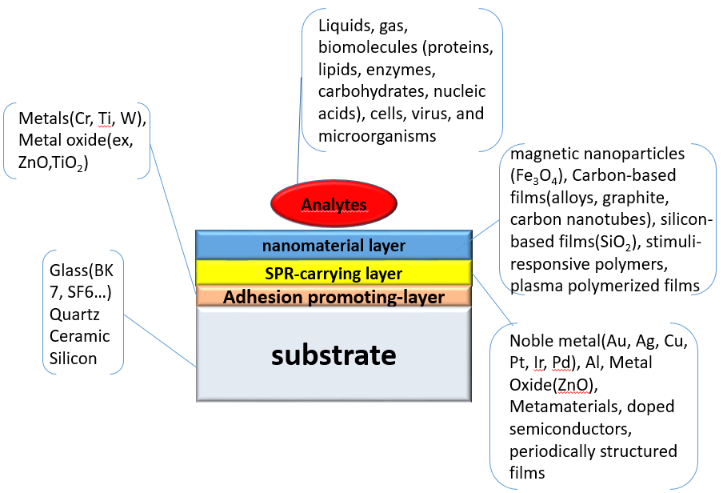
Figure S5. Different materials, structures and applications of SPR-based biosensors. (modified with permission from Ref. (Abbas et al. 2011))

Note S3 Optimum choice of material and geometry of NPs on performance enhancement of LSPR
Studies on performance enhancement methods target optimum choice of material and geometry of NPs: (i) NP size and aspect ratios, (ii) NP shapes, and (iii) NP materials. As with SPR, LSPR sensing is normally conducted on gold (Au) or silver (Ag) NPs. Au is advantageous because of its resistance to oxidation and chemical stability; However Ag exhibits sharper resonances and thus higher RI sensitivity than Au.
For a given metal and medium, the NP surface polarization distribution can greatly influence the intensity of a plasmon resonance. Therefore, any change in the shape of a metal NP can make a change to the surface polarization, causing the plasmon resonance variation accordingly. For example, absorption (red), extinction (black) and scattering (blue) spectra simulated for AgNPs with various shapes using discrete dipole approximation method, which is commonly used in LSPR-based biosensors, are presented in Figure S6 (Lu et al. 2009). Such results offer some rules for designing the shapes of metal NPs, such as improving the NP symmetry to increase the LSPR peak intensity and changing the number of NP geometry to change the number of LSPR peaks.
Figure S6. Absorption (red), extinction (black), and scattering (blue) spectra simulated for AgNPs with various shapes using discrete dipole approximation method (reprinted from Ref. (Lu et al. 2009) with permission). (a) sphere, (b) cube, (c) tetrahedron, (d) octahedron, and (e) triangular plate. (f) extinction spectra of rectangular blocks with 2 (black), 3 (red), and 4 (blue) aspect ratios, respectively.

Figure S7. Illustration of PC categories utilized for biosensors: (a) 1D PCs, (b) PC slabs, (c) PC waveguides, and (d) PC microcavities (reprinted with permission from Ref. (Threm et al. 2012)).

Note S4 Physisorbed surface functionalization
The approach to anchore receptor molecules onto the solid sensing surface plays a crucial role in biosensor-related method, which strongly affects the analytical performance (Sicard and Brennan 2013). Ideally, surface functionalization should fit the following requirements (Banuls et al. 2013): homogeneous thin layer formation in a functional conformation and suitable for sensing within evanescent field; robustness and reusability; minor non-specific adsorption; simple reactions; low cost; not too harsh to keep the active structures of both the receptor molecules and the solid sensing surface; low interfering adsorption at the working wavelengths; and integrability with mass-scale fabrication.
Entrapment and physical adsorption are the major classifications of physisorbed surface functionalization. Entrapment enables inclusion of a receptor (e.g. enzyme, antibody, and nucleic acid) in a gel lattice (network composed of polymer) via physical interception, including microcapsule, organic polymer, silica sol-gel or membrane device (hollow fibers). Physical entrapment is easy to perform and capable of depositing diverse receptor molecules in the same way. In 1962, the first work using entrapment immobilization to construct biosensors was reported by Clark et al. In this design, two layers of semipermeable dialysis membranes were utilized to entrap concentrated glucose oxidase for the construction of the first gluose biosensor (Clark Jr and Lyons 1962). However, the oxidase intercepted by the membrane was vulnerable to leakage, resulting in unstable sensor signals. Therefore, Updike and Hicks improved this approach by entrapping glucose oxidase in a gel matrix, which marked the beginning of the biosensor commercialization (Updike and Hicks 1967). Entrapment enables the retention of the biological activities of receptor molecules to the maximum extent given the absence of modification so that biological activity is preserved during immobilization. However, the performances of the systems can be greatly restricted due to the existence of possible diffusion barriers (Sassolas et al. 2013), especially for the affinity interaction-based biosensor.
Physical adsorption is another predominant approach of immobilizing biological receptors onto any kind of surface materials. This strategy utilizes a series of weak interactions between the solid surface and the functional moieties of the receptors, including van der Waals forces, hydrophobic interactions, hydrogen bonding and attractive/repulsive electrostatic interactions (Hartmann and Kostrov 2013). This approach features its simplicity without tedious chemical modification. It also brings the retention of biological activity of immobilized receptor molecules. Given that the binding forces between receptor molecules and the solid surfaceare only physical adsorption, the risk of folding and desorption may be caused by slight changes in ambient conditions, including pH, temperature and ionic strength variations. To meet the challenge, various of strategies are developed to improve biomolecules binding to the solid surface, which has been summarized in a review paper (Sassolas et al. 2012).
Although bioreceptor physisorption is generally used in the design of novel optical sensors(Bañuls et al. 2013), it suffers from long incubation time, random orientation, low reproducibility and vulnerability to external environment. In the case of electronically neutral and non-porous surface (e.g. silicon nitride), physisorption functionalization is ineffective (Williams and Blanch 1994).

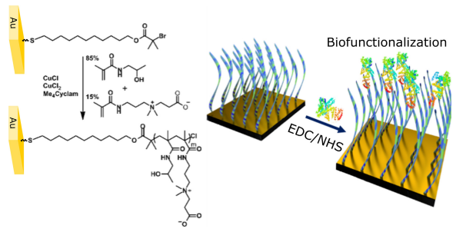
Figure S8. Schematic illustration of the chemical structure and fabrication of the poly[(N-(2-hydroxypropyl) mechacrylamide)-co-(carboxybetaine methacrylamide)] polymer brush (left) and the post-modification of protein receptor onto gold surface with tethered brush (right) (reprinted from Ref. (Riedel et al. 2016) with permission).

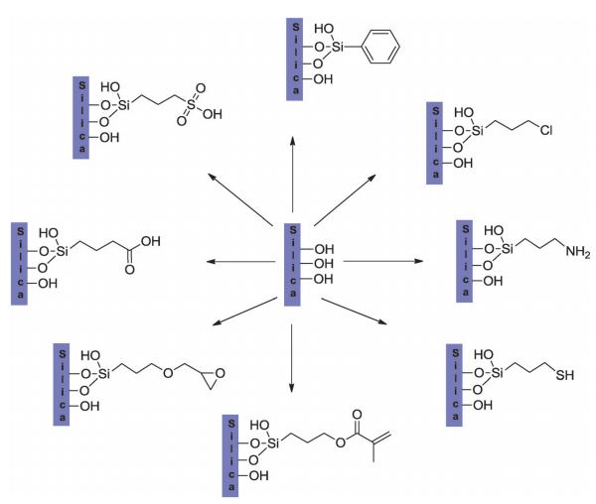
Figure S9. Surface functionalization of mesoporous silica glass materials with various functional groups (reprinted from Ref. (Hartmann and Kostrov 2013) with permission). This process is similar to the functionalization of silica materials.

Note S5 Example of surface functionalization on silica
A generally accepted approach for surface immobilization of biomolecules (such as antibody, DNA and enzyme) on silica surface is depicted in Figure S10 (Liang et al. 2017). After exposing reactive hydroxyl groups, the surface is silanized with 5% 3-aminopropyltriethoxysilane (APTES) for 1 h. Subsequently, 2.5% glutaraldehyde solution is treated as a bifunctional reagent for 30 mins. This step generates aldehyde groups for covalent coupling with the aminated single-stranded DNA probes, lasting for another 1 h. This whole covalent procedure can possibly provide the surface with stability, reproducibility and well-defined surface property.
Figure S10. Schematic of surface functionalization for microRNA detection, including silanization of APTES, treatment with glutaraldehyde, covalent functionalization of amine-modified DNA probes and detection of miRNA by hybridization (reprinted from Ref. (Liang et al. 2017) with permission).

Figure S11. Schematic representation of biochemically modified silicon substrates by utilizing the linkers of APTES and glutaraldehyde. The surface functionalization strategy comprises clean of silicon substrates by using piranha solution, UV/ozone treatment, or oxygen plasma treatment, creation of silane layer by utilizing APTES (2%, v/v), reaction with glutaraldehyde, and antibodies immobilization (with a slight modification from Ref. (Gunda et al. 2014)).

Note S6 Selective surface functionalization of a silicon nitride-based nanosubstrate
The chemical modification was conducted through a single step under mild conditions. In brief, a fully cleaned chip was etched with 1% HF to eliminate the native silicon oxide layer covering on the silicon nitride, simultaneously forming the N-H groups on the surface. Once the etching was completed, 5% glutaraldehyde solution was used to immerse the chip under argon for 2 h at room temperature, which selectively modified the silicon nitride-based substrate, providing the spatial discrimination for further immobilization of biomolecules on the nitride region rather than the silicon oxide as sensing surface (Figure 22). This method is simple, quick, and effective, resulting in targeted modification.
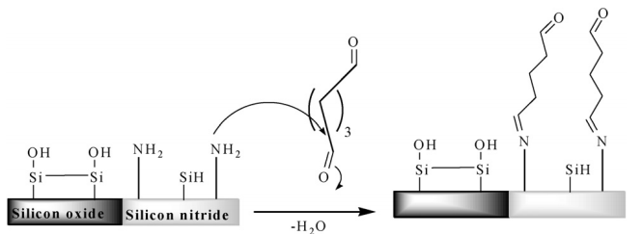
Figure S12. Chemical reaction mechanism for the direct glutaraldehyde modiﬁcation of silicon nitride surface (reprinted from Ref. (Bañuls et al. 2010) with permission).
Reference:
Abbas, A., Linman, M.J., Cheng, Q., 2011. Biosens Bioelectron 26(5), 1815-1824.
Andrade, J.D., Vanwagenen, R.A., Gregonis, D.E., Newby, K., Lin, J., 1985. IEEE Transactions on Electron Devices 32(7), 1175-1179.
Bañuls, M.-J., González-Pedro, V., Barrios, C.A., Puchades, R., Maquieira, Á., 2010. Biosensors and Bioelectronics 25(6), 1460-1466.
Bañuls, M.-J., Puchades, R., Maquieira, Á., 2013. Analytica chimica acta 777, 1-16.
Banuls, M.J., Puchades, R., Maquieira, A., 2013. Anal Chim Acta 777, 1-16.
Brandenburg, A., Krauter, R., Künzel, C., Stefan, M., Schulte, H., 2000. Appl. Opt. 39(34), 6396-6405.
Clark Jr, L.C., Lyons, C., 1962. Annals of the New York Academy of sciences 102(1), 29-45.
Fan, X., White, I.M., Shopova, S.I., Zhu, H., Suter, J.D., Sun, Y., 2008. Anal Chim Acta 620(1-2), 8-26.
Gunda, N.S.K., Singh, M., Norman, L., Kaur, K., Mitra, S.K., 2014. Applied Surface Science 305, 522-530.
Harris, R.D., Wilkinson, J.S., 1995. Sensors and Actuators B: Chemical 29(1), 261-267.
Hartmann, M., Kostrov, X., 2013. Chemical Society Reviews 42(15), 6277-6289.
Homola, J., 2008. Chemical reviews 108(2), 462-493.
Homola, J., Yee, S.S., Gauglitz, G., 1999. Sensors and Actuators B: Chemical 54(1), 3-15.
Lambeck, P.V., 1992. Sensors and Actuators B: Chemical 8(1), 103-116.
Liang, L., Jin, L., Ran, Y., Sun, L.-P., Guan, B.-O., 2017. Sensors and Actuators B: Chemical 242, 999-1006.
Liu, Q., Tu, X., Kim, K.W., Kee, J.S., Shin, Y., Han, K., Yoon, Y.-J., Lo, G.-Q., Park, M.K., 2013. Sensors and Actuators B: Chemical 188, 681-688.
Lu, X., Rycenga, M., Skrabalak, S.E., Wiley, B., Xia, Y., 2009. Annu Rev Phys Chem 60, 167-192.
Puiu, M., Bala, C., 2016. Sensors 16(6), 870.
Riedel, T., Surman, F., Hageneder, S., Pop-Georgievski, O., Noehammer, C., Hofner, M., Brynda, E., Rodriguez-Emmenegger, C., Dostálek, J., 2016. Biosensors and Bioelectronics 85, 272-279.
Sassolas, A., Blum, L.J., Leca-Bouvier, B.D., 2012. Biotechnology advances 30(3), 489-511.
Sassolas, A., Hayat, A., Marty, J.-L., 2013. Immobilization of Enzymes and Cells, pp. 229-239. Springer.
Sicard, C., Brennan, J.D., 2013. MRS bulletin 38(4), 331-334.
Threm, D., Nazirizadeh, Y., Gerken, M., 2012. J Biophotonics 5(8-9), 601-616.
Updike, S., Hicks, G., 1967. Nature 214(5092), 986.
Williams, R., Blanch, H., 1994. Biosensors and Bioelectronics 9(2), 159-167.

