Note: this is a draft of the journal article:

J.F.J. Soetens, P.R. Worsley, J.M. Herniman, G.J. Langley , D.L. Bader C.W.J. Oomens (2019) “The expression of anaerobic metabolites in sweat and sebum from human skin subjected to intermittent and continuous mechanical loading.”

Journal of Tissue Viability, accepted
The final, fully proofed and peer-reviewed journal article is available from the publisher online,

Title

The expression of anaerobic metabolites in sweat and sebum from human skin subjected to intermittent and continuous mechanical loading

Authors

J.F.J. Soetens 0000-0001-6781-4293

P.R. Worsley 0000-0003-0145-5042

J.M. Herniman 0000-0003-4834-1093

G.J. Langley 0000-0002-8323-7235

D.L. Bader 0000-0002-1208-3507 C.W.J. Oomens 0000-0002-3325-132X

Institutions

Eindhoven University of Technology, Department of Biomedical Engineering

University of Southampton, School of Health Sciences, Faculty of Environment and Health Sciences University of Southampton, School of Chemistry, Faculty of Engineering and Physical Sciences

Corresponding author

J.F.J. Soetens

e-mail: j.f.j.soetens@tue.nl

Address: Groene Loper, Building 15, Room 4.11, P.O. Box 513, 5612AZ Eindhoven, the Netherlands

The expression of anaerobic metabolites in sweat and sebum from human skin subjected to intermittent and continuous mechanical loading

August 19, 2019

Abstract

Pressure ulcers (PUs) represent a substantial burden to both patients and healthcare providers. Accordingly, effective prevention strategies should follow early detection of PUs. Anaerobic metabolites, such as lactate and pyruvate, are promising noninvasive biomarkers indicative of tissue ischaemia, one of the major mechanisms leading to PU development. The aim of this study was to investigate if the temporal release profile of these metabolites in sweat and sebum is sensitive to detect local tissue changes resulting from prolonged mechanical loads.
The sacrum of healthy volunteers was subjected to two different loading protocols. After a baseline measurement, the left and right side of the sacrum were subjected to continuous and intermittent loading regimen, respectively, at a pressure of 100 mmHg. Biomarker samples were collected every 20 minutes, with a total experimental time of 140 minutes. Sweat was collected at 37 °C and 80% relative humidity, and sebum at ambient conditions, from 11 and 13 volun­ teers, respectively. Both samples were analysed for lactate and pyruvate concentrations using ultra-high performance supercritical fluid chromatography mass spectrometry. Prior to analysis metabolite concentrations were normalised to individual baseline levels and, in the case of sweat,

additional normalization was performed to an unloaded control site to account for fatigue of sweat glands.
Although substantial variability was present, the temporal release profiles of both sweat and sebum metabolites reflected the applied loading regimen with increased levels upon load appli­ cation, and recovery to baseline levels following load removal. Highest relative increases were 20
% and 30 % for sweat lactate and pyruvate, respectively, and 41 % for sebum lactate. Sebum pyruvate was not present in quantifiable amounts. There was a linear correlation between the individual responses to intermittent and continuous loading.
The present study revealed that metabolite biomarkers in both sweat and sebum were sensitive to the application of mechanical loads, indicative of local ischaemia within skin and soft tissues. Similar trends in metabolic biomarkers were observed in response to intermittent and continuous loading regimens in both sweat and sebum. Metabolites represent a potential means to monitor the health of loaded skin and soft tissues informing timely interventions of PU prevention.

Introduction

A pressure ulcer (PU) has been defined in an International consensus as "a localized injury to skin and/or underlying tissue, usually over a bony prominence, as a result of prolonged mechanical load­ ing in the form of pressure, or pressure in combination with shear" [29]. Pressure ulcers represent a substantial burden to the healthcare providers with associated costs for prevention and treatment of these chronic wounds [10]. More importantly, developing a PU can have substantial effects on quality of life [43] and associated complications can potentially prove lethal [37].
The aetiology of a PU involves two main damage pathways [31], both related to the duration and magnitude of internal tissue deformation resulting from externally applied load [21, 30]. Thus di­ rect deformation damage, resulting from high internal deformations can lead to cell damage within minutes, involving rupture of the cell membrane and cytoskeleton disruption [22, 30]. Alternatively,

ischaemic damage can occur over a period of several hours, as a result of moderate internal tissue deformation causing the occlusion of blood and lymph vessels. This occlusion results in impaired transport of vital nutrients including oxygen into the tissue, forcing cells to switch from an aerobic to anaerobic metabolism under the hypoxic conditions. Moreover, the occluded lymph vessels are unable to remove metabolic waste products, which accumulate in the cellular environment, result­ ing in a damaging decrease in local pH [23]. The subsequent removal of mechanical load leads to tissue reperfusion, supplying oxygen and other nutrients to the tissue. However, this may result in an overproduction of oxygen-derived free radicals [24], which have been associated with further tissue damage.
PU risk assessment is routinely performed using tools such as the Braden, Norton or Waterlow scales in combination with clinical experience [28]. Although these subjective measures can pre­ dict PU occurrence to some extent, they often lead to inefficient use of preventive measures [41]. Moreover, identifying patients at risk is complicated due to individual variability in tissue tolerance to mechanical loading, which is an intrinsically determined property. Similar issues exist with the early detection of PUs in a clinical setting. The current gold standard is visual inspection and palpation [29], although the former is unable to detect a visible blanching response in darkly pig­ mented skin [39]. Thus, there is a need for an objective tool to monitor the status of loaded tissues, which reflects the local pathophysiological response in vulnerable tissue sites.
The analysis of biomarkers, which can be collected from a range of body fluids, including urine, blood, sweat and sebum, has been proposed as a strategy to assess tissue status in an objective manner [2]. Potential PU detection methods using biomarkers have been reported, typically mon­ itoring actual tissue breakdown or the response to known loads, involving inflammatory cytokines [5, 9, 18, 42, 46, 48, 49], C-reactive protein [17, 25], myoglobin [25, 45], troponin [45] and purines [1]. Indeed, the authors recently demonstrated the use of non-invasive inflammatory biomarkers as

a potential indicator of pressure-induced tissue damage [42].

Another promising approach is to use noninvasive biomarkers as early indicators of ischaemic dam­ age. Suitable candidates are the metabolic waste products, lactate and pyruvate, which are pro­ duced through glycolysis, and thus provide indicators for anaerobic cell metabolism. Indeed sweat lactate has been identified as a potential indicator of skin ischaemia, first reported by van Heynig­ nen and Weiner in 1952 [47], who observed an increase in concentration upon arterial occlusion of the arm. Subsequent studies have shown elevated sweat lactate concentrations during periods of load-induced ischaemia in a group of able-bodied subjects [12] and those with disability [35]. In addition, studies have combined the analysis of sweat lactate with transcutaneous oxygen tissue gas (TcP02), revealing a significant correlation after the latter exceeded a threshold reduction value of 60 % when compared to unloaded basal values [20]. The application of sampling sebum lactate in a clinical scenario was tested by Hemmes et al. [18], where the temporal release was monitored at the sacrum, with a cohort of healthy volunteers lying on a rigid spineboard. Lactate was found to increase with prolonged exposure to pressure, and to decrease in the unloaded prone position, although there was no significant relationship with pressure magnitude.
More recently, technological advances have enabled the simultaneous quantification of multiple metabolites in sweat [19]. The exploration of other relevant metabolites and metabolite ratios is therefore possible. Indeed, the lactate/pyruvate ratio (L/P) has proved a useful indicator for sever­ ity and prognosis of ischemic related diseases, including acute liver failure [11], myocardial injury [6] and traumatic brain injury [36]. However, this key metabolite ratio has not been investigated in the context of pressure-induced skin damage. Accordingly, the present study addressed the following questions:

  - Is the temporal release profile of anaerobic metabolites in sweat and sebum representative for local tissue status?

  - Is there a difference in the response profiles to intermittent and continuous loading?

The aims were achieved by examining the temporal profiles of metabolic waste products result­ ing from two distinct loading regimens at the sacrum of a cohort of healthy volunteers. Metabolic concentrations of lactate and pyruvate in sweat, and lactate in sebum were quantified using ultra­ high performance supercritical fluid chromatography-mass spectrometry (UHPSFC-MS).

Materials and methods

Participants

The participants were recruited from the local university population. The protocol was approved by the ethics committee of the University of Southampton (ERGO-FOHS-19647), and informed written consent was obtained from the participants before testing and for the publication of the images.

Test equipment

The test equipment has been recently described by Soetens et al. [42]. To review briefly, a double sided custom-made loading system was employed using two independent cylindrical weights (100 mmHg, 036 mm) suspended from a frame mounted over a hospital bed. Sebum was collected using Sebutape (CuDerm, Dallas, TX, USA). Sweat was collected on circular filter paper pads (Whatman Chromatography, Whatman paper, Maidstone, UK) which were 40 mm in diameter, covered with a sheet of Parafilm M (Bemis NA, Neenah, WI, USA) to prevent evaporation during the collection period. The fluid capacity of each filter paper was 240 µL.

Test protocol

The experimental protocol described by Soetens et al. [42] was performed at both ambient con­ ditions (temp. 20±2 °C, RH 40±5%), and in an environmental chamber (temp. 37±1 °C, RH 80±5%), to obtain sebum and sweat samples, respectively. To review briefly, while participants remained in a prone lying position, the left and right side of the sacrum were subjected to the different loading regimens using two independent cylindrical weights (diameter 35mm) suspended from a frame mounted over a hospital bed. This was equivalent to a significant pressure of 100 mmHg, similar in magnitude to that used in previous studies [20, 35]. The lower back acted as

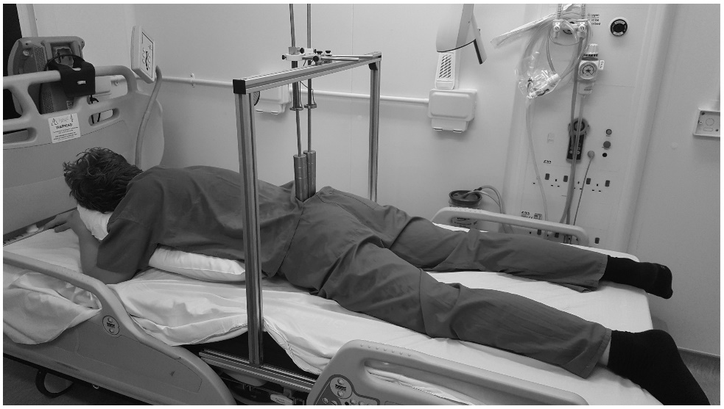
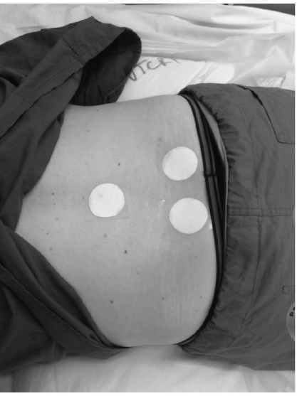
an unloaded control site (Fig. 1). Mild erythema in the absence of pain was observed in some of the participants following the intermittent loading regimen. The skin was checked for blanching to ensure no skin damage had resulted from the 2-hour test period.

Figure 1: Picture of the experimental setup in the environmental chamber (left), with the partici­ pant lying in prone position, while the left and right side of the sacrum were subjected to different loading regimen. Filter paper pads were applied to obtain sweat samples on three measurement sites (right): left sacrum (continuous loading), right sacrum (intermittent loading) and lower back (unloaded control).

Samples from each site were collected every 20 minutes, including an initial acclimatisation period, loading periods and offioading periods, resulting in a total experimental time of 2 hours and 20 minutes. The acclimatisation period provided baseline values, during which all three sites remained completely unloaded. Subsequently, the left and right side of the sacrum were subjected to continuous and intermittent loading, respectively (Fig. 2).
Sebutapes were applied to the skin for 2 minutes, using a gloved hand and tweezers to avoid cross contamination. The samples were coded and stored immediately at -80 °C.
By contrast, sweat was collected on the circular filter paper pads continuously during each loading

20 min
... Sebutape
20 min
... Sebutape
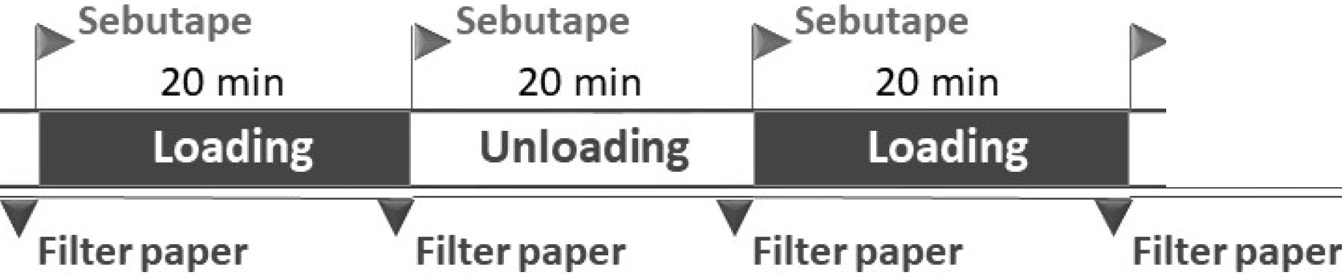
20 min
Sebutape
20 min
... .
.,_sebutape

Control ... . Loading
... .
Unloading
Unloading

Filter paper
Filter paper
FIiter paper

20 min
.,_sebutape
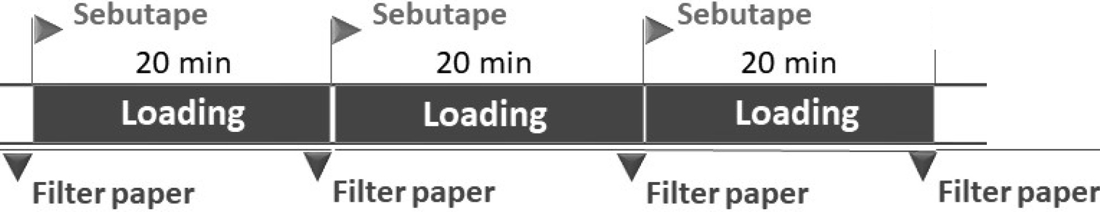
20 min
Sebutape
20 min
Sebutape
20 min
.,_sebutape

Control Unloading Unloading Unloading
TF1·1ter paper 'fF1.,ter paper

TF1.,ter paper

Measurement period
I 1 I 2 3 4 5 6 7

Figure 2: Schematic of the experimental protocol, with intermittent (top) and continuous loading (bottom) regimens applied to the right and left side of the sacrum, respectively. Each regimen consists of 7 measurement periods of 20 minutes (bottom row), in which either loading (grey) or no loading (white) was applied. Samples of either sweat (filter paper) or sebum (Sebutape) were sampled at the beginning and end of each 20 minute phase.

phase. At the end of each 20 minute period, the pads were removed and placed in self-standing 30 mL centrifuge tubes (Sterilin 128B/FS, Thermo Scientific, Waltham, MA, USA). The yield was measured gravimetrically and each pad was centrifuged at 3000 g for 10 minutes to extract the sweat. In the case of an insufficient yield (<160 µL), reverse osmosis water was applied to the pad prior to centrifuging to increase the volume with a maximum dilution factor of 25. Once collected, the sweat samples were stored at -80 °C.

  - Biochemical analysis

Sebum recovery was performed following an optimized protocol based on Perkins et al. [33]. The Sebutapes were submerged in 2 mL of phosphate buffered saline (PBS, Sigma-Aldrich Co., St. Louis, MO, USA) with the addition of 0.05 % TWEEN20 (Sigma-Aldrich Co., St. Louis, MO, USA). To optimize protein recovery, the tubes were subsequently placed on a roller mixer for 1 hour, sonicated for 10 minutes and individually vortexed for 2 minutes. The sweat samples were

diluted 5 times with reverse osmosis water directly after thawing, vortexed briefly and mixed with a sterile pipette tip prior to analysis.
UHPSFC-MS was performed, as described by Herniman et al. [19], using an Acquity UPC2 ultra

performance convergence chromatograph (Waters, Wilmslow, UK) with CO2 as the supercritical fluid. A UPC2 Torus Diol 3 x 100 mm, 1.7 µm column (Waters, Milford, USA) was used with 50 mM ammonium acetate methanol/2 % water modifier. The column temperature was 50 °C with an injection volume of 2 µL, elution flow rate of 1.5 mL/minute, ABPR set at 15 MPa and methanol/1
% HCOOH make-up flow solvent at 0.45 mL/minute.

Positive (and negative ion) ESI mass spectra were recorded using a Waters SQD2 single quadrupole mass spectrometer (Waters, Wilmslow, UK), with capillary voltage 3.3 (-3.3) kV, cone voltage 20 (-20) V, extractor 3.0 (-3.0) V, source temperature 150 °C, desolvation temperature 500 °C; desolvation gas flow 650 L/h. Single ion recording for the protonated (deprotonated) molecules was used for all experiments. Data acquisition and processing were undertaken using MassLynx
4.1 (Waters, Milford, USA). Linearity for both lactate and pyruvate standards was excellent in the range of interest, 1-2500 ppm, with R2=0.9976 and R2=0.9970, respectively.

2.5 Data analysis

Statistical analysis was performed using IBM SPSS Statistics V23 (IBM Corporation, Armonk, NY, USA). Measured sweat lactate and pyruvate concentrations from the sacral loading sites were normalized to values of the unloaded site (lower back) for the equivalent test periods. Subse­ quently they were normalized to baseline in order to allow comparison of relative ratio changes between participants. Sebum lactate concentrations were only normalized to baseline for the same reason. Pairwise comparisons were tested for significance using, due to small sample sizes, the non­ parametric Wilcoxon signed rank test. Data is presented using median (IQR) and the statistical

significance level was set at p< 0.05.

- Results

3.1 Sweat metabolite study

Eleven healthy participants (5 males and 6 females) were included in the study investigating sweat metabolites. Their mean age was 28 years (range 21-36 years), mean height was 1.71±0.08 m, mean weight was 72.7±10.6 kg, with a corresponding body mass index of 24.7±2.5 kg/m2 • Two participants were excluded from the analysis since their sweat rate was too low to obtain a sufficient yield for reliable analysis.

 | Control |  |  |  | Intermittent |  |  |  | Continuous
 | Sweat yield (µL) | L/P ratio (-) |  |  | Sweat yield (µL) | L/P ratio (-) |  |  | Sweat yield (µL) | L/P ratio (-)
Cl | 177.5±54.3 | 13.2 (10.1-17.4) |  | BL | 142.5±46.0 | 12.3 (10.8-17.3) |  | BL | 140.5±43.6 | 12.1 (10.0-17.1)
C2 | 246.3±59.1 | 17.0 (12.8-19.0) |  | Ll | 168.8±35.3 | 15.9 (14.1-21.8) 0•b |  | Ll | 176.3±55.3 | 16.9 (12.-18.8)
ca | 241.9±39.7 | 19.2 (17.9-30.w |  | Ul | 207.2±37.9 | 23.1 (17.0-29.1) 0 |  | L2 | 187.8±70.0 | 19.3 (16.7-23.8)",b
C4 | 233.5±28.2 | 26.7 (21.4-38. 7)",b |  | L2 | 183.4±60.2 | 27.7 (20.l-38.2) 0,b |  | La | 187.5±68.7 | 24.8 (20.5-34.6)",b
C5 | 229.5±68.7 | 38.7 (24.1-49.3)",b |  | U2 | 192±57.2 | 36.2 (27.4-47.7) 0,b |  | Ul | 208.2±41.7 | 27.4 (21.3-40.8)"
C6 | 212.9±64.4 | 48.5 (31.3-60.8)",b |  | La | 160.4±79.5 | 36.0 (25.6-50. 7)0 |  | U2 | 184.6±65.2 | 36.8 (25.1-47.0)",b
C7 | 171.2±71.4 | 44.0 (29.5-57.2)" |  | ua | 155.2±68.0 | 33.1 (25.9-40.8) 0 |  | ua | 141.2±57.8 | 35.7 (25.6-42.8)"
Notes: " Significant difference (p < 0.05) between current value and BL. b Significant difference (p < 0.05) between current and previous value.

Abbreviations: C = control; BL = baseline; L = loading; U = unloading.

Table 1: Sweat yield and absolute L/P ratio data for control, intermittent and continuous loading regimen, presented in mean ± SD and median (IQR), respectively.

For the remaining participants the sweat yield was sufficient for analysis from the three test sites and remained fairly constant throughout the test period, as indicated in Table 1. The mean yields ranged between 140-245 µL, with the largest volumes produced in the control lower back site for each test period. In general, the first and last measurement showed lowest sweat rates.
A gradual decrease in the temporal release profile of both lactate and pyruvate concentrations

Sweat lactate concentration Sweat pyruvate conc,entration
140 _ 14
le1 1 ,i .@
is
is •sg j
IE i l ,2!e@ i ,
I
120 !_ 12

C 100
]
C
0 10
:;:;

.I.!.! 80 i; 8
0 u

C..
C..

u 60 I! 6

..
C 0
! ..... 4
u 40

!.!.
20 > 2

u :,
>

...I 0
IL 0

1 2 3 4 5 6 7 1 2 3 4 5 6 7
Measurement period (-) Measurement period (·)

Figure 3: Box and whisker plots of absolute lactate (a) and pyruvate (b) concentrations in sweat, obtained at intermittent (black), continuous (grey) and unloaded control (white) sites.

was observed at all sites, as shown with their median absolute values in Fig. 3. Lactate concen- trations decreased over 2-fold, whereas pyruvate concentrations decreased over 5-fold. Accordingly, the L/P ratio increased at all loading sites (Table 1), irrespective of loaded state, such that the differences between measurement periods were statistically significant (p<0.05 in all cases). The absolute lactate concentrations were between 12.1-48.5 fold higher than the associated pyruvate concentrations.
In order to investigate the relative influence of load application, normalisation to metabolite levels with respect to the unloaded control site was performed to remove the systemic effect of sweat gland fatigue. As a result , for both intermittent and continuous loading, the median normalised lactate and pyruvate levels reflect the applied temporal loading profile (Fig. 4). Although substantial variance in the metabolite expression was observed across the participants, it was evident for the majority of cases that there was an up-regulation of both metabolites immediately following the loading periods, which generally recovered to baseline levels during unloading. Close examination revealed that the highest increases were associated with continuous loading, with a 20 % and 30
% median increase in lactate and pyruvate values, respectively. When compared to baseline val-

ues, the levels were significantly (p<0.05) up-regulated after 40 minutes of continuous loading for lactate, and at both 40 minutes and 1 hour for pyruvate (Fig. 4b,d). In the case of sweat lactate, concentrations following load removal were lower than that at baseline i.e. median ratio <l.

(a)
2,5
Sweat intermittent lactate
(b)
2,5
Sweat continuous lactate

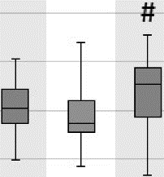
2
t"l'
.. 2
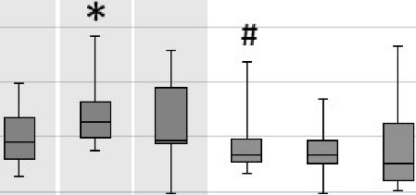
t"l'

..!! 1,5
"C.,l
.!::! 1
.;
E
0 0,5
z
..!! 1,5
"C.,l
.; 1
E
0 0,5
z

0
B-20min L-20min U-20min L-20min U-20min L-20min U-20min
Measurement period (-)

0
B-20min L-20min L-20min L-20min U-2in U-20min U-20min
Measurement period (-)

(c)
2,5
Sweat intermittent pyrwate
(d)
2,5
Sweat continuous pyruvate

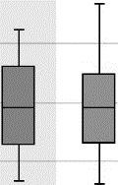
2
#
::,
:>:,
2
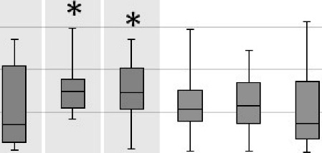
::,
::,

0.
"Cl
1,5
>, 1,5
0.
"Cl

- 1
.;
Eo o,s
z
0

8,-20min L-20min U-20min L-20min U-20min L-20min U-20min
Measurement period (-)
- 1
.;
E
0 0,5
z
0 '--------------------'
8,-20min L-20min L-20min L-20min U-20min U-20min U-20min
Measurement period (-)

Figure 4: Box and whisker plots of the lactate (a,b) and pyruvate (c,d) levels in sweat when subjected to intermittent (a,c) and continuous (b,d) loading, after individual normalization to unloaded control site and baseline values. Grey background depicts periods of loading. * significant
difference between current and baseline values; # significant difference between current and previous

values.

In a similar approach to a recent paper by the authors [42], the overall fresponse from each individual was quantified in order to reveal inter-participant variability. This involved calculation of the median accumulated response during the 2h load/unload periods for both regimens, as indicated with pyruvate for a single participant in Fig. 5.

- Participant 1 intermittent pyruvate
r
J
I
I
-
-
-
,
I I I
- - - -

u
J 1,5
:I
>

D. 1
- Participant 1 continuous pyruvate

u
J 1,5
2
>

"uCl
D. 1
"Cl
u

.!::!
10,5
0
C 0

8-20min L-20min U-20min L-20min U-20min L-20min U-20min
Measurement period (-)
1.!::! 0,5
0
Z O

8-20min L-20min L-20min L-20min U-20min U-20min U-20min
Measurement period (-)

Figure 5: The median accumulated response of pyruvate (outlined area) for an individual partici- pant during two hours of load/unload periods to both intermittent (a) and continuous (b) loading regimen . Grey background depicts period of applied loading.

The median values of lactate response to intermittent and continuous loading were 1.03 (0.84- 1.36) and 1.11 (0.68-1.56), respectively. These associated differences were not statistically significant ( Z=-0.089 , p=0.929). Equivalent findings were obtained for the pyruvate response (Z=-0.267, p=0.790). However, correlation of the pyruvate responses to intermittent and continuous loading was statistically significant (p=0.755, p=0.007), as indicated by the Spearman's rank correlation test (Fig. 6). For lactate this correlation was less pronounced (p=0.536, p=0.086).
Response intermittent vs. continuous pyruvate
. ·············. · .
t
··············· = 0.755
-
l
r
•
··· • p = 0.007
-- ······· · • f
t
Response intermittent vs. continuous lactate

2

1,8
g 1,6
i 1,4

2
J

;1,8
• g 1,6

C

0 ···········p·;0.536
C
i 1,4
0

.... 1
• ·r··········(
....•·::], ····•• t .
p = 0.086
.. 1

!" 1'2
..! 0,8
0,6
•···· t
!" 1,2
>
>
:I
0,8
.:.- 0,6

0
9" 0,4

0,2

0,5 0,8 1,1 1,4 1.,7
Response lactate interm ittent (-)
0,4
9- 0,2
..
a::

0,5 0,8 1,1 1,4 1,7
Response pyruvate intermittent (-)

Figure 6: Linear correlation between the individual responses to intermittent and continuous load- ing regimens for sweat lactate (a) and pyruvate (b).

3.2 Sebum lactate

In the study investigating sebum lactate, thirteen healthy participants (7 males and 6 females) were included, with a mean age of 31 years (range 21-65 years), mean height of 1.72±0.08 m, and mean weight of 73.3±10.2 kg with a corresponding body mass index of 24.7±2.3 kg/m 2 •
The absolute concentrations of both lactate and pyruvate were found to be three orders of magnitude lower than those in sweat, with the latter not present in quantifiable amounts. Nonetheless, the up-regulation of lactate concentrations in µM reflected both temporal loading profiles , as shown in Fig. 7, although, as with sweat metabolites , large individual variability was evident.

Sebum intermittent lactate concentration

150 --------------
..=: 125
C
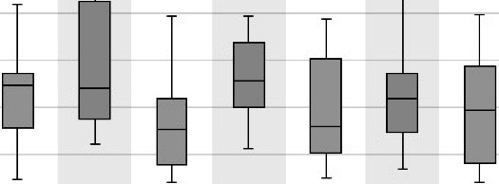
0
.; 100

Jl
75
u
C
..
g 50
u
!
25
u
..m..,
0 '-------------------'
ll-20min L-20min U-20min L-20min U-20min L-20min U-20min
Measurement period (-)
Sebum continuous lactate concentration

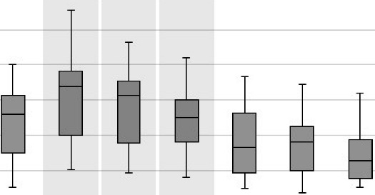
150 --------------
..=: 125
C
0
·.;; 100

Jl
75
u
C
..
g 50
u
!
u 25
....,
m

0 '-------------------'
- 0min L-20min L-20min L-20min U-20min U-20min U-20min
Measurement period (·)

Figure 7: Box and whisker plot of absolute lactate concentration in sebum when subjected to intermittent (a) and continuous (b) loading. Grey background depicts periods of loading.

The temporal lactate levels on the unloaded control site remained constant over all test periods, with no significant changes ( Z=-0.357 to -0.764, p=0 .445 to 0.721). Therefore for a quantitative comparison of individuals, in contrast with the sweat data, only baselin e normalization was per- formed for sebum lactate. During the intermittent regimen, the lactate levels increased upon load application, while load removal resulted in a recovery to baseline levels, with statistical significant differences evident in the first four test periods ( Z=-2.691 to -3.040, p=0 .002 to 0.007). In the continuous loading regimen, application (Z=-2.411 , p=0 .016) and removal ( Z=-2.411, p=0.016) of

the load resulted in a significant changes in lactate values (Fig. 8). For the first refractory period in the intermittent loading regimen and the final refractory period in the continuous loading regimen, the measured lactate levels were significantly lower than baseline (p< 0.05). The highest median increases to intermittent and continuous loading in separate periods were found to be 41 % and 32
%, respectively.

  - Sebum intermittent lactate
2,5
  - Sebum continuous lactate
2,5
----------------
8-20min L-20min L-20min L-20min U-20min U-20min U-20min

...:.. 2
....
!
_! 1,5
"Cl
- 1
ii
E
j 0,5
0
...:.. 2
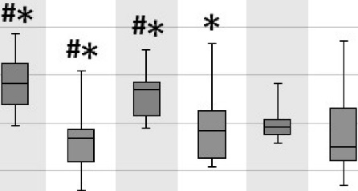
!
....
_! 1,5
"Cl
- 1
ii
E
l
0,5
0

8-20min L-20min U-20min L-20min U-20min L-20min U-20min
Measurement period (-)
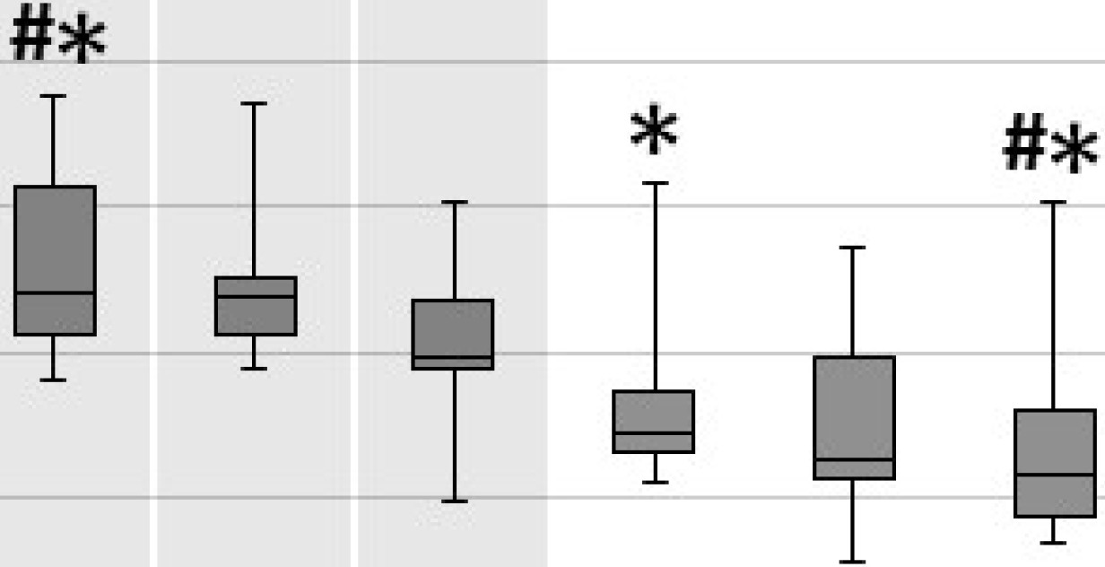

Measurement period (-)

Figure 8: Box and whisker plots of sebum lactate levels in response to intermittent (a) and con­ tinuous (b) loading, normalized to individual baseline values. Grey background depicts periods of loading. * significant difference between current and baseline values; # significant difference
between current and previous values.

In a similar manner to the sweat metabolite data, the median accumulated response to both loading regimens was determined. The differences in median response of 0.98 (0.89-1.25) and 0.93 (0.81-1.14) for intermittent and continuous loading regimens , respectively, were not statistically significant (Z=-1.712 , p=0.087). Although trends were evident, the correlation of lactate responses to intermittent and continuous loading was not statistically significant (Fig. 9), as shown by the Spearman correlation test (p=0.434, p=0.138).

Response intermittent vs. continuous sebum

0...
, _ -L..

2,50 .-----------------,

2,00
C
.. ..•..,···

2..
1,50 • f

.... p = 0.138

::,
1,00

i 0,50 t
C
8 0,00 . ,

0,50 1,00 1,50 2,00
Intermittent response (·)
2,50

Figure 9: Linear correlation between the individual responses to intermittent and continuous load- ing regimen for sebum lactate.

Discussion

The current study examined the temporal release profile of sweat and sebum metabolites resulting from both intermittent and continuous loading. Its primary aim was to evaluate if the anaerobic metabolites in sweat and sebum were representative of local loaded tissue status. Subsequently, the study revealed expression levels of lactate and pyruvate reflected the applied temporal loading pro­ files. Indeed, upon application of the two loading regimens normalized metabolite levels increased and load removal resulted in recovery to baseline levels in both sweat and sebum. Although testing was performed on a small group of healthy volunteers, the results suggest considerable potential for these biomarkers to be used as objective means to monitor the status of loaded skin and soft tissues.
The highest increases in sweat lactate and pyruvate were found to be 20 % and 30 % greater than baseline values, respectively. Similar findings from pre- and post- loaded studies have been reported. For example, Ferguson-Pel et al. [12] reported a 37 % increase in sweat lactate after 30 minutes of loading at the volar forearm with 150 mmHg. A similar magnitude and period of loading using a uniaxial indenter yielded a 76 % increase in sweat lactate [34]. In a study combining physical

sensors with sweat biomarkers, Knight et al. [20] reported an increase of lactate concentrations by 29-39 % as a result of sacral loading at interface pressures of 80-120mmHg applied for a period of 60 minutes. This relative change in lactate concentration was also observed in the sacral region of a cohort of spinal cord injured, following a period of prolonged lying postures [35].
In contrast to previous studies, the gradual temporal decrease in sweat metabolite concentrations across both control and loaded test sites (Fig. 3) necessitated the need for normalization. Estima­ tion of the L/P ratio revealed a monotonic temporal increase, on average from 13 to 38, irrespective of load application (Table 1). This might be attributed to fatigue of the local sweat glands, as sug­ gested by Ferguson-Pell et al. [12]. This fatigue process represents a systemic effect, since it was also observed at the unloaded control site, as a direct result of the experimental conditions associ­ ated with the high sweat rates in the elevated ambient conditions.
It was therefore worthwhile to investigate if metabolic biomarkers could also be measured at lower ambient conditions, as previously described by Hemmes et al. [18]. In the current study, the sebum metabolite release profile was constant over the course of the experiment at the control site, reflect­ ing limited fatigue of the sebaceous glands. Therefore, any changes observed over the loading sites can be attributed to the local tissue ischaemia, resulting from the applied loading. The relative increase in lactate levels, namely 42 % for continuous loading, was lower than those reported by Hemmes et al. [18], which is probably due to the difference loading magnitude (100 mmHg vs. 240 mmHg). Although the absolute sebum lactate concentrations were orders of magnitude lower than those in sweat, µm versus mM, respectively, the relative changes in normalized metabolites were indicative of the applied temporal loading profile, particularly associated with intermittent loading (Fig. 8). This is indicated by the statistical significant changes in lactate levels upon load application and removal. The present study therefore provides supporting evidence that sebum lactate can represent a promising biomarker for monitoring local tissue ischaemia under clinically

relevant ambient conditions. The associated absolute metabolite concentrations were well within the performance characteristics of the UHPSFC-MS, making it a sensitive methodology to detect change.
In order to assess whether a difference is observed between the responses of each loading regimens, the metabolite profiles were quantified by the median accumulated response, which accounts for the median metabolite level during both loading and unloading regimes (2 hours). For both sweat metabolites and sebum lactate, no differences between intermittent and continuous loading were observed (Figs. 6 and 9). These findings suggest that the duration of load-induced ischaemia in the current study, namely either 3x 20 minutes for intermittent or 60 minutes for continuous loading, was insufficient to reveal any benefits attributed to intermittent load relief.
The suitability of the metabolic biomarkers for the early detection of PU development needs further investigation. Previously, Stekelenburg et al. [44] reported that tissue damage in a rat model was not induced after two hours of complete ischaemia. Considering both the magnitude and duration of loading in the current study, the applied loading regimens were not sufficient to cause tissue damage. Therefore, the current experimental protocol should be extended beyond 2 hours with enhanced refractory periods. Alternatively, provided ethics are granted, the metabolic biomarker expression over grade I PUs could be sampled.
In line with previous studies [1, 20, 34, 42], the cohort of able-bodied volunteers revealed consid­ erable variability in biomarker expression, as indicated by the individual responses to intermittent and continuous loading regimens (Fig. 6 and 9). This might potentially be explained by the vari­ ability in individual tissue morpohology. In order to identify sub-populations that are at particular risk, additional information is required regarding the relationship between the physiological and biochemical response to loading on an individual basis. As an example, the metabolite expression levels could be related to internal tissue deformation and perfusion, e.g. via transcutaneous gas

measurement [20], on an individual basis. The loading device could be adapted to enable simultane­ ous measurement of mechanical and biochemical responses. For example, local tissue deformations and tissue perfusion could be assessed using photoacoustics, ultrasound and strain imaging [26]. Similarly, magnetic resonance imaging (MRI) has proven to be useful for this purpose in animal models [23, 24, 44].
Together with the inflammatory biomarkers from our previous study [42], both the ischaemic and inflammatory damage pathways can be monitored non-invasively. The current methodology en­ ables monitoring of the biological response of the tissue with a high level of accuracy and high sensitivity to change. The causal link between changes in ischemic and inflammatory biomark­ ers and skin damage need to be further explored, using temporal and spatial evaluations. The time over which biomaterials are sampled should incorporate the known physiological response to loading, including the changes in microvasculature (vasodilation) [3, 13] and signalling pathways of pro- and anti-inflammatory biomarkers [16]. However, in order to gain clinical translation it must be adapated into a point-of-care biosensor capable of monitoring the temporal metabolite and inflammatory expression levels. However, such a development for an early detection of PUs with adequate sensitivity is not trivial. It is also recognized that the presence of moisture, e.g. sweat, in the local microclimate of a loaded interface is not desirable as it can contribute to the development of a PU [29]. However, in some specific cases excessive perspiration is common, such as the residual limb-socket interface during exercise, making sweat a readily available biofluid for biomarker analysis.

- Conclusions

The present study suggests that metabolites in both sebum and sweat may have the potential to act as suitable biomarkers for the non-invasive detection of changes due to local ischaemia

in periodically-loaded skin tissues. However, sweat metabolite levels required normalisation to an unloaded control site to distinguish between systemic and local changes. Similar trends in metabolic biomarkers were observed in response to intermittent and continuous loading regimens in both sweat and sebum. This study supports previous study findings that metabolites can prove suitable biomarkers for the early detection physiological changes indicative of pressure ulcer risk induced by external mechanical loading.

Acknowledgement

This work forms part of the research programme "Surfaces for Health" (project number 12673) which is partly financed by the Netherlands Organisation for Scientific Research (NWO). Exper­ imental work was conducted within the facilities of the UK NetworkPlus "Medical Devices and Vulnerable Skin" (project number (EP/ N02723X/1)). We are also grateful to the Langley Research Group at School of Chemistry from the University of Southampton for providing all necessities for the UHPSFC-MS analysis presented in this study.

References

References

[1] Bader D. Wang YN. Knight S. Polliack A. James T. Taylor R. 2005. Biochemical Status of Soft Tissues Subjected to Sustained Pressure. In: Bader DL. Bouten CV. Colin D. Oomens CWJ. (eds) Pressure Ulcer Research. Springer, Berlin, Heidelberg.

[2] Bader D. Oomens C. 2018. The Potential of Biomarkers in the Early Detection of Pressure Ulcers. In: Romanelli M., Clark M., Gefen A., Ciprandi G. (eds) Science and Practice of

Pressure Ulcer Management. Springer, London.

[3] Bentov I, Reed MJ. 2015. The effect of aging on the cutaneous microvasculature. Microvasc Res. 100:25-31.
[4] Bronneberg D. Spiekstra SW. Cornelissen LH. Oomens CWJ. Gibbs S. Baaijens FP. Bouten CV. 2007. Cytokine and chemokine release upon prolonged mechanical loading of the epi­ dermis. Exp Dermatol 16: 567-73.
[5] Bronneberg D. 2007. Biochemical Markers for Early Detection of Superficial Pressure Ul­ cers. Eindhoven University of Technology, Dept. of Biomedical Technology, Eindhoven, The Netherlands (Ch. 6).
[6] Chowdhury UK. Sheil A. Kapoor PM. Narang R. Gharde P. Malik V. Kalaivani M. Chaud­ hury A. 2016. Short-term prognostic value of perioperative coronary sinus-derived-serum cardiac troponin-1, creatine kinase-MB, lactate, pyruvate, and lactate-pyruvate ratio in adult patients undergoing open heart surgery. Annals of Cardiac Anaesthesia. 19(3):439- 453.
[7] Cooper KL. Evidence based prevention of pressure ulcers in the Intensive Care Unit. 2013.

Crit Care Nurse 33(6):57-66.

[8] Cornelissen LH. Bronneberg D. Bader DL. Baaijens FPT. Oomens CWJ. 2009. The trans­ port profile of cytokines in epidermal equivalents subjected to mechanical loading. Ann Biomed Eng. 37(5):1007-1018.
[9] Cornelissen LH. 2007.The transport profile of cytokines in compromised human skin. PhD Thesis, Eindhoven University of Technology, Eindhoven, The Netherlands.

[10] Demarre L. Van Lancker A. Van Hecke A. Verhaeghe S. Grypdonck M. Lemey J. Annemans

L. Beeckman D. 2015. The cost of prevention and treatment of pressure ulcers: A systematic review. Int J Nurs Stud 52:1754-1774.
[11] Feldman AG. Sokol RJ. Hardison RM. Alonso EM. Squires RH. Narkewicz MR. 2015. Lactate and lactate:pyruvate ratio in the diagnosis and outcomes of pediatric acute liver failure. Journal of Pediatrics 182:217-222.

[12] Ferguson-Pell M. Hagisawa S. 1988. Biochemical changes in sweat following prolonged is­ chaemia. J Rehabil Res Dev 25:57-62.
[13] Fromy B. Lingueglia E. Sigaudo-Roussel D. Saumet JL. Lazdunski M. 2012. Asic3 is a neuronal mechanosensor for pressure-induced vasodilation that protects against pressure ulcers. Nature Medicine 18:1205-1207.
[14] Gefen A. Levine J. 2007. The false premise in measuring body-support interface pressures for preventing serious pressure ulcers. J Med Eng Technol 31:375-80.
[15] Gunningberg L. Sedin IM. Andersson S. Pingel R. 2017. Pressure mapping to prevent pres­ sure ulcers in a hospital setting: A pragmatic randomised controlled trial. International Journal of Nursing Studies 72:53-59.
[16] Gutowska-Owsiak D, Ogg GS. 2013. Cytokine regulation of the epidermal barrier. Clin Exp Allergy. 43(6):586-98.
[17] Hatanaka N. Yamamoto Y. lchihara K. Mastuo S. Nakamura Y. Watanabe M. lwatani Y. 2008. A new predictive indicator for development of pressure ulcers in bedridden patients based on common laboratory tests results. J Clin Pathol. 61:514-518.

[18] Hemmes B. de Wert LA. Brink PRG. Oomens CWJ. Bader DL. Poeze M. 2017. Cytokine ILlalpha and lactate as markers for tissue damage in spineboard immobilisation. A prospec­ tive, randomised open-label crossover trial. J Mech Behav Biomed Mater. 75:82-88.
[19] Herniman J. Langley GJ. Greenhill R. Worsley PR. Bader DL. Jenkins T. 2015. The analysis of sweat biomarkers in mechanically-loaded tissues using SFC-MS. In: American Society for Mass Spectrometry annual conference (ASMS). St Louis, USA.
[20] Knight S. Taylor R. Polliak A. Bader DL. 2001. Establishing predictive indicators for the status of loaded soft tissues. J Appl Physiol. 90:2231-2237.
[21] Linder-Ganz E. Shabshinb N. Itzchak Y. Gefen A. 2007. Assessment of mechanical condi­ tions in sub-dermal tissues during sitting: a combined experimental-MRI and finite element approach. J. Biomech. 40:1443-1454.
[22] Loerakker S. Stekelenburg A. Strijkers GJ. 2010. Temporal effects of mechanical loading on deformation-induced damage in skeletal muscle tissue. Ann Biomed Eng 38(8):2577-2587.
[23] Loerakker S. Manders E. Strijkers GJ. Nicolay K. Baaijens FPT. Bader DL. Oomens CWJ. 2011. The effects of deformation, ischemia, and reperfusion on the development of muscle damage during prolonged loading. J Appl Physiol 111:1168-1177.
[24] Loerakker S. Oomens CWJ. Manders E. Schakel T. Bader DL. Baaijens FPT. Nicolay K. Strijkers GJ. 2011. Ischemia-reperfusion injury in rat skeletal muscle assessed with T2- weighted and dynamic contrast-enhanced MRI. Magn Reson Med 66:528-537.
[25] Loerakker S. Huisman ES. Seelen HA. Glatz JF. Baaijens FP. Oomens CW. Bader DL. 2012. Plasma variations of biomarkers for muscle damage in male nondisabled and spinal cord injured subjects. J Rehabil Res Dev 49(3):361-372.

[26] Mallidi S. Karpiouk AB. Aglyamov SR. Sethuraman S. Emelianov SY. 2007. Measurement of blood perfusion using photoacoustic, ultrasound, and strain imaging. Proc. SPIE 643707.
[27] Mcinnes E. Jammali-Blasi A. Bell-Syer SE. Dumville JC. Cullum N. 2011. Support surfaces for pressure ulcer prevention. Cochrane Database Syst Rev. 13: CDOOl 735.
[28] Moore ZEH. Cowman S. 2014. Risk assessment tools for the prevention of pressure ulcers.

Cochrane Database Syst. Rev. 5:1-31.

[29] NPUAP. EPUAP. PPPIA. 2014. Prevention and Treatment of Pressure Ulcers: Clinical Practice guideline. Osborn Park, Western Australia: Cambridge media.
[30] Oomens CWJ. Loerakker S. Bader, DL. 2010. The importance of internal strains as opposed to interface pressures in the prevention of pressure related deep tissue injury. J. Tissue Viability 19:35-42.
[31] Oomens CWJ, Bader DL, Loerakker S, Baaijens FPT. 2015. Pressure induced deep tissue injury explained. Ann Biomed Eng 43:297-305.
[32] Peirce SM. Skalak TC. Rodeheaver GT. 2000. Ischemia-reperfusion injury in chronic pres­ sure ulcer formation: a skin model in the rat. Wound Repair Regen. 8:68-76.
[33] Perkins MA. Osterhues MA. Farage MA. Robinson MK. 2001. A noninvasive method to assess skin irritation and compromised skin conditions using simple tape adsorption of molecular markers of inflammation. Skin Res Technol 7:227-237.
[34] Polliack AA, Taylor RP, Bader DL. 1993. Analysis of sweat during soft tissue breakdown following pressure ischaemia. J Rehabil Res Dev 30:250-259.
[35] Polliack AA. Taylor RP. Bader DL. 1997. Sweat analysis following pressure ischaemia in a group of debilitated subjects. J Rehabil Res Dev 34:303-308.

[36] Quintard H. Patet C. Zerlauth JB. Suys T. Bouzat P. Pellerin L. Meuli R. Magistretti PJ. Oddo M. 2015. Improvement of neuroenergetics by hypertonic lactate therapy in patients with traumatic brain injury is dependent on baseline cerebral lactate/pyruvate ratio. J Neurotrauma 33(7):681-687.
[37] Redelings MD. Lee NE. Sorvillo F. 2005. Pressure ulcers: more lethal than we thought?

Adv Skin Wound Care 18:367-372.

[38] Reenalda J. Jannink M. Nederhand M. IJzerman M. 2009. Clinical use of interface pressure to predict pressure ulcer development: A systematic review, Assistive Technology 21:76-85.
[39] Scanlon E. Stubbs N. 2004. Pressure ulcer risk assessment in patients with darkly pigmented skin. Professional Nurse. 19(6):339-341
[40] Scholman RC. Giovannone B. Hiddingh S. Meerding JM. Malvar Fernandez B. van Dijk MEA. Tempelman MJ. Prakken BJ. de Jager W. 2017. Effect of anticoagulants on 162 circulating immune related proteins in healthy subjects. Cytokine. 106:114-124.
[41] Schoonhoven L. Haalboom JRE. Bousema MT. Algra A. Grobbee DE. Grypdonck MH. 2002. Prospective cohort study of routine use of risk assessment scales for prediction of pressure ulcers. BMJ 325:797.
[42] Soetens JFJ. Worsley PR. Bader DL. Oomens CWJ. 2019. Investigating the influence of intermittent and continuous mechanical loading on skin through non-invasive sampling of IL-la. Journal of Tissue Viability 28(1):1-6.
[43] Spilsbury K. Nelson A. Cullum N. Iglesias C. Nixon J. Mason S. 2007. Pressure ulcers and their treatment and effects on quality of life: hospital inpatient perspectives. J Adv Nurs 57:494-504.

[44] Stekelenburg A, Strijkers GJ, Parusel H, Bader DL, Nicolay K, Oomens CWJ. 2007. Role of ischemia and deformation in the onset of compression-induced deep tissue injury: MRI­ based studies in a rat model. J. Appl. Physiol. 102(5):2002-2011.
[45] Traa WA. Strijkers GJ. Bader DL. Oomens CWJ. 2019. Myoglobin and troponin concentra­ tions are increased in early stage deep tissue injury. J Mech Behav Biomed Mater 92:50-57.
[46] de Wert LA, Bader DL, Oomens CW, Schoonhoven L, Poeze M, Bouvy ND. 2015. A new method to evaluate the effects of shear on the skin. Wound Repair Regen. 23:885-90.
[47] van Heyningen R. Weiner JS. 1952. The effect of arterial occlusion on sweat composition. J Physiol 116:404-413.

[48] Worsley PR, Prudden G, Gower G, Bader DL. 2016. Investigating the effects of strap tension during non-invasive ventilation mask application: a combined biomechanical and biomarker approach. Medical Devices (Auckl). 9:409-417.
[49] Worsley PR, Stanger ND, Horrell AK, Bader DL. 2018. Investigating the effects of cervical collar design and fit on the biomechanical and biomarker reaction at the skin. Medical Devices (Auckland, NZ). 11:87-99

