A Lab-Based Chemical Escape Room: Educational, Mobile, and Fun!
Ran Peleg, Malka Yayon*, Dvora Katchevich, Mor Moria-Shipony, and Ron Blonder
Department of Science Teaching, Weizmann Institute of Science, Rehovot, Israel

Abstract
Imagine being locked in a chemical lab with 4 "bombs" that will detonate within 60 minutes unless you neutralize them. You now must use your brain, intuition, and need a bit of luck to neutralize the bombs and escape unharmed … This is the concept behind "chemical escape", an activity for high-school students, which brings the extremely popular genre of "escape rooms" into the chemistry classroom; it engages students in learning, increases motivation, bridges the gap between classroom chemistry and the real world; as well as allows for teamwork and peer learning. A mobile escape room was designed and built in Israel; it consisted of lab based activities and was suitable for high schools. To date, the activity has been introduced to more than 350 chemistry teachers who then implemented it to over 1500 students. An evaluation questionnaire was developed based on students' statements of their experience of the escape room (bottom-up); the results indicate that the students were highly engaged and motivated during the activity, and there was an appreciation for teachers' efforts to run the escape room, an increased feeling of efficacy, and effective teamwork. In this paper we provide a detailed description of all the puzzles and explanation of how to operate it in a school lab.

Graphical Abstract

Keywords
High School/Introductory Chemistry, Lab Instruction, Collaborative / Cooperative Learning, Hands-On Learning / Manipulatives, Humor / Puzzles / Games, Problem Solving / Decision Making, Acids / Bases.

Introduction
Escape rooms are a form of live action, team-based game in which participants are given a fixed amount of time (usually an hour) to discover clues, solve puzzles, complete tasks, and escape from a locked room¹. Escape rooms are usually designed with a certain guiding theme (e.g., a CIA office, a 1920s artist's studio, an old wine cellar, and a hospital) and can normally accommodate groups of 2-8 people. Here we describe an activity designed to spark students' interest through a game-type activity called escape-room, or in the context of the study: A lab-based Chemical Escape Room (ChEsRm).
The exact history and first appearance of escape rooms is not clear, but they seem to have appeared around a decade ago in Asia¹. Their origin stems from a number of different genres including role-playing games (such as Dungeons &Dragons), digital games, treasure hunts, interactive theatre, and TV adventure games (such as Survivor)¹. A search on Google Trends, which serves as a useful up-to-date tool to learn about public interest², reveals a tenfold increase in searches in the last four years³. It is this interest and enthusiasm, which we try to harness in the classroom in the form of a mobile chemical escape room.
We found no previous research that investigated why escape rooms have increased in popularity so much, or that investigated the learning and interactions that take place within the escape room. It might be that escape rooms provide an innovative solution that eliminates the need to reconnect with the real, non-virtual world as an answer to growing alienation owing to the ever rising screen time and more advanced virtual technology⁴. These advantages have been recognized by several education professionals^{5,6}. Chemistry educators in France, for example, developed a chemical escape classroom based on students competing in a historical contest by solving scientific puzzles based on their chemistry knowledge⁷.
The lab-activity described here is intended for high-school students in 11th or 12th grade (16-18 years old) who study chemistry as one of their majors in preparation for the external matriculation exams.

Design Guidelines
When setting out to design the ChEsRm, we decided to follow the six elements that characterize games in the following ways⁸:
- System: A game is a system consisting of several elements with certain attributes that interact with each other in a given environment. With escape rooms, the elements are puzzles that appear to stem from real-life situations. Solving these puzzles in the right order leads to achieving the aim of the game.
- Players: There must be more than one participant in the game. The escape room involves a team effort. Participants work in a group to solve the puzzles.
- Artificial: A disconnect from real life exists in both time and space. In many commercial escape rooms, this disconnect is created by elaborate scenery that creates a time and a place. Since our escape room is mobile (see below), we could not set up elaborate scenery. The disconnect is produced through a suitable story and appropriate props (e.g., Figure 1). In the ChEsRm, the story is about hidden bombs in the chemistry lab. Participants have 60 minutes to locate the hidden bombs and to neutralize them by using chemistry knowledge.
- Conflict: There must be a conflict to be resolved. In the ChEsRm activity, the conflict is the challenge of finding and disengaging the hidden bombs in the lab.
- Rules: There are clear rules that delineate what is and is not permitted in the game. These rules are established at the beginning of the activity through an introductory video⁹ made to resemble a flight safety demonstration. The rules are that (a) an escape room involves a combination of luck and intelligence. Therefore, students must use their senses to find things and use their brain to solve puzzles once they have found them. (b) Under no circumstances must force be used to solve any puzzle. (c) Students can collaborate with other members of their team. (d) They should contact their teacher if they are stuck; they might be able to help. (e) Since they are in a lab, students should follow the safety instructions when dealing with hazardous materials.
- Quantifiable outcome: The players must be able to determine whether they have won or lost the game. They know when they have disengaged the bomb and escaped from the room.

Although 'regular' escape rooms readily satisfy the above six elements, educational escape rooms need to adhere to several additional design constraints. They should be removable and suitable for a larger number of participants (a class) and must be fairly inexpensive to construct. The ChEsRm-designed principles included additional considerations:

- Curriculum: The ChEsRm must be linked to the chemistry curriculum that 11th and 12th graders are expected to master.
- Big groups: A regular chemistry lab class in Israel consists of 24 students. The room should fit an entire class simultaneously. To deal with this requirement, the participating classes are grouped into groups of 4-6 students that work simultaneously to solve the ChEsRm.
- Mobile: The ChEsRm must be mobile in order to reach students who learn in different schools. A fixed room would induce a financial burden due to student transportation costs.
- Costs: Materials must be inexpensive but of good quality to allow for considerable wear and tear. Working on a low budget requires finding materials that would fit the budget yet be sufficient to achieve an aesthetic appearance. In addition, we designed a ChEsRm that teachers can operate for their students, in the school lab.

Lending the Chemical Escape Room
The resulting ChEsRm is a kit that teachers can borrow. Schools provide consumables (chemicals) from their labs. The ChEsRm consists of nine puzzles or challenges that are interlinked (namely, the solution of one puzzle is needed to solve another puzzle), creating a storyline or flow. The stages that teachers undergo in order to operate the ChEsRm in their lab are presented in Table 1 (supplementary materials). The stages include: experiencing the ChEsRm, picking up the kit from the National Centre for Chemistry Teachers, setting up the ChEsRm in their school lab, returning the kit, and providing feedback. A contact person is available for support during the whole process. Readers can find detailed instructions for constructing their own kit in the supplementary materials.

Description of the Activity
The activity begins with the safety demonstration video⁹. The video consists of two parts; in the first, a pair of (airline look-alike) attendants specifies the rules of the games and some safety instructions. In the second part, the head of a Secret Intelligence Service (similar to "M" in James Bond movies) tells participants that their help is needed in finding and disengaging four bombs that were placed in the chemistry lab. Chemistry knowledge is essential and they must be careful – only last week agent "six-point-zero-two" and agent "ten-to-the-23" were lost in defusing bombs.
Immediately after watching the video, the students are assigned to 4 working groups by handing out color coded name tags. Plastic name tag holders are supplied as part of the kit and teachers are advised to divide the class into 4 heterogeneous groups and print out the name tags prior to the activity. The four groups work simultaneously, and for that, there are 4 replicates of each puzzle. Colored stickers are used to mark the group’s puzzles – so the students can identify their own puzzle.
Students are then led to the chemistry lab where the escape room is located. The room is 'sealed' with packaging tape and “do not enter” signs (Figure 1). The teacher rips the tape and lets the students in. The lab seems to be empty at first. In the background, action-movie-like theme music is broadcast and a 60 minutes countdown timer is projected on the whiteboard (range of completion times is about 40 min-60 min). From this moment, students are now on their own. The escape room puzzle can be solved with no further help or advice. Teachers are provided with "I'm not here” signs as a humorous assignment of their duty as operators and should stay in the room for safety reasons. Teachers may provide hints to weaker groups to prevent them from lagging behind (some hints that can be used by the teacher are provided in the supplementary materials).
In regular escape rooms usually an operator sits behind the scenes in a separate room and controls the flow of the activity with CCTV cameras and a microphone/loudspeaker system. The roles of the operator are (1) to ensure the safety of the participants, (2) to ensure the safety of the facilities (i.e., that participants do damage the room), and (3) to ensure that the activity flows well – on the one hand, the fun of an escape room lies in students dealing with puzzles on their own; however, being stuck on a single puzzle for too long can get frustrating. As a rule of thumb, operators should only give hints once they are requested to so by the participants; however, a hint can also be given if the operator feels it can significantly improve the participants’ enjoyment and feeling of accomplishment.

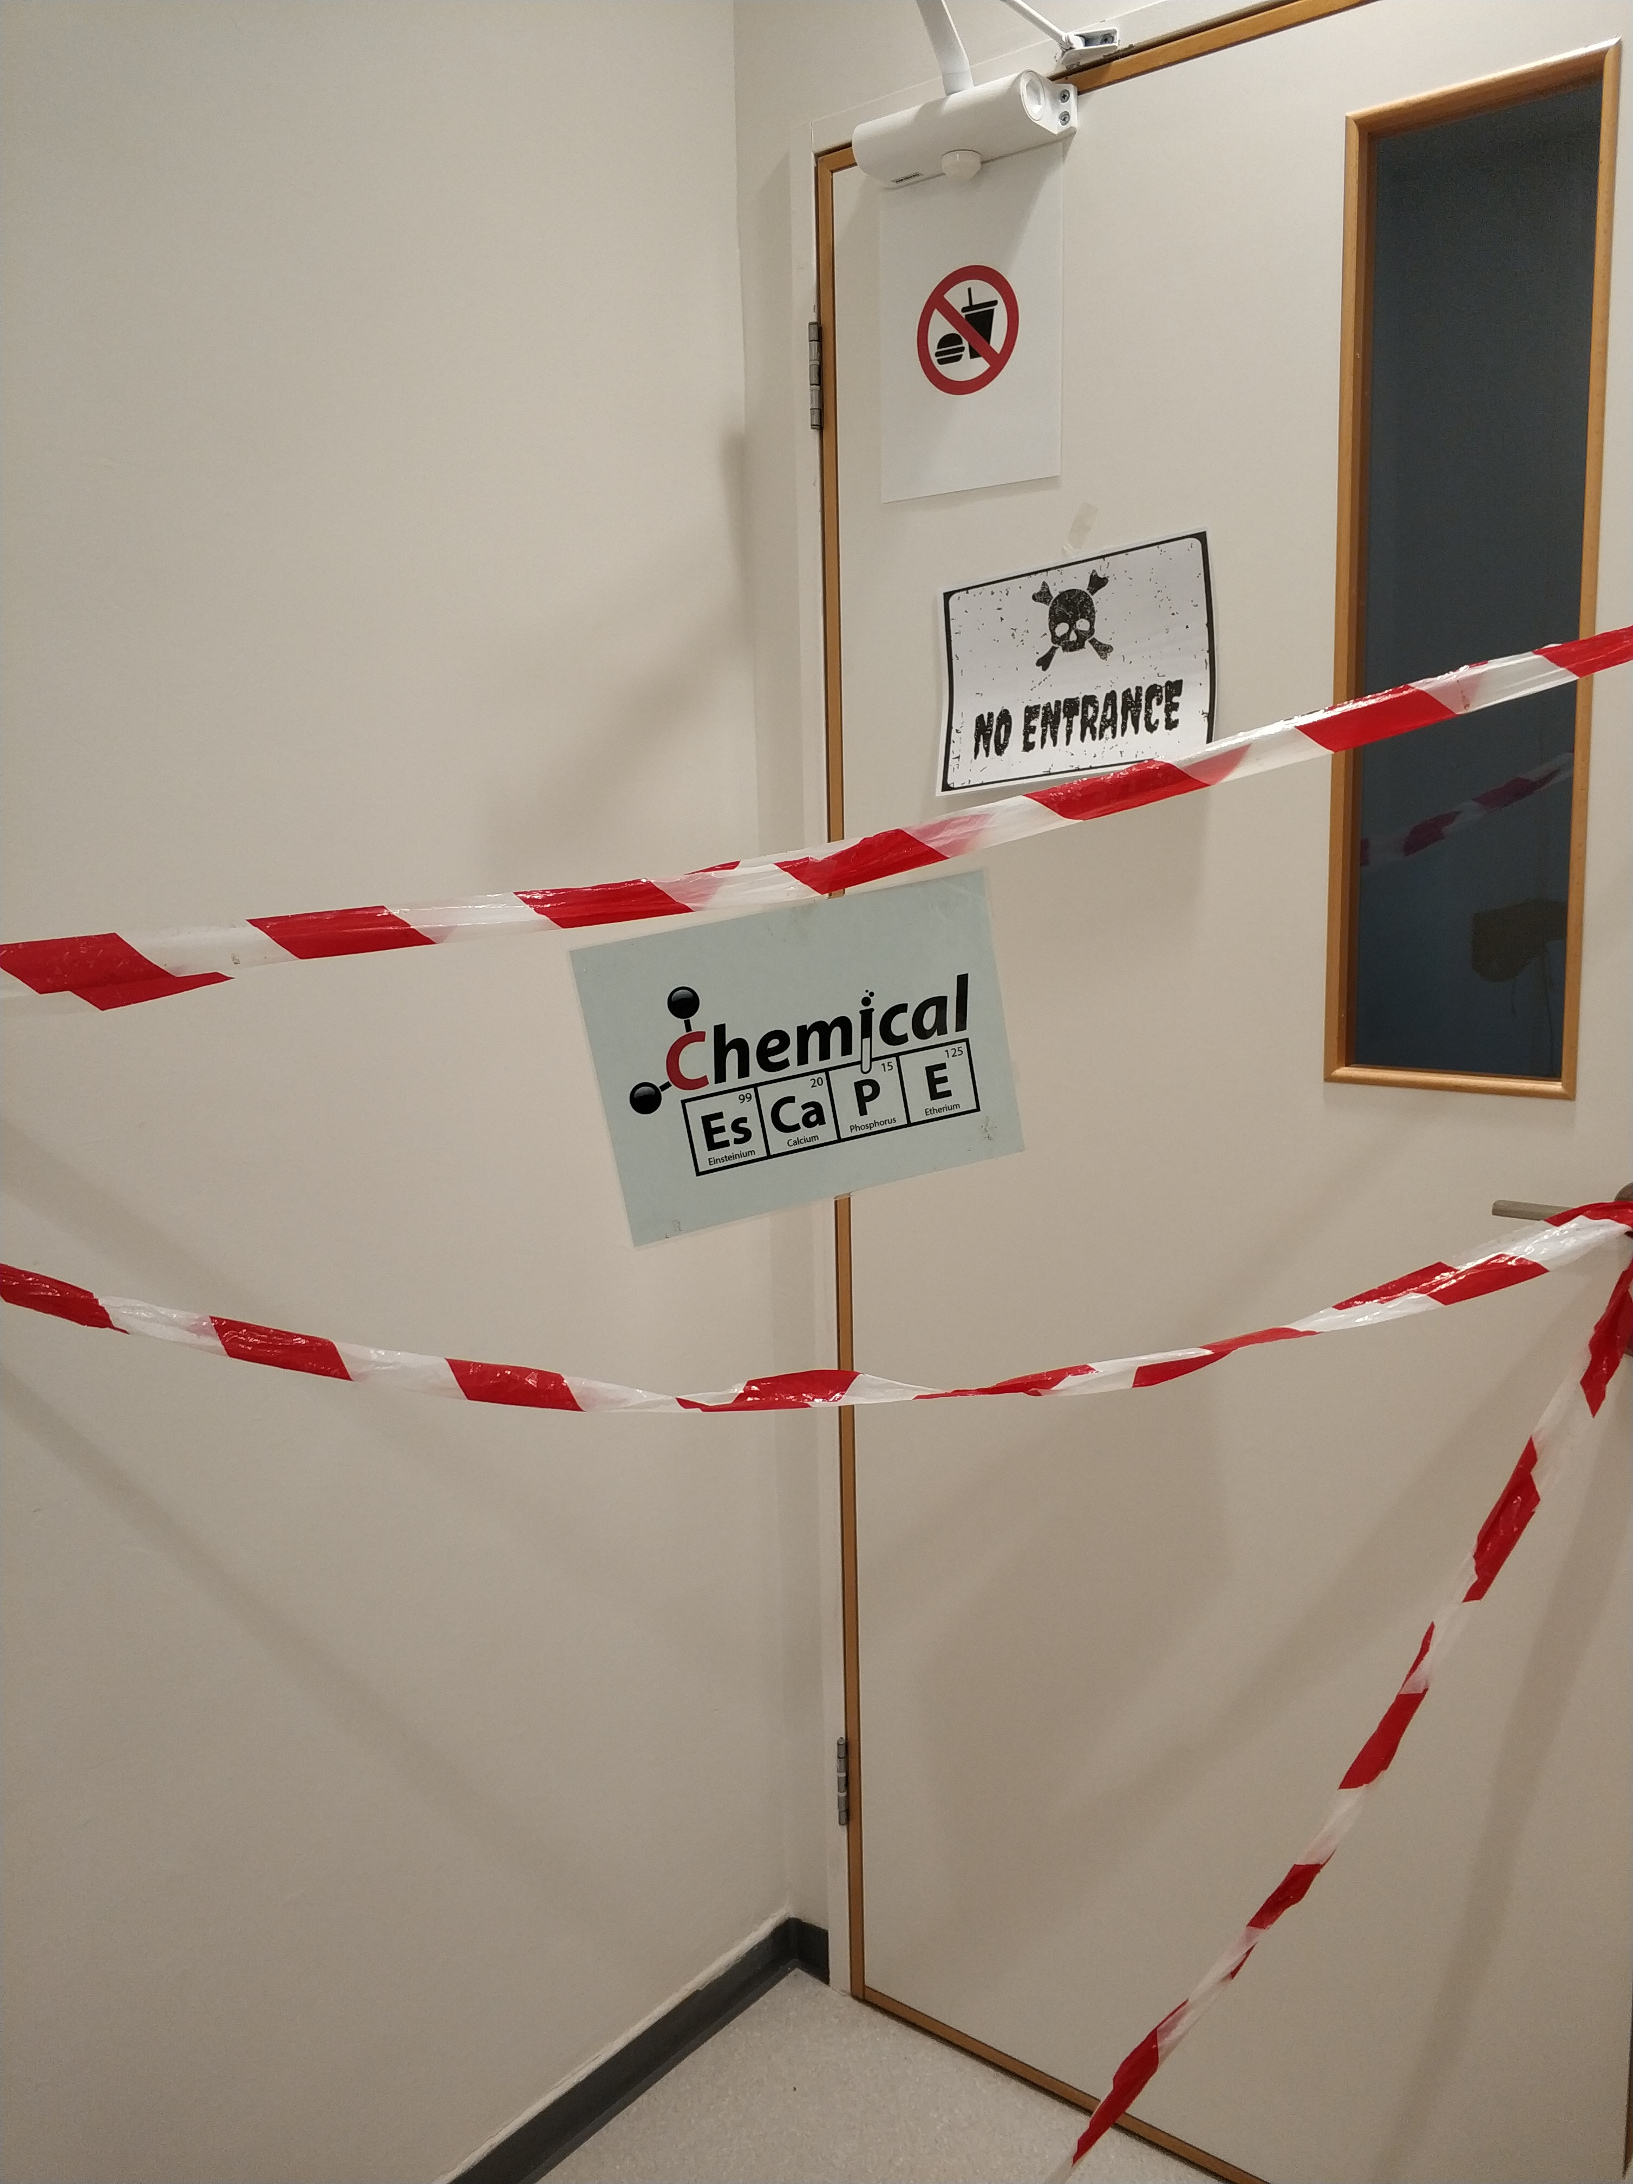
Figure 1. The sealed entry to the ChEsRm that creates the atmosphere of a “real” commercial escape room.

Once they enter the ChEsRm, the students start looking for hints hidden in the room and begin to solve puzzles. The path to solving the mystery is not linear, as can be seen in the map of the ChEsRm in Figure 2. Some puzzles immediately lead to the next ones. E.g., the “pH envelopes” (no. 1, Figure 2) in which a code is revealed that opens a padlock on a box. In other puzzles, students do not immediately know what to do with the solutions and the way to use them is revealed only at a later stage. E.g., in the "Preparation of Water" (no. 2, Figure 2), students create the maximum volume of neutral water that they can form by mixing solutions of varying pH. This water is needed to make conductive dough at a much later stage.
All the groups who participated in the ChEsRm finished before the explosion, sometimes they help each other. We think that it is important for the student to succeed. The time varies between 40 minutes to 55 minutes. In the beginning students think that they compete in groups. By the end of the activity they understand that they need the cooperation of everybody.
After the activity the teacher conducts a discussion with the students regarding their feelings and provides an opportunity to reflect upon the activity. In the reflection, students talk about the teamwork, the flow of time and their appreciation regarding the efforts of the teacher. They also ask questions regarding the unclear parts of the chemistry and solution of the puzzles.
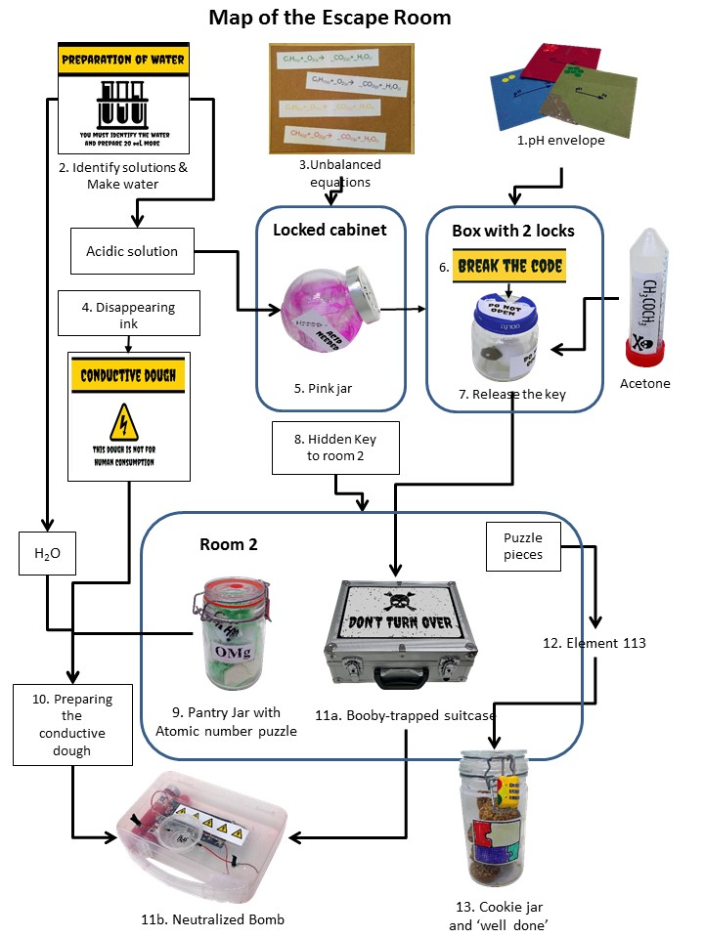
Figure 2: The puzzles, and lab-activities that construct the ChEsRm.

The Puzzles (or Challenges)
The details of all the puzzles and lab activities, and the chemistry content related can be found in the supplementary materials. There are two types of puzzles: 'wet' or 'dry': (1) 'Wet' puzzles require a hands-on lab activity with equipment and chemicals; and (2) 'Dry' puzzles require thinking without hands-on work. In addition, the level of thinking and chemical knowledge required to solve the puzzles varies: some puzzles provide specific instructions and require applying chemistry knowledge and thinking; some require just good observation skills. Next, we elaborate on four puzzles that represent different types of puzzles.

Four examples of puzzles/challenges

"Identify solutions & make water" – a "Wet & high level of knowledge" puzzle (no. 2 in Figure 2 and Figure 3).
Students find a tray with four test tubes containing transparent and colorless liquids, each with a 'danger' skull sticker and a small vial containing phenolphthalein. The tray looks like it has been prepared for a class lab with short instructions for the lab. On the tray are four stickers with the following labels: 1M H₂SO₄, 1M HCl, H₂O, 1M NaOH. The written instructions request that each solution be identified and that the maximum possible volume of water be prepared. However, the instructions do not provide the method of performing these actions. The puzzle relies on participants' knowledge of acid, bases, and indicators and applying this knowledge to an unknown situation.

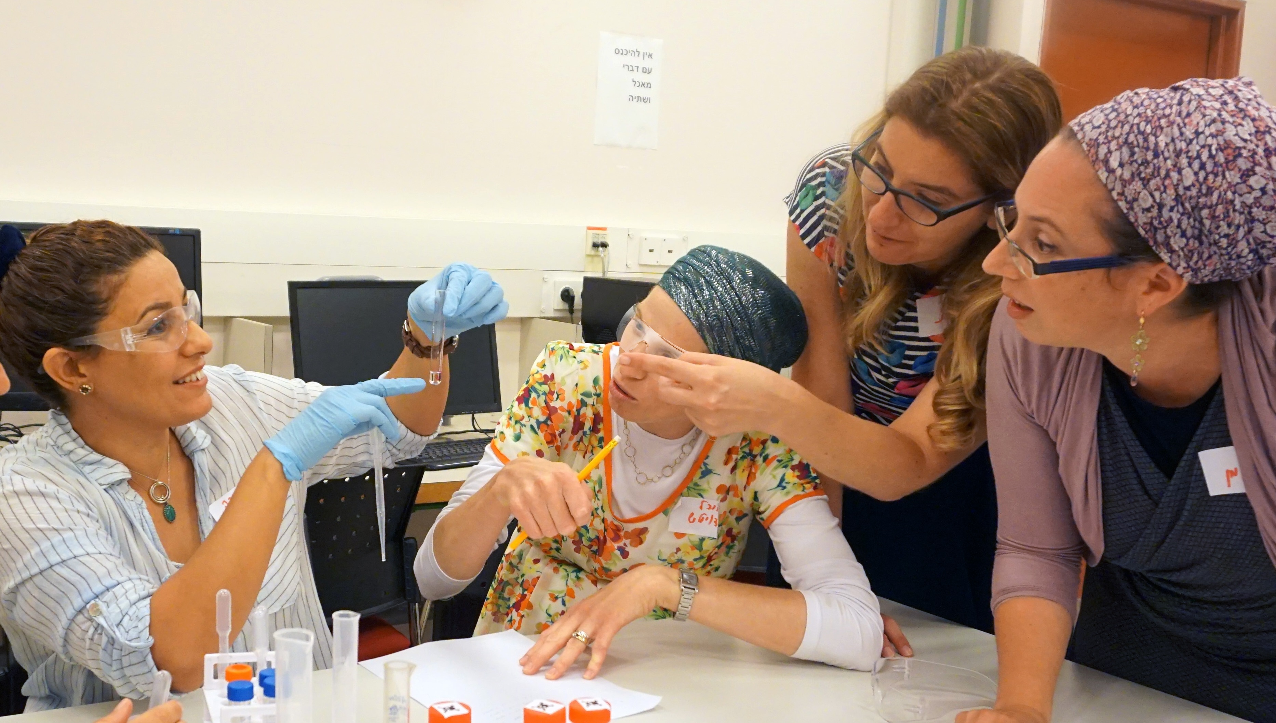
Figure 3. A group of chemistry teachers solving the identifying acid/base puzzle (no. 2, Figure 2).

The "pink jar" – a "Wet & low level of chemical knowledge" puzzle (no. 5, Figure 2).
Students find a jar with a pink solution and next to it a syringe. On the jar is a sticker stating, "Acid Needed" and a small icon of a syringe. By using the syringe, they inject the acid, which they identified in puzzle (2). Once students inject the acid into the jar, the pH of the solution drops and the solution becomes colorless, revealing a code written in pink ink on the inside of the jar¹⁰.
"pH envelopes" – a "Dry & high level of knowledge" puzzle (no. 1, Figure 2).
Students find an envelope with three cards, each of which contains a formula and a number (see Figure 4). The formulas are 1M HBr, H₂O, 1M KOH. There is an arrow on the envelope, and the letters "pH" next to the arrow. Students need to use their prior knowledge to arrange the cards in order of increasing pH. Reading the numbers of the cards in the correct order reveals a code (523) that opens a padlock on a box. This puzzle is dry, since no actual experiment is being conducted. Students need to apply their prior chemistry knowledge.

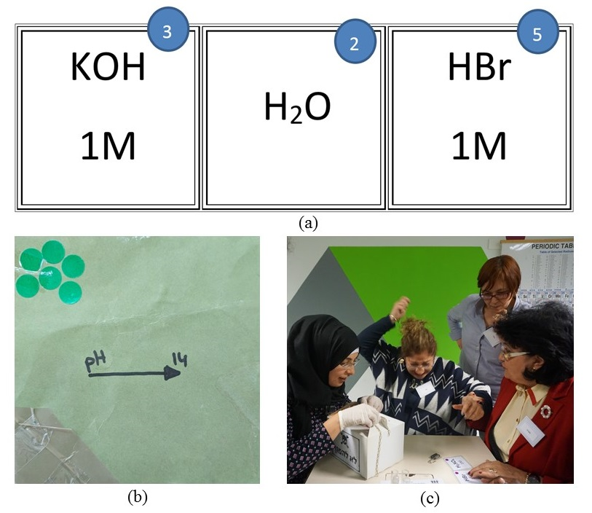
Figure 4. "pH envelopes". (a) The cards, (b) the envelope, and (c) a group of teachers opening the lock after solving the puzzle.

"Element 113" – a "Dry & no chemical knowledge required" jigsaw puzzle (no. 12, Figure 2).
Students find an envelope with pieces of a jigsaw puzzle. Each of the four groups gets different pieces of the same puzzle. Together the four groups must join forces (Figure 5) to build a jigsaw puzzle that reveals a picture of Kōsuke Morita, who led the group that discovered Nihonium (atomic number 113), next to the periodic table with the element Nihonium highlighted. Building the jigsaw puzzle reveals the number 113, which opens a cookie jar at the end of the activity after all bombs have been dismantled. This is a “dry” puzzle that does not require chemical knowledge.
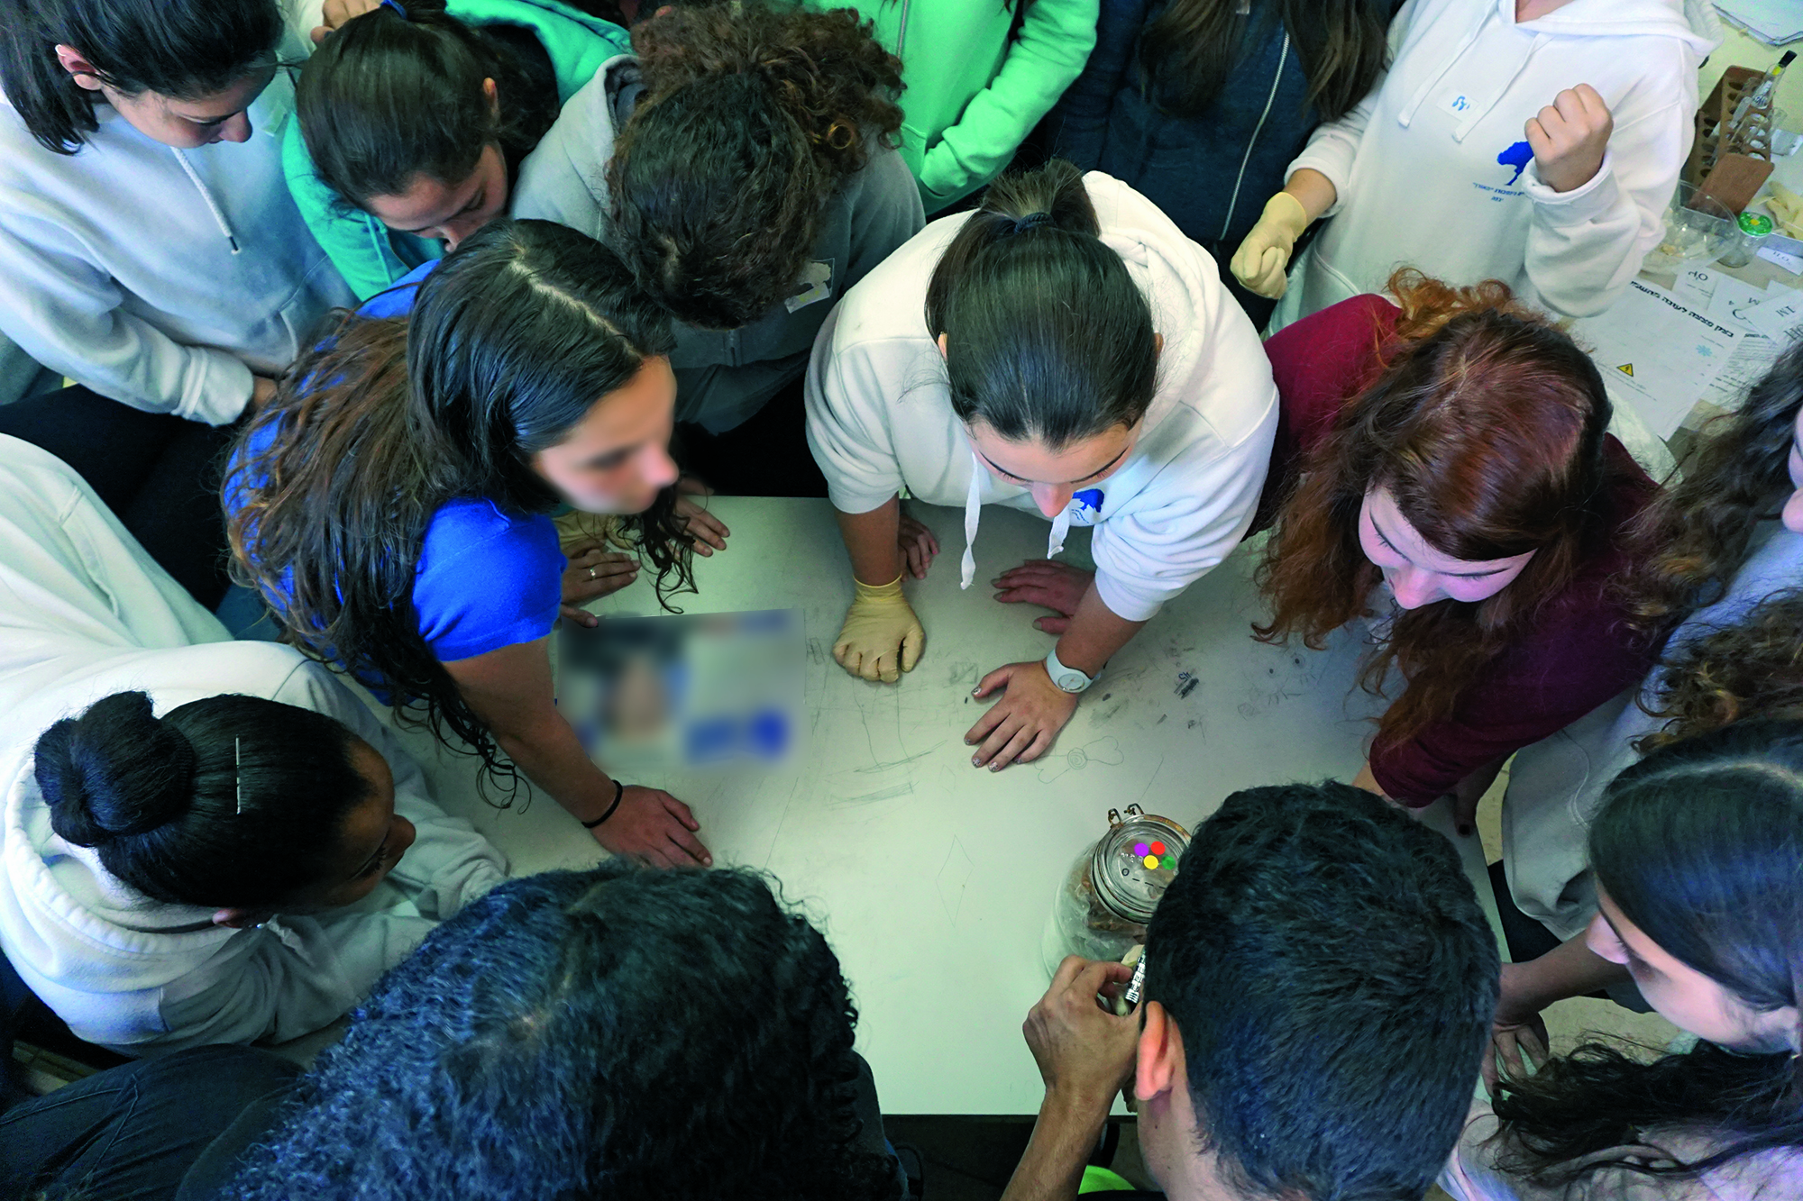
Figure 5. Students assemble the jigsaw puzzle.

Hazards
All puzzles that include lab activities are handled with gloves and goggles, since the identity of the chemicals is not given to the students. The safety video describes all the safety instructions. AT the end of the activity, students are invited to eat the cookies only after the end of the activity, during the discussion that is conducted outside the lab room.

Evaluation
From informal observations, we found that the ChEsRm activity was extremely popular with both the teachers and students. Teachers and students who used the ChEsRm in their school explained their enthusiasm, as can be seen in the following quotes:
Teacher 1: “When you see the joy of the students, their cooperation ... and you hear sentences like: the most impressive chem lesson that I have had so far, interesting and fascinating, the time flew by .... This is the goal of every teacher.”
Teacher 2: “Quiet students who were afraid to answer in class, expressed enthusiasm and leadership in their attempts to solve puzzles. They were surprised and expressed great joy and excitement when they (of all people) identified the clue and led the group in solving the problems. The students enjoyed seeing that other students who don’t study chemistry were jealous of the students in the chem class.”

Student 1: “Real escape rooms are built better, but I enjoyed it more than a real escape room because we could use our chem knowledge to solve puzzles.”

Next, we present some results that emphasize the unique contribution of ChEsRm for teaching and learning chemistry. The items in the questionnaire were developed by listening to students’ reflection after the activity. We used their words to phrase the items. After experiencing the ChEsRm, students were asked to complete a survey in which they graded their agreement to 21 statements, 4 of which are shown in Figure 6. A 4-point Likert scale was used (1=Fully disagree, 4=Fully agree). The survey was done anonymously in a Google form which we provided, this allowed to collect all the data automatically, not all the students who experienced the room answered the survey. . Most of the students felt that the teamwork and their previous knowledge helped them in dealing with the puzzles in the ChEsRm. They experienced a flow of time. Flow is a state in which one is swept away and fully engaged in an activity. It is considered a form of high intrinsic motivation and thus lends itself to create an ideal environment for personal growth and learning^{11,12}. Activities that tend to promote flow experiences are characterized by clear goals and rules. There is an immediate feedback for an action, and a balance between challenges and abilities¹². Students’ responses indicate that the ChEsRm created a high flow experience (Figure 6).

Figure 6. Students’ perceptions regarding ChEsRm (n= 133).

In addition, students highly appreciated the efforts of their teachers, who conducted the ChEsRm activity for them. In our model of enactment, the teachers were responsible for introducing and enacting the ChEsRm activity in school. Part of the rationale was to empower the teacher, and this aspect received the highest score of all statements (Figure 6). We also found that bringing ChEsRm to the school created a "buzz" around it, which included the wider school community. Non-chemistry major students and school staff frequently asked about the activity. This buzz was accredited to the chemistry teacher who introduced the activity to the school and thus, it served well in promoting chemistry in the school as a relevant and vibrant subject.

Discussion
The ChEsRm is a game-based classroom activity instituted on the popular genre of escape rooms. What sets ChEsRm apart from commercial escape rooms, is that it allows up to 24 participants who conduct actual experiments. It was almost immediately booked out by Israeli chemistry teachers, despite the effort required in its organization and operation. Evidence for teachers’ satisfaction is their intent to use the ChEsRm again in the next year.

An unforeseen outcome was that the activity often had a ripple effect as it became known outside the chemistry classroom. We think that the model, whereby teachers enacted the escape room (and not an outside agent) contributed to this ripple effect. From the school's and the students' points of views, the activity was associated with the chemistry teacher (and not with the National Chemistry Teachers' Center). In that sense, we as a center achieved our goal of empowering chemistry teachers in their respective schools. We hope that teachers who read this paper will also run ChEsRm in their class.
Students seemed to enjoy the activity and operated in a zone of flow. This enjoyment is probably due to working in a group, intellectual challenge, and the game-nature of the activity. From a chemical education point of view, it is important to note that students claimed that chemical knowledge previous learned in the classroom was needed for the activity to succeed.

Associated content

Supporting Information
We would like the readers to be able to duplicate our escape room. The supplementary materials which include detailed description of each one of the puzzles, how to build them, the chemical content related, hints, tips and the graphics related are available on the ACS Publications’ website at DOI: 10.1021/acs.jchemed..

AUTHOR INFORMATION

Corresponding Authors
*Malka Yayon, E-mail: Malka.Yayon@weizmann.ac.il, Ran Peleg, E-mail: rpeleg@gmail.com

Acknowledgments
The authors wish to thank the Israeli Center for Science and Technology Education (MLM), and the Ministry of Education for supporting this project through the National Chemistry Teachers' Center.
The authors would like to thank the following people for their invaluable support in making the escape room activity a reality: Dr. Shelley Rap, Dr. Dorit Taitelbaum- the Chemistry teaching superintendent of the Israeli Ministry of Education.

REFERENCEs
(1) Nicholson, S. Peeking behind the locked door: A survey of escape room facilities. White Paper available at http://scottnicholson.com/pubs/erfacwhite.pdf. 2015 (accessed Feb 8, 2019).
(2) Baram-Tsabari, A.; Segev, E. Just Google It! Exploring New Web-Based Tools for Identifying Public Interest in Science and Pseudoscience. In Proceedings of the Chais conference on instructional technologies research 2009: Learning in the technological era; 2009; pp 20–28.
(3) Google Trends. Google Trends https://www.google.com/trends (accessed Feb 10, 2019).
(4) Essig, T. The benefits of “non-virtual reality” (N-VR) just may make it the next big thing. Forbes 2016; http://www.forbes.com/sites/toddessig/2016/05/10/the-benefits-of-non-virtual-reality-n-vr-just-may-make-it-the-next-big-trend/print/ (accessed Feb 9, 2019).
(5) Mahaffey, A. L. Interfacing Virtual and Face-to-Face Teaching Methods in an Undergraduate Human Physiology Course for Health Professions Students. Adv. Physiol. Educ. 2018, 42, 477–481.
(6) Nicholson, S. Creating Engaging Escape Rooms for the Classroom. Child. Educ. 2018, 94 (1), 44–49.
(7) Dietrich, N. Escape Classroom: The Leblanc Process—an Educational “Escape Game.” J. Chem. Educ. 2018, 95 (6), 996–999; DOI: 10.1021/acs.jchemed.7b00690.
(8) Zimmerman, E.; Salen, K. Rules of Play; MIT Press: Cambridge, MA, 2003.
(9) Department of Science Teaching - Weizmann Institute of Science. Escape Room Safety Video in English https://vimeo.com/270324284 (accessed Feb 10, 2019).
(10) Department of Science Teaching - Weizmann Institute of Science. The Pink Jar https://vimeo.com/270324825 (accessed Feb 9, 2019).
(11) Csíkszentmihályi‏, M. The Flow Experience and Its Significance for Human Psychology. In Optimal experience: psychological studies of flow in consciousness; Csíkszentmihályi‏, M., Csikszentmihalyi‏, I. S., Eds.; Cambridge University Press: Cambridge, 1988.
(12) Csikszentmihalyi, M.; Hermanson, K. Intrinsic Motivation in Museums: Why One Does Want to Learn. In The Educational Role of the Museum, London: …; Hooper-Greenhill, E., Ed.; London and New York, 2001; pp 146–160.

