**Engineering critical assessment and variable sensitivity analysis for as-welded S690 steels**

Y Wang*1, A MacDonald2, L Xu2, M Wright2, RA Shenoi1

1. Fluid Structure Interactions Group, University of Southampton, Boldrewood Innovation Campus, Southampton, UK
2. Lloyd’s Register Global Technology Centre, Boldrewood Innovation Campus, Southampton, UK

[*yikun.wang@soton.ac.uk](mailto:*yikun.wang@soton.ac.uk)

# Abstract

Engineering critical assessment (ECA) or fitness-for-service (FFS) is a fracture mechanics based approach that is increasingly utilised for assessing the structural integrity of welded steel structures considering various degradation mechanisms which may occur during service. However, if sufficient number of inputs and/or accurate input values are not available, the ECA result is often considered overly conservative and for such cases adds potentially unnecessary obstacles to design and maintenance solutions High strength steels such as S690, S890 and S960 are increasingly used in the offshore and lifting applications, thus to enhance our confidence in using such steels, it is essential to develop better understanding into the relationship between the information from ECA, fracture toughness that can be currently achieved in industry and the required toughness from rules and regulations. This study explores the influence of different variables on critical fracture toughness requirement of S690 steel structures. In addition, the correlation between all the studied variables are investigated to provide quantitative indications of the most important variables in a static ECA process for high strength steel applications. Quantified sensitivity and correlations are obtained for the six studied variables. Industrial fracture toughness data of welded S690 with section thickness up to 160 mm are collected. This provides a snapshot of currently achievable fracture toughens of S690, in comparison with the ECA results and current rules and standards.

**Keywords**: structural integrity; structural steel; failure assessment diagram; fracture toughness; welds.

# Introduction

Originating in the 1960s, engineering critical assessment (ECA) or fitness-for-service (FFS) is a fracture mechanics based approach that is increasingly utilised for assessing the structural integrity of welded steel structures considering various degradation mechanisms which may occur during service. The development of British Standards BS PD 6493 and BS 7910 [1-3] was driven by the demand in the nuclear and offshore industries [4]. This is a practical approach to consider alternative designs or maintenance strategies in order to determine if a given flaw is safe from brittle fracture, fatigue, creep or plastic collapse. ECA was also utilised in failure investigation to pinpoint the root cause of structural failure [5]. The method is based on a collection of closed form formulas, linking three key aspects of an infrastructure: (1) flaw characteristics; (2) the stress field acting on the region of interest; (3) material properties. However, if sufficient number of inputs and/or accurate input values are not available, the ECA result can be overly conservative and hence adds unnecessary obstacles to design and maintenance solutions. For example, when standard fracture mechanics test results are not available, the Charpy V-notch (CVN) impact test data is often used to estimate the material toughness. The Master Curve method described in the Annex J of the current BS 7910 are specified for ferritic or bainitic steels based on pure empirical knowledge and can be excessively conservative depending on the steel grade [6]. Depending on the completeness of the CVN data and the method to determine the Charpy transition temperature, the toughness value could be underestimated by up to 80% [7], leading to large underestimate of capacity in the structures. A new approach addressing the estimate of toughness using Charpy data will be included in the 2019 version of BS 7910, aiming to provide a better toughness prediction [6, 8]. The assessment of flaw geometries depends on the Probability of Detection of the inspection technique, the sizing capability and interpretation of the non-destructive evaluation (NDE) results. In addition, the variability in material properties also contributes to the uncertainty and potential conservatism of the ECA process. The modelling uncertainty is found to decrease with more advanced method used for the fracture assessment procedures [9].

In the open literature, only a few studies are available examining the sensitivity of different variables used in ECA. In 2013, Kaida et al. conducted a sensitivity analysis for cylindrical pressure vessel FFS assessment considering static loading and corrosion [10]. Stochastic properties of nine variables were assumed in a limit state function using the first-order reliability method. The mean tensile strength was 400 MPa and the mean section thickness was 13 mm. It was found that the corrosion rate and remaining thickness were the most important variables in an FFS assessment. In 2014, parametric studies were carried out by Abson et al. on carbon steels of yield strength up to 460 MPa and plate thickness up to 100 mm [11]. A surface-breaking flaw with either proportional or fixed size was considered on butt-welded flat plates with different levels of residual stresses. Required toughness and CVN test temperature were provided as an indication of the need for post-weld heat treatment. When subject to fatigue load, Hval et al. [12] and Liu et al. [13] presented ECA sensitivity analysis on clad pipeline and T-joint, respectively. The yield strength of the steel was around 400 MPa and the section thickness was 21 mm and 25.5 mm. In both studies, the one-factor-at-a-time method was used to examine a range of variables including weld misalignment, flaw size/location, fracture toughness, maximum allowable ductile tearing, cyclic stress range and static load. The range of cyclic stress and fracture toughness were identified as key parameters to fatigue life assessment [13]. However, to date there is a lack of systematic studies on the design requirement of high strength steels (with yield strength of 690 MPa and above) based on the ECA method.

The development and use of high strength structural steels such as S690, S890 and S960 are driven by the balance between structural weight and manufacturing cost [14]. Recent research into the mechanical behaviour of such high strength steels has focused on the yield to tensile ratio [14], fracture toughness [15-18] and the welding effect [17, 19-21]. Extensive studies were also carried out to understand the microstructure in weld metal. It is found that good impact toughness was attributed to the fine-grained acicular ferrite and bainite in S690 weld metal, which contains high angle grain boundaries [17]. However, experimental data were only available for thinner sections (less than 60 mm in thickness). The aforementioned ECA studies also mainly focused on thin plates (approx. 20 mm). In practice, high strength steel plates with thickness of up to 200 mm are increasingly being used in structures such as lifting appliances and offshore platforms with design temperatures lower than -10˚C [22]. For such thick plates, limited data is available within the public domain regarding their fracture behaviour, especially in as welded conditions, where the welding-induced residual stress is an important contributor to uncertainty [23]. Due to the microstructural inhomogeneity across thickness, large variation in the Charpy transition temperature was observed depending on the sampling location for S690 steels with a section thickness of 100 mm [22]. Additionally, thick sections result in larger proportion of plane strain condition in front of a crack tip and larger plastic zone volume which increases the probability of cleavage fracture [24]. The relationships between required fracture toughness based on ECA or FFS, toughness that can be currently achieved in industry and the required toughness from rules and regulations need to be further understood to enhance our confidence in using such steels.

This study fills the gap in the literature by conducting a sensitivity analysis for ECA of S690 steels. It was reported that a source of uncertainty or conservatism in the ECA or FFS process is the fracture toughness value [16]. In addition, parameters such as residual stresses, misalignment, flaw size and flaw location may also significantly contribute to the conservatism of ECA if accurate inputs values are not used. Therefore, the influence of different variables on critical fracture toughness requirement was examined. In addition, the correlation between all the studied variables were investigated to provide quantitative indications of the most important variables in a static ECA process for high strength steel applications. Industrial fracture toughness data of S690 with section thickness up to 160 mm in as-weld condition are collected to compare with the ECA results and current rules/regulations. Ultimately this will help evaluate and set suitable fracture toughness requirements for S690 structures.

# Methodology

## Baseline brittle fracture case study

The ECA procedure described in BS 7910 is based on the failure assessment diagram (FAD) concept, as shown in Figure 1. The vertical axis, *K*r represents the proportion between the applied load, in terms of stress intensity factors, and the fracture toughness of the material. The horizontal axis, *L*r is the ratio of the applied primary load to the yield strength. For high strength steels such as S690, the stress-strain curve does not normally exhibit a yield plateau, which enables the use of the Option 1 method to generate the failure assessment curve *K*r = *f*(*L*r) [1]. Option 1 does not require detailed stress-strain relationship from tensile tests. Instead, basic tensile parameters including the Young’s modulus, Poisson ratio, yield and ultimate tensile strengths are the necessary inputs. For a certain geometry containing a specified flaw, the limiting or critical value of any input parameter can be found. This is reflected as a data point lying on the failure assessment curve, as indicated in Figure 1.

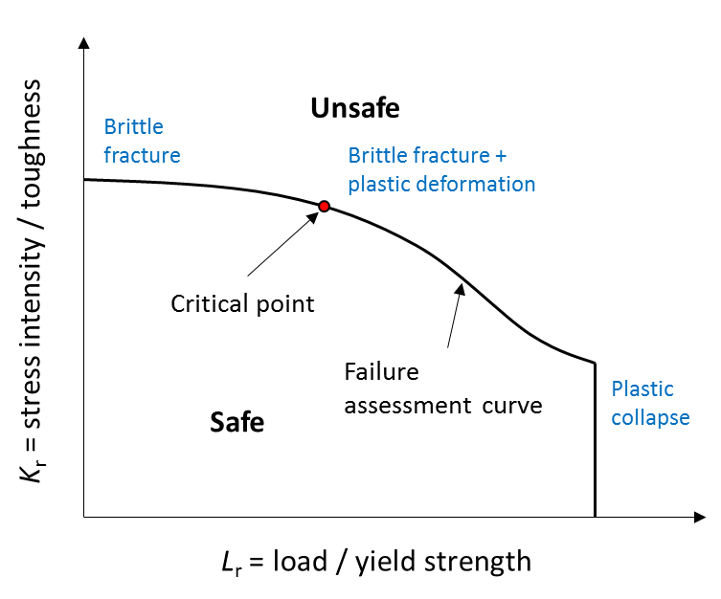

Figure 1. Schematic of a failure assessment diagram (FAD).

This study considered flat plates with an embedded flaw (Figure 2). As a baseline and a representative case study for xxxxx, the section thickness was set to be 65 mm. By using a ratio of *a*/*c* = 0.1, the dimension of the flaw was set at 30 mm in length and 3 mm in height, with a ligament of 3 mm. A weld toe correction factor based on two-dimensional (2D) finite element analysis was adopted with the attachment length equal to twice of the section thickness, taken as 130 mm. The room temperature (20 °C) tensile properties include a Young’s modulus of 206 GPa; a Poisson’s ratio of 0.3; a nominal yield strength of 690 MPa and an ultimate tensile strength of 720 MPa. The yield and tensile strengths were converted to values corresponding to the assessing temperature of –10 °C according to the following equations [1]:

$$σ_{y(T)}=σ_{y(RT)}+\frac{{10}^{5}}{(491+1.8T)}-189 (1)$$

$$σ_{u(T)}=σ_{u(RT)}×\left[0.7857+0.2423exp⁡(-\frac{T}{170.646})\right] (2)$$

where $σ_{y(T)}$ and $σ_{y(RT)}$ are yield strength at the assessing temperature $T$ (°C) and room temperature, respectively. Similarly, $σ_{u(T)}$ and $σ_{u(RT)}$ are tensile strengths at the assessing temperature $T$ (°C) and room temperature, respectively. The Young’s modulus was also converted according to Ref. [1]. The primary membrane stress was set to be two-thirds of the yield strength (460 MPa) at room temperature. No bending stress was considered. The stress concentration factor for the membrane stress was equal to one. In terms of secondary stresses, it was assumed that no post-weld heat treatment was conducted. The level of residual stress was set to be equal to the room temperature yield stress. The thermal membrane and bending stresses were set to be zero. An axial misalignment of 4 mm was also included, as seen in Figure 2(c). The study did not consider any partial safety factors or fatigue crack growth. Based on the aforementioned input variables, the critical fracture toughness value was determined. For materials with higher toughness than the critical value, the flaw was deemed safe for the studied loading condition. A summary of input variables for the baseline study is listed in Table 1. All ECA studies were carried out using CrackWise 5.0 to ensure result reliability.

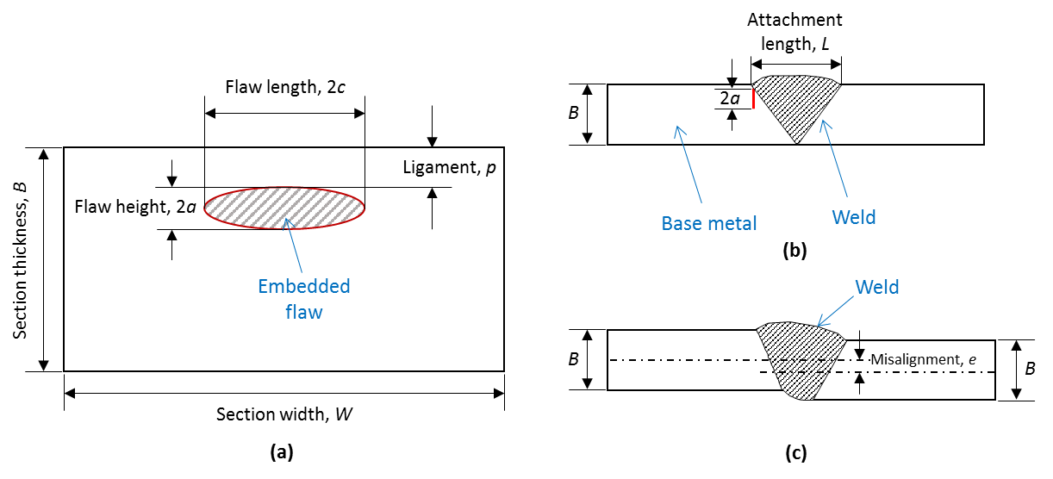

Figure 2. Geometries of the flat plates and an embedded crack: (a) crack cross-sectional view; (b) plate cross-sectional view; (c) axial misalignment.

Table 1. Studied variables in the sensitivity analysis

|  |  |  |
| --- | --- | --- |
|  | Value in baseline study | Values in sensitivity analysis |
| Thickness, *B* / mm | 65 | 25, 50, 100, 150, 200 |
| Flaw height, 2*a* / mm | 3 | 1, 2, 4, 5, 6 |
| Ligament, *p* / mm | 3 | 1, 2, 4, 5, 6, 7 |
| Primary membrane stress, *P*m / MPa | 460 | 230, 345 |
| Misalignment, *e* / mm | 4 | 1, 2, 3, 5 |
| Temperature, *T* / ˚C | -10 | –20, –30, –40, –50 |

## Sensitivity analysis

The sensitivity analysis was conducted regarding to the critical fracture toughness $K_{mat}$. In order to investigate and compare sensitivities of different input variables effectively, a normalised sensitivity parameter $S_{i}$ was defined:

$$S_{i}={\left.\frac{∆K_{mat}/K_{mat}}{∆x_{i}/x_{i}}=\frac{x_{i,o}}{K_{mat}(x^{o})}\frac{∂K_{mat}}{∂x_{i}}\right|}_{x^{o}} (3)$$

where $x_{i}$ represents a specific variable; $x^{o}$ is a collection of inputs used in the baseline study described in Section 2.1. The partial derivative in Equation 3 can be obtained using curve fitting, as used in Ref. [13]. However, as the objective function is not known, it was found that the shape of the fitted curve especially at both ends of the data range may have a significant effect on the sensitivity value and may not represent the actual trend for a specific variable. Therefore, the relative change in each variable and the critical toughness value with respect to the baseline case were used to calculate the normalised sensitivity.

The Spearman rank-order correlation was used to examine the correlation between each two of the six variables including thickness, flaw height, ligament, membrane stress, misalignment and fracture toughness. The correlation coefficient is defined as the Pearson correlation coefficient between the ranked variables:

$$ρ_{s}=\frac{cov[R\left(x_{i}\right), R\left(y_{i}\right)]}{σ_{R\left(x_{i}\right)}{∙σ}_{R\left(y_{i}\right)}} (4)$$

where $ρ_{s}$ is the Spearman correlation coefficient; $cov(R\left(x_{i}\right), R\left(y_{i}\right))$ is the covariance of the rank variables $x_{i}$ and $y_{i}$; $σ_{R\left(x_{i}\right)}$ and $σ_{R\left(y_{i}\right)}$ are the standard deviations of the rank variables $x_{i}$ and $y_{i}$.

For six variables (flaw height, thickness, ligament, misalignment, primary membrane stress and fracture toughness), used as direct inputs for in this study, the Principal Component Analysis (PCA) was also performed to help understand the variance in the data. The inverse variances of the ratings were used as weights to scale the data. More details about the PCA process can be found in Refs [25, 26]. All sensitivity analysis was completed via Matlab coding.

## Industrial data of S690 steels

A collection of test results from various steel manufacturers was used for quenched and tempered S690 steels, including both CVN and the corresponding CTOD measurements from heat-affected zone (HAZ)/fusion line (FL) and weld metal (WM) [7]. Prior to ECA, the CTOD values were converted to fracture toughness according to BS 7910. The section thickness ranged from 10 mm to 160 mm. Table 2 summarises the collected CVN data using standard Charpy specimen size of 10 mm × 10 mm cross-section and a 2 mm deep V-notch. Two heat inputs, i.e., 1.5 kJ mm–1 and 5 kJ mm–1, were tested on the welds in data sets No. 1 and 5. All corresponding CTOD measurements were obtained from full thickness specimens according to BS 7448. The specimen shape was for standard three-point bending set-ups. The minimum of three CTOD values were used according to BS 7910. It needs to be noted that due to the limitation of facilities capable of testing CTOD samples with thick sections, the collected data set only contains 420 points in total.

Table 2. Summary of the industrial CVN data of S690

|  |  |  |  |
| --- | --- | --- | --- |
| Dataset No. | Thickness / mm | Temperature / $℃$ | CVN sample locations |
| 1 | 12 | -20 | FL (root), WM |
| 2 | 25 | -20 | FL (cap), WM |
| 3 | 40 | -20 | FL (root plate centre and sub cap), WM |
| 4 | 80 | -10 | FL, FL+2 mm, FL+5 mm (subsurface and 1/2*t*) |
| 5 | 100 | -10 | FL, FL+2 mm, FL+5 mm (subsurface and 1/4*t*) |
| 6 | 120 | -10 | FL (subsurface) |
| 7 | 160 | -10 | FL, FL+2 mm (surface up; surface down and root) |

The fracture toughness values were estimated from CVN data primarily using the well-known Master Curve approach:

$$K_{mat}=20+\left\{11+77\exp\left[0.019\left(T-T_{0}-T_{k}\right)\right]\right\}{\left(\frac{25}{B}\right)}^{0.25}∙{\left[\ln\left(\frac{1}{1-P_{f}}\right)\right]}^{0.25} (5)$$

where $T$ is the temperature at which $K_{mat}$ is determined; $B$ is the section thickness; $T_{k}$ is the temperature term that describes the scatter in determining the 100 MPa√m median fracture toughness transition temperature $T_{0}$ (Equations 6 and 7). For a standard deviation of 15 $℃$ and 90% confidence, $T_{k}=25℃$. $P_{f}$ is the probability of $K_{mat}$ being less than estimated and was assumed 5% in the study.

$$T_{0}=T_{27J}-18℃ \left(6\right)$$

$$T_{0}=T_{40J}-24℃ (7)$$

where $T_{27J}$ and $T_{40J}$ are the Charpy transition temperatures at 27 J and 40 J, respectively. In current industrial practice there is no universally agreed methods to estimate the Charpy transition temperatures when the energy measurement is not exactly equal to 27 J or 40 J. Therefore the hyperbolic curve fitting and FITNET methods [27] were used depending on the completeness of the CVN dataset. Detailed calculations can be found in the authors’ previous paper [7]. The upper limit of $K_{mat}$, defined as $K_{mat0.2}$, is calculated as:

$$K_{mat0.2}=\sqrt{\frac{E\left(0.53∙{USE}^{1.28}\right)\left({0.2}^{0.133{∙USE}^{0.256}}\right)}{1000\left(1-ν^{2}\right)}} (8)$$

where $USE$ is the upper shelf energy; $E$ is the elastic modulus and $ν$ is the Poisson’s ratio. The full-thickness CTOD values were also converted to fracture toughness based on the following equations [1]:

$$K_{mat}=\sqrt{\frac{mσ_{y}δE}{\left(1-ν^{2}\right)}} (9)$$

where $E$ and $σ_{y}$ are determined at the same temperature as $K_{mat}$, $δ$ is the CTOD value in metre and $m$ is given as (for $0.3<\frac{σ_{y}}{σ_{u}}<0.98$) [1]:

$$m=1.517{\left(\frac{σ_{y}}{σ_{u}}\right)}^{-0.3188} (10)$$

where $σ_{u}$ is the tensile strength (MPa) of the material tested at CTOD temperature. Mean values of $σ_{y}$ and $σ_{u}$ should be used. For HAZ, the greater of WM or BM tensile properties should be assumed when direct measurements are not available [1]. If Equation (10) is not applicable, $m=1.5$ was assumed [1]. Based on Equations (9) and (10), the calculated CTOD values ranged from 136 to 223 MPa√m for specimens with thickness of 12 mm to 40 mm tested at -20 $℃$; and from 152 to 459 MPa√m for specimens with thickness of 100 mm to 160 mm tested at -10 $℃$.

# Results

## Variable sensitivity with respect to baseline ECA

Following the ECA process for fracture analysis, the critical toughness obtained from the baseline condition was 133.8 MPa√m, below which the embedded flaw is considered unsafe. Using the one-factor-at-a-time method, Figure 3 shows the critical toughness corresponding to the lowest and highest values of each input variable, as indicated in Table 1. It can be seen that within the studied range for each variable, the influence of the flaw height was the largest. Specifically, a 5 mm increase in the flaw height resulted in the required toughness increasing from 74.9 MPa√m to 195.4 MPa√m. The value of the crack ligament had an opposite effect compared to the flaw height. A ligament of 1 mm required a toughness at least 192.4 MPa√m whereas 7 mm ligament only required 116.7 MPa√m. This is followed by the primary membrane stress, misalignment, thickness and temperature, all of which lead to an increased toughness requirement when the input value increases. It needs to be noted that the assessing temperature does not have a direct effect in the ECA process, but rather to influence the tensile properties of the material. However, with 40 °C decrease in temperature, the toughness only increased by 2.8 MPa√m. Overall, the critical toughness value varied between approximately 45% below and above the baseline value.

Figure 3. Tornado diagram for the critical fracture toughness.

Figure 4. Influence of change in input variables on the critical fracture toughness with respect to the baseline scenario.

To further compare the relative influence on the required toughness, the critical toughness values were plotted versus the percentage change in each input variable with respect to the values used for the baseline study (see Figure 4). We can see that the trend generally corresponds to Figure 3, with the highest positive gradient in toughness change when changing the flaw height and the primary membrane stress. Additional information provided by this plot is the nonlinear toughness gradient associated with the ligament and section thickness. When the distance between the embedded flaw and the plate surface is greater than 3 mm (positive percentage change) with other variables taking the baseline inputs, the critical toughness is slightly decreased. However, as the flaw becomes closer to the plate surface, the required toughness is increased significantly indicating a much higher sensitivity to the ligament value. This is due to the stronger effects of stress intensity magnification factor and that the smaller ligament is more likely to suffer plastic collapse. In comparison, the influence of section thickness change does not show a monotonic trend. Instead, when reducing the section thickness to approximately 50 mm, the critical fracture toughness reaches the lowest point. The critical value then starts to increase when further increasing the thickness, due to constraint effects. . Similar trends were also reported by Abson et al. for lower strength steels [11].

Using Equation (4) allows us to examine the normalised sensitivity (*S*) of each input variable on the critical toughness, as shown in Figure 5. Again, each variable was investigated by keeping the other inputs equal to the values used in the baseline study. A large absolute value of *S* indicates high sensitivity. A positive *S* means that when the input increases, the output is also increased; whereas a negative *S* indicates the opposite effect. From Figure 5 we can see that the level of sensitivity for each variable corresponds to Figure 4 in general. Furthermore, the sensitivity to critical toughness decreases monotonically as the flaw height, the ligament or the assessing temperature is increased. In comparison, an increase in the primary membrane stress or the misalignment will result in enhanced influence on the critical toughness change. The normalised sensitivity of section thickness reaches the highest absolute value at both ends of the studied range and drops to zero when the thickness is between 25 mm to 50 mm.

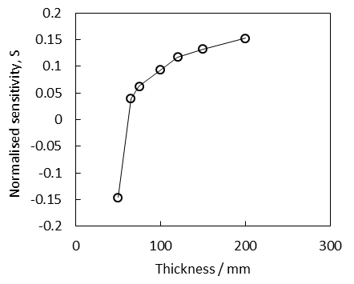

**(a)**

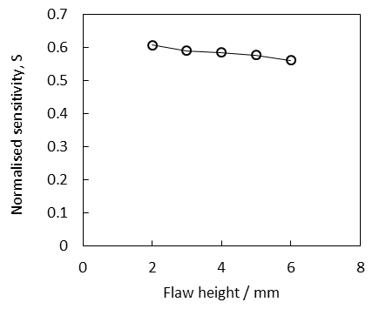

**(b)**

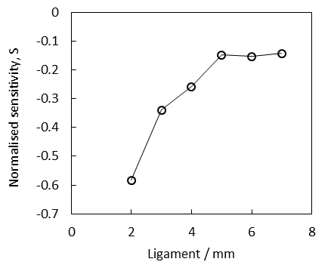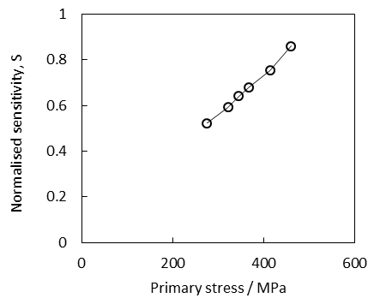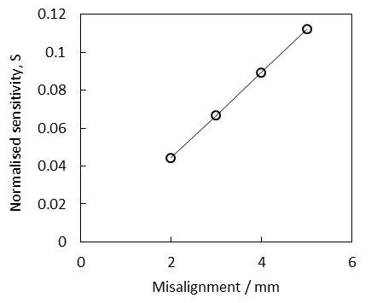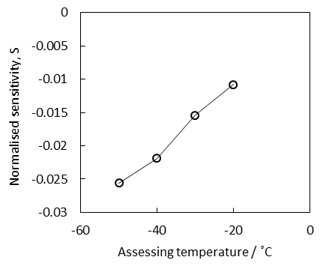

**(c)**

**(d)**

**(e)**

**(f)**

Figure 5. Normalised sensitivity of studied variables with respect to the baseline scenario.

## Correlations between studied variables

In addition to the critical fracture toughness, the interactions between each variable’s effect were also investigated. Therefore, the fracture toughness was included as a potential input variable. The test matrix was based on Table 1. Table 3 is the Spearman’s rank correlation result. The sign of the rank correlation coefficient indicates the association direction between two variables. All negative coefficients are highlighted in red shaded cells in Table 3, meaning that the increase of one variable will lead to reduction in the other. For example, when the section thickness is increased, there is a tendency that the critical flaw height will decrease. The colourless cells indicate positive associations between variables. Similarly, when the section thickness is increased, the critical value of ligament will also increase. The absolute value of the correlation coefficient, ranging from 0 to 1, represents the level of monotonicity of each correlation. The coefficient of 0.96 between thickness and ligament means that the critical values of one variable increases almost monotonically with increasing the other. Little correlation was observed between the critical ligament and the critical value of either primary membrane stress or misalignment.

Table 3. Spearman’s rank correlation result

|  |  |  |  |  |  |  |
| --- | --- | --- | --- | --- | --- | --- |
|  | Thickness, *B* | Flaw height, 2*a* | Ligament, *p* | Primary stress, *P*m | Misalignment, *e* | Toughness, *K*mat |
| Thickness, *B* | **1.00** | -0.19 | 0.96 | -0.14 | N/A | 0.11 |
| Flaw height, 2*a* | -0.19 | **1.00** | -0.17 | -0.80 | -0.08 | 0.78 |
| Ligament, *p* | 0.96 | -0.17 | **1.00** | 0.00 | 0.00 | -0.31 |
| Primary stress, *P*m | -0.14 | -0.80 | 0.00 | **1.00** | -0.09 | 0.44 |
| Misalignment, *e* | N/A | -0.08 | 0.00 | -0.09 | **1.00** | 0.11 |
| Toughness, *K*mat | 0.11 | 0.78 | -0.31 | 0.44 | 0.11 | **1.00** |



Figure 6. Variability of the studied ECA variables.

We used PCA to help further interpret the data. The variabilities of each variable in Table 1 are displayed in Figure 6. We can see that the distribution of each variable is very different from each other. The toughness and ligament show larger outliers compared to the other variables. There are more variabilities in the primary membrane stress and section thickness. This again justified the use of inverse variances of the ratings as weights for scaling the data. Figure 7 shows the first five principal components that represent variances from 25% to 14% (cumulative variance of 96.6%). Based on the first two components (approximately 50% of the total variance), the principal component coefficients (loadings) are listed in Table 4, with which the scores are plotted in Figure 8 for two assessing temperatures –10 ˚C and –50 ˚C. The first principal component is strongly related to the flaw height with a loading of –0.773, contributing to a quarter of the variability of the ECA results. Reductions in flaw height will increase the first principal component. Little influence from misalignment, thickness and ligament were observed on the first principal component. The second principal component is mainly correlated with the primary membrane stress and toughness. The second principal component increases when increasing both variables. The angles between vectors also confirm the characteristics of correlations identified in Table 3. Specifically, the flaw height is positively correlated with the toughness and negatively correlated with the primary stress. No significant difference was identified between the two assessing temperatures.



Cumulative variance

Figure 7. Scree plot of the first five principal components.

Table 4. Orthonormal principal component coefficient (loadings)

|  |  |  |  |  |  |  |
| --- | --- | --- | --- | --- | --- | --- |
| Variables | PC1 (25%) | PC2 (22%) | PC3 (19%) | PC4 (16%) | PC5 (14%) | PC6 (4%) |
| Thickness, *B* | -0.038 | 0.071 | **0.726** | 0.048 | **0.664** | 0.154 |
| Ligament, *p* | 0.071 | 0.129 | **0.668** | -0.037 | **-0.728** | -0.036 |
| Misalignment, *e* | -0.002 | 0.274 | -0.032 | **-0.958** | 0.066 | 0.034 |
| Primary stress, *P*m | 0.408 | **0.688** | -0.156 | 0.219 | -0.019 | **0.536** |
| Flaw height, 2*a* | **-0.773** | -0.036 | -0.035 | 0.005 | -0.145 | **0.616** |
| Toughness, *K*mat | -0.480 | **0.654** | -0.034 | 0.174 | 0.056 | **-0.554** |



-10˚C



-50˚C

**477**

**281**

**290**

**399**

Figure 8. PCA results showing the first two principal component scores (PC 1 and PC 2) and the orthonormal principal component coefficient of each variables for two assessing temperatures -10 ˚C and -50 ˚C.

As the ECA data were centred and scaled, for a variable that is operating at the mean level the principal component score will be approximately zero. To further analyse the individual data points in Figure 8 and to visualise the connection between score values and the raw/original data, the contribution plot was extracted for several score values that are far from the zero point, as indicated in Figure 8. The corresponding contribution plot regarding PC1 and PC2 are shown in Figure 9 (a) and (b) respectively. The raw data reviewed that Observations 399 and 477 have below average values in thickness and primary stress. The toughness and flaw height values are above average. However, only flaw height shows a major contribution to the large score along PC1. In comparison, Observations 281 and 290 contain above average thickness, primary stress, flaw height and toughness, within which the toughness has the most significant contribution to the large score value along PC2. Combining the loading information in Figure 8, we could therefore interpret the first principal component as primarily a representation of the severity of the flaw. A high value of the second principal component could be understood as a measure of a structure made of tough material and designed to carry high external load. A change of these three variables would contribute to approximately 50% of the total variability of the ECA results in the current study.



**(a)**

**(b)**

Figure 9. Contribution plots for (a) the first principal component PC 1 and (b) the second principal component PC 2).

## Comparison with industrial data and standards

The fracture toughness estimated from the CVN and CTOD measurements from an industrial dataset (described in Section 2.3) were compared with the baseline ECA results for different temperature (–10 °C and –20 °C) and section thickness (12 mm to 160 mm). The crack length was modified to 15 mm according to the suggested minimum detectable defect size in Annex T of BS 7910 [1]. Charpy requirements given in industrial codes and standards from Lloyd’s Register (LR) [28] and EN 13001-3-1 [29] for as-welded S690 steel components in lifting appliances were also utilised to calculate the fracture toughness according to Equations (5)-(7). Specifically, the required CVN test temperatures in LR rules depend on the design temperature and section thickness. The CVN test temperature in the EN standard is based on the sum of impact toughness parameters $\sum{q_{i}}$, which is a function of operating temperature (10 °C below design temperature), yield stress, thickness, characteristic value of stress range and static strength utilisation *σ*sd (ratio of design stress versus limit design stress). Specifically, the corresponding values of $q_{i}$ were used for a characteristic stress range (fatigue strength) of 90 MPa and a static strength utilisation of 0.66. The value of $P_{f}$ was assumed to be 5%, taking into account the failure of the component being assessed results in loss of life.

Figure 10 shows the comparison results for a design temperature of –10 °C. As the CVN test was only available at one single temperature in the industrial dataset, the FITNET method was used to calculate the Charpy transition temperature [27]. We can see that toughness predictions from either *T*27J or *T*40J are almost identical and are generally more conservative (up to 60% lower) compared to toughness converted from CTOD tests. The CVN converted toughness is below the ECA prediction. However, bearing in mind that the ECA only represent one typical structural condition, we would expect an approximately 45% change on both side of the line from the sensitivity study results in Sections 3.1. The fracture toughness converted from rule requirements are below the baseline ECA results by approximately 50%. However, the change of rule requirement versus thickness follows the same trend as ECA predictions. Additionally, the two sets of requirements are closely comparable with each other especially.

Figure 10. Comparison between baseline ECA, industrial data (CVN converted using FITNET method), EN standard and LR rule requirement for assessing temperature of -10 °C. Error bars represent the 95% confidence interval. Mini_CTOD represents the minimum of three CTOD test values.

Similarly, comparisons were made for a design temperature of -20 °C and the results are shown in Figure 11. Two methods (FITNET and tanh/hyperbolic) were used to obtain the Charpy transition temperature as the data set contains multiple temperature points [7]. Industrial data were only available for thickness below 50 mm. The average value is generally more conservative than the CTOD test. However, compared to Figure 10, we can see that the variation in the toughness estimated from CVN data is much larger, which leads to some overlap with the CTOD results. This is due to the curve fitting process involved, especially when using the hyperbolic curve fitting only (tanh method) with the upper shelf energy unknown [7]. The overall conservatism generated by estimating fracture toughness from CVN data appears to be independent of the method used for such estimate. Similar difference between rule requirements and ECA was observed. The range of the absolute value of fracture toughness converted from CTOD and CVN for both design temperatures are summarised in Table 5 for direct quantitative comparison.

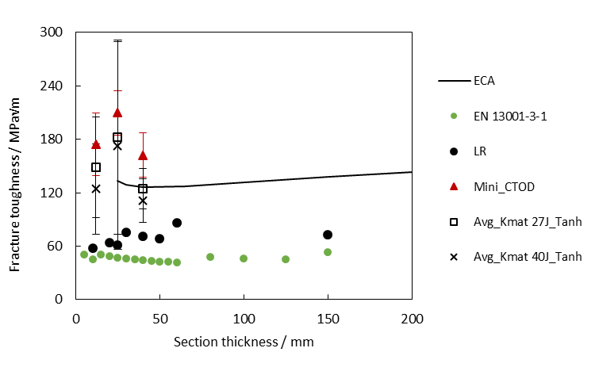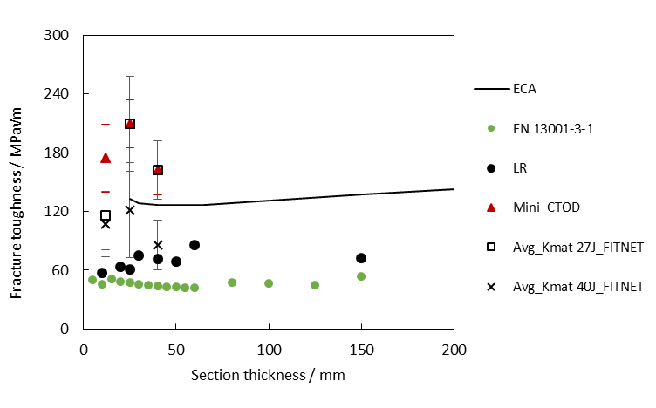

**(a)**

**(b)**

Figure 11. Comparison between baseline ECA, industrial data, EN standard and LR rule requirement for assessing temperature of -20 °C: (a) CVN converted using FITNET method; (b) CVN converted using Tanh (hyperbolic curve fitting) method. Error bars represent the 95% confidence interval. Mini_CTOD represents the minimum of three CTOD test values.

Table 5. Range of fracture toughness (MPa√m) converted from CTOD and CVN in the industrial dataset

|  |  |  |  |  |  |  |
| --- | --- | --- | --- | --- | --- | --- |
| Thickness | 12 mm | 25 mm | 40 mm | 100 mm | 120 mm | 160 mm |
| **Design temperature = -10 °C** | | | | | | |
| $K_{mat}$ from CTOD |  |  |  | 218 – 459 | 152 – 185 | 200 – 330 |
| $K_{mat}$ from *T*27J (FITNET) |  |  |  | 85 – 141 | 93 – 94 | 87 – 194 |
| $K_{mat}$ from *T*40J (FITNET) |  |  |  | 85 – 142 | 92 – 94 | 89 – 197 |
| **Design temperature = -20 °C** | | | | | | |
| $K_{mat}$ from CTOD | 136 – 202 | 196 – 223 | 148 – 184 |  |  |  |
| $K_{mat}$ from *T*27J (Tanh) | 77 – 196 | 135 – 281 | 105 – 147 |  |  |  |
| $K_{mat}$ from *T*40J (Tanh) | 64 – 179 | 123 – 281 | 88 – 131 |  |  |  |
| $K_{mat}$ from *T*27J (FITNET) | 80 – 142 | 84 – 151 | 73 – 131 |  |  |  |
| $K_{mat}$ from *T*40J (FITNET) | 72 – 130 | 79 – 128 | 69 – 117 |  |  |  |

# Discussion

From the viewpoint of critical or minimum fracture toughness required for S690 steel constructions to operate safely, the flaw height, flaw location (ligament) and loading are three most influential variables. Figure 12 summarises the frequency of the critical fracture toughness values obtained from the all of the relevant ECA studies with fracture toughness as an output. With the rest of the inputs equal to the baseline study, a 3 mm increase in flaw height will result in almost 50% increase in the critical toughness value. Besides, a 3 mm decrease in ligament will lead to over 40% increase the critical toughness due to the effects of stress intensity magnification factor and the increased possibility of plastic collapse. The size of the flaw is also identified to be the variable that drives the most variability of ECA results, as shown in Figure 8 and Table 4. This highlights the importance of the NDE technique to obtain the necessary accuracy and resolution for embedded flaw characterisation [30]. For embedded flaws, practically the minimum size of flaw height that can be reliably detected by ultrasonic testing (UT) is 3 mm [1]. However, there is a possibility of 4 mm undersizing or 1 mm oversizing by conventional UT [1]. The measurement error could potentially lead to a large variation of the critical values required for safe design/operation. In addition, given the fact that almost all welds contain certain degree of defects, it is of great importance to guarantee good welding workmanship and quality control to minimise the possibility of large flaw size. It is also imperative to select the correct NDE method (for example, Phased Array Ultrasonic Testing) to obtain the necessary accuracy of measurement, particularly when an ECA output derives a relatively small flaw size of exacting dimensions, as an allowable discontinuity. Equally important in this detection and measuring regime is the accuracy for ligament size/distance, particularly for the potential of surface acting, as this may have a further impact on the ECA allowance.

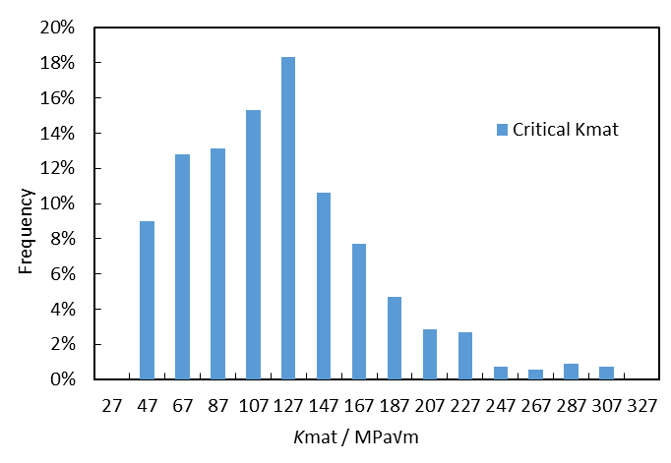

Figure 12. Frequency of the critical fracture toughness *K*mat obtained from all ECA sensitivity studies.

The fundamental assumption of the fracture mechanics analysis is that fracture will occur when the crack tip driving force exceeds the fracture toughness of the material. From the sensitivity study, the applied stress indeed plays a significant role in determining the critical fracture toughness requirement (Figure 5(d)), as well as the variability of the ECA results within the studied scope (Figure 8). The primary stress is also strongly correlated with the flaw height (Table 3). When considering the as-welded condition, this driving force is a combination of the applied external/service load and the residual stresses induced by welding. In this study, we assumed that the residual stress was equal to the room temperature yield stress of the parent/base material, as suggested by BS 7910. However, it needs to be noticed that as service time increases, the residual stress level may relax due to shake-down or creep effect, and hence may lead to a lower level of stress at the crack tip. Furthermore, experiments on S690 welded component with 16 mm thickness showed that the peak value of tensile residual stress was less than half of the yield stress of the base metal [21]. This indicates that the residual stress value used could be an overly conservative assumption, which led to a conservative estimate of the critical fracture toughness. Additionally, post weld heat treatment may be applied depending on the section thickness and service environment, which will further reduce the residual stress level. An accurate measurement/estimate of residual stresses is one of the key factors to removing conservatism of the ECA result. This could be achieved using experimental techniques such as X-ray diffraction and numerical simulation of the welding process.

The existence of misalignment affects both stress intensity factor and reference stresses. From Table 3 we found that the correlation between misalignment and critical fracture toughness is similar to the correlation between plate thickness and critical fracture toughness. When misalignment increases, the critical toughness value also increases. However, only axial misalignment was considered in this study. With more complex condition including angular or mixed misalignment, the total stress state will be changed, which further affects the estimate of critical fracture toughness. The stress intensity magnification factor based on 2D finite element analysis was also considered accounting for the geometry of a weld toe. The attachment length was assumed to be twice the section thickness. However, more accurate *M*k values could be obtained using 3D finite element method and/or using a more accurate value for the attachment length to reduce conservatism.

Section thickness and temperature show relatively small influences on the critical toughness value. The PCA results revealed that the thickness value contributes to less than 19% of the variance of the ECA process (Table 4). The effect of thickness is understood to be due to the effect of the reference stress solution and the stress intensity magnification factor *M*k for weld toes. When the section thickness is low (below 50 mm), the effect of thickness is reflected primarily by the high reference stress calculated according to Ref [1]. The value of *M*k is below 2. As the thickness value is further increased, the reference stress becomes asymptotic to the applied membrane stress while the value of *M*k increases significantly. This explains the nonlinear relationship between required toughness and thickness (Figure 4). From the material property viewpoint, section thickness and temperature strongly affect the fracture toughness of steels. Thin sections with a reduced crack-tip constraint tend to be affected by interactions between global plastic deformation and local crack front field. This will lead to relaxation of the stress triaxiality and increased cleavage fracture toughness. In constructions with thick sections (> 100 mm), the small-scale yielding condition is likely to be met, leading to high crack-tip constraint with limited plasticity. It is generally observed that the fracture toughness will decrease with increasing thickness, reducing temperature and increasing material strength. In addition, cleavage fracture is a highly localised phenomenon and is largely dependent on the microstructure of the material. This means local inhomogeneity tends to cause scatter in the measure toughness values. Therefore, for high strength steels of S690 and above, there is a need to balance the toughness requirement from fracture mechanics analysis and the toughness that can be achieved by manufacturers.

Indeed, industrial rules and standards contain toughness requirements reflecting both material properties and the service condition. Considering that the primary stresses used in the ECA in Figure 10 and Figure 11 are the maximum allowable stress (2/3 of the yield stress), in addition to the high residual stress level and the use of nominal tensile properties, the current industrial data appear to show adequate toughness in general. However, the discrepancy between CVN and CTOD converted toughness can be up to 60%. It needs to be noted that the CVN-toughness conversion is purely empirically based. Figures 10 and 11 highlight the conservatisms generated due to the absence of fracture toughness values (CTOD or J-integral) and existing conversion methods in industrial practice, which will intrinsically give a lower bound value of fracture toughens based on 5% failure probability. From the PCA study it was confirmed that material toughness is one of the most important variables causing variations in ECA results. With impact testing being widely used to indicate material toughness qualitatively in industry, it is important to gather more fracture toughness testing data to understand the actual toughness behaviour quantitatively particularly for thick sections of high strength steels such as S690 and above. It needs to be noted that Charpy requirements in rules and regulations are not intended to be used directed in the ECA process due to over-conservatism.

# Conclusions

This study examined a range of variable sensitivities on structural integrity results for high strength steel S690 in an as-welded condition. The obtained fracture toughness requirement was also compared with the fracture toughness properties from an industrial database and the current rule requirements. The main conclusions to be drawn are as follows:

* The flaw height had the greatest influence on the critical fracture toughness assessment. Other secondary influences include the primary membrane stress, misalignment, thickness and temperature; all of which lead to an increased toughness requirement when the input value increases. Conversely, the crack ligament has an opposite effect compared to the flaw height.
* Overall, the critical toughness value varied between approximately 45% below and above the baseline value.
* Spearman ranking correlation was obtained to inform the relationship between each two studied variables. For example, when the section thickness is increased, there is a tendency that the critical flaw height will decrease; when the section thickness is increased, the critical value of ligament will also increase.
* Negligible correlation was observed between the critical ligament and the critical values of either primary membrane stress or misalignment.
* PCA reveals that temperature has a minimum effect on the variability of the ECA results. We could interpret the first principal component as primarily a representation of the severity of the flaw. A high value of the second principal component could be understood as a measure of a structure made of tough material and designed to carry high external load. A change in either these three variables would contribute to approximately 50% of the total variability of the ECA results in the current study.
* The fracture toughness converted from LR and EN rule requirements are below the baseline ECA results by approximately 50%. However, the change of rule requirement versus thickness follows the same trend as ECA predictions. Additionally, the LR and EN requirements are closely comparable with each other especially.
* The mean toughness values from industrial database are in general above the LR and EN rule requirement. However, the conversion process from CVN energy to toughness may induce significant uncertainties. More data is needed in the future to better understand the quality of the high strength steel manufacturing.
* Practically, for some assessments that are carried out in service the fracture toughness data may not be available and so CVN is the only option. However, the actual fracture toughness data should be used in preference where available rather than CVN data.
* Development of standards on high strength steels should be based on a holistic understanding of structural integrity and material properties.

# Acknowledgement

The authors greatly appreciate the sponsorship from Lloyd’s Register Foundation.

# References

[1] BSI, Guide to methods for assessing the acceptability of flaws in metallic structures, in, 2015.

[2] I. Hadley, Y. Lei, Outline of the fracture clauses of BS 7910:2013, International Journal of Pressure Vessels and Piping, 168 (2018) 289-300.

[3] I. Hadley, BS 7910:2013 in brief, International Journal of Pressure Vessels and Piping, 165 (2018) 263-269.

[4] C. Holtman, EngD Thesis: Structural integrity assessment of C-Mn pipeline steels exposed to sour environments, in: Centre for Innovative and Collaborative Engineering (CICE), Loughborough University, Loughborough, 2010.

[5] Japan Transport Safety Board, Marine accident investigation report, in, 2011.

[6] H. Pisarski, B. Bezensek, Estimating fracture toughness from Charpy data, in: Proceedings of the ASME 2019 38th International Conference on Ocean, Offshore and Arctic Engineering OMAE 2019, ASME, Glasgow, UK, 2019.

[7] Y. Wang, R.A. Shenoi, W. He, L. Xu, A. MacDonald, Assessing toughness correlation methods for S690 steels based on complete and incomplete charpy transition curves, in: 3rd International Conference on Safety and Reliability of Ships, Offshore & Subsea Structures, ASRANet, Wuhan, China, 2018.

[8] I. Hadley, H. Pisarski, Materials properties fro engineering critical assessment: background to the advice given in BS 7910: 2013, International Journal of Pressure Vessels and Piping, 168 (2018) 191-199.

[9] I. Hadley, T. London, Optimising fracture assessment of welded structures using BS 7910, R6 and FEA, in: Proceedings of the ASME 2019 38th International Conference on Ocean, Offshore and Arctic Engineering OMAE 2019, ASME, Glasgow, UK, 2019.

[10] T. Kaida, S. Izumi, S. Sakai, Sensitivity analysis of fitnessfor-service assessment based on reliability for cylindrical pressure vessels with local metal loss, Journal of Pressure Vessel Technology, 135 (2013) 1-8.

[11] D.J. Abson, Y. Tkach, A. Kelleher, I. Hadley, F.M. Burdekin, Towards exemption from postweld heat treatment of C-Mn and low alloy steels, in, TWI Ltd., Cambridge, UK, 2004.

[12] M. Hval, T. Lamvik, R. Hoff, Engineering critical assessment of clad pipeline installed by S-lay for the operation phase, Procedia Materials Science, 3 (2014) 1216-1225.

[13] C. Liu, L. Li, Y. Liang, Sensitivity analysis for parameters of ECA fatigue fracture assessment of deep-water semi-submersible unit, in: 3rd International Conference on Safety and Reliability of Ships, Offshore & Subsea Structures, ASRANet, Wuhan, China, 2018.

[14] A.A. Alabi, P.L. Moore, L.C. Wrobel, J.C. Campbell, W. He, Tensile behaviour of S690QL and S960QL under high strain rate, Journal of Constructional Steel Research, 150 (2018) 570-580.

[15] A.A. Alabi, P.L. Moore, L.C. Wrobel, J.C. Campell, W. He, Influence of loading rate on the fracture toughness of high strength structural steel, Procedia Structural Integrity, 13 (2018) 877-885.

[16] J.S. Kim, N.O. Larrosa, A.J. Horn, Y.J. Kim, R.A. Ainsworth, Notch bluntness effects on fracture toughness of a modified S690 steel at 150°C, Engineering Fracture Mechanics, 188 (2018) 250-267.

[17] H.H. Wang, G.Q. Li, X.L. Wan, H.H. Wang, K.C. Nune, Y. Li, K.M. Wu, Microstructural characteristics and impact toughness in YS690MPa steel weld metal for offshore structures, Science and Technology of Welding and Joining, 22 (2017) 133-142.

[18] N. Enzinger, H. Cerjak, E. Roos, U. Eisele, Fracture mechanical investigation of steel grade S890 used in Cleuson–Dixence hydropower plant shaft, Science and Technology of Welding and Joining, 11 (2013) 422-428.

[19] C. Chen, S. Chiew, M. Zhao, C. Lee, T. Fung, Welding effect on tensile strength of grade S690Q steel butt joint, Journal of Constructional Steel Research, 153 (2019) 153-168.

[20] T. Li, G. Li, S. Chan, Y. Wang, Behavior of Q690 high-strength steel columns: Part 1: Experimental investigation, Journal of Constructional Steel Research, 2016 (2016) 18-30.

[21] T. Li, G. Li, Y. Wang, Residual stress tests of welded Q690 high-strength steel box- and H-sections, Journal of Constructional Steel Research, 115 (2015) 283-289.

[22] P. Moore, B. Yordanova, Y. Lu, Y.J. Janin, Influence of microstructural variation in thick section steels on the characterisation of fracture toughness using sub-size specimens, in: Proceedings of the ASME 2019 38th International Conference on Ocean, Offshore and Arctic Engineering OMAE 2019, ASME, Glasgow, UK, 2019

[23] A. Mirzaee-Sisan, G. Wu, Residual stress in pipeline girth welds - A review of recent data and modelling, International Journal of Pressure Vessels and Piping, 169 (2019) 142-152.

[24] I. Hadley, A. Horn, Treatment of constraint in BS 7910:2013, ISO 27306 and DNVGL-RP-F108, International Journal of Pressure Vessels and Piping, 169 (2019) 77-93.

[25] Z. Gniazdowski, New Interpretation of Principal Components Analysis, Zeszyty Naukowe WWSI, 11 (2017) 43-65.

[26] K. Dunn, Process Improvement Using Data, Kevin Dunn, 2019.

[27] FITNET, FITNET FITNESS-FOR-SERVICE (FFS) PROCEDURE Revision MK8, in, Mustafa Koçak 2008.

[28] LR, Code for Lifting Appliances in a Marine Environment, in, Lloyd's Register, 2018.

[29] BSI, BS EN 13001-3-1: Limit States and proof competence of steel structure, in: Cranes - General Design, BSI Standards Limited, UK, 2018.

[30] A.T. Smith, C.R.A. Schneider, C.R. Bird, M. Wall, Use of non-destructive testing for engineering critical assessment: Background to the advice given in BS 7910:2013, International Journal of Pressure Vessels and Piping, 169 (2019) 153-159.