Coherent Perfect Absorption of Single Photons in a Fibre Network

Anton N. Vetlugin^{1,a)}, Ruixiang Guo¹, Angelos Xomalis², Salih Yanikgonul^{1,3}, Giorgio Adamo¹, Cesare Soci^{1,a)}, Nikolay I. Zheludev^{1,2}

¹Centre for Disruptive Photonic Technologies, SPMS, TPI, Nanyang Technological University, Singapore 637371
²Optoelectronics Research Centre and Centre for Photonic Metamaterials, University of Southampton, Southampton SO17 1BJ, United Kingdom
³Advanced Optical Technologies, Institute of Materials Research and Engineering , Agency for Science, Technology and Research, Singapore 138634

Large distance implementation of quantum communication technologies requires coherent control of single photons in optical fibre networks. Here we demonstrate the phenomenon of coherent perfect absorption of single photons in a fully-fiberized ultrathin plasmonic metamaterial fabricated at the end facet of an optical fibre. Continuous control of single-photon absorption probability is achieved by driving the network between the regimes of coherent total absorption and coherent total transmission. To circumvent phase fluctuations inherent to optical fibre networks, we implemented a reference-based post selection technique which yielded interference fringe visibility comparable to that of free space experiments. Coherent absorption of quantum light in fibre environment provides new opportunities for dissipative single-photon switching, filtering and measurement, as well as for manipulation of entangled, weak coherent, and NOON states in optical fibre networks.

Coherent interaction of light beams in the presence of a sub-wavelength absorber allows to achieve regimes of coherent total absorption or coherent total transmission, without requiring intrinsic nonlinearity.¹ Reflection, absorption and transmission parameters necessary to achieve these regimes, however, are not easily accessible with natural materials, but can be reached by artificial nanostructuring. It was demonstrated that plasmonic ultrathin metamaterials provide nonlinear input-output signal dependencies,² and may be coherently controlled with multi-THz bandwidth,³ and without introducing signal distortion at very low intensity, down to the single photon level. The latter was used to extend the coherent perfect absorption (CPA) phenomenon to the quantum regime with manipulation of pure single-photon⁴, entangled⁵ and NOON⁶ states with a potential to control continuous-wave quantum states⁷ as well. We note, that CPA was demonstrated also as an effective approach to transfer light energy to other light-matter eigenstates such as exciton-polaritons⁸ and magnon-polaritons⁹ with a promise to bring phenomena of quantum optics to different platforms¹⁰.
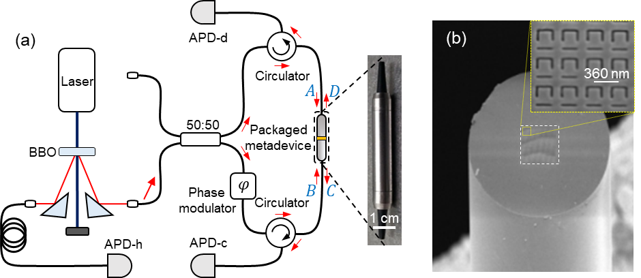
Application of CPA in practical light processing and communication, both in classical and quantum regimes, requires implementation in optical fibre environment, with an access to mainstream telecom technologies. Deep subwavelength thickness of metamaterial absorbers makes them suitable for such implementation. Indeed, an encapsulated plasmonic metamaterial (metadevice) was recently shown to operate all-optical switching and logical functions in the C-band of a telecom fibre network.¹¹ In this demonstration, the operation frequency (from 20 kHz up to 40 GHz) was few orders of magnitude higher than the characteristic phase fluctuation frequency of the fibre network (~Hz), thus no phase stabilization was required. However, realization of CPA at a single photon level is hindered by the low photon flux, which is incompatible with high signal modulation frequency. Techniques like fibre network stabilization or data post-selection processing are required in this case.
Figure 1. Coherent perfect absorption in a quantum network. (a) Schematic of the fiberized quantum network with plasmonic metamaterial absorber and heralded single photon source. Red arrows mark heralded single photon path. The inset shows a photograph of the packaged metadevice. (b) SEM image of the plasmonic metamaterial absorber deposited on the end-facet of an optical fibre. The inset shows SEM image of the nanostructure.
Here we show coherent interaction of light at single photon state on a plasmonic metamaterial performed in a fully-fiberized quantum network. We built a network based on an optical fibre Mach-Zehnder interferometer containing a fibre-packaged plasmonic metadevice. By exploiting access to both coincidence and single-photon counts information and using advanced data post-selection procedure we overcome the fibre stabilization problem. In this network we demonstrate the quantum regimes of coherent perfect transmission and coherent perfect absorption with a subwavelength lossy beamsplitter in fibre environment, thus providing an important step towards quantum light manipulation with direct implementation in fiberized quantum systems.
To introduce quantum regimes of perfect absorption and perfect transmission, let us consider an ultrathin lossy beamsplitter, or absorber, that produces a $π$-phase shift between transmitted and reflected fields.^{4,12} If such beamsplitter is interrogated with a single photon, whose wavefunction is split beforehand and recombined at the beamsplitter, the phase shift $φ$ between two “parts” of the photon’s wavefunction (defined at the metamaterial position), gives rise to two possible, and opposite, outcomes. Constructive interference occurs when $φ=±π$, with the photon passing through the absorber without any losses. Conversely, destructive interference occurs when $φ=0$, since reflected and transmitted fields cancel each other and the photon is fully dissipated (absorption probability under coherent illumination reaches unity if absorption of the beamsplitter for a traveling wave is 50%). These two limited cases are known as coherent perfect transmission and coherent perfect absorption, respectively. In more detail, the quantum state of the photon under consideration is described by path-entangled wave function:

$\left.\left|ψ\right.\right\rangle =\frac{1}{\sqrt{2}}\left({\left.\left|1\right.\right\rangle }_{A}{\left.\left|0\right.\right\rangle }_{B}+e^{iφ}{\left.\left|0\right.\right\rangle }_{A}{\left.\left|1\right.\right\rangle }_{B}\right),$ (1)

where index $A(B)$ corresponds to the top (bottom) input field of the absorber in Fig. 1a and is related to the annihilation operator $\hat{a}$ ($\hat{b}$), satisfying commutation relations, $\left[\hat{a},{\hat{a}}^{†}\right]=\left[\hat{b},{\hat{b}}^{†}\right]=1$, $\left[\hat{a},{\hat{b}}^{†}\right]=0$. The wave function $\left.\left|ψ\right.\right\rangle$ also contains controllable relative phase shift $φ$, which is accumulated during propagation through two optical passes to the absorber. A thin lossy beamsplitter mixes the input amplitudes and adds the Langevin noise operators ${\hat{f}}_{c}$ and ${\hat{f}}_{d}$ which are responsible for commutation relations conservation:^{13,14}

$$\hat{c}={t\hat{a}+r\hat{b}+\hat{f}}_{c}, \hat{d}={r\hat{a}+t\hat{b}+\hat{f}}_{d}.$$

Here $\hat{c}$ ($\hat{d}$) is the annihilation operator related to the bottom (top) output field of the absorber in Fig. 1a, and $t$ ($r$) is the amplitude transmission (reflection) coefficient for traveling waves. It is straightforward to calculate the probabilities $p_{c}$ and $p_{d}$ of detecting a photon at the corresponding output ports of the absorber, which, in case of a single photon input state and unitary detection efficiency, equal the mean values of the photon number operators:

$\left.p_{c}=〈{\hat{c}}^{†}\hat{c}〉\right.=\left({\left|t\right|}^{2}+{\left|r\right|}^{2}+2\left|t\right|\left|r\right|\cos\left(φ-Δ_{tr}\right)\right)/2,$ (2)
$p_{d}=\left.〈{\hat{d}}^{†}\hat{d}〉\right.=\left({\left|t\right|}^{2}+{\left|r\right|}^{2}+2\left|t\right|\left|r\right|\cos\left(φ+Δ_{tr}\right)\right)/2,$ (3)

where $t=\left|t\right|e^{iθ_{t}},r=\left|r\right|e^{iθ_{r}}$and $Δ_{tr}=θ_{t}-θ_{r}$ and quantum mechanical averaging is performed with initial state (1). We note that averaging of any contributions containing noise operators is equal to zero.¹³ Assuming $\left|r\right|=\left|t\right|$, (2) and (3) simplify as:

$p_{c}={\left|t\right|}^{2}\left(1+\cos\left(φ-Δ_{tr}\right)\right),$ (4)
${ p}_{d}={\left|t\right|}^{2}\left(1+\cos\left(φ+Δ_{tr}\right)\right).$ (5)

In the case of a lossless beamsplitter where we can put $\left|r\right|=\left|t\right|=1/\sqrt{2}$ and $Δ_{tr}=±π/2$, the probabilities $p_{c}$ and $p_{d}$ oscillate (with continuous modulation of $φ$) out of phase – a well-known single photon interference effect. On the contrary, for an ideal lossy beamsplitter with $\left|r\right|=\left|t\right|=1/2$ and $Δ_{tr}=±π$, the probabilities $p_{c}$ and $p_{d}$ oscillate in phase, both varying in the range of $0-0.5$ with total detection, or total transmission probability $p$, given by:

$p≡p_{c}+p_{d}=\left(1-\cos{φ}\right)/2.$ (6)

From the above quantum mechanical analysis, we conclude that for $φ=±π$ the transmission probability (6) is equal to one and the photon passes through the absorber without losses, while for $φ=0$ the transmission probability is equal to zero and the photon is absorbed deterministically.
In this work we demonstrate that regimes of coherent absorption and coherent transmission can be attained in a fully-fiberized single mode polarization maintaining fibre quantum network as presented in Fig. 1a. Heralded single photons at a wavelength of 810 nm are produced via degenerate spontaneous parametric down-conversion in a beta-barium borate (BBO) crystal, which is pumped by a CW laser at a wavelength of 405 nm. Detection of idler photon by avalanche photodiode APD-h heralds the presence of signal photon in the Mach-Zehnder interferometer containing metamaterial absorber. A piezo electric fibre stretcher, placed at the bottom arm of the interferometer, is used as phase modulator to produce phase delay φ between different arms of the interferometer.
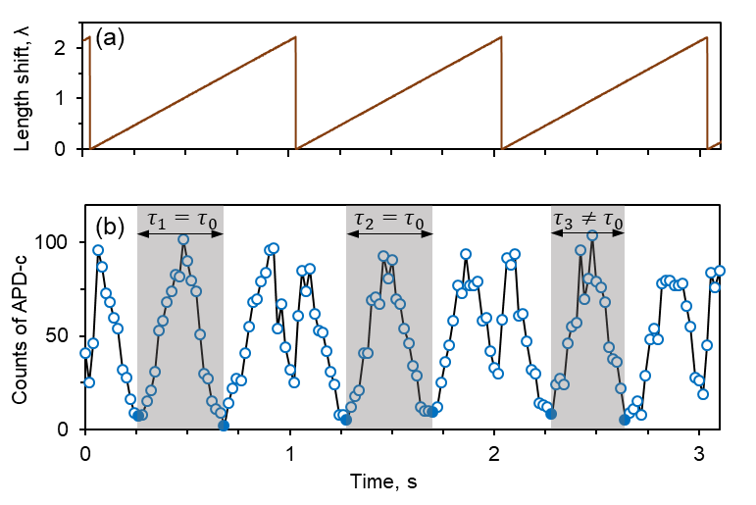
Few different ways to manufacture a coherent absorber in fibre environment were proposed, including encapsulated plasmonic metamaterial,¹¹ moderately-doped fibre in a cavity formed by fibre-Bragg grating mirrors¹⁵ and chromium layer deposited on fibre tip¹⁶. Here we follow the work presented in Ref. 11 and manufacture plasmonic packaged metadevice, which provides nanostructure design flexibility in a subwavelength film. The absorber, designed as an ideal lossy beamsplitter,² was manufactured on a 50 nm thick gold film deposited on the cleaved end facet of the fibre (Fig. 1b). The metamaterial nanostructure consisting of two-dimensional array of asymmetric split-ring resonators (inset in Fig. 1b) was carved over a 30 x 30 μm² area covering the core of the fibre by focused ion-beam milling. The fibre with deposited metamaterial was then mounted with glass fibre ferrules into a metal housing in such a way that the metamaterial symmetry axis was aligned to the slow axis of the fibres. The resulting metadevice package, shown in inset of Fig. 1a, was placed in the middle of the interferometer. The optical properties of the metadevice performs as follows at the wavelength of operation (810 nm): transmission $≈$ 20%, reflection metamaterial (bare fibre) side $≈$ 10 (6)% and absorption metamaterial (bare fibre) side $≈$ 70 (74)%. We note that these values include the inner losses in the metamaterial package due to fibre-to-fibre coupling, and actual transmission and reflection of the metamaterial is higher. Similar structures^{4,17} reveal that the performance of the metamaterial is broadband without significant changes around the wavelength of interest.
Figure 2. Reference-based post selection technique. (a) Fibre-stretcher periodically induced length shift of one arm of the interferometer showed in photon wavelength units (λ=810 nm). (b) Total single photon counts measured at the detector APD-c. Minima corresponding to the coherent perfect absorption regime (filled dots) within each fibre-stretcher cycle are used as references. The time intervals $τ_{i}$ between these points (shaded regions) are compared with the expected value $τ_{0}$ in the absence of noise. Time intervals $τ_{i}$ close to $τ_{0}$ are likely to be not affected by thermal fluctuations of the interferometer and are used for further data analysis.
Generally, fibre interferometers require active phase stabilization, since they are sensitive to thermally induced fibre-length fluctuations.¹⁸ In a number of experiments with single photons¹⁹ stabilization was achieved by introducing a feedback loop consisting of 1) reference laser at different wavelength which probes the same fibre paths as single photons, 2) multiplexer, demultiplexer and optical filters, 3) photodetector for laser power fluctuation measurement and 4) additional phase modulator to compensate fibre length drift. Nevertheless, we were able to perform proof-of-principle experiment without any active stabilization by reducing the noise amplitude and bandwidth. This was achieved by winding the fibres around the loop of small radius so that both interferometer arms experience the same temperature fluctuations and by carefully isolating the setup. Moreover, we refined the results by reference-based post selection, where data are acquired within time intervals shorter than the characteristic phase fluctuation time and the phase of each phase cycle is determined based on characteristic inflection points. Note that deterministic control of single-photon absorption probability would still require active stabilization, as elaborated elsewhere.²⁰
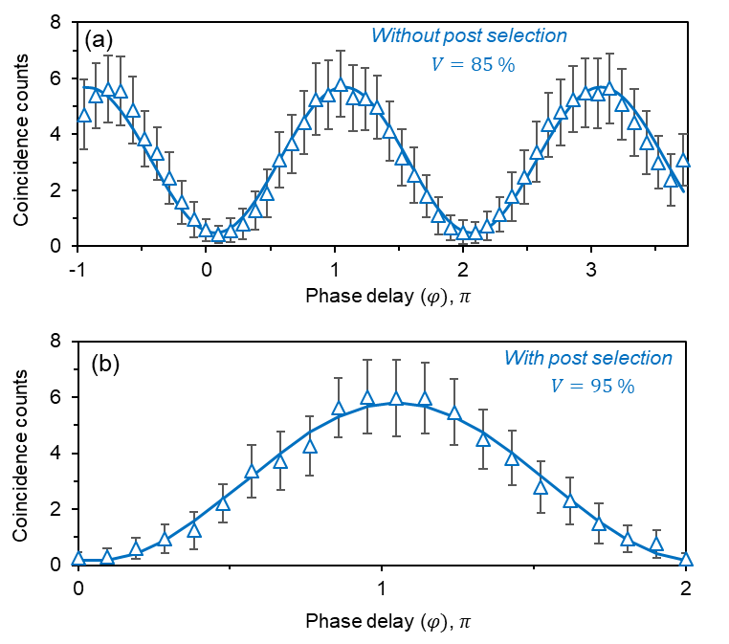
The reference-based post selection technique is illustrated in Fig. 2. The length of one arm of the interferometer is periodically modulated with a frequency that is higher than characteristic frequency of the fluctuation spectrum. The modulation amplitude exceeds two wavelengths of light (Fig. 2a) and at each cycle the interferometer reaches the condition of perfect absorption (filled points in Fig. 2b) twice, while the acquisition time ($20$ ms) of each point in Fig. 2b is much smaller than the period of oscillation ($∼440$ ms). In the absence of fluctuations, the time interval $τ_{i}$ between two points corresponding to perfect absorption is constant and equal to the expected value $τ_{0}$ (Fig. 2b). The data obtained during such intervals are unlikely to be strongly affected by the fluctuation and are used to characterize the photon absorption. In the presence of low-frequency fluctuations the time interval fluctuates indicating untrustworthy parts of the data. In experiment, the data are post-selected after recording a large number of modulation cycles (around 200). Further, the coincidence counts between detectors APD-h and APD-c (APD-d), recorded during noise-free intervals (around 75), are used to characterize the probability of heralded single photon to take output C (D).
Figure 3. Implementation of reference-based post selection technique. Coincidence counts between detectors APD-c and APD-h without (a) and with (b) post selection. The visibility V is shown for each fitting curve (solid lines) and improved by 10% after implementation of data processing. Fitting is done according to (4)-(6). Side points in (a) are not taken into account for fitting since phase modulation has a jump around these points (Fig. 2a). Error bars are defined by Poisson distribution of photon flux and cannot be improved by data post selection.
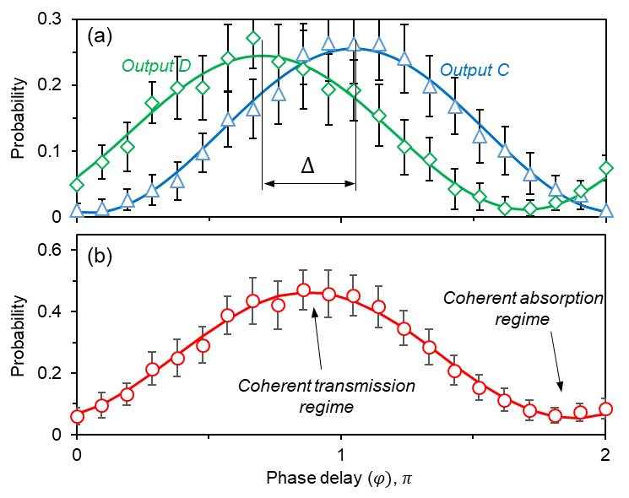
To validate the efficiency of the reference-based post selection technique we recorded interference fringes of output C without (Fig. 3a) and with (Fig. 3b) data processing. While standard deviation, which is mostly defined by Poisson statistics of incoming photon flux (in average, around 23 photons per detection window of 20 ms), remains the same, the visibility of modulation is increased by 10%. Next, by applying post selection, we demonstrate the quantum regimes of total absorption and total transmission in fibre network. We measure the probabilities $p_{c}$ and $p_{d}$ of detecting a heralded single photon at outputs C and D of the metamaterial absorber (Fig. 4a). By scanning the phase shift $φ$ we observe periodic close to in-phase oscillation of probabilities in a good agreement with (6). The phase shift $∆=π/3$ between $p_{c}$ and $p_{d}$ corresponds to not ideal parameters of the absorber and to asymmetry in the metamaterial package design, since light coming from opposite sides of the metamaterial absorber experiences different interfaces. The total probability $p$ of the heralded single photon detection (Fig. 4b) is modulated between 0.05 and 0.46 with the lowest (highest) value corresponding to coherent perfect absorption (transmission) regimes. Reduction of the modulation amplitude of $p_{c}$, $p_{d}$ and $p$ is mainly attributed to fibre-to-fibre coupling losses inside the metamaterial package. Nevertheless, this does not affect the visibility of the curves, which is higher than 90% for $p_{c}$ and $p_{d}$ and equals to 80% for $p$.
Figure 4. Single-photon coherent absorption. (a) Measured probabilities of the heralded photons, passing through the metamaterial absorber, to take output C (triangles) and output D (rhombi) and to be detected by the detectors APD-c and APD-d, respectively, in dependence on the phase delay $φ$ between two arms of the interferometer. (b) Total single-photon transmission probabilities (circles) in dependence on the phase delay $φ$. All lines are data fitting according to (4)-(6).
Interference fringe visibility demonstrated by reference-based post selection data processing is identical to visibility shown in free space experiments^{4,5}, where the total single-photon transmission probability $p$ varied in the range between 0.1 and 0.9. This clearly indicates that metamaterial coherent absorbers fabricated in fibre environment are able to carry the functionality of those implemented in a free space allowing quantum light manipulation in coherent networks including single-photon switching, filtering and measurement with applications in coherent quantum computation and quantum communication.
It is worth noting that demonstrated coherent optical fibre network can be extended for remote absorption control with polarization entangled photons⁵ and high-probability two-photon absorption of bosonic pairs¹⁰ or NOON-states⁶, and can be used as a part of a large multiport network²¹. Furthermore, implementation of CPA in quantum regime at telecom optical wavelength bands will open the ways towards quantum light processing at long distances.
In summary, we have demonstrated a continuous control over single-photon absorption probability in a fully-fiberized quantum network with a high visibility. Coherent perfect absorber was manufactured directly in fibre environment by fabrication of plasmonic metamaterial on fibre end facet. To overcome fibre length thermal fluctuations, we developed a simple data post-processing procedure which uses the total counts of single photon detector as a reference. Demonstrated effect can find applications in manipulation of single-photon, entangled, weak coherent and NOON states of light in fibre quantum networks compatible with telecom technologies.

This work was supported by the Singapore A*STAR QTE program (SERC A1685b0005), the Singapore Ministry of Education (MOE2016-T3-1-006 (S)) and the UK's Engineering and Physical Sciences Research Council (grant EP/M009122/1).

References:
¹ Y. D. Chong, L. Ge, H. Cao, and A. D. Stone, Phys. Rev. Lett. 105, 053901 (2010); W. Wan, Y. D. Chong, L. Ge, H. Noh, A. D. Stone, and H. Cao, Science 331, 889 (2011); D. G. Baranov, A. Krasnok, T. Shegai, A. Alu, and Y. D. Chong, Nat. Rev. Mater. 2, 17064 (2017).
² J. F. Zhang, K. F. MacDonald, and N. I. Zheludev, Light Sci. Appl. 1, e18 (2012).
³ X. Fang, M. L. Tseng, J. Y. Ou, K. F. MacDonald, D. P. Tsai, and N. I. Zheludev, Appl. Phys. Lett. 104, 141102 (2014).
⁴ T. Roger, S. Vezzoli, E. Bolduc, J. Valente, J. J. F. Heitz, J. Jeffers, C. Soci, J. Leach, C. Couteau, N. I. Zheludev, and D. Faccio, Nat. Commun. 6, 7031 (2015).
⁵ C. Altuzarra, S. Vezzoli, J. Valente, W. B. Gao, C. Soci, D. Faccio, and C. Couteau, ACS Photonics 4, 2124 (2017).
⁶ T. Roger, S. Restuccia, A. Lyons, D. Giovannini, J. Romero, J. Jeffers, M. Padgett, and D. Faccio, Phys. Rev. Lett. 117, 023601 (2016).
⁷ A. Ü. C. Hardal and M. Wubs, Optica 6, 181 (2019).
⁸ S. Zanotto, F. P. Mezzapesa, F. Bianco, G. Biasiol, L. Baldacci, M. S. Vitiello, L. Sorba, R. Colombelli, and A. Tredicucci, Nat. Phys. 10, 830 (2014).
⁹ D. Zhang, X.-Q. Luo, Y.-P. Wang, T.-F. Li, and J. Q. You, Nat. Commun. 8, 1368 (2017).
¹⁰ B. Vest, M. C. Dheur, E. Devaux, A. Baron, E. Rousseau, J. P. Hugonin, J. J. Greffet, G. Messin, and F. Marquier, Science 356, 1373 (2017).
¹¹ A. Xomalis, I. Demirtzioglou, E. Plum, Y. M. Jung, V. Nalla, C. Lacava, K. F. MacDonald, P. Petropoulos, D. J. Richardson, and N. I. Zheludev, Nat. Commun. 9, 182 (2018).
¹² S. Thongrattanasiri, F. H. L. Koppens, and F. J. G. de Abajo, Phys. Rev. Lett. 108, 047401 (2012).
¹³ S. M. Barnett, J. Jeffers, A. Gatti, and R. Loudon, Phys. Rev. A 57, 2134 (1998).
¹⁴ J. Jeffers, J. Mod. Opt. 47, 1819 (2000).
¹⁵ A. K. Jahromi, A. Van Newkirk, and A. F. Abouraddy, IEEE Photonics J. 10, 1 (2018).
¹⁶ A. Goodarzi, M. Ghanaatshoar, and M. Mozafari, Sci. Rep. 8, 15340 (2018).
¹⁷ A. Xomalis, I. Demirtzioglou, Y. Jung, E. Plum, C. Lacava, P. Petropoulos, D. J. Richardson, and N. I. Zheludev, Appl. Phys. Lett. 113, 051103 (2018).
¹⁸ T. Musha, J. Kamimura, and M. Nakazawa, Appl. Opt. 21, 694 (1982).
¹⁹ S. B. Cho and T. G. Noh, Opt. Express 17, 19027 (2009); G. B. Xavier and J. P. von der Weid, Opt. Lett. 36, 1764 (2011); P. Toliver, J. M. Dailey, A. Agarwal, and N. A. Peters, Opt. Express 23, 4135 (2015).
²⁰ S. Yanikgonul, R. Guo, A. Xomalis, A. N. Vetlugin, G. Adamo, C. Soci, and N. I. Zheludev, to be published.
²¹ K. Pichler, M. Kühmayer, J. Böhm, A. Brandstötter, P. Ambichl, U. Kuhl, and S. Rotter, Nature 567, 351 (2019); S. Fan, W. Suh, and J. D. Joannopoulos, J. Opt. Soc. Am. A 20, 569 (2003).

a) Authors to whom correspondence should be addressed. Electronic mail: a.vetlugin@ntu.edu.sg, csoci@ntu.edu.sg.

