FUZZY SYSTEM DYNAMICS RISK ANALYSIS (FuSDRA) OF
AUTONOMOUS UNDERWATER VEHICLE OPERATIONS IN THE ANTARCTIC

ABSTRACT

With the maturing of autonomous technology and better accessibility, there has been a growing interest in the use of Autonomous Underwater Vehicles (AUVs). The deployment of AUVs for under-ice marine science research in the Antarctic is one such example. However, a higher risk of AUV loss is present during such endeavours due to the extreme operating environment. To control the risk of loss, existing risk analyses approaches tend to focus more on the AUV’s technical aspects and neglects the role of soft factors, such as organizational and human influences. In addition, the dynamic and complex inter-relationships of risk variables is also often overlooked due to uncertainties and challenges in quantification. To overcome these shortfalls, a hybrid fuzzy system dynamics risk analysis (FuSDRA) is proposed. In the FuSDRA framework, system dynamics models the inter-relationships between risk variables from different dimensions and considers the time-dependent nature of risk while fuzzy logic accounts for uncertainties. To demonstrate its application, an example based on an actual Antarctic AUV program is presented. Focusing on funding and experience of the AUV team, simulation of the FuSDRA risk model shows a declining risk of loss from 0.293 in the early years of the Antarctic AUV program, reaching a minimum of 0.206 before increasing again in later years. Risk control policy recommendations were then derived from the analysis. The example demonstrated how FuSDRA can be applied to inform funding and risk management strategies, or broader application both within the AUV domain and on other complex technological systems.

Keywords: Autonomous Underwater Vehicle, System Dynamics, Fuzzy Set Theory, Risk Analysis

1. INTRODUCTION
  - Autonomous Underwater Vehicles and Risk of Loss
Autonomous Underwater Vehicles (AUVs) are robotic devices that are self-powered and piloted by onboard computer systems. With the maturing of autonomous technology and better accessibility, there has been a growing interest in the use of AUVs for various scientific, commercial and military applications. Under-ice marine science research in the Antarctic is one such example of usage (Nicholls et al., 2006)(Jenkins et al., 2010)(Cadena, 2011). Beneath Antarctic’s ice lies unique ecological, geological and physical oceanographic ecosystems which harbour valuable information on the Earth’s climate system and biogeochemical cycles. It also offers insights into other similar cold icy worlds such as that of Jupiter’s moon Europa, Saturn’s moons Enceladus and Titan, and even Neptune’s moon Triton (Cooper, 2016).
However, the use of AUVs in the Antarctic presents challenges such as ice cover, inaccessibility and limited field season. The extreme environment also tests the technological limits of the AUV and the on-site team both physiologically and psychologically (Gunderson, 1967). Therefore, it is not surprising that the risk of AUV loss during under-ice deployment in the Antarctic is higher as compared with open water missions (Mario Paulo Brito, Griffiths, & Challenor, 2010). Previous risk analysis of the Autosub 3 AUV showed the median probability of AUV loss for under sea-ice missions to be 4.9 times higher than that of open water missions. Risk of loss for under ice-shelf missions is even higher, with the median probability 9.4 times higher than open water missions (Mario Paulo Brito et al., 2010). In 2005, Autosub2, an AUV owned by the National Oceanography Centre, Southampton, United Kingdom was lost during an Antarctic mission with unknown exact cause of loss (Gwyn Griffiths & Collins, 2006). In another report, a SeaBED AUV owned by the Woods Hole Oceanographic Institution (WHOI) in Massachusetts was stuck under Antarctic ice during a mission and had to be recovered (Waters, n.d.). Seaglider SG522, an underwater glider owned by the University of East Anglia, United Kingdom, was lost at the Weddell Sea in the Antarctic due to erroneous parameters set by the AUV operator (Mario P. Brito, Smeed, & Griffiths, 2014).
The loss of an AUV can have several adverse consequences. For instance, it can result in higher insurance premiums for the AUV community, delay to research projects, damage to the reputation of the AUV community, loss of valuable research data and a possibility of harming the delicate Antarctic environment (Gwyn Griffiths & Collins, 2006). It is therefore imperative that risk of loss be analysed and managed effectively for any deployment of AUVs in the Antarctic.
1.2
Existing Risk Analysis Approaches
The most widely adopted definition of ‘risk’ is that it is a combination of the severity of an event (or scenario) and the likelihood of that scenario occurring (Kaplan & Garrick, 1981). Risk analysis, therefore, refers to the process to comprehend the nature of risk and to express the risk, with available knowledge (“Society for Risk Analysis Glossary,” 2015). In the AUV domain, Griffiths, Brito (M. Brito & Griffiths, 2016; G Griffiths & Brito, 2008, 2011) and their colleagues (Gwyn Griffiths, Brito, Robbins, & Moline, 2009) set the foundation by carrying out extensive risk studies using probabilistic models such as the Kaplan-Meier estimator, Bayesian Belief Network (BBN) and Markov chains to analyse historical failure fault log data of AUVs. These models, usually applied in synthesis with expert’s judgement, enable a probability of AUV loss to be predicted. In a different approach, Bian et al. (Bian, Mou, Yan, & Xu, 2009) proposed the use of a fuzzy fault tree for reliability analysis of AUVs. Although the study focuses solely on technical reliability, it demonstrates how the incorporation of fuzzy logic into fault tree analysis copes with the lack of data and account for uncertainties. In recent risk studies, more attention has been devoted to systemic issues, such as the role of organisational and human factors in the overall risk of AUV loss during deployment. Brito and Griffiths (Mario P Brito & Griffiths, 2012) applied system dynamics models to analyse the impact of multiple AUVs deployments on risk mitigation efforts. Based on a generic risk model, their study represents a proof of concept for using system dynamics in risk analysis. Although the study lacks a structured framework and validation of the model, several ways to improve the approach, including the integration of expert’s judgement to establish the inter-relationships between risk variables were suggested. A risk management framework which focused on both human and organisational factors was proposed by the Thieme et al. (Thieme, Utne, & Schjolberg, 2015). Based on human reliability analysis (SPAR-H), fault tree and event tree analysis, application of the framework found “internal faults of the AUV” as the most likely cause of AUV loss during a mission. Although the focus on organisational and human factors represents a significant development in risk analyses approaches to reduce risk of AUV loss, there still exists room for improvements.

1.3

Shortfalls
Three main shortfalls were identified despite the progress made in risk analyses approaches in reducing risk of AUV loss. First, existing approaches often view AUV incidents as a chain of events, neglecting the complex interrelationship between risk factors leading to systemic issues.

Second, much of existing focus still lies on the technical aspects of the AUV and neglects other risk dimensions such as human, organisational, social, political and environmental influences. In particular, soft factors, such as the reputation of organisation or attitude of an AUV team member, which are difficult to quantify are most often overlooked. Last, many existing approaches are discrete-based, and they do not capture the time dependency of risk factors effectively, such as ageing of the AUV with time. As a result of these shortfalls, most AUV operations still adopts early risk management strategies which are unsuitable for modern-day AUV operations (Mario P. Brito, 2017).

These analysis shortfalls are not unique to the AUV domain and have been addressed separately in other fields. To better account for the time-dependent risk factors as well as the underlying complex relationships, there has been a gradual shift in risk analysis focus from static chain of event models to complex dynamic risk models (Hollnagel, Pariès, Woods, & Wreathall, 2013)(Katsakiori, Sakellaropoulos, & Manatakis, 2009). The use of holistic, dynamic and system-based approaches for risk analysis started to gain traction after the investigations of several high-profile industrial accidents such as the Three Mile Island accident (Herndl, C.G, Fennell, B.A., & Miller, 1991), Bhopal gas tragedy (Aini & Fakhrul-Razi, 2010) and the Chernobyl nuclear disaster (Pidgeon & O’Leary, 2000). Although all three accidents were attributed, at least partially, to human errors of operators, these were the long-term effect of other systemic issues such as production pressure, poor workforce planning, weak governance, lack of communication channels, poor resource planning or placing a priority on productivity over safety (Leveson, 2011). In more recent development, there has been an increasing interest in the contribution of intangible soft factors to risk, an aspect often neglected in the past due to difficulty in quantification. Using a myriad of different approaches, soft factors ranging from organisational safety culture (Guldenmund, 2010) to personal beliefs (Nakayachi, Johnson, & Koketsu, 2018) and personalities (Sween, Ceschi, Tommasi, Sartori, & Weller, 2017) are now being considered in many risk studies.

This research presents a hybrid FuSDRA approach for risk analysis of AUV operations in the Antarctic. Utilising the strengths while overcoming weaknesses of system dynamics and fuzzy logic, the proposed approach addresses existing risk analysis shortfalls. The application of FuSDRA reveals a set of systemic behaviours influencing the risk of AUV loss. Through these insights, risk control policies can be recommended, with the eventual goal of achieving both better control and monitoring of risks. This paper is organised as follows: Section 2 describes the FuSDRA approach. Section 3 presents an example of FuSDRA application on an Antarctic AUV program. Section 4 discusses the benefits, limitations and scope for future work. Lastly, Section 5 concludes the paper.

2. METHODOLOGY
  - System Dynamics

Forrester (Forrester, 1958) established the field of system dynamics in the mid-1950s for analysis of dynamic complex systems. Sterman (Sterman, 2000) further demonstrated the application of system dynamics to facilitate learning about the dynamic complexity of a system, understand the sources of policy resistance and aid design of more effective policies.

The fundamentals of system dynamics lie in the field of feedback control, demonstrating how the structure of the system with its feedback loops are responsible for its dynamic behaviour. The main elements of system dynamics models are feedback processes, expressed through reinforcing and balancing loops (Fig. 1a), stock and flow structures (Fig. 1b) and time delays. A reinforcing loop is one where an initial change influences more of the same change while a balancing loop seeks an equilibrium by counteracting change. Stock represents the state of the system which accumulates or depletes over time while flows define the rate of change in a stock. This can be represented by the following equation 1,

$\frac{d}{dt} (Stock)$ = inflow (t) – outflow (t) --- (1)

Stocks characterise the system state by providing inertia and memory, which can also lead to time delays when a difference between inflow and outflow rate exist.
b
a
Fig. 1. a: An example of a causal loop diagram showing both reinforcing feedback (R) and balancing feedback loop (B) and b: An example of a simple stock and flow diagram.

System dynamics is an objective-oriented deterministic approach. It can overcome existing risk analysis shortfalls of AUV operations in the Antarctic by modelling the complex inter-relationships between risk variables of different risk dimensions. In addition, the use of stock and flow models expressed using differential equation notation also takes into account the dynamism of time-dependent risk factors. This strength of system dynamics is well recognised outside of the AUV domain and demonstrated in risk studies across various disciplinary boundaries, from chemical (Garbolino, Chery, & Guarnieri, 2016), mining (D. L. Cooke, 2003) to aerospace (Dulac et al., 2005). However, the deterministic nature of system dynamic models does not explicitly account for uncertainties in causal relationships and soft factors. This limitation has resulted in the recent development of various hybrid system dynamics approaches (Pruyt, 2007)(Alvanchi, Lee, & AbouRizk, 2011)(Magdy, 2008) as well as qualitative system dynamics models (Coyle, 2000). Here, we propose the integration of fuzzy logic with system dynamics to overcome this limitation.

  - Fuzzy Set Theory

Zadeh (Lotfi A. Zadeh, 1965) generalised the concept of multivalued logic and established fuzzy set theory. Fuzzy set theory utilises mathematical logic to account for human subjectivity and uncertainty. In contrast to traditional Boolean logic where an element either belongs or does not belong to a set, fuzzy logic takes a less rigid view and reflects more naturally each element’s association with a particular set (Fig. 2). It does so by using a membership function $μ\left(x\right)$ which assigns membership values of between 0 and 1 to its elements $x$, defined as:

$μ\left(x\right):X→[0,1]$ --- (2)

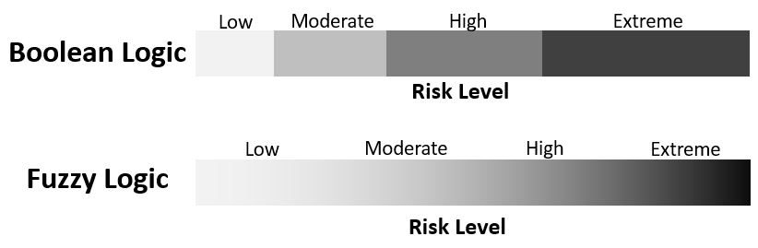

Fig. 2. Crisp boundaries of Boolean logic as compared to a smooth transition between risk level categories represented by fuzzy logic.

Another fundamental concept to the theory is that of linguistic variables. Linguistic variables are words or sentences in natural language which are often vague in nature (L. A. Zadeh, 1975). They are used in day to day conversations to represent opinions, easily comprehensible by most listeners and are independent of the measuring system. For instance, ‘risk’ is a linguistic variable if its values are described in linguistic terms of ‘low’, ‘moderate’, ‘high’ or ‘extreme’ instead of numerical values.

Fuzzy-based approaches are often the method of choice for handling of uncertainties, which includes the analysis of soft factors (Purba, Sony Tjahyani, Ekariansyah, & Tjahjono, 2015)(Helton, Johnson, Oberkampf, & Sallaberry, 2010)(Unwin, 1986). As a result of this, the use of fuzzy logic for risk analysis is common in various domains such as nuclear power plants (Rastogi & Gabbar, 2013), construction (Gürcanli & Müngen, 2009) and medical fields (Lee & Wang, 2011). The transparent characteristic of fuzzy logic is also the primary reason why it is chosen in this paper to reduce the opacity of system dynamic risk models.

  - Fuzzy System Dynamics Risk Analysis (FuSDRA)

Despite being proposed as early as 1994 (Tessem & Davidsen, 1994), the use of fuzzy system dynamics remained relatively uncommon. Khanzadi et al. (Khanzadi, Nasirzadeh, & Alipour, 2012) applied the approach to determine an optimal concession period for build-operate-transfer infrastructure projects. Nasirzadeh et al. (Nasirzadeh, Khanzadi, & Rezaie, 2014) used fuzzy system dynamics models to establish an optimum percentage of risk allocation between owners and contractors which helps to minimize construction project cost. Mutingi and Mbohwa (Mutingi & Mbohwa, 2014) demonstrated how fuzzy system dynamics approach has the ability to solve real-world manpower planning problems and help organisations design more effective manpower management strategies. To our best knowledge, this is the first time the use of fuzzy system dynamics has been proposed for analysing operational risk of autonomous systems. In addition, a systematic and structured framework to facilitate application and understanding of the approach is also novel.

The proposed FuSDRA approach follows a three-stage iterative framework, comprising the identification of risk variables, risk modelling and risk evaluation (Fig. 3).
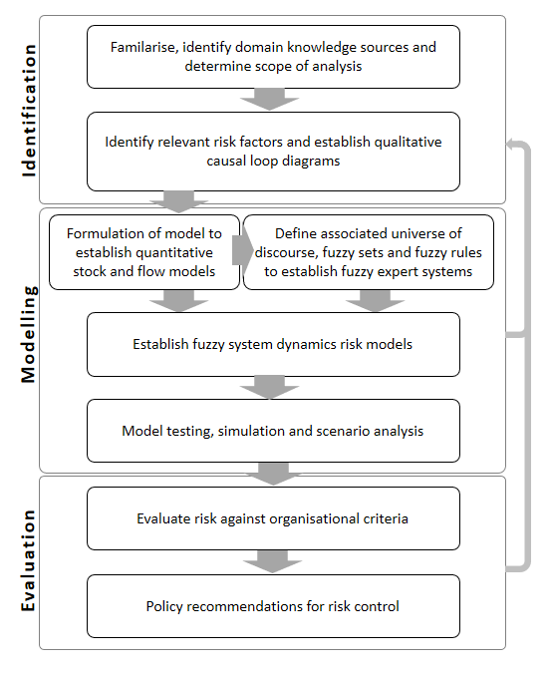
Fig. 3. An overview of the FuSDRA framework.

2.3.1 Identification

The first task is to become familiar with the Antarctic AUV program, the subject area under consideration and to identify domain knowledge sources. Experts’ knowledge is often the only and the best source of information for this process (Kuhnert, Martin, & Griffiths, 2010). As far as possible, the number of experts to interview should lie between 6 - 12 as recommended by Cooke and Probst (R. Cooke & Probst, 2006). Experts should have different roles and specialism in the AUV domain and this can come from AUV engineers, the program owner, the manufacturers or contractors. Additional information can also be sought from organisational documents such as the safe work procedures, technical specifications of the AUV, fault logs, risk assessment records, program schedules, budget plans, Antarctic deployment plans and expected performance requirements.

Tapping into the established domain knowledge sources, the second task involves identification of risk variables that can cause or culminate in the loss of the AUV during an Antarctic deployment. To ensure comprehensiveness, risk variables from different dimensions such as human, organisational, technical and external influences should be considered. Using semi-structured interviews with experts and other identified knowledge sources, causal relationships between risk variables are then identified and represented in a qualitative causal loop diagram (CLD). A CLD enables clear visualisation of the overall feedback structure influencing the risk of AUV loss during an Antarctic deployment.

2.3.2 Modelling

2.3.2.1 Establish FuSDRA Model

The next task aims to quantify the risk of loss by constructing quantitative stock and flow models from the qualitative CLDs. This is carried out through parameters’ estimation, formulation of behavioural relationships and establishing initial conditions. For uncertain causal relationships between risk variables, fuzzy logic is applied through a fuzzy expert system. The use of fuzzy expert system has many advantages. It provides consistent and objective results, help support and verify expert’s opinions and allows for modelling based on data and knowledge banks (Zimmermann, 2001). More importantly, it allows for a combination of hard and soft factors as well as uncertain causal relationships to be modelled. The generic architecture of a fuzzy expert system, which involves determining the universe of discourse, defining fuzzy sets and membership functions, and constructing fuzzy rules is shown in Fig. 4 (Mendel, 2001). The universe of discourse is the numerical range of possible values associated with the risk variable. To ascertain a fuzzy set, a list of typical adjectives associated with the risk variable is identified. The membership function then defines the degree to which a parameter belongs to a particular fuzzy set. An example of universe of discourse, fuzzy sets and membership functions for the risk variable ‘AUV Annual Utilisation Rate’ is shown in Table 1. Fuzzy rules, usually elicited from experts, then infer information using linguistic variables and fuzzy sets to produce an output in a process called fuzzy inference. Two of the most commonly used fuzzy inference methods are the Mandani (Mamdani & Assilian, 1975) and Sugeno (Sugeno, 1985) inference. Lastly, a crisp output value is derived through defuzzification using methods such as the centroid method, weighted average method, centre of sums, centre of largest area, mean-max membership or max-membership principal (Zhao & Govind, 1991)(Leekwijck & Kerre, 1999).

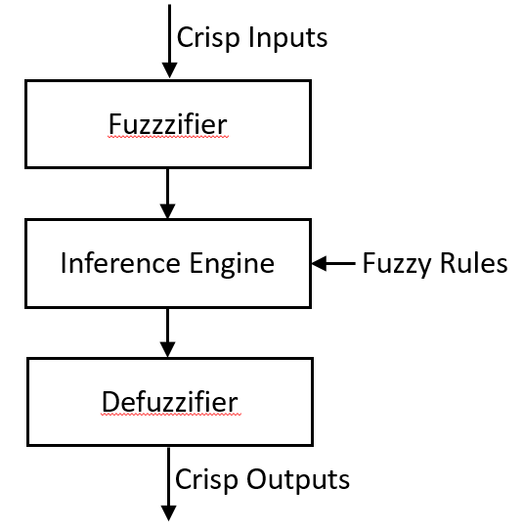
Fig. 4. The generic architecture of a fuzzy expert system adapted from Mendel (Mendel, 2001).

Risk Variable | Universe of Discourse (Units) | Fuzzy Sets | Membership Function
Risk Variable | Universe of Discourse (Units) | Fuzzy Sets | Min | Most Likely | Max
AUV Annual Utilisation Rate  (Time in water) | 0 – 0.5 (Year) | Minimal | - | 0 | 0.125
AUV Annual Utilisation Rate  (Time in water) | 0 – 0.5 (Year) | Low | 0 | 0.125 | 0.25
AUV Annual Utilisation Rate  (Time in water) | 0 – 0.5 (Year) | Average | 0.125 | 0.25 | 0.375
AUV Annual Utilisation Rate  (Time in water) | 0 – 0.5 (Year) | High | 0.25 | 0.375 | 0.5
AUV Annual Utilisation Rate  (Time in water) | 0 – 0.5 (Year) | Extreme | 0.375 | 0.5 | -

Table 1. An example of the universe of discourse, fuzzy sets and triangular membership function for the risk variable ‘Annual Utilisation Rate’.

The resultant fuzzy expert systems are incorporated with the stock and flow models to construct hybrid fuzzy system dynamics risk models. To do so, the stock and flow model is first converted into a block diagram. To demonstrate this, consider the stock and flow diagram given in Fig. 5a. The stock variable ‘Number of AUV Engineers’ (Engr) changes via flow variables ‘Hiring’ and ‘Attrition’ which are influenced by parameters ‘Hiring Rate’ (HR) and ‘Attrition Rate’ (AR). The corresponding integral equation of the model up to this point can be written as:

Engr_{t} = Engr₀ + $\int_{0}^{t}{\left(HR-AR\right) }$x Engr x $dt$ --- (3)

However, the hiring rate is further influenced by ‘Supply of Labour’ and ‘Workload in AUV Team’, where causal relationships are harder to quantify deterministically due to uncertainty. To model this, a fuzzy expert system can be established through the elicitation of experts’ opinion and integrated into the stock and flow model using a block diagram. The resultant fuzzy system dynamics model is shown in Fig.5b.

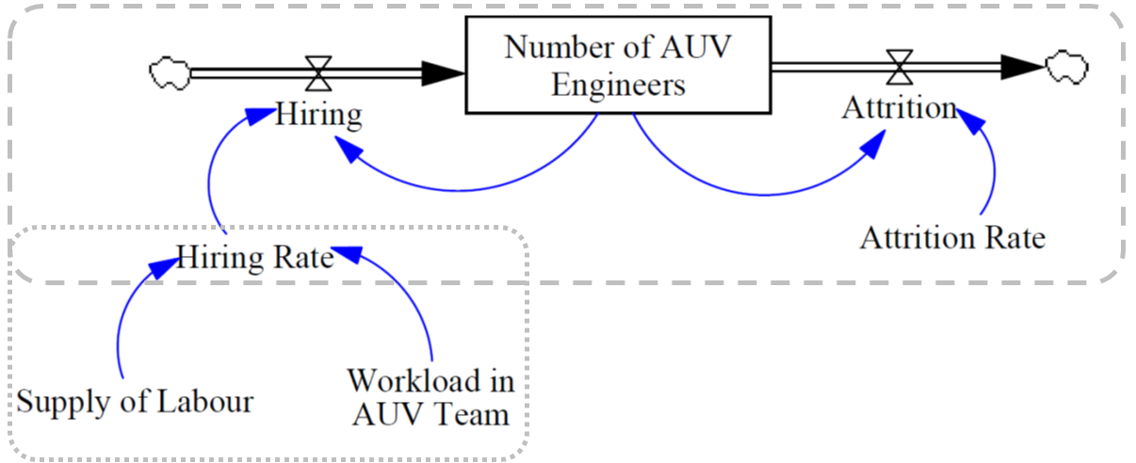

Fig. 5a. An example of stock and flow diagram to be modelled with fuzzy system dynamics.

Fig. 5b. Corresponding fuzzy system dynamics block diagram of Fig.5a.

2.3.2.2 Model Testing, Simulation and Scenario Analysis

To ensure relevance and suitability for its intended purpose, the established FuSDRA models should then be tested, reviewed and calibrated. A wide variety of tests are available in the literature for both system dynamics models and fuzzy expert systems. These can be broadly classified into model structure, model behaviour and policy implications tests (Sterman, 2000). The choice of tests often depends on several factors such as time and resource availability, size of the model and purpose of the model. Any unexpected behaviour revealed during the tests must be investigated and improvements made to the model accordingly. Once sufficient confidence is gained, simulation and scenario analysis can be undertaken. The types of scenarios to be analysed are selected based on discussion with the AUV team and decision-maker in the AUV program; the result of which is a set of systemic behaviour influencing the risk of AUV loss in the Antarctic.

2.3.3 Evaluation

To evaluate risk, simulation results are compared against pre-determined organisational evaluation criterion. For instance, this can be an acceptable probability of AUV loss based on the capital and operating cost of the AUV (Gwyn Griffiths & Collins, 2006). Insights attained through analysis of the risk models can improve mental models of decision-makers and lead to the identification of leverage points. For example, the causal loop diagram can be used to communicate risk, identify missing information and dispell misconception (Atman, Bostrom, Fischhoff, & Morgan, 1994). The eventual aim is to derive and recommend risk control policies to prevent loss of AUV in the long run. To ensure the effectiveness and pragmatism of the recommended risk control policies, it is critical that decision-makers, experts and other key stakeholders in the AUV program are closely involved in the entire FuSDRA process.
The FuSDRA approach does not end in this last step of the iterative framework. During the analysis process itself, new risk factors and information can surface during both the modelling and evaluation stage of the framework. As a result, the analysis must return to the task of identification to enhance the risk model. Even upon completion of the analysis, the inclusion of new information, filling of data gaps and review of models need to be performed on a regular basis to maintain relevancy and more refined analysis of risks. Revisiting the analysis also helps to refresh knowledge and facilitate open discussions. This will ensure the effectiveness and sustainability in controlling the risk of AUV loss for future Antarctic deployments.

  - Software

For this work, Vensim® (“Vensim User Guide,” 2017) was chosen for system dynamics modelling, which includes both causal loop diagrams and stock and flow diagrams. It has the advantage of a user-friendly interface, dimensional checks and visual clarity. The fuzzy expert systems were developed using the MATLAB® fuzzy logic toolbox 2017 (“Fuzzy Logic Toolbox User’s Guide,” 2017). This tool provides a comprehensive and user-friendly environment to build and evaluate fuzzy systems.
System dynamics models from Vensim® were converted into block diagrams to construct the fuzzy system dynamics models with the MATLAB® Simulink toolbox 2018 (“Simulink® User’s Guide,” 2015). This tool allows for the construction of mathematically complex systems involving many risk variables. More importantly, it enables the incorporation of fuzzy expert systems with system dynamics models with relative ease.

3. APPLICATION EXAMPLE
3.1 Overview

To demonstrate the FuSDRA approach, it was applied to an actual Antarctic AUV program. The nupiri muka AUV program is funded by the Australian government through the Antarctic Gateway Partnership and managed by the University of Tasmania. The partnership initiative aims to build polar research capability in Tasmania and the AUV program supports this by enabling the conduct of marine scientific research in the Antarctic. The Explorer-class AUV has the capability to explore depths of up to 5,000 meters, a present cruising range of 140km and allows for diverse scientific payload requirements to acquire high-resolution data.

Delivered in May 2017, the first Antarctic deployment to the Sørsdal Glacier took place during the summer field window, between December 2018 and February 2019. The nupiri muka AUV is still relatively new at the time of writing, with very limited historical data for any meaningful probabilistic risk quantification. The high level of uncertainty makes the FuSDRA approach highly suitable for analysing the long term risk of AUV loss.

3.2 Identification

The AUV operating team in the University of Tasmania consists of a facility manager, a research engineer and an engineer. They serve as the primary information source throughout the entire risk analysis process and were elicited through a series of both individual and group interviews. The semi-structured interview for individual consist of 11 questions including both open and closed questions. The group interviews were unstructured discussions focused on reviewing conflicting information provided by the interviewees to better understand the different perspectives, and to achieve a consensus. Other knowledge sources included data from trial runs, information from the manufacturer’s operating manual, direct observations, standard operating procedures, risk assessments records and literature on under-ice missions of other AUVs. Two common issues which may affect long term survivability of the AUV were brought up by all members of the AUV team. They are, the securing of funding to ensure the long-term sustainability of Antarctic deployments and the hiring of niche talent who are experienced in polar AUV operations. For example, an interviewee mentioned:

“Getting our finances right is one of the biggest risks. If we do not have the right finance, we will not be able to run the vehicle in the first place. The vehicle costs a lot of money to run and so that money has to come from somewhere.”
The FuSDRA approach was applied to examine the impact of these two issues on the risk of AUV loss. Other risk variables associated with the two issues were also identified through the interviews, as presented in Table 2.

Risk Dimension | Risk Variable (s)
Organisational | - Utilisation Rate  - Allocated Annual HR Budget  - Reputation in AUV Operations  - Third-Party AUV Hire Contracts  - Research Demand
Human | - Average Experience of AUV Team  - Human Error Incidents
Technical | - Technical and System Faults  - Effective AUV Age  - Reactive Maintenance Costs  - Preventive Maintenance Costs  - Total Expenses of Maintenance
External | - Commercial Demand

Table 2. Identified risk variables influencing the risk of AUV loss for the nupiri muka AUV.

Through the interviews, causal relationships between the risk variables were also identified. For instance, an interviewer highlighted the causal relationship between “Effective AUV Age”, “Technical and System Faults” and “Reactive maintenance cost”:
“We have to be able to maintain the vehicle, have the budget, because in three to five years’ time, some things need to be replaced or keep up to date.”
Each causal link was verified by the AUV team during group discussions and supported with literature when possible. The final diagram (Fig.6.), gradually established through the series of interviews, had a resultant reinforcing loops R1 and R2, and balancing loops B1 and B2. This diagram was reviewed and validated through group discussions, with frequent reassessment of the model until the models converge sufficiently to be deemed reflective of the real-world system by all members of the AUV team.

Fig.6. CLD showing causal relationships between identified risk variables and feedback loops.

In the reinforcing loops R1 and R2, average experience of the primary AUV operating team influences the number of human error incidents during a deployment. This causality is also supported in the literature (Wiegmann & Shappell, 2012)(Reason, 1990). Human error incidents determine partially, the overall incident rate, which reflects the risk level of losing the AUV in the Antarctic. Supporting this causality are several studies which found that human errors play a significant role in contributing to the overall risk of AUV loss (G Griffiths, Millard, McPhail, Stevenson, & Challenor, 2003)(Stokey et al., 1999)(Ho, Pavlovic, Arrabito, & Abdalla, 2011). The occurrence of incidents during deployments can cause delays and adversely impact reputation of the organisation in AUV operations. The level of research demand also influences the reputation of the organisation through research output such as the number of research publications. Subjected to a time delay, reputation of the organisation have an influence over the number of third-party AUV hire contracts, albeit limited by external commercial demand. Based on the amount of revenue generated from AUV hire contracts and gain in reputation contributed by the AUV program, senior management of the University then determines the amount of budget to be allocated for the AUV program in the next work year. This includes budget for human resources (HR), which can impact management strategies in areas such as recruitment, turnover and training. Logically, a higher amount of budget allocation for human resources translates to higher average experience of the AUV team, thus completing the two reinforcing feedback loops.

In the B1 balancing loop, reputation of the organisation in AUV operations determines the level of future AUV utilisation. Higher AUV usage will result in a higher rate of ageing, vice versa. The effective age of the AUV then directly influences technical and system failure rate with a typical ‘bathtub’ curve relationship consisting of three phases: a relatively short infant mortality phase with a decreasing failure rate, a normal operating period with low, relatively constant failure rate and a wear-out phase that exhibits an increasing failure rate. Technical and system failures determine, partially, the overall incident rate, which affects reputation of the organisation and completes the feedback loop.

In the B2 balancing loop, the level of technical and system failures affects reactive maintenance costs. Together with preventive maintenance costs, they make up the total expenses for overall maintenance. With a lump-sum budget allocation to the AUV program, higher spending on maintenance reduces the amount of budget allocated to human resources and vice versa.

To better analyse the interactions between feedback loops and quantify the risk of AUV loss, construction of the FuSDRA model was carried out next.

3.3 Modelling

Using the CLD as a basis, a stock and flow model was constructed and shown in Fig.7. Formulations, definitions and initial conditions were established using information sought from domain knowledge sources, as shown in Appendix I.

Fig.7. Stock and flow diagram with four stocks.

The formulations of causal relationships between several risk variables in the stock and flow model were uncertain due to a lack of data points and the presence of soft factors. These require the application of fuzzy logic through fuzzy expert systems to represent practical scenarios, which is the next step of the FuSDRA approach.

To develop fuzzy expert systems, the universe of discourse, fuzzy sets and membership function of the risk variables were identified through the semi-structured interviews with each member of the AUV team. Both triangular and trapezoidal membership functions were used as they are suited to effectively capture subjective and imprecise information, as well as being simple to compute (Barua, Mudunuri, & Kosheleva, 2014). Aggregation of opinions was performed using the lowest and greatest value provided by experts as the lower bound and upper bound. The average value is then used as the modal value (Tadic, Milanovic, Misita, & Tadic, 2011). Elicitation of fuzzy rules was then performed through group discussions with the AUV team using a hypercube matrix. A hypercube is a geometric shape of n-dimensions, determined by the number of input risk variables (McNeil & Thro, 1994). For instance, a 4D hypercube can be used for a fuzzy system consisting of four input risk variables and a 3D hypercube for a three-input risk variable fuzzy system. The fuzzy rules were elicited from experts in the form of IF-THEN rules such as:

IF Research Demand is High AND Incident Rate is Average
THEN Reputation in AUV Operations is Good

The universe of discourse, fuzzy sets, membership functions and fuzzy rules are presented in Appendix II. Fuzzy inference was then performed using the Mandani approach as it is widely accepted for capturing experts’ knowledge (Kaur & Kaur, 2012). Finally, defuzzification was carried out using the centroid method by finding a point representing the centre of gravity of the aggregated fuzzy set. It is chosen over other methods as it has the advantage of being well-balanced, sensitive to the height and width of the fuzzy output, and provides consistent results (Negnevitsky, 2005). The fuzzy inference and defuzzification process were implemented using MATLAB® fuzzy logic toolbox 2017 (“Fuzzy Logic Toolbox User’s Guide,” 2017).

The established fuzzy expert systems were incorporated into the system dynamics model by converting the stock and flow model into a block diagram, with the resultant model shown in Fig.8.
Fig.8. Fuzzy System Dynamics model

The main components of the FuSDRA model include eight fuzzy logic blocks, representing the eight uncertain causal relationships formulations in the stock and flow model (Appendix I). There are four integrator blocks which compute the level of stock variables, ‘AUV Effective Age’, ‘Average Experience of AUV Team’, ‘Reputation in AUV Operations’ and ‘Preventive Maintenance Costs’. Despite the nupiri muka being relatively new in operation, the primary AUV team had experience working on other AUVs such as the UBC-Gavia and the Memorial University Explorer AUV. Therefore, the initial average experience for the team was set at two years. Initial conditions for reputation in AUV operations was set as average, at 50%, due to positive publicity of the nupiri muka AUV program despite limited historical track record. For ‘Preventive Maintenance Costs’, the initial value was set at 50,000 AUD with a 5% annual increase to account for inflation, component deterioration and outdated technology. The integrator block outputs the integral of its input based on the following equation 4,

$y\left(t\right)=\int_{0}^{t}{u\left(t\right)dt+y\text{o} }$ --- (4)

where y is the output at simulation time t with input u and initial condition y_{o}. There are also four constant blocks and two gain blocks representing ‘Commercial Demand’, ‘Research Demand’, ‘Designed Utilisation Rate’, ‘Baseline Aging of Components and Systems’, ‘Annual Increase in Preventive Maintenance Costs’ and ‘Average Reactive Maintenance Cost per Technical and System Fault’. After discussion with the primary AUV team, both research and commercial demand were set at an average value of 5 out of 10 due to limited awareness, high cost, regulatory requirements and geographical limitations. An AUV that is kept in storage will continue to age and deteriorate. Therefore, ‘Baseline Aging of Components and Systems’ was set at an equivalent of 20% utilisation rate. ‘Designed Utilisation Rate’, the amount of time the AUV is expected to be operating in the water was set at 50%, based on a best estimate. Lastly, the ‘Annual Increase in Preventive Maintenance Costs’ and ‘Average Reactive Maintenance Cost Per Technical and System Fault’ were set at 5% and 10,000 AUD respectively. These constants and gain blocks also allow for easy future calibration of the risk model for a more accurate reflection of reality.

To build confidence in the developed FuSDRA model, three main approaches were taken. First, local knowledge from the AUV team and any available historical data were used to calibrate the model. Second, a series of tests were undertaken to uncover model errors and areas for improvement. Some key tests which were carried out include boundary adequacy, structure assessment, dimensional consistency, extensive extreme conditions and behaviour anomaly tests. To check for completeness of the fuzzy rule bases, the completeness measure approach by Jager (Jager, 1995) was applied. Any unexpected behaviour revealed during the tests were investigated and improvements made to the model accordingly. Last, simulation results from the model were discussed and compared with domain experts’ opinion. Once sufficient confidence was gained in the FuSDRA model through extensive model testing, custom scenarios can be created and analysed through the model.

Results from simulation of the FuSDRA model showed a declining risk of loss from 0.293 in the early years of the Antarctic AUV program, reaching a minimum of 0.206 before increasing again in later years. (Fig.9a). As the AUV team gradually gains experience with utilisation of the AUV (Fig.9b), human error incidents declined steadily towards a ‘baseline’ human error incident rate (Fig.9c). The number of technical and system faults exhibited a ‘bathtub’ curve, common to reliability engineering, with higher failure rates in the early phase and late phase of the AUV program (Fig.9d).
b
a
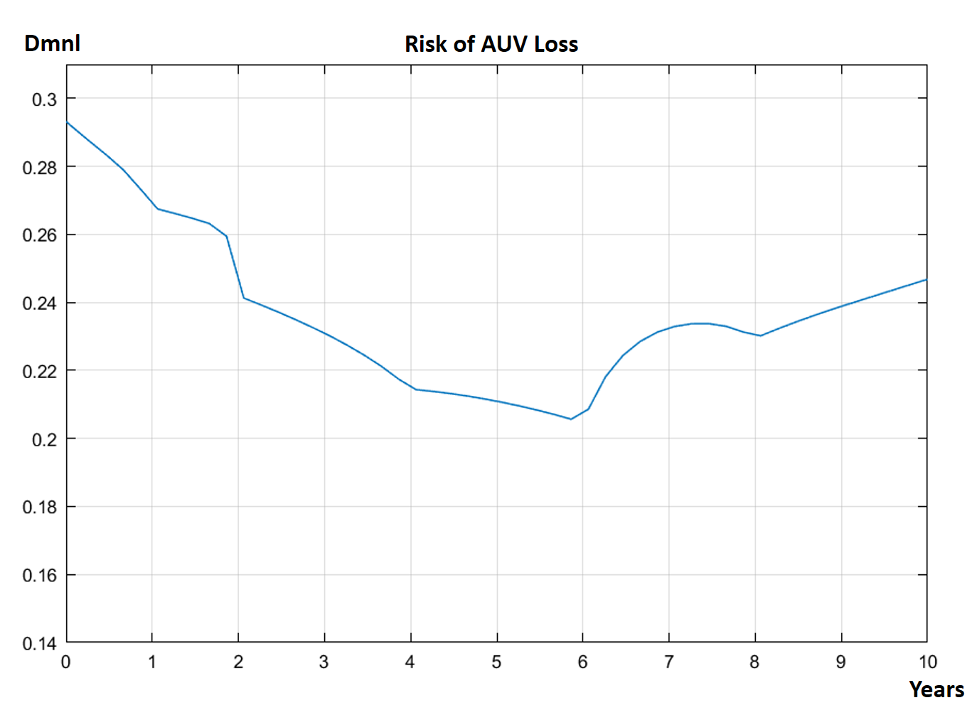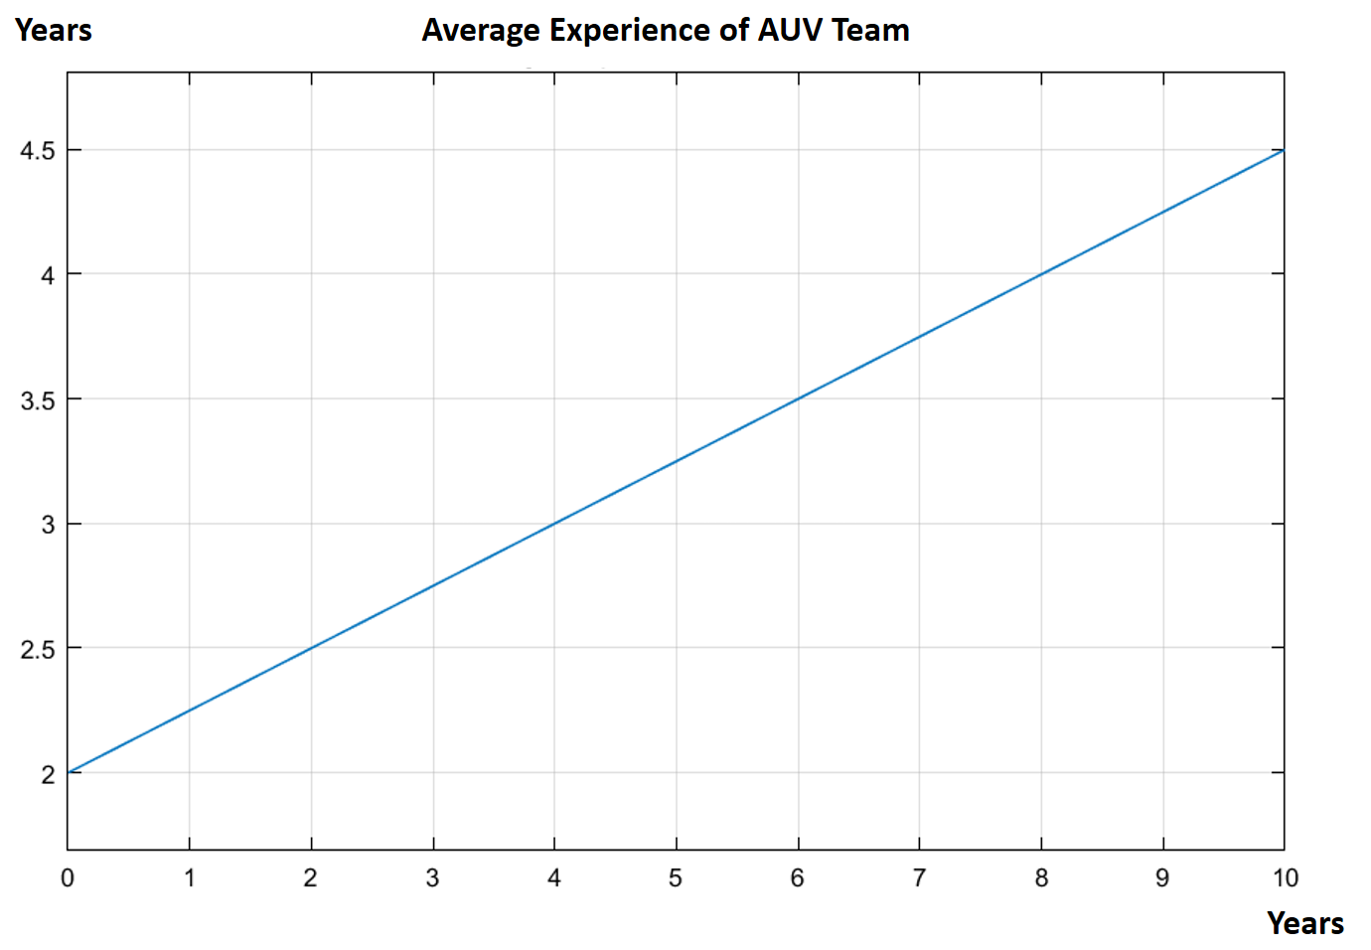
d
c
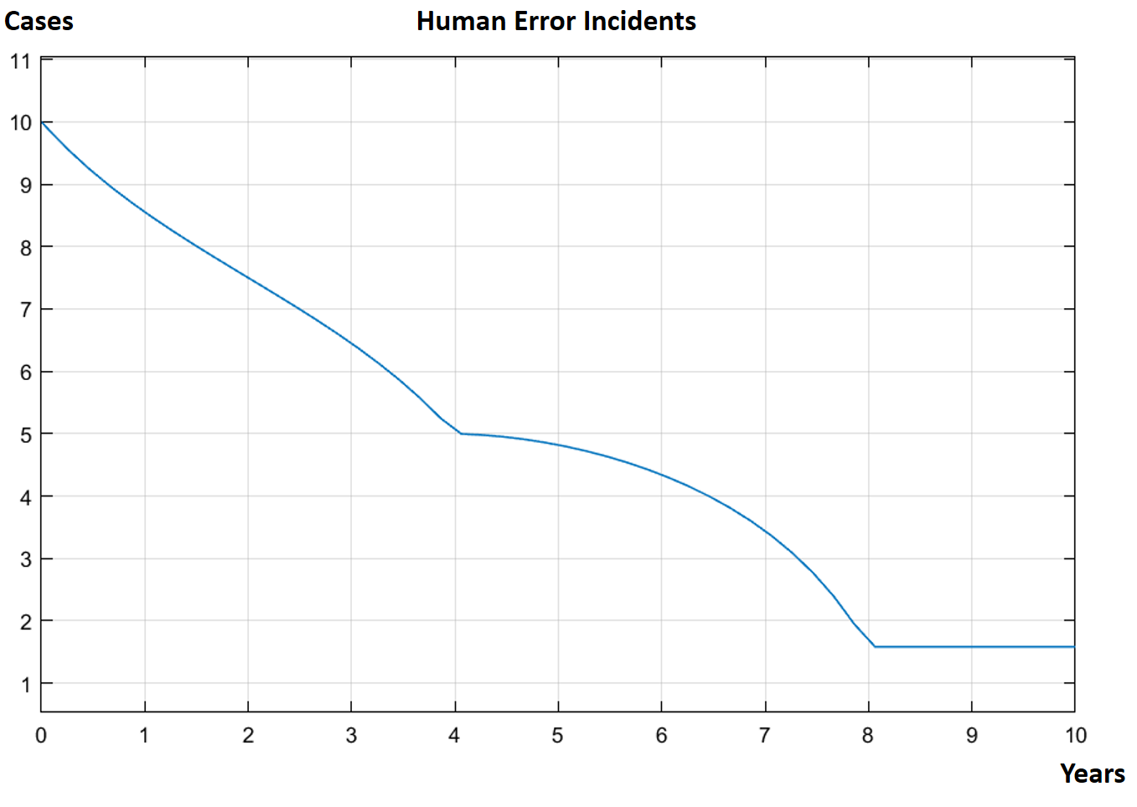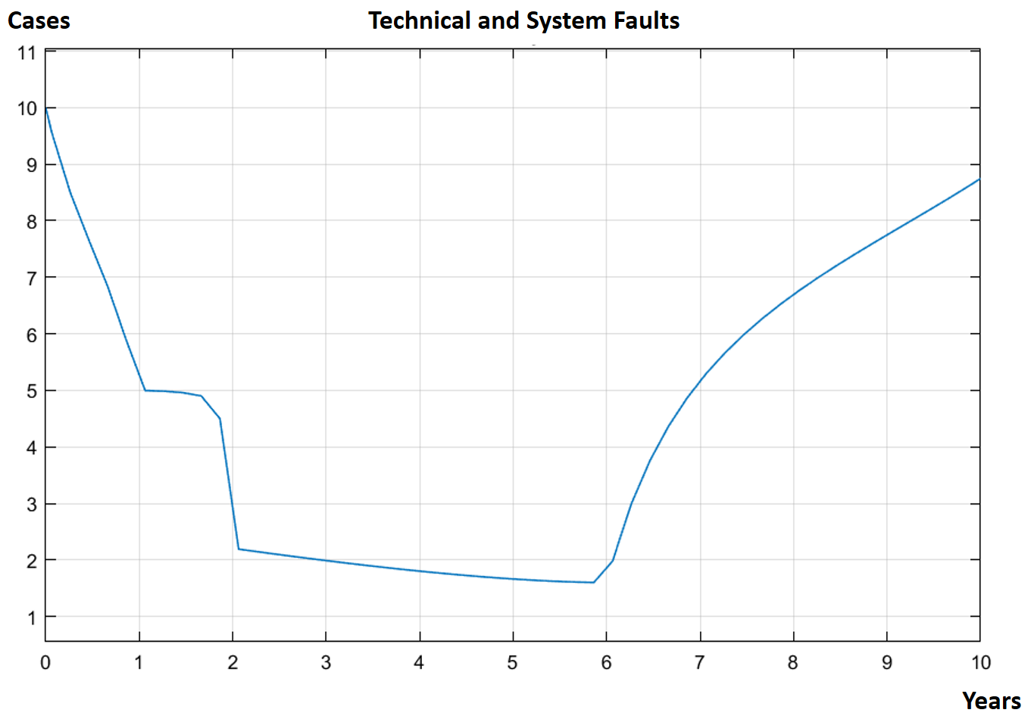
Fig. 9. Simulation results showing the trend of a: ‘Risk of AUV Loss’, b: ‘Average Experience of AUV Team’, c: ‘Human Error Incidents’ and d: ‘Technical and System Faults’.

To facilitate policy recommendations for risk control, various scenarios were simulated in the next step of the risk analysis. The first few scenarios concurrently checked for coherent results, useful for evaluating validity of the model. Various input combinations of risk variables were then simulated next to reflect various possible real-life scenarios.
The first scenario examines how initial ‘Average experience of AUV team’ can affect the risk of AUV loss (Fig. 10). The initial value of ‘Average experience of AUV team’ was increased from two to three years to reflect hiring of additional experienced AUV engineers in the initial phase of the AUV program. Results showed an apparent lower risk of loss as compared to the base scenario, although the difference is less pronounced in later years of the AUV program. On the contrary, if the initial value for ‘Average experience of AUV team’ was decreased from two to one year to reflect the departure of experienced AUV engineers, risk of AUV loss became higher throughout the entire timespan of the AUV program as compared to the base scenario.

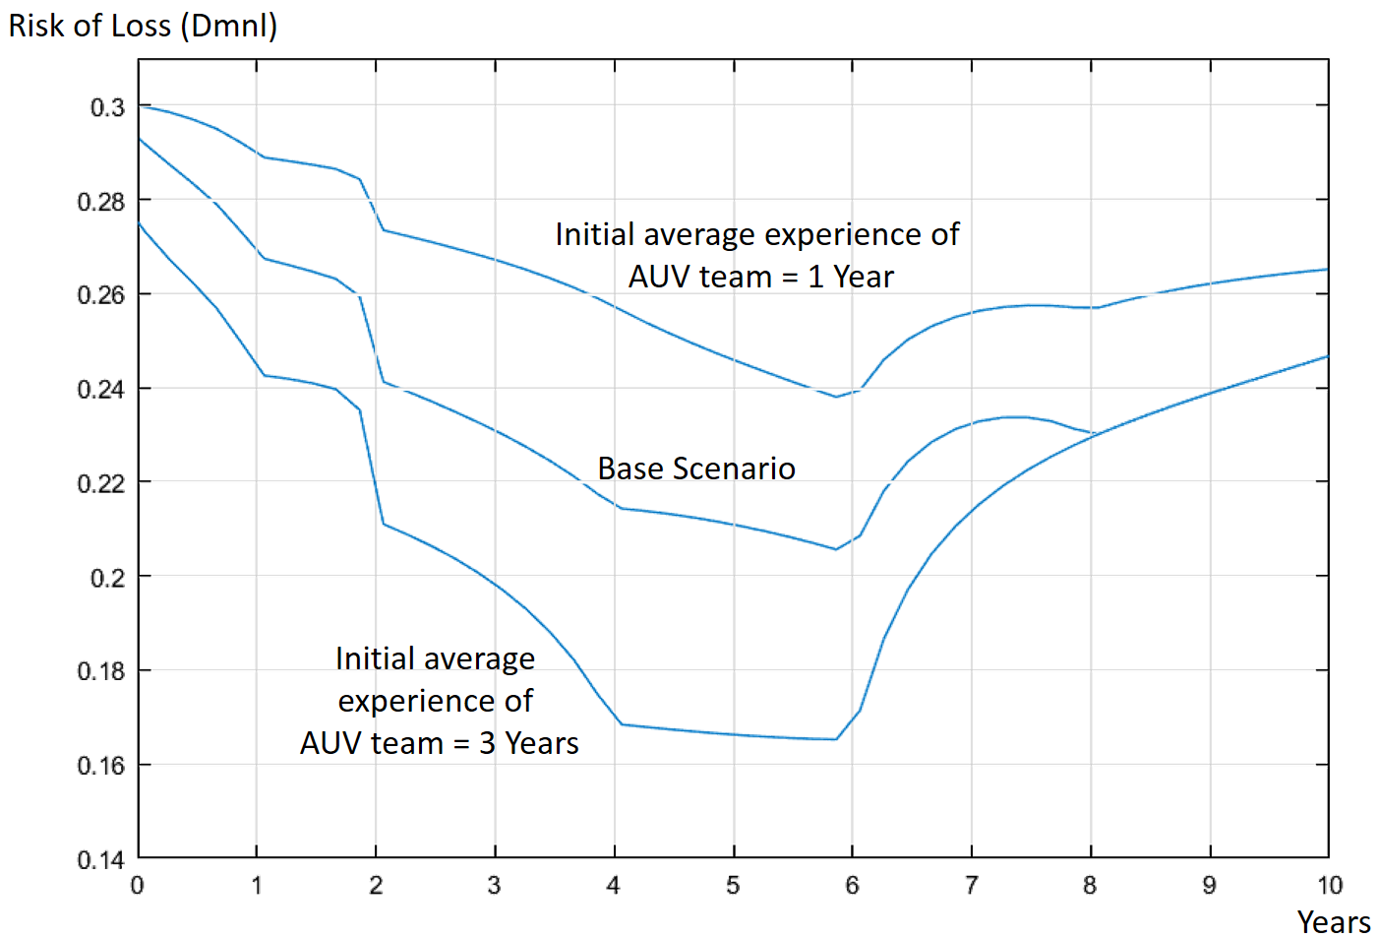
Fig.10. Simulation results showing the trend of risk of AUV loss for different initial average experience of AUV team.

The next scenario analyses how varying both research and commercial demand on the use of nupiri muka can impact the risk of AUV loss in the Antarctic (Fig.11a). Higher demand for the use of nupiri muka can occur due to an increase in oceanographic activities, awareness of AUV capabilities and a favourable regulatory framework. To simulate ‘average-high’ demand, a value of 7.5 instead of 5.0 out of 10 were used as inputs to both ‘Commercial demand’ and ‘Research demand’. Simulation results showed a lower risk of loss as compared to the base scenario. The contrary effect of ‘poor-average’ demand to reflect a situation such as technological obsolescence or unfavourable regulatory framework on the use of AUVs was simulated using a value of 2.5 as the inputs. Results showed a higher risk of risk throughout the entire timespan of the AUV program, being more pronounced in the later years. It is also noteworthy that under ‘poor-average’ demand, average experience of the AUV team reaches a peak between the third and fourth year of the AUV program before a steady decline (Fig.11b). This decline caused an increase in human error incident rates, thus exacerbating the problem further as explained in Fig. 6 in reinforcing loops R1 and R2.

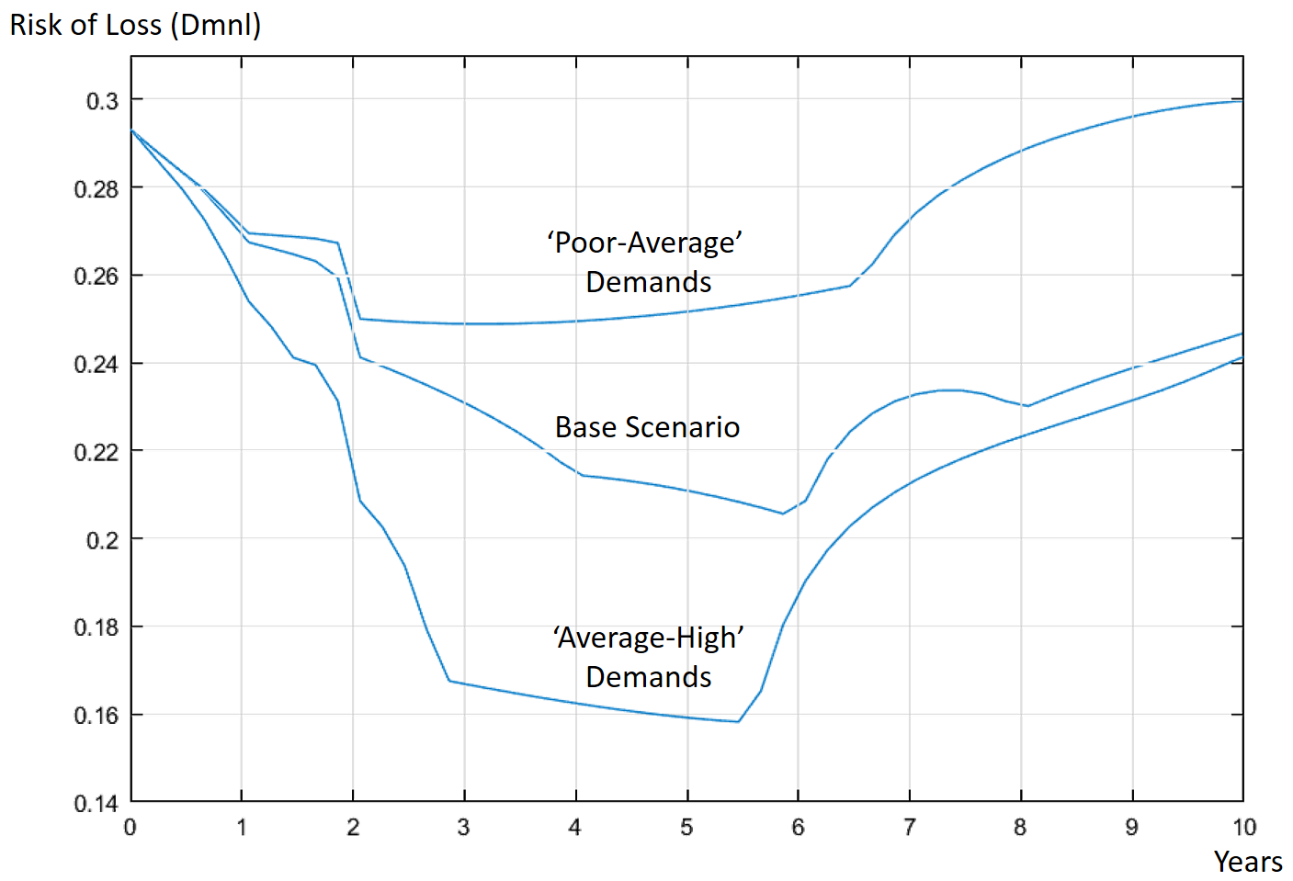
a
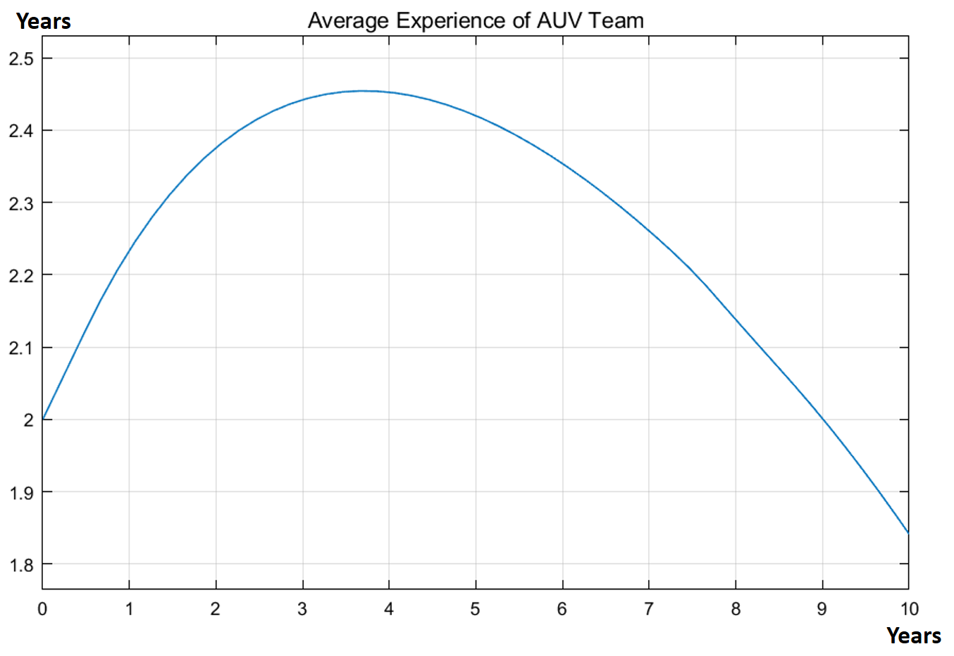
b
Fig.11. Simulation results showing (a) the trend of risk of AUV loss under different research and commercial demand and (b) average experience of AUV team under ‘poor-average’ demand.

With coherent results obtained thus far, the next scenario analysis consisted of having different input combinations of ‘Initial average experience of AUV team’, ‘Research demand’ and ‘Commercial demand’ to reflect different possible real-life scenarios. The resultant range for ‘risk of AUV loss’ is presented in Fig.12.

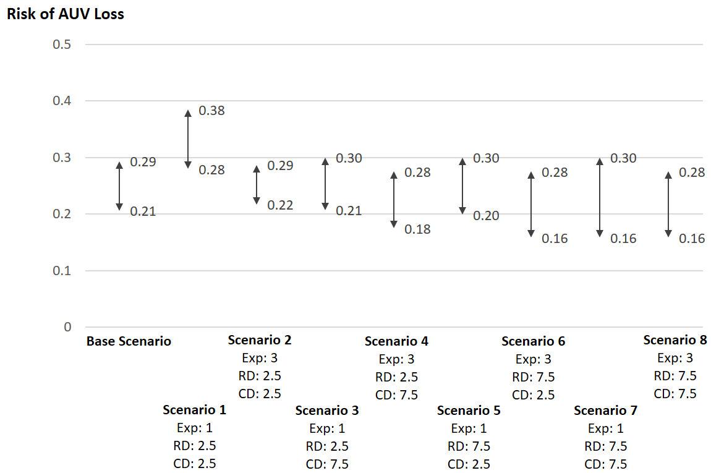

Fig.12. Simulation results showing range of ‘risk of AUV loss’ for various combinations of scenarios. Exp: Initial value for ‘Average Experience of AUV Team’ RD: ‘Research Demand’ CD: ‘Commercial Demand’.

Results from the simulations showed that the lowest range for risk of AUV loss occurred in scenario 6 and scenario 8. In both scenarios, the initial average experience of the AUV team is 3 years and research demand being ‘average-high’ on a scale of 7.5 out of 10. Commercial demand for scenario 6 is ‘poor-average’ at 2.5 and ‘average-high’ in scenario 8 at 7.5. The significance of these results was evaluated in the next phase of the FuSDRA framework.

3.4 Evaluation

In principle, simulation results from the base scenario can be used to evaluate against pre-determined evaluation criteria put forward by the AUV owner or higher management. However, the nupiri muka AUV program is still in its early phases with many uncertainties, such as the precise operating costs and level of value creation. Therefore, an exact set of evaluation criterion has yet to be established. The focus currently lies in ensuring the risk of loss to be as low as reasonably practicable before the first Antarctic deployment.

Despite lacking evaluation criterion, results from the scenario analysis can still be used to facilitate the formulation of risk control policies. For instance, the initial average experience of the AUV team has an apparent impact on the risk of AUV loss throughout the entire AUV program, as shown in Fig.10. and Fig.12. Therefore, it is a useful leverage point for risk control and more experienced crews should be recruited at the onset of the AUV program. Although such recommendation may seem intuitive, the FuSDRA model can support the optimising of recruitment strategy with both soft and hard factors taken into considerations. Soft factors such as team dynamics can be accounted for using linguistic expressions in fuzzy logic while hard factors such as availability of resources can be accounted using system dynamics. Alternatively, an intensive training regime and practice runs similar to the actual Antarctic operation should be implemented to increase hands-on-experience of the existing AUV team. Policies to boost morale and increase engagement with the AUV team will also help to reduce turnover of experienced crew and ensure knowledge retention.

The importance of having both long-term research and commercial demand to ensure ongoing utilisation of the AUV was demonstrated in both Fig.11 and Fig.12. It is therefore recommended that sustainable and effective communication channels are established both internally and externally to facilitate research collaboration. Fig.12 also shows that research demand seems to have more influence in reducing the risk of AUV loss than commercial demand. A higher research demand on use of the AUV would result in more research publications and a better reputation for the organisation, translating to better research funding opportunities. While commercial demand also builds upon the reputation of the institution (Williams, Buttle, & Biggemann, 2012), it is an external variable which can change rapidly due to momentous political, economic, sociological and technological changes (J Aguilar, 1967). However, in a realistic context of limited funding sources, it is not practical to recommend using the AUV solely for pure research or commercial works. Instead, the simulation result suggests that priority should be given for research purposes over commercial works. The AUV owner should also constantly support and encourage its own internal use of the AUV. High internal demand can also help to mitigate the effects of poor commercial demand and an AUV team with low experience. Finally, it is also logical to monitor the average experience of the AUV team and the level of demand for both internal and external use as leading indicators to risk of AUV loss.

4. DISCUSSION AND LIMITATIONS

The multidimensional, dynamic and sometimes fuzzy nature of risk (Haimes, 2009) makes the FuSDRA approach highly effective in analyzing risk of AUV loss in the Antarctic. It overcomes the shortcomings of existing risk analysis methods by taking into account complexity of the system, dynamic nature of risk variables, uncertainties in causal relationships as well as soft factors which are difficult to quantify. Therefore, the resultant risk control policy recommendations, if implemented, are expected to be more reliable and effective than those put forward by existing risk analysis approaches. As demonstrated in the application example, the FuSDRA approach, being without complex mathematical computations is relatively easy to understand and apply. The risk analysis process itself presents an invaluable learning opportunity for the involved stakeholders. Iterative discussions revealed insights on possible leverage points, indicators and decision rules to better manage the risk of AUV loss. In addition, regular review of the risk model not only helps to ensure relevance and sustainability of risk control efforts, but these sessions also act as refreshers on risk mitigation strategies for the stakeholders.

In our application example, the FuSDRA approach makes an attempt to capture the impact of funding and recruitment on the AUV risk, providing means to inform the implementation of risk management strategies. This enables AUV owners to adapt risk management strategies to the environment in which the department operates.

Despite the advantages of the FuSDRA approach in analyzing risk of AUV loss in the Antarctic, we also recognise that there are limitations. One major limitation is that the approach is dependent on expert judgement, which is subjected to bias. AUV experts come with a varied level of experience working with different types of AUVs. Even those who have had Antarctic experience may have worked for different organisations with various objectives. As a result, assumptions, perceptions and expectations differ between experts, often resulting in inconsistent or conflicting opinions during construction of the FuSDRA model. Similar issue was also encountered in other studies involving fuzzy logic (Ben-Arieh & Chen, 2006)(Meghdadi & Akbarzadeh-T, 2001). Exacerbating this problem is the fact that risk of AUV loss is a complex problem involving many risk variables. Attempts to include all suggested risk variables in a single risk model often results in models which are too complex for any practical analysis. To reduce the complexity of the risk model meant that assumptions had to be made, which may be subjected to differing interpretations. Lastly, the inability of the FuSDRA model to self-learn means that regular review is required to ensure the relevance and sustainability of risk control efforts. Despite these limitations, the long-term reduction to risk of AUV loss arising from implementation of the recommended policies justifies the effort for the modelling.

To overcome some of the mentioned challenges to further improve risk analysis of AUV operations in the Antarctic, further research can follow two tracks: First, to account for varying degrees of trust in experts in the risk model. This can be done with the use of intuitionistic fuzzy logic, which is an extension of classical fuzzy logic. It deals with vagueness by assigning to each element a membership degree and non-membership degree. Inputs provided by each individual experts can then be assigned a ‘certainty degree’ based on the level of trust (Takeuti & Titani, 1984). Secondly, to explore means of optimising fuzzy rules and facilitating self-learn by applying optimisation methods such as a genetic algorithm, neural networks or simulated annealing among others.

There are many different types of AUVs and organisations use them for different purposes in the Antarctic. This implies a wide variety of risk variables may influence the risk of AUV loss depending on the context. It is therefore important, to tailor the FuSDRA approach according to the identified problem and intent of the organisation. As a result, the output may also differ vastly depending on the organisations, vehicle characteristics or deployment types, and should only be compared with caution.

5. CONCLUSION

The deployment of AUVs in the Antarctic is of relatively high risk due to the extreme environment, which pushes the limits of both human and AUV technology. However, the risk of AUV loss is a dynamic and complex problem, influenced not only by Antarctic’s operating environment but also other risk variables. It is under such situations that the AUV owner often has to devise risk control measures and make difficult deployment decisions. Existing risk analysis approaches tend to be discrete-based and focus more on technicalities of the AUV, often neglecting risk variables from other risk dimensions including soft factors which are often neglected due to difficulties in quantification.

To overcome existing shortfalls, this research presents an integrated FuSDRA approach to achieve both better control and monitoring of long term risk of AUV loss in the Antarctic. System dynamics was used to model the dynamic complex inter-relationships between risk variables influencing the risk of AUV loss. Fuzzy logic was then integrated into the system dynamics models to account for uncertainties in causal relationships and soft factors. The proposed hybrid FuSDRA approach follows a three-stage iterative framework comprising of identification of risk variables, risk modelling and risk evaluation.

To demonstrate the application of FuSDRA, it was applied to the nupiri muka AUV program, managed by the University of Tasmania. A risk model was constructed, and simulation of the resultant risk model showed a declining risk of loss in the early years of the AUV program, reaching a minimal level before increasing again in later years. Scenario analysis was then performed to validate the risk model and facilitate policy recommendations. Results showed that the initial ‘Average experience of the AUV team’ is a suitable leverage point for reducing risk of AUV loss, which can be increased or maintained through recruitment, staff retention, as well as training and practice runs. Also demonstrated was the importance of having both external commercial and internal research demand on the use of the AUV for reducing risk of loss. As commercial demand may fall outside the control of the organisation, priority should be placed on internal research demand. AUV owners should continuously support and encourage their own use of AUV for research purposes as increased usage can help control risk of AUV loss in the long run. It is also recommended that the average experience of the AUV team and the level of demand for both internal and external use of the AUV be monitored as leading indicators to risk of AUV loss. These results arising from FuSDRA translates into policy recommendations to manage and control the risk of loss. For example, the University can implement an operation policy which places a priority on internal research use of the AUV over commercial use. There can also be a recruitment policy which requires new AUV crew to have a minimal of 3 years relevant experience. In addition, the risk analysis process, which revealed and analyses new risk variables, helped to improve mental models of decision-makers. For example, the role of organisational reputation and demand on AUV use have never been considered in other risk studies on AUV operations.

In summary, the FuSDRA framework provides a systematic and structured approach for risk analysis of AUV operations in the Antarctic, facilitating the building and customizing of risk models in accordance with the context of circumstances. It overcomes limitations of existing AUV risk analysis approaches, improves comprehensiveness of the analysis and can be used as a decision support tool. In the face of increasingly complex AUV operations such as higher autonomy and multi-vehicle missions, FuSDRA can help to understand the effectiveness of different risk management strategies. Due to the generic nature of the approach, the framework can also be applied to other types of AUV operations apart from Antarctic deployment. It may also be relevant to similar complex technological systems, such as the budding field of autonomous cars, unmanned aerial vehicles and unmanned vessels. The commonalities that they share is the apparent lack of data and the potential for low probabilities and high consequences accidents (Pagallo, 2017)(Ancel, Capristan, Foster, & Condotta, 2017)(Thieme & Utne, 2017). The only foreseeable difference between application of the FuSDRA approach to AUV and other technological systems lies in the risk variables being considered.

The proposed FuSDRA framework is not only useful to practitioners for analysis of risk. Academically, it also explores further into the concepts of non-probabilistic risk modelling, which is often challenging in real-life problems. Therefore, the FuSDRA approach provides both contribution to knowledge, as well as a pragmatic tool for the AUV community for better analysis of risks. Further advancement of this work to enhance the FuSDRA approach can focus on data aggregation, intuitionistic fuzzy logic as well as optimization and self-learning of the risk model.

ACKNOWLEDGEMENT

This research was supported by the Australian Research Council’s Special Research Initiative under the Antarctic Gateway Partnership (Project ID SR140300001). The first author also acknowledges the Australian Government Research Training Program Scholarship in support of this higher degree research.

APPENDIX I
Details of Stock and Flow Model (Figure 8.)

Table I. Formulations, definitions and initial conditions for the stock and flow diagram presented in Figure 8.

Risk variable | Definition | Equation
Allocated Annual HR Budget | Amount of budget to be allocated for human resources in the AUV program. Affects recruitment, turnover and training. | Function of (Third Party AUV Hire Contracts), (Reputation in AUV Operations) and (Expenditure)  Uncertain¹
Average Experience of AUV Team | Average experience of the primary AUV team in AUV operations. | INTEG (Change in Experience)  Initial value = 2 Years  INTEG = Numerical Integration
Baseline Aging of Components and Systems | Ageing of AUV components and systems which are independent of usage. | 0.2 years per year (For each year in operation)
Change in AUV Effective Age | Rate at which the effective age of the AUV increases. | MAX (Baseline Aging, Relative Utilisation Rate)  MAX= Maximum of two alternatives
Change in Experience | The amount of experience gained or lost due to turnover or training of staff. | Function of (Allocated Annual HR Budget)  Uncertain
Change in Reputation | Changes to reputation of the University of Tasmania in AUV operations. | Function of (Research Demand) and (Incident Rate)  Uncertain
Commercial Demand | Pool of potential customers hiring the AUV at a specific period considering the costs, awareness, regulations, geographical limitations and economic conditions. Utilises an arbitrary range of 0 – 10 where higher number indicates higher demand. | 5.0: Average commercial demand
Designed Utilisation Rate | The expected utilisation rate considered by the AUV manufacturer during design and production of the AUV. Measured in time spent in water. | 50% annually
Effective AUV Age | Basis of remaining useful life, which can be less than actual calendar age of the AUV | INTEG (Rate of Aging)  Initial value = 0
Human Error Incidents | Number of recorded human error related incidents. | Function of (Average Experience of AUV Team)  Uncertain
Incident Rate | Overall recorded incident rate, per AUV year in water. | (Human Error Incidents + Technical and System Faults) / Utilisation Rate
Increase in Costs | Increase in costs of preventive maintenance as AUV components and systems deteriorate or become obsolete with time. | 5% Annual Increase
Preventive Maintenance Costs | Amount of spending on routine preventive maintenance. | INTEG (Increase in Costs)  Initial value = 50,000 AUD
Reactive Maintenance Costs | Amount of spending on repairs in response to breakdown, fault or defect. | 10,000 AUD x Technical and System Faults
Relative Utilisation Rate | Actual utilisation rate as compared to designed utilisation rate. | Utilisation Rate / Designed Utilisation Rate
Research Demand | Amount of internal scientific or engineering research requests on use of the AUV. Utilises an arbitrary range of 0 – 10 where higher number indicates more requests. | 5.0: Average research demand
Reputation in AUV Operations | Perceived level of reputation of the University of Tasmania in AUV operations. Utilises an arbitrary range of 0 – 100 where higher number indicates better reputation. | INTEG (Change in Reputation)  Initial value = 50: Average reputation
Risk of AUV Loss | Likelihood of losing the AUV during a deployment to the Antarctic. | Function of (Incident Rate)  Uncertain
Technical and System Faults | Number of recorded technical and system-related faults | Function of (Effective AUV Age)  Uncertain
Third-Party AUV Hire Contracts | Perceived level of annual third-party AUV hires contracts. Utilises an arbitrary range of 0 – 10 where higher number indicates more contracts | Function of (Reputation in AUV Operations) and (Commercial Demand)  Uncertain
Total Expenses of Maintenance | Total expenditure on both preventive and reactive maintenance. | Reactive Maintenance Costs + Preventive Maintenance Costs
Utilisation Rate | The amount of time the AUV spends in water in a year. | Function of (Reputation in AUV Operations)  Uncertain

¹ Bolded uncertain represents presence of random factors somewhere in the functional relationships which may not be deterministically defined at this point in time.

APPENDIX II
Universe of Discourse, Fuzzy Sets, Membership Function and Fuzzy Rules
Table II-A. Risk variables and their associated universe of discourse, fuzzy sets and membership functions.
Risk Variables | Universe of Discourse (Units) | Fuzzy Sets and Membership Function
Commercial Demand | 0 to 10 (Dimensionless)
Reputation in AUV Operations. | 0 to 100 (Dimensionless)
Third Party AUV Hire Contracts | 0 to 10 (Dimensionless) | Very Low
Research Demand | 0 to 10 (Dimensionless)
Incident Rate | 0 to Positive Infinity, in practice usually ranges from 0 to 250  (No. of Cases / Year in Water) | 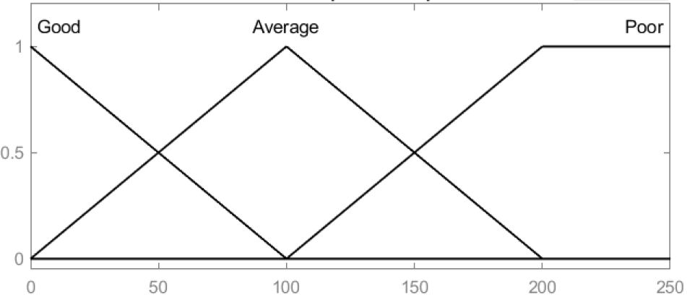
Change in Reputation. | -5 to 5 (Dimensionless)
Risk of AUV Loss | 0 to 1 (Dimensionless)
AUV Effective Age | 0 to 100, in practice usually ranges from 0 to 10 (Years) | 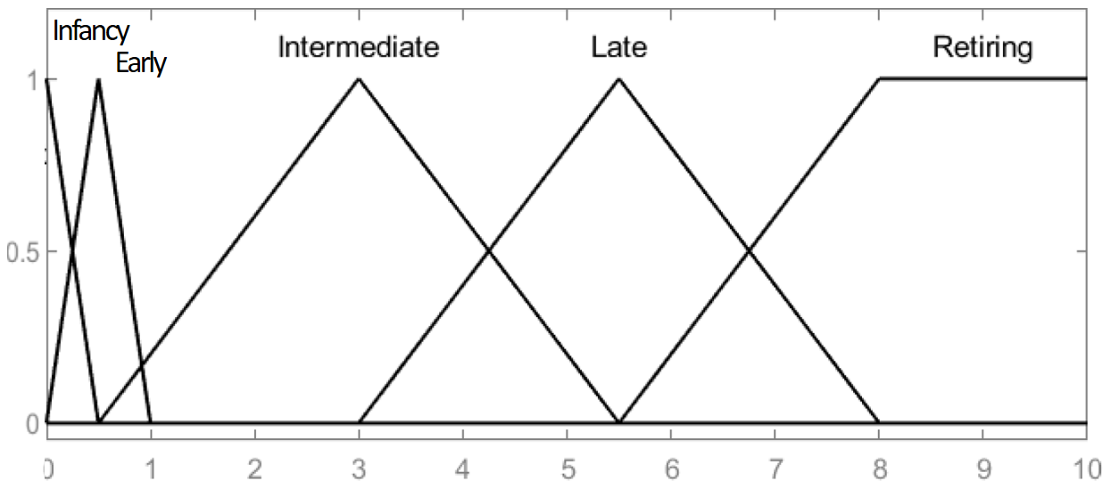
Technical and System Faults | 0 to Positive Infinity, in practice usually ranges from 0 to 20 (Cases per Year) | 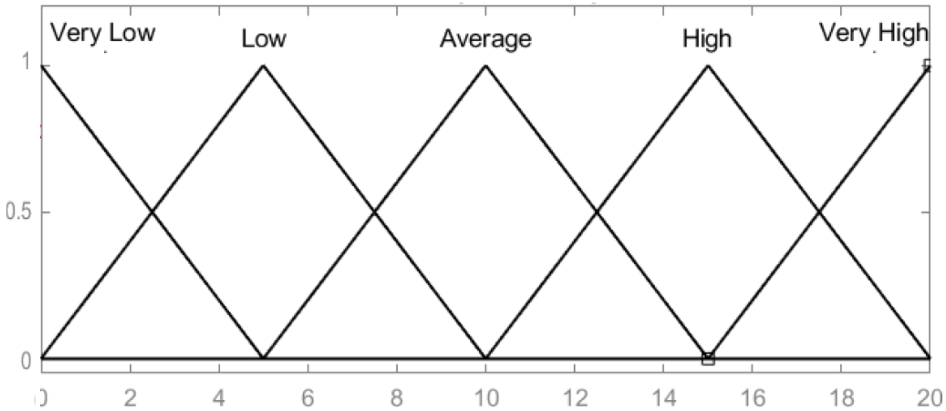
Actual Utilisation Rate | 0 to 0.5  (Percentage of time operational in water)
Allocated HR Budget | 0 to Positive Infinity, in practice usually ranges from 100,000 to 800,000 (AUD) | 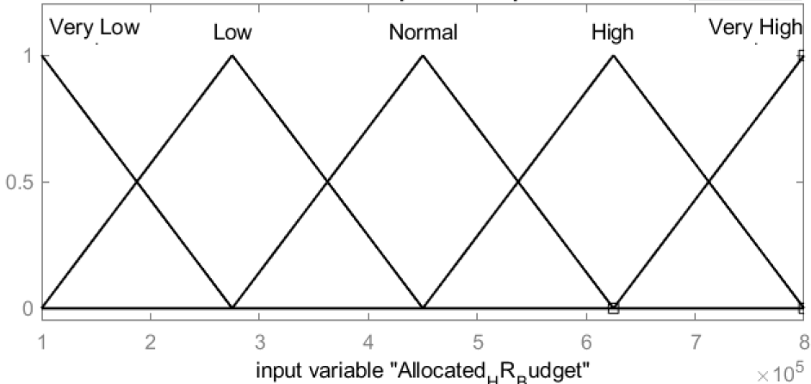
Change in Experience | -1.5 to 2 (Years)
Average Experience of AUV Team | 0 to 50, in practice usually ranges from 0 to 10 (Years) | 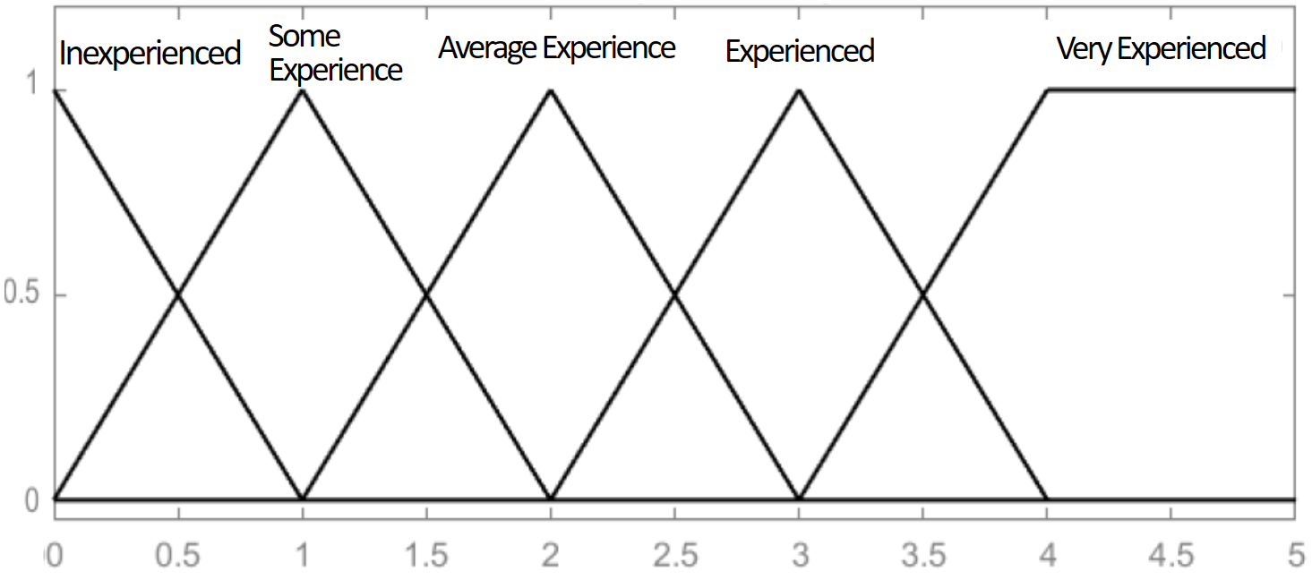
Human Error Incidents | 0 to Positive Infinity, in practice usually ranges from 0 to 25 (Cases per Year)
Total Expenses of Maintenance. | 0 to Positive Infinity, in practice usually ranges from 50,000 to 350,000 (AUD per Year)

Table II-B. Elicited fuzzy rules.
Input: Commercial Demand, Reputation in AUV Operations
Output: Third Party AUV Hire Contracts
 |  | Commercial Demand
 |  | Poor | Average | High
Reputation in AUV Operations | Notorious | Very Low | Low | Low
Reputation in AUV Operations | Poor | Very Low | Low | Average
Reputation in AUV Operations | Average | Low | Average | High
Reputation in AUV Operations | Good | Low | Average | High
Reputation in AUV Operations | Excellent | Low | High | Very High

Input: Research Demand, Incident Rate
Output: Reputation in AUV Operations
 |  | Research Demand
 |  | Low | Average | High
Incident Rate | Poor | Notorious | Poor | Average
Incident Rate | Average | Poor | Average | Good
Incident Rate | Good | Average | Good | Excellent

Input: Incident Rate
Output: Risk of AUV Loss
 |  | Risk of AUV Loss
Incident Rate | Poor | High
Incident Rate | Average | Moderate
Incident Rate | Good | Low

Input: AUV Effective Age
Output: Technical and System Faults
 |  | Technical and System Faults
AUV Effective Age | Infancy | Average
AUV Effective Age | Early | Low
AUV Effective Age | Intermediate | Very Low
AUV Effective Age | Late | Average
AUV Effective Age | Retiring | Very High

Input: Reputation in AUV Operations
Output: Actual Utilisation Rate
 |  | Actual Utilisation Rate
Reputation in AUV Operations | Notorious | Minimal
Reputation in AUV Operations | Poor | Low
Reputation in AUV Operations | Average | Average
Reputation in AUV Operations | Good | High
Reputation in AUV Operations | Excellent | Extreme

Input: Allocated Annual HR Budget
Output: Change in Experience
 |  | Change in Experience
Allocated Annual HR Budget | Very Low | High Loss
Allocated Annual HR Budget | Low | Loss
Allocated Annual HR Budget | Normal | Minimal Impact
Allocated Annual HR Budget | High | Gain
Allocated Annual HR Budget | Very High | High Gain

Input: Average Experience of AUV Team
Output: Human Error Incidents
 |  | Human Error Incidents
Average Experience of AUV Team | Inexperienced | High
Average Experience of AUV Team | Some Experience | Intermediate
Average Experience of AUV Team | Average Experience | Intermediate
Average Experience of AUV Team | Experienced | Low
Average Experience of AUV Team | Very Experienced | Excellent

Input: Total Expenses of Maintenance, Third Party AUV Hire Contracts, Reputation in AUV Operations
Output: Allocated Annual HR Budget
Total Expenses of Maintenance = Low |  | Third Party AUV Hire Contracts
 |  | Very Low | Low | Average | High | Very High
Reputation in AUV Operations | Notorious | Low | Low | Low | Normal | Normal
Reputation in AUV Operations | Poor | Low | Low | Normal | Normal | Normal
Reputation in AUV Operations | Average | Low | Normal | Normal | High | High
Reputation in AUV Operations | Good | Normal | Normal | High | High | Very High
Reputation in AUV Operations | Excellent | High | Very High | Very High | Very High | Very High

Total Expenses of Maintenance = Average |  | Third Party AUV Hire Contracts
 |  | Very Low | Low | Average | High | Very High
Reputation in AUV Operations | Notorious | Very Low | Low | Low | Low | Normal
Reputation in AUV Operations | Poor | Low | Low | Low | Normal | Normal
Reputation in AUV Operations | Average | Low | Normal | Normal | Normal | High
Reputation in AUV Operations | Good | Normal | Normal | High | High | High
Reputation in AUV Operations | Excellent | High | High | Very High | Very High | Very High

Total Expenses of Maintenance = High |  | Third Party AUV Hire Contracts
 |  | Very Low | Low | Average | High | Very High
Reputation in AUV Operations | Notorious | Very Low | Very Low | Low | Low | Low
Reputation in AUV Operations | Poor | Very Low | Low | Low | Low | Low
Reputation in AUV Operations | Average | Low | Low | Low | Normal | Normal
Reputation in AUV Operations | Good | Low | Normal | Normal | Normal | Normal
Reputation in AUV Operations | Excellent | Normal | Normal | High | High | Very High

REFERENCES

Aini, M. S., & Fakhrul-Razi, A. (2010). Development of Socio-Technical Disaster Model. Safety Science, 48(10), 1286–1295. https://doi.org/10.1016/j.ssci.2010.04.007
Alvanchi, A., Lee, S. H., & AbouRizk, S. (2011). Modeling Framework and Architecture of Hybrid System Dynamics and Discrete Event Simulation for Construction. Computer-Aided Civil and Infrastructure Engineering. https://doi.org/10.1111/j.1467-8667.2010.00650.x
Ancel, E., Capristan, F. M., Foster, J. V., & Condotta, R. C. (2017). Real-time Risk Assessment Framework for Unmanned Aircraft System (UAS) Traffic Management (UTM). https://doi.org/10.2514/6.2017-3273
Atman, C. J., Bostrom, A., Fischhoff, B., & Morgan, M. G. (1994). Designing Risk Communications: Completing and Correcting Mental Models of Hazardous Processes, Part I. Risk Analysis. https://doi.org/10.1111/j.1539-6924.1994.tb00289.x
Barua, A., Mudunuri, L. S., & Kosheleva, O. (2014). Why Trapezoidal and Triangular Membership Functions Work so Well: Towards a Theoretical Explanation. Journal of Uncertain Systems, 8(3), 164–168.
Ben-Arieh, D., & Chen, Z. (2006). Linguistic Group Decision-Making: Opinion Aggregation and Measures of Consensus. Fuzzy Optimization and Decision Making. https://doi.org/10.1007/s10700-006-0017-9
Bian, X., Mou, C., Yan, Z., & Xu, J. (2009). Reliability Analysis of AUV Based on Fuzzy Fault Tree. In 2009 IEEE International Conference on Mechatronics and Automation, ICMA 2009 (pp. 438–442). https://doi.org/10.1109/ICMA.2009.5246655
Brito, M., & Griffiths, G. (2016). A Bayesian Approach for Predicting Risk of Autonomous Underwater Vehicle Loss during their Missions. Reliability Engineering & System Safety, 146, 55–67. https://doi.org/10.1016/j.ress.2015.10.004
Brito, M. P. (2017). AUV development trends and their implications for risk management strategies. Underwater Technology. https://doi.org/10.3723/ut.34.103
Brito, M. P., & Griffiths, G. (2012). A Systems Dynamics Framework for Risk Management of Multiple Autonomous Underwater Vehicles. In 11th International Probabilistic Safety Assessment and Management Conference and the Annual European Safety and Reliability Conference 2012 (PSAM11 ESREL 2012)obabilistic Safety Assessment and Management Conference and the Annual European Safety and Relia. Red Hook NY, USA.
Brito, M. P., Griffiths, G., & Challenor, P. (2010). Risk Analysis for Autonomous Underwater Vehicle Operations in Extreme Environments. Risk Analysis, 30(12), 1771–88. https://doi.org/10.1111/j.1539-6924.2010.01476.x
Brito, M. P., Smeed, D. A., & Griffiths, G. (2014). Analysis of Causation of Loss of Communication with Marine Autonomous Systems: A Probability Tree Approach. Methods in Oceanography, 10, 122–137. https://doi.org/10.1016/j.mio.2014.07.003
Cadena, A. (2011). Development of a low cost Autonomous Underwater Vehicle for Antarctic exploration. 2011 IEEE Conference on Technologies for Practical Robot Applications, 76–81. https://doi.org/10.1109/TEPRA.2011.5753485
Cooke, D. L. (2003). A System Dynamics Analysis of the Westray Mine Disaster. System Dynamics Review, 19(2), 139–166. https://doi.org/10.1002/sdr.268
Cooke, R., & Probst, K. N. (2006). Highlights of the expert judgment policy symposium and technical workshop. Workshop on the Theory and Practice of Expert Judgment in Risk and Environmental Studies., 31. Retrieved from http://rff.org/Documents/Conference-Summary.pdf
Cooper, K. (2016). Icy Worlds and their Analog Sites. Retrieved from https://astrobiology.nasa.gov/news/icy-worlds-and-their-analog-sites/
Coyle, G. (2000). Qualitative and Quantitative Modelling in System Dynamics: Some Research Questions. System Dynamics Review. https://doi.org/10.1002/1099-1727(200023)16:3<225::AID-SDR195>3.0.CO;2-D
Dulac, N., Leveson, N., Zipkin, D., Friedenthal, S., Cutcher-Gershenfeld, J., Carroll, J., & Barrett, B. (2005). Using system dynamics for safety and risk management in complex engineering systems. Proceedings of the 2005 Winter Simulation Conference, 1311–1320.
Forrester, J. W. (1958). Industrial Dynamics. Harvard Business Review, 36(August), 37–66. https://doi.org/10.1225/58404
Fuzzy Logic Toolbox User’s Guide. (2017). The MATH WORKS Inc. The MathWorks, Inc. Retrieved from https://www.mathworks.com/help/pdf_doc/fuzzy/fuzzy.pdf
Garbolino, E., Chery, J.-P., & Guarnieri, F. (2016). A Simplified Approach to Risk Assessment Based on System Dynamics: An Industrial Case Study. Risk Analysis, 36(1), 16–29. https://doi.org/10.1111/risa.12534
Griffiths, G., & Brito, M. (2008). Predicting Risk in Missions Under Sea Ice with Autonomous Underwater Vehicles. In 2008 IEEE/OES Autonomous Underwater Vehicles, AUV 2008. Woods Hole, MA, USA: IEEE. Retrieved from http://www.scopus.com/inward/record.url?eid=2-s2.0-74349101464&partnerID=40&md5=b87b645e66d85155a98813290c7b2160
Griffiths, G., & Brito, M. (2011). Risk management for autonomous underwater vehicles operating under ice. In OTC Arctic Technology Conference. Houston, Texas: Offshore Technology Conference. https://doi.org/10.4043/22162-MS.pp.8
Griffiths, G., Brito, M., Robbins, I., & Moline, M. (2009). Reliability of Two REMUS-100 AUVs Based on Fault Log Analysis and Elicited Expert Judgment. In Proceedings of the International Symposium on Unmanned Untethered Submersible Technology (UUST 2009) (p. 12). Durham, New Hampshire. Retrieved from http://eprints.soton.ac.uk/69184/
Griffiths, G., & Collins, K. J. (2006). Proceedings of the Masterclass in AUV Technology for Polar Science. Collaborative Autosub Science in Extreme Environments, Masterclass in AUV Technology for Polar Science. Southampton: National Oceanography Centre. https://doi.org/10.3723/ut.28.187
Griffiths, G., Millard, N. W., McPhail, S. D., Stevenson, P., & Challenor, P. G. (2003). On the Reliability of the Autosub Autonomous Underwater Vehicle. Underwater Technology, 25(4), 175–184.
Guldenmund, F. W. (2010). (Mis)understanding Safety Culture and Its Relationship to Safety Management. Risk Analysis. https://doi.org/10.1111/j.1539-6924.2010.01452.x
Gunderson, E. K. E. (1967). Mental Health Problems in Antarctica. Archives of Environmental Health: An International Journal, 17(4), 558–64.
Gürcanli, G. E., & Müngen, U. (2009). An occupational safety risk analysis method at construction sites using fuzzy sets. International Journal of Industrial Ergonomics, 39(2), 371–387. https://doi.org/10.1016/j.ergon.2008.10.006
Haimes, Y. Y. (2009). On the Complex Definition of Risk: A Systems-Based Approach. Risk Analysis. https://doi.org/10.1111/j.1539-6924.2009.01310.x
Helton, J. C., Johnson, J. D., Oberkampf, W. L., & Sallaberry, C. J. (2010). Representation of Analysis Results Involving Aleatory and Epistemic Uncertainty. International Journal of General Systems, 39(6), 605–646. https://doi.org/10.1080/03081079.2010.486664
Herndl, C.G, Fennell, B.A., & Miller, C. R. (1991). Understanding Failures in Organizational Discourse: The Accident at Three Mile Island and the Shuttle Challenger Disaster. Textual Dynamics of the Professions: Historical and Contemporary Studies of Writing in Professional Communities. https://doi.org/10.1016/0889-4906(93)90009-D
Ho, G., Pavlovic, N., Arrabito, R., & Abdalla, R. (2011). Human Factors Issues When Operating Unmanned Underwater Vehicles. Defence R&D Canada Technical Report DRDC Toronto TR 2011-100. https://doi.org/10.1177/1071181311551088
Hollnagel, E., Pariès, J., Woods, D., & Wreathall, J. (2013). Resilience Engineering in Practice. Ashgate Studies in Resilence Engineering (1st ed.). CRC Press, Taylor & Francis Group.
J Aguilar, F. (1967). Scanning the Business Environment. New York: Macmillan.
Jager, R. (1995). Fuzzy Logic in Control. Technische Universiteit Delf. Retrieved from ftp://ftp.ucauca.edu.co/cuentas/fiet/docs/DEIC/Materias/Control Inteligente/documentos/Jager.pdf
Jenkins, A., Dutrieux, P., Jacobs, S. S., McPhail, S. D., Perrett, J. R., Webb, A. T., & White, D. (2010). Observations beneath Pine Island Glacier in west Antarctica and implications for its retreat. Nature Geoscience, 3(7), 468–472. https://doi.org/10.1038/ngeo890
Kaplan, S., & Garrick, B. J. (1981). On The Quantitative Definition of Risk. Risk Analysis, 1(1), 11–27. https://doi.org/10.1111/j.1539-6924.1981.tb01350.x
Katsakiori, P., Sakellaropoulos, G., & Manatakis, E. (2009). Towards an Evaluation of Accident Investigation Methods in Terms of their Alignment with Accident Causation Models. Safety Science, 47(7), 1007–1015. https://doi.org/10.1016/j.ssci.2008.11.002
Kaur, A., & Kaur, A. (2012). Comparison of Mamdani-Type and Sugeno-Type Fuzzy Inference Systems for Air Conditioning System. International Journal of Soft Computing & Engineering, 2(2), 323–325. Retrieved from http://citeseerx.ist.psu.edu/viewdoc/download?doi=10.1.1.486.1238&rep=rep1&type=pdf
Khanzadi, M., Nasirzadeh, F., & Alipour, M. (2012). Integrating System Dynamics and Fuzzy Logic Modeling to Determine Concession Period in BOT Projects. In Automation in Construction (Vol. 22, pp. 368–376). https://doi.org/10.1016/j.autcon.2011.09.015
Kuhnert, P. M., Martin, T. G., & Griffiths, S. P. (2010). A Guide to Eliciting and Using Expert Knowledge in Bayesian Ecological Models. Ecology Letters. https://doi.org/10.1111/j.1461-0248.2010.01477.x
Lee, C.-S., & Wang, M.-H. (2011). A Fuzzy Expert System for Diabetes Decision Support Application. IEEE Transactions on Systems, Man, and Cybernetics. Part B, Cybernetics : A Publication of the IEEE Systems, Man, and Cybernetics Society, 41(1), 139–153. https://doi.org/10.1109/TSMCB.2010.2048899
Leekwijck, W. Van, & Kerre, E. E. (1999). Defuzzification: Criteria and Classification. Fuzzy Sets and Systems, 108(2), 159–178. https://doi.org/10.1016/S0165-0114(97)00337-0
Leveson, N. G. (2011). Engineering a Safer World: Systems Thinking Applied to Safety. Vasa. The MIT Press. https://doi.org/10.1017/CBO9781107415324.004
Magdy, H. (2008). A Hybrid System Dynamics-Discrete Event Simulation Approach To Simulating The Manufacturing Enterprise. Higher Institute of Technology B.Sc. Benha Higher Institute of Technology.
Mamdani, E. H., & Assilian, S. (1975). An Experiment in Linguistic Synthesis with a Fuzzy Logic Controller. International Journal of Man-Machine Studies, 7(1), 1–13. https://doi.org/10.1016/S0020-7373(75)80002-2
McNeil, F., & Thro, E. (1994). Fuzzy Logic a Pratical Approach. Morgan Kaufmann Pub; Pap/Dskt edition. https://doi.org/10.1016/B978-0-7234-5558-5.00001-4
Meghdadi, A. H., & Akbarzadeh-T, M. R. (2001). Probabilistic Fuzzy Logic and Probabilistic Fuzzy Systems. IEEE International Conference on Fuzzy Systems.
Mendel, J. M. (2001). Uncertain Rule-based Fuzzy Logic Systems: Introduction and New Directions. IEEE Computational Intelligence Magazine (Vol. 2). Retrieved from http://scholar.google.com/scholar?hl=en&btnG=Search&q=intitle:Uncertain+rule-based+fuzzy+logic+systems:+introduction+and+new+directions#0
Mutingi, M., & Mbohwa, C. (2014). Fuzzy System Dynamics of Manpower Systems. In Handbook of Research on Novel Soft Computing Intelligent Algorithms: Theory and Practical Applications (Vol. 1–2, pp. 913–930). https://doi.org/10.4018/978-1-4666-4450-2
Nakayachi, K., Johnson, B. B., & Koketsu, K. (2018). Effects of Acknowledging Uncertainty about Earthquake Risk Estimates on San Francisco Bay Area Residents’ Beliefs, Attitudes, and Intentions. Risk Analysis. https://doi.org/10.1111/risa.12883
Nasirzadeh, F., Khanzadi, M., & Rezaie, M. (2014). Dynamic Modeling of the Quantitative Risk Allocation in Construction Projects. International Journal of Project Management, 32(3), 442–451. https://doi.org/10.1016/j.ijproman.2013.06.002
Negnevitsky, M. (2005). Artificial Intelligence: A Guide to Intelligent Systems (pp. 87–113). Canada: Pearson Education. Retrieved from https://books.google.ae/books/about/Artificial_Intelligence.html?id=1BxYQnrfv9MC&redir_esc=y
Nicholls, K. W., Abrahamsen, E. P., Buck, J. J. H., Dodd, P. A., Goldblatt, C., Griffiths, G., … Wilkinson, J. P. (2006). Measurements beneath an Antarctic ice shelf using an autonomous underwater vehicle. Geophysical Research Letters, 33(8). https://doi.org/10.1029/2006GL025998
Pagallo, U. (2017). From automation to autonomous systems: A legal phenomenology with problems of accountability. In IJCAI International Joint Conference on Artificial Intelligence.
Pidgeon, N., & O’Leary, M. (2000). Man-made Disasters: Why Technology and Organizations (Sometimes) Fail. In Safety Science (Vol. 34, pp. 15–30). https://doi.org/10.1016/S0925-7535(00)00004-7
Pruyt, E. (2007). Dealing with Uncertainties? Combining System Dynamics with Multiple Criteria Decision Analysis or with Exploratory Modelling. Policy Analysis.
Purba, J. H., Sony Tjahyani, D. T., Ekariansyah, A. S., & Tjahjono, H. (2015). Fuzzy Probability Based Fault Tree Analysis to Propagate and Quantify Epistemic Uncertainty. Annals of Nuclear Energy, 85, 1189–1199. https://doi.org/10.1016/j.anucene.2015.08.002
Rastogi, A., & Gabbar, H. A. (2013). Fuzzy-logic-based Safety Verification Framework for Nuclear Power Plants. Risk Analysis, 33(6), 1128–1145. https://doi.org/10.1111/j.1539-6924.2012.01899.x
Reason, J. (1990). Human error. Cambridge University Press.
Simulink® User’s Guide. (2015). Retrieved from https://fenix.tecnico.ulisboa.pt/downloadFile/845043405443232/sl_using_r2015a.pdf
Society for Risk Analysis Glossary. (2015). Retrieved June 1, 2018, from http://www.sra.org/sites/default/files/pdf/SRA_glossary_20150622.pdf
Sterman, J. D. (2000). Business Dynamics: Systems Thinking and Modeling for a Complex World (1st ed.). McGraw-Hill Education.
Stokey, R., Austin, T., Alt, C. Von, Purcell, M., Goldsborough, R., Forrester, N., & Allen, B. (1999). AUV Bloopers or Why Murphy Must have been an Optimist: A Practical Look at Achieving Mission Level Reliability in an Autonomous Underwater Vehicle. 11th International Symposium on Unmanned, Untethered, Submersible Technology (UUST ’99), (9970), 32–40.
Sugeno, M. (1985). Industrial Applications of Fuzzy Control. Elsevier Science Pub. Co., 269.
Sween, M., Ceschi, A., Tommasi, F., Sartori, R., & Weller, J. (2017). Who is a Distracted Driver? Associations between Mobile Phone Use while Driving, Domain-Specific Risk Taking, and Personality. Risk Analysis. https://doi.org/10.1111/risa.12773
Tadic, D., Milanovic, D. D., Misita, M., & Tadic, B. (2011). New Integrated Approach to the Problem of Ranking and Supplier Selection under Uncertainties. Proceedings of the Institution of Mechanical Engineers Part B-Journal of Engineering Manufacture, 225(B9), 1713–1724. https://doi.org/10.1243/09544054JEM2105
Takeuti, G., & Titani, S. (1984). Intuitionistic Fuzzy Logic and Intuitionistic Fuzzy Set Theory. The Journal of Symbolic Logic. https://doi.org/10.2307/2274139
Tessem, B., & Davidsen, P. I. (1994). Fuzzy System Dynamics: An Approach to Vague and Qualitative Variables in Simulation. System Dynamics Review, 10(1), 49–62. https://doi.org/10.1002/sdr.4260100104
Thieme, C. A., & Utne, I. B. (2017). A risk model for autonomous marine systems and operation focusing on human-autonomy collaboration. Proceedings of the Institution of Mechanical Engineers, Part O: Journal of Risk and Reliability. https://doi.org/10.1177/1748006X17709377
Thieme, C. A., Utne, I. B., & Schjolberg, I. (2015). A Risk Management Framework for Unmanned Underwater Vehciles Focusing on Human and Organisational Factors. In Proceedings of the ASME 34th International Conference on Ocean, Offshore and Artic Engineering, 2005, Vol 3.
Unwin, S. D. (1986). A Fuzzy Set Theoretic Foundation for Vagueness in Uncertainty Analysis. Risk Analysis, 6, 27–34. https://doi.org/10.1111/j.1539-6924.1986.tb00191.x
Vensim User Guide. (2017). Retrieved from https://www.vensim.com/documentation/index.html?users_guide.htm
Waters, H. (n.d.). The Robots That Dare to Explore Antarctica’s Frozen Ocean. Retrieved February 5, 2017, from https://motherboard.vice.com/en_us/article/the-robots-that-dare-to-explore-antarcticas-frozen-ocean
Wiegmann, D. A., & Shappell, S. A. (2012). A Human Error Approach to Aviation Accident Analysis: The Human Factors Analysis and Classification System. A Human Error Approach to Aviation Accident Analysis: The Human Factors Analysis and Classification System. Retrieved from http://www.scopus.com/inward/record.url?eid=2-s2.0-84946216241&partnerID=tZOtx3y1
Williams, M., Buttle, F., & Biggemann, S. (2012). Relating Word-of-Mouth to Corporate Reputation. Public Communication Review. https://doi.org/10.5130/pcr.v2i2.2590
Zadeh, L. A. (1965). Fuzzy Sets. Information and Control, 8(3), 338–353. https://doi.org/10.1016/S0019-9958(65)90241-X
Zadeh, L. A. (1975). The concept of a linguistic variable and its application to approximate reasoning-I. Information Sciences, 8(3), 199–249. https://doi.org/10.1016/0020-0255(75)90036-5
Zhao, R., & Govind, R. (1991). Defuzzification of Fuzzy Intervals. Fuzzy Sets and Systems, 43(1), 45–55. https://doi.org/10.1016/0165-0114(91)90020-Q
Zimmermann, H. J. (2001). Fuzzy Set Theory and its Applications. London Kluwer Academic Publishers. https://doi.org/10.1007/978-94-010-0646-0

